Oscar Avina
06/07/2026
Module 1.3 Assignment

- Link to my Github repo:
  - https://github.com/ocavina/csd-340
- Screenshot of initial errors
  - 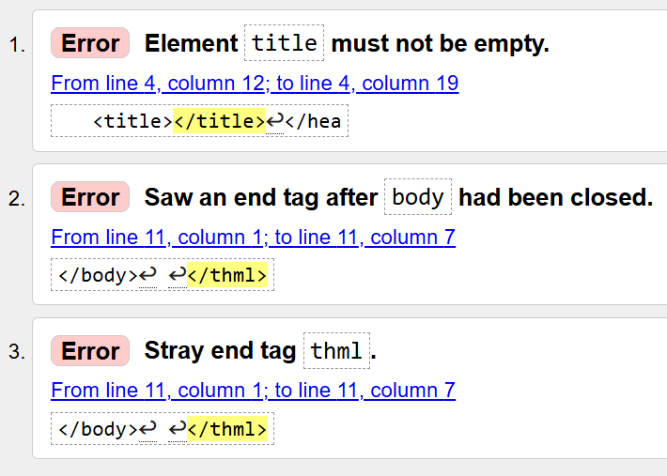

- Screenshot after fixing errors (both times)
  - 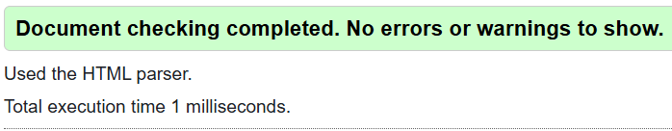

  - 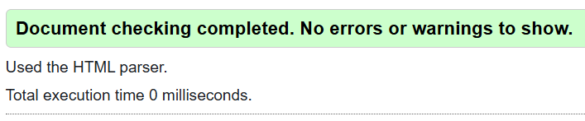

- Screenshot of webpage
  - 