Oscar Avina
08/16/2026
Module 1.2 Assignment

- Link to my Github repo:
  - https://github.com/ocavina/csd-420#
- Screenshot of my GitHub repository
  - 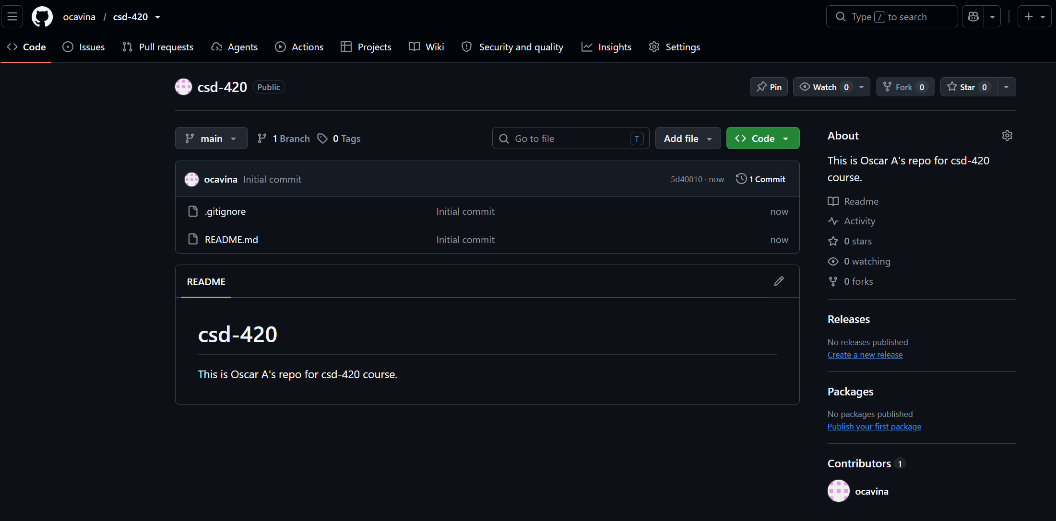

- Screenshot of my local directory
  - 