BURST Statistical Per Protocol Report
Inge Christoffer Olsen, PhD
01 October, 2026
Table of Contents

Introduction
This is the report for the per protocol analysis of the BURST trial where patient 3-009 has been taken out (wrong inclusion). The data are based on an export from the Viedoc electronic data capture at 2023-09-19 system time stamped “_20230919_063242”.
The results in this report is according to the true random allocation.
There were 12 included patients of which 9 were randomised and included in the full analysis set.

Demographics

All randomised
Demographics and baseline characteristics
All included
 | all obs (N=12)
Site name
Akademiska | 5 (41.67%)
OUS | 7 (58.33%)
Gender
Male | 2 (16.67%)
Female | 10 (83.33%)
Age (years)
n | 12
Mean (sd) | 53.56 (6.78)
IQR | 6.75
min - max | 38.90 - 66.70
Marital status
Married | 5 (41.67%)
Single | 0 (0.00%)
Divorsed | 1 (8.33%)
Cohabitant | 5 (41.67%)
Partner | 1 (8.33%)
Number of children
n | 12
Mean (sd) | 1.50 (1.09)
IQR | 1.00
min - max | 0.00 - 4.00
Working?
Yes | 7 (58.33%)
No | 5 (41.67%)
Working hours per week
n | 7
Mean (sd) | 30.43 (15.21)
IQR | 12.50
min - max | 0.00 - 40.00
Years not working
n | 5
Mean (sd) | 1.80 (0.84)
IQR | 1.00
min - max | 1.00 - 3.00
Type of governmental support
Alderstrygd, førtidspensjon (AFP) eller etterlattepensjon | 0 (0.00%)
Sykepenger helt (er helt sykmeldt) | 1 (8.33%)
Sykepenger delvis (er delvis sykmeldt) | 1 (8.33%)
Arbeidsavklaringspenger (AAP) | 4 (33.33%)
Uføreytelse/pensjon, hel | 1 (8.33%)
Uføreytelse/pensjon, delvis | 1 (8.33%)
Mottar ingen stønad, får lønn fra arbeidsgiver | 4 (33.33%)
Completed education
Grunnskole | 0 (0.00%)
Yrkesskole | 0 (0.00%)
Videregående/Gymnas | 6 (50.00%)
Høyskole, universitet < 4 år | 5 (41.67%)
Høyskole, universitet > 4 år | 1 (8.33%)
PCS Total score
n | 12
Mean (sd) | 19.25 (6.68)
IQR | 11.50
min - max | 8.00 - 28.00
PCS Rumination
n | 12
Mean (sd) | 8.08 (3.29)
IQR | 4.25
min - max | 3.00 - 14.00
PCS Magnification
n | 12
Mean (sd) | 2.67 (1.67)
IQR | 3.00
min - max | 0.00 - 5.00
PCS Helplessness
n | 12
Mean (sd) | 8.50 (3.23)
IQR | 4.00
min - max | 4.00 - 14.00
PCS Total score dichotomised at 24
PCS ≤ 24 | 8 (66.67%)
PCS > 24 | 4 (33.33%)
Treatment for neuropatic pain?
No | 8 (66.67%)
Yes | 4 (33.33%)
Amitriptyline
No | 11 (91.67%)
Yes | 1 (8.33%)
Gabapentin
No | 9 (75.00%)
Yes | 3 (25.00%)
Pregabalin
No | 11 (91.67%)
Yes | 1 (8.33%)
Duloxetine
No | 12 (100.00%)
Treatment with other non-opoids?
No | 2 (16.67%)
Yes | 10 (83.33%)
Paracetamol
No | 4 (33.33%)
Yes | 8 (66.67%)
NSAIDs
No | 8 (66.67%)
Yes | 4 (33.33%)
Antidepressiva
No | 12 (100.00%)
Treatmetn with opoids?
No | 7 (58.33%)
Yes | 5 (41.67%)
Total daily morphine milligram equivalents
n | 5
Mean (sd) | 18.50 (9.97)
IQR | 17.00
min - max | 7.50 - 30.00
Previous physiotherapy?
Yes | 12 (100.00%)
Previous chiropractor?
No | 5 (41.67%)
Yes | 7 (58.33%)
Previous psychologist?
No | 10 (83.33%)
Yes | 2 (16.67%)
Previous TENS?
No | 2 (16.67%)
Yes | 10 (83.33%)
Other previous treatment?
No | 9 (75.00%)
Yes | 3 (25.00%)
Other previous treatment, specify
Dry needling, Blockad SI-led och rotblockad. | 1
epidural injeksjon, iv infusjon lidokain, ketamin | 1
Specialdiet via dietist, rotblockader x 2, ryggkirurgi, värmebad. | 1
Current physiotherapy?
No | 9 (75.00%)
Yes | 3 (25.00%)
Current chiropractor?
No | 12 (100.00%)
Current psychologist?
No | 12 (100.00%)
Current TENS
No | 8 (66.67%)
Yes | 4 (33.33%)
Other current treatment?
No | 11 (91.67%)
Yes | 1 (8.33%)
Other current treatment, specify
Följer sjukgymnast-program hemma. | 1
Current back pain?
No | 2 (16.67%)
Yes | 10 (83.33%)
Duration of pain (years)
n | 12
Mean (sd) | 7.40 (10.17)
IQR | 8.20
min - max | 0.40 - 36.00
Duration of current pain level (years)
n | 12
Mean (sd) | 2.76 (3.63)
IQR | 2.50
min - max | 0.25 - 10.00
Weight (kg)
n | 12
Mean (sd) | 74.54 (12.25)
IQR | 18.50
min - max | 54.00 - 92.50
Height (cm)
n | 12
Mean (sd) | 167.08 (8.02)
IQR | 7.25
min - max | 155.00 - 183.00
BMI
n | 12
Mean (sd) | 26.61 (3.31)
IQR | 3.97
min - max | 20.30 - 32.00

Excluded from FAS
Demographics and baseline characteristics
Excluded before randomisation
 | all obs (N=3)
Site name
Akademiska | 2 (66.67%)
OUS | 1 (33.33%)
Gender
Male | 0 (0.00%)
Female | 3 (100.00%)
Age (years)
n | 3
Mean (sd) | 54.40 (4.51)
IQR | 4.05
min - max | 49.20 - 57.30
Marital status
Married | 0 (0.00%)
Single | 0 (0.00%)
Divorsed | 1 (33.33%)
Cohabitant | 2 (66.67%)
Partner | 0 (0.00%)
Number of children
n | 3
Mean (sd) | 0.67 (0.58)
IQR | 0.50
min - max | 0.00 - 1.00
Working?
Yes | 2 (66.67%)
No | 1 (33.33%)
Working hours per week
n | 2
Mean (sd) | 40.00 (0.00)
IQR | 0.00
min - max | 40.00 - 40.00
Years not working
n | 1
Mean (sd) | 1.00 (NA)
IQR | 0.00
min - max | 1.00 - 1.00
Type of governmental support
Alderstrygd, førtidspensjon (AFP) eller etterlattepensjon | 0 (0.00%)
Sykepenger helt (er helt sykmeldt) | 0 (0.00%)
Sykepenger delvis (er delvis sykmeldt) | 1 (33.33%)
Arbeidsavklaringspenger (AAP) | 1 (33.33%)
Uføreytelse/pensjon, hel | 0 (0.00%)
Uføreytelse/pensjon, delvis | 0 (0.00%)
Mottar ingen stønad, får lønn fra arbeidsgiver | 1 (33.33%)
Completed education
Grunnskole | 0 (0.00%)
Yrkesskole | 0 (0.00%)
Videregående/Gymnas | 2 (66.67%)
Høyskole, universitet < 4 år | 1 (33.33%)
Høyskole, universitet > 4 år | 0 (0.00%)
PCS Total score
n | 3
Mean (sd) | 24.33 (3.06)
IQR | 3.00
min - max | 21.00 - 27.00
PCS Rumination
n | 3
Mean (sd) | 9.67 (1.53)
IQR | 1.50
min - max | 8.00 - 11.00
PCS Magnification
n | 3
Mean (sd) | 4.00 (1.00)
IQR | 1.00
min - max | 3.00 - 5.00
PCS Helplessness
n | 3
Mean (sd) | 10.67 (3.21)
IQR | 3.00
min - max | 7.00 - 13.00
PCS Total score dichotomised at 24
PCS ≤ 24 | 1 (33.33%)
PCS > 24 | 2 (66.67%)
Treatment for neuropatic pain?
No | 2 (66.67%)
Yes | 1 (33.33%)
Amitriptyline
No | 3 (100.00%)
Yes | 0 (0.00%)
Gabapentin
No | 2 (66.67%)
Yes | 1 (33.33%)
Pregabalin
No | 3 (100.00%)
Yes | 0 (0.00%)
Duloxetine
No | 3 (100.00%)
Treatment with other non-opoids?
No | 0 (0.00%)
Yes | 3 (100.00%)
Paracetamol
No | 0 (0.00%)
Yes | 3 (100.00%)
NSAIDs
No | 2 (66.67%)
Yes | 1 (33.33%)
Antidepressiva
No | 3 (100.00%)
Treatmetn with opoids?
No | 1 (33.33%)
Yes | 2 (66.67%)
Total daily morphine milligram equivalents
n | 2
Mean (sd) | 8.75 (1.77)
IQR | 1.25
min - max | 7.50 - 10.00
Previous physiotherapy?
Yes | 3 (100.00%)
Previous chiropractor?
No | 2 (66.67%)
Yes | 1 (33.33%)
Previous psychologist?
No | 3 (100.00%)
Yes | 0 (0.00%)
Previous TENS?
No | 1 (33.33%)
Yes | 2 (66.67%)
Other previous treatment?
No | 3 (100.00%)
Yes | 0 (0.00%)
Other previous treatment, specify
n | 0
Current physiotherapy?
No | 1 (33.33%)
Yes | 2 (66.67%)
Current chiropractor?
No | 3 (100.00%)
Current psychologist?
No | 3 (100.00%)
Current TENS
No | 3 (100.00%)
Yes | 0 (0.00%)
Other current treatment?
No | 3 (100.00%)
Yes | 0 (0.00%)
Other current treatment, specify
n | 0
Current back pain?
No | 0 (0.00%)
Yes | 3 (100.00%)
Duration of pain (years)
n | 3
Mean (sd) | 0.97 (0.55)
IQR | 0.55
min - max | 0.40 - 1.50
Duration of current pain level (years)
n | 3
Mean (sd) | 0.53 (0.41)
IQR | 0.38
min - max | 0.25 - 1.00
Weight (kg)
n | 3
Mean (sd) | 69.00 (15.52)
IQR | 15.50
min - max | 54.00 - 85.00
Height (cm)
n | 3
Mean (sd) | 163.67 (1.15)
IQR | 1.00
min - max | 163.00 - 165.00
BMI
n | 3
Mean (sd) | 25.77 (5.89)
IQR | 5.85
min - max | 20.30 - 32.00

Full analysis set
Demographics and baseline characteristics
Full analysis set (randomised)
 | all obs (N=9)
Site name
Akademiska | 3 (33.33%)
OUS | 6 (66.67%)
Gender
Male | 2 (22.22%)
Female | 7 (77.78%)
Age (years)
n | 9
Mean (sd) | 53.28 (7.60)
IQR | 6.00
min - max | 38.90 - 66.70
Marital status
Married | 5 (55.56%)
Single | 0 (0.00%)
Divorsed | 0 (0.00%)
Cohabitant | 3 (33.33%)
Partner | 1 (11.11%)
Number of children
n | 9
Mean (sd) | 1.78 (1.09)
IQR | 1.00
min - max | 0.00 - 4.00
Working?
Yes | 5 (55.56%)
No | 4 (44.44%)
Working hours per week
n | 5
Mean (sd) | 26.60 (16.82)
IQR | 18.00
min - max | 0.00 - 40.00
Years not working
n | 4
Mean (sd) | 2.00 (0.82)
IQR | 0.50
min - max | 1.00 - 3.00
Type of governmental support
Alderstrygd, førtidspensjon (AFP) eller etterlattepensjon | 0 (0.00%)
Sykepenger helt (er helt sykmeldt) | 1 (11.11%)
Sykepenger delvis (er delvis sykmeldt) | 0 (0.00%)
Arbeidsavklaringspenger (AAP) | 3 (33.33%)
Uføreytelse/pensjon, hel | 1 (11.11%)
Uføreytelse/pensjon, delvis | 1 (11.11%)
Mottar ingen stønad, får lønn fra arbeidsgiver | 3 (33.33%)
Completed education
Grunnskole | 0 (0.00%)
Yrkesskole | 0 (0.00%)
Videregående/Gymnas | 4 (44.44%)
Høyskole, universitet < 4 år | 4 (44.44%)
Høyskole, universitet > 4 år | 1 (11.11%)
PCS Total score
n | 9
Mean (sd) | 17.56 (6.78)
IQR | 10.00
min - max | 8.00 - 28.00
PCS Rumination
n | 9
Mean (sd) | 7.56 (3.61)
IQR | 4.00
min - max | 3.00 - 14.00
PCS Magnification
n | 9
Mean (sd) | 2.22 (1.64)
IQR | 2.00
min - max | 0.00 - 5.00
PCS Helplessness
n | 9
Mean (sd) | 7.78 (3.07)
IQR | 4.00
min - max | 4.00 - 14.00
PCS Total score dichotomised at 24
PCS ≤ 24 | 7 (77.78%)
PCS > 24 | 2 (22.22%)
Treatment for neuropatic pain?
No | 6 (66.67%)
Yes | 3 (33.33%)
Amitriptyline
No | 8 (88.89%)
Yes | 1 (11.11%)
Gabapentin
No | 7 (77.78%)
Yes | 2 (22.22%)
Pregabalin
No | 8 (88.89%)
Yes | 1 (11.11%)
Duloxetine
No | 9 (100.00%)
Treatment with other non-opoids?
No | 2 (22.22%)
Yes | 7 (77.78%)
Paracetamol
No | 4 (44.44%)
Yes | 5 (55.56%)
NSAIDs
No | 6 (66.67%)
Yes | 3 (33.33%)
Antidepressiva
No | 9 (100.00%)
Treatmetn with opoids?
No | 6 (66.67%)
Yes | 3 (33.33%)
Total daily morphine milligram equivalents
n | 3
Mean (sd) | 25.00 (6.24)
IQR | 6.00
min - max | 18.00 - 30.00
Previous physiotherapy?
Yes | 9 (100.00%)
Previous chiropractor?
No | 3 (33.33%)
Yes | 6 (66.67%)
Previous psychologist?
No | 7 (77.78%)
Yes | 2 (22.22%)
Previous TENS?
No | 1 (11.11%)
Yes | 8 (88.89%)
Other previous treatment?
No | 6 (66.67%)
Yes | 3 (33.33%)
Other previous treatment, specify
Dry needling, Blockad SI-led och rotblockad. | 1
epidural injeksjon, iv infusjon lidokain, ketamin | 1
Specialdiet via dietist, rotblockader x 2, ryggkirurgi, värmebad. | 1
Current physiotherapy?
No | 8 (88.89%)
Yes | 1 (11.11%)
Current chiropractor?
No | 9 (100.00%)
Current psychologist?
No | 9 (100.00%)
Current TENS
No | 5 (55.56%)
Yes | 4 (44.44%)
Other current treatment?
No | 8 (88.89%)
Yes | 1 (11.11%)
Other current treatment, specify
Följer sjukgymnast-program hemma. | 1
Current back pain?
No | 2 (22.22%)
Yes | 7 (77.78%)
Duration of pain (years)
n | 9
Mean (sd) | 9.54 (11.02)
IQR | 7.20
min - max | 1.20 - 36.00
Duration of current pain level (years)
n | 9
Mean (sd) | 3.51 (3.95)
IQR | 4.00
min - max | 0.25 - 10.00
Weight (kg)
n | 9
Mean (sd) | 76.39 (11.43)
IQR | 18.00
min - max | 60.00 - 92.50
Height (cm)
n | 9
Mean (sd) | 168.22 (9.07)
IQR | 11.00
min - max | 155.00 - 183.00
BMI
n | 9
Mean (sd) | 26.89 (2.45)
IQR | 2.90
min - max | 22.60 - 30.50

Pain etc at baseline
Mean pain etc at baseline
Full analysis set (randomised)
 | all obs (N=9)
Strongest pain in leg
n | 9
Mean (sd) | 6.51 (0.97)
IQR | 1.29
min - max | 5.43 - 8.00
Weakest pain in leg
n | 9
Mean (sd) | 3.97 (1.23)
IQR | 1.57
min - max | 2.43 - 6.57
Most common pain in leg
n | 9
Mean (sd) | 5.13 (0.92)
IQR | 1.57
min - max | 4.29 - 6.71
Pain now in leg
n | 9
Mean (sd) | 5.32 (0.95)
IQR | 1.45
min - max | 4.14 - 6.71
Most common pain in back
n | 7
Mean (sd) | 4.98 (1.32)
IQR | 1.65
min - max | 2.71 - 6.29
Pain unpleasantness
n | 9
Mean (sd) | 4.41 (1.42)
IQR | 2.24
min - max | 2.00 - 6.29
Ability to do first activity (higher is better)
n | 9
Mean (sd) | 4.56 (0.51)
IQR | 0.43
min - max | 3.57 - 5.14
Ability to do second activity (higher is better)
n | 9
Mean (sd) | 4.56 (0.72)
IQR | 1.00
min - max | 3.57 - 5.86
Ability to do third activity (higher is better)
n | 9
Mean (sd) | 4.55 (0.69)
IQR | 0.43
min - max | 3.71 - 5.83
Patient Specific Functional Scale (PSFS) Total Score
n | 9
Mean (sd) | 4.56 (0.53)
IQR | 0.76
min - max | 3.90 - 5.38
EQ-5D-5L Utility index (Danish value set)
n | 9
Mean (sd) | 0.69 (0.16)
IQR | 0.30
min - max | 0.48 - 0.87
EQ-5D-5L VAS
n | 9
Mean (sd) | 46.56 (16.03)
IQR | 25.00
min - max | 26.00 - 70.00
Hopkins Symptom Checklist-25 mean score
n | 9
Mean (sd) | 1.74 (0.24)
IQR | 0.32
min - max | 1.32 - 2.04
Insomnia Severity Index score
n | 9
Mean (sd) | 16.67 (4.00)
IQR | 7.00
min - max | 12.00 - 22.00
HSCL score categorised at 1.75
HSCL ≤ 1.75 | 4 (44.44%)
HSCL > 1.75 | 5 (55.56%)
ISI score categorised at 15
ISI 8-14 | 4 (44.44%)
ISI 15-28 | 5 (55.56%)

Treatment information

Amplitude for sensory threshod
Period
Full analysis set
Amplitude for sensory treshold
 | 1 | 2 | 3 | 4 | 5 | 6
2-01
 | 0.75 | 0.8 | 0.85 | 0.85 | 0.95 | 0.9
2-03
 | 1.75 | 2.15 | 1.7 | 1.75 | 1.75 | 1.3
2-04
 | 1.3 | 1.5 | 1.6 | 1.35 | 1.3 | 1.3
2-05
 | 0.95 | 2.35 | 2.3 | 2.8 | 1.65 | 2.5
2-06
 | 1.3 | 1.7 | 2.2 | 2.2 | 2.5 | 2.4
2-07
 | 2.45 | 2.65 | 2.7 | 2.65 | 2.6 | 3.15
3-002
 | 0.35 | 0.25 | 0.1 | 0.2 | 0.2 | 0.3
3-004
 | 0.5 | 0.85 | 0.35 | 1.8 | NA | 1.5
3-008
 | 0.85 | 0.85 | 0.8 | 0.8 | 1 | 1

Impedance
Period
Full analysis set
Impedance
 | 1 | 2 | 3 | 4 | 5 | 6
2-01
 | 400 | 412 | 400 | 412 | 387 | 400
2-03
 | 375 | 362 | 425 | 375 | 387 | 437
2-04
 | 400 | 400 | 400 | 387 | 375 | 400
2-05
 | 450 | 425 | 450 | 462 | 437 | 425
2-06
 | 437 | 450 | 425 | 412 | 435 | 425
2-07
 | 275 | 300 | 362 | 362 | 312 | 375
3-002
 | 482 | 425 | 462 | 475 | 475 | 512
3-004
 | 450 | 512 | 412 | 450 | NA | 487
3-008
 | 350 | 375 | 337 | 387 | 362 | 362

Stimulation Amplitude as set before treatment period
Full analysis set
 | Baseline | Pair 1 |  | Pair 2 |  | Pair 3
 | Baseline | Burst stimulation | Sham | Burst stimulation | Sham | Burst stimulation | Sham
2-01
 | 0 | 0.45 | 0 | 0.5 | 0 | 0.55 | 0
2-03
 | 0 | 0.6 | 0 | 0.6 | 0 | 0.6 | 0
2-04
 | 0 | 0.6 | 0 | 0.6 | 0 | 0.6 | 0
2-05
 | 0 | 0.6 | 0 | 0.6 | 0 | 0.6 | 0
2-06
 | 0 | 0.6 | 0 | 0.6 | 0 | 0.6 | 0
2-07
 | 0 | 0.6 | 0 | 0.6 | 0 | 0.6 | 0
3-002
 | 0 | 0.2 | 0 | 0.05 | 0 | 0.1 | 0
3-004
 | 0 | 0.3 | 0 | 0.15 | 0 | 0.6 | 0
3-008
 | 0 | 0.5 | 0 | 0.25 | 0 | 0.6 | 0

Stimulation amplitude as registered after treatment period
Full analysis set
Stimulation Amplitude from previous period
 | Pair 1 |  | Pair 2 |  | Pair 3
 | Burst stimulation | Sham | Burst stimulation | Sham | Burst stimulation | Sham
2-01
 | 0.45 | 0 | 0.5 | 0 | 0.55 | 0
2-03
 | 0.6 | 0 | 0.6 | 0 | 0.6 | 0
2-04
 | 0.6 | 0 | 0.6 | 0 | 0.6 | 0
2-05
 | 0.6 | 0 | 0.6 | 0 | 0.6 | 0
2-06
 | 0.6 | 0 | 0.6 | 0 | 0.6 | 0
2-07
 | 0.6 | 0 | 0.6 | 0 | 0.6 | 0
3-002
 | 0.2 | 0 | 0.05 | 0 | 0.1 | 0
3-004
 | 0.3 | 0 | 0.15 | 0 | 0.6 | NA
3-008
 | 0.5 | 0 | 0.25 | 0 | 0.6 | NA

Analysis

Primary outcome: Usual pain intensity in lower extremity (NRS)

Plot
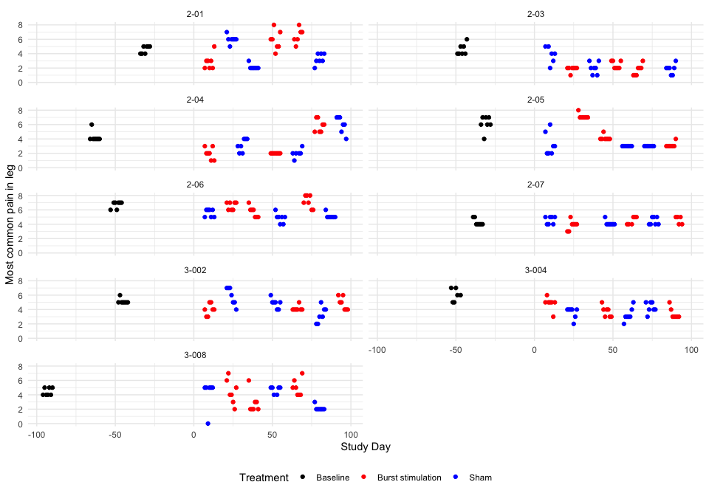

Descriptive table
Full analysis set
Most common pain in leg
 | Baseline | Pair 1 |  | Pair 2 |  | Pair 3
 | Baseline | Burst stimulation | Sham | Burst stimulation | Sham | Burst stimulation | Sham
2-01
n | 7 | 7 | 7 | 7 | 7 | 6 | 7
Mean (sd) | 4.57 (0.53) | 2.86 (1.07) | 6.00 (0.58) | 5.86 (1.35) | 2.14 (0.38) | 6.50 (1.05) | 3.29 (0.76)
IQR | 1.00 | 1.00 | 0.00 | 1.50 | 0.00 | 1.00 | 1.00
min - max | 4.00 - 5.00 | 2.00 - 5.00 | 5.00 - 7.00 | 4.00 - 8.00 | 2.00 - 3.00 | 5.00 - 8.00 | 2.00 - 4.00
2-03
n | 7 | 7 | 6 | 7 | 7 | 7 | 7
Mean (sd) | 4.57 (0.79) | 1.86 (0.38) | 3.83 (1.17) | 2.43 (0.53) | 2.00 (0.82) | 1.71 (0.76) | 1.86 (0.69)
IQR | 1.00 | 0.00 | 1.50 | 1.00 | 1.00 | 1.00 | 0.50
min - max | 4.00 - 6.00 | 1.00 - 2.00 | 2.00 - 5.00 | 2.00 - 3.00 | 1.00 - 3.00 | 1.00 - 3.00 | 1.00 - 3.00
2-04
n | 7 | 7 | 7 | 7 | 6 | 7 | 7
Mean (sd) | 4.29 (0.76) | 2.00 (0.82) | 3.14 (0.90) | 2.00 (0.00) | 2.00 (0.63) | 5.86 (0.90) | 6.00 (1.15)
IQR | 0.00 | 1.00 | 1.50 | 0.00 | 0.00 | 1.50 | 1.50
min - max | 4.00 - 6.00 | 1.00 - 3.00 | 2.00 - 4.00 | 2.00 - 2.00 | 1.00 - 3.00 | 5.00 - 7.00 | 4.00 - 7.00
2-05
n | 7 | 7 | 7 | 7 | 7 | 7 | 7
Mean (sd) | 6.14 (1.07) | 7.14 (0.38) | 3.29 (1.60) | 4.14 (0.38) | 3.00 (0.00) | 3.14 (0.38) | 3.00 (0.00)
IQR | 1.00 | 0.00 | 2.00 | 0.00 | 0.00 | 0.00 | 0.00
min - max | 4.00 - 7.00 | 7.00 - 8.00 | 2.00 - 6.00 | 4.00 - 5.00 | 3.00 - 3.00 | 3.00 - 4.00 | 3.00 - 3.00
2-06
n | 7 | 7 | 7 | 7 | 7 | 7 | 7
Mean (sd) | 6.71 (0.49) | 6.57 (0.53) | 5.57 (0.53) | 5.71 (0.76) | 4.86 (0.69) | 7.14 (0.90) | 5.14 (0.38)
IQR | 0.50 | 1.00 | 1.00 | 1.00 | 0.50 | 1.50 | 0.00
min - max | 6.00 - 7.00 | 6.00 - 7.00 | 5.00 - 6.00 | 5.00 - 7.00 | 4.00 - 6.00 | 6.00 - 8.00 | 5.00 - 6.00
2-07
n | 7 | 7 | 7 | 6 | 7 | 5 | 7
Mean (sd) | 4.29 (0.49) | 3.86 (0.69) | 4.57 (0.53) | 4.50 (0.55) | 4.14 (0.38) | 4.60 (0.55) | 4.43 (0.53)
IQR | 0.50 | 0.50 | 1.00 | 1.00 | 0.00 | 1.00 | 1.00
min - max | 4.00 - 5.00 | 3.00 - 5.00 | 4.00 - 5.00 | 4.00 - 5.00 | 4.00 - 5.00 | 4.00 - 5.00 | 4.00 - 5.00
3-002
n | 7 | 7 | 7 | 7 | 7 | 7 | 7
Mean (sd) | 5.14 (0.38) | 4.00 (0.82) | 5.86 (1.21) | 4.14 (0.38) | 4.86 (0.69) | 4.86 (0.90) | 3.29 (1.11)
IQR | 0.00 | 1.00 | 2.00 | 0.00 | 0.50 | 1.50 | 1.50
min - max | 5.00 - 6.00 | 3.00 - 5.00 | 4.00 - 7.00 | 4.00 - 5.00 | 4.00 - 6.00 | 4.00 - 6.00 | 2.00 - 5.00
3-004
n | 6 | 7 | 7 | 7 | 7 | 7 | 7
Mean (sd) | 6.00 (0.89) | 4.86 (0.90) | 3.57 (0.79) | 3.71 (0.76) | 3.29 (0.95) | 3.43 (0.79) | 4.29 (0.76)
IQR | 1.50 | 0.00 | 0.50 | 1.00 | 0.50 | 0.50 | 1.00
min - max | 5.00 - 7.00 | 3.00 - 6.00 | 2.00 - 4.00 | 3.00 - 5.00 | 2.00 - 5.00 | 3.00 - 5.00 | 3.00 - 5.00
3-008
n | 7 | 7 | 6 | 7 | 6 | 7 | 7
Mean (sd) | 4.43 (0.53) | 4.43 (1.72) | 4.17 (2.04) | 2.86 (1.46) | 4.67 (0.52) | 5.00 (1.15) | 2.14 (0.38)
IQR | 1.00 | 2.00 | 0.00 | 1.00 | 0.75 | 1.50 | 0.00
min - max | 4.00 - 5.00 | 2.00 - 7.00 | 0.00 - 5.00 | 2.00 - 6.00 | 4.00 - 5.00 | 4.00 - 7.00 | 2.00 - 3.00

Hypothesis test
Most common pain in leg
Subject ID | Difference Pair 1 | Difference Pair 2 | Difference Pair 3 | Overall difference
2-01 | -3.143 | 3.714 | 3.214 | 1.262
2-03 | -1.976 | 0.429 | -0.143 | -0.563
2-04 | -1.143 | 0.000 | -0.143 | -0.429
2-05 | 3.857 | 1.143 | 0.143 | 1.714
2-06 | 1.000 | 0.857 | 2.000 | 1.286
2-07 | -0.714 | 0.357 | 0.171 | -0.062
3-002 | -1.857 | -0.714 | 1.571 | -0.333
3-004 | 1.286 | 0.429 | -0.857 | 0.286
3-008 | 0.262 | -1.810 | 2.857 | 0.436
Values are Burst stimulation - Sham.
P-value of the null hypothesis test: 0.24.

Treatment effect estimates
QQ-plot
## Warning: For this model type, `marginaleffects` only takes into account the
## uncertainty in fixed-effect parameters. This is often appropriate when
## `re.form=NA`, but may be surprising to users who set `re.form=NULL` (default)
## or to some other value. Call `options(marginaleffects_safe = FALSE)` to silence
## this warning.
## Warning: For this model type, `marginaleffects` only takes into account the
## uncertainty in fixed-effect parameters. This is often appropriate when
## `re.form=NA`, but may be surprising to users who set `re.form=NULL` (default)
## or to some other value. Call `options(marginaleffects_safe = FALSE)` to silence
## this warning.
## Warning: For this model type, `marginaleffects` only takes into account the
## uncertainty in fixed-effect parameters. This is often appropriate when
## `re.form=NA`, but may be surprising to users who set `re.form=NULL` (default)
## or to some other value. Call `options(marginaleffects_safe = FALSE)` to silence
## this warning.
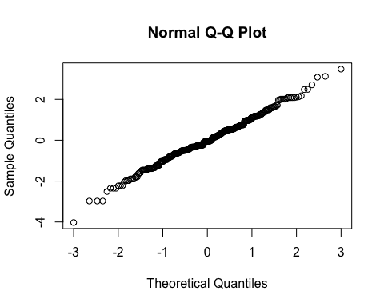
By subject
Subject ID | Estimate | Std. Err. | p-value | Lower CL | Upper CL
2-01 | 1.058 | 0.278 | 0.000 | 0.513 | 1.603
2-03 | -0.355 | 0.278 | 0.202 | -0.900 | 0.190
2-04 | -0.290 | 0.278 | 0.296 | -0.836 | 0.255
2-05 | 1.475 | 0.278 | 0.000 | 0.930 | 2.020
2-06 | 1.125 | 0.278 | 0.000 | 0.579 | 1.670
2-07 | 0.004 | 0.278 | 0.989 | -0.541 | 0.549
3-002 | -0.200 | 0.278 | 0.473 | -0.745 | 0.345
3-004 | 0.307 | 0.278 | 0.270 | -0.238 | 0.852
3-008 | 0.484 | 0.278 | 0.082 | -0.061 | 1.029
Overall
Treatment | Estimate | Std. Err. | p-value | Lower CL | Upper CL
Burst stimulation | 4.263 | 0.345 | 0 | 3.587 | 4.940
Sham | 3.858 | 0.345 | 0 | 3.181 | 4.534

Estimate | Std. Err. | p-value | Lower CL | Upper CL
0.406 | 0.278 | 0.145 | -0.139 | 0.951

Secondary outcome: Highest pain intensity in lower extremity (NRS)

Plot
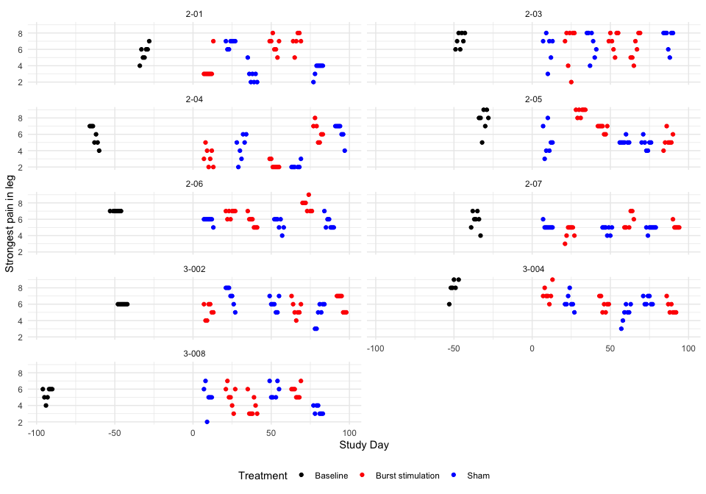

Descriptive table
Full analysis set
Strongest pain in leg
 | Baseline | Pair 1 |  | Pair 2 |  | Pair 3
 | Baseline | Burst stimulation | Sham | Burst stimulation | Sham | Burst stimulation | Sham
2-01
n | 7 | 7 | 7 | 7 | 7 | 6 | 7
Mean (sd) | 5.57 (0.98) | 3.57 (1.51) | 6.71 (0.49) | 6.57 (0.98) | 2.86 (1.07) | 7.00 (1.10) | 3.57 (0.79)
IQR | 1.00 | 0.00 | 0.50 | 1.00 | 1.00 | 0.75 | 0.50
min - max | 4.00 - 7.00 | 3.00 - 7.00 | 6.00 - 7.00 | 5.00 - 8.00 | 2.00 - 5.00 | 5.00 - 8.00 | 2.00 - 4.00
2-03
n | 7 | 7 | 6 | 7 | 7 | 7 | 7
Mean (sd) | 7.14 (0.90) | 6.43 (2.44) | 6.17 (1.83) | 7.00 (1.15) | 6.57 (1.62) | 6.14 (1.57) | 7.29 (1.25)
IQR | 1.50 | 2.50 | 1.50 | 1.50 | 2.50 | 2.50 | 1.00
min - max | 6.00 - 8.00 | 2.00 - 8.00 | 3.00 - 8.00 | 5.00 - 8.00 | 4.00 - 8.00 | 4.00 - 8.00 | 5.00 - 8.00
2-04
n | 7 | 7 | 7 | 7 | 6 | 7 | 7
Mean (sd) | 5.86 (1.21) | 3.29 (1.11) | 4.43 (1.51) | 2.29 (0.49) | 2.17 (0.41) | 6.29 (1.11) | 6.29 (1.11)
IQR | 2.00 | 1.50 | 2.00 | 0.50 | 0.00 | 1.50 | 1.00
min - max | 4.00 - 7.00 | 2.00 - 5.00 | 2.00 - 6.00 | 2.00 - 3.00 | 2.00 - 3.00 | 5.00 - 8.00 | 4.00 - 7.00
2-05
n | 7 | 7 | 7 | 7 | 7 | 7 | 7
Mean (sd) | 7.71 (1.38) | 8.71 (0.49) | 5.14 (1.77) | 6.71 (0.49) | 5.14 (0.38) | 5.29 (0.95) | 4.86 (0.69)
IQR | 1.00 | 0.50 | 2.00 | 0.50 | 0.00 | 0.50 | 0.50
min - max | 5.00 - 9.00 | 8.00 - 9.00 | 3.00 - 8.00 | 6.00 - 7.00 | 5.00 - 6.00 | 4.00 - 7.00 | 4.00 - 6.00
2-06
n | 7 | 7 | 7 | 7 | 7 | 7 | 7
Mean (sd) | 7.00 (0.00) | 6.71 (0.49) | 5.86 (0.38) | 5.71 (0.76) | 5.43 (0.79) | 7.71 (0.76) | 5.57 (0.79)
IQR | 0.00 | 0.50 | 0.00 | 1.00 | 1.00 | 1.00 | 1.00
min - max | 7.00 - 7.00 | 6.00 - 7.00 | 5.00 - 6.00 | 5.00 - 7.00 | 4.00 - 6.00 | 7.00 - 9.00 | 5.00 - 7.00
2-07
n | 7 | 7 | 7 | 6 | 7 | 5 | 7
Mean (sd) | 5.86 (1.07) | 4.43 (0.79) | 5.14 (0.38) | 5.83 (0.98) | 4.71 (0.49) | 5.20 (0.45) | 4.86 (0.38)
IQR | 1.00 | 1.00 | 0.00 | 1.75 | 0.50 | 0.00 | 0.00
min - max | 4.00 - 7.00 | 3.00 - 5.00 | 5.00 - 6.00 | 5.00 - 7.00 | 4.00 - 5.00 | 5.00 - 6.00 | 4.00 - 5.00
3-002
n | 7 | 7 | 7 | 7 | 7 | 7 | 7
Mean (sd) | 6.00 (0.00) | 5.14 (0.90) | 7.00 (1.15) | 5.43 (0.98) | 6.00 (0.82) | 6.14 (1.07) | 4.86 (1.35)
IQR | 0.00 | 1.50 | 1.50 | 1.00 | 1.00 | 2.00 | 2.00
min - max | 6.00 - 6.00 | 4.00 - 6.00 | 5.00 - 8.00 | 4.00 - 7.00 | 5.00 - 7.00 | 5.00 - 7.00 | 3.00 - 6.00
3-004
n | 6 | 7 | 7 | 7 | 7 | 7 | 7
Mean (sd) | 8.00 (1.10) | 7.29 (0.95) | 6.29 (0.95) | 6.00 (0.82) | 4.86 (1.07) | 5.57 (0.79) | 6.43 (0.53)
IQR | 0.75 | 0.50 | 0.50 | 1.00 | 1.00 | 1.00 | 1.00
min - max | 6.00 - 9.00 | 6.00 - 9.00 | 5.00 - 8.00 | 5.00 - 7.00 | 3.00 - 6.00 | 5.00 - 7.00 | 6.00 - 7.00
3-008
n | 7 | 7 | 6 | 7 | 6 | 7 | 7
Mean (sd) | 5.43 (0.79) | 5.14 (1.35) | 5.00 (1.67) | 3.86 (1.21) | 5.83 (0.98) | 5.71 (0.76) | 3.43 (0.53)
IQR | 1.00 | 1.50 | 0.75 | 1.50 | 1.75 | 1.00 | 1.00
min - max | 4.00 - 6.00 | 3.00 - 7.00 | 2.00 - 7.00 | 3.00 - 6.00 | 5.00 - 7.00 | 5.00 - 7.00 | 3.00 - 4.00

Hypothesis test
Strongest pain in leg
Subject ID | Difference Pair 1 | Difference Pair 2 | Difference Pair 3 | Overall difference
2-01 | -3.143 | 3.714 | 3.429 | 1.333
2-03 | 0.262 | 0.429 | -1.143 | -0.151
2-04 | -1.143 | 0.119 | 0.000 | -0.341
2-05 | 3.571 | 1.571 | 0.429 | 1.857
2-06 | 0.857 | 0.286 | 2.143 | 1.095
2-07 | -0.714 | 1.119 | 0.343 | 0.249
3-002 | -1.857 | -0.571 | 1.286 | -0.381
3-004 | 1.000 | 1.143 | -0.857 | 0.429
3-008 | 0.143 | -1.976 | 2.286 | 0.151
Values are Burst stimulation - Sham.
P-value of the null hypothesis test: 0.15.

Treatment effect estimates
QQ-plot
## Warning: For this model type, `marginaleffects` only takes into account the
## uncertainty in fixed-effect parameters. This is often appropriate when
## `re.form=NA`, but may be surprising to users who set `re.form=NULL` (default)
## or to some other value. Call `options(marginaleffects_safe = FALSE)` to silence
## this warning.
## Warning: For this model type, `marginaleffects` only takes into account the
## uncertainty in fixed-effect parameters. This is often appropriate when
## `re.form=NA`, but may be surprising to users who set `re.form=NULL` (default)
## or to some other value. Call `options(marginaleffects_safe = FALSE)` to silence
## this warning.
## Warning: For this model type, `marginaleffects` only takes into account the
## uncertainty in fixed-effect parameters. This is often appropriate when
## `re.form=NA`, but may be surprising to users who set `re.form=NULL` (default)
## or to some other value. Call `options(marginaleffects_safe = FALSE)` to silence
## this warning.
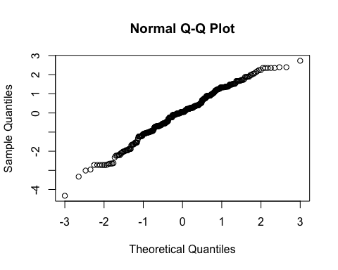
By subject
Subject ID | Estimate | Std. Err. | p-value | Lower CL | Upper CL
2-01 | 1.070 | 0.263 | 0.000 | 0.555 | 1.585
2-03 | -0.001 | 0.263 | 0.997 | -0.516 | 0.514
2-04 | -0.157 | 0.263 | 0.551 | -0.671 | 0.358
2-05 | 1.506 | 0.263 | 0.000 | 0.991 | 2.021
2-06 | 0.936 | 0.263 | 0.000 | 0.421 | 1.451
2-07 | 0.287 | 0.263 | 0.274 | -0.227 | 0.802
3-002 | -0.167 | 0.263 | 0.524 | -0.682 | 0.347
3-004 | 0.438 | 0.263 | 0.096 | -0.077 | 0.953
3-008 | 0.275 | 0.263 | 0.295 | -0.240 | 0.790
By treatment and Overall
Treatment | Estimate | Std. Err. | p-value | Lower CL | Upper CL
Burst stimulation | 5.753 | 0.297 | 0 | 5.170 | 6.335
Sham | 5.284 | 0.297 | 0 | 4.701 | 5.866

Estimate | Std. Err. | p-value | Lower CL | Upper CL
0.469 | 0.263 | 0.074 | -0.046 | 0.984

Secondary outcome: Lowest pain intensity in lower extremity (NRS)

Plot
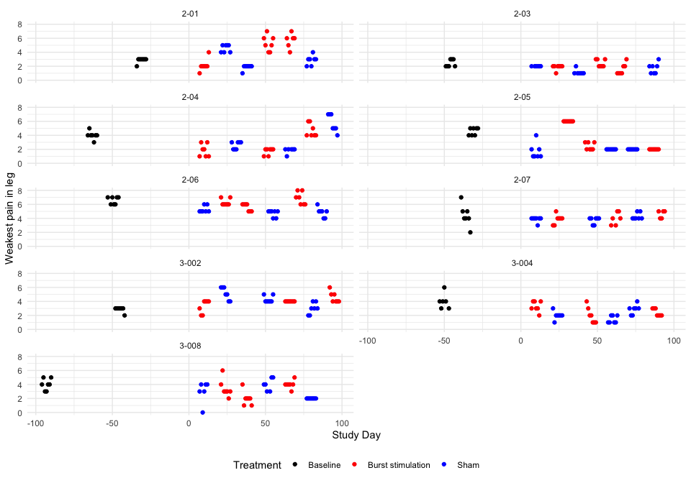

Descriptive table
Full analysis set
Weakest pain in leg
 | Baseline | Pair 1 |  | Pair 2 |  | Pair 3
 | Baseline | Burst stimulation | Sham | Burst stimulation | Sham | Burst stimulation | Sham
2-01
n | 7 | 7 | 7 | 7 | 7 | 6 | 7
Mean (sd) | 2.86 (0.38) | 2.14 (0.90) | 4.57 (0.53) | 5.29 (1.11) | 1.86 (0.38) | 5.67 (1.03) | 2.86 (0.69)
IQR | 0.00 | 0.00 | 1.00 | 1.50 | 0.00 | 0.75 | 0.50
min - max | 2.00 - 3.00 | 1.00 - 4.00 | 4.00 - 5.00 | 4.00 - 7.00 | 1.00 - 2.00 | 4.00 - 7.00 | 2.00 - 4.00
2-03
n | 7 | 7 | 6 | 7 | 7 | 7 | 7
Mean (sd) | 2.43 (0.53) | 1.86 (0.38) | 2.00 (0.00) | 2.43 (0.53) | 1.14 (0.38) | 1.57 (0.79) | 1.71 (0.76)
IQR | 1.00 | 0.00 | 0.00 | 1.00 | 0.00 | 1.00 | 1.00
min - max | 2.00 - 3.00 | 1.00 - 2.00 | 2.00 - 2.00 | 2.00 - 3.00 | 1.00 - 2.00 | 1.00 - 3.00 | 1.00 - 3.00
2-04
n | 7 | 7 | 7 | 7 | 6 | 7 | 7
Mean (sd) | 4.00 (0.58) | 1.86 (0.90) | 2.57 (0.53) | 1.71 (0.49) | 1.83 (0.41) | 4.71 (0.95) | 5.71 (1.25)
IQR | 0.00 | 1.50 | 1.00 | 0.50 | 0.00 | 1.50 | 2.00
min - max | 3.00 - 5.00 | 1.00 - 3.00 | 2.00 - 3.00 | 1.00 - 2.00 | 1.00 - 2.00 | 4.00 - 6.00 | 4.00 - 7.00
2-05
n | 7 | 7 | 7 | 7 | 7 | 7 | 7
Mean (sd) | 4.57 (0.53) | 6.00 (0.00) | 1.71 (1.11) | 2.43 (0.53) | 2.00 (0.00) | 2.00 (0.00) | 2.00 (0.00)
IQR | 1.00 | 0.00 | 1.00 | 1.00 | 0.00 | 0.00 | 0.00
min - max | 4.00 - 5.00 | 6.00 - 6.00 | 1.00 - 4.00 | 2.00 - 3.00 | 2.00 - 2.00 | 2.00 - 2.00 | 2.00 - 2.00
2-06
n | 7 | 7 | 7 | 7 | 7 | 7 | 7
Mean (sd) | 6.57 (0.53) | 6.29 (0.49) | 5.29 (0.49) | 5.57 (0.53) | 4.71 (0.49) | 6.86 (0.90) | 4.86 (0.69)
IQR | 1.00 | 0.50 | 0.50 | 1.00 | 0.50 | 1.50 | 0.50
min - max | 6.00 - 7.00 | 6.00 - 7.00 | 5.00 - 6.00 | 5.00 - 6.00 | 4.00 - 5.00 | 6.00 - 8.00 | 4.00 - 6.00
2-07
n | 7 | 7 | 7 | 6 | 7 | 5 | 7
Mean (sd) | 4.43 (1.51) | 3.86 (0.69) | 3.86 (0.38) | 4.00 (0.89) | 3.71 (0.49) | 4.60 (0.55) | 4.29 (0.49)
IQR | 1.00 | 0.50 | 0.00 | 1.50 | 0.50 | 1.00 | 0.50
min - max | 2.00 - 7.00 | 3.00 - 5.00 | 3.00 - 4.00 | 3.00 - 5.00 | 3.00 - 4.00 | 4.00 - 5.00 | 4.00 - 5.00
3-002
n | 7 | 7 | 7 | 7 | 7 | 7 | 7
Mean (sd) | 2.86 (0.38) | 3.29 (0.95) | 5.14 (0.90) | 4.00 (0.00) | 4.29 (0.49) | 4.57 (0.79) | 3.00 (0.82)
IQR | 0.00 | 1.50 | 1.50 | 0.00 | 0.50 | 1.00 | 1.00
min - max | 2.00 - 3.00 | 2.00 - 4.00 | 4.00 - 6.00 | 4.00 - 4.00 | 4.00 - 5.00 | 4.00 - 6.00 | 2.00 - 4.00
3-004
n | 6 | 7 | 7 | 7 | 7 | 7 | 7
Mean (sd) | 4.00 (1.10) | 3.29 (0.76) | 2.00 (0.58) | 2.00 (1.15) | 1.43 (0.53) | 2.43 (0.53) | 2.86 (0.69)
IQR | 0.75 | 1.00 | 0.00 | 1.50 | 1.00 | 1.00 | 0.50
min - max | 3.00 - 6.00 | 2.00 - 4.00 | 1.00 - 3.00 | 1.00 - 4.00 | 1.00 - 2.00 | 2.00 - 3.00 | 2.00 - 4.00
3-008
n | 7 | 7 | 6 | 7 | 6 | 7 | 7
Mean (sd) | 4.00 (0.82) | 3.43 (1.27) | 3.00 (1.55) | 2.00 (1.00) | 4.00 (0.89) | 4.00 (0.58) | 2.00 (0.00)
IQR | 1.00 | 0.50 | 1.00 | 0.50 | 1.50 | 0.00 | 0.00
min - max | 3.00 - 5.00 | 2.00 - 6.00 | 0.00 - 4.00 | 1.00 - 4.00 | 3.00 - 5.00 | 3.00 - 5.00 | 2.00 - 2.00

Hypothesis test
Weakest pain in leg
Subject ID | Difference Pair 1 | Difference Pair 2 | Difference Pair 3 | Overall difference
2-01 | -2.429 | 3.429 | 2.810 | 1.270
2-03 | -0.143 | 1.286 | -0.143 | 0.333
2-04 | -0.714 | -0.119 | -1.000 | -0.611
2-05 | 4.286 | 0.429 | 0.000 | 1.572
2-06 | 1.000 | 0.857 | 2.000 | 1.286
2-07 | 0.000 | 0.286 | 0.314 | 0.200
3-002 | -1.857 | -0.286 | 1.571 | -0.191
3-004 | 1.286 | 0.571 | -0.429 | 0.476
3-008 | 0.429 | -2.000 | 2.000 | 0.143
Values are Burst stimulation - Sham.
P-value of the null hypothesis test: 0.11.

Treatment effect estimates
QQ-plot
## Warning: For this model type, `marginaleffects` only takes into account the
## uncertainty in fixed-effect parameters. This is often appropriate when
## `re.form=NA`, but may be surprising to users who set `re.form=NULL` (default)
## or to some other value. Call `options(marginaleffects_safe = FALSE)` to silence
## this warning.
## Warning: For this model type, `marginaleffects` only takes into account the
## uncertainty in fixed-effect parameters. This is often appropriate when
## `re.form=NA`, but may be surprising to users who set `re.form=NULL` (default)
## or to some other value. Call `options(marginaleffects_safe = FALSE)` to silence
## this warning.
## Warning: For this model type, `marginaleffects` only takes into account the
## uncertainty in fixed-effect parameters. This is often appropriate when
## `re.form=NA`, but may be surprising to users who set `re.form=NULL` (default)
## or to some other value. Call `options(marginaleffects_safe = FALSE)` to silence
## this warning.
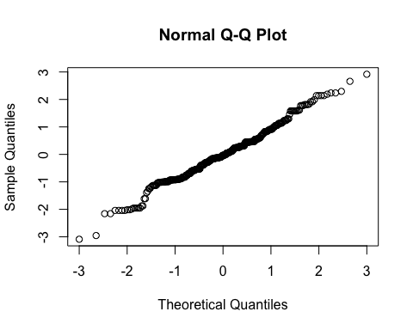
By subject
Subject ID | Estimate | Std. Err. | p-value | Lower CL | Upper CL
2-01 | 1.093 | 0.244 | 0.000 | 0.615 | 1.571
2-03 | 0.373 | 0.244 | 0.126 | -0.105 | 0.851
2-04 | -0.423 | 0.244 | 0.083 | -0.901 | 0.055
2-05 | 1.377 | 0.244 | 0.000 | 0.899 | 1.855
2-06 | 1.143 | 0.244 | 0.000 | 0.665 | 1.621
2-07 | 0.246 | 0.244 | 0.313 | -0.232 | 0.724
3-002 | -0.066 | 0.244 | 0.786 | -0.544 | 0.412
3-004 | 0.480 | 0.244 | 0.049 | 0.002 | 0.958
3-008 | 0.252 | 0.244 | 0.302 | -0.226 | 0.730
By treatment and overall
Treatment | Estimate | Std. Err. | p-value | Lower CL | Upper CL
Burst stimulation | 3.620 | 0.397 | 0 | 2.843 | 4.398
Sham | 3.119 | 0.397 | 0 | 2.341 | 3.896

Estimate | Std. Err. | p-value | Lower CL | Upper CL
0.502 | 0.244 | 0.04 | 0.024 | 0.98

Secondary outcome: Current pain intensity in lower extremity (NRS)

Plot
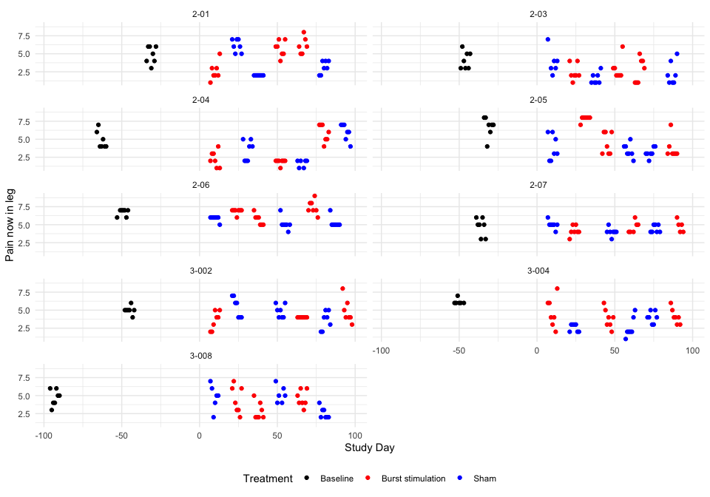

Descriptive table
Full analysis set
Pain now in leg
 | Baseline | Pair 1 |  | Pair 2 |  | Pair 3
 | Baseline | Burst stimulation | Sham | Burst stimulation | Sham | Burst stimulation | Sham
2-01
n | 7 | 7 | 7 | 7 | 7 | 6 | 7
Mean (sd) | 4.86 (1.21) | 2.57 (1.27) | 6.14 (0.90) | 5.71 (1.11) | 2.00 (0.00) | 6.17 (1.17) | 3.14 (0.90)
IQR | 2.00 | 1.00 | 1.50 | 1.50 | 0.00 | 1.50 | 1.50
min - max | 3.00 - 6.00 | 1.00 - 5.00 | 5.00 - 7.00 | 4.00 - 7.00 | 2.00 - 2.00 | 5.00 - 8.00 | 2.00 - 4.00
2-03
n | 7 | 7 | 6 | 7 | 7 | 7 | 7
Mean (sd) | 4.14 (1.21) | 2.43 (1.13) | 3.83 (1.72) | 2.86 (1.46) | 1.57 (0.79) | 2.71 (1.70) | 2.29 (1.60)
IQR | 2.00 | 1.00 | 1.00 | 1.00 | 1.00 | 3.00 | 2.00
min - max | 3.00 - 6.00 | 1.00 - 4.00 | 2.00 - 7.00 | 2.00 - 6.00 | 1.00 - 3.00 | 1.00 - 5.00 | 1.00 - 5.00
2-04
n | 7 | 7 | 7 | 7 | 6 | 7 | 7
Mean (sd) | 4.86 (1.21) | 2.29 (1.11) | 3.43 (1.40) | 1.86 (0.38) | 1.67 (0.52) | 5.86 (1.21) | 6.00 (1.15)
IQR | 1.50 | 1.50 | 2.50 | 0.00 | 0.75 | 2.00 | 1.50
min - max | 4.00 - 7.00 | 1.00 - 4.00 | 2.00 - 5.00 | 1.00 - 2.00 | 1.00 - 2.00 | 4.00 - 7.00 | 4.00 - 7.00
2-05
n | 7 | 7 | 7 | 7 | 7 | 7 | 7
Mean (sd) | 6.71 (1.38) | 7.86 (0.38) | 3.86 (1.77) | 4.43 (1.51) | 3.43 (0.98) | 3.71 (1.50) | 3.14 (0.69)
IQR | 1.00 | 0.00 | 3.00 | 3.00 | 1.00 | 0.50 | 0.50
min - max | 4.00 - 8.00 | 7.00 - 8.00 | 2.00 - 6.00 | 3.00 - 6.00 | 2.00 - 5.00 | 3.00 - 7.00 | 2.00 - 4.00
2-06
n | 7 | 7 | 7 | 7 | 7 | 7 | 7
Mean (sd) | 6.71 (0.49) | 6.86 (0.38) | 5.86 (0.38) | 5.71 (0.76) | 5.14 (0.90) | 7.43 (0.98) | 5.29 (0.76)
IQR | 0.50 | 0.00 | 0.00 | 1.00 | 0.00 | 1.00 | 0.00
min - max | 6.00 - 7.00 | 6.00 - 7.00 | 5.00 - 6.00 | 5.00 - 7.00 | 4.00 - 7.00 | 6.00 - 9.00 | 5.00 - 7.00
2-07
n | 7 | 7 | 7 | 6 | 7 | 5 | 7
Mean (sd) | 4.71 (1.25) | 4.14 (0.69) | 5.00 (0.58) | 4.67 (0.82) | 4.00 (0.58) | 4.80 (0.84) | 4.43 (0.53)
IQR | 1.50 | 0.50 | 0.00 | 1.00 | 0.00 | 1.00 | 1.00
min - max | 3.00 - 6.00 | 3.00 - 5.00 | 4.00 - 6.00 | 4.00 - 6.00 | 3.00 - 5.00 | 4.00 - 6.00 | 4.00 - 5.00
3-002
n | 7 | 7 | 7 | 7 | 7 | 7 | 7
Mean (sd) | 5.00 (0.58) | 3.57 (1.27) | 5.43 (1.40) | 4.00 (0.00) | 4.86 (0.90) | 4.86 (1.68) | 3.57 (1.27)
IQR | 0.00 | 2.00 | 2.50 | 0.00 | 1.50 | 1.50 | 2.00
min - max | 4.00 - 6.00 | 2.00 - 5.00 | 4.00 - 7.00 | 4.00 - 4.00 | 4.00 - 6.00 | 3.00 - 8.00 | 2.00 - 5.00
3-004
n | 6 | 7 | 7 | 7 | 7 | 7 | 7
Mean (sd) | 6.17 (0.41) | 4.71 (2.06) | 2.57 (0.53) | 3.86 (1.35) | 2.57 (1.40) | 4.14 (1.07) | 4.00 (0.82)
IQR | 0.00 | 2.50 | 1.00 | 1.50 | 1.00 | 1.00 | 1.00
min - max | 6.00 - 7.00 | 2.00 - 8.00 | 2.00 - 3.00 | 2.00 - 6.00 | 1.00 - 5.00 | 3.00 - 6.00 | 3.00 - 5.00
3-008
n | 7 | 7 | 6 | 7 | 6 | 7 | 7
Mean (sd) | 4.71 (1.11) | 4.43 (1.90) | 4.83 (1.72) | 2.86 (1.21) | 5.17 (1.17) | 4.57 (1.13) | 2.57 (0.79)
IQR | 1.50 | 3.00 | 1.50 | 1.50 | 1.50 | 1.50 | 1.00
min - max | 3.00 - 6.00 | 2.00 - 7.00 | 2.00 - 7.00 | 2.00 - 5.00 | 4.00 - 7.00 | 3.00 - 6.00 | 2.00 - 4.00

Hypothesis test
Pain now in leg
Subject ID | Difference Pair 1 | Difference Pair 2 | Difference Pair 3 | Overall difference
2-01 | -3.571 | 3.714 | 3.024 | 1.056
2-03 | -1.405 | 1.286 | 0.429 | 0.103
2-04 | -1.143 | 0.190 | -0.143 | -0.365
2-05 | 4.000 | 1.000 | 0.571 | 1.857
2-06 | 1.000 | 0.571 | 2.143 | 1.238
2-07 | -0.857 | 0.667 | 0.371 | 0.060
3-002 | -1.857 | -0.857 | 1.286 | -0.476
3-004 | 2.143 | 1.286 | 0.143 | 1.191
3-008 | -0.405 | -2.310 | 2.000 | -0.238
Values are Burst stimulation - Sham.
P-value of the null hypothesis test: 0.16.

Treatment effect estimates
QQ-plot
## Warning: For this model type, `marginaleffects` only takes into account the
## uncertainty in fixed-effect parameters. This is often appropriate when
## `re.form=NA`, but may be surprising to users who set `re.form=NULL` (default)
## or to some other value. Call `options(marginaleffects_safe = FALSE)` to silence
## this warning.
## Warning: For this model type, `marginaleffects` only takes into account the
## uncertainty in fixed-effect parameters. This is often appropriate when
## `re.form=NA`, but may be surprising to users who set `re.form=NULL` (default)
## or to some other value. Call `options(marginaleffects_safe = FALSE)` to silence
## this warning.
## Warning: For this model type, `marginaleffects` only takes into account the
## uncertainty in fixed-effect parameters. This is often appropriate when
## `re.form=NA`, but may be surprising to users who set `re.form=NULL` (default)
## or to some other value. Call `options(marginaleffects_safe = FALSE)` to silence
## this warning.
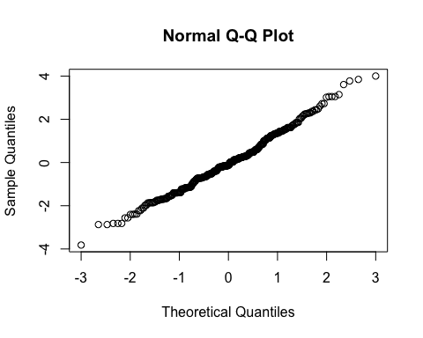
By subject
Subject ID | Estimate | Std. Err. | p-value | Lower CL | Upper CL
2-01 | 0.871 | 0.282 | 0.002 | 0.319 | 1.423
2-03 | 0.231 | 0.282 | 0.412 | -0.321 | 0.783
2-04 | -0.165 | 0.282 | 0.557 | -0.717 | 0.386
2-05 | 1.513 | 0.282 | 0.000 | 0.961 | 2.064
2-06 | 1.050 | 0.282 | 0.000 | 0.498 | 1.602
2-07 | 0.148 | 0.282 | 0.600 | -0.404 | 0.699
3-002 | -0.232 | 0.282 | 0.411 | -0.783 | 0.320
3-004 | 1.014 | 0.282 | 0.000 | 0.462 | 1.566
3-008 | 0.003 | 0.282 | 0.992 | -0.549 | 0.555
By treatment and overall
Treatment | Estimate | Std. Err. | p-value | Lower CL | Upper CL
Burst stimulation | 4.408 | 0.341 | 0 | 3.740 | 5.076
Sham | 3.909 | 0.341 | 0 | 3.241 | 4.577

Estimate | Std. Err. | p-value | Lower CL | Upper CL
0.499 | 0.282 | 0.076 | -0.053 | 1.051

Secondary outcome: Usual pain intensity in the back (NRS)

Plot
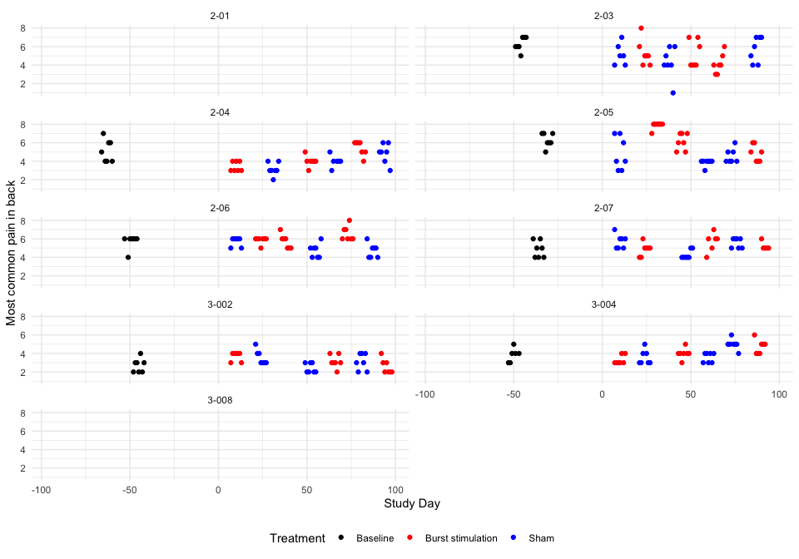

Descriptive table
Full analysis set
Most common pain in back
 | Baseline | Pair 1 |  | Pair 2 |  | Pair 3
 | Baseline | Burst stimulation | Sham | Burst stimulation | Sham | Burst stimulation | Sham
2-01
n | 0 | 0 | 0 | 0 | 0 | 0 | 0
Mean (sd) | NA | NA | NA | NA | NA | NA | NA
IQR | NA | NA | NA | NA | NA | NA | NA
min - max | Inf - -Inf | Inf - -Inf | Inf - -Inf | Inf - -Inf | Inf - -Inf | Inf - -Inf | Inf - -Inf
2-03
n | 7 | 7 | 6 | 7 | 7 | 7 | 7
Mean (sd) | 6.29 (0.76) | 5.29 (1.38) | 5.17 (1.17) | 5.14 (1.46) | 4.29 (1.70) | 4.14 (1.07) | 5.71 (1.38)
IQR | 1.00 | 1.00 | 1.50 | 2.50 | 1.50 | 1.00 | 2.50
min - max | 5.00 - 7.00 | 4.00 - 8.00 | 4.00 - 7.00 | 4.00 - 7.00 | 1.00 - 6.00 | 3.00 - 6.00 | 4.00 - 7.00
2-04
n | 7 | 7 | 7 | 7 | 6 | 7 | 7
Mean (sd) | 5.14 (1.21) | 3.43 (0.53) | 3.14 (0.69) | 4.00 (0.58) | 4.00 (0.63) | 5.43 (0.79) | 4.86 (1.07)
IQR | 2.00 | 1.00 | 0.50 | 0.00 | 0.00 | 1.00 | 1.00
min - max | 4.00 - 7.00 | 3.00 - 4.00 | 2.00 - 4.00 | 3.00 - 5.00 | 3.00 - 5.00 | 4.00 - 6.00 | 3.00 - 6.00
2-05
n | 7 | 7 | 7 | 7 | 7 | 7 | 7
Mean (sd) | 6.29 (0.76) | 7.86 (0.38) | 4.86 (1.77) | 6.14 (0.90) | 3.86 (0.38) | 4.86 (0.90) | 4.57 (0.79)
IQR | 1.00 | 0.00 | 3.00 | 1.50 | 0.00 | 1.50 | 1.00
min - max | 5.00 - 7.00 | 7.00 - 8.00 | 3.00 - 7.00 | 5.00 - 7.00 | 3.00 - 4.00 | 4.00 - 6.00 | 4.00 - 6.00
2-06
n | 7 | 7 | 7 | 7 | 7 | 7 | 7
Mean (sd) | 5.71 (0.76) | 5.86 (0.38) | 5.71 (0.49) | 5.71 (0.76) | 4.71 (0.76) | 6.57 (0.79) | 4.71 (0.76)
IQR | 0.00 | 0.00 | 0.50 | 1.00 | 1.00 | 1.00 | 1.00
min - max | 4.00 - 6.00 | 5.00 - 6.00 | 5.00 - 6.00 | 5.00 - 7.00 | 4.00 - 6.00 | 6.00 - 8.00 | 4.00 - 6.00
2-07
n | 7 | 7 | 7 | 6 | 7 | 5 | 7
Mean (sd) | 4.86 (0.90) | 4.86 (0.69) | 5.71 (0.76) | 5.67 (1.03) | 4.29 (0.49) | 5.20 (0.45) | 5.57 (0.53)
IQR | 1.50 | 0.50 | 1.00 | 0.75 | 0.50 | 0.00 | 1.00
min - max | 4.00 - 6.00 | 4.00 - 6.00 | 5.00 - 7.00 | 4.00 - 7.00 | 4.00 - 5.00 | 5.00 - 6.00 | 5.00 - 6.00
3-002
n | 7 | 7 | 7 | 7 | 7 | 7 | 7
Mean (sd) | 2.71 (0.76) | 3.71 (0.49) | 3.57 (0.79) | 3.14 (0.69) | 2.43 (0.53) | 2.57 (0.79) | 3.14 (0.90)
IQR | 1.00 | 0.50 | 1.00 | 0.50 | 1.00 | 1.00 | 1.50
min - max | 2.00 - 4.00 | 3.00 - 4.00 | 3.00 - 5.00 | 2.00 - 4.00 | 2.00 - 3.00 | 2.00 - 4.00 | 2.00 - 4.00
3-004
n | 6 | 7 | 7 | 7 | 7 | 7 | 7
Mean (sd) | 3.83 (0.75) | 3.29 (0.49) | 3.57 (0.79) | 4.00 (0.58) | 3.57 (0.53) | 4.71 (0.76) | 5.00 (0.58)
IQR | 0.75 | 0.50 | 1.00 | 0.00 | 1.00 | 1.00 | 0.00
min - max | 3.00 - 5.00 | 3.00 - 4.00 | 3.00 - 5.00 | 3.00 - 5.00 | 3.00 - 4.00 | 4.00 - 6.00 | 4.00 - 6.00
3-008
n | 0 | 0 | 0 | 0 | 0 | 0 | 0
Mean (sd) | NA | NA | NA | NA | NA | NA | NA
IQR | NA | NA | NA | NA | NA | NA | NA
min - max | Inf - -Inf | Inf - -Inf | Inf - -Inf | Inf - -Inf | Inf - -Inf | Inf - -Inf | Inf - -Inf

Hypothesis test
Most common pain in back
Subject ID | Difference Pair 1 | Difference Pair 2 | Difference Pair 3 | Overall difference
2-01 | NaN | NaN | NaN | NaN
2-03 | 0.119 | 0.857 | -1.571 | -0.198
2-04 | 0.286 | 0.000 | 0.571 | 0.286
2-05 | 3.000 | 2.286 | 0.286 | 1.857
2-06 | 0.143 | 1.000 | 1.857 | 1.000
2-07 | -0.857 | 1.381 | -0.371 | 0.051
3-002 | 0.143 | 0.714 | -0.571 | 0.095
3-004 | -0.286 | 0.429 | -0.286 | -0.048
3-008 | NaN | NaN | NaN | NaN
Values are Burst stimulation - Sham.
P-value of the null hypothesis test: 0.075.

Treatment effect estimates
QQ-plot
## Warning: For this model type, `marginaleffects` only takes into account the
## uncertainty in fixed-effect parameters. This is often appropriate when
## `re.form=NA`, but may be surprising to users who set `re.form=NULL` (default)
## or to some other value. Call `options(marginaleffects_safe = FALSE)` to silence
## this warning.
## Warning: For this model type, `marginaleffects` only takes into account the
## uncertainty in fixed-effect parameters. This is often appropriate when
## `re.form=NA`, but may be surprising to users who set `re.form=NULL` (default)
## or to some other value. Call `options(marginaleffects_safe = FALSE)` to silence
## this warning.
## Warning: For this model type, `marginaleffects` only takes into account the
## uncertainty in fixed-effect parameters. This is often appropriate when
## `re.form=NA`, but may be surprising to users who set `re.form=NULL` (default)
## or to some other value. Call `options(marginaleffects_safe = FALSE)` to silence
## this warning.
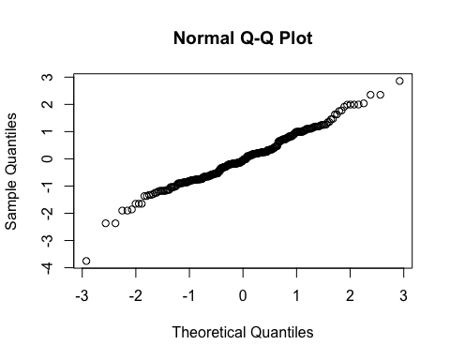
By subject
Subject ID | Estimate | Std. Err. | p-value | Lower CL | Upper CL
2-03 | -0.105 | 0.28 | 0.706 | -0.654 | 0.443
2-04 | 0.315 | 0.28 | 0.260 | -0.233 | 0.864
2-05 | 1.641 | 0.28 | 0.000 | 1.092 | 2.189
2-06 | 0.914 | 0.28 | 0.001 | 0.365 | 1.463
2-07 | 0.101 | 0.28 | 0.718 | -0.448 | 0.650
3-002 | 0.147 | 0.28 | 0.600 | -0.402 | 0.695
3-004 | 0.026 | 0.28 | 0.927 | -0.523 | 0.574
By treatment and overall
Treatment | Estimate | Std. Err. | p-value | Lower CL | Upper CL
Burst stimulation | 4.832 | 0.365 | 0 | 4.116 | 5.549
Sham | 4.393 | 0.365 | 0 | 3.677 | 5.109

Estimate | Std. Err. | p-value | Lower CL | Upper CL
0.44 | 0.28 | 0.116 | -0.109 | 0.988

Secondary outcome: Pain unpleasantness (NRS)

Plot
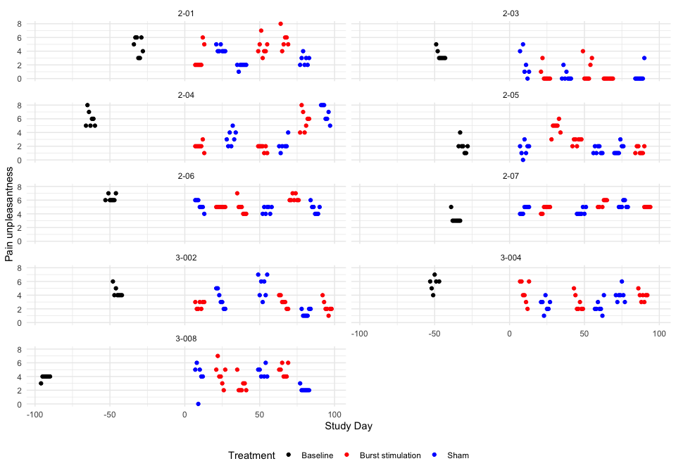

Descriptive table
Full analysis set
Pain unpleasantness
 | Baseline | Pair 1 |  | Pair 2 |  | Pair 3
 | Baseline | Burst stimulation | Sham | Burst stimulation | Sham | Burst stimulation | Sham
2-01
n | 7 | 7 | 7 | 7 | 7 | 6 | 7
Mean (sd) | 4.71 (1.38) | 3.00 (1.73) | 4.29 (0.49) | 4.57 (1.27) | 1.86 (0.38) | 5.67 (1.37) | 2.71 (0.76)
IQR | 2.50 | 1.50 | 0.50 | 1.00 | 0.00 | 1.00 | 1.00
min - max | 3.00 - 6.00 | 2.00 - 6.00 | 4.00 - 5.00 | 3.00 - 7.00 | 1.00 - 2.00 | 4.00 - 8.00 | 2.00 - 4.00
2-03
n | 7 | 7 | 6 | 7 | 7 | 7 | 7
Mean (sd) | 3.43 (0.79) | 0.57 (1.13) | 2.17 (1.94) | 1.29 (1.70) | 0.43 (0.79) | 0.00 (0.00) | 0.43 (1.13)
IQR | 0.50 | 0.50 | 2.50 | 2.50 | 0.50 | 0.00 | 0.00
min - max | 3.00 - 5.00 | 0.00 - 3.00 | 0.00 - 5.00 | 0.00 - 4.00 | 0.00 - 2.00 | 0.00 - 0.00 | 0.00 - 3.00
2-04
n | 7 | 7 | 7 | 7 | 6 | 7 | 7
Mean (sd) | 6.00 (1.15) | 2.00 (0.58) | 3.29 (1.11) | 1.71 (0.49) | 2.17 (0.98) | 5.71 (1.50) | 6.86 (1.21)
IQR | 1.50 | 0.00 | 1.50 | 0.50 | 0.00 | 2.00 | 2.00
min - max | 5.00 - 8.00 | 1.00 - 3.00 | 2.00 - 5.00 | 1.00 - 2.00 | 1.00 - 4.00 | 4.00 - 8.00 | 5.00 - 8.00
2-05
n | 7 | 7 | 7 | 7 | 7 | 7 | 7
Mean (sd) | 2.00 (1.00) | 4.71 (0.95) | 1.57 (0.98) | 2.71 (0.49) | 1.43 (0.53) | 1.43 (0.53) | 1.57 (0.79)
IQR | 0.50 | 0.50 | 1.00 | 0.50 | 1.00 | 1.00 | 1.00
min - max | 1.00 - 4.00 | 3.00 - 6.00 | 0.00 - 3.00 | 2.00 - 3.00 | 1.00 - 2.00 | 1.00 - 2.00 | 1.00 - 3.00
2-06
n | 7 | 7 | 7 | 7 | 7 | 7 | 7
Mean (sd) | 6.29 (0.49) | 5.00 (0.00) | 5.29 (0.76) | 4.86 (1.07) | 4.57 (0.53) | 6.29 (0.49) | 4.71 (0.76)
IQR | 0.50 | 0.00 | 1.00 | 1.00 | 1.00 | 0.50 | 1.00
min - max | 6.00 - 7.00 | 5.00 - 5.00 | 4.00 - 6.00 | 4.00 - 7.00 | 4.00 - 5.00 | 6.00 - 7.00 | 4.00 - 6.00
2-07
n | 7 | 7 | 7 | 6 | 7 | 5 | 7
Mean (sd) | 3.29 (0.76) | 4.71 (0.49) | 4.57 (0.53) | 5.50 (0.55) | 4.29 (0.49) | 5.00 (0.00) | 5.29 (0.49)
IQR | 0.00 | 0.50 | 1.00 | 1.00 | 0.50 | 0.00 | 0.50
min - max | 3.00 - 5.00 | 4.00 - 5.00 | 4.00 - 5.00 | 5.00 - 6.00 | 4.00 - 5.00 | 5.00 - 5.00 | 5.00 - 6.00
3-002
n | 7 | 7 | 7 | 7 | 7 | 7 | 7
Mean (sd) | 4.43 (0.79) | 2.57 (0.53) | 3.43 (1.27) | 3.00 (0.82) | 5.29 (1.60) | 2.29 (0.95) | 1.43 (0.53)
IQR | 0.50 | 1.00 | 2.00 | 1.00 | 2.50 | 0.50 | 1.00
min - max | 4.00 - 6.00 | 2.00 - 3.00 | 2.00 - 5.00 | 2.00 - 4.00 | 3.00 - 7.00 | 1.00 - 4.00 | 1.00 - 2.00
3-004
n | 6 | 7 | 7 | 7 | 7 | 7 | 7
Mean (sd) | 5.67 (1.03) | 4.43 (1.62) | 2.57 (0.98) | 2.86 (1.21) | 2.29 (0.95) | 3.86 (0.69) | 4.00 (1.00)
IQR | 0.75 | 2.50 | 1.00 | 1.50 | 0.50 | 0.50 | 0.50
min - max | 4.00 - 7.00 | 2.00 - 6.00 | 1.00 - 4.00 | 2.00 - 5.00 | 1.00 - 4.00 | 3.00 - 5.00 | 3.00 - 6.00
3-008
n | 7 | 7 | 6 | 7 | 6 | 7 | 7
Mean (sd) | 3.86 (0.38) | 4.29 (1.60) | 4.00 (2.10) | 2.71 (1.11) | 4.67 (0.82) | 4.86 (0.90) | 2.14 (0.38)
IQR | 0.00 | 1.50 | 1.00 | 1.00 | 1.00 | 1.50 | 0.00
min - max | 3.00 - 4.00 | 2.00 - 7.00 | 0.00 - 6.00 | 2.00 - 5.00 | 4.00 - 6.00 | 4.00 - 6.00 | 2.00 - 3.00

Hypothesis test
Pain unpleasantness
Subject ID | Difference Pair 1 | Difference Pair 2 | Difference Pair 3 | Overall difference
2-01 | -1.286 | 2.714 | 2.952 | 1.460
2-03 | -1.595 | 0.857 | -0.429 | -0.389
2-04 | -1.286 | -0.452 | -1.143 | -0.960
2-05 | 3.143 | 1.286 | -0.143 | 1.429
2-06 | -0.286 | 0.286 | 1.571 | 0.524
2-07 | 0.143 | 1.214 | -0.286 | 0.357
3-002 | -0.857 | -2.286 | 0.857 | -0.762
3-004 | 1.857 | 0.571 | -0.143 | 0.762
3-008 | 0.286 | -1.952 | 2.714 | 0.349
Values are Burst stimulation - Sham.
P-value of the null hypothesis test: 0.3.

Treatment effect estimates
QQ-plot
## Warning: For this model type, `marginaleffects` only takes into account the
## uncertainty in fixed-effect parameters. This is often appropriate when
## `re.form=NA`, but may be surprising to users who set `re.form=NULL` (default)
## or to some other value. Call `options(marginaleffects_safe = FALSE)` to silence
## this warning.
## Warning: For this model type, `marginaleffects` only takes into account the
## uncertainty in fixed-effect parameters. This is often appropriate when
## `re.form=NA`, but may be surprising to users who set `re.form=NULL` (default)
## or to some other value. Call `options(marginaleffects_safe = FALSE)` to silence
## this warning.
## Warning: For this model type, `marginaleffects` only takes into account the
## uncertainty in fixed-effect parameters. This is often appropriate when
## `re.form=NA`, but may be surprising to users who set `re.form=NULL` (default)
## or to some other value. Call `options(marginaleffects_safe = FALSE)` to silence
## this warning.
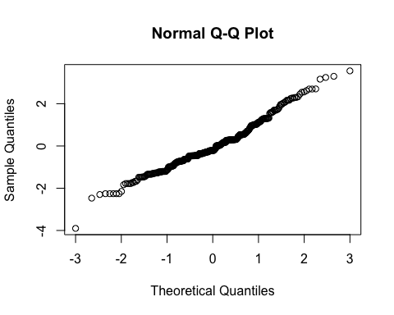
By subject
Subject ID | Estimate | Std. Err. | p-value | Lower CL | Upper CL
2-01 | 1.223 | 0.289 | 0.000 | 0.656 | 1.790
2-03 | -0.238 | 0.289 | 0.410 | -0.805 | 0.329
2-04 | -0.751 | 0.289 | 0.009 | -1.318 | -0.184
2-05 | 1.235 | 0.289 | 0.000 | 0.668 | 1.802
2-06 | 0.487 | 0.289 | 0.092 | -0.080 | 1.054
2-07 | 0.355 | 0.289 | 0.220 | -0.212 | 0.922
3-002 | -0.575 | 0.289 | 0.047 | -1.142 | -0.008
3-004 | 0.684 | 0.289 | 0.018 | 0.117 | 1.251
3-008 | 0.397 | 0.289 | 0.170 | -0.170 | 0.964
By treatment and overall
Treatment | Estimate | Std. Err. | p-value | Lower CL | Upper CL
Burst stimulation | 3.528 | 0.46 | 0 | 2.626 | 4.430
Sham | 3.214 | 0.46 | 0 | 2.312 | 4.116

Estimate | Std. Err. | p-value | Lower CL | Upper CL
0.314 | 0.289 | 0.278 | -0.253 | 0.881

Secondary outcome: Ability to do first activity (NRS)

Plot
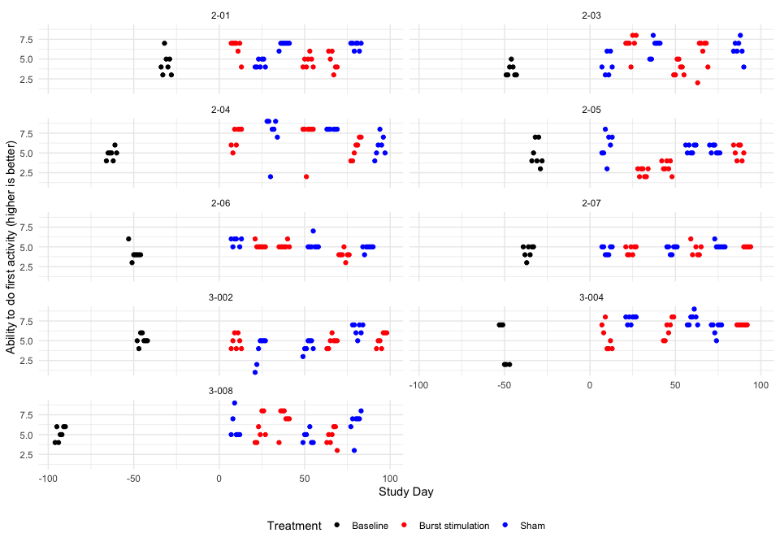

Descriptive table
Full analysis set
Ability to do first activity (higher is better)
 | Baseline | Pair 1 |  | Pair 2 |  | Pair 3
 | Baseline | Burst stimulation | Sham | Burst stimulation | Sham | Burst stimulation | Sham
2-01
n | 7 | 7 | 7 | 7 | 7 | 6 | 7
Mean (sd) | 4.43 (1.40) | 6.43 (1.13) | 4.43 (0.53) | 4.71 (0.76) | 6.86 (0.38) | 4.67 (1.21) | 6.71 (0.49)
IQR | 1.50 | 0.50 | 1.00 | 1.00 | 0.00 | 1.75 | 0.50
min - max | 3.00 - 7.00 | 4.00 - 7.00 | 4.00 - 5.00 | 4.00 - 6.00 | 6.00 - 7.00 | 3.00 - 6.00 | 6.00 - 7.00
2-03
n | 7 | 7 | 6 | 7 | 7 | 7 | 7
Mean (sd) | 3.57 (0.79) | 6.86 (1.35) | 4.33 (1.37) | 3.86 (0.90) | 6.57 (1.13) | 5.71 (1.98) | 6.29 (1.25)
IQR | 1.00 | 0.50 | 2.25 | 1.50 | 1.00 | 2.00 | 1.00
min - max | 3.00 - 5.00 | 4.00 - 8.00 | 3.00 - 6.00 | 3.00 - 5.00 | 5.00 - 8.00 | 2.00 - 7.00 | 4.00 - 8.00
2-04
n | 7 | 7 | 7 | 7 | 6 | 7 | 7
Mean (sd) | 4.86 (0.69) | 7.00 (1.29) | 7.43 (2.51) | 7.14 (2.27) | 8.00 (0.00) | 5.57 (1.27) | 5.86 (1.35)
IQR | 0.50 | 2.00 | 1.50 | 0.00 | 0.00 | 2.00 | 1.50
min - max | 4.00 - 6.00 | 5.00 - 8.00 | 2.00 - 9.00 | 2.00 - 8.00 | 8.00 - 8.00 | 4.00 - 7.00 | 4.00 - 8.00
2-05
n | 7 | 7 | 7 | 7 | 7 | 7 | 7
Mean (sd) | 4.86 (1.57) | 2.57 (0.53) | 5.86 (1.68) | 3.29 (0.76) | 5.57 (0.53) | 5.14 (0.90) | 5.43 (0.53)
IQR | 2.00 | 1.00 | 2.00 | 1.00 | 1.00 | 1.50 | 1.00
min - max | 3.00 - 7.00 | 2.00 - 3.00 | 3.00 - 8.00 | 2.00 - 4.00 | 5.00 - 6.00 | 4.00 - 6.00 | 5.00 - 6.00
2-06
n | 7 | 7 | 6 | 7 | 7 | 7 | 7
Mean (sd) | 4.14 (0.90) | 5.14 (0.38) | 5.67 (0.52) | 5.14 (0.38) | 5.29 (0.76) | 4.00 (0.58) | 4.86 (0.38)
IQR | 0.00 | 0.00 | 0.75 | 0.00 | 0.00 | 0.00 | 0.00
min - max | 3.00 - 6.00 | 5.00 - 6.00 | 5.00 - 6.00 | 5.00 - 6.00 | 5.00 - 7.00 | 3.00 - 5.00 | 4.00 - 5.00
2-07
n | 7 | 7 | 7 | 6 | 7 | 5 | 7
Mean (sd) | 4.43 (0.79) | 4.57 (0.53) | 4.57 (0.53) | 4.67 (0.82) | 4.71 (0.49) | 5.00 (0.00) | 5.14 (0.38)
IQR | 1.00 | 1.00 | 1.00 | 1.00 | 0.50 | 0.00 | 0.00
min - max | 3.00 - 5.00 | 4.00 - 5.00 | 4.00 - 5.00 | 4.00 - 6.00 | 4.00 - 5.00 | 5.00 - 5.00 | 5.00 - 6.00
3-002
n | 7 | 7 | 7 | 7 | 7 | 7 | 7
Mean (sd) | 5.14 (0.69) | 4.86 (0.90) | 3.86 (1.68) | 4.86 (0.69) | 4.29 (0.76) | 5.14 (0.90) | 6.43 (0.79)
IQR | 0.50 | 1.50 | 2.00 | 0.50 | 1.00 | 1.50 | 1.00
min - max | 4.00 - 6.00 | 4.00 - 6.00 | 1.00 - 5.00 | 4.00 - 6.00 | 3.00 - 5.00 | 4.00 - 6.00 | 5.00 - 7.00
3-004
n | 6 | 7 | 7 | 7 | 7 | 7 | 7
Mean (sd) | 4.50 (2.74) | 5.43 (1.62) | 7.71 (0.49) | 6.57 (1.27) | 7.71 (0.76) | 7.00 (0.00) | 6.57 (0.79)
IQR | 5.00 | 2.50 | 0.50 | 2.00 | 1.00 | 0.00 | 0.50
min - max | 2.00 - 7.00 | 4.00 - 8.00 | 7.00 - 8.00 | 5.00 - 8.00 | 7.00 - 9.00 | 7.00 - 7.00 | 5.00 - 7.00
3-008
n | 7 | 7 | 6 | 7 | 6 | 7 | 7
Mean (sd) | 5.14 (0.90) | 5.71 (1.70) | 6.00 (1.67) | 7.00 (1.41) | 4.67 (0.82) | 4.71 (1.11) | 6.43 (1.62)
IQR | 1.50 | 2.50 | 1.50 | 1.00 | 1.00 | 1.50 | 0.50
min - max | 4.00 - 6.00 | 4.00 - 8.00 | 5.00 - 9.00 | 4.00 - 8.00 | 4.00 - 6.00 | 3.00 - 6.00 | 3.00 - 8.00

Hypothesis test
Ability to do first activity (higher is better)
Subject ID | Difference Pair 1 | Difference Pair 2 | Difference Pair 3 | Overall difference
2-01 | 2.000 | -2.143 | -2.048 | -0.730
2-03 | 2.524 | -2.714 | -0.571 | -0.254
2-04 | -0.429 | -0.857 | -0.286 | -0.524
2-05 | -3.286 | -2.286 | -0.286 | -1.953
2-06 | -0.524 | -0.143 | -0.857 | -0.508
2-07 | 0.000 | -0.048 | -0.143 | -0.064
3-002 | 1.000 | 0.571 | -1.286 | 0.095
3-004 | -2.286 | -1.143 | 0.429 | -1.000
3-008 | -0.286 | 2.333 | -1.714 | 0.111
Values are Burst stimulation - Sham.
P-value of the null hypothesis test: 0.067.

Treatment effect estimates
QQ-plot
## Warning: For this model type, `marginaleffects` only takes into account the
## uncertainty in fixed-effect parameters. This is often appropriate when
## `re.form=NA`, but may be surprising to users who set `re.form=NULL` (default)
## or to some other value. Call `options(marginaleffects_safe = FALSE)` to silence
## this warning.
## Warning: For this model type, `marginaleffects` only takes into account the
## uncertainty in fixed-effect parameters. This is often appropriate when
## `re.form=NA`, but may be surprising to users who set `re.form=NULL` (default)
## or to some other value. Call `options(marginaleffects_safe = FALSE)` to silence
## this warning.
## Warning: For this model type, `marginaleffects` only takes into account the
## uncertainty in fixed-effect parameters. This is often appropriate when
## `re.form=NA`, but may be surprising to users who set `re.form=NULL` (default)
## or to some other value. Call `options(marginaleffects_safe = FALSE)` to silence
## this warning.
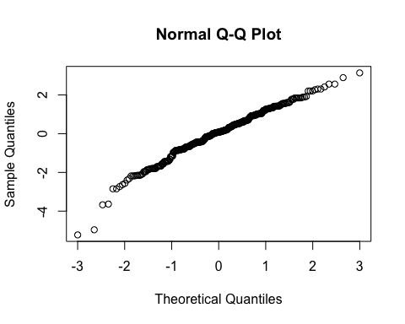
By subject
Subject ID | Estimate | Std. Err. | p-value | Lower CL | Upper CL
2-01 | -0.640 | 0.215 | 0.003 | -1.060 | -0.219
2-03 | -0.407 | 0.215 | 0.058 | -0.827 | 0.014
2-04 | -0.516 | 0.215 | 0.016 | -0.936 | -0.095
2-05 | -1.432 | 0.215 | 0.000 | -1.853 | -1.011
2-06 | -0.517 | 0.215 | 0.016 | -0.937 | -0.096
2-07 | -0.248 | 0.215 | 0.247 | -0.669 | 0.173
3-002 | -0.141 | 0.215 | 0.512 | -0.562 | 0.280
3-004 | -0.832 | 0.215 | 0.000 | -1.252 | -0.411
3-008 | -0.166 | 0.215 | 0.440 | -0.586 | 0.255
By treatment and overall
Treatment | Estimate | Std. Err. | p-value | Lower CL | Upper CL
Burst stimulation | 5.287 | 0.296 | 0 | 4.707 | 5.867
Sham | 5.836 | 0.296 | 0 | 5.256 | 6.416

Estimate | Std. Err. | p-value | Lower CL | Upper CL
-0.549 | 0.215 | 0.011 | -0.97 | -0.128

Secondary outcome: Ability to do second activity (NRS)

Plot
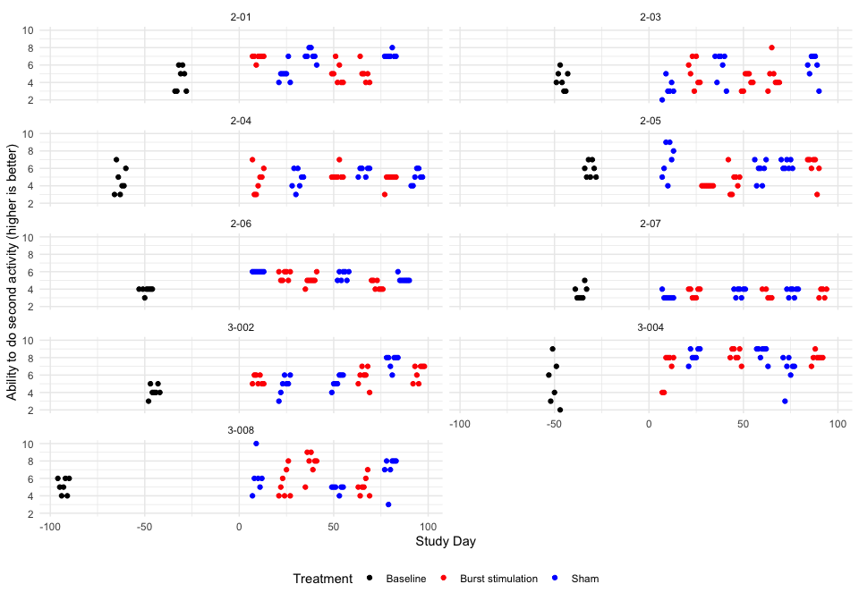

Descriptive table
Full analysis set
Ability to do second activity (higher is better)
 | Baseline | Pair 1 |  | Pair 2 |  | Pair 3
 | Baseline | Burst stimulation | Sham | Burst stimulation | Sham | Burst stimulation | Sham
2-01
n | 7 | 7 | 7 | 7 | 7 | 6 | 7
Mean (sd) | 4.43 (1.40) | 6.86 (0.38) | 5.00 (1.00) | 5.00 (1.15) | 7.14 (0.69) | 5.00 (1.10) | 7.14 (0.38)
IQR | 2.50 | 0.00 | 0.50 | 1.50 | 0.50 | 0.75 | 0.00
min - max | 3.00 - 6.00 | 6.00 - 7.00 | 4.00 - 7.00 | 4.00 - 7.00 | 6.00 - 8.00 | 4.00 - 7.00 | 7.00 - 8.00
2-03
n | 7 | 7 | 6 | 7 | 7 | 7 | 7
Mean (sd) | 4.29 (1.11) | 5.14 (1.57) | 3.33 (1.03) | 4.14 (0.90) | 5.86 (1.68) | 4.71 (1.60) | 5.86 (1.46)
IQR | 1.50 | 2.50 | 0.75 | 1.50 | 2.00 | 1.00 | 1.50
min - max | 3.00 - 6.00 | 3.00 - 7.00 | 2.00 - 5.00 | 3.00 - 5.00 | 3.00 - 7.00 | 3.00 - 8.00 | 3.00 - 7.00
2-04
n | 7 | 7 | 7 | 7 | 6 | 7 | 7
Mean (sd) | 4.57 (1.51) | 4.71 (1.50) | 4.71 (1.11) | 5.29 (0.76) | 5.67 (0.52) | 4.71 (0.76) | 5.00 (0.82)
IQR | 2.00 | 2.00 | 1.50 | 0.00 | 0.75 | 0.00 | 1.00
min - max | 3.00 - 7.00 | 3.00 - 7.00 | 3.00 - 6.00 | 5.00 - 7.00 | 5.00 - 6.00 | 3.00 - 5.00 | 4.00 - 6.00
2-05
n | 7 | 7 | 7 | 7 | 7 | 7 | 7
Mean (sd) | 5.86 (0.90) | 4.00 (0.00) | 6.86 (1.95) | 4.57 (1.40) | 5.71 (1.25) | 6.14 (1.46) | 6.43 (0.53)
IQR | 1.50 | 0.00 | 3.00 | 1.50 | 1.50 | 1.00 | 1.00
min - max | 5.00 - 7.00 | 4.00 - 4.00 | 4.00 - 9.00 | 3.00 - 7.00 | 4.00 - 7.00 | 3.00 - 7.00 | 6.00 - 7.00
2-06
n | 7 | 7 | 7 | 7 | 7 | 7 | 7
Mean (sd) | 3.86 (0.38) | 5.57 (0.53) | 6.00 (0.00) | 5.00 (0.58) | 5.57 (0.53) | 4.43 (0.53) | 5.14 (0.38)
IQR | 0.00 | 1.00 | 0.00 | 0.00 | 1.00 | 1.00 | 0.00
min - max | 3.00 - 4.00 | 5.00 - 6.00 | 6.00 - 6.00 | 4.00 - 6.00 | 5.00 - 6.00 | 4.00 - 5.00 | 5.00 - 6.00
2-07
n | 7 | 7 | 7 | 5 | 7 | 5 | 7
Mean (sd) | 3.57 (0.79) | 3.57 (0.53) | 3.14 (0.38) | 3.40 (0.55) | 3.71 (0.49) | 3.60 (0.55) | 3.71 (0.49)
IQR | 1.00 | 1.00 | 0.00 | 1.00 | 0.50 | 1.00 | 0.50
min - max | 3.00 - 5.00 | 3.00 - 4.00 | 3.00 - 4.00 | 3.00 - 4.00 | 3.00 - 4.00 | 3.00 - 4.00 | 3.00 - 4.00
3-002
n | 7 | 7 | 7 | 7 | 7 | 7 | 7
Mean (sd) | 4.14 (0.69) | 5.43 (0.53) | 4.86 (1.07) | 5.86 (1.07) | 5.29 (0.76) | 6.29 (0.95) | 7.57 (0.79)
IQR | 0.50 | 1.00 | 1.00 | 1.00 | 1.00 | 1.50 | 0.50
min - max | 3.00 - 5.00 | 5.00 - 6.00 | 3.00 - 6.00 | 4.00 - 7.00 | 4.00 - 6.00 | 5.00 - 7.00 | 6.00 - 8.00
3-004
n | 6 | 7 | 7 | 7 | 7 | 7 | 7
Mean (sd) | 5.17 (2.64) | 6.71 (1.89) | 8.29 (0.76) | 8.29 (0.76) | 8.57 (0.79) | 8.00 (0.58) | 6.57 (1.72)
IQR | 3.50 | 2.50 | 1.00 | 1.00 | 0.50 | 0.00 | 1.00
min - max | 2.00 - 9.00 | 4.00 - 8.00 | 7.00 - 9.00 | 7.00 - 9.00 | 7.00 - 9.00 | 7.00 - 9.00 | 3.00 - 8.00
3-008
n | 7 | 7 | 6 | 7 | 6 | 7 | 7
Mean (sd) | 5.14 (0.90) | 5.43 (1.62) | 6.17 (2.04) | 7.71 (1.38) | 4.83 (0.41) | 5.14 (1.07) | 7.00 (1.83)
IQR | 1.50 | 2.50 | 0.75 | 1.00 | 0.00 | 1.00 | 1.00
min - max | 4.00 - 6.00 | 4.00 - 8.00 | 4.00 - 10.00 | 5.00 - 9.00 | 4.00 - 5.00 | 4.00 - 7.00 | 3.00 - 8.00

Hypothesis test
Ability to do second activity (higher is better)
Subject ID | Difference Pair 1 | Difference Pair 2 | Difference Pair 3 | Overall difference
2-01 | 1.857 | -2.143 | -2.143 | -0.810
2-03 | 1.810 | -1.714 | -1.143 | -0.349
2-04 | 0.000 | -0.381 | -0.286 | -0.222
2-05 | -2.857 | -1.143 | -0.286 | -1.429
2-06 | -0.429 | -0.571 | -0.714 | -0.571
2-07 | 0.429 | -0.314 | -0.114 | 0.000
3-002 | 0.571 | 0.571 | -1.286 | -0.048
3-004 | -1.571 | -0.286 | 1.429 | -0.143
3-008 | -0.738 | 2.881 | -1.857 | 0.095
Values are Burst stimulation - Sham.
P-value of the null hypothesis test: 0.15.

Treatment effect estimates
QQ-plot
## Warning: For this model type, `marginaleffects` only takes into account the
## uncertainty in fixed-effect parameters. This is often appropriate when
## `re.form=NA`, but may be surprising to users who set `re.form=NULL` (default)
## or to some other value. Call `options(marginaleffects_safe = FALSE)` to silence
## this warning.
## Warning: For this model type, `marginaleffects` only takes into account the
## uncertainty in fixed-effect parameters. This is often appropriate when
## `re.form=NA`, but may be surprising to users who set `re.form=NULL` (default)
## or to some other value. Call `options(marginaleffects_safe = FALSE)` to silence
## this warning.
## Warning: For this model type, `marginaleffects` only takes into account the
## uncertainty in fixed-effect parameters. This is often appropriate when
## `re.form=NA`, but may be surprising to users who set `re.form=NULL` (default)
## or to some other value. Call `options(marginaleffects_safe = FALSE)` to silence
## this warning.
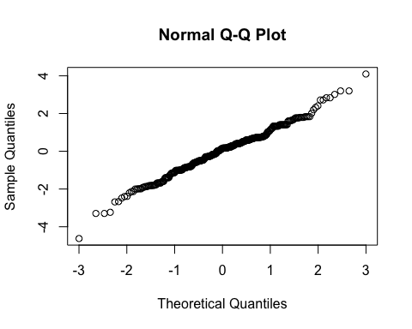
By subject
Subject ID | Estimate | Std. Err. | p-value | Lower CL | Upper CL
2-01 | -0.537 | 0.161 | 0.001 | -0.852 | -0.221
2-03 | -0.401 | 0.161 | 0.013 | -0.717 | -0.085
2-04 | -0.325 | 0.161 | 0.044 | -0.640 | -0.009
2-05 | -0.789 | 0.161 | 0.000 | -1.104 | -0.473
2-06 | -0.461 | 0.161 | 0.004 | -0.777 | -0.146
2-07 | -0.238 | 0.161 | 0.139 | -0.554 | 0.077
3-002 | -0.261 | 0.161 | 0.105 | -0.577 | 0.054
3-004 | -0.298 | 0.161 | 0.065 | -0.613 | 0.018
3-008 | -0.230 | 0.161 | 0.152 | -0.546 | 0.085
By treatment group and overall
Treatment | Estimate | Std. Err. | p-value | Lower CL | Upper CL
Burst stimulation | 5.384 | 0.387 | 0 | 4.625 | 6.144
Sham | 5.780 | 0.387 | 0 | 5.021 | 6.539

Estimate | Std. Err. | p-value | Lower CL | Upper CL
-0.396 | 0.161 | 0.014 | -0.711 | -0.08

Secondary outcome: Ability to do third activity (NRS)

Plot
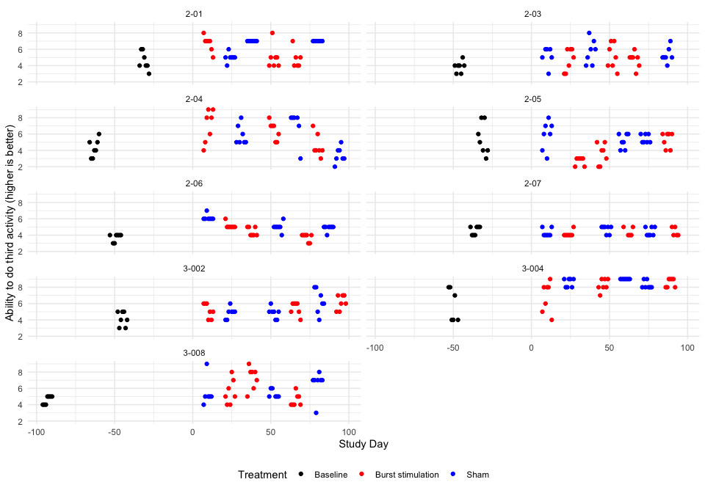

Descriptive table
Full analysis set
Ability to do third activity (higher is better)
 | Baseline | Pair 1 |  | Pair 2 |  | Pair 3
 | Baseline | Burst stimulation | Sham | Burst stimulation | Sham | Burst stimulation | Sham
2-01
n | 7 | 7 | 7 | 7 | 7 | 6 | 7
Mean (sd) | 4.57 (1.13) | 6.71 (0.95) | 5.00 (0.58) | 5.00 (1.41) | 7.00 (0.00) | 4.83 (1.17) | 7.00 (0.00)
IQR | 1.50 | 0.50 | 0.00 | 1.00 | 0.00 | 1.00 | 0.00
min - max | 3.00 - 6.00 | 5.00 - 8.00 | 4.00 - 6.00 | 4.00 - 8.00 | 7.00 - 7.00 | 4.00 - 7.00 | 7.00 - 7.00
2-03
n | 7 | 7 | 6 | 7 | 7 | 7 | 7
Mean (sd) | 3.86 (0.69) | 4.71 (1.38) | 5.17 (1.17) | 5.14 (1.57) | 5.71 (1.50) | 4.71 (0.95) | 5.29 (0.95)
IQR | 0.50 | 2.50 | 1.00 | 2.50 | 2.00 | 0.50 | 0.50
min - max | 3.00 - 5.00 | 3.00 - 6.00 | 3.00 - 6.00 | 3.00 - 7.00 | 4.00 - 8.00 | 3.00 - 6.00 | 4.00 - 7.00
2-04
n | 7 | 7 | 7 | 7 | 6 | 7 | 7
Mean (sd) | 4.29 (1.11) | 7.00 (2.00) | 5.86 (1.21) | 6.43 (1.13) | 7.00 (2.00) | 4.57 (1.40) | 3.43 (0.98)
IQR | 1.50 | 3.00 | 1.50 | 1.50 | 0.75 | 1.00 | 1.00
min - max | 3.00 - 6.00 | 4.00 - 9.00 | 5.00 - 8.00 | 5.00 - 8.00 | 3.00 - 8.00 | 3.00 - 7.00 | 2.00 - 5.00
2-05
n | 7 | 7 | 7 | 7 | 7 | 7 | 7
Mean (sd) | 5.43 (1.99) | 2.71 (0.49) | 5.86 (1.77) | 3.57 (1.27) | 5.14 (0.90) | 5.29 (0.95) | 5.43 (0.53)
IQR | 3.00 | 0.50 | 2.00 | 2.00 | 1.50 | 1.50 | 1.00
min - max | 3.00 - 8.00 | 2.00 - 3.00 | 3.00 - 8.00 | 2.00 - 5.00 | 4.00 - 6.00 | 4.00 - 6.00 | 5.00 - 6.00
2-06
n | 7 | 7 | 7 | 7 | 7 | 7 | 7
Mean (sd) | 3.71 (0.49) | 5.14 (0.38) | 6.14 (0.38) | 4.43 (0.53) | 5.00 (0.58) | 3.71 (0.49) | 4.86 (0.38)
IQR | 0.50 | 0.00 | 0.00 | 1.00 | 0.00 | 0.50 | 0.00
min - max | 3.00 - 4.00 | 5.00 - 6.00 | 6.00 - 7.00 | 4.00 - 5.00 | 4.00 - 6.00 | 3.00 - 4.00 | 4.00 - 5.00
2-07
n | 7 | 7 | 7 | 5 | 7 | 5 | 7
Mean (sd) | 4.57 (0.53) | 4.14 (0.38) | 4.29 (0.49) | 4.40 (0.55) | 4.71 (0.49) | 4.40 (0.55) | 4.43 (0.53)
IQR | 1.00 | 0.00 | 0.50 | 1.00 | 0.50 | 1.00 | 1.00
min - max | 4.00 - 5.00 | 4.00 - 5.00 | 4.00 - 5.00 | 4.00 - 5.00 | 4.00 - 5.00 | 4.00 - 5.00 | 4.00 - 5.00
3-002
n | 7 | 7 | 7 | 7 | 7 | 7 | 7
Mean (sd) | 4.14 (0.90) | 5.14 (0.90) | 4.86 (0.69) | 5.43 (0.79) | 4.86 (0.69) | 6.14 (0.90) | 6.29 (1.50)
IQR | 1.50 | 1.50 | 0.50 | 1.00 | 0.50 | 1.50 | 2.00
min - max | 3.00 - 5.00 | 4.00 - 6.00 | 4.00 - 6.00 | 4.00 - 6.00 | 4.00 - 6.00 | 5.00 - 7.00 | 4.00 - 8.00
3-004
n | 6 | 7 | 7 | 7 | 7 | 7 | 7
Mean (sd) | 5.83 (2.04) | 6.86 (1.86) | 8.57 (0.53) | 8.29 (0.76) | 9.00 (0.00) | 8.57 (0.53) | 8.29 (0.49)
IQR | 3.75 | 2.50 | 1.00 | 1.00 | 0.00 | 1.00 | 0.50
min - max | 4.00 - 8.00 | 4.00 - 9.00 | 8.00 - 9.00 | 7.00 - 9.00 | 9.00 - 9.00 | 8.00 - 9.00 | 8.00 - 9.00
3-008
n | 7 | 7 | 6 | 7 | 6 | 7 | 7
Mean (sd) | 4.57 (0.53) | 5.57 (1.51) | 5.50 (1.76) | 7.29 (1.38) | 5.33 (0.52) | 4.57 (0.79) | 6.57 (1.62)
IQR | 1.00 | 2.00 | 0.00 | 1.50 | 0.75 | 1.00 | 0.00
min - max | 4.00 - 5.00 | 4.00 - 8.00 | 4.00 - 9.00 | 5.00 - 9.00 | 5.00 - 6.00 | 4.00 - 6.00 | 3.00 - 8.00

Hypothesis test
Ability to do third activity (higher is better)
Subject ID | Difference Pair 1 | Difference Pair 2 | Difference Pair 3 | Overall difference
2-01 | 1.714 | -2.000 | -2.167 | -0.818
2-03 | -0.452 | -0.571 | -0.571 | -0.531
2-04 | 1.143 | -0.571 | 1.143 | 0.572
2-05 | -3.143 | -1.571 | -0.143 | -1.619
2-06 | -1.000 | -0.571 | -1.143 | -0.905
2-07 | -0.143 | -0.314 | -0.029 | -0.162
3-002 | 0.286 | 0.571 | -0.143 | 0.238
3-004 | -1.714 | -0.714 | 0.286 | -0.714
3-008 | 0.071 | 1.952 | -2.000 | 0.008
Values are Burst stimulation - Sham.
P-value of the null hypothesis test: 0.069.

Treatment effect estimates
QQ-plot
## Warning: For this model type, `marginaleffects` only takes into account the
## uncertainty in fixed-effect parameters. This is often appropriate when
## `re.form=NA`, but may be surprising to users who set `re.form=NULL` (default)
## or to some other value. Call `options(marginaleffects_safe = FALSE)` to silence
## this warning.
## Warning: For this model type, `marginaleffects` only takes into account the
## uncertainty in fixed-effect parameters. This is often appropriate when
## `re.form=NA`, but may be surprising to users who set `re.form=NULL` (default)
## or to some other value. Call `options(marginaleffects_safe = FALSE)` to silence
## this warning.
## Warning: For this model type, `marginaleffects` only takes into account the
## uncertainty in fixed-effect parameters. This is often appropriate when
## `re.form=NA`, but may be surprising to users who set `re.form=NULL` (default)
## or to some other value. Call `options(marginaleffects_safe = FALSE)` to silence
## this warning.
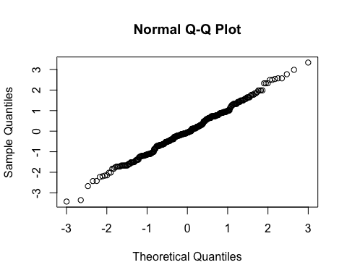
By subject
Subject ID | Estimate | Std. Err. | p-value | Lower CL | Upper CL
2-01 | -0.687 | 0.225 | 0.002 | -1.127 | -0.246
2-03 | -0.508 | 0.225 | 0.024 | -0.948 | -0.067
2-04 | 0.317 | 0.225 | 0.158 | -0.123 | 0.758
2-05 | -1.295 | 0.225 | 0.000 | -1.735 | -0.854
2-06 | -0.776 | 0.225 | 0.001 | -1.217 | -0.336
2-07 | -0.240 | 0.225 | 0.286 | -0.680 | 0.200
3-002 | 0.053 | 0.225 | 0.814 | -0.387 | 0.493
3-004 | -0.638 | 0.225 | 0.005 | -1.079 | -0.198
3-008 | -0.156 | 0.225 | 0.488 | -0.596 | 0.284
By treatment and overall
Treatment | Estimate | Std. Err. | p-value | Lower CL | Upper CL
Burst stimulation | 5.371 | 0.396 | 0 | 4.595 | 6.147
Sham | 5.813 | 0.396 | 0 | 5.037 | 6.588

Estimate | Std. Err. | p-value | Lower CL | Upper CL
-0.441 | 0.225 | 0.049 | -0.882 | -0.001

Post-hoc outcome: Patient Specific Functional Scale (PSFS) total score

Plot
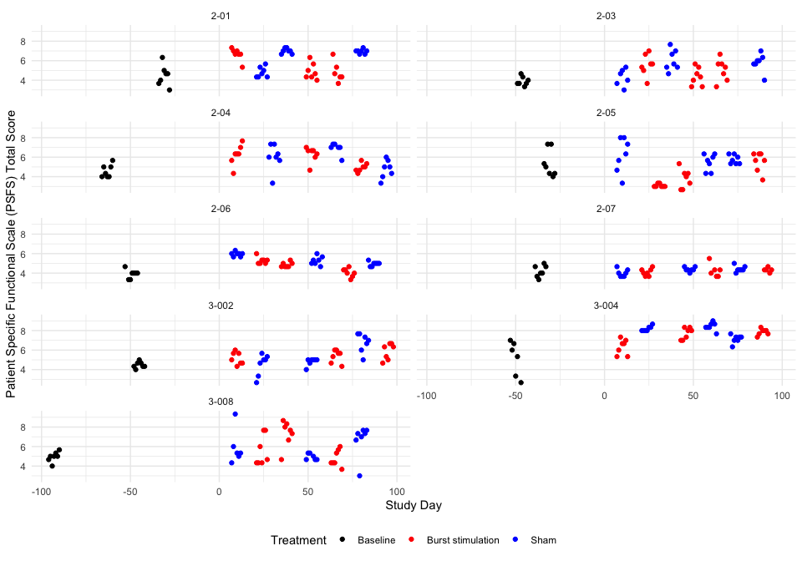

Descriptive table
Full analysis set
Patient Specific Functional Scale (PSFS) Total Score
 | Baseline | Pair 1 |  | Pair 2 |  | Pair 3
 | Baseline | Burst stimulation | Sham | Burst stimulation | Sham | Burst stimulation | Sham
2-01
n | 7 | 7 | 7 | 7 | 7 | 6 | 7
Mean (sd) | 4.48 (1.07) | 6.67 (0.64) | 4.81 (0.54) | 4.90 (0.83) | 7.00 (0.27) | 4.83 (1.05) | 6.95 (0.23)
IQR | 1.00 | 0.33 | 0.83 | 1.00 | 0.33 | 0.83 | 0.17
min - max | 3.00 - 6.33 | 5.33 - 7.33 | 4.33 - 5.67 | 4.00 - 6.33 | 6.67 - 7.33 | 3.67 - 6.67 | 6.67 - 7.33
2-03
n | 7 | 7 | 6 | 7 | 7 | 7 | 7
Mean (sd) | 3.90 (0.46) | 5.57 (1.10) | 4.28 (0.88) | 4.38 (0.91) | 6.05 (1.08) | 5.05 (1.13) | 5.81 (0.92)
IQR | 0.50 | 1.00 | 1.17 | 1.33 | 1.50 | 1.33 | 0.50
min - max | 3.33 - 4.67 | 3.67 - 7.00 | 3.00 - 5.33 | 3.33 - 5.67 | 4.67 - 7.67 | 3.33 - 6.67 | 4.00 - 7.00
2-04
n | 7 | 7 | 7 | 7 | 6 | 7 | 7
Mean (sd) | 4.57 (0.66) | 6.24 (1.05) | 6.00 (1.35) | 6.29 (0.78) | 6.89 (0.62) | 4.95 (0.45) | 4.76 (0.94)
IQR | 1.00 | 0.67 | 1.00 | 0.50 | 0.25 | 0.50 | 1.17
min - max | 4.00 - 5.67 | 4.33 - 7.67 | 3.33 - 7.33 | 4.67 - 7.00 | 5.67 - 7.33 | 4.33 - 5.67 | 3.33 - 6.00
2-05
n | 7 | 7 | 7 | 7 | 7 | 7 | 7
Mean (sd) | 5.38 (1.41) | 3.10 (0.16) | 6.19 (1.76) | 3.81 (0.98) | 5.48 (0.86) | 5.52 (1.02) | 5.76 (0.46)
IQR | 2.00 | 0.17 | 2.50 | 1.33 | 1.33 | 1.17 | 0.83
min - max | 4.00 - 7.33 | 3.00 - 3.33 | 3.33 - 8.00 | 2.67 - 5.33 | 4.33 - 6.33 | 3.67 - 6.33 | 5.33 - 6.33
2-06
n | 7 | 7 | 7 | 7 | 7 | 7 | 7
Mean (sd) | 3.90 (0.46) | 5.29 (0.36) | 5.95 (0.23) | 4.86 (0.26) | 5.29 (0.45) | 4.05 (0.45) | 4.95 (0.23)
IQR | 0.33 | 0.33 | 0.17 | 0.33 | 0.50 | 0.50 | 0.17
min - max | 3.33 - 4.67 | 5.00 - 6.00 | 5.67 - 6.33 | 4.67 - 5.33 | 4.67 - 6.00 | 3.33 - 4.67 | 4.67 - 5.33
2-07
n | 7 | 7 | 7 | 6 | 7 | 5 | 7
Mean (sd) | 4.19 (0.60) | 4.10 (0.37) | 4.00 (0.38) | 4.25 (0.68) | 4.38 (0.23) | 4.33 (0.24) | 4.43 (0.32)
IQR | 0.83 | 0.50 | 0.50 | 0.58 | 0.17 | 0.00 | 0.17
min - max | 3.33 - 5.00 | 3.67 - 4.67 | 3.67 - 4.67 | 3.67 - 5.50 | 4.00 - 4.67 | 4.00 - 4.67 | 4.00 - 5.00
3-002
n | 7 | 7 | 7 | 7 | 7 | 7 | 7
Mean (sd) | 4.48 (0.33) | 5.14 (0.63) | 4.52 (1.10) | 5.38 (0.65) | 4.81 (0.38) | 5.86 (0.84) | 6.76 (0.98)
IQR | 0.33 | 1.00 | 1.17 | 0.83 | 0.17 | 1.33 | 1.17
min - max | 4.00 - 5.00 | 4.33 - 6.00 | 2.67 - 5.67 | 4.33 - 6.00 | 4.00 - 5.00 | 4.67 - 6.67 | 5.00 - 7.67
3-004
n | 6 | 7 | 7 | 7 | 7 | 7 | 7
Mean (sd) | 5.17 (1.79) | 6.33 (0.79) | 8.19 (0.26) | 7.71 (0.59) | 8.43 (0.42) | 7.86 (0.33) | 7.14 (0.42)
IQR | 2.67 | 1.17 | 0.33 | 1.00 | 0.33 | 0.33 | 0.33
min - max | 2.67 - 7.00 | 5.33 - 7.33 | 8.00 - 8.67 | 7.00 - 8.33 | 7.67 - 9.00 | 7.33 - 8.33 | 6.33 - 7.67
3-008
n | 7 | 7 | 6 | 7 | 6 | 7 | 7
Mean (sd) | 4.95 (0.52) | 5.57 (1.55) | 5.89 (1.77) | 7.33 (1.35) | 4.94 (0.33) | 4.81 (0.86) | 6.67 (1.66)
IQR | 0.33 | 2.50 | 0.75 | 1.17 | 0.58 | 1.17 | 0.67
min - max | 4.00 - 5.67 | 4.33 - 7.67 | 4.33 - 9.33 | 4.67 - 8.67 | 4.67 - 5.33 | 3.67 - 6.00 | 3.00 - 7.67

Hypothesis test
Patient Specific Functional Scale (PSFS) Total Score
Subject ID | Difference Pair 1 | Difference Pair 2 | Difference Pair 3 | Overall difference
2-01 | 1.857 | -2.095 | -2.119 | -0.786
2-03 | 1.294 | -1.667 | -0.762 | -0.378
2-04 | 0.238 | -0.603 | 0.190 | -0.058
2-05 | -3.095 | -1.667 | -0.238 | -1.667
2-06 | -0.667 | -0.429 | -0.905 | -0.667
2-07 | 0.095 | -0.131 | -0.095 | -0.044
3-002 | 0.619 | 0.571 | -0.905 | 0.095
3-004 | -1.857 | -0.714 | 0.714 | -0.619
3-008 | -0.317 | 2.389 | -1.857 | 0.072
Values are Burst stimulation - Sham.
P-value of the null hypothesis test: 0.075.

Treatment effect estimates
QQ-plot
## Warning: For this model type, `marginaleffects` only takes into account the
## uncertainty in fixed-effect parameters. This is often appropriate when
## `re.form=NA`, but may be surprising to users who set `re.form=NULL` (default)
## or to some other value. Call `options(marginaleffects_safe = FALSE)` to silence
## this warning.
## Warning: For this model type, `marginaleffects` only takes into account the
## uncertainty in fixed-effect parameters. This is often appropriate when
## `re.form=NA`, but may be surprising to users who set `re.form=NULL` (default)
## or to some other value. Call `options(marginaleffects_safe = FALSE)` to silence
## this warning.
## Warning: For this model type, `marginaleffects` only takes into account the
## uncertainty in fixed-effect parameters. This is often appropriate when
## `re.form=NA`, but may be surprising to users who set `re.form=NULL` (default)
## or to some other value. Call `options(marginaleffects_safe = FALSE)` to silence
## this warning.
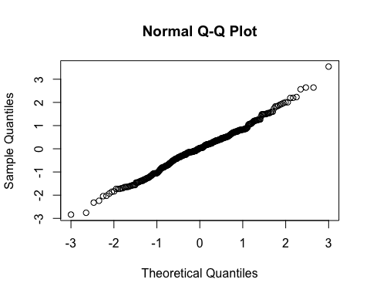
By subject
Subject ID | Estimate | Std. Err. | p-value | Lower CL | Upper CL
2-01 | -0.660 | 0.187 | 0.000 | -1.027 | -0.292
2-03 | -0.434 | 0.187 | 0.021 | -0.801 | -0.067
2-04 | -0.166 | 0.187 | 0.376 | -0.533 | 0.201
2-05 | -1.297 | 0.187 | 0.000 | -1.665 | -0.930
2-06 | -0.602 | 0.187 | 0.001 | -0.970 | -0.235
2-07 | -0.171 | 0.187 | 0.363 | -0.538 | 0.197
3-002 | -0.073 | 0.187 | 0.698 | -0.440 | 0.295
3-004 | -0.569 | 0.187 | 0.002 | -0.937 | -0.202
3-008 | -0.129 | 0.187 | 0.493 | -0.496 | 0.239
By treatment and overall
Treatment | Estimate | Std. Err. | p-value | Lower CL | Upper CL
Burst stimulation | 5.348 | 0.325 | 0 | 4.711 | 5.984
Sham | 5.807 | 0.325 | 0 | 5.171 | 6.444

Estimate | Std. Err. | p-value | Lower CL | Upper CL
-0.46 | 0.187 | 0.014 | -0.827 | -0.093

Secondary endpoint: Insomnia Severity Index questionnaire total score

Plot
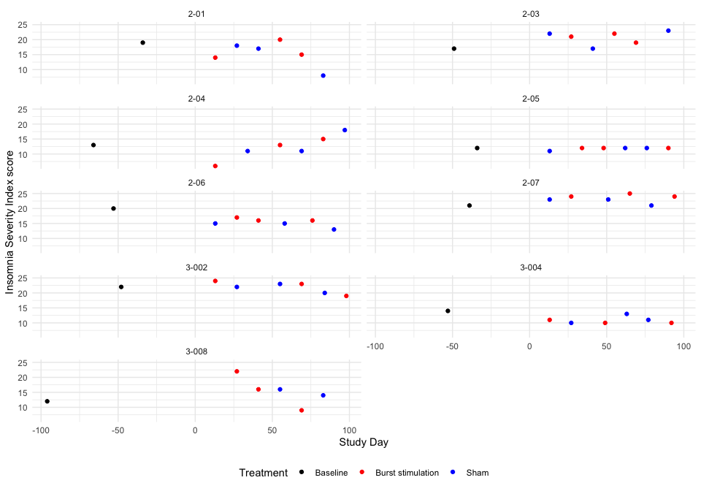 ### Descriptive table
Full analysis set
Insomnia Severity Index score
 | Baseline | Pair 1 |  | Pair 2 |  | Pair 3
 | Baseline | Burst stimulation | Sham | Burst stimulation | Sham | Burst stimulation | Sham
2-01
 | 19 | 14 | 18 | 20 | 17 | 15 | 8
2-03
 | 17 | 21 | 22 | 22 | 17 | 19 | 23
2-04
 | 13 | 6 | 11 | 13 | 11 | 15 | 18
2-05
 | 12 | 12 | 11 | 12 | 12 | 12 | 12
2-06
 | 20 | 17 | 15 | 16 | 15 | 16 | 13
2-07
 | 21 | 24 | 23 | 25 | 23 | 24 | 21
3-002
 | 22 | 24 | 22 | 23 | 23 | 19 | 20
3-004
 | 14 | 11 | 10 | 10 | 13 | 10 | 11
3-008
 | 12 | 22 | NA | 16 | 16 | 9 | 14

Hypothesis test
Insomnia Severity Index score
Subject ID | Difference Pair 1 | Difference Pair 2 | Difference Pair 3 | Overall difference
2-01 | -4 | 3 | 7 | 2.000
2-03 | -1 | 5 | -4 | 0.000
2-04 | -5 | 2 | -3 | -2.000
2-05 | 1 | 0 | 0 | 0.333
2-06 | 2 | 1 | 3 | 2.000
2-07 | 1 | 2 | 3 | 2.000
3-002 | 2 | 0 | -1 | 0.333
3-004 | 1 | -3 | -1 | -1.000
3-008 | NaN | 0 | -5 | -2.500
Values are Burst stimulation - Sham.
P-value of the null hypothesis test: 0.7.

Treatment effect estimates
QQ-plot
## Warning: For this model type, `marginaleffects` only takes into account the
## uncertainty in fixed-effect parameters. This is often appropriate when
## `re.form=NA`, but may be surprising to users who set `re.form=NULL` (default)
## or to some other value. Call `options(marginaleffects_safe = FALSE)` to silence
## this warning.
## Warning: For this model type, `marginaleffects` only takes into account the
## uncertainty in fixed-effect parameters. This is often appropriate when
## `re.form=NA`, but may be surprising to users who set `re.form=NULL` (default)
## or to some other value. Call `options(marginaleffects_safe = FALSE)` to silence
## this warning.
## Warning: For this model type, `marginaleffects` only takes into account the
## uncertainty in fixed-effect parameters. This is often appropriate when
## `re.form=NA`, but may be surprising to users who set `re.form=NULL` (default)
## or to some other value. Call `options(marginaleffects_safe = FALSE)` to silence
## this warning.
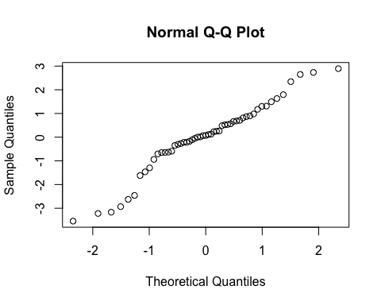
By subject
Subject ID | Estimate | Std. Err. | p-value | Lower CL | Upper CL
2-01 | 1.826 | 1.87 | 0.329 | -1.840 | 5.492
2-03 | 0.029 | 1.87 | 0.988 | -3.637 | 3.695
2-04 | -1.769 | 1.87 | 0.344 | -5.435 | 1.897
2-05 | 0.328 | 1.87 | 0.861 | -3.337 | 3.994
2-06 | 1.826 | 1.87 | 0.329 | -1.840 | 5.492
2-07 | 1.826 | 1.87 | 0.329 | -1.840 | 5.492
3-002 | 0.328 | 1.87 | 0.861 | -3.337 | 3.994
3-004 | -0.870 | 1.87 | 0.642 | -4.536 | 2.796
3-008 | -0.965 | 1.87 | 0.606 | -4.631 | 2.701
By treatment and overall
Treatment | Estimate | Std. Err. | p-value | Lower CL | Upper CL
Burst stimulation | 16.503 | 1.396 | 0 | 13.766 | 19.240
Sham | 16.195 | 1.401 | 0 | 13.448 | 18.942

Estimate | Std. Err. | p-value | Lower CL | Upper CL
0.308 | 1.87 | 0.869 | -3.358 | 3.974
Note that an error was discovered in the original analysis code and in the SAP where the insomnia score was only calculated across 4 of the 7 items. These analyses are now based on the correct total score on all 7 items spanning scores of 0-28. The error was discovered and rectified on the 1st of October 2026. The change was done after the unblinding. However, no other significant changes than adding the three items to the total score was made. This is documented in the git change log.

Secondary endpoint: EQ-5D-5L Utility Index

Plot
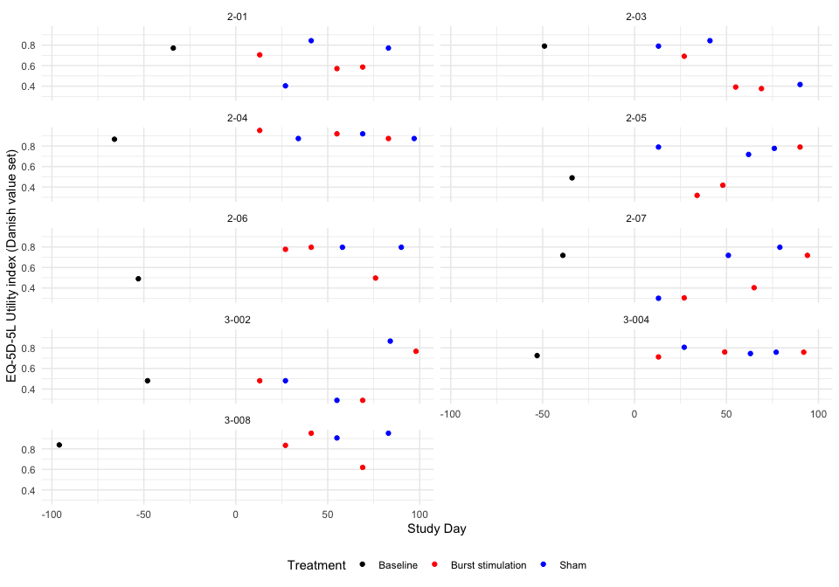 ### Descriptive table
Full analysis set
EQ-5D-5L Utility index (Danish value set)
 | Baseline | Pair 1 |  | Pair 2 |  | Pair 3
 | Baseline | Burst stimulation | Sham | Burst stimulation | Sham | Burst stimulation | Sham
2-01
 | 0.771 | 0.705 | 0.403 | 0.571 | 0.843 | 0.586 | 0.771
2-03
 | 0.79 | 0.691 | 0.79 | 0.391 | 0.843 | 0.376 | 0.416
2-04
 | 0.866 | 0.952 | 0.873 | 0.919 | 0.919 | 0.873 | 0.873
2-05
 | 0.49 | 0.319 | 0.79 | 0.418 | 0.718 | 0.79 | 0.777
2-06
 | 0.49 | 0.777 | NA | 0.797 | 0.797 | 0.497 | 0.797
2-07
 | 0.718 | 0.304 | 0.3 | 0.403 | 0.718 | 0.718 | 0.797
3-002
 | 0.48 | 0.48 | 0.48 | 0.289 | 0.289 | 0.767 | 0.866
3-004
 | 0.725 | 0.712 | 0.806 | 0.76 | 0.745 | 0.758 | 0.758
3-008
 | 0.838 | 0.834 | NA | 0.952 | 0.906 | 0.619 | 0.952

Hypothesis test
EQ-5D-5L Utility index (Danish value set)
Subject ID | Difference Pair 1 | Difference Pair 2 | Difference Pair 3 | Overall difference
2-01 | 0.302 | -0.272 | -0.185 | -0.052
2-03 | -0.099 | -0.452 | -0.040 | -0.197
2-04 | 0.079 | 0.000 | 0.000 | 0.026
2-05 | -0.471 | -0.300 | 0.013 | -0.253
2-06 | NaN | 0.000 | -0.300 | -0.150
2-07 | 0.004 | -0.315 | -0.079 | -0.130
3-002 | 0.000 | 0.000 | -0.099 | -0.033
3-004 | -0.094 | 0.015 | 0.000 | -0.026
3-008 | NaN | 0.046 | -0.333 | -0.144
Values are Burst stimulation - Sham.
P-value of the null hypothesis test: 0.0091.

Treatment effect estimates
QQ-plot
## Warning: For this model type, `marginaleffects` only takes into account the
## uncertainty in fixed-effect parameters. This is often appropriate when
## `re.form=NA`, but may be surprising to users who set `re.form=NULL` (default)
## or to some other value. Call `options(marginaleffects_safe = FALSE)` to silence
## this warning.
## Warning: For this model type, `marginaleffects` only takes into account the
## uncertainty in fixed-effect parameters. This is often appropriate when
## `re.form=NA`, but may be surprising to users who set `re.form=NULL` (default)
## or to some other value. Call `options(marginaleffects_safe = FALSE)` to silence
## this warning.
## Warning: For this model type, `marginaleffects` only takes into account the
## uncertainty in fixed-effect parameters. This is often appropriate when
## `re.form=NA`, but may be surprising to users who set `re.form=NULL` (default)
## or to some other value. Call `options(marginaleffects_safe = FALSE)` to silence
## this warning.
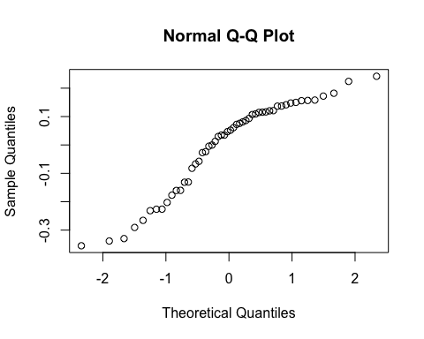
By subject
Subject ID | Estimate | Std. Err. | p-value | Lower CL | Upper CL
2-01 | -0.073 | 0.067 | 0.275 | -0.204 | 0.058
2-03 | -0.138 | 0.067 | 0.038 | -0.269 | -0.007
2-04 | -0.038 | 0.067 | 0.571 | -0.169 | 0.093
2-05 | -0.163 | 0.067 | 0.014 | -0.294 | -0.033
2-06 | -0.085 | 0.067 | 0.203 | -0.216 | 0.046
2-07 | -0.108 | 0.067 | 0.105 | -0.239 | 0.023
3-002 | -0.065 | 0.067 | 0.334 | -0.195 | 0.066
3-004 | -0.062 | 0.067 | 0.357 | -0.192 | 0.069
3-008 | -0.081 | 0.067 | 0.223 | -0.212 | 0.049
By treatment and overall
Treatment | Estimate | Std. Err. | p-value | Lower CL | Upper CL
Burst stimulation | 0.639 | 0.047 | 0 | 0.547 | 0.730
Sham | 0.729 | 0.048 | 0 | 0.636 | 0.823

Estimate | Std. Err. | p-value | Lower CL | Upper CL
-0.091 | 0.067 | 0.175 | -0.222 | 0.04

Secondary endpoint: EQ-5D-5L self-rated health (VAS)

Plot
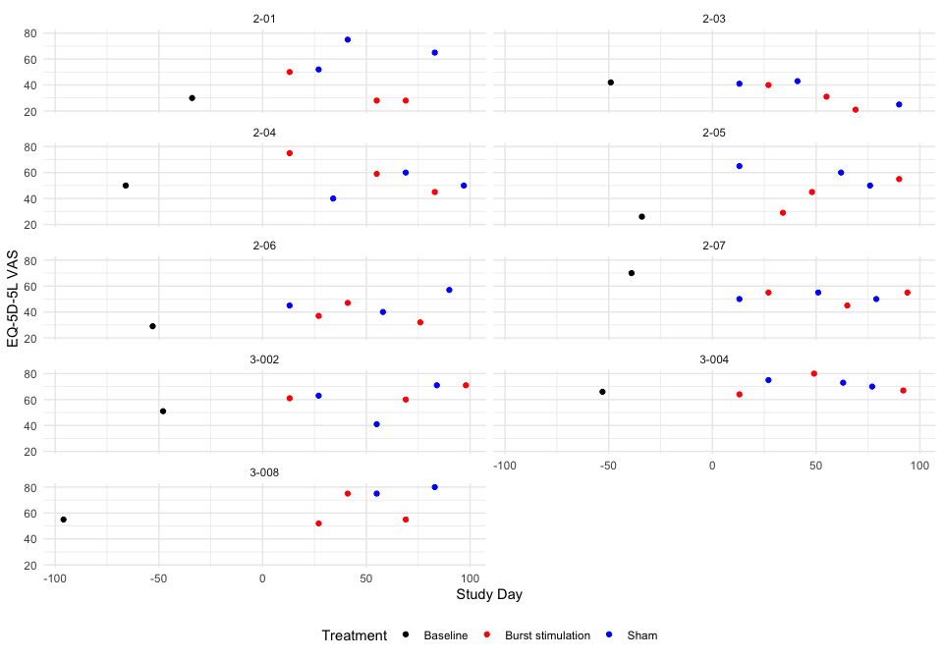 ### Descriptive table
Full analysis set
EQ-5D-5L VAS
 | Baseline | Pair 1 |  | Pair 2 |  | Pair 3
 | Baseline | Burst stimulation | Sham | Burst stimulation | Sham | Burst stimulation | Sham
2-01
 | 30 | 50 | 52 | 28 | 75 | 28 | 65
2-03
 | 42 | 40 | 41 | 31 | 43 | 21 | 25
2-04
 | 50 | 75 | 40 | 59 | 60 | 45 | 50
2-05
 | 26 | 29 | 65 | 45 | 60 | 55 | 50
2-06
 | 29 | 37 | 45 | 47 | 40 | 32 | 57
2-07
 | 70 | 55 | 50 | 45 | 55 | 55 | 50
3-002
 | 51 | 61 | 63 | 60 | 41 | 71 | 71
3-004
 | 66 | 64 | 75 | 80 | 73 | 67 | 70
3-008
 | 55 | 52 | NA | 75 | 75 | 55 | 80

Hypothesis test
EQ-5D-5L VAS
Subject ID | Difference Pair 1 | Difference Pair 2 | Difference Pair 3 | Overall difference
2-01 | -2 | -47 | -37 | -28.667
2-03 | -1 | -12 | -4 | -5.667
2-04 | 35 | -1 | -5 | 9.667
2-05 | -36 | -15 | 5 | -15.333
2-06 | -8 | 7 | -25 | -8.667
2-07 | 5 | -10 | 5 | 0.000
3-002 | -2 | 19 | 0 | 5.667
3-004 | -11 | 7 | -3 | -2.333
3-008 | NaN | 0 | -25 | -12.500
Values are Burst stimulation - Sham.
P-value of the null hypothesis test: 0.082.

Treatment effect estimates
QQ-plot
## Warning: For this model type, `marginaleffects` only takes into account the
## uncertainty in fixed-effect parameters. This is often appropriate when
## `re.form=NA`, but may be surprising to users who set `re.form=NULL` (default)
## or to some other value. Call `options(marginaleffects_safe = FALSE)` to silence
## this warning.
## Warning: For this model type, `marginaleffects` only takes into account the
## uncertainty in fixed-effect parameters. This is often appropriate when
## `re.form=NA`, but may be surprising to users who set `re.form=NULL` (default)
## or to some other value. Call `options(marginaleffects_safe = FALSE)` to silence
## this warning.
## Warning: For this model type, `marginaleffects` only takes into account the
## uncertainty in fixed-effect parameters. This is often appropriate when
## `re.form=NA`, but may be surprising to users who set `re.form=NULL` (default)
## or to some other value. Call `options(marginaleffects_safe = FALSE)` to silence
## this warning.
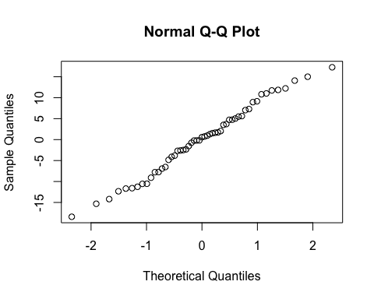
By subject
Subject ID | Estimate | Std. Err. | p-value | Lower CL | Upper CL
2-01 | -24.391 | 6.299 | 0.000 | -36.737 | -12.045
2-03 | -5.868 | 6.299 | 0.352 | -18.214 | 6.478
2-04 | 6.481 | 6.299 | 0.304 | -5.865 | 18.827
2-05 | -13.653 | 6.299 | 0.030 | -25.999 | -1.307
2-06 | -8.284 | 6.299 | 0.188 | -20.630 | 4.062
2-07 | -1.304 | 6.299 | 0.836 | -13.650 | 11.042
3-002 | 3.260 | 6.299 | 0.605 | -9.086 | 15.606
3-004 | -3.183 | 6.299 | 0.613 | -15.529 | 9.163
3-008 | -13.358 | 6.299 | 0.034 | -25.704 | -1.012
By treatment and overall
Treatment | Estimate | Std. Err. | p-value | Lower CL | Upper CL
Burst stimulation | 50.292 | 4.443 | 0 | 41.584 | 58.999
Sham | 56.866 | 4.465 | 0 | 48.115 | 65.617

Estimate | Std. Err. | p-value | Lower CL | Upper CL
-6.574 | 6.299 | 0.297 | -18.92 | 5.772

Secondary endpoint: Patient Global Impression of Change

Descriptive table
Full analysis set
Patient Global Impression of Change
 | Baseline - Burst stimulation | Baseline - Sham | Burst stimulation - Burst stimulation | Burst stimulation - Sham | Sham - Burst stimulation | Sham - Sham
Veldig mye bedre | 0 (0.00%) | 0 (0.00%) | 0 (0.00%) | 0 (0.00%) | 0 (0.00%) | 0 (0.00%)
Mye bedre | 2 (50.00%) | 1 (25.00%) | 3 (60.00%) | 8 (44.44%) | 3 (16.67%) | 1 (25.00%)
Minimalt bedre | 1 (25.00%) | 1 (25.00%) | 0 (0.00%) | 1 (5.56%) | 4 (22.22%) | 0 (0.00%)
Ingen endring | 0 (0.00%) | 1 (25.00%) | 1 (20.00%) | 4 (22.22%) | 1 (5.56%) | 1 (25.00%)
Minimalt verre | 1 (25.00%) | 0 (0.00%) | 0 (0.00%) | 2 (11.11%) | 1 (5.56%) | 1 (25.00%)
Mye verre | 0 (0.00%) | 1 (25.00%) | 1 (20.00%) | 2 (11.11%) | 9 (50.00%) | 1 (25.00%)
Veldig mye verre | 0 (0.00%) | 0 (0.00%) | 0 (0.00%) | 1 (5.56%) | 0 (0.00%) | 0 (0.00%)

Hypothesis test and treatment effect estimates
 | Mean | SD
Burst stimulation - Sham | 3.555556 | 1.688098
Sham - Burst stimulation | 4.500000 | 1.689065
## Warning: For this model type, `marginaleffects` only takes into account the
## uncertainty in fixed-effect parameters. This is often appropriate when
## `re.form=NA`, but may be surprising to users who set `re.form=NULL` (default)
## or to some other value. Call `options(marginaleffects_safe = FALSE)` to silence
## this warning.
contrast | estimate | std.error | p.value | s.value | conf.low | conf.high
Sham - Burst stimulation - Burst stimulation - Sham | 0.95 | 0.558 | 0.089 | 3.494 | -0.144 | 2.045

Secondary outcome: Patient blinding question

Descriptive table by participant
Full analysis set
Patient blinding question
 | Pair 1 |  | Pair 2 |  | Pair 3
 | Burst stimulation | Sham | Burst stimulation | Sham | Burst stimulation | Sham
2-01
Slått på | 1 (11.11%) | 0 (0.00%) | 0 (0.00%) | 1 (11.11%) | 0 (0.00%) | 1 (11.11%)
Slått av | 0 (0.00%) | 1 (12.50%) | 1 (11.11%) | 0 (0.00%) | 1 (11.11%) | 0 (0.00%)
Vet ikke | 0 (0.00%) | 0 (0.00%) | 0 (0.00%) | 0 (0.00%) | 0 (0.00%) | 0 (0.00%)
2-03
Slått på | 1 (11.11%) | 0 (0.00%) | 0 (0.00%) | 1 (11.11%) | 1 (11.11%) | 0 (0.00%)
Slått av | 0 (0.00%) | 1 (12.50%) | 1 (11.11%) | 0 (0.00%) | 0 (0.00%) | 0 (0.00%)
Vet ikke | 0 (0.00%) | 0 (0.00%) | 0 (0.00%) | 0 (0.00%) | 0 (0.00%) | 1 (11.11%)
2-04
Slått på | 1 (11.11%) | 0 (0.00%) | 1 (11.11%) | 1 (11.11%) | 0 (0.00%) | 0 (0.00%)
Slått av | 0 (0.00%) | 1 (12.50%) | 0 (0.00%) | 0 (0.00%) | 1 (11.11%) | 1 (11.11%)
Vet ikke | 0 (0.00%) | 0 (0.00%) | 0 (0.00%) | 0 (0.00%) | 0 (0.00%) | 0 (0.00%)
2-05
Slått på | 0 (0.00%) | 1 (12.50%) | 0 (0.00%) | 1 (11.11%) | 1 (11.11%) | 1 (11.11%)
Slått av | 1 (11.11%) | 0 (0.00%) | 0 (0.00%) | 0 (0.00%) | 0 (0.00%) | 0 (0.00%)
Vet ikke | 0 (0.00%) | 0 (0.00%) | 1 (11.11%) | 0 (0.00%) | 0 (0.00%) | 0 (0.00%)
2-06
Slått på | 0 (0.00%) | 1 (12.50%) | 1 (11.11%) | 1 (11.11%) | 0 (0.00%) | 1 (11.11%)
Slått av | 1 (11.11%) | 0 (0.00%) | 0 (0.00%) | 0 (0.00%) | 1 (11.11%) | 0 (0.00%)
Vet ikke | 0 (0.00%) | 0 (0.00%) | 0 (0.00%) | 0 (0.00%) | 0 (0.00%) | 0 (0.00%)
2-07
Slått på | 1 (11.11%) | 0 (0.00%) | 0 (0.00%) | 1 (11.11%) | 0 (0.00%) | 1 (11.11%)
Slått av | 0 (0.00%) | 0 (0.00%) | 0 (0.00%) | 0 (0.00%) | 0 (0.00%) | 0 (0.00%)
Vet ikke | 0 (0.00%) | 1 (12.50%) | 1 (11.11%) | 0 (0.00%) | 1 (11.11%) | 0 (0.00%)
3-002
Slått på | 1 (11.11%) | 0 (0.00%) | 0 (0.00%) | 0 (0.00%) | 0 (0.00%) | 1 (11.11%)
Slått av | 0 (0.00%) | 1 (12.50%) | 1 (11.11%) | 1 (11.11%) | 0 (0.00%) | 0 (0.00%)
Vet ikke | 0 (0.00%) | 0 (0.00%) | 0 (0.00%) | 0 (0.00%) | 1 (11.11%) | 0 (0.00%)
3-004
Slått på | 0 (0.00%) | 1 (12.50%) | 1 (11.11%) | 1 (11.11%) | 0 (0.00%) | 0 (0.00%)
Slått av | 1 (11.11%) | 0 (0.00%) | 0 (0.00%) | 0 (0.00%) | 0 (0.00%) | 1 (11.11%)
Vet ikke | 0 (0.00%) | 0 (0.00%) | 0 (0.00%) | 0 (0.00%) | 1 (11.11%) | 0 (0.00%)
3-008
Slått på | 0 (0.00%) | 0 (0.00%) | 1 (11.11%) | 0 (0.00%) | 0 (0.00%) | 1 (11.11%)
Slått av | 0 (0.00%) | 0 (0.00%) | 0 (0.00%) | 1 (11.11%) | 1 (11.11%) | 0 (0.00%)
Vet ikke | 1 (11.11%) | 0 (0.00%) | 0 (0.00%) | 0 (0.00%) | 0 (0.00%) | 0 (0.00%)
Full analysis set
Patient Blinding Quesiton
 | Burst stimulation | Sham
Slått på | 11 (40.74%) | 16 (61.54%)
Slått av | 10 (37.04%) | 8 (30.77%)
Vet ikke | 6 (22.22%) | 2 (7.69%)
P-value of the null hypothesis chi-squared test: 0.21.
P-value of the null hypothesis Fisher test: 0.21.

Secondary endpoint: Hopkins Symptom Checklist-25 mean score

Plot
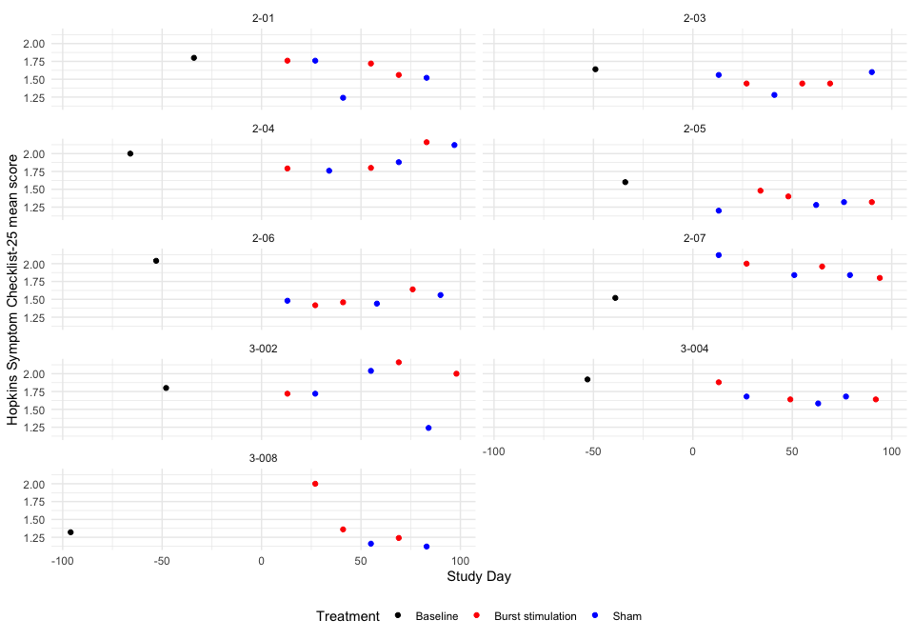 ### Descriptive table
Full analysis set
Hopkins Symptom Checklist-25 mean score
 | Baseline | Pair 1 |  | Pair 2 |  | Pair 3
 | Baseline | Burst stimulation | Sham | Burst stimulation | Sham | Burst stimulation | Sham
2-01
 | 1.8 | 1.76 | 1.76 | 1.72 | 1.24 | 1.56 | 1.52
2-03
 | 1.64 | 1.44 | 1.56 | 1.44 | 1.28 | 1.44 | 1.6
2-04
 | 2 | 1.79166666666667 | 1.76 | 1.8 | 1.88 | 2.16 | 2.12
2-05
 | 1.6 | 1.48 | 1.2 | 1.4 | 1.28 | 1.32 | 1.32
2-06
 | 2.04 | 1.41666666666667 | 1.48 | 1.45833333333333 | 1.44 | 1.64 | 1.56
2-07
 | 1.52 | 2 | 2.12 | 1.96 | 1.84 | 1.8 | 1.84
3-002
 | 1.8 | 1.72 | 1.72 | 2.16 | 2.04 | 2 | 1.24
3-004
 | 1.92 | 1.88 | 1.68 | 1.64 | 1.58333333333333 | 1.64 | 1.68
3-008
 | 1.32 | 2 | NA | 1.36 | 1.16 | 1.24 | 1.12

Hypothesis test
Hopkins Symptom Checklist-25 mean score
Subject ID | Difference Pair 1 | Difference Pair 2 | Difference Pair 3 | Overall difference
2-01 | 0.000 | 0.480 | 0.04 | 0.173
2-03 | -0.120 | 0.160 | -0.16 | -0.040
2-04 | 0.032 | -0.080 | 0.04 | -0.003
2-05 | 0.280 | 0.120 | 0.00 | 0.133
2-06 | -0.063 | 0.018 | 0.08 | 0.012
2-07 | -0.120 | 0.120 | -0.04 | -0.013
3-002 | 0.000 | 0.120 | 0.76 | 0.293
3-004 | 0.200 | 0.057 | -0.04 | 0.072
3-008 | NaN | 0.200 | 0.12 | 0.160
Values are Burst stimulation - Sham.
P-value of the null hypothesis test: 0.036.

Treatment effect estimates
QQ-plot
## Warning: For this model type, `marginaleffects` only takes into account the
## uncertainty in fixed-effect parameters. This is often appropriate when
## `re.form=NA`, but may be surprising to users who set `re.form=NULL` (default)
## or to some other value. Call `options(marginaleffects_safe = FALSE)` to silence
## this warning.
## Warning: For this model type, `marginaleffects` only takes into account the
## uncertainty in fixed-effect parameters. This is often appropriate when
## `re.form=NA`, but may be surprising to users who set `re.form=NULL` (default)
## or to some other value. Call `options(marginaleffects_safe = FALSE)` to silence
## this warning.
## Warning: For this model type, `marginaleffects` only takes into account the
## uncertainty in fixed-effect parameters. This is often appropriate when
## `re.form=NA`, but may be surprising to users who set `re.form=NULL` (default)
## or to some other value. Call `options(marginaleffects_safe = FALSE)` to silence
## this warning.
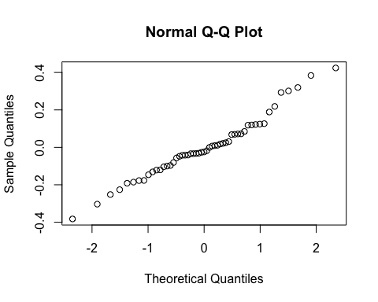
By subject
Subject ID | Estimate | Std. Err. | p-value | Lower CL | Upper CL
2-01 | 0.158 | 0.112 | 0.158 | -0.062 | 0.378
2-03 | -0.007 | 0.112 | 0.951 | -0.227 | 0.213
2-04 | 0.022 | 0.112 | 0.845 | -0.198 | 0.242
2-05 | 0.127 | 0.112 | 0.257 | -0.093 | 0.347
2-06 | 0.033 | 0.112 | 0.768 | -0.187 | 0.253
2-07 | 0.014 | 0.112 | 0.903 | -0.206 | 0.233
3-002 | 0.251 | 0.112 | 0.025 | 0.031 | 0.471
3-004 | 0.080 | 0.112 | 0.476 | -0.140 | 0.300
3-008 | 0.277 | 0.112 | 0.014 | 0.057 | 0.497
By treatment and overall
Treatment | Estimate | Std. Err. | p-value | Lower CL | Upper CL
Burst stimulation | 1.676 | 0.079 | 0 | 1.521 | 1.831
Sham | 1.573 | 0.079 | 0 | 1.418 | 1.729

Estimate | Std. Err. | p-value | Lower CL | Upper CL
0.103 | 0.112 | 0.359 | -0.117 | 0.323

Carry over effect
First fit the model:
## Linear mixed model fit by REML ['lmerMod']
## Formula:
## painleg3 ~ rantrt + pair + prevtrt + prevtrt:rantrt + (1 | subjectid) +
## (1 | subjectid:pair) + (1 | subjectid:rantrt)
## Data: data
##
## REML criterion at convergence: 1233.7
##
## Scaled residuals:
## Min 1Q Median 3Q Max
## -3.5267 -0.5314 -0.0363 0.5708 3.0218
##
## Random effects:
## Groups Name Variance Std.Dev.
## subjectid:pair (Intercept) 0.6485 0.8053
## subjectid:rantrt (Intercept) 0.3284 0.5731
## subjectid (Intercept) 0.4838 0.6956
## Residual 1.3256 1.1514
## Number of obs: 370, groups:
## subjectid:pair, 27; subjectid:rantrt, 18; subjectid, 9
##
## Fixed effects:
## Estimate Std. Error t value
## (Intercept) 4.24918 0.52934 8.027
## rantrtSham -0.25410 0.39355 -0.646
## pairPair 2 -0.55315 0.41566 -1.331
## pairPair 3 -0.05001 0.41263 -0.121
## prevtrtSham 0.25622 0.34113 0.751
## rantrtSham:prevtrtSham -0.06868 0.35044 -0.196
##
## Correlation of Fixed Effects:
## (Intr) rntrtS parPr2 parPr3 prvtrS
## rantrtSham -0.577
## pairPair 2 -0.489 0.091
## pairPair 3 -0.462 0.058 0.516
## prevtrtSham -0.606 0.625 0.179 0.131
## rntrtShm:pS 0.384 -0.587 -0.054 -0.018 -0.693
Then plot the expected outcome by current and previous treatment:
## Warning: For this model type, `marginaleffects` only takes into account the
## uncertainty in fixed-effect parameters. This is often appropriate when
## `re.form=NA`, but may be surprising to users who set `re.form=NULL` (default)
## or to some other value. Call `options(marginaleffects_safe = FALSE)` to silence
## this warning.
## Warning: For this model type, `marginaleffects` only takes into account the
## uncertainty in fixed-effect parameters. This is often appropriate when
## `re.form=NA`, but may be surprising to users who set `re.form=NULL` (default)
## or to some other value. Call `options(marginaleffects_safe = FALSE)` to silence
## this warning.
Outcome by tretment and previous treatment
prevtrt | rantrt | estimate | std.error | statistic | p.value | s.value | conf.low | conf.high | df
Burst stimulation | Burst stimulation | 4.055 | 0.446 | 9.091 | 0 | 63.143 | 3.180 | 4.929 | Inf
Burst stimulation | Sham | 3.795 | 0.360 | 10.547 | 0 | 83.983 | 3.090 | 4.501 | Inf
Sham | Burst stimulation | 4.311 | 0.354 | 12.173 | 0 | 110.834 | 3.617 | 5.005 | Inf
Sham | Sham | 3.983 | 0.393 | 10.137 | 0 | 77.812 | 3.213 | 4.753 | Inf
Then compute the treatment effect estimate by previous treatment:
## Warning: For this model type, `marginaleffects` only takes into account the
## uncertainty in fixed-effect parameters. This is often appropriate when
## `re.form=NA`, but may be surprising to users who set `re.form=NULL` (default)
## or to some other value. Call `options(marginaleffects_safe = FALSE)` to silence
## this warning.
contrast | prevtrt | estimate | std.error | p.value | s.value | conf.low | conf.high
Sham - Burst stimulation | Burst stimulation | -0.259 | 0.394 | 0.510 | 0.972 | -1.031 | 0.512
Sham - Burst stimulation | Sham | -0.328 | 0.340 | 0.335 | 1.579 | -0.995 | 0.339
Finally see if there is a difference:
## Warning: For this model type, `marginaleffects` only takes into account the
## uncertainty in fixed-effect parameters. This is often appropriate when
## `re.form=NA`, but may be surprising to users who set `re.form=NULL` (default)
## or to some other value. Call `options(marginaleffects_safe = FALSE)` to silence
## this warning.
hypothesis | estimate | std.error | p.value | s.value | conf.low | conf.high
(b1) - (b2) | 0.069 | 0.35 | 0.845 | 0.244 | -0.618 | 0.756

Safety Analysis
Site name | Subject Id | Date of informed consent | Gender | Alder | Date of first randomisation |  | Full Analysis Set? | Dato for oppstått komplikasjon | Beskrivelse av komplikasjon | Annet
OUS | 2-01 | 2021-02-18 | Female | 66 | 2021-03-25 | TRUE | TRUE | 2021-04-22 | Tråkket over 14.5, ankelbrudd høyre (Weber A), behandles konservativt, ikke brukt analgetika, oppfattes ikke relatert til ryggmargsstimulering. Hun er deltaker i studien pga. smerter i venstre underekstremitet. | Oppfattes ikke studierelatert
OUS | 2-03 | 2021-03-18 | Male | 38 | 2021-05-06 | TRUE | TRUE | 2021-05-06 | Moderate smerter over IPG som ikke påvirker funksjon. Fikk Versatisplaster. | NA
OUS | 2-07 | 2021-09-30 | Female | 50 | 2021-11-26 | TRUE | TRUE | 2021-11-12 | Smerter i relasjon til IPG, dette påvirker hennes funksjonsskåringer, utsetter derfor oppstart av burst/sham i to uker | NA
OUS | 2-08 | 2022-02-03 | Female | 49 | NA | FALSE | FALSE | 2022-03-17 | Signifikant elektrode-dislokasjon | Signifikant elektrode-dislokasjon, må ekskluderes fra studien
Akademiska | 3-003 | 2022-05-10 | Female | 56 | 2022-07-04 | TRUE | FALSE | 2022-07-04 | Ved Kontroll 1 ser man att elektroden har migrerat 2 hela segment kranielt, så att den nu ligger med spetsen/pol 1 vid kraniella delen av Th7. Ingen elektrod över Th9/10, således exklusion. | Elektrod-migration.
Akademiska | 3-004 | 2022-05-11 | Male | 55 | 2022-07-04 | TRUE | TRUE | 2022-07-19 | COVID konstaterad 19/7. Lindriga symtom i 3 dagar. | Lindrig COVID 19-21/7.
Akademiska | 3-007 | 2022-10-18 | Female | 57 | 2023-01-03 | TRUE | FALSE | 2023-01-03 | Elektrodmigration, ej möjligt att stimulera målområde Th9/10. Således eksklusion. | Elektrodemigration.

Parathesia Coverage
Site | Subject ID | Parathesia Coverage Leg | Parathesia Coverage Back
OUS | 2-01 | 100% | 0%
OUS | 2-03 | 1-24% | 0%
OUS | 2-04 | 100% | 25-49%
OUS | 2-05 | 100% | 75-99%
OUS | 2-06 | 100% | Ikke relevant
OUS | 2-07 | 100% | 0%
Akademiska | 3-002 | 100% | 0%
Akademiska | 3-004 | 75-99% | 0%
Akademiska | 3-008 | 100% | 1-24%

Listings

Analgetica
Subject | Studyday | Treatment | Period | Pair | Changed analgetica since last control? | Specify | Changed analgetica last 7 days | Specify | Any other use of analgetica last 7 days? | Specify
2-01 | 14 days | Burst stimulation | 1 | Pair 1 | Nei | NA | Nei | NA | Nei | NA
2-01 | 28 days | Sham | 2 | Pair 1 | Nei | NA | Nei | NA | Nei | NA
2-01 | 42 days | Sham | 3 | Pair 2 | Nei | NA | Nei | NA | Nei | NA
2-01 | 56 days | Burst stimulation | 4 | Pair 2 | Nei | NA | Nei | NA | Nei | NA
2-01 | 70 days | Burst stimulation | 5 | Pair 3 | Nei | NA | Nei | NA | Ja | Nobligan 50 mg, men ikke i måleperioden
2-01 | 84 days | Sham | 6 | Pair 3 | Nei | NA | Nei | NA | Nei | NA
2-03 | 14 days | Sham | 1 | Pair 1 | Nei | NA | Nei | NA | Nei | NA
2-03 | 28 days | Burst stimulation | 2 | Pair 1 | Nei | NA | Nei | NA | Nei | NA
2-03 | 42 days | Sham | 3 | Pair 2 | Nei | NA | Nei | NA | Ja | Ibux pga hodepine 14/6
2-03 | 56 days | Burst stimulation | 4 | Pair 2 | Nei | NA | Nei | NA | Nei | NA
2-03 | 77 days | Burst stimulation | 5 | Pair 3 | Nei | NA | Nei | NA | Ja | Ibux x3 én dag for hodepine under spørreskjemautfylling
2-03 | 92 days | Sham | 6 | Pair 3 | Nei | NA | Nei | NA | Nei | NA
2-04 | 21 days | Burst stimulation | 1 | Pair 1 | Nei | NA | Nei | NA | Nei | NA
2-04 | 42 days | Sham | 2 | Pair 1 | Nei | NA | Nei | NA | Ja | Typisk 1 Pinex forte noen dager under måle perioden.
2-04 | 56 days | Burst stimulation | 3 | Pair 2 | Nei | NA | Nei | NA | Nei | NA
2-04 | 70 days | Sham | 4 | Pair 2 | Nei | NA | Nei | NA | Nei | NA
2-04 | 84 days | Burst stimulation | 5 | Pair 3 | Nei | NA | Nei | NA | Ja | Pinex Forte, ettermidag kveld 3 av måletidspunkter
2-04 | 105 days | Sham | 6 | Pair 3 | Nei | NA | Nei | NA | Nei | NA
2-05 | 21 days | Sham | 1 | Pair 1 | Nei | NA | Nei | NA | Nei | NA
2-05 | 35 days | Burst stimulation | 2 | Pair 1 | Nei | NA | Nei | NA | Ja | 1 g paracetamol ekstra på kvelden halvparten av siste 7 måledager
2-05 | 49 days | Burst stimulation | 3 | Pair 2 | Nei | NA | Nei | NA | Nei | NA
2-05 | 63 days | Sham | 4 | Pair 2 | Nei | NA | Nei | NA | Nei | NA
2-05 | 77 days | Sham | 5 | Pair 3 | Nei | NA | Nei | NA | Nei | NA
2-05 | 91 days | Burst stimulation | 6 | Pair 3 | Nei | NA | Nei | NA | Nei | NA
2-06 | 14 days | Sham | 1 | Pair 1 | Nei | NA | Nei | NA | Nei | NA
2-06 | 28 days | Burst stimulation | 2 | Pair 1 | Nei | NA | Nei | NA | Nei | NA
2-06 | 45 days | Burst stimulation | 3 | Pair 2 | Nei | NA | Nei | NA | Nei | NA
2-06 | 63 days | Sham | 4 | Pair 2 | Nei | NA | Nei | NA | Nei | NA
2-06 | 77 days | Burst stimulation | 5 | Pair 3 | Nei | NA | Nei | NA | Nei | NA
2-06 | 91 days | Sham | 6 | Pair 3 | Nei | NA | Nei | NA | Nei | NA
2-07 | 14 days | Sham | 1 | Pair 1 | Nei | NA | Nei | NA | Nei | NA
2-07 | 38 days | Burst stimulation | 2 | Pair 1 | Nei | NA | Nei | NA | Nei | NA
2-07 | 52 days | Sham | 3 | Pair 2 | Nei | NA | Nei | NA | Ja | Paracet 1gx2 siste tre dager
2-07 | 66 days | Burst stimulation | 4 | Pair 2 | Nei | NA | Nei | NA | Ja | Tramadol fredag 28/1 og lørdag 29/1, Tramadol 50mg
2-07 | 81 days | Sham | 5 | Pair 3 | Nei | NA | Nei | NA | Nei | NA
2-07 | 97 days | Burst stimulation | 6 | Pair 3 | Nei | NA | Nei | NA | Nei | NA
3-002 | 14 days | Burst stimulation | 1 | Pair 1 | Nei | NA | Nei | NA | Nei | NA
3-002 | 42 days | Sham | 2 | Pair 1 | Nei | NA | Nei | NA | Ja | Paracetamol fulldos i v 5 pga av smärta och infektion (COVID).
3-002 | 56 days | Sham | 3 | Pair 2 | Nei | NA | Nei | NA | Ja | Alvedon till kvällen och enstaka Ipren.
3-002 | 71 days | Burst stimulation | 4 | Pair 2 | Nei | NA | Nei | NA | Ja | Ipren og paracetamol daglig.
3-002 | 85 days | Sham | 5 | Pair 3 | Nei | NA | Nei | NA | Ja | Paracetamol x 2 under de senaste 14 dagar,
3-002 | 99 days | Burst stimulation | 6 | Pair 3 | Nei | NA | Nei | NA | Ja | Naproxen 1x2, Alvedon 2x2, 9/4 pga av huvudvärk.
3-004 | 14 days | Burst stimulation | 1 | Pair 1 | Nei | NA | Nei | NA | Ja | Tar som tidigare 2-3 citodon per dag.
3-004 | 36 days | Sham | 2 | Pair 1 | Nei | NA | Ja | Halverat från 4 till ca 2 Citodon per dygn. | Ja | Citodon 2/dag.
3-004 | 50 days | Burst stimulation | 3 | Pair 2 | Nei | NA | Nei | NA | Ja | (1 tablett Citodon + 1 tablett Alvedon 500 mg) x 2 per dag i genomsnitt under senaste 7 dagar.
3-004 | 64 days | Sham | 4 | Pair 2 | Nei | NA | Nei | NA | Nei | NA
3-004 | 79 days | Sham | 5 | Pair 3 | Nei | NA | Nei | NA | Ja | Citodon 1,5 g och Alvedon 1,5 g per dag senaste 2 veckor.
3-004 | 94 days | Burst stimulation | 6 | Pair 3 | Nei | NA | Nei | NA | Ja | Citodon upp till 1,5 g/dygn
3-008 | 14 days | Sham | 1 | Pair 1 | Nei | NA | Nei | NA | Ja | Paracetamol vid två tillfällen senaset 14 dagar.
3-008 | 28 days | Burst stimulation | 2 | Pair 1 | Nei | NA | Nei | NA | Ja | Alvedon vb vid två tillfällen.
3-008 | 42 days | Burst stimulation | 3 | Pair 2 | Nei | NA | Nei | NA | Nei | NA
3-008 | 56 days | Sham | 4 | Pair 2 | Nei | NA | Nei | NA | Nei | NA
3-008 | 70 days | Burst stimulation | 5 | Pair 3 | Nei | NA | Nei | NA | Ja | Paracetamol 1g vid två tillfällen senaste 7 dagar.
3-008 | 84 days | Sham | 6 | Pair 3 | Nei | NA | Nei | NA | Nei | NA

Adverse reactions to the stimulation
Subject | Studyday | Treatment | Period | Pair | Any adverse reactions last 14 days? | Specify
2-01 | 14 days | Burst stimulation | 1 | Pair 1 | Nei | NA
2-01 | 28 days | Sham | 2 | Pair 1 | Nei | NA
2-01 | 42 days | Sham | 3 | Pair 2 | Nei | NA
2-01 | 56 days | Burst stimulation | 4 | Pair 2 | Ja | Ny sensasjon . Endret kuldefølelse i beinet.
2-01 | 70 days | Burst stimulation | 5 | Pair 3 | Nei | NA
2-01 | 84 days | Sham | 6 | Pair 3 | Nei | NA
2-03 | 14 days | Sham | 1 | Pair 1 | Nei | NA
2-03 | 28 days | Burst stimulation | 2 | Pair 1 | Nei | NA
2-03 | 42 days | Sham | 3 | Pair 2 | Nei | NA
2-03 | 56 days | Burst stimulation | 4 | Pair 2 | Nei | NA
2-03 | 77 days | Burst stimulation | 5 | Pair 3 | Ja | Kløe over ene hjørnet av IPG, nedre hjørne, medialt. Ingen infeksjonstegn
2-03 | 92 days | Sham | 6 | Pair 3 | Ja | kløe rundt generator
2-04 | 21 days | Burst stimulation | 1 | Pair 1 | Nei | NA
2-04 | 42 days | Sham | 2 | Pair 1 | Nei | NA
2-04 | 56 days | Burst stimulation | 3 | Pair 2 | Nei | NA
2-04 | 70 days | Sham | 4 | Pair 2 | Nei | NA
2-04 | 84 days | Burst stimulation | 5 | Pair 3 | Nei | NA
2-04 | 105 days | Sham | 6 | Pair 3 | Nei | NA
2-05 | 21 days | Sham | 1 | Pair 1 | Ja | Stikker litt over kanten av IPGen
2-05 | 35 days | Burst stimulation | 2 | Pair 1 | Nei | NA
2-05 | 49 days | Burst stimulation | 3 | Pair 2 | Nei | NA
2-05 | 63 days | Sham | 4 | Pair 2 | Nei | NA
2-05 | 77 days | Sham | 5 | Pair 3 | Nei | NA
2-05 | 91 days | Burst stimulation | 6 | Pair 3 | Nei | NA
2-06 | 14 days | Sham | 1 | Pair 1 | Nei | NA
2-06 | 28 days | Burst stimulation | 2 | Pair 1 | Nei | NA
2-06 | 45 days | Burst stimulation | 3 | Pair 2 | Nei | NA
2-06 | 63 days | Sham | 4 | Pair 2 | Nei | NA
2-06 | 77 days | Burst stimulation | 5 | Pair 3 | Nei | NA
2-06 | 91 days | Sham | 6 | Pair 3 | Nei | NA
2-07 | 14 days | Sham | 1 | Pair 1 | Nei | NA
2-07 | 38 days | Burst stimulation | 2 | Pair 1 | Nei | NA
2-07 | 52 days | Sham | 3 | Pair 2 | Nei | NA
2-07 | 66 days | Burst stimulation | 4 | Pair 2 | Nei | NA
2-07 | 81 days | Sham | 5 | Pair 3 | Nei | NA
2-07 | 97 days | Burst stimulation | 6 | Pair 3 | Nei | NA
3-002 | 14 days | Burst stimulation | 1 | Pair 1 | Ja | Obehag över dosfickan i ett par dagar (för ca 7 dagar sedan,
3-002 | 42 days | Sham | 2 | Pair 1 | Nei | NA
3-002 | 56 days | Sham | 3 | Pair 2 | Nei | NA
3-002 | 71 days | Burst stimulation | 4 | Pair 2 | Nei | NA
3-002 | 85 days | Sham | 5 | Pair 3 | Nei | NA
3-002 | 99 days | Burst stimulation | 6 | Pair 3 | Nei | NA
3-004 | 14 days | Burst stimulation | 1 | Pair 1 | Nei | NA
3-004 | 36 days | Sham | 2 | Pair 1 | Ja | Lätt sveda över IPG-fickan.
3-004 | 50 days | Burst stimulation | 3 | Pair 2 | Nei | NA
3-004 | 64 days | Sham | 4 | Pair 2 | Ja | Möjligt att kramper är relaterat till stimulering? Viss ömhet över IPG fortfarande.
3-004 | 79 days | Sham | 5 | Pair 3 | Nei | NA
3-004 | 94 days | Burst stimulation | 6 | Pair 3 | Ja | Smärta/obehag vid beröring av IPG.
3-008 | 14 days | Sham | 1 | Pair 1 | Nei | NA
3-008 | 28 days | Burst stimulation | 2 | Pair 1 | Nei | NA
3-008 | 42 days | Burst stimulation | 3 | Pair 2 | Nei | NA
3-008 | 56 days | Sham | 4 | Pair 2 | Nei | NA
3-008 | 70 days | Burst stimulation | 5 | Pair 3 | Nei | NA
3-008 | 84 days | Sham | 6 | Pair 3 | Nei | NA

Technical problems
Subject | Studyday | Treatment | Period | Pair | Any technical problems last 14 days? | Specify
2-01 | 14 days | Burst stimulation | 1 | Pair 1 | Nei | NA
2-01 | 28 days | Sham | 2 | Pair 1 | Nei | NA
2-01 | 42 days | Sham | 3 | Pair 2 | Nei | NA
2-01 | 56 days | Burst stimulation | 4 | Pair 2 | Nei | NA
2-01 | 70 days | Burst stimulation | 5 | Pair 3 | Nei | NA
2-01 | 84 days | Sham | 6 | Pair 3 | Nei | NA
2-03 | 14 days | Sham | 1 | Pair 1 | Nei | NA
2-03 | 28 days | Burst stimulation | 2 | Pair 1 | Ja | Butikkalarm gikk av én gang, ikke andre ganger.
2-03 | 42 days | Sham | 3 | Pair 2 | Ja | Kom borti strømgjere ved et uhell, kjente ekstra sterk støt. Lurer på om det kan ha hatt noe med stimulatoren å gjøre
2-03 | 56 days | Burst stimulation | 4 | Pair 2 | Nei | NA
2-03 | 77 days | Burst stimulation | 5 | Pair 3 | Nei | NA
2-03 | 92 days | Sham | 6 | Pair 3 | Nei | NA
2-04 | 21 days | Burst stimulation | 1 | Pair 1 | Nei | NA
2-04 | 42 days | Sham | 2 | Pair 1 | Nei | NA
2-04 | 56 days | Burst stimulation | 3 | Pair 2 | Nei | NA
2-04 | 70 days | Sham | 4 | Pair 2 | Nei | NA
2-04 | 84 days | Burst stimulation | 5 | Pair 3 | Nei | NA
2-04 | 105 days | Sham | 6 | Pair 3 | Nei | NA
2-05 | 21 days | Sham | 1 | Pair 1 | Nei | NA
2-05 | 35 days | Burst stimulation | 2 | Pair 1 | Nei | NA
2-05 | 49 days | Burst stimulation | 3 | Pair 2 | Nei | NA
2-05 | 63 days | Sham | 4 | Pair 2 | Nei | NA
2-05 | 77 days | Sham | 5 | Pair 3 | Nei | NA
2-05 | 91 days | Burst stimulation | 6 | Pair 3 | Nei | NA
2-06 | 14 days | Sham | 1 | Pair 1 | Nei | NA
2-06 | 28 days | Burst stimulation | 2 | Pair 1 | Nei | NA
2-06 | 45 days | Burst stimulation | 3 | Pair 2 | Nei | NA
2-06 | 63 days | Sham | 4 | Pair 2 | Nei | NA
2-06 | 77 days | Burst stimulation | 5 | Pair 3 | Nei | NA
2-06 | 91 days | Sham | 6 | Pair 3 | Nei | NA
2-07 | 14 days | Sham | 1 | Pair 1 | Nei | NA
2-07 | 38 days | Burst stimulation | 2 | Pair 1 | Nei | NA
2-07 | 52 days | Sham | 3 | Pair 2 | Nei | NA
2-07 | 66 days | Burst stimulation | 4 | Pair 2 | Nei | NA
2-07 | 81 days | Sham | 5 | Pair 3 | Nei | NA
2-07 | 97 days | Burst stimulation | 6 | Pair 3 | Nei | NA
3-002 | 14 days | Burst stimulation | 1 | Pair 1 | Nei | NA
3-002 | 42 days | Sham | 2 | Pair 1 | Nei | NA
3-002 | 56 days | Sham | 3 | Pair 2 | Nei | NA
3-002 | 71 days | Burst stimulation | 4 | Pair 2 | Nei | NA
3-002 | 85 days | Sham | 5 | Pair 3 | Nei | NA
3-002 | 99 days | Burst stimulation | 6 | Pair 3 | Nei | NA
3-004 | 14 days | Burst stimulation | 1 | Pair 1 | Nei | NA
3-004 | 36 days | Sham | 2 | Pair 1 | Nei | NA
3-004 | 50 days | Burst stimulation | 3 | Pair 2 | Nei | NA
3-004 | 64 days | Sham | 4 | Pair 2 | Nei | NA
3-004 | 79 days | Sham | 5 | Pair 3 | Nei | NA
3-004 | 94 days | Burst stimulation | 6 | Pair 3 | Nei | NA
3-008 | 14 days | Sham | 1 | Pair 1 | Nei | NA
3-008 | 28 days | Burst stimulation | 2 | Pair 1 | Nei | NA
3-008 | 42 days | Burst stimulation | 3 | Pair 2 | Nei | NA
3-008 | 56 days | Sham | 4 | Pair 2 | Nei | NA
3-008 | 70 days | Burst stimulation | 5 | Pair 3 | Nei | NA
3-008 | 84 days | Sham | 6 | Pair 3 | Nei | NA

Suppementary Materials
x
Arel-Bundock V, Greifer N, Heiss A (2024). “How to Interpret Statistical Models Using marginaleffects for R and Python.” Journal of Statistical Software, 111(9), 1-32. doi:10.18637/jss.v111.i09 https://doi.org/10.18637/jss.v111.i09.
Bache S, Wickham H (2026). magrittr: A Forward-Pipe Operator for R. doi:10.32614/CRAN.package.magrittr https://doi.org/10.32614/CRAN.package.magrittr. R package version 2.0.5, https://CRAN.R-project.org/package=magrittr.
Bates D, Mächler M, Bolker B, Walker S (2015). “Fitting Linear Mixed-Effects Models Using lme4.” Journal of Statistical Software, 67(1), 1-48. doi:10.18637/jss.v067.i01 https://doi.org/10.18637/jss.v067.i01.
Bates D, Maechler M, Jagan M (2026). Matrix: Sparse and Dense Matrix Classes and Methods. doi:10.32614/CRAN.package.Matrix https://doi.org/10.32614/CRAN.package.Matrix. R package version 1.7-5, https://CRAN.R-project.org/package=Matrix.
Becker G, Waddell A, Garolini D, de la Rua E, Zhu J (2025). formatters: ASCII Formatting for Values and Tables. doi:10.32614/CRAN.package.formatters https://doi.org/10.32614/CRAN.package.formatters. R package version 0.5.12, https://CRAN.R-project.org/package=formatters.
Becker G, Waddell A, Garolini D, de la Rua E, Zhu J (2026). rtables: Reporting Tables. doi:10.32614/CRAN.package.rtables https://doi.org/10.32614/CRAN.package.rtables. R package version 0.6.16, https://CRAN.R-project.org/package=rtables.
Becker G, Waddell A, Zhu J, Garolini D, de la Rua E (2025). rlistings: Clinical Trial Style Data Readout Listings. doi:10.32614/CRAN.package.rlistings https://doi.org/10.32614/CRAN.package.rlistings. R package version 0.2.13, https://CRAN.R-project.org/package=rlistings.
Garolini D, de la Rua E, Yogasekaram A, Zhu J (2026). rtables.officer: Exporting Tools for ‘rtables’. doi:10.32614/CRAN.package.rtables.officer https://doi.org/10.32614/CRAN.package.rtables.officer. R package version 0.1.2, https://CRAN.R-project.org/package=rtables.officer.
Gohel D, Skintzos P (2026). flextable: Functions for Tabular Reporting. doi:10.32614/CRAN.package.flextable https://doi.org/10.32614/CRAN.package.flextable. R package version 0.10.1, https://CRAN.R-project.org/package=flextable.
Grolemund G, Wickham H (2011). “Dates and Times Made Easy with lubridate.” Journal of Statistical Software, 40(3), 1-25. https://www.jstatsoft.org/v40/i03/.
Henry L, Wickham H (2026). rlang: Functions for Base Types and Core R and ‘Tidyverse’ Features. doi:10.32614/CRAN.package.rlang https://doi.org/10.32614/CRAN.package.rlang. R package version 1.2.0, https://CRAN.R-project.org/package=rlang.
Hester J, Bryan J (2026). glue: Interpreted String Literals. doi:10.32614/CRAN.package.glue https://doi.org/10.32614/CRAN.package.glue. R package version 1.8.1, https://CRAN.R-project.org/package=glue.
Larmarange J (2025). labelled: Manipulating Labelled Data. doi:10.32614/CRAN.package.labelled https://doi.org/10.32614/CRAN.package.labelled. R package version 2.16.0, https://CRAN.R-project.org/package=labelled.
Müller K, Wickham H (2026). tibble: Simple Data Frames. doi:10.32614/CRAN.package.tibble https://doi.org/10.32614/CRAN.package.tibble. R package version 3.3.1, https://CRAN.R-project.org/package=tibble.
R Core Team (2026). R: A Language and Environment for Statistical Computing. R Foundation for Statistical Computing, Vienna, Austria. doi:10.32614/R.manuals https://doi.org/10.32614/R.manuals. https://www.R-project.org/.
Ram K, Wickham H (2023). wesanderson: A Wes Anderson Palette Generator. doi:10.32614/CRAN.package.wesanderson https://doi.org/10.32614/CRAN.package.wesanderson. R package version 0.3.7, https://CRAN.R-project.org/package=wesanderson.
Wickham H (2016). ggplot2: Elegant Graphics for Data Analysis. Springer-Verlag New York. ISBN 978-3-319-24277-4. https://ggplot2.tidyverse.org.
Wickham H (2025). forcats: Tools for Working with Categorical Variables (Factors). doi:10.32614/CRAN.package.forcats https://doi.org/10.32614/CRAN.package.forcats. R package version 1.0.1, https://CRAN.R-project.org/package=forcats.
Wickham H (2025). stringr: Simple, Consistent Wrappers for Common String Operations. doi:10.32614/CRAN.package.stringr https://doi.org/10.32614/CRAN.package.stringr. R package version 1.6.0, https://CRAN.R-project.org/package=stringr.
Wickham H, Averick M, Bryan J, Chang W, McGowan LD, François R, Grolemund G, Hayes A, Henry L, Hester J, Kuhn M, Pedersen TL, Miller E, Bache SM, Müller K, Ooms J, Robinson D, Seidel DP, Spinu V, Takahashi K, Vaughan D, Wilke C, Woo K, Yutani H (2019). “Welcome to the tidyverse.” Journal of Open Source Software, 4(43), 1686. doi:10.21105/joss.01686 https://doi.org/10.21105/joss.01686.
Wickham H, François R, Henry L, Müller K, Vaughan D (2026). dplyr: A Grammar of Data Manipulation. doi:10.32614/CRAN.package.dplyr https://doi.org/10.32614/CRAN.package.dplyr. R package version 1.2.1, https://CRAN.R-project.org/package=dplyr.
Wickham H, Henry L (2026). purrr: Functional Programming Tools. doi:10.32614/CRAN.package.purrr https://doi.org/10.32614/CRAN.package.purrr. R package version 1.2.2, https://CRAN.R-project.org/package=purrr.
Wickham H, Hester J, Bryan J (2026). readr: Read Rectangular Text Data. doi:10.32614/CRAN.package.readr https://doi.org/10.32614/CRAN.package.readr. R package version 2.2.0, https://CRAN.R-project.org/package=readr.
Wickham H, Vaughan D, Girlich M (2025). tidyr: Tidy Messy Data. doi:10.32614/CRAN.package.tidyr https://doi.org/10.32614/CRAN.package.tidyr. R package version 1.3.2, https://CRAN.R-project.org/package=tidyr.
Xie Y (2025). knitr: A General-Purpose Package for Dynamic Report Generation in R. R package version 1.51, https://yihui.org/knitr/. Xie Y (2015). Dynamic Documents with R and knitr, 2nd edition. Chapman and Hall/CRC, Boca Raton, Florida. ISBN 978-1498716963, https://yihui.org/knitr/. Xie Y (2014). “knitr: A Comprehensive Tool for Reproducible Research in R.” In Stodden V, Leisch F, Peng RD (eds.), Implementing Reproducible Computational Research. Chapman and Hall/CRC. ISBN 978-1466561595.

