BURST Statistical Per Protocol Report

Inge Christoffer Olsen, PhD

17 October, 2024

Table of Contents

# Introduction

This is the report for the per protocol analysis of the BURST trial where patient 3-009 has been taken out (wrong inclusion). The data are based on an export from the Viedoc electronic data capture at 2023-09-19 system time stamped “_20230919_063242”.

The results in this report is according to the true random allocation.

There were 12 included patients of which 9 were randomised and included in the full analysis set.

# Demographics

## All randomised

| Demographics and baseline characteristics | |
| --- | --- |
| All included | |
|  | **all obs (N=12)** |
| **Site name** |  |
| Akademiska | 5 (41.67%) |
| OUS | 7 (58.33%) |
| **Gender** |  |
| Male | 2 (16.67%) |
| Female | 10 (83.33%) |
| **Age (years)** |  |
| n | 12 |
| Mean (sd) | 53.56 (6.78) |
| IQR | 6.75 |
| min - max | 38.90 - 66.70 |
| **Marital status** |  |
| Married | 5 (41.67%) |
| Single | 0 (0.00%) |
| Divorsed | 1 (8.33%) |
| Cohabitant | 5 (41.67%) |
| Partner | 1 (8.33%) |
| **Number of children** |  |
| n | 12 |
| Mean (sd) | 1.50 (1.09) |
| IQR | 1.00 |
| min - max | 0.00 - 4.00 |
| **Working?** |  |
| Yes | 7 (58.33%) |
| No | 5 (41.67%) |
| **Working hours per week** |  |
| n | 7 |
| Mean (sd) | 30.43 (15.21) |
| IQR | 12.50 |
| min - max | 0.00 - 40.00 |
| **Years not working** |  |
| n | 5 |
| Mean (sd) | 1.80 (0.84) |
| IQR | 1.00 |
| min - max | 1.00 - 3.00 |
| **Type of governmental support** |  |
| Alderstrygd, førtidspensjon (AFP) eller etterlattepensjon | 0 (0.00%) |
| Sykepenger helt (er helt sykmeldt) | 1 (8.33%) |
| Sykepenger delvis (er delvis sykmeldt) | 1 (8.33%) |
| Arbeidsavklaringspenger (AAP) | 4 (33.33%) |
| Uføreytelse/pensjon, hel | 1 (8.33%) |
| Uføreytelse/pensjon, delvis | 1 (8.33%) |
| Mottar ingen stønad, får lønn fra arbeidsgiver | 4 (33.33%) |
| **Completed education** |  |
| Grunnskole | 0 (0.00%) |
| Yrkesskole | 0 (0.00%) |
| Videregående/Gymnas | 6 (50.00%) |
| Høyskole, universitet < 4 år | 5 (41.67%) |
| Høyskole, universitet > 4 år | 1 (8.33%) |
| **PCS Total score** |  |
| n | 12 |
| Mean (sd) | 19.25 (6.68) |
| IQR | 11.50 |
| min - max | 8.00 - 28.00 |
| **PCS Rumination** |  |
| n | 12 |
| Mean (sd) | 8.08 (3.29) |
| IQR | 4.25 |
| min - max | 3.00 - 14.00 |
| **PCS Magnification** |  |
| n | 12 |
| Mean (sd) | 2.67 (1.67) |
| IQR | 3.00 |
| min - max | 0.00 - 5.00 |
| **PCS Helplessness** |  |
| n | 12 |
| Mean (sd) | 8.50 (3.23) |
| IQR | 4.00 |
| min - max | 4.00 - 14.00 |
| **PCS Total score dichotomised at 24** |  |
| PCS ≤ 24 | 8 (66.67%) |
| PCS > 24 | 4 (33.33%) |
| **Treatment for neuropatic pain?** |  |
| No | 8 (66.67%) |
| Yes | 4 (33.33%) |
| **Amitriptyline** |  |
| No | 11 (91.67%) |
| Yes | 1 (8.33%) |
| **Gabapentin** |  |
| No | 9 (75.00%) |
| Yes | 3 (25.00%) |
| **Pregabalin** |  |
| No | 11 (91.67%) |
| Yes | 1 (8.33%) |
| **Duloxetine** |  |
| No | 12 (100.00%) |
| **Treatment with other non-opoids?** |  |
| No | 2 (16.67%) |
| Yes | 10 (83.33%) |
| **Paracetamol** |  |
| No | 4 (33.33%) |
| Yes | 8 (66.67%) |
| **NSAIDs** |  |
| No | 8 (66.67%) |
| Yes | 4 (33.33%) |
| **Antidepressiva** |  |
| No | 12 (100.00%) |
| **Treatmetn with opoids?** |  |
| No | 7 (58.33%) |
| Yes | 5 (41.67%) |
| **Total daily morphine milligram equivalents** |  |
| n | 5 |
| Mean (sd) | 18.50 (9.97) |
| IQR | 17.00 |
| min - max | 7.50 - 30.00 |
| **Previous physiotherapy?** |  |
| Yes | 12 (100.00%) |
| **Previous chiropractor?** |  |
| No | 5 (41.67%) |
| Yes | 7 (58.33%) |
| **Previous psychologist?** |  |
| No | 10 (83.33%) |
| Yes | 2 (16.67%) |
| **Previous TENS?** |  |
| No | 2 (16.67%) |
| Yes | 10 (83.33%) |
| **Other previous treatment?** |  |
| No | 9 (75.00%) |
| Yes | 3 (25.00%) |
| **Other previous treatment, specify** |  |
| Dry needling, Blockad SI-led och rotblockad. | 1 |
| epidural injeksjon, iv infusjon lidokain, ketamin | 1 |
| Specialdiet via dietist, rotblockader x 2, ryggkirurgi, värmebad. | 1 |
| **Current physiotherapy?** |  |
| No | 9 (75.00%) |
| Yes | 3 (25.00%) |
| **Current chiropractor?** |  |
| No | 12 (100.00%) |
| **Current psychologist?** |  |
| No | 12 (100.00%) |
| **Current TENS** |  |
| No | 8 (66.67%) |
| Yes | 4 (33.33%) |
| **Other current treatment?** |  |
| No | 11 (91.67%) |
| Yes | 1 (8.33%) |
| **Other current treatment, specify** |  |
| Följer sjukgymnast-program hemma. | 1 |
| **Current back pain?** |  |
| No | 2 (16.67%) |
| Yes | 10 (83.33%) |
| **Duration of pain (years)** |  |
| n | 12 |
| Mean (sd) | 7.40 (10.17) |
| IQR | 8.20 |
| min - max | 0.40 - 36.00 |
| **Duration of current pain level (years)** |  |
| n | 12 |
| Mean (sd) | 2.76 (3.63) |
| IQR | 2.50 |
| min - max | 0.25 - 10.00 |
| **Weight (kg)** |  |
| n | 12 |
| Mean (sd) | 74.54 (12.25) |
| IQR | 18.50 |
| min - max | 54.00 - 92.50 |
| **Height (cm)** |  |
| n | 12 |
| Mean (sd) | 167.08 (8.02) |
| IQR | 7.25 |
| min - max | 155.00 - 183.00 |
| **BMI** |  |
| n | 12 |
| Mean (sd) | 26.61 (3.31) |
| IQR | 3.97 |
| min - max | 20.30 - 32.00 |

## Excluded from FAS

| Demographics and baseline characteristics | |
| --- | --- |
| Excluded before randomisation | |
|  | **all obs (N=3)** |
| **Site name** |  |
| Akademiska | 2 (66.67%) |
| OUS | 1 (33.33%) |
| **Gender** |  |
| Male | 0 (0.00%) |
| Female | 3 (100.00%) |
| **Age (years)** |  |
| n | 3 |
| Mean (sd) | 54.40 (4.51) |
| IQR | 4.05 |
| min - max | 49.20 - 57.30 |
| **Marital status** |  |
| Married | 0 (0.00%) |
| Single | 0 (0.00%) |
| Divorsed | 1 (33.33%) |
| Cohabitant | 2 (66.67%) |
| Partner | 0 (0.00%) |
| **Number of children** |  |
| n | 3 |
| Mean (sd) | 0.67 (0.58) |
| IQR | 0.50 |
| min - max | 0.00 - 1.00 |
| **Working?** |  |
| Yes | 2 (66.67%) |
| No | 1 (33.33%) |
| **Working hours per week** |  |
| n | 2 |
| Mean (sd) | 40.00 (0.00) |
| IQR | 0.00 |
| min - max | 40.00 - 40.00 |
| **Years not working** |  |
| n | 1 |
| Mean (sd) | 1.00 (NA) |
| IQR | 0.00 |
| min - max | 1.00 - 1.00 |
| **Type of governmental support** |  |
| Alderstrygd, førtidspensjon (AFP) eller etterlattepensjon | 0 (0.00%) |
| Sykepenger helt (er helt sykmeldt) | 0 (0.00%) |
| Sykepenger delvis (er delvis sykmeldt) | 1 (33.33%) |
| Arbeidsavklaringspenger (AAP) | 1 (33.33%) |
| Uføreytelse/pensjon, hel | 0 (0.00%) |
| Uføreytelse/pensjon, delvis | 0 (0.00%) |
| Mottar ingen stønad, får lønn fra arbeidsgiver | 1 (33.33%) |
| **Completed education** |  |
| Grunnskole | 0 (0.00%) |
| Yrkesskole | 0 (0.00%) |
| Videregående/Gymnas | 2 (66.67%) |
| Høyskole, universitet < 4 år | 1 (33.33%) |
| Høyskole, universitet > 4 år | 0 (0.00%) |
| **PCS Total score** |  |
| n | 3 |
| Mean (sd) | 24.33 (3.06) |
| IQR | 3.00 |
| min - max | 21.00 - 27.00 |
| **PCS Rumination** |  |
| n | 3 |
| Mean (sd) | 9.67 (1.53) |
| IQR | 1.50 |
| min - max | 8.00 - 11.00 |
| **PCS Magnification** |  |
| n | 3 |
| Mean (sd) | 4.00 (1.00) |
| IQR | 1.00 |
| min - max | 3.00 - 5.00 |
| **PCS Helplessness** |  |
| n | 3 |
| Mean (sd) | 10.67 (3.21) |
| IQR | 3.00 |
| min - max | 7.00 - 13.00 |
| **PCS Total score dichotomised at 24** |  |
| PCS ≤ 24 | 1 (33.33%) |
| PCS > 24 | 2 (66.67%) |
| **Treatment for neuropatic pain?** |  |
| No | 2 (66.67%) |
| Yes | 1 (33.33%) |
| **Amitriptyline** |  |
| No | 3 (100.00%) |
| Yes | 0 (0.00%) |
| **Gabapentin** |  |
| No | 2 (66.67%) |
| Yes | 1 (33.33%) |
| **Pregabalin** |  |
| No | 3 (100.00%) |
| Yes | 0 (0.00%) |
| **Duloxetine** |  |
| No | 3 (100.00%) |
| **Treatment with other non-opoids?** |  |
| No | 0 (0.00%) |
| Yes | 3 (100.00%) |
| **Paracetamol** |  |
| No | 0 (0.00%) |
| Yes | 3 (100.00%) |
| **NSAIDs** |  |
| No | 2 (66.67%) |
| Yes | 1 (33.33%) |
| **Antidepressiva** |  |
| No | 3 (100.00%) |
| **Treatmetn with opoids?** |  |
| No | 1 (33.33%) |
| Yes | 2 (66.67%) |
| **Total daily morphine milligram equivalents** |  |
| n | 2 |
| Mean (sd) | 8.75 (1.77) |
| IQR | 1.25 |
| min - max | 7.50 - 10.00 |
| **Previous physiotherapy?** |  |
| Yes | 3 (100.00%) |
| **Previous chiropractor?** |  |
| No | 2 (66.67%) |
| Yes | 1 (33.33%) |
| **Previous psychologist?** |  |
| No | 3 (100.00%) |
| Yes | 0 (0.00%) |
| **Previous TENS?** |  |
| No | 1 (33.33%) |
| Yes | 2 (66.67%) |
| **Other previous treatment?** |  |
| No | 3 (100.00%) |
| Yes | 0 (0.00%) |
| **Other previous treatment, specify** |  |
| s_summary |  |
| **Current physiotherapy?** |  |
| No | 1 (33.33%) |
| Yes | 2 (66.67%) |
| **Current chiropractor?** |  |
| No | 3 (100.00%) |
| **Current psychologist?** |  |
| No | 3 (100.00%) |
| **Current TENS** |  |
| No | 3 (100.00%) |
| Yes | 0 (0.00%) |
| **Other current treatment?** |  |
| No | 3 (100.00%) |
| Yes | 0 (0.00%) |
| **Other current treatment, specify** |  |
| s_summary |  |
| **Current back pain?** |  |
| No | 0 (0.00%) |
| Yes | 3 (100.00%) |
| **Duration of pain (years)** |  |
| n | 3 |
| Mean (sd) | 0.97 (0.55) |
| IQR | 0.55 |
| min - max | 0.40 - 1.50 |
| **Duration of current pain level (years)** |  |
| n | 3 |
| Mean (sd) | 0.53 (0.41) |
| IQR | 0.38 |
| min - max | 0.25 - 1.00 |
| **Weight (kg)** |  |
| n | 3 |
| Mean (sd) | 69.00 (15.52) |
| IQR | 15.50 |
| min - max | 54.00 - 85.00 |
| **Height (cm)** |  |
| n | 3 |
| Mean (sd) | 163.67 (1.15) |
| IQR | 1.00 |
| min - max | 163.00 - 165.00 |
| **BMI** |  |
| n | 3 |
| Mean (sd) | 25.77 (5.89) |
| IQR | 5.85 |
| min - max | 20.30 - 32.00 |

## Full analysis set

| Demographics and baseline characteristics | |
| --- | --- |
| Full analysis set (randomised) | |
|  | **all obs (N=9)** |
| **Site name** |  |
| Akademiska | 3 (33.33%) |
| OUS | 6 (66.67%) |
| **Gender** |  |
| Male | 2 (22.22%) |
| Female | 7 (77.78%) |
| **Age (years)** |  |
| n | 9 |
| Mean (sd) | 53.28 (7.60) |
| IQR | 6.00 |
| min - max | 38.90 - 66.70 |
| **Marital status** |  |
| Married | 5 (55.56%) |
| Single | 0 (0.00%) |
| Divorsed | 0 (0.00%) |
| Cohabitant | 3 (33.33%) |
| Partner | 1 (11.11%) |
| **Number of children** |  |
| n | 9 |
| Mean (sd) | 1.78 (1.09) |
| IQR | 1.00 |
| min - max | 0.00 - 4.00 |
| **Working?** |  |
| Yes | 5 (55.56%) |
| No | 4 (44.44%) |
| **Working hours per week** |  |
| n | 5 |
| Mean (sd) | 26.60 (16.82) |
| IQR | 18.00 |
| min - max | 0.00 - 40.00 |
| **Years not working** |  |
| n | 4 |
| Mean (sd) | 2.00 (0.82) |
| IQR | 0.50 |
| min - max | 1.00 - 3.00 |
| **Type of governmental support** |  |
| Alderstrygd, førtidspensjon (AFP) eller etterlattepensjon | 0 (0.00%) |
| Sykepenger helt (er helt sykmeldt) | 1 (11.11%) |
| Sykepenger delvis (er delvis sykmeldt) | 0 (0.00%) |
| Arbeidsavklaringspenger (AAP) | 3 (33.33%) |
| Uføreytelse/pensjon, hel | 1 (11.11%) |
| Uføreytelse/pensjon, delvis | 1 (11.11%) |
| Mottar ingen stønad, får lønn fra arbeidsgiver | 3 (33.33%) |
| **Completed education** |  |
| Grunnskole | 0 (0.00%) |
| Yrkesskole | 0 (0.00%) |
| Videregående/Gymnas | 4 (44.44%) |
| Høyskole, universitet < 4 år | 4 (44.44%) |
| Høyskole, universitet > 4 år | 1 (11.11%) |
| **PCS Total score** |  |
| n | 9 |
| Mean (sd) | 17.56 (6.78) |
| IQR | 10.00 |
| min - max | 8.00 - 28.00 |
| **PCS Rumination** |  |
| n | 9 |
| Mean (sd) | 7.56 (3.61) |
| IQR | 4.00 |
| min - max | 3.00 - 14.00 |
| **PCS Magnification** |  |
| n | 9 |
| Mean (sd) | 2.22 (1.64) |
| IQR | 2.00 |
| min - max | 0.00 - 5.00 |
| **PCS Helplessness** |  |
| n | 9 |
| Mean (sd) | 7.78 (3.07) |
| IQR | 4.00 |
| min - max | 4.00 - 14.00 |
| **PCS Total score dichotomised at 24** |  |
| PCS ≤ 24 | 7 (77.78%) |
| PCS > 24 | 2 (22.22%) |
| **Treatment for neuropatic pain?** |  |
| No | 6 (66.67%) |
| Yes | 3 (33.33%) |
| **Amitriptyline** |  |
| No | 8 (88.89%) |
| Yes | 1 (11.11%) |
| **Gabapentin** |  |
| No | 7 (77.78%) |
| Yes | 2 (22.22%) |
| **Pregabalin** |  |
| No | 8 (88.89%) |
| Yes | 1 (11.11%) |
| **Duloxetine** |  |
| No | 9 (100.00%) |
| **Treatment with other non-opoids?** |  |
| No | 2 (22.22%) |
| Yes | 7 (77.78%) |
| **Paracetamol** |  |
| No | 4 (44.44%) |
| Yes | 5 (55.56%) |
| **NSAIDs** |  |
| No | 6 (66.67%) |
| Yes | 3 (33.33%) |
| **Antidepressiva** |  |
| No | 9 (100.00%) |
| **Treatmetn with opoids?** |  |
| No | 6 (66.67%) |
| Yes | 3 (33.33%) |
| **Total daily morphine milligram equivalents** |  |
| n | 3 |
| Mean (sd) | 25.00 (6.24) |
| IQR | 6.00 |
| min - max | 18.00 - 30.00 |
| **Previous physiotherapy?** |  |
| Yes | 9 (100.00%) |
| **Previous chiropractor?** |  |
| No | 3 (33.33%) |
| Yes | 6 (66.67%) |
| **Previous psychologist?** |  |
| No | 7 (77.78%) |
| Yes | 2 (22.22%) |
| **Previous TENS?** |  |
| No | 1 (11.11%) |
| Yes | 8 (88.89%) |
| **Other previous treatment?** |  |
| No | 6 (66.67%) |
| Yes | 3 (33.33%) |
| **Other previous treatment, specify** |  |
| Dry needling, Blockad SI-led och rotblockad. | 1 |
| epidural injeksjon, iv infusjon lidokain, ketamin | 1 |
| Specialdiet via dietist, rotblockader x 2, ryggkirurgi, värmebad. | 1 |
| **Current physiotherapy?** |  |
| No | 8 (88.89%) |
| Yes | 1 (11.11%) |
| **Current chiropractor?** |  |
| No | 9 (100.00%) |
| **Current psychologist?** |  |
| No | 9 (100.00%) |
| **Current TENS** |  |
| No | 5 (55.56%) |
| Yes | 4 (44.44%) |
| **Other current treatment?** |  |
| No | 8 (88.89%) |
| Yes | 1 (11.11%) |
| **Other current treatment, specify** |  |
| Följer sjukgymnast-program hemma. | 1 |
| **Current back pain?** |  |
| No | 2 (22.22%) |
| Yes | 7 (77.78%) |
| **Duration of pain (years)** |  |
| n | 9 |
| Mean (sd) | 9.54 (11.02) |
| IQR | 7.20 |
| min - max | 1.20 - 36.00 |
| **Duration of current pain level (years)** |  |
| n | 9 |
| Mean (sd) | 3.51 (3.95) |
| IQR | 4.00 |
| min - max | 0.25 - 10.00 |
| **Weight (kg)** |  |
| n | 9 |
| Mean (sd) | 76.39 (11.43) |
| IQR | 18.00 |
| min - max | 60.00 - 92.50 |
| **Height (cm)** |  |
| n | 9 |
| Mean (sd) | 168.22 (9.07) |
| IQR | 11.00 |
| min - max | 155.00 - 183.00 |
| **BMI** |  |
| n | 9 |
| Mean (sd) | 26.89 (2.45) |
| IQR | 2.90 |
| min - max | 22.60 - 30.50 |

## Pain etc at baseline

| Mean pain etc at baseline | |
| --- | --- |
| Full analysis set (randomised) | |
|  | **all obs (N=9)** |
| **Strongest pain in leg** |  |
| n | 9 |
| Mean (sd) | 6.51 (0.97) |
| IQR | 1.29 |
| min - max | 5.43 - 8.00 |
| **Weakest pain in leg** |  |
| n | 9 |
| Mean (sd) | 3.97 (1.23) |
| IQR | 1.57 |
| min - max | 2.43 - 6.57 |
| **Most common pain in leg** |  |
| n | 9 |
| Mean (sd) | 5.13 (0.92) |
| IQR | 1.57 |
| min - max | 4.29 - 6.71 |
| **Pain now in leg** |  |
| n | 9 |
| Mean (sd) | 5.32 (0.95) |
| IQR | 1.45 |
| min - max | 4.14 - 6.71 |
| **Most common pain in back** |  |
| n | 7 |
| Mean (sd) | 4.98 (1.32) |
| IQR | 1.65 |
| min - max | 2.71 - 6.29 |
| **Pain unpleasantness** |  |
| n | 9 |
| Mean (sd) | 4.41 (1.42) |
| IQR | 2.24 |
| min - max | 2.00 - 6.29 |
| **Ability to do first activity (higher is better)** |  |
| n | 9 |
| Mean (sd) | 4.56 (0.51) |
| IQR | 0.43 |
| min - max | 3.57 - 5.14 |
| **Ability to do second activity (higher is better)** |  |
| n | 9 |
| Mean (sd) | 4.56 (0.72) |
| IQR | 1.00 |
| min - max | 3.57 - 5.86 |
| **Ability to do third activity (higher is better)** |  |
| n | 9 |
| Mean (sd) | 4.55 (0.69) |
| IQR | 0.43 |
| min - max | 3.71 - 5.83 |
| **Patient Specific Functional Scale (PSFS) Total Score** |  |
| n | 9 |
| Mean (sd) | 4.56 (0.53) |
| IQR | 0.76 |
| min - max | 3.90 - 5.38 |
| **EQ-5D-5L Utility index (Danish value set)** |  |
| n | 9 |
| Mean (sd) | 0.69 (0.16) |
| IQR | 0.30 |
| min - max | 0.48 - 0.87 |
| **EQ-5D-5L VAS** |  |
| n | 9 |
| Mean (sd) | 46.56 (16.03) |
| IQR | 25.00 |
| min - max | 26.00 - 70.00 |
| **Hopkins Symptom Checklist-25 mean score** |  |
| n | 9 |
| Mean (sd) | 1.74 (0.24) |
| IQR | 0.32 |
| min - max | 1.32 - 2.04 |
| **Insomnia Severity Index score** |  |
| n | 9 |
| Mean (sd) | 10.89 (1.90) |
| IQR | 3.00 |
| min - max | 8.00 - 14.00 |
| **HSCL score categorised at 1.75** |  |
| HSCL ≤ 1.75 | 4 (44.44%) |
| HSCL > 1.75 | 5 (55.56%) |
| **ISI score categorised at 15** |  |
| ISI 8-14 | 9 (100.00%) |
| ISI 15-28 | 0 (0.00%) |

# Treatment information

## Amplitude for sensory threshod

| Period | | | | | | |
| --- | --- | --- | --- | --- | --- | --- |
| Full analysis set | | | | | | |
| Amplitude for sensory treshold | | | | | | |
|  | **1** | **2** | **3** | **4** | **5** | **6** |
| **2-01** |  |  |  |  |  |  |
|  | 0.75 | 0.8 | 0.85 | 0.85 | 0.95 | 0.9 |
| **2-03** |  |  |  |  |  |  |
|  | 1.75 | 2.15 | 1.7 | 1.75 | 1.75 | 1.3 |
| **2-04** |  |  |  |  |  |  |
|  | 1.3 | 1.5 | 1.6 | 1.35 | 1.3 | 1.3 |
| **2-05** |  |  |  |  |  |  |
|  | 0.95 | 2.35 | 2.3 | 2.8 | 1.65 | 2.5 |
| **2-06** |  |  |  |  |  |  |
|  | 1.3 | 1.7 | 2.2 | 2.2 | 2.5 | 2.4 |
| **2-07** |  |  |  |  |  |  |
|  | 2.45 | 2.65 | 2.7 | 2.65 | 2.6 | 3.15 |
| **3-002** |  |  |  |  |  |  |
|  | 0.35 | 0.25 | 0.1 | 0.2 | 0.2 | 0.3 |
| **3-004** |  |  |  |  |  |  |
|  | 0.5 | 0.85 | 0.35 | 1.8 | NA | 1.5 |
| **3-008** |  |  |  |  |  |  |
|  | 0.85 | 0.85 | 0.8 | 0.8 | 1 | 1 |

## Impedance

| Period | | | | | | |
| --- | --- | --- | --- | --- | --- | --- |
| Full analysis set | | | | | | |
| Impedance | | | | | | |
|  | **1** | **2** | **3** | **4** | **5** | **6** |
| **2-01** |  |  |  |  |  |  |
|  | 400 | 412 | 400 | 412 | 387 | 400 |
| **2-03** |  |  |  |  |  |  |
|  | 375 | 362 | 425 | 375 | 387 | 437 |
| **2-04** |  |  |  |  |  |  |
|  | 400 | 400 | 400 | 387 | 375 | 400 |
| **2-05** |  |  |  |  |  |  |
|  | 450 | 425 | 450 | 462 | 437 | 425 |
| **2-06** |  |  |  |  |  |  |
|  | 437 | 450 | 425 | 412 | 435 | 425 |
| **2-07** |  |  |  |  |  |  |
|  | 275 | 300 | 362 | 362 | 312 | 375 |
| **3-002** |  |  |  |  |  |  |
|  | 482 | 425 | 462 | 475 | 475 | 512 |
| **3-004** |  |  |  |  |  |  |
|  | 450 | 512 | 412 | 450 | NA | 487 |
| **3-008** |  |  |  |  |  |  |
|  | 350 | 375 | 337 | 387 | 362 | 362 |

## Stimulation Amplitude as set before treatment period

| Full analysis set | | | | | | | |
| --- | --- | --- | --- | --- | --- | --- | --- |
|  | **Baseline** | **Pair 1** | | **Pair 2** | | **Pair 3** | |
|  | **Baseline** | **Burst stimulation** | **Sham** | **Burst stimulation** | **Sham** | **Burst stimulation** | **Sham** |
| **2-01** |  |  |  |  |  |  |  |
|  | 0 | 0.45 | 0 | 0.5 | 0 | 0.55 | 0 |
| **2-03** |  |  |  |  |  |  |  |
|  | 0 | 0.6 | 0 | 0.6 | 0 | 0.6 | 0 |
| **2-04** |  |  |  |  |  |  |  |
|  | 0 | 0.6 | 0 | 0.6 | 0 | 0.6 | 0 |
| **2-05** |  |  |  |  |  |  |  |
|  | 0 | 0.6 | 0 | 0.6 | 0 | 0.6 | 0 |
| **2-06** |  |  |  |  |  |  |  |
|  | 0 | 0.6 | 0 | 0.6 | 0 | 0.6 | 0 |
| **2-07** |  |  |  |  |  |  |  |
|  | 0 | 0.6 | 0 | 0.6 | 0 | 0.6 | 0 |
| **3-002** |  |  |  |  |  |  |  |
|  | 0 | 0.2 | 0 | 0.05 | 0 | 0.1 | 0 |
| **3-004** |  |  |  |  |  |  |  |
|  | 0 | 0.3 | 0 | 0.15 | 0 | 0.6 | 0 |
| **3-008** |  |  |  |  |  |  |  |
|  | 0 | 0.5 | 0 | 0.25 | 0 | 0.6 | 0 |

## Stimulation amplitude as registered after treatment period

| Full analysis set | | | | | | |
| --- | --- | --- | --- | --- | --- | --- |
| Stimulation Amplitude from previous period | | | | | | |
|  | **Pair 1** | | **Pair 2** | | **Pair 3** | |
|  | **Burst stimulation** | **Sham** | **Burst stimulation** | **Sham** | **Burst stimulation** | **Sham** |
| **2-01** |  |  |  |  |  |  |
|  | 0.45 | 0 | 0.5 | 0 | 0.55 | 0 |
| **2-03** |  |  |  |  |  |  |
|  | 0.6 | 0 | 0.6 | 0 | 0.6 | 0 |
| **2-04** |  |  |  |  |  |  |
|  | 0.6 | 0 | 0.6 | 0 | 0.6 | 0 |
| **2-05** |  |  |  |  |  |  |
|  | 0.6 | 0 | 0.6 | 0 | 0.6 | 0 |
| **2-06** |  |  |  |  |  |  |
|  | 0.6 | 0 | 0.6 | 0 | 0.6 | 0 |
| **2-07** |  |  |  |  |  |  |
|  | 0.6 | 0 | 0.6 | 0 | 0.6 | 0 |
| **3-002** |  |  |  |  |  |  |
|  | 0.2 | 0 | 0.05 | 0 | 0.1 | 0 |
| **3-004** |  |  |  |  |  |  |
|  | 0.3 | 0 | 0.15 | 0 | 0.6 | NA |
| **3-008** |  |  |  |  |  |  |
|  | 0.5 | 0 | 0.25 | 0 | 0.6 | NA |

# Analysis

## Primary outcome: Usual pain intensity in lower extremity (NRS)

### Plot

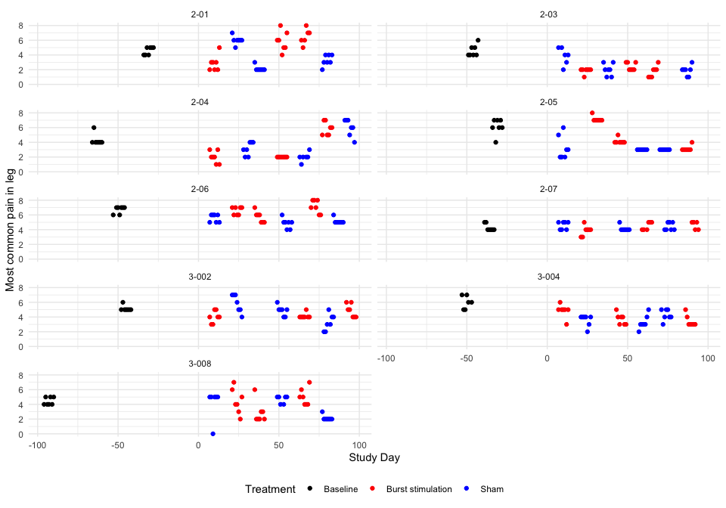

### Descriptive table

| Full analysis set | | | | | | | |
| --- | --- | --- | --- | --- | --- | --- | --- |
| Most common pain in leg | | | | | | | |
|  | **Baseline** | **Pair 1** | | **Pair 2** | | **Pair 3** | |
|  | **Baseline** | **Burst stimulation** | **Sham** | **Burst stimulation** | **Sham** | **Burst stimulation** | **Sham** |
| **2-01** |  |  |  |  |  |  |  |
| n | 7 | 7 | 7 | 7 | 7 | 6 | 7 |
| Mean (sd) | 4.57 (0.53) | 2.86 (1.07) | 6.00 (0.58) | 5.86 (1.35) | 2.14 (0.38) | 6.50 (1.05) | 3.29 (0.76) |
| IQR | 1.00 | 1.00 | 0.00 | 1.50 | 0.00 | 1.00 | 1.00 |
| min - max | 4.00 - 5.00 | 2.00 - 5.00 | 5.00 - 7.00 | 4.00 - 8.00 | 2.00 - 3.00 | 5.00 - 8.00 | 2.00 - 4.00 |
| **2-03** |  |  |  |  |  |  |  |
| n | 7 | 7 | 6 | 7 | 7 | 7 | 7 |
| Mean (sd) | 4.57 (0.79) | 1.86 (0.38) | 3.83 (1.17) | 2.43 (0.53) | 2.00 (0.82) | 1.71 (0.76) | 1.86 (0.69) |
| IQR | 1.00 | 0.00 | 1.50 | 1.00 | 1.00 | 1.00 | 0.50 |
| min - max | 4.00 - 6.00 | 1.00 - 2.00 | 2.00 - 5.00 | 2.00 - 3.00 | 1.00 - 3.00 | 1.00 - 3.00 | 1.00 - 3.00 |
| **2-04** |  |  |  |  |  |  |  |
| n | 7 | 7 | 7 | 7 | 6 | 7 | 7 |
| Mean (sd) | 4.29 (0.76) | 2.00 (0.82) | 3.14 (0.90) | 2.00 (0.00) | 2.00 (0.63) | 5.86 (0.90) | 6.00 (1.15) |
| IQR | 0.00 | 1.00 | 1.50 | 0.00 | 0.00 | 1.50 | 1.50 |
| min - max | 4.00 - 6.00 | 1.00 - 3.00 | 2.00 - 4.00 | 2.00 - 2.00 | 1.00 - 3.00 | 5.00 - 7.00 | 4.00 - 7.00 |
| **2-05** |  |  |  |  |  |  |  |
| n | 7 | 7 | 7 | 7 | 7 | 7 | 7 |
| Mean (sd) | 6.14 (1.07) | 7.14 (0.38) | 3.29 (1.60) | 4.14 (0.38) | 3.00 (0.00) | 3.14 (0.38) | 3.00 (0.00) |
| IQR | 1.00 | 0.00 | 2.00 | 0.00 | 0.00 | 0.00 | 0.00 |
| min - max | 4.00 - 7.00 | 7.00 - 8.00 | 2.00 - 6.00 | 4.00 - 5.00 | 3.00 - 3.00 | 3.00 - 4.00 | 3.00 - 3.00 |
| **2-06** |  |  |  |  |  |  |  |
| n | 7 | 7 | 7 | 7 | 7 | 7 | 7 |
| Mean (sd) | 6.71 (0.49) | 6.57 (0.53) | 5.57 (0.53) | 5.71 (0.76) | 4.86 (0.69) | 7.14 (0.90) | 5.14 (0.38) |
| IQR | 0.50 | 1.00 | 1.00 | 1.00 | 0.50 | 1.50 | 0.00 |
| min - max | 6.00 - 7.00 | 6.00 - 7.00 | 5.00 - 6.00 | 5.00 - 7.00 | 4.00 - 6.00 | 6.00 - 8.00 | 5.00 - 6.00 |
| **2-07** |  |  |  |  |  |  |  |
| n | 7 | 7 | 7 | 6 | 7 | 5 | 7 |
| Mean (sd) | 4.29 (0.49) | 3.86 (0.69) | 4.57 (0.53) | 4.50 (0.55) | 4.14 (0.38) | 4.60 (0.55) | 4.43 (0.53) |
| IQR | 0.50 | 0.50 | 1.00 | 1.00 | 0.00 | 1.00 | 1.00 |
| min - max | 4.00 - 5.00 | 3.00 - 5.00 | 4.00 - 5.00 | 4.00 - 5.00 | 4.00 - 5.00 | 4.00 - 5.00 | 4.00 - 5.00 |
| **3-002** |  |  |  |  |  |  |  |
| n | 7 | 7 | 7 | 7 | 7 | 7 | 7 |
| Mean (sd) | 5.14 (0.38) | 4.00 (0.82) | 5.86 (1.21) | 4.14 (0.38) | 4.86 (0.69) | 4.86 (0.90) | 3.29 (1.11) |
| IQR | 0.00 | 1.00 | 2.00 | 0.00 | 0.50 | 1.50 | 1.50 |
| min - max | 5.00 - 6.00 | 3.00 - 5.00 | 4.00 - 7.00 | 4.00 - 5.00 | 4.00 - 6.00 | 4.00 - 6.00 | 2.00 - 5.00 |
| **3-004** |  |  |  |  |  |  |  |
| n | 6 | 7 | 7 | 7 | 7 | 7 | 7 |
| Mean (sd) | 6.00 (0.89) | 4.86 (0.90) | 3.57 (0.79) | 3.71 (0.76) | 3.29 (0.95) | 3.43 (0.79) | 4.29 (0.76) |
| IQR | 1.50 | 0.00 | 0.50 | 1.00 | 0.50 | 0.50 | 1.00 |
| min - max | 5.00 - 7.00 | 3.00 - 6.00 | 2.00 - 4.00 | 3.00 - 5.00 | 2.00 - 5.00 | 3.00 - 5.00 | 3.00 - 5.00 |
| **3-008** |  |  |  |  |  |  |  |
| n | 7 | 7 | 6 | 7 | 6 | 7 | 7 |
| Mean (sd) | 4.43 (0.53) | 4.43 (1.72) | 4.17 (2.04) | 2.86 (1.46) | 4.67 (0.52) | 5.00 (1.15) | 2.14 (0.38) |
| IQR | 1.00 | 2.00 | 0.00 | 1.00 | 0.75 | 1.50 | 0.00 |
| min - max | 4.00 - 5.00 | 2.00 - 7.00 | 0.00 - 5.00 | 2.00 - 6.00 | 4.00 - 5.00 | 4.00 - 7.00 | 2.00 - 3.00 |

### Hypothesis test

Most common pain in leg

| Subject ID | Difference Pair 1 | Difference Pair 2 | Difference Pair 3 | Overall difference |
| --- | --- | --- | --- | --- |
| 2-01 | -3.143 | 3.714 | 3.214 | 1.262 |
| 2-03 | -1.976 | 0.429 | -0.143 | -0.563 |
| 2-04 | -1.143 | 0.000 | -0.143 | -0.429 |
| 2-05 | 3.857 | 1.143 | 0.143 | 1.714 |
| 2-06 | 1.000 | 0.857 | 2.000 | 1.286 |
| 2-07 | -0.714 | 0.357 | 0.171 | -0.062 |
| 3-002 | -1.857 | -0.714 | 1.571 | -0.333 |
| 3-004 | 1.286 | 0.429 | -0.857 | 0.286 |
| 3-008 | 0.262 | -1.810 | 2.857 | 0.436 |

Values are Burst stimulation - Sham.

P-value of the null hypothesis test: 0.24.

### Treatment effect estimates

QQ-plot

## Warning: For this model type, `marginaleffects` only takes into account the  
## uncertainty in fixed-effect parameters. You can use the `re.form=NA`  
## argument to acknowledge this explicitly and silence this warning.  
## Warning: For this model type, `marginaleffects` only takes into account the  
## uncertainty in fixed-effect parameters. You can use the `re.form=NA`  
## argument to acknowledge this explicitly and silence this warning.  
## Warning: For this model type, `marginaleffects` only takes into account the  
## uncertainty in fixed-effect parameters. You can use the `re.form=NA`  
## argument to acknowledge this explicitly and silence this warning.

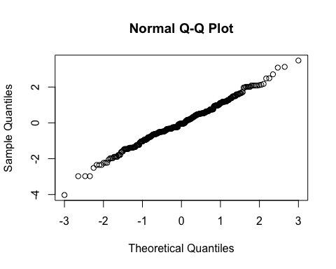

By subject

| Subject ID | Estimate | Std. Err. | p-value | Lower CL | Upper CL |
| --- | --- | --- | --- | --- | --- |
| 2-01 | 1.058 | 0.278 | 0.000 | 0.513 | 1.603 |
| 2-03 | -0.355 | 0.278 | 0.202 | -0.900 | 0.190 |
| 2-04 | -0.290 | 0.278 | 0.296 | -0.836 | 0.255 |
| 2-05 | 1.475 | 0.278 | 0.000 | 0.930 | 2.020 |
| 2-06 | 1.125 | 0.278 | 0.000 | 0.579 | 1.670 |
| 2-07 | 0.004 | 0.278 | 0.989 | -0.541 | 0.549 |
| 3-002 | -0.200 | 0.278 | 0.473 | -0.745 | 0.345 |
| 3-004 | 0.307 | 0.278 | 0.270 | -0.238 | 0.852 |
| 3-008 | 0.484 | 0.278 | 0.082 | -0.061 | 1.029 |

Overall

| Treatment | Estimate | Std. Err. | p-value | Lower CL | Upper CL |
| --- | --- | --- | --- | --- | --- |
| Sham | 3.858 | 0.345 | 0 | 3.181 | 4.534 |
| Burst stimulation | 4.263 | 0.345 | 0 | 3.587 | 4.940 |

| Estimate | Std. Err. | p-value | Lower CL | Upper CL |
| --- | --- | --- | --- | --- |
| 0.406 | 0.278 | 0.145 | -0.139 | 0.951 |

## Secondary outcome: Highest pain intensity in lower extremity (NRS)

### Plot

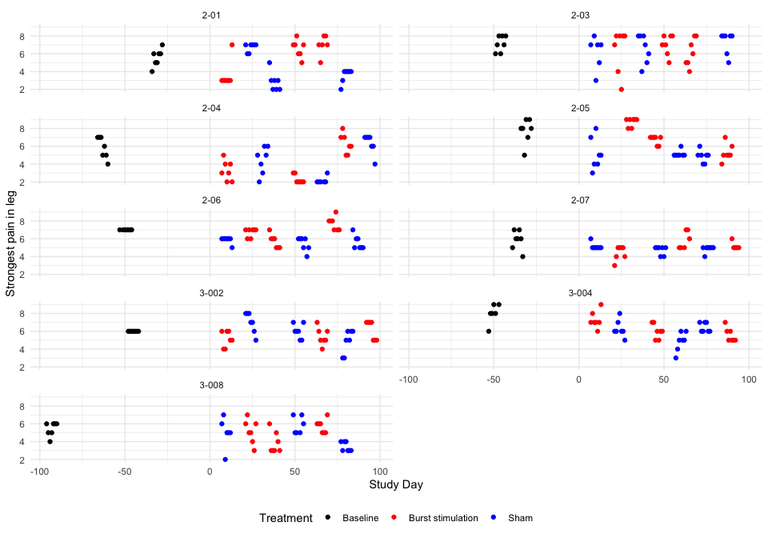

### Descriptive table

| Full analysis set | | | | | | | |
| --- | --- | --- | --- | --- | --- | --- | --- |
| Strongest pain in leg | | | | | | | |
|  | **Baseline** | **Pair 1** | | **Pair 2** | | **Pair 3** | |
|  | **Baseline** | **Burst stimulation** | **Sham** | **Burst stimulation** | **Sham** | **Burst stimulation** | **Sham** |
| **2-01** |  |  |  |  |  |  |  |
| n | 7 | 7 | 7 | 7 | 7 | 6 | 7 |
| Mean (sd) | 5.57 (0.98) | 3.57 (1.51) | 6.71 (0.49) | 6.57 (0.98) | 2.86 (1.07) | 7.00 (1.10) | 3.57 (0.79) |
| IQR | 1.00 | 0.00 | 0.50 | 1.00 | 1.00 | 0.75 | 0.50 |
| min - max | 4.00 - 7.00 | 3.00 - 7.00 | 6.00 - 7.00 | 5.00 - 8.00 | 2.00 - 5.00 | 5.00 - 8.00 | 2.00 - 4.00 |
| **2-03** |  |  |  |  |  |  |  |
| n | 7 | 7 | 6 | 7 | 7 | 7 | 7 |
| Mean (sd) | 7.14 (0.90) | 6.43 (2.44) | 6.17 (1.83) | 7.00 (1.15) | 6.57 (1.62) | 6.14 (1.57) | 7.29 (1.25) |
| IQR | 1.50 | 2.50 | 1.50 | 1.50 | 2.50 | 2.50 | 1.00 |
| min - max | 6.00 - 8.00 | 2.00 - 8.00 | 3.00 - 8.00 | 5.00 - 8.00 | 4.00 - 8.00 | 4.00 - 8.00 | 5.00 - 8.00 |
| **2-04** |  |  |  |  |  |  |  |
| n | 7 | 7 | 7 | 7 | 6 | 7 | 7 |
| Mean (sd) | 5.86 (1.21) | 3.29 (1.11) | 4.43 (1.51) | 2.29 (0.49) | 2.17 (0.41) | 6.29 (1.11) | 6.29 (1.11) |
| IQR | 2.00 | 1.50 | 2.00 | 0.50 | 0.00 | 1.50 | 1.00 |
| min - max | 4.00 - 7.00 | 2.00 - 5.00 | 2.00 - 6.00 | 2.00 - 3.00 | 2.00 - 3.00 | 5.00 - 8.00 | 4.00 - 7.00 |
| **2-05** |  |  |  |  |  |  |  |
| n | 7 | 7 | 7 | 7 | 7 | 7 | 7 |
| Mean (sd) | 7.71 (1.38) | 8.71 (0.49) | 5.14 (1.77) | 6.71 (0.49) | 5.14 (0.38) | 5.29 (0.95) | 4.86 (0.69) |
| IQR | 1.00 | 0.50 | 2.00 | 0.50 | 0.00 | 0.50 | 0.50 |
| min - max | 5.00 - 9.00 | 8.00 - 9.00 | 3.00 - 8.00 | 6.00 - 7.00 | 5.00 - 6.00 | 4.00 - 7.00 | 4.00 - 6.00 |
| **2-06** |  |  |  |  |  |  |  |
| n | 7 | 7 | 7 | 7 | 7 | 7 | 7 |
| Mean (sd) | 7.00 (0.00) | 6.71 (0.49) | 5.86 (0.38) | 5.71 (0.76) | 5.43 (0.79) | 7.71 (0.76) | 5.57 (0.79) |
| IQR | 0.00 | 0.50 | 0.00 | 1.00 | 1.00 | 1.00 | 1.00 |
| min - max | 7.00 - 7.00 | 6.00 - 7.00 | 5.00 - 6.00 | 5.00 - 7.00 | 4.00 - 6.00 | 7.00 - 9.00 | 5.00 - 7.00 |
| **2-07** |  |  |  |  |  |  |  |
| n | 7 | 7 | 7 | 6 | 7 | 5 | 7 |
| Mean (sd) | 5.86 (1.07) | 4.43 (0.79) | 5.14 (0.38) | 5.83 (0.98) | 4.71 (0.49) | 5.20 (0.45) | 4.86 (0.38) |
| IQR | 1.00 | 1.00 | 0.00 | 1.75 | 0.50 | 0.00 | 0.00 |
| min - max | 4.00 - 7.00 | 3.00 - 5.00 | 5.00 - 6.00 | 5.00 - 7.00 | 4.00 - 5.00 | 5.00 - 6.00 | 4.00 - 5.00 |
| **3-002** |  |  |  |  |  |  |  |
| n | 7 | 7 | 7 | 7 | 7 | 7 | 7 |
| Mean (sd) | 6.00 (0.00) | 5.14 (0.90) | 7.00 (1.15) | 5.43 (0.98) | 6.00 (0.82) | 6.14 (1.07) | 4.86 (1.35) |
| IQR | 0.00 | 1.50 | 1.50 | 1.00 | 1.00 | 2.00 | 2.00 |
| min - max | 6.00 - 6.00 | 4.00 - 6.00 | 5.00 - 8.00 | 4.00 - 7.00 | 5.00 - 7.00 | 5.00 - 7.00 | 3.00 - 6.00 |
| **3-004** |  |  |  |  |  |  |  |
| n | 6 | 7 | 7 | 7 | 7 | 7 | 7 |
| Mean (sd) | 8.00 (1.10) | 7.29 (0.95) | 6.29 (0.95) | 6.00 (0.82) | 4.86 (1.07) | 5.57 (0.79) | 6.43 (0.53) |
| IQR | 0.75 | 0.50 | 0.50 | 1.00 | 1.00 | 1.00 | 1.00 |
| min - max | 6.00 - 9.00 | 6.00 - 9.00 | 5.00 - 8.00 | 5.00 - 7.00 | 3.00 - 6.00 | 5.00 - 7.00 | 6.00 - 7.00 |
| **3-008** |  |  |  |  |  |  |  |
| n | 7 | 7 | 6 | 7 | 6 | 7 | 7 |
| Mean (sd) | 5.43 (0.79) | 5.14 (1.35) | 5.00 (1.67) | 3.86 (1.21) | 5.83 (0.98) | 5.71 (0.76) | 3.43 (0.53) |
| IQR | 1.00 | 1.50 | 0.75 | 1.50 | 1.75 | 1.00 | 1.00 |
| min - max | 4.00 - 6.00 | 3.00 - 7.00 | 2.00 - 7.00 | 3.00 - 6.00 | 5.00 - 7.00 | 5.00 - 7.00 | 3.00 - 4.00 |

### Hypothesis test

Strongest pain in leg

| Subject ID | Difference Pair 1 | Difference Pair 2 | Difference Pair 3 | Overall difference |
| --- | --- | --- | --- | --- |
| 2-01 | -3.143 | 3.714 | 3.429 | 1.333 |
| 2-03 | 0.262 | 0.429 | -1.143 | -0.151 |
| 2-04 | -1.143 | 0.119 | 0.000 | -0.341 |
| 2-05 | 3.571 | 1.571 | 0.429 | 1.857 |
| 2-06 | 0.857 | 0.286 | 2.143 | 1.095 |
| 2-07 | -0.714 | 1.119 | 0.343 | 0.249 |
| 3-002 | -1.857 | -0.571 | 1.286 | -0.381 |
| 3-004 | 1.000 | 1.143 | -0.857 | 0.429 |
| 3-008 | 0.143 | -1.976 | 2.286 | 0.151 |

Values are Burst stimulation - Sham.

P-value of the null hypothesis test: 0.15.

### Treatment effect estimates

QQ-plot

## Warning: For this model type, `marginaleffects` only takes into account the  
## uncertainty in fixed-effect parameters. You can use the `re.form=NA`  
## argument to acknowledge this explicitly and silence this warning.  
## Warning: For this model type, `marginaleffects` only takes into account the  
## uncertainty in fixed-effect parameters. You can use the `re.form=NA`  
## argument to acknowledge this explicitly and silence this warning.  
## Warning: For this model type, `marginaleffects` only takes into account the  
## uncertainty in fixed-effect parameters. You can use the `re.form=NA`  
## argument to acknowledge this explicitly and silence this warning.

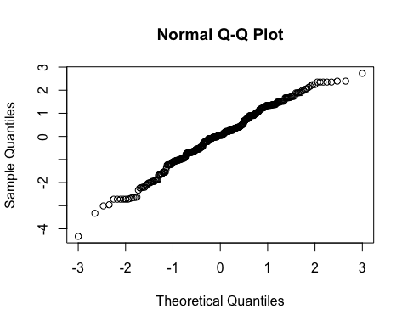

By subject

| Subject ID | Estimate | Std. Err. | p-value | Lower CL | Upper CL |
| --- | --- | --- | --- | --- | --- |
| 2-01 | 1.070 | 0.263 | 0.000 | 0.555 | 1.585 |
| 2-03 | -0.001 | 0.263 | 0.997 | -0.516 | 0.514 |
| 2-04 | -0.157 | 0.263 | 0.551 | -0.671 | 0.358 |
| 2-05 | 1.506 | 0.263 | 0.000 | 0.991 | 2.021 |
| 2-06 | 0.936 | 0.263 | 0.000 | 0.421 | 1.451 |
| 2-07 | 0.287 | 0.263 | 0.274 | -0.227 | 0.802 |
| 3-002 | -0.167 | 0.263 | 0.524 | -0.682 | 0.347 |
| 3-004 | 0.438 | 0.263 | 0.096 | -0.077 | 0.953 |
| 3-008 | 0.275 | 0.263 | 0.295 | -0.240 | 0.790 |

By treatment and Overall

| Treatment | Estimate | Std. Err. | p-value | Lower CL | Upper CL |
| --- | --- | --- | --- | --- | --- |
| Sham | 5.284 | 0.297 | 0 | 4.701 | 5.866 |
| Burst stimulation | 5.753 | 0.297 | 0 | 5.170 | 6.335 |

| Estimate | Std. Err. | p-value | Lower CL | Upper CL |
| --- | --- | --- | --- | --- |
| 0.469 | 0.263 | 0.074 | -0.046 | 0.984 |

## Secondary outcome: Lowest pain intensity in lower extremity (NRS)

### Plot

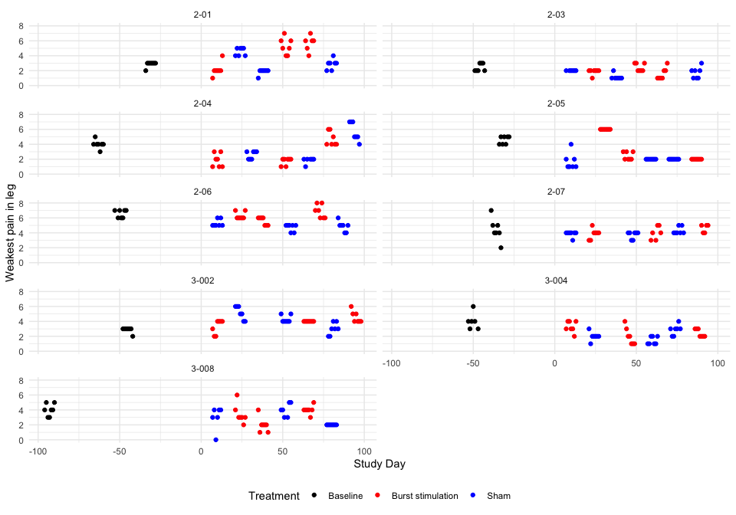

### Descriptive table

| Full analysis set | | | | | | | |
| --- | --- | --- | --- | --- | --- | --- | --- |
| Weakest pain in leg | | | | | | | |
|  | **Baseline** | **Pair 1** | | **Pair 2** | | **Pair 3** | |
|  | **Baseline** | **Burst stimulation** | **Sham** | **Burst stimulation** | **Sham** | **Burst stimulation** | **Sham** |
| **2-01** |  |  |  |  |  |  |  |
| n | 7 | 7 | 7 | 7 | 7 | 6 | 7 |
| Mean (sd) | 2.86 (0.38) | 2.14 (0.90) | 4.57 (0.53) | 5.29 (1.11) | 1.86 (0.38) | 5.67 (1.03) | 2.86 (0.69) |
| IQR | 0.00 | 0.00 | 1.00 | 1.50 | 0.00 | 0.75 | 0.50 |
| min - max | 2.00 - 3.00 | 1.00 - 4.00 | 4.00 - 5.00 | 4.00 - 7.00 | 1.00 - 2.00 | 4.00 - 7.00 | 2.00 - 4.00 |
| **2-03** |  |  |  |  |  |  |  |
| n | 7 | 7 | 6 | 7 | 7 | 7 | 7 |
| Mean (sd) | 2.43 (0.53) | 1.86 (0.38) | 2.00 (0.00) | 2.43 (0.53) | 1.14 (0.38) | 1.57 (0.79) | 1.71 (0.76) |
| IQR | 1.00 | 0.00 | 0.00 | 1.00 | 0.00 | 1.00 | 1.00 |
| min - max | 2.00 - 3.00 | 1.00 - 2.00 | 2.00 - 2.00 | 2.00 - 3.00 | 1.00 - 2.00 | 1.00 - 3.00 | 1.00 - 3.00 |
| **2-04** |  |  |  |  |  |  |  |
| n | 7 | 7 | 7 | 7 | 6 | 7 | 7 |
| Mean (sd) | 4.00 (0.58) | 1.86 (0.90) | 2.57 (0.53) | 1.71 (0.49) | 1.83 (0.41) | 4.71 (0.95) | 5.71 (1.25) |
| IQR | 0.00 | 1.50 | 1.00 | 0.50 | 0.00 | 1.50 | 2.00 |
| min - max | 3.00 - 5.00 | 1.00 - 3.00 | 2.00 - 3.00 | 1.00 - 2.00 | 1.00 - 2.00 | 4.00 - 6.00 | 4.00 - 7.00 |
| **2-05** |  |  |  |  |  |  |  |
| n | 7 | 7 | 7 | 7 | 7 | 7 | 7 |
| Mean (sd) | 4.57 (0.53) | 6.00 (0.00) | 1.71 (1.11) | 2.43 (0.53) | 2.00 (0.00) | 2.00 (0.00) | 2.00 (0.00) |
| IQR | 1.00 | 0.00 | 1.00 | 1.00 | 0.00 | 0.00 | 0.00 |
| min - max | 4.00 - 5.00 | 6.00 - 6.00 | 1.00 - 4.00 | 2.00 - 3.00 | 2.00 - 2.00 | 2.00 - 2.00 | 2.00 - 2.00 |
| **2-06** |  |  |  |  |  |  |  |
| n | 7 | 7 | 7 | 7 | 7 | 7 | 7 |
| Mean (sd) | 6.57 (0.53) | 6.29 (0.49) | 5.29 (0.49) | 5.57 (0.53) | 4.71 (0.49) | 6.86 (0.90) | 4.86 (0.69) |
| IQR | 1.00 | 0.50 | 0.50 | 1.00 | 0.50 | 1.50 | 0.50 |
| min - max | 6.00 - 7.00 | 6.00 - 7.00 | 5.00 - 6.00 | 5.00 - 6.00 | 4.00 - 5.00 | 6.00 - 8.00 | 4.00 - 6.00 |
| **2-07** |  |  |  |  |  |  |  |
| n | 7 | 7 | 7 | 6 | 7 | 5 | 7 |
| Mean (sd) | 4.43 (1.51) | 3.86 (0.69) | 3.86 (0.38) | 4.00 (0.89) | 3.71 (0.49) | 4.60 (0.55) | 4.29 (0.49) |
| IQR | 1.00 | 0.50 | 0.00 | 1.50 | 0.50 | 1.00 | 0.50 |
| min - max | 2.00 - 7.00 | 3.00 - 5.00 | 3.00 - 4.00 | 3.00 - 5.00 | 3.00 - 4.00 | 4.00 - 5.00 | 4.00 - 5.00 |
| **3-002** |  |  |  |  |  |  |  |
| n | 7 | 7 | 7 | 7 | 7 | 7 | 7 |
| Mean (sd) | 2.86 (0.38) | 3.29 (0.95) | 5.14 (0.90) | 4.00 (0.00) | 4.29 (0.49) | 4.57 (0.79) | 3.00 (0.82) |
| IQR | 0.00 | 1.50 | 1.50 | 0.00 | 0.50 | 1.00 | 1.00 |
| min - max | 2.00 - 3.00 | 2.00 - 4.00 | 4.00 - 6.00 | 4.00 - 4.00 | 4.00 - 5.00 | 4.00 - 6.00 | 2.00 - 4.00 |
| **3-004** |  |  |  |  |  |  |  |
| n | 6 | 7 | 7 | 7 | 7 | 7 | 7 |
| Mean (sd) | 4.00 (1.10) | 3.29 (0.76) | 2.00 (0.58) | 2.00 (1.15) | 1.43 (0.53) | 2.43 (0.53) | 2.86 (0.69) |
| IQR | 0.75 | 1.00 | 0.00 | 1.50 | 1.00 | 1.00 | 0.50 |
| min - max | 3.00 - 6.00 | 2.00 - 4.00 | 1.00 - 3.00 | 1.00 - 4.00 | 1.00 - 2.00 | 2.00 - 3.00 | 2.00 - 4.00 |
| **3-008** |  |  |  |  |  |  |  |
| n | 7 | 7 | 6 | 7 | 6 | 7 | 7 |
| Mean (sd) | 4.00 (0.82) | 3.43 (1.27) | 3.00 (1.55) | 2.00 (1.00) | 4.00 (0.89) | 4.00 (0.58) | 2.00 (0.00) |
| IQR | 1.00 | 0.50 | 1.00 | 0.50 | 1.50 | 0.00 | 0.00 |
| min - max | 3.00 - 5.00 | 2.00 - 6.00 | 0.00 - 4.00 | 1.00 - 4.00 | 3.00 - 5.00 | 3.00 - 5.00 | 2.00 - 2.00 |

### Hypothesis test

Weakest pain in leg

| Subject ID | Difference Pair 1 | Difference Pair 2 | Difference Pair 3 | Overall difference |
| --- | --- | --- | --- | --- |
| 2-01 | -2.429 | 3.429 | 2.810 | 1.270 |
| 2-03 | -0.143 | 1.286 | -0.143 | 0.333 |
| 2-04 | -0.714 | -0.119 | -1.000 | -0.611 |
| 2-05 | 4.286 | 0.429 | 0.000 | 1.572 |
| 2-06 | 1.000 | 0.857 | 2.000 | 1.286 |
| 2-07 | 0.000 | 0.286 | 0.314 | 0.200 |
| 3-002 | -1.857 | -0.286 | 1.571 | -0.191 |
| 3-004 | 1.286 | 0.571 | -0.429 | 0.476 |
| 3-008 | 0.429 | -2.000 | 2.000 | 0.143 |

Values are Burst stimulation - Sham.

P-value of the null hypothesis test: 0.11.

### Treatment effect estimates

QQ-plot

## Warning: For this model type, `marginaleffects` only takes into account the  
## uncertainty in fixed-effect parameters. You can use the `re.form=NA`  
## argument to acknowledge this explicitly and silence this warning.  
## Warning: For this model type, `marginaleffects` only takes into account the  
## uncertainty in fixed-effect parameters. You can use the `re.form=NA`  
## argument to acknowledge this explicitly and silence this warning.  
## Warning: For this model type, `marginaleffects` only takes into account the  
## uncertainty in fixed-effect parameters. You can use the `re.form=NA`  
## argument to acknowledge this explicitly and silence this warning.

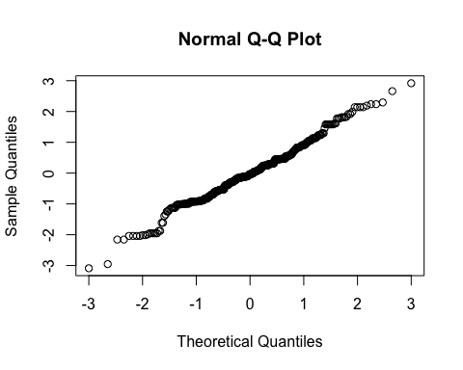

By subject

| Subject ID | Estimate | Std. Err. | p-value | Lower CL | Upper CL |
| --- | --- | --- | --- | --- | --- |
| 2-01 | 1.093 | 0.244 | 0.000 | 0.615 | 1.571 |
| 2-03 | 0.373 | 0.244 | 0.126 | -0.105 | 0.851 |
| 2-04 | -0.423 | 0.244 | 0.083 | -0.901 | 0.055 |
| 2-05 | 1.377 | 0.244 | 0.000 | 0.899 | 1.855 |
| 2-06 | 1.143 | 0.244 | 0.000 | 0.665 | 1.621 |
| 2-07 | 0.246 | 0.244 | 0.313 | -0.232 | 0.724 |
| 3-002 | -0.066 | 0.244 | 0.786 | -0.544 | 0.412 |
| 3-004 | 0.480 | 0.244 | 0.049 | 0.002 | 0.958 |
| 3-008 | 0.252 | 0.244 | 0.302 | -0.226 | 0.730 |

By treatment and overall

| Treatment | Estimate | Std. Err. | p-value | Lower CL | Upper CL |
| --- | --- | --- | --- | --- | --- |
| Sham | 3.119 | 0.397 | 0 | 2.341 | 3.896 |
| Burst stimulation | 3.620 | 0.397 | 0 | 2.843 | 4.398 |

| Estimate | Std. Err. | p-value | Lower CL | Upper CL |
| --- | --- | --- | --- | --- |
| 0.502 | 0.244 | 0.04 | 0.024 | 0.98 |

## Secondary outcome: Current pain intensity in lower extremity (NRS)

### Plot

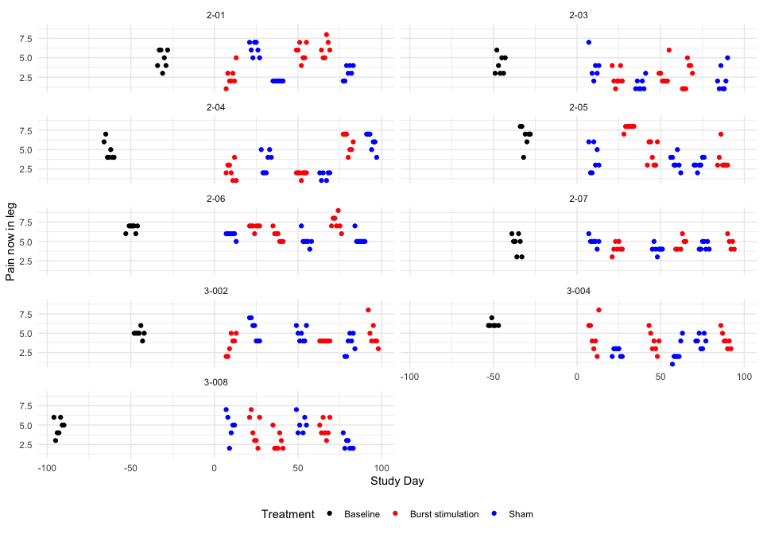

### Descriptive table

| Full analysis set | | | | | | | |
| --- | --- | --- | --- | --- | --- | --- | --- |
| Pain now in leg | | | | | | | |
|  | **Baseline** | **Pair 1** | | **Pair 2** | | **Pair 3** | |
|  | **Baseline** | **Burst stimulation** | **Sham** | **Burst stimulation** | **Sham** | **Burst stimulation** | **Sham** |
| **2-01** |  |  |  |  |  |  |  |
| n | 7 | 7 | 7 | 7 | 7 | 6 | 7 |
| Mean (sd) | 4.86 (1.21) | 2.57 (1.27) | 6.14 (0.90) | 5.71 (1.11) | 2.00 (0.00) | 6.17 (1.17) | 3.14 (0.90) |
| IQR | 2.00 | 1.00 | 1.50 | 1.50 | 0.00 | 1.50 | 1.50 |
| min - max | 3.00 - 6.00 | 1.00 - 5.00 | 5.00 - 7.00 | 4.00 - 7.00 | 2.00 - 2.00 | 5.00 - 8.00 | 2.00 - 4.00 |
| **2-03** |  |  |  |  |  |  |  |
| n | 7 | 7 | 6 | 7 | 7 | 7 | 7 |
| Mean (sd) | 4.14 (1.21) | 2.43 (1.13) | 3.83 (1.72) | 2.86 (1.46) | 1.57 (0.79) | 2.71 (1.70) | 2.29 (1.60) |
| IQR | 2.00 | 1.00 | 1.00 | 1.00 | 1.00 | 3.00 | 2.00 |
| min - max | 3.00 - 6.00 | 1.00 - 4.00 | 2.00 - 7.00 | 2.00 - 6.00 | 1.00 - 3.00 | 1.00 - 5.00 | 1.00 - 5.00 |
| **2-04** |  |  |  |  |  |  |  |
| n | 7 | 7 | 7 | 7 | 6 | 7 | 7 |
| Mean (sd) | 4.86 (1.21) | 2.29 (1.11) | 3.43 (1.40) | 1.86 (0.38) | 1.67 (0.52) | 5.86 (1.21) | 6.00 (1.15) |
| IQR | 1.50 | 1.50 | 2.50 | 0.00 | 0.75 | 2.00 | 1.50 |
| min - max | 4.00 - 7.00 | 1.00 - 4.00 | 2.00 - 5.00 | 1.00 - 2.00 | 1.00 - 2.00 | 4.00 - 7.00 | 4.00 - 7.00 |
| **2-05** |  |  |  |  |  |  |  |
| n | 7 | 7 | 7 | 7 | 7 | 7 | 7 |
| Mean (sd) | 6.71 (1.38) | 7.86 (0.38) | 3.86 (1.77) | 4.43 (1.51) | 3.43 (0.98) | 3.71 (1.50) | 3.14 (0.69) |
| IQR | 1.00 | 0.00 | 3.00 | 3.00 | 1.00 | 0.50 | 0.50 |
| min - max | 4.00 - 8.00 | 7.00 - 8.00 | 2.00 - 6.00 | 3.00 - 6.00 | 2.00 - 5.00 | 3.00 - 7.00 | 2.00 - 4.00 |
| **2-06** |  |  |  |  |  |  |  |
| n | 7 | 7 | 7 | 7 | 7 | 7 | 7 |
| Mean (sd) | 6.71 (0.49) | 6.86 (0.38) | 5.86 (0.38) | 5.71 (0.76) | 5.14 (0.90) | 7.43 (0.98) | 5.29 (0.76) |
| IQR | 0.50 | 0.00 | 0.00 | 1.00 | 0.00 | 1.00 | 0.00 |
| min - max | 6.00 - 7.00 | 6.00 - 7.00 | 5.00 - 6.00 | 5.00 - 7.00 | 4.00 - 7.00 | 6.00 - 9.00 | 5.00 - 7.00 |
| **2-07** |  |  |  |  |  |  |  |
| n | 7 | 7 | 7 | 6 | 7 | 5 | 7 |
| Mean (sd) | 4.71 (1.25) | 4.14 (0.69) | 5.00 (0.58) | 4.67 (0.82) | 4.00 (0.58) | 4.80 (0.84) | 4.43 (0.53) |
| IQR | 1.50 | 0.50 | 0.00 | 1.00 | 0.00 | 1.00 | 1.00 |
| min - max | 3.00 - 6.00 | 3.00 - 5.00 | 4.00 - 6.00 | 4.00 - 6.00 | 3.00 - 5.00 | 4.00 - 6.00 | 4.00 - 5.00 |
| **3-002** |  |  |  |  |  |  |  |
| n | 7 | 7 | 7 | 7 | 7 | 7 | 7 |
| Mean (sd) | 5.00 (0.58) | 3.57 (1.27) | 5.43 (1.40) | 4.00 (0.00) | 4.86 (0.90) | 4.86 (1.68) | 3.57 (1.27) |
| IQR | 0.00 | 2.00 | 2.50 | 0.00 | 1.50 | 1.50 | 2.00 |
| min - max | 4.00 - 6.00 | 2.00 - 5.00 | 4.00 - 7.00 | 4.00 - 4.00 | 4.00 - 6.00 | 3.00 - 8.00 | 2.00 - 5.00 |
| **3-004** |  |  |  |  |  |  |  |
| n | 6 | 7 | 7 | 7 | 7 | 7 | 7 |
| Mean (sd) | 6.17 (0.41) | 4.71 (2.06) | 2.57 (0.53) | 3.86 (1.35) | 2.57 (1.40) | 4.14 (1.07) | 4.00 (0.82) |
| IQR | 0.00 | 2.50 | 1.00 | 1.50 | 1.00 | 1.00 | 1.00 |
| min - max | 6.00 - 7.00 | 2.00 - 8.00 | 2.00 - 3.00 | 2.00 - 6.00 | 1.00 - 5.00 | 3.00 - 6.00 | 3.00 - 5.00 |
| **3-008** |  |  |  |  |  |  |  |
| n | 7 | 7 | 6 | 7 | 6 | 7 | 7 |
| Mean (sd) | 4.71 (1.11) | 4.43 (1.90) | 4.83 (1.72) | 2.86 (1.21) | 5.17 (1.17) | 4.57 (1.13) | 2.57 (0.79) |
| IQR | 1.50 | 3.00 | 1.50 | 1.50 | 1.50 | 1.50 | 1.00 |
| min - max | 3.00 - 6.00 | 2.00 - 7.00 | 2.00 - 7.00 | 2.00 - 5.00 | 4.00 - 7.00 | 3.00 - 6.00 | 2.00 - 4.00 |

### Hypothesis test

Pain now in leg

| Subject ID | Difference Pair 1 | Difference Pair 2 | Difference Pair 3 | Overall difference |
| --- | --- | --- | --- | --- |
| 2-01 | -3.571 | 3.714 | 3.024 | 1.056 |
| 2-03 | -1.405 | 1.286 | 0.429 | 0.103 |
| 2-04 | -1.143 | 0.190 | -0.143 | -0.365 |
| 2-05 | 4.000 | 1.000 | 0.571 | 1.857 |
| 2-06 | 1.000 | 0.571 | 2.143 | 1.238 |
| 2-07 | -0.857 | 0.667 | 0.371 | 0.060 |
| 3-002 | -1.857 | -0.857 | 1.286 | -0.476 |
| 3-004 | 2.143 | 1.286 | 0.143 | 1.191 |
| 3-008 | -0.405 | -2.310 | 2.000 | -0.238 |

Values are Burst stimulation - Sham.

P-value of the null hypothesis test: 0.16.

### Treatment effect estimates

QQ-plot

## Warning: For this model type, `marginaleffects` only takes into account the  
## uncertainty in fixed-effect parameters. You can use the `re.form=NA`  
## argument to acknowledge this explicitly and silence this warning.  
## Warning: For this model type, `marginaleffects` only takes into account the  
## uncertainty in fixed-effect parameters. You can use the `re.form=NA`  
## argument to acknowledge this explicitly and silence this warning.  
## Warning: For this model type, `marginaleffects` only takes into account the  
## uncertainty in fixed-effect parameters. You can use the `re.form=NA`  
## argument to acknowledge this explicitly and silence this warning.

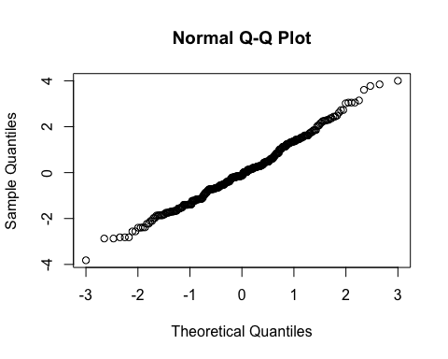

By subject

| Subject ID | Estimate | Std. Err. | p-value | Lower CL | Upper CL |
| --- | --- | --- | --- | --- | --- |
| 2-01 | 0.871 | 0.282 | 0.002 | 0.319 | 1.423 |
| 2-03 | 0.231 | 0.282 | 0.412 | -0.321 | 0.783 |
| 2-04 | -0.165 | 0.282 | 0.557 | -0.717 | 0.386 |
| 2-05 | 1.513 | 0.282 | 0.000 | 0.961 | 2.064 |
| 2-06 | 1.050 | 0.282 | 0.000 | 0.498 | 1.602 |
| 2-07 | 0.148 | 0.282 | 0.600 | -0.404 | 0.699 |
| 3-002 | -0.232 | 0.282 | 0.411 | -0.783 | 0.320 |
| 3-004 | 1.014 | 0.282 | 0.000 | 0.462 | 1.566 |
| 3-008 | 0.003 | 0.282 | 0.992 | -0.549 | 0.555 |

By treatment and overall

| Treatment | Estimate | Std. Err. | p-value | Lower CL | Upper CL |
| --- | --- | --- | --- | --- | --- |
| Sham | 3.909 | 0.341 | 0 | 3.241 | 4.577 |
| Burst stimulation | 4.408 | 0.341 | 0 | 3.740 | 5.076 |

| Estimate | Std. Err. | p-value | Lower CL | Upper CL |
| --- | --- | --- | --- | --- |
| 0.499 | 0.282 | 0.076 | -0.053 | 1.051 |

## Secondary outcome: Usual pain intensity in the back (NRS)

### Plot

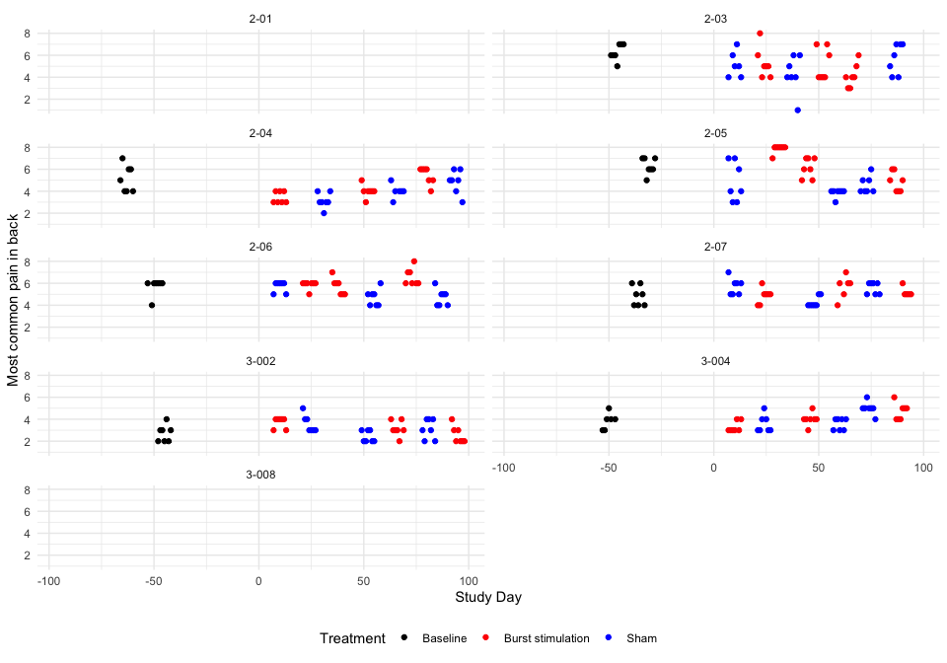

### Descriptive table

| Full analysis set | | | | | | | |
| --- | --- | --- | --- | --- | --- | --- | --- |
| Most common pain in back | | | | | | | |
|  | **Baseline** | **Pair 1** | | **Pair 2** | | **Pair 3** | |
|  | **Baseline** | **Burst stimulation** | **Sham** | **Burst stimulation** | **Sham** | **Burst stimulation** | **Sham** |
| **2-01** |  |  |  |  |  |  |  |
| n | 0 | 0 | 0 | 0 | 0 | 0 | 0 |
| Mean (sd) | NA | NA | NA | NA | NA | NA | NA |
| IQR | NA | NA | NA | NA | NA | NA | NA |
| min - max | Inf - -Inf | Inf - -Inf | Inf - -Inf | Inf - -Inf | Inf - -Inf | Inf - -Inf | Inf - -Inf |
| **2-03** |  |  |  |  |  |  |  |
| n | 7 | 7 | 6 | 7 | 7 | 7 | 7 |
| Mean (sd) | 6.29 (0.76) | 5.29 (1.38) | 5.17 (1.17) | 5.14 (1.46) | 4.29 (1.70) | 4.14 (1.07) | 5.71 (1.38) |
| IQR | 1.00 | 1.00 | 1.50 | 2.50 | 1.50 | 1.00 | 2.50 |
| min - max | 5.00 - 7.00 | 4.00 - 8.00 | 4.00 - 7.00 | 4.00 - 7.00 | 1.00 - 6.00 | 3.00 - 6.00 | 4.00 - 7.00 |
| **2-04** |  |  |  |  |  |  |  |
| n | 7 | 7 | 7 | 7 | 6 | 7 | 7 |
| Mean (sd) | 5.14 (1.21) | 3.43 (0.53) | 3.14 (0.69) | 4.00 (0.58) | 4.00 (0.63) | 5.43 (0.79) | 4.86 (1.07) |
| IQR | 2.00 | 1.00 | 0.50 | 0.00 | 0.00 | 1.00 | 1.00 |
| min - max | 4.00 - 7.00 | 3.00 - 4.00 | 2.00 - 4.00 | 3.00 - 5.00 | 3.00 - 5.00 | 4.00 - 6.00 | 3.00 - 6.00 |
| **2-05** |  |  |  |  |  |  |  |
| n | 7 | 7 | 7 | 7 | 7 | 7 | 7 |
| Mean (sd) | 6.29 (0.76) | 7.86 (0.38) | 4.86 (1.77) | 6.14 (0.90) | 3.86 (0.38) | 4.86 (0.90) | 4.57 (0.79) |
| IQR | 1.00 | 0.00 | 3.00 | 1.50 | 0.00 | 1.50 | 1.00 |
| min - max | 5.00 - 7.00 | 7.00 - 8.00 | 3.00 - 7.00 | 5.00 - 7.00 | 3.00 - 4.00 | 4.00 - 6.00 | 4.00 - 6.00 |
| **2-06** |  |  |  |  |  |  |  |
| n | 7 | 7 | 7 | 7 | 7 | 7 | 7 |
| Mean (sd) | 5.71 (0.76) | 5.86 (0.38) | 5.71 (0.49) | 5.71 (0.76) | 4.71 (0.76) | 6.57 (0.79) | 4.71 (0.76) |
| IQR | 0.00 | 0.00 | 0.50 | 1.00 | 1.00 | 1.00 | 1.00 |
| min - max | 4.00 - 6.00 | 5.00 - 6.00 | 5.00 - 6.00 | 5.00 - 7.00 | 4.00 - 6.00 | 6.00 - 8.00 | 4.00 - 6.00 |
| **2-07** |  |  |  |  |  |  |  |
| n | 7 | 7 | 7 | 6 | 7 | 5 | 7 |
| Mean (sd) | 4.86 (0.90) | 4.86 (0.69) | 5.71 (0.76) | 5.67 (1.03) | 4.29 (0.49) | 5.20 (0.45) | 5.57 (0.53) |
| IQR | 1.50 | 0.50 | 1.00 | 0.75 | 0.50 | 0.00 | 1.00 |
| min - max | 4.00 - 6.00 | 4.00 - 6.00 | 5.00 - 7.00 | 4.00 - 7.00 | 4.00 - 5.00 | 5.00 - 6.00 | 5.00 - 6.00 |
| **3-002** |  |  |  |  |  |  |  |
| n | 7 | 7 | 7 | 7 | 7 | 7 | 7 |
| Mean (sd) | 2.71 (0.76) | 3.71 (0.49) | 3.57 (0.79) | 3.14 (0.69) | 2.43 (0.53) | 2.57 (0.79) | 3.14 (0.90) |
| IQR | 1.00 | 0.50 | 1.00 | 0.50 | 1.00 | 1.00 | 1.50 |
| min - max | 2.00 - 4.00 | 3.00 - 4.00 | 3.00 - 5.00 | 2.00 - 4.00 | 2.00 - 3.00 | 2.00 - 4.00 | 2.00 - 4.00 |
| **3-004** |  |  |  |  |  |  |  |
| n | 6 | 7 | 7 | 7 | 7 | 7 | 7 |
| Mean (sd) | 3.83 (0.75) | 3.29 (0.49) | 3.57 (0.79) | 4.00 (0.58) | 3.57 (0.53) | 4.71 (0.76) | 5.00 (0.58) |
| IQR | 0.75 | 0.50 | 1.00 | 0.00 | 1.00 | 1.00 | 0.00 |
| min - max | 3.00 - 5.00 | 3.00 - 4.00 | 3.00 - 5.00 | 3.00 - 5.00 | 3.00 - 4.00 | 4.00 - 6.00 | 4.00 - 6.00 |
| **3-008** |  |  |  |  |  |  |  |
| n | 0 | 0 | 0 | 0 | 0 | 0 | 0 |
| Mean (sd) | NA | NA | NA | NA | NA | NA | NA |
| IQR | NA | NA | NA | NA | NA | NA | NA |
| min - max | Inf - -Inf | Inf - -Inf | Inf - -Inf | Inf - -Inf | Inf - -Inf | Inf - -Inf | Inf - -Inf |

### Hypothesis test

Most common pain in back

| Subject ID | Difference Pair 1 | Difference Pair 2 | Difference Pair 3 | Overall difference |
| --- | --- | --- | --- | --- |
| 2-01 | NaN | NaN | NaN | NaN |
| 2-03 | 0.119 | 0.857 | -1.571 | -0.198 |
| 2-04 | 0.286 | 0.000 | 0.571 | 0.286 |
| 2-05 | 3.000 | 2.286 | 0.286 | 1.857 |
| 2-06 | 0.143 | 1.000 | 1.857 | 1.000 |
| 2-07 | -0.857 | 1.381 | -0.371 | 0.051 |
| 3-002 | 0.143 | 0.714 | -0.571 | 0.095 |
| 3-004 | -0.286 | 0.429 | -0.286 | -0.048 |
| 3-008 | NaN | NaN | NaN | NaN |

Values are Burst stimulation - Sham.

P-value of the null hypothesis test: 0.075.

### Treatment effect estimates

QQ-plot

## Warning: For this model type, `marginaleffects` only takes into account the  
## uncertainty in fixed-effect parameters. You can use the `re.form=NA`  
## argument to acknowledge this explicitly and silence this warning.  
## Warning: For this model type, `marginaleffects` only takes into account the  
## uncertainty in fixed-effect parameters. You can use the `re.form=NA`  
## argument to acknowledge this explicitly and silence this warning.  
## Warning: For this model type, `marginaleffects` only takes into account the  
## uncertainty in fixed-effect parameters. You can use the `re.form=NA`  
## argument to acknowledge this explicitly and silence this warning.

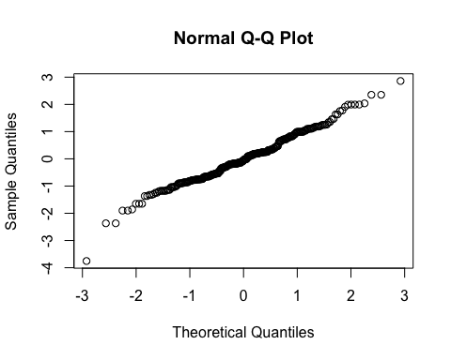

By subject

| Subject ID | Estimate | Std. Err. | p-value | Lower CL | Upper CL |
| --- | --- | --- | --- | --- | --- |
| 2-03 | -0.105 | 0.28 | 0.706 | -0.654 | 0.443 |
| 2-04 | 0.315 | 0.28 | 0.260 | -0.233 | 0.864 |
| 2-05 | 1.641 | 0.28 | 0.000 | 1.092 | 2.189 |
| 2-06 | 0.914 | 0.28 | 0.001 | 0.365 | 1.463 |
| 2-07 | 0.101 | 0.28 | 0.718 | -0.448 | 0.650 |
| 3-002 | 0.147 | 0.28 | 0.600 | -0.402 | 0.695 |
| 3-004 | 0.026 | 0.28 | 0.927 | -0.523 | 0.574 |

By treatment and overall

| Treatment | Estimate | Std. Err. | p-value | Lower CL | Upper CL |
| --- | --- | --- | --- | --- | --- |
| Sham | 4.393 | 0.365 | 0 | 3.677 | 5.109 |
| Burst stimulation | 4.832 | 0.365 | 0 | 4.116 | 5.549 |

| Estimate | Std. Err. | p-value | Lower CL | Upper CL |
| --- | --- | --- | --- | --- |
| 0.44 | 0.28 | 0.116 | -0.109 | 0.988 |

## Secondary outcome: Pain unpleasantness (NRS)

### Plot

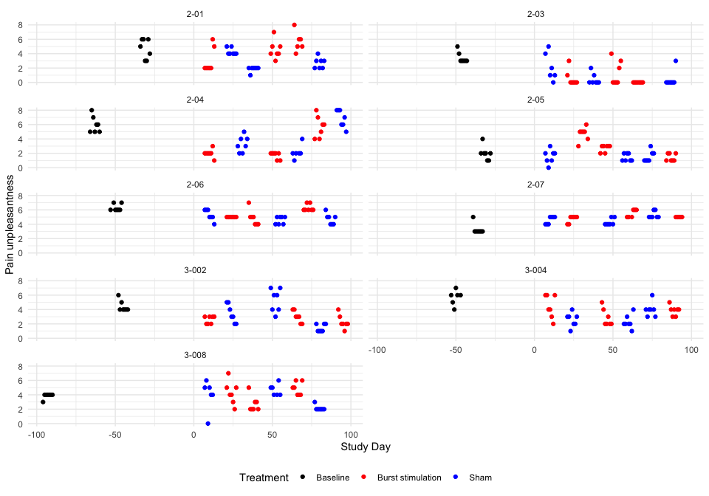

### Descriptive table

| Full analysis set | | | | | | | |
| --- | --- | --- | --- | --- | --- | --- | --- |
| Pain unpleasantness | | | | | | | |
|  | **Baseline** | **Pair 1** | | **Pair 2** | | **Pair 3** | |
|  | **Baseline** | **Burst stimulation** | **Sham** | **Burst stimulation** | **Sham** | **Burst stimulation** | **Sham** |
| **2-01** |  |  |  |  |  |  |  |
| n | 7 | 7 | 7 | 7 | 7 | 6 | 7 |
| Mean (sd) | 4.71 (1.38) | 3.00 (1.73) | 4.29 (0.49) | 4.57 (1.27) | 1.86 (0.38) | 5.67 (1.37) | 2.71 (0.76) |
| IQR | 2.50 | 1.50 | 0.50 | 1.00 | 0.00 | 1.00 | 1.00 |
| min - max | 3.00 - 6.00 | 2.00 - 6.00 | 4.00 - 5.00 | 3.00 - 7.00 | 1.00 - 2.00 | 4.00 - 8.00 | 2.00 - 4.00 |
| **2-03** |  |  |  |  |  |  |  |
| n | 7 | 7 | 6 | 7 | 7 | 7 | 7 |
| Mean (sd) | 3.43 (0.79) | 0.57 (1.13) | 2.17 (1.94) | 1.29 (1.70) | 0.43 (0.79) | 0.00 (0.00) | 0.43 (1.13) |
| IQR | 0.50 | 0.50 | 2.50 | 2.50 | 0.50 | 0.00 | 0.00 |
| min - max | 3.00 - 5.00 | 0.00 - 3.00 | 0.00 - 5.00 | 0.00 - 4.00 | 0.00 - 2.00 | 0.00 - 0.00 | 0.00 - 3.00 |
| **2-04** |  |  |  |  |  |  |  |
| n | 7 | 7 | 7 | 7 | 6 | 7 | 7 |
| Mean (sd) | 6.00 (1.15) | 2.00 (0.58) | 3.29 (1.11) | 1.71 (0.49) | 2.17 (0.98) | 5.71 (1.50) | 6.86 (1.21) |
| IQR | 1.50 | 0.00 | 1.50 | 0.50 | 0.00 | 2.00 | 2.00 |
| min - max | 5.00 - 8.00 | 1.00 - 3.00 | 2.00 - 5.00 | 1.00 - 2.00 | 1.00 - 4.00 | 4.00 - 8.00 | 5.00 - 8.00 |
| **2-05** |  |  |  |  |  |  |  |
| n | 7 | 7 | 7 | 7 | 7 | 7 | 7 |
| Mean (sd) | 2.00 (1.00) | 4.71 (0.95) | 1.57 (0.98) | 2.71 (0.49) | 1.43 (0.53) | 1.43 (0.53) | 1.57 (0.79) |
| IQR | 0.50 | 0.50 | 1.00 | 0.50 | 1.00 | 1.00 | 1.00 |
| min - max | 1.00 - 4.00 | 3.00 - 6.00 | 0.00 - 3.00 | 2.00 - 3.00 | 1.00 - 2.00 | 1.00 - 2.00 | 1.00 - 3.00 |
| **2-06** |  |  |  |  |  |  |  |
| n | 7 | 7 | 7 | 7 | 7 | 7 | 7 |
| Mean (sd) | 6.29 (0.49) | 5.00 (0.00) | 5.29 (0.76) | 4.86 (1.07) | 4.57 (0.53) | 6.29 (0.49) | 4.71 (0.76) |
| IQR | 0.50 | 0.00 | 1.00 | 1.00 | 1.00 | 0.50 | 1.00 |
| min - max | 6.00 - 7.00 | 5.00 - 5.00 | 4.00 - 6.00 | 4.00 - 7.00 | 4.00 - 5.00 | 6.00 - 7.00 | 4.00 - 6.00 |
| **2-07** |  |  |  |  |  |  |  |
| n | 7 | 7 | 7 | 6 | 7 | 5 | 7 |
| Mean (sd) | 3.29 (0.76) | 4.71 (0.49) | 4.57 (0.53) | 5.50 (0.55) | 4.29 (0.49) | 5.00 (0.00) | 5.29 (0.49) |
| IQR | 0.00 | 0.50 | 1.00 | 1.00 | 0.50 | 0.00 | 0.50 |
| min - max | 3.00 - 5.00 | 4.00 - 5.00 | 4.00 - 5.00 | 5.00 - 6.00 | 4.00 - 5.00 | 5.00 - 5.00 | 5.00 - 6.00 |
| **3-002** |  |  |  |  |  |  |  |
| n | 7 | 7 | 7 | 7 | 7 | 7 | 7 |
| Mean (sd) | 4.43 (0.79) | 2.57 (0.53) | 3.43 (1.27) | 3.00 (0.82) | 5.29 (1.60) | 2.29 (0.95) | 1.43 (0.53) |
| IQR | 0.50 | 1.00 | 2.00 | 1.00 | 2.50 | 0.50 | 1.00 |
| min - max | 4.00 - 6.00 | 2.00 - 3.00 | 2.00 - 5.00 | 2.00 - 4.00 | 3.00 - 7.00 | 1.00 - 4.00 | 1.00 - 2.00 |
| **3-004** |  |  |  |  |  |  |  |
| n | 6 | 7 | 7 | 7 | 7 | 7 | 7 |
| Mean (sd) | 5.67 (1.03) | 4.43 (1.62) | 2.57 (0.98) | 2.86 (1.21) | 2.29 (0.95) | 3.86 (0.69) | 4.00 (1.00) |
| IQR | 0.75 | 2.50 | 1.00 | 1.50 | 0.50 | 0.50 | 0.50 |
| min - max | 4.00 - 7.00 | 2.00 - 6.00 | 1.00 - 4.00 | 2.00 - 5.00 | 1.00 - 4.00 | 3.00 - 5.00 | 3.00 - 6.00 |
| **3-008** |  |  |  |  |  |  |  |
| n | 7 | 7 | 6 | 7 | 6 | 7 | 7 |
| Mean (sd) | 3.86 (0.38) | 4.29 (1.60) | 4.00 (2.10) | 2.71 (1.11) | 4.67 (0.82) | 4.86 (0.90) | 2.14 (0.38) |
| IQR | 0.00 | 1.50 | 1.00 | 1.00 | 1.00 | 1.50 | 0.00 |
| min - max | 3.00 - 4.00 | 2.00 - 7.00 | 0.00 - 6.00 | 2.00 - 5.00 | 4.00 - 6.00 | 4.00 - 6.00 | 2.00 - 3.00 |

### Hypothesis test

Pain unpleasantness

| Subject ID | Difference Pair 1 | Difference Pair 2 | Difference Pair 3 | Overall difference |
| --- | --- | --- | --- | --- |
| 2-01 | -1.286 | 2.714 | 2.952 | 1.460 |
| 2-03 | -1.595 | 0.857 | -0.429 | -0.389 |
| 2-04 | -1.286 | -0.452 | -1.143 | -0.960 |
| 2-05 | 3.143 | 1.286 | -0.143 | 1.429 |
| 2-06 | -0.286 | 0.286 | 1.571 | 0.524 |
| 2-07 | 0.143 | 1.214 | -0.286 | 0.357 |
| 3-002 | -0.857 | -2.286 | 0.857 | -0.762 |
| 3-004 | 1.857 | 0.571 | -0.143 | 0.762 |
| 3-008 | 0.286 | -1.952 | 2.714 | 0.349 |

Values are Burst stimulation - Sham.

P-value of the null hypothesis test: 0.3.

### Treatment effect estimates

QQ-plot

## Warning: For this model type, `marginaleffects` only takes into account the  
## uncertainty in fixed-effect parameters. You can use the `re.form=NA`  
## argument to acknowledge this explicitly and silence this warning.  
## Warning: For this model type, `marginaleffects` only takes into account the  
## uncertainty in fixed-effect parameters. You can use the `re.form=NA`  
## argument to acknowledge this explicitly and silence this warning.  
## Warning: For this model type, `marginaleffects` only takes into account the  
## uncertainty in fixed-effect parameters. You can use the `re.form=NA`  
## argument to acknowledge this explicitly and silence this warning.

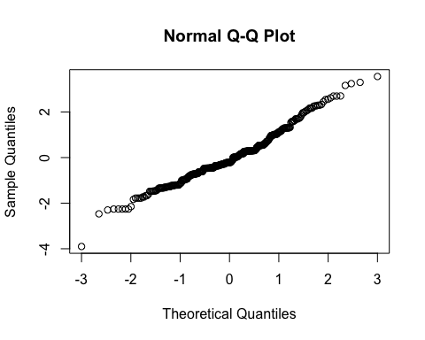

By subject

| Subject ID | Estimate | Std. Err. | p-value | Lower CL | Upper CL |
| --- | --- | --- | --- | --- | --- |
| 2-01 | 1.223 | 0.289 | 0.000 | 0.656 | 1.790 |
| 2-03 | -0.238 | 0.289 | 0.410 | -0.805 | 0.329 |
| 2-04 | -0.751 | 0.289 | 0.009 | -1.318 | -0.184 |
| 2-05 | 1.235 | 0.289 | 0.000 | 0.668 | 1.802 |
| 2-06 | 0.487 | 0.289 | 0.092 | -0.080 | 1.054 |
| 2-07 | 0.355 | 0.289 | 0.220 | -0.212 | 0.922 |
| 3-002 | -0.575 | 0.289 | 0.047 | -1.142 | -0.008 |
| 3-004 | 0.684 | 0.289 | 0.018 | 0.117 | 1.251 |
| 3-008 | 0.397 | 0.289 | 0.170 | -0.170 | 0.964 |

By treatment and overall

| Treatment | Estimate | Std. Err. | p-value | Lower CL | Upper CL |
| --- | --- | --- | --- | --- | --- |
| Sham | 3.214 | 0.46 | 0 | 2.312 | 4.116 |
| Burst stimulation | 3.528 | 0.46 | 0 | 2.626 | 4.430 |

| Estimate | Std. Err. | p-value | Lower CL | Upper CL |
| --- | --- | --- | --- | --- |
| 0.314 | 0.289 | 0.278 | -0.253 | 0.881 |

## Secondary outcome: Ability to do first activity (NRS)

### Plot

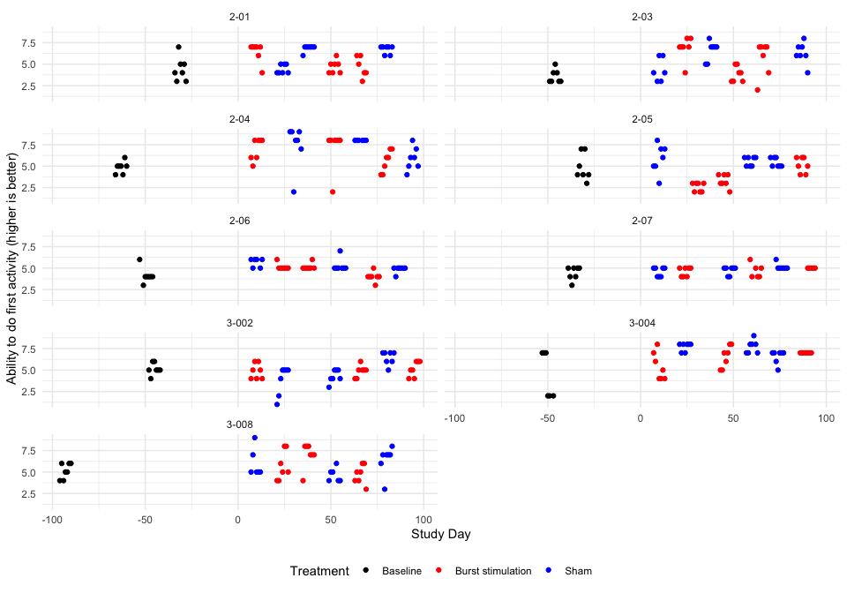

### Descriptive table

| Full analysis set | | | | | | | |
| --- | --- | --- | --- | --- | --- | --- | --- |
| Ability to do first activity (higher is better) | | | | | | | |
|  | **Baseline** | **Pair 1** | | **Pair 2** | | **Pair 3** | |
|  | **Baseline** | **Burst stimulation** | **Sham** | **Burst stimulation** | **Sham** | **Burst stimulation** | **Sham** |
| **2-01** |  |  |  |  |  |  |  |
| n | 7 | 7 | 7 | 7 | 7 | 6 | 7 |
| Mean (sd) | 4.43 (1.40) | 6.43 (1.13) | 4.43 (0.53) | 4.71 (0.76) | 6.86 (0.38) | 4.67 (1.21) | 6.71 (0.49) |
| IQR | 1.50 | 0.50 | 1.00 | 1.00 | 0.00 | 1.75 | 0.50 |
| min - max | 3.00 - 7.00 | 4.00 - 7.00 | 4.00 - 5.00 | 4.00 - 6.00 | 6.00 - 7.00 | 3.00 - 6.00 | 6.00 - 7.00 |
| **2-03** |  |  |  |  |  |  |  |
| n | 7 | 7 | 6 | 7 | 7 | 7 | 7 |
| Mean (sd) | 3.57 (0.79) | 6.86 (1.35) | 4.33 (1.37) | 3.86 (0.90) | 6.57 (1.13) | 5.71 (1.98) | 6.29 (1.25) |
| IQR | 1.00 | 0.50 | 2.25 | 1.50 | 1.00 | 2.00 | 1.00 |
| min - max | 3.00 - 5.00 | 4.00 - 8.00 | 3.00 - 6.00 | 3.00 - 5.00 | 5.00 - 8.00 | 2.00 - 7.00 | 4.00 - 8.00 |
| **2-04** |  |  |  |  |  |  |  |
| n | 7 | 7 | 7 | 7 | 6 | 7 | 7 |
| Mean (sd) | 4.86 (0.69) | 7.00 (1.29) | 7.43 (2.51) | 7.14 (2.27) | 8.00 (0.00) | 5.57 (1.27) | 5.86 (1.35) |
| IQR | 0.50 | 2.00 | 1.50 | 0.00 | 0.00 | 2.00 | 1.50 |
| min - max | 4.00 - 6.00 | 5.00 - 8.00 | 2.00 - 9.00 | 2.00 - 8.00 | 8.00 - 8.00 | 4.00 - 7.00 | 4.00 - 8.00 |
| **2-05** |  |  |  |  |  |  |  |
| n | 7 | 7 | 7 | 7 | 7 | 7 | 7 |
| Mean (sd) | 4.86 (1.57) | 2.57 (0.53) | 5.86 (1.68) | 3.29 (0.76) | 5.57 (0.53) | 5.14 (0.90) | 5.43 (0.53) |
| IQR | 2.00 | 1.00 | 2.00 | 1.00 | 1.00 | 1.50 | 1.00 |
| min - max | 3.00 - 7.00 | 2.00 - 3.00 | 3.00 - 8.00 | 2.00 - 4.00 | 5.00 - 6.00 | 4.00 - 6.00 | 5.00 - 6.00 |
| **2-06** |  |  |  |  |  |  |  |
| n | 7 | 7 | 6 | 7 | 7 | 7 | 7 |
| Mean (sd) | 4.14 (0.90) | 5.14 (0.38) | 5.67 (0.52) | 5.14 (0.38) | 5.29 (0.76) | 4.00 (0.58) | 4.86 (0.38) |
| IQR | 0.00 | 0.00 | 0.75 | 0.00 | 0.00 | 0.00 | 0.00 |
| min - max | 3.00 - 6.00 | 5.00 - 6.00 | 5.00 - 6.00 | 5.00 - 6.00 | 5.00 - 7.00 | 3.00 - 5.00 | 4.00 - 5.00 |
| **2-07** |  |  |  |  |  |  |  |
| n | 7 | 7 | 7 | 6 | 7 | 5 | 7 |
| Mean (sd) | 4.43 (0.79) | 4.57 (0.53) | 4.57 (0.53) | 4.67 (0.82) | 4.71 (0.49) | 5.00 (0.00) | 5.14 (0.38) |
| IQR | 1.00 | 1.00 | 1.00 | 1.00 | 0.50 | 0.00 | 0.00 |
| min - max | 3.00 - 5.00 | 4.00 - 5.00 | 4.00 - 5.00 | 4.00 - 6.00 | 4.00 - 5.00 | 5.00 - 5.00 | 5.00 - 6.00 |
| **3-002** |  |  |  |  |  |  |  |
| n | 7 | 7 | 7 | 7 | 7 | 7 | 7 |
| Mean (sd) | 5.14 (0.69) | 4.86 (0.90) | 3.86 (1.68) | 4.86 (0.69) | 4.29 (0.76) | 5.14 (0.90) | 6.43 (0.79) |
| IQR | 0.50 | 1.50 | 2.00 | 0.50 | 1.00 | 1.50 | 1.00 |
| min - max | 4.00 - 6.00 | 4.00 - 6.00 | 1.00 - 5.00 | 4.00 - 6.00 | 3.00 - 5.00 | 4.00 - 6.00 | 5.00 - 7.00 |
| **3-004** |  |  |  |  |  |  |  |
| n | 6 | 7 | 7 | 7 | 7 | 7 | 7 |
| Mean (sd) | 4.50 (2.74) | 5.43 (1.62) | 7.71 (0.49) | 6.57 (1.27) | 7.71 (0.76) | 7.00 (0.00) | 6.57 (0.79) |
| IQR | 5.00 | 2.50 | 0.50 | 2.00 | 1.00 | 0.00 | 0.50 |
| min - max | 2.00 - 7.00 | 4.00 - 8.00 | 7.00 - 8.00 | 5.00 - 8.00 | 7.00 - 9.00 | 7.00 - 7.00 | 5.00 - 7.00 |
| **3-008** |  |  |  |  |  |  |  |
| n | 7 | 7 | 6 | 7 | 6 | 7 | 7 |
| Mean (sd) | 5.14 (0.90) | 5.71 (1.70) | 6.00 (1.67) | 7.00 (1.41) | 4.67 (0.82) | 4.71 (1.11) | 6.43 (1.62) |
| IQR | 1.50 | 2.50 | 1.50 | 1.00 | 1.00 | 1.50 | 0.50 |
| min - max | 4.00 - 6.00 | 4.00 - 8.00 | 5.00 - 9.00 | 4.00 - 8.00 | 4.00 - 6.00 | 3.00 - 6.00 | 3.00 - 8.00 |

### Hypothesis test

Ability to do first activity (higher is better)

| Subject ID | Difference Pair 1 | Difference Pair 2 | Difference Pair 3 | Overall difference |
| --- | --- | --- | --- | --- |
| 2-01 | 2.000 | -2.143 | -2.048 | -0.730 |
| 2-03 | 2.524 | -2.714 | -0.571 | -0.254 |
| 2-04 | -0.429 | -0.857 | -0.286 | -0.524 |
| 2-05 | -3.286 | -2.286 | -0.286 | -1.953 |
| 2-06 | -0.524 | -0.143 | -0.857 | -0.508 |
| 2-07 | 0.000 | -0.048 | -0.143 | -0.064 |
| 3-002 | 1.000 | 0.571 | -1.286 | 0.095 |
| 3-004 | -2.286 | -1.143 | 0.429 | -1.000 |
| 3-008 | -0.286 | 2.333 | -1.714 | 0.111 |

Values are Burst stimulation - Sham.

P-value of the null hypothesis test: 0.067.

### Treatment effect estimates

QQ-plot

## Warning: For this model type, `marginaleffects` only takes into account the  
## uncertainty in fixed-effect parameters. You can use the `re.form=NA`  
## argument to acknowledge this explicitly and silence this warning.  
## Warning: For this model type, `marginaleffects` only takes into account the  
## uncertainty in fixed-effect parameters. You can use the `re.form=NA`  
## argument to acknowledge this explicitly and silence this warning.  
## Warning: For this model type, `marginaleffects` only takes into account the  
## uncertainty in fixed-effect parameters. You can use the `re.form=NA`  
## argument to acknowledge this explicitly and silence this warning.

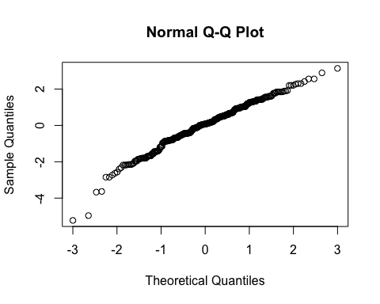

By subject

| Subject ID | Estimate | Std. Err. | p-value | Lower CL | Upper CL |
| --- | --- | --- | --- | --- | --- |
| 2-01 | -0.640 | 0.215 | 0.003 | -1.060 | -0.219 |
| 2-03 | -0.407 | 0.215 | 0.058 | -0.827 | 0.014 |
| 2-04 | -0.516 | 0.215 | 0.016 | -0.936 | -0.095 |
| 2-05 | -1.432 | 0.215 | 0.000 | -1.853 | -1.011 |
| 2-06 | -0.517 | 0.215 | 0.016 | -0.937 | -0.096 |
| 2-07 | -0.248 | 0.215 | 0.247 | -0.669 | 0.173 |
| 3-002 | -0.141 | 0.215 | 0.512 | -0.562 | 0.280 |
| 3-004 | -0.832 | 0.215 | 0.000 | -1.252 | -0.411 |
| 3-008 | -0.166 | 0.215 | 0.440 | -0.586 | 0.255 |

By treatment and overall

| Treatment | Estimate | Std. Err. | p-value | Lower CL | Upper CL |
| --- | --- | --- | --- | --- | --- |
| Sham | 5.836 | 0.296 | 0 | 5.256 | 6.416 |
| Burst stimulation | 5.287 | 0.296 | 0 | 4.707 | 5.867 |

| Estimate | Std. Err. | p-value | Lower CL | Upper CL |
| --- | --- | --- | --- | --- |
| -0.549 | 0.215 | 0.011 | -0.97 | -0.128 |

## Secondary outcome: Ability to do second activity (NRS)

### Plot

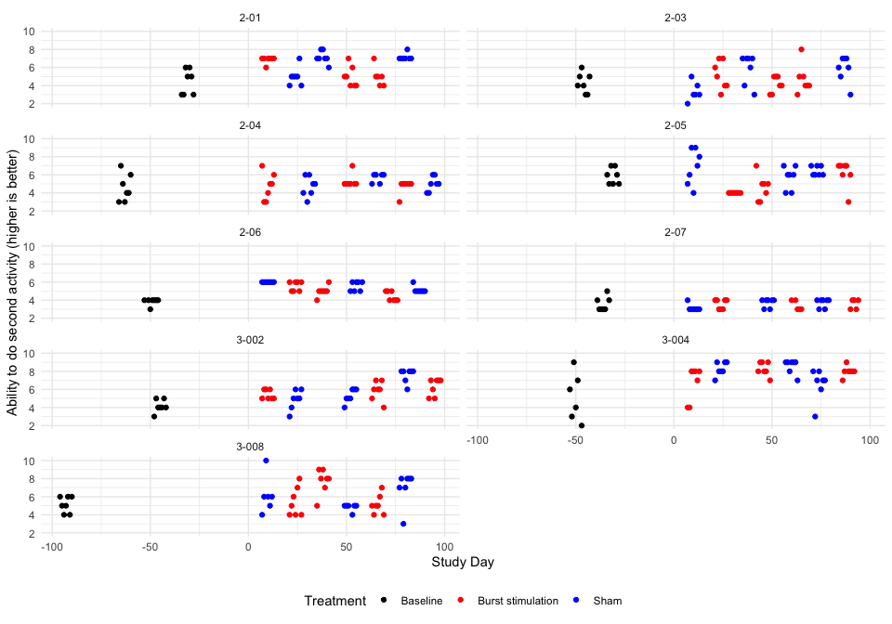

### Descriptive table

| Full analysis set | | | | | | | |
| --- | --- | --- | --- | --- | --- | --- | --- |
| Ability to do second activity (higher is better) | | | | | | | |
|  | **Baseline** | **Pair 1** | | **Pair 2** | | **Pair 3** | |
|  | **Baseline** | **Burst stimulation** | **Sham** | **Burst stimulation** | **Sham** | **Burst stimulation** | **Sham** |
| **2-01** |  |  |  |  |  |  |  |
| n | 7 | 7 | 7 | 7 | 7 | 6 | 7 |
| Mean (sd) | 4.43 (1.40) | 6.86 (0.38) | 5.00 (1.00) | 5.00 (1.15) | 7.14 (0.69) | 5.00 (1.10) | 7.14 (0.38) |
| IQR | 2.50 | 0.00 | 0.50 | 1.50 | 0.50 | 0.75 | 0.00 |
| min - max | 3.00 - 6.00 | 6.00 - 7.00 | 4.00 - 7.00 | 4.00 - 7.00 | 6.00 - 8.00 | 4.00 - 7.00 | 7.00 - 8.00 |
| **2-03** |  |  |  |  |  |  |  |
| n | 7 | 7 | 6 | 7 | 7 | 7 | 7 |
| Mean (sd) | 4.29 (1.11) | 5.14 (1.57) | 3.33 (1.03) | 4.14 (0.90) | 5.86 (1.68) | 4.71 (1.60) | 5.86 (1.46) |
| IQR | 1.50 | 2.50 | 0.75 | 1.50 | 2.00 | 1.00 | 1.50 |
| min - max | 3.00 - 6.00 | 3.00 - 7.00 | 2.00 - 5.00 | 3.00 - 5.00 | 3.00 - 7.00 | 3.00 - 8.00 | 3.00 - 7.00 |
| **2-04** |  |  |  |  |  |  |  |
| n | 7 | 7 | 7 | 7 | 6 | 7 | 7 |
| Mean (sd) | 4.57 (1.51) | 4.71 (1.50) | 4.71 (1.11) | 5.29 (0.76) | 5.67 (0.52) | 4.71 (0.76) | 5.00 (0.82) |
| IQR | 2.00 | 2.00 | 1.50 | 0.00 | 0.75 | 0.00 | 1.00 |
| min - max | 3.00 - 7.00 | 3.00 - 7.00 | 3.00 - 6.00 | 5.00 - 7.00 | 5.00 - 6.00 | 3.00 - 5.00 | 4.00 - 6.00 |
| **2-05** |  |  |  |  |  |  |  |
| n | 7 | 7 | 7 | 7 | 7 | 7 | 7 |
| Mean (sd) | 5.86 (0.90) | 4.00 (0.00) | 6.86 (1.95) | 4.57 (1.40) | 5.71 (1.25) | 6.14 (1.46) | 6.43 (0.53) |
| IQR | 1.50 | 0.00 | 3.00 | 1.50 | 1.50 | 1.00 | 1.00 |
| min - max | 5.00 - 7.00 | 4.00 - 4.00 | 4.00 - 9.00 | 3.00 - 7.00 | 4.00 - 7.00 | 3.00 - 7.00 | 6.00 - 7.00 |
| **2-06** |  |  |  |  |  |  |  |
| n | 7 | 7 | 7 | 7 | 7 | 7 | 7 |
| Mean (sd) | 3.86 (0.38) | 5.57 (0.53) | 6.00 (0.00) | 5.00 (0.58) | 5.57 (0.53) | 4.43 (0.53) | 5.14 (0.38) |
| IQR | 0.00 | 1.00 | 0.00 | 0.00 | 1.00 | 1.00 | 0.00 |
| min - max | 3.00 - 4.00 | 5.00 - 6.00 | 6.00 - 6.00 | 4.00 - 6.00 | 5.00 - 6.00 | 4.00 - 5.00 | 5.00 - 6.00 |
| **2-07** |  |  |  |  |  |  |  |
| n | 7 | 7 | 7 | 5 | 7 | 5 | 7 |
| Mean (sd) | 3.57 (0.79) | 3.57 (0.53) | 3.14 (0.38) | 3.40 (0.55) | 3.71 (0.49) | 3.60 (0.55) | 3.71 (0.49) |
| IQR | 1.00 | 1.00 | 0.00 | 1.00 | 0.50 | 1.00 | 0.50 |
| min - max | 3.00 - 5.00 | 3.00 - 4.00 | 3.00 - 4.00 | 3.00 - 4.00 | 3.00 - 4.00 | 3.00 - 4.00 | 3.00 - 4.00 |
| **3-002** |  |  |  |  |  |  |  |
| n | 7 | 7 | 7 | 7 | 7 | 7 | 7 |
| Mean (sd) | 4.14 (0.69) | 5.43 (0.53) | 4.86 (1.07) | 5.86 (1.07) | 5.29 (0.76) | 6.29 (0.95) | 7.57 (0.79) |
| IQR | 0.50 | 1.00 | 1.00 | 1.00 | 1.00 | 1.50 | 0.50 |
| min - max | 3.00 - 5.00 | 5.00 - 6.00 | 3.00 - 6.00 | 4.00 - 7.00 | 4.00 - 6.00 | 5.00 - 7.00 | 6.00 - 8.00 |
| **3-004** |  |  |  |  |  |  |  |
| n | 6 | 7 | 7 | 7 | 7 | 7 | 7 |
| Mean (sd) | 5.17 (2.64) | 6.71 (1.89) | 8.29 (0.76) | 8.29 (0.76) | 8.57 (0.79) | 8.00 (0.58) | 6.57 (1.72) |
| IQR | 3.50 | 2.50 | 1.00 | 1.00 | 0.50 | 0.00 | 1.00 |
| min - max | 2.00 - 9.00 | 4.00 - 8.00 | 7.00 - 9.00 | 7.00 - 9.00 | 7.00 - 9.00 | 7.00 - 9.00 | 3.00 - 8.00 |
| **3-008** |  |  |  |  |  |  |  |
| n | 7 | 7 | 6 | 7 | 6 | 7 | 7 |
| Mean (sd) | 5.14 (0.90) | 5.43 (1.62) | 6.17 (2.04) | 7.71 (1.38) | 4.83 (0.41) | 5.14 (1.07) | 7.00 (1.83) |
| IQR | 1.50 | 2.50 | 0.75 | 1.00 | 0.00 | 1.00 | 1.00 |
| min - max | 4.00 - 6.00 | 4.00 - 8.00 | 4.00 - 10.00 | 5.00 - 9.00 | 4.00 - 5.00 | 4.00 - 7.00 | 3.00 - 8.00 |

### Hypothesis test

Ability to do second activity (higher is better)

| Subject ID | Difference Pair 1 | Difference Pair 2 | Difference Pair 3 | Overall difference |
| --- | --- | --- | --- | --- |
| 2-01 | 1.857 | -2.143 | -2.143 | -0.810 |
| 2-03 | 1.810 | -1.714 | -1.143 | -0.349 |
| 2-04 | 0.000 | -0.381 | -0.286 | -0.222 |
| 2-05 | -2.857 | -1.143 | -0.286 | -1.429 |
| 2-06 | -0.429 | -0.571 | -0.714 | -0.571 |
| 2-07 | 0.429 | -0.314 | -0.114 | 0.000 |
| 3-002 | 0.571 | 0.571 | -1.286 | -0.048 |
| 3-004 | -1.571 | -0.286 | 1.429 | -0.143 |
| 3-008 | -0.738 | 2.881 | -1.857 | 0.095 |

Values are Burst stimulation - Sham.

P-value of the null hypothesis test: 0.15.

### Treatment effect estimates

QQ-plot

## Warning: For this model type, `marginaleffects` only takes into account the  
## uncertainty in fixed-effect parameters. You can use the `re.form=NA`  
## argument to acknowledge this explicitly and silence this warning.  
## Warning: For this model type, `marginaleffects` only takes into account the  
## uncertainty in fixed-effect parameters. You can use the `re.form=NA`  
## argument to acknowledge this explicitly and silence this warning.  
## Warning: For this model type, `marginaleffects` only takes into account the  
## uncertainty in fixed-effect parameters. You can use the `re.form=NA`  
## argument to acknowledge this explicitly and silence this warning.

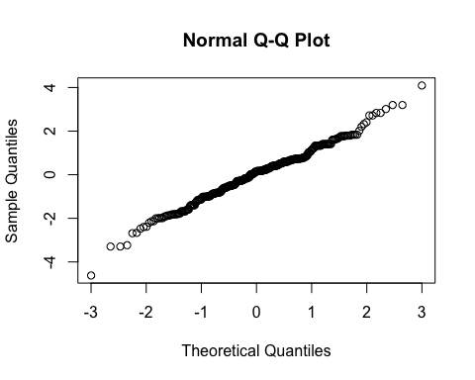

By subject

| Subject ID | Estimate | Std. Err. | p-value | Lower CL | Upper CL |
| --- | --- | --- | --- | --- | --- |
| 2-01 | -0.537 | 0.161 | 0.001 | -0.852 | -0.221 |
| 2-03 | -0.401 | 0.161 | 0.013 | -0.717 | -0.085 |
| 2-04 | -0.325 | 0.161 | 0.044 | -0.640 | -0.009 |
| 2-05 | -0.789 | 0.161 | 0.000 | -1.105 | -0.473 |
| 2-06 | -0.461 | 0.161 | 0.004 | -0.777 | -0.146 |
| 2-07 | -0.238 | 0.161 | 0.139 | -0.554 | 0.077 |
| 3-002 | -0.261 | 0.161 | 0.105 | -0.577 | 0.054 |
| 3-004 | -0.298 | 0.161 | 0.065 | -0.613 | 0.018 |
| 3-008 | -0.230 | 0.161 | 0.152 | -0.546 | 0.085 |

By treatment group and overall

| Treatment | Estimate | Std. Err. | p-value | Lower CL | Upper CL |
| --- | --- | --- | --- | --- | --- |
| Sham | 5.780 | 0.387 | 0 | 5.021 | 6.539 |
| Burst stimulation | 5.384 | 0.387 | 0 | 4.625 | 6.144 |

| Estimate | Std. Err. | p-value | Lower CL | Upper CL |
| --- | --- | --- | --- | --- |
| -0.396 | 0.161 | 0.014 | -0.711 | -0.08 |

## Secondary outcome: Ability to do third activity (NRS)

### Plot

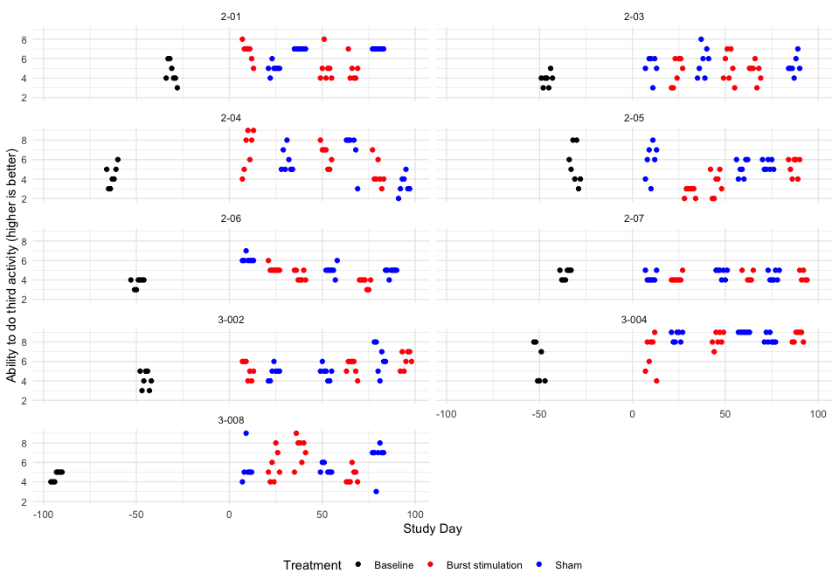

### Descriptive table

| Full analysis set | | | | | | | |
| --- | --- | --- | --- | --- | --- | --- | --- |
| Ability to do third activity (higher is better) | | | | | | | |
|  | **Baseline** | **Pair 1** | | **Pair 2** | | **Pair 3** | |
|  | **Baseline** | **Burst stimulation** | **Sham** | **Burst stimulation** | **Sham** | **Burst stimulation** | **Sham** |
| **2-01** |  |  |  |  |  |  |  |
| n | 7 | 7 | 7 | 7 | 7 | 6 | 7 |
| Mean (sd) | 4.57 (1.13) | 6.71 (0.95) | 5.00 (0.58) | 5.00 (1.41) | 7.00 (0.00) | 4.83 (1.17) | 7.00 (0.00) |
| IQR | 1.50 | 0.50 | 0.00 | 1.00 | 0.00 | 1.00 | 0.00 |
| min - max | 3.00 - 6.00 | 5.00 - 8.00 | 4.00 - 6.00 | 4.00 - 8.00 | 7.00 - 7.00 | 4.00 - 7.00 | 7.00 - 7.00 |
| **2-03** |  |  |  |  |  |  |  |
| n | 7 | 7 | 6 | 7 | 7 | 7 | 7 |
| Mean (sd) | 3.86 (0.69) | 4.71 (1.38) | 5.17 (1.17) | 5.14 (1.57) | 5.71 (1.50) | 4.71 (0.95) | 5.29 (0.95) |
| IQR | 0.50 | 2.50 | 1.00 | 2.50 | 2.00 | 0.50 | 0.50 |
| min - max | 3.00 - 5.00 | 3.00 - 6.00 | 3.00 - 6.00 | 3.00 - 7.00 | 4.00 - 8.00 | 3.00 - 6.00 | 4.00 - 7.00 |
| **2-04** |  |  |  |  |  |  |  |
| n | 7 | 7 | 7 | 7 | 6 | 7 | 7 |
| Mean (sd) | 4.29 (1.11) | 7.00 (2.00) | 5.86 (1.21) | 6.43 (1.13) | 7.00 (2.00) | 4.57 (1.40) | 3.43 (0.98) |
| IQR | 1.50 | 3.00 | 1.50 | 1.50 | 0.75 | 1.00 | 1.00 |
| min - max | 3.00 - 6.00 | 4.00 - 9.00 | 5.00 - 8.00 | 5.00 - 8.00 | 3.00 - 8.00 | 3.00 - 7.00 | 2.00 - 5.00 |
| **2-05** |  |  |  |  |  |  |  |
| n | 7 | 7 | 7 | 7 | 7 | 7 | 7 |
| Mean (sd) | 5.43 (1.99) | 2.71 (0.49) | 5.86 (1.77) | 3.57 (1.27) | 5.14 (0.90) | 5.29 (0.95) | 5.43 (0.53) |
| IQR | 3.00 | 0.50 | 2.00 | 2.00 | 1.50 | 1.50 | 1.00 |
| min - max | 3.00 - 8.00 | 2.00 - 3.00 | 3.00 - 8.00 | 2.00 - 5.00 | 4.00 - 6.00 | 4.00 - 6.00 | 5.00 - 6.00 |
| **2-06** |  |  |  |  |  |  |  |
| n | 7 | 7 | 7 | 7 | 7 | 7 | 7 |
| Mean (sd) | 3.71 (0.49) | 5.14 (0.38) | 6.14 (0.38) | 4.43 (0.53) | 5.00 (0.58) | 3.71 (0.49) | 4.86 (0.38) |
| IQR | 0.50 | 0.00 | 0.00 | 1.00 | 0.00 | 0.50 | 0.00 |
| min - max | 3.00 - 4.00 | 5.00 - 6.00 | 6.00 - 7.00 | 4.00 - 5.00 | 4.00 - 6.00 | 3.00 - 4.00 | 4.00 - 5.00 |
| **2-07** |  |  |  |  |  |  |  |
| n | 7 | 7 | 7 | 5 | 7 | 5 | 7 |
| Mean (sd) | 4.57 (0.53) | 4.14 (0.38) | 4.29 (0.49) | 4.40 (0.55) | 4.71 (0.49) | 4.40 (0.55) | 4.43 (0.53) |
| IQR | 1.00 | 0.00 | 0.50 | 1.00 | 0.50 | 1.00 | 1.00 |
| min - max | 4.00 - 5.00 | 4.00 - 5.00 | 4.00 - 5.00 | 4.00 - 5.00 | 4.00 - 5.00 | 4.00 - 5.00 | 4.00 - 5.00 |
| **3-002** |  |  |  |  |  |  |  |
| n | 7 | 7 | 7 | 7 | 7 | 7 | 7 |
| Mean (sd) | 4.14 (0.90) | 5.14 (0.90) | 4.86 (0.69) | 5.43 (0.79) | 4.86 (0.69) | 6.14 (0.90) | 6.29 (1.50) |
| IQR | 1.50 | 1.50 | 0.50 | 1.00 | 0.50 | 1.50 | 2.00 |
| min - max | 3.00 - 5.00 | 4.00 - 6.00 | 4.00 - 6.00 | 4.00 - 6.00 | 4.00 - 6.00 | 5.00 - 7.00 | 4.00 - 8.00 |
| **3-004** |  |  |  |  |  |  |  |
| n | 6 | 7 | 7 | 7 | 7 | 7 | 7 |
| Mean (sd) | 5.83 (2.04) | 6.86 (1.86) | 8.57 (0.53) | 8.29 (0.76) | 9.00 (0.00) | 8.57 (0.53) | 8.29 (0.49) |
| IQR | 3.75 | 2.50 | 1.00 | 1.00 | 0.00 | 1.00 | 0.50 |
| min - max | 4.00 - 8.00 | 4.00 - 9.00 | 8.00 - 9.00 | 7.00 - 9.00 | 9.00 - 9.00 | 8.00 - 9.00 | 8.00 - 9.00 |
| **3-008** |  |  |  |  |  |  |  |
| n | 7 | 7 | 6 | 7 | 6 | 7 | 7 |
| Mean (sd) | 4.57 (0.53) | 5.57 (1.51) | 5.50 (1.76) | 7.29 (1.38) | 5.33 (0.52) | 4.57 (0.79) | 6.57 (1.62) |
| IQR | 1.00 | 2.00 | 0.00 | 1.50 | 0.75 | 1.00 | 0.00 |
| min - max | 4.00 - 5.00 | 4.00 - 8.00 | 4.00 - 9.00 | 5.00 - 9.00 | 5.00 - 6.00 | 4.00 - 6.00 | 3.00 - 8.00 |

### Hypothesis test

Ability to do third activity (higher is better)

| Subject ID | Difference Pair 1 | Difference Pair 2 | Difference Pair 3 | Overall difference |
| --- | --- | --- | --- | --- |
| 2-01 | 1.714 | -2.000 | -2.167 | -0.818 |
| 2-03 | -0.452 | -0.571 | -0.571 | -0.531 |
| 2-04 | 1.143 | -0.571 | 1.143 | 0.572 |
| 2-05 | -3.143 | -1.571 | -0.143 | -1.619 |
| 2-06 | -1.000 | -0.571 | -1.143 | -0.905 |
| 2-07 | -0.143 | -0.314 | -0.029 | -0.162 |
| 3-002 | 0.286 | 0.571 | -0.143 | 0.238 |
| 3-004 | -1.714 | -0.714 | 0.286 | -0.714 |
| 3-008 | 0.071 | 1.952 | -2.000 | 0.008 |

Values are Burst stimulation - Sham.

P-value of the null hypothesis test: 0.069.

### Treatment effect estimates

QQ-plot

## Warning: For this model type, `marginaleffects` only takes into account the  
## uncertainty in fixed-effect parameters. You can use the `re.form=NA`  
## argument to acknowledge this explicitly and silence this warning.  
## Warning: For this model type, `marginaleffects` only takes into account the  
## uncertainty in fixed-effect parameters. You can use the `re.form=NA`  
## argument to acknowledge this explicitly and silence this warning.  
## Warning: For this model type, `marginaleffects` only takes into account the  
## uncertainty in fixed-effect parameters. You can use the `re.form=NA`  
## argument to acknowledge this explicitly and silence this warning.

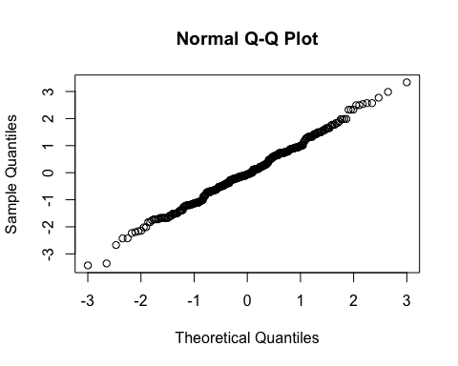

By subject

| Subject ID | Estimate | Std. Err. | p-value | Lower CL | Upper CL |
| --- | --- | --- | --- | --- | --- |
| 2-01 | -0.687 | 0.225 | 0.002 | -1.127 | -0.246 |
| 2-03 | -0.508 | 0.225 | 0.024 | -0.948 | -0.067 |
| 2-04 | 0.317 | 0.225 | 0.158 | -0.123 | 0.758 |
| 2-05 | -1.295 | 0.225 | 0.000 | -1.735 | -0.854 |
| 2-06 | -0.776 | 0.225 | 0.001 | -1.217 | -0.336 |
| 2-07 | -0.240 | 0.225 | 0.286 | -0.680 | 0.200 |
| 3-002 | 0.053 | 0.225 | 0.814 | -0.387 | 0.493 |
| 3-004 | -0.638 | 0.225 | 0.005 | -1.079 | -0.198 |
| 3-008 | -0.156 | 0.225 | 0.488 | -0.596 | 0.284 |

By treatment and overall

| Treatment | Estimate | Std. Err. | p-value | Lower CL | Upper CL |
| --- | --- | --- | --- | --- | --- |
| Sham | 5.813 | 0.396 | 0 | 5.037 | 6.588 |
| Burst stimulation | 5.371 | 0.396 | 0 | 4.595 | 6.147 |

| Estimate | Std. Err. | p-value | Lower CL | Upper CL |
| --- | --- | --- | --- | --- |
| -0.441 | 0.225 | 0.049 | -0.882 | -0.001 |

## Post-hoc outcome: Patient Specific Functional Scale (PSFS) total score

### Plot

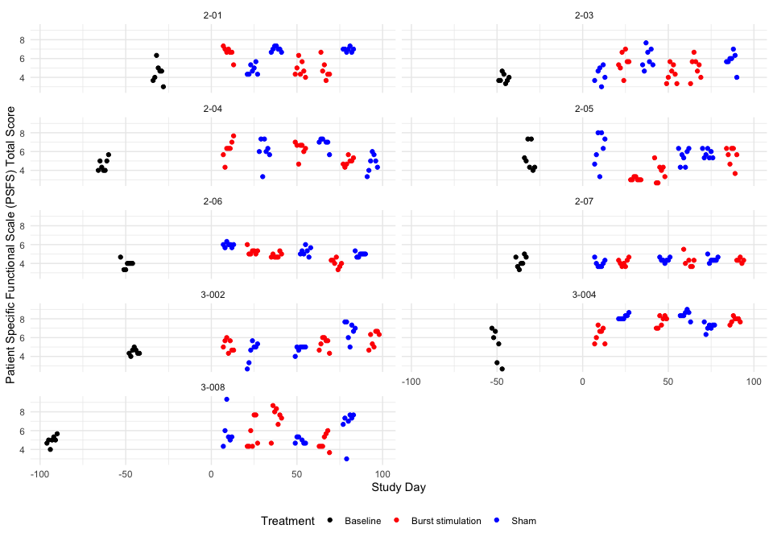

### Descriptive table

| Full analysis set | | | | | | | |
| --- | --- | --- | --- | --- | --- | --- | --- |
| Patient Specific Functional Scale (PSFS) Total Score | | | | | | | |
|  | **Baseline** | **Pair 1** | | **Pair 2** | | **Pair 3** | |
|  | **Baseline** | **Burst stimulation** | **Sham** | **Burst stimulation** | **Sham** | **Burst stimulation** | **Sham** |
| **2-01** |  |  |  |  |  |  |  |
| n | 7 | 7 | 7 | 7 | 7 | 6 | 7 |
| Mean (sd) | 4.48 (1.07) | 6.67 (0.64) | 4.81 (0.54) | 4.90 (0.83) | 7.00 (0.27) | 4.83 (1.05) | 6.95 (0.23) |
| IQR | 1.00 | 0.33 | 0.83 | 1.00 | 0.33 | 0.83 | 0.17 |
| min - max | 3.00 - 6.33 | 5.33 - 7.33 | 4.33 - 5.67 | 4.00 - 6.33 | 6.67 - 7.33 | 3.67 - 6.67 | 6.67 - 7.33 |
| **2-03** |  |  |  |  |  |  |  |
| n | 7 | 7 | 6 | 7 | 7 | 7 | 7 |
| Mean (sd) | 3.90 (0.46) | 5.57 (1.10) | 4.28 (0.88) | 4.38 (0.91) | 6.05 (1.08) | 5.05 (1.13) | 5.81 (0.92) |
| IQR | 0.50 | 1.00 | 1.17 | 1.33 | 1.50 | 1.33 | 0.50 |
| min - max | 3.33 - 4.67 | 3.67 - 7.00 | 3.00 - 5.33 | 3.33 - 5.67 | 4.67 - 7.67 | 3.33 - 6.67 | 4.00 - 7.00 |
| **2-04** |  |  |  |  |  |  |  |
| n | 7 | 7 | 7 | 7 | 6 | 7 | 7 |
| Mean (sd) | 4.57 (0.66) | 6.24 (1.05) | 6.00 (1.35) | 6.29 (0.78) | 6.89 (0.62) | 4.95 (0.45) | 4.76 (0.94) |
| IQR | 1.00 | 0.67 | 1.00 | 0.50 | 0.25 | 0.50 | 1.17 |
| min - max | 4.00 - 5.67 | 4.33 - 7.67 | 3.33 - 7.33 | 4.67 - 7.00 | 5.67 - 7.33 | 4.33 - 5.67 | 3.33 - 6.00 |
| **2-05** |  |  |  |  |  |  |  |
| n | 7 | 7 | 7 | 7 | 7 | 7 | 7 |
| Mean (sd) | 5.38 (1.41) | 3.10 (0.16) | 6.19 (1.76) | 3.81 (0.98) | 5.48 (0.86) | 5.52 (1.02) | 5.76 (0.46) |
| IQR | 2.00 | 0.17 | 2.50 | 1.33 | 1.33 | 1.17 | 0.83 |
| min - max | 4.00 - 7.33 | 3.00 - 3.33 | 3.33 - 8.00 | 2.67 - 5.33 | 4.33 - 6.33 | 3.67 - 6.33 | 5.33 - 6.33 |
| **2-06** |  |  |  |  |  |  |  |
| n | 7 | 7 | 7 | 7 | 7 | 7 | 7 |
| Mean (sd) | 3.90 (0.46) | 5.29 (0.36) | 5.95 (0.23) | 4.86 (0.26) | 5.29 (0.45) | 4.05 (0.45) | 4.95 (0.23) |
| IQR | 0.33 | 0.33 | 0.17 | 0.33 | 0.50 | 0.50 | 0.17 |
| min - max | 3.33 - 4.67 | 5.00 - 6.00 | 5.67 - 6.33 | 4.67 - 5.33 | 4.67 - 6.00 | 3.33 - 4.67 | 4.67 - 5.33 |
| **2-07** |  |  |  |  |  |  |  |
| n | 7 | 7 | 7 | 6 | 7 | 5 | 7 |
| Mean (sd) | 4.19 (0.60) | 4.10 (0.37) | 4.00 (0.38) | 4.25 (0.68) | 4.38 (0.23) | 4.33 (0.24) | 4.43 (0.32) |
| IQR | 0.83 | 0.50 | 0.50 | 0.58 | 0.17 | 0.00 | 0.17 |
| min - max | 3.33 - 5.00 | 3.67 - 4.67 | 3.67 - 4.67 | 3.67 - 5.50 | 4.00 - 4.67 | 4.00 - 4.67 | 4.00 - 5.00 |
| **3-002** |  |  |  |  |  |  |  |
| n | 7 | 7 | 7 | 7 | 7 | 7 | 7 |
| Mean (sd) | 4.48 (0.33) | 5.14 (0.63) | 4.52 (1.10) | 5.38 (0.65) | 4.81 (0.38) | 5.86 (0.84) | 6.76 (0.98) |
| IQR | 0.33 | 1.00 | 1.17 | 0.83 | 0.17 | 1.33 | 1.17 |
| min - max | 4.00 - 5.00 | 4.33 - 6.00 | 2.67 - 5.67 | 4.33 - 6.00 | 4.00 - 5.00 | 4.67 - 6.67 | 5.00 - 7.67 |
| **3-004** |  |  |  |  |  |  |  |
| n | 6 | 7 | 7 | 7 | 7 | 7 | 7 |
| Mean (sd) | 5.17 (1.79) | 6.33 (0.79) | 8.19 (0.26) | 7.71 (0.59) | 8.43 (0.42) | 7.86 (0.33) | 7.14 (0.42) |
| IQR | 2.67 | 1.17 | 0.33 | 1.00 | 0.33 | 0.33 | 0.33 |
| min - max | 2.67 - 7.00 | 5.33 - 7.33 | 8.00 - 8.67 | 7.00 - 8.33 | 7.67 - 9.00 | 7.33 - 8.33 | 6.33 - 7.67 |
| **3-008** |  |  |  |  |  |  |  |
| n | 7 | 7 | 6 | 7 | 6 | 7 | 7 |
| Mean (sd) | 4.95 (0.52) | 5.57 (1.55) | 5.89 (1.77) | 7.33 (1.35) | 4.94 (0.33) | 4.81 (0.86) | 6.67 (1.66) |
| IQR | 0.33 | 2.50 | 0.75 | 1.17 | 0.58 | 1.17 | 0.67 |
| min - max | 4.00 - 5.67 | 4.33 - 7.67 | 4.33 - 9.33 | 4.67 - 8.67 | 4.67 - 5.33 | 3.67 - 6.00 | 3.00 - 7.67 |

### Hypothesis test

Patient Specific Functional Scale (PSFS) Total Score

| Subject ID | Difference Pair 1 | Difference Pair 2 | Difference Pair 3 | Overall difference |
| --- | --- | --- | --- | --- |
| 2-01 | 1.857 | -2.095 | -2.119 | -0.786 |
| 2-03 | 1.294 | -1.667 | -0.762 | -0.378 |
| 2-04 | 0.238 | -0.603 | 0.190 | -0.058 |
| 2-05 | -3.095 | -1.667 | -0.238 | -1.667 |
| 2-06 | -0.667 | -0.429 | -0.905 | -0.667 |
| 2-07 | 0.095 | -0.131 | -0.095 | -0.044 |
| 3-002 | 0.619 | 0.571 | -0.905 | 0.095 |
| 3-004 | -1.857 | -0.714 | 0.714 | -0.619 |
| 3-008 | -0.317 | 2.389 | -1.857 | 0.072 |

Values are Burst stimulation - Sham.

P-value of the null hypothesis test: 0.075.

### Treatment effect estimates

QQ-plot

## Warning: For this model type, `marginaleffects` only takes into account the  
## uncertainty in fixed-effect parameters. You can use the `re.form=NA`  
## argument to acknowledge this explicitly and silence this warning.  
## Warning: For this model type, `marginaleffects` only takes into account the  
## uncertainty in fixed-effect parameters. You can use the `re.form=NA`  
## argument to acknowledge this explicitly and silence this warning.  
## Warning: For this model type, `marginaleffects` only takes into account the  
## uncertainty in fixed-effect parameters. You can use the `re.form=NA`  
## argument to acknowledge this explicitly and silence this warning.

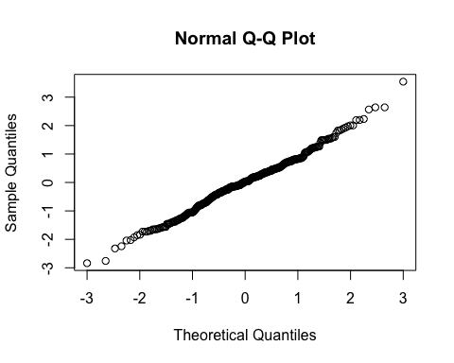

By subject

| Subject ID | Estimate | Std. Err. | p-value | Lower CL | Upper CL |
| --- | --- | --- | --- | --- | --- |
| 2-01 | -0.660 | 0.187 | 0.000 | -1.027 | -0.292 |
| 2-03 | -0.434 | 0.187 | 0.021 | -0.801 | -0.067 |
| 2-04 | -0.166 | 0.187 | 0.376 | -0.533 | 0.201 |
| 2-05 | -1.297 | 0.187 | 0.000 | -1.665 | -0.930 |
| 2-06 | -0.602 | 0.187 | 0.001 | -0.970 | -0.235 |
| 2-07 | -0.171 | 0.187 | 0.363 | -0.538 | 0.197 |
| 3-002 | -0.073 | 0.187 | 0.698 | -0.440 | 0.295 |
| 3-004 | -0.569 | 0.187 | 0.002 | -0.937 | -0.202 |
| 3-008 | -0.129 | 0.187 | 0.493 | -0.496 | 0.239 |

By treatment and overall

| Treatment | Estimate | Std. Err. | p-value | Lower CL | Upper CL |
| --- | --- | --- | --- | --- | --- |
| Sham | 5.807 | 0.325 | 0 | 5.171 | 6.444 |
| Burst stimulation | 5.348 | 0.325 | 0 | 4.711 | 5.984 |

| Estimate | Std. Err. | p-value | Lower CL | Upper CL |
| --- | --- | --- | --- | --- |
| -0.46 | 0.187 | 0.014 | -0.827 | -0.093 |

## Secondary endpoint: Insomnia Severity Index questionnaire total score

### Plot

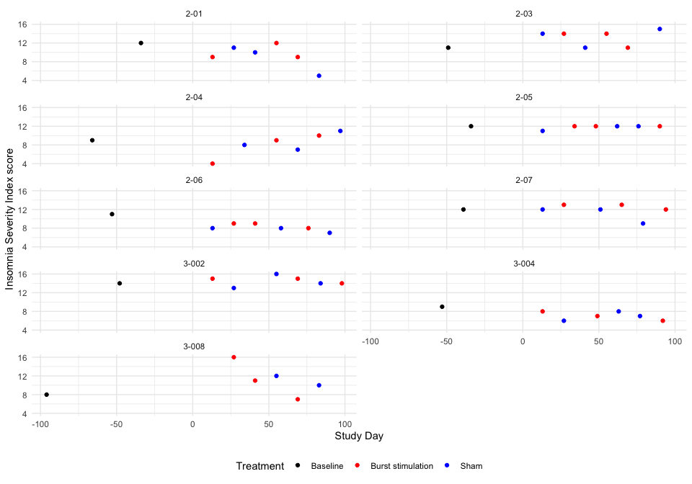 ### Descriptive table

| Full analysis set | | | | | | | |
| --- | --- | --- | --- | --- | --- | --- | --- |
| Insomnia Severity Index score | | | | | | | |
|  | **Baseline** | **Pair 1** | | **Pair 2** | | **Pair 3** | |
|  | **Baseline** | **Burst stimulation** | **Sham** | **Burst stimulation** | **Sham** | **Burst stimulation** | **Sham** |
| **2-01** |  |  |  |  |  |  |  |
|  | 12 | 9 | 11 | 12 | 10 | 9 | 5 |
| **2-03** |  |  |  |  |  |  |  |
|  | 11 | 14 | 14 | 14 | 11 | 11 | 15 |
| **2-04** |  |  |  |  |  |  |  |
|  | 9 | 4 | 8 | 9 | 7 | 10 | 11 |
| **2-05** |  |  |  |  |  |  |  |
|  | 12 | 12 | 11 | 12 | 12 | 12 | 12 |
| **2-06** |  |  |  |  |  |  |  |
|  | 11 | 9 | 8 | 9 | 8 | 8 | 7 |
| **2-07** |  |  |  |  |  |  |  |
|  | 12 | 13 | 12 | 13 | 12 | 12 | 9 |
| **3-002** |  |  |  |  |  |  |  |
|  | 14 | 15 | 13 | 15 | 16 | 14 | 14 |
| **3-004** |  |  |  |  |  |  |  |
|  | 9 | 8 | 6 | 7 | 8 | 6 | 7 |
| **3-008** |  |  |  |  |  |  |  |
|  | 8 | 16 | NA | 11 | 12 | 7 | 10 |

### Hypothesis test

Insomnia Severity Index score

| Subject ID | Difference Pair 1 | Difference Pair 2 | Difference Pair 3 | Overall difference |
| --- | --- | --- | --- | --- |
| 2-01 | -2 | 2 | 4 | 1.333 |
| 2-03 | 0 | 3 | -4 | -0.333 |
| 2-04 | -4 | 2 | -1 | -1.000 |
| 2-05 | 1 | 0 | 0 | 0.333 |
| 2-06 | 1 | 1 | 1 | 1.000 |
| 2-07 | 1 | 1 | 3 | 1.667 |
| 3-002 | 2 | -1 | 0 | 0.333 |
| 3-004 | 2 | -1 | -1 | 0.000 |
| 3-008 | NaN | -1 | -3 | -2.000 |

Values are Burst stimulation - Sham.

P-value of the null hypothesis test: 0.57.

### Treatment effect estimates

QQ-plot

## Warning: For this model type, `marginaleffects` only takes into account the  
## uncertainty in fixed-effect parameters. You can use the `re.form=NA`  
## argument to acknowledge this explicitly and silence this warning.  
## Warning: For this model type, `marginaleffects` only takes into account the  
## uncertainty in fixed-effect parameters. You can use the `re.form=NA`  
## argument to acknowledge this explicitly and silence this warning.  
## Warning: For this model type, `marginaleffects` only takes into account the  
## uncertainty in fixed-effect parameters. You can use the `re.form=NA`  
## argument to acknowledge this explicitly and silence this warning.

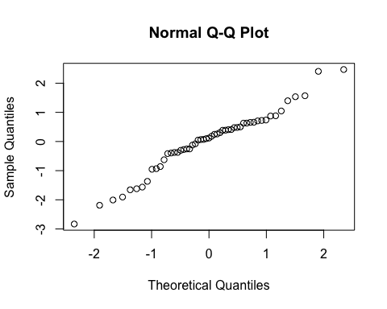

By subject

| Subject ID | Estimate | Std. Err. | p-value | Lower CL | Upper CL |
| --- | --- | --- | --- | --- | --- |
| 2-01 | 1.157 | 1.019 | 0.256 | -0.841 | 3.155 |
| 2-03 | -0.227 | 1.019 | 0.824 | -2.224 | 1.771 |
| 2-04 | -0.780 | 1.019 | 0.444 | -2.778 | 1.217 |
| 2-05 | 0.327 | 1.019 | 0.749 | -1.671 | 2.324 |
| 2-06 | 0.880 | 1.019 | 0.388 | -1.117 | 2.878 |
| 2-07 | 1.434 | 1.019 | 0.160 | -0.564 | 3.431 |
| 3-002 | 0.327 | 1.019 | 0.749 | -1.671 | 2.324 |
| 3-004 | 0.050 | 1.019 | 0.961 | -1.948 | 2.048 |
| 3-008 | -0.517 | 1.019 | 0.612 | -2.514 | 1.481 |

By treatment and overall

| Treatment | Estimate | Std. Err. | p-value | Lower CL | Upper CL |
| --- | --- | --- | --- | --- | --- |
| Sham | 10.416 | 0.774 | 0 | 8.898 | 11.934 |
| Burst stimulation | 10.726 | 0.770 | 0 | 9.216 | 12.236 |

| Estimate | Std. Err. | p-value | Lower CL | Upper CL |
| --- | --- | --- | --- | --- |
| 0.31 | 1.019 | 0.761 | -1.688 | 2.307 |

## Secondary endpoint: EQ-5D-5L Utility Index

### Plot

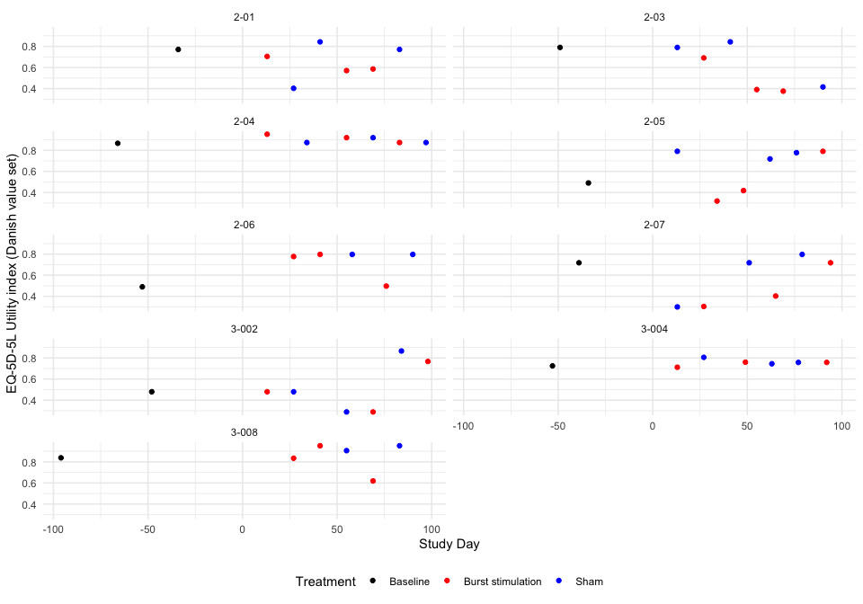 ### Descriptive table

| Full analysis set | | | | | | | |
| --- | --- | --- | --- | --- | --- | --- | --- |
| EQ-5D-5L Utility index (Danish value set) | | | | | | | |
|  | **Baseline** | **Pair 1** | | **Pair 2** | | **Pair 3** | |
|  | **Baseline** | **Burst stimulation** | **Sham** | **Burst stimulation** | **Sham** | **Burst stimulation** | **Sham** |
| **2-01** |  |  |  |  |  |  |  |
|  | 0.771 | 0.705 | 0.403 | 0.571 | 0.843 | 0.586 | 0.771 |
| **2-03** |  |  |  |  |  |  |  |
|  | 0.79 | 0.691 | 0.79 | 0.391 | 0.843 | 0.376 | 0.416 |
| **2-04** |  |  |  |  |  |  |  |
|  | 0.866 | 0.952 | 0.873 | 0.919 | 0.919 | 0.873 | 0.873 |
| **2-05** |  |  |  |  |  |  |  |
|  | 0.49 | 0.319 | 0.79 | 0.418 | 0.718 | 0.79 | 0.777 |
| **2-06** |  |  |  |  |  |  |  |
|  | 0.49 | 0.777 | NA | 0.797 | 0.797 | 0.497 | 0.797 |
| **2-07** |  |  |  |  |  |  |  |
|  | 0.718 | 0.304 | 0.3 | 0.403 | 0.718 | 0.718 | 0.797 |
| **3-002** |  |  |  |  |  |  |  |
|  | 0.48 | 0.48 | 0.48 | 0.289 | 0.289 | 0.767 | 0.866 |
| **3-004** |  |  |  |  |  |  |  |
|  | 0.725 | 0.712 | 0.806 | 0.76 | 0.745 | 0.758 | 0.758 |
| **3-008** |  |  |  |  |  |  |  |
|  | 0.838 | 0.834 | NA | 0.952 | 0.906 | 0.619 | 0.952 |

### Hypothesis test

EQ-5D-5L Utility index (Danish value set)

| Subject ID | Difference Pair 1 | Difference Pair 2 | Difference Pair 3 | Overall difference |
| --- | --- | --- | --- | --- |
| 2-01 | 0.302 | -0.272 | -0.185 | -0.052 |
| 2-03 | -0.099 | -0.452 | -0.040 | -0.197 |
| 2-04 | 0.079 | 0.000 | 0.000 | 0.026 |
| 2-05 | -0.471 | -0.300 | 0.013 | -0.253 |
| 2-06 | NaN | 0.000 | -0.300 | -0.150 |
| 2-07 | 0.004 | -0.315 | -0.079 | -0.130 |
| 3-002 | 0.000 | 0.000 | -0.099 | -0.033 |
| 3-004 | -0.094 | 0.015 | 0.000 | -0.026 |
| 3-008 | NaN | 0.046 | -0.333 | -0.144 |

Values are Burst stimulation - Sham.

P-value of the null hypothesis test: 0.0091.

### Treatment effect estimates

QQ-plot

## Warning: For this model type, `marginaleffects` only takes into account the  
## uncertainty in fixed-effect parameters. You can use the `re.form=NA`  
## argument to acknowledge this explicitly and silence this warning.  
## Warning: For this model type, `marginaleffects` only takes into account the  
## uncertainty in fixed-effect parameters. You can use the `re.form=NA`  
## argument to acknowledge this explicitly and silence this warning.  
## Warning: For this model type, `marginaleffects` only takes into account the  
## uncertainty in fixed-effect parameters. You can use the `re.form=NA`  
## argument to acknowledge this explicitly and silence this warning.

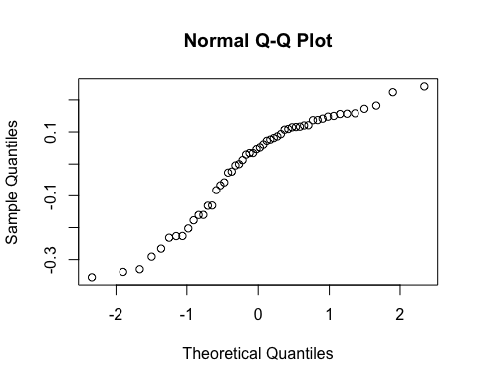

By subject

| Subject ID | Estimate | Std. Err. | p-value | Lower CL | Upper CL |
| --- | --- | --- | --- | --- | --- |
| 2-01 | -0.073 | 0.067 | 0.275 | -0.204 | 0.058 |
| 2-03 | -0.138 | 0.067 | 0.038 | -0.269 | -0.007 |
| 2-04 | -0.038 | 0.067 | 0.571 | -0.169 | 0.093 |
| 2-05 | -0.163 | 0.067 | 0.014 | -0.294 | -0.033 |
| 2-06 | -0.085 | 0.067 | 0.203 | -0.216 | 0.046 |
| 2-07 | -0.108 | 0.067 | 0.105 | -0.239 | 0.023 |
| 3-002 | -0.065 | 0.067 | 0.334 | -0.195 | 0.066 |
| 3-004 | -0.062 | 0.067 | 0.357 | -0.192 | 0.069 |
| 3-008 | -0.081 | 0.067 | 0.223 | -0.212 | 0.049 |

By treatment and overall

| Treatment | Estimate | Std. Err. | p-value | Lower CL | Upper CL |
| --- | --- | --- | --- | --- | --- |
| Sham | 0.729 | 0.048 | 0 | 0.636 | 0.823 |
| Burst stimulation | 0.639 | 0.047 | 0 | 0.547 | 0.730 |

| Estimate | Std. Err. | p-value | Lower CL | Upper CL |
| --- | --- | --- | --- | --- |
| -0.091 | 0.067 | 0.175 | -0.222 | 0.04 |

## Secondary endpoint: EQ-5D-5L self-rated health (VAS)

### Plot

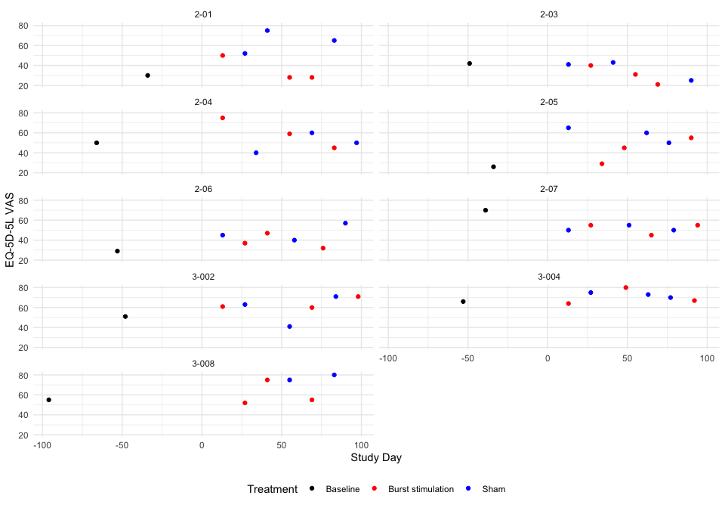 ### Descriptive table

| Full analysis set | | | | | | | |
| --- | --- | --- | --- | --- | --- | --- | --- |
| EQ-5D-5L VAS | | | | | | | |
|  | **Baseline** | **Pair 1** | | **Pair 2** | | **Pair 3** | |
|  | **Baseline** | **Burst stimulation** | **Sham** | **Burst stimulation** | **Sham** | **Burst stimulation** | **Sham** |
| **2-01** |  |  |  |  |  |  |  |
|  | 30 | 50 | 52 | 28 | 75 | 28 | 65 |
| **2-03** |  |  |  |  |  |  |  |
|  | 42 | 40 | 41 | 31 | 43 | 21 | 25 |
| **2-04** |  |  |  |  |  |  |  |
|  | 50 | 75 | 40 | 59 | 60 | 45 | 50 |
| **2-05** |  |  |  |  |  |  |  |
|  | 26 | 29 | 65 | 45 | 60 | 55 | 50 |
| **2-06** |  |  |  |  |  |  |  |
|  | 29 | 37 | 45 | 47 | 40 | 32 | 57 |
| **2-07** |  |  |  |  |  |  |  |
|  | 70 | 55 | 50 | 45 | 55 | 55 | 50 |
| **3-002** |  |  |  |  |  |  |  |
|  | 51 | 61 | 63 | 60 | 41 | 71 | 71 |
| **3-004** |  |  |  |  |  |  |  |
|  | 66 | 64 | 75 | 80 | 73 | 67 | 70 |
| **3-008** |  |  |  |  |  |  |  |
|  | 55 | 52 | NA | 75 | 75 | 55 | 80 |

### Hypothesis test

EQ-5D-5L VAS

| Subject ID | Difference Pair 1 | Difference Pair 2 | Difference Pair 3 | Overall difference |
| --- | --- | --- | --- | --- |
| 2-01 | -2 | -47 | -37 | -28.667 |
| 2-03 | -1 | -12 | -4 | -5.667 |
| 2-04 | 35 | -1 | -5 | 9.667 |
| 2-05 | -36 | -15 | 5 | -15.333 |
| 2-06 | -8 | 7 | -25 | -8.667 |
| 2-07 | 5 | -10 | 5 | 0.000 |
| 3-002 | -2 | 19 | 0 | 5.667 |
| 3-004 | -11 | 7 | -3 | -2.333 |
| 3-008 | NaN | 0 | -25 | -12.500 |

Values are Burst stimulation - Sham.

P-value of the null hypothesis test: 0.082.

### Treatment effect estimates

QQ-plot

## Warning: For this model type, `marginaleffects` only takes into account the  
## uncertainty in fixed-effect parameters. You can use the `re.form=NA`  
## argument to acknowledge this explicitly and silence this warning.  
## Warning: For this model type, `marginaleffects` only takes into account the  
## uncertainty in fixed-effect parameters. You can use the `re.form=NA`  
## argument to acknowledge this explicitly and silence this warning.  
## Warning: For this model type, `marginaleffects` only takes into account the  
## uncertainty in fixed-effect parameters. You can use the `re.form=NA`  
## argument to acknowledge this explicitly and silence this warning.

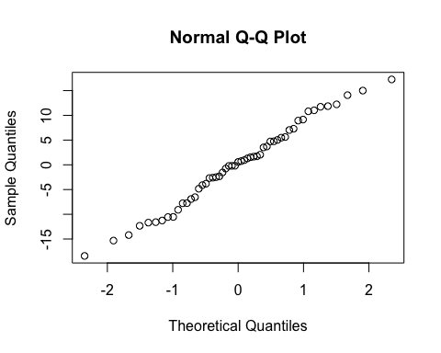

By subject

| Subject ID | Estimate | Std. Err. | p-value | Lower CL | Upper CL |
| --- | --- | --- | --- | --- | --- |
| 2-01 | -24.391 | 6.299 | 0.000 | -36.737 | -12.045 |
| 2-03 | -5.868 | 6.299 | 0.352 | -18.214 | 6.478 |
| 2-04 | 6.481 | 6.299 | 0.304 | -5.865 | 18.827 |
| 2-05 | -13.653 | 6.299 | 0.030 | -25.999 | -1.307 |
| 2-06 | -8.284 | 6.299 | 0.188 | -20.630 | 4.062 |
| 2-07 | -1.304 | 6.299 | 0.836 | -13.650 | 11.042 |
| 3-002 | 3.260 | 6.299 | 0.605 | -9.086 | 15.606 |
| 3-004 | -3.183 | 6.299 | 0.613 | -15.529 | 9.163 |
| 3-008 | -13.358 | 6.299 | 0.034 | -25.704 | -1.012 |

By treatment and overall

| Treatment | Estimate | Std. Err. | p-value | Lower CL | Upper CL |
| --- | --- | --- | --- | --- | --- |
| Sham | 56.866 | 4.465 | 0 | 48.115 | 65.617 |
| Burst stimulation | 50.292 | 4.443 | 0 | 41.584 | 58.999 |

| Estimate | Std. Err. | p-value | Lower CL | Upper CL |
| --- | --- | --- | --- | --- |
| -6.574 | 6.299 | 0.297 | -18.92 | 5.772 |

## Secondary endpoint: Patient Global Impression of Change

### Descriptive table

| Full analysis set | | | | | | |
| --- | --- | --- | --- | --- | --- | --- |
| Patient Global Impression of Change | | | | | | |
|  | **Baseline - Burst stimulation** | **Baseline - Sham** | **Burst stimulation - Burst stimulation** | **Burst stimulation - Sham** | **Sham - Burst stimulation** | **Sham - Sham** |
| Veldig mye bedre | 0 (0.00%) | 0 (0.00%) | 0 (0.00%) | 0 (0.00%) | 0 (0.00%) | 0 (0.00%) |
| Mye bedre | 2 (50.00%) | 1 (25.00%) | 3 (60.00%) | 8 (44.44%) | 3 (16.67%) | 1 (25.00%) |
| Minimalt bedre | 1 (25.00%) | 1 (25.00%) | 0 (0.00%) | 1 (5.56%) | 4 (22.22%) | 0 (0.00%) |
| Ingen endring | 0 (0.00%) | 1 (25.00%) | 1 (20.00%) | 4 (22.22%) | 1 (5.56%) | 1 (25.00%) |
| Minimalt verre | 1 (25.00%) | 0 (0.00%) | 0 (0.00%) | 2 (11.11%) | 1 (5.56%) | 1 (25.00%) |
| Mye verre | 0 (0.00%) | 1 (25.00%) | 1 (20.00%) | 2 (11.11%) | 9 (50.00%) | 1 (25.00%) |
| Veldig mye verre | 0 (0.00%) | 0 (0.00%) | 0 (0.00%) | 1 (5.56%) | 0 (0.00%) | 0 (0.00%) |

### Hypothesis test and treatment effect estimates

|  | Mean | SD |
| --- | --- | --- |
| Burst stimulation - Sham | 3.555556 | 1.688098 |
| Sham - Burst stimulation | 4.500000 | 1.689065 |

## Warning: For this model type, `marginaleffects` only takes into account the  
## uncertainty in fixed-effect parameters. You can use the `re.form=NA`  
## argument to acknowledge this explicitly and silence this warning.

| contrast | estimate | std.error | p.value | s.value | conf.low | conf.high |
| --- | --- | --- | --- | --- | --- | --- |
| Sham - Burst stimulation - Burst stimulation - Sham | 0.95 | 0.558 | 0.089 | 3.494 | -0.144 | 2.045 |

## Secondary outcome: Patient blinding question

### Descriptive table by participant

| Full analysis set | | | | | | |
| --- | --- | --- | --- | --- | --- | --- |
| Patient blinding question | | | | | | |
|  | **Pair 1** | | **Pair 2** | | **Pair 3** | |
|  | **Burst stimulation** | **Sham** | **Burst stimulation** | **Sham** | **Burst stimulation** | **Sham** |
| **2-01** |  |  |  |  |  |  |
| Slått på | 1 (11.11%) | 0 (0.00%) | 0 (0.00%) | 1 (11.11%) | 0 (0.00%) | 1 (11.11%) |
| Slått av | 0 (0.00%) | 1 (12.50%) | 1 (11.11%) | 0 (0.00%) | 1 (11.11%) | 0 (0.00%) |
| Vet ikke | 0 (0.00%) | 0 (0.00%) | 0 (0.00%) | 0 (0.00%) | 0 (0.00%) | 0 (0.00%) |
| **2-03** |  |  |  |  |  |  |
| Slått på | 1 (11.11%) | 0 (0.00%) | 0 (0.00%) | 1 (11.11%) | 1 (11.11%) | 0 (0.00%) |
| Slått av | 0 (0.00%) | 1 (12.50%) | 1 (11.11%) | 0 (0.00%) | 0 (0.00%) | 0 (0.00%) |
| Vet ikke | 0 (0.00%) | 0 (0.00%) | 0 (0.00%) | 0 (0.00%) | 0 (0.00%) | 1 (11.11%) |
| **2-04** |  |  |  |  |  |  |
| Slått på | 1 (11.11%) | 0 (0.00%) | 1 (11.11%) | 1 (11.11%) | 0 (0.00%) | 0 (0.00%) |
| Slått av | 0 (0.00%) | 1 (12.50%) | 0 (0.00%) | 0 (0.00%) | 1 (11.11%) | 1 (11.11%) |
| Vet ikke | 0 (0.00%) | 0 (0.00%) | 0 (0.00%) | 0 (0.00%) | 0 (0.00%) | 0 (0.00%) |
| **2-05** |  |  |  |  |  |  |
| Slått på | 0 (0.00%) | 1 (12.50%) | 0 (0.00%) | 1 (11.11%) | 1 (11.11%) | 1 (11.11%) |
| Slått av | 1 (11.11%) | 0 (0.00%) | 0 (0.00%) | 0 (0.00%) | 0 (0.00%) | 0 (0.00%) |
| Vet ikke | 0 (0.00%) | 0 (0.00%) | 1 (11.11%) | 0 (0.00%) | 0 (0.00%) | 0 (0.00%) |
| **2-06** |  |  |  |  |  |  |
| Slått på | 0 (0.00%) | 1 (12.50%) | 1 (11.11%) | 1 (11.11%) | 0 (0.00%) | 1 (11.11%) |
| Slått av | 1 (11.11%) | 0 (0.00%) | 0 (0.00%) | 0 (0.00%) | 1 (11.11%) | 0 (0.00%) |
| Vet ikke | 0 (0.00%) | 0 (0.00%) | 0 (0.00%) | 0 (0.00%) | 0 (0.00%) | 0 (0.00%) |
| **2-07** |  |  |  |  |  |  |
| Slått på | 1 (11.11%) | 0 (0.00%) | 0 (0.00%) | 1 (11.11%) | 0 (0.00%) | 1 (11.11%) |
| Slått av | 0 (0.00%) | 0 (0.00%) | 0 (0.00%) | 0 (0.00%) | 0 (0.00%) | 0 (0.00%) |
| Vet ikke | 0 (0.00%) | 1 (12.50%) | 1 (11.11%) | 0 (0.00%) | 1 (11.11%) | 0 (0.00%) |
| **3-002** |  |  |  |  |  |  |
| Slått på | 1 (11.11%) | 0 (0.00%) | 0 (0.00%) | 0 (0.00%) | 0 (0.00%) | 1 (11.11%) |
| Slått av | 0 (0.00%) | 1 (12.50%) | 1 (11.11%) | 1 (11.11%) | 0 (0.00%) | 0 (0.00%) |
| Vet ikke | 0 (0.00%) | 0 (0.00%) | 0 (0.00%) | 0 (0.00%) | 1 (11.11%) | 0 (0.00%) |
| **3-004** |  |  |  |  |  |  |
| Slått på | 0 (0.00%) | 1 (12.50%) | 1 (11.11%) | 1 (11.11%) | 0 (0.00%) | 0 (0.00%) |
| Slått av | 1 (11.11%) | 0 (0.00%) | 0 (0.00%) | 0 (0.00%) | 0 (0.00%) | 1 (11.11%) |
| Vet ikke | 0 (0.00%) | 0 (0.00%) | 0 (0.00%) | 0 (0.00%) | 1 (11.11%) | 0 (0.00%) |
| **3-008** |  |  |  |  |  |  |
| Slått på | 0 (0.00%) | 0 (0.00%) | 1 (11.11%) | 0 (0.00%) | 0 (0.00%) | 1 (11.11%) |
| Slått av | 0 (0.00%) | 0 (0.00%) | 0 (0.00%) | 1 (11.11%) | 1 (11.11%) | 0 (0.00%) |
| Vet ikke | 1 (11.11%) | 0 (0.00%) | 0 (0.00%) | 0 (0.00%) | 0 (0.00%) | 0 (0.00%) |

| Full analysis set | | |
| --- | --- | --- |
| Patient Blinding Quesiton | | |
|  | **Burst stimulation** | **Sham** |
| Slått på | 11 (40.74%) | 16 (61.54%) |
| Slått av | 10 (37.04%) | 8 (30.77%) |
| Vet ikke | 6 (22.22%) | 2 (7.69%) |

P-value of the null hypothesis chi-squared test: 0.21.

P-value of the null hypothesis Fisher test: 0.21.

## Secondary endpoint: Hopkins Symptom Checklist-25 mean score

### Plot

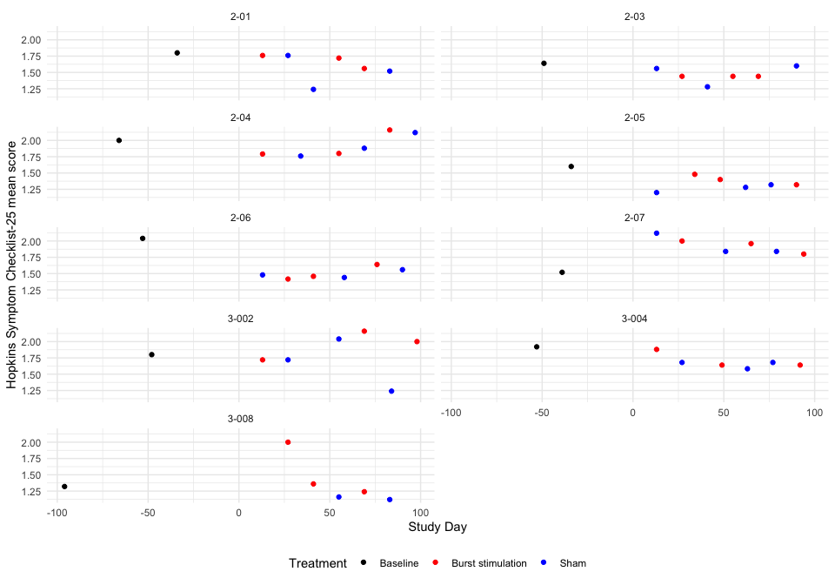 ### Descriptive table

| Full analysis set | | | | | | | |
| --- | --- | --- | --- | --- | --- | --- | --- |
| Hopkins Symptom Checklist-25 mean score | | | | | | | |
|  | **Baseline** | **Pair 1** | | **Pair 2** | | **Pair 3** | |
|  | **Baseline** | **Burst stimulation** | **Sham** | **Burst stimulation** | **Sham** | **Burst stimulation** | **Sham** |
| **2-01** |  |  |  |  |  |  |  |
|  | 1.8 | 1.76 | 1.76 | 1.72 | 1.24 | 1.56 | 1.52 |
| **2-03** |  |  |  |  |  |  |  |
|  | 1.64 | 1.44 | 1.56 | 1.44 | 1.28 | 1.44 | 1.6 |
| **2-04** |  |  |  |  |  |  |  |
|  | 2 | 1.79166666666667 | 1.76 | 1.8 | 1.88 | 2.16 | 2.12 |
| **2-05** |  |  |  |  |  |  |  |
|  | 1.6 | 1.48 | 1.2 | 1.4 | 1.28 | 1.32 | 1.32 |
| **2-06** |  |  |  |  |  |  |  |
|  | 2.04 | 1.41666666666667 | 1.48 | 1.45833333333333 | 1.44 | 1.64 | 1.56 |
| **2-07** |  |  |  |  |  |  |  |
|  | 1.52 | 2 | 2.12 | 1.96 | 1.84 | 1.8 | 1.84 |
| **3-002** |  |  |  |  |  |  |  |
|  | 1.8 | 1.72 | 1.72 | 2.16 | 2.04 | 2 | 1.24 |
| **3-004** |  |  |  |  |  |  |  |
|  | 1.92 | 1.88 | 1.68 | 1.64 | 1.58333333333333 | 1.64 | 1.68 |
| **3-008** |  |  |  |  |  |  |  |
|  | 1.32 | 2 | NA | 1.36 | 1.16 | 1.24 | 1.12 |

### Hypothesis test

Hopkins Symptom Checklist-25 mean score

| Subject ID | Difference Pair 1 | Difference Pair 2 | Difference Pair 3 | Overall difference |
| --- | --- | --- | --- | --- |
| 2-01 | 0.000 | 0.480 | 0.04 | 0.173 |
| 2-03 | -0.120 | 0.160 | -0.16 | -0.040 |
| 2-04 | 0.032 | -0.080 | 0.04 | -0.003 |
| 2-05 | 0.280 | 0.120 | 0.00 | 0.133 |
| 2-06 | -0.063 | 0.018 | 0.08 | 0.012 |
| 2-07 | -0.120 | 0.120 | -0.04 | -0.013 |
| 3-002 | 0.000 | 0.120 | 0.76 | 0.293 |
| 3-004 | 0.200 | 0.057 | -0.04 | 0.072 |
| 3-008 | NaN | 0.200 | 0.12 | 0.160 |

Values are Burst stimulation - Sham.

P-value of the null hypothesis test: 0.036.

### Treatment effect estimates

QQ-plot

## Warning: For this model type, `marginaleffects` only takes into account the  
## uncertainty in fixed-effect parameters. You can use the `re.form=NA`  
## argument to acknowledge this explicitly and silence this warning.  
## Warning: For this model type, `marginaleffects` only takes into account the  
## uncertainty in fixed-effect parameters. You can use the `re.form=NA`  
## argument to acknowledge this explicitly and silence this warning.  
## Warning: For this model type, `marginaleffects` only takes into account the  
## uncertainty in fixed-effect parameters. You can use the `re.form=NA`  
## argument to acknowledge this explicitly and silence this warning.

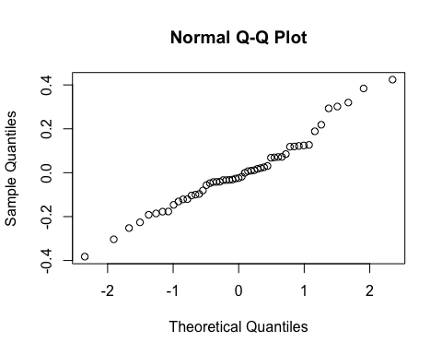

By subject

| Subject ID | Estimate | Std. Err. | p-value | Lower CL | Upper CL |
| --- | --- | --- | --- | --- | --- |
| 2-01 | 0.158 | 0.112 | 0.158 | -0.062 | 0.378 |
| 2-03 | -0.007 | 0.112 | 0.951 | -0.227 | 0.213 |
| 2-04 | 0.022 | 0.112 | 0.845 | -0.198 | 0.242 |
| 2-05 | 0.127 | 0.112 | 0.257 | -0.093 | 0.347 |
| 2-06 | 0.033 | 0.112 | 0.768 | -0.187 | 0.253 |
| 2-07 | 0.014 | 0.112 | 0.903 | -0.206 | 0.233 |
| 3-002 | 0.251 | 0.112 | 0.025 | 0.031 | 0.471 |
| 3-004 | 0.080 | 0.112 | 0.476 | -0.140 | 0.300 |
| 3-008 | 0.277 | 0.112 | 0.014 | 0.057 | 0.497 |

By treatment and overall

| Treatment | Estimate | Std. Err. | p-value | Lower CL | Upper CL |
| --- | --- | --- | --- | --- | --- |
| Sham | 1.573 | 0.079 | 0 | 1.418 | 1.729 |
| Burst stimulation | 1.676 | 0.079 | 0 | 1.521 | 1.831 |

| Estimate | Std. Err. | p-value | Lower CL | Upper CL |
| --- | --- | --- | --- | --- |
| 0.103 | 0.112 | 0.359 | -0.117 | 0.323 |

## Carry over effect

First fit the model:

## Linear mixed model fit by REML ['lmerMod']  
## Formula:   
## painleg3 ~ rantrt + pair + prevtrt + prevtrt:rantrt + (1 | subjectid) +   
## (1 | subjectid:pair) + (1 | subjectid:rantrt)  
## Data: data  
##   
## REML criterion at convergence: 1233.7  
##   
## Scaled residuals:   
## Min 1Q Median 3Q Max   
## -3.5267 -0.5314 -0.0363 0.5708 3.0218   
##   
## Random effects:  
## Groups Name Variance Std.Dev.  
## subjectid:pair (Intercept) 0.6485 0.8053   
## subjectid:rantrt (Intercept) 0.3284 0.5731   
## subjectid (Intercept) 0.4838 0.6956   
## Residual 1.3256 1.1514   
## Number of obs: 370, groups:   
## subjectid:pair, 27; subjectid:rantrt, 18; subjectid, 9  
##   
## Fixed effects:  
## Estimate Std. Error t value  
## (Intercept) 4.24918 0.52934 8.027  
## rantrtSham -0.25410 0.39355 -0.646  
## pairPair 2 -0.55315 0.41566 -1.331  
## pairPair 3 -0.05001 0.41263 -0.121  
## prevtrtSham 0.25622 0.34113 0.751  
## rantrtSham:prevtrtSham -0.06868 0.35044 -0.196  
##   
## Correlation of Fixed Effects:  
## (Intr) rntrtS parPr2 parPr3 prvtrS  
## rantrtSham -0.577   
## pairPair 2 -0.489 0.091   
## pairPair 3 -0.462 0.058 0.516   
## prevtrtSham -0.606 0.625 0.179 0.131   
## rntrtShm:pS 0.384 -0.587 -0.054 -0.018 -0.693

Then plot the expected outcome by current and previous treatment:

## Warning: For this model type, `marginaleffects` only takes into account the  
## uncertainty in fixed-effect parameters. You can use the `re.form=NA`  
## argument to acknowledge this explicitly and silence this warning.

Outcome by tretment and previous treatment

| prevtrt | rantrt | estimate | std.error | statistic | p.value | s.value | conf.low | conf.high | term |
| --- | --- | --- | --- | --- | --- | --- | --- | --- | --- |
| Sham | Sham | 3.983 | 0.393 | 10.138 | 0 | 77.813 | 3.213 | 4.753 | Sham Sham |
| Burst stimulation | Sham | 3.795 | 0.360 | 10.547 | 0 | 83.982 | 3.090 | 4.501 | Burst stimulation Sham |
| Sham | Burst stimulation | 4.311 | 0.354 | 12.173 | 0 | 110.833 | 3.617 | 5.005 | Sham Burst stimulation |
| Burst stimulation | Burst stimulation | 4.055 | 0.446 | 9.091 | 0 | 63.143 | 3.180 | 4.929 | Burst stimulation Burst stimulation |

Then compute the treatment effect estimate by previous treatment:

## Warning: For this model type, `marginaleffects` only takes into account the  
## uncertainty in fixed-effect parameters. You can use the `re.form=NA`  
## argument to acknowledge this explicitly and silence this warning.

| contrast | prevtrt | estimate | std.error | p.value | s.value | conf.low | conf.high |
| --- | --- | --- | --- | --- | --- | --- | --- |
| mean(Sham) - mean(Burst stimulation) | Burst stimulation | -0.259 | 0.394 | 0.510 | 0.972 | -1.031 | 0.512 |
| mean(Sham) - mean(Burst stimulation) | Sham | -0.328 | 0.340 | 0.335 | 1.579 | -0.995 | 0.339 |

Finally see if there is a difference:

## Warning: For this model type, `marginaleffects` only takes into account the  
## uncertainty in fixed-effect parameters. You can use the `re.form=NA`  
## argument to acknowledge this explicitly and silence this warning.  
## Warning: For this model type, `marginaleffects` only takes into account the  
## uncertainty in fixed-effect parameters. You can use the `re.form=NA`  
## argument to acknowledge this explicitly and silence this warning.  
## Warning: For this model type, `marginaleffects` only takes into account the  
## uncertainty in fixed-effect parameters. You can use the `re.form=NA`  
## argument to acknowledge this explicitly and silence this warning.

| estimate | std.error | p.value | s.value | conf.low | conf.high |
| --- | --- | --- | --- | --- | --- |
| 0.069 | 0.35 | 0.845 | 0.244 | -0.618 | 0.756 |

# Safety Analysis

| Site name | Subject Id | Date of informed consent | Gender | Alder | Date of first randomisation |  | Full Analysis Set? | Dato for oppstått komplikasjon | Beskrivelse av komplikasjon | Annet |
| --- | --- | --- | --- | --- | --- | --- | --- | --- | --- | --- |
| OUS | 2-01 | 2021-02-18 | Female | 66 | 2021-03-25 | TRUE | TRUE | 2021-04-22 | Tråkket over 14.5, ankelbrudd høyre (Weber A), behandles konservativt, ikke brukt analgetika, oppfattes ikke relatert til ryggmargsstimulering. Hun er deltaker i studien pga. smerter i venstre underekstremitet. | Oppfattes ikke studierelatert |
| OUS | 2-03 | 2021-03-18 | Male | 38 | 2021-05-06 | TRUE | TRUE | 2021-05-06 | Moderate smerter over IPG som ikke påvirker funksjon. Fikk Versatisplaster. | NA |
| OUS | 2-07 | 2021-09-30 | Female | 50 | 2021-11-26 | TRUE | TRUE | 2021-11-12 | Smerter i relasjon til IPG, dette påvirker hennes funksjonsskåringer, utsetter derfor oppstart av burst/sham i to uker | NA |
| OUS | 2-08 | 2022-02-03 | Female | 49 | NA | FALSE | FALSE | 2022-03-17 | Signifikant elektrode-dislokasjon | Signifikant elektrode-dislokasjon, må ekskluderes fra studien |
| Akademiska | 3-003 | 2022-05-10 | Female | 56 | 2022-07-04 | TRUE | FALSE | 2022-07-04 | Ved Kontroll 1 ser man att elektroden har migrerat 2 hela segment kranielt, så att den nu ligger med spetsen/pol 1 vid kraniella delen av Th7. Ingen elektrod över Th9/10, således exklusion. | Elektrod-migration. |
| Akademiska | 3-004 | 2022-05-11 | Male | 55 | 2022-07-04 | TRUE | TRUE | 2022-07-19 | COVID konstaterad 19/7. Lindriga symtom i 3 dagar. | Lindrig COVID 19-21/7. |
| Akademiska | 3-007 | 2022-10-18 | Female | 57 | 2023-01-03 | TRUE | FALSE | 2023-01-03 | Elektrodmigration, ej möjligt att stimulera målområde Th9/10. Således eksklusion. | Elektrodemigration. |

# Parathesia Coverage

| Site | Subject ID | Parathesia Coverage Leg | Parathesia Coverage Back |
| --- | --- | --- | --- |
| OUS | 2-01 | 100% | 0% |
| OUS | 2-03 | 1-24% | 0% |
| OUS | 2-04 | 100% | 25-49% |
| OUS | 2-05 | 100% | 75-99% |
| OUS | 2-06 | 100% | Ikke relevant |
| OUS | 2-07 | 100% | 0% |
| Akademiska | 3-002 | 100% | 0% |
| Akademiska | 3-004 | 75-99% | 0% |
| Akademiska | 3-008 | 100% | 1-24% |

# Listings

## Analgetica

| Subject | Studyday | Treatment | Period | Pair | Changed analgetica since last control? | Specify | Changed analgetica last 7 days | Specify | Any other use of analgetica last 7 days? | Specify |
| --- | --- | --- | --- | --- | --- | --- | --- | --- | --- | --- |
| 2-01 | 14 days | Burst stimulation | 1 | Pair 1 | Nei | NA | Nei | NA | Nei | NA |
| 2-01 | 28 days | Sham | 2 | Pair 1 | Nei | NA | Nei | NA | Nei | NA |
| 2-01 | 42 days | Sham | 3 | Pair 2 | Nei | NA | Nei | NA | Nei | NA |
| 2-01 | 56 days | Burst stimulation | 4 | Pair 2 | Nei | NA | Nei | NA | Nei | NA |
| 2-01 | 70 days | Burst stimulation | 5 | Pair 3 | Nei | NA | Nei | NA | Ja | Nobligan 50 mg, men ikke i måleperioden |
| 2-01 | 84 days | Sham | 6 | Pair 3 | Nei | NA | Nei | NA | Nei | NA |
| 2-03 | 14 days | Sham | 1 | Pair 1 | Nei | NA | Nei | NA | Nei | NA |
| 2-03 | 28 days | Burst stimulation | 2 | Pair 1 | Nei | NA | Nei | NA | Nei | NA |
| 2-03 | 42 days | Sham | 3 | Pair 2 | Nei | NA | Nei | NA | Ja | Ibux pga hodepine 14/6 |
| 2-03 | 56 days | Burst stimulation | 4 | Pair 2 | Nei | NA | Nei | NA | Nei | NA |
| 2-03 | 77 days | Burst stimulation | 5 | Pair 3 | Nei | NA | Nei | NA | Ja | Ibux x3 én dag for hodepine under spørreskjemautfylling |
| 2-03 | 92 days | Sham | 6 | Pair 3 | Nei | NA | Nei | NA | Nei | NA |
| 2-04 | 21 days | Burst stimulation | 1 | Pair 1 | Nei | NA | Nei | NA | Nei | NA |
| 2-04 | 42 days | Sham | 2 | Pair 1 | Nei | NA | Nei | NA | Ja | Typisk 1 Pinex forte noen dager under måle perioden. |
| 2-04 | 56 days | Burst stimulation | 3 | Pair 2 | Nei | NA | Nei | NA | Nei | NA |
| 2-04 | 70 days | Sham | 4 | Pair 2 | Nei | NA | Nei | NA | Nei | NA |
| 2-04 | 84 days | Burst stimulation | 5 | Pair 3 | Nei | NA | Nei | NA | Ja | Pinex Forte, ettermidag kveld 3 av måletidspunkter |
| 2-04 | 105 days | Sham | 6 | Pair 3 | Nei | NA | Nei | NA | Nei | NA |
| 2-05 | 21 days | Sham | 1 | Pair 1 | Nei | NA | Nei | NA | Nei | NA |
| 2-05 | 35 days | Burst stimulation | 2 | Pair 1 | Nei | NA | Nei | NA | Ja | 1 g paracetamol ekstra på kvelden halvparten av siste 7 måledager |
| 2-05 | 49 days | Burst stimulation | 3 | Pair 2 | Nei | NA | Nei | NA | Nei | NA |
| 2-05 | 63 days | Sham | 4 | Pair 2 | Nei | NA | Nei | NA | Nei | NA |
| 2-05 | 77 days | Sham | 5 | Pair 3 | Nei | NA | Nei | NA | Nei | NA |
| 2-05 | 91 days | Burst stimulation | 6 | Pair 3 | Nei | NA | Nei | NA | Nei | NA |
| 2-06 | 14 days | Sham | 1 | Pair 1 | Nei | NA | Nei | NA | Nei | NA |
| 2-06 | 28 days | Burst stimulation | 2 | Pair 1 | Nei | NA | Nei | NA | Nei | NA |
| 2-06 | 45 days | Burst stimulation | 3 | Pair 2 | Nei | NA | Nei | NA | Nei | NA |
| 2-06 | 63 days | Sham | 4 | Pair 2 | Nei | NA | Nei | NA | Nei | NA |
| 2-06 | 77 days | Burst stimulation | 5 | Pair 3 | Nei | NA | Nei | NA | Nei | NA |
| 2-06 | 91 days | Sham | 6 | Pair 3 | Nei | NA | Nei | NA | Nei | NA |
| 2-07 | 14 days | Sham | 1 | Pair 1 | Nei | NA | Nei | NA | Nei | NA |
| 2-07 | 38 days | Burst stimulation | 2 | Pair 1 | Nei | NA | Nei | NA | Nei | NA |
| 2-07 | 52 days | Sham | 3 | Pair 2 | Nei | NA | Nei | NA | Ja | Paracet 1gx2 siste tre dager |
| 2-07 | 66 days | Burst stimulation | 4 | Pair 2 | Nei | NA | Nei | NA | Ja | Tramadol fredag 28/1 og lørdag 29/1, Tramadol 50mg |
| 2-07 | 81 days | Sham | 5 | Pair 3 | Nei | NA | Nei | NA | Nei | NA |
| 2-07 | 97 days | Burst stimulation | 6 | Pair 3 | Nei | NA | Nei | NA | Nei | NA |
| 3-002 | 14 days | Burst stimulation | 1 | Pair 1 | Nei | NA | Nei | NA | Nei | NA |
| 3-002 | 42 days | Sham | 2 | Pair 1 | Nei | NA | Nei | NA | Ja | Paracetamol fulldos i v 5 pga av smärta och infektion (COVID). |
| 3-002 | 56 days | Sham | 3 | Pair 2 | Nei | NA | Nei | NA | Ja | Alvedon till kvällen och enstaka Ipren. |
| 3-002 | 71 days | Burst stimulation | 4 | Pair 2 | Nei | NA | Nei | NA | Ja | Ipren og paracetamol daglig. |
| 3-002 | 85 days | Sham | 5 | Pair 3 | Nei | NA | Nei | NA | Ja | Paracetamol x 2 under de senaste 14 dagar, |
| 3-002 | 99 days | Burst stimulation | 6 | Pair 3 | Nei | NA | Nei | NA | Ja | Naproxen 1x2, Alvedon 2x2, 9/4 pga av huvudvärk. |
| 3-004 | 14 days | Burst stimulation | 1 | Pair 1 | Nei | NA | Nei | NA | Ja | Tar som tidigare 2-3 citodon per dag. |
| 3-004 | 36 days | Sham | 2 | Pair 1 | Nei | NA | Ja | Halverat från 4 till ca 2 Citodon per dygn. | Ja | Citodon 2/dag. |
| 3-004 | 50 days | Burst stimulation | 3 | Pair 2 | Nei | NA | Nei | NA | Ja | (1 tablett Citodon + 1 tablett Alvedon 500 mg) x 2 per dag i genomsnitt under senaste 7 dagar. |
| 3-004 | 64 days | Sham | 4 | Pair 2 | Nei | NA | Nei | NA | Nei | NA |
| 3-004 | 79 days | Sham | 5 | Pair 3 | Nei | NA | Nei | NA | Ja | Citodon 1,5 g och Alvedon 1,5 g per dag senaste 2 veckor. |
| 3-004 | 94 days | Burst stimulation | 6 | Pair 3 | Nei | NA | Nei | NA | Ja | Citodon upp till 1,5 g/dygn |
| 3-008 | 14 days | Sham | 1 | Pair 1 | Nei | NA | Nei | NA | Ja | Paracetamol vid två tillfällen senaset 14 dagar. |
| 3-008 | 28 days | Burst stimulation | 2 | Pair 1 | Nei | NA | Nei | NA | Ja | Alvedon vb vid två tillfällen. |
| 3-008 | 42 days | Burst stimulation | 3 | Pair 2 | Nei | NA | Nei | NA | Nei | NA |
| 3-008 | 56 days | Sham | 4 | Pair 2 | Nei | NA | Nei | NA | Nei | NA |
| 3-008 | 70 days | Burst stimulation | 5 | Pair 3 | Nei | NA | Nei | NA | Ja | Paracetamol 1g vid två tillfällen senaste 7 dagar. |
| 3-008 | 84 days | Sham | 6 | Pair 3 | Nei | NA | Nei | NA | Nei | NA |

## Adverse reactions to the stimulation

| Subject | Studyday | Treatment | Period | Pair | Any adverse reactions last 14 days? | Specify |
| --- | --- | --- | --- | --- | --- | --- |
| 2-01 | 14 days | Burst stimulation | 1 | Pair 1 | Nei | NA |
| 2-01 | 28 days | Sham | 2 | Pair 1 | Nei | NA |
| 2-01 | 42 days | Sham | 3 | Pair 2 | Nei | NA |
| 2-01 | 56 days | Burst stimulation | 4 | Pair 2 | Ja | Ny sensasjon . Endret kuldefølelse i beinet. |
| 2-01 | 70 days | Burst stimulation | 5 | Pair 3 | Nei | NA |
| 2-01 | 84 days | Sham | 6 | Pair 3 | Nei | NA |
| 2-03 | 14 days | Sham | 1 | Pair 1 | Nei | NA |
| 2-03 | 28 days | Burst stimulation | 2 | Pair 1 | Nei | NA |
| 2-03 | 42 days | Sham | 3 | Pair 2 | Nei | NA |
| 2-03 | 56 days | Burst stimulation | 4 | Pair 2 | Nei | NA |
| 2-03 | 77 days | Burst stimulation | 5 | Pair 3 | Ja | Kløe over ene hjørnet av IPG, nedre hjørne, medialt. Ingen infeksjonstegn |
| 2-03 | 92 days | Sham | 6 | Pair 3 | Ja | kløe rundt generator |
| 2-04 | 21 days | Burst stimulation | 1 | Pair 1 | Nei | NA |
| 2-04 | 42 days | Sham | 2 | Pair 1 | Nei | NA |
| 2-04 | 56 days | Burst stimulation | 3 | Pair 2 | Nei | NA |
| 2-04 | 70 days | Sham | 4 | Pair 2 | Nei | NA |
| 2-04 | 84 days | Burst stimulation | 5 | Pair 3 | Nei | NA |
| 2-04 | 105 days | Sham | 6 | Pair 3 | Nei | NA |
| 2-05 | 21 days | Sham | 1 | Pair 1 | Ja | Stikker litt over kanten av IPGen |
| 2-05 | 35 days | Burst stimulation | 2 | Pair 1 | Nei | NA |
| 2-05 | 49 days | Burst stimulation | 3 | Pair 2 | Nei | NA |
| 2-05 | 63 days | Sham | 4 | Pair 2 | Nei | NA |
| 2-05 | 77 days | Sham | 5 | Pair 3 | Nei | NA |
| 2-05 | 91 days | Burst stimulation | 6 | Pair 3 | Nei | NA |
| 2-06 | 14 days | Sham | 1 | Pair 1 | Nei | NA |
| 2-06 | 28 days | Burst stimulation | 2 | Pair 1 | Nei | NA |
| 2-06 | 45 days | Burst stimulation | 3 | Pair 2 | Nei | NA |
| 2-06 | 63 days | Sham | 4 | Pair 2 | Nei | NA |
| 2-06 | 77 days | Burst stimulation | 5 | Pair 3 | Nei | NA |
| 2-06 | 91 days | Sham | 6 | Pair 3 | Nei | NA |
| 2-07 | 14 days | Sham | 1 | Pair 1 | Nei | NA |
| 2-07 | 38 days | Burst stimulation | 2 | Pair 1 | Nei | NA |
| 2-07 | 52 days | Sham | 3 | Pair 2 | Nei | NA |
| 2-07 | 66 days | Burst stimulation | 4 | Pair 2 | Nei | NA |
| 2-07 | 81 days | Sham | 5 | Pair 3 | Nei | NA |
| 2-07 | 97 days | Burst stimulation | 6 | Pair 3 | Nei | NA |
| 3-002 | 14 days | Burst stimulation | 1 | Pair 1 | Ja | Obehag över dosfickan i ett par dagar (för ca 7 dagar sedan, |
| 3-002 | 42 days | Sham | 2 | Pair 1 | Nei | NA |
| 3-002 | 56 days | Sham | 3 | Pair 2 | Nei | NA |
| 3-002 | 71 days | Burst stimulation | 4 | Pair 2 | Nei | NA |
| 3-002 | 85 days | Sham | 5 | Pair 3 | Nei | NA |
| 3-002 | 99 days | Burst stimulation | 6 | Pair 3 | Nei | NA |
| 3-004 | 14 days | Burst stimulation | 1 | Pair 1 | Nei | NA |
| 3-004 | 36 days | Sham | 2 | Pair 1 | Ja | Lätt sveda över IPG-fickan. |
| 3-004 | 50 days | Burst stimulation | 3 | Pair 2 | Nei | NA |
| 3-004 | 64 days | Sham | 4 | Pair 2 | Ja | Möjligt att kramper är relaterat till stimulering? Viss ömhet över IPG fortfarande. |
| 3-004 | 79 days | Sham | 5 | Pair 3 | Nei | NA |
| 3-004 | 94 days | Burst stimulation | 6 | Pair 3 | Ja | Smärta/obehag vid beröring av IPG. |
| 3-008 | 14 days | Sham | 1 | Pair 1 | Nei | NA |
| 3-008 | 28 days | Burst stimulation | 2 | Pair 1 | Nei | NA |
| 3-008 | 42 days | Burst stimulation | 3 | Pair 2 | Nei | NA |
| 3-008 | 56 days | Sham | 4 | Pair 2 | Nei | NA |
| 3-008 | 70 days | Burst stimulation | 5 | Pair 3 | Nei | NA |
| 3-008 | 84 days | Sham | 6 | Pair 3 | Nei | NA |

## Technical problems

| Subject | Studyday | Treatment | Period | Pair | Any technical problems last 14 days? | Specify |
| --- | --- | --- | --- | --- | --- | --- |
| 2-01 | 14 days | Burst stimulation | 1 | Pair 1 | Nei | NA |
| 2-01 | 28 days | Sham | 2 | Pair 1 | Nei | NA |
| 2-01 | 42 days | Sham | 3 | Pair 2 | Nei | NA |
| 2-01 | 56 days | Burst stimulation | 4 | Pair 2 | Nei | NA |
| 2-01 | 70 days | Burst stimulation | 5 | Pair 3 | Nei | NA |
| 2-01 | 84 days | Sham | 6 | Pair 3 | Nei | NA |
| 2-03 | 14 days | Sham | 1 | Pair 1 | Nei | NA |
| 2-03 | 28 days | Burst stimulation | 2 | Pair 1 | Ja | Butikkalarm gikk av én gang, ikke andre ganger. |
| 2-03 | 42 days | Sham | 3 | Pair 2 | Ja | Kom borti strømgjere ved et uhell, kjente ekstra sterk støt. Lurer på om det kan ha hatt noe med stimulatoren å gjøre |
| 2-03 | 56 days | Burst stimulation | 4 | Pair 2 | Nei | NA |
| 2-03 | 77 days | Burst stimulation | 5 | Pair 3 | Nei | NA |
| 2-03 | 92 days | Sham | 6 | Pair 3 | Nei | NA |
| 2-04 | 21 days | Burst stimulation | 1 | Pair 1 | Nei | NA |
| 2-04 | 42 days | Sham | 2 | Pair 1 | Nei | NA |
| 2-04 | 56 days | Burst stimulation | 3 | Pair 2 | Nei | NA |
| 2-04 | 70 days | Sham | 4 | Pair 2 | Nei | NA |
| 2-04 | 84 days | Burst stimulation | 5 | Pair 3 | Nei | NA |
| 2-04 | 105 days | Sham | 6 | Pair 3 | Nei | NA |
| 2-05 | 21 days | Sham | 1 | Pair 1 | Nei | NA |
| 2-05 | 35 days | Burst stimulation | 2 | Pair 1 | Nei | NA |
| 2-05 | 49 days | Burst stimulation | 3 | Pair 2 | Nei | NA |
| 2-05 | 63 days | Sham | 4 | Pair 2 | Nei | NA |
| 2-05 | 77 days | Sham | 5 | Pair 3 | Nei | NA |
| 2-05 | 91 days | Burst stimulation | 6 | Pair 3 | Nei | NA |
| 2-06 | 14 days | Sham | 1 | Pair 1 | Nei | NA |
| 2-06 | 28 days | Burst stimulation | 2 | Pair 1 | Nei | NA |
| 2-06 | 45 days | Burst stimulation | 3 | Pair 2 | Nei | NA |
| 2-06 | 63 days | Sham | 4 | Pair 2 | Nei | NA |
| 2-06 | 77 days | Burst stimulation | 5 | Pair 3 | Nei | NA |
| 2-06 | 91 days | Sham | 6 | Pair 3 | Nei | NA |
| 2-07 | 14 days | Sham | 1 | Pair 1 | Nei | NA |
| 2-07 | 38 days | Burst stimulation | 2 | Pair 1 | Nei | NA |
| 2-07 | 52 days | Sham | 3 | Pair 2 | Nei | NA |
| 2-07 | 66 days | Burst stimulation | 4 | Pair 2 | Nei | NA |
| 2-07 | 81 days | Sham | 5 | Pair 3 | Nei | NA |
| 2-07 | 97 days | Burst stimulation | 6 | Pair 3 | Nei | NA |
| 3-002 | 14 days | Burst stimulation | 1 | Pair 1 | Nei | NA |
| 3-002 | 42 days | Sham | 2 | Pair 1 | Nei | NA |
| 3-002 | 56 days | Sham | 3 | Pair 2 | Nei | NA |
| 3-002 | 71 days | Burst stimulation | 4 | Pair 2 | Nei | NA |
| 3-002 | 85 days | Sham | 5 | Pair 3 | Nei | NA |
| 3-002 | 99 days | Burst stimulation | 6 | Pair 3 | Nei | NA |
| 3-004 | 14 days | Burst stimulation | 1 | Pair 1 | Nei | NA |
| 3-004 | 36 days | Sham | 2 | Pair 1 | Nei | NA |
| 3-004 | 50 days | Burst stimulation | 3 | Pair 2 | Nei | NA |
| 3-004 | 64 days | Sham | 4 | Pair 2 | Nei | NA |
| 3-004 | 79 days | Sham | 5 | Pair 3 | Nei | NA |
| 3-004 | 94 days | Burst stimulation | 6 | Pair 3 | Nei | NA |
| 3-008 | 14 days | Sham | 1 | Pair 1 | Nei | NA |
| 3-008 | 28 days | Burst stimulation | 2 | Pair 1 | Nei | NA |
| 3-008 | 42 days | Burst stimulation | 3 | Pair 2 | Nei | NA |
| 3-008 | 56 days | Sham | 4 | Pair 2 | Nei | NA |
| 3-008 | 70 days | Burst stimulation | 5 | Pair 3 | Nei | NA |
| 3-008 | 84 days | Sham | 6 | Pair 3 | Nei | NA |

# Suppementary Materials

| x |
| --- |
| Arel-Bundock V (2024). *marginaleffects: Predictions, Comparisons, Slopes, Marginal Means, and Hypothesis Tests*. R package version 0.20.0, <https://CRAN.R-project.org/package=marginaleffects>. |
| Bache S, Wickham H (2022). *magrittr: A Forward-Pipe Operator for R*. R package version 2.0.3, <https://CRAN.R-project.org/package=magrittr>. |
| Bates D, Mächler M, Bolker B, Walker S (2015). “Fitting Linear Mixed-Effects Models Using lme4.” *Journal of Statistical Software*, *67*(1), 1-48. <doi:10.18637/jss.v067.i01> <https://doi.org/10.18637/jss.v067.i01>. |
| Bates D, Maechler M, Jagan M (2024). *Matrix: Sparse and Dense Matrix Classes and Methods*. R package version 1.7-0, <https://CRAN.R-project.org/package=Matrix>. |
| Becker G, Waddell A (2024). *formatters: ASCII Formatting for Values and Tables*. R package version 0.5.6, <https://CRAN.R-project.org/package=formatters>. |
| Becker G, Waddell A (2024). *rtables: Reporting Tables*. R package version 0.6.7, <https://CRAN.R-project.org/package=rtables>. |
| Gohel D, Skintzos P (2024). *flextable: Functions for Tabular Reporting*. R package version 0.9.6, <https://CRAN.R-project.org/package=flextable>. |
| Grolemund G, Wickham H (2011). “Dates and Times Made Easy with lubridate.” *Journal of Statistical Software*, *40*(3), 1-25. <https://www.jstatsoft.org/v40/i03/>. |
| Henry L, Wickham H (2024). *rlang: Functions for Base Types and Core R and ‘Tidyverse’ Features*. R package version 1.1.3, <https://CRAN.R-project.org/package=rlang>. |
| Hester J, Bryan J (2024). *glue: Interpreted String Literals*. R package version 1.7.0, <https://CRAN.R-project.org/package=glue>. |
| Larmarange J (2024). *labelled: Manipulating Labelled Data*. R package version 2.13.0, <https://CRAN.R-project.org/package=labelled>. |
| Müller K, Wickham H (2023). *tibble: Simple Data Frames*. R package version 3.2.1, <https://CRAN.R-project.org/package=tibble>. |
| R Core Team (2024). *R: A Language and Environment for Statistical Computing*. R Foundation for Statistical Computing, Vienna, Austria. <https://www.R-project.org/>. |
| Ram K, Wickham H (2023). *wesanderson: A Wes Anderson Palette Generator*. R package version 0.3.7, <https://CRAN.R-project.org/package=wesanderson>. |
| Wickham H (2016). *ggplot2: Elegant Graphics for Data Analysis*. Springer-Verlag New York. ISBN 978-3-319-24277-4, <https://ggplot2.tidyverse.org>. |
| Wickham H (2023). *forcats: Tools for Working with Categorical Variables (Factors)*. R package version 1.0.0, <https://CRAN.R-project.org/package=forcats>. |
| Wickham H (2023). *stringr: Simple, Consistent Wrappers for Common String Operations*. R package version 1.5.1, <https://CRAN.R-project.org/package=stringr>. |
| Wickham H, Averick M, Bryan J, Chang W, McGowan LD, François R, Grolemund G, Hayes A, Henry L, Hester J, Kuhn M, Pedersen TL, Miller E, Bache SM, Müller K, Ooms J, Robinson D, Seidel DP, Spinu V, Takahashi K, Vaughan D, Wilke C, Woo K, Yutani H (2019). “Welcome to the tidyverse.” *Journal of Open Source Software*, *4*(43), 1686. <doi:10.21105/joss.01686> <https://doi.org/10.21105/joss.01686>. |
| Wickham H, François R, Henry L, Müller K, Vaughan D (2023). *dplyr: A Grammar of Data Manipulation*. R package version 1.1.4, <https://CRAN.R-project.org/package=dplyr>. |
| Wickham H, Henry L (2023). *purrr: Functional Programming Tools*. R package version 1.0.2, <https://CRAN.R-project.org/package=purrr>. |
| Wickham H, Hester J, Bryan J (2024). *readr: Read Rectangular Text Data*. R package version 2.1.5, <https://CRAN.R-project.org/package=readr>. |
| Wickham H, Vaughan D, Girlich M (2024). *tidyr: Tidy Messy Data*. R package version 1.3.1, <https://CRAN.R-project.org/package=tidyr>. |
| Xie Y (2024). *knitr: A General-Purpose Package for Dynamic Report Generation in R*. R package version 1.46, <https://yihui.org/knitr/>. Xie Y (2015). *Dynamic Documents with R and knitr*, 2nd edition. Chapman and Hall/CRC, Boca Raton, Florida. ISBN 978-1498716963, <https://yihui.org/knitr/>. Xie Y (2014). “knitr: A Comprehensive Tool for Reproducible Research in R.” In Stodden V, Leisch F, Peng RD (eds.), *Implementing Reproducible Computational Research*. Chapman and Hall/CRC. ISBN 978-1466561595. |