Burst Statistical Report

# Introduction

This is the report for the first interim analysis of the NOR-SOLIDARITY trial. The data are based on an export from the Viedoc electronic data capture at “2020-10-16 08:41:09” system time stamped “ous_20201016_084109”. While the results are based on real data, the treatment allocation has been drawn randomly for this report. Thus, this is a mock-up report intended to show how the final report will look like, without showing the actual results of the trial and the treatment differences. There were 181 included patients.

# Inclusion status

## Inclusion rate

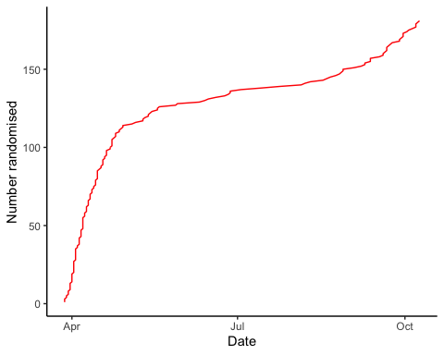

## Inclusion by hospital

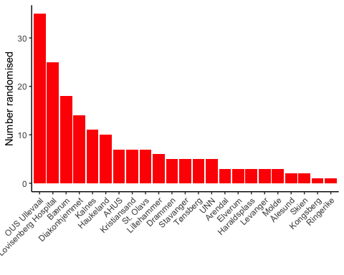

## By treatment

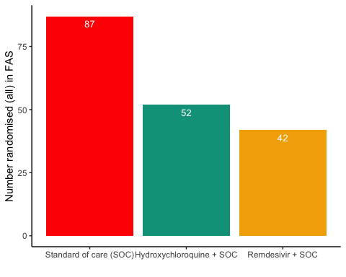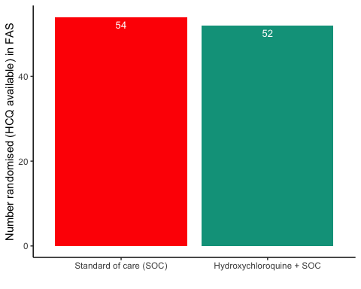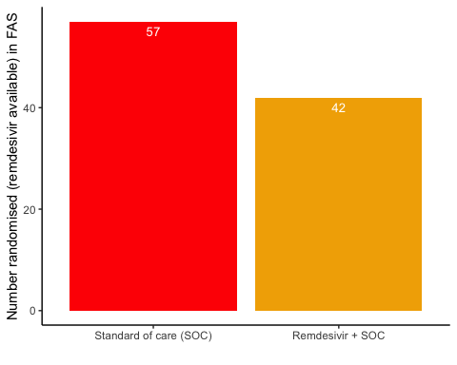

# Patient flow

## Note: Using an external vector in selections is ambiguous.  
## ℹ Use `all_of(group)` instead of `group` to silence this message.  
## ℹ See <https://tidyselect.r-lib.org/reference/faq-external-vector.html>.  
## This message is displayed once per session.

Patient flow total

|  |  |
| --- | --- |
| Parameter | Total |
| Enrolled | 186 (100%) |
| Randomised | 185 (99.5%) |
| Included in FAS | 181 (97.3%) |
| Excluded from FAS, No post-randomisation information | 4 (2.2%) |
| Excluded from FAS, incorrect inclusion | 1 (0.5%) |

Patient flow by arm

|  |  |  |  |
| --- | --- | --- | --- |
| Parameter | SOC | SOC + HCQ | SOC + Remdesivir |
| Randomised | 88 (100%) | 54 (100%) | 43 (100%) |
| Included in FAS | 87 (98.9%) | 52 (96.3%) | 42 (97.7%) |
| Excluded from FAS, No post-randomisation information | 1 (1.1%) | 1 (1.9%) | 1 (2.3%) |
| Excluded from FAS, incorrect inclusion | 0 (0%) | 1 (1.9%) | 0 (0%) |

Patient flow during study (FAS)

|  |  |  |  |  |
| --- | --- | --- | --- | --- |
| Reason | Standard of care (SOC) | Hydroxychloroquine + SOC | Remdesivir + SOC | Total |
| Voluntary discontinuation by the patient | 3 | 3 | 1 | 7 |
| Patient lost to follow-up | 2 | 2 | 2 | 6 |
| Death | 5 | 5 | 2 | 12 |
| Other | 5 | 0 | 1 | 6 |
| Completed | 72 | 42 | 36 | 150 |

# Demographics

Demographics, all patients (FAS)

|  |  |
| --- | --- |
| Parameter | All patients (N=181) |
| **Demographics** |  |
| Age (years) | 59.8 (15.3) |
| Female, n (%) | 62 (34.3%) |
| Body Mass Index (kg/m2) | 28 (5) |
| Body Mass Index (kg/m2) | 27 (25 - 31) |
| Symptoms prior to admission (days) | 8 (4.9) |
| P/F-ratio at admittance (kPa) | 41 (13) |
| P/F-ratio < 40kPa, n (%) | 77 (43%) |
| Temperature (°C) | 37.4 (0.9) |
| Admitted to ward, n(%) | 171 (94.5%) |
| Admitted to ICU, n(%) | 10 (5.5%) |
| WHO Moderate disease state (4-5), n(%) | 171 (94.5%) |
| WHO Severe disease state (6-9), n(%) | 10 (5.5%) |
| WHO Severe disease state (6), n(%) | 5 (2.8%) |
| WHO Severe disease state (5), n(%) | 90 (49.7%) |
| **Comorbidities** |  |
| Chronic cardiac disease, including congenital heart disease | 28 (15.6%) |
| Chronic pulmonary disease, n(%) | 10 (5.6%) |
| Ever smoking, n(%) | 71 (39.4%) |
| Hypertension, n(%) | 55 (30.6%) |
| Diabetes, n(%) | 31 (17.2%) |
| Obese (BMI > 30 kg/m2), n(%) | 44 (26.8%) |
| **Co-medications** |  |
| Steroids | 8 (4.5%) |
| Other immunomodulatory drugs | 8 (4.5%) |
| ACE inhibitor | 12 (6.7%) |
| AT-II blockers | 30 (16.8%) |
| **Hematology** |  |
| Hemoglobin (g/dL) | 13.2 (12.3 - 14.1) |
| WBC (x109/L) | 6.2 (4.7 - 8.7) |
| Neutrophils (x109/L) | 4.3 (3 - 6.6) |
| Lymphocytes (x109/L) | 1.1 (0.8 - 1.4) |
| Platelet counts (x10^9/L) | 202.5 (158.5 - 270.5) |
| **Inflammatory markers** |  |
| CRP (mg/L) | 70 (36.5 - 137.5) |
| Procalcitonin (µg/L) | 0.12 (0.1 - 0.21) |
| Ferritin (µg/L) | 613 (319 - 1173) |
| **Other** |  |
| LDH (U/L) | 277 (214 - 360) |
| D-dimer (mg/L FEU) | 0.68 (0.45 - 1.12) |
| AST | 39 (27.2 - 59) |
| ALT | 33 (20 - 58) |
| eGFR (mL/min/1.73 m2) | 89.7 (74.2 - 105.5) |
| **Viral count** |  |
| Viral count (log10 counts/1000 cells) | 2 (1.6) |
| **Anti-SARS-CoV-2 Antibodies** |  |
| Zero converted (RBD ≤ 5) | 67 (52.8%) |
| **Supplementary baseline information** |  |
| Systolic Blood Pressure (mmHg) | 125 (18) |
| Diastolic Blood Pressure (mmHg) | 74 (11) |
| Mean Arterial Blood Pressure (mmHg) | 91 (12) |
| SOFA score | 1.6 (1.6) |
| Chronic kidney disease, n(%) | 11 (6.1%) |
| Autoimmune disease, n(%) | 8 (4.4%) |
| Cognitive impairment/dementia, n(%) | 4 (2.2%) |
| Neurological disorder, n(%) | 7 (3.9%) |
| Cancer, n(%) | 13 (7.2%) |
| Cirrhosis, n(%) | 0 (0%) |
| Asthma, n(%) | 22 (12.2%) |
| HIV, n(%) | 0 (0%) |
| Active TB, n(%) | 0 (0%) |
| Note, all percentages are given with observed values in the denominator, missing values discarded |  |

Demographics, all arms (FAS)

|  |  |  |  |
| --- | --- | --- | --- |
| Parameter | SOC (N=87) | SOC + HCQ (N=52) | SOC + Remdesivir (N=42) |
| **Demographics** |  |  |  |
| Age (years) | 59.2 (16.2) | 59.4 (13.4) | 61.4 (16.1) |
| Female, n (%) | 34 (39.1%) | 15 (28.8%) | 13 (31%) |
| Body Mass Index (kg/m2) | 28 (5) | 28 (4) | 28 (5) |
| Body Mass Index (kg/m2) | 28 (24 - 32) | 27 (25 - 30) | 27 (25 - 30) |
| Symptoms prior to admission (days) | 8.4 (6) | 7.5 (4) | 7.9 (3.2) |
| P/F-ratio at admittance (kPa) | 40 (13) | 40 (15) | 44 (10) |
| P/F-ratio < 40kPa, n (%) | 39 (45.3%) | 25 (48.1%) | 13 (31.7%) |
| Temperature (°C) | 37.4 (0.9) | 37.4 (0.9) | 37.4 (0.9) |
| Admitted to ward, n(%) | 84 (96.6%) | 47 (90.4%) | 40 (95.2%) |
| Admitted to ICU, n(%) | 3 (3.4%) | 5 (9.6%) | 2 (4.8%) |
| WHO Moderate disease state (4-5), n(%) | 84 (96.6%) | 48 (92.3%) | 39 (92.9%) |
| WHO Severe disease state (6-9), n(%) | 3 (3.4%) | 4 (7.7%) | 3 (7.1%) |
| WHO Severe disease state (6), n(%) | 1 (1.1%) | 2 (3.8%) | 2 (4.8%) |
| WHO Severe disease state (5), n(%) | 51 (58.6%) | 25 (48.1%) | 14 (33.3%) |
| **Comorbidities** |  |  |  |
| Chronic cardiac disease, including congenital heart disease | 10 (11.6%) | 9 (17.3%) | 9 (21.4%) |
| Chronic pulmonary disease, n(%) | 6 (7%) | 3 (5.8%) | 1 (2.4%) |
| Ever smoking, n(%) | 34 (39.5%) | 18 (34.6%) | 19 (45.2%) |
| Hypertension, n(%) | 27 (31.4%) | 18 (34.6%) | 10 (23.8%) |
| Diabetes, n(%) | 15 (17.4%) | 13 (25%) | 3 (7.1%) |
| Obese (BMI > 30 kg/m2), n(%) | 24 (30%) | 11 (24.4%) | 9 (23.1%) |
| **Co-medications** |  |  |  |
| Steroids | 3 (3.5%) | 3 (5.9%) | 2 (4.8%) |
| Other immunomodulatory drugs | 5 (5.8%) | 1 (2%) | 2 (4.8%) |
| ACE inhibitor | 4 (4.7%) | 6 (11.8%) | 2 (4.8%) |
| AT-II blockers | 13 (15.1%) | 9 (17.6%) | 8 (19%) |
| **Hematology** |  |  |  |
| Hemoglobin (g/dL) | 13.2 (12.2 - 14) | 13.4 (12.9 - 14.5) | 13.1 (12 - 13.9) |
| WBC (x109/L) | 6.3 (4.8 - 9.1) | 6 (4.6 - 8.2) | 5.8 (4.7 - 7.4) |
| Neutrophils (x109/L) | 4.8 (2.9 - 7) | 4.3 (3.2 - 5.6) | 4 (2.5 - 6.5) |
| Lymphocytes (x109/L) | 1.1 (0.8 - 1.4) | 1 (0.8 - 1.3) | 1 (0.8 - 1.6) |
| Platelet counts (x10^9/L) | 211.5 (161.2 - 286.5) | 186 (158 - 238) | 176 (156 - 279) |
| **Inflammatory markers** |  |  |  |
| CRP (mg/L) | 83 (50 - 152) | 61.5 (31.8 - 112) | 64.5 (29.2 - 129) |
| Procalcitonin (µg/L) | 0.14 (0.1 - 0.24) | 0.1 (0.1 - 0.2) | 0.12 (0.1 - 0.2) |
| Ferritin (µg/L) | 539 (301 - 1109) | 608 (276 - 1103.5) | 677 (442 - 1488) |
| **Other** |  |  |  |
| LDH (U/L) | 271 (209.2 - 353.5) | 275 (220.5 - 367.5) | 287 (214.8 - 361) |
| D-dimer (mg/L FEU) | 0.75 (0.5 - 1.19) | 0.6 (0.41 - 1) | 0.8 (0.44 - 1.04) |
| AST | 38 (28 - 65) | 43 (28 - 52) | 46 (27 - 63.5) |
| ALT | 31 (19 - 67) | 36.5 (22 - 52.5) | 32 (22 - 62.5) |
| eGFR (mL/min/1.73 m2) | 89.8 (73.8 - 106.2) | 85.7 (73.8 - 100.4) | 90.8 (76.9 - 105.1) |
| **Viral count** |  |  |  |
| Viral count (log10 counts/1000 cells) | 1.9 (1.6) | 2.2 (1.6) | 2 (1.7) |
| **Anti-SARS-CoV-2 Antibodies** |  |  |  |
| Zero converted (RBD ≤ 5) | 34 (54.8%) | 23 (62.2%) | 10 (35.7%) |
| **Supplementary baseline information** |  |  |  |
| Systolic Blood Pressure (mmHg) | 124 (17) | 131 (17) | 121 (18) |
| Diastolic Blood Pressure (mmHg) | 72 (10) | 77 (11) | 72 (13) |
| Mean Arterial Blood Pressure (mmHg) | 89 (11) | 95 (12) | 88 (13) |
| SOFA score | 1.6 (1.5) | 1.8 (2.1) | 1.3 (1.3) |
| Chronic kidney disease, n(%) | 6 (7%) | 2 (3.8%) | 3 (7.1%) |
| Autoimmune disease, n(%) | 5 (5.8%) | 0 (0%) | 3 (7.1%) |
| Cognitive impairment/dementia, n(%) | 3 (3.5%) | 1 (1.9%) | 0 (0%) |
| Neurological disorder, n(%) | 5 (5.8%) | 1 (1.9%) | 1 (2.4%) |
| Cancer, n(%) | 9 (10.5%) | 1 (1.9%) | 3 (7.1%) |
| Cirrhosis, n(%) | 0 (0%) | 0 (0%) | 0 (0%) |
| Asthma, n(%) | 10 (11.6%) | 4 (7.7%) | 8 (19%) |
| HIV, n(%) | 0 (0%) | 0 (0%) | 0 (0%) |
| Active TB, n(%) | 0 (0%) | 0 (0%) | 0 (0%) |
| Note, all percentages are given with observed values in the denominator, missing values discarded |  |  |  |

Demographics, HCQ (FAS)

|  |  |  |
| --- | --- | --- |
| Parameter | SOC (N=54) | SOC + HCQ (N=52) |
| **Demographics** |  |  |
| Age (years) | 59.9 (14.7) | 59.4 (13.4) |
| Female, n (%) | 23 (42.6%) | 15 (28.8%) |
| Body Mass Index (kg/m2) | 28 (5) | 28 (4) |
| Body Mass Index (kg/m2) | 28 (24 - 32) | 27 (25 - 30) |
| Symptoms prior to admission (days) | 8.6 (5.7) | 7.5 (4) |
| P/F-ratio at admittance (kPa) | 42 (14) | 40 (15) |
| P/F-ratio < 40kPa, n (%) | 23 (43.4%) | 25 (48.1%) |
| Temperature (°C) | 37.4 (0.9) | 37.4 (0.9) |
| Admitted to ward, n(%) | 53 (98.1%) | 47 (90.4%) |
| Admitted to ICU, n(%) | 1 (1.9%) | 5 (9.6%) |
| WHO Moderate disease state (4-5), n(%) | 52 (96.3%) | 48 (92.3%) |
| WHO Severe disease state (6-9), n(%) | 2 (3.7%) | 4 (7.7%) |
| WHO Severe disease state (6), n(%) | 1 (1.9%) | 2 (3.8%) |
| WHO Severe disease state (5), n(%) | 28 (51.9%) | 25 (48.1%) |
| **Comorbidities** |  |  |
| Chronic cardiac disease, including congenital heart disease | 7 (13.2%) | 9 (17.3%) |
| Chronic pulmonary disease, n(%) | 3 (5.7%) | 3 (5.8%) |
| Ever smoking, n(%) | 20 (37.7%) | 18 (34.6%) |
| Hypertension, n(%) | 15 (28.3%) | 18 (34.6%) |
| Diabetes, n(%) | 10 (18.9%) | 13 (25%) |
| Obese (BMI > 30 kg/m2), n(%) | 15 (30.6%) | 11 (24.4%) |
| **Co-medications** |  |  |
| Steroids | 3 (5.7%) | 3 (5.9%) |
| Other immunomodulatory drugs | 4 (7.5%) | 1 (2%) |
| ACE inhibitor | 1 (1.9%) | 6 (11.8%) |
| AT-II blockers | 9 (17%) | 9 (17.6%) |
| **Hematology** |  |  |
| Hemoglobin (g/dL) | 13.2 (12.1 - 14.1) | 13.4 (12.9 - 14.5) |
| WBC (x109/L) | 6.6 (4.7 - 9.6) | 6 (4.6 - 8.2) |
| Neutrophils (x109/L) | 4.8 (2.8 - 6.8) | 4.3 (3.2 - 5.6) |
| Lymphocytes (x109/L) | 1.2 (0.9 - 1.5) | 1 (0.8 - 1.3) |
| Platelet counts (x10^9/L) | 218 (160 - 293) | 186 (158 - 238) |
| **Inflammatory markers** |  |  |
| CRP (mg/L) | 70 (47.8 - 159.2) | 61.5 (31.8 - 112) |
| Procalcitonin (µg/L) | 0.13 (0.1 - 0.24) | 0.1 (0.1 - 0.2) |
| Ferritin (µg/L) | 480 (239 - 1038) | 608 (276 - 1103.5) |
| **Other** |  |  |
| LDH (U/L) | 260 (209 - 347) | 275 (220.5 - 367.5) |
| D-dimer (mg/L FEU) | 0.85 (0.5 - 1.25) | 0.6 (0.41 - 1) |
| AST | 34.5 (26.2 - 53.8) | 43 (28 - 52) |
| ALT | 28 (19 - 47.8) | 36.5 (22 - 52.5) |
| eGFR (mL/min/1.73 m2) | 90.3 (80.1 - 105.6) | 85.7 (73.8 - 100.4) |
| **Viral count** |  |  |
| Viral count (log10 counts/1000 cells) | 2 (1.6) | 2.2 (1.6) |
| **Anti-SARS-CoV-2 Antibodies** |  |  |
| Zero converted (RBD ≤ 5) | 18 (51.4%) | 23 (62.2%) |
| **Supplementary baseline information** |  |  |
| Systolic Blood Pressure (mmHg) | 123 (17) | 131 (17) |
| Diastolic Blood Pressure (mmHg) | 72 (11) | 77 (11) |
| Mean Arterial Blood Pressure (mmHg) | 89 (12) | 95 (12) |
| SOFA score | 1.6 (1.6) | 1.8 (2.1) |
| Chronic kidney disease, n(%) | 4 (7.5%) | 2 (3.8%) |
| Autoimmune disease, n(%) | 4 (7.5%) | 0 (0%) |
| Cognitive impairment/dementia, n(%) | 1 (1.9%) | 1 (1.9%) |
| Neurological disorder, n(%) | 4 (7.5%) | 1 (1.9%) |
| Cancer, n(%) | 4 (7.5%) | 1 (1.9%) |
| Cirrhosis, n(%) | 0 (0%) | 0 (0%) |
| Asthma, n(%) | 8 (15.1%) | 4 (7.7%) |
| HIV, n(%) | 0 (0%) | 0 (0%) |
| Active TB, n(%) | 0 (0%) | 0 (0%) |
| Note, all percentages are given with observed values in the denominator, missing values discarded |  |  |

Demographics, Remdesivir (FAS)

|  |  |  |
| --- | --- | --- |
| Parameter | SOC (N=57) | SOC + Remdesivir (N=42) |
| **Demographics** |  |  |
| Age (years) | 58.6 (16.4) | 61.4 (16.1) |
| Female, n (%) | 20 (35.1%) | 13 (31%) |
| Body Mass Index (kg/m2) | 28 (5) | 28 (5) |
| Body Mass Index (kg/m2) | 28 (24 - 32) | 27 (25 - 30) |
| Symptoms prior to admission (days) | 7.8 (6.2) | 7.9 (3.2) |
| P/F-ratio at admittance (kPa) | 39 (14) | 44 (10) |
| P/F-ratio < 40kPa, n (%) | 27 (47.4%) | 13 (31.7%) |
| Temperature (°C) | 37.6 (1) | 37.4 (0.9) |
| Admitted to ward, n(%) | 54 (94.7%) | 40 (95.2%) |
| Admitted to ICU, n(%) | 3 (5.3%) | 2 (4.8%) |
| WHO Moderate disease state (4-5), n(%) | 55 (96.5%) | 39 (92.9%) |
| WHO Severe disease state (6-9), n(%) | 2 (3.5%) | 3 (7.1%) |
| WHO Severe disease state (6), n(%) | NA | 2 (4.8%) |
| WHO Severe disease state (5), n(%) | 35 (61.4%) | 14 (33.3%) |
| **Comorbidities** |  |  |
| Chronic cardiac disease, including congenital heart disease | 7 (12.3%) | 9 (21.4%) |
| Chronic pulmonary disease, n(%) | 4 (7%) | 1 (2.4%) |
| Ever smoking, n(%) | 22 (38.6%) | 19 (45.2%) |
| Hypertension, n(%) | 19 (33.3%) | 10 (23.8%) |
| Diabetes, n(%) | 12 (21.1%) | 3 (7.1%) |
| Obese (BMI > 30 kg/m2), n(%) | 17 (31.5%) | 9 (23.1%) |
| **Co-medications** |  |  |
| Steroids | 1 (1.8%) | 2 (4.8%) |
| Other immunomodulatory drugs | 2 (3.5%) | 2 (4.8%) |
| ACE inhibitor | 3 (5.3%) | 2 (4.8%) |
| AT-II blockers | 9 (15.8%) | 8 (19%) |
| **Hematology** |  |  |
| Hemoglobin (g/dL) | 13.1 (12.3 - 13.7) | 13.1 (12 - 13.9) |
| WBC (x109/L) | 6.6 (5.1 - 9.4) | 5.8 (4.7 - 7.4) |
| Neutrophils (x109/L) | 5 (3.2 - 7.2) | 4 (2.5 - 6.5) |
| Lymphocytes (x109/L) | 1.1 (0.9 - 1.3) | 1 (0.8 - 1.6) |
| Platelet counts (x10^9/L) | 215 (168.8 - 290.2) | 176 (156 - 279) |
| **Inflammatory markers** |  |  |
| CRP (mg/L) | 106.5 (56.8 - 153.5) | 64.5 (29.2 - 129) |
| Procalcitonin (µg/L) | 0.16 (0.1 - 0.29) | 0.12 (0.1 - 0.2) |
| Ferritin (µg/L) | 563 (311.5 - 1218) | 677 (442 - 1488) |
| **Other** |  |  |
| LDH (U/L) | 281.5 (229 - 363.5) | 287 (214.8 - 361) |
| D-dimer (mg/L FEU) | 0.76 (0.58 - 1.18) | 0.8 (0.44 - 1.04) |
| AST | 42 (29.5 - 73.5) | 46 (27 - 63.5) |
| ALT | 32.5 (18.8 - 74.5) | 32 (22 - 62.5) |
| eGFR (mL/min/1.73 m2) | 87.9 (68 - 106.1) | 90.8 (76.9 - 105.1) |
| **Viral count** |  |  |
| Viral count (log10 counts/1000 cells) | 1.8 (1.6) | 2 (1.7) |
| **Anti-SARS-CoV-2 Antibodies** |  |  |
| Zero converted (RBD ≤ 5) | 24 (55.8%) | 10 (35.7%) |
| **Supplementary baseline information** |  |  |
| Systolic Blood Pressure (mmHg) | 123 (17) | 121 (18) |
| Diastolic Blood Pressure (mmHg) | 72 (10) | 72 (13) |
| Mean Arterial Blood Pressure (mmHg) | 89 (11) | 88 (13) |
| SOFA score | 1.7 (1.7) | 1.3 (1.3) |
| Chronic kidney disease, n(%) | 5 (8.8%) | 3 (7.1%) |
| Autoimmune disease, n(%) | 2 (3.5%) | 3 (7.1%) |
| Cognitive impairment/dementia, n(%) | 3 (5.3%) | 0 (0%) |
| Neurological disorder, n(%) | 3 (5.3%) | 1 (2.4%) |
| Cancer, n(%) | 7 (12.3%) | 3 (7.1%) |
| Cirrhosis, n(%) | 0 (0%) | 0 (0%) |
| Asthma, n(%) | 7 (12.3%) | 8 (19%) |
| HIV, n(%) | 0 (0%) | 0 (0%) |
| Active TB, n(%) | 0 (0%) | 0 (0%) |
| Note, all percentages are given with observed values in the denominator, missing values discarded |  |  |

Missing values, all arms (FAS)

|  |  |  |  |
| --- | --- | --- | --- |
| Parameter | SOC (N=87) | SOC + HCQ (N=52) | SOC + Remdesivir (N=42) |
| **Demographics** |  |  |  |
| Age (years) | 0 (0%) | 0 (0%) | 0 (0%) |
| Female, n (%) | 0 (0%) | 0 (0%) | 0 (0%) |
| Body Mass Index (kg/m2) | 7 (8%), 7 (8%) | 7 (13.5%), 7 (13.5%) | 3 (7.1%), 3 (7.1%) |
| Symptoms prior to admission (days) | 1 (1.1%) | 0 (0%) | 0 (0%) |
| P/F-ratio at admittance (kPa) | 1 (1.1%) | 0 (0%) | 1 (2.4%) |
| P/F-ratio < 40kPa, n (%) | 1 (1.1%) | 0 (0%) | 1 (2.4%) |
| Temperature (°C) | 0 (0%) | 0 (0%) | 0 (0%) |
| Admitted to ward, n(%) | 0 (0%) | 0 (0%) | 0 (0%) |
| Admitted to ICU, n(%) | 0 (0%) | 0 (0%) | 0 (0%) |
| WHO Moderate disease state (4-5), n(%) | 0 (0%) | 0 (0%) | 0 (0%) |
| WHO Severe disease state (6-9), n(%) | 0 (0%) | 0 (0%) | 0 (0%) |
| WHO Severe disease state (6), n(%) | 0 (0%) | 0 (0%) | 0 (0%) |
| WHO Severe disease state (5), n(%) | 0 (0%) | 0 (0%) | 0 (0%) |
| **Comorbidities** |  |  |  |
| Chronic cardiac disease, including congenital heart disease | 1 (1.1%) | 0 (0%) | 0 (0%) |
| Chronic pulmonary disease, n(%) | 1 (1.1%) | 0 (0%) | 0 (0%) |
| Ever smoking, n(%) | 1 (1.1%) | 0 (0%) | 0 (0%) |
| Hypertension, n(%) | 1 (1.1%) | 0 (0%) | 0 (0%) |
| Diabetes, n(%) | 1 (1.1%) | 0 (0%) | 0 (0%) |
| Obese (BMI > 30 kg/m2), n(%) | 7 (8%) | 7 (13.5%) | 3 (7.1%) |
| **Co-medications** |  |  |  |
| Steroids | 1 (1.1%) | 1 (1.9%) | 0 (0%) |
| Other immunomodulatory drugs | 1 (1.1%) | 1 (1.9%) | 0 (0%) |
| ACE inhibitor | 1 (1.1%) | 1 (1.9%) | 0 (0%) |
| AT-II blockers | 1 (1.1%) | 1 (1.9%) | 0 (0%) |
| **Hematology** |  |  |  |
| Hemoglobin (g/dL) | 1 (1.1%) | 0 (0%) | 2 (4.8%) |
| WBC (x109/L) | 0 (0%) | 0 (0%) | 1 (2.4%) |
| Neutrophils (x109/L) | 3 (3.4%) | 2 (3.8%) | 5 (11.9%) |
| Lymphocytes (x109/L) | 2 (2.3%) | 2 (3.8%) | 5 (11.9%) |
| Platelet counts (x10^9/L) | 1 (1.1%) | 1 (1.9%) | 1 (2.4%) |
| **Inflammatory markers** |  |  |  |
| CRP (mg/L) | 2 (2.3%) | 0 (0%) | 0 (0%) |
| Procalcitonin (µg/L) | 23 (26.4%) | 19 (36.5%) | 16 (38.1%) |
| Ferritin (µg/L) | 3 (3.4%) | 5 (9.6%) | 1 (2.4%) |
| **Other** |  |  |  |
| LDH (U/L) | 1 (1.1%) | 5 (9.6%) | 2 (4.8%) |
| D-dimer (mg/L FEU) | 8 (9.2%) | 7 (13.5%) | 4 (9.5%) |
| AST | 6 (6.9%) | 3 (5.8%) | 2 (4.8%) |
| ALT | 6 (6.9%) | 2 (3.8%) | 0 (0%) |
| eGFR (mL/min/1.73 m2) | 1 (1.1%) | 0 (0%) | 0 (0%) |
| **Viral count** |  |  |  |
| Viral count (log10 counts/1000 cells) | 20 (23%) | 12 (23.1%) | 9 (21.4%) |
| **Anti-SARS-CoV-2 Antibodies** |  |  |  |
| Zero converted (RBD ≤ 5) | 25 (28.7%) | 15 (28.8%) | 14 (33.3%) |
| **Supplementary baseline information** |  |  |  |
| Systolic Blood Pressure (mmHg) | 0 (0%) | 0 (0%) | 0 (0%) |
| Diastolic Blood Pressure (mmHg) | 0 (0%) | 0 (0%) | 0 (0%) |
| Mean Arterial Blood Pressure (mmHg) | 0 (0%) | 0 (0%) | 0 (0%) |
| SOFA score | 5 (5.7%) | 5 (9.6%) | 1 (2.4%) |
| Chronic kidney disease, n(%) | 1 (1.1%) | 0 (0%) | 0 (0%) |
| Autoimmune disease, n(%) | 1 (1.1%) | 0 (0%) | 0 (0%) |
| Cognitive impairment/dementia, n(%) | 1 (1.1%) | 0 (0%) | 0 (0%) |
| Neurological disorder, n(%) | 1 (1.1%) | 0 (0%) | 0 (0%) |
| Cancer, n(%) | 1 (1.1%) | 0 (0%) | 0 (0%) |
| Cirrhosis, n(%) | 1 (1.1%) | 0 (0%) | 0 (0%) |
| Asthma, n(%) | 1 (1.1%) | 0 (0%) | 0 (0%) |
| HIV, n(%) | 1 (1.1%) | 0 (0%) | 0 (0%) |
| Active TB, n(%) | 1 (1.1%) | 0 (0%) | 0 (0%) |
| Note, all percentages are given with observed values in the denominator, missing values discarded |  |  |  |

# Exposure

Exposure to study treatment

|  |  |  |
| --- | --- | --- |
| Parameter | SOC + HCQ (N=52) | SOC + Remdesivir (N=42) |
| Total dose (mg), median (IQR) | 4400 (1100 - 7600) | 2800 (700 - 5258) |
| Treatment duration, median (IQR) | 6 (4 - 9) | 4 (3 - 7) |
| Number of doses given, median (IQR) | 7 (4 - 10) | 6 (4 - 8) |
| Patients with any treatment discrepencies, n (%) | 9 (29%) | 6 (33.3%) |

# Efficacy

## Mortality

### Descriptives

All arms (FAS)

|  |  |  |  |
| --- | --- | --- | --- |
| Treatment | # deaths | # randomised | % |
| Standard of care (SOC) | 5 | 87 | 5.7 |
| Hydroxychloroquine + SOC | 5 | 52 | 9.6 |
| Remdesivir + SOC | 2 | 42 | 4.8 |

HCQ (FAS)

|  |  |  |  |
| --- | --- | --- | --- |
| Treatment | # deaths | # randomised | % |
| Standard of care (SOC) | 2 | 54 | 3.7 |
| Hydroxychloroquine + SOC | 5 | 52 | 9.6 |

Remdesivir (FAS)

|  |  |  |  |
| --- | --- | --- | --- |
| Treatment | # deaths | # randomised | % |
| Standard of care (SOC) | 4 | 57 | 7.0 |
| Remdesivir + SOC | 2 | 42 | 4.8 |

### Plots

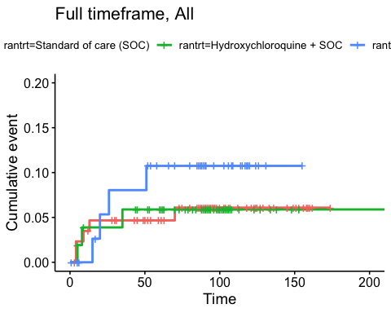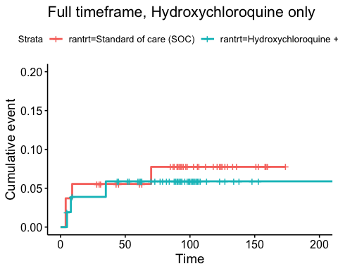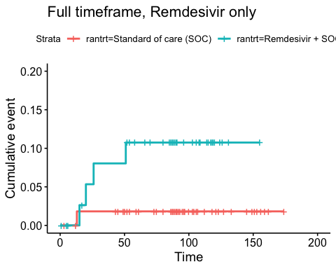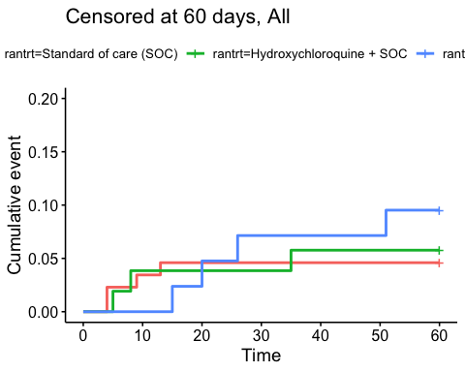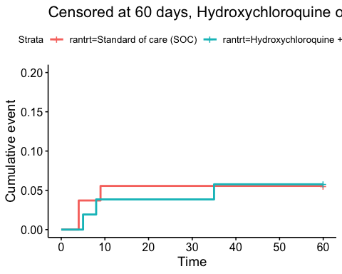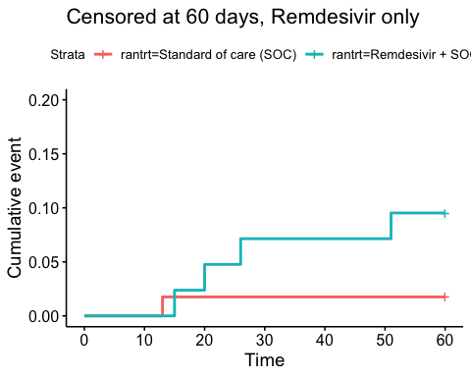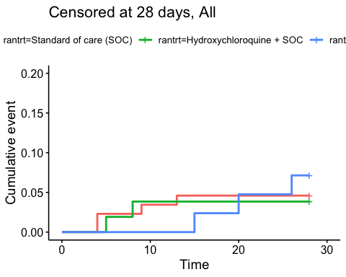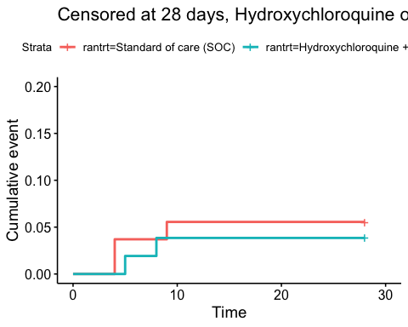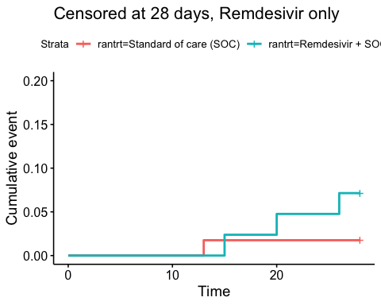

### Efficacy estimates

Relative risk estimates and p-values

|  |  |  |
| --- | --- | --- |
| Timeframe, Population | Relative risk | P-value |
| Full timeframe, All | Not applicable | 0.646 |
| Full timeframe, Hydroxychloroquine only | 0.78 (95% CI 0.18 to 3.44) | 0.744 |
| Full timeframe, Remdesivir only | 5.18 (95% CI 0.87 to 30.93) | 0.071 |
| Censored at 60 days, All | Not applicable | 0.575 |
| Censored at 60 days, Hydroxychloroquine only | 1.03 (95% CI 0.21 to 5.1) | 0.975 |
| Censored at 60 days, Remdesivir only | 4.75 (95% CI 0.8 to 28.03) | 0.086 |
| Censored at 28 days, All | Not applicable | 0.771 |
| Censored at 28 days, Hydroxychloroquine only | 0.69 (95% CI 0.12 to 3.98) | 0.676 |
| Censored at 28 days, Remdesivir only | 3.82 (95% CI 0.53 to 27.75) | 0.186 |

## Viral load

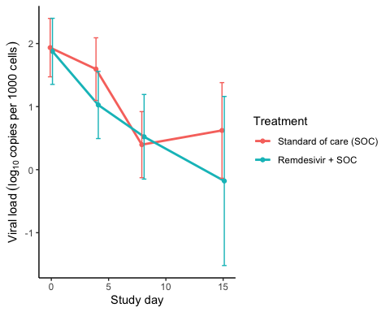

Estimated treatment effect, Remdesivir

|  |  |  |  |  |  |
| --- | --- | --- | --- | --- | --- |
| Treatment | Explanation | Estimate | Lower 95% CL | Upper 95% CL | P-value |
| Standard of care (SOC) | Slope by treatment | -0.177 | -0.249 | -0.104 | 0.000 |
| Remdesivir + SOC | Slope by treatment | -0.192 | -0.275 | -0.109 | 0.000 |
| Remdesivir + SOC | Difference in slope | -0.015 | -0.125 | 0.095 | 0.788 |

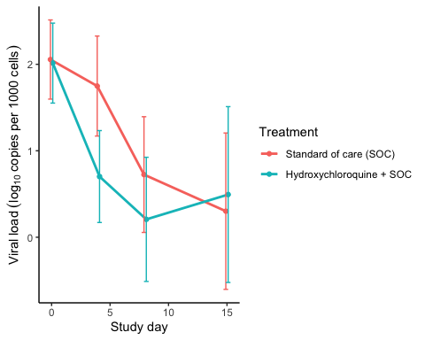

Estimated treatment effect, HCQ

|  |  |  |  |  |  |
| --- | --- | --- | --- | --- | --- |
| Treatment | Explanation | Estimate | Lower 95% CL | Upper 95% CL | P-value |
| Standard of care (SOC) | Slope by treatment | -0.148 | -0.239 | -0.057 | 0.001 |
| Hydroxychloroquine + SOC | Slope by treatment | -0.270 | -0.361 | -0.180 | 0.000 |
| Hydroxychloroquine + SOC | Difference in slope | -0.122 | -0.251 | 0.006 | 0.062 |

## Dichotomous endpoints

## Hydroxychloroquine results

|  |  |  |  |  |  |  |  |
| --- | --- | --- | --- | --- | --- | --- | --- |
| population | var | rantrt | margin | ci_lb | ci_ub | pvalue | type |
| fas_hcq | mv | Standard of care (SOC) | 11.1 | 2.7 | 19.5 | 0.009 | 0 |
| fas_hcq | mv | Hydroxychloroquine + SOC | 15.4 | 5.6 | 25.2 | 0.002 | 0 |
| fas_hcq | mv | Hydroxychloroquine + SOC | 4.3 | -8.6 | 17.2 | 0.516 | 1 |
| fas_hcq | mv28 | Standard of care (SOC) | 11.1 | 2.7 | 19.5 | 0.009 | 0 |
| fas_hcq | mv28 | Hydroxychloroquine + SOC | 15.4 | 5.6 | 25.2 | 0.002 | 0 |
| fas_hcq | mv28 | Hydroxychloroquine + SOC | 4.3 | -8.6 | 17.2 | 0.516 | 1 |
| fas_hcq | mv60 | Standard of care (SOC) | 11.1 | 2.7 | 19.5 | 0.009 | 0 |
| fas_hcq | mv60 | Hydroxychloroquine + SOC | 15.4 | 5.6 | 25.2 | 0.002 | 0 |
| fas_hcq | mv60 | Hydroxychloroquine + SOC | 4.3 | -8.6 | 17.2 | 0.516 | 1 |
| fas_hcq | progression | Standard of care (SOC) | 20.4 | 9.6 | 31.1 | 0.000 | 0 |
| fas_hcq | progression | Hydroxychloroquine + SOC | 21.2 | 10.1 | 32.3 | 0.000 | 0 |
| fas_hcq | progression | Hydroxychloroquine + SOC | 0.8 | -14.7 | 16.2 | 0.921 | 1 |
| fas_hcq | progression28 | Standard of care (SOC) | 20.4 | 9.6 | 31.1 | 0.000 | 0 |
| fas_hcq | progression28 | Hydroxychloroquine + SOC | 21.2 | 10.1 | 32.3 | 0.000 | 0 |
| fas_hcq | progression28 | Hydroxychloroquine + SOC | 0.8 | -14.7 | 16.2 | 0.921 | 1 |
| fas_hcq | progression60 | Standard of care (SOC) | 20.4 | 9.6 | 31.1 | 0.000 | 0 |
| fas_hcq | progression60 | Hydroxychloroquine + SOC | 21.2 | 10.1 | 32.3 | 0.000 | 0 |
| fas_hcq | progression60 | Hydroxychloroquine + SOC | 0.8 | -14.7 | 16.2 | 0.921 | 1 |
| fas_hcq | sq_admis_max | Standard of care (SOC) | 20.4 | 9.6 | 31.1 | 0.000 | 0 |
| fas_hcq | sq_admis_max | Hydroxychloroquine + SOC | 26.9 | 14.9 | 39.0 | 0.000 | 0 |
| fas_hcq | sq_admis_max | Hydroxychloroquine + SOC | 6.6 | -9.6 | 22.7 | 0.426 | 1 |
| fas_hcq | sq_admis_max28 | Standard of care (SOC) | 20.4 | 9.6 | 31.1 | 0.000 | 0 |
| fas_hcq | sq_admis_max28 | Hydroxychloroquine + SOC | 26.9 | 14.9 | 39.0 | 0.000 | 0 |
| fas_hcq | sq_admis_max28 | Hydroxychloroquine + SOC | 6.6 | -9.6 | 22.7 | 0.426 | 1 |
| fas_hcq | sq_admis_max60 | Standard of care (SOC) | 20.4 | 9.6 | 31.1 | 0.000 | 0 |
| fas_hcq | sq_admis_max60 | Hydroxychloroquine + SOC | 26.9 | 14.9 | 39.0 | 0.000 | 0 |
| fas_hcq | sq_admis_max60 | Hydroxychloroquine + SOC | 6.6 | -9.6 | 22.7 | 0.426 | 1 |
| fas_hcq | survcens | Standard of care (SOC) | 3.7 | -1.3 | 8.7 | 0.150 | 0 |
| fas_hcq | survcens | Hydroxychloroquine + SOC | 9.6 | 1.6 | 17.6 | 0.019 | 0 |
| fas_hcq | survcens | Hydroxychloroquine + SOC | 5.9 | -3.6 | 15.4 | 0.221 | 1 |
| fas_hcq | survcens_28 | Standard of care (SOC) | 1.9 | -1.7 | 5.4 | 0.313 | 0 |
| fas_hcq | survcens_28 | Hydroxychloroquine + SOC | 5.8 | -0.6 | 12.1 | 0.074 | 0 |
| fas_hcq | survcens_28 | Hydroxychloroquine + SOC | 3.9 | -3.4 | 11.2 | 0.292 | 1 |
| fas_hcq | survcens_60 | Standard of care (SOC) | 3.7 | -1.3 | 8.7 | 0.150 | 0 |
| fas_hcq | survcens_60 | Hydroxychloroquine + SOC | 7.7 | 0.4 | 14.9 | 0.037 | 0 |
| fas_hcq | survcens_60 | Hydroxychloroquine + SOC | 4.0 | -4.8 | 12.8 | 0.376 | 1 |
| fas_rem | mv | Standard of care (SOC) | 12.3 | 3.8 | 20.8 | 0.005 | 0 |
| fas_rem | mv | Remdesivir + SOC | 4.8 | -1.7 | 11.2 | 0.147 | 0 |
| fas_rem | mv | Remdesivir + SOC | -7.5 | -18.2 | 3.2 | 0.168 | 1 |
| fas_rem | mv28 | Standard of care (SOC) | 12.3 | 3.8 | 20.8 | 0.005 | 0 |
| fas_rem | mv28 | Remdesivir + SOC | 4.8 | -1.7 | 11.2 | 0.147 | 0 |
| fas_rem | mv28 | Remdesivir + SOC | -7.5 | -18.2 | 3.2 | 0.168 | 1 |
| fas_rem | mv60 | Standard of care (SOC) | 12.3 | 3.8 | 20.8 | 0.005 | 0 |
| fas_rem | mv60 | Remdesivir + SOC | 4.8 | -1.7 | 11.2 | 0.147 | 0 |
| fas_rem | mv60 | Remdesivir + SOC | -7.5 | -18.2 | 3.2 | 0.168 | 1 |
| fas_rem | progression | Standard of care (SOC) | 19.3 | 9.1 | 29.5 | 0.000 | 0 |
| fas_rem | progression | Remdesivir + SOC | 11.9 | 2.1 | 21.7 | 0.017 | 0 |
| fas_rem | progression | Remdesivir + SOC | -7.4 | -21.6 | 6.8 | 0.307 | 1 |
| fas_rem | progression28 | Standard of care (SOC) | 19.3 | 9.1 | 29.5 | 0.000 | 0 |
| fas_rem | progression28 | Remdesivir + SOC | 11.9 | 2.1 | 21.7 | 0.017 | 0 |
| fas_rem | progression28 | Remdesivir + SOC | -7.4 | -21.6 | 6.8 | 0.307 | 1 |
| fas_rem | progression60 | Standard of care (SOC) | 19.3 | 9.1 | 29.5 | 0.000 | 0 |
| fas_rem | progression60 | Remdesivir + SOC | 11.9 | 2.1 | 21.7 | 0.017 | 0 |
| fas_rem | progression60 | Remdesivir + SOC | -7.4 | -21.6 | 6.8 | 0.307 | 1 |
| fas_rem | sq_admis_max | Standard of care (SOC) | 21.1 | 10.5 | 31.6 | 0.000 | 0 |
| fas_rem | sq_admis_max | Remdesivir + SOC | 9.5 | 0.6 | 18.4 | 0.035 | 0 |
| fas_rem | sq_admis_max | Remdesivir + SOC | -11.5 | -25.3 | 2.3 | 0.102 | 1 |
| fas_rem | sq_admis_max28 | Standard of care (SOC) | 21.1 | 10.5 | 31.6 | 0.000 | 0 |
| fas_rem | sq_admis_max28 | Remdesivir + SOC | 9.5 | 0.6 | 18.4 | 0.035 | 0 |
| fas_rem | sq_admis_max28 | Remdesivir + SOC | -11.5 | -25.3 | 2.3 | 0.102 | 1 |
| fas_rem | sq_admis_max60 | Standard of care (SOC) | 21.1 | 10.5 | 31.6 | 0.000 | 0 |
| fas_rem | sq_admis_max60 | Remdesivir + SOC | 9.5 | 0.6 | 18.4 | 0.035 | 0 |
| fas_rem | sq_admis_max60 | Remdesivir + SOC | -11.5 | -25.3 | 2.3 | 0.102 | 1 |
| fas_rem | survcens | Standard of care (SOC) | 7.0 | 0.4 | 13.6 | 0.038 | 0 |
| fas_rem | survcens | Remdesivir + SOC | 4.8 | -1.7 | 11.2 | 0.147 | 0 |
| fas_rem | survcens | Remdesivir + SOC | -2.3 | -11.5 | 7.0 | 0.632 | 1 |
| fas_rem | survcens_28 | Standard of care (SOC) | 7.0 | 0.4 | 13.6 | 0.038 | 0 |
| fas_rem | survcens_28 | Remdesivir + SOC | 4.8 | -1.7 | 11.2 | 0.147 | 0 |
| fas_rem | survcens_28 | Remdesivir + SOC | -2.3 | -11.5 | 7.0 | 0.632 | 1 |
| fas_rem | survcens_60 | Standard of care (SOC) | 7.0 | 0.4 | 13.6 | 0.038 | 0 |
| fas_rem | survcens_60 | Remdesivir + SOC | 4.8 | -1.7 | 11.2 | 0.147 | 0 |
| fas_rem | survcens_60 | Remdesivir + SOC | -2.3 | -11.5 | 7.0 | 0.632 | 1 |

# Inflammatory laboratory parameters

### Descriptives

CRP (mg/L), HCQ

|  |  |  |  |
| --- | --- | --- | --- |
| Days since randomisation | Statistic | Standard of care (SOC) | Hydroxychloroquine + SOC |
| 0 days | Mean (SD) | 83.16 (51.76) | 99.87 (81.43) |
| 0 days | Median [IQR] | 68.5 [48 - 110.75] | 79 [30 - 150] |
| 0 days | Missing / Non-Missing | 0 / 54 | 1 / 51 |
| 1 days | Mean (SD) | 88.59 (53.46) | 111.99 (88.97) |
| 1 days | Median [IQR] | 79 [53.5 - 110.25] | 94 [44.25 - 154.75] |
| 1 days | Missing / Non-Missing | 10 / 44 | 9 / 42 |
| 2 days | Mean (SD) | 84.19 (61.57) | 102.12 (91.51) |
| 2 days | Median [IQR] | 70 [43.75 - 111] | 87.5 [25.75 - 137.5] |
| 2 days | Missing / Non-Missing | 5 / 48 | 7 / 42 |
| 3 days | Mean (SD) | 76.7 (51.87) | 99.38 (86.47) |
| 3 days | Median [IQR] | 68 [33 - 104.25] | 70 [33.5 - 137.5] |
| 3 days | Missing / Non-Missing | 10 / 40 | 8 / 39 |
| 4 days | Mean (SD) | 76.31 (59.55) | 108.75 (82.87) |
| 4 days | Median [IQR] | 71 [24 - 116.75] | 99 [48 - 138.5] |
| 4 days | Missing / Non-Missing | 3 / 36 | 6 / 31 |
| 5 days | Mean (SD) | 75.74 (63.92) | 104.33 (89.96) |
| 5 days | Median [IQR] | 53 [20 - 109] | 70 [48.5 - 137] |
| 5 days | Missing / Non-Missing | 8 / 27 | 2 / 31 |
| 6 days | Mean (SD) | 69.76 (66.49) | 102.68 (92.62) |
| 6 days | Median [IQR] | 57 [15 - 92] | 55 [34 - 155] |
| 6 days | Missing / Non-Missing | 4 / 29 | 3 / 25 |
| 7 days | Mean (SD) | 68.72 (51.15) | 90.86 (78.15) |
| 7 days | Median [IQR] | 60 [22.5 - 100] | 59.5 [32 - 131] |
| 7 days | Missing / Non-Missing | 3 / 23 | 0 / 24 |
| 8 days | Mean (SD) | 61.76 (52.41) | 65.93 (53.42) |
| 8 days | Median [IQR] | 55 [24 - 87] | 60 [20.25 - 99.5] |
| 8 days | Missing / Non-Missing | 0 / 23 | 4 / 16 |
| 9 days | Mean (SD) | 56.49 (55.12) | 58.35 (47.9) |
| 9 days | Median [IQR] | 40 [16 - 75.5] | 54 [12 - 91] |
| 9 days | Missing / Non-Missing | 4 / 19 | 2 / 13 |
| 10 days | Mean (SD) | 48.36 (67.45) | 55.77 (50.96) |
| 10 days | Median [IQR] | 23.5 [8.75 - 45] | 47.5 [7.63 - 84] |
| 10 days | Missing / Non-Missing | 4 / 16 | 0 / 12 |
| 11 days | Mean (SD) | 75.95 (123.68) | 67.7 (50.2) |
| 11 days | Median [IQR] | 29 [9 - 80.5] | 63 [25 - 105.5] |
| 11 days | Missing / Non-Missing | 6 / 11 | 0 / 10 |
| 12 days | Mean (SD) | 100.07 (210.31) | 103.5 (56.15) |
| 12 days | Median [IQR] | 11 [5 - 44] | 107 [93.5 - 109.25] |
| 12 days | Missing / Non-Missing | 5 / 9 | 0 / 6 |
| 13 days | Mean (SD) | 90.48 (129.67) | 102.83 (74.92) |
| 13 days | Median [IQR] | 24.5 [9.35 - 108.75] | 99 [61.25 - 112.75] |
| 13 days | Missing / Non-Missing | 3 / 8 | 0 / 6 |
| 14 days | Mean (SD) | 74.12 (108.22) | 42.67 (34.82) |
| 14 days | Median [IQR] | 24 [6.85 - 97.5] | 34 [23.5 - 57.5] |
| 14 days | Missing / Non-Missing | 1 / 7 | 0 / 3 |

CRP (mg/L), Remdesivir

|  |  |  |  |
| --- | --- | --- | --- |
| Days since randomisation | Statistic | Standard of care (SOC) | Remdesivir + SOC |
| 0 days | Mean (SD) | 87.77 (64.12) | 89.72 (70.93) |
| 0 days | Median [IQR] | 63 [45 - 135] | 76 [33 - 140] |
| 0 days | Missing / Non-Missing | 0 / 57 | 1 / 41 |
| 1 days | Mean (SD) | 93.78 (63.45) | 78.33 (65.32) |
| 1 days | Median [IQR] | 75 [55.25 - 123.5] | 66 [33 - 101] |
| 1 days | Missing / Non-Missing | 11 / 46 | 9 / 33 |
| 2 days | Mean (SD) | 84.1 (59.97) | 72.71 (74.33) |
| 2 days | Median [IQR] | 72.5 [39.75 - 118.25] | 49 [27 - 91.75] |
| 2 days | Missing / Non-Missing | 6 / 50 | 4 / 36 |
| 3 days | Mean (SD) | 73.17 (57.32) | 86.71 (86.31) |
| 3 days | Median [IQR] | 68 [26 - 93] | 53.5 [31.75 - 105.75] |
| 3 days | Missing / Non-Missing | 8 / 45 | 3 / 24 |
| 4 days | Mean (SD) | 77.75 (70.45) | 86.5 (106.14) |
| 4 days | Median [IQR] | 65.5 [26.25 - 106.75] | 38 [17 - 92] |
| 4 days | Missing / Non-Missing | 7 / 36 | 3 / 25 |
| 5 days | Mean (SD) | 77.56 (75.3) | 73.11 (80.85) |
| 5 days | Median [IQR] | 54.5 [24.75 - 109.75] | 34 [13 - 114] |
| 5 days | Missing / Non-Missing | 8 / 30 | 5 / 19 |
| 6 days | Mean (SD) | 71.49 (73.31) | 68.06 (76.33) |
| 6 days | Median [IQR] | 53 [16 - 105] | 33.5 [12 - 112.25] |
| 6 days | Missing / Non-Missing | 4 / 31 | 3 / 18 |
| 7 days | Mean (SD) | 61.92 (80.17) | 97.09 (92.45) |
| 7 days | Median [IQR] | 27 [8.85 - 67.5] | 61 [9.7 - 161] |
| 7 days | Missing / Non-Missing | 4 / 27 | 2 / 15 |
| 8 days | Mean (SD) | 74.02 (88.93) | 127.97 (115.22) |
| 8 days | Median [IQR] | 34 [23.75 - 73.75] | 154 [9 - 229] |
| 8 days | Missing / Non-Missing | 2 / 22 | 4 / 13 |
| 9 days | Mean (SD) | 77.39 (91.14) | 91.69 (99.18) |
| 9 days | Median [IQR] | 32 [16.5 - 134] | 23 [6.7 - 184] |
| 9 days | Missing / Non-Missing | 4 / 16 | 1 / 15 |
| 10 days | Mean (SD) | 61.37 (88.81) | 66.55 (74.2) |
| 10 days | Median [IQR] | 18 [8 - 99] | 22.5 [7.5 - 133.75] |
| 10 days | Missing / Non-Missing | 5 / 13 | 1 / 10 |
| 11 days | Mean (SD) | 64.7 (82.77) | 71.29 (98.75) |
| 11 days | Median [IQR] | 27 [11.5 - 91] | 55 [5 - 87] |
| 11 days | Missing / Non-Missing | 5 / 10 | 1 / 9 |
| 12 days | Mean (SD) | 93.56 (93.14) | 52.34 (53.43) |
| 12 days | Median [IQR] | 72 [25.1 - 130] | 42 [10.75 - 66.75] |
| 12 days | Missing / Non-Missing | 7 / 7 | 1 / 10 |
| 13 days | Mean (SD) | 95.13 (108.87) | 77.79 (61.44) |
| 13 days | Median [IQR] | 34.5 [9.75 - 204.5] | 70 [31 - 101] |
| 13 days | Missing / Non-Missing | 5 / 8 | 2 / 9 |
| 14 days | Mean (SD) | 39 (73.16) | 73.02 (94.56) |
| 14 days | Median [IQR] | 13 [6.93 - 22.75] | 29 [20 - 70] |
| 14 days | Missing / Non-Missing | 1 / 8 | 0 / 9 |

Ferritin (µg/L), HCQ

|  |  |  |  |
| --- | --- | --- | --- |
| Days since randomisation | Statistic | Standard of care (SOC) | Hydroxychloroquine + SOC |
| 0 days | Mean (SD) | 681.35 (589.07) | 1457.1 (3302.98) |
| 0 days | Median [IQR] | 544.5 [237 - 965.25] | 782 [376.5 - 1567.25] |
| 0 days | Missing / Non-Missing | 2 / 52 | 2 / 50 |
| 1 days | Mean (SD) | 739.36 (490.92) | 1550.41 (3175.87) |
| 1 days | Median [IQR] | 558 [345.5 - 1100] | 861 [409.75 - 1425.25] |
| 1 days | Missing / Non-Missing | 23 / 31 | 17 / 34 |
| 2 days | Mean (SD) | 752.37 (499.91) | 1338.92 (1873.44) |
| 2 days | Median [IQR] | 678 [290.5 - 1136] | 1002 [422 - 1416] |
| 2 days | Missing / Non-Missing | 10 / 43 | 12 / 37 |
| 3 days | Mean (SD) | 928.24 (599.64) | 1066.11 (785.52) |
| 3 days | Median [IQR] | 758 [421 - 1291] | 905 [537.5 - 1383] |
| 3 days | Missing / Non-Missing | 17 / 33 | 9 / 38 |
| 4 days | Mean (SD) | 1222.36 (1040.06) | 1203.14 (833.72) |
| 4 days | Median [IQR] | 1024 [486 - 1597] | 977 [568 - 1642.75] |
| 4 days | Missing / Non-Missing | 14 / 25 | 9 / 28 |
| 5 days | Mean (SD) | 1123.18 (863.34) | 1002.63 (674.67) |
| 5 days | Median [IQR] | 971.5 [407 - 1601.5] | 769 [507.5 - 1313] |
| 5 days | Missing / Non-Missing | 13 / 22 | 6 / 27 |
| 6 days | Mean (SD) | 1010.58 (682) | 1131.57 (810.79) |
| 6 days | Median [IQR] | 991 [441.25 - 1350.75] | 832 [649 - 1557] |
| 6 days | Missing / Non-Missing | 7 / 26 | 7 / 21 |
| 7 days | Mean (SD) | 1199.45 (783.04) | 995.16 (725.1) |
| 7 days | Median [IQR] | 1220.5 [413.75 - 1584.25] | 855 [451.5 - 1424] |
| 7 days | Missing / Non-Missing | 6 / 20 | 5 / 19 |
| 8 days | Mean (SD) | 937.8 (732.42) | 919.92 (705.43) |
| 8 days | Median [IQR] | 800.5 [406.5 - 1195] | 771 [384 - 1179] |
| 8 days | Missing / Non-Missing | 3 / 20 | 7 / 13 |
| 9 days | Mean (SD) | 823.53 (743.03) | 810.23 (474.76) |
| 9 days | Median [IQR] | 587 [282.5 - 1041.5] | 746 [508 - 1218] |
| 9 days | Missing / Non-Missing | 8 / 15 | 2 / 13 |
| 10 days | Mean (SD) | 908.64 (614.28) | 831.9 (483.97) |
| 10 days | Median [IQR] | 887 [565.5 - 1054.5] | 756 [549 - 1242] |
| 10 days | Missing / Non-Missing | 9 / 11 | 2 / 10 |
| 11 days | Mean (SD) | 709.45 (831.64) | 774.25 (476.2) |
| 11 days | Median [IQR] | 422 [194 - 888] | 697 [525.5 - 992.5] |
| 11 days | Missing / Non-Missing | 8 / 9 | 2 / 8 |
| 12 days | Mean (SD) | 437.33 (447.87) | 711.83 (279.55) |
| 12 days | Median [IQR] | 346 [74.25 - 626.75] | 689.5 [645.25 - 876.25] |
| 12 days | Missing / Non-Missing | 8 / 6 | 0 / 6 |
| 13 days | Mean (SD) | 703.67 (420.25) | 746.67 (353.28) |
| 13 days | Median [IQR] | 694 [474.5 - 840.75] | 730 [561.25 - 1026.25] |
| 13 days | Missing / Non-Missing | 5 / 6 | 0 / 6 |
| 14 days | Mean (SD) | 606.5 (431.41) | 729 (446.8) |
| 14 days | Median [IQR] | 579.5 [329.25 - 856.75] | 553 [475 - 895] |
| 14 days | Missing / Non-Missing | 4 / 4 | 0 / 3 |

Ferritin (µg/L), Remdesivir

|  |  |  |  |
| --- | --- | --- | --- |
| Days since randomisation | Statistic | Standard of care (SOC) | Remdesivir + SOC |
| 0 days | Mean (SD) | 860.69 (716.43) | 810.63 (770.15) |
| 0 days | Median [IQR] | 626 [302 - 1204] | 462 [319 - 1056] |
| 0 days | Missing / Non-Missing | 2 / 55 | 4 / 38 |
| 1 days | Mean (SD) | 1075.7 (828.3) | 960.09 (724.64) |
| 1 days | Median [IQR] | 1014 [524 - 1416] | 875.5 [422 - 1271.25] |
| 1 days | Missing / Non-Missing | 24 / 33 | 20 / 22 |
| 2 days | Mean (SD) | 969.22 (728.99) | 981.85 (825.38) |
| 2 days | Median [IQR] | 842 [409 - 1325.75] | 761 [476 - 1264] |
| 2 days | Missing / Non-Missing | 14 / 42 | 7 / 33 |
| 3 days | Mean (SD) | 1140.58 (953.57) | 1255.05 (1140.98) |
| 3 days | Median [IQR] | 912 [401 - 1759] | 817 [582.75 - 1551.75] |
| 3 days | Missing / Non-Missing | 20 / 33 | 7 / 20 |
| 4 days | Mean (SD) | 1574.35 (1398.29) | 1325.24 (1312.97) |
| 4 days | Median [IQR] | 1072 [637.5 - 1877.5] | 920 [525 - 1667] |
| 4 days | Missing / Non-Missing | 20 / 23 | 7 / 21 |
| 5 days | Mean (SD) | 1259.65 (819.34) | 1541.18 (1521.85) |
| 5 days | Median [IQR] | 887 [616.5 - 1895.5] | 928 [896.5 - 1273] |
| 5 days | Missing / Non-Missing | 18 / 20 | 13 / 11 |
| 6 days | Mean (SD) | 933.37 (779.65) | 1250.06 (1234.36) |
| 6 days | Median [IQR] | 739 [479.5 - 1166.5] | 982 [810 - 1206] |
| 6 days | Missing / Non-Missing | 8 / 27 | 4 / 17 |
| 7 days | Mean (SD) | 1123.67 (696.43) | 1305.64 (1133.22) |
| 7 days | Median [IQR] | 985 [523 - 1383] | 921 [753 - 1392.75] |
| 7 days | Missing / Non-Missing | 7 / 24 | 3 / 14 |
| 8 days | Mean (SD) | 896.71 (683.5) | 1452 (1327.6) |
| 8 days | Median [IQR] | 669 [457 - 1134] | 880 [729 - 1542] |
| 8 days | Missing / Non-Missing | 7 / 17 | 8 / 9 |
| 9 days | Mean (SD) | 820.62 (596.43) | 932.91 (592.98) |
| 9 days | Median [IQR] | 506 [456 - 1171] | 747 [553.5 - 1454] |
| 9 days | Missing / Non-Missing | 7 / 13 | 5 / 11 |
| 10 days | Mean (SD) | 938.09 (738.23) | 1207.5 (543.36) |
| 10 days | Median [IQR] | 761 [457 - 1157.5] | 1025.5 [854 - 1651.5] |
| 10 days | Missing / Non-Missing | 7 / 11 | 5 / 6 |
| 11 days | Mean (SD) | 845.13 (846.48) | 1276.4 (985.55) |
| 11 days | Median [IQR] | 682 [307.75 - 935.5] | 939 [771 - 1112] |
| 11 days | Missing / Non-Missing | 7 / 8 | 5 / 5 |
| 12 days | Mean (SD) | 1184.6 (900.1) | 1280.83 (1031.95) |
| 12 days | Median [IQR] | 1033 [667 - 1121] | 781 [715.5 - 1359.5] |
| 12 days | Missing / Non-Missing | 9 / 5 | 5 / 6 |
| 13 days | Mean (SD) | 1139.38 (886.98) | 743.17 (650.17) |
| 13 days | Median [IQR] | 796.5 [486.25 - 1648] | 669.5 [497.75 - 703.25] |
| 13 days | Missing / Non-Missing | 5 / 8 | 5 / 6 |
| 14 days | Mean (SD) | 609.33 (640.27) | 836.14 (576.86) |
| 14 days | Median [IQR] | 386 [286.75 - 558] | 698 [608.5 - 1093.5] |
| 14 days | Missing / Non-Missing | 3 / 6 | 2 / 7 |

LDH (U/L), HCQ

|  |  |  |  |
| --- | --- | --- | --- |
| Days since randomisation | Statistic | Standard of care (SOC) | Hydroxychloroquine + SOC |
| 0 days | Mean (SD) | 290.82 (96.23) | 305.29 (156.92) |
| 0 days | Median [IQR] | 275 [219 - 365.5] | 264 [199 - 365] |
| 0 days | Missing / Non-Missing | 3 / 51 | 3 / 49 |
| 1 days | Mean (SD) | 293.22 (86.01) | 323.96 (158.29) |
| 1 days | Median [IQR] | 284 [233 - 376.5] | 278 [221.25 - 392.5] |
| 1 days | Missing / Non-Missing | 27 / 27 | 25 / 26 |
| 2 days | Mean (SD) | 305 (96.72) | 331.03 (175.68) |
| 2 days | Median [IQR] | 305.5 [233 - 378] | 274 [220.25 - 376] |
| 2 days | Missing / Non-Missing | 19 / 34 | 19 / 30 |
| 3 days | Mean (SD) | 346.31 (131.79) | 302.59 (162.24) |
| 3 days | Median [IQR] | 335 [263.5 - 431.5] | 265 [212.5 - 324.75] |
| 3 days | Missing / Non-Missing | 24 / 26 | 13 / 34 |
| 4 days | Mean (SD) | 340.64 (128.56) | 338.56 (134.83) |
| 4 days | Median [IQR] | 320 [246.25 - 423.75] | 296 [246 - 388] |
| 4 days | Missing / Non-Missing | 17 / 22 | 12 / 25 |
| 5 days | Mean (SD) | 338.36 (102.67) | 324.59 (158.88) |
| 5 days | Median [IQR] | 314 [281.75 - 352.75] | 287.5 [216.25 - 346] |
| 5 days | Missing / Non-Missing | 21 / 14 | 11 / 22 |
| 6 days | Mean (SD) | 305.53 (89.32) | 323 (175.46) |
| 6 days | Median [IQR] | 300 [249.5 - 356] | 270 [218 - 386] |
| 6 days | Missing / Non-Missing | 14 / 19 | 9 / 19 |
| 7 days | Mean (SD) | 307.83 (100.45) | 297.45 (118.52) |
| 7 days | Median [IQR] | 290 [230 - 355.25] | 261.5 [225.25 - 383.5] |
| 7 days | Missing / Non-Missing | 8 / 18 | 6 / 18 |
| 8 days | Mean (SD) | 311.57 (104.26) | 310.77 (112.27) |
| 8 days | Median [IQR] | 292 [232.25 - 364.5] | 274 [235 - 370] |
| 8 days | Missing / Non-Missing | 9 / 14 | 7 / 13 |
| 9 days | Mean (SD) | 338.4 (142.39) | 295.67 (93.06) |
| 9 days | Median [IQR] | 325.5 [264.5 - 343] | 260.5 [223.5 - 385] |
| 9 days | Missing / Non-Missing | 13 / 10 | 3 / 12 |
| 10 days | Mean (SD) | 294.09 (109.5) | 312.56 (117.59) |
| 10 days | Median [IQR] | 280 [214.5 - 336] | 332 [225 - 378] |
| 10 days | Missing / Non-Missing | 9 / 11 | 3 / 9 |
| 11 days | Mean (SD) | 284.13 (90.62) | 280 (118.25) |
| 11 days | Median [IQR] | 265.5 [249 - 316] | 267.5 [196.25 - 376.5] |
| 11 days | Missing / Non-Missing | 9 / 8 | 2 / 8 |
| 12 days | Mean (SD) | 234.57 (58.34) | 343.67 (50.84) |
| 12 days | Median [IQR] | 219 [215 - 273] | 359.5 [318.75 - 365.75] |
| 12 days | Missing / Non-Missing | 7 / 7 | 0 / 6 |
| 13 days | Mean (SD) | 192.75 (45.6) | 354.6 (58.84) |
| 13 days | Median [IQR] | 198.5 [165.5 - 225.75] | 350 [317 - 382] |
| 13 days | Missing / Non-Missing | 7 / 4 | 1 / 5 |
| 14 days | Mean (SD) | 212.5 (55.92) | 358 (69.54) |
| 14 days | Median [IQR] | 225.5 [182.75 - 255.25] | 348 [321 - 390] |
| 14 days | Missing / Non-Missing | 4 / 4 | 0 / 3 |

LDH (U/L), Remdesivir

|  |  |  |  |
| --- | --- | --- | --- |
| Days since randomisation | Statistic | Standard of care (SOC) | Remdesivir + SOC |
| 0 days | Mean (SD) | 315.75 (120.86) | 282.9 (110.79) |
| 0 days | Median [IQR] | 302.5 [239.25 - 367.75] | 264 [209 - 310] |
| 0 days | Missing / Non-Missing | 1 / 56 | 1 / 41 |
| 1 days | Mean (SD) | 327.07 (128.78) | 306.14 (111.68) |
| 1 days | Median [IQR] | 297 [244 - 377] | 284.5 [226.25 - 347] |
| 1 days | Missing / Non-Missing | 27 / 30 | 20 / 22 |
| 2 days | Mean (SD) | 324.98 (98.83) | 302 (124.17) |
| 2 days | Median [IQR] | 314 [276 - 373] | 246 [217.5 - 364] |
| 2 days | Missing / Non-Missing | 15 / 41 | 9 / 31 |
| 3 days | Mean (SD) | 350.97 (149.05) | 383.57 (152.31) |
| 3 days | Median [IQR] | 336 [261 - 421] | 387 [268 - 439] |
| 3 days | Missing / Non-Missing | 20 / 33 | 6 / 21 |
| 4 days | Mean (SD) | 348.52 (122.75) | 392.95 (196.22) |
| 4 days | Median [IQR] | 315 [270 - 423] | 372 [247.5 - 490] |
| 4 days | Missing / Non-Missing | 22 / 21 | 9 / 19 |
| 5 days | Mean (SD) | 368.38 (113.79) | 392.64 (149.02) |
| 5 days | Median [IQR] | 323 [292 - 439] | 384.5 [274.75 - 510.75] |
| 5 days | Missing / Non-Missing | 17 / 21 | 10 / 14 |
| 6 days | Mean (SD) | 292.36 (69) | 338.6 (111.26) |
| 6 days | Median [IQR] | 282.5 [254.5 - 361.25] | 303 [273.5 - 422.5] |
| 6 days | Missing / Non-Missing | 13 / 22 | 6 / 15 |
| 7 days | Mean (SD) | 287.91 (91.94) | 313.75 (96.75) |
| 7 days | Median [IQR] | 263 [239 - 334.5] | 321 [244 - 382.75] |
| 7 days | Missing / Non-Missing | 8 / 23 | 5 / 12 |
| 8 days | Mean (SD) | 279.41 (45.92) | 366.88 (110.35) |
| 8 days | Median [IQR] | 282 [240 - 300] | 379 [326.5 - 420.75] |
| 8 days | Missing / Non-Missing | 7 / 17 | 9 / 8 |
| 9 days | Mean (SD) | 294.23 (73.84) | 326.22 (138.07) |
| 9 days | Median [IQR] | 286 [259 - 326] | 289 [245 - 409] |
| 9 days | Missing / Non-Missing | 7 / 13 | 7 / 9 |
| 10 days | Mean (SD) | 249.45 (53.63) | 307 (100.9) |
| 10 days | Median [IQR] | 220 [216 - 259] | 363 [241 - 382] |
| 10 days | Missing / Non-Missing | 9 / 9 | 4 / 7 |
| 11 days | Mean (SD) | 255.83 (57.66) | 262.5 (124.75) |
| 11 days | Median [IQR] | 258.5 [224.75 - 272] | 246 [159.25 - 364.25] |
| 11 days | Missing / Non-Missing | 9 / 6 | 4 / 6 |
| 12 days | Mean (SD) | 251 (76.76) | 297.86 (134.91) |
| 12 days | Median [IQR] | 269 [187 - 269] | 291 [190.5 - 399.5] |
| 12 days | Missing / Non-Missing | 9 / 5 | 4 / 7 |
| 13 days | Mean (SD) | 280.5 (104.15) | 197.2 (81.46) |
| 13 days | Median [IQR] | 253 [236 - 267.75] | 169 [142 - 197] |
| 13 days | Missing / Non-Missing | 7 / 6 | 6 / 5 |
| 14 days | Mean (SD) | 238.33 (126.62) | 243.38 (102.67) |
| 14 days | Median [IQR] | 205.5 [164.75 - 234.25] | 232 [146.5 - 334] |
| 14 days | Missing / Non-Missing | 3 / 6 | 1 / 8 |

Lymphocytes (x10^9/L), HCQ

|  |  |  |  |
| --- | --- | --- | --- |
| Days since randomisation | Statistic | Standard of care (SOC) | Hydroxychloroquine + SOC |
| 0 days | Mean (SD) | 1.31 (0.95) | 1.17 (0.47) |
| 0 days | Median [IQR] | 1.1 [0.9 - 1.5] | 1.2 [0.9 - 1.4] |
| 0 days | Missing / Non-Missing | 1 / 53 | 3 / 49 |
| 1 days | Mean (SD) | 1.2 (0.47) | 1.13 (0.54) |
| 1 days | Median [IQR] | 1.2 [0.85 - 1.5] | 1.1 [0.7 - 1.48] |
| 1 days | Missing / Non-Missing | 23 / 31 | 21 / 30 |
| 2 days | Mean (SD) | 1.39 (0.58) | 1.24 (0.58) |
| 2 days | Median [IQR] | 1.3 [1.08 - 1.7] | 1.1 [0.85 - 1.6] |
| 2 days | Missing / Non-Missing | 13 / 40 | 18 / 31 |
| 3 days | Mean (SD) | 1.36 (0.64) | 1.29 (0.61) |
| 3 days | Median [IQR] | 1.2 [1 - 1.6] | 1.2 [0.9 - 1.6] |
| 3 days | Missing / Non-Missing | 17 / 33 | 13 / 34 |
| 4 days | Mean (SD) | 1.48 (0.86) | 1.2 (0.62) |
| 4 days | Median [IQR] | 1.4 [0.88 - 1.83] | 1.1 [0.7 - 1.6] |
| 4 days | Missing / Non-Missing | 11 / 28 | 12 / 25 |
| 5 days | Mean (SD) | 1.54 (0.89) | 1.32 (0.66) |
| 5 days | Median [IQR] | 1.4 [0.9 - 1.8] | 1.2 [0.9 - 1.8] |
| 5 days | Missing / Non-Missing | 14 / 21 | 8 / 25 |
| 6 days | Mean (SD) | 1.53 (0.94) | 1.32 (0.64) |
| 6 days | Median [IQR] | 1.3 [1.05 - 2] | 1.25 [0.93 - 1.58] |
| 6 days | Missing / Non-Missing | 10 / 23 | 10 / 18 |
| 7 days | Mean (SD) | 1.48 (0.55) | 1.38 (0.58) |
| 7 days | Median [IQR] | 1.3 [1.2 - 1.8] | 1.3 [0.95 - 1.8] |
| 7 days | Missing / Non-Missing | 5 / 21 | 6 / 18 |
| 8 days | Mean (SD) | 1.51 (0.63) | 2.14 (2.04) |
| 8 days | Median [IQR] | 1.6 [1 - 1.8] | 1.6 [1.2 - 2.1] |
| 8 days | Missing / Non-Missing | 6 / 17 | 7 / 13 |
| 9 days | Mean (SD) | 1.52 (0.61) | 1.76 (0.83) |
| 9 days | Median [IQR] | 1.5 [1.15 - 1.8] | 1.55 [1.15 - 2.48] |
| 9 days | Missing / Non-Missing | 9 / 14 | 5 / 10 |
| 10 days | Mean (SD) | 1.87 (0.71) | 1.7 (0.69) |
| 10 days | Median [IQR] | 1.85 [1.63 - 2.25] | 1.6 [1.4 - 1.9] |
| 10 days | Missing / Non-Missing | 8 / 12 | 3 / 9 |
| 11 days | Mean (SD) | 1.71 (0.78) | 1.56 (0.82) |
| 11 days | Median [IQR] | 1.65 [1.38 - 2.03] | 1.6 [1 - 2.05] |
| 11 days | Missing / Non-Missing | 9 / 8 | 2 / 8 |
| 12 days | Mean (SD) | 1.85 (1.2) | 1.54 (1.01) |
| 12 days | Median [IQR] | 1.9 [0.93 - 2.58] | 1.4 [0.9 - 1.6] |
| 12 days | Missing / Non-Missing | 8 / 6 | 1 / 5 |
| 13 days | Mean (SD) | 1.73 (0.91) | 1.6 (1.18) |
| 13 days | Median [IQR] | 1.85 [1.48 - 2.1] | 1.25 [0.98 - 1.88] |
| 13 days | Missing / Non-Missing | 7 / 4 | 2 / 4 |
| 14 days | Mean (SD) | 1.22 (0.44) | 2.13 (0.85) |
| 14 days | Median [IQR] | 1.25 [0.95 - 1.48] | 2.1 [1.7 - 2.55] |
| 14 days | Missing / Non-Missing | 2 / 6 | 0 / 3 |

Lymphocytes (x10^9/L), Remdesivir

|  |  |  |  |
| --- | --- | --- | --- |
| Days since randomisation | Statistic | Standard of care (SOC) | Remdesivir + SOC |
| 0 days | Mean (SD) | 1.07 (0.47) | 1.13 (0.55) |
| 0 days | Median [IQR] | 1.1 [0.7 - 1.3] | 1 [0.8 - 1.43] |
| 0 days | Missing / Non-Missing | 4 / 53 | 2 / 40 |
| 1 days | Mean (SD) | 1.14 (0.5) | 1.24 (0.54) |
| 1 days | Median [IQR] | 1.2 [0.7 - 1.4] | 1.2 [0.8 - 1.48] |
| 1 days | Missing / Non-Missing | 18 / 39 | 16 / 26 |
| 2 days | Mean (SD) | 1.2 (0.48) | 1.35 (0.61) |
| 2 days | Median [IQR] | 1.1 [0.9 - 1.5] | 1.2 [0.93 - 1.7] |
| 2 days | Missing / Non-Missing | 9 / 47 | 6 / 34 |
| 3 days | Mean (SD) | 1.34 (0.65) | 1.14 (0.47) |
| 3 days | Median [IQR] | 1.2 [0.95 - 1.6] | 1.1 [0.9 - 1.5] |
| 3 days | Missing / Non-Missing | 14 / 39 | 6 / 21 |
| 4 days | Mean (SD) | 1.28 (0.8) | 1.28 (0.56) |
| 4 days | Median [IQR] | 1.2 [0.7 - 1.6] | 1.35 [0.95 - 1.63] |
| 4 days | Missing / Non-Missing | 14 / 29 | 8 / 20 |
| 5 days | Mean (SD) | 1.4 (0.78) | 1.21 (0.61) |
| 5 days | Median [IQR] | 1.2 [1 - 1.7] | 1.3 [0.6 - 1.6] |
| 5 days | Missing / Non-Missing | 11 / 27 | 13 / 11 |
| 6 days | Mean (SD) | 1.42 (0.86) | 1.41 (0.59) |
| 6 days | Median [IQR] | 1.2 [0.93 - 1.83] | 1.4 [1 - 1.75] |
| 6 days | Missing / Non-Missing | 9 / 26 | 6 / 15 |
| 7 days | Mean (SD) | 1.28 (0.53) | 1.38 (0.78) |
| 7 days | Median [IQR] | 1.2 [1.1 - 1.5] | 1.25 [1 - 1.7] |
| 7 days | Missing / Non-Missing | 6 / 25 | 5 / 12 |
| 8 days | Mean (SD) | 1.4 (0.53) | 1.73 (1.08) |
| 8 days | Median [IQR] | 1.6 [1 - 1.8] | 1.5 [1.2 - 2.1] |
| 8 days | Missing / Non-Missing | 3 / 21 | 8 / 9 |
| 9 days | Mean (SD) | 1.31 (0.59) | 1.47 (0.78) |
| 9 days | Median [IQR] | 1.1 [0.95 - 1.7] | 1.2 [0.9 - 1.85] |
| 9 days | Missing / Non-Missing | 5 / 15 | 5 / 11 |
| 10 days | Mean (SD) | 1.55 (0.64) | 1.77 (0.87) |
| 10 days | Median [IQR] | 1.7 [1 - 1.9] | 2 [1.1 - 2.35] |
| 10 days | Missing / Non-Missing | 5 / 13 | 4 / 7 |
| 11 days | Mean (SD) | 1.39 (0.69) | 1.83 (0.4) |
| 11 days | Median [IQR] | 1.65 [0.75 - 1.93] | 1.9 [1.7 - 2] |
| 11 days | Missing / Non-Missing | 7 / 8 | 3 / 7 |
| 12 days | Mean (SD) | 1.75 (1.38) | 2.09 (0.54) |
| 12 days | Median [IQR] | 1.3 [0.73 - 2.85] | 2.05 [1.85 - 2.33] |
| 12 days | Missing / Non-Missing | 8 / 6 | 3 / 8 |
| 13 days | Mean (SD) | 1.79 (0.85) | 2.04 (0.67) |
| 13 days | Median [IQR] | 1.7 [1.25 - 2.35] | 2 [1.75 - 2.25] |
| 13 days | Missing / Non-Missing | 6 / 7 | 4 / 7 |
| 14 days | Mean (SD) | 1.39 (1.16) | 2.06 (0.57) |
| 14 days | Median [IQR] | 1.1 [0.6 - 1.7] | 2.25 [1.85 - 2.33] |
| 14 days | Missing / Non-Missing | 2 / 7 | 1 / 8 |

Neutrophils (x10^9/L), HCQ

|  |  |  |  |
| --- | --- | --- | --- |
| Days since randomisation | Statistic | Standard of care (SOC) | Hydroxychloroquine + SOC |
| 0 days | Mean (SD) | 4.82 (2.3) | 5.27 (3.43) |
| 0 days | Median [IQR] | 4.3 [3 - 6.5] | 4.1 [3 - 6.7] |
| 0 days | Missing / Non-Missing | 1 / 53 | 4 / 48 |
| 1 days | Mean (SD) | 4.72 (2.88) | 4.87 (2.73) |
| 1 days | Median [IQR] | 3.9 [3.05 - 5.2] | 4.25 [3.33 - 6.53] |
| 1 days | Missing / Non-Missing | 23 / 31 | 21 / 30 |
| 2 days | Mean (SD) | 5.17 (2.77) | 4.86 (2.93) |
| 2 days | Median [IQR] | 4.6 [3.18 - 6.25] | 4.2 [2.7 - 6.4] |
| 2 days | Missing / Non-Missing | 13 / 40 | 17 / 32 |
| 3 days | Mean (SD) | 5.66 (3.14) | 4.77 (2.84) |
| 3 days | Median [IQR] | 4.8 [3.4 - 7.1] | 3.8 [3.13 - 5.93] |
| 3 days | Missing / Non-Missing | 17 / 33 | 13 / 34 |
| 4 days | Mean (SD) | 5.64 (3.15) | 5.42 (2.87) |
| 4 days | Median [IQR] | 4.9 [3.68 - 6.1] | 4.5 [3.4 - 7.4] |
| 4 days | Missing / Non-Missing | 11 / 28 | 12 / 25 |
| 5 days | Mean (SD) | 5.8 (2.87) | 5.3 (2.38) |
| 5 days | Median [IQR] | 5 [4.3 - 6.2] | 5 [3.7 - 6.5] |
| 5 days | Missing / Non-Missing | 14 / 21 | 8 / 25 |
| 6 days | Mean (SD) | 5.95 (2.71) | 5.43 (2.51) |
| 6 days | Median [IQR] | 4.8 [4.35 - 6.8] | 5.15 [3.45 - 7.03] |
| 6 days | Missing / Non-Missing | 10 / 23 | 10 / 18 |
| 7 days | Mean (SD) | 6.93 (3.21) | 5.32 (2.45) |
| 7 days | Median [IQR] | 6 [4.8 - 9.2] | 4.6 [3.13 - 7.65] |
| 7 days | Missing / Non-Missing | 5 / 21 | 6 / 18 |
| 8 days | Mean (SD) | 7.17 (3) | 5.95 (1.97) |
| 8 days | Median [IQR] | 6 [4.8 - 8.8] | 6.5 [4.2 - 7.4] |
| 8 days | Missing / Non-Missing | 6 / 17 | 7 / 13 |
| 9 days | Mean (SD) | 7.15 (2.78) | 5.9 (2.22) |
| 9 days | Median [IQR] | 7.05 [4.93 - 9.25] | 6.45 [4.58 - 7.23] |
| 9 days | Missing / Non-Missing | 9 / 14 | 5 / 10 |
| 10 days | Mean (SD) | 6.71 (2.73) | 6.09 (2.81) |
| 10 days | Median [IQR] | 5.8 [4.78 - 8.38] | 6.4 [4.1 - 8] |
| 10 days | Missing / Non-Missing | 8 / 12 | 3 / 9 |
| 11 days | Mean (SD) | 6.91 (3.3) | 6.51 (2.48) |
| 11 days | Median [IQR] | 5.7 [4.4 - 8.1] | 6.15 [4.43 - 8.58] |
| 11 days | Missing / Non-Missing | 9 / 8 | 2 / 8 |
| 12 days | Mean (SD) | 6.42 (3.34) | 9.16 (2.07) |
| 12 days | Median [IQR] | 5.3 [4 - 7.5] | 9.9 [7.1 - 11] |
| 12 days | Missing / Non-Missing | 7 / 7 | 1 / 5 |
| 13 days | Mean (SD) | 7.78 (3.7) | 9.2 (2.07) |
| 13 days | Median [IQR] | 6.9 [5.13 - 9.55] | 9.4 [7.73 - 10.88] |
| 13 days | Missing / Non-Missing | 7 / 4 | 2 / 4 |
| 14 days | Mean (SD) | 7.36 (2.99) | 8.17 (3.13) |
| 14 days | Median [IQR] | 6.5 [5.5 - 8] | 8.7 [6.75 - 9.85] |
| 14 days | Missing / Non-Missing | 3 / 5 | 0 / 3 |

Neutrophils (x10^9/L), Remdesivir

|  |  |  |  |
| --- | --- | --- | --- |
| Days since randomisation | Statistic | Standard of care (SOC) | Remdesivir + SOC |
| 0 days | Mean (SD) | 4.9 (2.92) | 4.48 (2.37) |
| 0 days | Median [IQR] | 4.1 [3 - 6.6] | 3.75 [2.55 - 6.05] |
| 0 days | Missing / Non-Missing | 4 / 53 | 2 / 40 |
| 1 days | Mean (SD) | 5.81 (4.37) | 4.72 (3.43) |
| 1 days | Median [IQR] | 4.8 [3.45 - 6.55] | 3.4 [2.13 - 5.8] |
| 1 days | Missing / Non-Missing | 18 / 39 | 16 / 26 |
| 2 days | Mean (SD) | 5.14 (3.37) | 5.07 (3.56) |
| 2 days | Median [IQR] | 4.5 [2.9 - 6.25] | 3.6 [2.73 - 6.63] |
| 2 days | Missing / Non-Missing | 9 / 47 | 6 / 34 |
| 3 days | Mean (SD) | 4.8 (2.92) | 5.66 (4.3) |
| 3 days | Median [IQR] | 4.5 [2.75 - 5.65] | 4.8 [2.3 - 8.1] |
| 3 days | Missing / Non-Missing | 14 / 39 | 6 / 21 |
| 4 days | Mean (SD) | 5.29 (3.05) | 6.23 (5.69) |
| 4 days | Median [IQR] | 4.65 [3.43 - 5.75] | 5 [2.8 - 6.1] |
| 4 days | Missing / Non-Missing | 15 / 28 | 7 / 21 |
| 5 days | Mean (SD) | 5.67 (3.14) | 6.91 (6.25) |
| 5 days | Median [IQR] | 5 [3.9 - 5.95] | 4.4 [3.43 - 6.28] |
| 5 days | Missing / Non-Missing | 11 / 27 | 14 / 10 |
| 6 days | Mean (SD) | 5.44 (2.73) | 6.91 (5.56) |
| 6 days | Median [IQR] | 4.65 [3.88 - 6.13] | 4.4 [3.65 - 8.65] |
| 6 days | Missing / Non-Missing | 9 / 26 | 6 / 15 |
| 7 days | Mean (SD) | 5.62 (2.83) | 7.31 (4.91) |
| 7 days | Median [IQR] | 5.2 [4.2 - 5.6] | 5.85 [4.23 - 9.58] |
| 7 days | Missing / Non-Missing | 6 / 25 | 5 / 12 |
| 8 days | Mean (SD) | 6.51 (3.59) | 8.12 (5.15) |
| 8 days | Median [IQR] | 5.4 [3.7 - 10.7] | 7.6 [5 - 8.2] |
| 8 days | Missing / Non-Missing | 3 / 21 | 8 / 9 |
| 9 days | Mean (SD) | 6.93 (3.18) | 7.76 (5.12) |
| 9 days | Median [IQR] | 6.1 [4.5 - 9.35] | 6.1 [4.25 - 11.05] |
| 9 days | Missing / Non-Missing | 5 / 15 | 5 / 11 |
| 10 days | Mean (SD) | 5.85 (2.57) | 10.82 (4.84) |
| 10 days | Median [IQR] | 5.3 [3.9 - 6.5] | 13.1 [6.7 - 14.35] |
| 10 days | Missing / Non-Missing | 5 / 13 | 4 / 7 |
| 11 days | Mean (SD) | 6.71 (2.91) | 7.83 (4.09) |
| 11 days | Median [IQR] | 6.7 [4.1 - 9.1] | 7.7 [5 - 9.85] |
| 11 days | Missing / Non-Missing | 6 / 9 | 3 / 7 |
| 12 days | Mean (SD) | 7.02 (3.66) | 9.56 (3.94) |
| 12 days | Median [IQR] | 5.75 [5.25 - 9.78] | 9 [6.2 - 11.33] |
| 12 days | Missing / Non-Missing | 8 / 6 | 3 / 8 |
| 13 days | Mean (SD) | 7.37 (3.99) | 9.59 (5.13) |
| 13 days | Median [IQR] | 6.05 [4.85 - 10.48] | 10.2 [5.7 - 11.6] |
| 13 days | Missing / Non-Missing | 7 / 6 | 4 / 7 |
| 14 days | Mean (SD) | 5.68 (2.28) | 8.39 (4.09) |
| 14 days | Median [IQR] | 5.75 [3.73 - 6.95] | 7.35 [6.1 - 10.75] |
| 14 days | Missing / Non-Missing | 3 / 6 | 1 / 8 |

Procalcitonin (µg/L), HCQ

|  |  |  |  |
| --- | --- | --- | --- |
| Days since randomisation | Statistic | Standard of care (SOC) | Hydroxychloroquine + SOC |
| 0 days | Mean (SD) | 0.5 (1.89) | 0.49 (1.18) |
| 0 days | Median [IQR] | 0.1 [0.1 - 0.2] | 0.11 [0.1 - 0.42] |
| 0 days | Missing / Non-Missing | 21 / 33 | 12 / 40 |
| 1 days | Mean (SD) | 0.23 (0.28) | 2.6 (5.53) |
| 1 days | Median [IQR] | 0.14 [0.1 - 0.2] | 0.38 [0.17 - 1.31] |
| 1 days | Missing / Non-Missing | 39 / 15 | 35 / 16 |
| 2 days | Mean (SD) | 0.42 (0.91) | 2.17 (6.08) |
| 2 days | Median [IQR] | 0.19 [0.1 - 0.28] | 0.22 [0.1 - 0.79] |
| 2 days | Missing / Non-Missing | 25 / 28 | 25 / 24 |
| 3 days | Mean (SD) | 0.32 (0.45) | 0.94 (3.6) |
| 3 days | Median [IQR] | 0.15 [0.1 - 0.21] | 0.1 [0.1 - 0.22] |
| 3 days | Missing / Non-Missing | 31 / 19 | 23 / 24 |
| 4 days | Mean (SD) | 0.36 (0.47) | 2.14 (4.28) |
| 4 days | Median [IQR] | 0.18 [0.1 - 0.22] | 0.21 [0.1 - 0.93] |
| 4 days | Missing / Non-Missing | 22 / 17 | 23 / 14 |
| 5 days | Mean (SD) | 0.29 (0.25) | 1.61 (3.51) |
| 5 days | Median [IQR] | 0.21 [0.11 - 0.25] | 0.13 [0.1 - 1.31] |
| 5 days | Missing / Non-Missing | 25 / 10 | 18 / 15 |
| 6 days | Mean (SD) | 0.16 (0.17) | 1.85 (2.95) |
| 6 days | Median [IQR] | 0.1 [0.1 - 0.14] | 0.5 [0.11 - 2.23] |
| 6 days | Missing / Non-Missing | 20 / 13 | 18 / 10 |
| 7 days | Mean (SD) | 0.21 (0.16) | 0.44 (0.62) |
| 7 days | Median [IQR] | 0.14 [0.1 - 0.3] | 0.13 [0.1 - 0.64] |
| 7 days | Missing / Non-Missing | 15 / 11 | 15 / 9 |
| 8 days | Mean (SD) | 0.24 (0.22) | 0.59 (1.03) |
| 8 days | Median [IQR] | 0.16 [0.1 - 0.27] | 0.14 [0.1 - 0.48] |
| 8 days | Missing / Non-Missing | 15 / 8 | 11 / 9 |
| 9 days | Mean (SD) | 0.23 (0.23) | 0.7 (0.82) |
| 9 days | Median [IQR] | 0.1 [0.1 - 0.27] | 0.33 [0.1 - 1.03] |
| 9 days | Missing / Non-Missing | 14 / 9 | 7 / 8 |
| 10 days | Mean (SD) | 0.21 (0.2) | 0.53 (0.62) |
| 10 days | Median [IQR] | 0.1 [0.1 - 0.22] | 0.22 [0.2 - 0.53] |
| 10 days | Missing / Non-Missing | 13 / 7 | 7 / 5 |
| 11 days | Mean (SD) | 0.36 (0.45) | 0.24 (0.24) |
| 11 days | Median [IQR] | 0.25 [0.08 - 0.37] | 0.13 [0.1 - 0.26] |
| 11 days | Missing / Non-Missing | 9 / 8 | 6 / 4 |
| 12 days | Mean (SD) | 0.32 (0.55) | 0.55 (0.63) |
| 12 days | Median [IQR] | 0.1 [0.05 - 0.1] | 0.27 [0.13 - 0.63] |
| 12 days | Missing / Non-Missing | 9 / 5 | 1 / 5 |
| 13 days | Mean (SD) | 0.33 (0.33) | 0.13 (0.04) |
| 13 days | Median [IQR] | 0.2 [0.1 - 0.43] | 0.13 [0.12 - 0.15] |
| 13 days | Missing / Non-Missing | 7 / 4 | 3 / 3 |
| 14 days | Mean (SD) | 0.25 (0.21) | 0.31 (0.18) |
| 14 days | Median [IQR] | 0.25 [0.18 - 0.33] | 0.3 [0.22 - 0.4] |
| 14 days | Missing / Non-Missing | 6 / 2 | 0 / 3 |

Procalcitonin (µg/L), Remdesivir

|  |  |  |  |
| --- | --- | --- | --- |
| Days since randomisation | Statistic | Standard of care (SOC) | Remdesivir + SOC |
| 0 days | Mean (SD) | 0.2 (0.2) | 0.19 (0.16) |
| 0 days | Median [IQR] | 0.1 [0.1 - 0.2] | 0.14 [0.1 - 0.18] |
| 0 days | Missing / Non-Missing | 14 / 43 | 18 / 24 |
| 1 days | Mean (SD) | 0.17 (0.18) | 0.59 (1.43) |
| 1 days | Median [IQR] | 0.1 [0.1 - 0.12] | 0.17 [0.1 - 0.24] |
| 1 days | Missing / Non-Missing | 40 / 17 | 28 / 14 |
| 2 days | Mean (SD) | 0.24 (0.28) | 0.35 (0.61) |
| 2 days | Median [IQR] | 0.1 [0.1 - 0.23] | 0.15 [0.1 - 0.35] |
| 2 days | Missing / Non-Missing | 26 / 30 | 20 / 20 |
| 3 days | Mean (SD) | 0.18 (0.19) | 0.24 (0.18) |
| 3 days | Median [IQR] | 0.1 [0.1 - 0.2] | 0.19 [0.11 - 0.26] |
| 3 days | Missing / Non-Missing | 28 / 25 | 12 / 15 |
| 4 days | Mean (SD) | 0.13 (0.06) | 0.29 (0.19) |
| 4 days | Median [IQR] | 0.1 [0.1 - 0.16] | 0.2 [0.14 - 0.48] |
| 4 days | Missing / Non-Missing | 33 / 10 | 16 / 12 |
| 5 days | Mean (SD) | 0.2 (0.18) | 0.24 (0.14) |
| 5 days | Median [IQR] | 0.11 [0.1 - 0.2] | 0.23 [0.12 - 0.33] |
| 5 days | Missing / Non-Missing | 27 / 11 | 17 / 7 |
| 6 days | Mean (SD) | 0.14 (0.09) | 0.22 (0.16) |
| 6 days | Median [IQR] | 0.1 [0.1 - 0.14] | 0.19 [0.1 - 0.23] |
| 6 days | Missing / Non-Missing | 18 / 17 | 9 / 12 |
| 7 days | Mean (SD) | 0.17 (0.14) | 0.2 (0.15) |
| 7 days | Median [IQR] | 0.1 [0.1 - 0.18] | 0.11 [0.1 - 0.21] |
| 7 days | Missing / Non-Missing | 15 / 16 | 6 / 11 |
| 8 days | Mean (SD) | 0.17 (0.16) | 0.31 (0.38) |
| 8 days | Median [IQR] | 0.1 [0.1 - 0.17] | 0.1 [0.1 - 0.34] |
| 8 days | Missing / Non-Missing | 13 / 11 | 10 / 7 |
| 9 days | Mean (SD) | 0.16 (0.14) | 0.3 (0.37) |
| 9 days | Median [IQR] | 0.1 [0.1 - 0.11] | 0.12 [0.1 - 0.29] |
| 9 days | Missing / Non-Missing | 11 / 9 | 9 / 7 |
| 10 days | Mean (SD) | 0.16 (0.14) | 0.18 (0.13) |
| 10 days | Median [IQR] | 0.1 [0.08 - 0.22] | 0.12 [0.1 - 0.16] |
| 10 days | Missing / Non-Missing | 12 / 6 | 6 / 5 |
| 11 days | Mean (SD) | 0.18 (0.22) | 1.35 (2.66) |
| 11 days | Median [IQR] | 0.09 [0.07 - 0.2] | 0.11 [0.1 - 0.33] |
| 11 days | Missing / Non-Missing | 11 / 4 | 5 / 5 |
| 12 days | Mean (SD) | 0.1 (0.01) | 0.15 (0.09) |
| 12 days | Median [IQR] | 0.1 [0.09 - 0.1] | 0.1 [0.1 - 0.18] |
| 12 days | Missing / Non-Missing | 12 / 2 | 5 / 6 |
| 13 days | Mean (SD) | 0.65 (0.89) | 0.18 (0.11) |
| 13 days | Median [IQR] | 0.16 [0.1 - 0.85] | 0.13 [0.1 - 0.21] |
| 13 days | Missing / Non-Missing | 6 / 7 | 7 / 4 |
| 14 days | Mean (SD) | 0.56 (1.03) | 0.32 (0.27) |
| 14 days | Median [IQR] | 0.11 [0.1 - 0.15] | 0.23 [0.17 - 0.38] |
| 14 days | Missing / Non-Missing | 4 / 5 | 5 / 4 |

### Plots

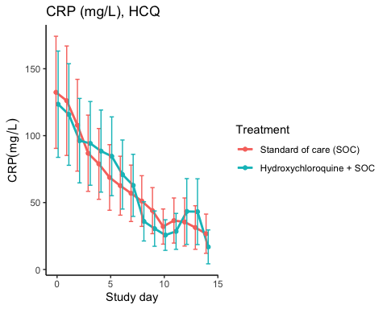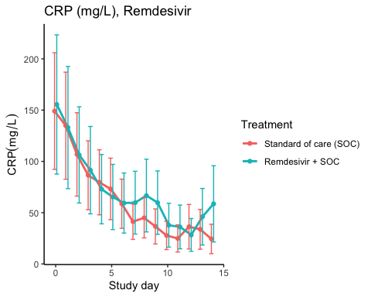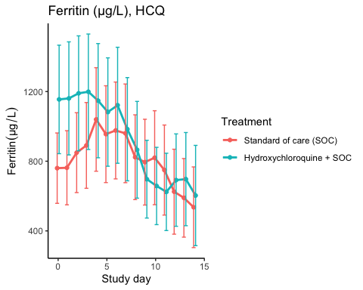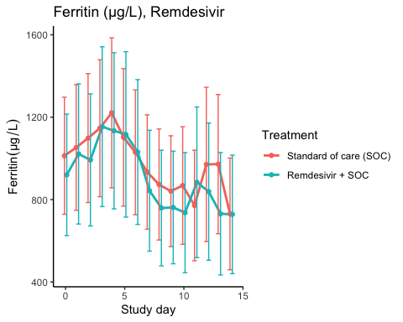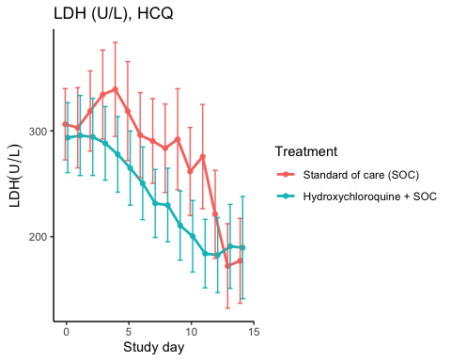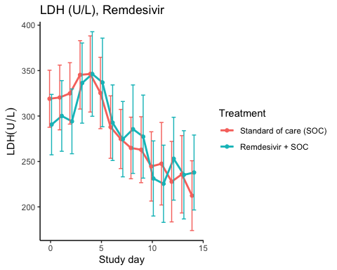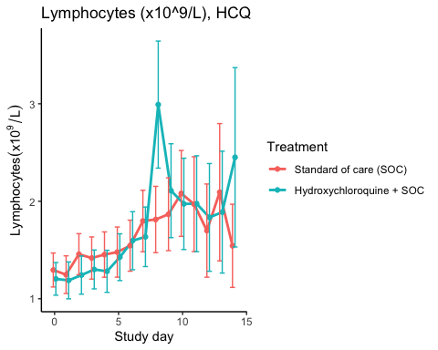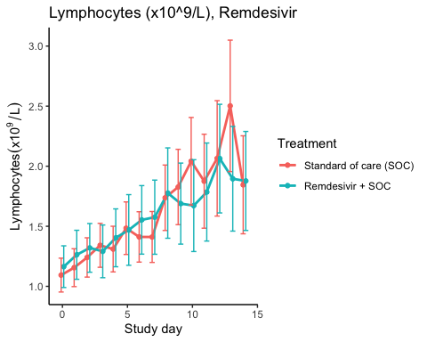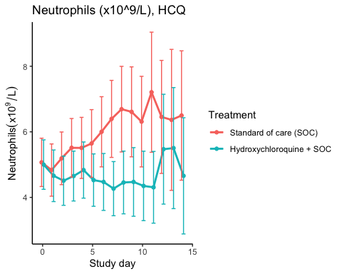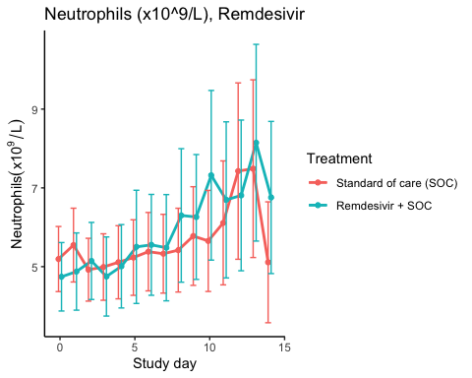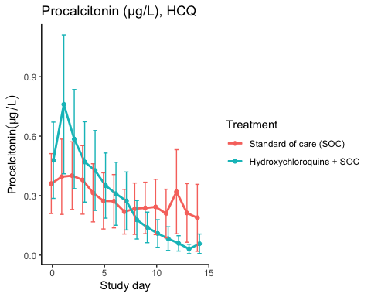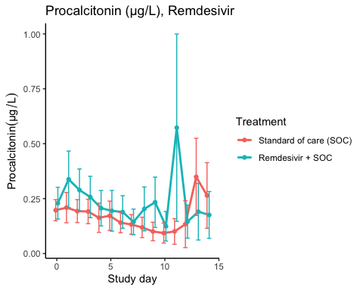

### Efficacy estimates

CRP (mg/L), HCQ

|  |  |  |  |  |  |
| --- | --- | --- | --- | --- | --- |
| Treatment | Days since randomisation | Treatment difference | Lower 95% CL | Upper 95% CL | P-value |
| Slope 1st week by treatment | Standard of care (SOC) | -11.107 | -15.360 | -6.854 | 0.000 |
| Slope 1st week by treatment | Hydroxychloroquine + SOC | -9.533 | -13.561 | -5.505 | 0.000 |
| Difference in 1st week slope | Hydroxychloroquine + SOC | 1.574 | -3.910 | 7.058 | 0.574 |
| Day 14 level by treatment | Standard of care (SOC) | 26.257 | 15.549 | 36.965 | 0.000 |
| Day 14 level by treatment | Hydroxychloroquine + SOC | 23.061 | 13.130 | 32.993 | 0.000 |
| Day 14 treatment difference | Hydroxychloroquine + SOC | -3.196 | -17.443 | 11.051 | 0.660 |

CRP (mg/L), Remdesivir

|  |  |  |  |  |  |
| --- | --- | --- | --- | --- | --- |
| Treatment | Days since randomisation | Treatment difference | Lower 95% CL | Upper 95% CL | P-value |
| Slope 1st week by treatment | Standard of care (SOC) | -14.453 | -20.386 | -8.521 | 0.000 |
| Slope 1st week by treatment | Remdesivir + SOC | -12.975 | -19.476 | -6.474 | 0.000 |
| Difference in 1st week slope | Remdesivir + SOC | 1.478 | -6.383 | 9.339 | 0.712 |
| Day 14 level by treatment | Standard of care (SOC) | 25.036 | 13.566 | 36.506 | 0.000 |
| Day 14 level by treatment | Remdesivir + SOC | 40.917 | 20.790 | 61.044 | 0.000 |
| Day 14 treatment difference | Remdesivir + SOC | 15.881 | -6.030 | 37.791 | 0.155 |

Ferritin (µg/L), HCQ

|  |  |  |  |  |  |
| --- | --- | --- | --- | --- | --- |
| Treatment | Days since randomisation | Treatment difference | Lower 95% CL | Upper 95% CL | P-value |
| Slope 1st week by treatment | Standard of care (SOC) | 31.237 | 12.183 | 50.291 | 0.001 |
| Slope 1st week by treatment | Hydroxychloroquine + SOC | -27.657 | -50.080 | -5.234 | 0.016 |
| Difference in 1st week slope | Hydroxychloroquine + SOC | -58.894 | -88.572 | -29.216 | 0.000 |
| Day 14 level by treatment | Standard of care (SOC) | 536.146 | 366.754 | 705.537 | 0.000 |
| Day 14 level by treatment | Hydroxychloroquine + SOC | 529.305 | 358.869 | 699.741 | 0.000 |
| Day 14 treatment difference | Hydroxychloroquine + SOC | -6.840 | -235.304 | 221.623 | 0.953 |

Ferritin (µg/L), Remdesivir

|  |  |  |  |  |  |
| --- | --- | --- | --- | --- | --- |
| Treatment | Days since randomisation | Treatment difference | Lower 95% CL | Upper 95% CL | P-value |
| Slope 1st week by treatment | Standard of care (SOC) | -10.588 | -28.423 | 7.246 | 0.245 |
| Slope 1st week by treatment | Remdesivir + SOC | -5.852 | -27.052 | 15.348 | 0.588 |
| Difference in 1st week slope | Remdesivir + SOC | 4.737 | -22.849 | 32.322 | 0.736 |
| Day 14 level by treatment | Standard of care (SOC) | 791.678 | 542.269 | 1041.088 | 0.000 |
| Day 14 level by treatment | Remdesivir + SOC | 695.226 | 448.308 | 942.144 | 0.000 |
| Day 14 treatment difference | Remdesivir + SOC | -96.453 | -423.041 | 230.136 | 0.563 |

LDH (U/L), HCQ

|  |  |  |  |  |  |
| --- | --- | --- | --- | --- | --- |
| Treatment | Days since randomisation | Treatment difference | Lower 95% CL | Upper 95% CL | P-value |
| Slope 1st week by treatment | Standard of care (SOC) | 0.090 | -3.684 | 3.865 | 0.963 |
| Slope 1st week by treatment | Hydroxychloroquine + SOC | -8.545 | -11.845 | -5.245 | 0.000 |
| Difference in 1st week slope | Hydroxychloroquine + SOC | -8.635 | -13.634 | -3.636 | 0.001 |
| Day 14 level by treatment | Standard of care (SOC) | 192.576 | 162.498 | 222.654 | 0.000 |
| Day 14 level by treatment | Hydroxychloroquine + SOC | 168.770 | 142.349 | 195.192 | 0.000 |
| Day 14 treatment difference | Hydroxychloroquine + SOC | -23.805 | -63.753 | 16.142 | 0.243 |

LDH (U/L), Remdesivir

|  |  |  |  |  |  |
| --- | --- | --- | --- | --- | --- |
| Treatment | Days since randomisation | Treatment difference | Lower 95% CL | Upper 95% CL | P-value |
| Slope 1st week by treatment | Standard of care (SOC) | -5.421 | -8.731 | -2.111 | 0.001 |
| Slope 1st week by treatment | Remdesivir + SOC | 0.497 | -3.637 | 4.630 | 0.814 |
| Difference in 1st week slope | Remdesivir + SOC | 5.918 | 0.640 | 11.195 | 0.028 |
| Day 14 level by treatment | Standard of care (SOC) | 213.314 | 183.809 | 242.819 | 0.000 |
| Day 14 level by treatment | Remdesivir + SOC | 222.554 | 189.900 | 255.208 | 0.000 |
| Day 14 treatment difference | Remdesivir + SOC | 9.240 | -34.586 | 53.067 | 0.679 |

Lymphocytes (x10^9/L), HCQ

|  |  |  |  |  |  |
| --- | --- | --- | --- | --- | --- |
| Treatment | Days since randomisation | Treatment difference | Lower 95% CL | Upper 95% CL | P-value |
| Slope 1st week by treatment | Standard of care (SOC) | 0.069 | 0.041 | 0.097 | 0.000 |
| Slope 1st week by treatment | Hydroxychloroquine + SOC | 0.094 | 0.063 | 0.126 | 0.000 |
| Difference in 1st week slope | Hydroxychloroquine + SOC | 0.025 | -0.017 | 0.067 | 0.237 |
| Day 14 level by treatment | Standard of care (SOC) | 1.914 | 1.515 | 2.313 | 0.000 |
| Day 14 level by treatment | Hydroxychloroquine + SOC | 2.264 | 1.734 | 2.794 | 0.000 |
| Day 14 treatment difference | Hydroxychloroquine + SOC | 0.350 | -0.307 | 1.008 | 0.296 |

Lymphocytes (x10^9/L), Remdesivir

|  |  |  |  |  |  |
| --- | --- | --- | --- | --- | --- |
| Treatment | Days since randomisation | Treatment difference | Lower 95% CL | Upper 95% CL | P-value |
| Slope 1st week by treatment | Standard of care (SOC) | 0.068 | 0.048 | 0.088 | 0.000 |
| Slope 1st week by treatment | Remdesivir + SOC | 0.065 | 0.038 | 0.092 | 0.000 |
| Difference in 1st week slope | Remdesivir + SOC | -0.003 | -0.036 | 0.031 | 0.874 |
| Day 14 level by treatment | Standard of care (SOC) | 2.338 | 1.942 | 2.733 | 0.000 |
| Day 14 level by treatment | Remdesivir + SOC | 1.974 | 1.620 | 2.327 | 0.000 |
| Day 14 treatment difference | Remdesivir + SOC | -0.364 | -0.887 | 0.159 | 0.173 |

Neutrophils (x10^9/L), HCQ

|  |  |  |  |  |  |
| --- | --- | --- | --- | --- | --- |
| Treatment | Days since randomisation | Treatment difference | Lower 95% CL | Upper 95% CL | P-value |
| Slope 1st week by treatment | Standard of care (SOC) | 0.204 | 0.103 | 0.305 | 0.000 |
| Slope 1st week by treatment | Hydroxychloroquine + SOC | -0.079 | -0.162 | 0.005 | 0.065 |
| Difference in 1st week slope | Hydroxychloroquine + SOC | -0.283 | -0.414 | -0.152 | 0.000 |
| Day 14 level by treatment | Standard of care (SOC) | 6.777 | 5.364 | 8.191 | 0.000 |
| Day 14 level by treatment | Hydroxychloroquine + SOC | 5.036 | 3.883 | 6.189 | 0.000 |
| Day 14 treatment difference | Hydroxychloroquine + SOC | -1.742 | -3.559 | 0.076 | 0.060 |

Neutrophils (x10^9/L), Remdesivir

|  |  |  |  |  |  |
| --- | --- | --- | --- | --- | --- |
| Treatment | Days since randomisation | Treatment difference | Lower 95% CL | Upper 95% CL | P-value |
| Slope 1st week by treatment | Standard of care (SOC) | 0.010 | -0.079 | 0.099 | 0.822 |
| Slope 1st week by treatment | Remdesivir + SOC | 0.151 | 0.026 | 0.275 | 0.018 |
| Difference in 1st week slope | Remdesivir + SOC | 0.141 | -0.012 | 0.293 | 0.071 |
| Day 14 level by treatment | Standard of care (SOC) | 6.622 | 5.171 | 8.073 | 0.000 |
| Day 14 level by treatment | Remdesivir + SOC | 7.632 | 5.887 | 9.376 | 0.000 |
| Day 14 treatment difference | Remdesivir + SOC | 1.010 | -1.240 | 3.259 | 0.379 |

Procalcitonin (µg/L), HCQ

|  |  |  |  |  |  |
| --- | --- | --- | --- | --- | --- |
| Treatment | Days since randomisation | Treatment difference | Lower 95% CL | Upper 95% CL | P-value |
| Slope 1st week by treatment | Standard of care (SOC) | -0.023 | -0.040 | -0.005 | 0.013 |
| Slope 1st week by treatment | Hydroxychloroquine + SOC | -0.044 | -0.070 | -0.018 | 0.001 |
| Difference in 1st week slope | Hydroxychloroquine + SOC | -0.021 | -0.051 | 0.009 | 0.164 |
| Day 14 level by treatment | Standard of care (SOC) | 0.237 | 0.101 | 0.373 | 0.001 |
| Day 14 level by treatment | Hydroxychloroquine + SOC | 0.032 | 0.014 | 0.050 | 0.000 |
| Day 14 treatment difference | Hydroxychloroquine + SOC | -0.205 | -0.341 | -0.069 | 0.003 |

Procalcitonin (µg/L), Remdesivir

|  |  |  |  |  |  |
| --- | --- | --- | --- | --- | --- |
| Treatment | Days since randomisation | Treatment difference | Lower 95% CL | Upper 95% CL | P-value |
| Slope 1st week by treatment | Standard of care (SOC) | -0.015 | -0.022 | -0.007 | 0.000 |
| Slope 1st week by treatment | Remdesivir + SOC | -0.016 | -0.029 | -0.003 | 0.015 |
| Difference in 1st week slope | Remdesivir + SOC | -0.001 | -0.016 | 0.013 | 0.857 |
| Day 14 level by treatment | Standard of care (SOC) | 0.237 | 0.139 | 0.335 | 0.000 |
| Day 14 level by treatment | Remdesivir + SOC | 0.219 | 0.124 | 0.313 | 0.000 |
| Day 14 treatment difference | Remdesivir + SOC | -0.018 | -0.154 | 0.117 | 0.792 |

# SARS-CoV2 antibodies at day 90

## Main results by quantreg

## Loading required package: SparseM

##   
## Attaching package: 'SparseM'

## The following object is masked from 'package:base':  
##   
## backsolve

##   
## Attaching package: 'quantreg'

## The following object is masked from 'package:survival':  
##   
## untangle.specials

|  |  |  |  |  |  |  |  |  |  |
| --- | --- | --- | --- | --- | --- | --- | --- | --- | --- |
| population | var | term | estimate | std.error | statistic | p.value | conf.low | conf.high | tau |
| fas_hcq | abace2rbd | (Intercept) | 15.137 | 9.858 | 1.536 | 0.128 | -4.463 | 34.738 | 0.5 |
| fas_hcq | abace2rbd | rantrtHydroxychloroquine + SOC | 1.181 | 10.984 | 0.108 | 0.915 | -20.658 | 23.021 | 0.5 |
| fas_hcq | abnormrbd | (Intercept) | 15.334 | 2.296 | 6.678 | 0.000 | 10.769 | 19.899 | 0.5 |
| fas_hcq | abnormrbd | rantrtHydroxychloroquine + SOC | -0.299 | 2.804 | -0.107 | 0.915 | -5.875 | 5.276 | 0.5 |
| fas_hcq | abrbd | (Intercept) | 57.420 | 11.425 | 5.026 | 0.000 | 34.704 | 80.137 | 0.5 |
| fas_hcq | abrbd | rantrtHydroxychloroquine + SOC | -16.979 | 13.099 | -1.296 | 0.198 | -43.024 | 9.066 | 0.5 |
| fas_rem | abace2rbd | (Intercept) | 12.338 | 4.199 | 2.938 | 0.004 | 3.984 | 20.692 | 0.5 |
| fas_rem | abace2rbd | rantrtRemdesivir + SOC | 8.032 | 5.295 | 1.517 | 0.133 | -2.501 | 18.564 | 0.5 |
| fas_rem | abnormrbd | (Intercept) | 15.334 | 2.364 | 6.485 | 0.000 | 10.630 | 20.038 | 0.5 |
| fas_rem | abnormrbd | rantrtRemdesivir + SOC | 2.282 | 4.288 | 0.532 | 0.596 | -6.248 | 10.812 | 0.5 |
| fas_rem | abrbd | (Intercept) | 49.121 | 15.683 | 3.132 | 0.002 | 17.922 | 80.319 | 0.5 |
| fas_rem | abrbd | rantrtRemdesivir + SOC | 18.635 | 20.696 | 0.900 | 0.371 | -22.536 | 59.806 | 0.5 |

## HCQ results from Stata

## .   
## . qreg abrbd i.rantrt  
## Iteration 1: WLS sum of weighted deviations = 1409.5208  
##   
## Iteration 1: sum of abs. weighted deviations = 1404.6108  
## Iteration 2: sum of abs. weighted deviations = 1402.4373  
##   
## Median regression Number of obs = 87  
## Raw sum of deviations 1442.164 (about 49.726769)  
## Min sum of deviations 1402.437 Pseudo R2 = 0.0275  
##   
## ------------------------------------------------------------------------------  
## abrbd | Coef. Std. Err. t P>|t| [95% Conf. Interval]  
## -------------+----------------------------------------------------------------  
## rantrt |  
## Hydroxych.. | -19.35636 13.4357 -1.44 0.153 -46.07012 7.357404  
## _cons | 59.79758 9.22343 6.48 0.000 41.45893 78.13623  
## ------------------------------------------------------------------------------  
## . qreg abnormrbd i.rantrt  
## Iteration 1: WLS sum of weighted deviations = 373.58137  
##   
## Iteration 1: sum of abs. weighted deviations = 373.75348  
## note: alternate solutions exist  
## Iteration 2: sum of abs. weighted deviations = 371.84791  
##   
## Median regression Number of obs = 87  
## Raw sum of deviations 371.9975 (about 15.333916)  
## Min sum of deviations 371.8479 Pseudo R2 = 0.0004  
##   
## ------------------------------------------------------------------------------  
## abnormrbd | Coef. Std. Err. t P>|t| [95% Conf. Interval]  
## -------------+----------------------------------------------------------------  
## rantrt |  
## Hydroxych.. | -.6739238 2.996132 -0.22 0.823 -6.631037 5.283189  
## _cons | 15.70872 2.056806 7.64 0.000 11.61924 19.7982  
## ------------------------------------------------------------------------------  
## . qreg abace2rbd i.rantrt  
## Iteration 1: WLS sum of weighted deviations = 1942.8592  
##   
## Iteration 1: sum of abs. weighted deviations = 1962.3145  
## Iteration 2: sum of abs. weighted deviations = 1830.1493  
## note: alternate solutions exist  
## Iteration 3: sum of abs. weighted deviations = 1743.8883  
##   
## Median regression Number of obs = 87  
## Raw sum of deviations 1743.888 (about 16.318782)  
## Min sum of deviations 1743.888 Pseudo R2 = 0.0000  
##   
## ------------------------------------------------------------------------------  
## abace2rbd | Coef. Std. Err. t P>|t| [95% Conf. Interval]  
## -------------+----------------------------------------------------------------  
## rantrt |  
## Hydroxych.. | -1.882254 14.44898 -0.13 0.897 -30.6107 26.8462  
## _cons | 18.20104 9.919039 1.83 0.070 -1.520671 37.92274  
## ------------------------------------------------------------------------------  
## .

## Remdesivir results by Stata

## .   
## . qreg abrbd i.rantrt  
## Iteration 1: WLS sum of weighted deviations = 1409.5208  
##   
## Iteration 1: sum of abs. weighted deviations = 1404.6108  
## Iteration 2: sum of abs. weighted deviations = 1402.4373  
##   
## Median regression Number of obs = 87  
## Raw sum of deviations 1442.164 (about 49.726769)  
## Min sum of deviations 1402.437 Pseudo R2 = 0.0275  
##   
## ------------------------------------------------------------------------------  
## abrbd | Coef. Std. Err. t P>|t| [95% Conf. Interval]  
## -------------+----------------------------------------------------------------  
## rantrt |  
## Hydroxych.. | -19.35636 13.4357 -1.44 0.153 -46.07012 7.357404  
## _cons | 59.79758 9.22343 6.48 0.000 41.45893 78.13623  
## ------------------------------------------------------------------------------  
## . qreg abnormrbd i.rantrt  
## Iteration 1: WLS sum of weighted deviations = 373.58137  
##   
## Iteration 1: sum of abs. weighted deviations = 373.75348  
## note: alternate solutions exist  
## Iteration 2: sum of abs. weighted deviations = 371.84791  
##   
## Median regression Number of obs = 87  
## Raw sum of deviations 371.9975 (about 15.333916)  
## Min sum of deviations 371.8479 Pseudo R2 = 0.0004  
##   
## ------------------------------------------------------------------------------  
## abnormrbd | Coef. Std. Err. t P>|t| [95% Conf. Interval]  
## -------------+----------------------------------------------------------------  
## rantrt |  
## Hydroxych.. | -.6739238 2.996132 -0.22 0.823 -6.631037 5.283189  
## _cons | 15.70872 2.056806 7.64 0.000 11.61924 19.7982  
## ------------------------------------------------------------------------------  
## . qreg abace2rbd i.rantrt  
## Iteration 1: WLS sum of weighted deviations = 1942.8592  
##   
## Iteration 1: sum of abs. weighted deviations = 1962.3145  
## Iteration 2: sum of abs. weighted deviations = 1830.1493  
## note: alternate solutions exist  
## Iteration 3: sum of abs. weighted deviations = 1743.8883  
##   
## Median regression Number of obs = 87  
## Raw sum of deviations 1743.888 (about 16.318782)  
## Min sum of deviations 1743.888 Pseudo R2 = 0.0000  
##   
## ------------------------------------------------------------------------------  
## abace2rbd | Coef. Std. Err. t P>|t| [95% Conf. Interval]  
## -------------+----------------------------------------------------------------  
## rantrt |  
## Hydroxych.. | -1.882254 14.44898 -0.13 0.897 -30.6107 26.8462  
## _cons | 18.20104 9.919039 1.83 0.070 -1.520671 37.92274  
## ------------------------------------------------------------------------------  
## .

## Sensitivity results by ANOVA

|  |  |  |  |  |  |  |  |  |
| --- | --- | --- | --- | --- | --- | --- | --- | --- |
| population | var | term | estimate | std.error | statistic | p.value | conf.low | conf.high |
| fas_hcq | abace2rbd | (Intercept) | 49.993 | 8.816 | 5.671 | 0.000 | 32.465 | 67.521 |
| fas_hcq | abace2rbd | rantrtHydroxychloroquine + SOC | -8.141 | 12.842 | -0.634 | 0.528 | -33.674 | 17.391 |
| fas_hcq | abnormrbd | (Intercept) | 17.442 | 1.585 | 11.007 | 0.000 | 14.292 | 20.593 |
| fas_hcq | abnormrbd | rantrtHydroxychloroquine + SOC | -1.920 | 2.308 | -0.832 | 0.408 | -6.509 | 2.670 |
| fas_hcq | abrbd | (Intercept) | 60.795 | 5.791 | 10.498 | 0.000 | 49.282 | 72.309 |
| fas_hcq | abrbd | rantrtHydroxychloroquine + SOC | -15.352 | 8.436 | -1.820 | 0.072 | -32.124 | 1.420 |
| fas_rem | abace2rbd | (Intercept) | 40.486 | 8.132 | 4.979 | 0.000 | 24.309 | 56.662 |
| fas_rem | abace2rbd | rantrtRemdesivir + SOC | -1.360 | 12.782 | -0.106 | 0.916 | -26.786 | 24.067 |
| fas_rem | abnormrbd | (Intercept) | 15.627 | 1.620 | 9.646 | 0.000 | 12.404 | 18.849 |
| fas_rem | abnormrbd | rantrtRemdesivir + SOC | 6.053 | 2.546 | 2.377 | 0.020 | 0.987 | 11.118 |
| fas_rem | abrbd | (Intercept) | 51.014 | 6.139 | 8.309 | 0.000 | 38.801 | 63.228 |
| fas_rem | abrbd | rantrtRemdesivir + SOC | 28.188 | 9.650 | 2.921 | 0.005 | 8.991 | 47.385 |

# Time to last discharge

## Remdesivir

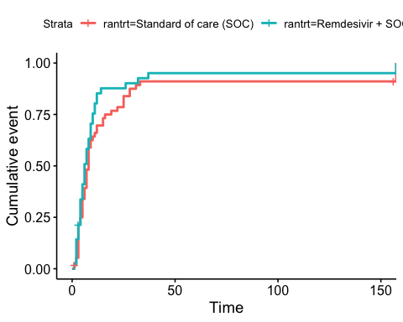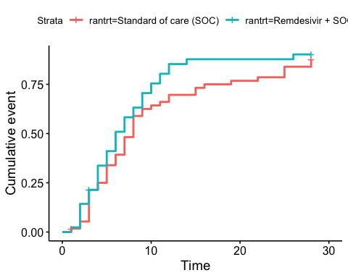 ## HCQ

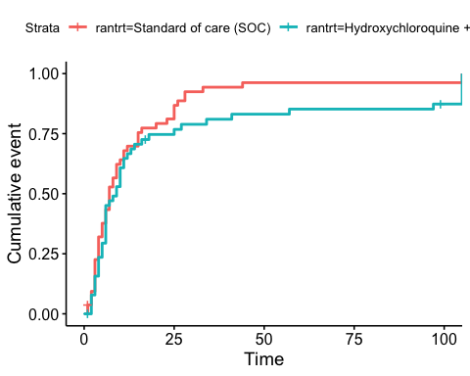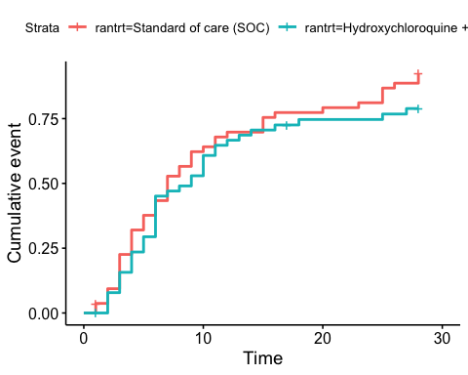

# Adverse Events

## AE Summary

Summary of Adverse Events

|  |  |  |  |
| --- | --- | --- | --- |
| Parameter | SOC (N=87) | SOC + HCQ (N=52) | SOC + Remdesivir (N=42) |
| Number of AEs | [45] 28 (32.2%) | [32] 19 (36.5%) | [16] 11 (26.2%) |
| Number of patients with any AEs? | 28 (32.2%) | 19 (36.5%) | 11 (26.2%) |
| Number of patients with one AE | 20 (23%) | 12 (23.1%) | 8 (19%) |
| Number of patients with two AE | 2 (2.3%) | 3 (5.8%) | 1 (2.4%) |
| Number of patients with three or more AEs | 6 (6.9%) | 4 (7.7%) | 2 (4.8%) |
| Number of SAEs | [24] 16 (18.4%) | [15] 9 (17.3%) | [6] 6 (14.3%) |
| Number of patients with any SAEs? | 16 (18.4%) | 9 (17.3%) | 6 (14.3%) |

The numbers are [Number of events] Number of patients (percentage of patients), or Number of patients (percentage of patients)

## By System Organ Class and Preferred Term

Adverse Events by System Organ Class and Preferred term

|  |  |  |  |  |
| --- | --- | --- | --- | --- |
| System Organ Class | Preferred Term | SOC (N=87) | SOC + HCQ (N=52) | SOC + Remdesivir (N=42) |
| Blood and lymphatic system disorders | #Total | [2] 1 (1.1%) |  |  |
|  | Leukopenia | [1] 1 (1.1%) |  |  |
|  | Thrombocytopenia | [1] 1 (1.1%) |  |  |
| Cardiac disorders | #Total |  | [1] 1 (1.9%) | [3] 2 (4.8%) |
|  | Arrhythmia |  |  | [2] 1 (2.4%) |
|  | Ventricular tachycardia |  | [1] 1 (1.9%) | [1] 1 (2.4%) |
| Gastrointestinal disorders | #Total | [5] 5 (5.7%) | [1] 1 (1.9%) | [4] 3 (7.1%) |
|  | Abdominal pain | [1] 1 (1.1%) |  |  |
|  | Diarrhoea | [1] 1 (1.1%) |  |  |
|  | Diarrhoea haemorrhagic | [1] 1 (1.1%) |  |  |
|  | Gastrooesophageal reflux disease |  |  | [1] 1 (2.4%) |
|  | Intestinal pseudo-obstruction |  | [1] 1 (1.9%) |  |
|  | Nausea |  |  | [2] 2 (4.8%) |
|  | Pancreatic failure | [1] 1 (1.1%) |  |  |
|  | Vomiting | [1] 1 (1.1%) |  | [1] 1 (2.4%) |
| General disorders and administration site conditions | #Total | [2] 2 (2.3%) | [1] 1 (1.9%) | [2] 2 (4.8%) |
|  | Chest pain |  |  | [1] 1 (2.4%) |
|  | General physical health deterioration |  |  | [1] 1 (2.4%) |
|  | Medical device site reaction | [1] 1 (1.1%) |  |  |
|  | Pyrexia | [1] 1 (1.1%) | [1] 1 (1.9%) |  |
| Hepatobiliary disorders | #Total | [1] 1 (1.1%) |  |  |
|  | Cholecystitis | [1] 1 (1.1%) |  |  |
| Infections and infestations | #Total | [3] 3 (3.4%) | [1] 1 (1.9%) | [1] 1 (2.4%) |
|  | COVID-19 | [1] 1 (1.1%) |  |  |
|  | Infection |  |  | [1] 1 (2.4%) |
|  | Pneumonia bacterial | [1] 1 (1.1%) | [1] 1 (1.9%) |  |
|  | Superinfection bacterial | [1] 1 (1.1%) |  |  |
| Injury, poisoning and procedural complications | #Total | [2] 2 (2.3%) |  |  |
|  | Hepatobiliary procedural complication | [1] 1 (1.1%) |  |  |
|  | Procedural pneumothorax | [1] 1 (1.1%) |  |  |
| Investigations | #Total | [11] 6 (6.9%) | [5] 4 (7.7%) | [3] 3 (7.1%) |
|  | Alanine aminotransferase increased | [2] 1 (1.1%) | [2] 2 (3.8%) |  |
|  | Amylase increased | [1] 1 (1.1%) |  |  |
|  | Aspartate aminotransferase increased | [4] 4 (4.6%) | [1] 1 (1.9%) |  |
|  | Blood creatine phosphokinase increased | [1] 1 (1.1%) |  |  |
|  | Electrocardiogram QT prolonged | [2] 2 (2.3%) |  |  |
|  | Fibrin D dimer increased |  |  | [1] 1 (2.4%) |
|  | Gamma-glutamyltransferase increased | [1] 1 (1.1%) |  |  |
|  | Hepatic enzyme increased |  |  | [2] 2 (4.8%) |
|  | Myocardial necrosis marker increased |  | [1] 1 (1.9%) |  |
|  | Neutrophil count decreased |  | [1] 1 (1.9%) |  |
| Metabolism and nutrition disorders | #Total | [1] 1 (1.1%) |  |  |
|  | Hypercalcaemia | [1] 1 (1.1%) |  |  |
| Musculoskeletal and connective tissue disorders | #Total |  | [3] 1 (1.9%) | [1] 1 (2.4%) |
|  | Arthralgia |  | [1] 1 (1.9%) |  |
|  | Arthritis reactive |  | [1] 1 (1.9%) |  |
|  | Joint swelling |  | [1] 1 (1.9%) |  |
|  | Tendonitis |  |  | [1] 1 (2.4%) |
| Neoplasms benign, malignant and unspecified (incl cysts and polyps) | #Total | [1] 1 (1.1%) |  |  |
|  | Neoplasm malignant | [1] 1 (1.1%) |  |  |
| Nervous system disorders | #Total | [3] 3 (3.4%) | [2] 2 (3.8%) |  |
|  | Haemorrhage intracranial | [1] 1 (1.1%) |  |  |
|  | Headache |  | [1] 1 (1.9%) |  |
|  | Loss of consciousness | [1] 1 (1.1%) |  |  |
|  | Syncope | [1] 1 (1.1%) | [1] 1 (1.9%) |  |
| Renal and urinary disorders | #Total |  | [2] 2 (3.8%) |  |
|  | Renal failure |  | [2] 2 (3.8%) |  |
| Respiratory, thoracic and mediastinal disorders | #Total | [12] 11 (12.6%) | [13] 8 (15.4%) | [2] 2 (4.8%) |
|  | Bronchopleural fistula | [1] 1 (1.1%) |  |  |
|  | Chronic obstructive pulmonary disease |  | [2] 1 (1.9%) |  |
|  | Cough | [1] 1 (1.1%) |  |  |
|  | Dyspnoea |  | [4] 2 (3.8%) |  |
|  | Pulmonary embolism | [1] 1 (1.1%) |  |  |
|  | Respiratory distress | [2] 2 (2.3%) | [5] 4 (7.7%) | [1] 1 (2.4%) |
|  | Respiratory failure | [7] 7 (8%) | [2] 1 (1.9%) | [1] 1 (2.4%) |
| Skin and subcutaneous tissue disorders | #Total | [1] 1 (1.1%) | [1] 1 (1.9%) |  |
|  | Alopecia | [1] 1 (1.1%) | [1] 1 (1.9%) |  |
| Vascular disorders | #Total | [1] 1 (1.1%) | [2] 2 (3.8%) |  |
|  | Hypotension |  | [1] 1 (1.9%) |  |
|  | Thrombophlebitis |  | [1] 1 (1.9%) |  |
|  | Thrombosis | [1] 1 (1.1%) |  |  |

## Serious Adverse Events

Serious Adverse Events by System Organ Class and Preferred term

|  |  |  |  |  |
| --- | --- | --- | --- | --- |
| System Organ Class | Preferred Term | SOC (N=87) | SOC + HCQ (N=52) | SOC + Remdesivir (N=42) |
| Gastrointestinal disorders | #Total | [2] 2 (2.3%) |  |  |
|  | Abdominal pain | [1] 1 (1.1%) |  |  |
|  | Diarrhoea haemorrhagic | [1] 1 (1.1%) |  |  |
| General disorders and administration site conditions | #Total | [1] 1 (1.1%) |  | [2] 2 (4.8%) |
|  | Chest pain |  |  | [1] 1 (2.4%) |
|  | General physical health deterioration |  |  | [1] 1 (2.4%) |
|  | Pyrexia | [1] 1 (1.1%) |  |  |
| Hepatobiliary disorders | #Total | [1] 1 (1.1%) |  |  |
|  | Cholecystitis | [1] 1 (1.1%) |  |  |
| Infections and infestations | #Total | [3] 3 (3.4%) |  |  |
|  | COVID-19 | [1] 1 (1.1%) |  |  |
|  | Pneumonia bacterial | [1] 1 (1.1%) |  |  |
|  | Superinfection bacterial | [1] 1 (1.1%) |  |  |
| Injury, poisoning and procedural complications | #Total | [2] 2 (2.3%) |  |  |
|  | Hepatobiliary procedural complication | [1] 1 (1.1%) |  |  |
|  | Procedural pneumothorax | [1] 1 (1.1%) |  |  |
| Investigations | #Total | [3] 3 (3.4%) |  | [2] 2 (4.8%) |
|  | Alanine aminotransferase increased | [1] 1 (1.1%) |  |  |
|  | Aspartate aminotransferase increased | [1] 1 (1.1%) |  |  |
|  | Blood creatine phosphokinase increased | [1] 1 (1.1%) |  |  |
|  | Hepatic enzyme increased |  |  | [2] 2 (4.8%) |
| Neoplasms benign, malignant and unspecified (incl cysts and polyps) | #Total | [1] 1 (1.1%) |  |  |
|  | Neoplasm malignant | [1] 1 (1.1%) |  |  |
| Nervous system disorders | #Total | [2] 2 (2.3%) |  |  |
|  | Haemorrhage intracranial | [1] 1 (1.1%) |  |  |
|  | Loss of consciousness | [1] 1 (1.1%) |  |  |
| Renal and urinary disorders | #Total |  | [2] 2 (3.8%) |  |
|  | Renal failure |  | [2] 2 (3.8%) |  |
| Respiratory, thoracic and mediastinal disorders | #Total | [9] 8 (9.2%) | [13] 8 (15.4%) | [2] 2 (4.8%) |
|  | Bronchopleural fistula | [1] 1 (1.1%) |  |  |
|  | Chronic obstructive pulmonary disease |  | [2] 1 (1.9%) |  |
|  | Dyspnoea |  | [4] 2 (3.8%) |  |
|  | Pulmonary embolism | [1] 1 (1.1%) |  |  |
|  | Respiratory distress | [1] 1 (1.1%) | [5] 4 (7.7%) | [1] 1 (2.4%) |
|  | Respiratory failure | [6] 6 (6.9%) | [2] 1 (1.9%) | [1] 1 (2.4%) |

## Suspected Unexpected Serious Adverse Reaction

Suspected Unexpected Serious Adverse Reaction by System Organ Class and Preferred term

|  |  |  |
| --- | --- | --- |
| System Organ Class | Preferred Term | Standard of care (SOC) |
| Gastrointestinal disorders | #Total | [1] 1 (1.1%) |
|  | Diarrhoea haemorrhagic | [1] 1 (1.1%) |