AHUS-NO-COVID-19 report

Corina Rueegg, PhD

20200924

# Introduction

This report presents the final results of the AHUS-NO-COVID-19 trial. The safety analysis is based on the Safety Analysis Set including all subjects with any safety information after baseline (N=53). Patients randomised to hydroxychloroquine without receiving any amount of the treatment will be excluded from the safety population (nobody was excluded based on that condition). The primary efficacy analysis is based on the Full Analysis Set (FAS) including all randomised subjects who have had at least one baseline and one post-randomisation evaluation of efficacy (N=51). The secondary efficacy analysis is based on the Per Protocol Set including all participants of the FAS who took at least 7 of the 8 first hydroxychloroquine doses (N=49)

Analysis according to final SAP version 2.1, dated 28.05.2020

Data extraction Viedoc electronic data capture system, time stamped: 26.05.2020 12:06 UTC

# 1. Patient enrolment and disposition

## 1.1. Inclusion by treatment arm

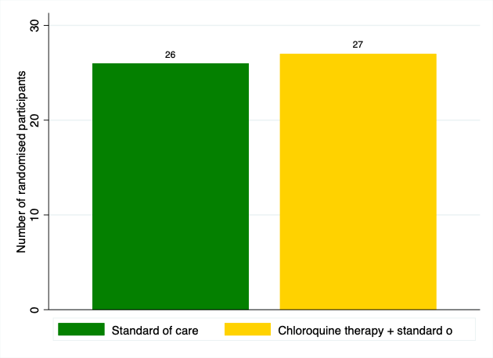

## 1.3. Description of patient disposition

**Table 1. Overview of study completion and reasons for non-completion**

|  |  |  |  |  |  |  |  |  |
| --- | --- | --- | --- | --- | --- | --- | --- | --- |
| |  |  |  |  | | --- | --- | --- | --- | |  | | Standard of care | Chloroquine therapy + standard of care | |  | | (N = 26) | (N = 27) | |
| |  |  |  |  | | --- | --- | --- | --- | | **Study completed** | |  |  | | No | | 2 (7.7%) | 4 (14.8%) | | Yes | | 24 (92.3%) | 23 (85.2%) | | **Reason for discontinuation** | |  |  | | Voluntary discontinuation | | 1 (50.0%) | 1 (25.0%) | | Lost to follow-up | | 0 (0.0%) | 2 (50.0%) | | Death | | 1 (50.0%) | 1 (25.0%) | |

## 1.4. Description of protocol deviations

One protocol deviation reported in the standard of care arm: Patient moved to ICU and started chloroquine treatment at the time of moving. At this stage of the pandemic, chloroquine was considered SOC for those who had serious covid-19. Date of deviation: 27.03.2020

# 2. Baseline characteristics

**Table 2. Baseline characteristics for all randomised participants (N=53)**

|  |  |  |  |  |  |  |  |  |  |  |
| --- | --- | --- | --- | --- | --- | --- | --- | --- | --- | --- |
| |  |  |  |  |  | | --- | --- | --- | --- | --- | |  | | Standard of care | Chloroquine therapy + standard of care | Total | |  | | (N = 26) | (N = 27) | (N = 53) | |
| |  |  |  |  |  | | --- | --- | --- | --- | --- | | **NEWS score** | |  |  |  | | Mean (SD) | | 4.96 (2.55) | 4.26 (2.89) | 4.60 (2.73) | | Median (Q1, Q3) | | 5.0 (3.0, 7.0) | 4.0 (2.0, 6.0) | 5.0 (2.0, 6.0) | | Min, Max | | 1.0, 10.0 | 0.0, 10.0 | 0.0, 10.0 | | N (% Non-missing) | | 26 (100.0%) | 27 (100.0%) | 53 (100.0%) | | **Age** | |  |  |  | | Mean (SD) | | 63.73 (13.55) | 57.00 (15.49) | 60.30 (14.83) | | Median (Q1, Q3) | | 69.0 (51.0, 74.0) | 56.0 (41.0, 72.0) | 62.0 (50.0, 73.0) | | Min, Max | | 30.0, 83.0 | 30.0, 85.0 | 30.0, 85.0 | | N (% Non-missing) | | 26 (100.0%) | 27 (100.0%) | 53 (100.0%) | | **BMI** | |  |  |  | | Mean (SD) | | 28.72 (4.70) | 26.95 (4.41) | 27.83 (4.60) | | Median (Q1, Q3) | | 27.6 (24.2, 33.0) | 25.6 (23.9, 29.4) | 26.4 (23.9, 30.5) | | Min, Max | | 21.9, 37.0 | 21.6, 38.6 | 21.6, 38.6 | | N (% Non-missing) | | 26 (100.0%) | 26 (96.3%) | 52 (98.1%) | | **Respiratory rate** | |  |  |  | | Mean (SD) | | 26.96 (7.84) | 25.30 (8.65) | 26.11 (8.22) | | Median (Q1, Q3) | | 26.0 (20.0, 32.0) | 22.0 (20.0, 30.0) | 24.0 (20.0, 32.0) | | Min, Max | | 16.0, 44.0 | 14.0, 48.0 | 14.0, 48.0 | | N (% Non-missing) | | 26 (100.0%) | 27 (100.0%) | 53 (100.0%) | | **Body temperature** | |  |  |  | | Mean (SD) | | 38.01 (0.97) | 38.06 (1.00) | 38.03 (0.98) | | Median (Q1, Q3) | | 38.2 (37.5, 38.6) | 38.2 (37.3, 38.7) | 38.2 (37.5, 38.7) | | Min, Max | | 36.0, 39.8 | 36.0, 40.0 | 36.0, 40.0 | | N (% Non-missing) | | 26 (100.0%) | 27 (100.0%) | 53 (100.0%) | | **Systolic blood pressure** | |  |  |  | | Mean (SD) | | 138.38 (12.67) | 135.15 (20.25) | 136.74 (16.88) | | Median (Q1, Q3) | | 137.0 (130.0, 145.0) | 129.0 (120.0, 142.0) | 134.0 (124.0, 144.0) | | Min, Max | | 119.0, 168.0 | 109.0, 180.0 | 109.0, 180.0 | | N (% Non-missing) | | 26 (100.0%) | 27 (100.0%) | 53 (100.0%) | | **Diastolic blood pressure** | |  |  |  | | Mean (SD) | | 75.12 (9.18) | 77.59 (12.33) | 76.38 (10.87) | | Median (Q1, Q3) | | 74.0 (71.0, 79.0) | 75.0 (70.0, 87.0) | 75.0 (71.0, 85.0) | | Min, Max | | 58.0, 102.0 | 56.0, 107.0 | 56.0, 107.0 | | N (% Non-missing) | | 26 (100.0%) | 27 (100.0%) | 53 (100.0%) | | **Oxygen saturation** | |  |  |  | | Mean (SD) | | 93.73 (3.31) | 95.07 (2.06) | 94.42 (2.80) | | Median (Q1, Q3) | | 94.5 (92.0, 96.0) | 95.0 (94.0, 96.0) | 95.0 (93.0, 96.0) | | Min, Max | | 85.0, 99.0 | 90.0, 99.0 | 85.0, 99.0 | | N (% Non-missing) | | 26 (100.0%) | 27 (100.0%) | 53 (100.0%) | | **Heart rate** | |  |  |  | | Mean (SD) | | 89.81 (12.94) | 89.30 (17.47) | 89.55 (15.27) | | Median (Q1, Q3) | | 85.5 (80.0, 100.0) | 88.0 (76.0, 98.0) | 86.0 (80.0, 98.0) | | Min, Max | | 68.0, 115.0 | 66.0, 148.0 | 66.0, 148.0 | | N (% Non-missing) | | 26 (100.0%) | 27 (100.0%) | 53 (100.0%) | | **Gender** | |  |  |  | | Male | | 16 (61.5%) | 19 (70.4%) | 35 (66.0%) | | Female | | 10 (38.5%) | 8 (29.6%) | 18 (34.0%) | | **Supplemental oxygen** | |  |  |  | | No | | 14 (53.8%) | 19 (70.4%) | 33 (62.3%) | | Yes | | 12 (46.2%) | 8 (29.6%) | 20 (37.7%) | | **Hypertension** | |  |  |  | | No | | 15 (57.7%) | 21 (77.8%) | 36 (67.9%) | | Yes | | 11 (42.3%) | 6 (22.2%) | 17 (32.1%) | | **Diabetes** | |  |  |  | | No | | 21 (80.8%) | 23 (85.2%) | 44 (83.0%) | | Yes | | 5 (19.2%) | 4 (14.8%) | 9 (17.0%) | | **Coronary artery disease** | |  |  |  | | No | | 24 (92.3%) | 24 (88.9%) | 48 (90.6%) | | Yes | | 2 (7.7%) | 3 (11.1%) | 5 (9.4%) | | **Obstructive pulmonary disease** | |  |  |  | | No | | 17 (65.4%) | 22 (81.5%) | 39 (73.6%) | | Yes | | 9 (34.6%) | 5 (18.5%) | 14 (26.4%) | | **Obesity** | |  |  |  | | No | | 15 (57.7%) | 21 (80.8%) | 36 (69.2%) | | Yes | | 11 (42.3%) | 5 (19.2%) | 16 (30.8%) | | . | | 0 (.%) | 1 (.%) | 1 (.%) | | **Any coexisting condition** | |  |  |  | | No codition | | 7 (26.9%) | 13 (48.1%) | 20 (37.7%) | | ≥1 condition | | 19 (73.1%) | 14 (51.9%) | 33 (62.3%) | | **Temperature >37.8** | |  |  |  | | No | | 8 (30.8%) | 10 (37.0%) | 18 (34.0%) | | Yes | | 18 (69.2%) | 17 (63.0%) | 35 (66.0%) | | **Current smoker** | |  |  |  | | No | | 25 (96.2%) | 26 (96.3%) | 51 (96.2%) | | Yes | | 1 (3.8%) | 1 (3.7%) | 2 (3.8%) | |

# 3. Study drug exposure

**Table 3. Description of study drug exposure among those randomised to the hydroxychloroquine arm (N=27)**

|  |  |  |  |  |  |  |
| --- | --- | --- | --- | --- | --- | --- |
| |  |  |  | | --- | --- | --- | |  | | Total | |  | | (N = 53) | |
| |  |  |  | | --- | --- | --- | | **Total dose (mg)** | |  | | Median (Q1, Q3) | | 0 (0, 5600) | | Min, Max | | 0, 6000 | | N (% Non-missing) | | 53 (100.0%) | | **Total number of 400mg doses received** | |  | | 0 | | 27 (50.9%) | | 4 | | 2 (3.8%) | | 8 | | 1 (1.9%) | | 10 | | 1 (1.9%) | | 12 | | 1 (1.9%) | | 14 | | 19 (35.8%) | | 15 | | 2 (3.8%) | |

# 4. Safety analysis

## 4.1. Adverse events of special interest

**Table 4. Description of Adverse Events of Special Interest (AESI)**

|  |  |  |  |  |  |  |  |  |  |  |
| --- | --- | --- | --- | --- | --- | --- | --- | --- | --- | --- |
| |  |  |  |  |  | | --- | --- | --- | --- | --- | |  | | Standard of care | Chloroquine therapy + standard of care | Total | |  | | (N = 152) | (N = 163) | (N = 315) | |
| |  |  |  |  |  | | --- | --- | --- | --- | --- | | **Vomiting/nausea** | |  |  |  | | Number of events | | 35 (100.0%) | 30 (100.0%) | 65 (100.0%) | | **Severity vomiting/nausea** | |  |  |  | | Mild | | 23 (65.7%) | 23 (76.7%) | 46 (70.8%) | | Moderate | | 12 (34.3%) | 7 (23.3%) | 19 (29.2%) | | **Diarrhoea** | |  |  |  | | Number of events | | 52 (100.0%) | 62 (100.0%) | 114 (100.0%) | | **Severity diarrhoea** | |  |  |  | | Mild | | 39 (75.0%) | 45 (72.6%) | 84 (73.7%) | | Moderate | | 13 (25.0%) | 16 (25.8%) | 29 (25.4%) | | Severe | | 0 (0.0%) | 1 (1.6%) | 1 (0.9%) | | **Abdominal pain** | |  |  |  | | Number of events | | 18 (100.0%) | 28 (100.0%) | 46 (100.0%) | | **Severity abd.pain** | |  |  |  | | Mild | | 14 (77.8%) | 20 (71.4%) | 34 (73.9%) | | Moderate | | 4 (22.2%) | 8 (28.6%) | 12 (26.1%) | | **Skin rash** | |  |  |  | | Number of events | | 6 (100.0%) | 1 (100.0%) | 7 (100.0%) | | **Severity skin rash** | |  |  |  | | Mild | | 3 (50.0%) | 1 (100.0%) | 4 (57.1%) | | Moderate | | 3 (50.0%) | 0 (0.0%) | 3 (42.9%) | | **Blurry vision** | |  |  |  | | Number of events | | 1 (100.0%) | 4 (100.0%) | 5 (100.0%) | | **Severity blurry vision** | |  |  |  | | Mild | | 1 (100.0%) | 4 (100.0%) | 5 (100.0%) | |

**Table 5. Description of patients with Adverse Events of Special Interest (AESI, N=53)**

|  |  |  |  |  |  |  |  |  |  |  |
| --- | --- | --- | --- | --- | --- | --- | --- | --- | --- | --- |
| |  |  |  |  |  | | --- | --- | --- | --- | --- | |  | | Standard of care | Chloroquine therapy + standard of care | Total | |  | | (N = 26) | (N = 27) | (N = 53) | |
| |  |  |  |  |  | | --- | --- | --- | --- | --- | | **Number of nausea events per person** | |  |  |  | | 0 | | 11 (42.3%) | 15 (55.6%) | 26 (49.1%) | | 1 | | 8 (30.8%) | 4 (14.8%) | 12 (22.6%) | | 2 | | 2 (7.7%) | 3 (11.1%) | 5 (9.4%) | | ≥3 | | 5 (19.2%) | 5 (18.5%) | 10 (18.9%) | | **Number of diarrhea events per person** | |  |  |  | | 0 | | 9 (34.6%) | 6 (22.2%) | 15 (28.3%) | | 1 | | 5 (19.2%) | 5 (18.5%) | 10 (18.9%) | | 2 | | 4 (15.4%) | 4 (14.8%) | 8 (15.1%) | | ≥3 | | 8 (30.8%) | 12 (44.4%) | 20 (37.7%) | | **Number of abdominal pain events per person** | |  |  |  | | 0 | | 17 (65.4%) | 15 (55.6%) | 32 (60.4%) | | 1 | | 6 (23.1%) | 3 (11.1%) | 9 (17.0%) | | 2 | | 2 (7.7%) | 5 (18.5%) | 7 (13.2%) | | ≥3 | | 1 (3.8%) | 4 (14.8%) | 5 (9.4%) | | **Number of skin rash events per person** | |  |  |  | | 0 | | 24 (92.3%) | 26 (96.3%) | 50 (94.3%) | | 1 | | 1 (3.8%) | 1 (3.7%) | 2 (3.8%) | | ≥3 | | 1 (3.8%) | 0 (0.0%) | 1 (1.9%) | | **Number of blurry vision events per person** | |  |  |  | | 0 | | 25 (96.2%) | 25 (92.6%) | 50 (94.3%) | | 1 | | 1 (3.8%) | 0 (0.0%) | 1 (1.9%) | | 2 | | 0 (0.0%) | 2 (7.4%) | 2 (3.8%) | | **Number of any AESI per person** | |  |  |  | | 0 | | 4 (15.4%) | 4 (14.8%) | 8 (15.1%) | | 1 | | 3 (11.5%) | 4 (14.8%) | 7 (13.2%) | | 2 | | 6 (23.1%) | 0 (0.0%) | 6 (11.3%) | | ≥3 | | 13 (50.0%) | 19 (70.4%) | 32 (60.4%) | |

## 4.2. Additional adverse events and serious adverse events

Note: there was no patient with more than one adverse event/serious adverse event

**Table 6. Description of patients with Adverse Events (N=53)**

|  |  |  |  |  |  |  |  |  |  |  |
| --- | --- | --- | --- | --- | --- | --- | --- | --- | --- | --- |
| |  |  |  |  |  | | --- | --- | --- | --- | --- | |  | | Standard of care | Chloroquine therapy + standard of care | Total | |  | | (N = 26) | (N = 27) | (N = 53) | |
| |  |  |  |  |  | | --- | --- | --- | --- | --- | | **Patients with any adverse event** | |  |  |  | | No AE | | 19 (73.1%) | 20 (74.1%) | 39 (73.6%) | | With AE | | 7 (26.9%) | 7 (25.9%) | 14 (26.4%) | | **Patients with any serious adverse event** | |  |  |  | | No SAE | | 20 (76.9%) | 22 (81.5%) | 42 (79.2%) | | With SAE | | 6 (23.1%) | 5 (18.5%) | 11 (20.8%) | | **Adverse event by Preferred Term** | |  |  |  | | No AE | | 19 (73.1%) | 20 (74.1%) | 39 (73.6%) | | Acute respiratory distress syndrome | | 0 (0.0%) | 1 (3.7%) | 1 (1.9%) | | Dyspnoea | | 0 (0.0%) | 1 (3.7%) | 1 (1.9%) | | Hypoaesthesia | | 0 (0.0%) | 1 (3.7%) | 1 (1.9%) | | Pneumonia | | 2 (7.7%) | 1 (3.7%) | 3 (5.7%) | | Respiratory failure | | 4 (15.4%) | 3 (11.1%) | 7 (13.2%) | | Urinary tract infection | | 1 (3.8%) | 0 (0.0%) | 1 (1.9%) | | **Adverse event by System Organ Class** | |  |  |  | | No AE | | 19 (73.1%) | 20 (74.1%) | 39 (73.6%) | | Infections and infestations | | 3 (11.5%) | 1 (3.7%) | 4 (7.5%) | | Nervous system disorders | | 0 (0.0%) | 1 (3.7%) | 1 (1.9%) | | Respiratory, thoracic and mediastinal disorders | | 4 (15.4%) | 5 (18.5%) | 9 (17.0%) | | **Serious adverse event by Preferred Term** | |  |  |  | | No SAE | | 20 (76.9%) | 22 (81.5%) | 42 (79.2%) | | Acute respiratory distress syndrome | | 0 (0.0%) | 1 (3.7%) | 1 (1.9%) | | Pneumonia | | 1 (3.8%) | 1 (3.7%) | 2 (3.8%) | | Respiratory failure | | 4 (15.4%) | 3 (11.1%) | 7 (13.2%) | | Urinary tract infection | | 1 (3.8%) | 0 (0.0%) | 1 (1.9%) | | **SAEs resulting in death** | |  |  |  | | Not resulted in death | | 25 (96.2%) | 26 (96.3%) | 51 (96.2%) | | Respiratory failure | | 1 (3.8%) | 1 (3.7%) | 2 (3.8%) | | **SUSAR** | |  |  |  | | No SUSAR (expected SAE) | | 25 (96.2%) | 27 (100.0%) | 52 (98.1%) | | Urinary tract infection | | 1 (3.8%) | 0 (0.0%) | 1 (1.9%) | |

# 5. Effect of hydroxychloroquine on viral load

## 5.1. Hypothesis to be tested

The primary null hypothesis is that there is no difference in the slope of the viral load from randomisation to 48 and 96 hours between the two treatment regimes.

## 5.2. Description of the viral load data

**Table 7. Description of viral load overall and by study time point**

|  |  |  |  |  |  |  |  |  |  |  |  |  |
| --- | --- | --- | --- | --- | --- | --- | --- | --- | --- | --- | --- | --- |
| |  |  |  |  |  |  | | --- | --- | --- | --- | --- | --- | |  | | Randomisation | 48 hours | 96 hours | Total | |  | | (N = 51) | (N = 51) | (N = 31) | (N = 133) | |
| |  |  |  |  |  |  | | --- | --- | --- | --- | --- | --- | | **Viral load in RNA copies/ml** | |  |  |  |  | | Mean (SD) | | 5.76e+07 (3.69e+08) | 1.64e+07 (5.32e+07) | 1.63e+06 (5.00e+06) | 2.87e+07 (2.31e+08) | | Median (Q1, Q3) | | 40008.0 (1180.9, 1245751.4) | 53494.0 (205.6, 4723276.6) | 32893.0 (1713.8, 621908.5) | 40008.0 (1162.9, 1748575.5) | | Min, Max | | 0.0, 2.6e+09 | 0.0, 2.5e+08 | 0.0, 2.7e+07 | 0.0, 2.6e+09 | | **Viral load log10 in RNA copies/ml** | |  |  |  |  | | Mean (SD) | | 4.55 (2.09) | 4.40 (2.59) | 4.22 (2.21) | 4.42 (2.31) | | Median (Q1, Q3) | | 4.6 (3.1, 6.1) | 4.7 (2.3, 6.7) | 4.5 (3.2, 5.8) | 4.6 (3.1, 6.2) | | Min, Max | | 0.0, 9.4 | 0.0, 8.4 | 0.0, 7.4 | 0.0, 9.4 | |

## 5.3. Results from modelling of the treatment effect in the FAS (N=51)

Model: The primary endpoint (slope of the viral load (log10) from baseline to 48h and 96 hours post-randomisation) was analysed using a mixed model with fixed and random intercept and slope.

|  |  |  |  |  |  |  |
| --- | --- | --- | --- | --- | --- | --- |
| Table 8. Model results | | | | | | |
| log_viralload | Coef. | Std. Err. | z | P>|z| | [95% Conf. Interval] | |
| Study_Day | -.1362788 | .1211353 | -1.13 | 0.261 | -.3736996 | .101142 |
|  |  |  |  |  |  |  |
| allocation |  |  |  |  |  |  |
| Chloroquine therapy + standard of c.. | .2736335 | .6115515 | 0.45 | 0.655 | -.9249854 | 1.472252 |
|  |  |  |  |  |  |  |
| allocation#c.Study_Day |  |  |  |  |  |  |
| Chloroquine therapy + standard of c.. | -.1079655 | .1641541 | -0.66 | 0.511 | -.4297015 | .2137706 |
|  |  |  |  |  |  |  |
| _cons | 4.490594 | .4371274 | 10.27 | 0.000 | 3.633841 | 5.347348 |

|  |  |  |  |  |  |  |
| --- | --- | --- | --- | --- | --- | --- |
| Table 9. Estimated slope for each treatment group | | | | | | |
|  |  | Delta-method |  |  |  |  |
|  | dy/dx | Std. Err. | z | P>|z| | [95% Conf. Interval] | |
| Study_Day |  |  |  |  |  |  |
| allocation |  |  |  |  |  |  |
| Standard of care | -.1362788 | .1211353 | -1.13 | 0.261 | -.3736996 | .101142 |
| Chloroquine therapy + standard of c.. | -.2442443 | .1107826 | -2.20 | 0.027 | -.4613743 | -.0271143 |

|  |  |  |  |
| --- | --- | --- | --- |
| Table 10. Estimated difference in slope between the treatment groups | | | |
|  | df | chi2 | P>chi2 |
| Study_Day |  |  |  |
| allocation | 1 | 0.43 | 0.5107 |

|  |  |  |  |  |
| --- | --- | --- | --- | --- |
| Table 10. Estimated difference in slope between the treatment groups | | | | |
|  | Contrast | Delta-method |  |  |
|  | dy/dx | Std. Err. | [95% Conf. Interval] | |
| Study_Day |  |  |  |  |
| allocation |  |  |  |  |
| (Chloroquine therapy + standard of care |  |  |  |  |
| vs |  |  |  |  |
| Standard of care) | -.1079655 | .1641541 | -.4297015 | .2137706 |

|  |  |  |  |  |  |  |
| --- | --- | --- | --- | --- | --- | --- |
| Table 11. Estimated marginal mean by treatment group at time point 96 hours | | | | | | |
|  |  | Delta-method |  |  |  |  |
|  | Margin | Std. Err. | z | P>|z| | [95% Conf. Interval] | |
| allocation |  |  |  |  |  |  |
| Standard of care | 3.945479 | .5612134 | 7.03 | 0.000 | 2.845521 | 5.045437 |
| Chloroquine therapy + standard of c.. | 3.787251 | .5314509 | 7.13 | 0.000 | 2.745626 | 4.828875 |

|  |  |  |  |  |  |  |
| --- | --- | --- | --- | --- | --- | --- |
| Table 12. Estimated marginal mean difference between the treatment groups at time point 96 hours | | | | | | |
|  |  | Delta-method |  |  |  |  |
|  | dy/dx | Std. Err. | z | P>|z| | [95% Conf. Interval] | |
| allocation |  |  |  |  |  |  |
| Chloroquine therapy + standard of c.. | -.1582285 | .7729169 | -0.20 | 0.838 | -1.673118 | 1.356661 |

**Figure 3. Marginsplot to illustrate the estimated mean viral load (log10) with 95% CIs over time and by treatment arm**

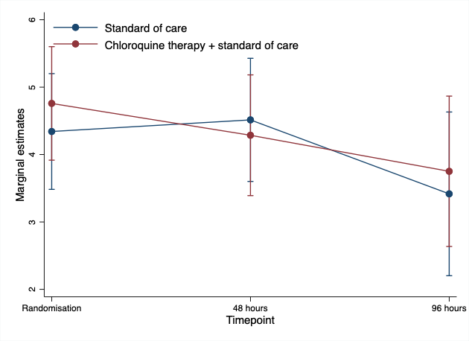

## 5.4. Results from modelling of the treatment effect in the Per Protocol Set (N=49)

Model: The primary endpoint (slope of the viral load (log10) from baseline to 48h and 96 hours post-randomisation) was analysed using a mixed model with fixed and random intercept and slope.

|  |  |  |  |  |  |  |
| --- | --- | --- | --- | --- | --- | --- |
| Table 13. Model results | | | | | | |
| log_viralload | Coef. | Std. Err. | z | P>|z| | [95% Conf. Interval] | |
| Study_Day | -.1362246 | .1216899 | -1.12 | 0.263 | -.3747325 | .1022833 |
|  |  |  |  |  |  |  |
| allocation |  |  |  |  |  |  |
| Chloroquine therapy + standard of c.. | .2926682 | .6298359 | 0.46 | 0.642 | -.9417874 | 1.527124 |
|  |  |  |  |  |  |  |
| allocation#c.Study_Day |  |  |  |  |  |  |
| Chloroquine therapy + standard of c.. | -.0892337 | .1663146 | -0.54 | 0.592 | -.4152043 | .236737 |
|  |  |  |  |  |  |  |
| _cons | 4.490558 | .4414283 | 10.17 | 0.000 | 3.625375 | 5.355742 |

|  |  |  |  |  |  |  |
| --- | --- | --- | --- | --- | --- | --- |
| Table 14. Estimated slope for each treatment group | | | | | | |
|  |  | Delta-method |  |  |  |  |
|  | dy/dx | Std. Err. | z | P>|z| | [95% Conf. Interval] | |
| Study_Day |  |  |  |  |  |  |
| allocation |  |  |  |  |  |  |
| Standard of care | -.1362246 | .1216899 | -1.12 | 0.263 | -.3747325 | .1022833 |
| Chloroquine therapy + standard of c.. | -.2254582 | .1133672 | -1.99 | 0.047 | -.4476538 | -.0032627 |

|  |  |  |  |
| --- | --- | --- | --- |
| Table 15. Estimated difference in slope between the treatment groups | | | |
|  | df | chi2 | P>chi2 |
| Study_Day |  |  |  |
| allocation | 1 | 0.29 | 0.5916 |

|  |  |  |  |  |
| --- | --- | --- | --- | --- |
| Table 15. Estimated difference in slope between the treatment groups | | | | |
|  | Contrast | Delta-method |  |  |
|  | dy/dx | Std. Err. | [95% Conf. Interval] | |
| Study_Day |  |  |  |  |
| allocation |  |  |  |  |
| (Chloroquine therapy + standard of care |  |  |  |  |
| vs |  |  |  |  |
| Standard of care) | -.0892337 | .1663146 | -.4152043 | .236737 |

|  |  |  |  |  |  |  |
| --- | --- | --- | --- | --- | --- | --- |
| Table 16. Estimated marginal mean by treatment group at time point 96 hours | | | | | | |
|  |  | Delta-method |  |  |  |  |
|  | Margin | Std. Err. | z | P>|z| | [95% Conf. Interval] | |
| allocation |  |  |  |  |  |  |
| Standard of care | 3.94566 | .5652045 | 6.98 | 0.000 | 2.837879 | 5.053441 |
| Chloroquine therapy + standard of c.. | 3.881394 | .5515198 | 7.04 | 0.000 | 2.800435 | 4.962353 |

|  |  |  |  |  |  |  |
| --- | --- | --- | --- | --- | --- | --- |
| Table 17. Estimated marginal mean difference between the treatment groups at time point 96 hours | | | | | | |
|  |  | Delta-method |  |  |  |  |
|  | dy/dx | Std. Err. | z | P>|z| | [95% Conf. Interval] | |
| allocation |  |  |  |  |  |  |
| Chloroquine therapy + standard of c.. | -.0642664 | .7897026 | -0.08 | 0.935 | -1.612055 | 1.483522 |

**Figure 4. Marginsplot to illustrate the estimated mean viral load (log10) with 95% CIs over time and by treatment arm**

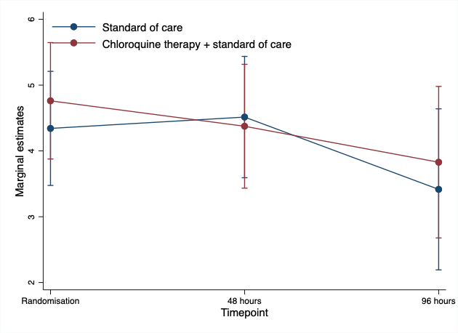

# 6. Post-hoc analyses

## 6.1. Individual viral load trajectories

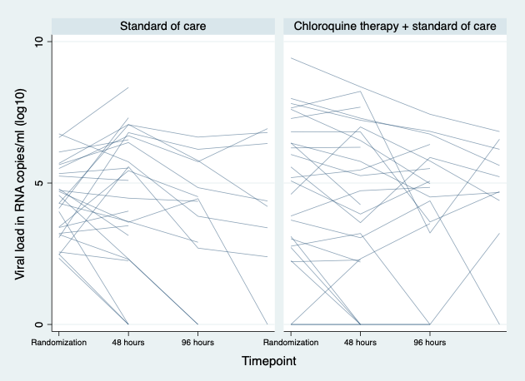

## 6.2. Estimated marginal mean differences at baseline and time point 48h

Estimated marginal means based on the model described under section 5.3., FAS (N=51)

|  |  |  |  |  |  |  |
| --- | --- | --- | --- | --- | --- | --- |
| Table 18. Estimated marginal mean by treatment group at baseline | | | | | | |
|  |  | Delta-method |  |  |  |  |
|  | Margin | Std. Err. | z | P>|z| | [95% Conf. Interval] | |
| allocation |  |  |  |  |  |  |
| Standard of care | 4.548272 | .4422744 | 10.28 | 0.000 | 3.68143 | 5.415114 |
| Chloroquine therapy + standard of c.. | 4.732071 | .4327872 | 10.93 | 0.000 | 3.883824 | 5.580318 |

|  |  |  |  |  |  |  |
| --- | --- | --- | --- | --- | --- | --- |
| Table 19. Estimated marginal mean difference between the treatment groups at baseline | | | | | | |
|  |  | Delta-method |  |  |  |  |
|  | dy/dx | Std. Err. | z | P>|z| | [95% Conf. Interval] | |
| allocation |  |  |  |  |  |  |
| Chloroquine therapy + standard of c.. | .1837988 | .6187983 | 0.30 | 0.766 | -1.029024 | 1.396621 |

|  |  |  |  |  |  |  |
| --- | --- | --- | --- | --- | --- | --- |
| Table 20. Estimated marginal mean by treatment group at time point 48 hours | | | | | | |
|  |  | Delta-method |  |  |  |  |
|  | Margin | Std. Err. | z | P>|z| | [95% Conf. Interval] | |
| allocation |  |  |  |  |  |  |
| Standard of care | 4.178108 | .4266573 | 9.79 | 0.000 | 3.341876 | 5.014341 |
| Chloroquine therapy + standard of c.. | 4.307968 | .415359 | 10.37 | 0.000 | 3.493879 | 5.122057 |

|  |  |  |  |  |  |  |
| --- | --- | --- | --- | --- | --- | --- |
| Table 21. Estimated marginal mean difference between the treatment groups at time point 48 hours | | | | | | |
|  |  | Delta-method |  |  |  |  |
|  | dy/dx | Std. Err. | z | P>|z| | [95% Conf. Interval] | |
| allocation |  |  |  |  |  |  |
| Chloroquine therapy + standard of c.. | .1298598 | .595449 | 0.22 | 0.827 | -1.037199 | 1.296918 |