NOR-SOLIDARITY First Interim Report
Inge Christoffer Olsen, PhD
29 December, 2020
Table of Contents
2 Introduction 2
3 Inclusion status 3
3.1 Inclusion rate 3
3.2 Inclusion by hospital 4
3.3 By treatment 5
4 Patient flow 9
5 Demographics 10
6 Exposure 24
7 Efficacy 25
7.1 Mortality 25
7.1.1 Descriptives 25
7.1.2 Plots 26
7.1.3 Efficacy estimates 35
7.2 Viral load 37
7.3 Dichotomous endpoints 40
7.3.1 Descriptives 40
7.3.2 Marginal probability estimates by treatment group and difference 41
7.4 Inflammatory laboratory parameters 43
7.4.1 Descriptives 43
7.4.2 Plots 67
7.4.3 Efficacy estimates 79
7.5 SARS-CoV2 antibodies at day 90 84
7.5.1 Descriptives 84
7.5.2 Marginal probability estimates by treatment group and difference 85
7.6 Time to last discharge 86
7.6.1 HCQ 86
7.6.2 Remdesivir 89
8 Adverse Events 92
8.1 AE Summary 92
8.2 By System Organ Class and Preferred Term 92
8.3 Serious Adverse Events 96
8.4 Suspected Unexpected Serious Adverse Reaction 99

Introduction
This is the report for the first interim analysis of the NOR-SOLIDARITY trial. The data are based on an export from the Viedoc electronic data capture at “2020-11-21 15:46:31” system time stamped “ous_20201121_154631”. While the results are based on real data, the treatment allocation has been drawn randomly for this report. Thus, this is a mock-up report intended to show how the final report will look like, without showing the actual results of the trial and the treatment differences. There were 181 included patients.

Inclusion status

Inclusion rate
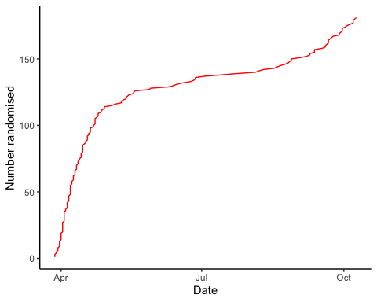

Inclusion by hospital
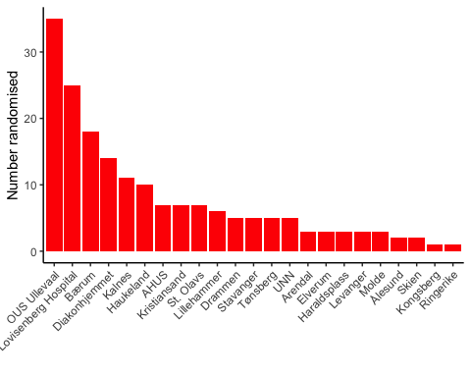

By treatment
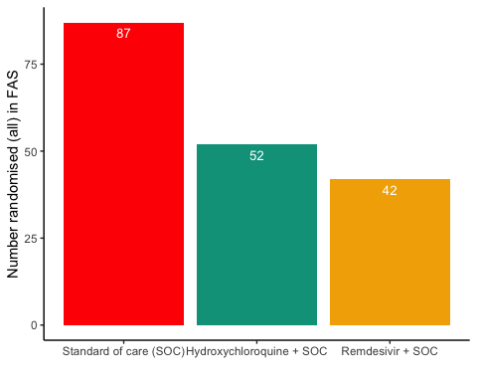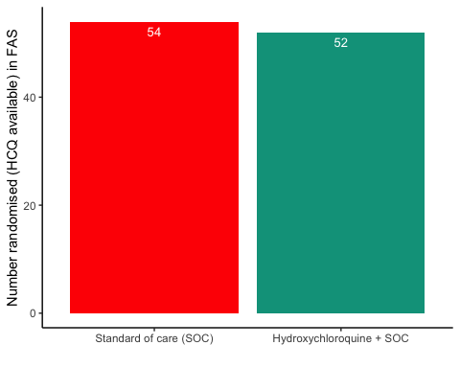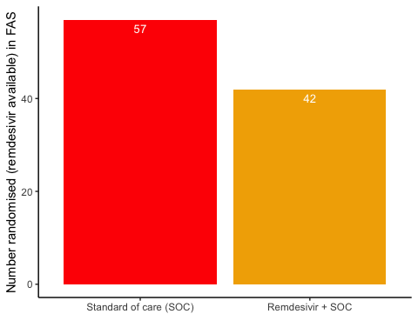

Patient flow
## Note: Using an external vector in selections is ambiguous.
## ℹ Use `all_of(group)` instead of `group` to silence this message.
## ℹ See <https://tidyselect.r-lib.org/reference/faq-external-vector.html>.
## This message is displayed once per session.
Patient flow total
Parameter | Total
Enrolled | 186 (100%)
Randomised | 185 (99.5%)
Included in FAS | 181 (97.3%)
Excluded from FAS, No post-randomisation information | 4 (2.2%)
Excluded from FAS, incorrect inclusion | 1 (0.5%)

Patient flow by arm
Parameter | SOC | SOC + HCQ | SOC + Remdesivir
Randomised | 88 (100%) | 54 (100%) | 43 (100%)
Included in FAS | 87 (98.9%) | 52 (96.3%) | 42 (97.7%)
Excluded from FAS, No post-randomisation information | 1 (1.1%) | 1 (1.9%) | 1 (2.3%)
Excluded from FAS, incorrect inclusion | 0 (0%) | 1 (1.9%) | 0 (0%)

Patient flow during study (FAS)
Reason | Standard of care (SOC) | Hydroxychloroquine + SOC | Remdesivir + SOC | Total
Voluntary discontinuation by the patient | 3 | 3 | 1 | 7
Patient lost to follow-up | 2 | 2 | 2 | 6
Death | 5 | 5 | 2 | 12
Other | 5 | 0 | 1 | 6
Completed | 72 | 42 | 36 | 150

Demographics
Demographics, all patients (FAS)
Parameter | All patients (N=181)
Demographics
Age (years) | 59.8 (15.3)
Female, n (%) | 62 (34.3%)
Body Mass Index (kg/m²) | 28 (5)
Body Mass Index (kg/m²) | 27 (25 - 31)
Symptoms prior to admission (days) | 8 (4.9)
P/F-ratio at admittance (kPa) | 41 (13)
P/F-ratio < 40kPa, n (%) | 77 (43%)
Temperature (°C) | 37.4 (0.9)
Admitted to ward, n(%) | 171 (94.5%)
Admitted to ICU, n(%) | 10 (5.5%)
WHO Moderate disease state (4-5), n(%) | 171 (94.5%)
WHO Severe disease state (6-9), n(%) | 10 (5.5%)
WHO Severe disease state (6), n(%) | 5 (2.8%)
WHO Severe disease state (5), n(%) | 90 (49.7%)
Comorbidities
Chronic cardiac disease, including congenital heart disease | 28 (15.6%)
Chronic pulmonary disease, n(%) | 10 (5.6%)
Ever smoking, n(%) | 71 (39.4%)
Hypertension, n(%) | 55 (30.6%)
Diabetes, n(%) | 31 (17.2%)
Obese (BMI > 30 kg/m²), n(%) | 44 (26.8%)
Co-medications
Steroids | 8 (4.5%)
Other immunomodulatory drugs | 8 (4.5%)
ACE inhibitor | 12 (6.7%)
AT-II blockers | 30 (16.8%)
Hematology
Hemoglobin (g/dL) | 13.2 (12.3 - 14.1)
WBC (x10⁹/L) | 6.2 (4.7 - 8.7)
Neutrophils (x10⁹/L) | 4.3 (3 - 6.6)
Lymphocytes (x10⁹/L) | 1.1 (0.8 - 1.4)
Platelet counts (x10^9/L) | 202.5 (158.5 - 270.5)
Inflammatory markers
CRP (mg/L) | 70 (36.5 - 137.5)
Procalcitonin (µg/L) | 0.12 (0.1 - 0.21)
Ferritin (µg/L) | 613 (319 - 1173)
Other
LDH (U/L) | 277 (214 - 360)
D-dimer (mg/L FEU) | 0.68 (0.45 - 1.12)
AST | 39 (27.2 - 59)
ALT | 33 (20 - 58)
eGFR (mL/min/1.73 m²) | 89.7 (74.2 - 105.5)
Viral count
Viral count (log₁₀ counts/1000 cells) | 2 (1.6)
Anti-SARS-CoV-2 Antibodies
Zero converted (RBD ≤ 5) | 67 (52.8%)
Supplementary baseline information
Systolic Blood Pressure (mmHg) | 125 (18)
Diastolic Blood Pressure (mmHg) | 74 (11)
Mean Arterial Blood Pressure (mmHg) | 91 (12)
SOFA score | 1.6 (1.6)
Chronic kidney disease, n(%) | 11 (6.1%)
Autoimmune disease, n(%) | 8 (4.4%)
Cognitive impairment/dementia, n(%) | 4 (2.2%)
Neurological disorder, n(%) | 7 (3.9%)
Cancer, n(%) | 13 (7.2%)
Cirrhosis, n(%) | 0 (0%)
Asthma, n(%) | 22 (12.2%)
HIV, n(%) | 0 (0%)
Active TB, n(%) | 0 (0%)
Note, all percentages are given with observed values in the denominator, missing values discarded

Demographics, all arms (FAS)
Parameter | SOC (N=87) | SOC + HCQ (N=52) | SOC + Remdesivir (N=42)
Demographics
Age (years) | 59.2 (16.2) | 59.4 (13.4) | 61.4 (16.1)
Female, n (%) | 34 (39.1%) | 15 (28.8%) | 13 (31%)
Body Mass Index (kg/m²) | 28 (5) | 28 (4) | 28 (5)
Body Mass Index (kg/m²) | 28 (24 - 32) | 27 (25 - 30) | 27 (25 - 30)
Symptoms prior to admission (days) | 8.4 (6) | 7.5 (4) | 7.9 (3.2)
P/F-ratio at admittance (kPa) | 40 (13) | 40 (15) | 44 (10)
P/F-ratio < 40kPa, n (%) | 39 (45.3%) | 25 (48.1%) | 13 (31.7%)
Temperature (°C) | 37.4 (0.9) | 37.4 (0.9) | 37.4 (0.9)
Admitted to ward, n(%) | 84 (96.6%) | 47 (90.4%) | 40 (95.2%)
Admitted to ICU, n(%) | 3 (3.4%) | 5 (9.6%) | 2 (4.8%)
WHO Moderate disease state (4-5), n(%) | 84 (96.6%) | 48 (92.3%) | 39 (92.9%)
WHO Severe disease state (6-9), n(%) | 3 (3.4%) | 4 (7.7%) | 3 (7.1%)
WHO Severe disease state (6), n(%) | 1 (1.1%) | 2 (3.8%) | 2 (4.8%)
WHO Severe disease state (5), n(%) | 51 (58.6%) | 25 (48.1%) | 14 (33.3%)
Comorbidities
Chronic cardiac disease, including congenital heart disease | 10 (11.6%) | 9 (17.3%) | 9 (21.4%)
Chronic pulmonary disease, n(%) | 6 (7%) | 3 (5.8%) | 1 (2.4%)
Ever smoking, n(%) | 34 (39.5%) | 18 (34.6%) | 19 (45.2%)
Hypertension, n(%) | 27 (31.4%) | 18 (34.6%) | 10 (23.8%)
Diabetes, n(%) | 15 (17.4%) | 13 (25%) | 3 (7.1%)
Obese (BMI > 30 kg/m²), n(%) | 24 (30%) | 11 (24.4%) | 9 (23.1%)
Co-medications
Steroids | 3 (3.5%) | 3 (5.9%) | 2 (4.8%)
Other immunomodulatory drugs | 5 (5.8%) | 1 (2%) | 2 (4.8%)
ACE inhibitor | 4 (4.7%) | 6 (11.8%) | 2 (4.8%)
AT-II blockers | 13 (15.1%) | 9 (17.6%) | 8 (19%)
Hematology
Hemoglobin (g/dL) | 13.2 (12.2 - 14) | 13.4 (12.9 - 14.5) | 13.1 (12 - 13.9)
WBC (x10⁹/L) | 6.3 (4.8 - 9.1) | 6 (4.6 - 8.2) | 5.8 (4.7 - 7.4)
Neutrophils (x10⁹/L) | 4.8 (2.9 - 7) | 4.3 (3.2 - 5.6) | 4 (2.5 - 6.5)
Lymphocytes (x10⁹/L) | 1.1 (0.8 - 1.4) | 1 (0.8 - 1.3) | 1 (0.8 - 1.6)
Platelet counts (x10^9/L) | 211.5 (161.2 - 286.5) | 186 (158 - 238) | 176 (156 - 279)
Inflammatory markers
CRP (mg/L) | 83 (50 - 152) | 61.5 (31.8 - 112) | 64.5 (29.2 - 129)
Procalcitonin (µg/L) | 0.14 (0.1 - 0.24) | 0.1 (0.1 - 0.2) | 0.12 (0.1 - 0.2)
Ferritin (µg/L) | 539 (301 - 1109) | 608 (276 - 1103.5) | 677 (442 - 1488)
Other
LDH (U/L) | 271 (209.2 - 353.5) | 275 (220.5 - 367.5) | 287 (214.8 - 361)
D-dimer (mg/L FEU) | 0.75 (0.5 - 1.19) | 0.6 (0.41 - 1) | 0.8 (0.44 - 1.04)
AST | 38 (28 - 65) | 43 (28 - 52) | 46 (27 - 63.5)
ALT | 31 (19 - 67) | 36.5 (22 - 52.5) | 32 (22 - 62.5)
eGFR (mL/min/1.73 m²) | 89.8 (73.8 - 106.2) | 85.7 (73.8 - 100.4) | 90.8 (76.9 - 105.1)
Viral count
Viral count (log₁₀ counts/1000 cells) | 1.9 (1.6) | 2.2 (1.6) | 2 (1.7)
Anti-SARS-CoV-2 Antibodies
Zero converted (RBD ≤ 5) | 34 (54.8%) | 23 (62.2%) | 10 (35.7%)
Supplementary baseline information
Systolic Blood Pressure (mmHg) | 124 (17) | 131 (17) | 121 (18)
Diastolic Blood Pressure (mmHg) | 72 (10) | 77 (11) | 72 (13)
Mean Arterial Blood Pressure (mmHg) | 89 (11) | 95 (12) | 88 (13)
SOFA score | 1.6 (1.5) | 1.8 (2.1) | 1.3 (1.3)
Chronic kidney disease, n(%) | 6 (7%) | 2 (3.8%) | 3 (7.1%)
Autoimmune disease, n(%) | 5 (5.8%) | 0 (0%) | 3 (7.1%)
Cognitive impairment/dementia, n(%) | 3 (3.5%) | 1 (1.9%) | 0 (0%)
Neurological disorder, n(%) | 5 (5.8%) | 1 (1.9%) | 1 (2.4%)
Cancer, n(%) | 9 (10.5%) | 1 (1.9%) | 3 (7.1%)
Cirrhosis, n(%) | 0 (0%) | 0 (0%) | 0 (0%)
Asthma, n(%) | 10 (11.6%) | 4 (7.7%) | 8 (19%)
HIV, n(%) | 0 (0%) | 0 (0%) | 0 (0%)
Active TB, n(%) | 0 (0%) | 0 (0%) | 0 (0%)
Note, all percentages are given with observed values in the denominator, missing values discarded

Demographics, HCQ (FAS)
Parameter | SOC (N=54) | SOC + HCQ (N=52)
Demographics
Age (years) | 59.9 (14.7) | 59.4 (13.4)
Female, n (%) | 23 (42.6%) | 15 (28.8%)
Body Mass Index (kg/m²) | 28 (5) | 28 (4)
Body Mass Index (kg/m²) | 28 (24 - 32) | 27 (25 - 30)
Symptoms prior to admission (days) | 8.6 (5.7) | 7.5 (4)
P/F-ratio at admittance (kPa) | 42 (14) | 40 (15)
P/F-ratio < 40kPa, n (%) | 23 (43.4%) | 25 (48.1%)
Temperature (°C) | 37.4 (0.9) | 37.4 (0.9)
Admitted to ward, n(%) | 53 (98.1%) | 47 (90.4%)
Admitted to ICU, n(%) | 1 (1.9%) | 5 (9.6%)
WHO Moderate disease state (4-5), n(%) | 52 (96.3%) | 48 (92.3%)
WHO Severe disease state (6-9), n(%) | 2 (3.7%) | 4 (7.7%)
WHO Severe disease state (6), n(%) | 1 (1.9%) | 2 (3.8%)
WHO Severe disease state (5), n(%) | 28 (51.9%) | 25 (48.1%)
Comorbidities
Chronic cardiac disease, including congenital heart disease | 7 (13.2%) | 9 (17.3%)
Chronic pulmonary disease, n(%) | 3 (5.7%) | 3 (5.8%)
Ever smoking, n(%) | 20 (37.7%) | 18 (34.6%)
Hypertension, n(%) | 15 (28.3%) | 18 (34.6%)
Diabetes, n(%) | 10 (18.9%) | 13 (25%)
Obese (BMI > 30 kg/m²), n(%) | 15 (30.6%) | 11 (24.4%)
Co-medications
Steroids | 3 (5.7%) | 3 (5.9%)
Other immunomodulatory drugs | 4 (7.5%) | 1 (2%)
ACE inhibitor | 1 (1.9%) | 6 (11.8%)
AT-II blockers | 9 (17%) | 9 (17.6%)
Hematology
Hemoglobin (g/dL) | 13.2 (12.1 - 14.1) | 13.4 (12.9 - 14.5)
WBC (x10⁹/L) | 6.6 (4.7 - 9.6) | 6 (4.6 - 8.2)
Neutrophils (x10⁹/L) | 4.8 (2.8 - 6.8) | 4.3 (3.2 - 5.6)
Lymphocytes (x10⁹/L) | 1.2 (0.9 - 1.5) | 1 (0.8 - 1.3)
Platelet counts (x10^9/L) | 218 (160 - 293) | 186 (158 - 238)
Inflammatory markers
CRP (mg/L) | 70 (47.8 - 159.2) | 61.5 (31.8 - 112)
Procalcitonin (µg/L) | 0.13 (0.1 - 0.24) | 0.1 (0.1 - 0.2)
Ferritin (µg/L) | 480 (239 - 1038) | 608 (276 - 1103.5)
Other
LDH (U/L) | 260 (209 - 347) | 275 (220.5 - 367.5)
D-dimer (mg/L FEU) | 0.85 (0.5 - 1.25) | 0.6 (0.41 - 1)
AST | 34.5 (26.2 - 53.8) | 43 (28 - 52)
ALT | 28 (19 - 47.8) | 36.5 (22 - 52.5)
eGFR (mL/min/1.73 m²) | 90.3 (80.1 - 105.6) | 85.7 (73.8 - 100.4)
Viral count
Viral count (log₁₀ counts/1000 cells) | 2 (1.6) | 2.2 (1.6)
Anti-SARS-CoV-2 Antibodies
Zero converted (RBD ≤ 5) | 18 (51.4%) | 23 (62.2%)
Supplementary baseline information
Systolic Blood Pressure (mmHg) | 123 (17) | 131 (17)
Diastolic Blood Pressure (mmHg) | 72 (11) | 77 (11)
Mean Arterial Blood Pressure (mmHg) | 89 (12) | 95 (12)
SOFA score | 1.6 (1.6) | 1.8 (2.1)
Chronic kidney disease, n(%) | 4 (7.5%) | 2 (3.8%)
Autoimmune disease, n(%) | 4 (7.5%) | 0 (0%)
Cognitive impairment/dementia, n(%) | 1 (1.9%) | 1 (1.9%)
Neurological disorder, n(%) | 4 (7.5%) | 1 (1.9%)
Cancer, n(%) | 4 (7.5%) | 1 (1.9%)
Cirrhosis, n(%) | 0 (0%) | 0 (0%)
Asthma, n(%) | 8 (15.1%) | 4 (7.7%)
HIV, n(%) | 0 (0%) | 0 (0%)
Active TB, n(%) | 0 (0%) | 0 (0%)
Note, all percentages are given with observed values in the denominator, missing values discarded

Demographics, Remdesivir (FAS)
Parameter | SOC (N=57) | SOC + Remdesivir (N=42)
Demographics
Age (years) | 58.6 (16.4) | 61.4 (16.1)
Female, n (%) | 20 (35.1%) | 13 (31%)
Body Mass Index (kg/m²) | 28 (5) | 28 (5)
Body Mass Index (kg/m²) | 28 (24 - 32) | 27 (25 - 30)
Symptoms prior to admission (days) | 7.8 (6.2) | 7.9 (3.2)
P/F-ratio at admittance (kPa) | 39 (14) | 44 (10)
P/F-ratio < 40kPa, n (%) | 27 (47.4%) | 13 (31.7%)
Temperature (°C) | 37.6 (1) | 37.4 (0.9)
Admitted to ward, n(%) | 54 (94.7%) | 40 (95.2%)
Admitted to ICU, n(%) | 3 (5.3%) | 2 (4.8%)
WHO Moderate disease state (4-5), n(%) | 55 (96.5%) | 39 (92.9%)
WHO Severe disease state (6-9), n(%) | 2 (3.5%) | 3 (7.1%)
WHO Severe disease state (6), n(%) | NA | 2 (4.8%)
WHO Severe disease state (5), n(%) | 35 (61.4%) | 14 (33.3%)
Comorbidities
Chronic cardiac disease, including congenital heart disease | 7 (12.3%) | 9 (21.4%)
Chronic pulmonary disease, n(%) | 4 (7%) | 1 (2.4%)
Ever smoking, n(%) | 22 (38.6%) | 19 (45.2%)
Hypertension, n(%) | 19 (33.3%) | 10 (23.8%)
Diabetes, n(%) | 12 (21.1%) | 3 (7.1%)
Obese (BMI > 30 kg/m²), n(%) | 17 (31.5%) | 9 (23.1%)
Co-medications
Steroids | 1 (1.8%) | 2 (4.8%)
Other immunomodulatory drugs | 2 (3.5%) | 2 (4.8%)
ACE inhibitor | 3 (5.3%) | 2 (4.8%)
AT-II blockers | 9 (15.8%) | 8 (19%)
Hematology
Hemoglobin (g/dL) | 13.1 (12.3 - 13.7) | 13.1 (12 - 13.9)
WBC (x10⁹/L) | 6.6 (5.1 - 9.4) | 5.8 (4.7 - 7.4)
Neutrophils (x10⁹/L) | 5 (3.2 - 7.2) | 4 (2.5 - 6.5)
Lymphocytes (x10⁹/L) | 1.1 (0.9 - 1.3) | 1 (0.8 - 1.6)
Platelet counts (x10^9/L) | 215 (168.8 - 290.2) | 176 (156 - 279)
Inflammatory markers
CRP (mg/L) | 106.5 (56.8 - 153.5) | 64.5 (29.2 - 129)
Procalcitonin (µg/L) | 0.16 (0.1 - 0.29) | 0.12 (0.1 - 0.2)
Ferritin (µg/L) | 563 (311.5 - 1218) | 677 (442 - 1488)
Other
LDH (U/L) | 281.5 (229 - 363.5) | 287 (214.8 - 361)
D-dimer (mg/L FEU) | 0.76 (0.58 - 1.18) | 0.8 (0.44 - 1.04)
AST | 42 (29.5 - 73.5) | 46 (27 - 63.5)
ALT | 32.5 (18.8 - 74.5) | 32 (22 - 62.5)
eGFR (mL/min/1.73 m²) | 87.9 (68 - 106.1) | 90.8 (76.9 - 105.1)
Viral count
Viral count (log₁₀ counts/1000 cells) | 1.8 (1.6) | 2 (1.7)
Anti-SARS-CoV-2 Antibodies
Zero converted (RBD ≤ 5) | 24 (55.8%) | 10 (35.7%)
Supplementary baseline information
Systolic Blood Pressure (mmHg) | 123 (17) | 121 (18)
Diastolic Blood Pressure (mmHg) | 72 (10) | 72 (13)
Mean Arterial Blood Pressure (mmHg) | 89 (11) | 88 (13)
SOFA score | 1.7 (1.7) | 1.3 (1.3)
Chronic kidney disease, n(%) | 5 (8.8%) | 3 (7.1%)
Autoimmune disease, n(%) | 2 (3.5%) | 3 (7.1%)
Cognitive impairment/dementia, n(%) | 3 (5.3%) | 0 (0%)
Neurological disorder, n(%) | 3 (5.3%) | 1 (2.4%)
Cancer, n(%) | 7 (12.3%) | 3 (7.1%)
Cirrhosis, n(%) | 0 (0%) | 0 (0%)
Asthma, n(%) | 7 (12.3%) | 8 (19%)
HIV, n(%) | 0 (0%) | 0 (0%)
Active TB, n(%) | 0 (0%) | 0 (0%)
Note, all percentages are given with observed values in the denominator, missing values discarded

Missing values, all arms (FAS)
Parameter | SOC (N=87) | SOC + HCQ (N=52) | SOC + Remdesivir (N=42)
Demographics
Age (years) | 0 (0%) | 0 (0%) | 0 (0%)
Female, n (%) | 0 (0%) | 0 (0%) | 0 (0%)
Body Mass Index (kg/m²) | 7 (8%), 7 (8%) | 7 (13.5%), 7 (13.5%) | 3 (7.1%), 3 (7.1%)
Symptoms prior to admission (days) | 1 (1.1%) | 0 (0%) | 0 (0%)
P/F-ratio at admittance (kPa) | 1 (1.1%) | 0 (0%) | 1 (2.4%)
P/F-ratio < 40kPa, n (%) | 1 (1.1%) | 0 (0%) | 1 (2.4%)
Temperature (°C) | 0 (0%) | 0 (0%) | 0 (0%)
Admitted to ward, n(%) | 0 (0%) | 0 (0%) | 0 (0%)
Admitted to ICU, n(%) | 0 (0%) | 0 (0%) | 0 (0%)
WHO Moderate disease state (4-5), n(%) | 0 (0%) | 0 (0%) | 0 (0%)
WHO Severe disease state (6-9), n(%) | 0 (0%) | 0 (0%) | 0 (0%)
WHO Severe disease state (6), n(%) | 0 (0%) | 0 (0%) | 0 (0%)
WHO Severe disease state (5), n(%) | 0 (0%) | 0 (0%) | 0 (0%)
Comorbidities
Chronic cardiac disease, including congenital heart disease | 1 (1.1%) | 0 (0%) | 0 (0%)
Chronic pulmonary disease, n(%) | 1 (1.1%) | 0 (0%) | 0 (0%)
Ever smoking, n(%) | 1 (1.1%) | 0 (0%) | 0 (0%)
Hypertension, n(%) | 1 (1.1%) | 0 (0%) | 0 (0%)
Diabetes, n(%) | 1 (1.1%) | 0 (0%) | 0 (0%)
Obese (BMI > 30 kg/m²), n(%) | 7 (8%) | 7 (13.5%) | 3 (7.1%)
Co-medications
Steroids | 1 (1.1%) | 1 (1.9%) | 0 (0%)
Other immunomodulatory drugs | 1 (1.1%) | 1 (1.9%) | 0 (0%)
ACE inhibitor | 1 (1.1%) | 1 (1.9%) | 0 (0%)
AT-II blockers | 1 (1.1%) | 1 (1.9%) | 0 (0%)
Hematology
Hemoglobin (g/dL) | 1 (1.1%) | 0 (0%) | 2 (4.8%)
WBC (x10⁹/L) | 0 (0%) | 0 (0%) | 1 (2.4%)
Neutrophils (x10⁹/L) | 3 (3.4%) | 2 (3.8%) | 5 (11.9%)
Lymphocytes (x10⁹/L) | 2 (2.3%) | 2 (3.8%) | 5 (11.9%)
Platelet counts (x10^9/L) | 1 (1.1%) | 1 (1.9%) | 1 (2.4%)
Inflammatory markers
CRP (mg/L) | 2 (2.3%) | 0 (0%) | 0 (0%)
Procalcitonin (µg/L) | 23 (26.4%) | 19 (36.5%) | 16 (38.1%)
Ferritin (µg/L) | 3 (3.4%) | 5 (9.6%) | 1 (2.4%)
Other
LDH (U/L) | 1 (1.1%) | 5 (9.6%) | 2 (4.8%)
D-dimer (mg/L FEU) | 8 (9.2%) | 7 (13.5%) | 4 (9.5%)
AST | 6 (6.9%) | 3 (5.8%) | 2 (4.8%)
ALT | 6 (6.9%) | 2 (3.8%) | 0 (0%)
eGFR (mL/min/1.73 m²) | 1 (1.1%) | 0 (0%) | 0 (0%)
Viral count
Viral count (log₁₀ counts/1000 cells) | 20 (23%) | 12 (23.1%) | 9 (21.4%)
Anti-SARS-CoV-2 Antibodies
Zero converted (RBD ≤ 5) | 25 (28.7%) | 15 (28.8%) | 14 (33.3%)
Supplementary baseline information
Systolic Blood Pressure (mmHg) | 0 (0%) | 0 (0%) | 0 (0%)
Diastolic Blood Pressure (mmHg) | 0 (0%) | 0 (0%) | 0 (0%)
Mean Arterial Blood Pressure (mmHg) | 0 (0%) | 0 (0%) | 0 (0%)
SOFA score | 5 (5.7%) | 5 (9.6%) | 1 (2.4%)
Chronic kidney disease, n(%) | 1 (1.1%) | 0 (0%) | 0 (0%)
Autoimmune disease, n(%) | 1 (1.1%) | 0 (0%) | 0 (0%)
Cognitive impairment/dementia, n(%) | 1 (1.1%) | 0 (0%) | 0 (0%)
Neurological disorder, n(%) | 1 (1.1%) | 0 (0%) | 0 (0%)
Cancer, n(%) | 1 (1.1%) | 0 (0%) | 0 (0%)
Cirrhosis, n(%) | 1 (1.1%) | 0 (0%) | 0 (0%)
Asthma, n(%) | 1 (1.1%) | 0 (0%) | 0 (0%)
HIV, n(%) | 1 (1.1%) | 0 (0%) | 0 (0%)
Active TB, n(%) | 1 (1.1%) | 0 (0%) | 0 (0%)
Note, all percentages are given with observed values in the denominator, missing values discarded

Exposure
Exposure to study treatment
Parameter | SOC + HCQ (N=52) | SOC + Remdesivir (N=42)
Total dose (mg), median (IQR) | 4400 (1100 - 7600) | 2800 (700 - 5258)
Treatment duration, median (IQR) | 6 (4 - 9) | 4 (3 - 7)
Number of doses given, median (IQR) | 7 (4 - 10) | 6 (4 - 8)
Patients with any treatment discrepencies, n (%) | 9 (29%) | 6 (33.3%)

Efficacy

Mortality

Descriptives
All arms (FAS)
Treatment | # deaths | # randomised | %
Standard of care (SOC) | 5 | 87 | 5.7
Hydroxychloroquine + SOC | 5 | 52 | 9.6
Remdesivir + SOC | 2 | 42 | 4.8

HCQ (FAS)
Treatment | # deaths | # randomised | %
Standard of care (SOC) | 2 | 54 | 3.7
Hydroxychloroquine + SOC | 5 | 52 | 9.6

Remdesivir (FAS)
Treatment | # deaths | # randomised | %
Standard of care (SOC) | 4 | 57 | 7.0
Remdesivir + SOC | 2 | 42 | 4.8

Plots
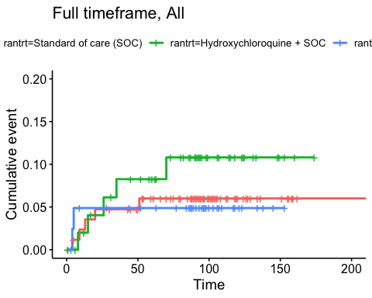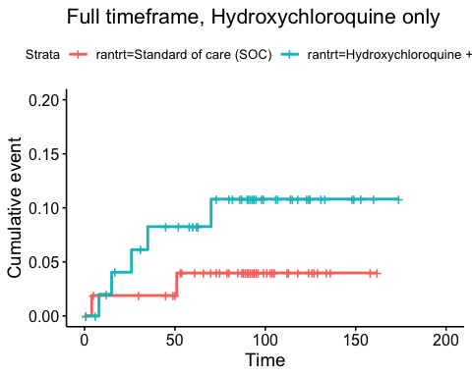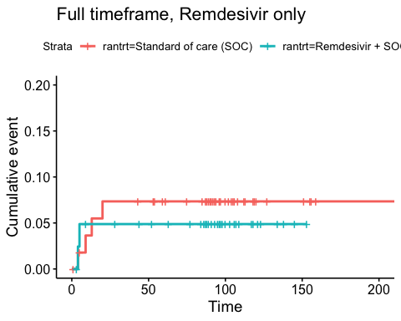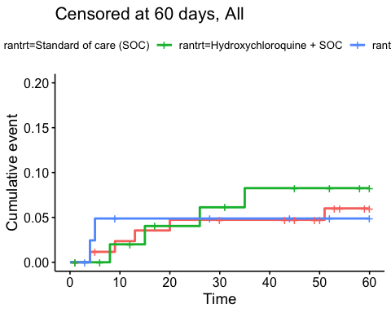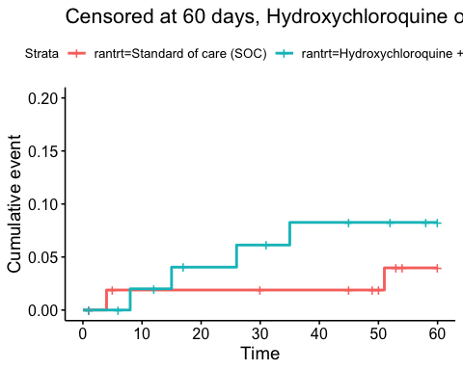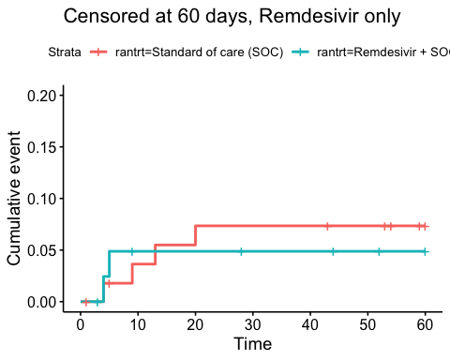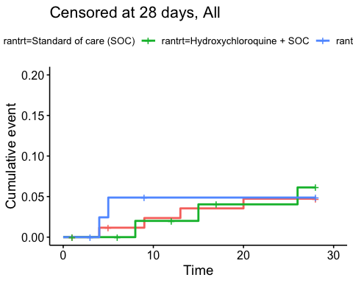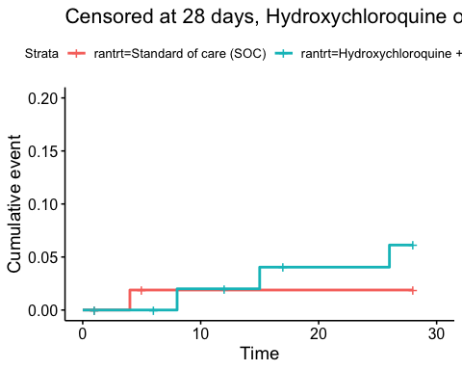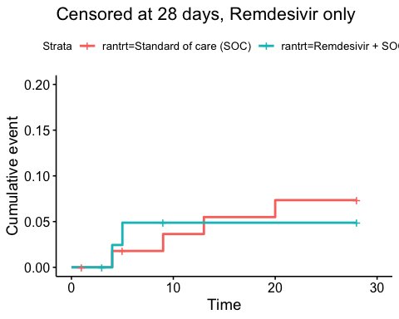

Efficacy estimates
Relative risk estimates and p-values
Timeframe, Population | Relative risk | P-value
Full timeframe, All | Not applicable | 0.574
Full timeframe, Hydroxychloroquine only | 2.58 (95% CI 0.59 to 11.37) | 0.211
Full timeframe, Remdesivir only | 0.69 (95% CI 0.14 to 3.5) | 0.655
Censored at 60 days, All | Not applicable | 0.825
Censored at 60 days, Hydroxychloroquine only | 2.12 (95% CI 0.43 to 10.5) | 0.359
Censored at 60 days, Remdesivir only | 0.69 (95% CI 0.14 to 3.5) | 0.655
Censored at 28 days, All | Not applicable | 0.949
Censored at 28 days, Hydroxychloroquine only | 2.88 (95% CI 0.4 to 20.44) | 0.291
Censored at 28 days, Remdesivir only | 0.69 (95% CI 0.14 to 3.5) | 0.655

Viral load
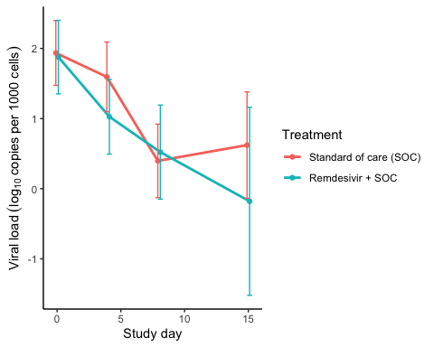
Estimated treatment effect, Remdesivir
Treatment | Explanation | Estimate | Lower 95% CL | Upper 95% CL | P-value
Standard of care (SOC) | Slope by treatment | -0.177 | -0.249 | -0.104 | 0.000
Remdesivir + SOC | Slope by treatment | -0.192 | -0.275 | -0.109 | 0.000
Remdesivir + SOC | Difference in slope | -0.015 | -0.125 | 0.095 | 0.788
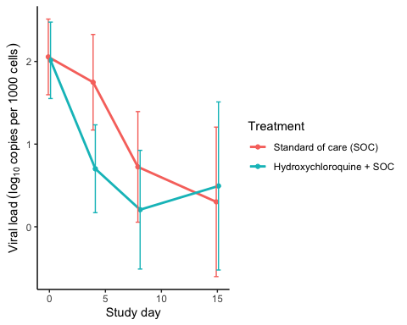
Estimated treatment effect, HCQ
Treatment | Explanation | Estimate | Lower 95% CL | Upper 95% CL | P-value
Standard of care (SOC) | Slope by treatment | -0.148 | -0.239 | -0.057 | 0.001
Hydroxychloroquine + SOC | Slope by treatment | -0.270 | -0.361 | -0.180 | 0.000
Hydroxychloroquine + SOC | Difference in slope | -0.122 | -0.251 | 0.006 | 0.062

Dichotomous endpoints

Descriptives
Hydroxycholoquine
Outcome | Standard of care (SOC) | Hydroxychloroquine + SOC
Mortality during hospitalisation | 2 (3.7%) | 5 (9.6%)
Mortality (censored at day 28) | 1 (1.9%) | 3 (5.8%)
Mortality (censored at day 60) | 2 (3.7%) | 4 (7.7%)
WHO disease state progression | 11 (20.4%) | 11 (21.2%)
WHO disease state progression (censoreda at day 28) | 11 (20.4%) | 11 (21.2%)
WHO disease state progression (censoreda at day 60) | 11 (20.4%) | 11 (21.2%)
Mechanical ventilation during hospitalisation | 6 (11.1%) | 8 (15.4%)
Mechanical ventilation (censored at day 28) | 6 (11.1%) | 8 (15.4%)
Mechanical ventilation (censored at day 60) | 6 (11.1%) | 8 (15.4%)
Admission to ICU during hospitalisation | 11 (20.4%) | 14 (26.9%)
Admission to ICU (censored at day 28) | 11 (20.4%) | 14 (26.9%)
Admission to ICU (censored at day 60) | 11 (20.4%) | 14 (26.9%)
Figures are number of patients with the outcome and percent (%)
Remdesivir
Outcome | Standard of care (SOC) | Remdesivir + SOC
Mortality during hospitalisation | 4 (7%) | 2 (4.8%)
Mortality (censored at day 28) | 4 (7%) | 2 (4.8%)
Mortality (censored at day 60) | 4 (7%) | 2 (4.8%)
WHO disease state progression | 11 (19.3%) | 5 (11.9%)
WHO disease state progression (censoreda at day 28) | 11 (19.3%) | 5 (11.9%)
WHO disease state progression (censoreda at day 60) | 11 (19.3%) | 5 (11.9%)
Mechanical ventilation during hospitalisation | 7 (12.3%) | 2 (4.8%)
Mechanical ventilation (censored at day 28) | 7 (12.3%) | 2 (4.8%)
Mechanical ventilation (censored at day 60) | 7 (12.3%) | 2 (4.8%)
Admission to ICU during hospitalisation | 12 (21.1%) | 4 (9.5%)
Admission to ICU (censored at day 28) | 12 (21.1%) | 4 (9.5%)
Admission to ICU (censored at day 60) | 12 (21.1%) | 4 (9.5%)
Figures are number of patients with the outcome and percent (%)

Marginal probability estimates by treatment group and difference
Hydroxychloroquine
Outcome | Standard of care (SOC) | Hydroxychloroquine + SOC | Estimated marginal treatment effect
Mortality during hospitalisation | 3.7% (-1.3 to 8.7) | 9.6% (1.6 to 17.6) | 5.9% (-3.6 to 15.4)
Mortality (censored at day 28) | 1.9% (-1.7 to 5.4) | 5.8% (-0.6 to 12.1) | 3.9% (-3.4 to 11.2)
Mortality (censored at day 60) | 3.7% (-1.3 to 8.7) | 7.7% (0.4 to 14.9) | 4% (-4.8 to 12.8)
WHO disease state progression | 20.4% (9.6 to 31.1) | 21.2% (10.1 to 32.3) | 0.8% (-14.7 to 16.2)
WHO disease state progression (censoreda at day 28) | 20.4% (9.6 to 31.1) | 21.2% (10.1 to 32.3) | 0.8% (-14.7 to 16.2)
WHO disease state progression (censoreda at day 60) | 20.4% (9.6 to 31.1) | 21.2% (10.1 to 32.3) | 0.8% (-14.7 to 16.2)
Mechanical ventilation during hospitalisation | 11.1% (2.7 to 19.5) | 15.4% (5.6 to 25.2) | 4.3% (-8.6 to 17.2)
Mechanical ventilation (censored at day 28) | 11.1% (2.7 to 19.5) | 15.4% (5.6 to 25.2) | 4.3% (-8.6 to 17.2)
Mechanical ventilation (censored at day 60) | 11.1% (2.7 to 19.5) | 15.4% (5.6 to 25.2) | 4.3% (-8.6 to 17.2)
Admission to ICU during hospitalisation | 20.4% (9.6 to 31.1) | 26.9% (14.9 to 39) | 6.6% (-9.6 to 22.7)
Admission to ICU (censored at day 28) | 20.4% (9.6 to 31.1) | 26.9% (14.9 to 39) | 6.6% (-9.6 to 22.7)
Admission to ICU (censored at day 60) | 20.4% (9.6 to 31.1) | 26.9% (14.9 to 39) | 6.6% (-9.6 to 22.7)

Remdesivir
Outcome | Standard of care (SOC) | Remdesivir + SOC | Estimated marginal treatment effect
Mortality during hospitalisation | 7% (0.4 to 13.6) | 4.8% (-1.7 to 11.2) | -2.3% (-11.5 to 7)
Mortality (censored at day 28) | 7% (0.4 to 13.6) | 4.8% (-1.7 to 11.2) | -2.3% (-11.5 to 7)
Mortality (censored at day 60) | 7% (0.4 to 13.6) | 4.8% (-1.7 to 11.2) | -2.3% (-11.5 to 7)
WHO disease state progression | 19.3% (9.1 to 29.5) | 11.9% (2.1 to 21.7) | -7.4% (-21.6 to 6.8)
WHO disease state progression (censoreda at day 28) | 19.3% (9.1 to 29.5) | 11.9% (2.1 to 21.7) | -7.4% (-21.6 to 6.8)
WHO disease state progression (censoreda at day 60) | 19.3% (9.1 to 29.5) | 11.9% (2.1 to 21.7) | -7.4% (-21.6 to 6.8)
Mechanical ventilation during hospitalisation | 12.3% (3.8 to 20.8) | 4.8% (-1.7 to 11.2) | -7.5% (-18.2 to 3.2)
Mechanical ventilation (censored at day 28) | 12.3% (3.8 to 20.8) | 4.8% (-1.7 to 11.2) | -7.5% (-18.2 to 3.2)
Mechanical ventilation (censored at day 60) | 12.3% (3.8 to 20.8) | 4.8% (-1.7 to 11.2) | -7.5% (-18.2 to 3.2)
Admission to ICU during hospitalisation | 21.1% (10.5 to 31.6) | 9.5% (0.6 to 18.4) | -11.5% (-25.3 to 2.3)
Admission to ICU (censored at day 28) | 21.1% (10.5 to 31.6) | 9.5% (0.6 to 18.4) | -11.5% (-25.3 to 2.3)
Admission to ICU (censored at day 60) | 21.1% (10.5 to 31.6) | 9.5% (0.6 to 18.4) | -11.5% (-25.3 to 2.3)

Inflammatory laboratory parameters

Descriptives
CRP (mg/L), HCQ
Days since randomisation | Statistic | Standard of care (SOC) | Hydroxychloroquine + SOC
0 days | Mean (SD) | 104.82 (83.35) | 81.71 (66.1)
0 days | Median [IQR] | 70 [47.75 - 159.25] | 61.5 [31.75 - 112]
0 days | Missing / Non-Missing | 2 / 52 | 0 / 52
1 days | Mean (SD) | 106.69 (80.54) | 95.14 (76.73)
1 days | Median [IQR] | 88.5 [42 - 170.75] | 78 [44.5 - 133]
1 days | Missing / Non-Missing | 12 / 42 | 8 / 44
2 days | Mean (SD) | 104.25 (86.57) | 89.43 (77.6)
2 days | Median [IQR] | 86 [46 - 130] | 67 [35 - 127.75]
2 days | Missing / Non-Missing | 5 / 45 | 7 / 44
3 days | Mean (SD) | 96.42 (84.44) | 89.62 (62.96)
3 days | Median [IQR] | 74 [26.5 - 134.25] | 72 [33.75 - 132.25]
3 days | Missing / Non-Missing | 6 / 38 | 5 / 40
4 days | Mean (SD) | 104.96 (86.68) | 93.61 (64.45)
4 days | Median [IQR] | 90 [44 - 145] | 92.5 [40 - 131.5]
4 days | Missing / Non-Missing | 5 / 33 | 7 / 34
5 days | Mean (SD) | 92.69 (81.28) | 95.82 (78.64)
5 days | Median [IQR] | 70 [34 - 148] | 68 [39 - 130]
5 days | Missing / Non-Missing | 5 / 29 | 4 / 33
6 days | Mean (SD) | 85.95 (81.09) | 95.45 (86.95)
6 days | Median [IQR] | 57 [24.5 - 116] | 63 [36.5 - 142.5]
6 days | Missing / Non-Missing | 0 / 31 | 6 / 27
7 days | Mean (SD) | 84.47 (84.32) | 107.83 (88.24)
7 days | Median [IQR] | 63.5 [14.25 - 103.75] | 100.5 [26.5 - 167.25]
7 days | Missing / Non-Missing | 1 / 26 | 3 / 24
8 days | Mean (SD) | 93.07 (90.34) | 94.18 (84.54)
8 days | Median [IQR] | 47.5 [28.5 - 165] | 61.5 [28 - 156.75]
8 days | Missing / Non-Missing | 1 / 22 | 3 / 22
9 days | Mean (SD) | 87.63 (88.83) | 95.72 (70.67)
9 days | Median [IQR] | 43 [18.25 - 155.25] | 83 [40.25 - 162.25]
9 days | Missing / Non-Missing | 2 / 18 | 5 / 18
10 days | Mean (SD) | 72.49 (89.35) | 65.65 (63.18)
10 days | Median [IQR] | 18 [12 - 106] | 33 [12 - 122]
10 days | Missing / Non-Missing | 4 / 13 | 4 / 17
11 days | Mean (SD) | 74.2 (78.39) | 72.57 (81.65)
11 days | Median [IQR] | 60.5 [10.5 - 103.25] | 52 [13 - 107]
11 days | Missing / Non-Missing | 4 / 12 | 2 / 15
12 days | Mean (SD) | 72.55 (80.66) | 89.64 (65.42)
12 days | Median [IQR] | 44 [7.9 - 107] | 89 [30.5 - 138.5]
12 days | Missing / Non-Missing | 4 / 11 | 4 / 11
13 days | Mean (SD) | 117.87 (83.72) | 83.79 (86.47)
13 days | Median [IQR] | 106 [54 - 187] | 60.5 [10.25 - 111.5]
13 days | Missing / Non-Missing | 5 / 9 | 1 / 14
14 days | Mean (SD) | 73.81 (94.77) | 80.58 (109.08)
14 days | Median [IQR] | 24 [18 - 81] | 24 [11.25 - 107]
14 days | Missing / Non-Missing | 1 / 9 | 1 / 8

CRP (mg/L), Remdesivir
Days since randomisation | Statistic | Standard of care (SOC) | Remdesivir + SOC
0 days | Mean (SD) | 108.71 (66.52) | 79.17 (59.24)
0 days | Median [IQR] | 106.5 [56.75 - 153.5] | 64.5 [29.25 - 129]
0 days | Missing / Non-Missing | 1 / 56 | 0 / 42
1 days | Mean (SD) | 107.49 (68.4) | 82.35 (58.49)
1 days | Median [IQR] | 90 [56.5 - 147.5] | 71.5 [43.5 - 107.5]
1 days | Missing / Non-Missing | 10 / 47 | 5 / 36
2 days | Mean (SD) | 96.45 (80.56) | 73.41 (58)
2 days | Median [IQR] | 76 [44.5 - 120.5] | 59 [29 - 99.5]
2 days | Missing / Non-Missing | 9 / 47 | 1 / 39
3 days | Mean (SD) | 89.98 (81.69) | 76.68 (67.37)
3 days | Median [IQR] | 69 [41 - 120] | 64 [26 - 98.75]
3 days | Missing / Non-Missing | 10 / 41 | 4 / 32
4 days | Mean (SD) | 87.54 (84.29) | 75.26 (90.57)
4 days | Median [IQR] | 70.5 [37.5 - 104.75] | 43.5 [20.25 - 87.25]
4 days | Missing / Non-Missing | 5 / 36 | 3 / 28
5 days | Mean (SD) | 66.27 (64.15) | 85.82 (88.82)
5 days | Median [IQR] | 45.5 [21.5 - 91] | 55 [15 - 106]
5 days | Missing / Non-Missing | 7 / 32 | 5 / 21
6 days | Mean (SD) | 73.86 (73.89) | 66.39 (65.45)
6 days | Median [IQR] | 48 [16.75 - 101] | 48 [11.08 - 104.25]
6 days | Missing / Non-Missing | 6 / 30 | 2 / 20
7 days | Mean (SD) | 64.24 (63.19) | 58.07 (49.44)
7 days | Median [IQR] | 38 [11.25 - 100] | 48.5 [22.5 - 79.25]
7 days | Missing / Non-Missing | 2 / 30 | 2 / 16
8 days | Mean (SD) | 80.67 (83.25) | 49.12 (34.88)
8 days | Median [IQR] | 49 [19.5 - 124] | 42 [22.5 - 79.5]
8 days | Missing / Non-Missing | 3 / 24 | 4 / 11
9 days | Mean (SD) | 75.6 (82.18) | 29.26 (33.37)
9 days | Median [IQR] | 43 [17.25 - 117.5] | 12 [3.65 - 44.5]
9 days | Missing / Non-Missing | 2 / 20 | 2 / 11
10 days | Mean (SD) | 63.4 (75.24) | 26.22 (27.84)
10 days | Median [IQR] | 18 [13.5 - 113.5] | 18.55 [4.35 - 34.25]
10 days | Missing / Non-Missing | 4 / 15 | 0 / 10
11 days | Mean (SD) | 77.03 (115.56) | 40.5 (24.45)
11 days | Median [IQR] | 17 [9 - 107] | 41.5 [31 - 52.75]
11 days | Missing / Non-Missing | 4 / 13 | 2 / 6
12 days | Mean (SD) | 92.41 (188.13) | 28.6 (28.59)
12 days | Median [IQR] | 11 [6.4 - 88] | 19 [5 - 42]
12 days | Missing / Non-Missing | 5 / 11 | 1 / 5
13 days | Mean (SD) | 75.18 (104.7) | 30.33 (16.01)
13 days | Median [IQR] | 44.5 [11.5 - 86.5] | 31 [22.5 - 38.5]
13 days | Missing / Non-Missing | 4 / 10 | 1 / 3
14 days | Mean (SD) | 38.46 (48.82) | 25.53 (16.63)
14 days | Median [IQR] | 19 [8.93 - 43.5] | 32 [22.03 - 35.5]
14 days | Missing / Non-Missing | 1 / 10 | 0 / 4

Ferritin (µg/L), HCQ
Days since randomisation | Statistic | Standard of care (SOC) | Hydroxychloroquine + SOC
0 days | Mean (SD) | 749.55 (720.33) | 744.28 (582.02)
0 days | Median [IQR] | 480 [239 - 1038] | 608 [276 - 1103.5]
0 days | Missing / Non-Missing | 1 / 53 | 5 / 47
1 days | Mean (SD) | 962.1 (820.33) | 869.78 (530.91)
1 days | Median [IQR] | 683 [397 - 1118] | 767 [385 - 1209]
1 days | Missing / Non-Missing | 24 / 30 | 15 / 37
2 days | Mean (SD) | 820.2 (695.02) | 959.5 (702.21)
2 days | Median [IQR] | 586 [273 - 1120] | 1028.5 [368.75 - 1326.5]
2 days | Missing / Non-Missing | 9 / 41 | 11 / 40
3 days | Mean (SD) | 1171.87 (1030.2) | 902.72 (662.04)
3 days | Median [IQR] | 884 [282.75 - 1768.75] | 842 [397 - 1212.5]
3 days | Missing / Non-Missing | 14 / 30 | 10 / 35
4 days | Mean (SD) | 1463.46 (1672.36) | 1180.1 (698.66)
4 days | Median [IQR] | 865.5 [418.75 - 1936] | 1070 [667 - 1546]
4 days | Missing / Non-Missing | 14 / 24 | 12 / 29
5 days | Mean (SD) | 1210.05 (1365.82) | 1108.18 (651.93)
5 days | Median [IQR] | 667 [365.5 - 1691] | 951 [642.25 - 1327.25]
5 days | Missing / Non-Missing | 15 / 19 | 9 / 28
6 days | Mean (SD) | 1281.85 (1219.43) | 975.69 (561.6)
6 days | Median [IQR] | 896 [498 - 1642] | 872.5 [678.75 - 1187.25]
6 days | Missing / Non-Missing | 4 / 27 | 7 / 26
7 days | Mean (SD) | 1130.2 (752.46) | 1159 (654.58)
7 days | Median [IQR] | 944 [628.75 - 1535.75] | 1033 [735 - 1366.5]
7 days | Missing / Non-Missing | 7 / 20 | 4 / 23
8 days | Mean (SD) | 850.47 (643.2) | 1053.4 (647.06)
8 days | Median [IQR] | 713 [243 - 1209] | 812 [617 - 1393]
8 days | Missing / Non-Missing | 4 / 19 | 10 / 15
9 days | Mean (SD) | 973.14 (704.68) | 993.35 (648.58)
9 days | Median [IQR] | 1016 [326.75 - 1559.75] | 746 [508 - 1251]
9 days | Missing / Non-Missing | 6 / 14 | 6 / 17
10 days | Mean (SD) | 1044 (850.91) | 1048.46 (536.31)
10 days | Median [IQR] | 954 [363.5 - 1559.5] | 899 [784 - 1361]
10 days | Missing / Non-Missing | 6 / 11 | 8 / 13
11 days | Mean (SD) | 924.64 (1036.71) | 949.89 (731.93)
11 days | Median [IQR] | 800 [169.5 - 1052] | 728 [584 - 1112]
11 days | Missing / Non-Missing | 5 / 11 | 8 / 9
12 days | Mean (SD) | 1187 (1155.17) | 648.14 (234.03)
12 days | Median [IQR] | 1068 [174 - 1533] | 664 [578.5 - 714]
12 days | Missing / Non-Missing | 6 / 9 | 8 / 7
13 days | Mean (SD) | 1266.57 (936.99) | 682.82 (480.73)
13 days | Median [IQR] | 1160 [587 - 1764.5] | 598 [470 - 863]
13 days | Missing / Non-Missing | 7 / 7 | 4 / 11
14 days | Mean (SD) | 853.57 (631.24) | 645.2 (716.78)
14 days | Median [IQR] | 698 [362 - 1335.5] | 397 [392 - 553]
14 days | Missing / Non-Missing | 3 / 7 | 4 / 5

Ferritin (µg/L), Remdesivir
Days since randomisation | Statistic | Standard of care (SOC) | Remdesivir + SOC
0 days | Mean (SD) | 1332.65 (3204.54) | 1048.29 (879.59)
0 days | Median [IQR] | 563 [311.5 - 1218] | 677 [442 - 1488]
0 days | Missing / Non-Missing | 3 / 54 | 1 / 41
1 days | Mean (SD) | 1548.54 (3142.56) | 1020.27 (885.43)
1 days | Median [IQR] | 880 [397.5 - 1451] | 769.5 [510.25 - 1080.75]
1 days | Missing / Non-Missing | 22 / 35 | 19 / 22
2 days | Mean (SD) | 1166.1 (1837.36) | 1067.97 (798.91)
2 days | Median [IQR] | 603.5 [383.5 - 1277] | 909 [545.5 - 1226.75]
2 days | Missing / Non-Missing | 16 / 40 | 6 / 34
3 days | Mean (SD) | 1128.94 (785.77) | 1215.85 (959.44)
3 days | Median [IQR] | 940 [575 - 1754.5] | 948 [485 - 1737]
3 days | Missing / Non-Missing | 19 / 32 | 9 / 27
4 days | Mean (SD) | 1066.56 (970.7) | 1463.86 (952.38)
4 days | Median [IQR] | 638 [489 - 1206] | 1232.5 [786.75 - 1906.75]
4 days | Missing / Non-Missing | 16 / 25 | 9 / 22
5 days | Mean (SD) | 1067.57 (827.36) | 1247.3 (756.44)
5 days | Median [IQR] | 872 [489 - 1322] | 943 [705 - 1627]
5 days | Missing / Non-Missing | 18 / 21 | 9 / 17
6 days | Mean (SD) | 908.36 (638.77) | 1138.18 (820.12)
6 days | Median [IQR] | 710 [419 - 1462] | 919 [739 - 1332]
6 days | Missing / Non-Missing | 11 / 25 | 5 / 17
7 days | Mean (SD) | 998 (931.84) | 1235.87 (799.31)
7 days | Median [IQR] | 707 [413 - 1446] | 1255 [799.5 - 1415.5]
7 days | Missing / Non-Missing | 7 / 25 | 3 / 15
8 days | Mean (SD) | 942.1 (1018.34) | 1106.6 (822.67)
8 days | Median [IQR] | 691 [375.75 - 1157.5] | 834 [745.75 - 997.25]
8 days | Missing / Non-Missing | 7 / 20 | 5 / 10
9 days | Mean (SD) | 666.2 (508.9) | 747.56 (523.32)
9 days | Median [IQR] | 456 [316.5 - 952] | 744 [506 - 861]
9 days | Missing / Non-Missing | 7 / 15 | 4 / 9
10 days | Mean (SD) | 761 (555.87) | 789.86 (434.71)
10 days | Median [IQR] | 612 [389 - 1113] | 728 [612.5 - 933]
10 days | Missing / Non-Missing | 6 / 13 | 3 / 7
11 days | Mean (SD) | 757.33 (821.49) | 850.5 (510.72)
11 days | Median [IQR] | 566.5 [181.75 - 973.75] | 615 [562.75 - 902.75]
11 days | Missing / Non-Missing | 5 / 12 | 4 / 4
12 days | Mean (SD) | 883.11 (1000.46) | 644.33 (35.85)
12 days | Median [IQR] | 839 [174 - 1068] | 663 [633 - 665]
12 days | Missing / Non-Missing | 7 / 9 | 3 / 3
13 days | Mean (SD) | 873.78 (578.45) | 677.33 (46.74)
13 days | Median [IQR] | 723 [358 - 1160] | 665 [651.5 - 697]
13 days | Missing / Non-Missing | 5 / 9 | 1 / 3
14 days | Mean (SD) | 685.33 (567.83) | 671 (83.86)
14 days | Median [IQR] | 396 [257 - 1126] | 634 [623 - 700.5]
14 days | Missing / Non-Missing | 2 / 9 | 1 / 3

LDH (U/L), HCQ
Days since randomisation | Statistic | Standard of care (SOC) | Hydroxychloroquine + SOC
0 days | Mean (SD) | 290.43 (130.76) | 311.81 (138.59)
0 days | Median [IQR] | 260 [209 - 347] | 275 [220.5 - 367.5]
0 days | Missing / Non-Missing | 1 / 53 | 5 / 47
1 days | Mean (SD) | 310.54 (139) | 334.67 (145.15)
1 days | Median [IQR] | 278 [203.25 - 374.5] | 311 [233 - 392]
1 days | Missing / Non-Missing | 28 / 26 | 19 / 33
2 days | Mean (SD) | 307.62 (123.11) | 332.68 (157.5)
2 days | Median [IQR] | 298 [208 - 374] | 294.5 [226.75 - 391.25]
2 days | Missing / Non-Missing | 13 / 37 | 17 / 34
3 days | Mean (SD) | 342.08 (137.77) | 341.31 (167.89)
3 days | Median [IQR] | 332 [240 - 441] | 321 [218 - 437]
3 days | Missing / Non-Missing | 17 / 27 | 13 / 32
4 days | Mean (SD) | 359.38 (133.65) | 393.16 (183.41)
4 days | Median [IQR] | 304 [256 - 488] | 351 [261 - 480]
4 days | Missing / Non-Missing | 17 / 21 | 16 / 25
5 days | Mean (SD) | 353.63 (127.07) | 401.27 (176.76)
5 days | Median [IQR] | 332 [282.5 - 442.5] | 326 [279.25 - 525.75]
5 days | Missing / Non-Missing | 15 / 19 | 15 / 22
6 days | Mean (SD) | 302.29 (112.53) | 354.63 (151.29)
6 days | Median [IQR] | 288.5 [240.5 - 375.25] | 279 [270.5 - 442]
6 days | Missing / Non-Missing | 7 / 24 | 14 / 19
7 days | Mean (SD) | 303.72 (86.25) | 338.86 (108.52)
7 days | Median [IQR] | 281.5 [253.75 - 359.25] | 293 [239 - 400]
7 days | Missing / Non-Missing | 9 / 18 | 6 / 21
8 days | Mean (SD) | 282.44 (79.75) | 369.69 (92.84)
8 days | Median [IQR] | 266.5 [229 - 331.75] | 336 [289 - 410]
8 days | Missing / Non-Missing | 7 / 16 | 12 / 13
9 days | Mean (SD) | 307.46 (73.96) | 370.17 (125.18)
9 days | Median [IQR] | 286 [281 - 356] | 357 [303.25 - 395]
9 days | Missing / Non-Missing | 9 / 11 | 11 / 12
10 days | Mean (SD) | 274.45 (88.55) | 337 (95.56)
10 days | Median [IQR] | 258 [213 - 374] | 340 [284.75 - 369.75]
10 days | Missing / Non-Missing | 8 / 9 | 9 / 12
11 days | Mean (SD) | 279.22 (93.29) | 290.83 (76.81)
11 days | Median [IQR] | 252 [240 - 360] | 267.5 [260 - 298.25]
11 days | Missing / Non-Missing | 7 / 9 | 11 / 6
12 days | Mean (SD) | 298.45 (118.8) | 318.72 (57.5)
12 days | Median [IQR] | 269 [215 - 366] | 307 [277 - 357.5]
12 days | Missing / Non-Missing | 6 / 9 | 8 / 7
13 days | Mean (SD) | 262.5 (111.87) | 279.63 (107.99)
13 days | Median [IQR] | 247 [182.25 - 320.75] | 268.5 [217 - 325.25]
13 days | Missing / Non-Missing | 8 / 6 | 7 / 8
14 days | Mean (SD) | 286.13 (106.76) | 305.2 (125.07)
14 days | Median [IQR] | 308 [206.25 - 358] | 294 [254 - 348]
14 days | Missing / Non-Missing | 2 / 8 | 4 / 5

LDH (U/L), Remdesivir
Days since randomisation | Statistic | Standard of care (SOC) | Remdesivir + SOC
0 days | Mean (SD) | 320.63 (143.26) | 297.78 (103.02)
0 days | Median [IQR] | 281.5 [229 - 363.5] | 287 [214.75 - 361]
0 days | Missing / Non-Missing | 1 / 56 | 2 / 40
1 days | Mean (SD) | 342.3 (139.87) | 271.33 (60.68)
1 days | Median [IQR] | 311 [243.5 - 413.5] | 270 [243 - 302]
1 days | Missing / Non-Missing | 30 / 27 | 20 / 21
2 days | Mean (SD) | 320.33 (126.34) | 312.52 (95.06)
2 days | Median [IQR] | 301 [233 - 380] | 310 [239 - 361]
2 days | Missing / Non-Missing | 23 / 33 | 11 / 29
3 days | Mean (SD) | 331.5 (116.96) | 351.56 (169.8)
3 days | Median [IQR] | 319.5 [263.5 - 380] | 287 [230 - 422]
3 days | Missing / Non-Missing | 21 / 30 | 11 / 25
4 days | Mean (SD) | 335.52 (117.82) | 324.9 (125.07)
4 days | Median [IQR] | 300 [264.5 - 354] | 282.5 [241.25 - 384]
4 days | Missing / Non-Missing | 18 / 23 | 11 / 20
5 days | Mean (SD) | 342.42 (112.42) | 304.63 (91.8)
5 days | Median [IQR] | 300 [275 - 397.5] | 278 [238.25 - 370.25]
5 days | Missing / Non-Missing | 20 / 19 | 10 / 16
6 days | Mean (SD) | 315.2 (113.45) | 262.67 (67.14)
6 days | Median [IQR] | 286.5 [251.75 - 353] | 263 [208 - 303.5]
6 days | Missing / Non-Missing | 16 / 20 | 7 / 15
7 days | Mean (SD) | 282.96 (112.47) | 245.58 (51.85)
7 days | Median [IQR] | 259.5 [201.5 - 352.75] | 229.5 [211.25 - 283.5]
7 days | Missing / Non-Missing | 6 / 26 | 6 / 12
8 days | Mean (SD) | 304 (106.18) | 257.56 (67.03)
8 days | Median [IQR] | 249 [230.25 - 375.75] | 235 [227 - 290]
8 days | Missing / Non-Missing | 11 / 16 | 6 / 9
9 days | Mean (SD) | 328.36 (113.7) | 213.45 (53.15)
9 days | Median [IQR] | 317.5 [235 - 402.75] | 207 [170 - 238]
9 days | Missing / Non-Missing | 8 / 14 | 4 / 9
10 days | Mean (SD) | 295.92 (100.63) | 210.25 (51.95)
10 days | Median [IQR] | 280 [216 - 374] | 200.5 [188.75 - 227]
10 days | Missing / Non-Missing | 6 / 13 | 2 / 8
11 days | Mean (SD) | 298.7 (111.72) | 216.83 (88.64)
11 days | Median [IQR] | 271 [243 - 405] | 181.5 [161 - 274.75]
11 days | Missing / Non-Missing | 7 / 10 | 2 / 6
12 days | Mean (SD) | 271 (106.61) | 206.25 (69.5)
12 days | Median [IQR] | 242 [194 - 351.25] | 194 [161.5 - 238.75]
12 days | Missing / Non-Missing | 6 / 10 | 2 / 4
13 days | Mean (SD) | 268.63 (109.01) | 193 (5.66)
13 days | Median [IQR] | 246 [201.75 - 348.25] | 193 [191 - 195]
13 days | Missing / Non-Missing | 6 / 8 | 2 / 2
14 days | Mean (SD) | 229.11 (100.73) | 191.33 (61.45)
14 days | Median [IQR] | 197 [158 - 237] | 176 [157.5 - 217.5]
14 days | Missing / Non-Missing | 2 / 9 | 1 / 3

Lymphocytes (x10^9/L), HCQ
Days since randomisation | Statistic | Standard of care (SOC) | Hydroxychloroquine + SOC
0 days | Mean (SD) | 1.33 (0.96) | 1.08 (0.46)
0 days | Median [IQR] | 1.2 [0.95 - 1.5] | 1 [0.8 - 1.3]
0 days | Missing / Non-Missing | 2 / 52 | 2 / 50
1 days | Mean (SD) | 1.28 (0.63) | 1.07 (0.45)
1 days | Median [IQR] | 1.2 [0.9 - 1.65] | 1 [0.7 - 1.38]
1 days | Missing / Non-Missing | 24 / 30 | 18 / 34
2 days | Mean (SD) | 1.45 (0.71) | 1.25 (0.49)
2 days | Median [IQR] | 1.35 [1 - 1.8] | 1.1 [0.9 - 1.73]
2 days | Missing / Non-Missing | 8 / 42 | 15 / 36
3 days | Mean (SD) | 1.3 (0.61) | 1.18 (0.53)
3 days | Median [IQR] | 1.1 [1 - 1.6] | 1 [0.8 - 1.58]
3 days | Missing / Non-Missing | 13 / 31 | 11 / 34
4 days | Mean (SD) | 1.33 (0.78) | 1.19 (0.57)
4 days | Median [IQR] | 1.2 [0.7 - 1.6] | 1 [0.8 - 1.5]
4 days | Missing / Non-Missing | 10 / 28 | 14 / 27
5 days | Mean (SD) | 1.3 (0.77) | 1.23 (0.56)
5 days | Median [IQR] | 1.15 [0.9 - 1.5] | 1.1 [0.8 - 1.55]
5 days | Missing / Non-Missing | 12 / 22 | 13 / 24
6 days | Mean (SD) | 1.35 (0.81) | 1.24 (0.54)
6 days | Median [IQR] | 1.2 [0.83 - 1.58] | 1.15 [0.93 - 1.48]
6 days | Missing / Non-Missing | 5 / 26 | 15 / 18
7 days | Mean (SD) | 1.28 (0.48) | 1.3 (0.54)
7 days | Median [IQR] | 1.25 [0.95 - 1.6] | 1.3 [1 - 1.6]
7 days | Missing / Non-Missing | 5 / 22 | 8 / 19
8 days | Mean (SD) | 1.4 (0.46) | 1.83 (1.92)
8 days | Median [IQR] | 1.5 [1.05 - 1.65] | 1.4 [1.13 - 1.8]
8 days | Missing / Non-Missing | 4 / 19 | 9 / 16
9 days | Mean (SD) | 1.37 (0.44) | 1.23 (0.61)
9 days | Median [IQR] | 1.2 [1.1 - 1.6] | 1.2 [0.8 - 1.5]
9 days | Missing / Non-Missing | 5 / 15 | 12 / 11
10 days | Mean (SD) | 1.75 (0.59) | 1.56 (0.68)
10 days | Median [IQR] | 1.8 [1.2 - 2.03] | 1.65 [1.08 - 1.93]
10 days | Missing / Non-Missing | 5 / 12 | 9 / 12
11 days | Mean (SD) | 1.82 (0.66) | 1.39 (0.83)
11 days | Median [IQR] | 1.9 [1.45 - 2.08] | 1.6 [0.7 - 1.8]
11 days | Missing / Non-Missing | 6 / 10 | 8 / 9
12 days | Mean (SD) | 1.97 (0.62) | 1.34 (0.98)
12 days | Median [IQR] | 2 [1.5 - 2.5] | 0.9 [0.7 - 1.75]
12 days | Missing / Non-Missing | 6 / 9 | 8 / 7
13 days | Mean (SD) | 1.83 (0.55) | 1.76 (0.85)
13 days | Median [IQR] | 1.8 [1.55 - 2.05] | 1.9 [1.2 - 2.08]
13 days | Missing / Non-Missing | 8 / 6 | 5 / 10
14 days | Mean (SD) | 1.79 (0.65) | 1.58 (0.92)
14 days | Median [IQR] | 1.85 [1.25 - 2.23] | 1.55 [1.03 - 2]
14 days | Missing / Non-Missing | 2 / 8 | 3 / 6

Lymphocytes (x10^9/L), Remdesivir
Days since randomisation | Statistic | Standard of care (SOC) | Remdesivir + SOC
0 days | Mean (SD) | 1.18 (0.87) | 1.17 (0.59)
0 days | Median [IQR] | 1.1 [0.9 - 1.3] | 1 [0.8 - 1.6]
0 days | Missing / Non-Missing | 1 / 56 | 5 / 37
1 days | Mean (SD) | 1.18 (0.51) | 1.13 (0.44)
1 days | Median [IQR] | 1.1 [0.8 - 1.48] | 1.2 [0.78 - 1.43]
1 days | Missing / Non-Missing | 23 / 34 | 13 / 28
2 days | Mean (SD) | 1.3 (0.57) | 1.19 (0.48)
2 days | Median [IQR] | 1.1 [1 - 1.5] | 1.1 [0.83 - 1.6]
2 days | Missing / Non-Missing | 17 / 39 | 6 / 34
3 days | Mean (SD) | 1.34 (0.66) | 1.3 (0.6)
3 days | Median [IQR] | 1.15 [1 - 1.6] | 1.3 [0.9 - 1.55]
3 days | Missing / Non-Missing | 17 / 34 | 9 / 27
4 days | Mean (SD) | 1.36 (0.81) | 1.37 (0.64)
4 days | Median [IQR] | 1.3 [0.85 - 1.7] | 1.4 [0.9 - 1.7]
4 days | Missing / Non-Missing | 14 / 27 | 10 / 21
5 days | Mean (SD) | 1.48 (0.9) | 1.44 (0.66)
5 days | Median [IQR] | 1.4 [0.95 - 1.7] | 1.35 [1.05 - 1.95]
5 days | Missing / Non-Missing | 16 / 23 | 8 / 18
6 days | Mean (SD) | 1.55 (0.8) | 1.59 (0.81)
6 days | Median [IQR] | 1.4 [1.18 - 1.83] | 1.35 [1.18 - 2.03]
6 days | Missing / Non-Missing | 12 / 24 | 6 / 16
7 days | Mean (SD) | 1.51 (0.59) | 1.44 (0.7)
7 days | Median [IQR] | 1.4 [1.23 - 1.98] | 1.3 [1.1 - 1.6]
7 days | Missing / Non-Missing | 6 / 26 | 5 / 13
8 days | Mean (SD) | 1.58 (0.61) | 1.92 (1.03)
8 days | Median [IQR] | 1.7 [1.1 - 2.1] | 1.7 [1.6 - 2]
8 days | Missing / Non-Missing | 8 / 19 | 6 / 9
9 days | Mean (SD) | 1.69 (0.74) | 1.65 (0.84)
9 days | Median [IQR] | 1.8 [1.05 - 2.23] | 1.55 [1.08 - 1.8]
9 days | Missing / Non-Missing | 6 / 16 | 3 / 10
10 days | Mean (SD) | 1.8 (0.74) | 1.81 (0.84)
10 days | Median [IQR] | 1.9 [1.33 - 2.25] | 1.7 [1.4 - 2.6]
10 days | Missing / Non-Missing | 7 / 12 | 1 / 9
11 days | Mean (SD) | 1.75 (0.68) | 1.54 (0.71)
11 days | Median [IQR] | 1.75 [1.53 - 1.98] | 1.6 [1.1 - 2]
11 days | Missing / Non-Missing | 7 / 10 | 3 / 5
12 days | Mean (SD) | 2.25 (1.04) | 2 (1.33)
12 days | Median [IQR] | 2.5 [1.4 - 2.9] | 1.95 [1.05 - 2.9]
12 days | Missing / Non-Missing | 7 / 9 | 2 / 4
13 days | Mean (SD) | 2 (0.84) | 2.1 (1.56)
13 days | Median [IQR] | 2.1 [1.65 - 2.55] | 2.1 [1.55 - 2.65]
13 days | Missing / Non-Missing | 7 / 7 | 2 / 2
14 days | Mean (SD) | 1.72 (0.96) | 1.4 (0.76)
14 days | Median [IQR] | 1.8 [1.1 - 2.3] | 1.3 [0.98 - 1.73]
14 days | Missing / Non-Missing | 2 / 9 | 0 / 4

Neutrophils (x10^9/L), HCQ
Days since randomisation | Statistic | Standard of care (SOC) | Hydroxychloroquine + SOC
0 days | Mean (SD) | 5.33 (3.45) | 4.87 (2.53)
0 days | Median [IQR] | 4.8 [2.8 - 6.78] | 4.35 [3.23 - 5.58]
0 days | Missing / Non-Missing | 2 / 52 | 2 / 50
1 days | Mean (SD) | 5.01 (4.48) | 4.89 (2.54)
1 days | Median [IQR] | 3.9 [2.33 - 5.15] | 4.2 [3.3 - 5.95]
1 days | Missing / Non-Missing | 24 / 30 | 18 / 34
2 days | Mean (SD) | 5.13 (3.44) | 5.1 (2.82)
2 days | Median [IQR] | 4.2 [2.95 - 6.33] | 4.2 [3.18 - 6.65]
2 days | Missing / Non-Missing | 8 / 42 | 15 / 36
3 days | Mean (SD) | 5.36 (2.86) | 5.05 (2.83)
3 days | Median [IQR] | 5.3 [3.25 - 6.95] | 3.95 [3.15 - 6.4]
3 days | Missing / Non-Missing | 13 / 31 | 11 / 34
4 days | Mean (SD) | 5.13 (2.7) | 5.48 (2.47)
4 days | Median [IQR] | 4.6 [3.2 - 7.35] | 5 [3.85 - 6.35]
4 days | Missing / Non-Missing | 11 / 27 | 14 / 27
5 days | Mean (SD) | 4.5 (1.94) | 5.53 (2.42)
5 days | Median [IQR] | 4.15 [3.1 - 5.5] | 5 [4.1 - 6.3]
5 days | Missing / Non-Missing | 12 / 22 | 14 / 23
6 days | Mean (SD) | 5.47 (3.18) | 5.52 (2.66)
6 days | Median [IQR] | 4.7 [3.85 - 6.63] | 4.55 [3.65 - 7.78]
6 days | Missing / Non-Missing | 5 / 26 | 15 / 18
7 days | Mean (SD) | 5.9 (3.24) | 6.06 (2.3)
7 days | Median [IQR] | 5.25 [3.6 - 7.8] | 5.6 [4.3 - 7.95]
7 days | Missing / Non-Missing | 5 / 22 | 8 / 19
8 days | Mean (SD) | 6.38 (3.17) | 6.2 (2.37)
8 days | Median [IQR] | 6 [4.3 - 7.5] | 5.95 [4.33 - 7.83]
8 days | Missing / Non-Missing | 4 / 19 | 9 / 16
9 days | Mean (SD) | 6.91 (3.88) | 6.41 (1.3)
9 days | Median [IQR] | 6.5 [4.2 - 8.65] | 6.1 [5.3 - 7.35]
9 days | Missing / Non-Missing | 5 / 15 | 12 / 11
10 days | Mean (SD) | 6.96 (3.87) | 6.59 (3.25)
10 days | Median [IQR] | 6 [4.18 - 8.45] | 6.4 [4.68 - 7.78]
10 days | Missing / Non-Missing | 5 / 12 | 9 / 12
11 days | Mean (SD) | 5.56 (2.29) | 7.23 (3.57)
11 days | Median [IQR] | 4.7 [4.25 - 6.55] | 6.9 [6.1 - 8.2]
11 days | Missing / Non-Missing | 5 / 11 | 8 / 9
12 days | Mean (SD) | 7.46 (4.26) | 9.24 (2.81)
12 days | Median [IQR] | 6.1 [5.3 - 7.7] | 9.9 [7.2 - 11]
12 days | Missing / Non-Missing | 6 / 9 | 8 / 7
13 days | Mean (SD) | 9.13 (5.63) | 7.77 (3.4)
13 days | Median [IQR] | 6.95 [4.95 - 11.73] | 7.1 [5.3 - 10.8]
13 days | Missing / Non-Missing | 8 / 6 | 6 / 9
14 days | Mean (SD) | 7.6 (3.11) | 7.18 (2.81)
14 days | Median [IQR] | 6.7 [6 - 8.25] | 7.55 [5.9 - 8.53]
14 days | Missing / Non-Missing | 2 / 8 | 3 / 6

Neutrophils (x10^9/L), Remdesivir
Days since randomisation | Statistic | Standard of care (SOC) | Remdesivir + SOC
0 days | Mean (SD) | 5.6 (3.32) | 4.56 (2.28)
0 days | Median [IQR] | 5 [3.25 - 7.25] | 4 [2.5 - 6.5]
0 days | Missing / Non-Missing | 2 / 55 | 5 / 37
1 days | Mean (SD) | 5.63 (4.6) | 5.23 (3.08)
1 days | Median [IQR] | 4 [2.85 - 7.35] | 4.3 [3.23 - 7]
1 days | Missing / Non-Missing | 23 / 34 | 13 / 28
2 days | Mean (SD) | 5.19 (3.39) | 5.05 (3.25)
2 days | Median [IQR] | 4.25 [2.9 - 6.18] | 4.7 [2.7 - 6.4]
2 days | Missing / Non-Missing | 16 / 40 | 6 / 34
3 days | Mean (SD) | 4.94 (2.85) | 5.36 (3.95)
3 days | Median [IQR] | 4.6 [3.03 - 6.6] | 3.9 [2.75 - 7.3]
3 days | Missing / Non-Missing | 17 / 34 | 9 / 27
4 days | Mean (SD) | 5.45 (3.35) | 6.08 (5.52)
4 days | Median [IQR] | 4.65 [3.58 - 5.85] | 4.4 [3.1 - 7.8]
4 days | Missing / Non-Missing | 13 / 28 | 10 / 21
5 days | Mean (SD) | 5.98 (3.34) | 6.78 (4.44)
5 days | Median [IQR] | 5.4 [3.8 - 6.15] | 5.65 [4 - 8.2]
5 days | Missing / Non-Missing | 16 / 23 | 8 / 18
6 days | Mean (SD) | 5.86 (2.65) | 6.67 (4.42)
6 days | Median [IQR] | 5.15 [4.08 - 6.93] | 6.1 [4.5 - 6.9]
6 days | Missing / Non-Missing | 12 / 24 | 6 / 16
7 days | Mean (SD) | 6.29 (3.03) | 6.62 (4.01)
7 days | Median [IQR] | 5.4 [4.13 - 7.98] | 5.5 [3.9 - 8.8]
7 days | Missing / Non-Missing | 6 / 26 | 5 / 13
8 days | Mean (SD) | 6.79 (2.65) | 8.69 (5.16)
8 days | Median [IQR] | 6.4 [5.35 - 8.1] | 6.3 [4.8 - 12.1]
8 days | Missing / Non-Missing | 8 / 19 | 6 / 9
9 days | Mean (SD) | 7.2 (2.5) | 7.23 (4.92)
9 days | Median [IQR] | 7.5 [4.55 - 9.38] | 5.6 [3.13 - 11.43]
9 days | Missing / Non-Missing | 6 / 16 | 3 / 10
10 days | Mean (SD) | 6.56 (2.55) | 7.38 (4.35)
10 days | Median [IQR] | 6.3 [4.35 - 8.2] | 5.6 [4.9 - 11.3]
10 days | Missing / Non-Missing | 7 / 12 | 1 / 9
11 days | Mean (SD) | 6.91 (2.8) | 8.34 (2.83)
11 days | Median [IQR] | 5.4 [4.85 - 8.65] | 9.8 [6.7 - 9.9]
11 days | Missing / Non-Missing | 6 / 11 | 3 / 5
12 days | Mean (SD) | 6.46 (3.5) | 7.64 (2.83)
12 days | Median [IQR] | 5.7 [3.6 - 7.1] | 7.4 [5.4 - 10.3]
12 days | Missing / Non-Missing | 7 / 9 | 1 / 5
13 days | Mean (SD) | 8.12 (3.1) | 8.1 (4.38)
13 days | Median [IQR] | 8 [5.7 - 10.05] | 8.1 [6.55 - 9.65]
13 days | Missing / Non-Missing | 7 / 7 | 2 / 2
14 days | Mean (SD) | 5.5 (1.82) | 10.47 (4.84)
14 days | Median [IQR] | 5.2 [4.6 - 6.5] | 12.2 [8.6 - 13.2]
14 days | Missing / Non-Missing | 2 / 9 | 1 / 3

Procalcitonin (µg/L), HCQ
Days since randomisation | Statistic | Standard of care (SOC) | Hydroxychloroquine + SOC
0 days | Mean (SD) | 0.22 (0.21) | 0.51 (1.3)
0 days | Median [IQR] | 0.13 [0.1 - 0.24] | 0.1 [0.1 - 0.2]
0 days | Missing / Non-Missing | 15 / 39 | 19 / 33
1 days | Mean (SD) | 0.29 (0.29) | 2.73 (5.62)
1 days | Median [IQR] | 0.17 [0.1 - 0.38] | 0.14 [0.1 - 1.96]
1 days | Missing / Non-Missing | 38 / 16 | 36 / 16
2 days | Mean (SD) | 0.29 (0.32) | 2.24 (6.08)
2 days | Median [IQR] | 0.18 [0.1 - 0.29] | 0.2 [0.1 - 0.88]
2 days | Missing / Non-Missing | 20 / 30 | 27 / 24
3 days | Mean (SD) | 0.29 (0.28) | 0.96 (3.77)
3 days | Median [IQR] | 0.2 [0.1 - 0.33] | 0.1 [0.1 - 0.14]
3 days | Missing / Non-Missing | 24 / 20 | 23 / 22
4 days | Mean (SD) | 0.31 (0.29) | 1.74 (3.83)
4 days | Median [IQR] | 0.2 [0.13 - 0.34] | 0.19 [0.1 - 0.58]
4 days | Missing / Non-Missing | 27 / 11 | 23 / 18
5 days | Mean (SD) | 0.47 (0.52) | 1.38 (3.43)
5 days | Median [IQR] | 0.27 [0.16 - 0.49] | 0.2 [0.11 - 0.37]
5 days | Missing / Non-Missing | 24 / 10 | 21 / 16
6 days | Mean (SD) | 0.22 (0.28) | 1.24 (2.51)
6 days | Median [IQR] | 0.1 [0.1 - 0.19] | 0.14 [0.11 - 0.65]
6 days | Missing / Non-Missing | 14 / 17 | 18 / 15
7 days | Mean (SD) | 0.24 (0.21) | 0.32 (0.48)
7 days | Median [IQR] | 0.1 [0.1 - 0.35] | 0.16 [0.11 - 0.26]
7 days | Missing / Non-Missing | 13 / 14 | 12 / 15
8 days | Mean (SD) | 0.2 (0.2) | 0.51 (0.9)
8 days | Median [IQR] | 0.1 [0.1 - 0.17] | 0.22 [0.1 - 0.43]
8 days | Missing / Non-Missing | 11 / 12 | 13 / 12
9 days | Mean (SD) | 0.17 (0.19) | 0.68 (0.77)
9 days | Median [IQR] | 0.1 [0.1 - 0.1] | 0.3 [0.15 - 0.81]
9 days | Missing / Non-Missing | 8 / 12 | 14 / 9
10 days | Mean (SD) | 0.23 (0.22) | 0.38 (0.49)
10 days | Median [IQR] | 0.1 [0.1 - 0.33] | 0.2 [0.1 - 0.4]
10 days | Missing / Non-Missing | 11 / 6 | 12 / 9
11 days | Mean (SD) | 0.22 (0.21) | 1.75 (2.9)
11 days | Median [IQR] | 0.1 [0.1 - 0.33] | 0.4 [0.25 - 1.9]
11 days | Missing / Non-Missing | 7 / 9 | 13 / 4
12 days | Mean (SD) | 0.11 (0.08) | 0.56 (0.61)
12 days | Median [IQR] | 0.1 [0.09 - 0.1] | 0.27 [0.2 - 0.63]
12 days | Missing / Non-Missing | 7 / 8 | 10 / 5
13 days | Mean (SD) | 0.38 (0.46) | 0.48 (0.85)
13 days | Median [IQR] | 0.23 [0.12 - 0.33] | 0.1 [0.1 - 0.29]
13 days | Missing / Non-Missing | 8 / 6 | 8 / 7
14 days | Mean (SD) | 0.22 (0.19) | 0.89 (1.04)
14 days | Median [IQR] | 0.15 [0.1 - 0.27] | 0.5 [0.26 - 1.13]
14 days | Missing / Non-Missing | 6 / 4 | 5 / 4

Procalcitonin (µg/L), Remdesivir
Days since randomisation | Statistic | Standard of care (SOC) | Remdesivir + SOC
0 days | Mean (SD) | 0.48 (1.64) | 0.19 (0.16)
0 days | Median [IQR] | 0.16 [0.1 - 0.29] | 0.12 [0.1 - 0.2]
0 days | Missing / Non-Missing | 13 / 44 | 16 / 26
1 days | Mean (SD) | 0.3 (0.29) | 0.28 (0.46)
1 days | Median [IQR] | 0.18 [0.1 - 0.4] | 0.12 [0.1 - 0.21]
1 days | Missing / Non-Missing | 36 / 21 | 28 / 13
2 days | Mean (SD) | 0.46 (0.87) | 0.24 (0.31)
2 days | Median [IQR] | 0.2 [0.1 - 0.4] | 0.1 [0.1 - 0.25]
2 days | Missing / Non-Missing | 25 / 31 | 20 / 20
3 days | Mean (SD) | 0.27 (0.26) | 0.33 (0.48)
3 days | Median [IQR] | 0.2 [0.1 - 0.29] | 0.16 [0.1 - 0.2]
3 days | Missing / Non-Missing | 24 / 27 | 21 / 15
4 days | Mean (SD) | 0.37 (0.39) | 0.22 (0.25)
4 days | Median [IQR] | 0.2 [0.13 - 0.34] | 0.1 [0.1 - 0.21]
4 days | Missing / Non-Missing | 26 / 15 | 21 / 10
5 days | Mean (SD) | 0.3 (0.29) | 0.23 (0.22)
5 days | Median [IQR] | 0.2 [0.12 - 0.3] | 0.1 [0.1 - 0.34]
5 days | Missing / Non-Missing | 27 / 12 | 16 / 10
6 days | Mean (SD) | 0.19 (0.18) | 0.17 (0.08)
6 days | Median [IQR] | 0.11 [0.1 - 0.2] | 0.14 [0.1 - 0.24]
6 days | Missing / Non-Missing | 22 / 14 | 15 / 7
7 days | Mean (SD) | 0.23 (0.2) | 0.13 (0.05)
7 days | Median [IQR] | 0.1 [0.1 - 0.3] | 0.1 [0.1 - 0.16]
7 days | Missing / Non-Missing | 12 / 20 | 12 / 6
8 days | Mean (SD) | 0.27 (0.31) | 0.11 (0.04)
8 days | Median [IQR] | 0.11 [0.1 - 0.26] | 0.1 [0.1 - 0.11]
8 days | Missing / Non-Missing | 14 / 13 | 10 / 5
9 days | Mean (SD) | 0.3 (0.35) | 0.18 (0.18)
9 days | Median [IQR] | 0.1 [0.1 - 0.34] | 0.1 [0.1 - 0.16]
9 days | Missing / Non-Missing | 12 / 10 | 8 / 5
10 days | Mean (SD) | 0.22 (0.19) | 0.1 (0.02)
10 days | Median [IQR] | 0.1 [0.1 - 0.28] | 0.1 [0.09 - 0.11]
10 days | Missing / Non-Missing | 12 / 7 | 6 / 4
11 days | Mean (SD) | 0.32 (0.4) | 0.1 (0.02)
11 days | Median [IQR] | 0.15 [0.1 - 0.41] | 0.1 [0.09 - 0.11]
11 days | Missing / Non-Missing | 6 / 11 | 5 / 3
12 days | Mean (SD) | 0.29 (0.5) | 0.1 (0.01)
12 days | Median [IQR] | 0.1 [0.06 - 0.12] | 0.1 [0.1 - 0.1]
12 days | Missing / Non-Missing | 10 / 6 | 3 / 3
13 days | Mean (SD) | 0.26 (0.28) | 0.12 (0.06)
13 days | Median [IQR] | 0.12 [0.1 - 0.26] | 0.12 [0.1 - 0.14]
13 days | Missing / Non-Missing | 8 / 6 | 2 / 2
14 days | Mean (SD) | 0.21 (0.17) | 0.17 (0.15)
14 days | Median [IQR] | 0.11 [0.1 - 0.28] | 0.17 [0.11 - 0.22]
14 days | Missing / Non-Missing | 4 / 7 | 2 / 2

Plots
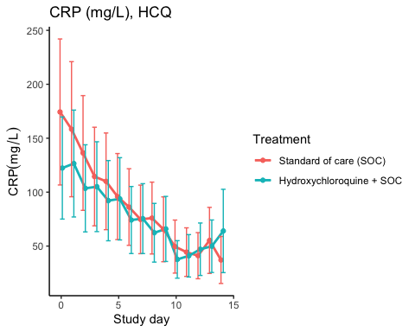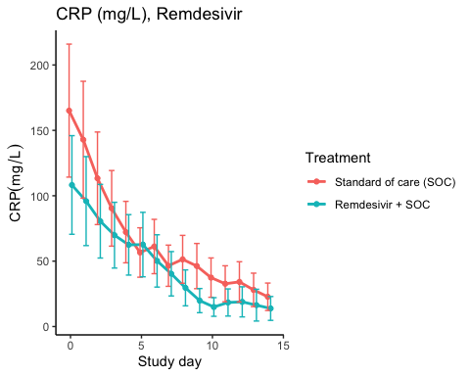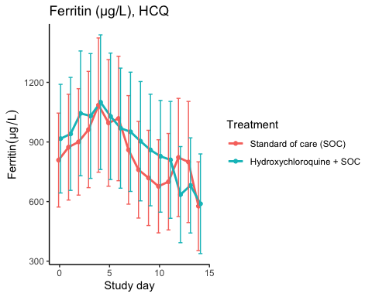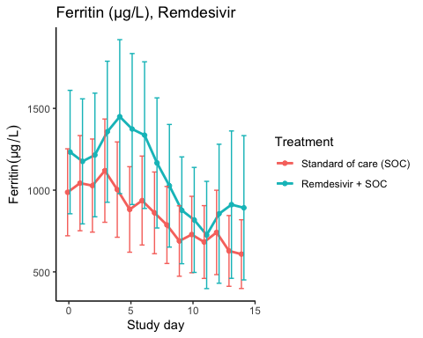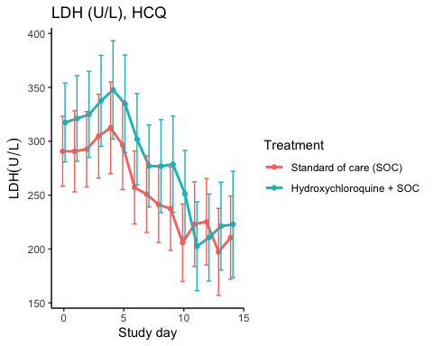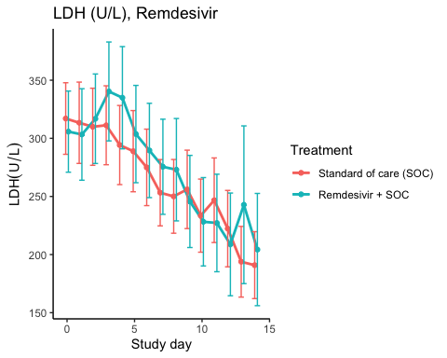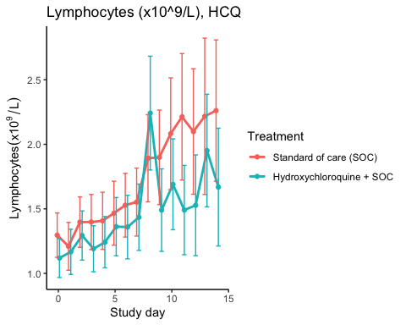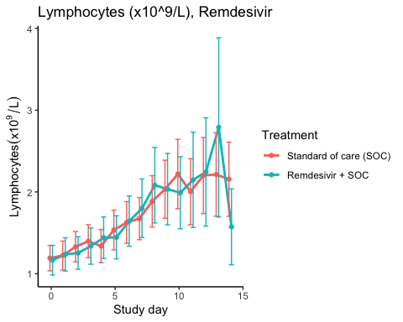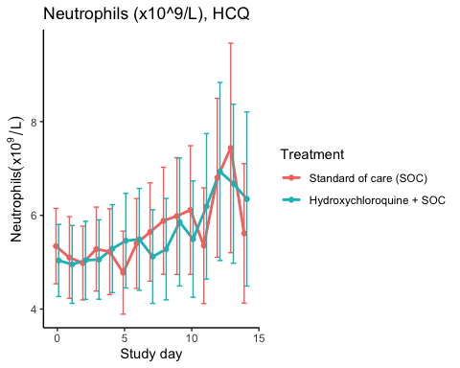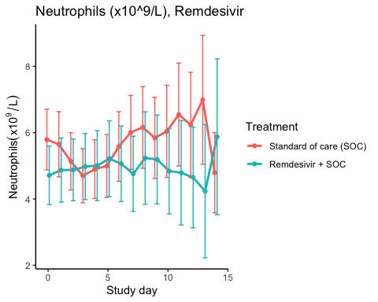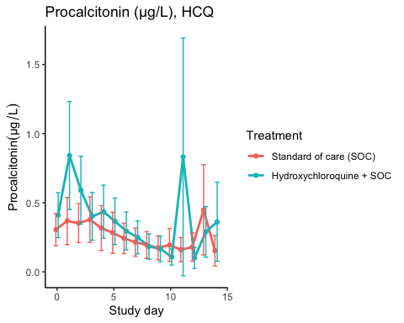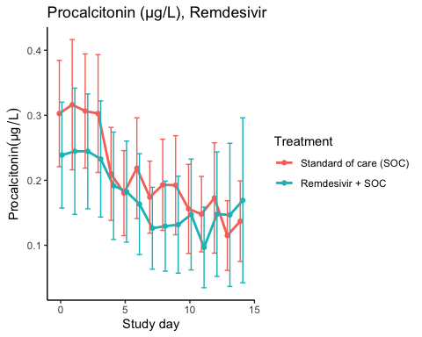

Efficacy estimates
CRP (mg/L), HCQ
Estimator | Treatment | Estimate | Lower 95% CL | Upper 95% CL | P-value
Slope 1st week by treatment | Standard of care (SOC) | -12.614 | -18.451 | -6.776 | 0.000
Slope 1st week by treatment | Hydroxychloroquine + SOC | -7.758 | -11.910 | -3.605 | 0.000
Difference in 1st week slope | Hydroxychloroquine + SOC | 4.856 | -1.734 | 11.446 | 0.149
Day 14 level by treatment | Standard of care (SOC) | 37.793 | 21.084 | 54.503 | 0.000
Day 14 level by treatment | Hydroxychloroquine + SOC | 42.974 | 24.536 | 61.411 | 0.000
Day 14 treatment difference | Hydroxychloroquine + SOC | 5.180 | -18.101 | 28.462 | 0.663

CRP (mg/L), Remdesivir
Estimator | Treatment | Estimate | Lower 95% CL | Upper 95% CL | P-value
Slope 1st week by treatment | Standard of care (SOC) | -15.675 | -20.902 | -10.448 | 0.000
Slope 1st week by treatment | Remdesivir + SOC | -9.649 | -13.547 | -5.751 | 0.000
Difference in 1st week slope | Remdesivir + SOC | 6.026 | -0.045 | 12.097 | 0.052
Day 14 level by treatment | Standard of care (SOC) | 26.701 | 16.935 | 36.466 | 0.000
Day 14 level by treatment | Remdesivir + SOC | 10.602 | 5.595 | 15.610 | 0.000
Day 14 treatment difference | Remdesivir + SOC | -16.098 | -26.775 | -5.422 | 0.003

Ferritin (µg/L), HCQ
Estimator | Treatment | Estimate | Lower 95% CL | Upper 95% CL | P-value
Slope 1st week by treatment | Standard of care (SOC) | 10.131 | -7.145 | 27.406 | 0.250
Slope 1st week by treatment | Hydroxychloroquine + SOC | 7.282 | -10.721 | 25.284 | 0.428
Difference in 1st week slope | Hydroxychloroquine + SOC | -2.849 | -27.793 | 22.094 | 0.823
Day 14 level by treatment | Standard of care (SOC) | 616.126 | 415.900 | 816.352 | 0.000
Day 14 level by treatment | Hydroxychloroquine + SOC | 610.460 | 410.031 | 810.888 | 0.000
Day 14 treatment difference | Hydroxychloroquine + SOC | -5.666 | -268.573 | 257.240 | 0.966

Ferritin (µg/L), Remdesivir
Estimator | Treatment | Estimate | Lower 95% CL | Upper 95% CL | P-value
Slope 1st week by treatment | Standard of care (SOC) | -24.011 | -42.544 | -5.477 | 0.011
Slope 1st week by treatment | Remdesivir + SOC | -0.533 | -28.428 | 27.362 | 0.970
Difference in 1st week slope | Remdesivir + SOC | 23.477 | -9.946 | 56.901 | 0.169
Day 14 level by treatment | Standard of care (SOC) | 597.689 | 419.167 | 776.210 | 0.000
Day 14 level by treatment | Remdesivir + SOC | 695.204 | 430.890 | 959.517 | 0.000
Day 14 treatment difference | Remdesivir + SOC | 97.515 | -205.387 | 400.417 | 0.528

LDH (U/L), HCQ
Estimator | Treatment | Estimate | Lower 95% CL | Upper 95% CL | P-value
Slope 1st week by treatment | Standard of care (SOC) | -5.305 | -8.742 | -1.868 | 0.002
Slope 1st week by treatment | Hydroxychloroquine + SOC | -3.371 | -7.234 | 0.492 | 0.087
Difference in 1st week slope | Hydroxychloroquine + SOC | 1.934 | -3.205 | 7.073 | 0.461
Day 14 level by treatment | Standard of care (SOC) | 198.091 | 169.616 | 226.566 | 0.000
Day 14 level by treatment | Hydroxychloroquine + SOC | 200.403 | 170.171 | 230.636 | 0.000
Day 14 treatment difference | Hydroxychloroquine + SOC | 2.312 | -39.106 | 43.731 | 0.913

LDH (U/L), Remdesivir
Estimator | Treatment | Estimate | Lower 95% CL | Upper 95% CL | P-value
Slope 1st week by treatment | Standard of care (SOC) | -7.635 | -10.575 | -4.696 | 0.000
Slope 1st week by treatment | Remdesivir + SOC | -3.185 | -6.948 | 0.579 | 0.097
Difference in 1st week slope | Remdesivir + SOC | 4.450 | -0.318 | 9.219 | 0.067
Day 14 level by treatment | Standard of care (SOC) | 198.348 | 174.417 | 222.278 | 0.000
Day 14 level by treatment | Remdesivir + SOC | 191.667 | 159.838 | 223.497 | 0.000
Day 14 treatment difference | Remdesivir + SOC | -6.680 | -46.348 | 32.987 | 0.741

Lymphocytes (x10^9/L), HCQ
Estimator | Treatment | Estimate | Lower 95% CL | Upper 95% CL | P-value
Slope 1st week by treatment | Standard of care (SOC) | 0.056 | 0.028 | 0.083 | 0.000
Slope 1st week by treatment | Hydroxychloroquine + SOC | 0.062 | 0.037 | 0.087 | 0.000
Difference in 1st week slope | Hydroxychloroquine + SOC | 0.006 | -0.030 | 0.043 | 0.736
Day 14 level by treatment | Standard of care (SOC) | 2.454 | 2.010 | 2.899 | 0.000
Day 14 level by treatment | Hydroxychloroquine + SOC | 1.787 | 1.455 | 2.118 | 0.000
Day 14 treatment difference | Hydroxychloroquine + SOC | -0.668 | -1.216 | -0.120 | 0.017

Lymphocytes (x10^9/L), Remdesivir
Estimator | Treatment | Estimate | Lower 95% CL | Upper 95% CL | P-value
Slope 1st week by treatment | Standard of care (SOC) | 0.084 | 0.061 | 0.108 | 0.000
Slope 1st week by treatment | Remdesivir + SOC | 0.096 | 0.066 | 0.127 | 0.000
Difference in 1st week slope | Remdesivir + SOC | 0.012 | -0.026 | 0.050 | 0.541
Day 14 level by treatment | Standard of care (SOC) | 2.366 | 1.972 | 2.761 | 0.000
Day 14 level by treatment | Remdesivir + SOC | 2.210 | 1.710 | 2.710 | 0.000
Day 14 treatment difference | Remdesivir + SOC | -0.157 | -0.786 | 0.473 | 0.626

Neutrophils (x10^9/L), HCQ
Estimator | Treatment | Estimate | Lower 95% CL | Upper 95% CL | P-value
Slope 1st week by treatment | Standard of care (SOC) | 0.043 | -0.050 | 0.136 | 0.364
Slope 1st week by treatment | Hydroxychloroquine + SOC | 0.049 | -0.045 | 0.144 | 0.309
Difference in 1st week slope | Hydroxychloroquine + SOC | 0.006 | -0.126 | 0.139 | 0.928
Day 14 level by treatment | Standard of care (SOC) | 6.541 | 5.244 | 7.838 | 0.000
Day 14 level by treatment | Hydroxychloroquine + SOC | 6.780 | 5.405 | 8.155 | 0.000
Day 14 treatment difference | Hydroxychloroquine + SOC | 0.239 | -1.639 | 2.117 | 0.803

Neutrophils (x10^9/L), Remdesivir
Estimator | Treatment | Estimate | Lower 95% CL | Upper 95% CL | P-value
Slope 1st week by treatment | Standard of care (SOC) | 0.021 | -0.069 | 0.111 | 0.649
Slope 1st week by treatment | Remdesivir + SOC | 0.045 | -0.060 | 0.150 | 0.400
Difference in 1st week slope | Remdesivir + SOC | 0.024 | -0.114 | 0.162 | 0.732
Day 14 level by treatment | Standard of care (SOC) | 6.180 | 4.932 | 7.428 | 0.000
Day 14 level by treatment | Remdesivir + SOC | 4.937 | 3.603 | 6.270 | 0.000
Day 14 treatment difference | Remdesivir + SOC | -1.244 | -3.058 | 0.571 | 0.179

Procalcitonin (µg/L), HCQ
Estimator | Treatment | Estimate | Lower 95% CL | Upper 95% CL | P-value
Slope 1st week by treatment | Standard of care (SOC) | -0.021 | -0.037 | -0.005 | 0.011
Slope 1st week by treatment | Hydroxychloroquine + SOC | -0.056 | -0.087 | -0.025 | 0.000
Difference in 1st week slope | Hydroxychloroquine + SOC | -0.035 | -0.069 | -0.002 | 0.038
Day 14 level by treatment | Standard of care (SOC) | 0.202 | 0.099 | 0.304 | 0.000
Day 14 level by treatment | Hydroxychloroquine + SOC | 0.217 | 0.098 | 0.337 | 0.000
Day 14 treatment difference | Hydroxychloroquine + SOC | 0.016 | -0.137 | 0.168 | 0.842

Procalcitonin (µg/L), Remdesivir
Estimator | Treatment | Estimate | Lower 95% CL | Upper 95% CL | P-value
Slope 1st week by treatment | Standard of care (SOC) | -0.019 | -0.028 | -0.010 | 0.000
Slope 1st week by treatment | Remdesivir + SOC | -0.016 | -0.027 | -0.006 | 0.002
Difference in 1st week slope | Remdesivir + SOC | 0.003 | -0.011 | 0.016 | 0.683
Day 14 level by treatment | Standard of care (SOC) | 0.136 | 0.089 | 0.183 | 0.000
Day 14 level by treatment | Remdesivir + SOC | 0.141 | 0.069 | 0.214 | 0.000
Day 14 treatment difference | Remdesivir + SOC | 0.006 | -0.080 | 0.091 | 0.898

SARS-CoV2 antibodies at day 90

Descriptives
Hydroxychloroquine
Outcome | Statistic | Standard of care (SOC) | Hydroxychloroquine + SOC
Receptor-bindind domain | Mean (SD) | 60.8 (41.7) | 45.4 (36.4)
 | Median (IQR) | 58.6 (26.4 - 96.1) | 40.4 (11.3 - 63.3)
Normalised receptor-binding domain | Mean (SD) | 17.4 (12.1) | 15.5 (9)
 | Median (IQR) | 15.5 (9 - 23.2) | 15 (8.4 - 22.1)
log10 ACE2 receptor-binding domain | Mean (SD) | 1.26 (0.71) | 1.17 (0.69)
 | Median (IQR) | 1.22 (0.73 - 1.93) | 1.21 (0.6 - 1.73)

Remdesivir
Outcome | Statistic | Standard of care (SOC) | Remdesivir + SOC
Receptor-bindind domain | Mean (SD) | 51 (43.4) | 79.2 (43.4)
 | Median (IQR) | 40.7 (13.2 - 90.9) | 69 (51.6 - 102)
Normalised receptor-binding domain | Mean (SD) | 15.6 (11.2) | 21.7 (11.8)
 | Median (IQR) | 15.2 (5.7 - 25.1) | 17.7 (13.3 - 30.9)
log10 ACE2 receptor-binding domain | Mean (SD) | 1.11 (0.72) | 1.3 (0.54)
 | Median (IQR) | 1.09 (0.46 - 1.63) | 1.33 (1.15 - 1.46)

Marginal probability estimates by treatment group and difference
Hydroxychloroquine
Outcome | Standard of care (SOC) | Hydroxychloroquine + SOC | Estimated marginal treatment effect
Receptor-bindind domain | 60.8 (49.3 to 72.3) | 45.4 (33.2 to 57.6) | -15.4 (-32.1 to 1.4)
Normalised receptor-binding domain | 17.4 (14.3 to 20.6) | 15.5 (12.2 to 18.9) | -1.9 (-6.5 to 2.7)
log10 ACE2 receptor-binding domain | 1.26 (1.06 to 1.47) | 1.17 (0.95 to 1.39) | -0.09 (-0.39 to 0.21)
Estimates are presented with 95% confidence limits
Remdesivir
Outcome | Standard of care (SOC) | Remdesivir + SOC | Estimated marginal treatment effect
Receptor-bindind domain | 51 (38.8 to 63.2) | 79.2 (64.4 to 94) | 28.2 (9 to 47.4)
Normalised receptor-binding domain | 15.6 (12.4 to 18.8) | 21.7 (17.8 to 25.6) | 6.1 (1 to 11.1)
log10 ACE2 receptor-binding domain | 1.11 (0.93 to 1.29) | 1.3 (1.07 to 1.52) | 0.19 (-0.1 to 0.47)
Estimates are presented with 95% confidence limits

Time to last discharge

HCQ
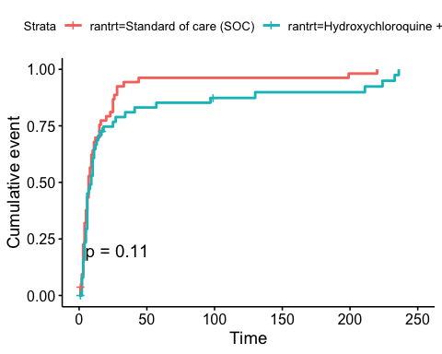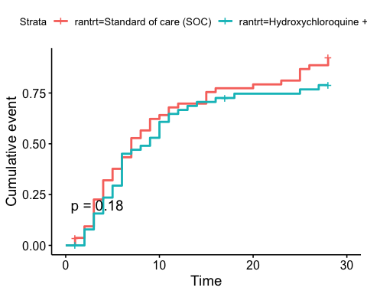

Remdesivir
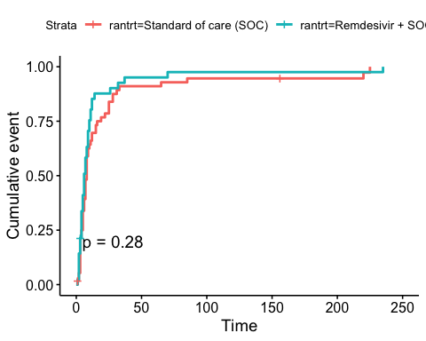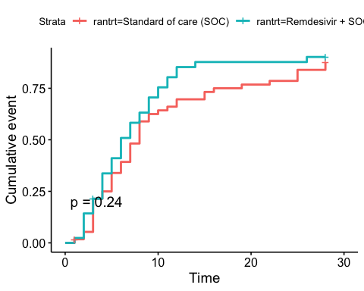

Adverse Events

AE Summary
Summary of Adverse Events
Parameter | SOC (N=87) | SOC + HCQ (N=52) | SOC + Remdesivir (N=42)
Number of AEs | [45] 28 (32.2%) | [32] 19 (36.5%) | [16] 11 (26.2%)
Number of patients with any AEs? | 28 (32.2%) | 19 (36.5%) | 11 (26.2%)
Number of patients with one AE | 20 (23%) | 12 (23.1%) | 8 (19%)
Number of patients with two AE | 2 (2.3%) | 3 (5.8%) | 1 (2.4%)
Number of patients with three or more AEs | 6 (6.9%) | 4 (7.7%) | 2 (4.8%)
Number of SAEs | [24] 16 (18.4%) | [15] 9 (17.3%) | [6] 6 (14.3%)
Number of patients with any SAEs? | 16 (18.4%) | 9 (17.3%) | 6 (14.3%)
The numbers are [Number of events] Number of patients (percentage of patients), or Number of patients (percentage of patients)

By System Organ Class and Preferred Term
Adverse Events by System Organ Class and Preferred term
System Organ Class | Preferred Term | SOC (N=87) | SOC + HCQ (N=52) | SOC + Remdesivir (N=42)
Blood and lymphatic system disorders | #Total | [2] 1 (1.1%)
 | Leukopenia | [1] 1 (1.1%)
 | Thrombocytopenia | [1] 1 (1.1%)
Cardiac disorders | #Total |  | [1] 1 (1.9%) | [3] 2 (4.8%)
 | Arrhythmia |  |  | [2] 1 (2.4%)
 | Ventricular tachycardia |  | [1] 1 (1.9%) | [1] 1 (2.4%)
Gastrointestinal disorders | #Total | [5] 5 (5.7%) | [1] 1 (1.9%) | [4] 3 (7.1%)
 | Abdominal pain | [1] 1 (1.1%)
 | Diarrhoea | [1] 1 (1.1%)
 | Diarrhoea haemorrhagic | [1] 1 (1.1%)
 | Gastrooesophageal reflux disease |  |  | [1] 1 (2.4%)
 | Intestinal pseudo-obstruction |  | [1] 1 (1.9%)
 | Nausea |  |  | [2] 2 (4.8%)
 | Pancreatic failure | [1] 1 (1.1%)
 | Vomiting | [1] 1 (1.1%) |  | [1] 1 (2.4%)
General disorders and administration site conditions | #Total | [2] 2 (2.3%) | [1] 1 (1.9%) | [2] 2 (4.8%)
 | Chest pain |  |  | [1] 1 (2.4%)
 | General physical health deterioration |  |  | [1] 1 (2.4%)
 | Medical device site reaction | [1] 1 (1.1%)
 | Pyrexia | [1] 1 (1.1%) | [1] 1 (1.9%)
Hepatobiliary disorders | #Total | [1] 1 (1.1%)
 | Cholecystitis | [1] 1 (1.1%)
Infections and infestations | #Total | [3] 3 (3.4%) | [1] 1 (1.9%) | [1] 1 (2.4%)
 | COVID-19 | [1] 1 (1.1%)
 | Infection |  |  | [1] 1 (2.4%)
 | Pneumonia bacterial | [1] 1 (1.1%) | [1] 1 (1.9%)
 | Superinfection bacterial | [1] 1 (1.1%)
Injury, poisoning and procedural complications | #Total | [2] 2 (2.3%)
 | Hepatobiliary procedural complication | [1] 1 (1.1%)
 | Procedural pneumothorax | [1] 1 (1.1%)
Investigations | #Total | [11] 6 (6.9%) | [5] 4 (7.7%) | [3] 3 (7.1%)
 | Alanine aminotransferase increased | [2] 1 (1.1%) | [2] 2 (3.8%)
 | Amylase increased | [1] 1 (1.1%)
 | Aspartate aminotransferase increased | [4] 4 (4.6%) | [1] 1 (1.9%)
 | Blood creatine phosphokinase increased | [1] 1 (1.1%)
 | Electrocardiogram QT prolonged | [2] 2 (2.3%)
 | Fibrin D dimer increased |  |  | [1] 1 (2.4%)
 | Gamma-glutamyltransferase increased | [1] 1 (1.1%)
 | Hepatic enzyme increased |  |  | [2] 2 (4.8%)
 | Myocardial necrosis marker increased |  | [1] 1 (1.9%)
 | Neutrophil count decreased |  | [1] 1 (1.9%)
Metabolism and nutrition disorders | #Total | [1] 1 (1.1%)
 | Hypercalcaemia | [1] 1 (1.1%)
Musculoskeletal and connective tissue disorders | #Total |  | [3] 1 (1.9%) | [1] 1 (2.4%)
 | Arthralgia |  | [1] 1 (1.9%)
 | Arthritis reactive |  | [1] 1 (1.9%)
 | Joint swelling |  | [1] 1 (1.9%)
 | Tendonitis |  |  | [1] 1 (2.4%)
Neoplasms benign, malignant and unspecified (incl cysts and polyps) | #Total | [1] 1 (1.1%)
 | Neoplasm malignant | [1] 1 (1.1%)
Nervous system disorders | #Total | [3] 3 (3.4%) | [2] 2 (3.8%)
 | Haemorrhage intracranial | [1] 1 (1.1%)
 | Headache |  | [1] 1 (1.9%)
 | Loss of consciousness | [1] 1 (1.1%)
 | Syncope | [1] 1 (1.1%) | [1] 1 (1.9%)
Renal and urinary disorders | #Total |  | [2] 2 (3.8%)
 | Renal failure |  | [2] 2 (3.8%)
Respiratory, thoracic and mediastinal disorders | #Total | [12] 11 (12.6%) | [13] 8 (15.4%) | [2] 2 (4.8%)
 | Bronchopleural fistula | [1] 1 (1.1%)
 | Chronic obstructive pulmonary disease |  | [2] 1 (1.9%)
 | Cough | [1] 1 (1.1%)
 | Dyspnoea |  | [4] 2 (3.8%)
 | Pulmonary embolism | [1] 1 (1.1%)
 | Respiratory distress | [2] 2 (2.3%) | [5] 4 (7.7%) | [1] 1 (2.4%)
 | Respiratory failure | [7] 7 (8%) | [2] 1 (1.9%) | [1] 1 (2.4%)
Skin and subcutaneous tissue disorders | #Total | [1] 1 (1.1%) | [1] 1 (1.9%)
 | Alopecia | [1] 1 (1.1%) | [1] 1 (1.9%)
Vascular disorders | #Total | [1] 1 (1.1%) | [2] 2 (3.8%)
 | Hypotension |  | [1] 1 (1.9%)
 | Thrombophlebitis |  | [1] 1 (1.9%)
 | Thrombosis | [1] 1 (1.1%)

Serious Adverse Events
Serious Adverse Events by System Organ Class and Preferred term
System Organ Class | Preferred Term | SOC (N=87) | SOC + HCQ (N=52) | SOC + Remdesivir (N=42)
Gastrointestinal disorders | #Total | [2] 2 (2.3%)
 | Abdominal pain | [1] 1 (1.1%)
 | Diarrhoea haemorrhagic | [1] 1 (1.1%)
General disorders and administration site conditions | #Total | [1] 1 (1.1%) |  | [2] 2 (4.8%)
 | Chest pain |  |  | [1] 1 (2.4%)
 | General physical health deterioration |  |  | [1] 1 (2.4%)
 | Pyrexia | [1] 1 (1.1%)
Hepatobiliary disorders | #Total | [1] 1 (1.1%)
 | Cholecystitis | [1] 1 (1.1%)
Infections and infestations | #Total | [3] 3 (3.4%)
 | COVID-19 | [1] 1 (1.1%)
 | Pneumonia bacterial | [1] 1 (1.1%)
 | Superinfection bacterial | [1] 1 (1.1%)
Injury, poisoning and procedural complications | #Total | [2] 2 (2.3%)
 | Hepatobiliary procedural complication | [1] 1 (1.1%)
 | Procedural pneumothorax | [1] 1 (1.1%)
Investigations | #Total | [3] 3 (3.4%) |  | [2] 2 (4.8%)
 | Alanine aminotransferase increased | [1] 1 (1.1%)
 | Aspartate aminotransferase increased | [1] 1 (1.1%)
 | Blood creatine phosphokinase increased | [1] 1 (1.1%)
 | Hepatic enzyme increased |  |  | [2] 2 (4.8%)
Neoplasms benign, malignant and unspecified (incl cysts and polyps) | #Total | [1] 1 (1.1%)
 | Neoplasm malignant | [1] 1 (1.1%)
Nervous system disorders | #Total | [2] 2 (2.3%)
 | Haemorrhage intracranial | [1] 1 (1.1%)
 | Loss of consciousness | [1] 1 (1.1%)
Renal and urinary disorders | #Total |  | [2] 2 (3.8%)
 | Renal failure |  | [2] 2 (3.8%)
Respiratory, thoracic and mediastinal disorders | #Total | [9] 8 (9.2%) | [13] 8 (15.4%) | [2] 2 (4.8%)
 | Bronchopleural fistula | [1] 1 (1.1%)
 | Chronic obstructive pulmonary disease |  | [2] 1 (1.9%)
 | Dyspnoea |  | [4] 2 (3.8%)
 | Pulmonary embolism | [1] 1 (1.1%)
 | Respiratory distress | [1] 1 (1.1%) | [5] 4 (7.7%) | [1] 1 (2.4%)
 | Respiratory failure | [6] 6 (6.9%) | [2] 1 (1.9%) | [1] 1 (2.4%)

Suspected Unexpected Serious Adverse Reaction
Suspected Unexpected Serious Adverse Reaction by System Organ Class and Preferred term
System Organ Class | Preferred Term | Standard of care (SOC)
Gastrointestinal disorders | #Total | [1] 1 (1.1%)
 | Diarrhoea haemorrhagic | [1] 1 (1.1%)
END

