NOR-SOLIDARITY First Interim Report
Inge Christoffer Olsen, PhD
28 December, 2020

Introduction
This is the report for the first interim analysis of the NOR-SOLIDARITY trial. The data are based on an export from the Viedoc electronic data capture at “2020-10-16 08:41:09” system time stamped “ous_20201016_084109”. While the results are based on real data, the treatment allocation has been drawn randomly for this report. Thus, this is a mock-up report intended to show how the final report will look like, without showing the actual results of the trial and the treatment differences. There were 181 included patients.

Inclusion status

Inclusion rate
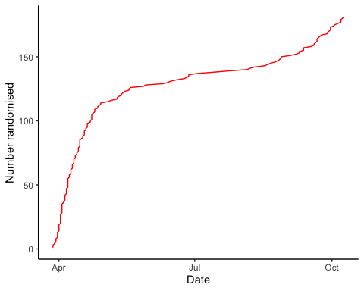

Inclusion by hospital
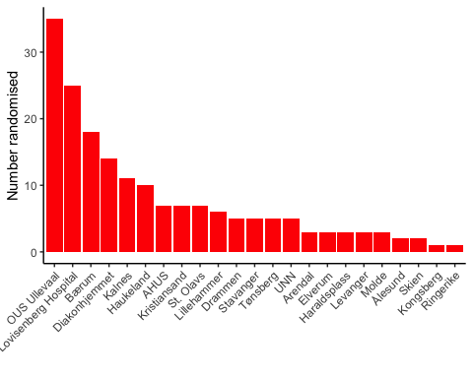

By treatment
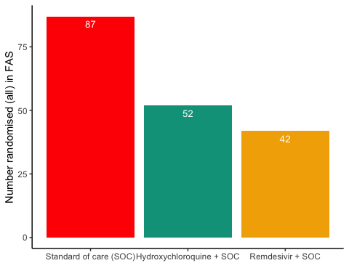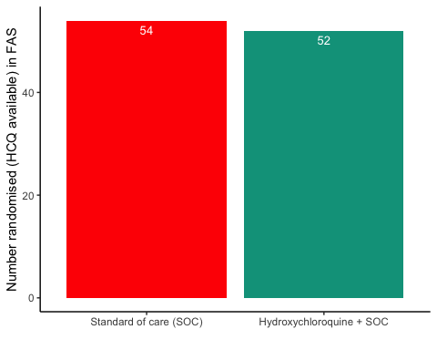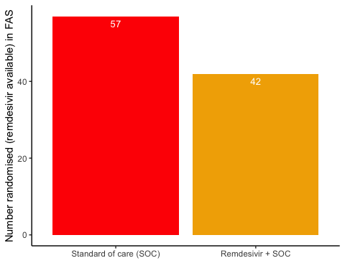

Patient flow
Patient flow total
Parameter | Total
Enrolled | 186 (100%)
Randomised | 185 (99.5%)
Included in FAS | 181 (97.3%)
Excluded from FAS, No post-randomisation information | 4 (2.2%)
Excluded from FAS, incorrect inclusion | 1 (0.5%)

Patient flow by arm
Parameter | SOC | SOC + HCQ | SOC + Remdesivir
Randomised | 88 (100%) | 54 (100%) | 43 (100%)
Included in FAS | 87 (98.9%) | 52 (96.3%) | 42 (97.7%)
Excluded from FAS, No post-randomisation information | 1 (1.1%) | 1 (1.9%) | 1 (2.3%)
Excluded from FAS, incorrect inclusion | 0 (0%) | 1 (1.9%) | 0 (0%)

Patient flow after randomisation (FAS)
Reason | Standard of care (SOC) | Hydroxychloroquine + SOC | Remdesivir + SOC | Total
Voluntary discontinuation by the patient | 2 | 4 | 1 | 7
Patient lost to follow-up | 2 | 1 | 3 | 6
Death | 6 | 3 | 3 | 12
Other | 3 | 2 | 1 | 6
Completed | 74 | 42 | 34 | 150

Demographics
Demographics, all patients (FAS)
Parameter | All patients (N=181)
Demographics
Age (years) | 59.8 (15.3)
Female, n (%) | 62 (34.3%)
Body Mass Index (kg/m²) | 28 (5)
Body Mass Index (kg/m²) | 27 (25 - 31)
Symptoms prior to admission (days) | 8 (4.9)
P/F-ratio at admittance (kPa) | 41 (13)
P/F-ratio < 40kPa, n (%) | 77 (43%)
Temperature (°C) | 37.4 (0.9)
Admitted to ward, n(%) | 171 (94.5%)
Admitted to ICU, n(%) | 10 (5.5%)
WHO Moderate disease state (4-5), n(%) | 171 (94.5%)
WHO Severe disease state (6-9), n(%) | 10 (5.5%)
WHO Severe disease state (6), n(%) | 5 (2.8%)
WHO Severe disease state (5), n(%) | 90 (49.7%)
Comorbidities
Chronic cardiac disease, including congenital heart disease | 28 (15.6%)
Chronic pulmonary disease, n(%) | 10 (5.6%)
Ever smoking, n(%) | 71 (39.4%)
Hypertension, n(%) | 55 (30.6%)
Diabetes, n(%) | 31 (17.2%)
Obese (BMI > 30 kg/m²), n(%) | 44 (26.8%)
Co-medications
Steroids | 8 (4.5%)
Other immunomodulatory drugs | 8 (4.5%)
ACE inhibitor | 12 (6.7%)
AT-II blockers | 30 (16.8%)
Hematology
Hemoglobin (g/dL) | 13.2 (12.3 - 14.1)
WBC (x10⁹/L) | 6.2 (4.7 - 8.7)
Neutrophils (x10⁹/L) | 4.3 (3 - 6.6)
Lymphocytes (x10⁹/L) | 1.1 (0.8 - 1.4)
Platelet counts (x10^9/L) | 202.5 (158.5 - 270.5)
Inflammatory markers
CRP (mg/L) | 70 (36.5 - 137.5)
Procalcitonin (µg/L) | 0.12 (0.1 - 0.21)
Ferritin (µg/L) | 613 (319 - 1173)
Other
LDH (U/L) | 277 (214 - 360)
D-dimer (mg/L FEU) | 0.68 (0.45 - 1.12)
AST | 39 (27.2 - 59)
ALT | 33 (20 - 58)
eGFR (mL/min/1.73 m²) | 89.7 (74.2 - 105.5)
Viral count
Viral count (log₁₀ counts/1000 cells) | 2 (1.6)
Anti-SARS-CoV-2 Antibodies
Zero converted (RBD ≤ 5) | 67 (52.8%)
Supplementary baseline information
Systolic Blood Pressure (mmHg) | 125 (18)
Diastolic Blood Pressure (mmHg) | 74 (11)
Mean Arterial Blood Pressure (mmHg) | 91 (12)
SOFA score | 1.6 (1.6)
Chronic kidney disease, n(%) | 11 (6.1%)
Autoimmune disease, n(%) | 8 (4.4%)
Cognitive impairment/dementia, n(%) | 4 (2.2%)
Neurological disorder, n(%) | 7 (3.9%)
Cancer, n(%) | 13 (7.2%)
Cirrhosis, n(%) | 0 (0%)
Asthma, n(%) | 22 (12.2%)
HIV, n(%) | 0 (0%)
Active TB, n(%) | 0 (0%)
Note, all percentages are given with observed values in the denominator, missing values discarded

Demographics, all arms (FAS)
Parameter | SOC (N=87) | SOC + HCQ (N=52) | SOC + Remdesivir (N=42)
Demographics
Age (years) | 58.6 (15.8) | 61.2 (13.9) | 60.4 (16.2)
Female, n (%) | 27 (31%) | 19 (36.5%) | 16 (38.1%)
Body Mass Index (kg/m²) | 29 (5) | 27 (4) | 28 (5)
Body Mass Index (kg/m²) | 28 (25 - 31) | 27 (25 - 30) | 27 (24 - 29)
Symptoms prior to admission (days) | 7.5 (4) | 9.3 (6) | 7.5 (5)
P/F-ratio at admittance (kPa) | 41 (14) | 41 (13) | 41 (11)
P/F-ratio < 40kPa, n (%) | 36 (41.9%) | 25 (48.1%) | 16 (39%)
Temperature (°C) | 37.5 (0.9) | 37.4 (1) | 37.3 (0.9)
Admitted to ward, n(%) | 83 (95.4%) | 49 (94.2%) | 39 (92.9%)
Admitted to ICU, n(%) | 4 (4.6%) | 3 (5.8%) | 3 (7.1%)
WHO Moderate disease state (4-5), n(%) | 83 (95.4%) | 49 (94.2%) | 39 (92.9%)
WHO Severe disease state (6-9), n(%) | 4 (4.6%) | 3 (5.8%) | 3 (7.1%)
WHO Severe disease state (6), n(%) | 4 (4.6%) | NA | 1 (2.4%)
WHO Severe disease state (5), n(%) | 43 (49.4%) | 28 (53.8%) | 19 (45.2%)
Comorbidities
Chronic cardiac disease, including congenital heart disease | 12 (13.8%) | 9 (17.3%) | 7 (17.1%)
Chronic pulmonary disease, n(%) | 5 (5.7%) | 2 (3.8%) | 3 (7.3%)
Ever smoking, n(%) | 35 (40.2%) | 18 (34.6%) | 18 (43.9%)
Hypertension, n(%) | 29 (33.3%) | 14 (26.9%) | 12 (29.3%)
Diabetes, n(%) | 18 (20.7%) | 8 (15.4%) | 5 (12.2%)
Obese (BMI > 30 kg/m²), n(%) | 22 (28.6%) | 12 (26.1%) | 10 (24.4%)
Co-medications
Steroids | 6 (7%) | 1 (1.9%) | 1 (2.4%)
Other immunomodulatory drugs | 5 (5.8%) | 2 (3.8%) | 1 (2.4%)
ACE inhibitor | 5 (5.8%) | 4 (7.7%) | 3 (7.3%)
AT-II blockers | 16 (18.6%) | 8 (15.4%) | 6 (14.6%)
Hematology
Hemoglobin (g/dL) | 13.2 (12.7 - 14.1) | 13.3 (12.3 - 14.3) | 13 (11.9 - 14.1)
WBC (x10⁹/L) | 6.3 (4.7 - 9.1) | 5.9 (4.9 - 8) | 6 (4.5 - 7.8)
Neutrophils (x10⁹/L) | 4.7 (3 - 6.8) | 4.1 (3 - 6.7) | 3.8 (2.6 - 6)
Lymphocytes (x10⁹/L) | 1.1 (0.7 - 1.4) | 1.2 (0.9 - 1.4) | 1 (0.8 - 1.4)
Platelet counts (x10^9/L) | 203 (153.8 - 265.8) | 204 (164 - 304.5) | 196 (154 - 243)
Inflammatory markers
CRP (mg/L) | 68 (47 - 125) | 79 (30 - 150) | 76 (33 - 140)
Procalcitonin (µg/L) | 0.11 (0.1 - 0.2) | 0.11 (0.1 - 0.42) | 0.14 (0.1 - 0.18)
Ferritin (µg/L) | 607.5 (294.5 - 1140) | 782 (376.5 - 1567.2) | 462 (319 - 1056)
Other
LDH (U/L) | 291 (231 - 366) | 264 (199 - 365) | 264 (209 - 310)
D-dimer (mg/L FEU) | 0.6 (0.44 - 1.09) | 0.8 (0.57 - 1.01) | 0.75 (0.42 - 1.31)
AST | 40.5 (28.2 - 59.8) | 35 (27 - 57) | 39 (24.5 - 55)
ALT | 30 (22 - 63.2) | 33 (20 - 50) | 37 (18 - 58.8)
eGFR (mL/min/1.73 m²) | 86.3 (75.3 - 103.9) | 91.8 (73.2 - 105.7) | 89 (75.2 - 105.3)
Viral count
Viral count (log₁₀ counts/1000 cells) | 2.1 (1.7) | 1.5 (1.5) | 2.2 (1.6)
Anti-SARS-CoV-2 Antibodies
Zero converted (RBD ≤ 5) | 33 (57.9%) | 20 (50%) | 14 (46.7%)
Supplementary baseline information
Systolic Blood Pressure (mmHg) | 126 (17) | 123 (19) | 125 (17)
Diastolic Blood Pressure (mmHg) | 73 (12) | 73 (11) | 75 (11)
Mean Arterial Blood Pressure (mmHg) | 91 (12) | 90 (12) | 92 (11)
SOFA score | 1.5 (1.1) | 1.9 (2.3) | 1.5 (1.5)
Chronic kidney disease, n(%) | 6 (6.9%) | 4 (7.7%) | 1 (2.4%)
Autoimmune disease, n(%) | 3 (3.4%) | 3 (5.8%) | 2 (4.9%)
Cognitive impairment/dementia, n(%) | 3 (3.4%) | 1 (1.9%) | 0 (0%)
Neurological disorder, n(%) | 3 (3.4%) | 3 (5.8%) | 1 (2.4%)
Cancer, n(%) | 6 (6.9%) | 3 (5.8%) | 4 (9.8%)
Cirrhosis, n(%) | 0 (0%) | 0 (0%) | 0 (0%)
Asthma, n(%) | 12 (13.8%) | 3 (5.8%) | 7 (17.1%)
HIV, n(%) | 0 (0%) | 0 (0%) | 0 (0%)
Active TB, n(%) | 0 (0%) | 0 (0%) | 0 (0%)
Note, all percentages are given with observed values in the denominator, missing values discarded

Demographics, HCQ (FAS)
Parameter | SOC (N=54) | SOC + HCQ (N=52)
Demographics
Age (years) | 59.2 (16) | 61.2 (13.9)
Female, n (%) | 21 (38.9%) | 19 (36.5%)
Body Mass Index (kg/m²) | 29 (5) | 27 (4)
Body Mass Index (kg/m²) | 28 (25 - 32) | 27 (25 - 30)
Symptoms prior to admission (days) | 7.4 (4.4) | 9.3 (6)
P/F-ratio at admittance (kPa) | 42 (14) | 41 (13)
P/F-ratio < 40kPa, n (%) | 19 (35.2%) | 25 (48.1%)
Temperature (°C) | 37.5 (0.9) | 37.4 (1)
Admitted to ward, n(%) | 51 (94.4%) | 49 (94.2%)
Admitted to ICU, n(%) | 3 (5.6%) | 3 (5.8%)
WHO Moderate disease state (4-5), n(%) | 51 (94.4%) | 49 (94.2%)
WHO Severe disease state (6-9), n(%) | 3 (5.6%) | 3 (5.8%)
WHO Severe disease state (6), n(%) | 3 (5.6%) | NA
WHO Severe disease state (5), n(%) | 24 (44.4%) | 28 (53.8%)
Comorbidities
Chronic cardiac disease, including congenital heart disease | 9 (16.7%) | 9 (17.3%)
Chronic pulmonary disease, n(%) | 2 (3.7%) | 2 (3.8%)
Ever smoking, n(%) | 22 (40.7%) | 18 (34.6%)
Hypertension, n(%) | 16 (29.6%) | 14 (26.9%)
Diabetes, n(%) | 11 (20.4%) | 8 (15.4%)
Obese (BMI > 30 kg/m²), n(%) | 16 (32%) | 12 (26.1%)
Co-medications
Steroids | 3 (5.7%) | 1 (1.9%)
Other immunomodulatory drugs | 3 (5.7%) | 2 (3.8%)
ACE inhibitor | 4 (7.5%) | 4 (7.7%)
AT-II blockers | 9 (17%) | 8 (15.4%)
Hematology
Hemoglobin (g/dL) | 13.1 (12.7 - 13.9) | 13.3 (12.3 - 14.3)
WBC (x10⁹/L) | 6.6 (4.7 - 9) | 5.9 (4.9 - 8)
Neutrophils (x10⁹/L) | 4.3 (3 - 6.5) | 4.1 (3 - 6.7)
Lymphocytes (x10⁹/L) | 1.1 (0.9 - 1.5) | 1.2 (0.9 - 1.4)
Platelet counts (x10^9/L) | 198 (152 - 260) | 204 (164 - 304.5)
Inflammatory markers
CRP (mg/L) | 68.5 (48 - 110.8) | 79 (30 - 150)
Procalcitonin (µg/L) | 0.1 (0.1 - 0.2) | 0.11 (0.1 - 0.42)
Ferritin (µg/L) | 544.5 (237 - 965.2) | 782 (376.5 - 1567.2)
Other
LDH (U/L) | 275 (219 - 365.5) | 264 (199 - 365)
D-dimer (mg/L FEU) | 0.6 (0.41 - 1.08) | 0.8 (0.57 - 1.01)
AST | 39 (24 - 56) | 35 (27 - 57)
ALT | 30 (20 - 55) | 33 (20 - 50)
eGFR (mL/min/1.73 m²) | 88.3 (71.5 - 105) | 91.8 (73.2 - 105.7)
Viral count
Viral count (log₁₀ counts/1000 cells) | 2.1 (1.7) | 1.5 (1.5)
Anti-SARS-CoV-2 Antibodies
Zero converted (RBD ≤ 5) | 22 (62.9%) | 20 (50%)
Supplementary baseline information
Systolic Blood Pressure (mmHg) | 125 (16) | 123 (19)
Diastolic Blood Pressure (mmHg) | 73 (11) | 73 (11)
Mean Arterial Blood Pressure (mmHg) | 90 (11) | 90 (12)
SOFA score | 1.5 (1.1) | 1.9 (2.3)
Chronic kidney disease, n(%) | 5 (9.3%) | 4 (7.7%)
Autoimmune disease, n(%) | 1 (1.9%) | 3 (5.8%)
Cognitive impairment/dementia, n(%) | 3 (5.6%) | 1 (1.9%)
Neurological disorder, n(%) | 2 (3.7%) | 3 (5.8%)
Cancer, n(%) | 3 (5.6%) | 3 (5.8%)
Cirrhosis, n(%) | 0 (0%) | 0 (0%)
Asthma, n(%) | 9 (16.7%) | 3 (5.8%)
HIV, n(%) | 0 (0%) | 0 (0%)
Active TB, n(%) | 0 (0%) | 0 (0%)
Note, all percentages are given with observed values in the denominator, missing values discarded

Demographics, Remdesivir (FAS)
Parameter | SOC (N=57) | SOC + Remdesivir (N=42)
Demographics
Age (years) | 58 (16.3) | 60.4 (16.2)
Female, n (%) | 15 (26.3%) | 16 (38.1%)
Body Mass Index (kg/m²) | 29 (5) | 28 (5)
Body Mass Index (kg/m²) | 28 (25 - 33) | 27 (24 - 29)
Symptoms prior to admission (days) | 7.4 (3.5) | 7.5 (5)
P/F-ratio at admittance (kPa) | 43 (13) | 41 (11)
P/F-ratio < 40kPa, n (%) | 23 (41.1%) | 16 (39%)
Temperature (°C) | 37.5 (1) | 37.3 (0.9)
Admitted to ward, n(%) | 55 (96.5%) | 39 (92.9%)
Admitted to ICU, n(%) | 2 (3.5%) | 3 (7.1%)
WHO Moderate disease state (4-5), n(%) | 55 (96.5%) | 39 (92.9%)
WHO Severe disease state (6-9), n(%) | 2 (3.5%) | 3 (7.1%)
WHO Severe disease state (6), n(%) | 2 (3.5%) | 1 (2.4%)
WHO Severe disease state (5), n(%) | 27 (47.4%) | 19 (45.2%)
Comorbidities
Chronic cardiac disease, including congenital heart disease | 7 (12.3%) | 7 (17.1%)
Chronic pulmonary disease, n(%) | 3 (5.3%) | 3 (7.3%)
Ever smoking, n(%) | 23 (40.4%) | 18 (43.9%)
Hypertension, n(%) | 18 (31.6%) | 12 (29.3%)
Diabetes, n(%) | 10 (17.5%) | 5 (12.2%)
Obese (BMI > 30 kg/m²), n(%) | 15 (30.6%) | 10 (24.4%)
Co-medications
Steroids | 4 (7%) | 1 (2.4%)
Other immunomodulatory drugs | 3 (5.3%) | 1 (2.4%)
ACE inhibitor | 2 (3.5%) | 3 (7.3%)
AT-II blockers | 11 (19.3%) | 6 (14.6%)
Hematology
Hemoglobin (g/dL) | 13.3 (12.9 - 14.1) | 13 (11.9 - 14.1)
WBC (x10⁹/L) | 6.1 (4.5 - 8.6) | 6 (4.5 - 7.8)
Neutrophils (x10⁹/L) | 4.1 (3 - 6.6) | 3.8 (2.6 - 6)
Lymphocytes (x10⁹/L) | 1.1 (0.7 - 1.3) | 1 (0.8 - 1.4)
Platelet counts (x10^9/L) | 205.5 (149.8 - 257.2) | 196 (154 - 243)
Inflammatory markers
CRP (mg/L) | 63 (45 - 135) | 76 (33 - 140)
Procalcitonin (µg/L) | 0.1 (0.1 - 0.2) | 0.14 (0.1 - 0.18)
Ferritin (µg/L) | 626 (302 - 1204) | 462 (319 - 1056)
Other
LDH (U/L) | 302.5 (239.2 - 367.8) | 264 (209 - 310)
D-dimer (mg/L FEU) | 0.6 (0.45 - 0.9) | 0.75 (0.42 - 1.31)
AST | 44.5 (30.2 - 69.8) | 39 (24.5 - 55)
ALT | 35 (22 - 57.8) | 37 (18 - 58.8)
eGFR (mL/min/1.73 m²) | 84.8 (76.7 - 102.3) | 89 (75.2 - 105.3)
Viral count
Viral count (log₁₀ counts/1000 cells) | 2.2 (1.8) | 2.2 (1.6)
Anti-SARS-CoV-2 Antibodies
Zero converted (RBD ≤ 5) | 20 (52.6%) | 14 (46.7%)
Supplementary baseline information
Systolic Blood Pressure (mmHg) | 127 (19) | 125 (17)
Diastolic Blood Pressure (mmHg) | 73 (13) | 75 (11)
Mean Arterial Blood Pressure (mmHg) | 91 (13) | 92 (11)
SOFA score | 1.5 (1.1) | 1.5 (1.5)
Chronic kidney disease, n(%) | 4 (7%) | 1 (2.4%)
Autoimmune disease, n(%) | 2 (3.5%) | 2 (4.9%)
Cognitive impairment/dementia, n(%) | 0 (0%) | 0 (0%)
Neurological disorder, n(%) | 2 (3.5%) | 1 (2.4%)
Cancer, n(%) | 3 (5.3%) | 4 (9.8%)
Cirrhosis, n(%) | 0 (0%) | 0 (0%)
Asthma, n(%) | 4 (7%) | 7 (17.1%)
HIV, n(%) | 0 (0%) | 0 (0%)
Active TB, n(%) | 0 (0%) | 0 (0%)
Note, all percentages are given with observed values in the denominator, missing values discarded

Missing values, all arms (FAS)
Parameter | SOC (N=87) | SOC + HCQ (N=52) | SOC + Remdesivir (N=42)
Demographics
Age (years) | 0 (0%) | 0 (0%) | 0 (0%)
Female, n (%) | 0 (0%) | 0 (0%) | 0 (0%)
Body Mass Index (kg/m²) | 10 (11.5%), 10 (11.5%) | 6 (11.5%), 6 (11.5%) | 1 (2.4%), 1 (2.4%)
Symptoms prior to admission (days) | 0 (0%) | 0 (0%) | 1 (2.4%)
P/F-ratio at admittance (kPa) | 1 (1.1%) | 0 (0%) | 1 (2.4%)
P/F-ratio < 40kPa, n (%) | 1 (1.1%) | 0 (0%) | 1 (2.4%)
Temperature (°C) | 0 (0%) | 0 (0%) | 0 (0%)
Admitted to ward, n(%) | 0 (0%) | 0 (0%) | 0 (0%)
Admitted to ICU, n(%) | 0 (0%) | 0 (0%) | 0 (0%)
WHO Moderate disease state (4-5), n(%) | 0 (0%) | 0 (0%) | 0 (0%)
WHO Severe disease state (6-9), n(%) | 0 (0%) | 0 (0%) | 0 (0%)
WHO Severe disease state (6), n(%) | 0 (0%) | 0 (0%) | 0 (0%)
WHO Severe disease state (5), n(%) | 0 (0%) | 0 (0%) | 0 (0%)
Comorbidities
Chronic cardiac disease, including congenital heart disease | 0 (0%) | 0 (0%) | 1 (2.4%)
Chronic pulmonary disease, n(%) | 0 (0%) | 0 (0%) | 1 (2.4%)
Ever smoking, n(%) | 0 (0%) | 0 (0%) | 1 (2.4%)
Hypertension, n(%) | 0 (0%) | 0 (0%) | 1 (2.4%)
Diabetes, n(%) | 0 (0%) | 0 (0%) | 1 (2.4%)
Obese (BMI > 30 kg/m²), n(%) | 10 (11.5%) | 6 (11.5%) | 1 (2.4%)
Co-medications
Steroids | 1 (1.1%) | 0 (0%) | 1 (2.4%)
Other immunomodulatory drugs | 1 (1.1%) | 0 (0%) | 1 (2.4%)
ACE inhibitor | 1 (1.1%) | 0 (0%) | 1 (2.4%)
AT-II blockers | 1 (1.1%) | 0 (0%) | 1 (2.4%)
Hematology
Hemoglobin (g/dL) | 1 (1.1%) | 2 (3.8%) | 0 (0%)
WBC (x10⁹/L) | 1 (1.1%) | 0 (0%) | 0 (0%)
Neutrophils (x10⁹/L) | 4 (4.6%) | 4 (7.7%) | 2 (4.8%)
Lymphocytes (x10⁹/L) | 4 (4.6%) | 3 (5.8%) | 2 (4.8%)
Platelet counts (x10^9/L) | 1 (1.1%) | 1 (1.9%) | 1 (2.4%)
Inflammatory markers
CRP (mg/L) | 0 (0%) | 1 (1.9%) | 1 (2.4%)
Procalcitonin (µg/L) | 28 (32.2%) | 12 (23.1%) | 18 (42.9%)
Ferritin (µg/L) | 3 (3.4%) | 2 (3.8%) | 4 (9.5%)
Other
LDH (U/L) | 4 (4.6%) | 3 (5.8%) | 1 (2.4%)
D-dimer (mg/L FEU) | 13 (14.9%) | 3 (5.8%) | 3 (7.1%)
AST | 5 (5.7%) | 3 (5.8%) | 3 (7.1%)
ALT | 3 (3.4%) | 3 (5.8%) | 2 (4.8%)
eGFR (mL/min/1.73 m²) | 1 (1.1%) | 0 (0%) | 0 (0%)
Viral count
Viral count (log₁₀ counts/1000 cells) | 21 (24.1%) | 13 (25%) | 7 (16.7%)
Anti-SARS-CoV-2 Antibodies
Zero converted (RBD ≤ 5) | 30 (34.5%) | 12 (23.1%) | 12 (28.6%)
Supplementary baseline information
Systolic Blood Pressure (mmHg) | 0 (0%) | 0 (0%) | 0 (0%)
Diastolic Blood Pressure (mmHg) | 0 (0%) | 0 (0%) | 0 (0%)
Mean Arterial Blood Pressure (mmHg) | 0 (0%) | 0 (0%) | 0 (0%)
SOFA score | 4 (4.6%) | 3 (5.8%) | 4 (9.5%)
Chronic kidney disease, n(%) | 0 (0%) | 0 (0%) | 1 (2.4%)
Autoimmune disease, n(%) | 0 (0%) | 0 (0%) | 1 (2.4%)
Cognitive impairment/dementia, n(%) | 0 (0%) | 0 (0%) | 1 (2.4%)
Neurological disorder, n(%) | 0 (0%) | 0 (0%) | 1 (2.4%)
Cancer, n(%) | 0 (0%) | 0 (0%) | 1 (2.4%)
Cirrhosis, n(%) | 0 (0%) | 0 (0%) | 1 (2.4%)
Asthma, n(%) | 0 (0%) | 0 (0%) | 1 (2.4%)
HIV, n(%) | 0 (0%) | 0 (0%) | 1 (2.4%)
Active TB, n(%) | 0 (0%) | 0 (0%) | 1 (2.4%)
Note, all percentages are given with observed values in the denominator, missing values discarded

Exposure
Exposure to study treatment
Parameter | SOC + HCQ (N=52) | SOC + Remdesivir (N=42)
Total dose (mg), median (IQR) | 1100 (600 - 4400) | 2800 (1000 - 5700)
Treatment duration, median (IQR) | 5 (3 - 8) | 6 (4 - 9)
Number of doses given, median (IQR) | 6 (4 - 9) | 6 (4 - 10)
Patients with any treatment discrepencies, n (%) | 9 (36%) | 8 (33.3%)

Efficacy

Mortality

Descriptives
All arms (FAS)
Treatment | # deaths | # randomised | %
Standard of care (SOC) | 7 | 87 | 8.0
Hydroxychloroquine + SOC | 1 | 52 | 1.9
Remdesivir + SOC | 4 | 42 | 9.5

HCQ (FAS)
Treatment | # deaths | # randomised | %
Standard of care (SOC) | 4 | 54 | 7.4
Hydroxychloroquine + SOC | 1 | 52 | 1.9

Remdesivir (FAS)
Treatment | # deaths | # randomised | %
Standard of care (SOC) | 5 | 57 | 8.8
Remdesivir + SOC | 4 | 42 | 9.5

Analyses
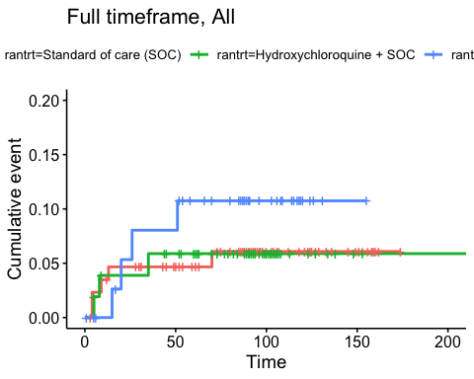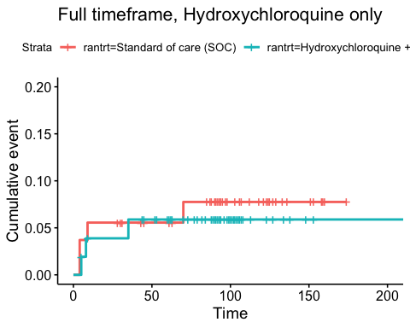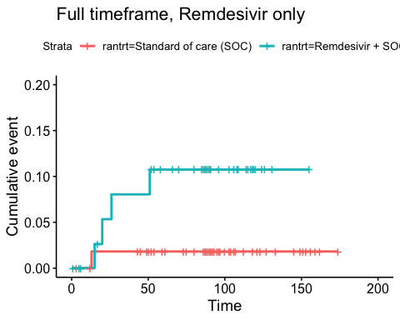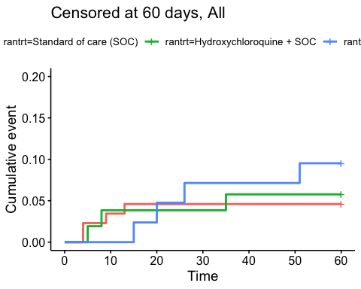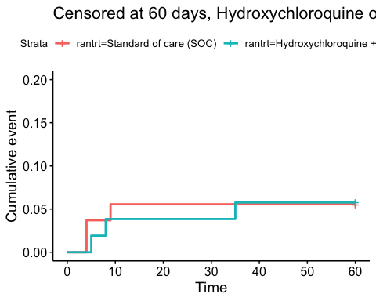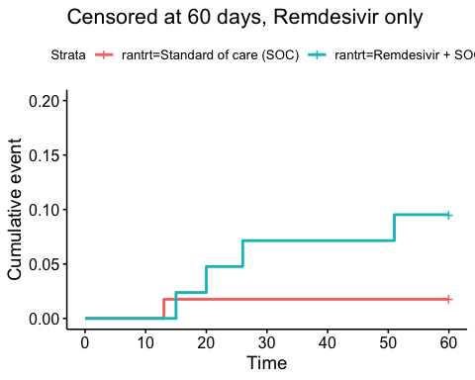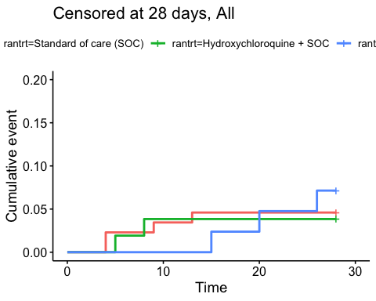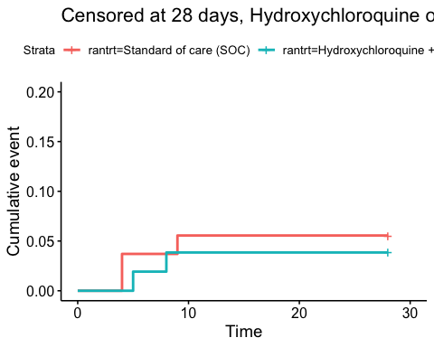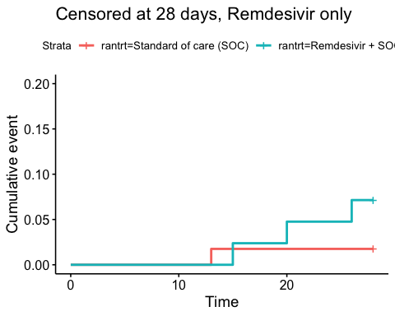
Relative risk estimates and p-values
Timeframe, Population | Relative risk | P-value
Full timeframe, All | Not applicable | 0.646
Full timeframe, Hydroxychloroquine only | 0.78 (95% CI 0.18 to 3.44) | 0.744
Full timeframe, Remdesivir only | 5.18 (95% CI 0.87 to 30.93) | 0.071
Censored at 60 days, All | Not applicable | 0.575
Censored at 60 days, Hydroxychloroquine only | 1.03 (95% CI 0.21 to 5.1) | 0.975
Censored at 60 days, Remdesivir only | 4.75 (95% CI 0.8 to 28.03) | 0.086
Censored at 28 days, All | Not applicable | 0.771
Censored at 28 days, Hydroxychloroquine only | 0.69 (95% CI 0.12 to 3.98) | 0.676
Censored at 28 days, Remdesivir only | 3.82 (95% CI 0.53 to 27.75) | 0.186

Viral load
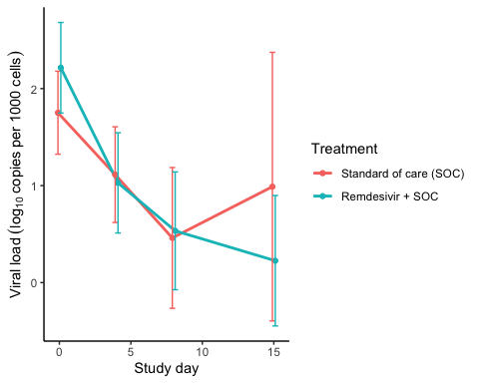
Estimated treatment effect, HCQ
Treatment | Explanation | Estimate | Lower 95% CL | Upper 95% CL | P-value
Standard of care (SOC) | Slope by treatment | -0.161 | -0.252 | -0.069 | 0.001
Remdesivir + SOC | Slope by treatment | -0.244 | -0.328 | -0.160 | 0.000
Remdesivir + SOC | Difference in slope | -0.084 | -0.208 | 0.041 | 0.188
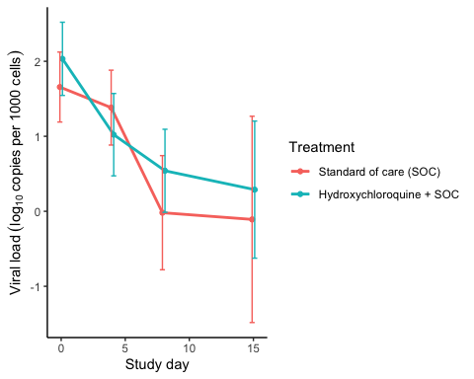
Estimated treatment effect, HCQ
Treatment | Explanation | Estimate | Lower 95% CL | Upper 95% CL | P-value
Standard of care (SOC) | Slope by treatment | -0.164 | -0.258 | -0.071 | 0.001
Hydroxychloroquine + SOC | Slope by treatment | -0.203 | -0.280 | -0.127 | 0.000
Hydroxychloroquine + SOC | Difference in slope | -0.039 | -0.159 | 0.082 | 0.529

Inflammatory laboratory parameters

Descriptives
CRP (mg/L), HCQ
Days since randomisation | Statistic | Standard of care (SOC) | Hydroxychloroquine + SOC
0 days | Mean (SD) | 83.16 (51.76) | 99.87 (81.43)
0 days | Median [IQR] | 68.5 [48 - 110.75] | 79 [30 - 150]
0 days | Missing / Non-Missing | 0 / 54 | 1 / 51
1 days | Mean (SD) | 88.59 (53.46) | 111.99 (88.97)
1 days | Median [IQR] | 79 [53.5 - 110.25] | 94 [44.25 - 154.75]
1 days | Missing / Non-Missing | 10 / 44 | 9 / 42
2 days | Mean (SD) | 84.19 (61.57) | 102.12 (91.51)
2 days | Median [IQR] | 70 [43.75 - 111] | 87.5 [25.75 - 137.5]
2 days | Missing / Non-Missing | 5 / 48 | 7 / 42
3 days | Mean (SD) | 76.7 (51.87) | 99.38 (86.47)
3 days | Median [IQR] | 68 [33 - 104.25] | 70 [33.5 - 137.5]
3 days | Missing / Non-Missing | 10 / 40 | 8 / 39
4 days | Mean (SD) | 76.31 (59.55) | 108.75 (82.87)
4 days | Median [IQR] | 71 [24 - 116.75] | 99 [48 - 138.5]
4 days | Missing / Non-Missing | 3 / 36 | 6 / 31
5 days | Mean (SD) | 75.74 (63.92) | 104.33 (89.96)
5 days | Median [IQR] | 53 [20 - 109] | 70 [48.5 - 137]
5 days | Missing / Non-Missing | 8 / 27 | 2 / 31
6 days | Mean (SD) | 69.76 (66.49) | 102.68 (92.62)
6 days | Median [IQR] | 57 [15 - 92] | 55 [34 - 155]
6 days | Missing / Non-Missing | 4 / 29 | 3 / 25
7 days | Mean (SD) | 68.72 (51.15) | 90.86 (78.15)
7 days | Median [IQR] | 60 [22.5 - 100] | 59.5 [32 - 131]
7 days | Missing / Non-Missing | 3 / 23 | 0 / 24
8 days | Mean (SD) | 61.76 (52.41) | 65.93 (53.42)
8 days | Median [IQR] | 55 [24 - 87] | 60 [20.25 - 99.5]
8 days | Missing / Non-Missing | 0 / 23 | 4 / 16
9 days | Mean (SD) | 56.49 (55.12) | 58.35 (47.9)
9 days | Median [IQR] | 40 [16 - 75.5] | 54 [12 - 91]
9 days | Missing / Non-Missing | 4 / 19 | 2 / 13
10 days | Mean (SD) | 48.36 (67.45) | 55.77 (50.96)
10 days | Median [IQR] | 23.5 [8.75 - 45] | 47.5 [7.63 - 84]
10 days | Missing / Non-Missing | 4 / 16 | 0 / 12
11 days | Mean (SD) | 75.95 (123.68) | 67.7 (50.2)
11 days | Median [IQR] | 29 [9 - 80.5] | 63 [25 - 105.5]
11 days | Missing / Non-Missing | 6 / 11 | 0 / 10
12 days | Mean (SD) | 100.07 (210.31) | 103.5 (56.15)
12 days | Median [IQR] | 11 [5 - 44] | 107 [93.5 - 109.25]
12 days | Missing / Non-Missing | 5 / 9 | 0 / 6
13 days | Mean (SD) | 90.48 (129.67) | 102.83 (74.92)
13 days | Median [IQR] | 24.5 [9.35 - 108.75] | 99 [61.25 - 112.75]
13 days | Missing / Non-Missing | 3 / 8 | 0 / 6
14 days | Mean (SD) | 74.12 (108.22) | 42.67 (34.82)
14 days | Median [IQR] | 24 [6.85 - 97.5] | 34 [23.5 - 57.5]
14 days | Missing / Non-Missing | 1 / 7 | 0 / 3

CRP (mg/L), Remdesivir
Days since randomisation | Statistic | Standard of care (SOC) | Remdesivir + SOC
0 days | Mean (SD) | 87.77 (64.12) | 89.72 (70.93)
0 days | Median [IQR] | 63 [45 - 135] | 76 [33 - 140]
0 days | Missing / Non-Missing | 0 / 57 | 1 / 41
1 days | Mean (SD) | 93.78 (63.45) | 78.33 (65.32)
1 days | Median [IQR] | 75 [55.25 - 123.5] | 66 [33 - 101]
1 days | Missing / Non-Missing | 11 / 46 | 9 / 33
2 days | Mean (SD) | 84.1 (59.97) | 72.71 (74.33)
2 days | Median [IQR] | 72.5 [39.75 - 118.25] | 49 [27 - 91.75]
2 days | Missing / Non-Missing | 6 / 50 | 4 / 36
3 days | Mean (SD) | 73.17 (57.32) | 86.71 (86.31)
3 days | Median [IQR] | 68 [26 - 93] | 53.5 [31.75 - 105.75]
3 days | Missing / Non-Missing | 8 / 45 | 3 / 24
4 days | Mean (SD) | 77.75 (70.45) | 86.5 (106.14)
4 days | Median [IQR] | 65.5 [26.25 - 106.75] | 38 [17 - 92]
4 days | Missing / Non-Missing | 7 / 36 | 3 / 25
5 days | Mean (SD) | 77.56 (75.3) | 73.11 (80.85)
5 days | Median [IQR] | 54.5 [24.75 - 109.75] | 34 [13 - 114]
5 days | Missing / Non-Missing | 8 / 30 | 5 / 19
6 days | Mean (SD) | 71.49 (73.31) | 68.06 (76.33)
6 days | Median [IQR] | 53 [16 - 105] | 33.5 [12 - 112.25]
6 days | Missing / Non-Missing | 4 / 31 | 3 / 18
7 days | Mean (SD) | 61.92 (80.17) | 97.09 (92.45)
7 days | Median [IQR] | 27 [8.85 - 67.5] | 61 [9.7 - 161]
7 days | Missing / Non-Missing | 4 / 27 | 2 / 15
8 days | Mean (SD) | 74.02 (88.93) | 127.97 (115.22)
8 days | Median [IQR] | 34 [23.75 - 73.75] | 154 [9 - 229]
8 days | Missing / Non-Missing | 2 / 22 | 4 / 13
9 days | Mean (SD) | 77.39 (91.14) | 91.69 (99.18)
9 days | Median [IQR] | 32 [16.5 - 134] | 23 [6.7 - 184]
9 days | Missing / Non-Missing | 4 / 16 | 1 / 15
10 days | Mean (SD) | 61.37 (88.81) | 66.55 (74.2)
10 days | Median [IQR] | 18 [8 - 99] | 22.5 [7.5 - 133.75]
10 days | Missing / Non-Missing | 5 / 13 | 1 / 10
11 days | Mean (SD) | 64.7 (82.77) | 71.29 (98.75)
11 days | Median [IQR] | 27 [11.5 - 91] | 55 [5 - 87]
11 days | Missing / Non-Missing | 5 / 10 | 1 / 9
12 days | Mean (SD) | 93.56 (93.14) | 52.34 (53.43)
12 days | Median [IQR] | 72 [25.1 - 130] | 42 [10.75 - 66.75]
12 days | Missing / Non-Missing | 7 / 7 | 1 / 10
13 days | Mean (SD) | 95.13 (108.87) | 77.79 (61.44)
13 days | Median [IQR] | 34.5 [9.75 - 204.5] | 70 [31 - 101]
13 days | Missing / Non-Missing | 5 / 8 | 2 / 9
14 days | Mean (SD) | 39 (73.16) | 73.02 (94.56)
14 days | Median [IQR] | 13 [6.93 - 22.75] | 29 [20 - 70]
14 days | Missing / Non-Missing | 1 / 8 | 0 / 9

Ferritin (µg/L), HCQ
Days since randomisation | Statistic | Standard of care (SOC) | Hydroxychloroquine + SOC
0 days | Mean (SD) | 681.35 (589.07) | 1457.1 (3302.98)
0 days | Median [IQR] | 544.5 [237 - 965.25] | 782 [376.5 - 1567.25]
0 days | Missing / Non-Missing | 2 / 52 | 2 / 50
1 days | Mean (SD) | 739.36 (490.92) | 1550.41 (3175.87)
1 days | Median [IQR] | 558 [345.5 - 1100] | 861 [409.75 - 1425.25]
1 days | Missing / Non-Missing | 23 / 31 | 17 / 34
2 days | Mean (SD) | 752.37 (499.91) | 1338.92 (1873.44)
2 days | Median [IQR] | 678 [290.5 - 1136] | 1002 [422 - 1416]
2 days | Missing / Non-Missing | 10 / 43 | 12 / 37
3 days | Mean (SD) | 928.24 (599.64) | 1066.11 (785.52)
3 days | Median [IQR] | 758 [421 - 1291] | 905 [537.5 - 1383]
3 days | Missing / Non-Missing | 17 / 33 | 9 / 38
4 days | Mean (SD) | 1222.36 (1040.06) | 1203.14 (833.72)
4 days | Median [IQR] | 1024 [486 - 1597] | 977 [568 - 1642.75]
4 days | Missing / Non-Missing | 14 / 25 | 9 / 28
5 days | Mean (SD) | 1123.18 (863.34) | 1002.63 (674.67)
5 days | Median [IQR] | 971.5 [407 - 1601.5] | 769 [507.5 - 1313]
5 days | Missing / Non-Missing | 13 / 22 | 6 / 27
6 days | Mean (SD) | 1010.58 (682) | 1131.57 (810.79)
6 days | Median [IQR] | 991 [441.25 - 1350.75] | 832 [649 - 1557]
6 days | Missing / Non-Missing | 7 / 26 | 7 / 21
7 days | Mean (SD) | 1199.45 (783.04) | 995.16 (725.1)
7 days | Median [IQR] | 1220.5 [413.75 - 1584.25] | 855 [451.5 - 1424]
7 days | Missing / Non-Missing | 6 / 20 | 5 / 19
8 days | Mean (SD) | 937.8 (732.42) | 919.92 (705.43)
8 days | Median [IQR] | 800.5 [406.5 - 1195] | 771 [384 - 1179]
8 days | Missing / Non-Missing | 3 / 20 | 7 / 13
9 days | Mean (SD) | 823.53 (743.03) | 810.23 (474.76)
9 days | Median [IQR] | 587 [282.5 - 1041.5] | 746 [508 - 1218]
9 days | Missing / Non-Missing | 8 / 15 | 2 / 13
10 days | Mean (SD) | 908.64 (614.28) | 831.9 (483.97)
10 days | Median [IQR] | 887 [565.5 - 1054.5] | 756 [549 - 1242]
10 days | Missing / Non-Missing | 9 / 11 | 2 / 10
11 days | Mean (SD) | 709.45 (831.64) | 774.25 (476.2)
11 days | Median [IQR] | 422 [194 - 888] | 697 [525.5 - 992.5]
11 days | Missing / Non-Missing | 8 / 9 | 2 / 8
12 days | Mean (SD) | 437.33 (447.87) | 711.83 (279.55)
12 days | Median [IQR] | 346 [74.25 - 626.75] | 689.5 [645.25 - 876.25]
12 days | Missing / Non-Missing | 8 / 6 | 0 / 6
13 days | Mean (SD) | 703.67 (420.25) | 746.67 (353.28)
13 days | Median [IQR] | 694 [474.5 - 840.75] | 730 [561.25 - 1026.25]
13 days | Missing / Non-Missing | 5 / 6 | 0 / 6
14 days | Mean (SD) | 606.5 (431.41) | 729 (446.8)
14 days | Median [IQR] | 579.5 [329.25 - 856.75] | 553 [475 - 895]
14 days | Missing / Non-Missing | 4 / 4 | 0 / 3

Ferritin (µg/L), Remdesivir
Days since randomisation | Statistic | Standard of care (SOC) | Remdesivir + SOC
0 days | Mean (SD) | 860.69 (716.43) | 810.63 (770.15)
0 days | Median [IQR] | 626 [302 - 1204] | 462 [319 - 1056]
0 days | Missing / Non-Missing | 2 / 55 | 4 / 38
1 days | Mean (SD) | 1075.7 (828.3) | 960.09 (724.64)
1 days | Median [IQR] | 1014 [524 - 1416] | 875.5 [422 - 1271.25]
1 days | Missing / Non-Missing | 24 / 33 | 20 / 22
2 days | Mean (SD) | 969.22 (728.99) | 981.85 (825.38)
2 days | Median [IQR] | 842 [409 - 1325.75] | 761 [476 - 1264]
2 days | Missing / Non-Missing | 14 / 42 | 7 / 33
3 days | Mean (SD) | 1140.58 (953.57) | 1255.05 (1140.98)
3 days | Median [IQR] | 912 [401 - 1759] | 817 [582.75 - 1551.75]
3 days | Missing / Non-Missing | 20 / 33 | 7 / 20
4 days | Mean (SD) | 1574.35 (1398.29) | 1325.24 (1312.97)
4 days | Median [IQR] | 1072 [637.5 - 1877.5] | 920 [525 - 1667]
4 days | Missing / Non-Missing | 20 / 23 | 7 / 21
5 days | Mean (SD) | 1259.65 (819.34) | 1541.18 (1521.85)
5 days | Median [IQR] | 887 [616.5 - 1895.5] | 928 [896.5 - 1273]
5 days | Missing / Non-Missing | 18 / 20 | 13 / 11
6 days | Mean (SD) | 933.37 (779.65) | 1250.06 (1234.36)
6 days | Median [IQR] | 739 [479.5 - 1166.5] | 982 [810 - 1206]
6 days | Missing / Non-Missing | 8 / 27 | 4 / 17
7 days | Mean (SD) | 1123.67 (696.43) | 1305.64 (1133.22)
7 days | Median [IQR] | 985 [523 - 1383] | 921 [753 - 1392.75]
7 days | Missing / Non-Missing | 7 / 24 | 3 / 14
8 days | Mean (SD) | 896.71 (683.5) | 1452 (1327.6)
8 days | Median [IQR] | 669 [457 - 1134] | 880 [729 - 1542]
8 days | Missing / Non-Missing | 7 / 17 | 8 / 9
9 days | Mean (SD) | 820.62 (596.43) | 932.91 (592.98)
9 days | Median [IQR] | 506 [456 - 1171] | 747 [553.5 - 1454]
9 days | Missing / Non-Missing | 7 / 13 | 5 / 11
10 days | Mean (SD) | 938.09 (738.23) | 1207.5 (543.36)
10 days | Median [IQR] | 761 [457 - 1157.5] | 1025.5 [854 - 1651.5]
10 days | Missing / Non-Missing | 7 / 11 | 5 / 6
11 days | Mean (SD) | 845.13 (846.48) | 1276.4 (985.55)
11 days | Median [IQR] | 682 [307.75 - 935.5] | 939 [771 - 1112]
11 days | Missing / Non-Missing | 7 / 8 | 5 / 5
12 days | Mean (SD) | 1184.6 (900.1) | 1280.83 (1031.95)
12 days | Median [IQR] | 1033 [667 - 1121] | 781 [715.5 - 1359.5]
12 days | Missing / Non-Missing | 9 / 5 | 5 / 6
13 days | Mean (SD) | 1139.38 (886.98) | 743.17 (650.17)
13 days | Median [IQR] | 796.5 [486.25 - 1648] | 669.5 [497.75 - 703.25]
13 days | Missing / Non-Missing | 5 / 8 | 5 / 6
14 days | Mean (SD) | 609.33 (640.27) | 836.14 (576.86)
14 days | Median [IQR] | 386 [286.75 - 558] | 698 [608.5 - 1093.5]
14 days | Missing / Non-Missing | 3 / 6 | 2 / 7

LDH (U/L), HCQ
Days since randomisation | Statistic | Standard of care (SOC) | Hydroxychloroquine + SOC
0 days | Mean (SD) | 290.82 (96.23) | 305.29 (156.92)
0 days | Median [IQR] | 275 [219 - 365.5] | 264 [199 - 365]
0 days | Missing / Non-Missing | 3 / 51 | 3 / 49
1 days | Mean (SD) | 293.22 (86.01) | 323.96 (158.29)
1 days | Median [IQR] | 284 [233 - 376.5] | 278 [221.25 - 392.5]
1 days | Missing / Non-Missing | 27 / 27 | 25 / 26
2 days | Mean (SD) | 305 (96.72) | 331.03 (175.68)
2 days | Median [IQR] | 305.5 [233 - 378] | 274 [220.25 - 376]
2 days | Missing / Non-Missing | 19 / 34 | 19 / 30
3 days | Mean (SD) | 346.31 (131.79) | 302.59 (162.24)
3 days | Median [IQR] | 335 [263.5 - 431.5] | 265 [212.5 - 324.75]
3 days | Missing / Non-Missing | 24 / 26 | 13 / 34
4 days | Mean (SD) | 340.64 (128.56) | 338.56 (134.83)
4 days | Median [IQR] | 320 [246.25 - 423.75] | 296 [246 - 388]
4 days | Missing / Non-Missing | 17 / 22 | 12 / 25
5 days | Mean (SD) | 338.36 (102.67) | 324.59 (158.88)
5 days | Median [IQR] | 314 [281.75 - 352.75] | 287.5 [216.25 - 346]
5 days | Missing / Non-Missing | 21 / 14 | 11 / 22
6 days | Mean (SD) | 305.53 (89.32) | 323 (175.46)
6 days | Median [IQR] | 300 [249.5 - 356] | 270 [218 - 386]
6 days | Missing / Non-Missing | 14 / 19 | 9 / 19
7 days | Mean (SD) | 307.83 (100.45) | 297.45 (118.52)
7 days | Median [IQR] | 290 [230 - 355.25] | 261.5 [225.25 - 383.5]
7 days | Missing / Non-Missing | 8 / 18 | 6 / 18
8 days | Mean (SD) | 311.57 (104.26) | 310.77 (112.27)
8 days | Median [IQR] | 292 [232.25 - 364.5] | 274 [235 - 370]
8 days | Missing / Non-Missing | 9 / 14 | 7 / 13
9 days | Mean (SD) | 338.4 (142.39) | 295.67 (93.06)
9 days | Median [IQR] | 325.5 [264.5 - 343] | 260.5 [223.5 - 385]
9 days | Missing / Non-Missing | 13 / 10 | 3 / 12
10 days | Mean (SD) | 294.09 (109.5) | 312.56 (117.59)
10 days | Median [IQR] | 280 [214.5 - 336] | 332 [225 - 378]
10 days | Missing / Non-Missing | 9 / 11 | 3 / 9
11 days | Mean (SD) | 284.13 (90.62) | 280 (118.25)
11 days | Median [IQR] | 265.5 [249 - 316] | 267.5 [196.25 - 376.5]
11 days | Missing / Non-Missing | 9 / 8 | 2 / 8
12 days | Mean (SD) | 234.57 (58.34) | 343.67 (50.84)
12 days | Median [IQR] | 219 [215 - 273] | 359.5 [318.75 - 365.75]
12 days | Missing / Non-Missing | 7 / 7 | 0 / 6
13 days | Mean (SD) | 192.75 (45.6) | 354.6 (58.84)
13 days | Median [IQR] | 198.5 [165.5 - 225.75] | 350 [317 - 382]
13 days | Missing / Non-Missing | 7 / 4 | 1 / 5
14 days | Mean (SD) | 212.5 (55.92) | 358 (69.54)
14 days | Median [IQR] | 225.5 [182.75 - 255.25] | 348 [321 - 390]
14 days | Missing / Non-Missing | 4 / 4 | 0 / 3

LDH (U/L), Remdesivir
Days since randomisation | Statistic | Standard of care (SOC) | Remdesivir + SOC
0 days | Mean (SD) | 315.75 (120.86) | 282.9 (110.79)
0 days | Median [IQR] | 302.5 [239.25 - 367.75] | 264 [209 - 310]
0 days | Missing / Non-Missing | 1 / 56 | 1 / 41
1 days | Mean (SD) | 327.07 (128.78) | 306.14 (111.68)
1 days | Median [IQR] | 297 [244 - 377] | 284.5 [226.25 - 347]
1 days | Missing / Non-Missing | 27 / 30 | 20 / 22
2 days | Mean (SD) | 324.98 (98.83) | 302 (124.17)
2 days | Median [IQR] | 314 [276 - 373] | 246 [217.5 - 364]
2 days | Missing / Non-Missing | 15 / 41 | 9 / 31
3 days | Mean (SD) | 350.97 (149.05) | 383.57 (152.31)
3 days | Median [IQR] | 336 [261 - 421] | 387 [268 - 439]
3 days | Missing / Non-Missing | 20 / 33 | 6 / 21
4 days | Mean (SD) | 348.52 (122.75) | 392.95 (196.22)
4 days | Median [IQR] | 315 [270 - 423] | 372 [247.5 - 490]
4 days | Missing / Non-Missing | 22 / 21 | 9 / 19
5 days | Mean (SD) | 368.38 (113.79) | 392.64 (149.02)
5 days | Median [IQR] | 323 [292 - 439] | 384.5 [274.75 - 510.75]
5 days | Missing / Non-Missing | 17 / 21 | 10 / 14
6 days | Mean (SD) | 292.36 (69) | 338.6 (111.26)
6 days | Median [IQR] | 282.5 [254.5 - 361.25] | 303 [273.5 - 422.5]
6 days | Missing / Non-Missing | 13 / 22 | 6 / 15
7 days | Mean (SD) | 287.91 (91.94) | 313.75 (96.75)
7 days | Median [IQR] | 263 [239 - 334.5] | 321 [244 - 382.75]
7 days | Missing / Non-Missing | 8 / 23 | 5 / 12
8 days | Mean (SD) | 279.41 (45.92) | 366.88 (110.35)
8 days | Median [IQR] | 282 [240 - 300] | 379 [326.5 - 420.75]
8 days | Missing / Non-Missing | 7 / 17 | 9 / 8
9 days | Mean (SD) | 294.23 (73.84) | 326.22 (138.07)
9 days | Median [IQR] | 286 [259 - 326] | 289 [245 - 409]
9 days | Missing / Non-Missing | 7 / 13 | 7 / 9
10 days | Mean (SD) | 249.45 (53.63) | 307 (100.9)
10 days | Median [IQR] | 220 [216 - 259] | 363 [241 - 382]
10 days | Missing / Non-Missing | 9 / 9 | 4 / 7
11 days | Mean (SD) | 255.83 (57.66) | 262.5 (124.75)
11 days | Median [IQR] | 258.5 [224.75 - 272] | 246 [159.25 - 364.25]
11 days | Missing / Non-Missing | 9 / 6 | 4 / 6
12 days | Mean (SD) | 251 (76.76) | 297.86 (134.91)
12 days | Median [IQR] | 269 [187 - 269] | 291 [190.5 - 399.5]
12 days | Missing / Non-Missing | 9 / 5 | 4 / 7
13 days | Mean (SD) | 280.5 (104.15) | 197.2 (81.46)
13 days | Median [IQR] | 253 [236 - 267.75] | 169 [142 - 197]
13 days | Missing / Non-Missing | 7 / 6 | 6 / 5
14 days | Mean (SD) | 238.33 (126.62) | 243.38 (102.67)
14 days | Median [IQR] | 205.5 [164.75 - 234.25] | 232 [146.5 - 334]
14 days | Missing / Non-Missing | 3 / 6 | 1 / 8

Lymphocytes (x10^9/L), HCQ
Days since randomisation | Statistic | Standard of care (SOC) | Hydroxychloroquine + SOC
0 days | Mean (SD) | 1.31 (0.95) | 1.17 (0.47)
0 days | Median [IQR] | 1.1 [0.9 - 1.5] | 1.2 [0.9 - 1.4]
0 days | Missing / Non-Missing | 1 / 53 | 3 / 49
1 days | Mean (SD) | 1.2 (0.47) | 1.13 (0.54)
1 days | Median [IQR] | 1.2 [0.85 - 1.5] | 1.1 [0.7 - 1.48]
1 days | Missing / Non-Missing | 23 / 31 | 21 / 30
2 days | Mean (SD) | 1.39 (0.58) | 1.24 (0.58)
2 days | Median [IQR] | 1.3 [1.08 - 1.7] | 1.1 [0.85 - 1.6]
2 days | Missing / Non-Missing | 13 / 40 | 18 / 31
3 days | Mean (SD) | 1.36 (0.64) | 1.29 (0.61)
3 days | Median [IQR] | 1.2 [1 - 1.6] | 1.2 [0.9 - 1.6]
3 days | Missing / Non-Missing | 17 / 33 | 13 / 34
4 days | Mean (SD) | 1.48 (0.86) | 1.2 (0.62)
4 days | Median [IQR] | 1.4 [0.88 - 1.83] | 1.1 [0.7 - 1.6]
4 days | Missing / Non-Missing | 11 / 28 | 12 / 25
5 days | Mean (SD) | 1.54 (0.89) | 1.32 (0.66)
5 days | Median [IQR] | 1.4 [0.9 - 1.8] | 1.2 [0.9 - 1.8]
5 days | Missing / Non-Missing | 14 / 21 | 8 / 25
6 days | Mean (SD) | 1.53 (0.94) | 1.32 (0.64)
6 days | Median [IQR] | 1.3 [1.05 - 2] | 1.25 [0.93 - 1.58]
6 days | Missing / Non-Missing | 10 / 23 | 10 / 18
7 days | Mean (SD) | 1.48 (0.55) | 1.38 (0.58)
7 days | Median [IQR] | 1.3 [1.2 - 1.8] | 1.3 [0.95 - 1.8]
7 days | Missing / Non-Missing | 5 / 21 | 6 / 18
8 days | Mean (SD) | 1.51 (0.63) | 2.14 (2.04)
8 days | Median [IQR] | 1.6 [1 - 1.8] | 1.6 [1.2 - 2.1]
8 days | Missing / Non-Missing | 6 / 17 | 7 / 13
9 days | Mean (SD) | 1.52 (0.61) | 1.76 (0.83)
9 days | Median [IQR] | 1.5 [1.15 - 1.8] | 1.55 [1.15 - 2.48]
9 days | Missing / Non-Missing | 9 / 14 | 5 / 10
10 days | Mean (SD) | 1.87 (0.71) | 1.7 (0.69)
10 days | Median [IQR] | 1.85 [1.63 - 2.25] | 1.6 [1.4 - 1.9]
10 days | Missing / Non-Missing | 8 / 12 | 3 / 9
11 days | Mean (SD) | 1.71 (0.78) | 1.56 (0.82)
11 days | Median [IQR] | 1.65 [1.38 - 2.03] | 1.6 [1 - 2.05]
11 days | Missing / Non-Missing | 9 / 8 | 2 / 8
12 days | Mean (SD) | 1.85 (1.2) | 1.54 (1.01)
12 days | Median [IQR] | 1.9 [0.93 - 2.58] | 1.4 [0.9 - 1.6]
12 days | Missing / Non-Missing | 8 / 6 | 1 / 5
13 days | Mean (SD) | 1.73 (0.91) | 1.6 (1.18)
13 days | Median [IQR] | 1.85 [1.48 - 2.1] | 1.25 [0.98 - 1.88]
13 days | Missing / Non-Missing | 7 / 4 | 2 / 4
14 days | Mean (SD) | 1.22 (0.44) | 2.13 (0.85)
14 days | Median [IQR] | 1.25 [0.95 - 1.48] | 2.1 [1.7 - 2.55]
14 days | Missing / Non-Missing | 2 / 6 | 0 / 3

Lymphocytes (x10^9/L), Remdesivir
Days since randomisation | Statistic | Standard of care (SOC) | Remdesivir + SOC
0 days | Mean (SD) | 1.07 (0.47) | 1.13 (0.55)
0 days | Median [IQR] | 1.1 [0.7 - 1.3] | 1 [0.8 - 1.43]
0 days | Missing / Non-Missing | 4 / 53 | 2 / 40
1 days | Mean (SD) | 1.14 (0.5) | 1.24 (0.54)
1 days | Median [IQR] | 1.2 [0.7 - 1.4] | 1.2 [0.8 - 1.48]
1 days | Missing / Non-Missing | 18 / 39 | 16 / 26
2 days | Mean (SD) | 1.2 (0.48) | 1.35 (0.61)
2 days | Median [IQR] | 1.1 [0.9 - 1.5] | 1.2 [0.93 - 1.7]
2 days | Missing / Non-Missing | 9 / 47 | 6 / 34
3 days | Mean (SD) | 1.34 (0.65) | 1.14 (0.47)
3 days | Median [IQR] | 1.2 [0.95 - 1.6] | 1.1 [0.9 - 1.5]
3 days | Missing / Non-Missing | 14 / 39 | 6 / 21
4 days | Mean (SD) | 1.28 (0.8) | 1.28 (0.56)
4 days | Median [IQR] | 1.2 [0.7 - 1.6] | 1.35 [0.95 - 1.63]
4 days | Missing / Non-Missing | 14 / 29 | 8 / 20
5 days | Mean (SD) | 1.4 (0.78) | 1.21 (0.61)
5 days | Median [IQR] | 1.2 [1 - 1.7] | 1.3 [0.6 - 1.6]
5 days | Missing / Non-Missing | 11 / 27 | 13 / 11
6 days | Mean (SD) | 1.42 (0.86) | 1.41 (0.59)
6 days | Median [IQR] | 1.2 [0.93 - 1.83] | 1.4 [1 - 1.75]
6 days | Missing / Non-Missing | 9 / 26 | 6 / 15
7 days | Mean (SD) | 1.28 (0.53) | 1.38 (0.78)
7 days | Median [IQR] | 1.2 [1.1 - 1.5] | 1.25 [1 - 1.7]
7 days | Missing / Non-Missing | 6 / 25 | 5 / 12
8 days | Mean (SD) | 1.4 (0.53) | 1.73 (1.08)
8 days | Median [IQR] | 1.6 [1 - 1.8] | 1.5 [1.2 - 2.1]
8 days | Missing / Non-Missing | 3 / 21 | 8 / 9
9 days | Mean (SD) | 1.31 (0.59) | 1.47 (0.78)
9 days | Median [IQR] | 1.1 [0.95 - 1.7] | 1.2 [0.9 - 1.85]
9 days | Missing / Non-Missing | 5 / 15 | 5 / 11
10 days | Mean (SD) | 1.55 (0.64) | 1.77 (0.87)
10 days | Median [IQR] | 1.7 [1 - 1.9] | 2 [1.1 - 2.35]
10 days | Missing / Non-Missing | 5 / 13 | 4 / 7
11 days | Mean (SD) | 1.39 (0.69) | 1.83 (0.4)
11 days | Median [IQR] | 1.65 [0.75 - 1.93] | 1.9 [1.7 - 2]
11 days | Missing / Non-Missing | 7 / 8 | 3 / 7
12 days | Mean (SD) | 1.75 (1.38) | 2.09 (0.54)
12 days | Median [IQR] | 1.3 [0.73 - 2.85] | 2.05 [1.85 - 2.33]
12 days | Missing / Non-Missing | 8 / 6 | 3 / 8
13 days | Mean (SD) | 1.79 (0.85) | 2.04 (0.67)
13 days | Median [IQR] | 1.7 [1.25 - 2.35] | 2 [1.75 - 2.25]
13 days | Missing / Non-Missing | 6 / 7 | 4 / 7
14 days | Mean (SD) | 1.39 (1.16) | 2.06 (0.57)
14 days | Median [IQR] | 1.1 [0.6 - 1.7] | 2.25 [1.85 - 2.33]
14 days | Missing / Non-Missing | 2 / 7 | 1 / 8

Neutrophils (x10^9/L), HCQ
Days since randomisation | Statistic | Standard of care (SOC) | Hydroxychloroquine + SOC
0 days | Mean (SD) | 4.82 (2.3) | 5.27 (3.43)
0 days | Median [IQR] | 4.3 [3 - 6.5] | 4.1 [3 - 6.7]
0 days | Missing / Non-Missing | 1 / 53 | 4 / 48
1 days | Mean (SD) | 4.72 (2.88) | 4.87 (2.73)
1 days | Median [IQR] | 3.9 [3.05 - 5.2] | 4.25 [3.33 - 6.53]
1 days | Missing / Non-Missing | 23 / 31 | 21 / 30
2 days | Mean (SD) | 5.17 (2.77) | 4.86 (2.93)
2 days | Median [IQR] | 4.6 [3.18 - 6.25] | 4.2 [2.7 - 6.4]
2 days | Missing / Non-Missing | 13 / 40 | 17 / 32
3 days | Mean (SD) | 5.66 (3.14) | 4.77 (2.84)
3 days | Median [IQR] | 4.8 [3.4 - 7.1] | 3.8 [3.13 - 5.93]
3 days | Missing / Non-Missing | 17 / 33 | 13 / 34
4 days | Mean (SD) | 5.64 (3.15) | 5.42 (2.87)
4 days | Median [IQR] | 4.9 [3.68 - 6.1] | 4.5 [3.4 - 7.4]
4 days | Missing / Non-Missing | 11 / 28 | 12 / 25
5 days | Mean (SD) | 5.8 (2.87) | 5.3 (2.38)
5 days | Median [IQR] | 5 [4.3 - 6.2] | 5 [3.7 - 6.5]
5 days | Missing / Non-Missing | 14 / 21 | 8 / 25
6 days | Mean (SD) | 5.95 (2.71) | 5.43 (2.51)
6 days | Median [IQR] | 4.8 [4.35 - 6.8] | 5.15 [3.45 - 7.03]
6 days | Missing / Non-Missing | 10 / 23 | 10 / 18
7 days | Mean (SD) | 6.93 (3.21) | 5.32 (2.45)
7 days | Median [IQR] | 6 [4.8 - 9.2] | 4.6 [3.13 - 7.65]
7 days | Missing / Non-Missing | 5 / 21 | 6 / 18
8 days | Mean (SD) | 7.17 (3) | 5.95 (1.97)
8 days | Median [IQR] | 6 [4.8 - 8.8] | 6.5 [4.2 - 7.4]
8 days | Missing / Non-Missing | 6 / 17 | 7 / 13
9 days | Mean (SD) | 7.15 (2.78) | 5.9 (2.22)
9 days | Median [IQR] | 7.05 [4.93 - 9.25] | 6.45 [4.58 - 7.23]
9 days | Missing / Non-Missing | 9 / 14 | 5 / 10
10 days | Mean (SD) | 6.71 (2.73) | 6.09 (2.81)
10 days | Median [IQR] | 5.8 [4.78 - 8.38] | 6.4 [4.1 - 8]
10 days | Missing / Non-Missing | 8 / 12 | 3 / 9
11 days | Mean (SD) | 6.91 (3.3) | 6.51 (2.48)
11 days | Median [IQR] | 5.7 [4.4 - 8.1] | 6.15 [4.43 - 8.58]
11 days | Missing / Non-Missing | 9 / 8 | 2 / 8
12 days | Mean (SD) | 6.42 (3.34) | 9.16 (2.07)
12 days | Median [IQR] | 5.3 [4 - 7.5] | 9.9 [7.1 - 11]
12 days | Missing / Non-Missing | 7 / 7 | 1 / 5
13 days | Mean (SD) | 7.78 (3.7) | 9.2 (2.07)
13 days | Median [IQR] | 6.9 [5.13 - 9.55] | 9.4 [7.73 - 10.88]
13 days | Missing / Non-Missing | 7 / 4 | 2 / 4
14 days | Mean (SD) | 7.36 (2.99) | 8.17 (3.13)
14 days | Median [IQR] | 6.5 [5.5 - 8] | 8.7 [6.75 - 9.85]
14 days | Missing / Non-Missing | 3 / 5 | 0 / 3

Neutrophils (x10^9/L), Remdesivir
Days since randomisation | Statistic | Standard of care (SOC) | Remdesivir + SOC
0 days | Mean (SD) | 4.9 (2.92) | 4.48 (2.37)
0 days | Median [IQR] | 4.1 [3 - 6.6] | 3.75 [2.55 - 6.05]
0 days | Missing / Non-Missing | 4 / 53 | 2 / 40
1 days | Mean (SD) | 5.81 (4.37) | 4.72 (3.43)
1 days | Median [IQR] | 4.8 [3.45 - 6.55] | 3.4 [2.13 - 5.8]
1 days | Missing / Non-Missing | 18 / 39 | 16 / 26
2 days | Mean (SD) | 5.14 (3.37) | 5.07 (3.56)
2 days | Median [IQR] | 4.5 [2.9 - 6.25] | 3.6 [2.73 - 6.63]
2 days | Missing / Non-Missing | 9 / 47 | 6 / 34
3 days | Mean (SD) | 4.8 (2.92) | 5.66 (4.3)
3 days | Median [IQR] | 4.5 [2.75 - 5.65] | 4.8 [2.3 - 8.1]
3 days | Missing / Non-Missing | 14 / 39 | 6 / 21
4 days | Mean (SD) | 5.29 (3.05) | 6.23 (5.69)
4 days | Median [IQR] | 4.65 [3.43 - 5.75] | 5 [2.8 - 6.1]
4 days | Missing / Non-Missing | 15 / 28 | 7 / 21
5 days | Mean (SD) | 5.67 (3.14) | 6.91 (6.25)
5 days | Median [IQR] | 5 [3.9 - 5.95] | 4.4 [3.43 - 6.28]
5 days | Missing / Non-Missing | 11 / 27 | 14 / 10
6 days | Mean (SD) | 5.44 (2.73) | 6.91 (5.56)
6 days | Median [IQR] | 4.65 [3.88 - 6.13] | 4.4 [3.65 - 8.65]
6 days | Missing / Non-Missing | 9 / 26 | 6 / 15
7 days | Mean (SD) | 5.62 (2.83) | 7.31 (4.91)
7 days | Median [IQR] | 5.2 [4.2 - 5.6] | 5.85 [4.23 - 9.58]
7 days | Missing / Non-Missing | 6 / 25 | 5 / 12
8 days | Mean (SD) | 6.51 (3.59) | 8.12 (5.15)
8 days | Median [IQR] | 5.4 [3.7 - 10.7] | 7.6 [5 - 8.2]
8 days | Missing / Non-Missing | 3 / 21 | 8 / 9
9 days | Mean (SD) | 6.93 (3.18) | 7.76 (5.12)
9 days | Median [IQR] | 6.1 [4.5 - 9.35] | 6.1 [4.25 - 11.05]
9 days | Missing / Non-Missing | 5 / 15 | 5 / 11
10 days | Mean (SD) | 5.85 (2.57) | 10.82 (4.84)
10 days | Median [IQR] | 5.3 [3.9 - 6.5] | 13.1 [6.7 - 14.35]
10 days | Missing / Non-Missing | 5 / 13 | 4 / 7
11 days | Mean (SD) | 6.71 (2.91) | 7.83 (4.09)
11 days | Median [IQR] | 6.7 [4.1 - 9.1] | 7.7 [5 - 9.85]
11 days | Missing / Non-Missing | 6 / 9 | 3 / 7
12 days | Mean (SD) | 7.02 (3.66) | 9.56 (3.94)
12 days | Median [IQR] | 5.75 [5.25 - 9.78] | 9 [6.2 - 11.33]
12 days | Missing / Non-Missing | 8 / 6 | 3 / 8
13 days | Mean (SD) | 7.37 (3.99) | 9.59 (5.13)
13 days | Median [IQR] | 6.05 [4.85 - 10.48] | 10.2 [5.7 - 11.6]
13 days | Missing / Non-Missing | 7 / 6 | 4 / 7
14 days | Mean (SD) | 5.68 (2.28) | 8.39 (4.09)
14 days | Median [IQR] | 5.75 [3.73 - 6.95] | 7.35 [6.1 - 10.75]
14 days | Missing / Non-Missing | 3 / 6 | 1 / 8

Procalcitonin (µg/L), HCQ
Days since randomisation | Statistic | Standard of care (SOC) | Hydroxychloroquine + SOC
0 days | Mean (SD) | 0.5 (1.89) | 0.49 (1.18)
0 days | Median [IQR] | 0.1 [0.1 - 0.2] | 0.11 [0.1 - 0.42]
0 days | Missing / Non-Missing | 21 / 33 | 12 / 40
1 days | Mean (SD) | 0.23 (0.28) | 2.6 (5.53)
1 days | Median [IQR] | 0.14 [0.1 - 0.2] | 0.38 [0.17 - 1.31]
1 days | Missing / Non-Missing | 39 / 15 | 35 / 16
2 days | Mean (SD) | 0.42 (0.91) | 2.17 (6.08)
2 days | Median [IQR] | 0.19 [0.1 - 0.28] | 0.22 [0.1 - 0.79]
2 days | Missing / Non-Missing | 25 / 28 | 25 / 24
3 days | Mean (SD) | 0.32 (0.45) | 0.94 (3.6)
3 days | Median [IQR] | 0.15 [0.1 - 0.21] | 0.1 [0.1 - 0.22]
3 days | Missing / Non-Missing | 31 / 19 | 23 / 24
4 days | Mean (SD) | 0.36 (0.47) | 2.14 (4.28)
4 days | Median [IQR] | 0.18 [0.1 - 0.22] | 0.21 [0.1 - 0.93]
4 days | Missing / Non-Missing | 22 / 17 | 23 / 14
5 days | Mean (SD) | 0.29 (0.25) | 1.61 (3.51)
5 days | Median [IQR] | 0.21 [0.11 - 0.25] | 0.13 [0.1 - 1.31]
5 days | Missing / Non-Missing | 25 / 10 | 18 / 15
6 days | Mean (SD) | 0.16 (0.17) | 1.85 (2.95)
6 days | Median [IQR] | 0.1 [0.1 - 0.14] | 0.5 [0.11 - 2.23]
6 days | Missing / Non-Missing | 20 / 13 | 18 / 10
7 days | Mean (SD) | 0.21 (0.16) | 0.44 (0.62)
7 days | Median [IQR] | 0.14 [0.1 - 0.3] | 0.13 [0.1 - 0.64]
7 days | Missing / Non-Missing | 15 / 11 | 15 / 9
8 days | Mean (SD) | 0.24 (0.22) | 0.59 (1.03)
8 days | Median [IQR] | 0.16 [0.1 - 0.27] | 0.14 [0.1 - 0.48]
8 days | Missing / Non-Missing | 15 / 8 | 11 / 9
9 days | Mean (SD) | 0.23 (0.23) | 0.7 (0.82)
9 days | Median [IQR] | 0.1 [0.1 - 0.27] | 0.33 [0.1 - 1.03]
9 days | Missing / Non-Missing | 14 / 9 | 7 / 8
10 days | Mean (SD) | 0.21 (0.2) | 0.53 (0.62)
10 days | Median [IQR] | 0.1 [0.1 - 0.22] | 0.22 [0.2 - 0.53]
10 days | Missing / Non-Missing | 13 / 7 | 7 / 5
11 days | Mean (SD) | 0.36 (0.45) | 0.24 (0.24)
11 days | Median [IQR] | 0.25 [0.08 - 0.37] | 0.13 [0.1 - 0.26]
11 days | Missing / Non-Missing | 9 / 8 | 6 / 4
12 days | Mean (SD) | 0.32 (0.55) | 0.55 (0.63)
12 days | Median [IQR] | 0.1 [0.05 - 0.1] | 0.27 [0.13 - 0.63]
12 days | Missing / Non-Missing | 9 / 5 | 1 / 5
13 days | Mean (SD) | 0.33 (0.33) | 0.13 (0.04)
13 days | Median [IQR] | 0.2 [0.1 - 0.43] | 0.13 [0.12 - 0.15]
13 days | Missing / Non-Missing | 7 / 4 | 3 / 3
14 days | Mean (SD) | 0.25 (0.21) | 0.31 (0.18)
14 days | Median [IQR] | 0.25 [0.18 - 0.33] | 0.3 [0.22 - 0.4]
14 days | Missing / Non-Missing | 6 / 2 | 0 / 3

Procalcitonin (µg/L), Remdesivir
Days since randomisation | Statistic | Standard of care (SOC) | Remdesivir + SOC
0 days | Mean (SD) | 0.2 (0.2) | 0.19 (0.16)
0 days | Median [IQR] | 0.1 [0.1 - 0.2] | 0.14 [0.1 - 0.18]
0 days | Missing / Non-Missing | 14 / 43 | 18 / 24
1 days | Mean (SD) | 0.17 (0.18) | 0.59 (1.43)
1 days | Median [IQR] | 0.1 [0.1 - 0.12] | 0.17 [0.1 - 0.24]
1 days | Missing / Non-Missing | 40 / 17 | 28 / 14
2 days | Mean (SD) | 0.24 (0.28) | 0.35 (0.61)
2 days | Median [IQR] | 0.1 [0.1 - 0.23] | 0.15 [0.1 - 0.35]
2 days | Missing / Non-Missing | 26 / 30 | 20 / 20
3 days | Mean (SD) | 0.18 (0.19) | 0.24 (0.18)
3 days | Median [IQR] | 0.1 [0.1 - 0.2] | 0.19 [0.11 - 0.26]
3 days | Missing / Non-Missing | 28 / 25 | 12 / 15
4 days | Mean (SD) | 0.13 (0.06) | 0.29 (0.19)
4 days | Median [IQR] | 0.1 [0.1 - 0.16] | 0.2 [0.14 - 0.48]
4 days | Missing / Non-Missing | 33 / 10 | 16 / 12
5 days | Mean (SD) | 0.2 (0.18) | 0.24 (0.14)
5 days | Median [IQR] | 0.11 [0.1 - 0.2] | 0.23 [0.12 - 0.33]
5 days | Missing / Non-Missing | 27 / 11 | 17 / 7
6 days | Mean (SD) | 0.14 (0.09) | 0.22 (0.16)
6 days | Median [IQR] | 0.1 [0.1 - 0.14] | 0.19 [0.1 - 0.23]
6 days | Missing / Non-Missing | 18 / 17 | 9 / 12
7 days | Mean (SD) | 0.17 (0.14) | 0.2 (0.15)
7 days | Median [IQR] | 0.1 [0.1 - 0.18] | 0.11 [0.1 - 0.21]
7 days | Missing / Non-Missing | 15 / 16 | 6 / 11
8 days | Mean (SD) | 0.17 (0.16) | 0.31 (0.38)
8 days | Median [IQR] | 0.1 [0.1 - 0.17] | 0.1 [0.1 - 0.34]
8 days | Missing / Non-Missing | 13 / 11 | 10 / 7
9 days | Mean (SD) | 0.16 (0.14) | 0.3 (0.37)
9 days | Median [IQR] | 0.1 [0.1 - 0.11] | 0.12 [0.1 - 0.29]
9 days | Missing / Non-Missing | 11 / 9 | 9 / 7
10 days | Mean (SD) | 0.16 (0.14) | 0.18 (0.13)
10 days | Median [IQR] | 0.1 [0.08 - 0.22] | 0.12 [0.1 - 0.16]
10 days | Missing / Non-Missing | 12 / 6 | 6 / 5
11 days | Mean (SD) | 0.18 (0.22) | 1.35 (2.66)
11 days | Median [IQR] | 0.09 [0.07 - 0.2] | 0.11 [0.1 - 0.33]
11 days | Missing / Non-Missing | 11 / 4 | 5 / 5
12 days | Mean (SD) | 0.1 (0.01) | 0.15 (0.09)
12 days | Median [IQR] | 0.1 [0.09 - 0.1] | 0.1 [0.1 - 0.18]
12 days | Missing / Non-Missing | 12 / 2 | 5 / 6
13 days | Mean (SD) | 0.65 (0.89) | 0.18 (0.11)
13 days | Median [IQR] | 0.16 [0.1 - 0.85] | 0.13 [0.1 - 0.21]
13 days | Missing / Non-Missing | 6 / 7 | 7 / 4
14 days | Mean (SD) | 0.56 (1.03) | 0.32 (0.27)
14 days | Median [IQR] | 0.11 [0.1 - 0.15] | 0.23 [0.17 - 0.38]
14 days | Missing / Non-Missing | 4 / 5 | 5 / 4

Plots
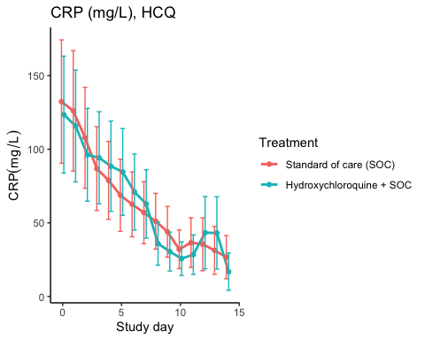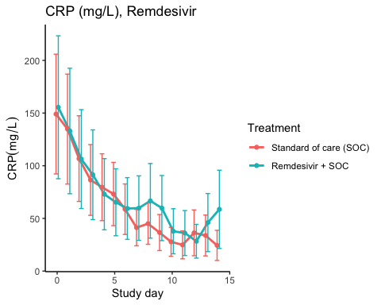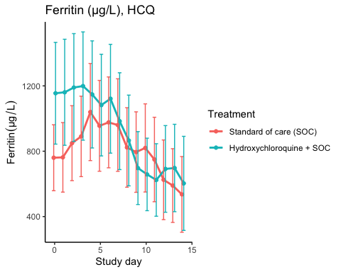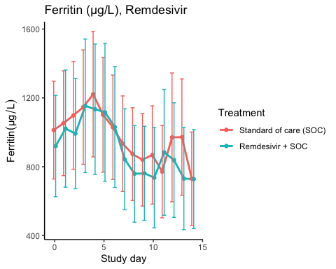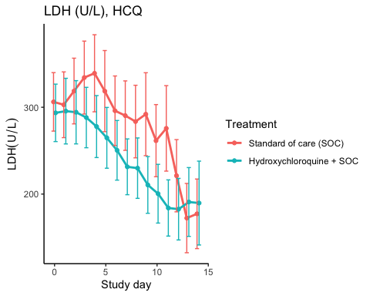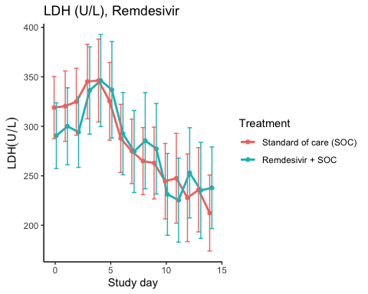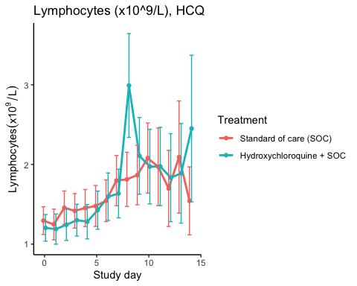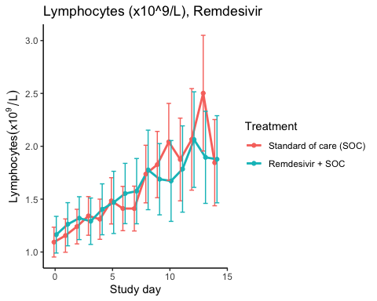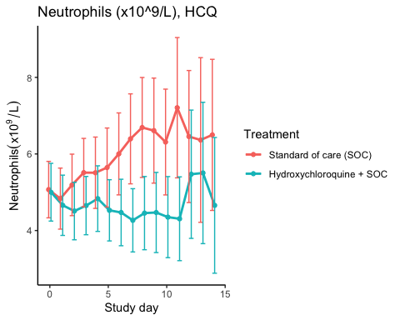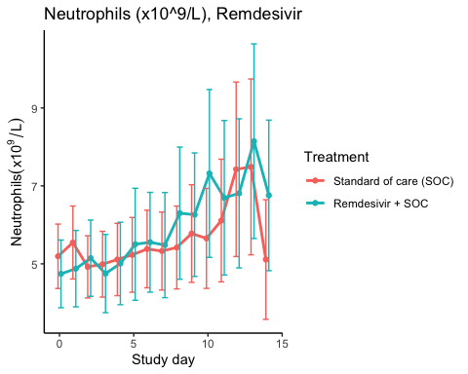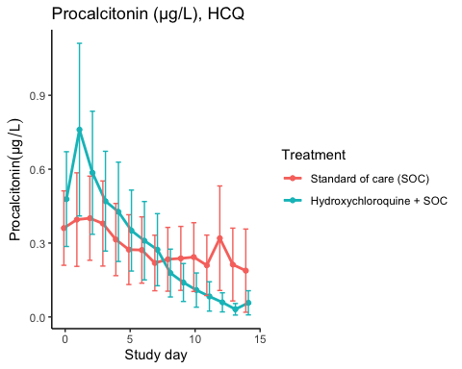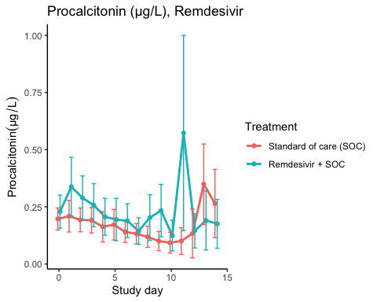

Efficacy estimates
CRP (mg/L), HCQ
Treatment | Days since randomisation | Treatment difference | Lower 95% CL | Upper 95% CL | P-value
Slope 1st week by treatment | Standard of care (SOC) | -11.107 | -15.360 | -6.854 | 0.000
Slope 1st week by treatment | Hydroxychloroquine + SOC | -9.533 | -13.561 | -5.505 | 0.000
Difference in 1st week slope | Hydroxychloroquine + SOC | 1.574 | -3.910 | 7.058 | 0.574
Day 14 level by treatment | Standard of care (SOC) | 26.257 | 15.549 | 36.965 | 0.000
Day 14 level by treatment | Hydroxychloroquine + SOC | 23.061 | 13.130 | 32.993 | 0.000
Day 14 treatment difference | Hydroxychloroquine + SOC | -3.196 | -17.443 | 11.051 | 0.660

CRP (mg/L), Remdesivir
Treatment | Days since randomisation | Treatment difference | Lower 95% CL | Upper 95% CL | P-value
Slope 1st week by treatment | Standard of care (SOC) | -14.453 | -20.386 | -8.521 | 0.000
Slope 1st week by treatment | Remdesivir + SOC | -12.975 | -19.476 | -6.474 | 0.000
Difference in 1st week slope | Remdesivir + SOC | 1.478 | -6.383 | 9.339 | 0.712
Day 14 level by treatment | Standard of care (SOC) | 25.036 | 13.566 | 36.506 | 0.000
Day 14 level by treatment | Remdesivir + SOC | 40.917 | 20.790 | 61.044 | 0.000
Day 14 treatment difference | Remdesivir + SOC | 15.881 | -6.030 | 37.791 | 0.155

Ferritin (µg/L), HCQ
Treatment | Days since randomisation | Treatment difference | Lower 95% CL | Upper 95% CL | P-value
Slope 1st week by treatment | Standard of care (SOC) | 31.237 | 12.183 | 50.291 | 0.001
Slope 1st week by treatment | Hydroxychloroquine + SOC | -27.657 | -50.080 | -5.234 | 0.016
Difference in 1st week slope | Hydroxychloroquine + SOC | -58.894 | -88.572 | -29.216 | 0.000
Day 14 level by treatment | Standard of care (SOC) | 536.146 | 366.754 | 705.537 | 0.000
Day 14 level by treatment | Hydroxychloroquine + SOC | 529.305 | 358.869 | 699.741 | 0.000
Day 14 treatment difference | Hydroxychloroquine + SOC | -6.840 | -235.304 | 221.623 | 0.953

Ferritin (µg/L), Remdesivir
Treatment | Days since randomisation | Treatment difference | Lower 95% CL | Upper 95% CL | P-value
Slope 1st week by treatment | Standard of care (SOC) | -10.588 | -28.423 | 7.246 | 0.245
Slope 1st week by treatment | Remdesivir + SOC | -5.852 | -27.052 | 15.348 | 0.588
Difference in 1st week slope | Remdesivir + SOC | 4.737 | -22.849 | 32.322 | 0.736
Day 14 level by treatment | Standard of care (SOC) | 791.678 | 542.269 | 1041.088 | 0.000
Day 14 level by treatment | Remdesivir + SOC | 695.226 | 448.308 | 942.144 | 0.000
Day 14 treatment difference | Remdesivir + SOC | -96.453 | -423.041 | 230.136 | 0.563

LDH (U/L), HCQ
Treatment | Days since randomisation | Treatment difference | Lower 95% CL | Upper 95% CL | P-value
Slope 1st week by treatment | Standard of care (SOC) | 0.090 | -3.684 | 3.865 | 0.963
Slope 1st week by treatment | Hydroxychloroquine + SOC | -8.545 | -11.845 | -5.245 | 0.000
Difference in 1st week slope | Hydroxychloroquine + SOC | -8.635 | -13.634 | -3.636 | 0.001
Day 14 level by treatment | Standard of care (SOC) | 192.576 | 162.498 | 222.654 | 0.000
Day 14 level by treatment | Hydroxychloroquine + SOC | 168.770 | 142.349 | 195.192 | 0.000
Day 14 treatment difference | Hydroxychloroquine + SOC | -23.805 | -63.753 | 16.142 | 0.243

LDH (U/L), Remdesivir
Treatment | Days since randomisation | Treatment difference | Lower 95% CL | Upper 95% CL | P-value
Slope 1st week by treatment | Standard of care (SOC) | -5.421 | -8.731 | -2.111 | 0.001
Slope 1st week by treatment | Remdesivir + SOC | 0.497 | -3.637 | 4.630 | 0.814
Difference in 1st week slope | Remdesivir + SOC | 5.918 | 0.640 | 11.195 | 0.028
Day 14 level by treatment | Standard of care (SOC) | 213.314 | 183.809 | 242.819 | 0.000
Day 14 level by treatment | Remdesivir + SOC | 222.554 | 189.900 | 255.208 | 0.000
Day 14 treatment difference | Remdesivir + SOC | 9.240 | -34.586 | 53.067 | 0.679

Lymphocytes (x10^9/L), HCQ
Treatment | Days since randomisation | Treatment difference | Lower 95% CL | Upper 95% CL | P-value
Slope 1st week by treatment | Standard of care (SOC) | 0.069 | 0.041 | 0.097 | 0.000
Slope 1st week by treatment | Hydroxychloroquine + SOC | 0.094 | 0.063 | 0.126 | 0.000
Difference in 1st week slope | Hydroxychloroquine + SOC | 0.025 | -0.017 | 0.067 | 0.237
Day 14 level by treatment | Standard of care (SOC) | 1.914 | 1.515 | 2.313 | 0.000
Day 14 level by treatment | Hydroxychloroquine + SOC | 2.264 | 1.734 | 2.794 | 0.000
Day 14 treatment difference | Hydroxychloroquine + SOC | 0.350 | -0.307 | 1.008 | 0.296

Lymphocytes (x10^9/L), Remdesivir
Treatment | Days since randomisation | Treatment difference | Lower 95% CL | Upper 95% CL | P-value
Slope 1st week by treatment | Standard of care (SOC) | 0.068 | 0.048 | 0.088 | 0.000
Slope 1st week by treatment | Remdesivir + SOC | 0.065 | 0.038 | 0.092 | 0.000
Difference in 1st week slope | Remdesivir + SOC | -0.003 | -0.036 | 0.031 | 0.874
Day 14 level by treatment | Standard of care (SOC) | 2.338 | 1.942 | 2.733 | 0.000
Day 14 level by treatment | Remdesivir + SOC | 1.974 | 1.620 | 2.327 | 0.000
Day 14 treatment difference | Remdesivir + SOC | -0.364 | -0.887 | 0.159 | 0.173

Neutrophils (x10^9/L), HCQ
Treatment | Days since randomisation | Treatment difference | Lower 95% CL | Upper 95% CL | P-value
Slope 1st week by treatment | Standard of care (SOC) | 0.204 | 0.103 | 0.305 | 0.000
Slope 1st week by treatment | Hydroxychloroquine + SOC | -0.079 | -0.162 | 0.005 | 0.065
Difference in 1st week slope | Hydroxychloroquine + SOC | -0.283 | -0.414 | -0.152 | 0.000
Day 14 level by treatment | Standard of care (SOC) | 6.777 | 5.364 | 8.191 | 0.000
Day 14 level by treatment | Hydroxychloroquine + SOC | 5.036 | 3.883 | 6.189 | 0.000
Day 14 treatment difference | Hydroxychloroquine + SOC | -1.742 | -3.559 | 0.076 | 0.060

Neutrophils (x10^9/L), Remdesivir
Treatment | Days since randomisation | Treatment difference | Lower 95% CL | Upper 95% CL | P-value
Slope 1st week by treatment | Standard of care (SOC) | 0.010 | -0.079 | 0.099 | 0.822
Slope 1st week by treatment | Remdesivir + SOC | 0.151 | 0.026 | 0.275 | 0.018
Difference in 1st week slope | Remdesivir + SOC | 0.141 | -0.012 | 0.293 | 0.071
Day 14 level by treatment | Standard of care (SOC) | 6.622 | 5.171 | 8.073 | 0.000
Day 14 level by treatment | Remdesivir + SOC | 7.632 | 5.887 | 9.376 | 0.000
Day 14 treatment difference | Remdesivir + SOC | 1.010 | -1.240 | 3.259 | 0.379

Procalcitonin (µg/L), HCQ
Treatment | Days since randomisation | Treatment difference | Lower 95% CL | Upper 95% CL | P-value
Slope 1st week by treatment | Standard of care (SOC) | -0.023 | -0.040 | -0.005 | 0.013
Slope 1st week by treatment | Hydroxychloroquine + SOC | -0.044 | -0.070 | -0.018 | 0.001
Difference in 1st week slope | Hydroxychloroquine + SOC | -0.021 | -0.051 | 0.009 | 0.164
Day 14 level by treatment | Standard of care (SOC) | 0.237 | 0.101 | 0.373 | 0.001
Day 14 level by treatment | Hydroxychloroquine + SOC | 0.032 | 0.014 | 0.050 | 0.000
Day 14 treatment difference | Hydroxychloroquine + SOC | -0.205 | -0.341 | -0.069 | 0.003

Procalcitonin (µg/L), Remdesivir
Treatment | Days since randomisation | Treatment difference | Lower 95% CL | Upper 95% CL | P-value
Slope 1st week by treatment | Standard of care (SOC) | -0.015 | -0.022 | -0.007 | 0.000
Slope 1st week by treatment | Remdesivir + SOC | -0.016 | -0.029 | -0.003 | 0.015
Difference in 1st week slope | Remdesivir + SOC | -0.001 | -0.016 | 0.013 | 0.857
Day 14 level by treatment | Standard of care (SOC) | 0.237 | 0.139 | 0.335 | 0.000
Day 14 level by treatment | Remdesivir + SOC | 0.219 | 0.124 | 0.313 | 0.000
Day 14 treatment difference | Remdesivir + SOC | -0.018 | -0.154 | 0.117 | 0.792

Adverse Events

AE Summary
Summary of Adverse Events
Parameter | SOC (N=87) | SOC + HCQ (N=52) | SOC + Remdesivir (N=42)
Number of AEs | [47] 30 (34.5%) | [26] 16 (30.8%) | [20] 12 (28.6%)
Number of patients with any AEs? | 30 (34.5%) | 16 (30.8%) | 12 (28.6%)
Number of patients with one AE | 22 (25.3%) | 11 (21.2%) | 7 (16.7%)
Number of patients with two AE | 2 (2.3%) | 2 (3.8%) | 2 (4.8%)
Number of patients with three or more AEs | 6 (6.9%) | 3 (5.8%) | 3 (7.1%)
Number of SAEs | [21] 16 (18.4%) | [12] 9 (17.3%) | [12] 6 (14.3%)
Number of patients with any SAEs? | 16 (18.4%) | 9 (17.3%) | 6 (14.3%)
The numbers are [Number of events] Number of patients (percentage of patients), or Number of patients (percentage of patients)

By System Organ Class and Preferred Term
Adverse Events by System Organ Class and Preferred term
System Organ Class | Preferred Term | SOC (N=87) | SOC + HCQ (N=52) | SOC + Remdesivir (N=42)
Blood and lymphatic system disorders | #Total |  | [2] 1 (1.9%)
 | Leukopenia |  | [1] 1 (1.9%)
 | Thrombocytopenia |  | [1] 1 (1.9%)
Cardiac disorders | #Total | [3] 2 (2.3%) | [1] 1 (1.9%)
 | Arrhythmia | [2] 1 (1.1%)
 | Ventricular tachycardia | [1] 1 (1.1%) | [1] 1 (1.9%)
Gastrointestinal disorders | #Total | [4] 4 (4.6%) |  | [6] 5 (11.9%)
 | Abdominal pain |  |  | [1] 1 (2.4%)
 | Diarrhoea |  |  | [1] 1 (2.4%)
 | Diarrhoea haemorrhagic | [1] 1 (1.1%)
 | Gastrooesophageal reflux disease |  |  | [1] 1 (2.4%)
 | Intestinal pseudo-obstruction | [1] 1 (1.1%)
 | Nausea | [1] 1 (1.1%) |  | [1] 1 (2.4%)
 | Pancreatic failure | [1] 1 (1.1%)
 | Vomiting |  |  | [2] 2 (4.8%)
General disorders and administration site conditions | #Total | [1] 1 (1.1%) | [3] 3 (5.8%) | [1] 1 (2.4%)
 | Chest pain |  | [1] 1 (1.9%)
 | General physical health deterioration |  | [1] 1 (1.9%)
 | Medical device site reaction |  | [1] 1 (1.9%)
 | Pyrexia | [1] 1 (1.1%) |  | [1] 1 (2.4%)
Hepatobiliary disorders | #Total |  | [1] 1 (1.9%)
 | Cholecystitis |  | [1] 1 (1.9%)
Infections and infestations | #Total | [2] 2 (2.3%) | [2] 2 (3.8%) | [1] 1 (2.4%)
 | COVID-19 | [1] 1 (1.1%)
 | Infection | [1] 1 (1.1%)
 | Pneumonia bacterial |  | [1] 1 (1.9%) | [1] 1 (2.4%)
 | Superinfection bacterial |  | [1] 1 (1.9%)
Injury, poisoning and procedural complications | #Total | [1] 1 (1.1%) |  | [1] 1 (2.4%)
 | Hepatobiliary procedural complication |  |  | [1] 1 (2.4%)
 | Procedural pneumothorax | [1] 1 (1.1%)
Investigations | #Total | [9] 6 (6.9%) | [9] 6 (11.5%) | [1] 1 (2.4%)
 | Alanine aminotransferase increased | [3] 2 (2.3%) | [1] 1 (1.9%)
 | Amylase increased |  | [1] 1 (1.9%)
 | Aspartate aminotransferase increased | [3] 3 (3.4%) | [2] 2 (3.8%)
 | Blood creatine phosphokinase increased | [1] 1 (1.1%)
 | Electrocardiogram QT prolonged |  | [2] 2 (3.8%)
 | Fibrin D dimer increased | [1] 1 (1.1%)
 | Gamma-glutamyltransferase increased |  | [1] 1 (1.9%)
 | Hepatic enzyme increased | [1] 1 (1.1%) |  | [1] 1 (2.4%)
 | Myocardial necrosis marker increased |  | [1] 1 (1.9%)
 | Neutrophil count decreased |  | [1] 1 (1.9%)
Metabolism and nutrition disorders | #Total |  | [1] 1 (1.9%)
 | Hypercalcaemia |  | [1] 1 (1.9%)
Musculoskeletal and connective tissue disorders | #Total | [4] 2 (2.3%)
 | Arthralgia | [1] 1 (1.1%)
 | Arthritis reactive | [1] 1 (1.1%)
 | Joint swelling | [1] 1 (1.1%)
 | Tendonitis | [1] 1 (1.1%)
Neoplasms benign, malignant and unspecified (incl cysts and polyps) | #Total |  |  | [1] 1 (2.4%)
 | Neoplasm malignant |  |  | [1] 1 (2.4%)
Nervous system disorders | #Total | [4] 4 (4.6%) |  | [1] 1 (2.4%)
 | Haemorrhage intracranial | [1] 1 (1.1%)
 | Headache | [1] 1 (1.1%)
 | Loss of consciousness | [1] 1 (1.1%)
 | Syncope | [1] 1 (1.1%) |  | [1] 1 (2.4%)
Renal and urinary disorders | #Total |  | [2] 2 (3.8%)
 | Renal failure |  | [2] 2 (3.8%)
Respiratory, thoracic and mediastinal disorders | #Total | [14] 12 (13.8%) | [5] 4 (7.7%) | [8] 5 (11.9%)
 | Bronchopleural fistula |  | [1] 1 (1.9%)
 | Chronic obstructive pulmonary disease | [2] 1 (1.1%)
 | Cough |  |  | [1] 1 (2.4%)
 | Dyspnoea |  | [1] 1 (1.9%) | [3] 1 (2.4%)
 | Pulmonary embolism | [1] 1 (1.1%)
 | Respiratory distress | [4] 4 (4.6%) | [2] 1 (1.9%) | [2] 2 (4.8%)
 | Respiratory failure | [7] 7 (8%) | [1] 1 (1.9%) | [2] 1 (2.4%)
Skin and subcutaneous tissue disorders | #Total | [2] 2 (2.3%)
 | Alopecia | [2] 2 (2.3%)
Vascular disorders | #Total | [3] 3 (3.4%)
 | Hypotension | [1] 1 (1.1%)
 | Thrombophlebitis | [1] 1 (1.1%)
 | Thrombosis | [1] 1 (1.1%)

Serious Adverse Events
Serious Adverse Events by System Organ Class and Preferred term
System Organ Class | Preferred Term | SOC (N=87) | SOC + HCQ (N=52) | SOC + Remdesivir (N=42)
Gastrointestinal disorders | #Total | [1] 1 (1.1%) |  | [1] 1 (2.4%)
 | Abdominal pain |  |  | [1] 1 (2.4%)
 | Diarrhoea haemorrhagic | [1] 1 (1.1%)
General disorders and administration site conditions | #Total |  | [2] 2 (3.8%) | [1] 1 (2.4%)
 | Chest pain |  | [1] 1 (1.9%)
 | General physical health deterioration |  | [1] 1 (1.9%)
 | Pyrexia |  |  | [1] 1 (2.4%)
Hepatobiliary disorders | #Total |  | [1] 1 (1.9%)
 | Cholecystitis |  | [1] 1 (1.9%)
Infections and infestations | #Total | [1] 1 (1.1%) | [1] 1 (1.9%) | [1] 1 (2.4%)
 | COVID-19 | [1] 1 (1.1%)
 | Pneumonia bacterial |  |  | [1] 1 (2.4%)
 | Superinfection bacterial |  | [1] 1 (1.9%)
Injury, poisoning and procedural complications | #Total | [1] 1 (1.1%) |  | [1] 1 (2.4%)
 | Hepatobiliary procedural complication |  |  | [1] 1 (2.4%)
 | Procedural pneumothorax | [1] 1 (1.1%)
Investigations | #Total | [3] 3 (3.4%) | [1] 1 (1.9%) | [1] 1 (2.4%)
 | Alanine aminotransferase increased | [1] 1 (1.1%)
 | Aspartate aminotransferase increased |  | [1] 1 (1.9%)
 | Blood creatine phosphokinase increased | [1] 1 (1.1%)
 | Hepatic enzyme increased | [1] 1 (1.1%) |  | [1] 1 (2.4%)
Neoplasms benign, malignant and unspecified (incl cysts and polyps) | #Total |  |  | [1] 1 (2.4%)
 | Neoplasm malignant |  |  | [1] 1 (2.4%)
Nervous system disorders | #Total | [2] 2 (2.3%)
 | Haemorrhage intracranial | [1] 1 (1.1%)
 | Loss of consciousness | [1] 1 (1.1%)
Renal and urinary disorders | #Total |  | [2] 2 (3.8%)
 | Renal failure |  | [2] 2 (3.8%)
Respiratory, thoracic and mediastinal disorders | #Total | [13] 11 (12.6%) | [5] 4 (7.7%) | [6] 3 (7.1%)
 | Bronchopleural fistula |  | [1] 1 (1.9%)
 | Chronic obstructive pulmonary disease | [2] 1 (1.1%)
 | Dyspnoea |  | [1] 1 (1.9%) | [3] 1 (2.4%)
 | Pulmonary embolism | [1] 1 (1.1%)
 | Respiratory distress | [4] 4 (4.6%) | [2] 1 (1.9%) | [1] 1 (2.4%)
 | Respiratory failure | [6] 6 (6.9%) | [1] 1 (1.9%) | [2] 1 (2.4%)

Suspected Unexpected Serious Adverse Reaction
Suspected Unexpected Serious Adverse Reaction by System Organ Class and Preferred term
System Organ Class | Preferred Term | Standard of care (SOC)
Gastrointestinal disorders | #Total | [1] 1 (1.1%)
 | Diarrhoea haemorrhagic | [1] 1 (1.1%)

