NOR-SOLIDARITY First Interim Report
Inge Christoffer Olsen, PhD
12 November, 2020

Introduction
This is the report for the first interim analysis of the NOR-SOLIDARITY trial. The data are based on an export from the Viedoc electronic data capture at “2020-10-16 08:41:09” system time stamped “ous_20201016_084109”. There were 186 included patients.

Inclusion status

Inclusion rate
## Warning: Removed 1 row(s) containing missing values (geom_path).
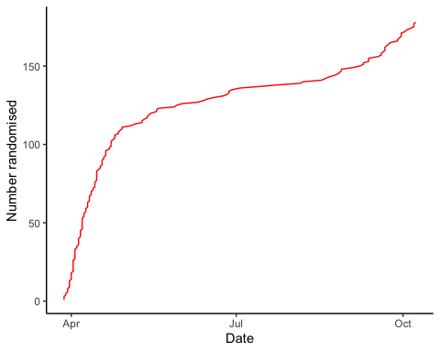

Inclusion by hospital
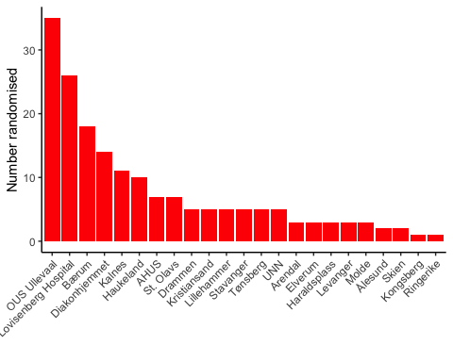

By treatment
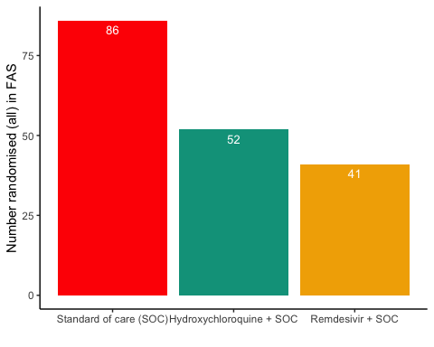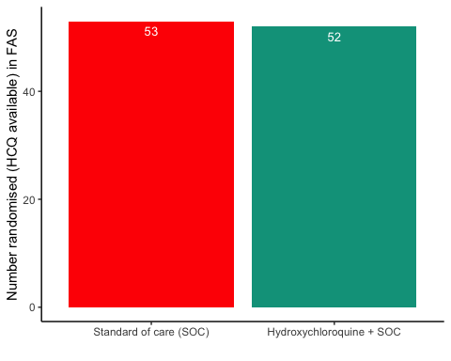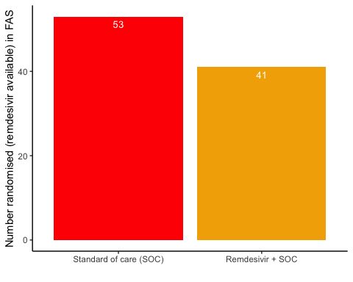

#Patient flow
## Note: Using an external vector in selections is ambiguous.
## ℹ Use `all_of(group)` instead of `group` to silence this message.
## ℹ See <https://tidyselect.r-lib.org/reference/faq-external-vector.html>.
## This message is displayed once per session.
Patient flow total
Parameter | Total
Enrolled | 186 (100%)
Randomised | 185 (99.5%)
Included in FAS | 179 (96.2%)
Excluded from FAS, No post-randomisation information | 6 (3.2%)
Excluded from FAS, incorrect inclusion | 1 (0.5%)

Patient flow by arm
Parameter | SOC | SOC + HCQ | SOC + Remdesivir
Randomised | 88 (100%) | 54 (100%) | 43 (100%)
Included in FAS | 86 (97.7%) | 52 (96.3%) | 41 (95.3%)
Excluded from FAS, No post-randomisation information | 2 (2.3%) | 1 (1.9%) | 2 (4.7%)
Excluded from FAS, incorrect inclusion | 0 (0%) | 1 (1.9%) | 0 (0%)

Demographics
Demographics, all arms (FAS)
Parameter | SOC (N=86) | SOC + HCQ (N=52) | SOC + Remdesivir (N=41)
Age (years) | 59.3 (15.9) | 57.5 (13.2) | 61.7 (16.7)
Female, n (%) | 29 (33.7%) | 13 (25%) | 16 (39%)
Admitted to ward, n(%) | 81 (94.2%) | 49 (94.2%) | 39 (95.1%)
Admitted to ICU, n(%) | 4 (4.7%) | 3 (5.8%) | 2 (4.9%)
Body Mass Index (kg/m²) mean | 31 (30) | 28 (5) | 28 (5)
Body Mass Index (kg/m²) median | 28 (25 - 30) | 28 (25 - 31) | 27 (25 - 31)
Obese (BMI > 30 kg/m²), n(%) | 19 (22.1%) | 14 (26.9%) | 11 (26.8%)
Systolic Blood Pressure (mmHg) | 126 (16) | 126 (18) | 120 (19)
Diastolic Blood Pressure (mmHg) | 73 (10) | 75 (11) | 72 (13)
Mean Arterial Blood Pressure (mmHg) | 90 (11) | 92 (13) | 88 (13)
Temperature (°C) | 37.5 (1) | 37.2 (0.9) | 37.4 (0.8)
SOFA score | 1.4 (1.5) | 1.9 (2) | 1.6 (1.3)
Comorbidities
Chronic cardiac disease, including congenital heart disease | 13 (15.1%) | 7 (13.5%) | 7 (17.1%)
Hypertension, n(%) | 26 (30.2%) | 17 (32.7%) | 13 (31.7%)
Chronic pulmonary disease, n(%) | 3 (3.5%) | 2 (3.8%) | 1 (2.4%)
Chronic kidney disease, n(%) | 7 (8.1%) | 2 (3.8%) | 2 (4.9%)
Autoimmune disease, n(%) | 3 (3.5%) | 1 (1.9%) | 4 (9.8%)
Diabetes, n(%) | 13 (15.1%) | 13 (25%) | 7 (17.1%)
Cognitive impairment/dementia, n(%) | 3 (3.5%) | 0 (0%) | 1 (2.4%)
Neurological disorder, n(%) | 3 (3.5%) | 0 (0%) | 3 (7.3%)
Cancer, n(%) | 6 (7%) | 4 (7.7%) | 3 (7.3%)
Cirrhosis, n(%) | 0 (0%) | 0 (0%) | 0 (0%)
Asthma, n(%) | 11 (12.8%) | 7 (13.5%) | 4 (9.8%)
HIV, n(%) | 0 (0%) | 0 (0%) | 0 (0%)
Active TB, n(%) | 0 (0%) | 0 (0%) | 0 (0%)
Median Laboratory values (IQR)
Ferritin result | 710 (329.5 - 1194) | 608 (311 - 1266) | 442 (261.5 - 810)
D-dimer result | 0.8 (0.5 - 1.1) | 0.6 (0.4 - 1.3) | 0.7 (0.4 - 1)
AST result | 43.5 (28.8 - 59.2) | 44 (28 - 65) | 33.5 (24 - 49.8)
ALT result | 31 (19 - 55) | 45 (26 - 71) | 26.5 (19.8 - 41.2)
LD result | 279 (231 - 382.5) | 281 (220.5 - 365) | 247.5 (190 - 340.2)
CRP result | 76 (35.5 - 141.5) | 87 (48 - 150.5) | 52 (26 - 111)
Hemoglobin result | 13.3 (12.3 - 14.1) | 13.2 (12.4 - 14.1) | 13.1 (12.5 - 13.9)
Platelet counts result | 196 (158.5 - 271.8) | 219 (171.5 - 285.5) | 182 (151.8 - 211)
Neutrophils result | 4.8 (2.8 - 6.7) | 5 (3.3 - 7.4) | 3.6 (3 - 5.3)
Lymphocytes result | 1.1 (0.9 - 1.4) | 1.1 (0.8 - 1.3) | 1 (0.7 - 1.4)
WBC result | 6.4 (4.4 - 8.8) | 6.6 (5.2 - 9.3) | 5.4 (4.4 - 6.7)

Demographics, HCQ (FAS)
Parameter | SOC (N=53) | SOC + HCQ (N=52)
Age (years) | 59.4 (16.5) | 57.5 (13.2)
Female, n (%) | 15 (28.3%) | 13 (25%)
Admitted to ward, n(%) | 49 (92.5%) | 49 (94.2%)
Admitted to ICU, n(%) | 3 (5.7%) | 3 (5.8%)
Body Mass Index (kg/m²) mean | 33 (37) | 28 (5)
Body Mass Index (kg/m²) median | 28 (24 - 29) | 28 (25 - 31)
Obese (BMI > 30 kg/m²), n(%) | 12 (22.6%) | 14 (26.9%)
Systolic Blood Pressure (mmHg) | 126 (18) | 126 (18)
Diastolic Blood Pressure (mmHg) | 73 (10) | 75 (11)
Mean Arterial Blood Pressure (mmHg) | 90 (11) | 92 (13)
Temperature (°C) | 37.6 (1.1) | 37.2 (0.9)
SOFA score | 1.4 (1.3) | 1.9 (2)
Comorbidities
Chronic cardiac disease, including congenital heart disease | 8 (15.1%) | 7 (13.5%)
Hypertension, n(%) | 13 (24.5%) | 17 (32.7%)
Chronic pulmonary disease, n(%) | 2 (3.8%) | 2 (3.8%)
Chronic kidney disease, n(%) | 2 (3.8%) | 2 (3.8%)
Autoimmune disease, n(%) | 1 (1.9%) | 1 (1.9%)
Diabetes, n(%) | 5 (9.4%) | 13 (25%)
Cognitive impairment/dementia, n(%) | 2 (3.8%) | 0 (0%)
Neurological disorder, n(%) | 3 (5.7%) | 0 (0%)
Cancer, n(%) | 5 (9.4%) | 4 (7.7%)
Cirrhosis, n(%) | 0 (0%) | 0 (0%)
Asthma, n(%) | 7 (13.2%) | 7 (13.5%)
HIV, n(%) | 0 (0%) | 0 (0%)
Active TB, n(%) | 0 (0%) | 0 (0%)
Median Laboratory values (IQR)
Ferritin result | 945.5 (328.8 - 1222.5) | 608 (311 - 1266)
D-dimer result | 0.8 (0.5 - 1.1) | 0.6 (0.4 - 1.3)
AST result | 46 (31 - 67) | 44 (28 - 65)
ALT result | 37 (20 - 64.8) | 45 (26 - 71)
LD result | 282 (232.5 - 402) | 281 (220.5 - 365)
CRP result | 82 (38.8 - 142.2) | 87 (48 - 150.5)
Hemoglobin result | 13.3 (12.3 - 14.1) | 13.2 (12.4 - 14.1)
Platelet counts result | 199 (153.5 - 267.5) | 219 (171.5 - 285.5)
Neutrophils result | 4.8 (2.8 - 6.4) | 5 (3.3 - 7.4)
Lymphocytes result | 1 (0.9 - 1.3) | 1.1 (0.8 - 1.3)
WBC result | 6.3 (4.4 - 8.8) | 6.6 (5.2 - 9.3)

Demographics, Remdesivir (FAS)
Parameter | SOC (N=53) | SOC + Remdesivir (N=41)
Age (years) | 62.4 (14.6) | 61.7 (16.7)
Female, n (%) | 17 (32.1%) | 16 (39%)
Admitted to ward, n(%) | 49 (92.5%) | 39 (95.1%)
Admitted to ICU, n(%) | 3 (5.7%) | 2 (4.9%)
Body Mass Index (kg/m²) mean | 28 (5) | 28 (5)
Body Mass Index (kg/m²) median | 28 (25 - 32) | 27 (25 - 31)
Obese (BMI > 30 kg/m²), n(%) | 13 (24.5%) | 11 (26.8%)
Systolic Blood Pressure (mmHg) | 128 (16) | 120 (19)
Diastolic Blood Pressure (mmHg) | 72 (10) | 72 (13)
Mean Arterial Blood Pressure (mmHg) | 91 (11) | 88 (13)
Temperature (°C) | 37.3 (0.9) | 37.4 (0.8)
SOFA score | 1.6 (1.5) | 1.6 (1.3)
Comorbidities
Chronic cardiac disease, including congenital heart disease | 6 (11.3%) | 7 (17.1%)
Hypertension, n(%) | 17 (32.1%) | 13 (31.7%)
Chronic pulmonary disease, n(%) | 2 (3.8%) | 1 (2.4%)
Chronic kidney disease, n(%) | 6 (11.3%) | 2 (4.9%)
Autoimmune disease, n(%) | 2 (3.8%) | 4 (9.8%)
Diabetes, n(%) | 9 (17%) | 7 (17.1%)
Cognitive impairment/dementia, n(%) | 2 (3.8%) | 1 (2.4%)
Neurological disorder, n(%) | 2 (3.8%) | 3 (7.3%)
Cancer, n(%) | 4 (7.5%) | 3 (7.3%)
Cirrhosis, n(%) | 0 (0%) | 0 (0%)
Asthma, n(%) | 7 (13.2%) | 4 (9.8%)
HIV, n(%) | 0 (0%) | 0 (0%)
Active TB, n(%) | 0 (0%) | 0 (0%)
Median Laboratory values (IQR)
Ferritin result | 764 (376.8 - 1222.5) | 442 (261.5 - 810)
D-dimer result | 0.8 (0.5 - 1.1) | 0.7 (0.4 - 1)
AST result | 44 (30 - 59.2) | 33.5 (24 - 49.8)
ALT result | 32 (19 - 51) | 26.5 (19.8 - 41.2)
LD result | 282.5 (236.2 - 395) | 247.5 (190 - 340.2)
CRP result | 80 (46.5 - 147.5) | 52 (26 - 111)
Hemoglobin result | 13.3 (12.3 - 14.1) | 13.1 (12.5 - 13.9)
Platelet counts result | 202.5 (160.5 - 299) | 182 (151.8 - 211)
Neutrophils result | 5.2 (3.4 - 7) | 3.6 (3 - 5.3)
Lymphocytes result | 1.1 (0.9 - 1.4) | 1 (0.7 - 1.4)
WBC result | 7 (5 - 8.9) | 5.4 (4.4 - 6.7)

Missing values, all arms (FAS)
Parameter | SOC (N=86) | SOC + HCQ (N=52) | SOC + Remdesivir (N=41)
Age (years) | 0 (0%) | 0 (0%) | 0 (0%)
Female, n (%) | 0 (0%) | 0 (0%) | 0 (0%)
Admitted to ward, n(%) | 1 (1.2%) | 0 (0%) | 0 (0%)
Admitted to ICU, n(%) | 1 (1.2%) | 0 (0%) | 0 (0%)
Body Mass Index (kg/m²) mean | 11 (12.8%) | 6 (11.5%) | 4 (9.8%)
Body Mass Index (kg/m²) median | 11 (12.8%) | 6 (11.5%) | 4 (9.8%)
Obese (BMI > 30 kg/m²), n(%) | 11 (12.8%) | 6 (11.5%) | 4 (9.8%)
Systolic Blood Pressure (mmHg) | 2 (2.3%) | 1 (1.9%) | 0 (0%)
Diastolic Blood Pressure (mmHg) | 2 (2.3%) | 1 (1.9%) | 0 (0%)
Mean Arterial Blood Pressure (mmHg) | 2 (2.3%) | 1 (1.9%) | 0 (0%)
Temperature (°C) | 2 (2.3%) | 1 (1.9%) | 0 (0%)
SOFA score | 6 (7%) | 6 (11.5%) | 3 (7.3%)
Comorbidities
Chronic cardiac disease, including congenital heart disease | 3 (3.5%) | 1 (1.9%) | 0 (0%)
Hypertension, n(%) | 3 (3.5%) | 1 (1.9%) | 0 (0%)
Chronic pulmonary disease, n(%) | 3 (3.5%) | 1 (1.9%) | 0 (0%)
Chronic kidney disease, n(%) | 3 (3.5%) | 1 (1.9%) | 0 (0%)
Autoimmune disease, n(%) | 3 (3.5%) | 1 (1.9%) | 0 (0%)
Diabetes, n(%) | 3 (3.5%) | 1 (1.9%) | 0 (0%)
Cognitive impairment/dementia, n(%) | 3 (3.5%) | 1 (1.9%) | 0 (0%)
Neurological disorder, n(%) | 3 (3.5%) | 1 (1.9%) | 0 (0%)
Cancer, n(%) | 3 (3.5%) | 1 (1.9%) | 0 (0%)
Cirrhosis, n(%) | 3 (3.5%) | 1 (1.9%) | 0 (0%)
Asthma, n(%) | 3 (3.5%) | 1 (1.9%) | 0 (0%)
HIV, n(%) | 3 (3.5%) | 1 (1.9%) | 0 (0%)
Active TB, n(%) | 3 (3.5%) | 1 (1.9%) | 0 (0%)
Median Laboratory values (IQR)
Ferritin result | 7 (8.1%) | 3 (5.8%) | 2 (4.9%)
D-dimer result | 13 (15.1%) | 5 (9.6%) | 4 (9.8%)
AST result | 6 (7%) | 3 (5.8%) | 5 (12.2%)
ALT result | 5 (5.8%) | 1 (1.9%) | 5 (12.2%)
LD result | 7 (8.1%) | 1 (1.9%) | 3 (7.3%)
CRP result | 3 (3.5%) | 1 (1.9%) | 0 (0%)
Hemoglobin result | 5 (5.8%) | 1 (1.9%) | 0 (0%)
Platelet counts result | 4 (4.7%) | 1 (1.9%) | 1 (2.4%)
Neutrophils result | 8 (9.3%) | 1 (1.9%) | 2 (4.9%)
Lymphocytes result | 8 (9.3%) | 1 (1.9%) | 2 (4.9%)
WBC result | 3 (3.5%) | 1 (1.9%) | 0 (0%)

Exposure
Exposure to study treatment
Parameter | SOC + HCQ (N=52) | SOC + Remdesivir (N=41)
Total dose (mg), median (IQR) | 3000 (750 - 6100) | 5200 (1100 - 8400)
Treatment duration, median (IQR) | 4 (3 - 8) | 9 (5 - 9)
Number of doses given, median (IQR) | 5 (4 - 9) | 10 (6 - 10)
Patients with any treatment discrepencies, n (%) | 10 (19.2%) | 8 (19.5%)

Adverse Events

AE Summary
Summary of Adverse Events
Parameter | SOC (N=86) | SOC + HCQ (N=52) | SOC + Remdesivir (N=41)
Number of AEs | [36] 25 (29.1%) | [28] 13 (25%) | [25] 16 (39%)
Number of patients with any AEs? | 25 (29.1%) | 13 (25%) | 16 (39%)
Number of patients with one AE | 18 (20.9%) | 7 (13.5%) | 11 (26.8%)
Number of patients with two AE | 3 (3.5%) | 1 (1.9%) | 2 (4.9%)
Number of patients with three or more AEs | 4 (4.7%) | 5 (9.6%) | 3 (7.3%)
Number of SAEs | [18] 11 (12.8%) | [12] 8 (15.4%) | [12] 9 (22%)
Number of patients with any SAEs? | 11 (12.8%) | 8 (15.4%) | 9 (22%)
The numbers are [Number of events] Number of patients (percentage of patients), or Number of patients (percentage of patients)

By System Organ Class and Preferred Term
Adverse Events by System Organ Class and Preferred term
System Organ Class | Preferred Term | SOC (N=86) | SOC + HCQ (N=52) | SOC + Remdesivir (N=41)
Blood and lymphatic system disorders | #Total |  |  | [2] 1 (2.4%)
 | Leukopenia |  |  | [1] 1 (2.4%)
 | Thrombocytopenia |  |  | [1] 1 (2.4%)
Cardiac disorders | #Total | [1] 1 (1.2%) | [1] 1 (1.9%) | [2] 1 (2.4%)
 | Arrhythmia |  |  | [2] 1 (2.4%)
 | Ventricular tachycardia | [1] 1 (1.2%) | [1] 1 (1.9%)
Gastrointestinal disorders | #Total | [3] 3 (3.5%) | [3] 2 (3.8%) | [3] 3 (7.3%)
 | Abdominal pain | [1] 1 (1.2%)
 | Diarrhoea | [1] 1 (1.2%)
 | Gastrooesophageal reflux disease |  | [1] 1 (1.9%)
 | Intestinal pseudo-obstruction | [1] 1 (1.2%)
 | Nausea |  | [1] 1 (1.9%) | [1] 1 (2.4%)
 | Pancreatic failure |  |  | [1] 1 (2.4%)
 | Vomiting |  | [1] 1 (1.9%) | [1] 1 (2.4%)
General disorders and administration site conditions | #Total | [3] 3 (3.5%) |  | [2] 2 (4.9%)
 | Chest pain | [1] 1 (1.2%)
 | General physical health deterioration |  |  | [1] 1 (2.4%)
 | Medical device site reaction |  |  | [1] 1 (2.4%)
 | Pyrexia | [2] 2 (2.3%)
Infections and infestations | #Total | [3] 3 (3.5%) |  | [1] 1 (2.4%)
 | COVID-19 |  |  | [1] 1 (2.4%)
 | Infection | [1] 1 (1.2%)
 | Pneumonia bacterial | [2] 2 (2.3%)
Investigations | #Total | [9] 6 (7%) | [6] 3 (5.8%) | [4] 4 (9.8%)
 | Alanine aminotransferase increased | [4] 3 (3.5%)
 | Amylase increased |  | [1] 1 (1.9%)
 | Aspartate aminotransferase increased | [2] 2 (2.3%) | [1] 1 (1.9%) | [2] 2 (4.9%)
 | Blood creatine phosphokinase increased |  |  | [1] 1 (2.4%)
 | Electrocardiogram QT prolonged | [1] 1 (1.2%) | [1] 1 (1.9%)
 | Fibrin D dimer increased | [1] 1 (1.2%)
 | Gamma-glutamyltransferase increased |  | [1] 1 (1.9%)
 | Hepatic enzyme increased |  | [1] 1 (1.9%) | [1] 1 (2.4%)
 | Myocardial necrosis marker increased |  | [1] 1 (1.9%)
 | Neutrophil count decreased | [1] 1 (1.2%)
Metabolism and nutrition disorders | #Total |  | [1] 1 (1.9%)
 | Hypercalcaemia |  | [1] 1 (1.9%)
Musculoskeletal and connective tissue disorders | #Total |  | [3] 1 (1.9%) | [1] 1 (2.4%)
 | Arthralgia |  | [1] 1 (1.9%)
 | Arthritis reactive |  | [1] 1 (1.9%)
 | Joint swelling |  | [1] 1 (1.9%)
 | Tendonitis |  |  | [1] 1 (2.4%)
Neoplasms benign, malignant and unspecified (incl cysts and polyps) | #Total | [1] 1 (1.2%)
 | Neoplasm malignant | [1] 1 (1.2%)
Nervous system disorders | #Total | [1] 1 (1.2%) | [2] 2 (3.8%) | [1] 1 (2.4%)
 | Headache |  | [1] 1 (1.9%)
 | Loss of consciousness | [1] 1 (1.2%)
 | Syncope |  | [1] 1 (1.9%) | [1] 1 (2.4%)
Renal and urinary disorders | #Total | [1] 1 (1.2%) | [1] 1 (1.9%)
 | Renal failure | [1] 1 (1.2%) | [1] 1 (1.9%)
Respiratory, thoracic and mediastinal disorders | #Total | [9] 6 (7%) | [7] 6 (11.5%) | [8] 6 (14.6%)
 | Bronchopleural fistula |  |  | [1] 1 (2.4%)
 | Chronic obstructive pulmonary disease |  | [2] 1 (1.9%)
 | Cough |  |  | [1] 1 (2.4%)
 | Dyspnoea | [4] 2 (2.3%)
 | Pulmonary embolism |  |  | [1] 1 (2.4%)
 | Respiratory distress | [3] 2 (2.3%) | [2] 2 (3.8%) | [2] 2 (4.9%)
 | Respiratory failure | [2] 2 (2.3%) | [3] 3 (5.8%) | [3] 2 (4.9%)
Vascular disorders | #Total | [1] 1 (1.2%) | [2] 2 (3.8%)
 | Hypotension |  | [1] 1 (1.9%)
 | Thrombophlebitis |  | [1] 1 (1.9%)
 | Thrombosis | [1] 1 (1.2%)

Serious Adverse Events
Serious Adverse Events by System Organ Class and Preferred term
System Organ Class | Preferred Term | SOC (N=86) | SOC + HCQ (N=52) | SOC + Remdesivir (N=41)
Gastrointestinal disorders | #Total | [1] 1 (1.1%) |  | [1] 1 (2.3%)
 | Abdominal pain | [1] 1 (1.1%)
General disorders and administration site conditions | #Total | [2] 2 (2.3%) |  | [1] 1 (2.3%)
 | Chest pain | [1] 1 (1.1%)
 | General physical health deterioration |  |  | [1] 1 (2.3%)
 | Pyrexia | [1] 1 (1.1%)
Infections and infestations | #Total | [1] 1 (1.1%) |  | [1] 1 (2.3%)
 | COVID-19 |  |  | [1] 1 (2.3%)
 | Pneumonia bacterial | [1] 1 (1.1%)
Investigations | #Total | [1] 1 (1.1%) | [2] 2 (3.7%) | [2] 2 (4.7%)
 | Alanine aminotransferase increased | [1] 1 (1.1%)
 | Aspartate aminotransferase increased |  | [1] 1 (1.9%)
 | Blood creatine phosphokinase increased |  |  | [1] 1 (2.3%)
 | Hepatic enzyme increased |  | [1] 1 (1.9%) | [1] 1 (2.3%)
Neoplasms benign, malignant and unspecified (incl cysts and polyps) | #Total | [1] 1 (1.1%)
 | Neoplasm malignant | [1] 1 (1.1%)
Nervous system disorders | #Total | [1] 1 (1.1%)
 | Loss of consciousness | [1] 1 (1.1%)
Renal and urinary disorders | #Total | [1] 1 (1.1%) | [1] 1 (1.9%)
 | Renal failure | [1] 1 (1.1%) | [1] 1 (1.9%)
Respiratory, thoracic and mediastinal disorders | #Total | [9] 6 (6.8%) | [7] 6 (11.1%) | [7] 5 (11.6%)
 | Bronchopleural fistula |  |  | [1] 1 (2.3%)
 | Chronic obstructive pulmonary disease |  | [2] 1 (1.9%)
 | Dyspnoea | [4] 2 (2.3%)
 | Pulmonary embolism |  |  | [1] 1 (2.3%)
 | Respiratory distress | [3] 2 (2.3%) | [2] 2 (3.7%) | [2] 2 (4.7%)
 | Respiratory failure | [2] 2 (2.3%) | [3] 3 (5.6%) | [3] 2 (4.7%)

Suspected Unexpected Serious Adverse Reaction
Suspected Unexpected Serious Adverse Reaction by System Organ Class and Preferred term
System Organ Class | Preferred Term | Remdesivir + SOC
Gastrointestinal disorders | #Total | [1] 1 (2.3%)

Mortality and other outcomes by admission state
Outcome
outcome | Ward | ICU | NA
Alive and discharged | 151 (86.3%) | 9 (90%) | NA
Withdrawn | 6 (3.4%) | NA | NA
Ongoing | 6 (3.4%) | 1 (10%) | 1 (100%)
Dead | 12 (6.9%) | NA | NA

