NOR-SOLIDARITY First Interim Report
Inge Christoffer Olsen, PhD
04 January, 2021
Table of Contents
2 Introduction 3
3 Inclusion status 4
3.1 Inclusion rate 4
3.2 Inclusion by hospital 5
3.3 By treatment 6
4 Patient flow 10
5 Demographics 11
6 Exposure 25
7 Efficacy 25
7.1 Mortality 25
7.1.1 Descriptives 25
7.1.2 Plots 27
7.1.3 Efficacy estimates 36
7.2 Viral load 38
7.2.1 Plots 38
7.2.2 Marginal probability estimates by treatment group and difference 42
7.3 Viral load subgroup analyses 44
7.3.1 Plots, Hydroxychloroquine 44
7.3.2 Marginal probability estimates by treatment group and difference Hydroxychloroquine 56
7.3.3 Plots Remdesivir 61
7.3.4 Marginal probability estimates by treatment group and difference Remdesivir 73
7.4 Respiratory failure by pO2/FiO2-ratio 78
7.4.1 Plots 78
7.4.2 Marginal probability estimates by treatment group and difference 82
7.5 Dichotomous endpoints 83
7.5.1 Descriptives 83
7.5.2 Marginal probability estimates by treatment group and difference 85
7.6 Inflammatory laboratory parameters 86
7.6.1 Descriptives 86
7.6.2 Plots 110
7.6.3 Efficacy estimates 122
7.7 SARS-CoV2 antibodies at day 90 127
7.7.1 Descriptives 127
7.7.2 Marginal probability estimates by treatment group and difference 128
7.8 Time to last discharge 129
7.8.1 HCQ 129
7.8.2 Remdesivir 132
8 Adverse Events 135
8.1 AE Summary 135
8.2 By System Organ Class and Preferred Term 135
8.3 Serious Adverse Events 140
8.4 Suspected Unexpected Serious Adverse Reaction 142

Introduction
This is the report for the first interim analysis of the NOR-SOLIDARITY trial. The data are based on an export from the Viedoc electronic data capture at “2021-01-04 00:30:34” system time stamped “ous_20210104_003034”. The results in this report is according to the true random allocation. There were 181 included patients.

Inclusion status

Inclusion rate
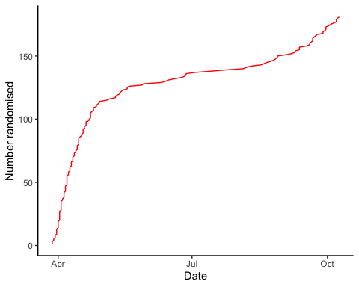

Inclusion by hospital
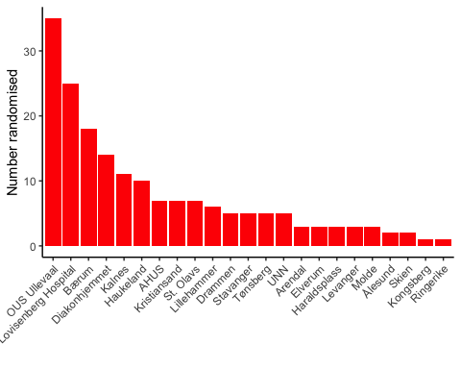

By treatment
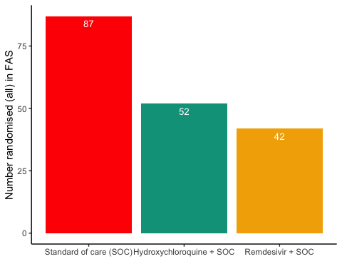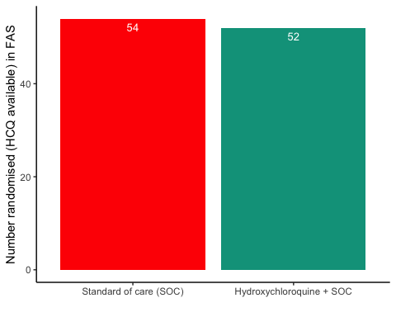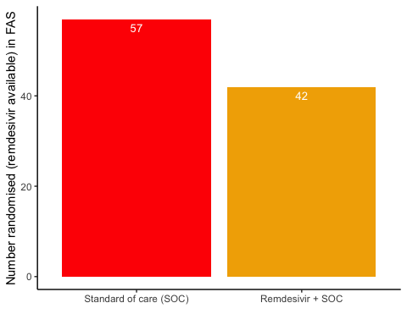

Patient flow
## Note: Using an external vector in selections is ambiguous.
## ℹ Use `all_of(group)` instead of `group` to silence this message.
## ℹ See <https://tidyselect.r-lib.org/reference/faq-external-vector.html>.
## This message is displayed once per session.
Patient flow total
Parameter | Total
Enrolled | 186 (100%)
Randomised | 185 (99.5%)
Included in FAS | 181 (97.3%)
Excluded from FAS, No post-randomisation information | 4 (2.2%)
Excluded from FAS, incorrect inclusion | 1 (0.5%)

Patient flow by arm
Parameter | SOC | SOC + HCQ | SOC + Remdesivir
Randomised | 88 (100%) | 54 (100%) | 43 (100%)
Included in FAS | 87 (98.9%) | 52 (96.3%) | 42 (97.7%)
Excluded from FAS, No post-randomisation information | 1 (1.1%) | 1 (1.9%) | 1 (2.3%)
Excluded from FAS, incorrect inclusion | 0 (0%) | 1 (1.9%) | 0 (0%)

Patient flow during study (FAS)
Reason | Standard of care (SOC) | Hydroxychloroquine + SOC | Remdesivir + SOC | Total
Voluntary discontinuation by the patient | 2 | 5 | 0 | 7
Patient lost to follow-up | 2 | 1 | 3 | 6
Death | 5 | 4 | 3 | 12
Other | 4 | 1 | 2 | 7
Completed | 74 | 41 | 34 | 149

Demographics
Demographics, all patients (FAS)
Parameter | All patients (N=181)
Demographics
Age (years) | 59.8 (15.3)
Female, n (%) | 62 (34.3%)
Body Mass Index (kg/m²) | 28 (5)
Body Mass Index (kg/m²) | 27 (25 - 31)
Symptoms prior to admission (days) | 8 (4.9)
P/F-ratio at admittance (kPa) | 41 (13)
P/F-ratio < 40kPa, n (%) | 77 (43%)
Temperature (°C) | 37.4 (0.9)
Admitted to ward, n(%) | 171 (94.5%)
Admitted to ICU, n(%) | 10 (5.5%)
WHO Moderate disease state (4-5), n(%) | 171 (94.5%)
WHO Severe disease state (6-9), n(%) | 10 (5.5%)
WHO Severe disease state (6), n(%) | 5 (2.8%)
WHO Severe disease state (5), n(%) | 90 (49.7%)
Comorbidities
Chronic cardiac disease, including congenital heart disease | 28 (15.6%)
Chronic pulmonary disease, n(%) | 10 (5.6%)
Ever smoking, n(%) | 71 (39.4%)
Hypertension, n(%) | 55 (30.6%)
Diabetes, n(%) | 31 (17.2%)
Obese (BMI > 30 kg/m²), n(%) | 44 (26.8%)
Co-medications
Steroids | 8 (4.5%)
Other immunomodulatory drugs | 8 (4.5%)
ACE inhibitor | 12 (6.7%)
AT-II blockers | 30 (16.8%)
Hematology
Hemoglobin (g/dL) | 13.2 (12.3 - 14.1)
WBC (x10⁹/L) | 6.2 (4.7 - 8.7)
Neutrophils (x10⁹/L) | 4.3 (3 - 6.6)
Lymphocytes (x10⁹/L) | 1.1 (0.8 - 1.4)
Platelet counts (x10^9/L) | 202.5 (158.5 - 270.5)
Inflammatory markers
CRP (mg/L) | 70 (36.5 - 137.5)
Procalcitonin (µg/L) | 0.12 (0.1 - 0.21)
Ferritin (µg/L) | 613 (319 - 1173)
Other
LDH (U/L) | 277 (214 - 360)
D-dimer (mg/L FEU) | 0.68 (0.45 - 1.12)
AST | 39 (27.2 - 59)
ALT | 33 (20 - 58)
eGFR (mL/min/1.73 m²) | 89.7 (74.2 - 105.5)
Viral count
Viral count (log₁₀ counts/1000 cells) | 2 (1.6)
Anti-SARS-CoV-2 Antibodies
Sero converted (RBD ≥ 5) | 60 (47.2%)
Supplementary baseline information
Systolic Blood Pressure (mmHg) | 125 (18)
Diastolic Blood Pressure (mmHg) | 74 (11)
Mean Arterial Blood Pressure (mmHg) | 91 (12)
SOFA score | 1.6 (1.6)
Chronic kidney disease, n(%) | 11 (6.1%)
Autoimmune disease, n(%) | 8 (4.4%)
Cognitive impairment/dementia, n(%) | 4 (2.2%)
Neurological disorder, n(%) | 7 (3.9%)
Cancer, n(%) | 13 (7.2%)
Cirrhosis, n(%) | 0 (0%)
Asthma, n(%) | 22 (12.2%)
HIV, n(%) | 0 (0%)
Active TB, n(%) | 0 (0%)
Note, all percentages are given with observed values in the denominator, missing values discarded

Demographics, all arms (FAS)
Parameter | SOC (N=87) | SOC + HCQ (N=52) | SOC + Remdesivir (N=42)
Demographics
Age (years) | 59.5 (16.1) | 60.3 (13.3) | 59.7 (16.5)
Female, n (%) | 28 (32.2%) | 21 (40.4%) | 13 (31%)
Body Mass Index (kg/m²) | 28 (4) | 28 (5) | 28 (5)
Body Mass Index (kg/m²) | 28 (25 - 29) | 27 (25 - 32) | 27 (25 - 32)
Symptoms prior to admission (days) | 8 (4.7) | 8.4 (4.3) | 7.5 (6.1)
P/F-ratio at admittance (kPa) | 42 (12) | 41 (15) | 38 (13)
P/F-ratio < 40kPa, n (%) | 31 (35.6%) | 24 (48%) | 22 (52.4%)
Temperature (°C) | 37.4 (0.9) | 37.6 (0.9) | 37.2 (0.9)
Admitted to ward, n(%) | 85 (97.7%) | 47 (90.4%) | 39 (92.9%)
Admitted to ICU, n(%) | 2 (2.3%) | 5 (9.6%) | 3 (7.1%)
WHO Moderate disease state (4-5), n(%) | 85 (97.7%) | 45 (86.5%) | 41 (97.6%)
WHO Severe disease state (6-9), n(%) | 2 (2.3%) | 7 (13.5%) | 1 (2.4%)
WHO Severe disease state (6), n(%) | NA | 5 (9.6%) | NA
WHO Severe disease state (5), n(%) | 41 (47.1%) | 22 (42.3%) | 27 (64.3%)
Comorbidities
Chronic cardiac disease, including congenital heart disease | 16 (18.4%) | 6 (11.5%) | 6 (14.6%)
Chronic pulmonary disease, n(%) | 4 (4.6%) | 2 (3.8%) | 4 (9.8%)
Ever smoking, n(%) | 37 (42.5%) | 18 (34.6%) | 16 (39%)
Hypertension, n(%) | 23 (26.4%) | 17 (32.7%) | 15 (36.6%)
Diabetes, n(%) | 15 (17.2%) | 7 (13.5%) | 9 (22%)
Obese (BMI > 30 kg/m²), n(%) | 17 (22.1%) | 16 (32.7%) | 11 (28.9%)
Co-medications
Steroids | 5 (5.8%) | 2 (3.8%) | 1 (2.4%)
Other immunomodulatory drugs | 5 (5.8%) | 2 (3.8%) | 1 (2.4%)
ACE inhibitor | 9 (10.5%) | 1 (1.9%) | 2 (4.9%)
AT-II blockers | 10 (11.6%) | 9 (17.3%) | 11 (26.8%)
Hematology
Hemoglobin (g/dL) | 13.3 (12.7 - 14.1) | 13 (12 - 14.1) | 13.2 (12.4 - 14.3)
WBC (x10⁹/L) | 6.1 (4.8 - 8.1) | 6.6 (4.4 - 9.2) | 6 (4.9 - 8.7)
Neutrophils (x10⁹/L) | 4.1 (2.9 - 6.4) | 4.9 (3 - 6.8) | 4.3 (2.7 - 6.8)
Lymphocytes (x10⁹/L) | 1.1 (0.8 - 1.4) | 1 (0.7 - 1.3) | 1.1 (0.9 - 1.5)
Platelet counts (x10^9/L) | 205.5 (164 - 271.2) | 184 (151.5 - 270) | 206 (162 - 268)
Inflammatory markers
CRP (mg/L) | 68 (34 - 137.2) | 76 (47 - 133) | 70 (39.8 - 139.2)
Procalcitonin (µg/L) | 0.1 (0.1 - 0.2) | 0.13 (0.1 - 0.26) | 0.13 (0.1 - 0.2)
Ferritin (µg/L) | 551 (320 - 1040) | 626 (295 - 1298) | 694.5 (343.2 - 1262.2)
Other
LDH (U/L) | 251 (205 - 350) | 287 (234.5 - 360.5) | 284 (234 - 400)
D-dimer (mg/L FEU) | 0.62 (0.41 - 0.9) | 0.9 (0.5 - 1.53) | 0.76 (0.47 - 1.03)
AST | 33 (25 - 54) | 39 (28 - 59) | 49 (34.5 - 77)
ALT | 30 (19 - 50.2) | 33 (22 - 53) | 41 (22 - 69.2)
eGFR (mL/min/1.73 m²) | 89.6 (79.3 - 105.3) | 86.3 (67.5 - 101.2) | 90.6 (77.2 - 106.2)
Viral count
Viral count (log₁₀ counts/1000 cells) | 2.1 (1.7) | 2.3 (1.5) | 1.6 (1.6)
Anti-SARS-CoV-2 Antibodies
Sero converted (RBD ≥ 5) | 31 (52.5%) | 15 (42.9%) | 14 (42.4%)
Supplementary baseline information
Systolic Blood Pressure (mmHg) | 122 (16) | 126 (18) | 130 (20)
Diastolic Blood Pressure (mmHg) | 73 (12) | 73 (11) | 76 (11)
Mean Arterial Blood Pressure (mmHg) | 89 (12) | 90 (11) | 94 (12)
SOFA score | 1.5 (1.6) | 1.9 (1.8) | 1.4 (1.3)
Chronic kidney disease, n(%) | 5 (5.7%) | 5 (9.6%) | 1 (2.4%)
Autoimmune disease, n(%) | 7 (8%) | 1 (1.9%) | 0 (0%)
Cognitive impairment/dementia, n(%) | 0 (0%) | 2 (3.8%) | 2 (4.9%)
Neurological disorder, n(%) | 1 (1.1%) | 5 (9.6%) | 1 (2.4%)
Cancer, n(%) | 11 (12.6%) | 0 (0%) | 2 (4.9%)
Cirrhosis, n(%) | 0 (0%) | 0 (0%) | 0 (0%)
Asthma, n(%) | 13 (14.9%) | 7 (13.5%) | 2 (4.9%)
HIV, n(%) | 0 (0%) | 0 (0%) | 0 (0%)
Active TB, n(%) | 0 (0%) | 0 (0%) | 0 (0%)
Note, all percentages are given with observed values in the denominator, missing values discarded

Demographics, HCQ (FAS)
Parameter | SOC (N=54) | SOC + HCQ (N=52)
Demographics
Age (years) | 59.2 (16.4) | 60.3 (13.3)
Female, n (%) | 20 (37%) | 21 (40.4%)
Body Mass Index (kg/m²) | 27 (4) | 28 (5)
Body Mass Index (kg/m²) | 27 (25 - 29) | 27 (25 - 32)
Symptoms prior to admission (days) | 8.6 (5.3) | 8.4 (4.3)
P/F-ratio at admittance (kPa) | 43 (11) | 41 (15)
P/F-ratio < 40kPa, n (%) | 15 (27.8%) | 24 (48%)
Temperature (°C) | 37.3 (0.8) | 37.6 (0.9)
Admitted to ward, n(%) | 53 (98.1%) | 47 (90.4%)
Admitted to ICU, n(%) | 1 (1.9%) | 5 (9.6%)
WHO Moderate disease state (4-5), n(%) | 53 (98.1%) | 45 (86.5%)
WHO Severe disease state (6-9), n(%) | 1 (1.9%) | 7 (13.5%)
WHO Severe disease state (6), n(%) | NA | 5 (9.6%)
WHO Severe disease state (5), n(%) | 21 (38.9%) | 22 (42.3%)
Comorbidities
Chronic cardiac disease, including congenital heart disease | 9 (16.7%) | 6 (11.5%)
Chronic pulmonary disease, n(%) | 1 (1.9%) | 2 (3.8%)
Ever smoking, n(%) | 21 (38.9%) | 18 (34.6%)
Hypertension, n(%) | 18 (33.3%) | 17 (32.7%)
Diabetes, n(%) | 8 (14.8%) | 7 (13.5%)
Obese (BMI > 30 kg/m²), n(%) | 11 (22%) | 16 (32.7%)
Co-medications
Steroids | 4 (7.4%) | 2 (3.8%)
Other immunomodulatory drugs | 4 (7.4%) | 2 (3.8%)
ACE inhibitor | 7 (13%) | 1 (1.9%)
AT-II blockers | 7 (13%) | 9 (17.3%)
Hematology
Hemoglobin (g/dL) | 13.2 (12.6 - 14) | 13 (12 - 14.1)
WBC (x10⁹/L) | 6 (4.8 - 8.5) | 6.6 (4.4 - 9.2)
Neutrophils (x10⁹/L) | 4.1 (2.8 - 6.3) | 4.9 (3 - 6.8)
Lymphocytes (x10⁹/L) | 1.1 (0.9 - 1.4) | 1 (0.7 - 1.3)
Platelet counts (x10^9/L) | 208 (167 - 276) | 184 (151.5 - 270)
Inflammatory markers
CRP (mg/L) | 65.5 (34 - 124) | 76 (47 - 133)
Procalcitonin (µg/L) | 0.1 (0.1 - 0.2) | 0.13 (0.1 - 0.26)
Ferritin (µg/L) | 531.5 (320.8 - 991.2) | 626 (295 - 1298)
Other
LDH (U/L) | 251.5 (199.8 - 324.8) | 287 (234.5 - 360.5)
D-dimer (mg/L FEU) | 0.77 (0.5 - 1.26) | 0.9 (0.5 - 1.53)
AST | 32.5 (24.2 - 53) | 39 (28 - 59)
ALT | 30 (18.8 - 52) | 33 (22 - 53)
eGFR (mL/min/1.73 m²) | 91.8 (82.7 - 104.7) | 86.3 (67.5 - 101.2)
Viral count
Viral count (log₁₀ counts/1000 cells) | 2 (1.5) | 2.3 (1.5)
Anti-SARS-CoV-2 Antibodies
Sero converted (RBD ≥ 5) | 20 (54.1%) | 15 (42.9%)
Supplementary baseline information
Systolic Blood Pressure (mmHg) | 125 (18) | 126 (18)
Diastolic Blood Pressure (mmHg) | 73 (13) | 73 (11)
Mean Arterial Blood Pressure (mmHg) | 90 (13) | 90 (11)
SOFA score | 1.4 (1.8) | 1.9 (1.8)
Chronic kidney disease, n(%) | 2 (3.7%) | 5 (9.6%)
Autoimmune disease, n(%) | 6 (11.1%) | 1 (1.9%)
Cognitive impairment/dementia, n(%) | 0 (0%) | 2 (3.8%)
Neurological disorder, n(%) | 1 (1.9%) | 5 (9.6%)
Cancer, n(%) | 7 (13%) | 0 (0%)
Cirrhosis, n(%) | 0 (0%) | 0 (0%)
Asthma, n(%) | 10 (18.5%) | 7 (13.5%)
HIV, n(%) | 0 (0%) | 0 (0%)
Active TB, n(%) | 0 (0%) | 0 (0%)
Note, all percentages are given with observed values in the denominator, missing values discarded

Demographics, Remdesivir (FAS)
Parameter | SOC (N=57) | SOC + Remdesivir (N=42)
Demographics
Age (years) | 58.1 (15.7) | 59.7 (16.5)
Female, n (%) | 14 (24.6%) | 13 (31%)
Body Mass Index (kg/m²) | 28 (4) | 28 (5)
Body Mass Index (kg/m²) | 28 (25 - 29) | 27 (25 - 32)
Symptoms prior to admission (days) | 7.2 (3.5) | 7.5 (6.1)
P/F-ratio at admittance (kPa) | 43 (12) | 38 (13)
P/F-ratio < 40kPa, n (%) | 22 (38.6%) | 22 (52.4%)
Temperature (°C) | 37.5 (1) | 37.2 (0.9)
Admitted to ward, n(%) | 56 (98.2%) | 39 (92.9%)
Admitted to ICU, n(%) | 1 (1.8%) | 3 (7.1%)
WHO Moderate disease state (4-5), n(%) | 56 (98.2%) | 41 (97.6%)
WHO Severe disease state (6-9), n(%) | 1 (1.8%) | 1 (2.4%)
WHO Severe disease state (5), n(%) | 30 (52.6%) | 27 (64.3%)
Comorbidities
Chronic cardiac disease, including congenital heart disease | 12 (21.1%) | 6 (14.6%)
Chronic pulmonary disease, n(%) | 3 (5.3%) | 4 (9.8%)
Ever smoking, n(%) | 27 (47.4%) | 16 (39%)
Hypertension, n(%) | 14 (24.6%) | 15 (36.6%)
Diabetes, n(%) | 9 (15.8%) | 9 (22%)
Obese (BMI > 30 kg/m²), n(%) | 9 (18.4%) | 11 (28.9%)
Co-medications
Steroids | 2 (3.6%) | 1 (2.4%)
Other immunomodulatory drugs | 1 (1.8%) | 1 (2.4%)
ACE inhibitor | 4 (7.1%) | 2 (4.9%)
AT-II blockers | 7 (12.5%) | 11 (26.8%)
Hematology
Hemoglobin (g/dL) | 13.6 (12.9 - 14.1) | 13.2 (12.4 - 14.3)
WBC (x10⁹/L) | 6.3 (4.8 - 8) | 6 (4.9 - 8.7)
Neutrophils (x10⁹/L) | 4.5 (2.9 - 6.6) | 4.3 (2.7 - 6.8)
Lymphocytes (x10⁹/L) | 1 (0.8 - 1.5) | 1.1 (0.9 - 1.5)
Platelet counts (x10^9/L) | 203 (166 - 269) | 206 (162 - 268)
Inflammatory markers
CRP (mg/L) | 82 (33 - 141.8) | 70 (39.8 - 139.2)
Procalcitonin (µg/L) | 0.11 (0.1 - 0.3) | 0.13 (0.1 - 0.2)
Ferritin (µg/L) | 589 (317.8 - 1076.8) | 694.5 (343.2 - 1262.2)
Other
LDH (U/L) | 238.5 (195.2 - 351.8) | 284 (234 - 400)
D-dimer (mg/L FEU) | 0.5 (0.37 - 0.87) | 0.76 (0.47 - 1.03)
AST | 34 (24 - 54.8) | 49 (34.5 - 77)
ALT | 31 (20.5 - 54) | 41 (22 - 69.2)
eGFR (mL/min/1.73 m²) | 89.7 (79.8 - 105.6) | 90.6 (77.2 - 106.2)
Viral count
Viral count (log₁₀ counts/1000 cells) | 2.3 (1.8) | 1.6 (1.6)
Anti-SARS-CoV-2 Antibodies
Sero converted (RBD ≥ 5) | 18 (46.2%) | 14 (42.4%)
Supplementary baseline information
Systolic Blood Pressure (mmHg) | 121 (16) | 130 (20)
Diastolic Blood Pressure (mmHg) | 72 (10) | 76 (11)
Mean Arterial Blood Pressure (mmHg) | 89 (11) | 94 (12)
SOFA score | 1.5 (1.2) | 1.4 (1.3)
Chronic kidney disease, n(%) | 3 (5.3%) | 1 (2.4%)
Autoimmune disease, n(%) | 2 (3.5%) | 0 (0%)
Cognitive impairment/dementia, n(%) | 0 (0%) | 2 (4.9%)
Neurological disorder, n(%) | 1 (1.8%) | 1 (2.4%)
Cancer, n(%) | 6 (10.5%) | 2 (4.9%)
Cirrhosis, n(%) | 0 (0%) | 0 (0%)
Asthma, n(%) | 6 (10.5%) | 2 (4.9%)
HIV, n(%) | 0 (0%) | 0 (0%)
Active TB, n(%) | 0 (0%) | 0 (0%)
Note, all percentages are given with observed values in the denominator, missing values discarded

Missing values, all arms (FAS)
Parameter | SOC (N=87) | SOC + HCQ (N=52) | SOC + Remdesivir (N=42)
Demographics
Age (years) | 0 (0%) | 0 (0%) | 0 (0%)
Female, n (%) | 0 (0%) | 0 (0%) | 0 (0%)
Body Mass Index (kg/m²) | 10 (11.5%), 10 (11.5%) | 3 (5.8%), 3 (5.8%) | 4 (9.5%), 4 (9.5%)
Symptoms prior to admission (days) | 0 (0%) | 0 (0%) | 1 (2.4%)
P/F-ratio at admittance (kPa) | 0 (0%) | 2 (3.8%) | 0 (0%)
P/F-ratio < 40kPa, n (%) | 0 (0%) | 2 (3.8%) | 0 (0%)
Temperature (°C) | 0 (0%) | 0 (0%) | 0 (0%)
Admitted to ward, n(%) | 0 (0%) | 0 (0%) | 0 (0%)
Admitted to ICU, n(%) | 0 (0%) | 0 (0%) | 0 (0%)
WHO Moderate disease state (4-5), n(%) | 0 (0%) | 0 (0%) | 0 (0%)
WHO Severe disease state (6-9), n(%) | 0 (0%) | 0 (0%) | 0 (0%)
WHO Severe disease state (6), n(%) | 0 (0%) | 0 (0%) | 0 (0%)
WHO Severe disease state (5), n(%) | 0 (0%) | 0 (0%) | 0 (0%)
Comorbidities
Chronic cardiac disease, including congenital heart disease | 0 (0%) | 0 (0%) | 1 (2.4%)
Chronic pulmonary disease, n(%) | 0 (0%) | 0 (0%) | 1 (2.4%)
Ever smoking, n(%) | 0 (0%) | 0 (0%) | 1 (2.4%)
Hypertension, n(%) | 0 (0%) | 0 (0%) | 1 (2.4%)
Diabetes, n(%) | 0 (0%) | 0 (0%) | 1 (2.4%)
Obese (BMI > 30 kg/m²), n(%) | 10 (11.5%) | 3 (5.8%) | 4 (9.5%)
Co-medications
Steroids | 1 (1.1%) | 0 (0%) | 1 (2.4%)
Other immunomodulatory drugs | 1 (1.1%) | 0 (0%) | 1 (2.4%)
ACE inhibitor | 1 (1.1%) | 0 (0%) | 1 (2.4%)
AT-II blockers | 1 (1.1%) | 0 (0%) | 1 (2.4%)
Hematology
Hemoglobin (g/dL) | 1 (1.1%) | 1 (1.9%) | 1 (2.4%)
WBC (x10⁹/L) | 0 (0%) | 0 (0%) | 1 (2.4%)
Neutrophils (x10⁹/L) | 5 (5.7%) | 2 (3.8%) | 3 (7.1%)
Lymphocytes (x10⁹/L) | 5 (5.7%) | 2 (3.8%) | 2 (4.8%)
Platelet counts (x10^9/L) | 1 (1.1%) | 1 (1.9%) | 1 (2.4%)
Inflammatory markers
CRP (mg/L) | 1 (1.1%) | 1 (1.9%) | 0 (0%)
Procalcitonin (µg/L) | 28 (32.2%) | 21 (40.4%) | 9 (21.4%)
Ferritin (µg/L) | 6 (6.9%) | 3 (5.8%) | 0 (0%)
Other
LDH (U/L) | 6 (6.9%) | 1 (1.9%) | 1 (2.4%)
D-dimer (mg/L FEU) | 11 (12.6%) | 6 (11.5%) | 2 (4.8%)
AST | 6 (6.9%) | 3 (5.8%) | 2 (4.8%)
ALT | 3 (3.4%) | 3 (5.8%) | 2 (4.8%)
eGFR (mL/min/1.73 m²) | 0 (0%) | 1 (1.9%) | 0 (0%)
Viral count
Viral count (log₁₀ counts/1000 cells) | 21 (24.1%) | 17 (32.7%) | 10 (23.8%)
Anti-SARS-CoV-2 Antibodies
Sero converted (RBD ≥ 5) | 28 (32.2%) | 17 (32.7%) | 9 (21.4%)
Supplementary baseline information
Systolic Blood Pressure (mmHg) | 0 (0%) | 0 (0%) | 0 (0%)
Diastolic Blood Pressure (mmHg) | 0 (0%) | 0 (0%) | 0 (0%)
Mean Arterial Blood Pressure (mmHg) | 0 (0%) | 0 (0%) | 0 (0%)
SOFA score | 7 (8%) | 2 (3.8%) | 2 (4.8%)
Chronic kidney disease, n(%) | 0 (0%) | 0 (0%) | 1 (2.4%)
Autoimmune disease, n(%) | 0 (0%) | 0 (0%) | 1 (2.4%)
Cognitive impairment/dementia, n(%) | 0 (0%) | 0 (0%) | 1 (2.4%)
Neurological disorder, n(%) | 0 (0%) | 0 (0%) | 1 (2.4%)
Cancer, n(%) | 0 (0%) | 0 (0%) | 1 (2.4%)
Cirrhosis, n(%) | 0 (0%) | 0 (0%) | 1 (2.4%)
Asthma, n(%) | 0 (0%) | 0 (0%) | 1 (2.4%)
HIV, n(%) | 0 (0%) | 0 (0%) | 1 (2.4%)
Active TB, n(%) | 0 (0%) | 0 (0%) | 1 (2.4%)
Note, all percentages are given with observed values in the denominator, missing values discarded

Exposure
Exposure to study treatment
Parameter | SOC + HCQ (N=52) | SOC + Remdesivir (N=42)
Total dose (mg), median (IQR) | 5400 (3600 - 8500) | 700 (500 - 1075)
Treatment duration, median (IQR) | 6 (3 - 9) | 5 (3 - 9)
Number of doses given, median (IQR) | 6 (4 - 10) | 6 (4 - 10)
Patients with any treatment discrepencies, n (%) | 21 (40.4%) | 13 (31%)

Efficacy

Mortality

Descriptives
All arms (FAS)
Treatment | # deaths | # randomised | %
Standard of care (SOC) | 5 | 87 | 5.7
Hydroxychloroquine + SOC | 4 | 52 | 7.7
Remdesivir + SOC | 3 | 42 | 7.1

HCQ (FAS)
Treatment | # deaths | # randomised | %
Standard of care (SOC) | 2 | 54 | 3.7
Hydroxychloroquine + SOC | 4 | 52 | 7.7

Remdesivir (FAS)
Treatment | # deaths | # randomised | %
Standard of care (SOC) | 4 | 57 | 7.0
Remdesivir + SOC | 3 | 42 | 7.1

Plots
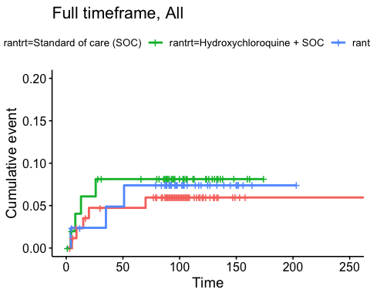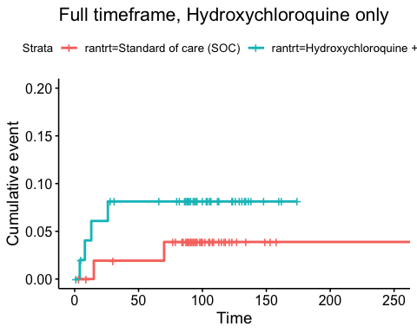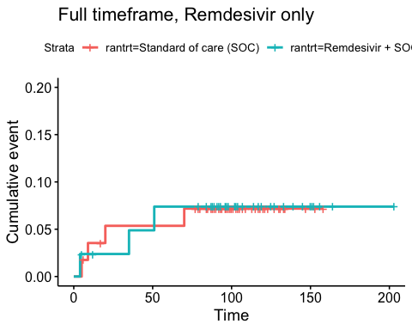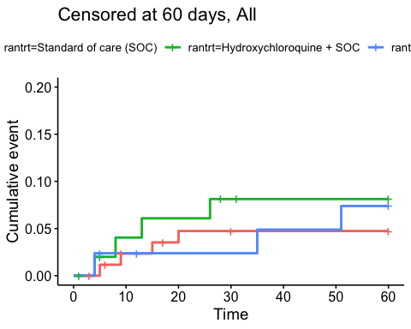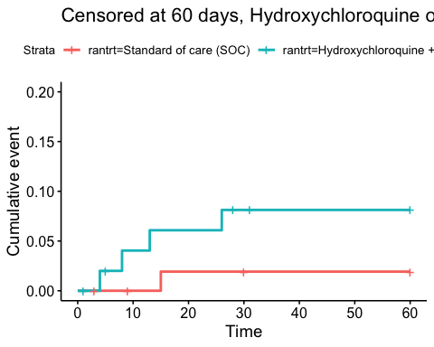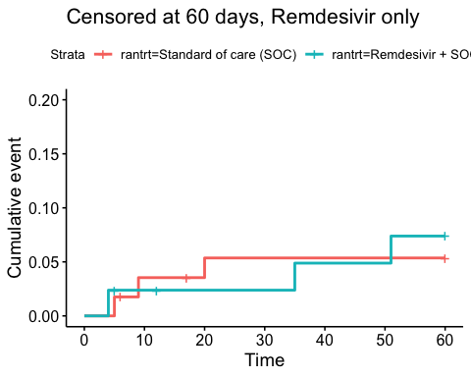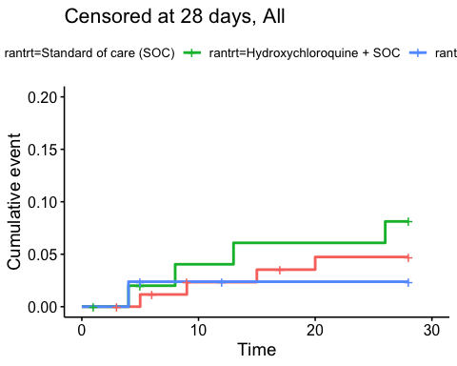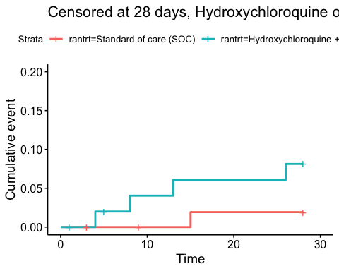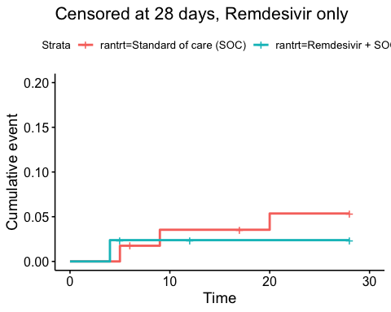

Efficacy estimates
Relative risk estimates and p-values
Timeframe, Population | Relative risk | P-value
Full timeframe, All | Not applicable | 0.871
Full timeframe, Hydroxychloroquine only | 2.18 (95% CI 0.44 to 10.82) | 0.341
Full timeframe, Remdesivir only | 1.03 (95% CI 0.23 to 4.6) | 0.972
Censored at 60 days, All | Not applicable | 0.703
Censored at 60 days, Hydroxychloroquine only | 3.67 (95% CI 0.63 to 21.22) | 0.147
Censored at 60 days, Remdesivir only | 1.37 (95% CI 0.27 to 6.92) | 0.703
Censored at 28 days, All | Not applicable | 0.471
Censored at 28 days, Hydroxychloroquine only | 3.67 (95% CI 0.63 to 21.22) | 0.147
Censored at 28 days, Remdesivir only | 0.49 (95% CI 0.07 to 3.6) | 0.486

Viral load

Plots
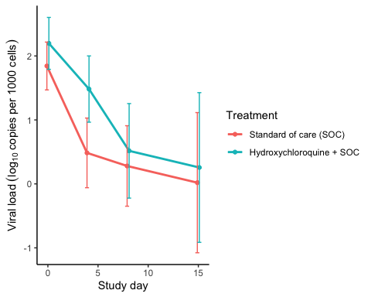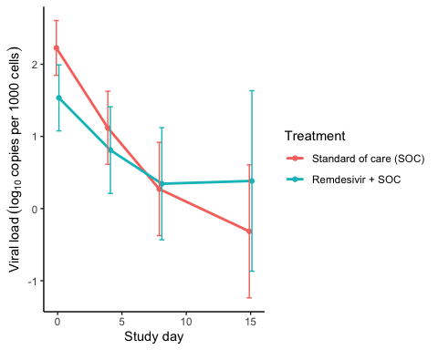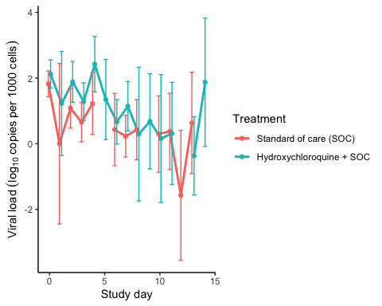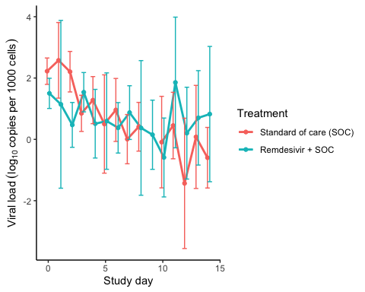

Marginal probability estimates by treatment group and difference
Estimated treatment effect, Hydroxychloroquine
Treatment | Explanation | Estimate | Lower 95% CL | Upper 95% CL | P-value
Standard of care (SOC) | Slope 1st week | -0.224 | -0.300 | -0.148 | 0.000
Hydroxychloroquine + SOC | Slope 1st week | -0.197 | -0.278 | -0.115 | 0.000
Hydroxychloroquine + SOC | Difference in slope | 0.028 | -0.084 | 0.139 | 0.628
Standard of care (SOC) | Level at day 10 | 0.259 | -0.179 | 0.697 | 0.247
Hydroxychloroquine + SOC | Level at day 10 | 0.574 | 0.108 | 1.041 | 0.016
Hydroxychloroquine + SOC | Difference at day 10 | 0.315 | -0.325 | 0.955 | 0.334

Estimated treatment effect, Remdesivir
Treatment | Explanation | Estimate | Lower 95% CL | Upper 95% CL | P-value
Standard of care (SOC) | Slope 1st week | -0.264 | -0.339 | -0.188 | 0.000
Remdesivir + SOC | Slope 1st week | -0.151 | -0.237 | -0.065 | 0.001
Remdesivir + SOC | Difference in slope | 0.113 | -0.001 | 0.227 | 0.053
Standard of care (SOC) | Level at day 10 | 0.292 | -0.062 | 0.646 | 0.106
Remdesivir + SOC | Level at day 10 | 0.495 | 0.073 | 0.917 | 0.021
Remdesivir + SOC | Difference at day 10 | 0.203 | -0.348 | 0.754 | 0.470

Viral load subgroup analyses

Plots, Hydroxychloroquine
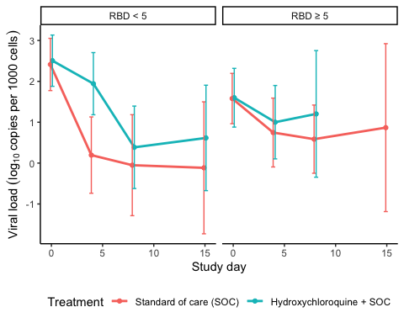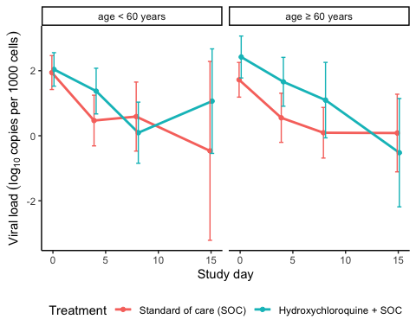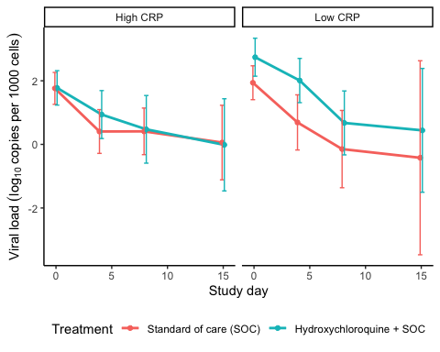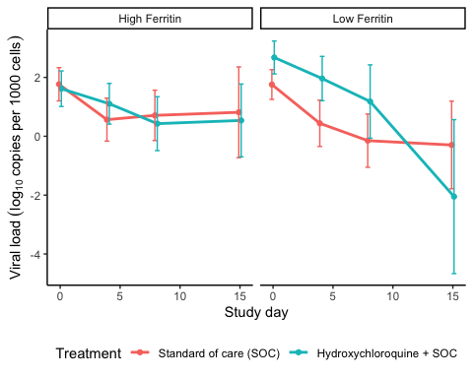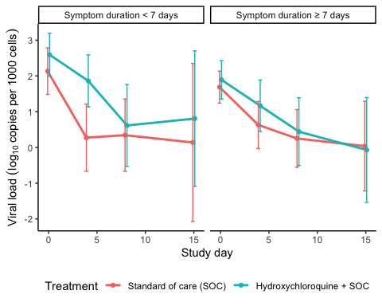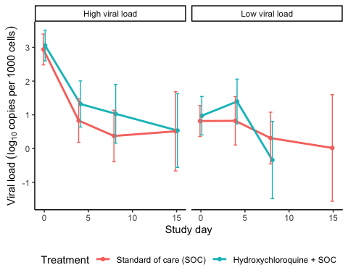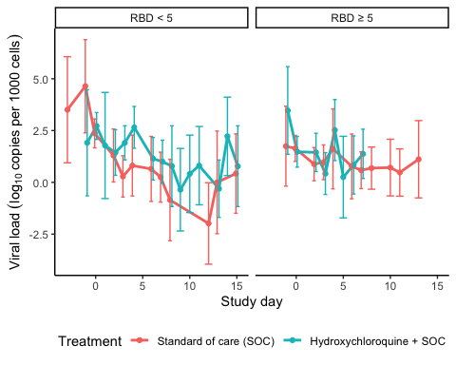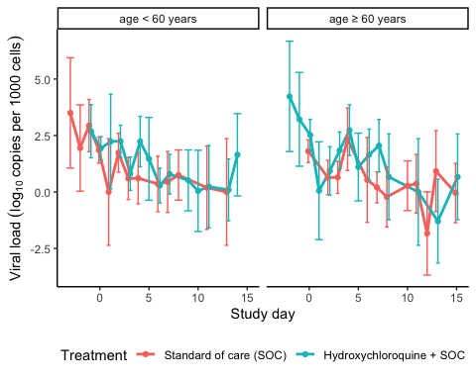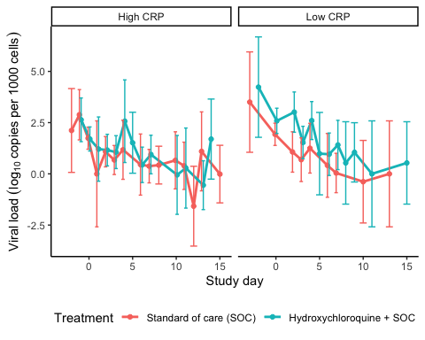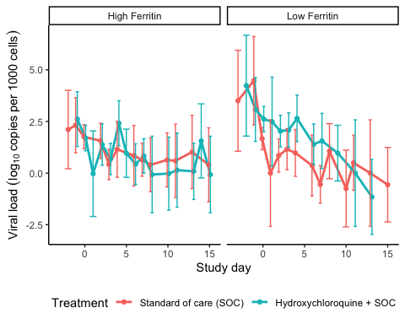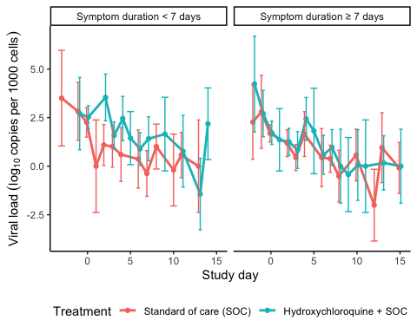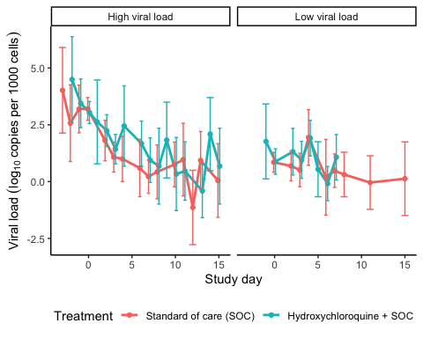

Marginal probability estimates by treatment group and difference Hydroxychloroquine
Estimated treatment effect, Hydroxychloroquine
Treatment | Subgroup | Explanation | Estimate | Lower 95% CL | Upper 95% CL | P-value
Standard of care (SOC) | RBD < 5 | Slope 1st week by treatment and subgroup | -0.391 | -0.527 | -0.255 | 0.000
Standard of care (SOC) | RBD ≥ 5 | Slope 1st week by treatment and subgroup | -0.145 | -0.260 | -0.030 | 0.013
Hydroxychloroquine + SOC | RBD < 5 | Slope 1st week by treatment and subgroup | -0.235 | -0.359 | -0.111 | 0.000
Hydroxychloroquine + SOC | RBD ≥ 5 | Slope 1st week by treatment and subgroup | NA | NA | NA | NA
Hydroxychloroquine + SOC | RBD < 5 | Treatment effect (Difference in slope) | 0.156 | -0.028 | 0.340 | 0.096
Hydroxychloroquine + SOC | RBD ≥ 5 | Treatment effect (Difference in slope) | NA | NA | NA | NA
Hydroxychloroquine + SOC | RBD ≥ 5 | Treatment/Subgroup interaction | NA | NA | NA | NA

Estimated treatment effect, Hydroxychloroquine
Treatment | Subgroup | Explanation | Estimate | Lower 95% CL | Upper 95% CL | P-value
Standard of care (SOC) | age < 60 years | Slope 1st week by treatment and subgroup | -0.256 | -0.385 | -0.127 | 0.000
Standard of care (SOC) | age ≥ 60 years | Slope 1st week by treatment and subgroup | -0.224 | -0.323 | -0.125 | 0.000
Hydroxychloroquine + SOC | age < 60 years | Slope 1st week by treatment and subgroup | -0.226 | -0.331 | -0.121 | 0.000
Hydroxychloroquine + SOC | age ≥ 60 years | Slope 1st week by treatment and subgroup | -0.162 | -0.293 | -0.031 | 0.015
Hydroxychloroquine + SOC | age < 60 years | Treatment effect (Difference in slope) | 0.030 | -0.136 | 0.196 | 0.723
Hydroxychloroquine + SOC | age ≥ 60 years | Treatment effect (Difference in slope) | 0.062 | -0.102 | 0.226 | 0.459
Hydroxychloroquine + SOC | age ≥ 60 years | Treatment/Subgroup interaction | 0.032 | -0.202 | 0.265 | 0.790

Estimated treatment effect, Hydroxychloroquine
Treatment | Subgroup | Explanation | Estimate | Lower 95% CL | Upper 95% CL | P-value
Standard of care (SOC) | High CRP | Slope 1st week by treatment and subgroup | -0.211 | -0.308 | -0.114 | 0.000
Standard of care (SOC) | Low CRP | Slope 1st week by treatment and subgroup | -0.277 | -0.406 | -0.147 | 0.000
Hydroxychloroquine + SOC | High CRP | Slope 1st week by treatment and subgroup | -0.175 | -0.285 | -0.064 | 0.002
Hydroxychloroquine + SOC | Low CRP | Slope 1st week by treatment and subgroup | -0.240 | -0.364 | -0.116 | 0.000
Hydroxychloroquine + SOC | High CRP | Treatment effect (Difference in slope) | 0.036 | -0.111 | 0.183 | 0.630
Hydroxychloroquine + SOC | Low CRP | Treatment effect (Difference in slope) | 0.036 | -0.143 | 0.216 | 0.691
Hydroxychloroquine + SOC | Low CRP | Treatment/Subgroup interaction | 0.000 | -0.232 | 0.232 | 0.998

Estimated treatment effect, Hydroxychloroquine
Treatment | Subgroup | Explanation | Estimate | Lower 95% CL | Upper 95% CL | P-value
Standard of care (SOC) | High Ferritin | Slope 1st week by treatment and subgroup | -0.174 | -0.277 | -0.071 | 0.001
Standard of care (SOC) | Low Ferritin | Slope 1st week by treatment and subgroup | -0.280 | -0.388 | -0.173 | 0.000
Hydroxychloroquine + SOC | High Ferritin | Slope 1st week by treatment and subgroup | -0.142 | -0.247 | -0.038 | 0.008
Hydroxychloroquine + SOC | Low Ferritin | Slope 1st week by treatment and subgroup | -0.183 | -0.315 | -0.051 | 0.007
Hydroxychloroquine + SOC | High Ferritin | Treatment effect (Difference in slope) | 0.032 | -0.115 | 0.179 | 0.668
Hydroxychloroquine + SOC | Low Ferritin | Treatment effect (Difference in slope) | 0.097 | -0.073 | 0.268 | 0.264
Hydroxychloroquine + SOC | Low Ferritin | Treatment/Subgroup interaction | 0.065 | -0.160 | 0.290 | 0.571

Estimated treatment effect, Hydroxychloroquine
Treatment | Subgroup | Explanation | Estimate | Lower 95% CL | Upper 95% CL | P-value
Standard of care (SOC) | Symptom duration < 7 days | Slope 1st week by treatment and subgroup | -0.309 | -0.442 | -0.176 | 0.000
Standard of care (SOC) | Symptom duration ≥ 7 days | Slope 1st week by treatment and subgroup | -0.202 | -0.299 | -0.106 | 0.000
Hydroxychloroquine + SOC | Symptom duration < 7 days | Slope 1st week by treatment and subgroup | -0.230 | -0.348 | -0.113 | 0.000
Hydroxychloroquine + SOC | Symptom duration ≥ 7 days | Slope 1st week by treatment and subgroup | -0.176 | -0.291 | -0.061 | 0.003
Hydroxychloroquine + SOC | Symptom duration < 7 days | Treatment effect (Difference in slope) | 0.078 | -0.099 | 0.256 | 0.387
Hydroxychloroquine + SOC | Symptom duration ≥ 7 days | Treatment effect (Difference in slope) | 0.026 | -0.124 | 0.177 | 0.730
Hydroxychloroquine + SOC | Symptom duration ≥ 7 days | Treatment/Subgroup interaction | -0.052 | -0.284 | 0.181 | 0.662

Estimated treatment effect, Hydroxychloroquine
Treatment | Subgroup | Explanation | Estimate | Lower 95% CL | Upper 95% CL | P-value
Standard of care (SOC) | High viral load | Slope 1st week by treatment and subgroup | -0.396 | -0.490 | -0.302 | 0.000
Standard of care (SOC) | Low viral load | Slope 1st week by treatment and subgroup | -0.052 | -0.154 | 0.050 | 0.321
Hydroxychloroquine + SOC | High viral load | Slope 1st week by treatment and subgroup | -0.310 | -0.417 | -0.203 | 0.000
Hydroxychloroquine + SOC | Low viral load | Slope 1st week by treatment and subgroup | NA | NA | NA | NA
Hydroxychloroquine + SOC | High viral load | Treatment effect (Difference in slope) | 0.086 | -0.057 | 0.228 | 0.240
Hydroxychloroquine + SOC | Low viral load | Treatment effect (Difference in slope) | NA | NA | NA | NA
Hydroxychloroquine + SOC | Low viral load | Treatment/Subgroup interaction | NA | NA | NA | NA

Plots Remdesivir
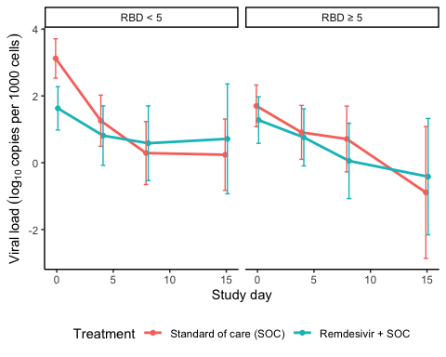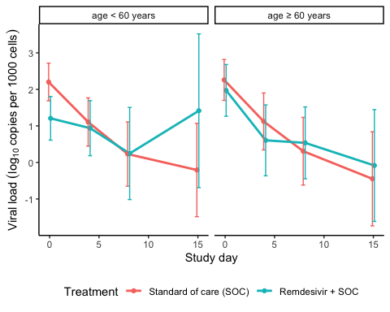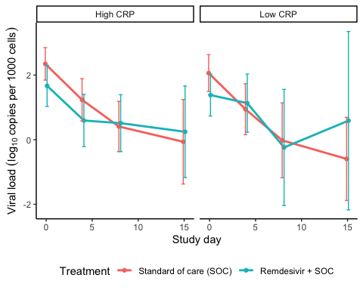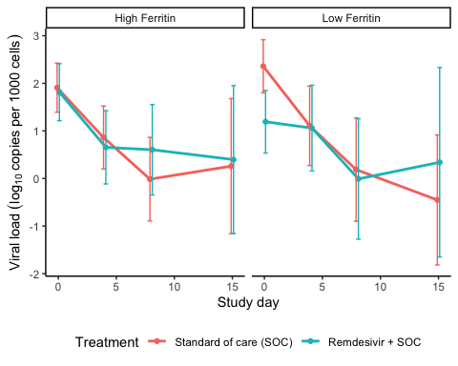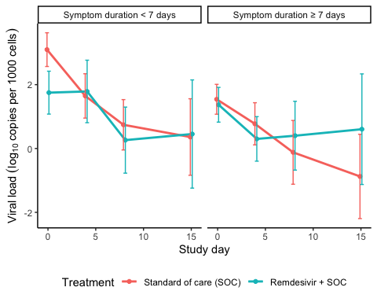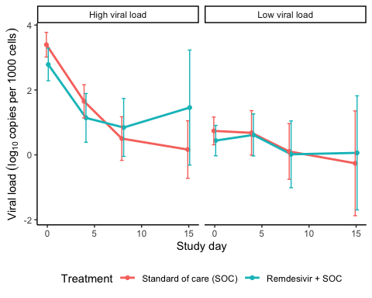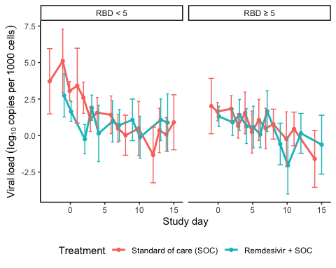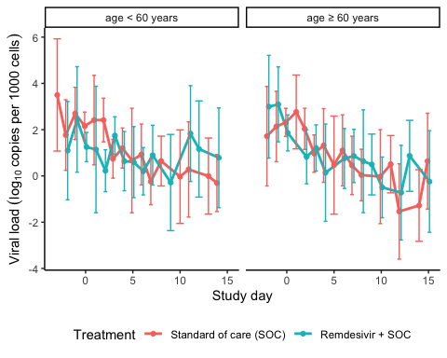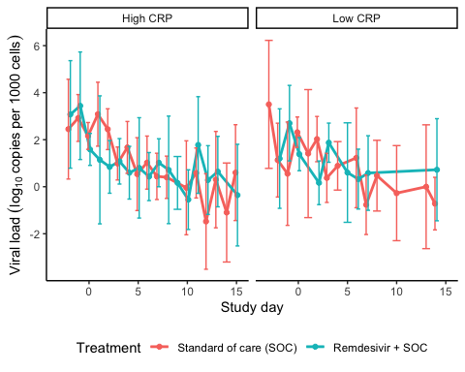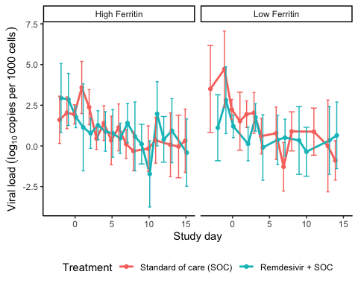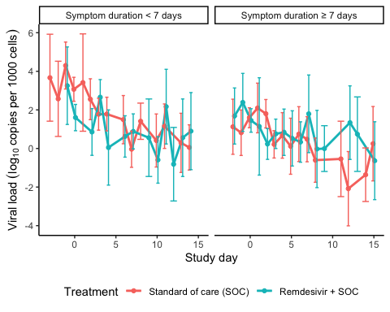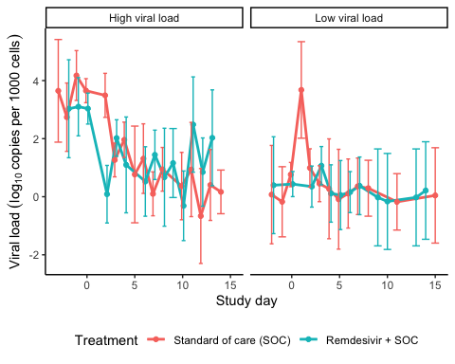

Marginal probability estimates by treatment group and difference Remdesivir
Estimated treatment effect, Remdesivir
Treatment | Subgroup | Explanation | Estimate | Lower 95% CL | Upper 95% CL | P-value
Standard of care (SOC) | RBD < 5 | Slope 1st week by treatment and subgroup | -0.394 | -0.508 | -0.280 | 0.000
Standard of care (SOC) | RBD ≥ 5 | Slope 1st week by treatment and subgroup | -0.145 | -0.277 | -0.013 | 0.031
Remdesivir + SOC | RBD < 5 | Slope 1st week by treatment and subgroup | -0.153 | -0.285 | -0.020 | 0.024
Remdesivir + SOC | RBD ≥ 5 | Slope 1st week by treatment and subgroup | -0.138 | -0.265 | -0.010 | 0.034
Remdesivir + SOC | RBD < 5 | Treatment effect (Difference in slope) | 0.241 | 0.066 | 0.416 | 0.007
Remdesivir + SOC | RBD ≥ 5 | Treatment effect (Difference in slope) | 0.007 | -0.176 | 0.190 | 0.940
Remdesivir + SOC | RBD ≥ 5 | Treatment/Subgroup interaction | -0.234 | -0.487 | 0.020 | 0.071

Estimated treatment effect, Remdesivir
Treatment | Subgroup | Explanation | Estimate | Lower 95% CL | Upper 95% CL | P-value
Standard of care (SOC) | age < 60 years | Slope 1st week by treatment and subgroup | -0.270 | -0.374 | -0.167 | 0.000
Standard of care (SOC) | age ≥ 60 years | Slope 1st week by treatment and subgroup | -0.263 | -0.381 | -0.145 | 0.000
Remdesivir + SOC | age < 60 years | Slope 1st week by treatment and subgroup | -0.101 | -0.227 | 0.024 | 0.112
Remdesivir + SOC | age ≥ 60 years | Slope 1st week by treatment and subgroup | -0.211 | -0.333 | -0.089 | 0.001
Remdesivir + SOC | age < 60 years | Treatment effect (Difference in slope) | 0.169 | 0.006 | 0.332 | 0.042
Remdesivir + SOC | age ≥ 60 years | Treatment effect (Difference in slope) | 0.052 | -0.118 | 0.222 | 0.548
Remdesivir + SOC | age ≥ 60 years | Treatment/Subgroup interaction | -0.117 | -0.352 | 0.119 | 0.330

Estimated treatment effect, Remdesivir
Treatment | Subgroup | Explanation | Estimate | Lower 95% CL | Upper 95% CL | P-value
Standard of care (SOC) | High CRP | Slope 1st week by treatment and subgroup | -0.262 | -0.361 | -0.163 | 0.000
Standard of care (SOC) | Low CRP | Slope 1st week by treatment and subgroup | -0.285 | -0.418 | -0.153 | 0.000
Remdesivir + SOC | High CRP | Slope 1st week by treatment and subgroup | -0.169 | -0.280 | -0.059 | 0.003
Remdesivir + SOC | Low CRP | Slope 1st week by treatment and subgroup | -0.138 | -0.289 | 0.014 | 0.076
Remdesivir + SOC | High CRP | Treatment effect (Difference in slope) | 0.093 | -0.056 | 0.241 | 0.220
Remdesivir + SOC | Low CRP | Treatment effect (Difference in slope) | 0.148 | -0.054 | 0.349 | 0.151
Remdesivir + SOC | Low CRP | Treatment/Subgroup interaction | 0.055 | -0.195 | 0.305 | 0.667

Estimated treatment effect, Remdesivir
Treatment | Subgroup | Explanation | Estimate | Lower 95% CL | Upper 95% CL | P-value
Standard of care (SOC) | High Ferritin | Slope 1st week by treatment and subgroup | -0.253 | -0.357 | -0.150 | 0.000
Standard of care (SOC) | Low Ferritin | Slope 1st week by treatment and subgroup | -0.309 | -0.446 | -0.172 | 0.000
Remdesivir + SOC | High Ferritin | Slope 1st week by treatment and subgroup | -0.189 | -0.302 | -0.077 | 0.001
Remdesivir + SOC | Low Ferritin | Slope 1st week by treatment and subgroup | -0.113 | -0.253 | 0.028 | 0.115
Remdesivir + SOC | High Ferritin | Treatment effect (Difference in slope) | 0.064 | -0.089 | 0.217 | 0.413
Remdesivir + SOC | Low Ferritin | Treatment effect (Difference in slope) | 0.196 | 0.000 | 0.392 | 0.050
Remdesivir + SOC | Low Ferritin | Treatment/Subgroup interaction | 0.132 | -0.116 | 0.381 | 0.297

Estimated treatment effect, Remdesivir
Treatment | Subgroup | Explanation | Estimate | Lower 95% CL | Upper 95% CL | P-value
Standard of care (SOC) | Symptom duration < 7 days | Slope 1st week by treatment and subgroup | -0.338 | -0.442 | -0.233 | 0.000
Standard of care (SOC) | Symptom duration ≥ 7 days | Slope 1st week by treatment and subgroup | -0.200 | -0.316 | -0.084 | 0.001
Remdesivir + SOC | Symptom duration < 7 days | Slope 1st week by treatment and subgroup | -0.143 | -0.265 | -0.022 | 0.021
Remdesivir + SOC | Symptom duration ≥ 7 days | Slope 1st week by treatment and subgroup | -0.183 | -0.308 | -0.059 | 0.004
Remdesivir + SOC | Symptom duration < 7 days | Treatment effect (Difference in slope) | 0.194 | 0.034 | 0.355 | 0.018
Remdesivir + SOC | Symptom duration ≥ 7 days | Treatment effect (Difference in slope) | 0.017 | -0.154 | 0.187 | 0.847
Remdesivir + SOC | Symptom duration ≥ 7 days | Treatment/Subgroup interaction | -0.178 | -0.412 | 0.056 | 0.137

Estimated treatment effect, Remdesivir
Treatment | Subgroup | Explanation | Estimate | Lower 95% CL | Upper 95% CL | P-value
Standard of care (SOC) | High viral load | Slope 1st week by treatment and subgroup | -0.411 | -0.500 | -0.322 | 0.000
Standard of care (SOC) | Low viral load | Slope 1st week by treatment and subgroup | -0.062 | -0.175 | 0.050 | 0.278
Remdesivir + SOC | High viral load | Slope 1st week by treatment and subgroup | -0.293 | -0.408 | -0.178 | 0.000
Remdesivir + SOC | Low viral load | Slope 1st week by treatment and subgroup | -0.018 | -0.128 | 0.092 | 0.749
Remdesivir + SOC | High viral load | Treatment effect (Difference in slope) | 0.118 | -0.028 | 0.263 | 0.112
Remdesivir + SOC | Low viral load | Treatment effect (Difference in slope) | 0.044 | -0.113 | 0.202 | 0.581
Remdesivir + SOC | Low viral load | Treatment/Subgroup interaction | -0.074 | -0.288 | 0.141 | 0.502

Respiratory failure by pO2/FiO2-ratio

Plots
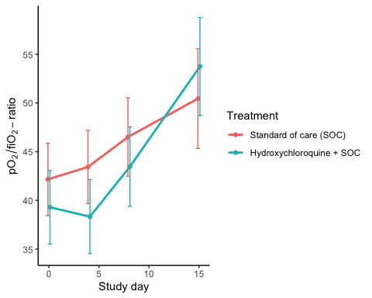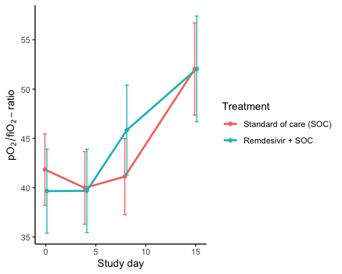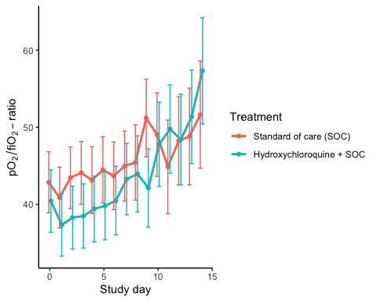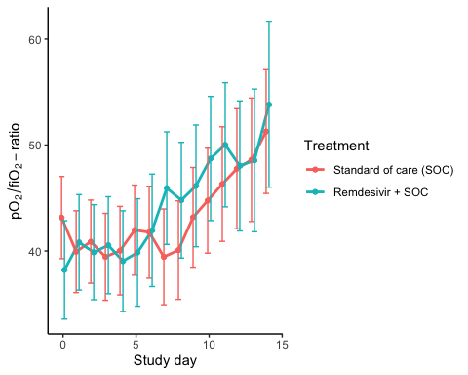

Marginal probability estimates by treatment group and difference
Estimated treatment effect, Hydroxychloroquine
Treatment | Explanation | Estimate | Lower 95% CL | Upper 95% CL | P-value
Standard of care (SOC) | Slope 1st week | 0.693 | 0.166 | 1.221 | 0.010
Hydroxychloroquine + SOC | Slope 1st week | 0.697 | 0.152 | 1.242 | 0.012
Hydroxychloroquine + SOC | Difference in slope | 0.003 | -0.755 | 0.762 | 0.993
Standard of care (SOC) | Level at day 10 | 53.521 | 47.990 | 59.053 | 0.000
Hydroxychloroquine + SOC | Level at day 10 | 50.143 | 44.424 | 55.863 | 0.000
Hydroxychloroquine + SOC | Difference at day 10 | -3.378 | -11.335 | 4.579 | 0.405

Estimated treatment effect, Remdesivir
Treatment | Explanation | Estimate | Lower 95% CL | Upper 95% CL | P-value
Standard of care (SOC) | Slope 1st week | 0.015 | -0.589 | 0.620 | 0.960
Remdesivir + SOC | Slope 1st week | 0.974 | 0.253 | 1.696 | 0.008
Remdesivir + SOC | Difference in slope | 0.959 | 0.017 | 1.900 | 0.046
Standard of care (SOC) | Level at day 10 | 52.507 | 46.239 | 58.775 | 0.000
Remdesivir + SOC | Level at day 10 | 52.815 | 45.454 | 60.175 | 0.000
Remdesivir + SOC | Difference at day 10 | 0.308 | -9.360 | 9.975 | 0.950

Dichotomous endpoints

Descriptives
Hydroxycholoquine
Outcome | Standard of care (SOC) | Hydroxychloroquine + SOC
Mortality during hospitalisation | 2 (3.7%) | 4 (7.7%)
Mortality (censored at day 28) | 1 (1.9%) | 4 (7.7%)
Mortality (censored at day 60) | 1 (1.9%) | 4 (7.7%)
WHO disease state progression | 7 (13%) | 10 (19.2%)
WHO disease state progression (censoreda at day 28) | 7 (13%) | 10 (19.2%)
WHO disease state progression (censoreda at day 60) | 7 (13%) | 10 (19.2%)
Mechanical ventilation during hospitalisation | 4 (7.4%) | 8 (15.4%)
Mechanical ventilation (censored at day 28) | 4 (7.4%) | 8 (15.4%)
Mechanical ventilation (censored at day 60) | 4 (7.4%) | 8 (15.4%)
Admission to ICU during hospitalisation | 7 (13%) | 12 (23.1%)
Admission to ICU (censored at day 28) | 7 (13%) | 12 (23.1%)
Admission to ICU (censored at day 60) | 7 (13%) | 12 (23.1%)
Figures are number of patients with the outcome and percent (%)
Remdesivir
Outcome | Standard of care (SOC) | Remdesivir + SOC
Mortality during hospitalisation | 4 (7%) | 3 (7.1%)
Mortality (censored at day 28) | 3 (5.3%) | 1 (2.4%)
Mortality (censored at day 60) | 3 (5.3%) | 3 (7.1%)
WHO disease state progression | 13 (22.8%) | 6 (14.3%)
WHO disease state progression (censoreda at day 28) | 13 (22.8%) | 6 (14.3%)
WHO disease state progression (censoreda at day 60) | 13 (22.8%) | 6 (14.3%)
Mechanical ventilation during hospitalisation | 4 (7%) | 4 (9.5%)
Mechanical ventilation (censored at day 28) | 4 (7%) | 4 (9.5%)
Mechanical ventilation (censored at day 60) | 4 (7%) | 4 (9.5%)
Admission to ICU during hospitalisation | 11 (19.3%) | 8 (19%)
Admission to ICU (censored at day 28) | 11 (19.3%) | 8 (19%)
Admission to ICU (censored at day 60) | 11 (19.3%) | 8 (19%)
Figures are number of patients with the outcome and percent (%)

Marginal probability estimates by treatment group and difference
Hydroxychloroquine
Outcome | Standard of care (SOC) | Hydroxychloroquine + SOC | Estimated marginal treatment effect
Mortality during hospitalisation | 3.7% (-1.3 to 8.7) | 7.7% (0.4 to 14.9) | 4% (-4.8 to 12.8)
Mortality (censored at day 28) | 1.9% (-1.7 to 5.4) | 7.7% (0.4 to 14.9) | 5.8% (-2.2 to 13.9)
Mortality (censored at day 60) | 1.9% (-1.7 to 5.4) | 7.7% (0.4 to 14.9) | 5.8% (-2.2 to 13.9)
WHO disease state progression | 13% (4 to 21.9) | 19.2% (8.5 to 29.9) | 6.3% (-7.7 to 20.2)
WHO disease state progression (censoreda at day 28) | 13% (4 to 21.9) | 19.2% (8.5 to 29.9) | 6.3% (-7.7 to 20.2)
WHO disease state progression (censoreda at day 60) | 13% (4 to 21.9) | 19.2% (8.5 to 29.9) | 6.3% (-7.7 to 20.2)
Mechanical ventilation during hospitalisation | 7.4% (0.4 to 14.4) | 15.4% (5.6 to 25.2) | 8% (-4.1 to 20)
Mechanical ventilation (censored at day 28) | 7.4% (0.4 to 14.4) | 15.4% (5.6 to 25.2) | 8% (-4.1 to 20)
Mechanical ventilation (censored at day 60) | 7.4% (0.4 to 14.4) | 15.4% (5.6 to 25.2) | 8% (-4.1 to 20)
Admission to ICU during hospitalisation | 13% (4 to 21.9) | 23.1% (11.6 to 34.5) | 10.1% (-4.4 to 24.7)
Admission to ICU (censored at day 28) | 13% (4 to 21.9) | 23.1% (11.6 to 34.5) | 10.1% (-4.4 to 24.7)
Admission to ICU (censored at day 60) | 13% (4 to 21.9) | 23.1% (11.6 to 34.5) | 10.1% (-4.4 to 24.7)

Remdesivir
Outcome | Standard of care (SOC) | Remdesivir + SOC | Estimated marginal treatment effect
Mortality during hospitalisation | 7% (0.4 to 13.6) | 7.1% (-0.6 to 14.9) | 0.1% (-10.1 to 10.4)
Mortality (censored at day 28) | 5.3% (-0.5 to 11.1) | 2.4% (-2.2 to 7) | -2.9% (-10.3 to 4.5)
Mortality (censored at day 60) | 5.3% (-0.5 to 11.1) | 7.1% (-0.6 to 14.9) | 1.9% (-7.8 to 11.6)
WHO disease state progression | 22.8% (11.9 to 33.7) | 14.3% (3.7 to 24.9) | -8.5% (-23.7 to 6.7)
WHO disease state progression (censoreda at day 28) | 22.8% (11.9 to 33.7) | 14.3% (3.7 to 24.9) | -8.5% (-23.7 to 6.7)
WHO disease state progression (censoreda at day 60) | 22.8% (11.9 to 33.7) | 14.3% (3.7 to 24.9) | -8.5% (-23.7 to 6.7)
Mechanical ventilation during hospitalisation | 7% (0.4 to 13.6) | 9.5% (0.6 to 18.4) | 2.5% (-8.6 to 13.6)
Mechanical ventilation (censored at day 28) | 7% (0.4 to 13.6) | 9.5% (0.6 to 18.4) | 2.5% (-8.6 to 13.6)
Mechanical ventilation (censored at day 60) | 7% (0.4 to 13.6) | 9.5% (0.6 to 18.4) | 2.5% (-8.6 to 13.6)
Admission to ICU during hospitalisation | 19.3% (9.1 to 29.5) | 19% (7.2 to 30.9) | -0.3% (-15.9 to 15.4)
Admission to ICU (censored at day 28) | 19.3% (9.1 to 29.5) | 19% (7.2 to 30.9) | -0.3% (-15.9 to 15.4)
Admission to ICU (censored at day 60) | 19.3% (9.1 to 29.5) | 19% (7.2 to 30.9) | -0.3% (-15.9 to 15.4)

Inflammatory laboratory parameters

Descriptives
CRP (mg/L), HCQ
Days since randomisation | Statistic | Standard of care (SOC) | Hydroxychloroquine + SOC
0 days | Mean (SD) | 88.7 (74.69) | 95.33 (68.36)
0 days | Median [IQR] | 65.5 [34 - 124] | 76 [47 - 133]
0 days | Missing / Non-Missing | 0 / 54 | 1 / 51
1 days | Mean (SD) | 95.17 (84.09) | 105.68 (70.55)
1 days | Median [IQR] | 68 [34.5 - 125] | 88.5 [52.5 - 145]
1 days | Missing / Non-Missing | 8 / 46 | 7 / 44
2 days | Mean (SD) | 89.31 (78.63) | 96.96 (81.41)
2 days | Median [IQR] | 67.5 [37.75 - 113.75] | 85.5 [42.75 - 124.75]
2 days | Missing / Non-Missing | 4 / 48 | 6 / 44
3 days | Mean (SD) | 92.94 (74.99) | 92.05 (74)
3 days | Median [IQR] | 70 [33 - 121] | 69.5 [44 - 132.25]
3 days | Missing / Non-Missing | 9 / 37 | 5 / 40
4 days | Mean (SD) | 91.99 (76.7) | 98.54 (80.75)
4 days | Median [IQR] | 67 [46 - 132] | 80 [39.5 - 141.5]
4 days | Missing / Non-Missing | 4 / 33 | 6 / 35
5 days | Mean (SD) | 97.34 (84.39) | 91.36 (65.87)
5 days | Median [IQR] | 65.5 [48.75 - 147] | 85 [36.5 - 140.5]
5 days | Missing / Non-Missing | 7 / 30 | 6 / 28
6 days | Mean (SD) | 83.32 (82.1) | 83.15 (67.95)
6 days | Median [IQR] | 48 [25.75 - 138] | 62 [28 - 115.5]
6 days | Missing / Non-Missing | 1 / 32 | 5 / 26
7 days | Mean (SD) | 77.12 (68.38) | 102.86 (94.13)
7 days | Median [IQR] | 46 [16.5 - 140.75] | 71 [20 - 157.5]
7 days | Missing / Non-Missing | 1 / 26 | 3 / 24
8 days | Mean (SD) | 75.68 (67.25) | 110.3 (101.33)
8 days | Median [IQR] | 65 [21 - 94] | 58 [29 - 191]
8 days | Missing / Non-Missing | 2 / 21 | 4 / 17
9 days | Mean (SD) | 66.24 (65.64) | 108.29 (93.13)
9 days | Median [IQR] | 41.5 [16.5 - 102.75] | 74.5 [35.5 - 171]
9 days | Missing / Non-Missing | 2 / 16 | 4 / 14
10 days | Mean (SD) | 49.63 (53.44) | 93.83 (93.8)
10 days | Median [IQR] | 29 [12 - 66] | 67 [23.25 - 144.75]
10 days | Missing / Non-Missing | 1 / 13 | 3 / 12
11 days | Mean (SD) | 73.3 (97.24) | 90.88 (85.01)
11 days | Median [IQR] | 41.5 [7.55 - 111] | 75.5 [26.25 - 110]
11 days | Missing / Non-Missing | 2 / 10 | 5 / 8
12 days | Mean (SD) | 84.51 (74.7) | 73.75 (85.95)
12 days | Median [IQR] | 72 [11 - 155] | 51 [18.25 - 79.25]
12 days | Missing / Non-Missing | 3 / 9 | 4 / 8
13 days | Mean (SD) | 109.43 (92.12) | 58.11 (65.81)
13 days | Median [IQR] | 101 [35 - 187] | 23 [14 - 99]
13 days | Missing / Non-Missing | 2 / 9 | 2 / 9
14 days | Mean (SD) | 117.33 (127.38) | 33.17 (28.59)
14 days | Median [IQR] | 37 [15.85 - 231.5] | 24.5 [13.25 - 46.25]
14 days | Missing / Non-Missing | 0 / 7 | 1 / 6

CRP (mg/L), Remdesivir
Days since randomisation | Statistic | Standard of care (SOC) | Remdesivir + SOC
0 days | Mean (SD) | 93.54 (74.88) | 90.47 (64.37)
0 days | Median [IQR] | 82 [33 - 141.75] | 70 [39.75 - 139.25]
0 days | Missing / Non-Missing | 1 / 56 | 0 / 42
1 days | Mean (SD) | 91.65 (74.14) | 92.89 (65.11)
1 days | Median [IQR] | 74 [38 - 122] | 79 [46.5 - 128.5]
1 days | Missing / Non-Missing | 12 / 45 | 7 / 35
2 days | Mean (SD) | 87.71 (69.43) | 78.57 (72.11)
2 days | Median [IQR] | 70.5 [35.5 - 118] | 56 [30 - 121]
2 days | Missing / Non-Missing | 6 / 46 | 5 / 37
3 days | Mean (SD) | 93.23 (72.66) | 68.64 (72.08)
3 days | Median [IQR] | 74 [31.5 - 137.5] | 46 [23.75 - 81.75]
3 days | Missing / Non-Missing | 6 / 39 | 5 / 34
4 days | Mean (SD) | 95.7 (82.48) | 69.4 (84.06)
4 days | Median [IQR] | 75.5 [44.5 - 123.5] | 38 [22 - 89.5]
4 days | Missing / Non-Missing | 5 / 36 | 4 / 26
5 days | Mean (SD) | 89.7 (82.84) | 70.37 (89.75)
5 days | Median [IQR] | 66 [31.25 - 108.75] | 27 [15 - 83]
5 days | Missing / Non-Missing | 4 / 36 | 3 / 21
6 days | Mean (SD) | 87.88 (85.5) | 70.9 (85.43)
6 days | Median [IQR] | 55.5 [25.5 - 126.75] | 42 [14.5 - 75]
6 days | Missing / Non-Missing | 5 / 30 | 3 / 19
7 days | Mean (SD) | 80.38 (66.49) | 56.79 (66.01)
7 days | Median [IQR] | 67.5 [26.75 - 131.75] | 35 [12 - 49]
7 days | Missing / Non-Missing | 3 / 26 | 2 / 17
8 days | Mean (SD) | 76.13 (74.2) | 56.86 (66.24)
8 days | Median [IQR] | 55 [32 - 89.5] | 28 [14 - 91]
8 days | Missing / Non-Missing | 0 / 27 | 4 / 13
9 days | Mean (SD) | 81.37 (76.94) | 42.07 (55.8)
9 days | Median [IQR] | 60 [22.75 - 95.25] | 18 [7 - 36]
9 days | Missing / Non-Missing | 4 / 20 | 2 / 13
10 days | Mean (SD) | 59.98 (67.48) | 35.27 (50.51)
10 days | Median [IQR] | 31 [17.5 - 76] | 12 [6 - 22]
10 days | Missing / Non-Missing | 4 / 16 | 1 / 13
11 days | Mean (SD) | 83.04 (118.51) | 37.82 (46.38)
11 days | Median [IQR] | 43.5 [12.5 - 80.75] | 9 [5 - 76]
11 days | Missing / Non-Missing | 1 / 16 | 2 / 11
12 days | Mean (SD) | 135.4 (212.94) | 56.79 (59.44)
12 days | Median [IQR] | 57 [34.25 - 110] | 19 [5 - 107]
12 days | Missing / Non-Missing | 5 / 8 | 1 / 9
13 days | Mean (SD) | 86.01 (109.53) | 109.86 (95.62)
13 days | Median [IQR] | 48.5 [16 - 93.25] | 92 [41.5 - 166.5]
13 days | Missing / Non-Missing | 4 / 10 | 2 / 7
14 days | Mean (SD) | 58.77 (87.75) | 53.42 (84.6)
14 days | Median [IQR] | 24.5 [13.5 - 36.25] | 13.95 [4.98 - 57.5]
14 days | Missing / Non-Missing | 1 / 10 | 0 / 6

Ferritin (µg/L), HCQ
Days since randomisation | Statistic | Standard of care (SOC) | Hydroxychloroquine + SOC
0 days | Mean (SD) | 732.58 (629.2) | 894.45 (773.07)
0 days | Median [IQR] | 531.5 [320.75 - 991.25] | 626 [295 - 1298]
0 days | Missing / Non-Missing | 4 / 50 | 3 / 49
1 days | Mean (SD) | 854.03 (622.07) | 1027.07 (740.52)
1 days | Median [IQR] | 737.5 [408.75 - 1091.75] | 1018.5 [429 - 1416.25]
1 days | Missing / Non-Missing | 18 / 36 | 21 / 30
2 days | Mean (SD) | 800.51 (513.73) | 931.55 (797.63)
2 days | Median [IQR] | 803 [403.5 - 1104.5] | 789.5 [272.5 - 1235.75]
2 days | Missing / Non-Missing | 9 / 43 | 10 / 40
3 days | Mean (SD) | 1013.23 (739.09) | 1081.88 (825.14)
3 days | Median [IQR] | 856 [440.5 - 1366] | 953 [420.75 - 1426.75]
3 days | Missing / Non-Missing | 15 / 31 | 11 / 34
4 days | Mean (SD) | 1274.5 (1244.34) | 1141.12 (856.24)
4 days | Median [IQR] | 851 [495.75 - 1811.25] | 988.5 [461.5 - 1593]
4 days | Missing / Non-Missing | 11 / 26 | 15 / 26
5 days | Mean (SD) | 1046.7 (766.12) | 1164.4 (708.71)
5 days | Median [IQR] | 791.5 [475 - 1641.75] | 1017 [804 - 1452]
5 days | Missing / Non-Missing | 17 / 20 | 9 / 25
6 days | Mean (SD) | 1144.04 (921.54) | 1023.5 (519.61)
6 days | Median [IQR] | 896 [468.5 - 1628] | 939 [712.5 - 1254]
6 days | Missing / Non-Missing | 6 / 27 | 7 / 24
7 days | Mean (SD) | 1173.6 (778.48) | 1251.77 (959.32)
7 days | Median [IQR] | 959.5 [508 - 1466.75] | 1151.5 [788.75 - 1452.25]
7 days | Missing / Non-Missing | 7 / 20 | 5 / 22
8 days | Mean (SD) | 820.93 (663.69) | 1179.2 (1144.8)
8 days | Median [IQR] | 758.5 [301 - 1039] | 805 [666.5 - 1452.5]
8 days | Missing / Non-Missing | 9 / 14 | 6 / 15
9 days | Mean (SD) | 882.87 (678.11) | 853.62 (673.46)
9 days | Median [IQR] | 762 [492 - 1128] | 731 [531 - 1256]
9 days | Missing / Non-Missing | 3 / 15 | 5 / 13
10 days | Mean (SD) | 737.1 (511) | 1240.36 (654.25)
10 days | Median [IQR] | 807.5 [309.25 - 985.5] | 939 [793.5 - 1469]
10 days | Missing / Non-Missing | 4 / 10 | 4 / 11
11 days | Mean (SD) | 569.4 (334.51) | 1969.75 (1042.66)
11 days | Median [IQR] | 607 [300 - 766.5] | 1969.5 [1146.75 - 2792.5]
11 days | Missing / Non-Missing | 2 / 10 | 9 / 4
12 days | Mean (SD) | 527 (526.63) | 1515 (1167.09)
12 days | Median [IQR] | 518 [107.5 - 691] | 890.5 [676.25 - 2298]
12 days | Missing / Non-Missing | 5 / 7 | 6 / 6
13 days | Mean (SD) | 477.29 (316.13) | 1133.67 (774.96)
13 days | Median [IQR] | 451 [284 - 726] | 864 [665 - 1160]
13 days | Missing / Non-Missing | 4 / 7 | 2 / 9
14 days | Mean (SD) | 347.2 (267.07) | 1075 (529.09)
14 days | Median [IQR] | 392 [141 - 583] | 1002 [713.5 - 1363.5]
14 days | Missing / Non-Missing | 2 / 5 | 3 / 4

Ferritin (µg/L), Remdesivir
Days since randomisation | Statistic | Standard of care (SOC) | Remdesivir + SOC
0 days | Mean (SD) | 820.65 (722.45) | 1552.26 (3597.9)
0 days | Median [IQR] | 589 [317.75 - 1076.75] | 694.5 [343.25 - 1262.25]
0 days | Missing / Non-Missing | 3 / 54 | 0 / 42
1 days | Mean (SD) | 893.06 (692.71) | 1877.77 (3604.5)
1 days | Median [IQR] | 651 [409 - 1115] | 1001.5 [440.5 - 1729.75]
1 days | Missing / Non-Missing | 24 / 33 | 16 / 26
2 days | Mean (SD) | 918.08 (668.31) | 1519.66 (1994.66)
2 days | Median [IQR] | 842 [437.5 - 1133.75] | 1238.5 [500.25 - 1636.5]
2 days | Missing / Non-Missing | 14 / 38 | 10 / 32
3 days | Mean (SD) | 1204.46 (938.02) | 1123.79 (979.93)
3 days | Median [IQR] | 912 [596 - 1597] | 980.5 [433 - 1307]
3 days | Missing / Non-Missing | 12 / 33 | 11 / 28
4 days | Mean (SD) | 1585.43 (1495.06) | 1386.7 (901.34)
4 days | Median [IQR] | 985 [648.5 - 1927.25] | 1130.5 [849.25 - 1707.25]
4 days | Missing / Non-Missing | 13 / 28 | 10 / 20
5 days | Mean (SD) | 1115.82 (1104.14) | 1268.93 (756.48)
5 days | Median [IQR] | 751 [517.5 - 1333] | 1119.5 [782.5 - 1841.75]
5 days | Missing / Non-Missing | 12 / 28 | 10 / 14
6 days | Mean (SD) | 1363.89 (1260.9) | 859.69 (546.39)
6 days | Median [IQR] | 914.5 [578.5 - 1555.75] | 736.5 [463.5 - 1158]
6 days | Missing / Non-Missing | 9 / 26 | 6 / 16
7 days | Mean (SD) | 1270.36 (836.9) | 935 (425.38)
7 days | Median [IQR] | 1029 [644 - 1835] | 891.5 [597 - 1368.75]
7 days | Missing / Non-Missing | 4 / 25 | 5 / 14
8 days | Mean (SD) | 1062 (783.77) | 936.2 (405.76)
8 days | Median [IQR] | 817 [499.5 - 1218.5] | 912 [754.75 - 1167.75]
8 days | Missing / Non-Missing | 5 / 22 | 7 / 10
9 days | Mean (SD) | 965.13 (703.14) | 912.8 (490.17)
9 days | Median [IQR] | 576 [501.5 - 1416] | 956.5 [503 - 1250]
9 days | Missing / Non-Missing | 9 / 15 | 5 / 10
10 days | Mean (SD) | 894.08 (544.78) | 954.75 (613.4)
10 days | Median [IQR] | 670.5 [516.5 - 1223.75] | 811.5 [669.5 - 1206]
10 days | Missing / Non-Missing | 8 / 12 | 6 / 8
11 days | Mean (SD) | 641.92 (456.89) | 961.63 (775.46)
11 days | Median [IQR] | 561.5 [324.5 - 878] | 806 [621.25 - 993.25]
11 days | Missing / Non-Missing | 5 / 12 | 5 / 8
12 days | Mean (SD) | 698 (293.69) | 816.83 (308.87)
12 days | Median [IQR] | 639 [603 - 667] | 884.5 [752 - 1007.25]
12 days | Missing / Non-Missing | 8 / 5 | 4 / 6
13 days | Mean (SD) | 588.43 (422.05) | 966.83 (665)
13 days | Median [IQR] | 549 [404.5 - 683.5] | 891 [431 - 1449.25]
13 days | Missing / Non-Missing | 7 / 7 | 3 / 6
14 days | Mean (SD) | 589.89 (451.01) | 796 (638.04)
14 days | Median [IQR] | 583 [376 - 634] | 698 [396 - 753]
14 days | Missing / Non-Missing | 2 / 9 | 1 / 5

LDH (U/L), HCQ
Days since randomisation | Statistic | Standard of care (SOC) | Hydroxychloroquine + SOC
0 days | Mean (SD) | 277.36 (110.83) | 307.77 (125.77)
0 days | Median [IQR] | 251.5 [199.75 - 324.75] | 287 [234.5 - 360.5]
0 days | Missing / Non-Missing | 4 / 50 | 1 / 51
1 days | Mean (SD) | 286.48 (93.23) | 306.82 (123.33)
1 days | Median [IQR] | 277 [226 - 312.5] | 283 [233 - 347]
1 days | Missing / Non-Missing | 27 / 27 | 18 / 33
2 days | Mean (SD) | 284.74 (97.59) | 323.03 (118.18)
2 days | Median [IQR] | 272.5 [227.5 - 332.25] | 318 [241.5 - 378]
2 days | Missing / Non-Missing | 14 / 38 | 12 / 38
3 days | Mean (SD) | 311 (103.69) | 336.38 (130.74)
3 days | Median [IQR] | 294 [261 - 343] | 315 [239.75 - 438.5]
3 days | Missing / Non-Missing | 17 / 29 | 11 / 34
4 days | Mean (SD) | 324.38 (112.76) | 357.65 (125.62)
4 days | Median [IQR] | 284.5 [245.25 - 358] | 333.5 [267.5 - 458.25]
4 days | Missing / Non-Missing | 13 / 24 | 15 / 26
5 days | Mean (SD) | 323.5 (120.27) | 348.17 (110.99)
5 days | Median [IQR] | 292 [259 - 354.5] | 319 [280.5 - 389]
5 days | Missing / Non-Missing | 17 / 20 | 11 / 23
6 days | Mean (SD) | 280.91 (88.94) | 318.76 (120.08)
6 days | Median [IQR] | 270 [234.5 - 283.25] | 309 [271 - 379]
6 days | Missing / Non-Missing | 11 / 22 | 10 / 21
7 days | Mean (SD) | 271.8 (73.66) | 296.8 (85.94)
7 days | Median [IQR] | 256.5 [226.75 - 288.75] | 281 [234 - 353]
7 days | Missing / Non-Missing | 7 / 20 | 7 / 20
8 days | Mean (SD) | 279.29 (104.06) | 314 (50.51)
8 days | Median [IQR] | 248.5 [228.5 - 311.25] | 324 [289 - 345]
8 days | Missing / Non-Missing | 9 / 14 | 8 / 13
9 days | Mean (SD) | 285.25 (138.68) | 316.75 (75.75)
9 days | Median [IQR] | 259.5 [213 - 290.5] | 330 [284.75 - 366.75]
9 days | Missing / Non-Missing | 6 / 12 | 6 / 12
10 days | Mean (SD) | 256.73 (92.99) | 308.1 (65.75)
10 days | Median [IQR] | 225 [200.5 - 292] | 324.5 [252 - 358]
10 days | Missing / Non-Missing | 3 / 11 | 5 / 10
11 days | Mean (SD) | 219.38 (63.52) | 333.25 (73.73)
11 days | Median [IQR] | 234.5 [173 - 260] | 332.5 [290.75 - 375]
11 days | Missing / Non-Missing | 4 / 8 | 9 / 4
12 days | Mean (SD) | 250.13 (99.29) | 330.17 (89.4)
12 days | Median [IQR] | 231.5 [203.5 - 270] | 326 [276.25 - 363]
12 days | Missing / Non-Missing | 4 / 8 | 6 / 6
13 days | Mean (SD) | 190.83 (56.2) | 288.72 (85.03)
13 days | Median [IQR] | 179 [148.75 - 213.75] | 272 [241 - 327]
13 days | Missing / Non-Missing | 5 / 6 | 4 / 7
14 days | Mean (SD) | 200.17 (97) | 347.75 (70.69)
14 days | Median [IQR] | 146 [141.25 - 227.25] | 350 [325.75 - 372]
14 days | Missing / Non-Missing | 1 / 6 | 3 / 4

LDH (U/L), Remdesivir
Days since randomisation | Statistic | Standard of care (SOC) | Remdesivir + SOC
0 days | Mean (SD) | 270.71 (100.52) | 334.51 (155.86)
0 days | Median [IQR] | 238.5 [195.25 - 351.75] | 284 [234 - 400]
0 days | Missing / Non-Missing | 5 / 52 | 1 / 41
1 days | Mean (SD) | 286.04 (85.9) | 367.81 (180.29)
1 days | Median [IQR] | 277 [227.5 - 330.5] | 333 [230 - 489]
1 days | Missing / Non-Missing | 30 / 27 | 21 / 21
2 days | Mean (SD) | 296.94 (125.07) | 339.73 (163.58)
2 days | Median [IQR] | 280 [229 - 336] | 321 [214.5 - 429.5]
2 days | Missing / Non-Missing | 19 / 33 | 16 / 26
3 days | Mean (SD) | 325.25 (128.4) | 372.58 (210.63)
3 days | Median [IQR] | 300 [229 - 389.75] | 330 [225.25 - 428.75]
3 days | Missing / Non-Missing | 17 / 28 | 13 / 26
4 days | Mean (SD) | 335.92 (126.59) | 413.43 (221.76)
4 days | Median [IQR] | 296 [239 - 420] | 347.5 [279 - 495]
4 days | Missing / Non-Missing | 16 / 25 | 16 / 14
5 days | Mean (SD) | 322.44 (144.59) | 414.22 (157.11)
5 days | Median [IQR] | 295 [231 - 376] | 384.5 [287.25 - 502.25]
5 days | Missing / Non-Missing | 17 / 23 | 10 / 14
6 days | Mean (SD) | 296.61 (136.44) | 353 (127.95)
6 days | Median [IQR] | 259.5 [206.5 - 316.5] | 301 [276 - 379]
6 days | Missing / Non-Missing | 17 / 18 | 9 / 13
7 days | Mean (SD) | 302.1 (106.59) | 306.79 (140.1)
7 days | Median [IQR] | 256 [226 - 364] | 299 [198.5 - 385.75]
7 days | Missing / Non-Missing | 8 / 21 | 5 / 14
8 days | Mean (SD) | 313.37 (126.31) | 338.13 (105.51)
8 days | Median [IQR] | 255 [229.5 - 409] | 314.5 [251.5 - 424.25]
8 days | Missing / Non-Missing | 8 / 19 | 9 / 8
9 days | Mean (SD) | 331.79 (159.93) | 324.14 (108.08)
9 days | Median [IQR] | 295.5 [227.5 - 401.5] | 289 [231.5 - 415]
9 days | Missing / Non-Missing | 10 / 14 | 8 / 7
10 days | Mean (SD) | 293 (117.78) | 322.29 (122.95)
10 days | Median [IQR] | 258.5 [204 - 371] | 285 [222.5 - 403]
10 days | Missing / Non-Missing | 8 / 12 | 7 / 7
11 days | Mean (SD) | 257.31 (99.93) | 257.83 (135.56)
11 days | Median [IQR] | 269 [179 - 308] | 197 [159.25 - 372]
11 days | Missing / Non-Missing | 4 / 13 | 7 / 6
12 days | Mean (SD) | 260.14 (75.77) | 283.5 (105.14)
12 days | Median [IQR] | 291 [219 - 308.5] | 285.5 [192.75 - 364]
12 days | Missing / Non-Missing | 6 / 7 | 4 / 6
13 days | Mean (SD) | 198.17 (42.02) | 339.5 (144.32)
13 days | Median [IQR] | 193 [174 - 227] | 366 [297.75 - 407.75]
13 days | Missing / Non-Missing | 8 / 6 | 5 / 4
14 days | Mean (SD) | 209.89 (67.57) | 250.2 (143.69)
14 days | Median [IQR] | 197 [147 - 237] | 185 [158 - 288]
14 days | Missing / Non-Missing | 2 / 9 | 1 / 5

Lymphocytes (x10^9/L), HCQ
Days since randomisation | Statistic | Standard of care (SOC) | Hydroxychloroquine + SOC
0 days | Mean (SD) | 1.19 (0.58) | 1.16 (0.94)
0 days | Median [IQR] | 1.1 [0.85 - 1.45] | 1 [0.7 - 1.3]
0 days | Missing / Non-Missing | 3 / 51 | 2 / 50
1 days | Mean (SD) | 1.18 (0.55) | 1.06 (0.37)
1 days | Median [IQR] | 1.2 [0.7 - 1.5] | 1 [0.8 - 1.25]
1 days | Missing / Non-Missing | 17 / 37 | 16 / 35
2 days | Mean (SD) | 1.3 (0.65) | 1.2 (0.5)
2 days | Median [IQR] | 1.2 [0.9 - 1.75] | 1.1 [0.9 - 1.45]
2 days | Missing / Non-Missing | 9 / 43 | 7 / 43
3 days | Mean (SD) | 1.21 (0.58) | 1.13 (0.39)
3 days | Median [IQR] | 1 [0.9 - 1.55] | 1 [0.8 - 1.43]
3 days | Missing / Non-Missing | 15 / 31 | 9 / 36
4 days | Mean (SD) | 1.22 (0.6) | 1.19 (0.52)
4 days | Median [IQR] | 1.1 [0.7 - 1.6] | 1.1 [0.8 - 1.5]
4 days | Missing / Non-Missing | 10 / 27 | 12 / 29
5 days | Mean (SD) | 1.14 (0.54) | 1.19 (0.46)
5 days | Median [IQR] | 1 [0.8 - 1.4] | 1.2 [0.9 - 1.4]
5 days | Missing / Non-Missing | 16 / 21 | 9 / 25
6 days | Mean (SD) | 1.39 (0.66) | 1.25 (0.5)
6 days | Median [IQR] | 1.4 [0.95 - 1.75] | 1.25 [1.1 - 1.48]
6 days | Missing / Non-Missing | 6 / 27 | 9 / 22
7 days | Mean (SD) | 1.42 (0.48) | 1.24 (0.5)
7 days | Median [IQR] | 1.3 [1.2 - 1.9] | 1.2 [1 - 1.5]
7 days | Missing / Non-Missing | 6 / 21 | 4 / 23
8 days | Mean (SD) | 1.42 (0.48) | 1.46 (0.82)
8 days | Median [IQR] | 1.5 [1.2 - 1.8] | 1.25 [0.9 - 2.18]
8 days | Missing / Non-Missing | 6 / 17 | 7 / 14
9 days | Mean (SD) | 1.39 (0.62) | 1.37 (0.62)
9 days | Median [IQR] | 1.3 [1 - 1.6] | 1.1 [1.1 - 1.8]
9 days | Missing / Non-Missing | 5 / 13 | 5 / 13
10 days | Mean (SD) | 1.66 (0.61) | 1.78 (0.75)
10 days | Median [IQR] | 1.6 [1.25 - 1.95] | 1.9 [1.4 - 2]
10 days | Missing / Non-Missing | 3 / 11 | 4 / 11
11 days | Mean (SD) | 1.57 (0.76) | 1.68 (0.81)
11 days | Median [IQR] | 1.6 [1.1 - 1.75] | 1.7 [1.1 - 1.9]
11 days | Missing / Non-Missing | 2 / 10 | 8 / 5
12 days | Mean (SD) | 1.54 (0.77) | 2.68 (1.08)
12 days | Median [IQR] | 1.5 [0.88 - 2.05] | 3.05 [2.45 - 3.28]
12 days | Missing / Non-Missing | 4 / 8 | 8 / 4
13 days | Mean (SD) | 1.69 (0.64) | 2.23 (0.64)
13 days | Median [IQR] | 1.9 [1.1 - 2] | 2.1 [1.88 - 2.48]
13 days | Missing / Non-Missing | 4 / 7 | 5 / 6
14 days | Mean (SD) | 1.35 (0.63) | 1.82 (0.7)
14 days | Median [IQR] | 1.3 [0.9 - 1.78] | 1.5 [1.4 - 1.9]
14 days | Missing / Non-Missing | 1 / 6 | 2 / 5

Lymphocytes (x10^9/L), Remdesivir
Days since randomisation | Statistic | Standard of care (SOC) | Remdesivir + SOC
0 days | Mean (SD) | 1.16 (0.55) | 1.19 (0.53)
0 days | Median [IQR] | 1 [0.8 - 1.5] | 1.1 [0.88 - 1.5]
0 days | Missing / Non-Missing | 4 / 53 | 2 / 40
1 days | Mean (SD) | 1.19 (0.48) | 1.2 (0.66)
1 days | Median [IQR] | 1.2 [0.75 - 1.45] | 1.1 [0.7 - 1.5]
1 days | Missing / Non-Missing | 22 / 35 | 19 / 23
2 days | Mean (SD) | 1.3 (0.53) | 1.35 (0.59)
2 days | Median [IQR] | 1.25 [1 - 1.78] | 1.3 [0.9 - 1.6]
2 days | Missing / Non-Missing | 14 / 38 | 14 / 28
3 days | Mean (SD) | 1.3 (0.59) | 1.47 (0.79)
3 days | Median [IQR] | 1.3 [0.9 - 1.7] | 1.2 [0.9 - 1.8]
3 days | Missing / Non-Missing | 11 / 34 | 12 / 27
4 days | Mean (SD) | 1.32 (0.57) | 1.34 (0.99)
4 days | Median [IQR] | 1.4 [0.88 - 1.7] | 1.2 [0.6 - 1.55]
4 days | Missing / Non-Missing | 13 / 28 | 11 / 19
5 days | Mean (SD) | 1.44 (0.66) | 1.56 (1.06)
5 days | Median [IQR] | 1.4 [0.93 - 1.88] | 1.3 [0.75 - 2.23]
5 days | Missing / Non-Missing | 10 / 30 | 10 / 14
6 days | Mean (SD) | 1.43 (0.57) | 1.56 (1.13)
6 days | Median [IQR] | 1.4 [1 - 1.83] | 1.35 [0.7 - 1.95]
6 days | Missing / Non-Missing | 13 / 22 | 8 / 14
7 days | Mean (SD) | 1.56 (0.68) | 1.29 (0.57)
7 days | Median [IQR] | 1.5 [1.3 - 1.98] | 1.3 [1.1 - 1.8]
7 days | Missing / Non-Missing | 7 / 22 | 6 / 13
8 days | Mean (SD) | 1.69 (0.69) | 2.11 (2.37)
8 days | Median [IQR] | 1.65 [1.33 - 1.8] | 1.55 [1.15 - 1.98]
8 days | Missing / Non-Missing | 5 / 22 | 7 / 10
9 days | Mean (SD) | 1.68 (0.75) | 1.32 (0.75)
9 days | Median [IQR] | 1.55 [1.25 - 1.8] | 1.1 [0.8 - 1.9]
9 days | Missing / Non-Missing | 10 / 14 | 6 / 9
10 days | Mean (SD) | 1.82 (0.6) | 1.25 (0.73)
10 days | Median [IQR] | 1.75 [1.58 - 2.03] | 1.2 [0.7 - 1.6]
10 days | Missing / Non-Missing | 8 / 12 | 5 / 9
11 days | Mean (SD) | 1.68 (0.58) | 1.36 (0.67)
11 days | Median [IQR] | 1.85 [1.55 - 2.03] | 1.55 [0.93 - 1.93]
11 days | Missing / Non-Missing | 5 / 12 | 5 / 8
12 days | Mean (SD) | 1.8 (1.05) | 1.61 (1.01)
12 days | Median [IQR] | 1.9 [1.1 - 2.4] | 1.45 [1.05 - 2.05]
12 days | Missing / Non-Missing | 6 / 7 | 2 / 8
13 days | Mean (SD) | 1.83 (1.02) | 1.37 (0.69)
13 days | Median [IQR] | 2 [1.05 - 2.5] | 1.45 [0.8 - 1.65]
13 days | Missing / Non-Missing | 7 / 7 | 3 / 6
14 days | Mean (SD) | 1.51 (0.73) | 1.94 (1.4)
14 days | Median [IQR] | 1.4 [0.95 - 2.25] | 2.3 [0.6 - 2.8]
14 days | Missing / Non-Missing | 1 / 10 | 1 / 5

Neutrophils (x10^9/L), HCQ
Days since randomisation | Statistic | Standard of care (SOC) | Hydroxychloroquine + SOC
0 days | Mean (SD) | 4.84 (2.56) | 5.19 (2.83)
0 days | Median [IQR] | 4.1 [2.8 - 6.35] | 4.9 [3.03 - 6.83]
0 days | Missing / Non-Missing | 3 / 51 | 2 / 50
1 days | Mean (SD) | 4.67 (2.35) | 4.77 (2.76)
1 days | Median [IQR] | 4 [3 - 5.7] | 3.9 [2.9 - 6.05]
1 days | Missing / Non-Missing | 17 / 37 | 16 / 35
2 days | Mean (SD) | 4.48 (2.41) | 4.92 (2.51)
2 days | Median [IQR] | 3.65 [2.78 - 5.7] | 4.5 [3.2 - 6.55]
2 days | Missing / Non-Missing | 8 / 44 | 7 / 43
3 days | Mean (SD) | 4.88 (2.85) | 4.96 (2.73)
3 days | Median [IQR] | 3.8 [3.1 - 6.95] | 4.8 [3.13 - 6.6]
3 days | Missing / Non-Missing | 15 / 31 | 9 / 36
4 days | Mean (SD) | 4.52 (2.26) | 5.38 (2.51)
4 days | Median [IQR] | 3.7 [3.05 - 5.55] | 5.2 [3.9 - 5.9]
4 days | Missing / Non-Missing | 9 / 28 | 12 / 29
5 days | Mean (SD) | 5.05 (2.47) | 5.08 (2.04)
5 days | Median [IQR] | 4.6 [3.4 - 6.1] | 4.8 [3.85 - 6.2]
5 days | Missing / Non-Missing | 16 / 21 | 10 / 24
6 days | Mean (SD) | 5.06 (2.62) | 5.28 (2.2)
6 days | Median [IQR] | 4.5 [3.5 - 6.25] | 4.65 [3.85 - 6.38]
6 days | Missing / Non-Missing | 6 / 27 | 9 / 22
7 days | Mean (SD) | 5.12 (2.59) | 5.59 (2.24)
7 days | Median [IQR] | 3.9 [2.9 - 7.1] | 5.3 [4.3 - 6.95]
7 days | Missing / Non-Missing | 6 / 21 | 4 / 23
8 days | Mean (SD) | 5.87 (3.17) | 5.68 (1.84)
8 days | Median [IQR] | 5.7 [4.1 - 7.5] | 5.45 [4.2 - 7.1]
8 days | Missing / Non-Missing | 6 / 17 | 7 / 14
9 days | Mean (SD) | 4.83 (2.09) | 6.22 (2.14)
9 days | Median [IQR] | 5.3 [2.7 - 5.9] | 7.3 [4.4 - 7.7]
9 days | Missing / Non-Missing | 5 / 13 | 5 / 13
10 days | Mean (SD) | 5.78 (3.62) | 5.66 (1.62)
10 days | Median [IQR] | 4.4 [3.65 - 6.05] | 5.2 [4.85 - 6.9]
10 days | Missing / Non-Missing | 3 / 11 | 4 / 11
11 days | Mean (SD) | 5.9 (3.61) | 6.8 (2.15)
11 days | Median [IQR] | 4.9 [4.25 - 6.55] | 7.1 [5.4 - 7.7]
11 days | Missing / Non-Missing | 2 / 10 | 8 / 5
12 days | Mean (SD) | 7.18 (3.46) | 7.04 (2.46)
12 days | Median [IQR] | 6.5 [4.88 - 8.53] | 6.3 [6.1 - 7.4]
12 days | Missing / Non-Missing | 4 / 8 | 7 / 5
13 days | Mean (SD) | 8.77 (5.21) | 5.9 (3.08)
13 days | Median [IQR] | 8.5 [4.8 - 10.5] | 5.3 [4.8 - 5.4]
13 days | Missing / Non-Missing | 4 / 7 | 6 / 5
14 days | Mean (SD) | 6.92 (4.01) | 7.98 (3.38)
14 days | Median [IQR] | 5.95 [4.7 - 7.73] | 6.4 [5.5 - 11]
14 days | Missing / Non-Missing | 1 / 6 | 2 / 5

Neutrophils (x10^9/L), Remdesivir
Days since randomisation | Statistic | Standard of care (SOC) | Remdesivir + SOC
0 days | Mean (SD) | 5 (2.98) | 5.02 (3.16)
0 days | Median [IQR] | 4.5 [2.9 - 6.6] | 4.3 [2.7 - 6.85]
0 days | Missing / Non-Missing | 4 / 53 | 3 / 39
1 days | Mean (SD) | 5.93 (4.81) | 4.95 (2.83)
1 days | Median [IQR] | 4.3 [3.3 - 6.45] | 3.8 [2.95 - 7]
1 days | Missing / Non-Missing | 22 / 35 | 19 / 23
2 days | Mean (SD) | 5.33 (4.01) | 5.61 (3.55)
2 days | Median [IQR] | 4.1 [2.65 - 7] | 5.2 [3 - 7.1]
2 days | Missing / Non-Missing | 13 / 39 | 14 / 28
3 days | Mean (SD) | 5.75 (4.17) | 4.69 (2.46)
3 days | Median [IQR] | 3.85 [3.03 - 8.5] | 4.2 [3.25 - 5.5]
3 days | Missing / Non-Missing | 11 / 34 | 12 / 27
4 days | Mean (SD) | 6.28 (5.39) | 5.23 (2.93)
4 days | Median [IQR] | 4.05 [3.18 - 8.43] | 4.75 [3.15 - 6.8]
4 days | Missing / Non-Missing | 13 / 28 | 12 / 18
5 days | Mean (SD) | 6.66 (4.44) | 5.18 (2.12)
5 days | Median [IQR] | 5.25 [3.75 - 8.2] | 5 [4.13 - 6.03]
5 days | Missing / Non-Missing | 10 / 30 | 10 / 14
6 days | Mean (SD) | 6.65 (4.25) | 6.68 (3.85)
6 days | Median [IQR] | 5.05 [4.13 - 7.25] | 5.35 [4.5 - 8]
6 days | Missing / Non-Missing | 13 / 22 | 8 / 14
7 days | Mean (SD) | 7.05 (3.89) | 6 (3.3)
7 days | Median [IQR] | 5.85 [4.53 - 8.93] | 4.8 [3.8 - 8]
7 days | Missing / Non-Missing | 7 / 22 | 6 / 13
8 days | Mean (SD) | 8.15 (4) | 5.94 (3.27)
8 days | Median [IQR] | 7.55 [5.35 - 11.33] | 5.2 [3.95 - 6.85]
8 days | Missing / Non-Missing | 5 / 22 | 7 / 10
9 days | Mean (SD) | 7.71 (3.58) | 8.09 (4.61)
9 days | Median [IQR] | 6.55 [5.33 - 10.08] | 6.9 [4.6 - 9.3]
9 days | Missing / Non-Missing | 10 / 14 | 6 / 9
10 days | Mean (SD) | 8.2 (3.74) | 7.9 (4.49)
10 days | Median [IQR] | 6.25 [5.6 - 10.63] | 7.2 [4.2 - 9.4]
10 days | Missing / Non-Missing | 8 / 12 | 5 / 9
11 days | Mean (SD) | 7.26 (4.03) | 6.88 (2.47)
11 days | Median [IQR] | 6.7 [4.2 - 9.8] | 6.55 [5.08 - 9.25]
11 days | Missing / Non-Missing | 4 / 13 | 5 / 8
12 days | Mean (SD) | 9.82 (3.11) | 8.33 (4.52)
12 days | Median [IQR] | 10.3 [7.9 - 12] | 6.95 [5.58 - 11]
12 days | Missing / Non-Missing | 6 / 7 | 2 / 8
13 days | Mean (SD) | 10.43 (5.03) | 8.8 (2.87)
13 days | Median [IQR] | 11.2 [7.6 - 12.15] | 7.55 [6.95 - 11]
13 days | Missing / Non-Missing | 7 / 7 | 3 / 6
14 days | Mean (SD) | 8.3 (3.84) | 5.68 (2.71)
14 days | Median [IQR] | 7.8 [6.5 - 9] | 5.2 [3.3 - 7.1]
14 days | Missing / Non-Missing | 2 / 9 | 1 / 5

Procalcitonin (µg/L), HCQ
Days since randomisation | Statistic | Standard of care (SOC) | Hydroxychloroquine + SOC
0 days | Mean (SD) | 0.21 (0.25) | 0.24 (0.22)
0 days | Median [IQR] | 0.1 [0.1 - 0.2] | 0.13 [0.1 - 0.26]
0 days | Missing / Non-Missing | 19 / 35 | 21 / 31
1 days | Mean (SD) | 0.56 (1.05) | 1.75 (5.05)
1 days | Median [IQR] | 0.14 [0.1 - 0.24] | 0.2 [0.11 - 0.4]
1 days | Missing / Non-Missing | 35 / 19 | 34 / 17
2 days | Mean (SD) | 0.47 (1.07) | 1.42 (5.52)
2 days | Median [IQR] | 0.13 [0.1 - 0.2] | 0.18 [0.1 - 0.45]
2 days | Missing / Non-Missing | 25 / 27 | 23 / 27
3 days | Mean (SD) | 0.31 (0.44) | 1.14 (4.04)
3 days | Median [IQR] | 0.1 [0.1 - 0.21] | 0.12 [0.1 - 0.21]
3 days | Missing / Non-Missing | 23 / 23 | 26 / 19
4 days | Mean (SD) | 0.33 (0.46) | 0.8 (2.2)
4 days | Median [IQR] | 0.12 [0.1 - 0.2] | 0.2 [0.1 - 0.34]
4 days | Missing / Non-Missing | 22 / 15 | 26 / 15
5 days | Mean (SD) | 0.36 (0.48) | 0.51 (1.07)
5 days | Median [IQR] | 0.12 [0.1 - 0.46] | 0.2 [0.11 - 0.24]
5 days | Missing / Non-Missing | 23 / 14 | 19 / 15
6 days | Mean (SD) | 0.46 (0.97) | 0.31 (0.65)
6 days | Median [IQR] | 0.11 [0.1 - 0.22] | 0.14 [0.1 - 0.17]
6 days | Missing / Non-Missing | 17 / 16 | 17 / 14
7 days | Mean (SD) | 0.16 (0.14) | 0.35 (0.5)
7 days | Median [IQR] | 0.1 [0.1 - 0.14] | 0.17 [0.1 - 0.26]
7 days | Missing / Non-Missing | 13 / 14 | 13 / 14
8 days | Mean (SD) | 0.2 (0.2) | 0.2 (0.2)
8 days | Median [IQR] | 0.11 [0.1 - 0.2] | 0.1 [0.1 - 0.18]
8 days | Missing / Non-Missing | 13 / 10 | 11 / 10
9 days | Mean (SD) | 0.32 (0.52) | 0.27 (0.25)
9 days | Median [IQR] | 0.1 [0.1 - 0.14] | 0.11 [0.1 - 0.44]
9 days | Missing / Non-Missing | 8 / 10 | 8 / 10
10 days | Mean (SD) | 0.19 (0.2) | 0.23 (0.19)
10 days | Median [IQR] | 0.1 [0.09 - 0.15] | 0.1 [0.1 - 0.37]
10 days | Missing / Non-Missing | 8 / 6 | 8 / 7
11 days | Mean (SD) | 0.91 (2.1) | 0.4 (0.26)
11 days | Median [IQR] | 0.1 [0.1 - 0.35] | 0.5 [0.3 - 0.55]
11 days | Missing / Non-Missing | 4 / 8 | 10 / 3
12 days | Mean (SD) | 0.33 (0.62) | 0.17 (0.08)
12 days | Median [IQR] | 0.1 [0.06 - 0.1] | 0.15 [0.1 - 0.22]
12 days | Missing / Non-Missing | 6 / 6 | 8 / 4
13 days | Mean (SD) | 0.18 (0.13) | 0.36 (0.47)
13 days | Median [IQR] | 0.1 [0.1 - 0.3] | 0.14 [0.1 - 0.34]
13 days | Missing / Non-Missing | 6 / 5 | 5 / 6
14 days | Mean (SD) | 0.08 (0.03) | 0.25 (0.22)
14 days | Median [IQR] | 0.08 [0.07 - 0.09] | 0.14 [0.12 - 0.32]
14 days | Missing / Non-Missing | 5 / 2 | 4 / 3

Procalcitonin (µg/L), Remdesivir
Days since randomisation | Statistic | Standard of care (SOC) | Remdesivir + SOC
0 days | Mean (SD) | 0.24 (0.3) | 0.78 (2.23)
0 days | Median [IQR] | 0.11 [0.1 - 0.3] | 0.13 [0.1 - 0.2]
0 days | Missing / Non-Missing | 18 / 39 | 9 / 33
1 days | Mean (SD) | 0.34 (0.47) | 1.28 (3.28)
1 days | Median [IQR] | 0.13 [0.1 - 0.3] | 0.14 [0.1 - 0.52]
1 days | Missing / Non-Missing | 41 / 16 | 32 / 10
2 days | Mean (SD) | 0.33 (0.47) | 0.93 (2.19)
2 days | Median [IQR] | 0.14 [0.1 - 0.3] | 0.2 [0.1 - 0.53]
2 days | Missing / Non-Missing | 27 / 25 | 21 / 21
3 days | Mean (SD) | 0.32 (0.41) | 0.2 (0.18)
3 days | Median [IQR] | 0.14 [0.1 - 0.3] | 0.1 [0.1 - 0.2]
3 days | Missing / Non-Missing | 23 / 22 | 17 / 22
4 days | Mean (SD) | 1.07 (3.49) | 0.84 (1.08)
4 days | Median [IQR] | 0.14 [0.1 - 0.21] | 0.43 [0.16 - 1.03]
4 days | Missing / Non-Missing | 24 / 17 | 22 / 8
5 days | Mean (SD) | 1.12 (3.46) | 0.54 (0.65)
5 days | Median [IQR] | 0.11 [0.1 - 0.43] | 0.24 [0.12 - 0.77]
5 days | Missing / Non-Missing | 25 / 15 | 18 / 6
6 days | Mean (SD) | 0.96 (2.66) | 0.25 (0.24)
6 days | Median [IQR] | 0.13 [0.1 - 0.3] | 0.1 [0.1 - 0.3]
6 days | Missing / Non-Missing | 23 / 12 | 13 / 9
7 days | Mean (SD) | 0.18 (0.12) | 0.24 (0.21)
7 days | Median [IQR] | 0.1 [0.1 - 0.21] | 0.1 [0.1 - 0.34]
7 days | Missing / Non-Missing | 14 / 15 | 10 / 9
8 days | Mean (SD) | 0.55 (0.96) | 0.2 (0.15)
8 days | Median [IQR] | 0.17 [0.12 - 0.38] | 0.11 [0.1 - 0.26]
8 days | Missing / Non-Missing | 16 / 11 | 9 / 8
9 days | Mean (SD) | 0.54 (0.76) | 0.19 (0.13)
9 days | Median [IQR] | 0.16 [0.1 - 0.58] | 0.11 [0.1 - 0.3]
9 days | Missing / Non-Missing | 16 / 8 | 8 / 7
10 days | Mean (SD) | 0.36 (0.56) | 0.18 (0.07)
10 days | Median [IQR] | 0.12 [0.1 - 0.28] | 0.2 [0.1 - 0.22]
10 days | Missing / Non-Missing | 13 / 7 | 9 / 5
11 days | Mean (SD) | 0.94 (1.98) | 0.17 (0.1)
11 days | Median [IQR] | 0.11 [0.1 - 0.33] | 0.13 [0.1 - 0.19]
11 days | Missing / Non-Missing | 8 / 9 | 9 / 4
12 days | Mean (SD) | 0.49 (0.51) | 0.11 (0.01)
12 days | Median [IQR] | 0.31 [0.1 - 0.63] | 0.1 [0.1 - 0.11]
12 days | Missing / Non-Missing | 8 / 5 | 6 / 4
13 days | Mean (SD) | 0.3 (0.3) | 0.58 (1.02)
13 days | Median [IQR] | 0.16 [0.1 - 0.34] | 0.13 [0.1 - 0.16]
13 days | Missing / Non-Missing | 9 / 5 | 4 / 5
14 days | Mean (SD) | 0.23 (0.12) | 0.83 (1.09)
14 days | Median [IQR] | 0.23 [0.16 - 0.29] | 0.41 [0.11 - 1.13]
14 days | Missing / Non-Missing | 5 / 6 | 2 / 4

Plots
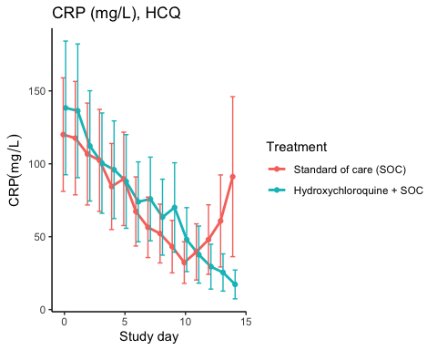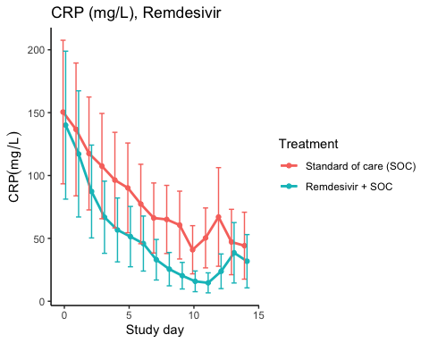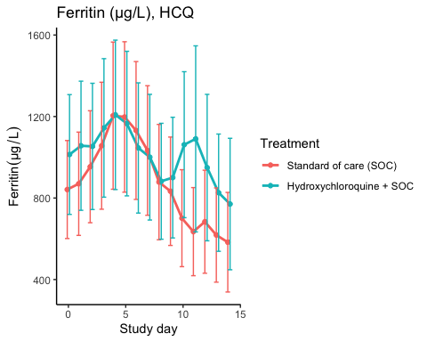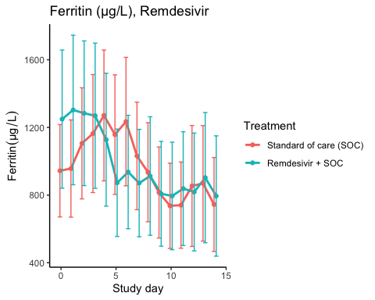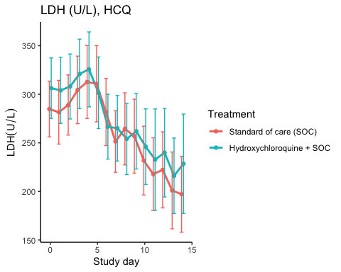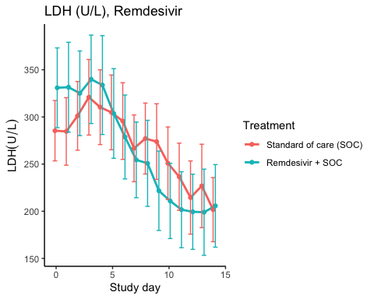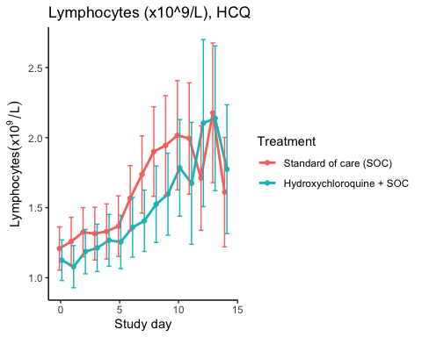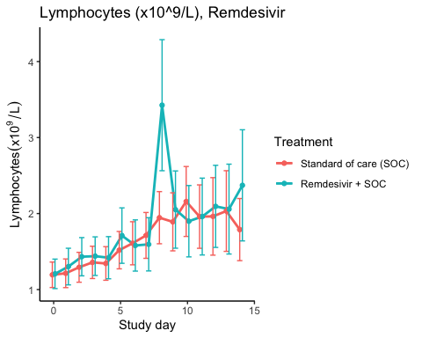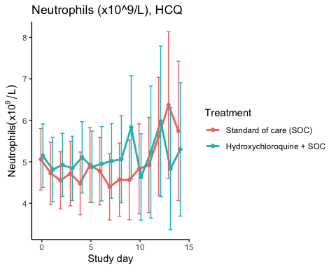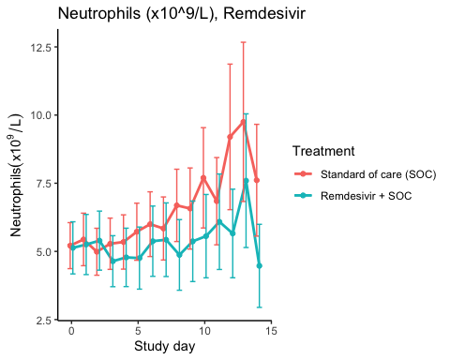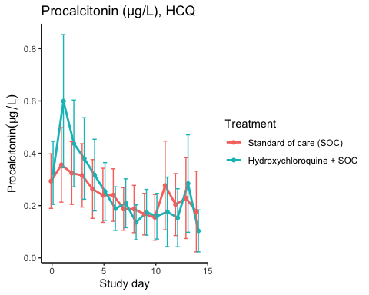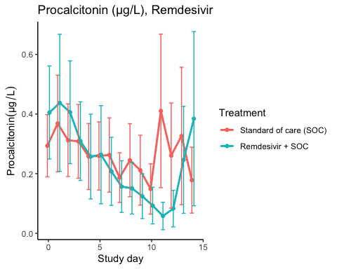

Efficacy estimates
CRP (mg/L), HCQ
Estimator | Treatment | Estimate | Lower 95% CL | Upper 95% CL | P-value
Slope 1st week by treatment | Standard of care (SOC) | -10.388 | -14.618 | -6.158 | 0.000
Slope 1st week by treatment | Hydroxychloroquine + SOC | -8.250 | -12.288 | -4.212 | 0.000
Difference in 1st week slope | Hydroxychloroquine + SOC | 2.138 | -3.378 | 7.655 | 0.447
Day 10 level by treatment | Standard of care (SOC) | 54.715 | 37.632 | 71.798 | 0.000
Day 10 level by treatment | Hydroxychloroquine + SOC | 43.973 | 29.907 | 58.039 | 0.000
Day 10 treatment difference | Hydroxychloroquine + SOC | -10.742 | -31.500 | 10.016 | 0.310

CRP (mg/L), Remdesivir
Estimator | Treatment | Estimate | Lower 95% CL | Upper 95% CL | P-value
Slope 1st week by treatment | Standard of care (SOC) | -11.188 | -16.511 | -5.865 | 0.000
Slope 1st week by treatment | Remdesivir + SOC | -15.543 | -22.193 | -8.893 | 0.000
Difference in 1st week slope | Remdesivir + SOC | -4.355 | -12.034 | 3.324 | 0.266
Day 10 level by treatment | Standard of care (SOC) | 56.090 | 36.193 | 75.986 | 0.000
Day 10 level by treatment | Remdesivir + SOC | 25.938 | 15.654 | 36.223 | 0.000
Day 10 treatment difference | Remdesivir + SOC | -30.151 | -50.930 | -9.373 | 0.004

Ferritin (µg/L), HCQ
Estimator | Treatment | Estimate | Lower 95% CL | Upper 95% CL | P-value
Slope 1st week by treatment | Standard of care (SOC) | 35.689 | 15.250 | 56.127 | 0.001
Slope 1st week by treatment | Hydroxychloroquine + SOC | 1.741 | -17.435 | 20.916 | 0.859
Difference in 1st week slope | Hydroxychloroquine + SOC | -33.948 | -62.032 | -5.864 | 0.018
Day 10 level by treatment | Standard of care (SOC) | 793.815 | 568.342 | 1019.288 | 0.000
Day 10 level by treatment | Hydroxychloroquine + SOC | 954.703 | 680.440 | 1228.965 | 0.000
Day 10 treatment difference | Hydroxychloroquine + SOC | 160.888 | -164.668 | 486.443 | 0.333

Ferritin (µg/L), Remdesivir
Estimator | Treatment | Estimate | Lower 95% CL | Upper 95% CL | P-value
Slope 1st week by treatment | Standard of care (SOC) | 16.912 | -3.383 | 37.206 | 0.102
Slope 1st week by treatment | Remdesivir + SOC | -63.202 | -95.031 | -31.373 | 0.000
Difference in 1st week slope | Remdesivir + SOC | -80.114 | -118.118 | -42.110 | 0.000
Day 10 level by treatment | Standard of care (SOC) | 894.199 | 639.446 | 1148.953 | 0.000
Day 10 level by treatment | Remdesivir + SOC | 863.890 | 583.578 | 1144.202 | 0.000
Day 10 treatment difference | Remdesivir + SOC | -30.310 | -377.642 | 317.023 | 0.864

LDH (U/L), HCQ
Estimator | Treatment | Estimate | Lower 95% CL | Upper 95% CL | P-value
Slope 1st week by treatment | Standard of care (SOC) | -1.345 | -4.704 | 2.014 | 0.432
Slope 1st week by treatment | Hydroxychloroquine + SOC | -5.275 | -8.735 | -1.816 | 0.003
Difference in 1st week slope | Hydroxychloroquine + SOC | -3.930 | -8.736 | 0.875 | 0.109
Day 10 level by treatment | Standard of care (SOC) | 239.448 | 215.635 | 263.260 | 0.000
Day 10 level by treatment | Hydroxychloroquine + SOC | 250.169 | 224.334 | 276.004 | 0.000
Day 10 treatment difference | Hydroxychloroquine + SOC | 10.722 | -24.293 | 45.736 | 0.548

LDH (U/L), Remdesivir
Estimator | Treatment | Estimate | Lower 95% CL | Upper 95% CL | P-value
Slope 1st week by treatment | Standard of care (SOC) | 0.298 | -2.903 | 3.500 | 0.855
Slope 1st week by treatment | Remdesivir + SOC | -10.164 | -14.364 | -5.963 | 0.000
Difference in 1st week slope | Remdesivir + SOC | -10.462 | -15.726 | -5.197 | 0.000
Day 10 level by treatment | Standard of care (SOC) | 252.601 | 224.572 | 280.631 | 0.000
Day 10 level by treatment | Remdesivir + SOC | 229.234 | 199.424 | 259.045 | 0.000
Day 10 treatment difference | Remdesivir + SOC | -23.367 | -63.935 | 17.201 | 0.259

Lymphocytes (x10^9/L), HCQ
Estimator | Treatment | Estimate | Lower 95% CL | Upper 95% CL | P-value
Slope 1st week by treatment | Standard of care (SOC) | 0.075 | 0.052 | 0.099 | 0.000
Slope 1st week by treatment | Hydroxychloroquine + SOC | 0.047 | 0.028 | 0.067 | 0.000
Difference in 1st week slope | Hydroxychloroquine + SOC | -0.028 | -0.058 | 0.002 | 0.072
Day 10 level by treatment | Standard of care (SOC) | 1.828 | 1.598 | 2.058 | 0.000
Day 10 level by treatment | Hydroxychloroquine + SOC | 1.681 | 1.461 | 1.900 | 0.000
Day 10 treatment difference | Hydroxychloroquine + SOC | -0.148 | -0.459 | 0.164 | 0.353

Lymphocytes (x10^9/L), Remdesivir
Estimator | Treatment | Estimate | Lower 95% CL | Upper 95% CL | P-value
Slope 1st week by treatment | Standard of care (SOC) | 0.089 | 0.061 | 0.117 | 0.000
Slope 1st week by treatment | Remdesivir + SOC | 0.105 | 0.065 | 0.144 | 0.000
Difference in 1st week slope | Remdesivir + SOC | 0.016 | -0.032 | 0.064 | 0.520
Day 10 level by treatment | Standard of care (SOC) | 1.870 | 1.615 | 2.125 | 0.000
Day 10 level by treatment | Remdesivir + SOC | 2.027 | 1.699 | 2.355 | 0.000
Day 10 treatment difference | Remdesivir + SOC | 0.157 | -0.247 | 0.561 | 0.447

Neutrophils (x10^9/L), HCQ
Estimator | Treatment | Estimate | Lower 95% CL | Upper 95% CL | P-value
Slope 1st week by treatment | Standard of care (SOC) | -0.062 | -0.139 | 0.016 | 0.119
Slope 1st week by treatment | Hydroxychloroquine + SOC | 0.002 | -0.082 | 0.086 | 0.958
Difference in 1st week slope | Hydroxychloroquine + SOC | 0.064 | -0.050 | 0.178 | 0.272
Day 10 level by treatment | Standard of care (SOC) | 5.035 | 4.318 | 5.752 | 0.000
Day 10 level by treatment | Hydroxychloroquine + SOC | 5.175 | 4.402 | 5.947 | 0.000
Day 10 treatment difference | Hydroxychloroquine + SOC | 0.140 | -0.902 | 1.181 | 0.793

Neutrophils (x10^9/L), Remdesivir
Estimator | Treatment | Estimate | Lower 95% CL | Upper 95% CL | P-value
Slope 1st week by treatment | Standard of care (SOC) | 0.132 | 0.025 | 0.238 | 0.015
Slope 1st week by treatment | Remdesivir + SOC | -0.011 | -0.126 | 0.105 | 0.858
Difference in 1st week slope | Remdesivir + SOC | -0.142 | -0.299 | 0.015 | 0.075
Day 10 level by treatment | Standard of care (SOC) | 7.108 | 5.992 | 8.223 | 0.000
Day 10 level by treatment | Remdesivir + SOC | 5.480 | 4.482 | 6.478 | 0.000
Day 10 treatment difference | Remdesivir + SOC | -1.628 | -3.101 | -0.155 | 0.030

Procalcitonin (µg/L), HCQ
Estimator | Treatment | Estimate | Lower 95% CL | Upper 95% CL | P-value
Slope 1st week by treatment | Standard of care (SOC) | -0.019 | -0.033 | -0.006 | 0.005
Slope 1st week by treatment | Hydroxychloroquine + SOC | -0.040 | -0.060 | -0.020 | 0.000
Difference in 1st week slope | Hydroxychloroquine + SOC | -0.021 | -0.044 | 0.003 | 0.082
Day 10 level by treatment | Standard of care (SOC) | 0.212 | 0.138 | 0.287 | 0.000
Day 10 level by treatment | Hydroxychloroquine + SOC | 0.187 | 0.119 | 0.255 | 0.000
Day 10 treatment difference | Hydroxychloroquine + SOC | -0.025 | -0.120 | 0.070 | 0.600

Procalcitonin (µg/L), Remdesivir
Estimator | Treatment | Estimate | Lower 95% CL | Upper 95% CL | P-value
Slope 1st week by treatment | Standard of care (SOC) | -0.013 | -0.028 | 0.001 | 0.074
Slope 1st week by treatment | Remdesivir + SOC | -0.048 | -0.072 | -0.024 | 0.000
Difference in 1st week slope | Remdesivir + SOC | -0.034 | -0.062 | -0.007 | 0.014
Day 10 level by treatment | Standard of care (SOC) | 0.249 | 0.162 | 0.336 | 0.000
Day 10 level by treatment | Remdesivir + SOC | 0.163 | 0.098 | 0.229 | 0.000
Day 10 treatment difference | Remdesivir + SOC | -0.086 | -0.191 | 0.018 | 0.106

SARS-CoV2 antibodies at day 90

Descriptives
Hydroxychloroquine
Outcome | Statistic | Standard of care (SOC) | Hydroxychloroquine + SOC
Receptor-bindind domain | Mean (SD) | 60.1 (48.5) | 61.7 (37.3)
 | Median (IQR) | 53.6 (19.5 - 89.3) | 63.9 (32.8 - 97.9)
Normalised receptor-binding domain | Mean (SD) | 17.6 (11.9) | 18.7 (9.6)
 | Median (IQR) | 13.8 (8 - 28.4) | 18.3 (12 - 25.1)
log10 ACE2 receptor-binding domain | Mean (SD) | 1.3 (0.66) | 1.23 (0.66)
 | Median (IQR) | 1.31 (0.93 - 1.66) | 1.22 (0.69 - 1.79)

Remdesivir
Outcome | Statistic | Standard of care (SOC) | Remdesivir + SOC
Receptor-bindind domain | Mean (SD) | 65.9 (44) | 48.4 (39.2)
 | Median (IQR) | 59.1 (31.3 - 91.2) | 52.9 (10.2 - 78.6)
Normalised receptor-binding domain | Mean (SD) | 18.7 (11.4) | 14.9 (12)
 | Median (IQR) | 16 (11.3 - 26.3) | 14.2 (4.6 - 25)
log10 ACE2 receptor-binding domain | Mean (SD) | 1.09 (0.54) | 1.07 (0.68)
 | Median (IQR) | 1.19 (0.75 - 1.46) | 1.23 (0.4 - 1.43)

Marginal probability estimates by treatment group and difference
Hydroxychloroquine
Outcome | Standard of care (SOC) | Hydroxychloroquine + SOC | Estimated marginal treatment effect
Receptor-bindind domain | 60.1 (48.4 to 71.7) | 61.7 (49.2 to 74.2) | 1.6 (-15.5 to 18.7)
Normalised receptor-binding domain | 17.6 (14.6 to 20.5) | 18.7 (15.6 to 21.9) | 1.2 (-3.1 to 5.5)
log10 ACE2 receptor-binding domain | 1.3 (1.13 to 1.48) | 1.23 (1.04 to 1.41) | -0.08 (-0.33 to 0.18)
Estimates are presented with 95% confidence limits
Remdesivir
Outcome | Standard of care (SOC) | Remdesivir + SOC | Estimated marginal treatment effect
Receptor-bindind domain | 65.9 (51.7 to 80) | 48.4 (32.5 to 64.2) | -17.5 (-38.8 to 3.7)
Normalised receptor-binding domain | 18.7 (14.7 to 22.6) | 14.9 (10.5 to 19.4) | -3.7 (-9.6 to 2.2)
log10 ACE2 receptor-binding domain | 1.09 (0.89 to 1.3) | 1.07 (0.84 to 1.3) | -0.03 (-0.33 to 0.28)
Estimates are presented with 95% confidence limits

Time to last discharge

HCQ
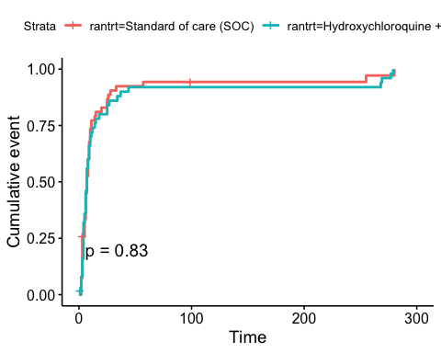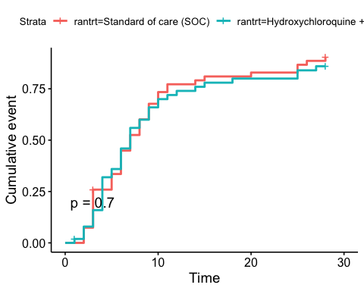

Remdesivir
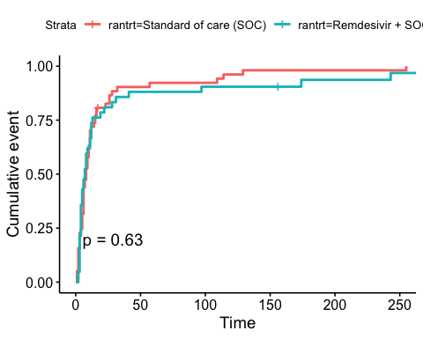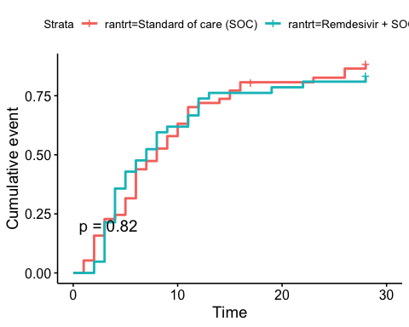

Adverse Events

AE Summary
Summary of Adverse Events
Parameter | SOC (N=87) | SOC + HCQ (N=52) | SOC + Remdesivir (N=42)
Number of AEs | [33] 22 (25.3%) | [34] 20 (38.5%) | [26] 16 (38.1%)
Number of patients with any AEs? | 22 (25.3%) | 20 (38.5%) | 16 (38.1%)
Number of patients with one AE | 15 (17.2%) | 14 (26.9%) | 11 (26.2%)
Number of patients with two AE | 3 (3.4%) | 2 (3.8%) | 1 (2.4%)
Number of patients with three or more AEs | 4 (4.6%) | 4 (7.7%) | 4 (9.5%)
Number of SAEs | [20] 13 (14.9%) | [13] 8 (15.4%) | [12] 10 (23.8%)
Number of patients with any SAEs? | 13 (14.9%) | 8 (15.4%) | 10 (23.8%)
The numbers are [Number of events] Number of patients (percentage of patients), or Number of patients (percentage of patients)

By System Organ Class and Preferred Term
Adverse Events by System Organ Class and Preferred term
System Organ Class | Preferred Term | SOC (N=87) | SOC + HCQ (N=52) | SOC + Remdesivir (N=42)
Blood and lymphatic system disorders | #Total |  | [2] 1 (1.9%)
 | Leukopenia |  | [1] 1 (1.9%)
 | Thrombocytopenia |  | [1] 1 (1.9%)
Cardiac disorders | #Total | [1] 1 (1.1%) |  | [3] 2 (4.8%)
 | Arrhythmia |  |  | [2] 1 (2.4%)
 | Ventricular tachycardia | [1] 1 (1.1%) |  | [1] 1 (2.4%)
Gastrointestinal disorders | #Total | [2] 2 (2.3%) | [4] 4 (7.7%) | [4] 3 (7.1%)
 | Abdominal pain | [1] 1 (1.1%)
 | Diarrhoea | [1] 1 (1.1%)
 | Diarrhoea haemorrhagic |  |  | [1] 1 (2.4%)
 | Gastrooesophageal reflux disease |  | [1] 1 (1.9%)
 | Intestinal pseudo-obstruction |  | [1] 1 (1.9%)
 | Nausea |  |  | [2] 2 (4.8%)
 | Pancreatic failure |  | [1] 1 (1.9%)
 | Vomiting |  | [1] 1 (1.9%) | [1] 1 (2.4%)
General disorders and administration site conditions | #Total | [3] 3 (3.4%) |  | [2] 2 (4.8%)
 | Chest pain |  |  | [1] 1 (2.4%)
 | General physical health deterioration | [1] 1 (1.1%)
 | Medical device site reaction |  |  | [1] 1 (2.4%)
 | Pyrexia | [2] 2 (2.3%)
Hepatobiliary disorders | #Total | [1] 1 (1.1%)
 | Cholecystitis | [1] 1 (1.1%)
Infections and infestations | #Total | [4] 4 (4.6%) | [1] 1 (1.9%)
 | COVID-19 |  | [1] 1 (1.9%)
 | Infection | [1] 1 (1.1%)
 | Pneumonia bacterial | [2] 2 (2.3%)
 | Superinfection bacterial | [1] 1 (1.1%)
Injury, poisoning and procedural complications | #Total | [2] 2 (2.3%)
 | Hepatobiliary procedural complication | [1] 1 (1.1%)
 | Procedural pneumothorax | [1] 1 (1.1%)
Investigations | #Total | [5] 3 (3.4%) | [10] 6 (11.5%) | [4] 4 (9.5%)
 | Alanine aminotransferase increased | [2] 1 (1.1%) | [2] 2 (3.8%)
 | Amylase increased |  | [1] 1 (1.9%)
 | Aspartate aminotransferase increased | [1] 1 (1.1%) | [3] 3 (5.8%) | [1] 1 (2.4%)
 | Blood creatine phosphokinase increased |  | [1] 1 (1.9%)
 | Electrocardiogram QT prolonged |  | [2] 2 (3.8%)
 | Fibrin D dimer increased | [1] 1 (1.1%)
 | Gamma-glutamyltransferase increased |  | [1] 1 (1.9%)
 | Hepatic enzyme increased |  |  | [2] 2 (4.8%)
 | Myocardial necrosis marker increased | [1] 1 (1.1%)
 | Neutrophil count decreased |  |  | [1] 1 (2.4%)
Metabolism and nutrition disorders | #Total |  | [1] 1 (1.9%)
 | Hypercalcaemia |  | [1] 1 (1.9%)
Musculoskeletal and connective tissue disorders | #Total |  | [4] 2 (3.8%)
 | Arthralgia |  | [1] 1 (1.9%)
 | Arthritis reactive |  | [1] 1 (1.9%)
 | Joint swelling |  | [1] 1 (1.9%)
 | Tendonitis |  | [1] 1 (1.9%)
Neoplasms benign, malignant and unspecified (incl cysts and polyps) | #Total | [1] 1 (1.1%)
 | Neoplasm malignant | [1] 1 (1.1%)
Nervous system disorders | #Total | [2] 2 (2.3%) | [1] 1 (1.9%) | [2] 2 (4.8%)
 | Haemorrhage intracranial | [1] 1 (1.1%)
 | Headache |  |  | [1] 1 (2.4%)
 | Loss of consciousness |  |  | [1] 1 (2.4%)
 | Syncope | [1] 1 (1.1%) | [1] 1 (1.9%)
Renal and urinary disorders | #Total | [1] 1 (1.1%) | [1] 1 (1.9%)
 | Renal failure | [1] 1 (1.1%) | [1] 1 (1.9%)
Respiratory, thoracic and mediastinal disorders | #Total | [10] 8 (9.2%) | [9] 7 (13.5%) | [8] 6 (14.3%)
 | Bronchopleural fistula |  |  | [1] 1 (2.4%)
 | Chronic obstructive pulmonary disease |  |  | [2] 1 (2.4%)
 | Cough | [1] 1 (1.1%)
 | Dyspnoea | [3] 1 (1.1%) |  | [1] 1 (2.4%)
 | Pulmonary embolism |  | [1] 1 (1.9%)
 | Respiratory distress | [3] 3 (3.4%) | [4] 3 (5.8%) | [1] 1 (2.4%)
 | Respiratory failure | [3] 3 (3.4%) | [4] 4 (7.7%) | [3] 2 (4.8%)
Skin and subcutaneous tissue disorders | #Total |  |  | [2] 2 (4.8%)
 | Alopecia |  |  | [2] 2 (4.8%)
Vascular disorders | #Total | [1] 1 (1.1%) | [1] 1 (1.9%) | [1] 1 (2.4%)
 | Hypotension |  |  | [1] 1 (2.4%)
 | Thrombophlebitis |  | [1] 1 (1.9%)
 | Thrombosis | [1] 1 (1.1%)

Serious Adverse Events
Serious Adverse Events by System Organ Class and Preferred term
System Organ Class | Preferred Term | SOC (N=87) | SOC + HCQ (N=52) | SOC + Remdesivir (N=42)
Gastrointestinal disorders | #Total | [1] 1 (1.1%) |  | [1] 1 (2.4%)
 | Abdominal pain | [1] 1 (1.1%)
 | Diarrhoea haemorrhagic |  |  | [1] 1 (2.4%)
General disorders and administration site conditions | #Total | [2] 2 (2.3%) |  | [1] 1 (2.4%)
 | Chest pain |  |  | [1] 1 (2.4%)
 | General physical health deterioration | [1] 1 (1.1%)
 | Pyrexia | [1] 1 (1.1%)
Hepatobiliary disorders | #Total | [1] 1 (1.1%)
 | Cholecystitis | [1] 1 (1.1%)
Infections and infestations | #Total | [2] 2 (2.3%) | [1] 1 (1.9%)
 | COVID-19 |  | [1] 1 (1.9%)
 | Pneumonia bacterial | [1] 1 (1.1%)
 | Superinfection bacterial | [1] 1 (1.1%)
Injury, poisoning and procedural complications | #Total | [2] 2 (2.3%)
 | Hepatobiliary procedural complication | [1] 1 (1.1%)
 | Procedural pneumothorax | [1] 1 (1.1%)
Investigations | #Total | [1] 1 (1.1%) | [2] 2 (3.8%) | [2] 2 (4.8%)
 | Alanine aminotransferase increased | [1] 1 (1.1%)
 | Aspartate aminotransferase increased |  | [1] 1 (1.9%)
 | Blood creatine phosphokinase increased |  | [1] 1 (1.9%)
 | Hepatic enzyme increased |  |  | [2] 2 (4.8%)
Neoplasms benign, malignant and unspecified (incl cysts and polyps) | #Total | [1] 1 (1.1%)
 | Neoplasm malignant | [1] 1 (1.1%)
Nervous system disorders | #Total | [1] 1 (1.1%) |  | [1] 1 (2.4%)
 | Haemorrhage intracranial | [1] 1 (1.1%)
 | Loss of consciousness |  |  | [1] 1 (2.4%)
Renal and urinary disorders | #Total | [1] 1 (1.1%) | [1] 1 (1.9%)
 | Renal failure | [1] 1 (1.1%) | [1] 1 (1.9%)
Respiratory, thoracic and mediastinal disorders | #Total | [8] 6 (6.9%) | [9] 7 (13.5%) | [7] 5 (11.9%)
 | Bronchopleural fistula |  |  | [1] 1 (2.4%)
 | Chronic obstructive pulmonary disease |  |  | [2] 1 (2.4%)
 | Dyspnoea | [3] 1 (1.1%) |  | [1] 1 (2.4%)
 | Pulmonary embolism |  | [1] 1 (1.9%)
 | Respiratory distress | [3] 3 (3.4%) | [4] 3 (5.8%)
 | Respiratory failure | [2] 2 (2.3%) | [4] 4 (7.7%) | [3] 2 (4.8%)

Suspected Unexpected Serious Adverse Reaction
Suspected Unexpected Serious Adverse Reaction by System Organ Class and Preferred term
System Organ Class | Preferred Term | Remdesivir + SOC
Gastrointestinal disorders | #Total | [1] 1 (2.4%)
 | Diarrhoea haemorrhagic | [1] 1 (2.4%)
END

