NOR-SOLIDARITY First Interim Report
Inge Christoffer Olsen, PhD
13 December, 2020

Introduction
This is the report for the first interim analysis of the NOR-SOLIDARITY trial. The data are based on an export from the Viedoc electronic data capture at “2020-10-16 08:41:09” system time stamped “ous_20201016_084109”. While the results are based on real data, the treatment allocation has been drawn randomly for this report. Thus, this is a mock-up report intended to show how the final report will look like, without showing the actual results of the trial and the treatment differences. There were 181 included patients.

Inclusion status

Inclusion rate
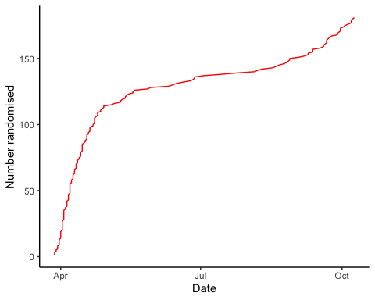

Inclusion by hospital
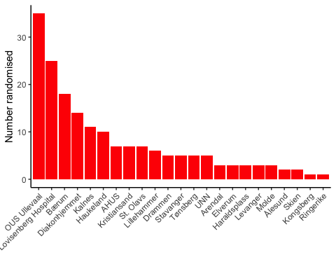

By treatment
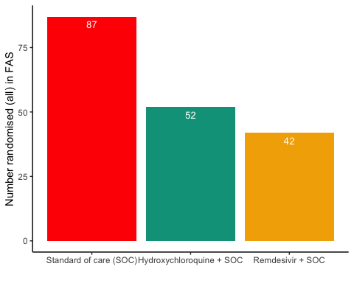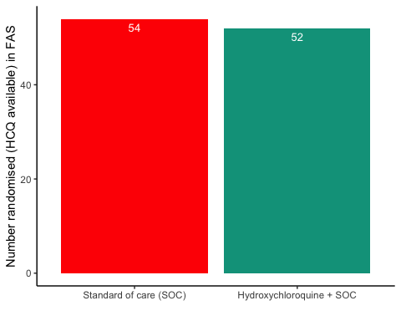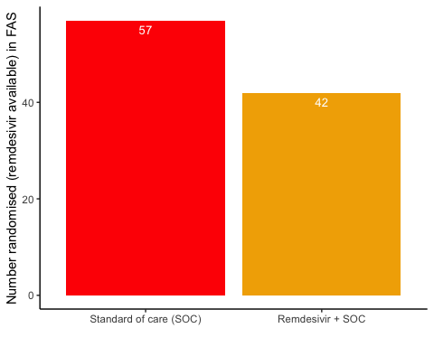

#Patient flow
## Note: Using an external vector in selections is ambiguous.
## ℹ Use `all_of(group)` instead of `group` to silence this message.
## ℹ See <https://tidyselect.r-lib.org/reference/faq-external-vector.html>.
## This message is displayed once per session.
Patient flow total
Parameter | Total
Enrolled | 181 (100%)
Randomised | 181 (100%)
Included in FAS | 181 (100%)
Excluded from FAS, No post-randomisation information | 0 (0%)
Excluded from FAS, incorrect inclusion | 0 (0%)

Patient flow by arm
Parameter | SOC | SOC + HCQ | SOC + Remdesivir
Randomised | 87 (100%) | 52 (100%) | 42 (100%)
Included in FAS | 87 (100%) | 52 (100%) | 42 (100%)
Excluded from FAS, No post-randomisation information | 0 (0%) | 0 (0%) | 0 (0%)
Excluded from FAS, incorrect inclusion | 0 (0%) | 0 (0%) | 0 (0%)

Demographics
Demographics, all arms (FAS)
Parameter | SOC (N=87) | SOC + HCQ (N=52) | SOC + Remdesivir (N=42)
Age (years) | 59.9 (15.7) | 60.7 (13.9) | 58.4 (16.6)
Female, n (%) | 30 (34.5%) | 15 (28.8%) | 17 (40.5%)
Admitted to ward, n(%) | 82 (94.3%) | 51 (98.1%) | 38 (90.5%)
Admitted to ICU, n(%) | 5 (5.7%) | 1 (1.9%) | 4 (9.5%)
WHO Moderate disease state (4-5), n(%) | 83 (95.4%) | 51 (98.1%) | 37 (88.1%)
WHO Severe disease state (6-9), n(%) | 4 (4.6%) | 1 (1.9%) | 5 (11.9%)
WHO Severe disease state (6), n(%) | 1 (1.1%) | 1 (1.9%) | 3 (7.1%)
Body Mass Index (kg/m²) mean | 28 (5) | 27 (4) | 29 (6)
Body Mass Index (kg/m²) median | 27 (25 - 30) | 27 (25 - 29) | 29 (25 - 33)
Obese (BMI > 30 kg/m²), n(%) | 20 (23%) | 9 (17.3%) | 15 (35.7%)
Systolic Blood Pressure (mmHg) | 125 (18) | 126 (16) | 125 (19)
Diastolic Blood Pressure (mmHg) | 73 (12) | 74 (9) | 75 (11)
Mean Arterial Blood Pressure (mmHg) | 90 (13) | 91 (10) | 92 (12)
Temperature (°C) | 37.6 (0.9) | 37.3 (0.9) | 37.2 (0.9)
SOFA score | 1.5 (1.5) | 1.5 (1) | 1.8 (2.3)
Comorbidities or risk factors
Chronic cardiac disease, including congenital heart disease | 15 (17.2%) | 8 (15.4%) | 5 (11.9%)
Ever smoking, n(%) | 36 (41.4%) | 17 (32.7%) | 18 (42.9%)
Hypertension, n(%) | 27 (31%) | 15 (28.8%) | 13 (31%)
Chronic pulmonary disease, n(%) | 7 (8%) | 2 (3.8%) | 1 (2.4%)
Chronic kidney disease, n(%) | 4 (4.6%) | 4 (7.7%) | 3 (7.1%)
Autoimmune disease, n(%) | 2 (2.3%) | 3 (5.8%) | 3 (7.1%)
Diabetes, n(%) | 20 (23%) | 5 (9.6%) | 6 (14.3%)
Cognitive impairment/dementia, n(%) | 2 (2.3%) | 1 (1.9%) | 1 (2.4%)
Neurological disorder, n(%) | 5 (5.7%) | 2 (3.8%) | 0 (0%)
Cancer, n(%) | 7 (8%) | 3 (5.8%) | 3 (7.1%)
Cirrhosis, n(%) | 0 (0%) | 0 (0%) | 0 (0%)
Asthma, n(%) | 9 (10.3%) | 4 (7.7%) | 9 (21.4%)
HIV, n(%) | 0 (0%) | 0 (0%) | 0 (0%)
Active TB, n(%) | 0 (0%) | 0 (0%) | 0 (0%)
Co-medications
Steroids | 4 (4.6%) | 1 (1.9%) | 3 (7.1%)
Other immunomodulatory drugs | 2 (2.3%) | 2 (3.8%) | 4 (9.5%)
ACE inhibitor | 4 (4.6%) | 6 (11.5%) | 2 (4.8%)
AT-II blockers | 16 (18.4%) | 7 (13.5%) | 7 (16.7%)
Median Laboratory values (IQR)
Ferritin result | 624 (335 - 1152.5) | 722 (295 - 1400) | 532 (331 - 1038)
D-dimer result | 0.6 (0.4 - 1) | 0.8 (0.4 - 1.3) | 0.8 (0.6 - 1.1)
AST result | 44 (27 - 63) | 41 (29 - 61) | 35 (24.8 - 52.8)
ALT result | 31.5 (22 - 57.8) | 41 (19.2 - 66.8) | 30 (20 - 46)
LD result | 292 (219 - 366) | 268.5 (209.8 - 314.2) | 275.5 (207.8 - 352.2)
CRP result | 76 (30 - 150) | 69 (47 - 128.8) | 67.5 (36.2 - 134.2)
Procalcitonin result | 0.1 (0.1 - 0.3) | 0.1 (0.1 - 0.2) | 0.1 (0.1 - 0.2)
Hemoglobin result | 13.2 (12.5 - 14.1) | 13.4 (12.1 - 14.1) | 13.1 (12.4 - 14.1)
Platelet counts result | 195.5 (164.5 - 268.2) | 207 (152 - 268.8) | 205 (145.5 - 313.2)
Neutrophils result | 4.5 (3.1 - 7.1) | 3.7 (2.8 - 5.8) | 4.6 (3 - 6.5)
Lymphocytes result | 1.1 (0.8 - 1.4) | 1 (0.6 - 1.4) | 1.1 (0.9 - 1.2)
WBC result | 6.2 (4.8 - 9.1) | 5.7 (4.2 - 7.5) | 6.3 (4.6 - 8)

Demographics, HCQ (FAS)
Parameter | SOC (N=54) | SOC + HCQ (N=52)
Age (years) | 61.1 (16.5) | 60.7 (13.9)
Female, n (%) | 19 (35.2%) | 15 (28.8%)
Admitted to ward, n(%) | 50 (92.6%) | 51 (98.1%)
Admitted to ICU, n(%) | 4 (7.4%) | 1 (1.9%)
WHO Moderate disease state (4-5), n(%) | 51 (94.4%) | 51 (98.1%)
WHO Severe disease state (6-9), n(%) | 3 (5.6%) | 1 (1.9%)
WHO Severe disease state (6), n(%) | 1 (1.9%) | 1 (1.9%)
Body Mass Index (kg/m²) mean | 28 (5) | 27 (4)
Body Mass Index (kg/m²) median | 27 (25 - 29) | 27 (25 - 29)
Obese (BMI > 30 kg/m²), n(%) | 11 (20.4%) | 9 (17.3%)
Systolic Blood Pressure (mmHg) | 125 (18) | 126 (16)
Diastolic Blood Pressure (mmHg) | 74 (14) | 74 (9)
Mean Arterial Blood Pressure (mmHg) | 91 (14) | 91 (10)
Temperature (°C) | 37.5 (0.9) | 37.3 (0.9)
SOFA score | 1.5 (1.3) | 1.5 (1)
Comorbidities or risk factors
Chronic cardiac disease, including congenital heart disease | 10 (18.5%) | 8 (15.4%)
Ever smoking, n(%) | 19 (35.2%) | 17 (32.7%)
Hypertension, n(%) | 19 (35.2%) | 15 (28.8%)
Chronic pulmonary disease, n(%) | 3 (5.6%) | 2 (3.8%)
Chronic kidney disease, n(%) | 3 (5.6%) | 4 (7.7%)
Autoimmune disease, n(%) | 1 (1.9%) | 3 (5.8%)
Diabetes, n(%) | 12 (22.2%) | 5 (9.6%)
Cognitive impairment/dementia, n(%) | 2 (3.7%) | 1 (1.9%)
Neurological disorder, n(%) | 4 (7.4%) | 2 (3.8%)
Cancer, n(%) | 5 (9.3%) | 3 (5.8%)
Cirrhosis, n(%) | 0 (0%) | 0 (0%)
Asthma, n(%) | 7 (13%) | 4 (7.7%)
HIV, n(%) | 0 (0%) | 0 (0%)
Active TB, n(%) | 0 (0%) | 0 (0%)
Co-medications
Steroids | 1 (1.9%) | 1 (1.9%)
Other immunomodulatory drugs | 2 (3.7%) | 2 (3.8%)
ACE inhibitor | 3 (5.6%) | 6 (11.5%)
AT-II blockers | 11 (20.4%) | 7 (13.5%)
Median Laboratory values (IQR)
Ferritin result | 677 (354.2 - 1143) | 722 (295 - 1400)
D-dimer result | 0.6 (0.5 - 1) | 0.8 (0.4 - 1.3)
AST result | 45 (25.5 - 65.5) | 41 (29 - 61)
ALT result | 29.5 (20 - 60) | 41 (19.2 - 66.8)
LD result | 292 (228 - 367) | 268.5 (209.8 - 314.2)
CRP result | 76 (31 - 158.8) | 69 (47 - 128.8)
Procalcitonin result | 0.2 (0.1 - 0.3) | 0.1 (0.1 - 0.2)
Hemoglobin result | 13.2 (12.6 - 14.1) | 13.4 (12.1 - 14.1)
Platelet counts result | 184 (162 - 253) | 207 (152 - 268.8)
Neutrophils result | 4.7 (2.9 - 6.6) | 3.7 (2.8 - 5.8)
Lymphocytes result | 1.1 (0.8 - 1.5) | 1 (0.6 - 1.4)
WBC result | 6 (4.5 - 9) | 5.7 (4.2 - 7.5)

Demographics, Remdesivir (FAS)
Parameter | SOC (N=57) | SOC + Remdesivir (N=42)
Age (years) | 58.8 (15) | 58.4 (16.6)
Female, n (%) | 20 (35.1%) | 17 (40.5%)
Admitted to ward, n(%) | 55 (96.5%) | 38 (90.5%)
Admitted to ICU, n(%) | 2 (3.5%) | 4 (9.5%)
WHO Moderate disease state (4-5), n(%) | 55 (96.5%) | 37 (88.1%)
WHO Severe disease state (6-9), n(%) | 2 (3.5%) | 5 (11.9%)
WHO Severe disease state (6), n(%) | NA | 3 (7.1%)
Body Mass Index (kg/m²) mean | 28 (5) | 29 (6)
Body Mass Index (kg/m²) median | 27 (25 - 32) | 29 (25 - 33)
Obese (BMI > 30 kg/m²), n(%) | 16 (28.1%) | 15 (35.7%)
Systolic Blood Pressure (mmHg) | 125 (18) | 125 (19)
Diastolic Blood Pressure (mmHg) | 73 (13) | 75 (11)
Mean Arterial Blood Pressure (mmHg) | 90 (13) | 92 (12)
Temperature (°C) | 37.6 (1) | 37.2 (0.9)
SOFA score | 1.5 (1.6) | 1.8 (2.3)
Comorbidities or risk factors
Chronic cardiac disease, including congenital heart disease | 8 (14%) | 5 (11.9%)
Ever smoking, n(%) | 21 (36.8%) | 18 (42.9%)
Hypertension, n(%) | 18 (31.6%) | 13 (31%)
Chronic pulmonary disease, n(%) | 4 (7%) | 1 (2.4%)
Chronic kidney disease, n(%) | 1 (1.8%) | 3 (7.1%)
Autoimmune disease, n(%) | 1 (1.8%) | 3 (7.1%)
Diabetes, n(%) | 15 (26.3%) | 6 (14.3%)
Cognitive impairment/dementia, n(%) | 0 (0%) | 1 (2.4%)
Neurological disorder, n(%) | 2 (3.5%) | 0 (0%)
Cancer, n(%) | 4 (7%) | 3 (7.1%)
Cirrhosis, n(%) | 0 (0%) | 0 (0%)
Asthma, n(%) | 4 (7%) | 9 (21.4%)
HIV, n(%) | 0 (0%) | 0 (0%)
Active TB, n(%) | 0 (0%) | 0 (0%)
Co-medications
Steroids | 3 (5.3%) | 3 (7.1%)
Other immunomodulatory drugs | 0 (0%) | 4 (9.5%)
ACE inhibitor | 2 (3.5%) | 2 (4.8%)
AT-II blockers | 11 (19.3%) | 7 (16.7%)
Median Laboratory values (IQR)
Ferritin result | 618 (356 - 1040) | 532 (331 - 1038)
D-dimer result | 0.6 (0.4 - 1) | 0.8 (0.6 - 1.1)
AST result | 41 (28 - 59.2) | 35 (24.8 - 52.8)
ALT result | 30.5 (22 - 54.5) | 30 (20 - 46)
LD result | 295 (213.2 - 357.8) | 275.5 (207.8 - 352.2)
CRP result | 76 (37.5 - 144.5) | 67.5 (36.2 - 134.2)
Procalcitonin result | 0.1 (0.1 - 0.3) | 0.1 (0.1 - 0.2)
Hemoglobin result | 13.2 (12.4 - 14.1) | 13.1 (12.4 - 14.1)
Platelet counts result | 205 (167.8 - 278.2) | 205 (145.5 - 313.2)
Neutrophils result | 4.5 (3.2 - 7.8) | 4.6 (3 - 6.5)
Lymphocytes result | 1.1 (0.9 - 1.4) | 1.1 (0.9 - 1.2)
WBC result | 6.2 (4.9 - 9.6) | 6.3 (4.6 - 8)

Missing values, all arms (FAS)
Parameter | SOC (N=87) | SOC + HCQ (N=52) | SOC + Remdesivir (N=42)
Age (years) | 0 (0%) | 0 (0%) | 0 (0%)
Female, n (%) | 0 (0%) | 0 (0%) | 0 (0%)
Admitted to ward, n(%) | 0 (0%) | 0 (0%) | 0 (0%)
Admitted to ICU, n(%) | 0 (0%) | 0 (0%) | 0 (0%)
WHO Moderate disease state (4-5), n(%) | 0 (0%) | 0 (0%) | 0 (0%)
WHO Severe disease state (6-9), n(%) | 0 (0%) | 0 (0%) | 0 (0%)
WHO Severe disease state (6), n(%) | 0 (0%) | 0 (0%) | 0 (0%)
Body Mass Index (kg/m²) mean | 8 (9.2%) | 5 (9.6%) | 4 (9.5%)
Body Mass Index (kg/m²) median | 8 (9.2%) | 5 (9.6%) | 4 (9.5%)
Obese (BMI > 30 kg/m²), n(%) | 8 (9.2%) | 5 (9.6%) | 4 (9.5%)
Systolic Blood Pressure (mmHg) | 0 (0%) | 0 (0%) | 0 (0%)
Diastolic Blood Pressure (mmHg) | 0 (0%) | 0 (0%) | 0 (0%)
Mean Arterial Blood Pressure (mmHg) | 0 (0%) | 0 (0%) | 0 (0%)
Temperature (°C) | 0 (0%) | 0 (0%) | 0 (0%)
SOFA score | 8 (9.2%) | 2 (3.8%) | 1 (2.4%)
Comorbidities or risk factors
Chronic cardiac disease, including congenital heart disease | 0 (0%) | 1 (1.9%) | 0 (0%)
Ever smoking, n(%) | 0 (0%) | 1 (1.9%) | 0 (0%)
Hypertension, n(%) | 0 (0%) | 1 (1.9%) | 0 (0%)
Chronic pulmonary disease, n(%) | 0 (0%) | 1 (1.9%) | 0 (0%)
Chronic kidney disease, n(%) | 0 (0%) | 1 (1.9%) | 0 (0%)
Autoimmune disease, n(%) | 0 (0%) | 1 (1.9%) | 0 (0%)
Diabetes, n(%) | 0 (0%) | 1 (1.9%) | 0 (0%)
Cognitive impairment/dementia, n(%) | 0 (0%) | 1 (1.9%) | 0 (0%)
Neurological disorder, n(%) | 0 (0%) | 1 (1.9%) | 0 (0%)
Cancer, n(%) | 0 (0%) | 1 (1.9%) | 0 (0%)
Cirrhosis, n(%) | 0 (0%) | 1 (1.9%) | 0 (0%)
Asthma, n(%) | 0 (0%) | 1 (1.9%) | 0 (0%)
HIV, n(%) | 0 (0%) | 1 (1.9%) | 0 (0%)
Active TB, n(%) | 0 (0%) | 1 (1.9%) | 0 (0%)
Co-medications
Steroids | 1 (1.1%) | 1 (1.9%) | 0 (0%)
Other immunomodulatory drugs | 1 (1.1%) | 1 (1.9%) | 0 (0%)
ACE inhibitor | 1 (1.1%) | 1 (1.9%) | 0 (0%)
AT-II blockers | 1 (1.1%) | 1 (1.9%) | 0 (0%)
Median Laboratory values (IQR)
Ferritin result | 5 (5.7%) | 3 (5.8%) | 1 (2.4%)
D-dimer result | 13 (14.9%) | 3 (5.8%) | 3 (7.1%)
AST result | 10 (11.5%) | 1 (1.9%) | 0 (0%)
ALT result | 5 (5.7%) | 2 (3.8%) | 1 (2.4%)
LD result | 8 (9.2%) | 0 (0%) | 0 (0%)
CRP result | 2 (2.3%) | 0 (0%) | 0 (0%)
Procalcitonin result | 30 (34.5%) | 18 (34.6%) | 10 (23.8%)
Hemoglobin result | 3 (3.4%) | 0 (0%) | 0 (0%)
Platelet counts result | 3 (3.4%) | 0 (0%) | 0 (0%)
Neutrophils result | 7 (8%) | 1 (1.9%) | 2 (4.8%)
Lymphocytes result | 6 (6.9%) | 1 (1.9%) | 2 (4.8%)
WBC result | 1 (1.1%) | 0 (0%) | 0 (0%)

Exposure
Exposure to study treatment
Parameter | SOC + HCQ (N=52) | SOC + Remdesivir (N=42)
Total dose (mg), median (IQR) | 3600 (1000 - 5600) | 1100 (675 - 4800)
Treatment duration, median (IQR) | 5 (3 - 8) | 6 (3 - 9)
Number of doses given, median (IQR) | 6 (4 - 9) | 6 (4 - 9)
Patients with any treatment discrepencies, n (%) | 11 (21.2%) | 9 (21.4%)

Efficacy

Mortality

Descriptives
All arms (FAS)
Treatment | # deaths | # randomised | %
Standard of care (SOC) | 5 | 87 | 5.7
Hydroxychloroquine + SOC | 2 | 52 | 3.8
Remdesivir + SOC | 5 | 42 | 11.9

HCQ (FAS)
Treatment | # deaths | # randomised | %
Standard of care (SOC) | 3 | 54 | 5.6
Hydroxychloroquine + SOC | 2 | 52 | 3.8

Remdesivir (FAS)
Treatment | # deaths | # randomised | %
Standard of care (SOC) | 2 | 57 | 3.5
Remdesivir + SOC | 5 | 42 | 11.9
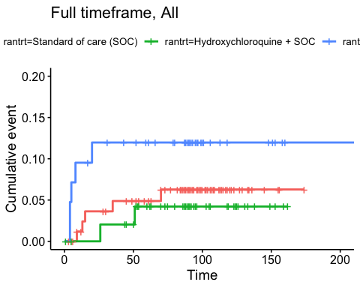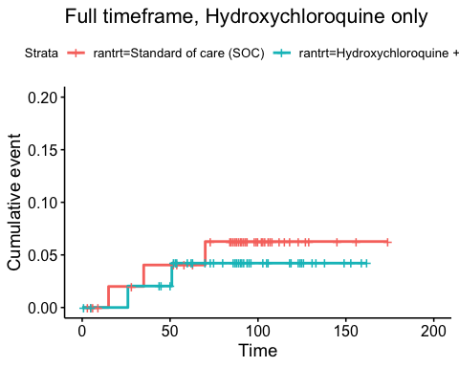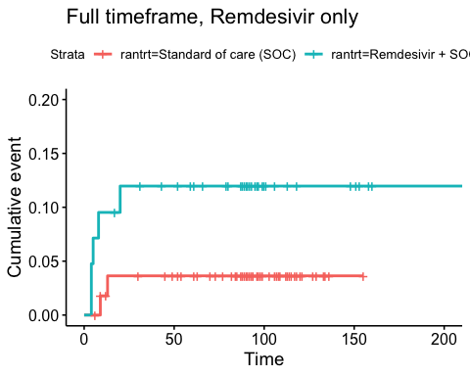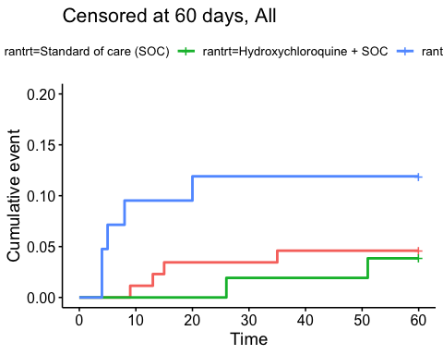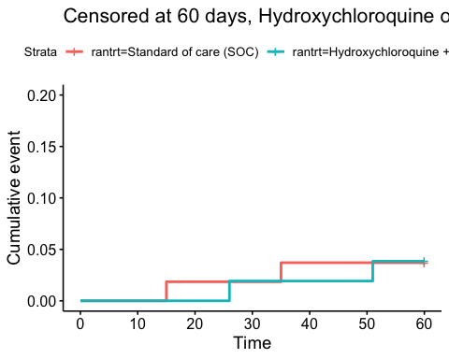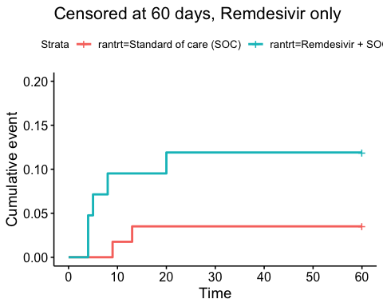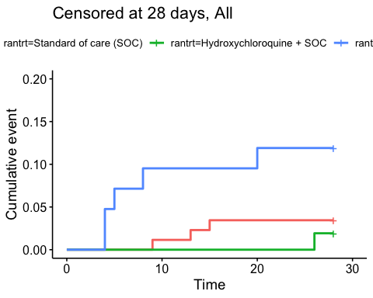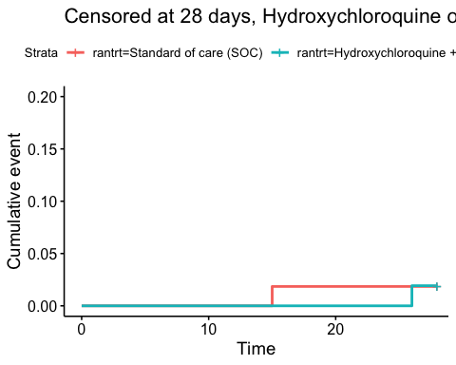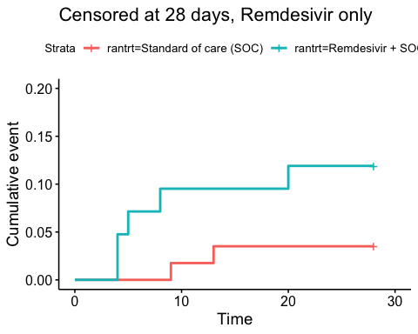
Relative risk estimates and p-values
Timeframe, Population | Relative risk | P-value
Full timeframe, All | Not applicable | 0.260
Full timeframe, Hydroxychloroquine only | 0.7 (95% CI 0.12 to 4.02) | 0.685
Full timeframe, Remdesivir only | 3.43 (95% CI 0.76 to 15.48) | 0.108
Censored at 60 days, All | Not applicable | 0.168
Censored at 60 days, Hydroxychloroquine only | 1.03 (95% CI 0.14 to 7.31) | 0.977
Censored at 60 days, Remdesivir only | 3.51 (95% CI 0.78 to 15.84) | 0.103
Censored at 28 days, All | Not applicable | 0.049
Censored at 28 days, Hydroxychloroquine only | 1.03 (95% CI 0.06 to 16.45) | 0.984
Censored at 28 days, Remdesivir only | 3.51 (95% CI 0.78 to 15.84) | 0.103

CRP result, fas
Days since randomisation | Statistic | Standard of care (SOC) | Hydroxychloroquine + SOC | Remdesivir + SOC
0 days | Mean (SD) | 85.64 (64.76) | 101.6 (72.11) | 90.48 (73.12)
0 days | Median [IQR] | 69 [35 - 127.75] | 87 [42.5 - 149] | 61.5 [46.5 - 118]
0 days | Missing | 1 | 1 | 0
1 days | Mean (SD) | 82.15 (63) | 110.9 (76.83) | 101.22 (78.05)
1 days | Median [IQR] | 66.5 [33.25 - 117.5] | 86.5 [57 - 148.25] | 78 [45 - 139]
1 days | Missing | 17 | 10 | 4
2 days | Mean (SD) | 80.41 (63.06) | 97.59 (88.84) | 93.77 (78.27)
2 days | Median [IQR] | 67 [38 - 116] | 77.5 [29.75 - 118.25] | 70 [49 - 130.5]
2 days | Missing | 7 | 5 | 8
3 days | Mean (SD) | 73.05 (57.88) | 104.97 (88.47) | 89.71 (72.58)
3 days | Median [IQR] | 59 [26 - 109.75] | 77 [36.5 - 137.25] | 74.5 [45.25 - 117.25]
3 days | Missing | 12 | 6 | 5
4 days | Mean (SD) | 81.31 (79.61) | 95.48 (86.61) | 97.64 (77.14)
4 days | Median [IQR] | 59 [16.5 - 124.25] | 70 [35.5 - 126.25] | 78.5 [39.5 - 137]
4 days | Missing | 11 | 1 | 6
5 days | Mean (SD) | 78.39 (84.38) | 97.83 (81.87) | 87.88 (67.62)
5 days | Median [IQR] | 52.5 [17.25 - 91] | 87 [25 - 144] | 68 [43 - 118]
5 days | Missing | 9 | 4 | 5
6 days | Mean (SD) | 70.53 (83.08) | 89.52 (71.43) | 94.17 (83.9)
6 days | Median [IQR] | 39 [13 - 106] | 66 [39.25 - 142.75] | 62 [43.5 - 117.5]
6 days | Missing | 8 | 2 | 4
7 days | Mean (SD) | 71.9 (80.35) | 82.82 (68.02) | 95.8 (81.08)
7 days | Median [IQR] | 31.5 [11.5 - 116.25] | 57 [29.75 - 134.75] | 68.5 [37.25 - 152.25]
7 days | Missing | 4 | 2 | 2
8 days | Mean (SD) | 65.95 (69.53) | 90.05 (93.53) | 102.44 (86.36)
8 days | Median [IQR] | 35.5 [13.25 - 106.75] | 43 [28 - 116] | 81 [33 - 154]
8 days | Missing | 6 | 2 | 2
9 days | Mean (SD) | 61.08 (69.45) | 88.14 (92.78) | 81.1 (63.49)
9 days | Median [IQR] | 20.5 [8.5 - 93.25] | 54 [19 - 95] | 53 [34 - 130]
9 days | Missing | 5 | 0 | 5
10 days | Mean (SD) | 45.81 (58.97) | 63.53 (81.14) | 74.76 (73.65)
10 days | Median [IQR] | 12 [6.25 - 67.25] | 29 [12 - 79] | 33 [22 - 106]
10 days | Missing | 4 | 3 | 2
11 days | Mean (SD) | 45.88 (43.67) | 71.44 (92.87) | 102.7 (122.77)
11 days | Median [IQR] | 35 [5 - 90.25] | 37 [10 - 101] | 67 [26.5 - 125]
11 days | Missing | 7 | 1 | 2
12 days | Mean (SD) | 54.1 (51.34) | 68.28 (87.23) | 152.15 (205.2)
12 days | Median [IQR] | 42 [8 - 96.5] | 19 [8 - 72] | 107 [42 - 121.25]
12 days | Missing | 5 | 3 | 3
13 days | Mean (SD) | 82.21 (93.88) | 71.48 (74.61) | 124.67 (114.77)
13 days | Median [IQR] | 41 [8.75 - 132.75] | 50 [16 - 77.75] | 106 [23 - 187]
13 days | Missing | 5 | 2 | 2
14 days | Mean (SD) | 65.01 (87.42) | 27.08 (21.55) | 94.57 (116.01)
14 days | Median [IQR] | 31.5 [7.08 - 74] | 20 [13 - 37] | 20 [12 - 160]
14 days | Missing | 1 | 1 | 0

CRP result, fas_hcq
Days since randomisation | Statistic | Standard of care (SOC) | Hydroxychloroquine + SOC
0 days | Mean (SD) | 72.77 (53.16) | 101.6 (72.11)
0 days | Median [IQR] | 53 [34 - 99] | 87 [42.5 - 149]
0 days | Missing | 1 | 1
1 days | Mean (SD) | 67.25 (50.48) | 110.9 (76.83)
1 days | Median [IQR] | 55 [29 - 92] | 86.5 [57 - 148.25]
1 days | Missing | 11 | 10
2 days | Mean (SD) | 65.96 (52.85) | 97.59 (88.84)
2 days | Median [IQR] | 51 [30 - 93.25] | 77.5 [29.75 - 118.25]
2 days | Missing | 6 | 5
3 days | Mean (SD) | 61.1 (56.22) | 104.97 (88.47)
3 days | Median [IQR] | 38 [20 - 101] | 77 [36.5 - 137.25]
3 days | Missing | 9 | 6
4 days | Mean (SD) | 74.36 (89.2) | 95.48 (86.61)
4 days | Median [IQR] | 48 [13.25 - 99] | 70 [35.5 - 126.25]
4 days | Missing | 6 | 1
5 days | Mean (SD) | 72.5 (88.82) | 97.83 (81.87)
5 days | Median [IQR] | 33 [11.5 - 84.25] | 87 [25 - 144]
5 days | Missing | 6 | 4
6 days | Mean (SD) | 56.01 (78.93) | 89.52 (71.43)
6 days | Median [IQR] | 23.5 [10.5 - 51.5] | 66 [39.25 - 142.75]
6 days | Missing | 4 | 2
7 days | Mean (SD) | 64.55 (89.16) | 82.82 (68.02)
7 days | Median [IQR] | 17 [7.6 - 84] | 57 [29.75 - 134.75]
7 days | Missing | 2 | 2
8 days | Mean (SD) | 58.09 (74.28) | 90.05 (93.53)
8 days | Median [IQR] | 22.5 [6.85 - 76.25] | 43 [28 - 116]
8 days | Missing | 6 | 2
9 days | Mean (SD) | 46.13 (66.29) | 88.14 (92.78)
9 days | Median [IQR] | 13.5 [6.03 - 68.75] | 54 [19 - 95]
9 days | Missing | 3 | 0
10 days | Mean (SD) | 37.35 (57.92) | 63.53 (81.14)
10 days | Median [IQR] | 9 [5.25 - 37] | 29 [12 - 79]
10 days | Missing | 1 | 3
11 days | Mean (SD) | 51.2 (43.57) | 71.44 (92.87)
11 days | Median [IQR] | 55 [9 - 87] | 37 [10 - 101]
11 days | Missing | 3 | 1
12 days | Mean (SD) | 51.44 (52.97) | 68.28 (87.23)
12 days | Median [IQR] | 42 [7.35 - 82] | 19 [8 - 72]
12 days | Missing | 1 | 3
13 days | Mean (SD) | 89.67 (98.32) | 71.48 (74.61)
13 days | Median [IQR] | 65 [13 - 132.75] | 50 [16 - 77.75]
13 days | Missing | 2 | 2
14 days | Mean (SD) | 57.12 (90.06) | 27.08 (21.55)
14 days | Median [IQR] | 18.45 [6.08 - 69.5] | 20 [13 - 37]
14 days | Missing | 1 | 1

CRP result, fas_rem
Days since randomisation | Statistic | Standard of care (SOC) | Remdesivir + SOC
0 days | Mean (SD) | 89.51 (70.81) | 90.48 (73.12)
0 days | Median [IQR] | 68 [35 - 139] | 61.5 [46.5 - 118]
0 days | Missing | 0 | 0
1 days | Mean (SD) | 87.44 (66.88) | 101.22 (78.05)
1 days | Median [IQR] | 67 [39 - 116] | 78 [45 - 139]
1 days | Missing | 8 | 4
2 days | Mean (SD) | 83.97 (65.11) | 93.77 (78.27)
2 days | Median [IQR] | 68.5 [39.5 - 117.75] | 70 [49 - 130.5]
2 days | Missing | 4 | 8
3 days | Mean (SD) | 72.94 (57.14) | 89.71 (72.58)
3 days | Median [IQR] | 62 [26 - 106.25] | 74.5 [45.25 - 117.25]
3 days | Missing | 6 | 5
4 days | Mean (SD) | 73.29 (61.06) | 97.64 (77.14)
4 days | Median [IQR] | 59 [15.75 - 122.75] | 78.5 [39.5 - 137]
4 days | Missing | 11 | 6
5 days | Mean (SD) | 62.68 (67.66) | 87.88 (67.62)
5 days | Median [IQR] | 38.5 [15.5 - 89] | 68 [43 - 118]
5 days | Missing | 4 | 5
6 days | Mean (SD) | 66.5 (77.79) | 94.17 (83.9)
6 days | Median [IQR] | 39 [13 - 100] | 62 [43.5 - 117.5]
6 days | Missing | 7 | 4
7 days | Mean (SD) | 68.79 (70.8) | 95.8 (81.08)
7 days | Median [IQR] | 34.5 [12.18 - 122.75] | 68.5 [37.25 - 152.25]
7 days | Missing | 3 | 2
8 days | Mean (SD) | 70.36 (72.38) | 102.44 (86.36)
8 days | Median [IQR] | 42.5 [14.5 - 111.75] | 81 [33 - 154]
8 days | Missing | 4 | 2
9 days | Mean (SD) | 65.11 (73.91) | 81.1 (63.49)
9 days | Median [IQR] | 29 [9.75 - 83.5] | 53 [34 - 130]
9 days | Missing | 3 | 5
10 days | Mean (SD) | 55.76 (65.74) | 74.76 (73.65)
10 days | Median [IQR] | 25 [7.35 - 88.25] | 33 [22 - 106]
10 days | Missing | 4 | 2
11 days | Mean (SD) | 43.4 (45.06) | 102.7 (122.77)
11 days | Median [IQR] | 29 [5 - 87] | 67 [26.5 - 125]
11 days | Missing | 5 | 2
12 days | Mean (SD) | 44.24 (46.95) | 152.15 (205.2)
12 days | Median [IQR] | 19 [8 - 74.5] | 107 [42 - 121.25]
12 days | Missing | 4 | 3
13 days | Mean (SD) | 65.02 (83.44) | 124.67 (114.77)
13 days | Median [IQR] | 32.5 [8.75 - 87] | 106 [23 - 187]
13 days | Missing | 4 | 2
14 days | Mean (SD) | 59.9 (89.51) | 94.57 (116.01)
14 days | Median [IQR] | 34 [7.9 - 35] | 20 [12 - 160]
14 days | Missing | 0 | 0

Eosinophils result, fas
Days since randomisation | Statistic | Standard of care (SOC) | Hydroxychloroquine + SOC | Remdesivir + SOC
0 days | Mean (SD) | 0.03 (0.06) | 0.02 (0.04) | 0.05 (0.18)
0 days | Median [IQR] | 0 [0 - 0.04] | 0 [0 - 0] | 0 [0 - 0.01]
0 days | Missing | 4 | 5 | 1
1 days | Mean (SD) | 0.07 (0.11) | 0.05 (0.08) | 0.02 (0.04)
1 days | Median [IQR] | 0 [0 - 0.1] | 0 [0 - 0.08] | 0 [0 - 0.02]
1 days | Missing | 35 | 20 | 12
2 days | Mean (SD) | 0.08 (0.14) | 0.07 (0.1) | 0.05 (0.08)
2 days | Median [IQR] | 0 [0 - 0.1] | 0.06 [0 - 0.1] | 0 [0 - 0.1]
2 days | Missing | 19 | 11 | 12
3 days | Mean (SD) | 0.08 (0.13) | 0.08 (0.1) | 0.06 (0.07)
3 days | Median [IQR] | 0 [0 - 0.1] | 0.06 [0 - 0.1] | 0 [0 - 0.1]
3 days | Missing | 25 | 13 | 9
4 days | Mean (SD) | 0.09 (0.11) | 0.13 (0.22) | 0.06 (0.07)
4 days | Median [IQR] | 0.09 [0 - 0.1] | 0.1 [0.01 - 0.15] | 0 [0 - 0.1]
4 days | Missing | 22 | 9 | 13
5 days | Mean (SD) | 0.39 (1.57) | 0.1 (0.07) | 0.07 (0.09)
5 days | Median [IQR] | 0.1 [0.02 - 0.2] | 0.1 [0.05 - 0.16] | 0.04 [0 - 0.1]
5 days | Missing | 22 | 12 | 8
6 days | Mean (SD) | 0.11 (0.1) | 0.14 (0.12) | 0.11 (0.11)
6 days | Median [IQR] | 0.1 [0 - 0.2] | 0.1 [0.1 - 0.2] | 0.1 [0 - 0.2]
6 days | Missing | 15 | 11 | 9
7 days | Mean (SD) | 0.12 (0.11) | 0.14 (0.15) | 0.14 (0.12)
7 days | Median [IQR] | 0.1 [0.06 - 0.18] | 0.1 [0.01 - 0.2] | 0.13 [0.02 - 0.2]
7 days | Missing | 9 | 8 | 4
8 days | Mean (SD) | 0.13 (0.11) | 0.16 (0.11) | 0.14 (0.11)
8 days | Median [IQR] | 0.1 [0.1 - 0.2] | 0.1 [0.1 - 0.2] | 0.1 [0.08 - 0.2]
8 days | Missing | 11 | 8 | 5
9 days | Mean (SD) | 0.1 (0.1) | 0.14 (0.1) | 0.11 (0.08)
9 days | Median [IQR] | 0.1 [0 - 0.15] | 0.1 [0.1 - 0.2] | 0.1 [0.1 - 0.1]
9 days | Missing | 10 | 6 | 7
10 days | Mean (SD) | 0.1 (0.08) | 0.2 (0.15) | 0.15 (0.08)
10 days | Median [IQR] | 0.1 [0.08 - 0.12] | 0.16 [0.1 - 0.3] | 0.19 [0.1 - 0.2]
10 days | Missing | 10 | 6 | 3
11 days | Mean (SD) | 0.1 (0.07) | 0.21 (0.16) | 0.14 (0.09)
11 days | Median [IQR] | 0.1 [0.1 - 0.1] | 0.2 [0.1 - 0.23] | 0.2 [0.05 - 0.2]
11 days | Missing | 13 | 6 | 2
12 days | Mean (SD) | 0.13 (0.09) | 0.16 (0.09) | 0.1 (0.09)
12 days | Median [IQR] | 0.1 [0.1 - 0.13] | 0.14 [0.1 - 0.2] | 0.08 [0.01 - 0.18]
12 days | Missing | 8 | 5 | 5
13 days | Mean (SD) | 0.15 (0.1) | 0.18 (0.15) | 0.1 (0.1)
13 days | Median [IQR] | 0.1 [0.1 - 0.15] | 0.1 [0.1 - 0.3] | 0.08 [0 - 0.2]
13 days | Missing | 11 | 4 | 6
14 days | Mean (SD) | 0.17 (0.16) | 0.12 (0.1) | 0.09 (0.08)
14 days | Median [IQR] | 0.1 [0.1 - 0.23] | 0.1 [0.06 - 0.15] | 0.1 [0 - 0.12]
14 days | Missing | 1 | 3 | 1

Eosinophils result, fas_hcq
Days since randomisation | Statistic | Standard of care (SOC) | Hydroxychloroquine + SOC
0 days | Mean (SD) | 0.04 (0.06) | 0.02 (0.04)
0 days | Median [IQR] | 0 [0 - 0.05] | 0 [0 - 0]
0 days | Missing | 3 | 5
1 days | Mean (SD) | 0.06 (0.09) | 0.05 (0.08)
1 days | Median [IQR] | 0 [0 - 0.1] | 0 [0 - 0.08]
1 days | Missing | 21 | 20
2 days | Mean (SD) | 0.05 (0.07) | 0.07 (0.1)
2 days | Median [IQR] | 0 [0 - 0.1] | 0.06 [0 - 0.1]
2 days | Missing | 13 | 11
3 days | Mean (SD) | 0.06 (0.08) | 0.08 (0.1)
3 days | Median [IQR] | 0 [0 - 0.1] | 0.06 [0 - 0.1]
3 days | Missing | 15 | 13
4 days | Mean (SD) | 0.09 (0.12) | 0.13 (0.22)
4 days | Median [IQR] | 0.04 [0 - 0.1] | 0.1 [0.01 - 0.15]
4 days | Missing | 12 | 9
5 days | Mean (SD) | 0.11 (0.1) | 0.1 (0.07)
5 days | Median [IQR] | 0.1 [0.01 - 0.17] | 0.1 [0.05 - 0.16]
5 days | Missing | 15 | 12
6 days | Mean (SD) | 0.1 (0.09) | 0.14 (0.12)
6 days | Median [IQR] | 0.1 [0 - 0.2] | 0.1 [0.1 - 0.2]
6 days | Missing | 7 | 11
7 days | Mean (SD) | 0.11 (0.11) | 0.14 (0.15)
7 days | Median [IQR] | 0.1 [0 - 0.14] | 0.1 [0.01 - 0.2]
7 days | Missing | 5 | 8
8 days | Mean (SD) | 0.1 (0.11) | 0.16 (0.11)
8 days | Median [IQR] | 0.1 [0 - 0.1] | 0.1 [0.1 - 0.2]
8 days | Missing | 10 | 8
9 days | Mean (SD) | 0.1 (0.13) | 0.14 (0.1)
9 days | Median [IQR] | 0.1 [0 - 0.15] | 0.1 [0.1 - 0.2]
9 days | Missing | 6 | 6
10 days | Mean (SD) | 0.07 (0.08) | 0.2 (0.15)
10 days | Median [IQR] | 0.1 [0 - 0.1] | 0.16 [0.1 - 0.3]
10 days | Missing | 5 | 6
11 days | Mean (SD) | 0.1 (0) | 0.21 (0.16)
11 days | Median [IQR] | 0.1 [0.1 - 0.1] | 0.2 [0.1 - 0.23]
11 days | Missing | 5 | 6
12 days | Mean (SD) | 0.08 (0.05) | 0.16 (0.09)
12 days | Median [IQR] | 0.1 [0.08 - 0.1] | 0.14 [0.1 - 0.2]
12 days | Missing | 4 | 5
13 days | Mean (SD) | 0.2 (0.14) | 0.18 (0.15)
13 days | Median [IQR] | 0.2 [0.15 - 0.25] | 0.1 [0.1 - 0.3]
13 days | Missing | 6 | 4
14 days | Mean (SD) | 0.15 (0.1) | 0.12 (0.1)
14 days | Median [IQR] | 0.1 [0.1 - 0.15] | 0.1 [0.06 - 0.15]
14 days | Missing | 1 | 3

Eosinophils result, fas_rem
Days since randomisation | Statistic | Standard of care (SOC) | Remdesivir + SOC
0 days | Mean (SD) | 0.03 (0.06) | 0.05 (0.18)
0 days | Median [IQR] | 0 [0 - 0.04] | 0 [0 - 0.01]
0 days | Missing | 2 | 1
1 days | Mean (SD) | 0.07 (0.12) | 0.02 (0.04)
1 days | Median [IQR] | 0 [0 - 0.1] | 0 [0 - 0.02]
1 days | Missing | 21 | 12
2 days | Mean (SD) | 0.08 (0.16) | 0.05 (0.08)
2 days | Median [IQR] | 0 [0 - 0.1] | 0 [0 - 0.1]
2 days | Missing | 13 | 12
3 days | Mean (SD) | 0.08 (0.15) | 0.06 (0.07)
3 days | Median [IQR] | 0 [0 - 0.1] | 0 [0 - 0.1]
3 days | Missing | 16 | 9
4 days | Mean (SD) | 0.08 (0.08) | 0.06 (0.07)
4 days | Median [IQR] | 0.1 [0 - 0.1] | 0 [0 - 0.1]
4 days | Missing | 19 | 13
5 days | Mean (SD) | 0.49 (1.84) | 0.07 (0.09)
5 days | Median [IQR] | 0.1 [0 - 0.2] | 0.04 [0 - 0.1]
5 days | Missing | 14 | 8
6 days | Mean (SD) | 0.12 (0.11) | 0.11 (0.11)
6 days | Median [IQR] | 0.1 [0.1 - 0.2] | 0.1 [0 - 0.2]
6 days | Missing | 13 | 9
7 days | Mean (SD) | 0.12 (0.12) | 0.14 (0.12)
7 days | Median [IQR] | 0.1 [0.06 - 0.18] | 0.13 [0.02 - 0.2]
7 days | Missing | 6 | 4
8 days | Mean (SD) | 0.15 (0.12) | 0.14 (0.11)
8 days | Median [IQR] | 0.1 [0.1 - 0.2] | 0.1 [0.08 - 0.2]
8 days | Missing | 7 | 5
9 days | Mean (SD) | 0.11 (0.11) | 0.11 (0.08)
9 days | Median [IQR] | 0.1 [0.01 - 0.18] | 0.1 [0.1 - 0.1]
9 days | Missing | 7 | 7
10 days | Mean (SD) | 0.12 (0.08) | 0.15 (0.08)
10 days | Median [IQR] | 0.1 [0.1 - 0.18] | 0.19 [0.1 - 0.2]
10 days | Missing | 10 | 3
11 days | Mean (SD) | 0.11 (0.09) | 0.14 (0.09)
11 days | Median [IQR] | 0.1 [0.08 - 0.13] | 0.2 [0.05 - 0.2]
11 days | Missing | 10 | 2
12 days | Mean (SD) | 0.16 (0.09) | 0.1 (0.09)
12 days | Median [IQR] | 0.1 [0.1 - 0.22] | 0.08 [0.01 - 0.18]
12 days | Missing | 6 | 5
13 days | Mean (SD) | 0.1 (0) | 0.1 (0.1)
13 days | Median [IQR] | 0.1 [0.1 - 0.1] | 0.08 [0 - 0.2]
13 days | Missing | 8 | 6
14 days | Mean (SD) | 0.18 (0.19) | 0.09 (0.08)
14 days | Median [IQR] | 0.1 [0.1 - 0.2] | 0.1 [0 - 0.12]
14 days | Missing | 0 | 1

Ferritin result, fas
Days since randomisation | Statistic | Standard of care (SOC) | Hydroxychloroquine + SOC | Remdesivir + SOC
0 days | Mean (SD) | 1046.18 (2562.91) | 942.31 (773.39) | 958.64 (984.14)
0 days | Median [IQR] | 594.5 [306.5 - 1090] | 735 [368 - 1212] | 570 [312 - 1272]
0 days | Missing | 3 | 3 | 3
1 days | Mean (SD) | 1171.83 (2556.39) | 1084 (670.99) | 1106.62 (1040.22)
1 days | Median [IQR] | 767 [387 - 1166] | 1051 [604 - 1396.25] | 645 [386 - 1686.5]
1 days | Missing | 34 | 22 | 15
2 days | Mean (SD) | 940.72 (1355.16) | 1037.17 (704.52) | 1296.42 (1121.8)
2 days | Median [IQR] | 699 [368.75 - 1221.5] | 1002.5 [505.75 - 1326] | 959 [485.5 - 1766.5]
2 days | Missing | 12 | 11 | 15
3 days | Mean (SD) | 853.71 (658.21) | 1164.97 (715.14) | 1480.04 (1211.29)
3 days | Median [IQR] | 734 [328.5 - 1130.5] | 940 [636.5 - 1687.5] | 1003.5 [673.75 - 1908.5]
3 days | Missing | 23 | 12 | 9
4 days | Mean (SD) | 1173.6 (1110.64) | 1065.52 (713.51) | 1983.78 (1422.05)
4 days | Median [IQR] | 969.5 [462.25 - 1448.5] | 920 [638 - 1206] | 1760 [929.25 - 2438.75]
4 days | Missing | 19 | 8 | 16
5 days | Mean (SD) | 970.82 (631.18) | 1050.78 (719.76) | 1572.15 (1273.94)
5 days | Median [IQR] | 902 [452 - 1235] | 835 [617 - 1158] | 1349 [614 - 2036.5]
5 days | Missing | 22 | 10 | 10
6 days | Mean (SD) | 863.37 (667.73) | 1179.39 (797.21) | 1426.8 (1210.98)
6 days | Median [IQR] | 752.5 [467.75 - 1085.25] | 919 [682.5 - 1519.5] | 1253 [862.75 - 1612]
6 days | Missing | 13 | 5 | 7
7 days | Mean (SD) | 863.38 (560.01) | 1260.4 (721.16) | 1511.79 (1086.62)
7 days | Median [IQR] | 779.5 [440 - 1150] | 1319.5 [678.5 - 1535.75] | 1315 [860.5 - 1923.5]
7 days | Missing | 10 | 4 | 5
8 days | Mean (SD) | 701.62 (412.64) | 1046.19 (725.38) | 1506 (1198.52)
8 days | Median [IQR] | 721 [414.75 - 884.25] | 974 [525.75 - 1306.5] | 1191.5 [670.75 - 2009.5]
8 days | Missing | 12 | 7 | 5
9 days | Mean (SD) | 694.05 (520.42) | 971.06 (621.37) | 1055.58 (674.6)
9 days | Median [IQR] | 554 [325 - 861] | 820.5 [524.75 - 1342.25] | 995.5 [564.75 - 1269.75]
9 days | Missing | 8 | 5 | 6
10 days | Mean (SD) | 781 (499.28) | 959.87 (725.91) | 1124.55 (515.6)
10 days | Median [IQR] | 761 [565.5 - 793.5] | 839 [504 - 1256.5] | 1113 [913 - 1472.5]
10 days | Missing | 11 | 5 | 4
11 days | Mean (SD) | 880.56 (755.34) | 1011.62 (921.84) | 648.43 (448.72)
11 days | Median [IQR] | 728 [422 - 939] | 771 [564 - 1112] | 584 [286.5 - 1029.5]
11 days | Missing | 10 | 5 | 5
12 days | Mean (SD) | 878.5 (325.65) | 1013.67 (1169.36) | 725.33 (386.37)
12 days | Median [IQR] | 718 [657 - 1055] | 667 [174 - 839] | 724 [425 - 1033.5]
12 days | Missing | 8 | 7 | 5
13 days | Mean (SD) | 859.5 (594.44) | 990.44 (857.9) | 720.67 (413.6)
13 days | Median [IQR] | 684.5 [615.75 - 1041] | 723 [598 - 862] | 529 [411 - 1081]
13 days | Missing | 7 | 5 | 2
14 days | Mean (SD) | 682.29 (584.91) | 599.71 (558.73) | 858 (463.11)
14 days | Median [IQR] | 634 [396.5 - 732.5] | 553 [199 - 682.5] | 854.5 [439.75 - 1209.25]
14 days | Missing | 2 | 3 | 3

Ferritin result, fas_hcq
Days since randomisation | Statistic | Standard of care (SOC) | Hydroxychloroquine + SOC
0 days | Mean (SD) | 1167.79 (3185.12) | 942.31 (773.39)
0 days | Median [IQR] | 570 [320 - 1053] | 735 [368 - 1212]
0 days | Missing | 1 | 3
1 days | Mean (SD) | 1349.29 (3119.94) | 1084 (670.99)
1 days | Median [IQR] | 767 [382.5 - 1135.5] | 1051 [604 - 1396.25]
1 days | Missing | 19 | 22
2 days | Mean (SD) | 1000.69 (1699.49) | 1037.17 (704.52)
2 days | Median [IQR] | 640.5 [360.75 - 1085.25] | 1002.5 [505.75 - 1326]
2 days | Missing | 10 | 11
3 days | Mean (SD) | 901.58 (720.62) | 1164.97 (715.14)
3 days | Median [IQR] | 812 [355.5 - 1124] | 940 [636.5 - 1687.5]
3 days | Missing | 15 | 12
4 days | Mean (SD) | 1345.44 (1306.73) | 1065.52 (713.51)
4 days | Median [IQR] | 953 [525 - 1712.5] | 920 [638 - 1206]
4 days | Missing | 9 | 8
5 days | Mean (SD) | 1102.39 (714.36) | 1050.78 (719.76)
5 days | Median [IQR] | 904 [635.25 - 1152.25] | 835 [617 - 1158]
5 days | Missing | 16 | 10
6 days | Mean (SD) | 898.08 (750.12) | 1179.39 (797.21)
6 days | Median [IQR] | 752.5 [472 - 906.5] | 919 [682.5 - 1519.5]
6 days | Missing | 6 | 5
7 days | Mean (SD) | 866.14 (613.47) | 1260.4 (721.16)
7 days | Median [IQR] | 743.5 [433.25 - 986.5] | 1319.5 [678.5 - 1535.75]
7 days | Missing | 4 | 4
8 days | Mean (SD) | 839.82 (453.25) | 1046.19 (725.38)
8 days | Median [IQR] | 812 [661.5 - 918.5] | 974 [525.75 - 1306.5]
8 days | Missing | 11 | 7
9 days | Mean (SD) | 747 (558.6) | 971.06 (621.37)
9 days | Median [IQR] | 682 [316.5 - 947.5] | 820.5 [524.75 - 1342.25]
9 days | Missing | 6 | 5
10 days | Mean (SD) | 645 (250.07) | 959.87 (725.91)
10 days | Median [IQR] | 761 [565.5 - 785] | 839 [504 - 1256.5]
10 days | Missing | 5 | 5
11 days | Mean (SD) | 673.6 (251.69) | 1011.62 (921.84)
11 days | Median [IQR] | 728 [559 - 841] | 771 [564 - 1112]
11 days | Missing | 3 | 5
12 days | Mean (SD) | 938.6 (386.2) | 1013.67 (1169.36)
12 days | Median [IQR] | 723 [713 - 1121] | 667 [174 - 839]
12 days | Missing | 3 | 7
13 days | Mean (SD) | 944.5 (428.96) | 990.44 (857.9)
13 days | Median [IQR] | 784 [687.5 - 1041] | 723 [598 - 862]
13 days | Missing | 4 | 5
14 days | Mean (SD) | 576 (159.14) | 599.71 (558.73)
14 days | Median [IQR] | 634 [515 - 666] | 553 [199 - 682.5]
14 days | Missing | 2 | 3

Ferritin result, fas_rem
Days since randomisation | Statistic | Standard of care (SOC) | Remdesivir + SOC
0 days | Mean (SD) | 765.02 (627.27) | 958.64 (984.14)
0 days | Median [IQR] | 570 [302 - 1045.5] | 570 [312 - 1272]
0 days | Missing | 2 | 3
1 days | Mean (SD) | 802.38 (584.27) | 1106.62 (1040.22)
1 days | Median [IQR] | 767 [387 - 1105] | 645 [386 - 1686.5]
1 days | Missing | 20 | 15
2 days | Mean (SD) | 797.7 (544.5) | 1296.42 (1121.8)
2 days | Median [IQR] | 605 [384.5 - 1179] | 959 [485.5 - 1766.5]
2 days | Missing | 9 | 15
3 days | Mean (SD) | 824.95 (656.61) | 1480.04 (1211.29)
3 days | Median [IQR] | 716 [331 - 1109] | 1003.5 [673.75 - 1908.5]
3 days | Missing | 13 | 9
4 days | Mean (SD) | 1075.85 (1132.6) | 1983.78 (1422.05)
4 days | Median [IQR] | 778 [424.5 - 1386.5] | 1760 [929.25 - 2438.75]
4 days | Missing | 16 | 16
5 days | Mean (SD) | 863.52 (462.75) | 1572.15 (1273.94)
5 days | Median [IQR] | 872 [452 - 1158] | 1349 [614 - 2036.5]
5 days | Missing | 13 | 10
6 days | Mean (SD) | 843.92 (750.3) | 1426.8 (1210.98)
6 days | Median [IQR] | 699 [419.75 - 1113.75] | 1253 [862.75 - 1612]
6 days | Missing | 10 | 7
7 days | Mean (SD) | 911.4 (621.65) | 1511.79 (1086.62)
7 days | Median [IQR] | 857 [437.25 - 1204] | 1315 [860.5 - 1923.5]
7 days | Missing | 7 | 5
8 days | Mean (SD) | 641.39 (453.38) | 1506 (1198.52)
8 days | Median [IQR] | 572.5 [359.25 - 802.75] | 1191.5 [670.75 - 2009.5]
8 days | Missing | 6 | 5
9 days | Mean (SD) | 655.76 (489.92) | 1055.58 (674.6)
9 days | Median [IQR] | 508 [325 - 747] | 995.5 [564.75 - 1269.75]
9 days | Missing | 4 | 6
10 days | Mean (SD) | 854.83 (687.37) | 1124.55 (515.6)
10 days | Median [IQR] | 706.5 [534.75 - 874.5] | 1113 [913 - 1472.5]
10 days | Missing | 10 | 4
11 days | Mean (SD) | 966.17 (937.24) | 648.43 (448.72)
11 days | Median [IQR] | 680.5 [331.25 - 1149] | 584 [286.5 - 1029.5]
11 days | Missing | 8 | 5
12 days | Mean (SD) | 762 (183.28) | 725.33 (386.37)
12 days | Median [IQR] | 688 [657 - 793] | 724 [425 - 1033.5]
12 days | Missing | 7 | 5
13 days | Mean (SD) | 760.4 (683.31) | 720.67 (413.6)
13 days | Median [IQR] | 665 [549 - 704] | 529 [411 - 1081]
13 days | Missing | 5 | 2
14 days | Mean (SD) | 688.8 (715.88) | 858 (463.11)
14 days | Median [IQR] | 397 [396 - 767] | 854.5 [439.75 - 1209.25]
14 days | Missing | 0 | 3

LD result, fas
Days since randomisation | Statistic | Standard of care (SOC) | Hydroxychloroquine + SOC | Remdesivir + SOC
0 days | Mean (SD) | 301.81 (126.27) | 294.39 (110.35) | 308.08 (145.53)
0 days | Median [IQR] | 281 [207 - 371] | 270 [227 - 350] | 279 [212.5 - 339]
0 days | Missing | 2 | 3 | 3
1 days | Mean (SD) | 310.91 (127.38) | 311.25 (110.53) | 322.38 (141.47)
1 days | Median [IQR] | 297 [243 - 366] | 278 [232.5 - 386.25] | 290.5 [224 - 350.75]
1 days | Missing | 42 | 28 | 15
2 days | Mean (SD) | 295.42 (109.32) | 308.03 (115.26) | 388.85 (170.43)
2 days | Median [IQR] | 290 [217.75 - 359] | 298.5 [227.75 - 371.75] | 369 [260.25 - 435.5]
2 days | Missing | 24 | 13 | 19
3 days | Mean (SD) | 311.74 (110.64) | 336.58 (158.86) | 397 (186.63)
3 days | Median [IQR] | 293 [231.5 - 383.5] | 329 [212.5 - 404.5] | 311.5 [267 - 475]
3 days | Missing | 27 | 15 | 11
4 days | Mean (SD) | 327.58 (117.3) | 354.77 (173.92) | 405.12 (143.11)
4 days | Median [IQR] | 300 [255 - 358.5] | 331 [233.75 - 407.5] | 424 [284 - 492]
4 days | Missing | 25 | 11 | 17
5 days | Mean (SD) | 341.81 (137.62) | 351.7 (132.25) | 373.35 (145.44)
5 days | Median [IQR] | 295 [275 - 371] | 334 [257.75 - 437.5] | 313 [277 - 486]
5 days | Missing | 24 | 13 | 13
6 days | Mean (SD) | 300.58 (108.82) | 302 (87.26) | 354.73 (170.57)
6 days | Median [IQR] | 278 [254 - 346] | 294.5 [236.75 - 340.25] | 276 [264.5 - 510]
6 days | Missing | 18 | 10 | 12
7 days | Mean (SD) | 274.1 (90.8) | 296.59 (102.72) | 340.72 (112.96)
7 days | Median [IQR] | 260 [227.5 - 292] | 309 [212 - 377] | 309.5 [242.75 - 446.75]
7 days | Missing | 11 | 7 | 6
8 days | Mean (SD) | 271.81 (70.27) | 304.08 (99.52) | 383.46 (98.39)
8 days | Median [IQR] | 256 [232 - 290] | 300 [227 - 336] | 371 [324 - 453]
8 days | Missing | 15 | 10 | 6
9 days | Mean (SD) | 274.27 (84.05) | 308 (114.81) | 366.75 (127.91)
9 days | Median [IQR] | 281 [217 - 317.5] | 285 [224.75 - 359] | 365 [289.75 - 414.5]
9 days | Missing | 14 | 7 | 6
10 days | Mean (SD) | 254.6 (68.74) | 261.07 (80.39) | 365.91 (107.96)
10 days | Median [IQR] | 230 [217 - 309] | 238 [202 - 326.25] | 378 [281.5 - 440.5]
10 days | Missing | 12 | 6 | 4
11 days | Mean (SD) | 195.83 (78.21) | 238.18 (77.72) | 356.22 (75.37)
11 days | Median [IQR] | 176 [132.25 - 254.25] | 240 [181.5 - 259] | 360 [273 - 426]
11 days | Missing | 13 | 7 | 3
12 days | Mean (SD) | 273 (105.47) | 255.9 (100.73) | 328.71 (56.74)
12 days | Median [IQR] | 258.5 [204.25 - 320.5] | 239 [182 - 285.5] | 336 [289.5 - 365.5]
12 days | Missing | 8 | 6 | 4
13 days | Mean (SD) | 268.75 (150.88) | 237.62 (77.25) | 279.62 (98.91)
13 days | Median [IQR] | 224 [183.25 - 309.5] | 247 [177 - 293.75] | 246 [217 - 358]
13 days | Missing | 11 | 6 | 3
14 days | Mean (SD) | 272.62 (116.76) | 217.86 (95.94) | 265.83 (101.3)
14 days | Median [IQR] | 273.5 [171.5 - 314.5] | 185 [139.5 - 287] | 245.5 [207 - 309.5]
14 days | Missing | 1 | 3 | 3

LD result, fas_hcq
Days since randomisation | Statistic | Standard of care (SOC) | Hydroxychloroquine + SOC
0 days | Mean (SD) | 299.21 (113.89) | 294.39 (110.35)
0 days | Median [IQR] | 279 [209 - 363] | 270 [227 - 350]
0 days | Missing | 1 | 3
1 days | Mean (SD) | 309.76 (102.09) | 311.25 (110.53)
1 days | Median [IQR] | 297 [244 - 387] | 278 [232.5 - 386.25]
1 days | Missing | 25 | 28
2 days | Mean (SD) | 292.71 (88.87) | 308.03 (115.26)
2 days | Median [IQR] | 300 [220.5 - 353.5] | 298.5 [227.75 - 371.75]
2 days | Missing | 17 | 13
3 days | Mean (SD) | 313.47 (95.13) | 336.58 (158.86)
3 days | Median [IQR] | 291 [240 - 387.25] | 329 [212.5 - 404.5]
3 days | Missing | 16 | 15
4 days | Mean (SD) | 331.12 (111.96) | 354.77 (173.92)
4 days | Median [IQR] | 302 [255 - 358.5] | 331 [233.75 - 407.5]
4 days | Missing | 12 | 11
5 days | Mean (SD) | 331.11 (101.91) | 351.7 (132.25)
5 days | Median [IQR] | 295 [278 - 375.5] | 334 [257.75 - 437.5]
5 days | Missing | 15 | 13
6 days | Mean (SD) | 295.13 (80.89) | 302 (87.26)
6 days | Median [IQR] | 278 [257.5 - 340] | 294.5 [236.75 - 340.25]
6 days | Missing | 9 | 10
7 days | Mean (SD) | 251.95 (64.19) | 296.59 (102.72)
7 days | Median [IQR] | 253 [198 - 277] | 309 [212 - 377]
7 days | Missing | 5 | 7
8 days | Mean (SD) | 263.6 (53.97) | 304.08 (99.52)
8 days | Median [IQR] | 248.5 [232.75 - 285.25] | 300 [227 - 336]
8 days | Missing | 12 | 10
9 days | Mean (SD) | 229.29 (50.17) | 308 (114.81)
9 days | Median [IQR] | 232 [191 - 270] | 285 [224.75 - 359]
9 days | Missing | 10 | 7
10 days | Mean (SD) | 215.5 (45.15) | 261.07 (80.39)
10 days | Median [IQR] | 218 [204 - 225.25] | 238 [202 - 326.25]
10 days | Missing | 6 | 6
11 days | Mean (SD) | 160.33 (43.5) | 238.18 (77.72)
11 days | Median [IQR] | 142 [135.5 - 176] | 240 [181.5 - 259]
11 days | Missing | 5 | 7
12 days | Mean (SD) | 249.75 (145.21) | 255.9 (100.73)
12 days | Median [IQR] | 198.5 [175 - 273.25] | 239 [182 - 285.5]
12 days | Missing | 4 | 6
13 days | Mean (SD) | 224 (38.18) | 237.62 (77.25)
13 days | Median [IQR] | 224 [210.5 - 237.5] | 247 [177 - 293.75]
13 days | Missing | 6 | 6
14 days | Mean (SD) | 249.5 (102.08) | 217.86 (95.94)
14 days | Median [IQR] | 232 [171.5 - 310] | 185 [139.5 - 287]
14 days | Missing | 1 | 3

LD result, fas_rem
Days since randomisation | Statistic | Standard of care (SOC) | Remdesivir + SOC
0 days | Mean (SD) | 298 (131.5) | 308.08 (145.53)
0 days | Median [IQR] | 283 [204.5 - 364] | 279 [212.5 - 339]
0 days | Missing | 2 | 3
1 days | Mean (SD) | 305.32 (130.65) | 322.38 (141.47)
1 days | Median [IQR] | 297 [235.5 - 331] | 290.5 [224 - 350.75]
1 days | Missing | 26 | 15
2 days | Mean (SD) | 291.07 (116.22) | 388.85 (170.43)
2 days | Median [IQR] | 279.5 [205 - 356.25] | 369 [260.25 - 435.5]
2 days | Missing | 14 | 19
3 days | Mean (SD) | 308.79 (112.82) | 397 (186.63)
3 days | Median [IQR] | 293 [233 - 376] | 311.5 [267 - 475]
3 days | Missing | 17 | 11
4 days | Mean (SD) | 328.95 (125.57) | 405.12 (143.11)
4 days | Median [IQR] | 298 [256.75 - 402] | 424 [284 - 492]
4 days | Missing | 21 | 17
5 days | Mean (SD) | 351 (158.9) | 373.35 (145.44)
5 days | Median [IQR] | 294 [263 - 388] | 313 [277 - 486]
5 days | Missing | 17 | 13
6 days | Mean (SD) | 303.63 (132.91) | 354.73 (170.57)
6 days | Median [IQR] | 275 [231.5 - 327.5] | 276 [264.5 - 510]
6 days | Missing | 15 | 12
7 days | Mean (SD) | 278.95 (101.75) | 340.72 (112.96)
7 days | Median [IQR] | 253 [227.5 - 292] | 309.5 [242.75 - 446.75]
7 days | Missing | 8 | 6
8 days | Mean (SD) | 270 (76.32) | 383.46 (98.39)
8 days | Median [IQR] | 254.5 [232.75 - 288.75] | 371 [324 - 453]
8 days | Missing | 10 | 6
9 days | Mean (SD) | 290.54 (78) | 366.75 (127.91)
9 days | Median [IQR] | 281 [232 - 325] | 365 [289.75 - 414.5]
9 days | Missing | 8 | 6
10 days | Mean (SD) | 289.67 (62.76) | 365.91 (107.96)
10 days | Median [IQR] | 301 [246 - 340.25] | 378 [281.5 - 440.5]
10 days | Missing | 10 | 4
11 days | Mean (SD) | 209 (91.7) | 356.22 (75.37)
11 days | Median [IQR] | 205.5 [136.5 - 278] | 360 [273 - 426]
11 days | Missing | 10 | 3
12 days | Mean (SD) | 274.4 (70.4) | 328.71 (56.74)
12 days | Median [IQR] | 298 [219 - 307] | 336 [289.5 - 365.5]
12 days | Missing | 6 | 4
13 days | Mean (SD) | 313.5 (242.54) | 279.62 (98.91)
13 days | Median [IQR] | 313.5 [227.75 - 399.25] | 246 [217 - 358]
13 days | Missing | 8 | 3
14 days | Mean (SD) | 268.2 (137) | 265.83 (101.3)
14 days | Median [IQR] | 259 [158 - 294] | 245.5 [207 - 309.5]
14 days | Missing | 0 | 3

Lymphocytes result, fas
Days since randomisation | Statistic | Standard of care (SOC) | Hydroxychloroquine + SOC | Remdesivir + SOC
0 days | Mean (SD) | 1.21 (0.54) | 1.2 (0.96) | 1.05 (0.49)
0 days | Median [IQR] | 1.1 [0.9 - 1.5] | 1.1 [0.75 - 1.3] | 1 [0.7 - 1.3]
0 days | Missing | 3 | 5 | 1
1 days | Mean (SD) | 1.22 (0.5) | 1.19 (0.58) | 1.02 (0.43)
1 days | Median [IQR] | 1.3 [0.88 - 1.5] | 1.1 [0.78 - 1.5] | 0.9 [0.7 - 1.2]
1 days | Missing | 35 | 20 | 12
2 days | Mean (SD) | 1.37 (0.6) | 1.24 (0.56) | 1.14 (0.44)
2 days | Median [IQR] | 1.3 [1 - 1.7] | 1.1 [0.88 - 1.63] | 1 [0.9 - 1.45]
2 days | Missing | 19 | 11 | 12
3 days | Mean (SD) | 1.37 (0.64) | 1.26 (0.66) | 1.12 (0.37)
3 days | Median [IQR] | 1.3 [0.92 - 1.6] | 1.15 [0.9 - 1.7] | 1 [0.85 - 1.35]
3 days | Missing | 24 | 12 | 8
4 days | Mean (SD) | 1.4 (0.78) | 1.27 (0.63) | 1.03 (0.42)
4 days | Median [IQR] | 1.3 [0.88 - 1.7] | 1.2 [0.9 - 1.7] | 0.9 [0.7 - 1.4]
4 days | Missing | 21 | 8 | 13
5 days | Mean (SD) | 1.47 (0.82) | 1.31 (0.67) | 1.15 (0.44)
5 days | Median [IQR] | 1.3 [0.9 - 2] | 1.25 [1 - 1.7] | 1.15 [0.8 - 1.48]
5 days | Missing | 22 | 11 | 8
6 days | Mean (SD) | 1.48 (0.81) | 1.36 (0.61) | 1.22 (0.61)
6 days | Median [IQR] | 1.3 [1 - 1.9] | 1.4 [0.9 - 1.8] | 1.2 [0.85 - 1.45]
6 days | Missing | 14 | 11 | 9
7 days | Mean (SD) | 1.36 (0.64) | 1.38 (0.62) | 1.38 (0.47)
7 days | Median [IQR] | 1.2 [1.1 - 1.7] | 1.35 [0.9 - 1.92] | 1.3 [1.2 - 1.63]
7 days | Missing | 9 | 8 | 4
8 days | Mean (SD) | 1.56 (0.83) | 1.45 (0.61) | 2.03 (1.96)
8 days | Median [IQR] | 1.5 [1.1 - 2] | 1.4 [1 - 1.7] | 1.7 [1.1 - 1.8]
8 days | Missing | 11 | 8 | 5
9 days | Mean (SD) | 1.49 (0.8) | 1.4 (0.6) | 1.55 (0.67)
9 days | Median [IQR] | 1.4 [1 - 1.85] | 1.2 [0.9 - 1.85] | 1.5 [1.1 - 1.8]
9 days | Missing | 10 | 6 | 7
10 days | Mean (SD) | 1.62 (0.8) | 1.65 (0.75) | 1.77 (0.58)
10 days | Median [IQR] | 1.55 [1.2 - 2.02] | 1.65 [1 - 1.98] | 1.85 [1.55 - 2]
10 days | Missing | 10 | 6 | 3
11 days | Mean (SD) | 1.71 (0.66) | 1.63 (0.81) | 1.44 (0.62)
11 days | Median [IQR] | 1.9 [1.55 - 2.1] | 1.6 [1.03 - 1.92] | 1.65 [1.02 - 1.98]
11 days | Missing | 12 | 6 | 2
12 days | Mean (SD) | 2.12 (1.08) | 1.85 (0.88) | 1.43 (1.1)
12 days | Median [IQR] | 1.85 [1.58 - 2.9] | 1.9 [1.15 - 2.55] | 1.1 [0.65 - 1.93]
12 days | Missing | 8 | 5 | 5
13 days | Mean (SD) | 2.02 (0.98) | 1.95 (0.72) | 1.5 (0.88)
13 days | Median [IQR] | 2 [1.7 - 2.6] | 1.95 [1.5 - 2.32] | 1.4 [0.85 - 1.95]
13 days | Missing | 10 | 4 | 4
14 days | Mean (SD) | 2.09 (0.94) | 1.61 (0.9) | 1.35 (0.64)
14 days | Median [IQR] | 2.15 [1.65 - 2.5] | 1.8 [0.85 - 2.1] | 1.2 [0.9 - 1.62]
14 days | Missing | 1 | 3 | 1

Lymphocytes result, fas_hcq
Days since randomisation | Statistic | Standard of care (SOC) | Hydroxychloroquine + SOC
0 days | Mean (SD) | 1.17 (0.51) | 1.2 (0.96)
0 days | Median [IQR] | 1.1 [0.88 - 1.4] | 1.1 [0.75 - 1.3]
0 days | Missing | 2 | 5
1 days | Mean (SD) | 1.24 (0.54) | 1.19 (0.58)
1 days | Median [IQR] | 1.2 [0.9 - 1.4] | 1.1 [0.78 - 1.5]
1 days | Missing | 21 | 20
2 days | Mean (SD) | 1.42 (0.68) | 1.24 (0.56)
2 days | Median [IQR] | 1.4 [1.05 - 1.6] | 1.1 [0.88 - 1.63]
2 days | Missing | 13 | 11
3 days | Mean (SD) | 1.36 (0.63) | 1.26 (0.66)
3 days | Median [IQR] | 1.3 [0.9 - 1.6] | 1.15 [0.9 - 1.7]
3 days | Missing | 14 | 12
4 days | Mean (SD) | 1.4 (0.79) | 1.27 (0.63)
4 days | Median [IQR] | 1.3 [0.8 - 1.6] | 1.2 [0.9 - 1.7]
4 days | Missing | 11 | 8
5 days | Mean (SD) | 1.55 (0.93) | 1.31 (0.67)
5 days | Median [IQR] | 1.2 [0.9 - 2.15] | 1.25 [1 - 1.7]
5 days | Missing | 15 | 11
6 days | Mean (SD) | 1.54 (0.83) | 1.36 (0.61)
6 days | Median [IQR] | 1.3 [1.1 - 2] | 1.4 [0.9 - 1.8]
6 days | Missing | 7 | 11
7 days | Mean (SD) | 1.49 (0.63) | 1.38 (0.62)
7 days | Median [IQR] | 1.3 [1.1 - 1.8] | 1.35 [0.9 - 1.92]
7 days | Missing | 5 | 8
8 days | Mean (SD) | 1.73 (0.92) | 1.45 (0.61)
8 days | Median [IQR] | 1.65 [1.3 - 1.85] | 1.4 [1 - 1.7]
8 days | Missing | 10 | 8
9 days | Mean (SD) | 1.58 (0.79) | 1.4 (0.6)
9 days | Median [IQR] | 1.6 [1.05 - 1.75] | 1.2 [0.9 - 1.85]
9 days | Missing | 6 | 6
10 days | Mean (SD) | 1.77 (0.61) | 1.65 (0.75)
10 days | Median [IQR] | 1.6 [1.3 - 2.05] | 1.65 [1 - 1.98]
10 days | Missing | 5 | 6
11 days | Mean (SD) | 1.95 (0.37) | 1.63 (0.81)
11 days | Median [IQR] | 1.95 [1.8 - 2.1] | 1.6 [1.03 - 1.92]
11 days | Missing | 4 | 6
12 days | Mean (SD) | 2.3 (0.86) | 1.85 (0.88)
12 days | Median [IQR] | 2 [1.7 - 2.7] | 1.9 [1.15 - 2.55]
12 days | Missing | 3 | 5
13 days | Mean (SD) | 2.5 (0.75) | 1.95 (0.72)
13 days | Median [IQR] | 2.6 [2.15 - 2.9] | 1.95 [1.5 - 2.32]
13 days | Missing | 5 | 4
14 days | Mean (SD) | 2.75 (0.62) | 1.61 (0.9)
14 days | Median [IQR] | 2.6 [2.35 - 3] | 1.8 [0.85 - 2.1]
14 days | Missing | 1 | 3

Lymphocytes result, fas_rem
Days since randomisation | Statistic | Standard of care (SOC) | Remdesivir + SOC
0 days | Mean (SD) | 1.21 (0.61) | 1.05 (0.49)
0 days | Median [IQR] | 1.1 [0.8 - 1.5] | 1 [0.7 - 1.3]
0 days | Missing | 2 | 1
1 days | Mean (SD) | 1.24 (0.56) | 1.02 (0.43)
1 days | Median [IQR] | 1.3 [0.8 - 1.5] | 0.9 [0.7 - 1.2]
1 days | Missing | 21 | 12
2 days | Mean (SD) | 1.38 (0.65) | 1.14 (0.44)
2 days | Median [IQR] | 1.3 [1 - 1.8] | 1 [0.9 - 1.45]
2 days | Missing | 13 | 12
3 days | Mean (SD) | 1.45 (0.72) | 1.12 (0.37)
3 days | Median [IQR] | 1.35 [1 - 1.87] | 1 [0.85 - 1.35]
3 days | Missing | 16 | 8
4 days | Mean (SD) | 1.45 (0.89) | 1.03 (0.42)
4 days | Median [IQR] | 1.4 [0.88 - 1.7] | 0.9 [0.7 - 1.4]
4 days | Missing | 19 | 13
5 days | Mean (SD) | 1.46 (0.89) | 1.15 (0.44)
5 days | Median [IQR] | 1.3 [0.85 - 1.8] | 1.15 [0.8 - 1.48]
5 days | Missing | 14 | 8
6 days | Mean (SD) | 1.5 (0.93) | 1.22 (0.61)
6 days | Median [IQR] | 1.35 [1.02 - 1.82] | 1.2 [0.85 - 1.45]
6 days | Missing | 12 | 9
7 days | Mean (SD) | 1.33 (0.66) | 1.38 (0.47)
7 days | Median [IQR] | 1.2 [0.9 - 1.8] | 1.3 [1.2 - 1.63]
7 days | Missing | 6 | 4
8 days | Mean (SD) | 1.39 (0.73) | 2.03 (1.96)
8 days | Median [IQR] | 1.4 [0.9 - 2] | 1.7 [1.1 - 1.8]
8 days | Missing | 7 | 5
9 days | Mean (SD) | 1.42 (0.79) | 1.55 (0.67)
9 days | Median [IQR] | 1.35 [0.77 - 1.87] | 1.5 [1.1 - 1.8]
9 days | Missing | 7 | 7
10 days | Mean (SD) | 1.4 (0.94) | 1.77 (0.58)
10 days | Median [IQR] | 1.45 [0.65 - 1.73] | 1.85 [1.55 - 2]
10 days | Missing | 10 | 3
11 days | Mean (SD) | 1.43 (0.75) | 1.44 (0.62)
11 days | Median [IQR] | 1.55 [1.23 - 1.75] | 1.65 [1.02 - 1.98]
11 days | Missing | 10 | 2
12 days | Mean (SD) | 2.28 (1.55) | 1.43 (1.1)
12 days | Median [IQR] | 2.55 [1.3 - 3.52] | 1.1 [0.65 - 1.93]
12 days | Missing | 7 | 5
13 days | Mean (SD) | 1.3 (0.99) | 1.5 (0.88)
13 days | Median [IQR] | 1.3 [0.95 - 1.65] | 1.4 [0.85 - 1.95]
13 days | Missing | 8 | 4
14 days | Mean (SD) | 1.86 (1.16) | 1.35 (0.64)
14 days | Median [IQR] | 1.7 [1.5 - 2.1] | 1.2 [0.9 - 1.62]
14 days | Missing | 0 | 1

Neutrophils result, fas
Days since randomisation | Statistic | Standard of care (SOC) | Hydroxychloroquine + SOC | Remdesivir + SOC
0 days | Mean (SD) | 4.69 (2.46) | 6.04 (3.56) | 4.43 (2.48)
0 days | Median [IQR] | 3.9 [2.95 - 6.5] | 5.7 [3.3 - 7.9] | 3.9 [2.4 - 5.6]
0 days | Missing | 4 | 5 | 1
1 days | Mean (SD) | 4.98 (3.21) | 5.71 (4.33) | 4.56 (2.81)
1 days | Median [IQR] | 3.9 [2.95 - 6.15] | 4.4 [3.18 - 7.4] | 3.6 [2.6 - 5.8]
1 days | Missing | 35 | 20 | 12
2 days | Mean (SD) | 5.07 (3.34) | 4.99 (2.85) | 5.21 (3.32)
2 days | Median [IQR] | 4.1 [2.9 - 6.4] | 4.3 [3.2 - 6.4] | 5 [2.65 - 7.6]
2 days | Missing | 19 | 10 | 12
3 days | Mean (SD) | 5.75 (3.69) | 4.64 (2.58) | 4.63 (2.71)
3 days | Median [IQR] | 4.6 [3.4 - 7.68] | 4.45 [3.2 - 5.72] | 3.7 [2.8 - 6.35]
3 days | Missing | 24 | 12 | 8
4 days | Mean (SD) | 5.97 (4.53) | 5.17 (2.91) | 5.23 (2.79)
4 days | Median [IQR] | 4.95 [3.4 - 7.25] | 4.4 [3.3 - 6.3] | 4.9 [3.4 - 5.7]
4 days | Missing | 21 | 8 | 13
5 days | Mean (SD) | 6.05 (3.86) | 5.24 (2.88) | 5.54 (2.68)
5 days | Median [IQR] | 5.1 [3.9 - 6.2] | 4.3 [3.4 - 6.3] | 5.15 [3.7 - 7.55]
5 days | Missing | 22 | 12 | 8
6 days | Mean (SD) | 6.3 (4.14) | 5.03 (1.81) | 5.64 (2.63)
6 days | Median [IQR] | 5.3 [3.6 - 7.1] | 4.5 [3.8 - 6.3] | 4.9 [4.03 - 6.82]
6 days | Missing | 14 | 11 | 9
7 days | Mean (SD) | 6.14 (3.71) | 6.32 (2.85) | 5.7 (2.44)
7 days | Median [IQR] | 5.2 [3.5 - 7.8] | 6.15 [4.6 - 8.15] | 5.05 [4.12 - 7.07]
7 days | Missing | 9 | 8 | 4
8 days | Mean (SD) | 6.85 (4.13) | 5.58 (2.3) | 7.39 (2.67)
8 days | Median [IQR] | 5.4 [3.8 - 8.5] | 5.7 [3.85 - 7] | 6.8 [5.8 - 8.5]
8 days | Missing | 11 | 8 | 5
9 days | Mean (SD) | 6.78 (4.04) | 6.43 (3.22) | 7.21 (2.35)
9 days | Median [IQR] | 6 [3.8 - 9.15] | 5.9 [4.2 - 7.35] | 7 [5.4 - 7.9]
9 days | Missing | 10 | 6 | 7
10 days | Mean (SD) | 7.48 (4.53) | 6.47 (3.68) | 6.64 (2.13)
10 days | Median [IQR] | 6.85 [4.43 - 10.1] | 5.2 [3.97 - 7.47] | 6.25 [5.25 - 7.78]
10 days | Missing | 10 | 6 | 3
11 days | Mean (SD) | 5.73 (2.77) | 7.08 (3.38) | 7.52 (2.83)
11 days | Median [IQR] | 4.5 [3.95 - 7.65] | 6.7 [4.4 - 9.6] | 7 [5.58 - 9.1]
11 days | Missing | 12 | 5 | 2
12 days | Mean (SD) | 8.44 (4.32) | 7.45 (3.37) | 8.57 (2.79)
12 days | Median [IQR] | 7.7 [5.2 - 10.3] | 6.1 [5.35 - 10.85] | 7.35 [6.88 - 10.15]
12 days | Missing | 7 | 5 | 5
13 days | Mean (SD) | 7.52 (4.42) | 7.84 (2.98) | 10.53 (4.89)
13 days | Median [IQR] | 7.1 [3.6 - 11.2] | 7.25 [5.1 - 10.65] | 9.8 [7.18 - 12.42]
13 days | Missing | 10 | 4 | 5
14 days | Mean (SD) | 8.09 (3.99) | 6 (2.46) | 7.97 (3.11)
14 days | Median [IQR] | 7.9 [5.98 - 10.25] | 5.2 [4.8 - 6.45] | 7.8 [6 - 8.5]
14 days | Missing | 1 | 3 | 2

Neutrophils result, fas_hcq
Days since randomisation | Statistic | Standard of care (SOC) | Hydroxychloroquine + SOC
0 days | Mean (SD) | 4.67 (2.61) | 6.04 (3.56)
0 days | Median [IQR] | 3.8 [2.8 - 6.15] | 5.7 [3.3 - 7.9]
0 days | Missing | 3 | 5
1 days | Mean (SD) | 4.92 (3.64) | 5.71 (4.33)
1 days | Median [IQR] | 3.8 [2.2 - 6.3] | 4.4 [3.18 - 7.4]
1 days | Missing | 21 | 20
2 days | Mean (SD) | 5.21 (3.75) | 4.99 (2.85)
2 days | Median [IQR] | 4.2 [2.65 - 6.4] | 4.3 [3.2 - 6.4]
2 days | Missing | 13 | 10
3 days | Mean (SD) | 5.83 (4.2) | 4.64 (2.58)
3 days | Median [IQR] | 4.55 [2.78 - 8.17] | 4.45 [3.2 - 5.72]
3 days | Missing | 14 | 12
4 days | Mean (SD) | 6.41 (5.37) | 5.17 (2.91)
4 days | Median [IQR] | 5 [3 - 7.4] | 4.4 [3.3 - 6.3]
4 days | Missing | 11 | 8
5 days | Mean (SD) | 6.43 (4.94) | 5.24 (2.88)
5 days | Median [IQR] | 5 [3.75 - 6] | 4.3 [3.4 - 6.3]
5 days | Missing | 15 | 12
6 days | Mean (SD) | 6.57 (4.95) | 5.03 (1.81)
6 days | Median [IQR] | 4.6 [3.5 - 7.5] | 4.5 [3.8 - 6.3]
6 days | Missing | 7 | 11
7 days | Mean (SD) | 6.35 (4.51) | 6.32 (2.85)
7 days | Median [IQR] | 4.8 [3.1 - 8.1] | 6.15 [4.6 - 8.15]
7 days | Missing | 5 | 8
8 days | Mean (SD) | 7.9 (5.58) | 5.58 (2.3)
8 days | Median [IQR] | 6.3 [3.08 - 12.22] | 5.7 [3.85 - 7]
8 days | Missing | 10 | 8
9 days | Mean (SD) | 7.15 (5.03) | 6.43 (3.22)
9 days | Median [IQR] | 6 [2.65 - 10.05] | 5.9 [4.2 - 7.35]
9 days | Missing | 6 | 6
10 days | Mean (SD) | 7.97 (5.85) | 6.47 (3.68)
10 days | Median [IQR] | 7.2 [2.75 - 12.35] | 5.2 [3.97 - 7.47]
10 days | Missing | 5 | 6
11 days | Mean (SD) | 6.7 (3.21) | 7.08 (3.38)
11 days | Median [IQR] | 6.75 [4.18 - 9.27] | 6.7 [4.4 - 9.6]
11 days | Missing | 4 | 5
12 days | Mean (SD) | 9.82 (5.24) | 7.45 (3.37)
12 days | Median [IQR] | 10.3 [7.7 - 11.9] | 6.1 [5.35 - 10.85]
12 days | Missing | 3 | 5
13 days | Mean (SD) | 8.97 (5.31) | 7.84 (2.98)
13 days | Median [IQR] | 11.2 [7.05 - 12] | 7.25 [5.1 - 10.65]
13 days | Missing | 5 | 4
14 days | Mean (SD) | 8.47 (4.63) | 6 (2.46)
14 days | Median [IQR] | 8.25 [5.98 - 10.75] | 5.2 [4.8 - 6.45]
14 days | Missing | 1 | 3

Neutrophils result, fas_rem
Days since randomisation | Statistic | Standard of care (SOC) | Remdesivir + SOC
0 days | Mean (SD) | 4.5 (2.2) | 4.43 (2.48)
0 days | Median [IQR] | 3.9 [2.85 - 6.45] | 3.9 [2.4 - 5.6]
0 days | Missing | 2 | 1
1 days | Mean (SD) | 4.84 (3.07) | 4.56 (2.81)
1 days | Median [IQR] | 3.9 [3.22 - 5.78] | 3.6 [2.6 - 5.8]
1 days | Missing | 21 | 12
2 days | Mean (SD) | 4.76 (3.07) | 5.21 (3.32)
2 days | Median [IQR] | 3.6 [2.65 - 6.1] | 5 [2.65 - 7.6]
2 days | Missing | 13 | 12
3 days | Mean (SD) | 5.44 (3.01) | 4.63 (2.71)
3 days | Median [IQR] | 4.45 [3.62 - 6.6] | 3.7 [2.8 - 6.35]
3 days | Missing | 16 | 8
4 days | Mean (SD) | 5.03 (3.22) | 5.23 (2.79)
4 days | Median [IQR] | 4.5 [3.1 - 5.6] | 4.9 [3.4 - 5.7]
4 days | Missing | 18 | 13
5 days | Mean (SD) | 5.46 (2.7) | 5.54 (2.68)
5 days | Median [IQR] | 4.95 [3.9 - 6.12] | 5.15 [3.7 - 7.55]
5 days | Missing | 14 | 8
6 days | Mean (SD) | 5.79 (2.94) | 5.64 (2.63)
6 days | Median [IQR] | 5.05 [4.12 - 7.05] | 4.9 [4.03 - 6.82]
6 days | Missing | 12 | 9
7 days | Mean (SD) | 5.71 (2.92) | 5.7 (2.44)
7 days | Median [IQR] | 5.2 [4 - 7.7] | 5.05 [4.12 - 7.07]
7 days | Missing | 6 | 4
8 days | Mean (SD) | 5.94 (2.72) | 7.39 (2.67)
8 days | Median [IQR] | 5.4 [3.8 - 8.2] | 6.8 [5.8 - 8.5]
8 days | Missing | 7 | 5
9 days | Mean (SD) | 5.69 (2.76) | 7.21 (2.35)
9 days | Median [IQR] | 4.95 [3.55 - 7.77] | 7 [5.4 - 7.9]
9 days | Missing | 7 | 7
10 days | Mean (SD) | 6 (2.65) | 6.64 (2.13)
10 days | Median [IQR] | 5.85 [4.98 - 7.1] | 6.25 [5.25 - 7.78]
10 days | Missing | 10 | 3
11 days | Mean (SD) | 4.42 (1.47) | 7.52 (2.83)
11 days | Median [IQR] | 4.45 [3.95 - 4.92] | 7 [5.58 - 9.1]
11 days | Missing | 10 | 2
12 days | Mean (SD) | 5.88 (2.85) | 8.57 (2.79)
12 days | Median [IQR] | 5.2 [4.4 - 7.4] | 7.35 [6.88 - 10.15]
12 days | Missing | 6 | 5
13 days | Mean (SD) | 5.35 (2.47) | 10.53 (4.89)
13 days | Median [IQR] | 5.35 [4.47 - 6.22] | 9.8 [7.18 - 12.42]
13 days | Missing | 8 | 5
14 days | Mean (SD) | 6.8 (3.93) | 7.97 (3.11)
14 days | Median [IQR] | 7.1 [3.2 - 8.7] | 7.8 [6 - 8.5]
14 days | Missing | 0 | 2

Procalcitonin result, fas
Days since randomisation | Statistic | Standard of care (SOC) | Hydroxychloroquine + SOC | Remdesivir + SOC
0 days | Mean (SD) | 0.36 (1.39) | 0.29 (0.29) | 0.5 (1.37)
0 days | Median [IQR] | 0.1 [0.1 - 0.17] | 0.16 [0.1 - 0.33] | 0.15 [0.1 - 0.26]
0 days | Missing | 24 | 20 | 14
1 days | Mean (SD) | 0.15 (0.07) | 1.96 (5.11) | 1.41 (3)
1 days | Median [IQR] | 0.11 [0.1 - 0.2] | 0.27 [0.11 - 0.9] | 0.21 [0.11 - 0.58]
1 days | Missing | 61 | 36 | 27
2 days | Mean (SD) | 0.33 (0.74) | 1.56 (5.57) | 1.19 (2.38)
2 days | Median [IQR] | 0.13 [0.1 - 0.22] | 0.18 [0.1 - 0.5] | 0.4 [0.15 - 0.88]
2 days | Missing | 38 | 24 | 24
3 days | Mean (SD) | 0.16 (0.11) | 1.04 (3.67) | 0.4 (0.46)
3 days | Median [IQR] | 0.12 [0.1 - 0.2] | 0.11 [0.1 - 0.37] | 0.18 [0.1 - 0.63]
3 days | Missing | 39 | 23 | 19
4 days | Mean (SD) | 0.92 (3.15) | 0.82 (2.14) | 0.71 (0.98)
4 days | Median [IQR] | 0.12 [0.1 - 0.23] | 0.2 [0.1 - 0.38] | 0.21 [0.14 - 0.76]
4 days | Missing | 40 | 21 | 23
5 days | Mean (SD) | 1.04 (3.26) | 0.62 (1.25) | 0.44 (0.45)
5 days | Median [IQR] | 0.11 [0.1 - 0.23] | 0.17 [0.11 - 0.38] | 0.25 [0.12 - 0.65]
5 days | Missing | 38 | 22 | 16
6 days | Mean (SD) | 0.55 (1.86) | 0.67 (1.18) | 0.34 (0.28)
6 days | Median [IQR] | 0.1 [0.1 - 0.19] | 0.13 [0.1 - 0.4] | 0.18 [0.12 - 0.58]
6 days | Missing | 26 | 15 | 20
7 days | Mean (SD) | 0.14 (0.07) | 0.31 (0.47) | 0.35 (0.26)
7 days | Median [IQR] | 0.1 [0.1 - 0.18] | 0.12 [0.1 - 0.26] | 0.32 [0.1 - 0.6]
7 days | Missing | 22 | 8 | 15
8 days | Mean (SD) | 0.35 (0.85) | 0.27 (0.33) | 0.32 (0.19)
8 days | Median [IQR] | 0.1 [0.1 - 0.16] | 0.11 [0.09 - 0.33] | 0.4 [0.13 - 0.48]
8 days | Missing | 22 | 11 | 10
9 days | Mean (SD) | 0.37 (0.62) | 0.39 (0.52) | 0.26 (0.17)
9 days | Median [IQR] | 0.11 [0.1 - 0.28] | 0.1 [0.1 - 0.7] | 0.3 [0.12 - 0.38]
9 days | Missing | 18 | 8 | 11
10 days | Mean (SD) | 0.34 (0.52) | 0.21 (0.22) | 0.24 (0.14)
10 days | Median [IQR] | 0.11 [0.1 - 0.28] | 0.1 [0.09 - 0.25] | 0.21 [0.12 - 0.36]
10 days | Missing | 14 | 12 | 9
11 days | Mean (SD) | 0.22 (0.15) | 0.74 (1.89) | 0.42 (0.44)
11 days | Median [IQR] | 0.22 [0.16 - 0.27] | 0.1 [0.1 - 0.18] | 0.32 [0.14 - 0.52]
11 days | Missing | 17 | 8 | 4
12 days | Mean (SD) | 0.19 (0.2) | 0.32 (0.57) | 0.46 (0.57)
12 days | Median [IQR] | 0.1 [0.1 - 0.15] | 0.1 [0.07 - 0.18] | 0.22 [0.12 - 0.56]
12 days | Missing | 9 | 9 | 7
13 days | Mean (SD) | 0.58 (1.02) | 0.31 (0.44) | 0.31 (0.27)
13 days | Median [IQR] | 0.16 [0.1 - 0.16] | 0.1 [0.1 - 0.23] | 0.24 [0.11 - 0.39]
13 days | Missing | 10 | 7 | 5
14 days | Mean (SD) | 0.77 (1.09) | 0.2 (0.25) | 0.31 (0.17)
14 days | Median [IQR] | 0.29 [0.23 - 0.82] | 0.1 [0.1 - 0.13] | 0.3 [0.18 - 0.43]
14 days | Missing | 5 | 4 | 5

Procalcitonin result, fas_hcq
Days since randomisation | Statistic | Standard of care (SOC) | Hydroxychloroquine + SOC
0 days | Mean (SD) | 0.45 (1.72) | 0.29 (0.29)
0 days | Median [IQR] | 0.1 [0.1 - 0.17] | 0.16 [0.1 - 0.33]
0 days | Missing | 14 | 20
1 days | Mean (SD) | 0.14 (0.08) | 1.96 (5.11)
1 days | Median [IQR] | 0.11 [0.1 - 0.17] | 0.27 [0.11 - 0.9]
1 days | Missing | 35 | 36
2 days | Mean (SD) | 0.35 (0.88) | 1.56 (5.57)
2 days | Median [IQR] | 0.13 [0.1 - 0.21] | 0.18 [0.1 - 0.5]
2 days | Missing | 24 | 24
3 days | Mean (SD) | 0.13 (0.06) | 1.04 (3.67)
3 days | Median [IQR] | 0.1 [0.1 - 0.19] | 0.11 [0.1 - 0.37]
3 days | Missing | 23 | 23
4 days | Mean (SD) | 0.27 (0.32) | 0.82 (2.14)
4 days | Median [IQR] | 0.12 [0.1 - 0.23] | 0.2 [0.1 - 0.38]
4 days | Missing | 23 | 21
5 days | Mean (SD) | 0.35 (0.56) | 0.62 (1.25)
5 days | Median [IQR] | 0.11 [0.1 - 0.3] | 0.17 [0.11 - 0.38]
5 days | Missing | 25 | 22
6 days | Mean (SD) | 0.19 (0.26) | 0.67 (1.18)
6 days | Median [IQR] | 0.1 [0.1 - 0.14] | 0.13 [0.1 - 0.4]
6 days | Missing | 14 | 15
7 days | Mean (SD) | 0.14 (0.07) | 0.31 (0.47)
7 days | Median [IQR] | 0.1 [0.1 - 0.13] | 0.12 [0.1 - 0.26]
7 days | Missing | 13 | 8
8 days | Mean (SD) | 0.11 (0.03) | 0.27 (0.33)
8 days | Median [IQR] | 0.1 [0.1 - 0.1] | 0.11 [0.09 - 0.33]
8 days | Missing | 16 | 11
9 days | Mean (SD) | 0.11 (0.03) | 0.39 (0.52)
9 days | Median [IQR] | 0.1 [0.1 - 0.11] | 0.1 [0.1 - 0.7]
9 days | Missing | 12 | 8
10 days | Mean (SD) | 0.11 (0.01) | 0.21 (0.22)
10 days | Median [IQR] | 0.1 [0.1 - 0.11] | 0.1 [0.09 - 0.25]
10 days | Missing | 8 | 12
11 days | Mean (SD) | 0.22 (0.15) | 0.74 (1.89)
11 days | Median [IQR] | 0.22 [0.16 - 0.27] | 0.1 [0.1 - 0.18]
11 days | Missing | 6 | 8
12 days | Mean (SD) | 0.12 (0.04) | 0.32 (0.57)
12 days | Median [IQR] | 0.1 [0.1 - 0.1] | 0.1 [0.07 - 0.18]
12 days | Missing | 3 | 9
13 days | Mean (SD) | 0.14 (0.03) | 0.31 (0.44)
13 days | Median [IQR] | 0.16 [0.13 - 0.16] | 0.1 [0.1 - 0.23]
13 days | Missing | 5 | 7
14 days | Mean (SD) | 0.19 (0.11) | 0.2 (0.25)
14 days | Median [IQR] | 0.19 [0.15 - 0.23] | 0.1 [0.1 - 0.13]
14 days | Missing | 3 | 4

Procalcitonin result, fas_rem
Days since randomisation | Statistic | Standard of care (SOC) | Remdesivir + SOC
0 days | Mean (SD) | 0.46 (1.73) | 0.5 (1.37)
0 days | Median [IQR] | 0.1 [0.1 - 0.18] | 0.15 [0.1 - 0.26]
0 days | Missing | 17 | 14
1 days | Mean (SD) | 0.14 (0.06) | 1.41 (3)
1 days | Median [IQR] | 0.1 [0.1 - 0.19] | 0.21 [0.11 - 0.58]
1 days | Missing | 40 | 27
2 days | Mean (SD) | 0.39 (0.92) | 1.19 (2.38)
2 days | Median [IQR] | 0.1 [0.1 - 0.2] | 0.4 [0.15 - 0.88]
2 days | Missing | 27 | 24
3 days | Mean (SD) | 0.15 (0.12) | 0.4 (0.46)
3 days | Median [IQR] | 0.1 [0.1 - 0.19] | 0.18 [0.1 - 0.63]
3 days | Missing | 24 | 19
4 days | Mean (SD) | 1.56 (4.34) | 0.71 (0.98)
4 days | Median [IQR] | 0.12 [0.1 - 0.3] | 0.21 [0.14 - 0.76]
4 days | Missing | 32 | 23
5 days | Mean (SD) | 1.36 (4.06) | 0.44 (0.45)
5 days | Median [IQR] | 0.1 [0.1 - 0.21] | 0.25 [0.12 - 0.65]
5 days | Missing | 27 | 16
6 days | Mean (SD) | 0.75 (2.39) | 0.34 (0.28)
6 days | Median [IQR] | 0.1 [0.1 - 0.16] | 0.18 [0.12 - 0.58]
6 days | Missing | 19 | 20
7 days | Mean (SD) | 0.16 (0.08) | 0.35 (0.26)
7 days | Median [IQR] | 0.1 [0.1 - 0.2] | 0.32 [0.1 - 0.6]
7 days | Missing | 14 | 15
8 days | Mean (SD) | 0.45 (1) | 0.32 (0.19)
8 days | Median [IQR] | 0.1 [0.1 - 0.19] | 0.4 [0.13 - 0.48]
8 days | Missing | 14 | 10
9 days | Mean (SD) | 0.42 (0.68) | 0.26 (0.17)
9 days | Median [IQR] | 0.1 [0.1 - 0.29] | 0.3 [0.12 - 0.38]
9 days | Missing | 12 | 11
10 days | Mean (SD) | 0.48 (0.63) | 0.24 (0.14)
10 days | Median [IQR] | 0.26 [0.1 - 0.34] | 0.21 [0.12 - 0.36]
10 days | Missing | 11 | 9
11 days | Mean (SD) | 0.32 (NA) | 0.42 (0.44)
11 days | Median [IQR] | 0.32 [0.32 - 0.32] | 0.32 [0.14 - 0.52]
11 days | Missing | 13 | 4
12 days | Mean (SD) | 0.31 (0.28) | 0.46 (0.57)
12 days | Median [IQR] | 0.2 [0.15 - 0.42] | 0.22 [0.12 - 0.56]
12 days | Missing | 8 | 7
13 days | Mean (SD) | 1.25 (1.63) | 0.31 (0.27)
13 days | Median [IQR] | 1.25 [0.68 - 1.82] | 0.24 [0.11 - 0.39]
13 days | Missing | 8 | 5
14 days | Mean (SD) | 0.94 (1.27) | 0.31 (0.17)
14 days | Median [IQR] | 0.3 [0.2 - 1.35] | 0.3 [0.18 - 0.43]
14 days | Missing | 2 | 5
## Warning: Problem with `mutate()` input `..3`.
## ℹ Removed 195 rows containing non-finite values (stat_boxplot).
## ℹ Input `..3` is `walk(desc_plot2, print)`.
## Warning: Removed 195 rows containing non-finite values (stat_boxplot).
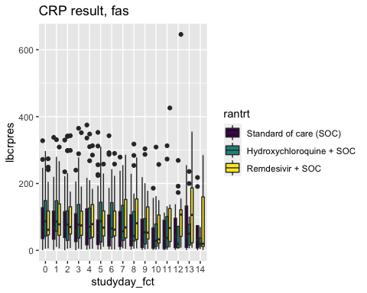
## Warning: Problem with `mutate()` input `..3`.
## ℹ Removed 105 rows containing non-finite values (stat_boxplot).
## ℹ Input `..3` is `walk(desc_plot2, print)`.
## Warning: Removed 105 rows containing non-finite values (stat_boxplot).
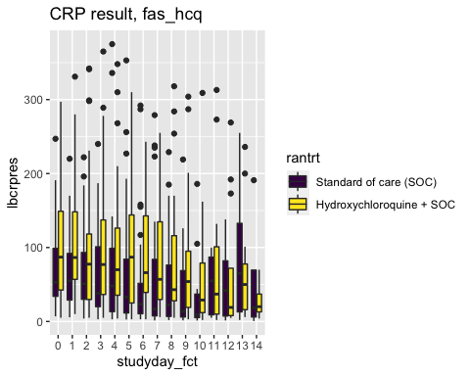
## Warning: Problem with `mutate()` input `..3`.
## ℹ Removed 117 rows containing non-finite values (stat_boxplot).
## ℹ Input `..3` is `walk(desc_plot2, print)`.
## Warning: Removed 117 rows containing non-finite values (stat_boxplot).
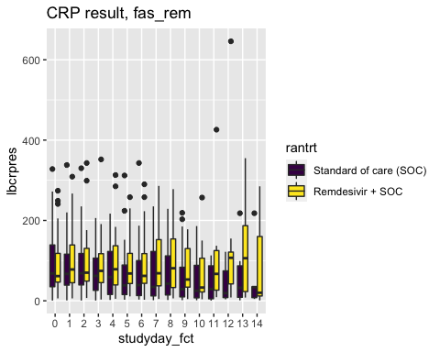
## Warning: Problem with `mutate()` input `..3`.
## ℹ Removed 439 rows containing non-finite values (stat_boxplot).
## ℹ Input `..3` is `walk(desc_plot2, print)`.
## Warning: Removed 439 rows containing non-finite values (stat_boxplot).
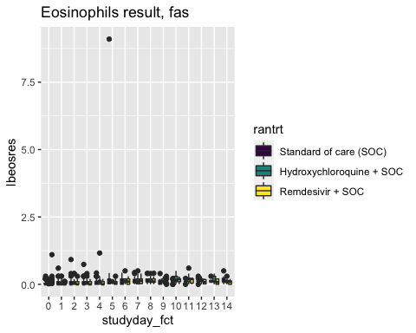
## Warning: Problem with `mutate()` input `..3`.
## ℹ Removed 255 rows containing non-finite values (stat_boxplot).
## ℹ Input `..3` is `walk(desc_plot2, print)`.
## Warning: Removed 255 rows containing non-finite values (stat_boxplot).
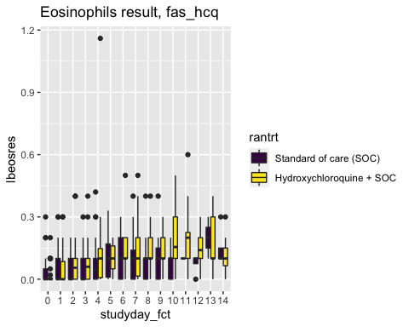
## Warning: Problem with `mutate()` input `..3`.
## ℹ Removed 249 rows containing non-finite values (stat_boxplot).
## ℹ Input `..3` is `walk(desc_plot2, print)`.
## Warning: Removed 249 rows containing non-finite values (stat_boxplot).
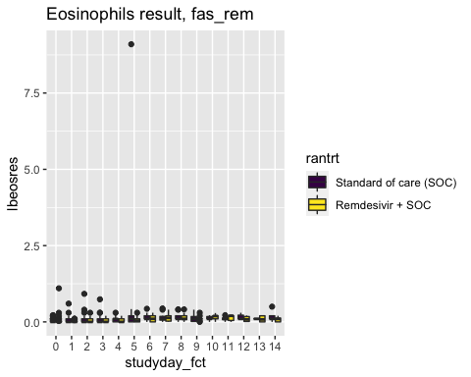
## Warning: Problem with `mutate()` input `..3`.
## ℹ Removed 416 rows containing non-finite values (stat_boxplot).
## ℹ Input `..3` is `walk(desc_plot2, print)`.
## Warning: Removed 416 rows containing non-finite values (stat_boxplot).
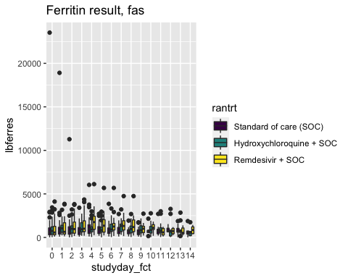
## Warning: Problem with `mutate()` input `..3`.
## ℹ Removed 226 rows containing non-finite values (stat_boxplot).
## ℹ Input `..3` is `walk(desc_plot2, print)`.
## Warning: Removed 226 rows containing non-finite values (stat_boxplot).
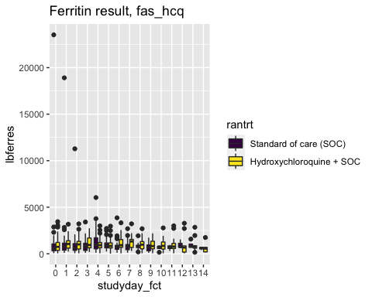
## Warning: Problem with `mutate()` input `..3`.
## ℹ Removed 240 rows containing non-finite values (stat_boxplot).
## ℹ Input `..3` is `walk(desc_plot2, print)`.
## Warning: Removed 240 rows containing non-finite values (stat_boxplot).
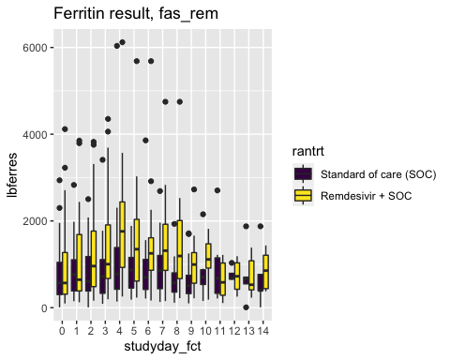
## Warning: Problem with `mutate()` input `..3`.
## ℹ Removed 517 rows containing non-finite values (stat_boxplot).
## ℹ Input `..3` is `walk(desc_plot2, print)`.
## Warning: Removed 517 rows containing non-finite values (stat_boxplot).
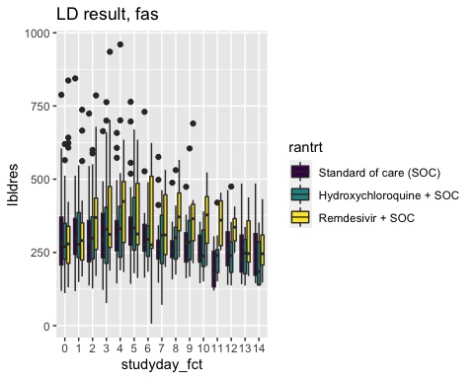
## Warning: Problem with `mutate()` input `..3`.
## ℹ Removed 289 rows containing non-finite values (stat_boxplot).
## ℹ Input `..3` is `walk(desc_plot2, print)`.
## Warning: Removed 289 rows containing non-finite values (stat_boxplot).
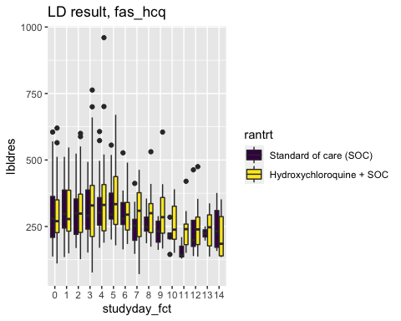
## Warning: Problem with `mutate()` input `..3`.
## ℹ Removed 297 rows containing non-finite values (stat_boxplot).
## ℹ Input `..3` is `walk(desc_plot2, print)`.
## Warning: Removed 297 rows containing non-finite values (stat_boxplot).
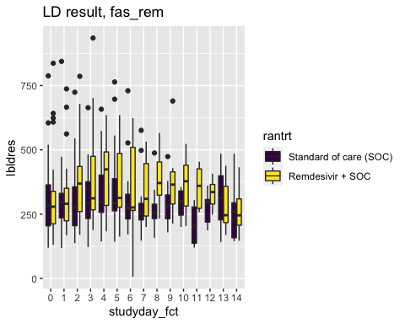
## Warning: Problem with `mutate()` input `..3`.
## ℹ Removed 427 rows containing non-finite values (stat_boxplot).
## ℹ Input `..3` is `walk(desc_plot2, print)`.
## Warning: Removed 427 rows containing non-finite values (stat_boxplot).
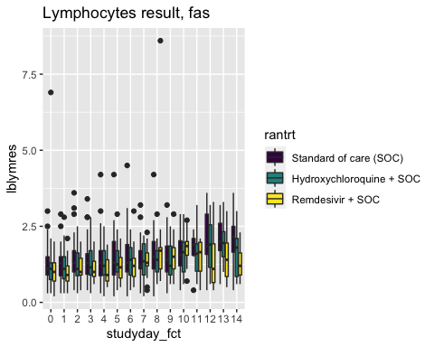
## Warning: Problem with `mutate()` input `..3`.
## ℹ Removed 246 rows containing non-finite values (stat_boxplot).
## ℹ Input `..3` is `walk(desc_plot2, print)`.
## Warning: Removed 246 rows containing non-finite values (stat_boxplot).
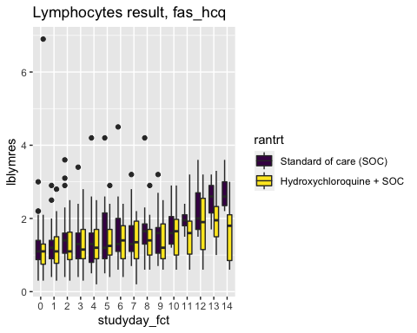
## Warning: Problem with `mutate()` input `..3`.
## ℹ Removed 246 rows containing non-finite values (stat_boxplot).
## ℹ Input `..3` is `walk(desc_plot2, print)`.
## Warning: Removed 246 rows containing non-finite values (stat_boxplot).
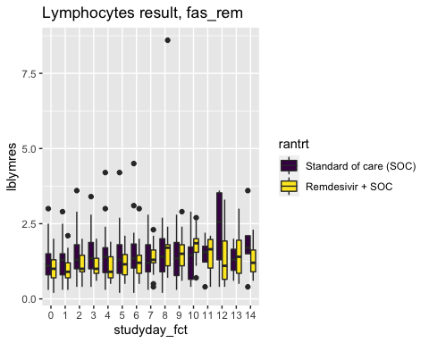
## Warning: Problem with `mutate()` input `..3`.
## ℹ Removed 428 rows containing non-finite values (stat_boxplot).
## ℹ Input `..3` is `walk(desc_plot2, print)`.
## Warning: Removed 428 rows containing non-finite values (stat_boxplot).
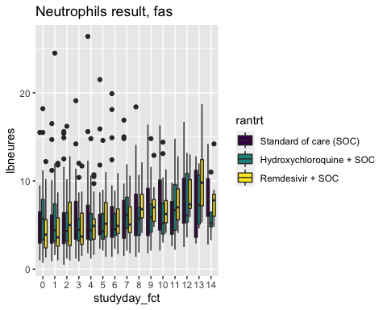
## Warning: Problem with `mutate()` input `..3`.
## ℹ Removed 246 rows containing non-finite values (stat_boxplot).
## ℹ Input `..3` is `walk(desc_plot2, print)`.
## Warning: Removed 246 rows containing non-finite values (stat_boxplot).
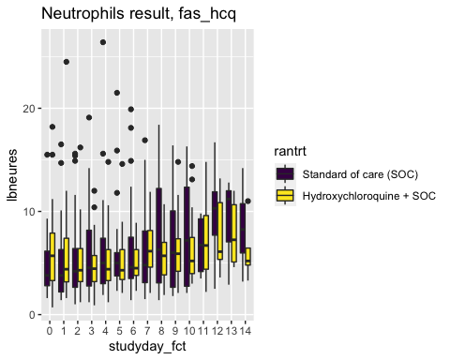
## Warning: Problem with `mutate()` input `..3`.
## ℹ Removed 246 rows containing non-finite values (stat_boxplot).
## ℹ Input `..3` is `walk(desc_plot2, print)`.
## Warning: Removed 246 rows containing non-finite values (stat_boxplot).
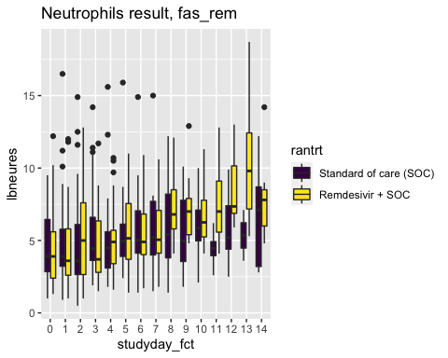
## Warning: Problem with `mutate()` input `..3`.
## ℹ Removed 820 rows containing non-finite values (stat_boxplot).
## ℹ Input `..3` is `walk(desc_plot2, print)`.
## Warning: Removed 820 rows containing non-finite values (stat_boxplot).
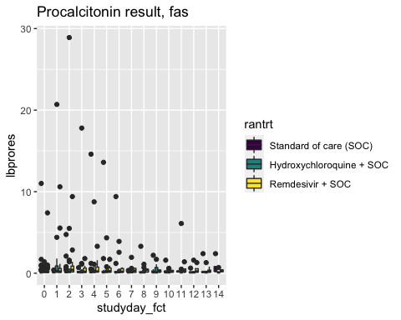
## Warning: Problem with `mutate()` input `..3`.
## ℹ Removed 452 rows containing non-finite values (stat_boxplot).
## ℹ Input `..3` is `walk(desc_plot2, print)`.
## Warning: Removed 452 rows containing non-finite values (stat_boxplot).
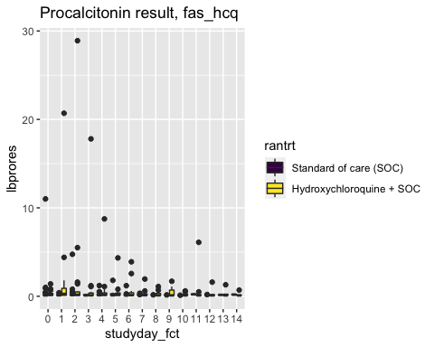
## Warning: Problem with `mutate()` input `..3`.
## ℹ Removed 477 rows containing non-finite values (stat_boxplot).
## ℹ Input `..3` is `walk(desc_plot2, print)`.
## Warning: Removed 477 rows containing non-finite values (stat_boxplot).
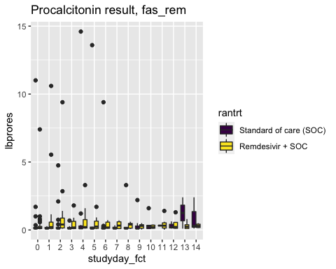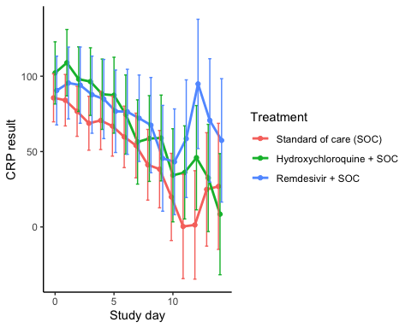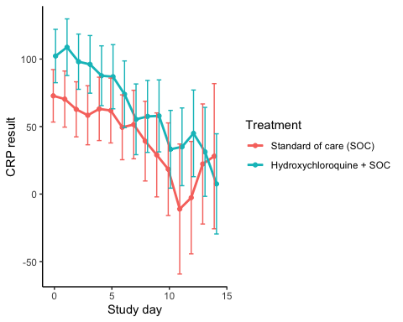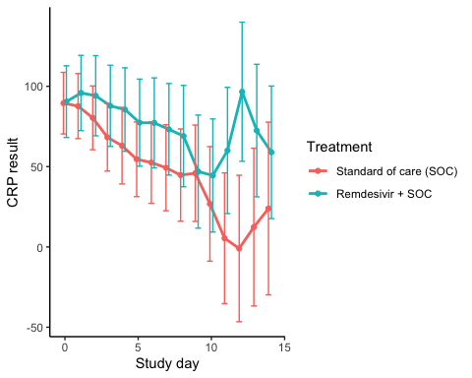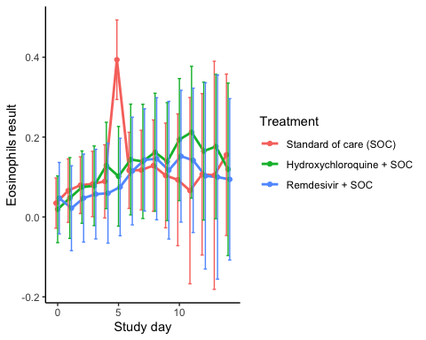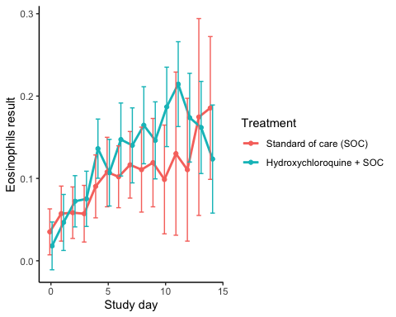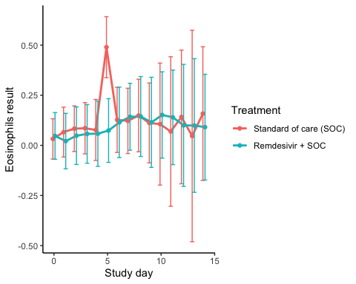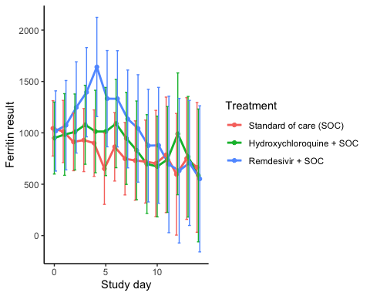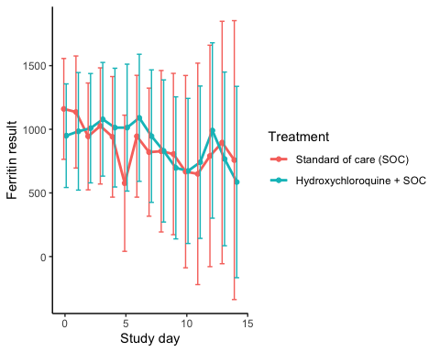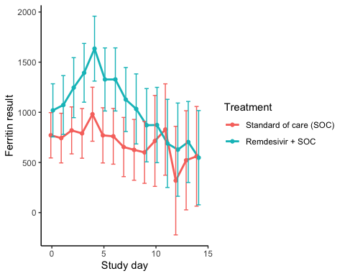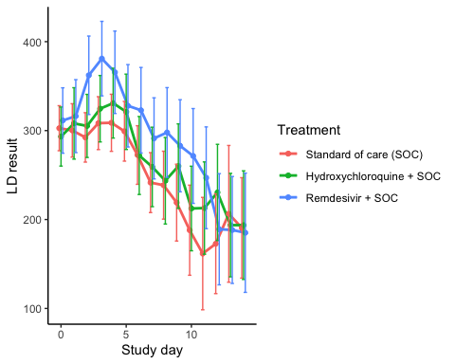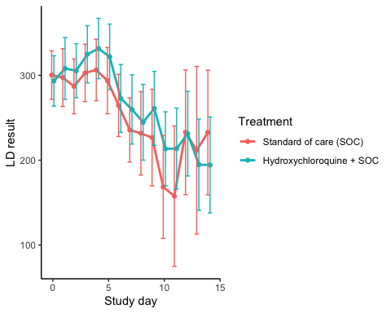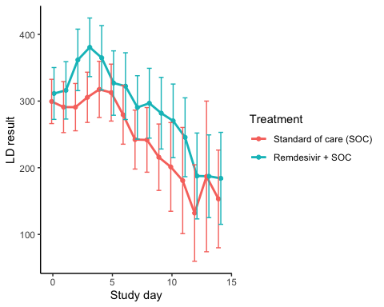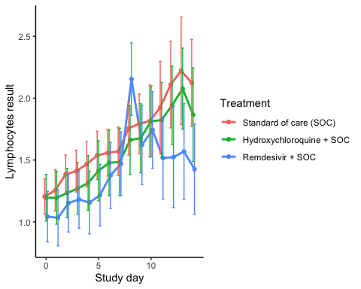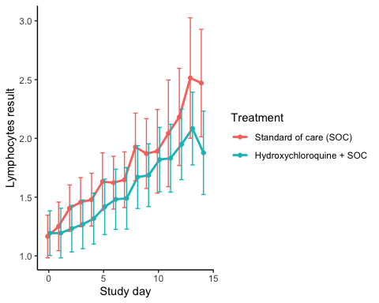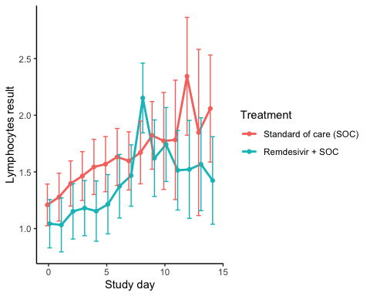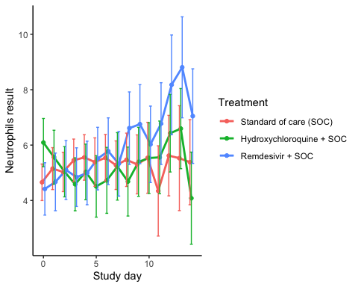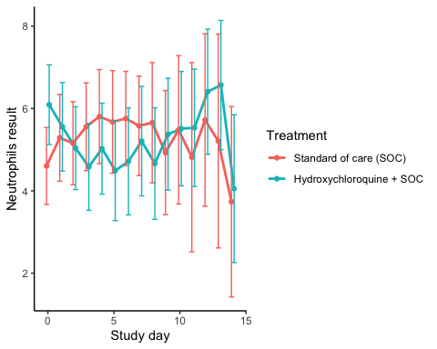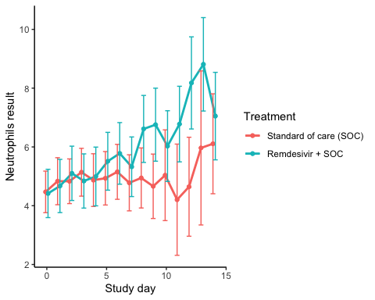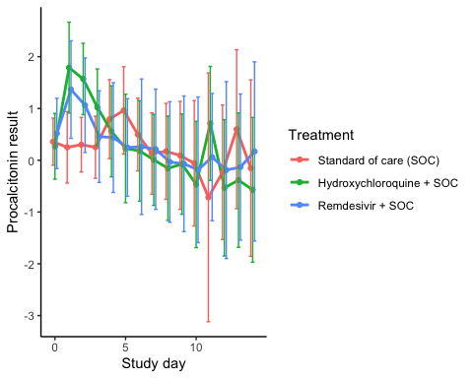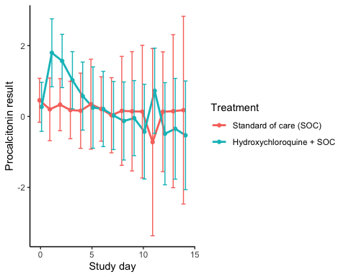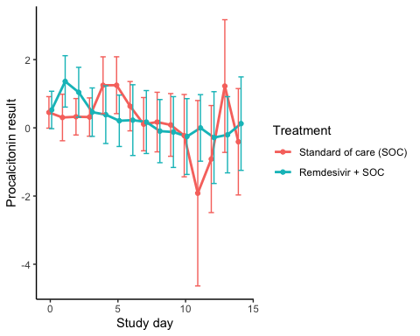
CRP result, fas
Treatment | Days since randomisation | Treatment difference | P-value | Lower 95% CL | Upper 95% CL
Hydroxychloroquine + SOC vs SOC | 0 | 16.536299 | 0.2136914 | -9.528118 | 42.60072
Hydroxychloroquine + SOC vs SOC | 1 | 24.867388 | 0.0803524 | -3.005151 | 52.73993
Hydroxychloroquine + SOC vs SOC | 2 | 21.343903 | 0.1224420 | -5.739589 | 48.42739
Hydroxychloroquine + SOC vs SOC | 3 | 27.644545 | 0.0588243 | -1.030872 | 56.31996
Hydroxychloroquine + SOC vs SOC | 4 | 17.412638 | 0.2597327 | -12.869032 | 47.69431
Hydroxychloroquine + SOC vs SOC | 5 | 20.504053 | 0.2106272 | -11.598387 | 52.60649
Hydroxychloroquine + SOC vs SOC | 6 | 14.816631 | 0.3822542 | -18.419476 | 48.05274
Hydroxychloroquine + SOC vs SOC | 7 | 2.322457 | 0.8971683 | -32.898529 | 37.54344
Hydroxychloroquine + SOC vs SOC | 8 | 17.410471 | 0.3547115 | -19.460726 | 54.28167
Hydroxychloroquine + SOC vs SOC | 9 | 20.659058 | 0.2906227 | -17.657253 | 58.97537
Hydroxychloroquine + SOC vs SOC | 10 | 14.363622 | 0.5058110 | -27.946657 | 56.67390
Hydroxychloroquine + SOC vs SOC | 11 | 35.868958 | 0.1294893 | -10.500663 | 82.23858
Hydroxychloroquine + SOC vs SOC | 12 | 44.586178 | 0.0798429 | -5.303858 | 94.47621
Hydroxychloroquine + SOC vs SOC | 13 | 7.601054 | 0.7734829 | -44.159363 | 59.36147
Hydroxychloroquine + SOC vs SOC | 14 | -18.456053 | 0.5327460 | -76.442673 | 39.53057
Remdesivir + SOC vs SOC | 0 | 4.843799 | 0.7327033 | -22.953529 | 32.64112
Remdesivir + SOC vs SOC | 1 | 11.418098 | 0.4452539 | -17.898758 | 40.73495
Remdesivir + SOC vs SOC | 2 | 17.392780 | 0.2596049 | -12.846243 | 47.63181
Remdesivir + SOC vs SOC | 3 | 18.952610 | 0.2338451 | -12.249450 | 50.15467
Remdesivir + SOC vs SOC | 4 | 14.209222 | 0.3928835 | -18.386248 | 46.80469
Remdesivir + SOC vs SOC | 5 | 9.855591 | 0.5679349 | -23.968180 | 43.67936
Remdesivir + SOC vs SOC | 6 | 16.634466 | 0.3488849 | -18.169693 | 51.43863
Remdesivir + SOC vs SOC | 7 | 18.060293 | 0.3226506 | -17.730009 | 53.85060
Remdesivir + SOC vs SOC | 8 | 26.307123 | 0.1898744 | -13.023884 | 65.63813
Remdesivir + SOC vs SOC | 9 | 7.200804 | 0.7454155 | -36.266209 | 50.66782
Remdesivir + SOC vs SOC | 10 | 23.310102 | 0.3150438 | -22.163372 | 68.78358
Remdesivir + SOC vs SOC | 11 | 58.219517 | 0.0286936 | 6.059870 | 110.37917
Remdesivir + SOC vs SOC | 12 | 93.547470 | 0.0010541 | 37.574196 | 149.52075
Remdesivir + SOC vs SOC | 13 | 45.762882 | 0.1066316 | -9.825903 | 101.35167
Remdesivir + SOC vs SOC | 14 | 30.506439 | 0.3068265 | -28.003500 | 89.01638

CRP result, fas_hcq
Treatment | Days since randomisation | Treatment difference | P-value | Lower 95% CL | Upper 95% CL
Hydroxychloroquine + SOC vs SOC | 0 | 29.471977 | 0.0372298 | 1.743948 | 57.20001
Hydroxychloroquine + SOC vs SOC | 1 | 38.402142 | 0.0108166 | 8.869163 | 67.93512
Hydroxychloroquine + SOC vs SOC | 2 | 35.284946 | 0.0166567 | 6.399628 | 64.17027
Hydroxychloroquine + SOC vs SOC | 3 | 37.693718 | 0.0156371 | 7.131095 | 68.25634
Hydroxychloroquine + SOC vs SOC | 4 | 24.556263 | 0.1356614 | -7.698929 | 56.81145
Hydroxychloroquine + SOC vs SOC | 5 | 25.042721 | 0.1463844 | -8.751072 | 58.83651
Hydroxychloroquine + SOC vs SOC | 6 | 24.473970 | 0.1637755 | -9.973867 | 58.92181
Hydroxychloroquine + SOC vs SOC | 7 | 3.847660 | 0.8362222 | -32.631523 | 40.32684
Hydroxychloroquine + SOC vs SOC | 8 | 18.308392 | 0.3668558 | -21.457392 | 58.07418
Hydroxychloroquine + SOC vs SOC | 9 | 28.902117 | 0.1666601 | -12.057005 | 69.86124
Hydroxychloroquine + SOC vs SOC | 10 | 14.767135 | 0.5180220 | -30.008802 | 59.54307
Hydroxychloroquine + SOC vs SOC | 11 | 46.069500 | 0.1075608 | -10.040081 | 102.17908
Hydroxychloroquine + SOC vs SOC | 12 | 47.628368 | 0.0758225 | -4.949578 | 100.20631
Hydroxychloroquine + SOC vs SOC | 13 | 8.969739 | 0.7507847 | -46.383213 | 64.32269
Hydroxychloroquine + SOC vs SOC | 14 | -20.502449 | 0.5384409 | -85.824081 | 44.81918

CRP result, fas_rem
Treatment | Days since randomisation | Treatment difference | P-value | Lower 95% CL | Upper 95% CL
Hydroxychloroquine + SOC vs SOC | 0 | 0.9745614 | 0.9482540 | -28.457155 | 30.40628
Hydroxychloroquine + SOC vs SOC | 1 | 8.1704865 | 0.6050662 | -22.796377 | 39.13735
Hydroxychloroquine + SOC vs SOC | 2 | 13.7735672 | 0.3973826 | -18.124737 | 45.67187
Hydroxychloroquine + SOC vs SOC | 3 | 19.5499916 | 0.2442908 | -13.359338 | 52.45932
Hydroxychloroquine + SOC vs SOC | 4 | 22.5196209 | 0.2105368 | -12.731532 | 57.77077
Hydroxychloroquine + SOC vs SOC | 5 | 22.7877903 | 0.2114705 | -12.956185 | 58.53177
Hydroxychloroquine + SOC vs SOC | 6 | 24.6775742 | 0.2011164 | -13.157230 | 62.51238
Hydroxychloroquine + SOC vs SOC | 7 | 23.9146500 | 0.2306397 | -15.187176 | 63.01648
Hydroxychloroquine + SOC vs SOC | 8 | 24.2702694 | 0.2649251 | -18.399044 | 66.93958
Hydroxychloroquine + SOC vs SOC | 9 | 1.0309896 | 0.9651594 | -45.230335 | 47.29231
Hydroxychloroquine + SOC vs SOC | 10 | 17.6929207 | 0.4890174 | -32.428284 | 67.81413
Hydroxychloroquine + SOC vs SOC | 11 | 54.6408310 | 0.0583892 | -1.939932 | 111.22159
Hydroxychloroquine + SOC vs SOC | 12 | 97.6181870 | 0.0023418 | 34.744682 | 160.49170
Hydroxychloroquine + SOC vs SOC | 13 | 60.0879631 | 0.0663588 | -4.057325 | 124.23325
Hydroxychloroquine + SOC vs SOC | 14 | 34.9951973 | 0.3115145 | -32.777515 | 102.76791

Eosinophils result, fas
Treatment | Days since randomisation | Treatment difference | P-value | Lower 95% CL | Upper 95% CL
Hydroxychloroquine + SOC vs SOC | 0 | -0.0155036 | 0.7712493 | -0.1200174 | 0.0890102
Hydroxychloroquine + SOC vs SOC | 1 | -0.0184342 | 0.7787278 | -0.1470225 | 0.1101541
Hydroxychloroquine + SOC vs SOC | 2 | -0.0049119 | 0.9333308 | -0.1199945 | 0.1101706
Hydroxychloroquine + SOC vs SOC | 3 | -0.0045073 | 0.9453598 | -0.1334078 | 0.1243932
Hydroxychloroquine + SOC vs SOC | 4 | 0.0398844 | 0.5812671 | -0.1018509 | 0.1816197
Hydroxychloroquine + SOC vs SOC | 5 | -0.2919297 | 0.0003393 | -0.4516069 | -0.1322524
Hydroxychloroquine + SOC vs SOC | 6 | 0.0271216 | 0.7521372 | -0.1411924 | 0.1954357
Hydroxychloroquine + SOC vs SOC | 7 | 0.0217380 | 0.8068570 | -0.1525310 | 0.1960070
Hydroxychloroquine + SOC vs SOC | 8 | 0.0335204 | 0.7250069 | -0.1532432 | 0.2202840
Hydroxychloroquine + SOC vs SOC | 9 | 0.0347708 | 0.7300237 | -0.1627104 | 0.2322520
Hydroxychloroquine + SOC vs SOC | 10 | 0.1006540 | 0.3803165 | -0.1242123 | 0.3255203
Hydroxychloroquine + SOC vs SOC | 11 | 0.1463395 | 0.3154576 | -0.1393846 | 0.4320636
Hydroxychloroquine + SOC vs SOC | 12 | 0.0581769 | 0.6678700 | -0.2075696 | 0.3239234
Hydroxychloroquine + SOC vs SOC | 13 | 0.0720474 | 0.6760855 | -0.2659296 | 0.4100245
Hydroxychloroquine + SOC vs SOC | 14 | -0.0364168 | 0.8092515 | -0.3321005 | 0.2592669
Remdesivir + SOC vs SOC | 0 | 0.0124300 | 0.8236108 | -0.0968656 | 0.1217256
Remdesivir + SOC vs SOC | 1 | -0.0439991 | 0.5155935 | -0.1766398 | 0.0886416
Remdesivir + SOC vs SOC | 2 | -0.0323241 | 0.6287587 | -0.1633633 | 0.0987151
Remdesivir + SOC vs SOC | 3 | -0.0254296 | 0.7196514 | -0.1642916 | 0.1134325
Remdesivir + SOC vs SOC | 4 | -0.0298245 | 0.7058312 | -0.1846881 | 0.1250391
Remdesivir + SOC vs SOC | 5 | -0.3186651 | 0.0000730 | -0.4761360 | -0.1611942
Remdesivir + SOC vs SOC | 6 | -0.0016320 | 0.9845462 | -0.1667675 | 0.1635036
Remdesivir + SOC vs SOC | 7 | 0.0254864 | 0.7580517 | -0.1366758 | 0.1876487
Remdesivir + SOC vs SOC | 8 | 0.0172056 | 0.8597780 | -0.1736866 | 0.2080978
Remdesivir + SOC vs SOC | 9 | 0.0131929 | 0.9049698 | -0.2033959 | 0.2297816
Remdesivir + SOC vs SOC | 10 | 0.0591162 | 0.6195200 | -0.1742342 | 0.2924666
Remdesivir + SOC vs SOC | 11 | 0.0759046 | 0.6141608 | -0.2191907 | 0.3710000
Remdesivir + SOC vs SOC | 12 | -0.0039220 | 0.9801222 | -0.3124402 | 0.3045963
Remdesivir + SOC vs SOC | 13 | -0.0045041 | 0.9816215 | -0.3877228 | 0.3787146
Remdesivir + SOC vs SOC | 14 | -0.0614793 | 0.6732402 | -0.3472171 | 0.2242586

Eosinophils result, fas_hcq
Treatment | Days since randomisation | Treatment difference | P-value | Lower 95% CL | Upper 95% CL
Hydroxychloroquine + SOC vs SOC | 0 | -0.0170435 | 0.4067606 | -0.0573090 | 0.0232221
Hydroxychloroquine + SOC vs SOC | 1 | -0.0107361 | 0.6591129 | -0.0584363 | 0.0369641
Hydroxychloroquine + SOC vs SOC | 2 | 0.0138376 | 0.5387623 | -0.0302845 | 0.0579597
Hydroxychloroquine + SOC vs SOC | 3 | 0.0180655 | 0.4612221 | -0.0299883 | 0.0661194
Hydroxychloroquine + SOC vs SOC | 4 | 0.0458267 | 0.0867917 | -0.0066200 | 0.0982734
Hydroxychloroquine + SOC vs SOC | 5 | -0.0007933 | 0.9787840 | -0.0592574 | 0.0576708
Hydroxychloroquine + SOC vs SOC | 6 | 0.0452719 | 0.1266697 | -0.0128224 | 0.1033662
Hydroxychloroquine + SOC vs SOC | 7 | 0.0236025 | 0.4476047 | -0.0373128 | 0.0845177
Hydroxychloroquine + SOC vs SOC | 8 | 0.0539026 | 0.1293213 | -0.0157495 | 0.1235548
Hydroxychloroquine + SOC vs SOC | 9 | 0.0270457 | 0.4564825 | -0.0441400 | 0.0982314
Hydroxychloroquine + SOC vs SOC | 10 | 0.0881401 | 0.0346841 | 0.0063460 | 0.1699342
Hydroxychloroquine + SOC vs SOC | 11 | 0.0843944 | 0.1385838 | -0.0272872 | 0.1960761
Hydroxychloroquine + SOC vs SOC | 12 | 0.0632399 | 0.2247287 | -0.0388547 | 0.1653344
Hydroxychloroquine + SOC vs SOC | 13 | -0.0126959 | 0.8504679 | -0.1446886 | 0.1192968
Hydroxychloroquine + SOC vs SOC | 14 | -0.0620336 | 0.2636240 | -0.1707976 | 0.0467304

Eosinophils result, fas_rem
Treatment | Days since randomisation | Treatment difference | P-value | Lower 95% CL | Upper 95% CL
Hydroxychloroquine + SOC vs SOC | 0 | 0.0149589 | 0.8489761 | -0.1390071 | 0.1689250
Hydroxychloroquine + SOC vs SOC | 1 | -0.0449282 | 0.6362197 | -0.2311004 | 0.1412439
Hydroxychloroquine + SOC vs SOC | 2 | -0.0349756 | 0.7082778 | -0.2181836 | 0.1482324
Hydroxychloroquine + SOC vs SOC | 3 | -0.0283101 | 0.7752891 | -0.2226841 | 0.1660640
Hydroxychloroquine + SOC vs SOC | 4 | -0.0185869 | 0.8701903 | -0.2415113 | 0.2043375
Hydroxychloroquine + SOC vs SOC | 5 | -0.4157243 | 0.0002155 | -0.6359314 | -0.1955173
Hydroxychloroquine + SOC vs SOC | 6 | -0.0125121 | 0.9184850 | -0.2521323 | 0.2271081
Hydroxychloroquine + SOC vs SOC | 7 | 0.0205478 | 0.8628651 | -0.2126104 | 0.2537061
Hydroxychloroquine + SOC vs SOC | 8 | -0.0050278 | 0.9708006 | -0.2742408 | 0.2641852
Hydroxychloroquine + SOC vs SOC | 9 | 0.0030119 | 0.9843277 | -0.2975080 | 0.3035319
Hydroxychloroquine + SOC vs SOC | 10 | 0.0455249 | 0.8108814 | -0.3273591 | 0.4184088
Hydroxychloroquine + SOC vs SOC | 11 | 0.0706547 | 0.7536380 | -0.3705831 | 0.5118926
Hydroxychloroquine + SOC vs SOC | 12 | -0.0421605 | 0.8547978 | -0.4937066 | 0.4093856
Hydroxychloroquine + SOC vs SOC | 13 | 0.0522503 | 0.8696291 | -0.5716998 | 0.6762003
Hydroxychloroquine + SOC vs SOC | 14 | -0.0676452 | 0.7551660 | -0.4928128 | 0.3575225

Ferritin result, fas
Treatment | Days since randomisation | Treatment difference | P-value | Lower 95% CL | Upper 95% CL
Hydroxychloroquine + SOC vs SOC | 0 | -94.26594 | 0.6758510 | -536.13141 | 347.5995
Hydroxychloroquine + SOC vs SOC | 1 | -29.16630 | 0.9088637 | -528.54572 | 470.2131
Hydroxychloroquine + SOC vs SOC | 2 | 96.88115 | 0.6822000 | -366.85699 | 560.6193
Hydroxychloroquine + SOC vs SOC | 3 | 148.87717 | 0.5527753 | -342.68399 | 640.4383
Hydroxychloroquine + SOC vs SOC | 4 | 113.39533 | 0.6664906 | -402.30423 | 629.0949
Hydroxychloroquine + SOC vs SOC | 5 | 361.47058 | 0.1994479 | -190.67265 | 913.6138
Hydroxychloroquine + SOC vs SOC | 6 | 226.13316 | 0.4147418 | -317.30121 | 769.5676
Hydroxychloroquine + SOC vs SOC | 7 | 197.72910 | 0.4964583 | -372.12439 | 767.5826
Hydroxychloroquine + SOC vs SOC | 8 | 99.01254 | 0.7527480 | -517.01886 | 715.0439
Hydroxychloroquine + SOC vs SOC | 9 | -23.86944 | 0.9405357 | -651.02002 | 603.2811
Hydroxychloroquine + SOC vs SOC | 10 | -29.43113 | 0.9354469 | -741.63300 | 682.7708
Hydroxychloroquine + SOC vs SOC | 11 | -44.72603 | 0.9084173 | -806.76648 | 717.3144
Hydroxychloroquine + SOC vs SOC | 12 | 393.85535 | 0.3566954 | -443.68277 | 1231.3934
Hydroxychloroquine + SOC vs SOC | 13 | 17.19721 | 0.9677494 | -816.46472 | 850.8591
Hydroxychloroquine + SOC vs SOC | 14 | -78.28500 | 0.8651538 | -981.81970 | 825.2496
Remdesivir + SOC vs SOC | 0 | -25.38473 | 0.9164399 | -499.58890 | 448.8195
Remdesivir + SOC vs SOC | 1 | 61.17880 | 0.8209368 | -468.59097 | 590.9485
Remdesivir + SOC vs SOC | 2 | 335.81198 | 0.2100866 | -189.33369 | 860.9577
Remdesivir + SOC vs SOC | 3 | 466.04898 | 0.0858684 | -65.76042 | 997.8584
Remdesivir + SOC vs SOC | 4 | 741.52014 | 0.0124100 | 160.24069 | 1322.7996
Remdesivir + SOC vs SOC | 5 | 681.05438 | 0.0221209 | 97.71697 | 1264.3917
Remdesivir + SOC vs SOC | 6 | 467.07956 | 0.1112293 | -107.70767 | 1041.8668
Remdesivir + SOC vs SOC | 7 | 386.78558 | 0.2005467 | -205.47102 | 979.0422
Remdesivir + SOC vs SOC | 8 | 312.44327 | 0.3458718 | -337.20676 | 962.0933
Remdesivir + SOC vs SOC | 9 | 154.99277 | 0.6554093 | -525.73169 | 835.7172
Remdesivir + SOC vs SOC | 10 | 176.09149 | 0.6518695 | -588.88770 | 941.0707
Remdesivir + SOC vs SOC | 11 | -93.29458 | 0.8335072 | -963.17633 | 776.5872
Remdesivir + SOC vs SOC | 12 | 35.16238 | 0.9402422 | -884.15375 | 954.4785
Remdesivir + SOC vs SOC | 13 | -43.01558 | 0.9209206 | -892.26996 | 806.2388
Remdesivir + SOC vs SOC | 14 | -111.71703 | 0.8178408 | -1062.38794 | 838.9539

Ferritin result, fas_hcq
Treatment | Days since randomisation | Treatment difference | P-value | Lower 95% CL | Upper 95% CL
Hydroxychloroquine + SOC vs SOC | 0 | -210.631531 | 0.4674187 | -778.7319 | 357.4688
Hydroxychloroquine + SOC vs SOC | 1 | -151.899429 | 0.6407529 | -789.8929 | 486.0941
Hydroxychloroquine + SOC vs SOC | 2 | 64.504311 | 0.8333076 | -536.2051 | 665.2137
Hydroxychloroquine + SOC vs SOC | 3 | 52.281422 | 0.8725184 | -586.3165 | 690.8793
Hydroxychloroquine + SOC vs SOC | 4 | 72.532730 | 0.8307410 | -592.5466 | 737.6121
Hydroxychloroquine + SOC vs SOC | 5 | 437.089172 | 0.2414846 | -294.3124 | 1168.4907
Hydroxychloroquine + SOC vs SOC | 6 | 145.042740 | 0.6810738 | -546.6354 | 836.7209
Hydroxychloroquine + SOC vs SOC | 7 | 126.257629 | 0.7325624 | -597.9059 | 850.4212
Hydroxychloroquine + SOC vs SOC | 8 | 2.131553 | 0.9960560 | -843.0386 | 847.3017
Hydroxychloroquine + SOC vs SOC | 9 | -108.768623 | 0.8007241 | -953.3570 | 735.8198
Hydroxychloroquine + SOC vs SOC | 10 | 5.502785 | 0.9909087 | -941.0297 | 952.0353
Hydroxychloroquine + SOC vs SOC | 11 | 91.693222 | 0.8648882 | -964.4931 | 1147.8795
Hydroxychloroquine + SOC vs SOC | 12 | 199.960266 | 0.7240156 | -909.9747 | 1309.8953
Hydroxychloroquine + SOC vs SOC | 13 | -128.628906 | 0.8296604 | -1300.4768 | 1043.2190
Hydroxychloroquine + SOC vs SOC | 14 | -172.231918 | 0.7994936 | -1501.2274 | 1156.7635

Ferritin result, fas_rem
Treatment | Days since randomisation | Treatment difference | P-value | Lower 95% CL | Upper 95% CL
Hydroxychloroquine + SOC vs SOC | 0 | 248.55676 | 0.1619247 | -99.75777 | 596.8713
Hydroxychloroquine + SOC vs SOC | 1 | 330.12555 | 0.0918234 | -53.67590 | 713.9270
Hydroxychloroquine + SOC vs SOC | 2 | 426.04022 | 0.0279988 | 46.01827 | 806.0622
Hydroxychloroquine + SOC vs SOC | 3 | 604.03906 | 0.0020331 | 220.32550 | 987.7526
Hydroxychloroquine + SOC vs SOC | 4 | 654.06091 | 0.0023317 | 232.97678 | 1075.1450
Hydroxychloroquine + SOC vs SOC | 5 | 557.35162 | 0.0089565 | 139.40561 | 975.2976
Hydroxychloroquine + SOC vs SOC | 6 | 566.92584 | 0.0081348 | 147.05588 | 986.7958
Hydroxychloroquine + SOC vs SOC | 7 | 473.54303 | 0.0328548 | 38.58930 | 908.4968
Hydroxychloroquine + SOC vs SOC | 8 | 407.98294 | 0.0838121 | -54.50381 | 870.4697
Hydroxychloroquine + SOC vs SOC | 9 | 271.09372 | 0.2666290 | -207.21529 | 749.4027
Hydroxychloroquine + SOC vs SOC | 10 | 158.48383 | 0.5978213 | -430.33377 | 747.3015
Hydroxychloroquine + SOC vs SOC | 11 | -138.71921 | 0.6676017 | -771.83087 | 494.3925
Hydroxychloroquine + SOC vs SOC | 12 | 308.60355 | 0.3966541 | -404.99170 | 1022.1988
Hydroxychloroquine + SOC vs SOC | 13 | 182.53116 | 0.5752977 | -456.01239 | 821.0747
Hydroxychloroquine + SOC vs SOC | 14 | -13.42076 | 0.9693268 | -697.48865 | 670.6472

LD result, fas
Treatment | Days since randomisation | Treatment difference | P-value | Lower 95% CL | Upper 95% CL
Hydroxychloroquine + SOC vs SOC | 0 | -9.3850555 | 0.6594947 | -51.1324806 | 32.36237
Hydroxychloroquine + SOC vs SOC | 1 | 7.8715572 | 0.7582829 | -42.2621536 | 58.00527
Hydroxychloroquine + SOC vs SOC | 2 | 12.9025755 | 0.5745755 | -32.1489525 | 57.95411
Hydroxychloroquine + SOC vs SOC | 3 | 16.2216339 | 0.5053705 | -31.5122776 | 63.95554
Hydroxychloroquine + SOC vs SOC | 4 | 22.0989304 | 0.3930408 | -28.6121101 | 72.80997
Hydroxychloroquine + SOC vs SOC | 5 | 21.8929272 | 0.4273194 | -32.1635704 | 75.94942
Hydroxychloroquine + SOC vs SOC | 6 | -0.5423706 | 0.9845322 | -55.3736954 | 54.28895
Hydroxychloroquine + SOC vs SOC | 7 | 17.6213932 | 0.5371018 | -38.3365021 | 73.57929
Hydroxychloroquine + SOC vs SOC | 8 | 4.9802151 | 0.8745843 | -56.8618774 | 66.82230
Hydroxychloroquine + SOC vs SOC | 9 | 41.0394821 | 0.2102780 | -23.1653614 | 105.24432
Hydroxychloroquine + SOC vs SOC | 10 | 24.4045887 | 0.4911676 | -45.0730934 | 93.88227
Hydroxychloroquine + SOC vs SOC | 11 | 51.2001724 | 0.2196191 | -30.5489864 | 132.94933
Hydroxychloroquine + SOC vs SOC | 12 | 57.7012062 | 0.1466744 | -20.2193794 | 135.62180
Hydroxychloroquine + SOC vs SOC | 13 | -12.6684952 | 0.7967819 | -109.0895767 | 83.75259
Hydroxychloroquine + SOC vs SOC | 14 | 3.0789447 | 0.9421573 | -80.0898590 | 86.24775
Remdesivir + SOC vs SOC | 0 | 8.6571989 | 0.7038555 | -35.9806633 | 53.29506
Remdesivir + SOC vs SOC | 1 | 16.0612965 | 0.5356861 | -34.7655144 | 66.88811
Remdesivir + SOC vs SOC | 2 | 69.8437500 | 0.0086390 | 17.7149715 | 121.97252
Remdesivir + SOC vs SOC | 3 | 72.5653992 | 0.0056364 | 21.1873703 | 123.94343
Remdesivir + SOC vs SOC | 4 | 56.7897606 | 0.0482265 | 0.4428183 | 113.13670
Remdesivir + SOC vs SOC | 5 | 28.6583138 | 0.3260462 | -28.5341835 | 85.85081
Remdesivir + SOC vs SOC | 6 | 50.3381920 | 0.0905899 | -7.9619851 | 108.63837
Remdesivir + SOC vs SOC | 7 | 49.7491570 | 0.0854406 | -6.9421806 | 106.44050
Remdesivir + SOC vs SOC | 8 | 59.2710266 | 0.0662342 | -3.9731071 | 122.51516
Remdesivir + SOC vs SOC | 9 | 63.9115448 | 0.0632549 | -3.5292897 | 131.35237
Remdesivir + SOC vs SOC | 10 | 83.4671707 | 0.0260985 | 9.9338875 | 157.00044
Remdesivir + SOC vs SOC | 11 | 85.2151794 | 0.0501126 | -0.0418793 | 170.47224
Remdesivir + SOC vs SOC | 12 | 16.2988243 | 0.7036663 | -67.6841431 | 100.28179
Remdesivir + SOC vs SOC | 13 | -18.1337585 | 0.7157521 | -115.7372589 | 79.46974
Remdesivir + SOC vs SOC | 14 | -5.4388556 | 0.9032052 | -93.0933228 | 82.21561

LD result, fas_hcq
Treatment | Days since randomisation | Treatment difference | P-value | Lower 95% CL | Upper 95% CL
Hydroxychloroquine + SOC vs SOC | 0 | -6.913344 | 0.7423425 | -48.12943 | 34.30274
Hydroxychloroquine + SOC vs SOC | 1 | 10.762110 | 0.6726184 | -39.15623 | 60.68045
Hydroxychloroquine + SOC vs SOC | 2 | 18.372103 | 0.4273700 | -26.99598 | 63.74018
Hydroxychloroquine + SOC vs SOC | 3 | 21.925486 | 0.3685899 | -25.86932 | 69.72029
Hydroxychloroquine + SOC vs SOC | 4 | 25.300449 | 0.3286858 | -25.46714 | 76.06804
Hydroxychloroquine + SOC vs SOC | 5 | 28.101372 | 0.3155855 | -26.78033 | 82.98307
Hydroxychloroquine + SOC vs SOC | 6 | 8.250627 | 0.7657699 | -46.03017 | 62.53142
Hydroxychloroquine + SOC vs SOC | 7 | 24.227045 | 0.3933677 | -31.40587 | 79.85996
Hydroxychloroquine + SOC vs SOC | 8 | 13.073088 | 0.6996782 | -53.34936 | 79.49553
Hydroxychloroquine + SOC vs SOC | 9 | 34.413746 | 0.3467165 | -37.26674 | 106.09422
Hydroxychloroquine + SOC vs SOC | 10 | 44.930683 | 0.2384548 | -29.77088 | 119.63225
Hydroxychloroquine + SOC vs SOC | 11 | 56.030743 | 0.2504203 | -39.51912 | 151.58060
Hydroxychloroquine + SOC vs SOC | 12 | -1.625621 | 0.9713686 | -90.39672 | 87.14548
Hydroxychloroquine + SOC vs SOC | 13 | -16.960318 | 0.7675125 | -129.40352 | 95.48289
Hydroxychloroquine + SOC vs SOC | 14 | -38.240482 | 0.4187446 | -130.93138 | 54.45042

LD result, fas_rem
Treatment | Days since randomisation | Treatment difference | P-value | Lower 95% CL | Upper 95% CL
Hydroxychloroquine + SOC vs SOC | 0 | 11.9638777 | 0.6465858 | -39.177311 | 63.10506
Hydroxychloroquine + SOC vs SOC | 1 | 25.1015415 | 0.3931598 | -32.514172 | 82.71725
Hydroxychloroquine + SOC vs SOC | 2 | 70.8820801 | 0.0169777 | 12.685479 | 129.07867
Hydroxychloroquine + SOC vs SOC | 3 | 75.0030670 | 0.0111092 | 17.110558 | 132.89557
Hydroxychloroquine + SOC vs SOC | 4 | 47.4109917 | 0.1472377 | -16.702803 | 111.52478
Hydroxychloroquine + SOC vs SOC | 5 | 14.3025322 | 0.6636719 | -50.162231 | 78.76730
Hydroxychloroquine + SOC vs SOC | 6 | 43.0018883 | 0.2063027 | -23.687708 | 109.69149
Hydroxychloroquine + SOC vs SOC | 7 | 48.2078552 | 0.1457763 | -16.748001 | 113.16371
Hydroxychloroquine + SOC vs SOC | 8 | 54.9902954 | 0.1310050 | -16.379398 | 126.35999
Hydroxychloroquine + SOC vs SOC | 9 | 66.0497513 | 0.0772281 | -7.212873 | 139.31238
Hydroxychloroquine + SOC vs SOC | 10 | 69.0790634 | 0.1173201 | -17.371731 | 155.52985
Hydroxychloroquine + SOC vs SOC | 11 | 64.9031296 | 0.1997211 | -34.296116 | 164.10237
Hydroxychloroquine + SOC vs SOC | 12 | 55.5921288 | 0.2606997 | -41.282413 | 152.46667
Hydroxychloroquine + SOC vs SOC | 13 | 0.2120062 | 0.9974280 | -128.690216 | 129.11423
Hydroxychloroquine + SOC vs SOC | 14 | 30.8954716 | 0.5474298 | -69.756805 | 131.54774

Lymphocytes result, fas
Treatment | Days since randomisation | Treatment difference | P-value | Lower 95% CL | Upper 95% CL
Hydroxychloroquine + SOC vs SOC | 0 | -0.0097876 | 0.9352705 | -0.2459904 | 0.2264152
Hydroxychloroquine + SOC vs SOC | 1 | -0.0605023 | 0.6615817 | -0.3314051 | 0.2104005
Hydroxychloroquine + SOC vs SOC | 2 | -0.1518148 | 0.2385662 | -0.4042812 | 0.1006517
Hydroxychloroquine + SOC vs SOC | 3 | -0.1403694 | 0.3065723 | -0.4094500 | 0.1287111
Hydroxychloroquine + SOC vs SOC | 4 | -0.1513424 | 0.3002979 | -0.4377174 | 0.1350325
Hydroxychloroquine + SOC vs SOC | 5 | -0.1243514 | 0.4334779 | -0.4355201 | 0.1868173
Hydroxychloroquine + SOC vs SOC | 6 | -0.0798547 | 0.6304994 | -0.4052279 | 0.2455185
Hydroxychloroquine + SOC vs SOC | 7 | -0.0852254 | 0.6187282 | -0.4208779 | 0.2504271
Hydroxychloroquine + SOC vs SOC | 8 | -0.0955543 | 0.5956960 | -0.4485187 | 0.2574102
Hydroxychloroquine + SOC vs SOC | 9 | -0.1165720 | 0.5350280 | -0.4848760 | 0.2517319
Hydroxychloroquine + SOC vs SOC | 10 | -0.0022729 | 0.9913005 | -0.4108430 | 0.4062972
Hydroxychloroquine + SOC vs SOC | 11 | -0.1015095 | 0.6791652 | -0.5825387 | 0.3795198
Hydroxychloroquine + SOC vs SOC | 12 | -0.1672340 | 0.4872338 | -0.6390424 | 0.3045745
Hydroxychloroquine + SOC vs SOC | 13 | -0.1445135 | 0.6027282 | -0.6887047 | 0.3996777
Hydroxychloroquine + SOC vs SOC | 14 | -0.2573039 | 0.3289731 | -0.7739137 | 0.2593059
Remdesivir + SOC vs SOC | 0 | -0.1621417 | 0.2018717 | -0.4111487 | 0.0868652
Remdesivir + SOC vs SOC | 1 | -0.2222325 | 0.1223966 | -0.5041915 | 0.0597264
Remdesivir + SOC vs SOC | 2 | -0.2332255 | 0.1021645 | -0.5128999 | 0.0464489
Remdesivir + SOC vs SOC | 3 | -0.2284060 | 0.1192338 | -0.5157412 | 0.0589292
Remdesivir + SOC vs SOC | 4 | -0.3099416 | 0.0517455 | -0.6222284 | 0.0023452
Remdesivir + SOC vs SOC | 5 | -0.3217296 | 0.0463689 | -0.6382820 | -0.0051773
Remdesivir + SOC vs SOC | 6 | -0.1816106 | 0.2751175 | -0.5077655 | 0.1445443
Remdesivir + SOC vs SOC | 7 | -0.0993124 | 0.5474975 | -0.4229101 | 0.2242854
Remdesivir + SOC vs SOC | 8 | 0.3967947 | 0.0324294 | 0.0332253 | 0.7603641
Remdesivir + SOC vs SOC | 9 | -0.1698172 | 0.4059803 | -0.5703470 | 0.2307127
Remdesivir + SOC vs SOC | 10 | -0.0721509 | 0.7393826 | -0.4972347 | 0.3529330
Remdesivir + SOC vs SOC | 11 | -0.4091543 | 0.1084491 | -0.9087346 | 0.0904259
Remdesivir + SOC vs SOC | 12 | -0.5861847 | 0.0327706 | -1.1243411 | -0.0480283
Remdesivir + SOC vs SOC | 13 | -0.6527095 | 0.0280474 | -1.2350978 | -0.0703213
Remdesivir + SOC vs SOC | 14 | -0.6976272 | 0.0070302 | -1.2049060 | -0.1903483

Lymphocytes result, fas_hcq
Treatment | Days since randomisation | Treatment difference | P-value | Lower 95% CL | Upper 95% CL
Hydroxychloroquine + SOC vs SOC | 0 | 0.0278615 | 0.8353572 | -0.2348823 | 0.2906053
Hydroxychloroquine + SOC vs SOC | 1 | -0.0569674 | 0.7055609 | -0.3524854 | 0.2385507
Hydroxychloroquine + SOC vs SOC | 2 | -0.1734196 | 0.2254381 | -0.4538170 | 0.1069779
Hydroxychloroquine + SOC vs SOC | 3 | -0.1880868 | 0.2107039 | -0.4826170 | 0.1064433
Hydroxychloroquine + SOC vs SOC | 4 | -0.1610872 | 0.3124860 | -0.4736803 | 0.1515059
Hydroxychloroquine + SOC vs SOC | 5 | -0.2146774 | 0.2158718 | -0.5546635 | 0.1253087
Hydroxychloroquine + SOC vs SOC | 6 | -0.1413628 | 0.4160296 | -0.4820196 | 0.1992940
Hydroxychloroquine + SOC vs SOC | 7 | -0.1583438 | 0.3799143 | -0.5117937 | 0.1951060
Hydroxychloroquine + SOC vs SOC | 8 | -0.2558460 | 0.2015404 | -0.6484696 | 0.1367775
Hydroxychloroquine + SOC vs SOC | 9 | -0.1843888 | 0.3658015 | -0.5840006 | 0.2152231
Hydroxychloroquine + SOC vs SOC | 10 | -0.0710287 | 0.7563841 | -0.5197681 | 0.3777108
Hydroxychloroquine + SOC vs SOC | 11 | -0.2117397 | 0.4403177 | -0.7495466 | 0.3260671
Hydroxychloroquine + SOC vs SOC | 12 | -0.2339597 | 0.3691399 | -0.7445486 | 0.2766292
Hydroxychloroquine + SOC vs SOC | 13 | -0.4299775 | 0.1592175 | -1.0286387 | 0.1686838
Hydroxychloroquine + SOC vs SOC | 14 | -0.5938653 | 0.0442228 | -1.1723795 | -0.0153512

Lymphocytes result, fas_rem
Treatment | Days since randomisation | Treatment difference | P-value | Lower 95% CL | Upper 95% CL
Hydroxychloroquine + SOC vs SOC | 0 | -0.1661872 | 0.2466722 | -0.4473519 | 0.1149775
Hydroxychloroquine + SOC vs SOC | 1 | -0.2456171 | 0.1304656 | -0.5639473 | 0.0727131
Hydroxychloroquine + SOC vs SOC | 2 | -0.2458750 | 0.1257925 | -0.5606598 | 0.0689098
Hydroxychloroquine + SOC vs SOC | 3 | -0.2824048 | 0.0884504 | -0.6073014 | 0.0424918
Hydroxychloroquine + SOC vs SOC | 4 | -0.3896610 | 0.0342626 | -0.7504230 | -0.0288990
Hydroxychloroquine + SOC vs SOC | 5 | -0.3538349 | 0.0523940 | -0.7113326 | 0.0036629
Hydroxychloroquine + SOC vs SOC | 6 | -0.2587211 | 0.1782511 | -0.6354105 | 0.1179683
Hydroxychloroquine + SOC vs SOC | 7 | -0.1286328 | 0.4991822 | -0.5017080 | 0.2444424
Hydroxychloroquine + SOC vs SOC | 8 | 0.4806282 | 0.0228566 | 0.0667060 | 0.8945503
Hydroxychloroquine + SOC vs SOC | 9 | -0.2011770 | 0.3817108 | -0.6519349 | 0.2495808
Hydroxychloroquine + SOC vs SOC | 10 | -0.0310538 | 0.9099535 | -0.5692139 | 0.5071062
Hydroxychloroquine + SOC vs SOC | 11 | -0.2686776 | 0.4051686 | -0.9012845 | 0.3639294
Hydroxychloroquine + SOC vs SOC | 12 | -0.8214035 | 0.0172369 | -1.4973820 | -0.1454249
Hydroxychloroquine + SOC vs SOC | 13 | -0.2805351 | 0.5126370 | -1.1203203 | 0.5592502
Hydroxychloroquine + SOC vs SOC | 14 | -0.6343507 | 0.0415112 | -1.2442960 | -0.0244056

Neutrophils result, fas
Treatment | Days since randomisation | Treatment difference | P-value | Lower 95% CL | Upper 95% CL
Hydroxychloroquine + SOC vs SOC | 0 | 1.4334949 | 0.0101164 | 0.3410420 | 2.5259480
Hydroxychloroquine + SOC vs SOC | 1 | 0.4111017 | 0.5137017 | -0.8226502 | 1.6448536
Hydroxychloroquine + SOC vs SOC | 2 | 0.0096764 | 0.9868742 | -1.1431267 | 1.1624794
Hydroxychloroquine + SOC vs SOC | 3 | -0.8649939 | 0.1667776 | -2.0911746 | 0.3611867
Hydroxychloroquine + SOC vs SOC | 4 | -0.5228561 | 0.4295482 | -1.8201025 | 0.7743903
Hydroxychloroquine + SOC vs SOC | 5 | -0.8784388 | 0.2230070 | -2.2913301 | 0.5344524
Hydroxychloroquine + SOC vs SOC | 6 | -0.8156590 | 0.2731650 | -2.2745547 | 0.6432366
Hydroxychloroquine + SOC vs SOC | 7 | -0.0417449 | 0.9565537 | -1.5435845 | 1.4600947
Hydroxychloroquine + SOC vs SOC | 8 | -0.7852771 | 0.3281547 | -2.3592756 | 0.7887216
Hydroxychloroquine + SOC vs SOC | 9 | 0.0913352 | 0.9129867 | -1.5469025 | 1.7295729
Hydroxychloroquine + SOC vs SOC | 10 | -0.0090423 | 0.9921765 | -1.8164562 | 1.7983717
Hydroxychloroquine + SOC vs SOC | 11 | 1.2131835 | 0.2553517 | -0.8772849 | 3.3036518
Hydroxychloroquine + SOC vs SOC | 12 | 0.8091044 | 0.4319119 | -1.2086670 | 2.8268759
Hydroxychloroquine + SOC vs SOC | 13 | 1.0667325 | 0.3803678 | -1.3166604 | 3.4501255
Hydroxychloroquine + SOC vs SOC | 14 | -1.2998264 | 0.2605616 | -3.5642407 | 0.9645879
Remdesivir + SOC vs SOC | 0 | -0.2399711 | 0.6833144 | -1.3929089 | 0.9129668
Remdesivir + SOC vs SOC | 1 | -0.4792656 | 0.4654513 | -1.7662133 | 0.8076822
Remdesivir + SOC vs SOC | 2 | 0.0721848 | 0.9118179 | -1.2053314 | 1.3497009
Remdesivir + SOC vs SOC | 3 | -0.6087487 | 0.3619979 | -1.9176252 | 0.7001277
Remdesivir + SOC vs SOC | 4 | -0.5609055 | 0.4361318 | -1.9726117 | 0.8508006
Remdesivir + SOC vs SOC | 5 | 0.1260036 | 0.8628293 | -1.3033954 | 1.5554026
Remdesivir + SOC vs SOC | 6 | 0.2370517 | 0.7518242 | -1.2321494 | 1.7062527
Remdesivir + SOC vs SOC | 7 | 0.0503787 | 0.9460294 | -1.4082553 | 1.5090127
Remdesivir + SOC vs SOC | 8 | 1.1420430 | 0.1683110 | -0.4827245 | 2.7668104
Remdesivir + SOC vs SOC | 9 | 1.4519452 | 0.1097635 | -0.3274814 | 3.2313719
Remdesivir + SOC vs SOC | 10 | 0.4851911 | 0.6134681 | -1.3974103 | 2.3677924
Remdesivir + SOC vs SOC | 11 | 2.4313316 | 0.0301762 | 0.2330715 | 4.6295919
Remdesivir + SOC vs SOC | 12 | 2.5575647 | 0.0300852 | 0.2464480 | 4.8686814
Remdesivir + SOC vs SOC | 13 | 3.2800143 | 0.0144552 | 0.6514888 | 5.9085398
Remdesivir + SOC vs SOC | 14 | 1.6633178 | 0.1558404 | -0.6337796 | 3.9604151

Neutrophils result, fas_hcq
Treatment | Days since randomisation | Treatment difference | P-value | Lower 95% CL | Upper 95% CL
Hydroxychloroquine + SOC vs SOC | 0 | 1.4880114 | 0.0300603 | 0.1435893 | 2.8324335
Hydroxychloroquine + SOC vs SOC | 1 | 0.2677602 | 0.7273552 | -1.2374933 | 1.7730136
Hydroxychloroquine + SOC vs SOC | 2 | -0.1194017 | 0.8695156 | -1.5439922 | 1.3051888
Hydroxychloroquine + SOC vs SOC | 3 | -0.9744723 | 0.2029757 | -2.4746702 | 0.5257254
Hydroxychloroquine + SOC vs SOC | 4 | -0.7786411 | 0.3371883 | -2.3687756 | 0.8114933
Hydroxychloroquine + SOC vs SOC | 5 | -1.1832318 | 0.1826331 | -2.9233882 | 0.5569247
Hydroxychloroquine + SOC vs SOC | 6 | -1.0423584 | 0.2380813 | -2.7740009 | 0.6892839
Hydroxychloroquine + SOC vs SOC | 7 | -0.3712930 | 0.6853059 | -2.1670995 | 1.4245135
Hydroxychloroquine + SOC vs SOC | 8 | -0.9911888 | 0.3296790 | -2.9841850 | 1.0018075
Hydroxychloroquine + SOC vs SOC | 9 | 0.4454438 | 0.6668656 | -1.5827739 | 2.4736614
Hydroxychloroquine + SOC vs SOC | 10 | 0.0280405 | 0.9807335 | -2.2477355 | 2.3038166
Hydroxychloroquine + SOC vs SOC | 11 | 0.7158598 | 0.6038492 | -1.9881908 | 3.4199104
Hydroxychloroquine + SOC vs SOC | 12 | 0.6871656 | 0.6027343 | -1.9005210 | 3.2748523
Hydroxychloroquine + SOC vs SOC | 13 | 1.3599248 | 0.3795396 | -1.6732692 | 4.3931189
Hydroxychloroquine + SOC vs SOC | 14 | 0.3192099 | 0.8308353 | -2.6094000 | 3.2478197

Neutrophils result, fas_rem
Treatment | Days since randomisation | Treatment difference | P-value | Lower 95% CL | Upper 95% CL
Hydroxychloroquine + SOC vs SOC | 0 | -0.0524454 | 0.9244655 | -1.1366210 | 1.0317303
Hydroxychloroquine + SOC vs SOC | 1 | -0.1621814 | 0.7925119 | -1.3705814 | 1.0462185
Hydroxychloroquine + SOC vs SOC | 2 | 0.2696833 | 0.6586533 | -0.9267895 | 1.4661561
Hydroxychloroquine + SOC vs SOC | 3 | -0.2980437 | 0.6348640 | -1.5281231 | 0.9320357
Hydroxychloroquine + SOC vs SOC | 4 | 0.1236529 | 0.8567657 | -1.2190900 | 1.4663959
Hydroxychloroquine + SOC vs SOC | 5 | 0.5792111 | 0.3967777 | -0.7604704 | 1.9188926
Hydroxychloroquine + SOC vs SOC | 6 | 0.6271811 | 0.3814427 | -0.7772918 | 2.0316541
Hydroxychloroquine + SOC vs SOC | 7 | 0.5463854 | 0.4418138 | -0.8459542 | 1.9387250
Hydroxychloroquine + SOC vs SOC | 8 | 1.6686587 | 0.0326412 | 0.1378567 | 3.1994607
Hydroxychloroquine + SOC vs SOC | 9 | 2.0962951 | 0.0131318 | 0.4396923 | 3.7528982
Hydroxychloroquine + SOC vs SOC | 10 | 0.9915657 | 0.3207892 | -0.9658878 | 2.9490192
Hydroxychloroquine + SOC vs SOC | 11 | 2.5737872 | 0.0274762 | 0.2856913 | 4.8618832
Hydroxychloroquine + SOC vs SOC | 12 | 3.5332077 | 0.0026134 | 1.2324744 | 5.8339405
Hydroxychloroquine + SOC vs SOC | 13 | 2.8456492 | 0.0688422 | -0.2197597 | 5.9110579
Hydroxychloroquine + SOC vs SOC | 14 | 0.9416389 | 0.4141372 | -1.3183411 | 3.2016189

Procalcitonin result, fas
Treatment | Days since randomisation | Treatment difference | P-value | Lower 95% CL | Upper 95% CL
Hydroxychloroquine + SOC vs SOC | 0 | -0.0888011 | 0.8235701 | -0.8694364 | 0.6918342
Hydroxychloroquine + SOC vs SOC | 1 | 1.5394027 | 0.0069075 | 0.4224573 | 2.6563480
Hydroxychloroquine + SOC vs SOC | 2 | 1.2689489 | 0.0041661 | 0.4009453 | 2.1369526
Hydroxychloroquine + SOC vs SOC | 3 | 0.7714714 | 0.1127850 | -0.1820268 | 1.7249695
Hydroxychloroquine + SOC vs SOC | 4 | -0.2343630 | 0.6931742 | -1.3985800 | 0.9298539
Hydroxychloroquine + SOC vs SOC | 5 | -0.7343450 | 0.2848055 | -2.0799956 | 0.6113058
Hydroxychloroquine + SOC vs SOC | 6 | -0.3165889 | 0.6047637 | -1.5154842 | 0.8823064
Hydroxychloroquine + SOC vs SOC | 7 | -0.1211471 | 0.8404481 | -1.3005810 | 1.0582868
Hydroxychloroquine + SOC vs SOC | 8 | -0.3265309 | 0.6401787 | -1.6956408 | 1.0425789
Hydroxychloroquine + SOC vs SOC | 9 | -0.1681001 | 0.8170022 | -1.5918976 | 1.2556974
Hydroxychloroquine + SOC vs SOC | 10 | -0.4080917 | 0.6417634 | -2.1273208 | 1.3111373
Hydroxychloroquine + SOC vs SOC | 11 | 1.4286052 | 0.2892436 | -1.2134606 | 4.0706711
Hydroxychloroquine + SOC vs SOC | 12 | -0.2992927 | 0.7512094 | -2.1495118 | 1.5509263
Hydroxychloroquine + SOC vs SOC | 13 | -0.9842534 | 0.3371821 | -2.9942615 | 1.0257547
Hydroxychloroquine + SOC vs SOC | 14 | -0.4191047 | 0.7094769 | -2.6239386 | 1.7857291
Remdesivir + SOC vs SOC | 0 | 0.1588613 | 0.7030121 | -0.6578109 | 0.9755335
Remdesivir + SOC vs SOC | 1 | 1.1156598 | 0.0611764 | -0.0522878 | 2.2836075
Remdesivir + SOC vs SOC | 2 | 0.7624179 | 0.1564240 | -0.2919920 | 1.8168279
Remdesivir + SOC vs SOC | 3 | 0.2052923 | 0.7069088 | -0.8647979 | 1.2753826
Remdesivir + SOC vs SOC | 4 | -0.3551577 | 0.5940281 | -1.6611350 | 0.9508196
Remdesivir + SOC vs SOC | 5 | -0.7165761 | 0.2671019 | -1.9821305 | 0.5489783
Remdesivir + SOC vs SOC | 6 | -0.2357629 | 0.7558180 | -1.7216818 | 1.2501560
Remdesivir + SOC vs SOC | 7 | 0.0849791 | 0.9054588 | -1.3173794 | 1.4873376
Remdesivir + SOC vs SOC | 8 | -0.2050672 | 0.7871053 | -1.6932822 | 1.2831477
Remdesivir + SOC vs SOC | 9 | -0.1621093 | 0.8495094 | -1.8366162 | 1.5123974
Remdesivir + SOC vs SOC | 10 | -0.1251113 | 0.8948900 | -1.9811140 | 1.7308915
Remdesivir + SOC vs SOC | 11 | 0.7765769 | 0.5726930 | -1.9216869 | 3.4748406
Remdesivir + SOC vs SOC | 12 | 0.0435775 | 0.9682602 | -2.1029282 | 2.1900830
Remdesivir + SOC vs SOC | 13 | -0.7314960 | 0.4917641 | -2.8168693 | 1.3538772
Remdesivir + SOC vs SOC | 14 | 0.3224760 | 0.7947340 | -2.1068807 | 2.7518327

Procalcitonin result, fas_hcq
Treatment | Days since randomisation | Treatment difference | P-value | Lower 95% CL | Upper 95% CL
Hydroxychloroquine + SOC vs SOC | 0 | -0.1864262 | 0.6940463 | -1.1152939 | 0.7424415
Hydroxychloroquine + SOC vs SOC | 1 | 1.5944606 | 0.0166573 | 0.2891793 | 2.8997421
Hydroxychloroquine + SOC vs SOC | 2 | 1.2337645 | 0.0215002 | 0.1819830 | 2.2855461
Hydroxychloroquine + SOC vs SOC | 3 | 0.8410464 | 0.1498772 | -0.3037177 | 1.9858105
Hydroxychloroquine + SOC vs SOC | 4 | 0.4135790 | 0.5712588 | -1.0180740 | 1.8452320
Hydroxychloroquine + SOC vs SOC | 5 | -0.0953750 | 0.9129650 | -1.8056464 | 1.6148964
Hydroxychloroquine + SOC vs SOC | 6 | -0.0007938 | 0.9991118 | -1.3983673 | 1.3967797
Hydroxychloroquine + SOC vs SOC | 7 | -0.0086060 | 0.9905988 | -1.4401191 | 1.4229071
Hydroxychloroquine + SOC vs SOC | 8 | -0.2846930 | 0.7680718 | -2.1768317 | 1.6074458
Hydroxychloroquine + SOC vs SOC | 9 | -0.1918196 | 0.8501216 | -2.1814096 | 1.7977704
Hydroxychloroquine + SOC vs SOC | 10 | -0.5664616 | 0.6295009 | -2.8678222 | 1.7348992
Hydroxychloroquine + SOC vs SOC | 11 | 1.4489452 | 0.3281139 | -1.4550558 | 4.3529463
Hydroxychloroquine + SOC vs SOC | 12 | -0.6197022 | 0.5847390 | -2.8422964 | 1.6028922
Hydroxychloroquine + SOC vs SOC | 13 | -0.4968021 | 0.7065488 | -3.0830617 | 2.0894575
Hydroxychloroquine + SOC vs SOC | 14 | -0.7098783 | 0.6495019 | -3.7714307 | 2.3516741

Procalcitonin result, fas_rem
Treatment | Days since randomisation | Treatment difference | P-value | Lower 95% CL | Upper 95% CL
Hydroxychloroquine + SOC vs SOC | 0 | 0.0714735 | 0.8451699 | -0.6458656 | 0.7888127
Hydroxychloroquine + SOC vs SOC | 1 | 1.0581036 | 0.0413302 | 0.0416138 | 2.0745933
Hydroxychloroquine + SOC vs SOC | 2 | 0.7177554 | 0.1204197 | -0.1880795 | 1.6235902
Hydroxychloroquine + SOC vs SOC | 3 | 0.1435289 | 0.7559314 | -0.7615099 | 1.0485677
Hydroxychloroquine + SOC vs SOC | 4 | -0.8624804 | 0.1546193 | -2.0500782 | 0.3251174
Hydroxychloroquine + SOC vs SOC | 5 | -1.0433290 | 0.0688787 | -2.1673782 | 0.0807203
Hydroxychloroquine + SOC vs SOC | 6 | -0.4081436 | 0.5269766 | -1.6726259 | 0.8563387
Hydroxychloroquine + SOC vs SOC | 7 | 0.0627767 | 0.9189422 | -1.1462684 | 1.2718217
Hydroxychloroquine + SOC vs SOC | 8 | -0.2649917 | 0.6833432 | -1.5382634 | 1.0082800
Hydroxychloroquine + SOC vs SOC | 9 | -0.2089677 | 0.7677736 | -1.5959821 | 1.1780466
Hydroxychloroquine + SOC vs SOC | 10 | -0.0264714 | 0.9747785 | -1.6675249 | 1.6145821
Hydroxychloroquine + SOC vs SOC | 11 | 1.9153706 | 0.1937095 | -0.9730694 | 4.8038106
Hydroxychloroquine + SOC vs SOC | 12 | 0.6297097 | 0.5505855 | -1.4380462 | 2.6974654
Hydroxychloroquine + SOC vs SOC | 13 | -1.4280787 | 0.2121998 | -3.6716816 | 0.8155242
Hydroxychloroquine + SOC vs SOC | 14 | 0.5318106 | 0.6156174 | -1.5442488 | 2.6078701

Adverse Events

AE Summary
Summary of Adverse Events
Parameter | SOC (N=87) | SOC + HCQ (N=52) | SOC + Remdesivir (N=42)
Number of AEs | [37] 27 (31%) | [26] 15 (28.8%) | [30] 16 (38.1%)
Number of patients with any AEs? | 27 (31%) | 15 (28.8%) | 16 (38.1%)
Number of patients with one AE | 22 (25.3%) | 9 (17.3%) | 9 (21.4%)
Number of patients with two AE | 1 (1.1%) | 2 (3.8%) | 3 (7.1%)
Number of patients with three or more AEs | 4 (4.6%) | 4 (7.7%) | 4 (9.5%)
Number of SAEs | [17] 14 (16.1%) | [16] 9 (17.3%) | [12] 8 (19%)
Number of patients with any SAEs? | 14 (16.1%) | 9 (17.3%) | 8 (19%)
The numbers are [Number of events] Number of patients (percentage of patients), or Number of patients (percentage of patients)

By System Organ Class and Preferred Term
Adverse Events by System Organ Class and Preferred term
System Organ Class | Preferred Term | SOC (N=87) | SOC + HCQ (N=52) | SOC + Remdesivir (N=42)
Blood and lymphatic system disorders | #Total |  | [2] 1 (1.9%)
 | Leukopenia |  | [1] 1 (1.9%)
 | Thrombocytopenia |  | [1] 1 (1.9%)
Cardiac disorders | #Total | [4] 3 (3.4%)
 | Arrhythmia | [2] 1 (1.1%)
 | Ventricular tachycardia | [2] 2 (2.3%)
Gastrointestinal disorders | #Total | [3] 3 (3.4%) | [4] 4 (7.7%) | [3] 2 (4.8%)
 | Abdominal pain |  | [1] 1 (1.9%)
 | Diarrhoea | [1] 1 (1.1%)
 | Diarrhoea haemorrhagic |  | [1] 1 (1.9%)
 | Gastrooesophageal reflux disease |  | [1] 1 (1.9%)
 | Intestinal pseudo-obstruction | [1] 1 (1.1%)
 | Nausea |  |  | [2] 2 (4.8%)
 | Pancreatic failure |  | [1] 1 (1.9%)
 | Vomiting | [1] 1 (1.1%) |  | [1] 1 (2.4%)
General disorders and administration site conditions | #Total | [3] 3 (3.4%) | [1] 1 (1.9%) | [1] 1 (2.4%)
 | Chest pain |  |  | [1] 1 (2.4%)
 | General physical health deterioration | [1] 1 (1.1%)
 | Medical device site reaction | [1] 1 (1.1%)
 | Pyrexia | [1] 1 (1.1%) | [1] 1 (1.9%)
Hepatobiliary disorders | #Total | [1] 1 (1.1%)
 | Cholecystitis | [1] 1 (1.1%)
Infections and infestations | #Total |  | [3] 3 (5.8%) | [2] 2 (4.8%)
 | COVID-19 |  | [1] 1 (1.9%)
 | Infection |  |  | [1] 1 (2.4%)
 | Pneumonia bacterial |  | [1] 1 (1.9%) | [1] 1 (2.4%)
 | Superinfection bacterial |  | [1] 1 (1.9%)
Injury, poisoning and procedural complications | #Total |  | [2] 2 (3.8%)
 | Hepatobiliary procedural complication |  | [1] 1 (1.9%)
 | Procedural pneumothorax |  | [1] 1 (1.9%)
Investigations | #Total | [7] 6 (6.9%) | [5] 3 (5.8%) | [7] 4 (9.5%)
 | Alanine aminotransferase increased | [2] 2 (2.3%) | [2] 1 (1.9%)
 | Amylase increased |  |  | [1] 1 (2.4%)
 | Aspartate aminotransferase increased | [3] 3 (3.4%) | [1] 1 (1.9%) | [1] 1 (2.4%)
 | Blood creatine phosphokinase increased |  | [1] 1 (1.9%)
 | Electrocardiogram QT prolonged |  | [1] 1 (1.9%) | [1] 1 (2.4%)
 | Fibrin D dimer increased |  |  | [1] 1 (2.4%)
 | Gamma-glutamyltransferase increased |  |  | [1] 1 (2.4%)
 | Hepatic enzyme increased | [1] 1 (1.1%) |  | [1] 1 (2.4%)
 | Myocardial necrosis marker increased |  |  | [1] 1 (2.4%)
 | Neutrophil count decreased | [1] 1 (1.1%)
Metabolism and nutrition disorders | #Total |  | [1] 1 (1.9%)
 | Hypercalcaemia |  | [1] 1 (1.9%)
Musculoskeletal and connective tissue disorders | #Total | [1] 1 (1.1%) |  | [3] 1 (2.4%)
 | Arthralgia |  |  | [1] 1 (2.4%)
 | Arthritis reactive |  |  | [1] 1 (2.4%)
 | Joint swelling |  |  | [1] 1 (2.4%)
 | Tendonitis | [1] 1 (1.1%)
Neoplasms benign, malignant and unspecified (incl cysts and polyps) | #Total |  | [1] 1 (1.9%)
 | Neoplasm malignant |  | [1] 1 (1.9%)
Nervous system disorders | #Total | [3] 3 (3.4%) | [1] 1 (1.9%) | [1] 1 (2.4%)
 | Haemorrhage intracranial |  | [1] 1 (1.9%)
 | Headache | [1] 1 (1.1%)
 | Loss of consciousness | [1] 1 (1.1%)
 | Syncope | [1] 1 (1.1%) |  | [1] 1 (2.4%)
Renal and urinary disorders | #Total |  |  | [2] 2 (4.8%)
 | Renal failure |  |  | [2] 2 (4.8%)
Respiratory, thoracic and mediastinal disorders | #Total | [14] 11 (12.6%) | [5] 4 (7.7%) | [8] 6 (14.3%)
 | Bronchopleural fistula | [1] 1 (1.1%)
 | Chronic obstructive pulmonary disease | [2] 1 (1.1%)
 | Cough |  |  | [1] 1 (2.4%)
 | Dyspnoea | [4] 2 (2.3%)
 | Pulmonary embolism |  | [1] 1 (1.9%)
 | Respiratory distress | [4] 4 (4.6%) | [2] 2 (3.8%) | [2] 1 (2.4%)
 | Respiratory failure | [3] 3 (3.4%) | [2] 2 (3.8%) | [5] 4 (9.5%)
Skin and subcutaneous tissue disorders | #Total |  |  | [2] 2 (4.8%)
 | Alopecia |  |  | [2] 2 (4.8%)
Vascular disorders | #Total | [1] 1 (1.1%) | [1] 1 (1.9%) | [1] 1 (2.4%)
 | Hypotension | [1] 1 (1.1%)
 | Thrombophlebitis |  |  | [1] 1 (2.4%)
 | Thrombosis |  | [1] 1 (1.9%)

Serious Adverse Events
Serious Adverse Events by System Organ Class and Preferred term
System Organ Class | Preferred Term | SOC (N=87) | SOC + HCQ (N=52) | SOC + Remdesivir (N=42)
Gastrointestinal disorders | #Total |  | [2] 2 (3.8%)
 | Abdominal pain |  | [1] 1 (1.9%)
 | Diarrhoea haemorrhagic |  | [1] 1 (1.9%)
General disorders and administration site conditions | #Total | [1] 1 (1.1%) | [1] 1 (1.9%) | [1] 1 (2.4%)
 | Chest pain |  |  | [1] 1 (2.4%)
 | General physical health deterioration | [1] 1 (1.1%)
 | Pyrexia |  | [1] 1 (1.9%)
Hepatobiliary disorders | #Total | [1] 1 (1.1%)
 | Cholecystitis | [1] 1 (1.1%)
Infections and infestations | #Total |  | [3] 3 (5.8%)
 | COVID-19 |  | [1] 1 (1.9%)
 | Pneumonia bacterial |  | [1] 1 (1.9%)
 | Superinfection bacterial |  | [1] 1 (1.9%)
Injury, poisoning and procedural complications | #Total |  | [2] 2 (3.8%)
 | Hepatobiliary procedural complication |  | [1] 1 (1.9%)
 | Procedural pneumothorax |  | [1] 1 (1.9%)
Investigations | #Total | [1] 1 (1.1%) | [2] 2 (3.8%) | [2] 2 (4.8%)
 | Alanine aminotransferase increased |  | [1] 1 (1.9%)
 | Aspartate aminotransferase increased |  |  | [1] 1 (2.4%)
 | Blood creatine phosphokinase increased |  | [1] 1 (1.9%)
 | Hepatic enzyme increased | [1] 1 (1.1%) |  | [1] 1 (2.4%)
Neoplasms benign, malignant and unspecified (incl cysts and polyps) | #Total |  | [1] 1 (1.9%)
 | Neoplasm malignant |  | [1] 1 (1.9%)
Nervous system disorders | #Total | [1] 1 (1.1%) | [1] 1 (1.9%)
 | Haemorrhage intracranial |  | [1] 1 (1.9%)
 | Loss of consciousness | [1] 1 (1.1%)
Renal and urinary disorders | #Total |  |  | [2] 2 (4.8%)
 | Renal failure |  |  | [2] 2 (4.8%)
Respiratory, thoracic and mediastinal disorders | #Total | [13] 10 (11.5%) | [4] 3 (5.8%) | [7] 5 (11.9%)
 | Bronchopleural fistula | [1] 1 (1.1%)
 | Chronic obstructive pulmonary disease | [2] 1 (1.1%)
 | Dyspnoea | [4] 2 (2.3%)
 | Pulmonary embolism |  | [1] 1 (1.9%)
 | Respiratory distress | [4] 4 (4.6%) | [1] 1 (1.9%) | [2] 1 (2.4%)
 | Respiratory failure | [2] 2 (2.3%) | [2] 2 (3.8%) | [5] 4 (9.5%)

Suspected Unexpected Serious Adverse Reaction
Suspected Unexpected Serious Adverse Reaction by System Organ Class and Preferred term
System Organ Class | Preferred Term | Hydroxychloroquine + SOC
Gastrointestinal disorders | #Total | [1] 1 (1.9%)
 | Diarrhoea haemorrhagic | [1] 1 (1.9%)

