NOR-SOLIDARITY DMC report

Inge Christoffer Olsen, PhD

28 October, 2020

# Introduction

This is the report for the Data Monitoring Committee meeting in the NOR-SOLIDARITY trial. The data are based on an export from the Viedoc electronic data capture system time stamped “ous_20201016_084109”. There were 185 included patients.

# Inclusion status

## Inclusion rate

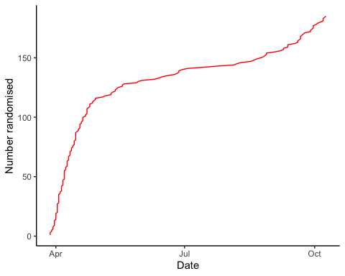

## Inclusion by hospital

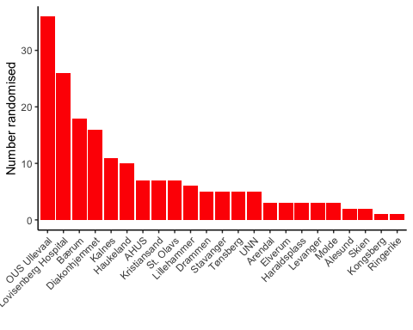

## By treatment

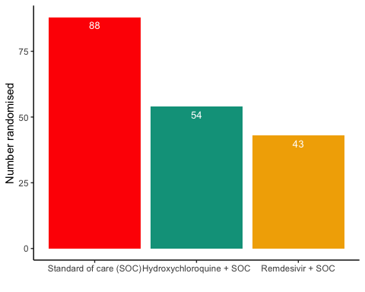

# Demographics

Demographics

|  |  |  |  |
| --- | --- | --- | --- |
| Parameter | SOC (N=88) | SOC + HCQ (N=54) | SOC + Remdesivir (N=43) |
| Age (years) | 59.3 (16.1) | 60.3 (13.8) | 60 (16.4) |
| Female, n (%) | 28 (31.8%) | 21 (38.9%) | 13 (30.2%) |

# Exposure

Exposure to study treatment

|  |  |  |
| --- | --- | --- |
| Parameter | Hydroxychloroquine + SOC | Remdesivir + SOC |
| Total dose, median (IQR), mg | 5200 (3600 - 8400) | 700 (500 - 1100) |
| Days with treatment, median (IQR) | 6 (4 - 10) | 6 (4 - 10) |
| Patients with any treatment discrepencies, n (%) | 23 (42.6%) | 11 (25.6%) |

# Adverse Events

## AE Summary

Summary of Adverse Events

|  |  |  |  |
| --- | --- | --- | --- |
| Parameter | SOC (N=88) | SOC + HCQ (N=54) | SOC + Remdesivir (N=43) |
| Number of AEs | [31] 20 (22.7%) | [34] 20 (37%) | [26] 16 (37.2%) |
| Number of patients with any AEs? | 20 (22.7%) | 20 (37%) | 16 (37.2%) |
| Number of patients with one AE | 13 (14.8%) | 14 (25.9%) | 11 (25.6%) |
| Number of patients with two AE | 3 (3.4%) | 2 (3.7%) | 1 (2.3%) |
| Number of patients with three or more AEs | 4 (4.5%) | 4 (7.4%) | 4 (9.3%) |
| Number of SAEs | [18] 11 (12.5%) | [13] 8 (14.8%) | [12] 10 (23.3%) |
| Number of patients with any SAEs? | 11 (12.5%) | 8 (14.8%) | 10 (23.3%) |

The numbers are [Number of events] Number of patients (percentage of patients), or Number of patients (percentage of patients)

## By System Organ Class and Preferred Term

Adverse Events by System Organ Class and Preferred term

|  |  |  |  |  |
| --- | --- | --- | --- | --- |
| System Organ Class | Preferred Term | SOC (N=88) | SOC + HCQ (N=54) | SOC + Remdesivir (N=43) |
| Blood and lymphatic system disorders | #Total |  | [2] 1 (1.9%) |  |
|  | Leukopenia |  | [1] 1 (1.9%) |  |
|  | Thrombocytopenia |  | [1] 1 (1.9%) |  |
| Cardiac disorders | #Total | [1] 1 (1.1%) |  | [3] 2 (4.7%) |
|  | Arrhythmia |  |  | [2] 1 (2.3%) |
|  | Ventricular tachycardia | [1] 1 (1.1%) |  | [1] 1 (2.3%) |
| Gastrointestinal disorders | #Total | [2] 2 (2.3%) | [4] 4 (7.4%) | [4] 3 (7%) |
|  | Abdominal pain | [1] 1 (1.1%) |  |  |
|  | Diarrhoea | [1] 1 (1.1%) |  |  |
|  | Diarrhoea haemorrhagic |  |  | [1] 1 (2.3%) |
|  | Gastrooesophageal reflux disease |  | [1] 1 (1.9%) |  |
|  | Intestinal pseudo-obstruction |  | [1] 1 (1.9%) |  |
|  | Nausea |  |  | [2] 2 (4.7%) |
|  | Pancreatic failure |  | [1] 1 (1.9%) |  |
|  | Vomiting |  | [1] 1 (1.9%) | [1] 1 (2.3%) |
| General disorders and administration site conditions | #Total | [3] 3 (3.4%) |  | [2] 2 (4.7%) |
|  | Chest pain |  |  | [1] 1 (2.3%) |
|  | General physical health deterioration | [1] 1 (1.1%) |  |  |
|  | Medical device site reaction |  |  | [1] 1 (2.3%) |
|  | Pyrexia | [2] 2 (2.3%) |  |  |
| Infections and infestations | #Total | [3] 3 (3.4%) | [1] 1 (1.9%) |  |
|  | COVID-19 |  | [1] 1 (1.9%) |  |
|  | Infection | [1] 1 (1.1%) |  |  |
|  | Pneumonia bacterial | [2] 2 (2.3%) |  |  |
| Investigations | #Total | [5] 3 (3.4%) | [10] 6 (11.1%) | [4] 4 (9.3%) |
|  | Alanine aminotransferase increased | [2] 1 (1.1%) | [2] 2 (3.7%) |  |
|  | Amylase increased |  | [1] 1 (1.9%) |  |
|  | Aspartate aminotransferase increased | [1] 1 (1.1%) | [3] 3 (5.6%) | [1] 1 (2.3%) |
|  | Blood creatine phosphokinase increased |  | [1] 1 (1.9%) |  |
|  | Electrocardiogram QT prolonged |  | [2] 2 (3.7%) |  |
|  | Fibrin D dimer increased | [1] 1 (1.1%) |  |  |
|  | Gamma-glutamyltransferase increased |  | [1] 1 (1.9%) |  |
|  | Hepatic enzyme increased |  |  | [2] 2 (4.7%) |
|  | Myocardial necrosis marker increased | [1] 1 (1.1%) |  |  |
|  | Neutrophil count decreased |  |  | [1] 1 (2.3%) |
| Metabolism and nutrition disorders | #Total |  | [1] 1 (1.9%) |  |
|  | Hypercalcaemia |  | [1] 1 (1.9%) |  |
| Musculoskeletal and connective tissue disorders | #Total |  | [4] 2 (3.7%) |  |
|  | Arthralgia |  | [1] 1 (1.9%) |  |
|  | Arthritis reactive |  | [1] 1 (1.9%) |  |
|  | Joint swelling |  | [1] 1 (1.9%) |  |
|  | Tendonitis |  | [1] 1 (1.9%) |  |
| Neoplasms benign, malignant and unspecified (incl cysts and polyps) | #Total | [1] 1 (1.1%) |  |  |
|  | Neoplasm malignant | [1] 1 (1.1%) |  |  |
| Nervous system disorders | #Total | [1] 1 (1.1%) | [1] 1 (1.9%) | [2] 2 (4.7%) |
|  | Headache |  |  | [1] 1 (2.3%) |
|  | Loss of consciousness |  |  | [1] 1 (2.3%) |
|  | Syncope | [1] 1 (1.1%) | [1] 1 (1.9%) |  |
| Renal and urinary disorders | #Total | [1] 1 (1.1%) | [1] 1 (1.9%) |  |
|  | Renal failure | [1] 1 (1.1%) | [1] 1 (1.9%) |  |
| Respiratory, thoracic and mediastinal disorders | #Total | [8] 6 (6.8%) | [9] 7 (13%) | [7] 5 (11.6%) |
|  | Bronchopleural fistula |  |  | [1] 1 (2.3%) |
|  | Chronic obstructive pulmonary disease |  |  | [2] 1 (2.3%) |
|  | Cough | [1] 1 (1.1%) |  |  |
|  | Dyspnoea | [3] 1 (1.1%) |  | [1] 1 (2.3%) |
|  | Pulmonary embolism |  | [1] 1 (1.9%) |  |
|  | Respiratory distress | [3] 3 (3.4%) | [4] 3 (5.6%) |  |
|  | Respiratory failure | [1] 1 (1.1%) | [4] 4 (7.4%) | [3] 2 (4.7%) |
| Skin and subcutaneous tissue disorders | #Total |  |  | [1] 1 (2.3%) |
|  | Alopecia |  |  | [1] 1 (2.3%) |
| Vascular disorders | #Total | [1] 1 (1.1%) | [1] 1 (1.9%) | [1] 1 (2.3%) |
|  | Hypotension |  |  | [1] 1 (2.3%) |
|  | Thrombophlebitis |  | [1] 1 (1.9%) |  |
|  | Thrombosis | [1] 1 (1.1%) |  |  |

## Serious Adverse Events

Serious Adverse Events by System Organ Class and Preferred term

|  |  |  |  |  |
| --- | --- | --- | --- | --- |
| System Organ Class | Preferred Term | SOC (N=88) | SOC + HCQ (N=54) | SOC + Remdesivir (N=43) |
| Gastrointestinal disorders | #Total | [1] 1 (1.1%) |  | [1] 1 (2.3%) |
|  | Abdominal pain | [1] 1 (1.1%) |  |  |
|  | Diarrhoea haemorrhagic |  |  | [1] 1 (2.3%) |
| General disorders and administration site conditions | #Total | [2] 2 (2.3%) |  | [1] 1 (2.3%) |
|  | Chest pain |  |  | [1] 1 (2.3%) |
|  | General physical health deterioration | [1] 1 (1.1%) |  |  |
|  | Pyrexia | [1] 1 (1.1%) |  |  |
| Infections and infestations | #Total | [1] 1 (1.1%) | [1] 1 (1.9%) |  |
|  | COVID-19 |  | [1] 1 (1.9%) |  |
|  | Pneumonia bacterial | [1] 1 (1.1%) |  |  |
| Investigations | #Total | [1] 1 (1.1%) | [2] 2 (3.7%) | [2] 2 (4.7%) |
|  | Alanine aminotransferase increased | [1] 1 (1.1%) |  |  |
|  | Aspartate aminotransferase increased |  | [1] 1 (1.9%) |  |
|  | Blood creatine phosphokinase increased |  | [1] 1 (1.9%) |  |
|  | Hepatic enzyme increased |  |  | [2] 2 (4.7%) |
| Neoplasms benign, malignant and unspecified (incl cysts and polyps) | #Total | [1] 1 (1.1%) |  |  |
|  | Neoplasm malignant | [1] 1 (1.1%) |  |  |
| Nervous system disorders | #Total |  |  | [1] 1 (2.3%) |
|  | Loss of consciousness |  |  | [1] 1 (2.3%) |
| Renal and urinary disorders | #Total | [1] 1 (1.1%) | [1] 1 (1.9%) |  |
|  | Renal failure | [1] 1 (1.1%) | [1] 1 (1.9%) |  |
| Respiratory, thoracic and mediastinal disorders | #Total | [7] 5 (5.7%) | [9] 7 (13%) | [7] 5 (11.6%) |
|  | Bronchopleural fistula |  |  | [1] 1 (2.3%) |
|  | Chronic obstructive pulmonary disease |  |  | [2] 1 (2.3%) |
|  | Dyspnoea | [3] 1 (1.1%) |  | [1] 1 (2.3%) |
|  | Pulmonary embolism |  | [1] 1 (1.9%) |  |
|  | Respiratory distress | [3] 3 (3.4%) | [4] 3 (5.6%) |  |
|  | Respiratory failure | [1] 1 (1.1%) | [4] 4 (7.4%) | [3] 2 (4.7%) |

## Suspected Unexpected Serious Adverse Reaction

Suspected Unexpected Serious Adverse Reaction by System Organ Class and Preferred term

|  |  |  |
| --- | --- | --- |
| System Organ Class | Preferred Term | Remdesivir + SOC |
| Gastrointestinal disorders | #Total | [1] 1 (2.3%) |
|  | Diarrhoea haemorrhagic | [1] 1 (2.3%) |

# Mortality and other outcomes by admission state

Outcome

|  |  |  |
| --- | --- | --- |
| outcome | Ward | ICU |
| Alive and discharged | 151 (86.3%) | 9 (90%) |
| Withdrawn | 6 (3.4%) | NA |
| Ongoing | 6 (3.4%) | 1 (10%) |
| Dead | 12 (6.9%) | NA |