NOR-SOLIDARITY First Interim Report

Inge Christoffer Olsen, PhD

10 January, 2021

Table of Contents

# Introduction

This is the report for the first interim analysis of the NOR-SOLIDARITY trial. The data are based on an export from the Viedoc electronic data capture at “2021-01-04 00:30:34” system time stamped “ous_20210104_003034”. The results in this report is according to the true random allocation. There were 181 included patients.

# Inclusion status

## Inclusion rate

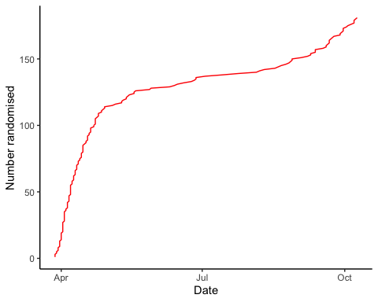

## Inclusion by hospital

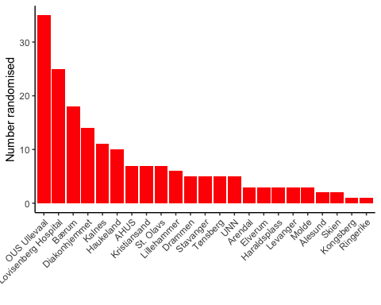

## By treatment

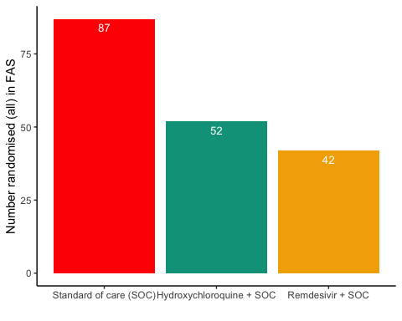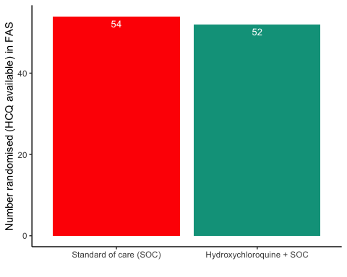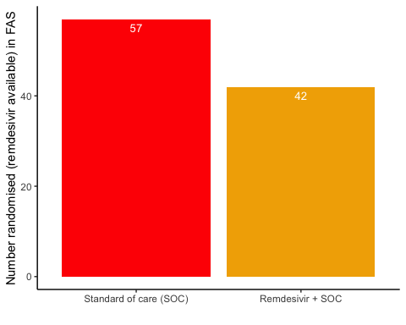

# Patient flow

## Note: Using an external vector in selections is ambiguous.  
## ℹ Use `all_of(group)` instead of `group` to silence this message.  
## ℹ See <https://tidyselect.r-lib.org/reference/faq-external-vector.html>.  
## This message is displayed once per session.

Patient flow total

|  |  |
| --- | --- |
| Parameter | Total |
| Enrolled | 186 (100%) |
| Randomised | 185 (99.5%) |
| Included in FAS | 181 (97.3%) |
| Excluded from FAS, No post-randomisation information | 4 (2.2%) |
| Excluded from FAS, incorrect inclusion | 1 (0.5%) |

Patient flow by arm

|  |  |  |  |
| --- | --- | --- | --- |
| Parameter | SOC | SOC + HCQ | SOC + Remdesivir |
| Randomised | 88 (100%) | 54 (100%) | 43 (100%) |
| Included in FAS | 87 (98.9%) | 52 (96.3%) | 42 (97.7%) |
| Excluded from FAS, No post-randomisation information | 1 (1.1%) | 1 (1.9%) | 1 (2.3%) |
| Excluded from FAS, incorrect inclusion | 0 (0%) | 1 (1.9%) | 0 (0%) |

Patient flow by arm in HCQ

|  |  |  |
| --- | --- | --- |
| Parameter | SOC | SOC + HCQ |
| Randomised | 54 (100%) | 54 (100%) |
| Included in FAS | 54 (100%) | 52 (96.3%) |
| Excluded from FAS, No post-randomisation information | 0 (0%) | 1 (1.9%) |
| Excluded from FAS, incorrect inclusion | 0 (0%) | 1 (1.9%) |

Patient flow by arm in Remdesivir

|  |  |  |
| --- | --- | --- |
| Parameter | SOC | SOC + Remdesivir |
| Randomised | 58 (100%) | 43 (100%) |
| Included in FAS | 57 (98.3%) | 42 (97.7%) |
| Excluded from FAS, No post-randomisation information | 1 (1.7%) | 1 (2.3%) |
| Excluded from FAS, incorrect inclusion | 0 (0%) | 0 (0%) |

Patient flow during study (FAS)

|  |  |  |  |  |
| --- | --- | --- | --- | --- |
| Reason | Standard of care (SOC) | Hydroxychloroquine + SOC | Remdesivir + SOC | Total |
| Voluntary discontinuation by the patient | 2 | 5 | 0 | 7 |
| Patient lost to follow-up | 2 | 1 | 3 | 6 |
| Death | 5 | 4 | 3 | 12 |
| Other | 4 | 1 | 2 | 7 |
| Completed | 74 | 41 | 34 | 149 |

Patient flow during study (FAS) in HCQ

|  |  |  |  |
| --- | --- | --- | --- |
| Reason | Standard of care (SOC) | Hydroxychloroquine + SOC | Total |
| Voluntary discontinuation by the patient | 1 | 5 | 6 |
| Patient lost to follow-up | 1 | 1 | 2 |
| Death | 2 | 4 | 6 |
| Other | 4 | 1 | 5 |
| Completed | 46 | 41 | 87 |

Patient flow during study (FAS) in Remdesivir

|  |  |  |  |
| --- | --- | --- | --- |
| Reason | Standard of care (SOC) | Remdesivir + SOC | Total |
| Voluntary discontinuation by the patient | 1 | 0 | 1 |
| Patient lost to follow-up | 1 | 3 | 4 |
| Death | 4 | 3 | 7 |
| Other | 2 | 2 | 4 |
| Completed | 49 | 34 | 83 |

# Demographics

Demographics, all patients (FAS)

|  |  |
| --- | --- |
| Parameter | All patients (N=181) |
| **Demographics** |  |
| Age (years) | 59.8 (15.3) |
| Female, n (%) | 62 (34.3%) |
| Body Mass Index (kg/m2) | 28 (5) |
| Body Mass Index (kg/m2) | 27 (25 - 31) |
| Symptoms prior to admission (days) | 8 (4.9) |
| P/F-ratio at admittance (kPa) | 41 (13) |
| P/F-ratio < 40kPa, n (%) | 77 (43%) |
| Temperature (°C) | 37.4 (0.9) |
| Admitted to ward, n(%) | 171 (94.5%) |
| Admitted to ICU, n(%) | 10 (5.5%) |
| WHO Moderate disease state (4-5), n(%) | 171 (94.5%) |
| WHO Severe disease state (6-9), n(%) | 10 (5.5%) |
| WHO Severe disease state (6), n(%) | 5 (2.8%) |
| WHO Severe disease state (5), n(%) | 90 (49.7%) |
| **Comorbidities** |  |
| Chronic cardiac disease, including congenital heart disease | 28 (15.6%) |
| Chronic pulmonary disease, n(%) | 10 (5.6%) |
| Ever smoking, n(%) | 71 (39.4%) |
| Hypertension, n(%) | 55 (30.6%) |
| Diabetes, n(%) | 31 (17.2%) |
| Obese (BMI > 30 kg/m2), n(%) | 44 (26.8%) |
| **Co-medications** |  |
| Steroids | 8 (4.5%) |
| Other immunomodulatory drugs | 8 (4.5%) |
| ACE inhibitor | 12 (6.7%) |
| AT-II blockers | 30 (16.8%) |
| **Hematology** |  |
| Hemoglobin (g/dL) | 13.2 (12.3 - 14.1) |
| WBC (x109/L) | 6.2 (4.7 - 8.7) |
| Neutrophils (x109/L) | 4.3 (3 - 6.6) |
| Lymphocytes (x109/L) | 1.1 (0.8 - 1.4) |
| Platelet counts (x10^9/L) | 202.5 (158.5 - 270.5) |
| **Inflammatory markers** |  |
| CRP (mg/L) | 70 (36.5 - 137.5) |
| Procalcitonin (µg/L) | 0.12 (0.1 - 0.21) |
| Ferritin (µg/L) | 613 (319 - 1173) |
| **Other** |  |
| LDH (U/L) | 277 (214 - 360) |
| D-dimer (mg/L FEU) | 0.68 (0.45 - 1.12) |
| AST | 39 (27.2 - 59) |
| ALT | 33 (20 - 58) |
| eGFR (mL/min/1.73 m2) | 89.7 (74.2 - 105.5) |
| **Viral count** |  |
| Viral count (log10 counts/1000 cells) | 2 (1.6) |
| **Anti-SARS-CoV-2 Antibodies** |  |
| Sero converted (RBD ≥ 5) | 60 (47.2%) |
| **Supplementary baseline information** |  |
| Systolic Blood Pressure (mmHg) | 125 (18) |
| Diastolic Blood Pressure (mmHg) | 74 (11) |
| Mean Arterial Blood Pressure (mmHg) | 91 (12) |
| SOFA score | 1.6 (1.6) |
| Chronic kidney disease, n(%) | 11 (6.1%) |
| Autoimmune disease, n(%) | 8 (4.4%) |
| Cognitive impairment/dementia, n(%) | 4 (2.2%) |
| Neurological disorder, n(%) | 7 (3.9%) |
| Cancer, n(%) | 13 (7.2%) |
| Cirrhosis, n(%) | 0 (0%) |
| Asthma, n(%) | 22 (12.2%) |
| HIV, n(%) | 0 (0%) |
| Active TB, n(%) | 0 (0%) |
| Note, all percentages are given with observed values in the denominator, missing values discarded |  |

Demographics, all arms (FAS)

|  |  |  |  |
| --- | --- | --- | --- |
| Parameter | SOC (N=87) | SOC + HCQ (N=52) | SOC + Remdesivir (N=42) |
| **Demographics** |  |  |  |
| Age (years) | 59.5 (16.1) | 60.3 (13.3) | 59.7 (16.5) |
| Female, n (%) | 28 (32.2%) | 21 (40.4%) | 13 (31%) |
| Body Mass Index (kg/m2) | 28 (4) | 28 (5) | 28 (5) |
| Body Mass Index (kg/m2) | 28 (25 - 29) | 27 (25 - 32) | 27 (25 - 32) |
| Symptoms prior to admission (days) | 8 (4.7) | 8.4 (4.3) | 7.5 (6.1) |
| P/F-ratio at admittance (kPa) | 42 (12) | 41 (15) | 38 (13) |
| P/F-ratio < 40kPa, n (%) | 31 (35.6%) | 24 (48%) | 22 (52.4%) |
| Temperature (°C) | 37.4 (0.9) | 37.6 (0.9) | 37.2 (0.9) |
| Admitted to ward, n(%) | 85 (97.7%) | 47 (90.4%) | 39 (92.9%) |
| Admitted to ICU, n(%) | 2 (2.3%) | 5 (9.6%) | 3 (7.1%) |
| WHO Moderate disease state (4-5), n(%) | 85 (97.7%) | 45 (86.5%) | 41 (97.6%) |
| WHO Severe disease state (6-9), n(%) | 2 (2.3%) | 7 (13.5%) | 1 (2.4%) |
| WHO Severe disease state (6), n(%) | NA | 5 (9.6%) | NA |
| WHO Severe disease state (5), n(%) | 41 (47.1%) | 22 (42.3%) | 27 (64.3%) |
| **Comorbidities** |  |  |  |
| Chronic cardiac disease, including congenital heart disease | 16 (18.4%) | 6 (11.5%) | 6 (14.6%) |
| Chronic pulmonary disease, n(%) | 4 (4.6%) | 2 (3.8%) | 4 (9.8%) |
| Ever smoking, n(%) | 37 (42.5%) | 18 (34.6%) | 16 (39%) |
| Hypertension, n(%) | 23 (26.4%) | 17 (32.7%) | 15 (36.6%) |
| Diabetes, n(%) | 15 (17.2%) | 7 (13.5%) | 9 (22%) |
| Obese (BMI > 30 kg/m2), n(%) | 17 (22.1%) | 16 (32.7%) | 11 (28.9%) |
| **Co-medications** |  |  |  |
| Steroids | 5 (5.8%) | 2 (3.8%) | 1 (2.4%) |
| Other immunomodulatory drugs | 5 (5.8%) | 2 (3.8%) | 1 (2.4%) |
| ACE inhibitor | 9 (10.5%) | 1 (1.9%) | 2 (4.9%) |
| AT-II blockers | 10 (11.6%) | 9 (17.3%) | 11 (26.8%) |
| **Hematology** |  |  |  |
| Hemoglobin (g/dL) | 13.3 (12.7 - 14.1) | 13 (12 - 14.1) | 13.2 (12.4 - 14.3) |
| WBC (x109/L) | 6.1 (4.8 - 8.1) | 6.6 (4.4 - 9.2) | 6 (4.9 - 8.7) |
| Neutrophils (x109/L) | 4.1 (2.9 - 6.4) | 4.9 (3 - 6.8) | 4.3 (2.7 - 6.8) |
| Lymphocytes (x109/L) | 1.1 (0.8 - 1.4) | 1 (0.7 - 1.3) | 1.1 (0.9 - 1.5) |
| Platelet counts (x10^9/L) | 205.5 (164 - 271.2) | 184 (151.5 - 270) | 206 (162 - 268) |
| **Inflammatory markers** |  |  |  |
| CRP (mg/L) | 68 (34 - 137.2) | 76 (47 - 133) | 70 (39.8 - 139.2) |
| Procalcitonin (µg/L) | 0.1 (0.1 - 0.2) | 0.13 (0.1 - 0.26) | 0.13 (0.1 - 0.2) |
| Ferritin (µg/L) | 551 (320 - 1040) | 626 (295 - 1298) | 694.5 (343.2 - 1262.2) |
| **Other** |  |  |  |
| LDH (U/L) | 251 (205 - 350) | 287 (234.5 - 360.5) | 284 (234 - 400) |
| D-dimer (mg/L FEU) | 0.62 (0.41 - 0.9) | 0.9 (0.5 - 1.53) | 0.76 (0.47 - 1.03) |
| AST | 33 (25 - 54) | 39 (28 - 59) | 49 (34.5 - 77) |
| ALT | 30 (19 - 50.2) | 33 (22 - 53) | 41 (22 - 69.2) |
| eGFR (mL/min/1.73 m2) | 89.6 (79.3 - 105.3) | 86.3 (67.5 - 101.2) | 90.6 (77.2 - 106.2) |
| **Viral count** |  |  |  |
| Viral count (log10 counts/1000 cells) | 2.1 (1.7) | 2.3 (1.5) | 1.6 (1.6) |
| **Anti-SARS-CoV-2 Antibodies** |  |  |  |
| Sero converted (RBD ≥ 5) | 31 (52.5%) | 15 (42.9%) | 14 (42.4%) |
| **Supplementary baseline information** |  |  |  |
| Systolic Blood Pressure (mmHg) | 122 (16) | 126 (18) | 130 (20) |
| Diastolic Blood Pressure (mmHg) | 73 (12) | 73 (11) | 76 (11) |
| Mean Arterial Blood Pressure (mmHg) | 89 (12) | 90 (11) | 94 (12) |
| SOFA score | 1.5 (1.6) | 1.9 (1.8) | 1.4 (1.3) |
| Chronic kidney disease, n(%) | 5 (5.7%) | 5 (9.6%) | 1 (2.4%) |
| Autoimmune disease, n(%) | 7 (8%) | 1 (1.9%) | 0 (0%) |
| Cognitive impairment/dementia, n(%) | 0 (0%) | 2 (3.8%) | 2 (4.9%) |
| Neurological disorder, n(%) | 1 (1.1%) | 5 (9.6%) | 1 (2.4%) |
| Cancer, n(%) | 11 (12.6%) | 0 (0%) | 2 (4.9%) |
| Cirrhosis, n(%) | 0 (0%) | 0 (0%) | 0 (0%) |
| Asthma, n(%) | 13 (14.9%) | 7 (13.5%) | 2 (4.9%) |
| HIV, n(%) | 0 (0%) | 0 (0%) | 0 (0%) |
| Active TB, n(%) | 0 (0%) | 0 (0%) | 0 (0%) |
| Note, all percentages are given with observed values in the denominator, missing values discarded |  |  |  |

Demographics, HCQ (FAS)

|  |  |  |
| --- | --- | --- |
| Parameter | SOC (N=54) | SOC + HCQ (N=52) |
| **Demographics** |  |  |
| Age (years) | 59.2 (16.4) | 60.3 (13.3) |
| Female, n (%) | 20 (37%) | 21 (40.4%) |
| Body Mass Index (kg/m2) | 27 (4) | 28 (5) |
| Body Mass Index (kg/m2) | 27 (25 - 29) | 27 (25 - 32) |
| Symptoms prior to admission (days) | 8.6 (5.3) | 8.4 (4.3) |
| P/F-ratio at admittance (kPa) | 43 (11) | 41 (15) |
| P/F-ratio < 40kPa, n (%) | 15 (27.8%) | 24 (48%) |
| Temperature (°C) | 37.3 (0.8) | 37.6 (0.9) |
| Admitted to ward, n(%) | 53 (98.1%) | 47 (90.4%) |
| Admitted to ICU, n(%) | 1 (1.9%) | 5 (9.6%) |
| WHO Moderate disease state (4-5), n(%) | 53 (98.1%) | 45 (86.5%) |
| WHO Severe disease state (6-9), n(%) | 1 (1.9%) | 7 (13.5%) |
| WHO Severe disease state (6), n(%) | NA | 5 (9.6%) |
| WHO Severe disease state (5), n(%) | 21 (38.9%) | 22 (42.3%) |
| **Comorbidities** |  |  |
| Chronic cardiac disease, including congenital heart disease | 9 (16.7%) | 6 (11.5%) |
| Chronic pulmonary disease, n(%) | 1 (1.9%) | 2 (3.8%) |
| Ever smoking, n(%) | 21 (38.9%) | 18 (34.6%) |
| Hypertension, n(%) | 18 (33.3%) | 17 (32.7%) |
| Diabetes, n(%) | 8 (14.8%) | 7 (13.5%) |
| Obese (BMI > 30 kg/m2), n(%) | 11 (22%) | 16 (32.7%) |
| **Co-medications** |  |  |
| Steroids | 4 (7.4%) | 2 (3.8%) |
| Other immunomodulatory drugs | 4 (7.4%) | 2 (3.8%) |
| ACE inhibitor | 7 (13%) | 1 (1.9%) |
| AT-II blockers | 7 (13%) | 9 (17.3%) |
| **Hematology** |  |  |
| Hemoglobin (g/dL) | 13.2 (12.6 - 14) | 13 (12 - 14.1) |
| WBC (x109/L) | 6 (4.8 - 8.5) | 6.6 (4.4 - 9.2) |
| Neutrophils (x109/L) | 4.1 (2.8 - 6.3) | 4.9 (3 - 6.8) |
| Lymphocytes (x109/L) | 1.1 (0.9 - 1.4) | 1 (0.7 - 1.3) |
| Platelet counts (x10^9/L) | 208 (167 - 276) | 184 (151.5 - 270) |
| **Inflammatory markers** |  |  |
| CRP (mg/L) | 65.5 (34 - 124) | 76 (47 - 133) |
| Procalcitonin (µg/L) | 0.1 (0.1 - 0.2) | 0.13 (0.1 - 0.26) |
| Ferritin (µg/L) | 531.5 (320.8 - 991.2) | 626 (295 - 1298) |
| **Other** |  |  |
| LDH (U/L) | 251.5 (199.8 - 324.8) | 287 (234.5 - 360.5) |
| D-dimer (mg/L FEU) | 0.77 (0.5 - 1.26) | 0.9 (0.5 - 1.53) |
| AST | 32.5 (24.2 - 53) | 39 (28 - 59) |
| ALT | 30 (18.8 - 52) | 33 (22 - 53) |
| eGFR (mL/min/1.73 m2) | 91.8 (82.7 - 104.7) | 86.3 (67.5 - 101.2) |
| **Viral count** |  |  |
| Viral count (log10 counts/1000 cells) | 2 (1.5) | 2.3 (1.5) |
| **Anti-SARS-CoV-2 Antibodies** |  |  |
| Sero converted (RBD ≥ 5) | 20 (54.1%) | 15 (42.9%) |
| **Supplementary baseline information** |  |  |
| Systolic Blood Pressure (mmHg) | 125 (18) | 126 (18) |
| Diastolic Blood Pressure (mmHg) | 73 (13) | 73 (11) |
| Mean Arterial Blood Pressure (mmHg) | 90 (13) | 90 (11) |
| SOFA score | 1.4 (1.8) | 1.9 (1.8) |
| Chronic kidney disease, n(%) | 2 (3.7%) | 5 (9.6%) |
| Autoimmune disease, n(%) | 6 (11.1%) | 1 (1.9%) |
| Cognitive impairment/dementia, n(%) | 0 (0%) | 2 (3.8%) |
| Neurological disorder, n(%) | 1 (1.9%) | 5 (9.6%) |
| Cancer, n(%) | 7 (13%) | 0 (0%) |
| Cirrhosis, n(%) | 0 (0%) | 0 (0%) |
| Asthma, n(%) | 10 (18.5%) | 7 (13.5%) |
| HIV, n(%) | 0 (0%) | 0 (0%) |
| Active TB, n(%) | 0 (0%) | 0 (0%) |
| Note, all percentages are given with observed values in the denominator, missing values discarded |  |  |

Demographics, Remdesivir (FAS)

|  |  |  |
| --- | --- | --- |
| Parameter | SOC (N=57) | SOC + Remdesivir (N=42) |
| **Demographics** |  |  |
| Age (years) | 58.1 (15.7) | 59.7 (16.5) |
| Female, n (%) | 14 (24.6%) | 13 (31%) |
| Body Mass Index (kg/m2) | 28 (4) | 28 (5) |
| Body Mass Index (kg/m2) | 28 (25 - 29) | 27 (25 - 32) |
| Symptoms prior to admission (days) | 7.2 (3.5) | 7.5 (6.1) |
| P/F-ratio at admittance (kPa) | 43 (12) | 38 (13) |
| P/F-ratio < 40kPa, n (%) | 22 (38.6%) | 22 (52.4%) |
| Temperature (°C) | 37.5 (1) | 37.2 (0.9) |
| Admitted to ward, n(%) | 56 (98.2%) | 39 (92.9%) |
| Admitted to ICU, n(%) | 1 (1.8%) | 3 (7.1%) |
| WHO Moderate disease state (4-5), n(%) | 56 (98.2%) | 41 (97.6%) |
| WHO Severe disease state (6-9), n(%) | 1 (1.8%) | 1 (2.4%) |
| WHO Severe disease state (5), n(%) | 30 (52.6%) | 27 (64.3%) |
| **Comorbidities** |  |  |
| Chronic cardiac disease, including congenital heart disease | 12 (21.1%) | 6 (14.6%) |
| Chronic pulmonary disease, n(%) | 3 (5.3%) | 4 (9.8%) |
| Ever smoking, n(%) | 27 (47.4%) | 16 (39%) |
| Hypertension, n(%) | 14 (24.6%) | 15 (36.6%) |
| Diabetes, n(%) | 9 (15.8%) | 9 (22%) |
| Obese (BMI > 30 kg/m2), n(%) | 9 (18.4%) | 11 (28.9%) |
| **Co-medications** |  |  |
| Steroids | 2 (3.6%) | 1 (2.4%) |
| Other immunomodulatory drugs | 1 (1.8%) | 1 (2.4%) |
| ACE inhibitor | 4 (7.1%) | 2 (4.9%) |
| AT-II blockers | 7 (12.5%) | 11 (26.8%) |
| **Hematology** |  |  |
| Hemoglobin (g/dL) | 13.6 (12.9 - 14.1) | 13.2 (12.4 - 14.3) |
| WBC (x109/L) | 6.3 (4.8 - 8) | 6 (4.9 - 8.7) |
| Neutrophils (x109/L) | 4.5 (2.9 - 6.6) | 4.3 (2.7 - 6.8) |
| Lymphocytes (x109/L) | 1 (0.8 - 1.5) | 1.1 (0.9 - 1.5) |
| Platelet counts (x10^9/L) | 203 (166 - 269) | 206 (162 - 268) |
| **Inflammatory markers** |  |  |
| CRP (mg/L) | 82 (33 - 141.8) | 70 (39.8 - 139.2) |
| Procalcitonin (µg/L) | 0.11 (0.1 - 0.3) | 0.13 (0.1 - 0.2) |
| Ferritin (µg/L) | 589 (317.8 - 1076.8) | 694.5 (343.2 - 1262.2) |
| **Other** |  |  |
| LDH (U/L) | 238.5 (195.2 - 351.8) | 284 (234 - 400) |
| D-dimer (mg/L FEU) | 0.5 (0.37 - 0.87) | 0.76 (0.47 - 1.03) |
| AST | 34 (24 - 54.8) | 49 (34.5 - 77) |
| ALT | 31 (20.5 - 54) | 41 (22 - 69.2) |
| eGFR (mL/min/1.73 m2) | 89.7 (79.8 - 105.6) | 90.6 (77.2 - 106.2) |
| **Viral count** |  |  |
| Viral count (log10 counts/1000 cells) | 2.3 (1.8) | 1.6 (1.6) |
| **Anti-SARS-CoV-2 Antibodies** |  |  |
| Sero converted (RBD ≥ 5) | 18 (46.2%) | 14 (42.4%) |
| **Supplementary baseline information** |  |  |
| Systolic Blood Pressure (mmHg) | 121 (16) | 130 (20) |
| Diastolic Blood Pressure (mmHg) | 72 (10) | 76 (11) |
| Mean Arterial Blood Pressure (mmHg) | 89 (11) | 94 (12) |
| SOFA score | 1.5 (1.2) | 1.4 (1.3) |
| Chronic kidney disease, n(%) | 3 (5.3%) | 1 (2.4%) |
| Autoimmune disease, n(%) | 2 (3.5%) | 0 (0%) |
| Cognitive impairment/dementia, n(%) | 0 (0%) | 2 (4.9%) |
| Neurological disorder, n(%) | 1 (1.8%) | 1 (2.4%) |
| Cancer, n(%) | 6 (10.5%) | 2 (4.9%) |
| Cirrhosis, n(%) | 0 (0%) | 0 (0%) |
| Asthma, n(%) | 6 (10.5%) | 2 (4.9%) |
| HIV, n(%) | 0 (0%) | 0 (0%) |
| Active TB, n(%) | 0 (0%) | 0 (0%) |
| Note, all percentages are given with observed values in the denominator, missing values discarded |  |  |

Missing values, all arms (FAS)

|  |  |  |  |
| --- | --- | --- | --- |
| Parameter | SOC (N=87) | SOC + HCQ (N=52) | SOC + Remdesivir (N=42) |
| **Demographics** |  |  |  |
| Age (years) | 0 (0%) | 0 (0%) | 0 (0%) |
| Female, n (%) | 0 (0%) | 0 (0%) | 0 (0%) |
| Body Mass Index (kg/m2) | 10 (11.5%), 10 (11.5%) | 3 (5.8%), 3 (5.8%) | 4 (9.5%), 4 (9.5%) |
| Symptoms prior to admission (days) | 0 (0%) | 0 (0%) | 1 (2.4%) |
| P/F-ratio at admittance (kPa) | 0 (0%) | 2 (3.8%) | 0 (0%) |
| P/F-ratio < 40kPa, n (%) | 0 (0%) | 2 (3.8%) | 0 (0%) |
| Temperature (°C) | 0 (0%) | 0 (0%) | 0 (0%) |
| Admitted to ward, n(%) | 0 (0%) | 0 (0%) | 0 (0%) |
| Admitted to ICU, n(%) | 0 (0%) | 0 (0%) | 0 (0%) |
| WHO Moderate disease state (4-5), n(%) | 0 (0%) | 0 (0%) | 0 (0%) |
| WHO Severe disease state (6-9), n(%) | 0 (0%) | 0 (0%) | 0 (0%) |
| WHO Severe disease state (6), n(%) | 0 (0%) | 0 (0%) | 0 (0%) |
| WHO Severe disease state (5), n(%) | 0 (0%) | 0 (0%) | 0 (0%) |
| **Comorbidities** |  |  |  |
| Chronic cardiac disease, including congenital heart disease | 0 (0%) | 0 (0%) | 1 (2.4%) |
| Chronic pulmonary disease, n(%) | 0 (0%) | 0 (0%) | 1 (2.4%) |
| Ever smoking, n(%) | 0 (0%) | 0 (0%) | 1 (2.4%) |
| Hypertension, n(%) | 0 (0%) | 0 (0%) | 1 (2.4%) |
| Diabetes, n(%) | 0 (0%) | 0 (0%) | 1 (2.4%) |
| Obese (BMI > 30 kg/m2), n(%) | 10 (11.5%) | 3 (5.8%) | 4 (9.5%) |
| **Co-medications** |  |  |  |
| Steroids | 1 (1.1%) | 0 (0%) | 1 (2.4%) |
| Other immunomodulatory drugs | 1 (1.1%) | 0 (0%) | 1 (2.4%) |
| ACE inhibitor | 1 (1.1%) | 0 (0%) | 1 (2.4%) |
| AT-II blockers | 1 (1.1%) | 0 (0%) | 1 (2.4%) |
| **Hematology** |  |  |  |
| Hemoglobin (g/dL) | 1 (1.1%) | 1 (1.9%) | 1 (2.4%) |
| WBC (x109/L) | 0 (0%) | 0 (0%) | 1 (2.4%) |
| Neutrophils (x109/L) | 5 (5.7%) | 2 (3.8%) | 3 (7.1%) |
| Lymphocytes (x109/L) | 5 (5.7%) | 2 (3.8%) | 2 (4.8%) |
| Platelet counts (x10^9/L) | 1 (1.1%) | 1 (1.9%) | 1 (2.4%) |
| **Inflammatory markers** |  |  |  |
| CRP (mg/L) | 1 (1.1%) | 1 (1.9%) | 0 (0%) |
| Procalcitonin (µg/L) | 28 (32.2%) | 21 (40.4%) | 9 (21.4%) |
| Ferritin (µg/L) | 6 (6.9%) | 3 (5.8%) | 0 (0%) |
| **Other** |  |  |  |
| LDH (U/L) | 6 (6.9%) | 1 (1.9%) | 1 (2.4%) |
| D-dimer (mg/L FEU) | 11 (12.6%) | 6 (11.5%) | 2 (4.8%) |
| AST | 6 (6.9%) | 3 (5.8%) | 2 (4.8%) |
| ALT | 3 (3.4%) | 3 (5.8%) | 2 (4.8%) |
| eGFR (mL/min/1.73 m2) | 0 (0%) | 1 (1.9%) | 0 (0%) |
| **Viral count** |  |  |  |
| Viral count (log10 counts/1000 cells) | 21 (24.1%) | 17 (32.7%) | 10 (23.8%) |
| **Anti-SARS-CoV-2 Antibodies** |  |  |  |
| Sero converted (RBD ≥ 5) | 28 (32.2%) | 17 (32.7%) | 9 (21.4%) |
| **Supplementary baseline information** |  |  |  |
| Systolic Blood Pressure (mmHg) | 0 (0%) | 0 (0%) | 0 (0%) |
| Diastolic Blood Pressure (mmHg) | 0 (0%) | 0 (0%) | 0 (0%) |
| Mean Arterial Blood Pressure (mmHg) | 0 (0%) | 0 (0%) | 0 (0%) |
| SOFA score | 7 (8%) | 2 (3.8%) | 2 (4.8%) |
| Chronic kidney disease, n(%) | 0 (0%) | 0 (0%) | 1 (2.4%) |
| Autoimmune disease, n(%) | 0 (0%) | 0 (0%) | 1 (2.4%) |
| Cognitive impairment/dementia, n(%) | 0 (0%) | 0 (0%) | 1 (2.4%) |
| Neurological disorder, n(%) | 0 (0%) | 0 (0%) | 1 (2.4%) |
| Cancer, n(%) | 0 (0%) | 0 (0%) | 1 (2.4%) |
| Cirrhosis, n(%) | 0 (0%) | 0 (0%) | 1 (2.4%) |
| Asthma, n(%) | 0 (0%) | 0 (0%) | 1 (2.4%) |
| HIV, n(%) | 0 (0%) | 0 (0%) | 1 (2.4%) |
| Active TB, n(%) | 0 (0%) | 0 (0%) | 1 (2.4%) |
| Note, all percentages are given with observed values in the denominator, missing values discarded |  |  |  |

# Exposure

Exposure to study treatment

|  |  |  |
| --- | --- | --- |
| Parameter | SOC + HCQ (N=52) | SOC + Remdesivir (N=42) |
| Total dose (mg), median (IQR) | 5400 (3600 - 8500) | 700 (500 - 1075) |
| Treatment duration, median (IQR) | 6 (3 - 9) | 5 (3 - 9) |
| Number of doses given, median (IQR) | 6 (4 - 10) | 6 (4 - 10) |
| Patients with any treatment discrepencies, n (%) | 21 (40.4%) | 13 (31%) |

# Efficacy

## Mortality

### Descriptives

All arms (FAS)

|  |  |  |  |
| --- | --- | --- | --- |
| Treatment | # deaths | # randomised | % |
| Standard of care (SOC) | 5 | 87 | 5.7 |
| Hydroxychloroquine + SOC | 4 | 52 | 7.7 |
| Remdesivir + SOC | 3 | 42 | 7.1 |

HCQ (FAS)

|  |  |  |  |
| --- | --- | --- | --- |
| Treatment | # deaths | # randomised | % |
| Standard of care (SOC) | 2 | 54 | 3.7 |
| Hydroxychloroquine + SOC | 4 | 52 | 7.7 |

Remdesivir (FAS)

|  |  |  |  |
| --- | --- | --- | --- |
| Treatment | # deaths | # randomised | % |
| Standard of care (SOC) | 4 | 57 | 7.0 |
| Remdesivir + SOC | 3 | 42 | 7.1 |

### Plots

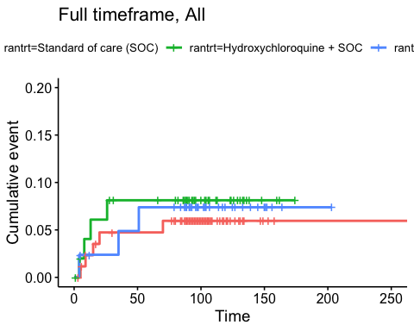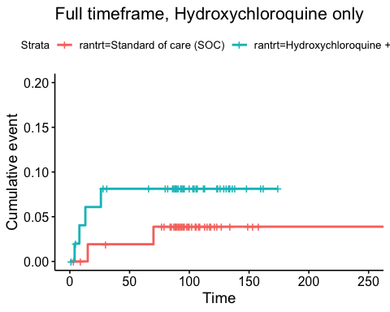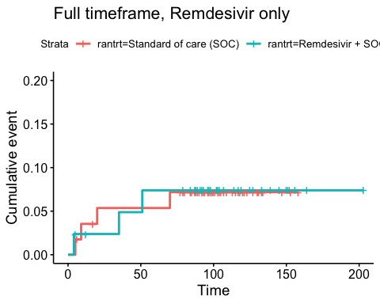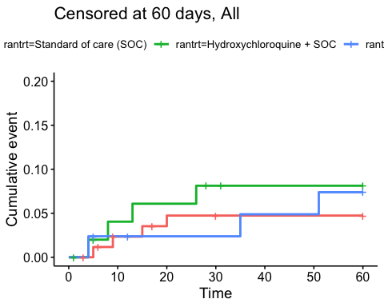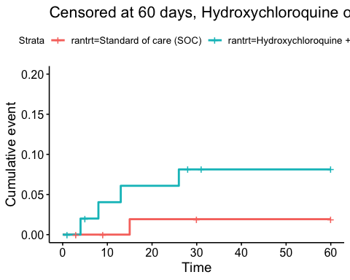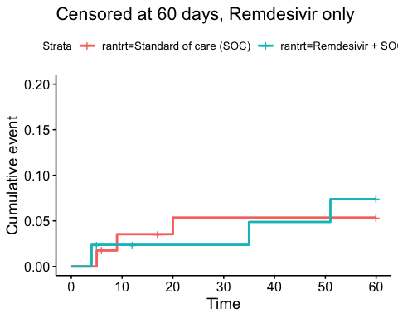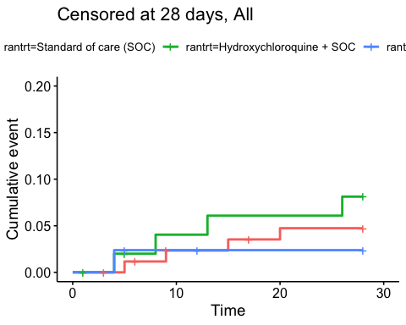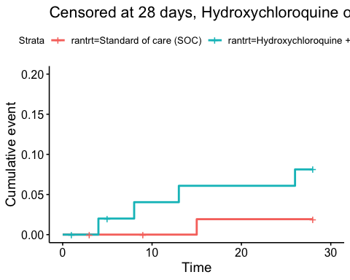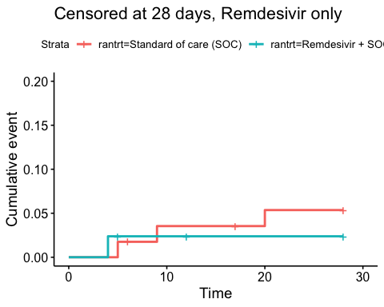

### Efficacy estimates

Relative risk estimates and p-values

|  |  |  |
| --- | --- | --- |
| Timeframe, Population | Relative risk | P-value |
| Full timeframe, All | Not applicable | 0.871 |
| Full timeframe, Hydroxychloroquine only | 2.18 (95% CI 0.44 to 10.82) | 0.341 |
| Full timeframe, Remdesivir only | 1.03 (95% CI 0.23 to 4.6) | 0.972 |
| Censored at 60 days, All | Not applicable | 0.703 |
| Censored at 60 days, Hydroxychloroquine only | 3.67 (95% CI 0.63 to 21.22) | 0.147 |
| Censored at 60 days, Remdesivir only | 1.37 (95% CI 0.27 to 6.92) | 0.703 |
| Censored at 28 days, All | Not applicable | 0.471 |
| Censored at 28 days, Hydroxychloroquine only | 3.67 (95% CI 0.63 to 21.22) | 0.147 |
| Censored at 28 days, Remdesivir only | 0.49 (95% CI 0.07 to 3.6) | 0.486 |

## Viral load

### Plots

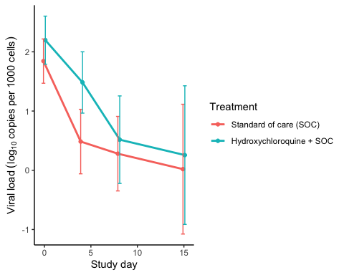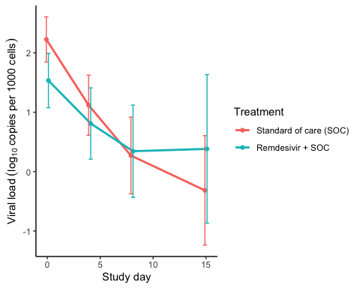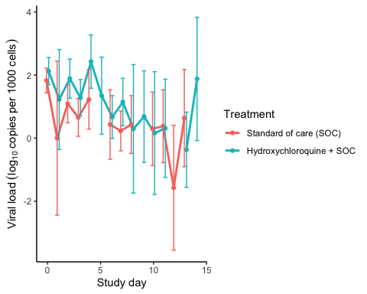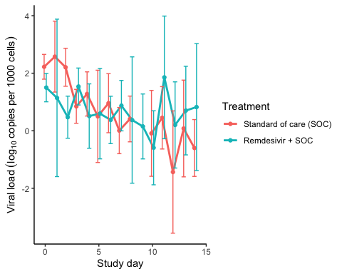

### Marginal probability estimates by treatment group and difference

Estimated treatment effect, Hydroxychloroquine

|  |  |  |  |  |  |
| --- | --- | --- | --- | --- | --- |
| Treatment | Explanation | Estimate | Lower 95% CL | Upper 95% CL | P-value |
| Standard of care (SOC) | Slope 1st week | -0.224 | -0.300 | -0.148 | 0.000 |
| Hydroxychloroquine + SOC | Slope 1st week | -0.197 | -0.278 | -0.115 | 0.000 |
| Hydroxychloroquine + SOC | Difference in slope | 0.028 | -0.084 | 0.139 | 0.628 |
| Standard of care (SOC) | Level at day 10 | 0.259 | -0.179 | 0.697 | 0.247 |
| Hydroxychloroquine + SOC | Level at day 10 | 0.574 | 0.108 | 1.041 | 0.016 |
| Hydroxychloroquine + SOC | Difference at day 10 | 0.315 | -0.325 | 0.955 | 0.334 |

Estimated treatment effect, Remdesivir

|  |  |  |  |  |  |
| --- | --- | --- | --- | --- | --- |
| Treatment | Explanation | Estimate | Lower 95% CL | Upper 95% CL | P-value |
| Standard of care (SOC) | Slope 1st week | -0.264 | -0.339 | -0.188 | 0.000 |
| Remdesivir + SOC | Slope 1st week | -0.151 | -0.237 | -0.065 | 0.001 |
| Remdesivir + SOC | Difference in slope | 0.113 | -0.001 | 0.227 | 0.053 |
| Standard of care (SOC) | Level at day 10 | 0.292 | -0.062 | 0.646 | 0.106 |
| Remdesivir + SOC | Level at day 10 | 0.495 | 0.073 | 0.917 | 0.021 |
| Remdesivir + SOC | Difference at day 10 | 0.203 | -0.348 | 0.754 | 0.470 |

## Viral load subgroup analyses

### Plots, Hydroxychloroquine

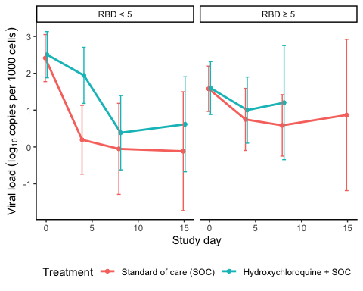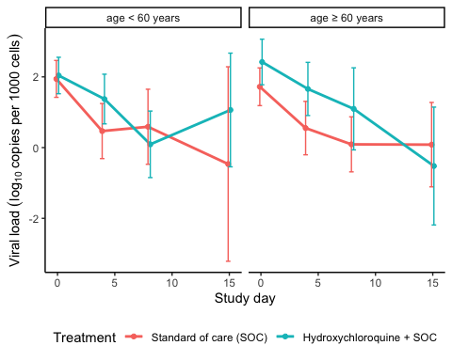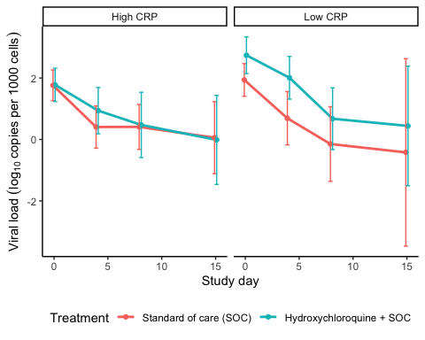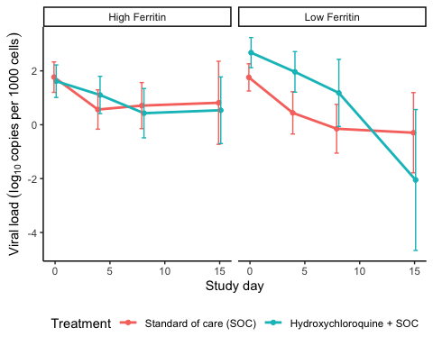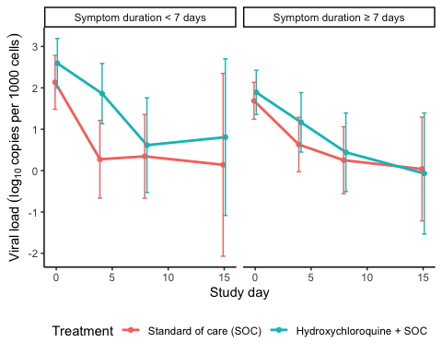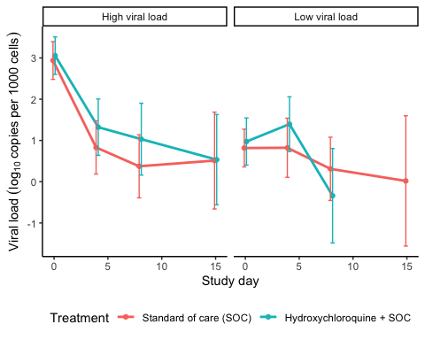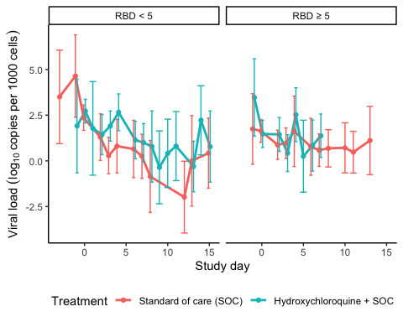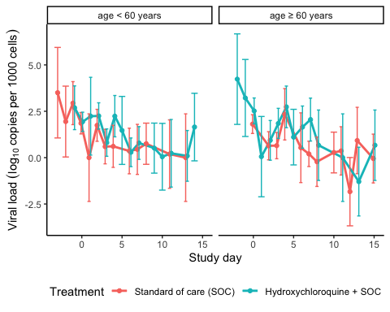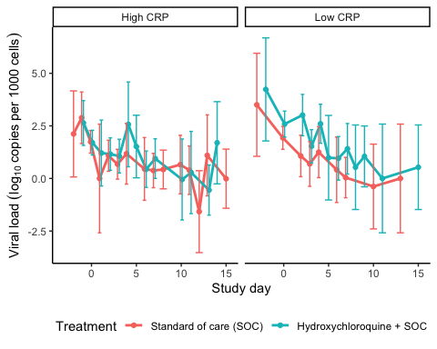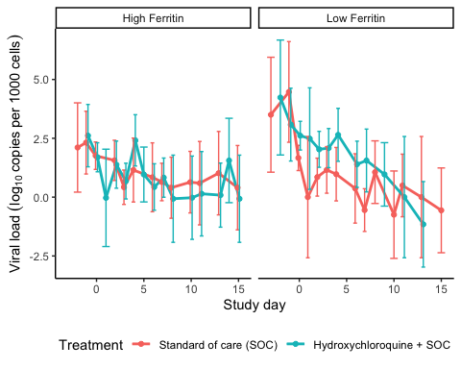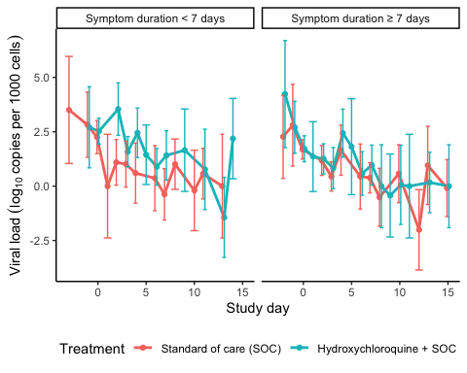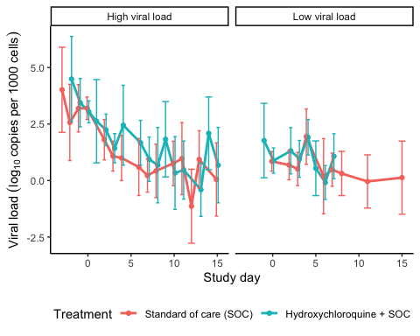

### Marginal probability estimates by treatment group and difference Hydroxychloroquine

Estimated treatment effect, Hydroxychloroquine

|  |  |  |  |  |  |  |
| --- | --- | --- | --- | --- | --- | --- |
| Treatment | Subgroup | Explanation | Estimate | Lower 95% CL | Upper 95% CL | P-value |
| Standard of care (SOC) | RBD < 5 | Slope 1st week by treatment and subgroup | -0.391 | -0.527 | -0.255 | 0.000 |
| Standard of care (SOC) | RBD ≥ 5 | Slope 1st week by treatment and subgroup | -0.145 | -0.260 | -0.030 | 0.013 |
| Hydroxychloroquine + SOC | RBD < 5 | Slope 1st week by treatment and subgroup | -0.235 | -0.359 | -0.111 | 0.000 |
| Hydroxychloroquine + SOC | RBD ≥ 5 | Slope 1st week by treatment and subgroup | NA | NA | NA | NA |
| Hydroxychloroquine + SOC | RBD < 5 | Treatment effect (Difference in slope) | 0.156 | -0.028 | 0.340 | 0.096 |
| Hydroxychloroquine + SOC | RBD ≥ 5 | Treatment effect (Difference in slope) | NA | NA | NA | NA |
| Hydroxychloroquine + SOC | RBD ≥ 5 | Treatment/Subgroup interaction | NA | NA | NA | NA |

Estimated treatment effect, Hydroxychloroquine

|  |  |  |  |  |  |  |
| --- | --- | --- | --- | --- | --- | --- |
| Treatment | Subgroup | Explanation | Estimate | Lower 95% CL | Upper 95% CL | P-value |
| Standard of care (SOC) | age < 60 years | Slope 1st week by treatment and subgroup | -0.256 | -0.385 | -0.127 | 0.000 |
| Standard of care (SOC) | age ≥ 60 years | Slope 1st week by treatment and subgroup | -0.224 | -0.323 | -0.125 | 0.000 |
| Hydroxychloroquine + SOC | age < 60 years | Slope 1st week by treatment and subgroup | -0.226 | -0.331 | -0.121 | 0.000 |
| Hydroxychloroquine + SOC | age ≥ 60 years | Slope 1st week by treatment and subgroup | -0.162 | -0.293 | -0.031 | 0.015 |
| Hydroxychloroquine + SOC | age < 60 years | Treatment effect (Difference in slope) | 0.030 | -0.136 | 0.196 | 0.723 |
| Hydroxychloroquine + SOC | age ≥ 60 years | Treatment effect (Difference in slope) | 0.062 | -0.102 | 0.226 | 0.459 |
| Hydroxychloroquine + SOC | age ≥ 60 years | Treatment/Subgroup interaction | 0.032 | -0.202 | 0.265 | 0.790 |

Estimated treatment effect, Hydroxychloroquine

|  |  |  |  |  |  |  |
| --- | --- | --- | --- | --- | --- | --- |
| Treatment | Subgroup | Explanation | Estimate | Lower 95% CL | Upper 95% CL | P-value |
| Standard of care (SOC) | High CRP | Slope 1st week by treatment and subgroup | -0.211 | -0.308 | -0.114 | 0.000 |
| Standard of care (SOC) | Low CRP | Slope 1st week by treatment and subgroup | -0.277 | -0.406 | -0.147 | 0.000 |
| Hydroxychloroquine + SOC | High CRP | Slope 1st week by treatment and subgroup | -0.175 | -0.285 | -0.064 | 0.002 |
| Hydroxychloroquine + SOC | Low CRP | Slope 1st week by treatment and subgroup | -0.240 | -0.364 | -0.116 | 0.000 |
| Hydroxychloroquine + SOC | High CRP | Treatment effect (Difference in slope) | 0.036 | -0.111 | 0.183 | 0.630 |
| Hydroxychloroquine + SOC | Low CRP | Treatment effect (Difference in slope) | 0.036 | -0.143 | 0.216 | 0.691 |
| Hydroxychloroquine + SOC | Low CRP | Treatment/Subgroup interaction | 0.000 | -0.232 | 0.232 | 0.998 |

Estimated treatment effect, Hydroxychloroquine

|  |  |  |  |  |  |  |
| --- | --- | --- | --- | --- | --- | --- |
| Treatment | Subgroup | Explanation | Estimate | Lower 95% CL | Upper 95% CL | P-value |
| Standard of care (SOC) | High Ferritin | Slope 1st week by treatment and subgroup | -0.174 | -0.277 | -0.071 | 0.001 |
| Standard of care (SOC) | Low Ferritin | Slope 1st week by treatment and subgroup | -0.280 | -0.388 | -0.173 | 0.000 |
| Hydroxychloroquine + SOC | High Ferritin | Slope 1st week by treatment and subgroup | -0.142 | -0.247 | -0.038 | 0.008 |
| Hydroxychloroquine + SOC | Low Ferritin | Slope 1st week by treatment and subgroup | -0.183 | -0.315 | -0.051 | 0.007 |
| Hydroxychloroquine + SOC | High Ferritin | Treatment effect (Difference in slope) | 0.032 | -0.115 | 0.179 | 0.668 |
| Hydroxychloroquine + SOC | Low Ferritin | Treatment effect (Difference in slope) | 0.097 | -0.073 | 0.268 | 0.264 |
| Hydroxychloroquine + SOC | Low Ferritin | Treatment/Subgroup interaction | 0.065 | -0.160 | 0.290 | 0.571 |

Estimated treatment effect, Hydroxychloroquine

|  |  |  |  |  |  |  |
| --- | --- | --- | --- | --- | --- | --- |
| Treatment | Subgroup | Explanation | Estimate | Lower 95% CL | Upper 95% CL | P-value |
| Standard of care (SOC) | Symptom duration < 7 days | Slope 1st week by treatment and subgroup | -0.309 | -0.442 | -0.176 | 0.000 |
| Standard of care (SOC) | Symptom duration ≥ 7 days | Slope 1st week by treatment and subgroup | -0.202 | -0.299 | -0.106 | 0.000 |
| Hydroxychloroquine + SOC | Symptom duration < 7 days | Slope 1st week by treatment and subgroup | -0.230 | -0.348 | -0.113 | 0.000 |
| Hydroxychloroquine + SOC | Symptom duration ≥ 7 days | Slope 1st week by treatment and subgroup | -0.176 | -0.291 | -0.061 | 0.003 |
| Hydroxychloroquine + SOC | Symptom duration < 7 days | Treatment effect (Difference in slope) | 0.078 | -0.099 | 0.256 | 0.387 |
| Hydroxychloroquine + SOC | Symptom duration ≥ 7 days | Treatment effect (Difference in slope) | 0.026 | -0.124 | 0.177 | 0.730 |
| Hydroxychloroquine + SOC | Symptom duration ≥ 7 days | Treatment/Subgroup interaction | -0.052 | -0.284 | 0.181 | 0.662 |

Estimated treatment effect, Hydroxychloroquine

|  |  |  |  |  |  |  |
| --- | --- | --- | --- | --- | --- | --- |
| Treatment | Subgroup | Explanation | Estimate | Lower 95% CL | Upper 95% CL | P-value |
| Standard of care (SOC) | High viral load | Slope 1st week by treatment and subgroup | -0.396 | -0.490 | -0.302 | 0.000 |
| Standard of care (SOC) | Low viral load | Slope 1st week by treatment and subgroup | -0.052 | -0.154 | 0.050 | 0.321 |
| Hydroxychloroquine + SOC | High viral load | Slope 1st week by treatment and subgroup | -0.310 | -0.417 | -0.203 | 0.000 |
| Hydroxychloroquine + SOC | Low viral load | Slope 1st week by treatment and subgroup | NA | NA | NA | NA |
| Hydroxychloroquine + SOC | High viral load | Treatment effect (Difference in slope) | 0.086 | -0.057 | 0.228 | 0.240 |
| Hydroxychloroquine + SOC | Low viral load | Treatment effect (Difference in slope) | NA | NA | NA | NA |
| Hydroxychloroquine + SOC | Low viral load | Treatment/Subgroup interaction | NA | NA | NA | NA |

### Plots Remdesivir

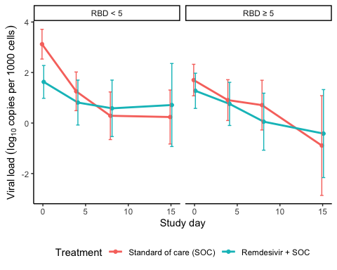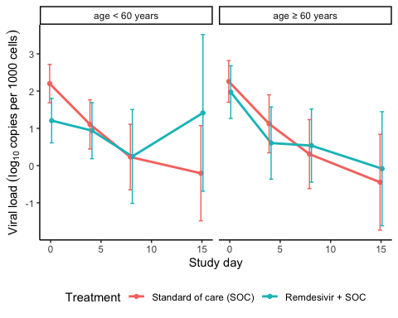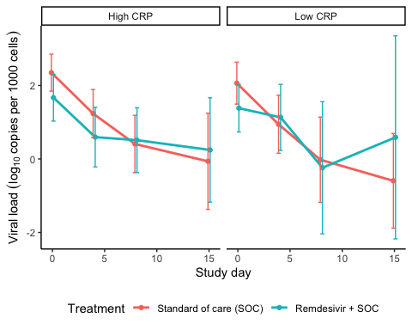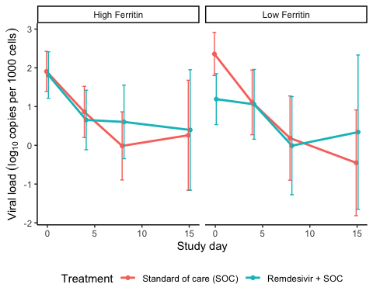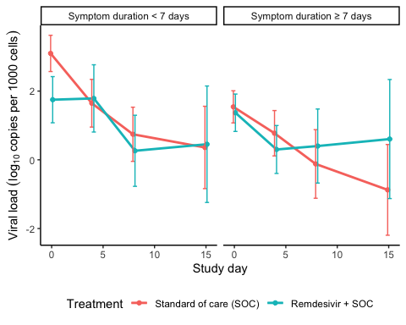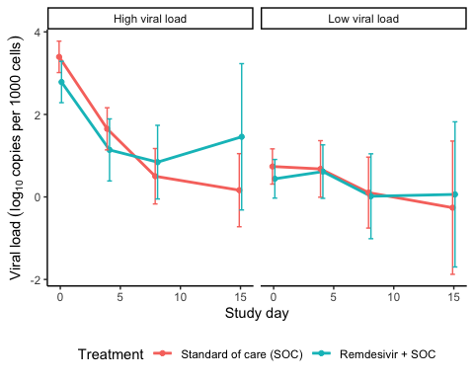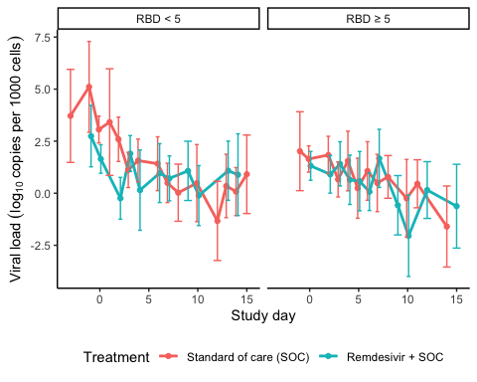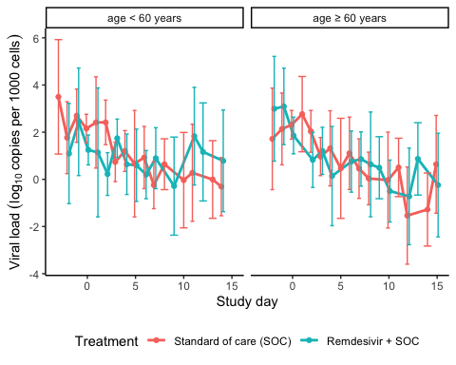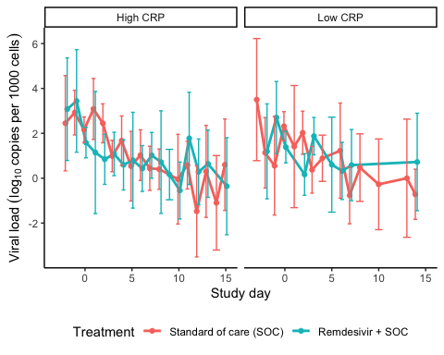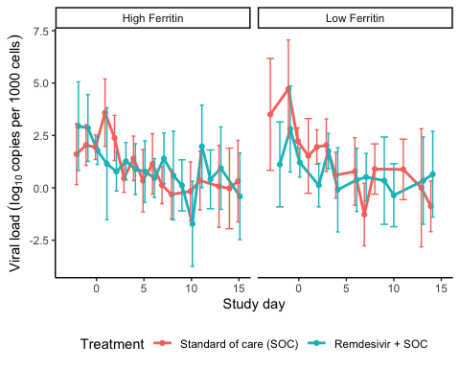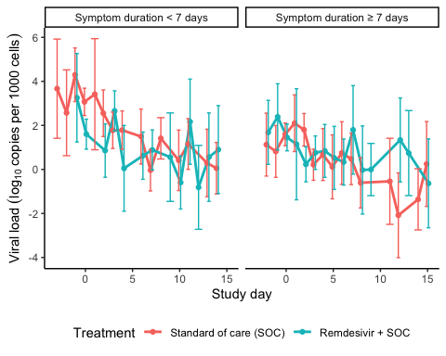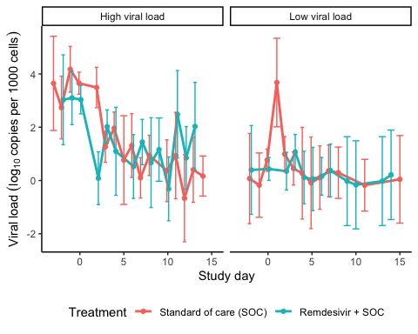

### Marginal probability estimates by treatment group and difference Remdesivir

Estimated treatment effect, Remdesivir

|  |  |  |  |  |  |  |
| --- | --- | --- | --- | --- | --- | --- |
| Treatment | Subgroup | Explanation | Estimate | Lower 95% CL | Upper 95% CL | P-value |
| Standard of care (SOC) | RBD < 5 | Slope 1st week by treatment and subgroup | -0.394 | -0.508 | -0.280 | 0.000 |
| Standard of care (SOC) | RBD ≥ 5 | Slope 1st week by treatment and subgroup | -0.145 | -0.277 | -0.013 | 0.031 |
| Remdesivir + SOC | RBD < 5 | Slope 1st week by treatment and subgroup | -0.153 | -0.285 | -0.020 | 0.024 |
| Remdesivir + SOC | RBD ≥ 5 | Slope 1st week by treatment and subgroup | -0.138 | -0.265 | -0.010 | 0.034 |
| Remdesivir + SOC | RBD < 5 | Treatment effect (Difference in slope) | 0.241 | 0.066 | 0.416 | 0.007 |
| Remdesivir + SOC | RBD ≥ 5 | Treatment effect (Difference in slope) | 0.007 | -0.176 | 0.190 | 0.940 |
| Remdesivir + SOC | RBD ≥ 5 | Treatment/Subgroup interaction | -0.234 | -0.487 | 0.020 | 0.071 |

Estimated treatment effect, Remdesivir

|  |  |  |  |  |  |  |
| --- | --- | --- | --- | --- | --- | --- |
| Treatment | Subgroup | Explanation | Estimate | Lower 95% CL | Upper 95% CL | P-value |
| Standard of care (SOC) | age < 60 years | Slope 1st week by treatment and subgroup | -0.270 | -0.374 | -0.167 | 0.000 |
| Standard of care (SOC) | age ≥ 60 years | Slope 1st week by treatment and subgroup | -0.263 | -0.381 | -0.145 | 0.000 |
| Remdesivir + SOC | age < 60 years | Slope 1st week by treatment and subgroup | -0.101 | -0.227 | 0.024 | 0.112 |
| Remdesivir + SOC | age ≥ 60 years | Slope 1st week by treatment and subgroup | -0.211 | -0.333 | -0.089 | 0.001 |
| Remdesivir + SOC | age < 60 years | Treatment effect (Difference in slope) | 0.169 | 0.006 | 0.332 | 0.042 |
| Remdesivir + SOC | age ≥ 60 years | Treatment effect (Difference in slope) | 0.052 | -0.118 | 0.222 | 0.548 |
| Remdesivir + SOC | age ≥ 60 years | Treatment/Subgroup interaction | -0.117 | -0.352 | 0.119 | 0.330 |

Estimated treatment effect, Remdesivir

|  |  |  |  |  |  |  |
| --- | --- | --- | --- | --- | --- | --- |
| Treatment | Subgroup | Explanation | Estimate | Lower 95% CL | Upper 95% CL | P-value |
| Standard of care (SOC) | High CRP | Slope 1st week by treatment and subgroup | -0.262 | -0.361 | -0.163 | 0.000 |
| Standard of care (SOC) | Low CRP | Slope 1st week by treatment and subgroup | -0.285 | -0.418 | -0.153 | 0.000 |
| Remdesivir + SOC | High CRP | Slope 1st week by treatment and subgroup | -0.169 | -0.280 | -0.059 | 0.003 |
| Remdesivir + SOC | Low CRP | Slope 1st week by treatment and subgroup | -0.138 | -0.289 | 0.014 | 0.076 |
| Remdesivir + SOC | High CRP | Treatment effect (Difference in slope) | 0.093 | -0.056 | 0.241 | 0.220 |
| Remdesivir + SOC | Low CRP | Treatment effect (Difference in slope) | 0.148 | -0.054 | 0.349 | 0.151 |
| Remdesivir + SOC | Low CRP | Treatment/Subgroup interaction | 0.055 | -0.195 | 0.305 | 0.667 |

Estimated treatment effect, Remdesivir

|  |  |  |  |  |  |  |
| --- | --- | --- | --- | --- | --- | --- |
| Treatment | Subgroup | Explanation | Estimate | Lower 95% CL | Upper 95% CL | P-value |
| Standard of care (SOC) | High Ferritin | Slope 1st week by treatment and subgroup | -0.253 | -0.357 | -0.150 | 0.000 |
| Standard of care (SOC) | Low Ferritin | Slope 1st week by treatment and subgroup | -0.309 | -0.446 | -0.172 | 0.000 |
| Remdesivir + SOC | High Ferritin | Slope 1st week by treatment and subgroup | -0.189 | -0.302 | -0.077 | 0.001 |
| Remdesivir + SOC | Low Ferritin | Slope 1st week by treatment and subgroup | -0.113 | -0.253 | 0.028 | 0.115 |
| Remdesivir + SOC | High Ferritin | Treatment effect (Difference in slope) | 0.064 | -0.089 | 0.217 | 0.413 |
| Remdesivir + SOC | Low Ferritin | Treatment effect (Difference in slope) | 0.196 | 0.000 | 0.392 | 0.050 |
| Remdesivir + SOC | Low Ferritin | Treatment/Subgroup interaction | 0.132 | -0.116 | 0.381 | 0.297 |

Estimated treatment effect, Remdesivir

|  |  |  |  |  |  |  |
| --- | --- | --- | --- | --- | --- | --- |
| Treatment | Subgroup | Explanation | Estimate | Lower 95% CL | Upper 95% CL | P-value |
| Standard of care (SOC) | Symptom duration < 7 days | Slope 1st week by treatment and subgroup | -0.338 | -0.442 | -0.233 | 0.000 |
| Standard of care (SOC) | Symptom duration ≥ 7 days | Slope 1st week by treatment and subgroup | -0.200 | -0.316 | -0.084 | 0.001 |
| Remdesivir + SOC | Symptom duration < 7 days | Slope 1st week by treatment and subgroup | -0.143 | -0.265 | -0.022 | 0.021 |
| Remdesivir + SOC | Symptom duration ≥ 7 days | Slope 1st week by treatment and subgroup | -0.183 | -0.308 | -0.059 | 0.004 |
| Remdesivir + SOC | Symptom duration < 7 days | Treatment effect (Difference in slope) | 0.194 | 0.034 | 0.355 | 0.018 |
| Remdesivir + SOC | Symptom duration ≥ 7 days | Treatment effect (Difference in slope) | 0.017 | -0.154 | 0.187 | 0.847 |
| Remdesivir + SOC | Symptom duration ≥ 7 days | Treatment/Subgroup interaction | -0.178 | -0.412 | 0.056 | 0.137 |

Estimated treatment effect, Remdesivir

|  |  |  |  |  |  |  |
| --- | --- | --- | --- | --- | --- | --- |
| Treatment | Subgroup | Explanation | Estimate | Lower 95% CL | Upper 95% CL | P-value |
| Standard of care (SOC) | High viral load | Slope 1st week by treatment and subgroup | -0.411 | -0.500 | -0.322 | 0.000 |
| Standard of care (SOC) | Low viral load | Slope 1st week by treatment and subgroup | -0.062 | -0.175 | 0.050 | 0.278 |
| Remdesivir + SOC | High viral load | Slope 1st week by treatment and subgroup | -0.293 | -0.408 | -0.178 | 0.000 |
| Remdesivir + SOC | Low viral load | Slope 1st week by treatment and subgroup | -0.018 | -0.128 | 0.092 | 0.749 |
| Remdesivir + SOC | High viral load | Treatment effect (Difference in slope) | 0.118 | -0.028 | 0.263 | 0.112 |
| Remdesivir + SOC | Low viral load | Treatment effect (Difference in slope) | 0.044 | -0.113 | 0.202 | 0.581 |
| Remdesivir + SOC | Low viral load | Treatment/Subgroup interaction | -0.074 | -0.288 | 0.141 | 0.502 |

## Respiratory failure by pO2/FiO2-ratio

### Plots

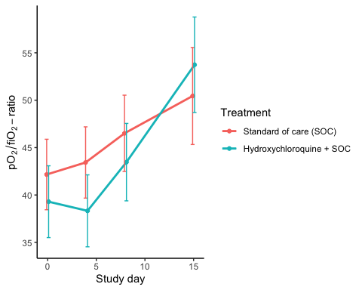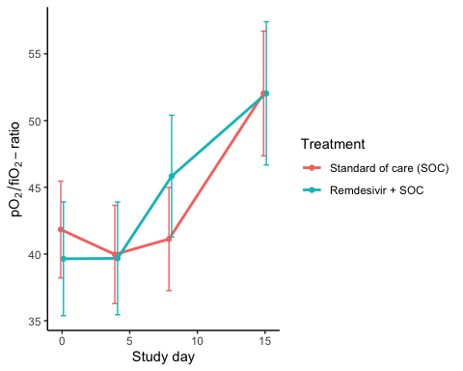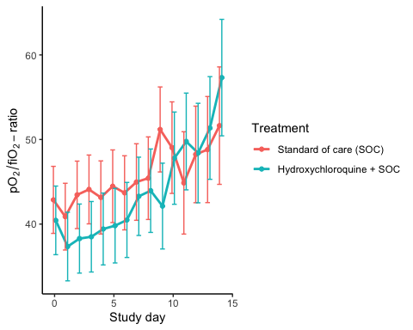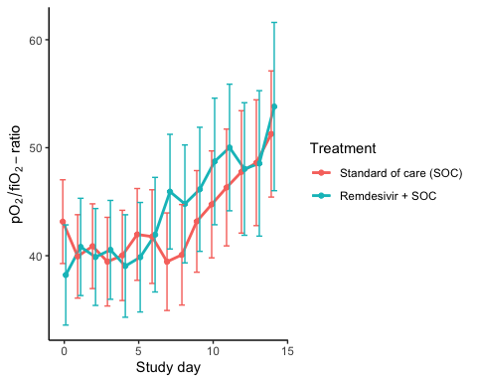

### Marginal probability estimates by treatment group and difference

Estimated treatment effect, Hydroxychloroquine

|  |  |  |  |  |  |
| --- | --- | --- | --- | --- | --- |
| Treatment | Explanation | Estimate | Lower 95% CL | Upper 95% CL | P-value |
| Standard of care (SOC) | Slope 1st week | 0.693 | 0.166 | 1.221 | 0.010 |
| Hydroxychloroquine + SOC | Slope 1st week | 0.697 | 0.152 | 1.242 | 0.012 |
| Hydroxychloroquine + SOC | Difference in slope | 0.003 | -0.755 | 0.762 | 0.993 |
| Standard of care (SOC) | Level at day 10 | 53.521 | 47.990 | 59.053 | 0.000 |
| Hydroxychloroquine + SOC | Level at day 10 | 50.143 | 44.424 | 55.863 | 0.000 |
| Hydroxychloroquine + SOC | Difference at day 10 | -3.378 | -11.335 | 4.579 | 0.405 |

Estimated treatment effect, Remdesivir

|  |  |  |  |  |  |
| --- | --- | --- | --- | --- | --- |
| Treatment | Explanation | Estimate | Lower 95% CL | Upper 95% CL | P-value |
| Standard of care (SOC) | Slope 1st week | 0.015 | -0.589 | 0.620 | 0.960 |
| Remdesivir + SOC | Slope 1st week | 0.974 | 0.253 | 1.696 | 0.008 |
| Remdesivir + SOC | Difference in slope | 0.959 | 0.017 | 1.900 | 0.046 |
| Standard of care (SOC) | Level at day 10 | 52.507 | 46.239 | 58.775 | 0.000 |
| Remdesivir + SOC | Level at day 10 | 52.815 | 45.454 | 60.175 | 0.000 |
| Remdesivir + SOC | Difference at day 10 | 0.308 | -9.360 | 9.975 | 0.950 |

## Dichotomous endpoints

### Descriptives

Hydroxycholoquine

|  |  |  |
| --- | --- | --- |
| Outcome | Standard of care (SOC) | Hydroxychloroquine + SOC |
| Mortality during hospitalisation | 2 (3.7%) | 4 (7.7%) |
| Mortality (censored at day 28) | 1 (1.9%) | 4 (7.7%) |
| Mortality (censored at day 60) | 1 (1.9%) | 4 (7.7%) |
| WHO disease state progression | 7 (13%) | 10 (19.2%) |
| WHO disease state progression (censoreda at day 28) | 7 (13%) | 10 (19.2%) |
| WHO disease state progression (censoreda at day 60) | 7 (13%) | 10 (19.2%) |
| Mechanical ventilation during hospitalisation | 4 (7.4%) | 8 (15.4%) |
| Mechanical ventilation (censored at day 28) | 4 (7.4%) | 8 (15.4%) |
| Mechanical ventilation (censored at day 60) | 4 (7.4%) | 8 (15.4%) |
| Admission to ICU during hospitalisation | 7 (13%) | 12 (23.1%) |
| Admission to ICU (censored at day 28) | 7 (13%) | 12 (23.1%) |
| Admission to ICU (censored at day 60) | 7 (13%) | 12 (23.1%) |

Figures are number of patients with the outcome and percent (%)

Remdesivir

|  |  |  |
| --- | --- | --- |
| Outcome | Standard of care (SOC) | Remdesivir + SOC |
| Mortality during hospitalisation | 4 (7%) | 3 (7.1%) |
| Mortality (censored at day 28) | 3 (5.3%) | 1 (2.4%) |
| Mortality (censored at day 60) | 3 (5.3%) | 3 (7.1%) |
| WHO disease state progression | 13 (22.8%) | 6 (14.3%) |
| WHO disease state progression (censoreda at day 28) | 13 (22.8%) | 6 (14.3%) |
| WHO disease state progression (censoreda at day 60) | 13 (22.8%) | 6 (14.3%) |
| Mechanical ventilation during hospitalisation | 4 (7%) | 4 (9.5%) |
| Mechanical ventilation (censored at day 28) | 4 (7%) | 4 (9.5%) |
| Mechanical ventilation (censored at day 60) | 4 (7%) | 4 (9.5%) |
| Admission to ICU during hospitalisation | 11 (19.3%) | 8 (19%) |
| Admission to ICU (censored at day 28) | 11 (19.3%) | 8 (19%) |
| Admission to ICU (censored at day 60) | 11 (19.3%) | 8 (19%) |

Figures are number of patients with the outcome and percent (%)

### Marginal probability estimates by treatment group and difference

Hydroxychloroquine

|  |  |  |  |
| --- | --- | --- | --- |
| Outcome | Standard of care (SOC) | Hydroxychloroquine + SOC | Estimated marginal treatment effect |
| Mortality during hospitalisation | 3.7% (-1.3 to 8.7) | 7.7% (0.4 to 14.9) | 4% (-4.8 to 12.8) |
| Mortality (censored at day 28) | 1.9% (-1.7 to 5.4) | 7.7% (0.4 to 14.9) | 5.8% (-2.2 to 13.9) |
| Mortality (censored at day 60) | 1.9% (-1.7 to 5.4) | 7.7% (0.4 to 14.9) | 5.8% (-2.2 to 13.9) |
| WHO disease state progression | 13% (4 to 21.9) | 19.2% (8.5 to 29.9) | 6.3% (-7.7 to 20.2) |
| WHO disease state progression (censoreda at day 28) | 13% (4 to 21.9) | 19.2% (8.5 to 29.9) | 6.3% (-7.7 to 20.2) |
| WHO disease state progression (censoreda at day 60) | 13% (4 to 21.9) | 19.2% (8.5 to 29.9) | 6.3% (-7.7 to 20.2) |
| Mechanical ventilation during hospitalisation | 7.4% (0.4 to 14.4) | 15.4% (5.6 to 25.2) | 8% (-4.1 to 20) |
| Mechanical ventilation (censored at day 28) | 7.4% (0.4 to 14.4) | 15.4% (5.6 to 25.2) | 8% (-4.1 to 20) |
| Mechanical ventilation (censored at day 60) | 7.4% (0.4 to 14.4) | 15.4% (5.6 to 25.2) | 8% (-4.1 to 20) |
| Admission to ICU during hospitalisation | 13% (4 to 21.9) | 23.1% (11.6 to 34.5) | 10.1% (-4.4 to 24.7) |
| Admission to ICU (censored at day 28) | 13% (4 to 21.9) | 23.1% (11.6 to 34.5) | 10.1% (-4.4 to 24.7) |
| Admission to ICU (censored at day 60) | 13% (4 to 21.9) | 23.1% (11.6 to 34.5) | 10.1% (-4.4 to 24.7) |

Remdesivir

|  |  |  |  |
| --- | --- | --- | --- |
| Outcome | Standard of care (SOC) | Remdesivir + SOC | Estimated marginal treatment effect |
| Mortality during hospitalisation | 7% (0.4 to 13.6) | 7.1% (-0.6 to 14.9) | 0.1% (-10.1 to 10.4) |
| Mortality (censored at day 28) | 5.3% (-0.5 to 11.1) | 2.4% (-2.2 to 7) | -2.9% (-10.3 to 4.5) |
| Mortality (censored at day 60) | 5.3% (-0.5 to 11.1) | 7.1% (-0.6 to 14.9) | 1.9% (-7.8 to 11.6) |
| WHO disease state progression | 22.8% (11.9 to 33.7) | 14.3% (3.7 to 24.9) | -8.5% (-23.7 to 6.7) |
| WHO disease state progression (censoreda at day 28) | 22.8% (11.9 to 33.7) | 14.3% (3.7 to 24.9) | -8.5% (-23.7 to 6.7) |
| WHO disease state progression (censoreda at day 60) | 22.8% (11.9 to 33.7) | 14.3% (3.7 to 24.9) | -8.5% (-23.7 to 6.7) |
| Mechanical ventilation during hospitalisation | 7% (0.4 to 13.6) | 9.5% (0.6 to 18.4) | 2.5% (-8.6 to 13.6) |
| Mechanical ventilation (censored at day 28) | 7% (0.4 to 13.6) | 9.5% (0.6 to 18.4) | 2.5% (-8.6 to 13.6) |
| Mechanical ventilation (censored at day 60) | 7% (0.4 to 13.6) | 9.5% (0.6 to 18.4) | 2.5% (-8.6 to 13.6) |
| Admission to ICU during hospitalisation | 19.3% (9.1 to 29.5) | 19% (7.2 to 30.9) | -0.3% (-15.9 to 15.4) |
| Admission to ICU (censored at day 28) | 19.3% (9.1 to 29.5) | 19% (7.2 to 30.9) | -0.3% (-15.9 to 15.4) |
| Admission to ICU (censored at day 60) | 19.3% (9.1 to 29.5) | 19% (7.2 to 30.9) | -0.3% (-15.9 to 15.4) |

## Inflammatory laboratory parameters

### Descriptives

CRP (mg/L), HCQ

|  |  |  |  |
| --- | --- | --- | --- |
| Days since randomisation | Statistic | Standard of care (SOC) | Hydroxychloroquine + SOC |
| 0 days | Mean (SD) | 88.7 (74.69) | 95.33 (68.36) |
| 0 days | Median [IQR] | 65.5 [34 - 124] | 76 [47 - 133] |
| 0 days | Missing / Non-Missing | 0 / 54 | 1 / 51 |
| 1 days | Mean (SD) | 95.17 (84.09) | 105.68 (70.55) |
| 1 days | Median [IQR] | 68 [34.5 - 125] | 88.5 [52.5 - 145] |
| 1 days | Missing / Non-Missing | 8 / 46 | 7 / 44 |
| 2 days | Mean (SD) | 89.31 (78.63) | 96.96 (81.41) |
| 2 days | Median [IQR] | 67.5 [37.75 - 113.75] | 85.5 [42.75 - 124.75] |
| 2 days | Missing / Non-Missing | 4 / 48 | 6 / 44 |
| 3 days | Mean (SD) | 92.94 (74.99) | 92.05 (74) |
| 3 days | Median [IQR] | 70 [33 - 121] | 69.5 [44 - 132.25] |
| 3 days | Missing / Non-Missing | 9 / 37 | 5 / 40 |
| 4 days | Mean (SD) | 91.99 (76.7) | 98.54 (80.75) |
| 4 days | Median [IQR] | 67 [46 - 132] | 80 [39.5 - 141.5] |
| 4 days | Missing / Non-Missing | 4 / 33 | 6 / 35 |
| 5 days | Mean (SD) | 97.34 (84.39) | 91.36 (65.87) |
| 5 days | Median [IQR] | 65.5 [48.75 - 147] | 85 [36.5 - 140.5] |
| 5 days | Missing / Non-Missing | 7 / 30 | 6 / 28 |
| 6 days | Mean (SD) | 83.32 (82.1) | 83.15 (67.95) |
| 6 days | Median [IQR] | 48 [25.75 - 138] | 62 [28 - 115.5] |
| 6 days | Missing / Non-Missing | 1 / 32 | 5 / 26 |
| 7 days | Mean (SD) | 77.12 (68.38) | 102.86 (94.13) |
| 7 days | Median [IQR] | 46 [16.5 - 140.75] | 71 [20 - 157.5] |
| 7 days | Missing / Non-Missing | 1 / 26 | 3 / 24 |
| 8 days | Mean (SD) | 75.68 (67.25) | 110.3 (101.33) |
| 8 days | Median [IQR] | 65 [21 - 94] | 58 [29 - 191] |
| 8 days | Missing / Non-Missing | 2 / 21 | 4 / 17 |
| 9 days | Mean (SD) | 66.24 (65.64) | 108.29 (93.13) |
| 9 days | Median [IQR] | 41.5 [16.5 - 102.75] | 74.5 [35.5 - 171] |
| 9 days | Missing / Non-Missing | 2 / 16 | 4 / 14 |
| 10 days | Mean (SD) | 49.63 (53.44) | 93.83 (93.8) |
| 10 days | Median [IQR] | 29 [12 - 66] | 67 [23.25 - 144.75] |
| 10 days | Missing / Non-Missing | 1 / 13 | 3 / 12 |
| 11 days | Mean (SD) | 73.3 (97.24) | 90.88 (85.01) |
| 11 days | Median [IQR] | 41.5 [7.55 - 111] | 75.5 [26.25 - 110] |
| 11 days | Missing / Non-Missing | 2 / 10 | 5 / 8 |
| 12 days | Mean (SD) | 84.51 (74.7) | 73.75 (85.95) |
| 12 days | Median [IQR] | 72 [11 - 155] | 51 [18.25 - 79.25] |
| 12 days | Missing / Non-Missing | 3 / 9 | 4 / 8 |
| 13 days | Mean (SD) | 109.43 (92.12) | 58.11 (65.81) |
| 13 days | Median [IQR] | 101 [35 - 187] | 23 [14 - 99] |
| 13 days | Missing / Non-Missing | 2 / 9 | 2 / 9 |
| 14 days | Mean (SD) | 117.33 (127.38) | 33.17 (28.59) |
| 14 days | Median [IQR] | 37 [15.85 - 231.5] | 24.5 [13.25 - 46.25] |
| 14 days | Missing / Non-Missing | 0 / 7 | 1 / 6 |

CRP (mg/L), Remdesivir

|  |  |  |  |
| --- | --- | --- | --- |
| Days since randomisation | Statistic | Standard of care (SOC) | Remdesivir + SOC |
| 0 days | Mean (SD) | 93.54 (74.88) | 90.47 (64.37) |
| 0 days | Median [IQR] | 82 [33 - 141.75] | 70 [39.75 - 139.25] |
| 0 days | Missing / Non-Missing | 1 / 56 | 0 / 42 |
| 1 days | Mean (SD) | 91.65 (74.14) | 92.89 (65.11) |
| 1 days | Median [IQR] | 74 [38 - 122] | 79 [46.5 - 128.5] |
| 1 days | Missing / Non-Missing | 12 / 45 | 7 / 35 |
| 2 days | Mean (SD) | 87.71 (69.43) | 78.57 (72.11) |
| 2 days | Median [IQR] | 70.5 [35.5 - 118] | 56 [30 - 121] |
| 2 days | Missing / Non-Missing | 6 / 46 | 5 / 37 |
| 3 days | Mean (SD) | 93.23 (72.66) | 68.64 (72.08) |
| 3 days | Median [IQR] | 74 [31.5 - 137.5] | 46 [23.75 - 81.75] |
| 3 days | Missing / Non-Missing | 6 / 39 | 5 / 34 |
| 4 days | Mean (SD) | 95.7 (82.48) | 69.4 (84.06) |
| 4 days | Median [IQR] | 75.5 [44.5 - 123.5] | 38 [22 - 89.5] |
| 4 days | Missing / Non-Missing | 5 / 36 | 4 / 26 |
| 5 days | Mean (SD) | 89.7 (82.84) | 70.37 (89.75) |
| 5 days | Median [IQR] | 66 [31.25 - 108.75] | 27 [15 - 83] |
| 5 days | Missing / Non-Missing | 4 / 36 | 3 / 21 |
| 6 days | Mean (SD) | 87.88 (85.5) | 70.9 (85.43) |
| 6 days | Median [IQR] | 55.5 [25.5 - 126.75] | 42 [14.5 - 75] |
| 6 days | Missing / Non-Missing | 5 / 30 | 3 / 19 |
| 7 days | Mean (SD) | 80.38 (66.49) | 56.79 (66.01) |
| 7 days | Median [IQR] | 67.5 [26.75 - 131.75] | 35 [12 - 49] |
| 7 days | Missing / Non-Missing | 3 / 26 | 2 / 17 |
| 8 days | Mean (SD) | 76.13 (74.2) | 56.86 (66.24) |
| 8 days | Median [IQR] | 55 [32 - 89.5] | 28 [14 - 91] |
| 8 days | Missing / Non-Missing | 0 / 27 | 4 / 13 |
| 9 days | Mean (SD) | 81.37 (76.94) | 42.07 (55.8) |
| 9 days | Median [IQR] | 60 [22.75 - 95.25] | 18 [7 - 36] |
| 9 days | Missing / Non-Missing | 4 / 20 | 2 / 13 |
| 10 days | Mean (SD) | 59.98 (67.48) | 35.27 (50.51) |
| 10 days | Median [IQR] | 31 [17.5 - 76] | 12 [6 - 22] |
| 10 days | Missing / Non-Missing | 4 / 16 | 1 / 13 |
| 11 days | Mean (SD) | 83.04 (118.51) | 37.82 (46.38) |
| 11 days | Median [IQR] | 43.5 [12.5 - 80.75] | 9 [5 - 76] |
| 11 days | Missing / Non-Missing | 1 / 16 | 2 / 11 |
| 12 days | Mean (SD) | 135.4 (212.94) | 56.79 (59.44) |
| 12 days | Median [IQR] | 57 [34.25 - 110] | 19 [5 - 107] |
| 12 days | Missing / Non-Missing | 5 / 8 | 1 / 9 |
| 13 days | Mean (SD) | 86.01 (109.53) | 109.86 (95.62) |
| 13 days | Median [IQR] | 48.5 [16 - 93.25] | 92 [41.5 - 166.5] |
| 13 days | Missing / Non-Missing | 4 / 10 | 2 / 7 |
| 14 days | Mean (SD) | 58.77 (87.75) | 53.42 (84.6) |
| 14 days | Median [IQR] | 24.5 [13.5 - 36.25] | 13.95 [4.98 - 57.5] |
| 14 days | Missing / Non-Missing | 1 / 10 | 0 / 6 |

Ferritin (µg/L), HCQ

|  |  |  |  |
| --- | --- | --- | --- |
| Days since randomisation | Statistic | Standard of care (SOC) | Hydroxychloroquine + SOC |
| 0 days | Mean (SD) | 732.58 (629.2) | 894.45 (773.07) |
| 0 days | Median [IQR] | 531.5 [320.75 - 991.25] | 626 [295 - 1298] |
| 0 days | Missing / Non-Missing | 4 / 50 | 3 / 49 |
| 1 days | Mean (SD) | 854.03 (622.07) | 1027.07 (740.52) |
| 1 days | Median [IQR] | 737.5 [408.75 - 1091.75] | 1018.5 [429 - 1416.25] |
| 1 days | Missing / Non-Missing | 18 / 36 | 21 / 30 |
| 2 days | Mean (SD) | 800.51 (513.73) | 931.55 (797.63) |
| 2 days | Median [IQR] | 803 [403.5 - 1104.5] | 789.5 [272.5 - 1235.75] |
| 2 days | Missing / Non-Missing | 9 / 43 | 10 / 40 |
| 3 days | Mean (SD) | 1013.23 (739.09) | 1081.88 (825.14) |
| 3 days | Median [IQR] | 856 [440.5 - 1366] | 953 [420.75 - 1426.75] |
| 3 days | Missing / Non-Missing | 15 / 31 | 11 / 34 |
| 4 days | Mean (SD) | 1274.5 (1244.34) | 1141.12 (856.24) |
| 4 days | Median [IQR] | 851 [495.75 - 1811.25] | 988.5 [461.5 - 1593] |
| 4 days | Missing / Non-Missing | 11 / 26 | 15 / 26 |
| 5 days | Mean (SD) | 1046.7 (766.12) | 1164.4 (708.71) |
| 5 days | Median [IQR] | 791.5 [475 - 1641.75] | 1017 [804 - 1452] |
| 5 days | Missing / Non-Missing | 17 / 20 | 9 / 25 |
| 6 days | Mean (SD) | 1144.04 (921.54) | 1023.5 (519.61) |
| 6 days | Median [IQR] | 896 [468.5 - 1628] | 939 [712.5 - 1254] |
| 6 days | Missing / Non-Missing | 6 / 27 | 7 / 24 |
| 7 days | Mean (SD) | 1173.6 (778.48) | 1251.77 (959.32) |
| 7 days | Median [IQR] | 959.5 [508 - 1466.75] | 1151.5 [788.75 - 1452.25] |
| 7 days | Missing / Non-Missing | 7 / 20 | 5 / 22 |
| 8 days | Mean (SD) | 820.93 (663.69) | 1179.2 (1144.8) |
| 8 days | Median [IQR] | 758.5 [301 - 1039] | 805 [666.5 - 1452.5] |
| 8 days | Missing / Non-Missing | 9 / 14 | 6 / 15 |
| 9 days | Mean (SD) | 882.87 (678.11) | 853.62 (673.46) |
| 9 days | Median [IQR] | 762 [492 - 1128] | 731 [531 - 1256] |
| 9 days | Missing / Non-Missing | 3 / 15 | 5 / 13 |
| 10 days | Mean (SD) | 737.1 (511) | 1240.36 (654.25) |
| 10 days | Median [IQR] | 807.5 [309.25 - 985.5] | 939 [793.5 - 1469] |
| 10 days | Missing / Non-Missing | 4 / 10 | 4 / 11 |
| 11 days | Mean (SD) | 569.4 (334.51) | 1969.75 (1042.66) |
| 11 days | Median [IQR] | 607 [300 - 766.5] | 1969.5 [1146.75 - 2792.5] |
| 11 days | Missing / Non-Missing | 2 / 10 | 9 / 4 |
| 12 days | Mean (SD) | 527 (526.63) | 1515 (1167.09) |
| 12 days | Median [IQR] | 518 [107.5 - 691] | 890.5 [676.25 - 2298] |
| 12 days | Missing / Non-Missing | 5 / 7 | 6 / 6 |
| 13 days | Mean (SD) | 477.29 (316.13) | 1133.67 (774.96) |
| 13 days | Median [IQR] | 451 [284 - 726] | 864 [665 - 1160] |
| 13 days | Missing / Non-Missing | 4 / 7 | 2 / 9 |
| 14 days | Mean (SD) | 347.2 (267.07) | 1075 (529.09) |
| 14 days | Median [IQR] | 392 [141 - 583] | 1002 [713.5 - 1363.5] |
| 14 days | Missing / Non-Missing | 2 / 5 | 3 / 4 |

Ferritin (µg/L), Remdesivir

|  |  |  |  |
| --- | --- | --- | --- |
| Days since randomisation | Statistic | Standard of care (SOC) | Remdesivir + SOC |
| 0 days | Mean (SD) | 820.65 (722.45) | 1552.26 (3597.9) |
| 0 days | Median [IQR] | 589 [317.75 - 1076.75] | 694.5 [343.25 - 1262.25] |
| 0 days | Missing / Non-Missing | 3 / 54 | 0 / 42 |
| 1 days | Mean (SD) | 893.06 (692.71) | 1877.77 (3604.5) |
| 1 days | Median [IQR] | 651 [409 - 1115] | 1001.5 [440.5 - 1729.75] |
| 1 days | Missing / Non-Missing | 24 / 33 | 16 / 26 |
| 2 days | Mean (SD) | 918.08 (668.31) | 1519.66 (1994.66) |
| 2 days | Median [IQR] | 842 [437.5 - 1133.75] | 1238.5 [500.25 - 1636.5] |
| 2 days | Missing / Non-Missing | 14 / 38 | 10 / 32 |
| 3 days | Mean (SD) | 1204.46 (938.02) | 1123.79 (979.93) |
| 3 days | Median [IQR] | 912 [596 - 1597] | 980.5 [433 - 1307] |
| 3 days | Missing / Non-Missing | 12 / 33 | 11 / 28 |
| 4 days | Mean (SD) | 1585.43 (1495.06) | 1386.7 (901.34) |
| 4 days | Median [IQR] | 985 [648.5 - 1927.25] | 1130.5 [849.25 - 1707.25] |
| 4 days | Missing / Non-Missing | 13 / 28 | 10 / 20 |
| 5 days | Mean (SD) | 1115.82 (1104.14) | 1268.93 (756.48) |
| 5 days | Median [IQR] | 751 [517.5 - 1333] | 1119.5 [782.5 - 1841.75] |
| 5 days | Missing / Non-Missing | 12 / 28 | 10 / 14 |
| 6 days | Mean (SD) | 1363.89 (1260.9) | 859.69 (546.39) |
| 6 days | Median [IQR] | 914.5 [578.5 - 1555.75] | 736.5 [463.5 - 1158] |
| 6 days | Missing / Non-Missing | 9 / 26 | 6 / 16 |
| 7 days | Mean (SD) | 1270.36 (836.9) | 935 (425.38) |
| 7 days | Median [IQR] | 1029 [644 - 1835] | 891.5 [597 - 1368.75] |
| 7 days | Missing / Non-Missing | 4 / 25 | 5 / 14 |
| 8 days | Mean (SD) | 1062 (783.77) | 936.2 (405.76) |
| 8 days | Median [IQR] | 817 [499.5 - 1218.5] | 912 [754.75 - 1167.75] |
| 8 days | Missing / Non-Missing | 5 / 22 | 7 / 10 |
| 9 days | Mean (SD) | 965.13 (703.14) | 912.8 (490.17) |
| 9 days | Median [IQR] | 576 [501.5 - 1416] | 956.5 [503 - 1250] |
| 9 days | Missing / Non-Missing | 9 / 15 | 5 / 10 |
| 10 days | Mean (SD) | 894.08 (544.78) | 954.75 (613.4) |
| 10 days | Median [IQR] | 670.5 [516.5 - 1223.75] | 811.5 [669.5 - 1206] |
| 10 days | Missing / Non-Missing | 8 / 12 | 6 / 8 |
| 11 days | Mean (SD) | 641.92 (456.89) | 961.63 (775.46) |
| 11 days | Median [IQR] | 561.5 [324.5 - 878] | 806 [621.25 - 993.25] |
| 11 days | Missing / Non-Missing | 5 / 12 | 5 / 8 |
| 12 days | Mean (SD) | 698 (293.69) | 816.83 (308.87) |
| 12 days | Median [IQR] | 639 [603 - 667] | 884.5 [752 - 1007.25] |
| 12 days | Missing / Non-Missing | 8 / 5 | 4 / 6 |
| 13 days | Mean (SD) | 588.43 (422.05) | 966.83 (665) |
| 13 days | Median [IQR] | 549 [404.5 - 683.5] | 891 [431 - 1449.25] |
| 13 days | Missing / Non-Missing | 7 / 7 | 3 / 6 |
| 14 days | Mean (SD) | 589.89 (451.01) | 796 (638.04) |
| 14 days | Median [IQR] | 583 [376 - 634] | 698 [396 - 753] |
| 14 days | Missing / Non-Missing | 2 / 9 | 1 / 5 |

LDH (U/L), HCQ

|  |  |  |  |
| --- | --- | --- | --- |
| Days since randomisation | Statistic | Standard of care (SOC) | Hydroxychloroquine + SOC |
| 0 days | Mean (SD) | 277.36 (110.83) | 307.77 (125.77) |
| 0 days | Median [IQR] | 251.5 [199.75 - 324.75] | 287 [234.5 - 360.5] |
| 0 days | Missing / Non-Missing | 4 / 50 | 1 / 51 |
| 1 days | Mean (SD) | 286.48 (93.23) | 306.82 (123.33) |
| 1 days | Median [IQR] | 277 [226 - 312.5] | 283 [233 - 347] |
| 1 days | Missing / Non-Missing | 27 / 27 | 18 / 33 |
| 2 days | Mean (SD) | 284.74 (97.59) | 323.03 (118.18) |
| 2 days | Median [IQR] | 272.5 [227.5 - 332.25] | 318 [241.5 - 378] |
| 2 days | Missing / Non-Missing | 14 / 38 | 12 / 38 |
| 3 days | Mean (SD) | 311 (103.69) | 336.38 (130.74) |
| 3 days | Median [IQR] | 294 [261 - 343] | 315 [239.75 - 438.5] |
| 3 days | Missing / Non-Missing | 17 / 29 | 11 / 34 |
| 4 days | Mean (SD) | 324.38 (112.76) | 357.65 (125.62) |
| 4 days | Median [IQR] | 284.5 [245.25 - 358] | 333.5 [267.5 - 458.25] |
| 4 days | Missing / Non-Missing | 13 / 24 | 15 / 26 |
| 5 days | Mean (SD) | 323.5 (120.27) | 348.17 (110.99) |
| 5 days | Median [IQR] | 292 [259 - 354.5] | 319 [280.5 - 389] |
| 5 days | Missing / Non-Missing | 17 / 20 | 11 / 23 |
| 6 days | Mean (SD) | 280.91 (88.94) | 318.76 (120.08) |
| 6 days | Median [IQR] | 270 [234.5 - 283.25] | 309 [271 - 379] |
| 6 days | Missing / Non-Missing | 11 / 22 | 10 / 21 |
| 7 days | Mean (SD) | 271.8 (73.66) | 296.8 (85.94) |
| 7 days | Median [IQR] | 256.5 [226.75 - 288.75] | 281 [234 - 353] |
| 7 days | Missing / Non-Missing | 7 / 20 | 7 / 20 |
| 8 days | Mean (SD) | 279.29 (104.06) | 314 (50.51) |
| 8 days | Median [IQR] | 248.5 [228.5 - 311.25] | 324 [289 - 345] |
| 8 days | Missing / Non-Missing | 9 / 14 | 8 / 13 |
| 9 days | Mean (SD) | 285.25 (138.68) | 316.75 (75.75) |
| 9 days | Median [IQR] | 259.5 [213 - 290.5] | 330 [284.75 - 366.75] |
| 9 days | Missing / Non-Missing | 6 / 12 | 6 / 12 |
| 10 days | Mean (SD) | 256.73 (92.99) | 308.1 (65.75) |
| 10 days | Median [IQR] | 225 [200.5 - 292] | 324.5 [252 - 358] |
| 10 days | Missing / Non-Missing | 3 / 11 | 5 / 10 |
| 11 days | Mean (SD) | 219.38 (63.52) | 333.25 (73.73) |
| 11 days | Median [IQR] | 234.5 [173 - 260] | 332.5 [290.75 - 375] |
| 11 days | Missing / Non-Missing | 4 / 8 | 9 / 4 |
| 12 days | Mean (SD) | 250.13 (99.29) | 330.17 (89.4) |
| 12 days | Median [IQR] | 231.5 [203.5 - 270] | 326 [276.25 - 363] |
| 12 days | Missing / Non-Missing | 4 / 8 | 6 / 6 |
| 13 days | Mean (SD) | 190.83 (56.2) | 288.72 (85.03) |
| 13 days | Median [IQR] | 179 [148.75 - 213.75] | 272 [241 - 327] |
| 13 days | Missing / Non-Missing | 5 / 6 | 4 / 7 |
| 14 days | Mean (SD) | 200.17 (97) | 347.75 (70.69) |
| 14 days | Median [IQR] | 146 [141.25 - 227.25] | 350 [325.75 - 372] |
| 14 days | Missing / Non-Missing | 1 / 6 | 3 / 4 |

LDH (U/L), Remdesivir

|  |  |  |  |
| --- | --- | --- | --- |
| Days since randomisation | Statistic | Standard of care (SOC) | Remdesivir + SOC |
| 0 days | Mean (SD) | 270.71 (100.52) | 334.51 (155.86) |
| 0 days | Median [IQR] | 238.5 [195.25 - 351.75] | 284 [234 - 400] |
| 0 days | Missing / Non-Missing | 5 / 52 | 1 / 41 |
| 1 days | Mean (SD) | 286.04 (85.9) | 367.81 (180.29) |
| 1 days | Median [IQR] | 277 [227.5 - 330.5] | 333 [230 - 489] |
| 1 days | Missing / Non-Missing | 30 / 27 | 21 / 21 |
| 2 days | Mean (SD) | 296.94 (125.07) | 339.73 (163.58) |
| 2 days | Median [IQR] | 280 [229 - 336] | 321 [214.5 - 429.5] |
| 2 days | Missing / Non-Missing | 19 / 33 | 16 / 26 |
| 3 days | Mean (SD) | 325.25 (128.4) | 372.58 (210.63) |
| 3 days | Median [IQR] | 300 [229 - 389.75] | 330 [225.25 - 428.75] |
| 3 days | Missing / Non-Missing | 17 / 28 | 13 / 26 |
| 4 days | Mean (SD) | 335.92 (126.59) | 413.43 (221.76) |
| 4 days | Median [IQR] | 296 [239 - 420] | 347.5 [279 - 495] |
| 4 days | Missing / Non-Missing | 16 / 25 | 16 / 14 |
| 5 days | Mean (SD) | 322.44 (144.59) | 414.22 (157.11) |
| 5 days | Median [IQR] | 295 [231 - 376] | 384.5 [287.25 - 502.25] |
| 5 days | Missing / Non-Missing | 17 / 23 | 10 / 14 |
| 6 days | Mean (SD) | 296.61 (136.44) | 353 (127.95) |
| 6 days | Median [IQR] | 259.5 [206.5 - 316.5] | 301 [276 - 379] |
| 6 days | Missing / Non-Missing | 17 / 18 | 9 / 13 |
| 7 days | Mean (SD) | 302.1 (106.59) | 306.79 (140.1) |
| 7 days | Median [IQR] | 256 [226 - 364] | 299 [198.5 - 385.75] |
| 7 days | Missing / Non-Missing | 8 / 21 | 5 / 14 |
| 8 days | Mean (SD) | 313.37 (126.31) | 338.13 (105.51) |
| 8 days | Median [IQR] | 255 [229.5 - 409] | 314.5 [251.5 - 424.25] |
| 8 days | Missing / Non-Missing | 8 / 19 | 9 / 8 |
| 9 days | Mean (SD) | 331.79 (159.93) | 324.14 (108.08) |
| 9 days | Median [IQR] | 295.5 [227.5 - 401.5] | 289 [231.5 - 415] |
| 9 days | Missing / Non-Missing | 10 / 14 | 8 / 7 |
| 10 days | Mean (SD) | 293 (117.78) | 322.29 (122.95) |
| 10 days | Median [IQR] | 258.5 [204 - 371] | 285 [222.5 - 403] |
| 10 days | Missing / Non-Missing | 8 / 12 | 7 / 7 |
| 11 days | Mean (SD) | 257.31 (99.93) | 257.83 (135.56) |
| 11 days | Median [IQR] | 269 [179 - 308] | 197 [159.25 - 372] |
| 11 days | Missing / Non-Missing | 4 / 13 | 7 / 6 |
| 12 days | Mean (SD) | 260.14 (75.77) | 283.5 (105.14) |
| 12 days | Median [IQR] | 291 [219 - 308.5] | 285.5 [192.75 - 364] |
| 12 days | Missing / Non-Missing | 6 / 7 | 4 / 6 |
| 13 days | Mean (SD) | 198.17 (42.02) | 339.5 (144.32) |
| 13 days | Median [IQR] | 193 [174 - 227] | 366 [297.75 - 407.75] |
| 13 days | Missing / Non-Missing | 8 / 6 | 5 / 4 |
| 14 days | Mean (SD) | 209.89 (67.57) | 250.2 (143.69) |
| 14 days | Median [IQR] | 197 [147 - 237] | 185 [158 - 288] |
| 14 days | Missing / Non-Missing | 2 / 9 | 1 / 5 |

Lymphocytes (x10^9/L), HCQ

|  |  |  |  |
| --- | --- | --- | --- |
| Days since randomisation | Statistic | Standard of care (SOC) | Hydroxychloroquine + SOC |
| 0 days | Mean (SD) | 1.19 (0.58) | 1.16 (0.94) |
| 0 days | Median [IQR] | 1.1 [0.85 - 1.45] | 1 [0.7 - 1.3] |
| 0 days | Missing / Non-Missing | 3 / 51 | 2 / 50 |
| 1 days | Mean (SD) | 1.18 (0.55) | 1.06 (0.37) |
| 1 days | Median [IQR] | 1.2 [0.7 - 1.5] | 1 [0.8 - 1.25] |
| 1 days | Missing / Non-Missing | 17 / 37 | 16 / 35 |
| 2 days | Mean (SD) | 1.3 (0.65) | 1.2 (0.5) |
| 2 days | Median [IQR] | 1.2 [0.9 - 1.75] | 1.1 [0.9 - 1.45] |
| 2 days | Missing / Non-Missing | 9 / 43 | 7 / 43 |
| 3 days | Mean (SD) | 1.21 (0.58) | 1.13 (0.39) |
| 3 days | Median [IQR] | 1 [0.9 - 1.55] | 1 [0.8 - 1.43] |
| 3 days | Missing / Non-Missing | 15 / 31 | 9 / 36 |
| 4 days | Mean (SD) | 1.22 (0.6) | 1.19 (0.52) |
| 4 days | Median [IQR] | 1.1 [0.7 - 1.6] | 1.1 [0.8 - 1.5] |
| 4 days | Missing / Non-Missing | 10 / 27 | 12 / 29 |
| 5 days | Mean (SD) | 1.14 (0.54) | 1.19 (0.46) |
| 5 days | Median [IQR] | 1 [0.8 - 1.4] | 1.2 [0.9 - 1.4] |
| 5 days | Missing / Non-Missing | 16 / 21 | 9 / 25 |
| 6 days | Mean (SD) | 1.39 (0.66) | 1.25 (0.5) |
| 6 days | Median [IQR] | 1.4 [0.95 - 1.75] | 1.25 [1.1 - 1.48] |
| 6 days | Missing / Non-Missing | 6 / 27 | 9 / 22 |
| 7 days | Mean (SD) | 1.42 (0.48) | 1.24 (0.5) |
| 7 days | Median [IQR] | 1.3 [1.2 - 1.9] | 1.2 [1 - 1.5] |
| 7 days | Missing / Non-Missing | 6 / 21 | 4 / 23 |
| 8 days | Mean (SD) | 1.42 (0.48) | 1.46 (0.82) |
| 8 days | Median [IQR] | 1.5 [1.2 - 1.8] | 1.25 [0.9 - 2.18] |
| 8 days | Missing / Non-Missing | 6 / 17 | 7 / 14 |
| 9 days | Mean (SD) | 1.39 (0.62) | 1.37 (0.62) |
| 9 days | Median [IQR] | 1.3 [1 - 1.6] | 1.1 [1.1 - 1.8] |
| 9 days | Missing / Non-Missing | 5 / 13 | 5 / 13 |
| 10 days | Mean (SD) | 1.66 (0.61) | 1.78 (0.75) |
| 10 days | Median [IQR] | 1.6 [1.25 - 1.95] | 1.9 [1.4 - 2] |
| 10 days | Missing / Non-Missing | 3 / 11 | 4 / 11 |
| 11 days | Mean (SD) | 1.57 (0.76) | 1.68 (0.81) |
| 11 days | Median [IQR] | 1.6 [1.1 - 1.75] | 1.7 [1.1 - 1.9] |
| 11 days | Missing / Non-Missing | 2 / 10 | 8 / 5 |
| 12 days | Mean (SD) | 1.54 (0.77) | 2.68 (1.08) |
| 12 days | Median [IQR] | 1.5 [0.88 - 2.05] | 3.05 [2.45 - 3.28] |
| 12 days | Missing / Non-Missing | 4 / 8 | 8 / 4 |
| 13 days | Mean (SD) | 1.69 (0.64) | 2.23 (0.64) |
| 13 days | Median [IQR] | 1.9 [1.1 - 2] | 2.1 [1.88 - 2.48] |
| 13 days | Missing / Non-Missing | 4 / 7 | 5 / 6 |
| 14 days | Mean (SD) | 1.35 (0.63) | 1.82 (0.7) |
| 14 days | Median [IQR] | 1.3 [0.9 - 1.78] | 1.5 [1.4 - 1.9] |
| 14 days | Missing / Non-Missing | 1 / 6 | 2 / 5 |

Lymphocytes (x10^9/L), Remdesivir

|  |  |  |  |
| --- | --- | --- | --- |
| Days since randomisation | Statistic | Standard of care (SOC) | Remdesivir + SOC |
| 0 days | Mean (SD) | 1.16 (0.55) | 1.19 (0.53) |
| 0 days | Median [IQR] | 1 [0.8 - 1.5] | 1.1 [0.88 - 1.5] |
| 0 days | Missing / Non-Missing | 4 / 53 | 2 / 40 |
| 1 days | Mean (SD) | 1.19 (0.48) | 1.2 (0.66) |
| 1 days | Median [IQR] | 1.2 [0.75 - 1.45] | 1.1 [0.7 - 1.5] |
| 1 days | Missing / Non-Missing | 22 / 35 | 19 / 23 |
| 2 days | Mean (SD) | 1.3 (0.53) | 1.35 (0.59) |
| 2 days | Median [IQR] | 1.25 [1 - 1.78] | 1.3 [0.9 - 1.6] |
| 2 days | Missing / Non-Missing | 14 / 38 | 14 / 28 |
| 3 days | Mean (SD) | 1.3 (0.59) | 1.47 (0.79) |
| 3 days | Median [IQR] | 1.3 [0.9 - 1.7] | 1.2 [0.9 - 1.8] |
| 3 days | Missing / Non-Missing | 11 / 34 | 12 / 27 |
| 4 days | Mean (SD) | 1.32 (0.57) | 1.34 (0.99) |
| 4 days | Median [IQR] | 1.4 [0.88 - 1.7] | 1.2 [0.6 - 1.55] |
| 4 days | Missing / Non-Missing | 13 / 28 | 11 / 19 |
| 5 days | Mean (SD) | 1.44 (0.66) | 1.56 (1.06) |
| 5 days | Median [IQR] | 1.4 [0.93 - 1.88] | 1.3 [0.75 - 2.23] |
| 5 days | Missing / Non-Missing | 10 / 30 | 10 / 14 |
| 6 days | Mean (SD) | 1.43 (0.57) | 1.56 (1.13) |
| 6 days | Median [IQR] | 1.4 [1 - 1.83] | 1.35 [0.7 - 1.95] |
| 6 days | Missing / Non-Missing | 13 / 22 | 8 / 14 |
| 7 days | Mean (SD) | 1.56 (0.68) | 1.29 (0.57) |
| 7 days | Median [IQR] | 1.5 [1.3 - 1.98] | 1.3 [1.1 - 1.8] |
| 7 days | Missing / Non-Missing | 7 / 22 | 6 / 13 |
| 8 days | Mean (SD) | 1.69 (0.69) | 2.11 (2.37) |
| 8 days | Median [IQR] | 1.65 [1.33 - 1.8] | 1.55 [1.15 - 1.98] |
| 8 days | Missing / Non-Missing | 5 / 22 | 7 / 10 |
| 9 days | Mean (SD) | 1.68 (0.75) | 1.32 (0.75) |
| 9 days | Median [IQR] | 1.55 [1.25 - 1.8] | 1.1 [0.8 - 1.9] |
| 9 days | Missing / Non-Missing | 10 / 14 | 6 / 9 |
| 10 days | Mean (SD) | 1.82 (0.6) | 1.25 (0.73) |
| 10 days | Median [IQR] | 1.75 [1.58 - 2.03] | 1.2 [0.7 - 1.6] |
| 10 days | Missing / Non-Missing | 8 / 12 | 5 / 9 |
| 11 days | Mean (SD) | 1.68 (0.58) | 1.36 (0.67) |
| 11 days | Median [IQR] | 1.85 [1.55 - 2.03] | 1.55 [0.93 - 1.93] |
| 11 days | Missing / Non-Missing | 5 / 12 | 5 / 8 |
| 12 days | Mean (SD) | 1.8 (1.05) | 1.61 (1.01) |
| 12 days | Median [IQR] | 1.9 [1.1 - 2.4] | 1.45 [1.05 - 2.05] |
| 12 days | Missing / Non-Missing | 6 / 7 | 2 / 8 |
| 13 days | Mean (SD) | 1.83 (1.02) | 1.37 (0.69) |
| 13 days | Median [IQR] | 2 [1.05 - 2.5] | 1.45 [0.8 - 1.65] |
| 13 days | Missing / Non-Missing | 7 / 7 | 3 / 6 |
| 14 days | Mean (SD) | 1.51 (0.73) | 1.94 (1.4) |
| 14 days | Median [IQR] | 1.4 [0.95 - 2.25] | 2.3 [0.6 - 2.8] |
| 14 days | Missing / Non-Missing | 1 / 10 | 1 / 5 |

Neutrophils (x10^9/L), HCQ

|  |  |  |  |
| --- | --- | --- | --- |
| Days since randomisation | Statistic | Standard of care (SOC) | Hydroxychloroquine + SOC |
| 0 days | Mean (SD) | 4.84 (2.56) | 5.19 (2.83) |
| 0 days | Median [IQR] | 4.1 [2.8 - 6.35] | 4.9 [3.03 - 6.83] |
| 0 days | Missing / Non-Missing | 3 / 51 | 2 / 50 |
| 1 days | Mean (SD) | 4.67 (2.35) | 4.77 (2.76) |
| 1 days | Median [IQR] | 4 [3 - 5.7] | 3.9 [2.9 - 6.05] |
| 1 days | Missing / Non-Missing | 17 / 37 | 16 / 35 |
| 2 days | Mean (SD) | 4.48 (2.41) | 4.92 (2.51) |
| 2 days | Median [IQR] | 3.65 [2.78 - 5.7] | 4.5 [3.2 - 6.55] |
| 2 days | Missing / Non-Missing | 8 / 44 | 7 / 43 |
| 3 days | Mean (SD) | 4.88 (2.85) | 4.96 (2.73) |
| 3 days | Median [IQR] | 3.8 [3.1 - 6.95] | 4.8 [3.13 - 6.6] |
| 3 days | Missing / Non-Missing | 15 / 31 | 9 / 36 |
| 4 days | Mean (SD) | 4.52 (2.26) | 5.38 (2.51) |
| 4 days | Median [IQR] | 3.7 [3.05 - 5.55] | 5.2 [3.9 - 5.9] |
| 4 days | Missing / Non-Missing | 9 / 28 | 12 / 29 |
| 5 days | Mean (SD) | 5.05 (2.47) | 5.08 (2.04) |
| 5 days | Median [IQR] | 4.6 [3.4 - 6.1] | 4.8 [3.85 - 6.2] |
| 5 days | Missing / Non-Missing | 16 / 21 | 10 / 24 |
| 6 days | Mean (SD) | 5.06 (2.62) | 5.28 (2.2) |
| 6 days | Median [IQR] | 4.5 [3.5 - 6.25] | 4.65 [3.85 - 6.38] |
| 6 days | Missing / Non-Missing | 6 / 27 | 9 / 22 |
| 7 days | Mean (SD) | 5.12 (2.59) | 5.59 (2.24) |
| 7 days | Median [IQR] | 3.9 [2.9 - 7.1] | 5.3 [4.3 - 6.95] |
| 7 days | Missing / Non-Missing | 6 / 21 | 4 / 23 |
| 8 days | Mean (SD) | 5.87 (3.17) | 5.68 (1.84) |
| 8 days | Median [IQR] | 5.7 [4.1 - 7.5] | 5.45 [4.2 - 7.1] |
| 8 days | Missing / Non-Missing | 6 / 17 | 7 / 14 |
| 9 days | Mean (SD) | 4.83 (2.09) | 6.22 (2.14) |
| 9 days | Median [IQR] | 5.3 [2.7 - 5.9] | 7.3 [4.4 - 7.7] |
| 9 days | Missing / Non-Missing | 5 / 13 | 5 / 13 |
| 10 days | Mean (SD) | 5.78 (3.62) | 5.66 (1.62) |
| 10 days | Median [IQR] | 4.4 [3.65 - 6.05] | 5.2 [4.85 - 6.9] |
| 10 days | Missing / Non-Missing | 3 / 11 | 4 / 11 |
| 11 days | Mean (SD) | 5.9 (3.61) | 6.8 (2.15) |
| 11 days | Median [IQR] | 4.9 [4.25 - 6.55] | 7.1 [5.4 - 7.7] |
| 11 days | Missing / Non-Missing | 2 / 10 | 8 / 5 |
| 12 days | Mean (SD) | 7.18 (3.46) | 7.04 (2.46) |
| 12 days | Median [IQR] | 6.5 [4.88 - 8.53] | 6.3 [6.1 - 7.4] |
| 12 days | Missing / Non-Missing | 4 / 8 | 7 / 5 |
| 13 days | Mean (SD) | 8.77 (5.21) | 5.9 (3.08) |
| 13 days | Median [IQR] | 8.5 [4.8 - 10.5] | 5.3 [4.8 - 5.4] |
| 13 days | Missing / Non-Missing | 4 / 7 | 6 / 5 |
| 14 days | Mean (SD) | 6.92 (4.01) | 7.98 (3.38) |
| 14 days | Median [IQR] | 5.95 [4.7 - 7.73] | 6.4 [5.5 - 11] |
| 14 days | Missing / Non-Missing | 1 / 6 | 2 / 5 |

Neutrophils (x10^9/L), Remdesivir

|  |  |  |  |
| --- | --- | --- | --- |
| Days since randomisation | Statistic | Standard of care (SOC) | Remdesivir + SOC |
| 0 days | Mean (SD) | 5 (2.98) | 5.02 (3.16) |
| 0 days | Median [IQR] | 4.5 [2.9 - 6.6] | 4.3 [2.7 - 6.85] |
| 0 days | Missing / Non-Missing | 4 / 53 | 3 / 39 |
| 1 days | Mean (SD) | 5.93 (4.81) | 4.95 (2.83) |
| 1 days | Median [IQR] | 4.3 [3.3 - 6.45] | 3.8 [2.95 - 7] |
| 1 days | Missing / Non-Missing | 22 / 35 | 19 / 23 |
| 2 days | Mean (SD) | 5.33 (4.01) | 5.61 (3.55) |
| 2 days | Median [IQR] | 4.1 [2.65 - 7] | 5.2 [3 - 7.1] |
| 2 days | Missing / Non-Missing | 13 / 39 | 14 / 28 |
| 3 days | Mean (SD) | 5.75 (4.17) | 4.69 (2.46) |
| 3 days | Median [IQR] | 3.85 [3.03 - 8.5] | 4.2 [3.25 - 5.5] |
| 3 days | Missing / Non-Missing | 11 / 34 | 12 / 27 |
| 4 days | Mean (SD) | 6.28 (5.39) | 5.23 (2.93) |
| 4 days | Median [IQR] | 4.05 [3.18 - 8.43] | 4.75 [3.15 - 6.8] |
| 4 days | Missing / Non-Missing | 13 / 28 | 12 / 18 |
| 5 days | Mean (SD) | 6.66 (4.44) | 5.18 (2.12) |
| 5 days | Median [IQR] | 5.25 [3.75 - 8.2] | 5 [4.13 - 6.03] |
| 5 days | Missing / Non-Missing | 10 / 30 | 10 / 14 |
| 6 days | Mean (SD) | 6.65 (4.25) | 6.68 (3.85) |
| 6 days | Median [IQR] | 5.05 [4.13 - 7.25] | 5.35 [4.5 - 8] |
| 6 days | Missing / Non-Missing | 13 / 22 | 8 / 14 |
| 7 days | Mean (SD) | 7.05 (3.89) | 6 (3.3) |
| 7 days | Median [IQR] | 5.85 [4.53 - 8.93] | 4.8 [3.8 - 8] |
| 7 days | Missing / Non-Missing | 7 / 22 | 6 / 13 |
| 8 days | Mean (SD) | 8.15 (4) | 5.94 (3.27) |
| 8 days | Median [IQR] | 7.55 [5.35 - 11.33] | 5.2 [3.95 - 6.85] |
| 8 days | Missing / Non-Missing | 5 / 22 | 7 / 10 |
| 9 days | Mean (SD) | 7.71 (3.58) | 8.09 (4.61) |
| 9 days | Median [IQR] | 6.55 [5.33 - 10.08] | 6.9 [4.6 - 9.3] |
| 9 days | Missing / Non-Missing | 10 / 14 | 6 / 9 |
| 10 days | Mean (SD) | 8.2 (3.74) | 7.9 (4.49) |
| 10 days | Median [IQR] | 6.25 [5.6 - 10.63] | 7.2 [4.2 - 9.4] |
| 10 days | Missing / Non-Missing | 8 / 12 | 5 / 9 |
| 11 days | Mean (SD) | 7.26 (4.03) | 6.88 (2.47) |
| 11 days | Median [IQR] | 6.7 [4.2 - 9.8] | 6.55 [5.08 - 9.25] |
| 11 days | Missing / Non-Missing | 4 / 13 | 5 / 8 |
| 12 days | Mean (SD) | 9.82 (3.11) | 8.33 (4.52) |
| 12 days | Median [IQR] | 10.3 [7.9 - 12] | 6.95 [5.58 - 11] |
| 12 days | Missing / Non-Missing | 6 / 7 | 2 / 8 |
| 13 days | Mean (SD) | 10.43 (5.03) | 8.8 (2.87) |
| 13 days | Median [IQR] | 11.2 [7.6 - 12.15] | 7.55 [6.95 - 11] |
| 13 days | Missing / Non-Missing | 7 / 7 | 3 / 6 |
| 14 days | Mean (SD) | 8.3 (3.84) | 5.68 (2.71) |
| 14 days | Median [IQR] | 7.8 [6.5 - 9] | 5.2 [3.3 - 7.1] |
| 14 days | Missing / Non-Missing | 2 / 9 | 1 / 5 |

Procalcitonin (µg/L), HCQ

|  |  |  |  |
| --- | --- | --- | --- |
| Days since randomisation | Statistic | Standard of care (SOC) | Hydroxychloroquine + SOC |
| 0 days | Mean (SD) | 0.21 (0.25) | 0.24 (0.22) |
| 0 days | Median [IQR] | 0.1 [0.1 - 0.2] | 0.13 [0.1 - 0.26] |
| 0 days | Missing / Non-Missing | 19 / 35 | 21 / 31 |
| 1 days | Mean (SD) | 0.56 (1.05) | 1.75 (5.05) |
| 1 days | Median [IQR] | 0.14 [0.1 - 0.24] | 0.2 [0.11 - 0.4] |
| 1 days | Missing / Non-Missing | 35 / 19 | 34 / 17 |
| 2 days | Mean (SD) | 0.47 (1.07) | 1.42 (5.52) |
| 2 days | Median [IQR] | 0.13 [0.1 - 0.2] | 0.18 [0.1 - 0.45] |
| 2 days | Missing / Non-Missing | 25 / 27 | 23 / 27 |
| 3 days | Mean (SD) | 0.31 (0.44) | 1.14 (4.04) |
| 3 days | Median [IQR] | 0.1 [0.1 - 0.21] | 0.12 [0.1 - 0.21] |
| 3 days | Missing / Non-Missing | 23 / 23 | 26 / 19 |
| 4 days | Mean (SD) | 0.33 (0.46) | 0.8 (2.2) |
| 4 days | Median [IQR] | 0.12 [0.1 - 0.2] | 0.2 [0.1 - 0.34] |
| 4 days | Missing / Non-Missing | 22 / 15 | 26 / 15 |
| 5 days | Mean (SD) | 0.36 (0.48) | 0.51 (1.07) |
| 5 days | Median [IQR] | 0.12 [0.1 - 0.46] | 0.2 [0.11 - 0.24] |
| 5 days | Missing / Non-Missing | 23 / 14 | 19 / 15 |
| 6 days | Mean (SD) | 0.46 (0.97) | 0.31 (0.65) |
| 6 days | Median [IQR] | 0.11 [0.1 - 0.22] | 0.14 [0.1 - 0.17] |
| 6 days | Missing / Non-Missing | 17 / 16 | 17 / 14 |
| 7 days | Mean (SD) | 0.16 (0.14) | 0.35 (0.5) |
| 7 days | Median [IQR] | 0.1 [0.1 - 0.14] | 0.17 [0.1 - 0.26] |
| 7 days | Missing / Non-Missing | 13 / 14 | 13 / 14 |
| 8 days | Mean (SD) | 0.2 (0.2) | 0.2 (0.2) |
| 8 days | Median [IQR] | 0.11 [0.1 - 0.2] | 0.1 [0.1 - 0.18] |
| 8 days | Missing / Non-Missing | 13 / 10 | 11 / 10 |
| 9 days | Mean (SD) | 0.32 (0.52) | 0.27 (0.25) |
| 9 days | Median [IQR] | 0.1 [0.1 - 0.14] | 0.11 [0.1 - 0.44] |
| 9 days | Missing / Non-Missing | 8 / 10 | 8 / 10 |
| 10 days | Mean (SD) | 0.19 (0.2) | 0.23 (0.19) |
| 10 days | Median [IQR] | 0.1 [0.09 - 0.15] | 0.1 [0.1 - 0.37] |
| 10 days | Missing / Non-Missing | 8 / 6 | 8 / 7 |
| 11 days | Mean (SD) | 0.91 (2.1) | 0.4 (0.26) |
| 11 days | Median [IQR] | 0.1 [0.1 - 0.35] | 0.5 [0.3 - 0.55] |
| 11 days | Missing / Non-Missing | 4 / 8 | 10 / 3 |
| 12 days | Mean (SD) | 0.33 (0.62) | 0.17 (0.08) |
| 12 days | Median [IQR] | 0.1 [0.06 - 0.1] | 0.15 [0.1 - 0.22] |
| 12 days | Missing / Non-Missing | 6 / 6 | 8 / 4 |
| 13 days | Mean (SD) | 0.18 (0.13) | 0.36 (0.47) |
| 13 days | Median [IQR] | 0.1 [0.1 - 0.3] | 0.14 [0.1 - 0.34] |
| 13 days | Missing / Non-Missing | 6 / 5 | 5 / 6 |
| 14 days | Mean (SD) | 0.08 (0.03) | 0.25 (0.22) |
| 14 days | Median [IQR] | 0.08 [0.07 - 0.09] | 0.14 [0.12 - 0.32] |
| 14 days | Missing / Non-Missing | 5 / 2 | 4 / 3 |

Procalcitonin (µg/L), Remdesivir

|  |  |  |  |
| --- | --- | --- | --- |
| Days since randomisation | Statistic | Standard of care (SOC) | Remdesivir + SOC |
| 0 days | Mean (SD) | 0.24 (0.3) | 0.78 (2.23) |
| 0 days | Median [IQR] | 0.11 [0.1 - 0.3] | 0.13 [0.1 - 0.2] |
| 0 days | Missing / Non-Missing | 18 / 39 | 9 / 33 |
| 1 days | Mean (SD) | 0.34 (0.47) | 1.28 (3.28) |
| 1 days | Median [IQR] | 0.13 [0.1 - 0.3] | 0.14 [0.1 - 0.52] |
| 1 days | Missing / Non-Missing | 41 / 16 | 32 / 10 |
| 2 days | Mean (SD) | 0.33 (0.47) | 0.93 (2.19) |
| 2 days | Median [IQR] | 0.14 [0.1 - 0.3] | 0.2 [0.1 - 0.53] |
| 2 days | Missing / Non-Missing | 27 / 25 | 21 / 21 |
| 3 days | Mean (SD) | 0.32 (0.41) | 0.2 (0.18) |
| 3 days | Median [IQR] | 0.14 [0.1 - 0.3] | 0.1 [0.1 - 0.2] |
| 3 days | Missing / Non-Missing | 23 / 22 | 17 / 22 |
| 4 days | Mean (SD) | 1.07 (3.49) | 0.84 (1.08) |
| 4 days | Median [IQR] | 0.14 [0.1 - 0.21] | 0.43 [0.16 - 1.03] |
| 4 days | Missing / Non-Missing | 24 / 17 | 22 / 8 |
| 5 days | Mean (SD) | 1.12 (3.46) | 0.54 (0.65) |
| 5 days | Median [IQR] | 0.11 [0.1 - 0.43] | 0.24 [0.12 - 0.77] |
| 5 days | Missing / Non-Missing | 25 / 15 | 18 / 6 |
| 6 days | Mean (SD) | 0.96 (2.66) | 0.25 (0.24) |
| 6 days | Median [IQR] | 0.13 [0.1 - 0.3] | 0.1 [0.1 - 0.3] |
| 6 days | Missing / Non-Missing | 23 / 12 | 13 / 9 |
| 7 days | Mean (SD) | 0.18 (0.12) | 0.24 (0.21) |
| 7 days | Median [IQR] | 0.1 [0.1 - 0.21] | 0.1 [0.1 - 0.34] |
| 7 days | Missing / Non-Missing | 14 / 15 | 10 / 9 |
| 8 days | Mean (SD) | 0.55 (0.96) | 0.2 (0.15) |
| 8 days | Median [IQR] | 0.17 [0.12 - 0.38] | 0.11 [0.1 - 0.26] |
| 8 days | Missing / Non-Missing | 16 / 11 | 9 / 8 |
| 9 days | Mean (SD) | 0.54 (0.76) | 0.19 (0.13) |
| 9 days | Median [IQR] | 0.16 [0.1 - 0.58] | 0.11 [0.1 - 0.3] |
| 9 days | Missing / Non-Missing | 16 / 8 | 8 / 7 |
| 10 days | Mean (SD) | 0.36 (0.56) | 0.18 (0.07) |
| 10 days | Median [IQR] | 0.12 [0.1 - 0.28] | 0.2 [0.1 - 0.22] |
| 10 days | Missing / Non-Missing | 13 / 7 | 9 / 5 |
| 11 days | Mean (SD) | 0.94 (1.98) | 0.17 (0.1) |
| 11 days | Median [IQR] | 0.11 [0.1 - 0.33] | 0.13 [0.1 - 0.19] |
| 11 days | Missing / Non-Missing | 8 / 9 | 9 / 4 |
| 12 days | Mean (SD) | 0.49 (0.51) | 0.11 (0.01) |
| 12 days | Median [IQR] | 0.31 [0.1 - 0.63] | 0.1 [0.1 - 0.11] |
| 12 days | Missing / Non-Missing | 8 / 5 | 6 / 4 |
| 13 days | Mean (SD) | 0.3 (0.3) | 0.58 (1.02) |
| 13 days | Median [IQR] | 0.16 [0.1 - 0.34] | 0.13 [0.1 - 0.16] |
| 13 days | Missing / Non-Missing | 9 / 5 | 4 / 5 |
| 14 days | Mean (SD) | 0.23 (0.12) | 0.83 (1.09) |
| 14 days | Median [IQR] | 0.23 [0.16 - 0.29] | 0.41 [0.11 - 1.13] |
| 14 days | Missing / Non-Missing | 5 / 6 | 2 / 4 |

### Plots

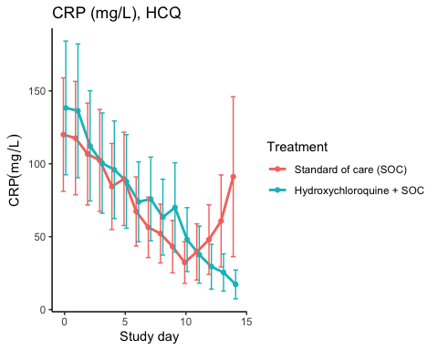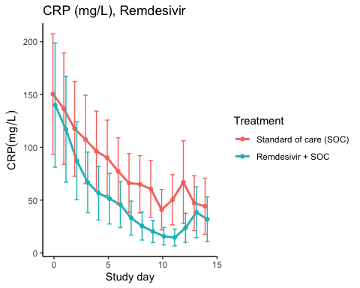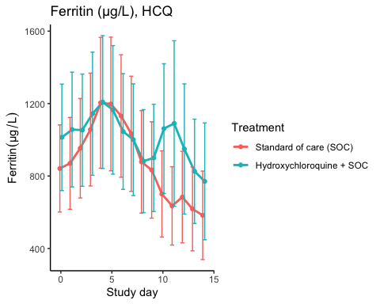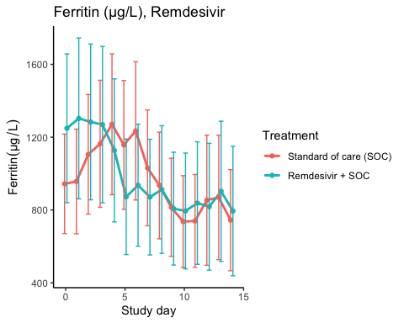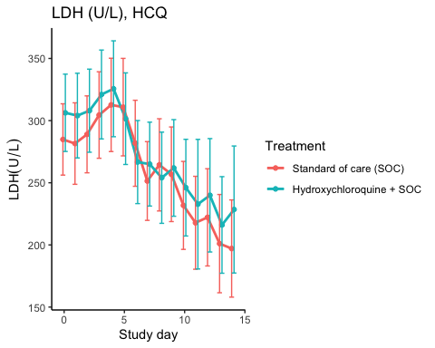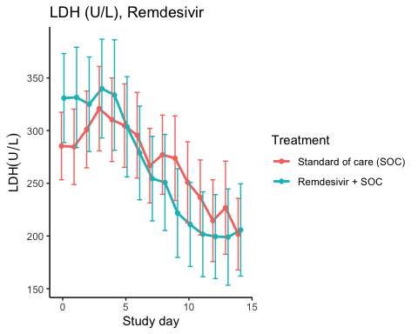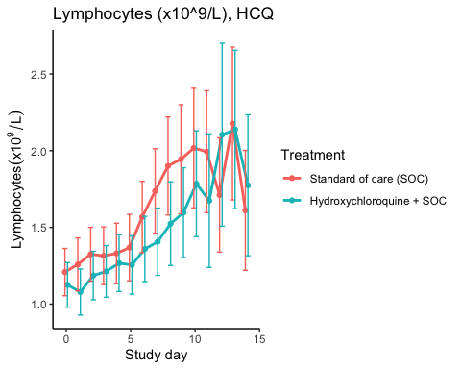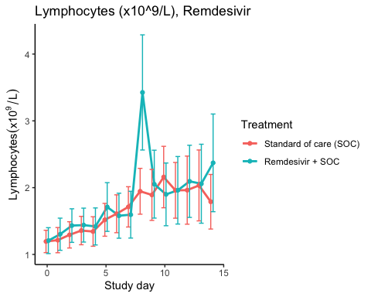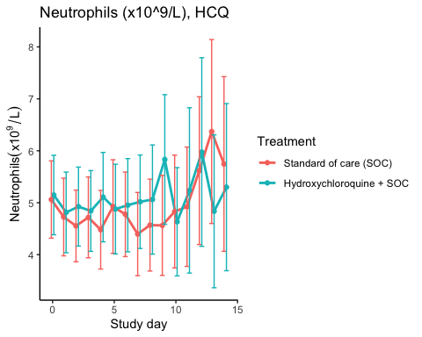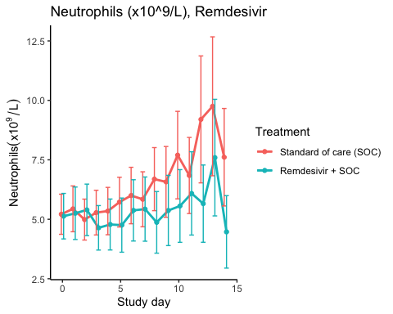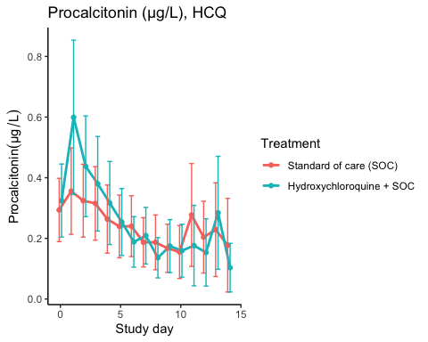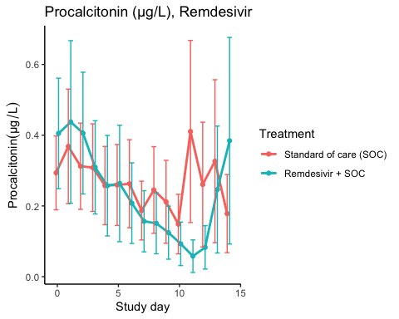

### Efficacy estimates

CRP (mg/L), HCQ

|  |  |  |  |  |  |
| --- | --- | --- | --- | --- | --- |
| Estimator | Treatment | Estimate | Lower 95% CL | Upper 95% CL | P-value |
| Slope 1st week by treatment | Standard of care (SOC) | -10.388 | -14.618 | -6.158 | 0.000 |
| Slope 1st week by treatment | Hydroxychloroquine + SOC | -8.250 | -12.288 | -4.212 | 0.000 |
| Difference in 1st week slope | Hydroxychloroquine + SOC | 2.138 | -3.378 | 7.655 | 0.447 |
| Day 10 level by treatment | Standard of care (SOC) | 54.715 | 37.632 | 71.798 | 0.000 |
| Day 10 level by treatment | Hydroxychloroquine + SOC | 43.973 | 29.907 | 58.039 | 0.000 |
| Day 10 treatment difference | Hydroxychloroquine + SOC | -10.742 | -31.500 | 10.016 | 0.310 |

CRP (mg/L), Remdesivir

|  |  |  |  |  |  |
| --- | --- | --- | --- | --- | --- |
| Estimator | Treatment | Estimate | Lower 95% CL | Upper 95% CL | P-value |
| Slope 1st week by treatment | Standard of care (SOC) | -11.188 | -16.511 | -5.865 | 0.000 |
| Slope 1st week by treatment | Remdesivir + SOC | -15.543 | -22.193 | -8.893 | 0.000 |
| Difference in 1st week slope | Remdesivir + SOC | -4.355 | -12.034 | 3.324 | 0.266 |
| Day 10 level by treatment | Standard of care (SOC) | 56.090 | 36.193 | 75.986 | 0.000 |
| Day 10 level by treatment | Remdesivir + SOC | 25.938 | 15.654 | 36.223 | 0.000 |
| Day 10 treatment difference | Remdesivir + SOC | -30.151 | -50.930 | -9.373 | 0.004 |

Ferritin (µg/L), HCQ

|  |  |  |  |  |  |
| --- | --- | --- | --- | --- | --- |
| Estimator | Treatment | Estimate | Lower 95% CL | Upper 95% CL | P-value |
| Slope 1st week by treatment | Standard of care (SOC) | 35.689 | 15.250 | 56.127 | 0.001 |
| Slope 1st week by treatment | Hydroxychloroquine + SOC | 1.741 | -17.435 | 20.916 | 0.859 |
| Difference in 1st week slope | Hydroxychloroquine + SOC | -33.948 | -62.032 | -5.864 | 0.018 |
| Day 10 level by treatment | Standard of care (SOC) | 793.815 | 568.342 | 1019.288 | 0.000 |
| Day 10 level by treatment | Hydroxychloroquine + SOC | 954.703 | 680.440 | 1228.965 | 0.000 |
| Day 10 treatment difference | Hydroxychloroquine + SOC | 160.888 | -164.668 | 486.443 | 0.333 |

Ferritin (µg/L), Remdesivir

|  |  |  |  |  |  |
| --- | --- | --- | --- | --- | --- |
| Estimator | Treatment | Estimate | Lower 95% CL | Upper 95% CL | P-value |
| Slope 1st week by treatment | Standard of care (SOC) | 16.912 | -3.383 | 37.206 | 0.102 |
| Slope 1st week by treatment | Remdesivir + SOC | -63.202 | -95.031 | -31.373 | 0.000 |
| Difference in 1st week slope | Remdesivir + SOC | -80.114 | -118.118 | -42.110 | 0.000 |
| Day 10 level by treatment | Standard of care (SOC) | 894.199 | 639.446 | 1148.953 | 0.000 |
| Day 10 level by treatment | Remdesivir + SOC | 863.890 | 583.578 | 1144.202 | 0.000 |
| Day 10 treatment difference | Remdesivir + SOC | -30.310 | -377.642 | 317.023 | 0.864 |

LDH (U/L), HCQ

|  |  |  |  |  |  |
| --- | --- | --- | --- | --- | --- |
| Estimator | Treatment | Estimate | Lower 95% CL | Upper 95% CL | P-value |
| Slope 1st week by treatment | Standard of care (SOC) | -1.345 | -4.704 | 2.014 | 0.432 |
| Slope 1st week by treatment | Hydroxychloroquine + SOC | -5.275 | -8.735 | -1.816 | 0.003 |
| Difference in 1st week slope | Hydroxychloroquine + SOC | -3.930 | -8.736 | 0.875 | 0.109 |
| Day 10 level by treatment | Standard of care (SOC) | 239.448 | 215.635 | 263.260 | 0.000 |
| Day 10 level by treatment | Hydroxychloroquine + SOC | 250.169 | 224.334 | 276.004 | 0.000 |
| Day 10 treatment difference | Hydroxychloroquine + SOC | 10.722 | -24.293 | 45.736 | 0.548 |

LDH (U/L), Remdesivir

|  |  |  |  |  |  |
| --- | --- | --- | --- | --- | --- |
| Estimator | Treatment | Estimate | Lower 95% CL | Upper 95% CL | P-value |
| Slope 1st week by treatment | Standard of care (SOC) | 0.298 | -2.903 | 3.500 | 0.855 |
| Slope 1st week by treatment | Remdesivir + SOC | -10.164 | -14.364 | -5.963 | 0.000 |
| Difference in 1st week slope | Remdesivir + SOC | -10.462 | -15.726 | -5.197 | 0.000 |
| Day 10 level by treatment | Standard of care (SOC) | 252.601 | 224.572 | 280.631 | 0.000 |
| Day 10 level by treatment | Remdesivir + SOC | 229.234 | 199.424 | 259.045 | 0.000 |
| Day 10 treatment difference | Remdesivir + SOC | -23.367 | -63.935 | 17.201 | 0.259 |

Lymphocytes (x10^9/L), HCQ

|  |  |  |  |  |  |
| --- | --- | --- | --- | --- | --- |
| Estimator | Treatment | Estimate | Lower 95% CL | Upper 95% CL | P-value |
| Slope 1st week by treatment | Standard of care (SOC) | 0.075 | 0.052 | 0.099 | 0.000 |
| Slope 1st week by treatment | Hydroxychloroquine + SOC | 0.047 | 0.028 | 0.067 | 0.000 |
| Difference in 1st week slope | Hydroxychloroquine + SOC | -0.028 | -0.058 | 0.002 | 0.072 |
| Day 10 level by treatment | Standard of care (SOC) | 1.828 | 1.598 | 2.058 | 0.000 |
| Day 10 level by treatment | Hydroxychloroquine + SOC | 1.681 | 1.461 | 1.900 | 0.000 |
| Day 10 treatment difference | Hydroxychloroquine + SOC | -0.148 | -0.459 | 0.164 | 0.353 |

Lymphocytes (x10^9/L), Remdesivir

|  |  |  |  |  |  |
| --- | --- | --- | --- | --- | --- |
| Estimator | Treatment | Estimate | Lower 95% CL | Upper 95% CL | P-value |
| Slope 1st week by treatment | Standard of care (SOC) | 0.089 | 0.061 | 0.117 | 0.000 |
| Slope 1st week by treatment | Remdesivir + SOC | 0.105 | 0.065 | 0.144 | 0.000 |
| Difference in 1st week slope | Remdesivir + SOC | 0.016 | -0.032 | 0.064 | 0.520 |
| Day 10 level by treatment | Standard of care (SOC) | 1.870 | 1.615 | 2.125 | 0.000 |
| Day 10 level by treatment | Remdesivir + SOC | 2.027 | 1.699 | 2.355 | 0.000 |
| Day 10 treatment difference | Remdesivir + SOC | 0.157 | -0.247 | 0.561 | 0.447 |

Neutrophils (x10^9/L), HCQ

|  |  |  |  |  |  |
| --- | --- | --- | --- | --- | --- |
| Estimator | Treatment | Estimate | Lower 95% CL | Upper 95% CL | P-value |
| Slope 1st week by treatment | Standard of care (SOC) | -0.062 | -0.139 | 0.016 | 0.119 |
| Slope 1st week by treatment | Hydroxychloroquine + SOC | 0.002 | -0.082 | 0.086 | 0.958 |
| Difference in 1st week slope | Hydroxychloroquine + SOC | 0.064 | -0.050 | 0.178 | 0.272 |
| Day 10 level by treatment | Standard of care (SOC) | 5.035 | 4.318 | 5.752 | 0.000 |
| Day 10 level by treatment | Hydroxychloroquine + SOC | 5.175 | 4.402 | 5.947 | 0.000 |
| Day 10 treatment difference | Hydroxychloroquine + SOC | 0.140 | -0.902 | 1.181 | 0.793 |

Neutrophils (x10^9/L), Remdesivir

|  |  |  |  |  |  |
| --- | --- | --- | --- | --- | --- |
| Estimator | Treatment | Estimate | Lower 95% CL | Upper 95% CL | P-value |
| Slope 1st week by treatment | Standard of care (SOC) | 0.132 | 0.025 | 0.238 | 0.015 |
| Slope 1st week by treatment | Remdesivir + SOC | -0.011 | -0.126 | 0.105 | 0.858 |
| Difference in 1st week slope | Remdesivir + SOC | -0.142 | -0.299 | 0.015 | 0.075 |
| Day 10 level by treatment | Standard of care (SOC) | 7.108 | 5.992 | 8.223 | 0.000 |
| Day 10 level by treatment | Remdesivir + SOC | 5.480 | 4.482 | 6.478 | 0.000 |
| Day 10 treatment difference | Remdesivir + SOC | -1.628 | -3.101 | -0.155 | 0.030 |

Procalcitonin (µg/L), HCQ

|  |  |  |  |  |  |
| --- | --- | --- | --- | --- | --- |
| Estimator | Treatment | Estimate | Lower 95% CL | Upper 95% CL | P-value |
| Slope 1st week by treatment | Standard of care (SOC) | -0.019 | -0.033 | -0.006 | 0.005 |
| Slope 1st week by treatment | Hydroxychloroquine + SOC | -0.040 | -0.060 | -0.020 | 0.000 |
| Difference in 1st week slope | Hydroxychloroquine + SOC | -0.021 | -0.044 | 0.003 | 0.082 |
| Day 10 level by treatment | Standard of care (SOC) | 0.212 | 0.138 | 0.287 | 0.000 |
| Day 10 level by treatment | Hydroxychloroquine + SOC | 0.187 | 0.119 | 0.255 | 0.000 |
| Day 10 treatment difference | Hydroxychloroquine + SOC | -0.025 | -0.120 | 0.070 | 0.600 |

Procalcitonin (µg/L), Remdesivir

|  |  |  |  |  |  |
| --- | --- | --- | --- | --- | --- |
| Estimator | Treatment | Estimate | Lower 95% CL | Upper 95% CL | P-value |
| Slope 1st week by treatment | Standard of care (SOC) | -0.013 | -0.028 | 0.001 | 0.074 |
| Slope 1st week by treatment | Remdesivir + SOC | -0.048 | -0.072 | -0.024 | 0.000 |
| Difference in 1st week slope | Remdesivir + SOC | -0.034 | -0.062 | -0.007 | 0.014 |
| Day 10 level by treatment | Standard of care (SOC) | 0.249 | 0.162 | 0.336 | 0.000 |
| Day 10 level by treatment | Remdesivir + SOC | 0.163 | 0.098 | 0.229 | 0.000 |
| Day 10 treatment difference | Remdesivir + SOC | -0.086 | -0.191 | 0.018 | 0.106 |

## SARS-CoV2 antibodies at day 90

### Descriptives

Hydroxychloroquine

|  |  |  |  |
| --- | --- | --- | --- |
| Outcome | Statistic | Standard of care (SOC) | Hydroxychloroquine + SOC |
| Receptor-bindind domain | Mean (SD) | 60.1 (48.5) | 61.7 (37.3) |
|  | Median (IQR) | 53.6 (19.5 - 89.3) | 63.9 (32.8 - 97.9) |
| Normalised receptor-binding domain | Mean (SD) | 17.6 (11.9) | 18.7 (9.6) |
|  | Median (IQR) | 13.8 (8 - 28.4) | 18.3 (12 - 25.1) |
| log10 ACE2 receptor-binding domain | Mean (SD) | 1.3 (0.66) | 1.23 (0.66) |
|  | Median (IQR) | 1.31 (0.93 - 1.66) | 1.22 (0.69 - 1.79) |

Remdesivir

|  |  |  |  |
| --- | --- | --- | --- |
| Outcome | Statistic | Standard of care (SOC) | Remdesivir + SOC |
| Receptor-bindind domain | Mean (SD) | 65.9 (44) | 48.4 (39.2) |
|  | Median (IQR) | 59.1 (31.3 - 91.2) | 52.9 (10.2 - 78.6) |
| Normalised receptor-binding domain | Mean (SD) | 18.7 (11.4) | 14.9 (12) |
|  | Median (IQR) | 16 (11.3 - 26.3) | 14.2 (4.6 - 25) |
| log10 ACE2 receptor-binding domain | Mean (SD) | 1.09 (0.54) | 1.07 (0.68) |
|  | Median (IQR) | 1.19 (0.75 - 1.46) | 1.23 (0.4 - 1.43) |

Number of positive antibodies (rbd ≥ 5) by treatment group

|  |  |  |
| --- | --- | --- |
| rantrt | tot | n |
| Standard of care (SOC) | 47 | 52 |
| Hydroxychloroquine + SOC | 31 | 35 |
| Remdesivir + SOC | 23 | 25 |

Number of positive antibodies (rbd ≥ 5) by treatment group in HCQ

|  |  |  |
| --- | --- | --- |
| rantrt | tot | n |
| Standard of care (SOC) | 34 | 38 |
| Hydroxychloroquine + SOC | 31 | 35 |

Number of positive antibodies (rbd ≥ 5) by treatment group in Remdesivir

|  |  |  |
| --- | --- | --- |
| rantrt | tot | n |
| Standard of care (SOC) | 28 | 29 |
| Remdesivir + SOC | 23 | 25 |

### Marginal probability estimates by treatment group and difference

Hydroxychloroquine

|  |  |  |  |
| --- | --- | --- | --- |
| Outcome | Standard of care (SOC) | Hydroxychloroquine + SOC | Estimated marginal treatment effect |
| Receptor-bindind domain | 60.1 (48.4 to 71.7) | 61.7 (49.2 to 74.2) | 1.6 (-15.5 to 18.7) |
| Normalised receptor-binding domain | 17.6 (14.6 to 20.5) | 18.7 (15.6 to 21.9) | 1.2 (-3.1 to 5.5) |
| log10 ACE2 receptor-binding domain | 1.3 (1.13 to 1.48) | 1.23 (1.04 to 1.41) | -0.08 (-0.33 to 0.18) |

Estimates are presented with 95% confidence limits

Remdesivir

|  |  |  |  |
| --- | --- | --- | --- |
| Outcome | Standard of care (SOC) | Remdesivir + SOC | Estimated marginal treatment effect |
| Receptor-bindind domain | 65.9 (51.7 to 80) | 48.4 (32.5 to 64.2) | -17.5 (-38.8 to 3.7) |
| Normalised receptor-binding domain | 18.7 (14.7 to 22.6) | 14.9 (10.5 to 19.4) | -3.7 (-9.6 to 2.2) |
| log10 ACE2 receptor-binding domain | 1.09 (0.89 to 1.3) | 1.07 (0.84 to 1.3) | -0.03 (-0.33 to 0.28) |

Estimates are presented with 95% confidence limits

## Time to last discharge

### HCQ

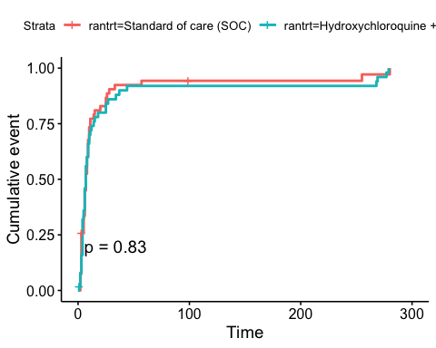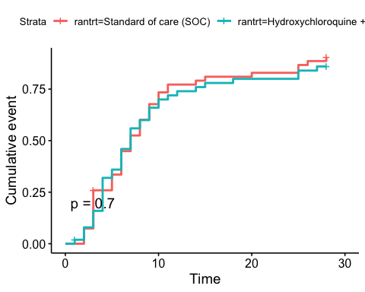

### Remdesivir

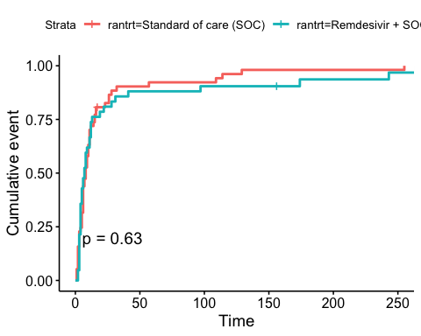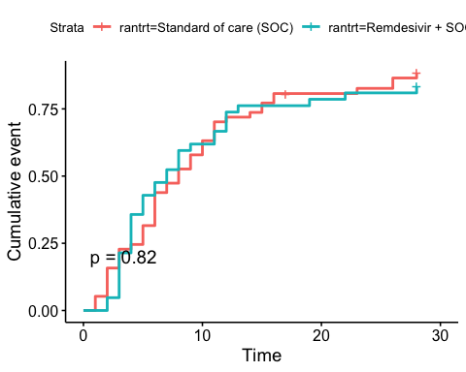

# Adverse Events

## AE Summary

Summary of Adverse Events

|  |  |  |  |
| --- | --- | --- | --- |
| Parameter | SOC (N=87) | SOC + HCQ (N=52) | SOC + Remdesivir (N=42) |
| Number of AEs | [33] 22 (25.3%) | [34] 20 (38.5%) | [26] 16 (38.1%) |
| Number of patients with any AEs? | 22 (25.3%) | 20 (38.5%) | 16 (38.1%) |
| Number of patients with one AE | 15 (17.2%) | 14 (26.9%) | 11 (26.2%) |
| Number of patients with two AE | 3 (3.4%) | 2 (3.8%) | 1 (2.4%) |
| Number of patients with three or more AEs | 4 (4.6%) | 4 (7.7%) | 4 (9.5%) |
| Number of SAEs | [20] 13 (14.9%) | [13] 8 (15.4%) | [12] 10 (23.8%) |
| Number of patients with any SAEs? | 13 (14.9%) | 8 (15.4%) | 10 (23.8%) |

The numbers are [Number of events] Number of patients (percentage of patients), or Number of patients (percentage of patients)

## By System Organ Class and Preferred Term

Adverse Events by System Organ Class and Preferred term

|  |  |  |  |  |
| --- | --- | --- | --- | --- |
| System Organ Class | Preferred Term | SOC (N=87) | SOC + HCQ (N=52) | SOC + Remdesivir (N=42) |
| Blood and lymphatic system disorders | #Total |  | [2] 1 (1.9%) |  |
|  | Leukopenia |  | [1] 1 (1.9%) |  |
|  | Thrombocytopenia |  | [1] 1 (1.9%) |  |
| Cardiac disorders | #Total | [1] 1 (1.1%) |  | [3] 2 (4.8%) |
|  | Arrhythmia |  |  | [2] 1 (2.4%) |
|  | Ventricular tachycardia | [1] 1 (1.1%) |  | [1] 1 (2.4%) |
| Gastrointestinal disorders | #Total | [2] 2 (2.3%) | [4] 4 (7.7%) | [4] 3 (7.1%) |
|  | Abdominal pain | [1] 1 (1.1%) |  |  |
|  | Diarrhoea | [1] 1 (1.1%) |  |  |
|  | Diarrhoea haemorrhagic |  |  | [1] 1 (2.4%) |
|  | Gastrooesophageal reflux disease |  | [1] 1 (1.9%) |  |
|  | Intestinal pseudo-obstruction |  | [1] 1 (1.9%) |  |
|  | Nausea |  |  | [2] 2 (4.8%) |
|  | Pancreatic failure |  | [1] 1 (1.9%) |  |
|  | Vomiting |  | [1] 1 (1.9%) | [1] 1 (2.4%) |
| General disorders and administration site conditions | #Total | [3] 3 (3.4%) |  | [2] 2 (4.8%) |
|  | Chest pain |  |  | [1] 1 (2.4%) |
|  | General physical health deterioration | [1] 1 (1.1%) |  |  |
|  | Medical device site reaction |  |  | [1] 1 (2.4%) |
|  | Pyrexia | [2] 2 (2.3%) |  |  |
| Hepatobiliary disorders | #Total | [1] 1 (1.1%) |  |  |
|  | Cholecystitis | [1] 1 (1.1%) |  |  |
| Infections and infestations | #Total | [4] 4 (4.6%) | [1] 1 (1.9%) |  |
|  | COVID-19 |  | [1] 1 (1.9%) |  |
|  | Infection | [1] 1 (1.1%) |  |  |
|  | Pneumonia bacterial | [2] 2 (2.3%) |  |  |
|  | Superinfection bacterial | [1] 1 (1.1%) |  |  |
| Injury, poisoning and procedural complications | #Total | [2] 2 (2.3%) |  |  |
|  | Hepatobiliary procedural complication | [1] 1 (1.1%) |  |  |
|  | Procedural pneumothorax | [1] 1 (1.1%) |  |  |
| Investigations | #Total | [5] 3 (3.4%) | [10] 6 (11.5%) | [4] 4 (9.5%) |
|  | Alanine aminotransferase increased | [2] 1 (1.1%) | [2] 2 (3.8%) |  |
|  | Amylase increased |  | [1] 1 (1.9%) |  |
|  | Aspartate aminotransferase increased | [1] 1 (1.1%) | [3] 3 (5.8%) | [1] 1 (2.4%) |
|  | Blood creatine phosphokinase increased |  | [1] 1 (1.9%) |  |
|  | Electrocardiogram QT prolonged |  | [2] 2 (3.8%) |  |
|  | Fibrin D dimer increased | [1] 1 (1.1%) |  |  |
|  | Gamma-glutamyltransferase increased |  | [1] 1 (1.9%) |  |
|  | Hepatic enzyme increased |  |  | [2] 2 (4.8%) |
|  | Myocardial necrosis marker increased | [1] 1 (1.1%) |  |  |
|  | Neutrophil count decreased |  |  | [1] 1 (2.4%) |
| Metabolism and nutrition disorders | #Total |  | [1] 1 (1.9%) |  |
|  | Hypercalcaemia |  | [1] 1 (1.9%) |  |
| Musculoskeletal and connective tissue disorders | #Total |  | [4] 2 (3.8%) |  |
|  | Arthralgia |  | [1] 1 (1.9%) |  |
|  | Arthritis reactive |  | [1] 1 (1.9%) |  |
|  | Joint swelling |  | [1] 1 (1.9%) |  |
|  | Tendonitis |  | [1] 1 (1.9%) |  |
| Neoplasms benign, malignant and unspecified (incl cysts and polyps) | #Total | [1] 1 (1.1%) |  |  |
|  | Neoplasm malignant | [1] 1 (1.1%) |  |  |
| Nervous system disorders | #Total | [2] 2 (2.3%) | [1] 1 (1.9%) | [2] 2 (4.8%) |
|  | Haemorrhage intracranial | [1] 1 (1.1%) |  |  |
|  | Headache |  |  | [1] 1 (2.4%) |
|  | Loss of consciousness |  |  | [1] 1 (2.4%) |
|  | Syncope | [1] 1 (1.1%) | [1] 1 (1.9%) |  |
| Renal and urinary disorders | #Total | [1] 1 (1.1%) | [1] 1 (1.9%) |  |
|  | Renal failure | [1] 1 (1.1%) | [1] 1 (1.9%) |  |
| Respiratory, thoracic and mediastinal disorders | #Total | [10] 8 (9.2%) | [9] 7 (13.5%) | [8] 6 (14.3%) |
|  | Bronchopleural fistula |  |  | [1] 1 (2.4%) |
|  | Chronic obstructive pulmonary disease |  |  | [2] 1 (2.4%) |
|  | Cough | [1] 1 (1.1%) |  |  |
|  | Dyspnoea | [3] 1 (1.1%) |  | [1] 1 (2.4%) |
|  | Pulmonary embolism |  | [1] 1 (1.9%) |  |
|  | Respiratory distress | [3] 3 (3.4%) | [4] 3 (5.8%) | [1] 1 (2.4%) |
|  | Respiratory failure | [3] 3 (3.4%) | [4] 4 (7.7%) | [3] 2 (4.8%) |
| Skin and subcutaneous tissue disorders | #Total |  |  | [2] 2 (4.8%) |
|  | Alopecia |  |  | [2] 2 (4.8%) |
| Vascular disorders | #Total | [1] 1 (1.1%) | [1] 1 (1.9%) | [1] 1 (2.4%) |
|  | Hypotension |  |  | [1] 1 (2.4%) |
|  | Thrombophlebitis |  | [1] 1 (1.9%) |  |
|  | Thrombosis | [1] 1 (1.1%) |  |  |

## Serious Adverse Events

Serious Adverse Events by System Organ Class and Preferred term

|  |  |  |  |  |
| --- | --- | --- | --- | --- |
| System Organ Class | Preferred Term | SOC (N=87) | SOC + HCQ (N=52) | SOC + Remdesivir (N=42) |
| Gastrointestinal disorders | #Total | [1] 1 (1.1%) |  | [1] 1 (2.4%) |
|  | Abdominal pain | [1] 1 (1.1%) |  |  |
|  | Diarrhoea haemorrhagic |  |  | [1] 1 (2.4%) |
| General disorders and administration site conditions | #Total | [2] 2 (2.3%) |  | [1] 1 (2.4%) |
|  | Chest pain |  |  | [1] 1 (2.4%) |
|  | General physical health deterioration | [1] 1 (1.1%) |  |  |
|  | Pyrexia | [1] 1 (1.1%) |  |  |
| Hepatobiliary disorders | #Total | [1] 1 (1.1%) |  |  |
|  | Cholecystitis | [1] 1 (1.1%) |  |  |
| Infections and infestations | #Total | [2] 2 (2.3%) | [1] 1 (1.9%) |  |
|  | COVID-19 |  | [1] 1 (1.9%) |  |
|  | Pneumonia bacterial | [1] 1 (1.1%) |  |  |
|  | Superinfection bacterial | [1] 1 (1.1%) |  |  |
| Injury, poisoning and procedural complications | #Total | [2] 2 (2.3%) |  |  |
|  | Hepatobiliary procedural complication | [1] 1 (1.1%) |  |  |
|  | Procedural pneumothorax | [1] 1 (1.1%) |  |  |
| Investigations | #Total | [1] 1 (1.1%) | [2] 2 (3.8%) | [2] 2 (4.8%) |
|  | Alanine aminotransferase increased | [1] 1 (1.1%) |  |  |
|  | Aspartate aminotransferase increased |  | [1] 1 (1.9%) |  |
|  | Blood creatine phosphokinase increased |  | [1] 1 (1.9%) |  |
|  | Hepatic enzyme increased |  |  | [2] 2 (4.8%) |
| Neoplasms benign, malignant and unspecified (incl cysts and polyps) | #Total | [1] 1 (1.1%) |  |  |
|  | Neoplasm malignant | [1] 1 (1.1%) |  |  |
| Nervous system disorders | #Total | [1] 1 (1.1%) |  | [1] 1 (2.4%) |
|  | Haemorrhage intracranial | [1] 1 (1.1%) |  |  |
|  | Loss of consciousness |  |  | [1] 1 (2.4%) |
| Renal and urinary disorders | #Total | [1] 1 (1.1%) | [1] 1 (1.9%) |  |
|  | Renal failure | [1] 1 (1.1%) | [1] 1 (1.9%) |  |
| Respiratory, thoracic and mediastinal disorders | #Total | [8] 6 (6.9%) | [9] 7 (13.5%) | [7] 5 (11.9%) |
|  | Bronchopleural fistula |  |  | [1] 1 (2.4%) |
|  | Chronic obstructive pulmonary disease |  |  | [2] 1 (2.4%) |
|  | Dyspnoea | [3] 1 (1.1%) |  | [1] 1 (2.4%) |
|  | Pulmonary embolism |  | [1] 1 (1.9%) |  |
|  | Respiratory distress | [3] 3 (3.4%) | [4] 3 (5.8%) |  |
|  | Respiratory failure | [2] 2 (2.3%) | [4] 4 (7.7%) | [3] 2 (4.8%) |

## Suspected Unexpected Serious Adverse Reaction

Suspected Unexpected Serious Adverse Reaction by System Organ Class and Preferred term

|  |  |  |
| --- | --- | --- |
| System Organ Class | Preferred Term | Remdesivir + SOC |
| Gastrointestinal disorders | #Total | [1] 1 (2.4%) |
|  | Diarrhoea haemorrhagic | [1] 1 (2.4%) |

END