NOR-SOLIDARITY First Interim Report

Inge Christoffer Olsen, PhD

12 November, 2020

# Introduction

This is the report for the first interim analysis of the NOR-SOLIDARITY trial. The data are based on an export from the Viedoc electronic data capture at “2020-10-16 08:41:09” system time stamped “ous_20201016_084109”. There were 186 included patients.

# Inclusion status

## Inclusion rate

## Warning: Removed 1 row(s) containing missing values (geom_path).

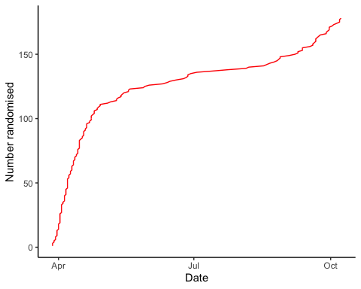

## Inclusion by hospital

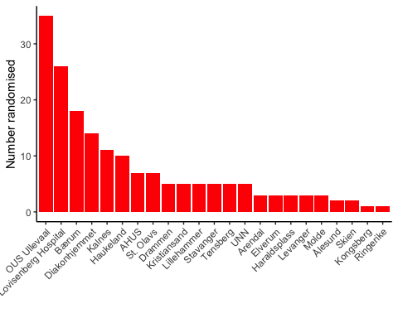

## By treatment

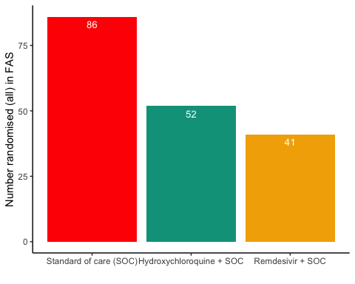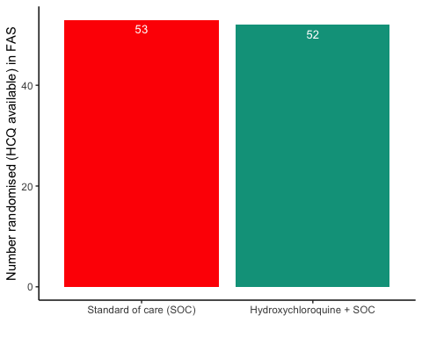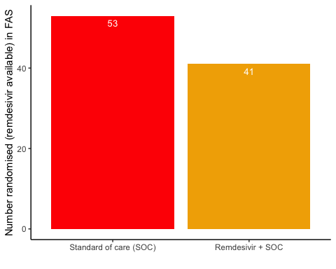

#Patient flow

## Note: Using an external vector in selections is ambiguous.  
## ℹ Use `all_of(group)` instead of `group` to silence this message.  
## ℹ See <https://tidyselect.r-lib.org/reference/faq-external-vector.html>.  
## This message is displayed once per session.

Patient flow total

|  |  |
| --- | --- |
| Parameter | Total |
| Enrolled | 186 (100%) |
| Randomised | 185 (99.5%) |
| Included in FAS | 179 (96.2%) |
| Excluded from FAS, No post-randomisation information | 6 (3.2%) |
| Excluded from FAS, incorrect inclusion | 1 (0.5%) |

Patient flow by arm

|  |  |  |  |
| --- | --- | --- | --- |
| Parameter | SOC | SOC + HCQ | SOC + Remdesivir |
| Randomised | 88 (100%) | 54 (100%) | 43 (100%) |
| Included in FAS | 86 (97.7%) | 52 (96.3%) | 41 (95.3%) |
| Excluded from FAS, No post-randomisation information | 2 (2.3%) | 1 (1.9%) | 2 (4.7%) |
| Excluded from FAS, incorrect inclusion | 0 (0%) | 1 (1.9%) | 0 (0%) |

# Demographics

Demographics, all arms (FAS)

|  |  |  |  |
| --- | --- | --- | --- |
| Parameter | SOC (N=86) | SOC + HCQ (N=52) | SOC + Remdesivir (N=41) |
| Age (years) | 59.3 (15.9) | 57.5 (13.2) | 61.7 (16.7) |
| Female, n (%) | 29 (33.7%) | 13 (25%) | 16 (39%) |
| Admitted to ward, n(%) | 81 (94.2%) | 49 (94.2%) | 39 (95.1%) |
| Admitted to ICU, n(%) | 4 (4.7%) | 3 (5.8%) | 2 (4.9%) |
| Body Mass Index (kg/m2) mean | 31 (30) | 28 (5) | 28 (5) |
| Body Mass Index (kg/m2) median | 28 (25 - 30) | 28 (25 - 31) | 27 (25 - 31) |
| Obese (BMI > 30 kg/m2), n(%) | 19 (22.1%) | 14 (26.9%) | 11 (26.8%) |
| Systolic Blood Pressure (mmHg) | 126 (16) | 126 (18) | 120 (19) |
| Diastolic Blood Pressure (mmHg) | 73 (10) | 75 (11) | 72 (13) |
| Mean Arterial Blood Pressure (mmHg) | 90 (11) | 92 (13) | 88 (13) |
| Temperature (°C) | 37.5 (1) | 37.2 (0.9) | 37.4 (0.8) |
| SOFA score | 1.4 (1.5) | 1.9 (2) | 1.6 (1.3) |
| **Comorbidities** |  |  |  |
| Chronic cardiac disease, including congenital heart disease | 13 (15.1%) | 7 (13.5%) | 7 (17.1%) |
| Hypertension, n(%) | 26 (30.2%) | 17 (32.7%) | 13 (31.7%) |
| Chronic pulmonary disease, n(%) | 3 (3.5%) | 2 (3.8%) | 1 (2.4%) |
| Chronic kidney disease, n(%) | 7 (8.1%) | 2 (3.8%) | 2 (4.9%) |
| Autoimmune disease, n(%) | 3 (3.5%) | 1 (1.9%) | 4 (9.8%) |
| Diabetes, n(%) | 13 (15.1%) | 13 (25%) | 7 (17.1%) |
| Cognitive impairment/dementia, n(%) | 3 (3.5%) | 0 (0%) | 1 (2.4%) |
| Neurological disorder, n(%) | 3 (3.5%) | 0 (0%) | 3 (7.3%) |
| Cancer, n(%) | 6 (7%) | 4 (7.7%) | 3 (7.3%) |
| Cirrhosis, n(%) | 0 (0%) | 0 (0%) | 0 (0%) |
| Asthma, n(%) | 11 (12.8%) | 7 (13.5%) | 4 (9.8%) |
| HIV, n(%) | 0 (0%) | 0 (0%) | 0 (0%) |
| Active TB, n(%) | 0 (0%) | 0 (0%) | 0 (0%) |
| Median Laboratory values (IQR) |  |  |  |
| Ferritin result | 710 (329.5 - 1194) | 608 (311 - 1266) | 442 (261.5 - 810) |
| D-dimer result | 0.8 (0.5 - 1.1) | 0.6 (0.4 - 1.3) | 0.7 (0.4 - 1) |
| AST result | 43.5 (28.8 - 59.2) | 44 (28 - 65) | 33.5 (24 - 49.8) |
| ALT result | 31 (19 - 55) | 45 (26 - 71) | 26.5 (19.8 - 41.2) |
| LD result | 279 (231 - 382.5) | 281 (220.5 - 365) | 247.5 (190 - 340.2) |
| CRP result | 76 (35.5 - 141.5) | 87 (48 - 150.5) | 52 (26 - 111) |
| Hemoglobin result | 13.3 (12.3 - 14.1) | 13.2 (12.4 - 14.1) | 13.1 (12.5 - 13.9) |
| Platelet counts result | 196 (158.5 - 271.8) | 219 (171.5 - 285.5) | 182 (151.8 - 211) |
| Neutrophils result | 4.8 (2.8 - 6.7) | 5 (3.3 - 7.4) | 3.6 (3 - 5.3) |
| Lymphocytes result | 1.1 (0.9 - 1.4) | 1.1 (0.8 - 1.3) | 1 (0.7 - 1.4) |
| WBC result | 6.4 (4.4 - 8.8) | 6.6 (5.2 - 9.3) | 5.4 (4.4 - 6.7) |

Demographics, HCQ (FAS)

|  |  |  |
| --- | --- | --- |
| Parameter | SOC (N=53) | SOC + HCQ (N=52) |
| Age (years) | 59.4 (16.5) | 57.5 (13.2) |
| Female, n (%) | 15 (28.3%) | 13 (25%) |
| Admitted to ward, n(%) | 49 (92.5%) | 49 (94.2%) |
| Admitted to ICU, n(%) | 3 (5.7%) | 3 (5.8%) |
| Body Mass Index (kg/m2) mean | 33 (37) | 28 (5) |
| Body Mass Index (kg/m2) median | 28 (24 - 29) | 28 (25 - 31) |
| Obese (BMI > 30 kg/m2), n(%) | 12 (22.6%) | 14 (26.9%) |
| Systolic Blood Pressure (mmHg) | 126 (18) | 126 (18) |
| Diastolic Blood Pressure (mmHg) | 73 (10) | 75 (11) |
| Mean Arterial Blood Pressure (mmHg) | 90 (11) | 92 (13) |
| Temperature (°C) | 37.6 (1.1) | 37.2 (0.9) |
| SOFA score | 1.4 (1.3) | 1.9 (2) |
| **Comorbidities** |  |  |
| Chronic cardiac disease, including congenital heart disease | 8 (15.1%) | 7 (13.5%) |
| Hypertension, n(%) | 13 (24.5%) | 17 (32.7%) |
| Chronic pulmonary disease, n(%) | 2 (3.8%) | 2 (3.8%) |
| Chronic kidney disease, n(%) | 2 (3.8%) | 2 (3.8%) |
| Autoimmune disease, n(%) | 1 (1.9%) | 1 (1.9%) |
| Diabetes, n(%) | 5 (9.4%) | 13 (25%) |
| Cognitive impairment/dementia, n(%) | 2 (3.8%) | 0 (0%) |
| Neurological disorder, n(%) | 3 (5.7%) | 0 (0%) |
| Cancer, n(%) | 5 (9.4%) | 4 (7.7%) |
| Cirrhosis, n(%) | 0 (0%) | 0 (0%) |
| Asthma, n(%) | 7 (13.2%) | 7 (13.5%) |
| HIV, n(%) | 0 (0%) | 0 (0%) |
| Active TB, n(%) | 0 (0%) | 0 (0%) |
| Median Laboratory values (IQR) |  |  |
| Ferritin result | 945.5 (328.8 - 1222.5) | 608 (311 - 1266) |
| D-dimer result | 0.8 (0.5 - 1.1) | 0.6 (0.4 - 1.3) |
| AST result | 46 (31 - 67) | 44 (28 - 65) |
| ALT result | 37 (20 - 64.8) | 45 (26 - 71) |
| LD result | 282 (232.5 - 402) | 281 (220.5 - 365) |
| CRP result | 82 (38.8 - 142.2) | 87 (48 - 150.5) |
| Hemoglobin result | 13.3 (12.3 - 14.1) | 13.2 (12.4 - 14.1) |
| Platelet counts result | 199 (153.5 - 267.5) | 219 (171.5 - 285.5) |
| Neutrophils result | 4.8 (2.8 - 6.4) | 5 (3.3 - 7.4) |
| Lymphocytes result | 1 (0.9 - 1.3) | 1.1 (0.8 - 1.3) |
| WBC result | 6.3 (4.4 - 8.8) | 6.6 (5.2 - 9.3) |

Demographics, Remdesivir (FAS)

|  |  |  |
| --- | --- | --- |
| Parameter | SOC (N=53) | SOC + Remdesivir (N=41) |
| Age (years) | 62.4 (14.6) | 61.7 (16.7) |
| Female, n (%) | 17 (32.1%) | 16 (39%) |
| Admitted to ward, n(%) | 49 (92.5%) | 39 (95.1%) |
| Admitted to ICU, n(%) | 3 (5.7%) | 2 (4.9%) |
| Body Mass Index (kg/m2) mean | 28 (5) | 28 (5) |
| Body Mass Index (kg/m2) median | 28 (25 - 32) | 27 (25 - 31) |
| Obese (BMI > 30 kg/m2), n(%) | 13 (24.5%) | 11 (26.8%) |
| Systolic Blood Pressure (mmHg) | 128 (16) | 120 (19) |
| Diastolic Blood Pressure (mmHg) | 72 (10) | 72 (13) |
| Mean Arterial Blood Pressure (mmHg) | 91 (11) | 88 (13) |
| Temperature (°C) | 37.3 (0.9) | 37.4 (0.8) |
| SOFA score | 1.6 (1.5) | 1.6 (1.3) |
| **Comorbidities** |  |  |
| Chronic cardiac disease, including congenital heart disease | 6 (11.3%) | 7 (17.1%) |
| Hypertension, n(%) | 17 (32.1%) | 13 (31.7%) |
| Chronic pulmonary disease, n(%) | 2 (3.8%) | 1 (2.4%) |
| Chronic kidney disease, n(%) | 6 (11.3%) | 2 (4.9%) |
| Autoimmune disease, n(%) | 2 (3.8%) | 4 (9.8%) |
| Diabetes, n(%) | 9 (17%) | 7 (17.1%) |
| Cognitive impairment/dementia, n(%) | 2 (3.8%) | 1 (2.4%) |
| Neurological disorder, n(%) | 2 (3.8%) | 3 (7.3%) |
| Cancer, n(%) | 4 (7.5%) | 3 (7.3%) |
| Cirrhosis, n(%) | 0 (0%) | 0 (0%) |
| Asthma, n(%) | 7 (13.2%) | 4 (9.8%) |
| HIV, n(%) | 0 (0%) | 0 (0%) |
| Active TB, n(%) | 0 (0%) | 0 (0%) |
| Median Laboratory values (IQR) |  |  |
| Ferritin result | 764 (376.8 - 1222.5) | 442 (261.5 - 810) |
| D-dimer result | 0.8 (0.5 - 1.1) | 0.7 (0.4 - 1) |
| AST result | 44 (30 - 59.2) | 33.5 (24 - 49.8) |
| ALT result | 32 (19 - 51) | 26.5 (19.8 - 41.2) |
| LD result | 282.5 (236.2 - 395) | 247.5 (190 - 340.2) |
| CRP result | 80 (46.5 - 147.5) | 52 (26 - 111) |
| Hemoglobin result | 13.3 (12.3 - 14.1) | 13.1 (12.5 - 13.9) |
| Platelet counts result | 202.5 (160.5 - 299) | 182 (151.8 - 211) |
| Neutrophils result | 5.2 (3.4 - 7) | 3.6 (3 - 5.3) |
| Lymphocytes result | 1.1 (0.9 - 1.4) | 1 (0.7 - 1.4) |
| WBC result | 7 (5 - 8.9) | 5.4 (4.4 - 6.7) |

Missing values, all arms (FAS)

|  |  |  |  |
| --- | --- | --- | --- |
| Parameter | SOC (N=86) | SOC + HCQ (N=52) | SOC + Remdesivir (N=41) |
| Age (years) | 0 (0%) | 0 (0%) | 0 (0%) |
| Female, n (%) | 0 (0%) | 0 (0%) | 0 (0%) |
| Admitted to ward, n(%) | 1 (1.2%) | 0 (0%) | 0 (0%) |
| Admitted to ICU, n(%) | 1 (1.2%) | 0 (0%) | 0 (0%) |
| Body Mass Index (kg/m2) mean | 11 (12.8%) | 6 (11.5%) | 4 (9.8%) |
| Body Mass Index (kg/m2) median | 11 (12.8%) | 6 (11.5%) | 4 (9.8%) |
| Obese (BMI > 30 kg/m2), n(%) | 11 (12.8%) | 6 (11.5%) | 4 (9.8%) |
| Systolic Blood Pressure (mmHg) | 2 (2.3%) | 1 (1.9%) | 0 (0%) |
| Diastolic Blood Pressure (mmHg) | 2 (2.3%) | 1 (1.9%) | 0 (0%) |
| Mean Arterial Blood Pressure (mmHg) | 2 (2.3%) | 1 (1.9%) | 0 (0%) |
| Temperature (°C) | 2 (2.3%) | 1 (1.9%) | 0 (0%) |
| SOFA score | 6 (7%) | 6 (11.5%) | 3 (7.3%) |
| **Comorbidities** |  |  |  |
| Chronic cardiac disease, including congenital heart disease | 3 (3.5%) | 1 (1.9%) | 0 (0%) |
| Hypertension, n(%) | 3 (3.5%) | 1 (1.9%) | 0 (0%) |
| Chronic pulmonary disease, n(%) | 3 (3.5%) | 1 (1.9%) | 0 (0%) |
| Chronic kidney disease, n(%) | 3 (3.5%) | 1 (1.9%) | 0 (0%) |
| Autoimmune disease, n(%) | 3 (3.5%) | 1 (1.9%) | 0 (0%) |
| Diabetes, n(%) | 3 (3.5%) | 1 (1.9%) | 0 (0%) |
| Cognitive impairment/dementia, n(%) | 3 (3.5%) | 1 (1.9%) | 0 (0%) |
| Neurological disorder, n(%) | 3 (3.5%) | 1 (1.9%) | 0 (0%) |
| Cancer, n(%) | 3 (3.5%) | 1 (1.9%) | 0 (0%) |
| Cirrhosis, n(%) | 3 (3.5%) | 1 (1.9%) | 0 (0%) |
| Asthma, n(%) | 3 (3.5%) | 1 (1.9%) | 0 (0%) |
| HIV, n(%) | 3 (3.5%) | 1 (1.9%) | 0 (0%) |
| Active TB, n(%) | 3 (3.5%) | 1 (1.9%) | 0 (0%) |
| Median Laboratory values (IQR) |  |  |  |
| Ferritin result | 7 (8.1%) | 3 (5.8%) | 2 (4.9%) |
| D-dimer result | 13 (15.1%) | 5 (9.6%) | 4 (9.8%) |
| AST result | 6 (7%) | 3 (5.8%) | 5 (12.2%) |
| ALT result | 5 (5.8%) | 1 (1.9%) | 5 (12.2%) |
| LD result | 7 (8.1%) | 1 (1.9%) | 3 (7.3%) |
| CRP result | 3 (3.5%) | 1 (1.9%) | 0 (0%) |
| Hemoglobin result | 5 (5.8%) | 1 (1.9%) | 0 (0%) |
| Platelet counts result | 4 (4.7%) | 1 (1.9%) | 1 (2.4%) |
| Neutrophils result | 8 (9.3%) | 1 (1.9%) | 2 (4.9%) |
| Lymphocytes result | 8 (9.3%) | 1 (1.9%) | 2 (4.9%) |
| WBC result | 3 (3.5%) | 1 (1.9%) | 0 (0%) |

# Exposure

Exposure to study treatment

|  |  |  |
| --- | --- | --- |
| Parameter | SOC + HCQ (N=52) | SOC + Remdesivir (N=41) |
| Total dose (mg), median (IQR) | 3000 (750 - 6100) | 5200 (1100 - 8400) |
| Treatment duration, median (IQR) | 4 (3 - 8) | 9 (5 - 9) |
| Number of doses given, median (IQR) | 5 (4 - 9) | 10 (6 - 10) |
| Patients with any treatment discrepencies, n (%) | 10 (19.2%) | 8 (19.5%) |

# Adverse Events

## AE Summary

Summary of Adverse Events

|  |  |  |  |
| --- | --- | --- | --- |
| Parameter | SOC (N=86) | SOC + HCQ (N=52) | SOC + Remdesivir (N=41) |
| Number of AEs | [36] 25 (29.1%) | [28] 13 (25%) | [25] 16 (39%) |
| Number of patients with any AEs? | 25 (29.1%) | 13 (25%) | 16 (39%) |
| Number of patients with one AE | 18 (20.9%) | 7 (13.5%) | 11 (26.8%) |
| Number of patients with two AE | 3 (3.5%) | 1 (1.9%) | 2 (4.9%) |
| Number of patients with three or more AEs | 4 (4.7%) | 5 (9.6%) | 3 (7.3%) |
| Number of SAEs | [18] 11 (12.8%) | [12] 8 (15.4%) | [12] 9 (22%) |
| Number of patients with any SAEs? | 11 (12.8%) | 8 (15.4%) | 9 (22%) |

The numbers are [Number of events] Number of patients (percentage of patients), or Number of patients (percentage of patients)

## By System Organ Class and Preferred Term

Adverse Events by System Organ Class and Preferred term

|  |  |  |  |  |
| --- | --- | --- | --- | --- |
| System Organ Class | Preferred Term | SOC (N=86) | SOC + HCQ (N=52) | SOC + Remdesivir (N=41) |
| Blood and lymphatic system disorders | #Total |  |  | [2] 1 (2.4%) |
|  | Leukopenia |  |  | [1] 1 (2.4%) |
|  | Thrombocytopenia |  |  | [1] 1 (2.4%) |
| Cardiac disorders | #Total | [1] 1 (1.2%) | [1] 1 (1.9%) | [2] 1 (2.4%) |
|  | Arrhythmia |  |  | [2] 1 (2.4%) |
|  | Ventricular tachycardia | [1] 1 (1.2%) | [1] 1 (1.9%) |  |
| Gastrointestinal disorders | #Total | [3] 3 (3.5%) | [3] 2 (3.8%) | [3] 3 (7.3%) |
|  | Abdominal pain | [1] 1 (1.2%) |  |  |
|  | Diarrhoea | [1] 1 (1.2%) |  |  |
|  | Gastrooesophageal reflux disease |  | [1] 1 (1.9%) |  |
|  | Intestinal pseudo-obstruction | [1] 1 (1.2%) |  |  |
|  | Nausea |  | [1] 1 (1.9%) | [1] 1 (2.4%) |
|  | Pancreatic failure |  |  | [1] 1 (2.4%) |
|  | Vomiting |  | [1] 1 (1.9%) | [1] 1 (2.4%) |
| General disorders and administration site conditions | #Total | [3] 3 (3.5%) |  | [2] 2 (4.9%) |
|  | Chest pain | [1] 1 (1.2%) |  |  |
|  | General physical health deterioration |  |  | [1] 1 (2.4%) |
|  | Medical device site reaction |  |  | [1] 1 (2.4%) |
|  | Pyrexia | [2] 2 (2.3%) |  |  |
| Infections and infestations | #Total | [3] 3 (3.5%) |  | [1] 1 (2.4%) |
|  | COVID-19 |  |  | [1] 1 (2.4%) |
|  | Infection | [1] 1 (1.2%) |  |  |
|  | Pneumonia bacterial | [2] 2 (2.3%) |  |  |
| Investigations | #Total | [9] 6 (7%) | [6] 3 (5.8%) | [4] 4 (9.8%) |
|  | Alanine aminotransferase increased | [4] 3 (3.5%) |  |  |
|  | Amylase increased |  | [1] 1 (1.9%) |  |
|  | Aspartate aminotransferase increased | [2] 2 (2.3%) | [1] 1 (1.9%) | [2] 2 (4.9%) |
|  | Blood creatine phosphokinase increased |  |  | [1] 1 (2.4%) |
|  | Electrocardiogram QT prolonged | [1] 1 (1.2%) | [1] 1 (1.9%) |  |
|  | Fibrin D dimer increased | [1] 1 (1.2%) |  |  |
|  | Gamma-glutamyltransferase increased |  | [1] 1 (1.9%) |  |
|  | Hepatic enzyme increased |  | [1] 1 (1.9%) | [1] 1 (2.4%) |
|  | Myocardial necrosis marker increased |  | [1] 1 (1.9%) |  |
|  | Neutrophil count decreased | [1] 1 (1.2%) |  |  |
| Metabolism and nutrition disorders | #Total |  | [1] 1 (1.9%) |  |
|  | Hypercalcaemia |  | [1] 1 (1.9%) |  |
| Musculoskeletal and connective tissue disorders | #Total |  | [3] 1 (1.9%) | [1] 1 (2.4%) |
|  | Arthralgia |  | [1] 1 (1.9%) |  |
|  | Arthritis reactive |  | [1] 1 (1.9%) |  |
|  | Joint swelling |  | [1] 1 (1.9%) |  |
|  | Tendonitis |  |  | [1] 1 (2.4%) |
| Neoplasms benign, malignant and unspecified (incl cysts and polyps) | #Total | [1] 1 (1.2%) |  |  |
|  | Neoplasm malignant | [1] 1 (1.2%) |  |  |
| Nervous system disorders | #Total | [1] 1 (1.2%) | [2] 2 (3.8%) | [1] 1 (2.4%) |
|  | Headache |  | [1] 1 (1.9%) |  |
|  | Loss of consciousness | [1] 1 (1.2%) |  |  |
|  | Syncope |  | [1] 1 (1.9%) | [1] 1 (2.4%) |
| Renal and urinary disorders | #Total | [1] 1 (1.2%) | [1] 1 (1.9%) |  |
|  | Renal failure | [1] 1 (1.2%) | [1] 1 (1.9%) |  |
| Respiratory, thoracic and mediastinal disorders | #Total | [9] 6 (7%) | [7] 6 (11.5%) | [8] 6 (14.6%) |
|  | Bronchopleural fistula |  |  | [1] 1 (2.4%) |
|  | Chronic obstructive pulmonary disease |  | [2] 1 (1.9%) |  |
|  | Cough |  |  | [1] 1 (2.4%) |
|  | Dyspnoea | [4] 2 (2.3%) |  |  |
|  | Pulmonary embolism |  |  | [1] 1 (2.4%) |
|  | Respiratory distress | [3] 2 (2.3%) | [2] 2 (3.8%) | [2] 2 (4.9%) |
|  | Respiratory failure | [2] 2 (2.3%) | [3] 3 (5.8%) | [3] 2 (4.9%) |
| Vascular disorders | #Total | [1] 1 (1.2%) | [2] 2 (3.8%) |  |
|  | Hypotension |  | [1] 1 (1.9%) |  |
|  | Thrombophlebitis |  | [1] 1 (1.9%) |  |
|  | Thrombosis | [1] 1 (1.2%) |  |  |

## Serious Adverse Events

Serious Adverse Events by System Organ Class and Preferred term

|  |  |  |  |  |
| --- | --- | --- | --- | --- |
| System Organ Class | Preferred Term | SOC (N=86) | SOC + HCQ (N=52) | SOC + Remdesivir (N=41) |
| Gastrointestinal disorders | #Total | [1] 1 (1.1%) |  | [1] 1 (2.3%) |
|  | Abdominal pain | [1] 1 (1.1%) |  |  |
| General disorders and administration site conditions | #Total | [2] 2 (2.3%) |  | [1] 1 (2.3%) |
|  | Chest pain | [1] 1 (1.1%) |  |  |
|  | General physical health deterioration |  |  | [1] 1 (2.3%) |
|  | Pyrexia | [1] 1 (1.1%) |  |  |
| Infections and infestations | #Total | [1] 1 (1.1%) |  | [1] 1 (2.3%) |
|  | COVID-19 |  |  | [1] 1 (2.3%) |
|  | Pneumonia bacterial | [1] 1 (1.1%) |  |  |
| Investigations | #Total | [1] 1 (1.1%) | [2] 2 (3.7%) | [2] 2 (4.7%) |
|  | Alanine aminotransferase increased | [1] 1 (1.1%) |  |  |
|  | Aspartate aminotransferase increased |  | [1] 1 (1.9%) |  |
|  | Blood creatine phosphokinase increased |  |  | [1] 1 (2.3%) |
|  | Hepatic enzyme increased |  | [1] 1 (1.9%) | [1] 1 (2.3%) |
| Neoplasms benign, malignant and unspecified (incl cysts and polyps) | #Total | [1] 1 (1.1%) |  |  |
|  | Neoplasm malignant | [1] 1 (1.1%) |  |  |
| Nervous system disorders | #Total | [1] 1 (1.1%) |  |  |
|  | Loss of consciousness | [1] 1 (1.1%) |  |  |
| Renal and urinary disorders | #Total | [1] 1 (1.1%) | [1] 1 (1.9%) |  |
|  | Renal failure | [1] 1 (1.1%) | [1] 1 (1.9%) |  |
| Respiratory, thoracic and mediastinal disorders | #Total | [9] 6 (6.8%) | [7] 6 (11.1%) | [7] 5 (11.6%) |
|  | Bronchopleural fistula |  |  | [1] 1 (2.3%) |
|  | Chronic obstructive pulmonary disease |  | [2] 1 (1.9%) |  |
|  | Dyspnoea | [4] 2 (2.3%) |  |  |
|  | Pulmonary embolism |  |  | [1] 1 (2.3%) |
|  | Respiratory distress | [3] 2 (2.3%) | [2] 2 (3.7%) | [2] 2 (4.7%) |
|  | Respiratory failure | [2] 2 (2.3%) | [3] 3 (5.6%) | [3] 2 (4.7%) |

## Suspected Unexpected Serious Adverse Reaction

Suspected Unexpected Serious Adverse Reaction by System Organ Class and Preferred term

|  |  |  |
| --- | --- | --- |
| System Organ Class | Preferred Term | Remdesivir + SOC |
| Gastrointestinal disorders | #Total | [1] 1 (2.3%) |

# Mortality and other outcomes by admission state

Outcome

|  |  |  |  |
| --- | --- | --- | --- |
| outcome | Ward | ICU | NA |
| Alive and discharged | 151 (86.3%) | 9 (90%) | NA |
| Withdrawn | 6 (3.4%) | NA | NA |
| Ongoing | 6 (3.4%) | 1 (10%) | 1 (100%) |
| Dead | 12 (6.9%) | NA | NA |