NOR-SOLIDARITY Annals of Internal Medicine review report

Inge Christoffer Olsen, PhD

03 May, 2021

Table of Contents

# Introduction

This is the report for the review from Annals of Internal Medicine of the primary article. This report is based on an export from Viedoc dated “2020-10-16 08:41:09” system time stamped “ous_20201016_084109”. While the results are based on real data, the treatment allocation has been drawn randomly for this report. Thus, this is a mock-up report intended to show how the final report will look like, without showing the actual results of the trial and the treatment differences. There were 181 included patients.

# 11. Discharged to

This is an answer to stats reviewer point no 11. “11. Please state whether any cases were discharged to other sites (e.g., hospice)?”

Discharged to (FAS)

|  |  |  |  |  |
| --- | --- | --- | --- | --- |
| Discharged to | Standard of care (SOC) | Hydroxychloroquine + SOC | Remdesivir + SOC | Total |
| Home | 64 | 37 | 28 | 129 |
| Home, requiring municipal assistance | 3 | 3 | 2 | 8 |
| Recreation stay | 3 | 2 | 3 | 8 |
| Municipal rehabilitation/nursing home | 8 | 4 | 5 | 17 |
| Local hospital | 1 | 0 | 0 | 1 |
| NA | 8 | 6 | 4 | 18 |

Discharged to (FAS) in HCQ

|  |  |  |  |
| --- | --- | --- | --- |
| Discharged to | Standard of care (SOC) | Hydroxychloroquine + SOC | Total |
| Home | 43 | 37 | 80 |
| Home, requiring municipal assistance | 0 | 3 | 3 |
| Recreation stay | 2 | 2 | 4 |
| Municipal rehabilitation/nursing home | 4 | 4 | 8 |
| Local hospital | 1 | 0 | 1 |
| NA | 4 | 6 | 10 |

Discharged to (FAS) in Remdesivir

|  |  |  |  |
| --- | --- | --- | --- |
| Discharged to | Standard of care (SOC) | Remdesivir + SOC | Total |
| Home | 42 | 28 | 70 |
| Home, requiring municipal assistance | 3 | 2 | 5 |
| Recreation stay | 1 | 3 | 4 |
| Municipal rehabilitation/nursing home | 6 | 5 | 11 |
| NA | 5 | 4 | 9 |

# 21 Missing data

This is answer to stats reviewer point no 21: “21. Table 1. Please include the number missing for each variable.”

Missing values, all arms (FAS)

|  |  |  |  |
| --- | --- | --- | --- |
| Parameter | SOC (N=87) | SOC + HCQ (N=52) | SOC + Remdesivir (N=42) |
| **Demographics** |  |  |  |
| Age (years) | 0 (0%) | 0 (0%) | 0 (0%) |
| Female, n (%) | 0 (0%) | 0 (0%) | 0 (0%) |
| Body Mass Index (kg/m2) | 10 (11.5%), 10 (11.5%) | 3 (5.8%), 3 (5.8%) | 4 (9.5%), 4 (9.5%) |
| Symptoms prior to admission (days) | 0 (0%) | 0 (0%) | 1 (2.4%) |
| P/F-ratio at admittance (kPa) | 0 (0%) | 2 (3.8%) | 0 (0%) |
| P/F-ratio < 40kPa, n (%) | 0 (0%) | 2 (3.8%) | 0 (0%) |
| Temperature (°C) | 0 (0%) | 0 (0%) | 0 (0%) |
| Respiratory rate (breaths/min) | 0 (0%) | 0 (0%) | 0 (0%) |
| Admitted to ward, n(%) | 0 (0%) | 0 (0%) | 0 (0%) |
| Admitted to ICU, n(%) | 0 (0%) | 0 (0%) | 0 (0%) |
| WHO Moderate disease state (4-5), n(%) | 0 (0%) | 0 (0%) | 0 (0%) |
| WHO Severe disease state (6-9), n(%) | 0 (0%) | 0 (0%) | 0 (0%) |
| WHO Severe disease state (6), n(%) | 0 (0%) | 0 (0%) | 0 (0%) |
| WHO Severe disease state (5), n(%) | 0 (0%) | 0 (0%) | 0 (0%) |
| **Comorbidities** |  |  |  |
| Chronic cardiac disease, including congenital heart disease | 0 (0%) | 0 (0%) | 1 (2.4%) |
| Chronic pulmonary disease, n(%) | 0 (0%) | 0 (0%) | 1 (2.4%) |
| Ever smoking, n(%) | 0 (0%) | 0 (0%) | 1 (2.4%) |
| Hypertension, n(%) | 0 (0%) | 0 (0%) | 1 (2.4%) |
| Diabetes, n(%) | 0 (0%) | 0 (0%) | 1 (2.4%) |
| Obese (BMI > 30 kg/m2), n(%) | 10 (11.5%) | 3 (5.8%) | 4 (9.5%) |
| **Co-medications** |  |  |  |
| Steroids | 1 (1.1%) | 0 (0%) | 1 (2.4%) |
| Other immunomodulatory drugs | 1 (1.1%) | 0 (0%) | 1 (2.4%) |
| ACE inhibitor | 1 (1.1%) | 0 (0%) | 1 (2.4%) |
| AT-II blockers | 1 (1.1%) | 0 (0%) | 1 (2.4%) |
| **Hematology** |  |  |  |
| Hemoglobin (g/dL) | 1 (1.1%) | 1 (1.9%) | 1 (2.4%) |
| WBC (x109/L) | 0 (0%) | 0 (0%) | 1 (2.4%) |
| Neutrophils (x109/L) | 5 (5.7%) | 2 (3.8%) | 3 (7.1%) |
| Lymphocytes (x109/L) | 5 (5.7%) | 2 (3.8%) | 2 (4.8%) |
| Platelet counts (x10^9/L) | 1 (1.1%) | 1 (1.9%) | 1 (2.4%) |
| **Inflammatory markers** |  |  |  |
| CRP (mg/L) | 1 (1.1%) | 1 (1.9%) | 0 (0%) |
| Procalcitonin (µg/L) | 28 (32.2%) | 21 (40.4%) | 9 (21.4%) |
| Ferritin (µg/L) | 6 (6.9%) | 3 (5.8%) | 0 (0%) |
| **Other** |  |  |  |
| LDH (U/L) | 6 (6.9%) | 1 (1.9%) | 1 (2.4%) |
| D-dimer (mg/L FEU) | 11 (12.6%) | 6 (11.5%) | 2 (4.8%) |
| AST | 6 (6.9%) | 3 (5.8%) | 2 (4.8%) |
| ALT | 3 (3.4%) | 3 (5.8%) | 2 (4.8%) |
| eGFR (mL/min/1.73 m2) | 0 (0%) | 1 (1.9%) | 0 (0%) |
| **Viral count** |  |  |  |
| Viral count (log10 counts/1000 cells) | 21 (24.1%) | 17 (32.7%) | 10 (23.8%) |
| **Anti-SARS-CoV-2 Antibodies** |  |  |  |
| Sero converted (RBD ≥ 5) | 28 (32.2%) | 17 (32.7%) | 9 (21.4%) |
| Sero converted (Capsid ≥ 10) | 28 (32.2%) | 17 (32.7%) | 9 (21.4%) |
| **Supplementary baseline information** |  |  |  |
| Systolic Blood Pressure (mmHg) | 0 (0%) | 0 (0%) | 0 (0%) |
| Diastolic Blood Pressure (mmHg) | 0 (0%) | 0 (0%) | 0 (0%) |
| Mean Arterial Blood Pressure (mmHg) | 0 (0%) | 0 (0%) | 0 (0%) |
| SOFA score | 7 (8%) | 2 (3.8%) | 2 (4.8%) |
| Chronic kidney disease, n(%) | 0 (0%) | 0 (0%) | 1 (2.4%) |
| Autoimmune disease, n(%) | 0 (0%) | 0 (0%) | 1 (2.4%) |
| Cognitive impairment/dementia, n(%) | 0 (0%) | 0 (0%) | 1 (2.4%) |
| Neurological disorder, n(%) | 0 (0%) | 0 (0%) | 1 (2.4%) |
| Cancer, n(%) | 0 (0%) | 0 (0%) | 1 (2.4%) |
| Cirrhosis, n(%) | 0 (0%) | 0 (0%) | 1 (2.4%) |
| Asthma, n(%) | 0 (0%) | 0 (0%) | 1 (2.4%) |
| HIV, n(%) | 0 (0%) | 0 (0%) | 1 (2.4%) |
| Active TB, n(%) | 0 (0%) | 0 (0%) | 1 (2.4%) |

Missing values, HCQ (FAS)

|  |  |  |
| --- | --- | --- |
| Parameter | SOC (N=54) | SOC + HCQ (N=52) |
| **Demographics** |  |  |
| Age (years) | 0 (0%) | 0 (0%) |
| Female, n (%) | 0 (0%) | 0 (0%) |
| Body Mass Index (kg/m2) | 4 (7.4%), 4 (7.4%) | 3 (5.8%), 3 (5.8%) |
| Symptoms prior to admission (days) | 0 (0%) | 0 (0%) |
| P/F-ratio at admittance (kPa) | 0 (0%) | 2 (3.8%) |
| P/F-ratio < 40kPa, n (%) | 0 (0%) | 2 (3.8%) |
| Temperature (°C) | 0 (0%) | 0 (0%) |
| Respiratory rate (breaths/min) | 0 (0%) | 0 (0%) |
| Admitted to ward, n(%) | 0 (0%) | 0 (0%) |
| Admitted to ICU, n(%) | 0 (0%) | 0 (0%) |
| WHO Moderate disease state (4-5), n(%) | 0 (0%) | 0 (0%) |
| WHO Severe disease state (6-9), n(%) | 0 (0%) | 0 (0%) |
| WHO Severe disease state (6), n(%) | 0 (0%) | 0 (0%) |
| WHO Severe disease state (5), n(%) | 0 (0%) | 0 (0%) |
| **Comorbidities** |  |  |
| Chronic cardiac disease, including congenital heart disease | 0 (0%) | 0 (0%) |
| Chronic pulmonary disease, n(%) | 0 (0%) | 0 (0%) |
| Ever smoking, n(%) | 0 (0%) | 0 (0%) |
| Hypertension, n(%) | 0 (0%) | 0 (0%) |
| Diabetes, n(%) | 0 (0%) | 0 (0%) |
| Obese (BMI > 30 kg/m2), n(%) | 4 (7.4%) | 3 (5.8%) |
| **Co-medications** |  |  |
| Steroids | 0 (0%) | 0 (0%) |
| Other immunomodulatory drugs | 0 (0%) | 0 (0%) |
| ACE inhibitor | 0 (0%) | 0 (0%) |
| AT-II blockers | 0 (0%) | 0 (0%) |
| **Hematology** |  |  |
| Hemoglobin (g/dL) | 0 (0%) | 1 (1.9%) |
| WBC (x109/L) | 0 (0%) | 0 (0%) |
| Neutrophils (x109/L) | 3 (5.6%) | 2 (3.8%) |
| Lymphocytes (x109/L) | 3 (5.6%) | 2 (3.8%) |
| Platelet counts (x10^9/L) | 1 (1.9%) | 1 (1.9%) |
| **Inflammatory markers** |  |  |
| CRP (mg/L) | 0 (0%) | 1 (1.9%) |
| Procalcitonin (µg/L) | 19 (35.2%) | 21 (40.4%) |
| Ferritin (µg/L) | 4 (7.4%) | 3 (5.8%) |
| **Other** |  |  |
| LDH (U/L) | 4 (7.4%) | 1 (1.9%) |
| D-dimer (mg/L FEU) | 7 (13%) | 6 (11.5%) |
| AST | 4 (7.4%) | 3 (5.8%) |
| ALT | 2 (3.7%) | 3 (5.8%) |
| eGFR (mL/min/1.73 m2) | 0 (0%) | 1 (1.9%) |
| **Viral count** |  |  |
| Viral count (log10 counts/1000 cells) | 11 (20.4%) | 17 (32.7%) |
| **Anti-SARS-CoV-2 Antibodies** |  |  |
| Sero converted (RBD ≥ 5) | 17 (31.5%) | 17 (32.7%) |
| Sero converted (Capsid ≥ 10) | 17 (31.5%) | 17 (32.7%) |
| **Supplementary baseline information** |  |  |
| Systolic Blood Pressure (mmHg) | 0 (0%) | 0 (0%) |
| Diastolic Blood Pressure (mmHg) | 0 (0%) | 0 (0%) |
| Mean Arterial Blood Pressure (mmHg) | 0 (0%) | 0 (0%) |
| SOFA score | 1 (1.9%) | 2 (3.8%) |
| Chronic kidney disease, n(%) | 0 (0%) | 0 (0%) |
| Autoimmune disease, n(%) | 0 (0%) | 0 (0%) |
| Cognitive impairment/dementia, n(%) | 0 (0%) | 0 (0%) |
| Neurological disorder, n(%) | 0 (0%) | 0 (0%) |
| Cancer, n(%) | 0 (0%) | 0 (0%) |
| Cirrhosis, n(%) | 0 (0%) | 0 (0%) |
| Asthma, n(%) | 0 (0%) | 0 (0%) |
| HIV, n(%) | 0 (0%) | 0 (0%) |
| Active TB, n(%) | 0 (0%) | 0 (0%) |

Missing values, Remdesevir (FAS)

|  |  |  |
| --- | --- | --- |
| Parameter | SOC (N=57) | SOC + Remdesivir (N=42) |
| **Demographics** |  |  |
| Age (years) | 0 (0%) | 0 (0%) |
| Female, n (%) | 0 (0%) | 0 (0%) |
| Body Mass Index (kg/m2) | 8 (14%), 8 (14%) | 4 (9.5%), 4 (9.5%) |
| Symptoms prior to admission (days) | 0 (0%) | 1 (2.4%) |
| P/F-ratio at admittance (kPa) | 0 (0%) | 0 (0%) |
| P/F-ratio < 40kPa, n (%) | 0 (0%) | 0 (0%) |
| Temperature (°C) | 0 (0%) | 0 (0%) |
| Respiratory rate (breaths/min) | 0 (0%) | 0 (0%) |
| Admitted to ward, n(%) | 0 (0%) | 0 (0%) |
| Admitted to ICU, n(%) | 0 (0%) | 0 (0%) |
| WHO Moderate disease state (4-5), n(%) | 0 (0%) | 0 (0%) |
| WHO Severe disease state (6-9), n(%) | 0 (0%) | 0 (0%) |
| WHO Severe disease state (6), n(%) | 0 (0%) | 0 (0%) |
| WHO Severe disease state (5), n(%) | 0 (0%) | 0 (0%) |
| **Comorbidities** |  |  |
| Chronic cardiac disease, including congenital heart disease | 0 (0%) | 1 (2.4%) |
| Chronic pulmonary disease, n(%) | 0 (0%) | 1 (2.4%) |
| Ever smoking, n(%) | 0 (0%) | 1 (2.4%) |
| Hypertension, n(%) | 0 (0%) | 1 (2.4%) |
| Diabetes, n(%) | 0 (0%) | 1 (2.4%) |
| Obese (BMI > 30 kg/m2), n(%) | 8 (14%) | 4 (9.5%) |
| **Co-medications** |  |  |
| Steroids | 1 (1.8%) | 1 (2.4%) |
| Other immunomodulatory drugs | 1 (1.8%) | 1 (2.4%) |
| ACE inhibitor | 1 (1.8%) | 1 (2.4%) |
| AT-II blockers | 1 (1.8%) | 1 (2.4%) |
| **Hematology** |  |  |
| Hemoglobin (g/dL) | 1 (1.8%) | 1 (2.4%) |
| WBC (x109/L) | 0 (0%) | 1 (2.4%) |
| Neutrophils (x109/L) | 4 (7%) | 3 (7.1%) |
| Lymphocytes (x109/L) | 4 (7%) | 2 (4.8%) |
| Platelet counts (x10^9/L) | 1 (1.8%) | 1 (2.4%) |
| **Inflammatory markers** |  |  |
| CRP (mg/L) | 1 (1.8%) | 0 (0%) |
| Procalcitonin (µg/L) | 18 (31.6%) | 9 (21.4%) |
| Ferritin (µg/L) | 3 (5.3%) | 0 (0%) |
| **Other** |  |  |
| LDH (U/L) | 5 (8.8%) | 1 (2.4%) |
| D-dimer (mg/L FEU) | 8 (14%) | 2 (4.8%) |
| AST | 5 (8.8%) | 2 (4.8%) |
| ALT | 2 (3.5%) | 2 (4.8%) |
| eGFR (mL/min/1.73 m2) | 0 (0%) | 0 (0%) |
| **Viral count** |  |  |
| Viral count (log10 counts/1000 cells) | 12 (21.1%) | 10 (23.8%) |
| **Anti-SARS-CoV-2 Antibodies** |  |  |
| Sero converted (RBD ≥ 5) | 18 (31.6%) | 9 (21.4%) |
| Sero converted (Capsid ≥ 10) | 18 (31.6%) | 9 (21.4%) |
| **Supplementary baseline information** |  |  |
| Systolic Blood Pressure (mmHg) | 0 (0%) | 0 (0%) |
| Diastolic Blood Pressure (mmHg) | 0 (0%) | 0 (0%) |
| Mean Arterial Blood Pressure (mmHg) | 0 (0%) | 0 (0%) |
| SOFA score | 6 (10.5%) | 2 (4.8%) |
| Chronic kidney disease, n(%) | 0 (0%) | 1 (2.4%) |
| Autoimmune disease, n(%) | 0 (0%) | 1 (2.4%) |
| Cognitive impairment/dementia, n(%) | 0 (0%) | 1 (2.4%) |
| Neurological disorder, n(%) | 0 (0%) | 1 (2.4%) |
| Cancer, n(%) | 0 (0%) | 1 (2.4%) |
| Cirrhosis, n(%) | 0 (0%) | 1 (2.4%) |
| Asthma, n(%) | 0 (0%) | 1 (2.4%) |
| HIV, n(%) | 0 (0%) | 1 (2.4%) |
| Active TB, n(%) | 0 (0%) | 1 (2.4%) |

# 25 Post-hoc power calculations

Anwer to stats review no 25: “25. This study had a small sample size. This should be stressed in the limitations. The authors state”there are no pre-assessment calculations of sample size needed nor the assumed power to detect a clinically meaningful treatment effect. " For the primary outcome(s), given the accrued sample sizes, please provide the readers with insight into how large a true between-arm effect size would need to be to produce 80% power."

We calculate the effect size needed to show a difference when we assume the mortality probability is 0.07 in the active group.

##   
## Two-sample comparison of proportions power calculation   
##   
## n = 50  
## p1 = 0.07  
## p2 = 0.2805295  
## sig.level = 0.05  
## power = 0.8  
## alternative = two.sided  
##   
## NOTE: n is number in *each* group

From the calculations we see that in a new trial we would need an absolute treatment difference in probability of death of 0.21 or 21% to reach 80% power with a sample size of 50 in each group.

# 7 Cox regression hazard ratio calculations

Answer to Statistical review comment no 7: “7. Please calculate hazard ratios via Cox models, and delete the”The natural logarithm of the average mortality rate ratio (logeRR) was estimated using the (O-E)/V estimator from the log-rank statistic with 95 % confidence intervals estimated using a normal distribution with 1/V as variance“.”

Cox hazard ratio estimates and corresponding p-values

|  |  |  |
| --- | --- | --- |
| Timeframe, Population | Hazard ratio | P-value |
| Full timeframe, All | Not applicable | 0.761 |
| Full timeframe, Hydroxychloroquine only | 3.11 (95% CI 0.28 to 34.35) | 0.354 |
| Full timeframe, Remdesivir only | 1.01 (95% CI 0.35 to 2.92) | 0.981 |
| Censored at 60 days, All | Not applicable | 0.563 |
| Censored at 60 days, Hydroxychloroquine only | 8.15 (95% CI 0.37 to 180.68) | 0.185 |
| Censored at 60 days, Remdesivir only | 1.25 (95% CI 0.4 to 3.86) | 0.704 |
| Censored at 28 days, All | Not applicable | 0.558 |
| Censored at 28 days, Hydroxychloroquine only | 8.15 (95% CI 0.37 to 180.68) | 0.185 |
| Censored at 28 days, Remdesivir only | 0.57 (95% CI 0.12 to 2.85) | 0.497 |
| Time to first mechanical ventilation (cens 28 days), All | Not applicable | 0.759 |
| Time to first mechanical ventilation (cens 28 days), Hydroxychloroquine only | 2.99 (95% CI 0.55 to 16.32) | 0.206 |
| Time to first mechanical ventilation (cens 28 days), Remdesivir only | 1.27 (95% CI 0.48 to 3.39) | 0.629 |

# 8 Box-plots

This is an answer to stats point 8

1. In sensitivity analyses, please include the results of some relatively simple between-arm comparisons for continuous outcomes (e.g. boxplots of the arithmetic change in the outcome from baseline to day 7 and baseline to day 10 by arm, with between-arm comparisons of these temporal changes using t-tests or Wilcoxon tests).

## Viral load

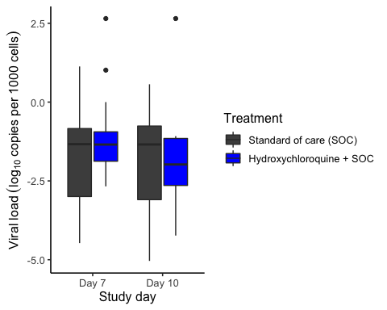

T-test HCQ

|  |  |  |  |  |  |  |  |  |
| --- | --- | --- | --- | --- | --- | --- | --- | --- |
| Timepoint | .y. | group1 | group2 | n1 | n2 | statistic | df | p |
| Day 7 | value | Standard of care (SOC) | Hydroxychloroquine + SOC | 18 | 17 | -1.1880155 | 32.20030 | 0.244 |
| Day 10 | value | Standard of care (SOC) | Hydroxychloroquine + SOC | 17 | 10 | -0.0576418 | 17.41063 | 0.955 |

Wilcoxon test HCQ

|  |  |  |  |  |  |  |  |
| --- | --- | --- | --- | --- | --- | --- | --- |
| Timepoint | .y. | group1 | group2 | n1 | n2 | statistic | p |
| Day 7 | value | Standard of care (SOC) | Hydroxychloroquine + SOC | 18 | 17 | 138.5 | 0.644 |
| Day 10 | value | Standard of care (SOC) | Hydroxychloroquine + SOC | 17 | 10 | 94.0 | 0.675 |

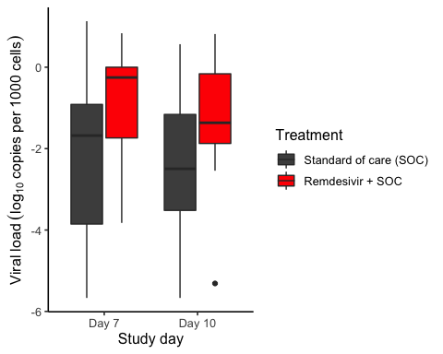

T-test remdesivir

|  |  |  |  |  |  |  |  |  |
| --- | --- | --- | --- | --- | --- | --- | --- | --- |
| Timepoint | .y. | group1 | group2 | n1 | n2 | statistic | df | p |
| Day 7 | value | Standard of care (SOC) | Hydroxychloroquine + SOC | 18 | 17 | -1.1880155 | 32.20030 | 0.244 |
| Day 10 | value | Standard of care (SOC) | Hydroxychloroquine + SOC | 17 | 10 | -0.0576418 | 17.41063 | 0.955 |

Wilcoxon test remdesivir

|  |  |  |  |  |  |  |  |
| --- | --- | --- | --- | --- | --- | --- | --- |
| Timepoint | .y. | group1 | group2 | n1 | n2 | statistic | p |
| Day 7 | value | Standard of care (SOC) | Hydroxychloroquine + SOC | 18 | 17 | 138.5 | 0.644 |
| Day 10 | value | Standard of care (SOC) | Hydroxychloroquine + SOC | 17 | 10 | 94.0 | 0.675 |

## PF-ratio

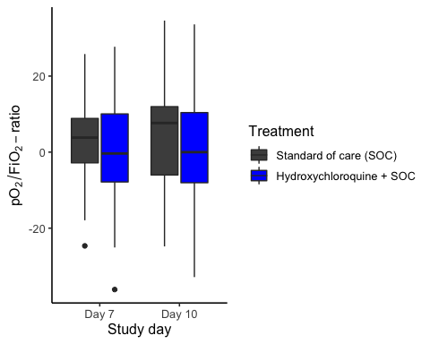

T-test HCQ

|  |  |  |  |  |  |  |  |  |
| --- | --- | --- | --- | --- | --- | --- | --- | --- |
| Timepoint | .y. | group1 | group2 | n1 | n2 | statistic | df | p |
| Day 7 | value | Standard of care (SOC) | Hydroxychloroquine + SOC | 31 | 31 | 0.5286818 | 57.90534 | 0.599 |
| Day 10 | value | Standard of care (SOC) | Hydroxychloroquine + SOC | 22 | 23 | 0.3496140 | 42.93537 | 0.728 |

Wilcoxon test HCQ

|  |  |  |  |  |  |  |  |
| --- | --- | --- | --- | --- | --- | --- | --- |
| Timepoint | .y. | group1 | group2 | n1 | n2 | statistic | p |
| Day 7 | value | Standard of care (SOC) | Hydroxychloroquine + SOC | 31 | 31 | 532 | 0.475 |
| Day 10 | value | Standard of care (SOC) | Hydroxychloroquine + SOC | 22 | 23 | 277 | 0.597 |

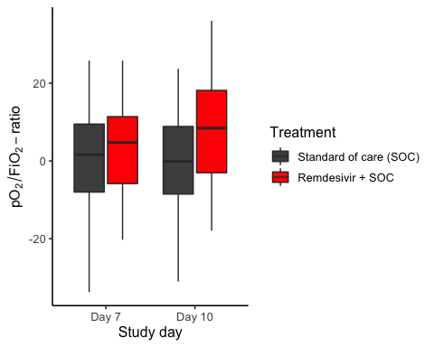

T-test remdesivir

|  |  |  |  |  |  |  |  |  |
| --- | --- | --- | --- | --- | --- | --- | --- | --- |
| Timepoint | .y. | group1 | group2 | n1 | n2 | statistic | df | p |
| Day 7 | value | Standard of care (SOC) | Hydroxychloroquine + SOC | 31 | 31 | 0.5286818 | 57.90534 | 0.599 |
| Day 10 | value | Standard of care (SOC) | Hydroxychloroquine + SOC | 22 | 23 | 0.3496140 | 42.93537 | 0.728 |

Wilcoxon test remdesivir

|  |  |  |  |  |  |  |  |
| --- | --- | --- | --- | --- | --- | --- | --- |
| Timepoint | .y. | group1 | group2 | n1 | n2 | statistic | p |
| Day 7 | value | Standard of care (SOC) | Hydroxychloroquine + SOC | 31 | 31 | 532 | 0.475 |
| Day 10 | value | Standard of care (SOC) | Hydroxychloroquine + SOC | 22 | 23 | 277 | 0.597 |

# 23 Number under observation

1. Figure 2: Please present the number of patients under observation at each time point separately by arm.

## Viral load

Counts for HCQ Viral load

|  |  |  |
| --- | --- | --- |
| Treatment | Period | Number with non-missing values |
| Standard of care (SOC) | Baseline | 44 |
| Standard of care (SOC) | Day 1 to 5 | 32 |
| Standard of care (SOC) | Day 6 to 10 | 19 |
| Standard of care (SOC) | Day 11 to 15 | 8 |
| Hydroxychloroquine + SOC | Baseline | 36 |
| Hydroxychloroquine + SOC | Day 1 to 5 | 35 |
| Hydroxychloroquine + SOC | Day 6 to 10 | 18 |
| Hydroxychloroquine + SOC | Day 11 to 15 | 6 |

Counts for remdesivir Viral load

|  |  |  |
| --- | --- | --- |
| Treatment | Period | Number of patients with non-missing values |
| Standard of care (SOC) | Baseline | 48 |
| Standard of care (SOC) | Day 1 to 5 | 38 |
| Standard of care (SOC) | Day 6 to 10 | 19 |
| Standard of care (SOC) | Day 11 to 15 | 13 |
| Remdesivir + SOC | Baseline | 33 |
| Remdesivir + SOC | Day 1 to 5 | 29 |
| Remdesivir + SOC | Day 6 to 10 | 18 |
| Remdesivir + SOC | Day 11 to 15 | 7 |

## PF ratio

Counts for HCQ PF ratio

|  |  |  |
| --- | --- | --- |
| Treatment | Period | Number with non-missing values |
| Standard of care (SOC) | Baseline | 54 |
| Standard of care (SOC) | Day 1 to 5 | 54 |
| Standard of care (SOC) | Day 6 to 10 | 33 |
| Standard of care (SOC) | Day 11 to 15 | 47 |
| Hydroxychloroquine + SOC | Baseline | 50 |
| Hydroxychloroquine + SOC | Day 1 to 5 | 52 |
| Hydroxychloroquine + SOC | Day 6 to 10 | 31 |
| Hydroxychloroquine + SOC | Day 11 to 15 | 40 |

Counts for remdesivir PF ratio

|  |  |  |
| --- | --- | --- |
| Treatment | Period | Number of patients with non-missing values |
| Standard of care (SOC) | Baseline | 57 |
| Standard of care (SOC) | Day 1 to 5 | 57 |
| Standard of care (SOC) | Day 6 to 10 | 36 |
| Standard of care (SOC) | Day 11 to 15 | 43 |
| Remdesivir + SOC | Baseline | 42 |
| Remdesivir + SOC | Day 1 to 5 | 42 |
| Remdesivir + SOC | Day 6 to 10 | 22 |
| Remdesivir + SOC | Day 11 to 15 | 28 |

# 4 Additional secondary endpoints

1. Please ensure that the definitions of primary and secondary outcomes exactly match the definitions and naming conventions in the protocol.

The following endpoints are missing: * Time to first receiving and duration of mechanical ventilation * Duration of intensive care

## Time to first receiving mechanical ventilation

Relative risks and corresponding p-values

|  |  |  |
| --- | --- | --- |
| Timeframe, Population | Relative risk | P-value |
| Full timeframe, All | Not applicable | 0.761 |
| Full timeframe, Hydroxychloroquine only | 2.18 (95% CI 0.44 to 10.82) | 0.354 |
| Full timeframe, Remdesivir only | 1.02 (95% CI 0.23 to 4.56) | 0.981 |
| Censored at 60 days, All | Not applicable | 0.563 |
| Censored at 60 days, Hydroxychloroquine only | 3.67 (95% CI 0.63 to 21.22) | 0.185 |
| Censored at 60 days, Remdesivir only | 1.37 (95% CI 0.27 to 6.93) | 0.704 |
| Censored at 28 days, All | Not applicable | 0.558 |
| Censored at 28 days, Hydroxychloroquine only | 3.67 (95% CI 0.63 to 21.22) | 0.185 |
| Censored at 28 days, Remdesivir only | 0.49 (95% CI 0.07 to 3.6) | 0.497 |
| Time to first mechanical ventilation (cens 28 days), All | Not applicable | 0.759 |
| Time to first mechanical ventilation (cens 28 days), Hydroxychloroquine only | 2.12 (95% CI 0.68 to 6.62) | 0.206 |
| Time to first mechanical ventilation (cens 28 days), Remdesivir only | 1.42 (95% CI 0.35 to 5.79) | 0.629 |

Cox hazard ratio estimates and corresponding p-values

|  |  |  |
| --- | --- | --- |
| Timeframe, Population | Hazard ratio | P-value |
| Full timeframe, All | Not applicable | 0.761 |
| Full timeframe, Hydroxychloroquine only | 3.11 (95% CI 0.28 to 34.35) | 0.354 |
| Full timeframe, Remdesivir only | 1.01 (95% CI 0.35 to 2.92) | 0.981 |
| Censored at 60 days, All | Not applicable | 0.563 |
| Censored at 60 days, Hydroxychloroquine only | 8.15 (95% CI 0.37 to 180.68) | 0.185 |
| Censored at 60 days, Remdesivir only | 1.25 (95% CI 0.4 to 3.86) | 0.704 |
| Censored at 28 days, All | Not applicable | 0.558 |
| Censored at 28 days, Hydroxychloroquine only | 8.15 (95% CI 0.37 to 180.68) | 0.185 |
| Censored at 28 days, Remdesivir only | 0.57 (95% CI 0.12 to 2.85) | 0.497 |
| Time to first mechanical ventilation (cens 28 days), All | Not applicable | 0.759 |
| Time to first mechanical ventilation (cens 28 days), Hydroxychloroquine only | 2.99 (95% CI 0.55 to 16.32) | 0.206 |
| Time to first mechanical ventilation (cens 28 days), Remdesivir only | 1.27 (95% CI 0.48 to 3.39) | 0.629 |

## Duration of mechanical ventilation and intensive care

These will only be reported by cumulative probability plots

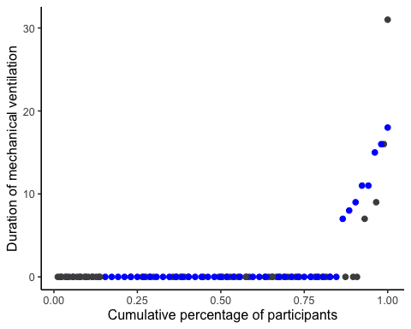

## Saving 5 x 4 in image

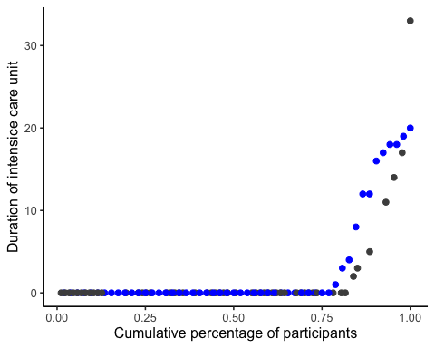

## Saving 5 x 4 in image

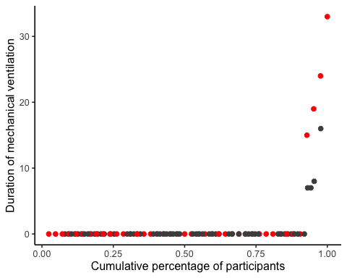

## Saving 5 x 4 in image

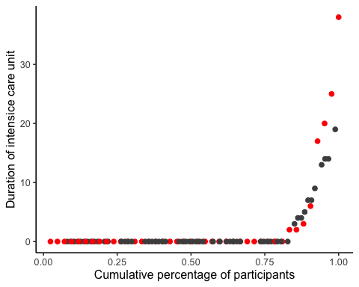

## Saving 5 x 4 in image

# Point Estimates

Stats reviewer point 19. Lines 258-264. Please discuss potential explanations for why the mortality rate in this cohort is substantially lower than in the parent study. Please include point estimates with confidence intervals for each arm in this study population.

The data are presented as in the original report, but with changed confidence intervals.

Hydroxychloroquine

|  |  |  |  |
| --- | --- | --- | --- |
| Outcome | Standard of care (SOC) | Hydroxychloroquine + SOC | Estimated marginal treatment effect |
| Mortality during hospitalisation | 3.6% (0.6 to 10.6) | 7.5% (2.4 to 16.7) | 4% (-4.6 to 12.6) |
| Mortality (censored at day 28) | 1.8% (0.1 to 7.6) | 7.5% (2.4 to 16.7) | 5.8% (-2.2 to 13.7) |
| Mortality (censored at day 60) | 1.8% (0.1 to 7.6) | 7.5% (2.4 to 16.7) | 5.8% (-2.2 to 13.7) |
| WHO disease state progression | 12.5% (5.6 to 22.8) | 18.9% (9.9 to 30.7) | 6.4% (-7.3 to 20) |
| WHO disease state progression (censoreda at day 28) | 12.5% (5.6 to 22.8) | 18.9% (9.9 to 30.7) | 6.4% (-7.3 to 20) |
| WHO disease state progression (censoreda at day 60) | 12.5% (5.6 to 22.8) | 18.9% (9.9 to 30.7) | 6.4% (-7.3 to 20) |
| Mechanical ventilation during hospitalisation | 10.7% (4.4 to 20.5) | 15.1% (7.2 to 26.3) | 4.4% (-8.2 to 17) |
| Mechanical ventilation (censored at day 28) | 10.7% (4.4 to 20.5) | 15.1% (7.2 to 26.3) | 4.4% (-8.2 to 17) |
| Mechanical ventilation (censored at day 60) | 10.7% (4.4 to 20.5) | 15.1% (7.2 to 26.3) | 4.4% (-8.2 to 17) |
| Admission to ICU during hospitalisation | 16.1% (8.1 to 27.1) | 22.6% (12.8 to 35) | 6.6% (-8.2 to 21.4) |
| Admission to ICU (censored at day 28) | 16.1% (8.1 to 27.1) | 22.6% (12.8 to 35) | 6.6% (-8.2 to 21.4) |
| Admission to ICU (censored at day 60) | 16.1% (8.1 to 27.1) | 22.6% (12.8 to 35) | 6.6% (-8.2 to 21.4) |
| Seroconverted (RBD ≥ 5) | 78.7% (65.7 to 88.7) | 87.2% (74.4 to 95.2) | 8.5% (-7.3 to 24.2) |
| Seroconverted (Capsid ≥ 10) | 78.7% (65.7 to 88.7) | 92.3% (81.3 to 98) | 13.6% (-0.8 to 28) |

Remdesivir

|  |  |  |  |
| --- | --- | --- | --- |
| Outcome | Standard of care (SOC) | Remdesivir + SOC | Estimated marginal treatment effect |
| Mortality during hospitalisation | 7% (2.2 to 15.6) | 7.1% (1.8 to 17.5) | 0.1% (-10.1 to 10.4) |
| Mortality (censored at day 28) | 5.3% (1.3 to 13.1) | 2.4% (0.1 to 10.1) | -2.9% (-10.3 to 4.5) |
| Mortality (censored at day 60) | 5.3% (1.3 to 13.1) | 7.1% (1.8 to 17.5) | 1.9% (-7.8 to 11.6) |
| WHO disease state progression | 22.8% (13.3 to 34.7) | 14.3% (5.9 to 26.8) | -8.5% (-23.7 to 6.7) |
| WHO disease state progression (censoreda at day 28) | 22.8% (13.3 to 34.7) | 14.3% (5.9 to 26.8) | -8.5% (-23.7 to 6.7) |
| WHO disease state progression (censoreda at day 60) | 22.8% (13.3 to 34.7) | 14.3% (5.9 to 26.8) | -8.5% (-23.7 to 6.7) |
| Mechanical ventilation during hospitalisation | 7% (2.2 to 15.6) | 9.5% (3.1 to 20.8) | 2.5% (-8.6 to 13.6) |
| Mechanical ventilation (censored at day 28) | 7% (2.2 to 15.6) | 9.5% (3.1 to 20.8) | 2.5% (-8.6 to 13.6) |
| Mechanical ventilation (censored at day 60) | 7% (2.2 to 15.6) | 9.5% (3.1 to 20.8) | 2.5% (-8.6 to 13.6) |
| Admission to ICU during hospitalisation | 19.3% (10.5 to 30.8) | 19% (9.2 to 32.6) | -0.3% (-15.9 to 15.4) |
| Admission to ICU (censored at day 28) | 19.3% (10.5 to 30.8) | 19% (9.2 to 32.6) | -0.3% (-15.9 to 15.4) |
| Admission to ICU (censored at day 60) | 19.3% (10.5 to 30.8) | 19% (9.2 to 32.6) | -0.3% (-15.9 to 15.4) |
| Seroconverted (RBD ≥ 5) | 88.5% (72.7 to 97) | 80% (56 to 94.6) | -8.5% (-32.1 to 15.2) |
| Seroconverted (Capsid ≥ 10) | 88.5% (72.7 to 97) | 66.7% (41.5 to 86.5) | -21.8% (-48.6 to 5) |