Trustworthy Explanations for Random-Forest Stock Price Forecasting
A SHAP and LIME reliability audit on 474 S&P 500 stocks
Contents

1. Problem statement

1.1 Background
- Adoption. Machine-learning models, Random Forests (RF) especially, are widely used to forecast stock prices from historical price and volume data. They are popular because they:
  - handle non-linear patterns;
  - need little tuning;
  - resist overfitting better than single trees.
- Explanations. Because these models are “black boxes”, studies increasingly attach explainable-AI (XAI) methods, mainly SHAP (Shapley additive explanations) and LIME (local interpretable model-agnostic explanations). These show which inputs drove a forecast.
- Why it matters. In finance, explanations are increasingly expected by investment committees, risk officers and regulators before a model is allowed to inform decisions.

1.2 The problem
Recent studies (Section 3) share two linked weaknesses.
Problem 1: accuracy is reported without a meaningful benchmark.
- Price forecasts are often judged by price-level accuracy (R², “accuracy %”). When returns are evaluated properly, the signal is weak: Indra et al. (2025) found near-zero R² and 49–54% directional accuracy.
- But a stock’s price tomorrow is almost the same as today. The naive forecast “tomorrow’s price = today’s price” already scores R² ≈ 0.999.
- Without comparing against that naive forecast and testing the difference, a reader can’t tell whether a model has any real predictive skill.
Problem 2: explanations are presented as findings, but never tested. Studies report SHAP or LIME outputs (“volume is the most important feature”) as insight about the market. They do not check whether those explanations are:
Property | Question | If it fails
Faithful | Does removing the features the explanation ranks highest actually change the forecast most? | The explanation describes features the model doesn’t really use
Stable | Do the explanations stay the same when the model is re-seeded or retrained? | The explanation is an artefact of one random seed or one training run
Consistent across explainers | Do SHAP, LIME and importance measures agree? | Conclusions depend on which XAI tool was picked
Meaningful | Do they differ from the explanations of a model trained on randomly shuffled labels? | The explanation reflects feature structure, not a learned relationship
Context-dependent | Do they change across market regimes (e.g. the COVID crash) and sectors? | A single “global” explanation misrepresents specific periods or sectors
Without these tests, an explanation may describe noise, one random seed or one market period, and misleading explanations in finance can lead to real financial losses and misplaced trust.

1.3 Formal problem definition
Element | Definition
Universe | N = 474 S&P 500 stocks, indexed by i; trading days indexed by t
Input | A feature vector xᵢ,ₜ ∈ ℝ³² for stock i on day t, computed only from prices and volumes up to t’s close (7 families: past returns, trend, oscillators, volatility, volume, candle, market & sector)
Output | Forecast of the next-day closing price P̂ᵢ,ₜ₊₁
Model | Random Forest f predicting the next-day log return r̂ = f(xᵢ,ₜ); price forecast P̂ᵢ,ₜ₊₁ = Pᵢ,ₜ · exp(r̂)
Explanations | A SHAP vector φᵢ,ₜ ∈ ℝ³² and a LIME weight vector λᵢ,ₜ ∈ ℝ³² for every explained forecast
Evaluation | Accuracy vs naive persistence (Diebold–Mariano test), plus a reliability audit of φ and λ: faithfulness, stability, agreement, sanity, regime and sector drift

1.4 Problem statement
Given daily price and volume data for 474 S&P 500 stocks (2012–2022), this project builds a Random Forest that forecasts each stock’s next-day closing price, measures its accuracy against naive and learned baselines with significance tests, and explains every forecast with SHAP and LIME. It then determines whether those explanations can be trusted, that is, whether they are faithful to the model, stable across random seeds and yearly retraining, consistent with each other and with importance-based explainers, different from the explanations of a model with no real signal, and consistent across market regimes (pre-COVID bull, COVID crash, recovery, 2022 bear) and GICS sectors.

1.5 Research questions
# | Research question
RQ1 | How accurate is the Random Forest’s next-day closing-price forecast (Jan 2019 – May 2022), and how much of that accuracy exceeds naive persistence?
RQ2 | Which features and feature families drive the forecasts, globally and for individual stock-days?
RQ3 | Are the SHAP explanations faithful to the model, and stable across random seeds and yearly retraining?
RQ4 | Do the explanations change significantly across market regimes and GICS sectors?
RQ5 | Do the explanations differ from those of models trained on shuffled (signal-free) labels?
RQ6 | Do SHAP and LIME agree, and which is more stable and faithful for this model?

1.6 Objectives
- Forecaster. Build a leakage-free, walk-forward Random Forest next-day price forecaster for 474 stocks.
- Honest accuracy. Benchmark it against naive persistence, historical drift, Ridge regression and a price-level Random Forest, with Diebold–Mariano and binomial tests.
- Explanations. Explain every forecast with TreeSHAP and LIME, and compare four explainers (TreeSHAP, LIME, permutation importance, MDI).
- Reliability audit. Test the explanations for faithfulness, stability and sanity against shuffled-label models.
- Drift tests. Test explanation drift across regimes and sectors with permutation tests.

1.7 Scope
- In scope:
  - daily data;
  - price and volume features only;
  - one-day-ahead forecasts;
  - S&P 500 constituents;
  - post-hoc explanations (SHAP, LIME).
- Out of scope:
  - news or sentiment data;
  - fundamentals;
  - intraday data;
  - trading costs;
  - portfolio optimisation;
  - deep-learning models.

1.8 Contributions
- Benchmarked accuracy. Shows that a Random Forest’s 98.4% price accuracy equals naive persistence, and that a price-level Random Forest is significantly worse than naive despite R² = 0.993.
- A five-part reliability audit of SHAP and LIME for stock forecasting: faithfulness, stability, explainer agreement, sanity, and regime and sector drift.
- A direct SHAP-vs-LIME comparison on the same forecasts: agreement, run-to-run stability, local fidelity and faithfulness.
- Statistical tests of explanation drift across four market regimes and 11 sectors, on a 474-stock universe.

2. Tech stack
Layer | Tool (version) | Used for
Language | Python 3.11.13 | All code (8 scripts in src/)
Environment | venv | Isolated, reproducible dependencies
Data handling | pandas 3.0.5, NumPy 2.1.3 | Cleaning the panel, feature engineering (wide date × ticker tables), results
Machine learning | scikit-learn 1.9.1 | RandomForestRegressor (main model), RandomForestClassifier (direction), RidgeCV (baseline), permutation_importance
XAI: SHAP | shap 0.51.0 | TreeExplainer: exact TreeSHAP values, local and global explanations
XAI: LIME | lime 0.2.0.1 | LimeTabularExplainer: local surrogate explanations
Statistics | SciPy 1.17.1 | Kendall τ, Spearman ρ, binomial test, normal distribution for the Diebold–Mariano test
Visualisation | Matplotlib 3.11.2 | All 12 figures
Model storage | joblib 1.6.0 | Saved yearly Random Forest models
Supporting | numba 0.67.0 | Required by shap
Result formats | JSON, CSV, pickle, PNG | Metrics, importances, explanation samples, figures
Hardware | Apple M3 Pro (12 cores), 18 GB RAM, macOS 14.4 | Full pipeline runs in about 30 minutes
Data source | ESTIMATE S&P 500 benchmark (Huynh et al., WSDM 2023) | 474 stocks, daily OHLCV and GICS sectors
Literature search | OpenAlex API, arXiv, publisher websites | Finding and verifying the 5 reviewed papers (2025–2026)
Pipeline.
Step | Script | Does | Output
1 | data.py | Clean the raw panel | data/panel_clean.pkl
2 | features.py | 32 features and next-day targets | data/features.pkl
3 | tune.py | Hyperparameters on 2017–2018 | results/tuning.json
4 | train.py | Walk-forward forecasts, 2019–2022 | results/predictions.pkl, models/
5 | evaluate.py | Accuracy and significance tests | results/metrics.json
6 | explain.py | SHAP explanations and reliability audit | results/xai.json
7 | lime_explain.py | LIME explanations and SHAP-vs-LIME audit | results/lime.json
8 | plots.py | All figures | results/figures/

3. Literature review
Five recent papers (2025–2026) closest to this project: stock prediction with Random Forest or tree-based models, explained with SHAP or LIME, or tested for explanation stability.
# | Paper | Authors | Methodology | Research gap
1 | Stock Return Prediction on the LQ45 Market Index in the Indonesia Stock Exchange Using a Machine Learning Algorithm Based on Technical Indicators, Journal of Risk and Financial Management, 2025 | S. Indra, Sudradjat Supian, Sukono, Riaman Riaman, Moch Panji Agung Saputra, Astrid Sulistya Azahra, Dede Irman Pirdaus | Random Forest, XGBoost, Linear and Ridge regression on technical indicators for 6 Indonesian stocks (5- and 21-day returns); SHAP to find the most important features | Only 6 stocks. SHAP results are reported but never checked to see if they are correct or stable.
2 | Comparing model-specific and model-agnostic features importance methods using machine learning with technical indicators: A NASDAQ sector-based study, Machine Learning with Applications, 2025 | Jeonghoe Lee, Lin Cai | Random Forest and neural networks on NASDAQ’s 11 sectors; compares different feature-importance methods for choosing technical indicators | Uses importance methods only to pick features. Does not test whether the explanations are trustworthy or change over time.
3 | An Explainable AI for Stock Market Prediction: A Machine Learning Approach with XAI and Deep Neural Networks, Journal of Computational and Cognitive Engineering, 2025 | Kangana Wallapure Manikrao, Shridhar Allagi, Wai Yie Leong, Mahantesh Laddi | LSTM with attention using sentiment and technical indicators; compared with Random Forest and XGBoost; SHAP and LIME for explanations | Uses SHAP and LIME side by side but does not check if they agree, or if LIME gives the same answer when run again.
4 | Regime-Aware LightGBM for Stock Market Forecasting: A Validated Walk-Forward Framework with Statistical Rigor and Explainable AI Analysis, Electronics, 2026 | A. Pagliaro | Tree model (LightGBM) on 51 NASDAQ-100 stocks, adjusted for bull and bear markets; explanations show the model behaves differently in each market phase | Says explanations change across market phases but does not test this statistically, and only covers 51 stocks.
5 | Attention Integration Strategies in MLP-Based Stock Movement Prediction: Effects on Performance, Stability, and Interpretability, Electronics, 2026 | Yoojeong Song, Woojin Cho, Sang Ik Han, Juhan Yoo | Neural network models trained 1,600 times with different random seeds on 20 stocks (10 CSI 300, 10 S&P 500) | Found that explanations change with the random seed, but only tested neural networks, not Random Forest with SHAP or LIME.
Methods and gaps are based on each paper’s abstract and publicly available details; confirm them against the full texts before submission.

4. Research gap

4.1 What is missing
What is missing | Seen in | How this project addresses it
Correctness (faithfulness): checking that SHAP or LIME point to features the model really uses | Papers 1, 3 | Deletion tests: removing top-ranked features must change the forecast more than removing random ones
Stability: same explanation when the model is re-seeded or retrained, or LIME is re-run | Papers 1, 3, 5 | 5 random seeds, yearly retraining, and 5 LIME runs per forecast
Agreement between explainers | Papers 2, 3 | SHAP vs LIME vs permutation importance vs MDI
Tested changes across market phases and sectors | Papers 2, 4 | Permutation tests across 4 market regimes and 11 sectors
Broad stock universe | Papers 1, 4, 5 (6–51 stocks) | 474 S&P 500 stocks

4.2 Overall research gap
These papers either use SHAP or LIME without checking whether the explanations can be trusted, or check only one aspect on a small number of stocks. No paper tests, for a Random Forest stock price model, whether SHAP and LIME explanations are (1) correct (faithful to the model), (2) stable when the model or LIME is re-run, (3) in agreement with each other, and (4) consistent across market phases such as the COVID crash and across sectors. This project fills that gap on 474 S&P 500 stocks, with price accuracy benchmarked against a naive forecast.

5. Data
Item | Detail
Source | Public S&P 500 benchmark released with ESTIMATE (Huynh et al., WSDM 2023), also used by StockMixer (Fan & Shen, AAAI 2024)
Universe | 474 S&P 500 constituents, 11 GICS sectors (21–67 stocks each)
Fields | Daily open, high, low, close, adjusted close, volume
Period | 14 May 2012 – 25 May 2022 (2,526 trading days), including the COVID crash and the 2022 bear market
Usable stock-days | 1,097,165 (after a 200-day feature warm-up and cleaning)
Test stock-days | 405,545 (856 trading days, Jan 2019 – May 2022)
Cleaning (data.py).
Issue found | Rows affected | Fix
Adjusted close missing before a stock was listed (e.g. PAYC, HLT) | 3,450 | Dropped
For 12 tickers, open/high/low were already dividend-adjusted while close was not, so high/low didn’t bracket the close | ~27,000 | Convention detected per ticker; OHLC put on one adjusted basis
GOOG before 27 March 2014: a different, unadjusted share-class series (a −300% jump) | 470 | Dropped
Real extreme moves are kept, e.g. the 9 March 2020 oil crash (APA −54%).

6. Methodology

6.1 Target and model
Target. For stock i on day t:
- the model predicts the next-day log return r̂ᵢ,ₜ₊₁;
- the price forecast is P̂ᵢ,ₜ₊₁ = Pᵢ,ₜ · exp(r̂ᵢ,ₜ₊₁).
Forecasting returns rather than price levels lets one model serve stocks priced from $10 to $3,000, and avoids a tree’s inability to predict beyond the price range seen in training (§7.1).
Random Forest (scikit-learn RandomForestRegressor).
- Fixed settings: 300 trees, each on a 25% bootstrap sample.
- Tuned settings: min_samples_leaf ∈ {200, 1000, 5000}, max_features ∈ {0.3, 0.6}.
- Tuning: by validation MSE averaged over 2017 and 2018, each validated with a model trained on all earlier data.
- Selected: min_samples_leaf = 5000, max_features = 0.3, the most regularised option. That is itself a sign of a low signal-to-noise problem.

6.2 Features
32 features, each computed only from data up to day t’s close:
Family | Features
Past returns | Log returns over 1, 2, 5, 10, 20, 60 days
Trend | Distance from 5/20/50/200-day moving average; MACD histogram
Oscillators | RSI(14), stochastic %K(14), Bollinger %B(20)
Volatility | Realised volatility (5, 20, 60 days), ATR(14), day range, Bollinger width
Volume | Volume vs 20-day average, 5 vs 20-day volume trend, log dollar volume
Candle | Overnight gap, open-to-close body, close position in the day range
Market & sector | Equal-weighted market return (1 day, 5 days) and 20-day volatility, sector 5-day return, 20-day relative strength, 60-day beta

6.3 Evaluation design
- Walk-forward test. At the start of 2019, 2020, 2021 and 2022, the model is retrained on all stock-days from March 2013 up to the previous 31 December, then forecasts every stock-day of that year. The test period is never used for tuning or design.
- Baselines:
  - naive persistence (P̂ₜ₊₁ = Pₜ);
  - historical drift (mean training return);
  - Ridge regression on the same features;
  - RF on raw price levels (close, 4 lags, open/high/low, moving averages in $);
  - RF classifier for next-day direction.
- Metrics:
  - price: MAE, RMSE, MAPE, R², share within 1% and 2%;
  - return skill: out-of-sample R² vs a zero forecast, daily IC and Rank IC, directional accuracy, AUC;
  - economic: top-minus-bottom decile next-day return.
- Significance tests:
  - Diebold–Mariano test (Newey–West, 5 lags) on daily mean squared percentage error vs naive;
  - binomial test of directional accuracy vs “always predict the majority direction”.

6.4 Explanation methods
TreeSHAP (shap.TreeExplainer).
- What it computes: exact Shapley values for tree ensembles. For every forecast, base value + Σ SHAP = prediction (verified: additivity error < 3×10⁻¹⁷).
- Sample: 40 random stocks per test day plus AAPL, MSFT, JPM, XOM and PFE on every day, giving 38,183 stock-days, each explained by its own year’s model.
LIME (lime.lime_tabular.LimeTabularExplainer).
- How it works: for one forecast, it samples 5,000 perturbed inputs, weights them by proximity, and fits a linear surrogate model whose weights form the explanation.
- Settings: default quartile discretisation; 5,000 training rows as the reference distribution.
- Sample: 804 stock-days (200 per test year plus the local cases), each explained with 5 different random seeds.
Comparison explainers.
- Permutation importance: increase in test MSE when a feature is shuffled; 3 repeats.
- MDI: the Random Forest’s built-in impurity importance.
Derived explanations.
- Global: mean |SHAP| and mean |LIME weight| per feature.
- Feature-family shares: each family’s share of total |SHAP|.
- Local, in dollars: attribution × close price ≈ each feature’s dollar contribution to the next-day price forecast.

6.5 Reliability audit
Check | SHAP | LIME
Faithfulness | Replace the top-k features (by |SHAP|) with values from 32 random training rows, k ∈ {1, 2, 4, 8, 16, 32}; compare with random order; AOPC; fidelity = corr(SHAP mass removed, actual change) | Same deletion test, ordered by |LIME weight|, on the LIME sample
Stability | 5 random seeds on identical 2013–2019 data (4,000 stock-days from 2020); consecutive yearly retrains (4,000 stock-days from 2022); global Kendall τ and per-row Spearman ρ | Same stock-day explained with 5 LIME seeds: median ρ, top-5 overlap, identical top feature
Local fit | Exact by construction (additivity) | R² of LIME’s surrogate model
Agreement | Global Kendall τ among TreeSHAP, LIME, permutation and MDI; per-row SHAP vs LIME: Spearman ρ, top-5 overlap, same top feature, sign agreement | (same)
Sanity (data randomisation) | RFs trained on fully shuffled labels (no signal) and on labels shuffled within each day (keeps market-wide timing only) | –
Regime and sector drift | Mean pairwise total-variation distance (TVD) between family-share vectors; null distribution from 1,000 permutations that shuffle whole days (regimes) or whole stocks (sectors) | –
Regimes (fixed in advance from market events):
- Pre-COVID bull: 2019-01-01 → 2020-02-19
- COVID crash: 2020-02-20 → 2020-03-23
- Recovery: 2020-03-24 → 2021-12-31
- 2022 bear: 2022-01-01 → 2022-05-24

7. Results

7.1 RQ1: price accuracy
Overall test performance (405,545 stock-days, Jan 2019 – May 2022):
Model | MAPE | “Price accuracy” (100 − MAPE) | RMSE | R² (price) | Within 2% | Direction accuracy | DM vs naive (p)
Naive (tomorrow = today) | 1.561% | 98.44% | $6.25 | 0.99938 | 75.3% | – | –
Historical drift | 1.560% | 98.44% | $6.25 | 0.99938 | 75.4% | 52.8% | 0.25
Ridge regression | 1.567% | 98.43% | $6.27 | 0.99937 | 75.3% | 51.7% | 0.17
RF on price levels | 1.583% | 98.42% | $21.56 | 0.99261 | 75.0% | 50.8% | < 0.001 (worse)
Random Forest (proposed) | 1.560% | 98.44% | $6.25 | 0.99938 | 75.4% | 51.8% | 0.30
RF classifier (direction) | – | – | – | – | – | 51.9% (AUC 0.505) | –
What this shows.
- Accurate as a price forecast. The Random Forest is within 1.56% of the actual next-day close on average (98.44% price accuracy, R² 0.9994), and within 2% on 75% of stock-days.
- But no better than naive. Naive persistence scores the same; the difference is not significant (Diebold–Mariano p = 0.30).
- Almost no skill beyond persistence:
  - out-of-sample return R² = +0.0001;
  - daily IC = +0.009 (t = 1.39, not significant);
  - direction accuracy 51.8%, below “always predict the majority direction” (52.8%).
- A small, non-significant economic signal: the top-minus-bottom decile of predicted returns earned +8.0 bp/day (t = 1.50).
The price-level Random Forest shows why unbenchmarked accuracy misleads.
- It reports R² 0.993 and 98.4% “accuracy”.
- Yet its RMSE is 3.4× naive, and it is significantly worse than naive (DM p < 0.001).
- Its RMSE grows from $6 (2019) to $36 (2021) as prices trend to new highs, because trees can’t predict above the training range.
By year and regime.
Period | RF MAPE | Naive MAPE | RF direction accuracy | Majority-direction rule | RF daily IC
2019 | 1.11% | 1.12% | 53.5% | 55.3% | +0.014
2020 | 2.20% | 2.20% | 51.0% | 51.8% | +0.018
2021 | 1.29% | 1.29% | 50.4% | 53.2% | −0.008
2022 (Jan–May) | 1.74% | 1.74% | 52.7% | 51.5% | +0.018
COVID crash | 5.78% | 5.72% | 34.7% | 65.8% (down) | −0.073
- COVID crash: the RF was significantly worse than naive (DM p = 0.04), because it kept forecasting small rebounds while 66% of stock-days fell.
- By sector: MAPE ranges from 1.13% (Utilities) to 2.24% (Energy), and the RF equals naive within 0.004 percentage points in every sector.
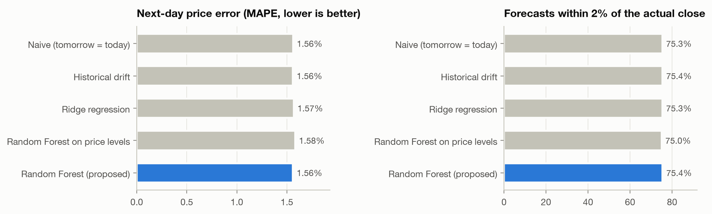
Figure 1. Next-day price error and share of forecasts within 2%, by model
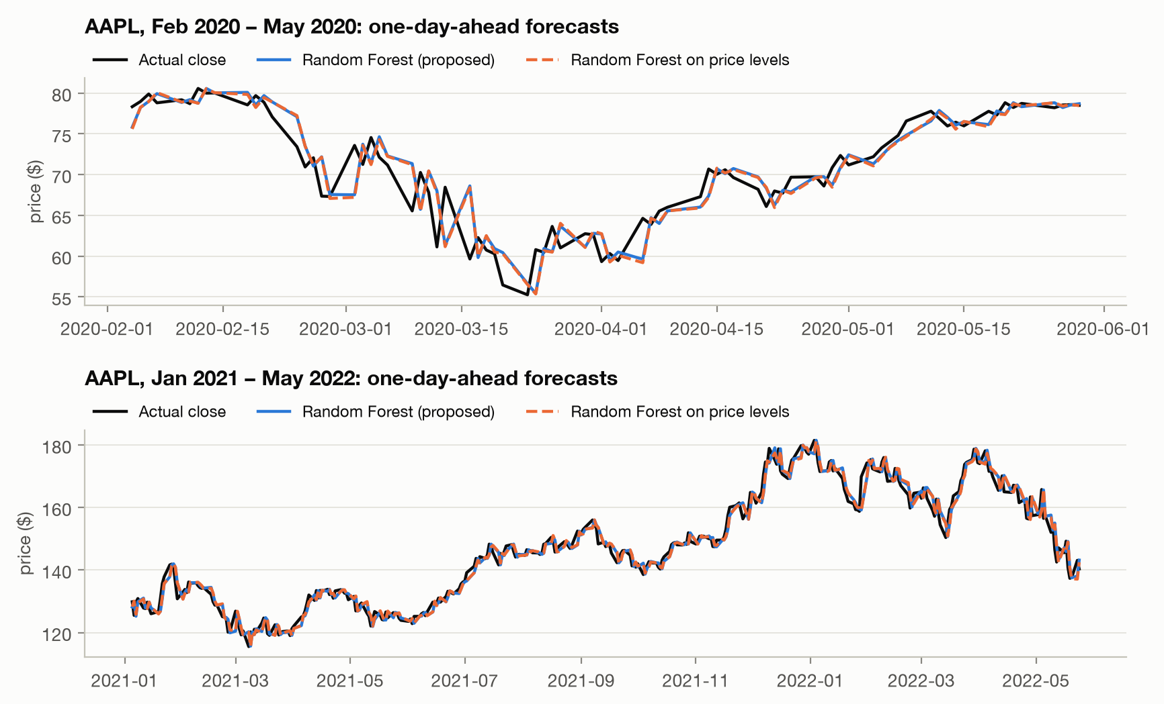
Figure 2. AAPL one-day-ahead forecasts vs actual closing prices

7.2 RQ2: what drives the forecasts (SHAP)
Global importance (mean |SHAP|, basis points of predicted return):
Rank | Feature | Family | Mean |SHAP| (bp)
1 | Market 20-day volatility | Market & sector | 5.37
2 | Market 5-day return | Market & sector | 3.33
3 | Market 1-day return | Market & sector | 3.28
4 | Overnight gap | Candle | 0.77
5 | Own 1-day return | Past returns | 0.57
6 | Sector 5-day return | Market & sector | 0.53
7 | ATR(14) | Volatility | 0.43
Family shares.
- Market & sector context: 72.2%.
- Other families: volatility 7.6%, past returns 7.0%, candle 5.9%, trend 3.8%, oscillators 2.0%, volume 1.5%.
What the features do (dependence plots):
- High market volatility raises the forecast by +10–15 bp.
- A falling 5-day market raises it by up to +25 bp.
- A strong up-day for the market lowers it.
The model mainly learned market-wide short-term reversal after volatile sell-offs.
Local example: AAPL on 16 March 2020 (worst day of the COVID crash):
- close $59.64 → forecast $59.82; actual next close $62.27;
- pushing the forecast up: market volatility (+$0.08), the −17.8% 5-day market fall (+$0.04);
- pushing it down: the −13.7% market day (−$0.01) and the overnight gap (−$0.01).
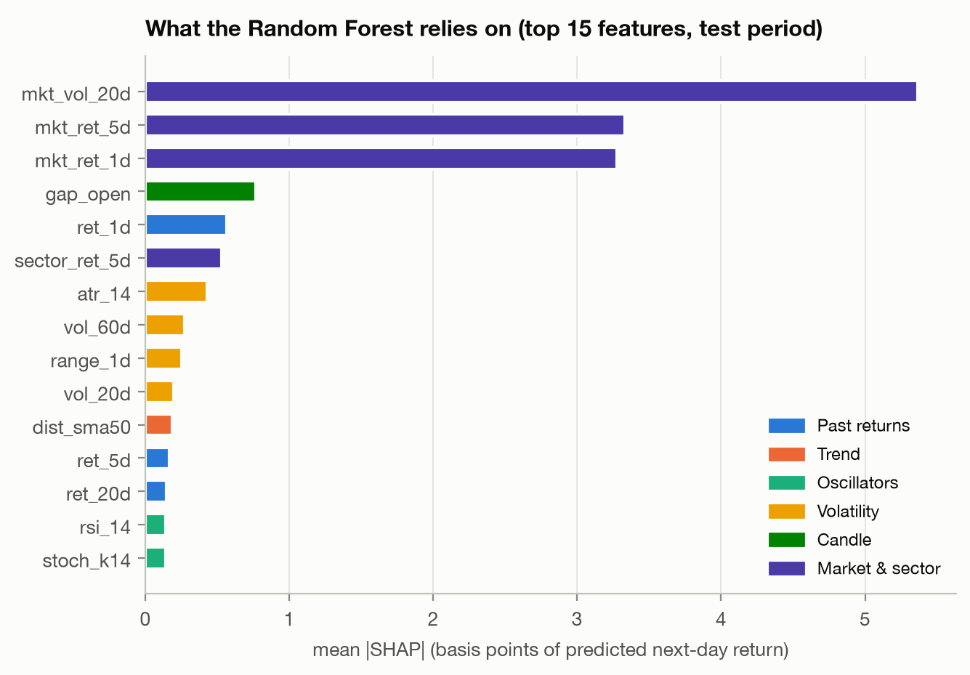
Figure 3. Top 15 features by mean |SHAP|
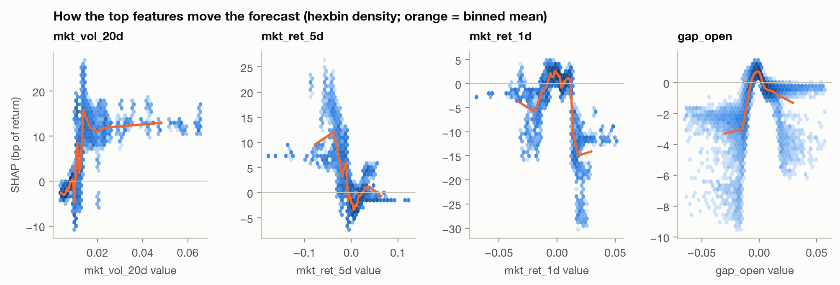
Figure 4. How the top features move the forecast (SHAP dependence)
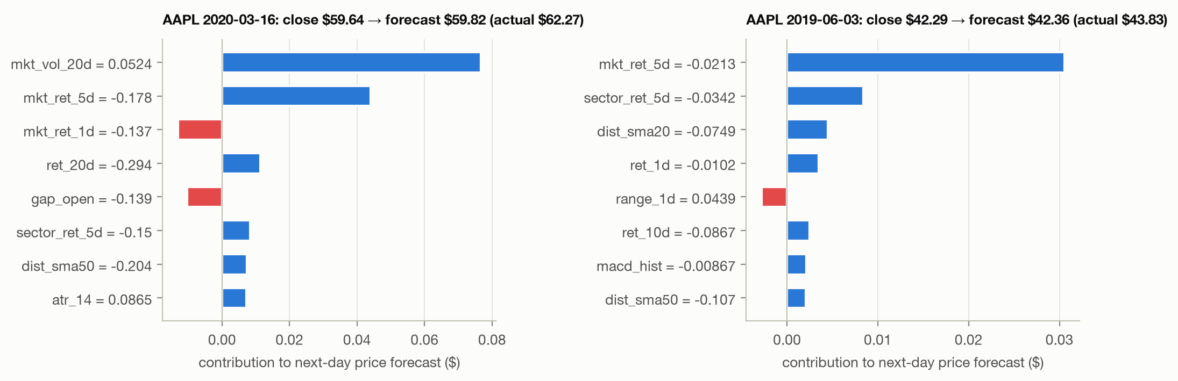
Figure 5. Local SHAP explanations in dollars for individual stock-days

7.3 RQ3: are the SHAP explanations faithful and stable?
Faithfulness.
Features removed (k) | 1 | 2 | 4 | 8 | 16 | 32
|Δ forecast|, top-SHAP first (bp) | 8.70 | 8.39 | 8.36 | 8.47 | 8.56 | 8.59
|Δ forecast|, random order (bp) | 0.65 | 1.19 | 2.04 | 3.65 | 5.88 | 8.59
Fidelity: corr(SHAP mass removed, actual Δ) | 0.98 | 0.99 | 0.99 | 1.00 | 1.00 | 1.00
- Faithful. Removing the single top-SHAP feature changes a forecast 13× more than removing a random one (AOPC 8.51 vs 3.67 bp), and fidelity is ≥ 0.98.
- One feature does almost all the work: removing it moves the forecast as much as removing all 32.
Stability.
Comparison | Global ranking τ | Top-5 overlap | Per-stock-day ρ
5 random seeds, same data | 0.85 | 92% | 0.86
2019 vs 2020 model | 0.75 | 80% | 0.73
2020 vs 2021 model | 0.44 | 100% | 0.57
2021 vs 2022 model | 0.77 | 80% | 0.77
- Stable to the random seed (forecast correlation between seeds 0.99).
- Less stable to retraining: once 2020 (COVID) enters the training data, agreement drops to τ = 0.44. The top 5 stay the same, but the other 27 features reorder.
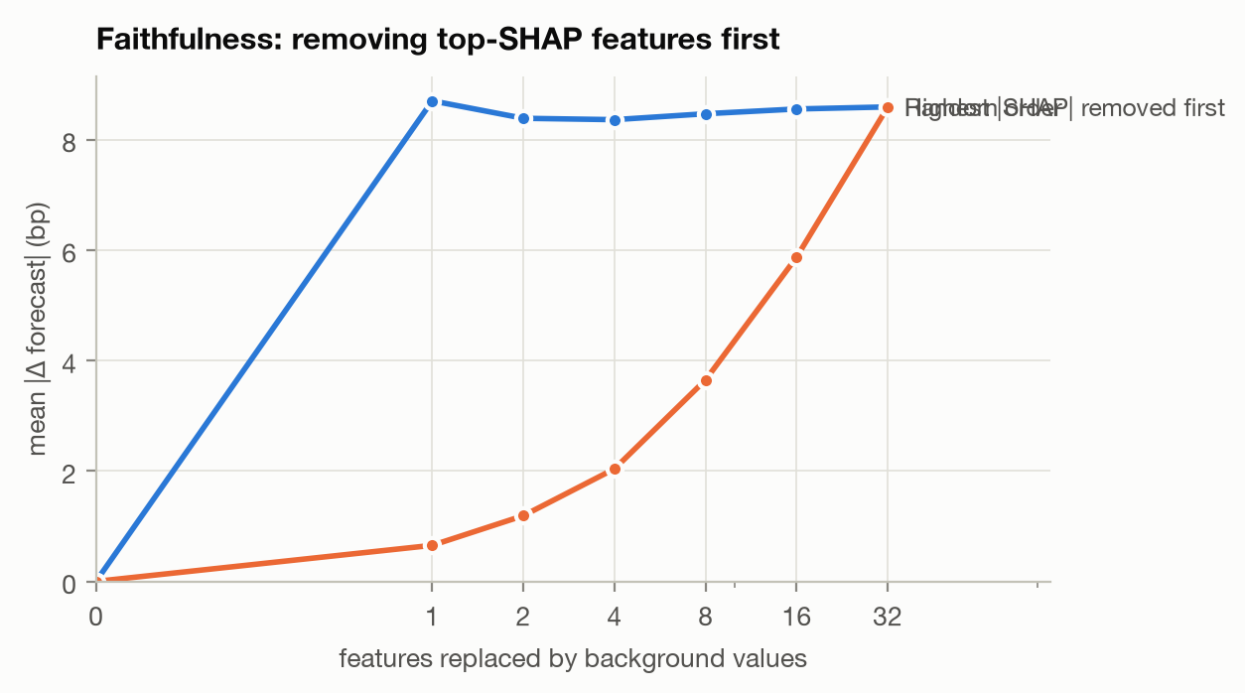
Figure 6. Faithfulness: forecast change when top-SHAP vs random features are removed
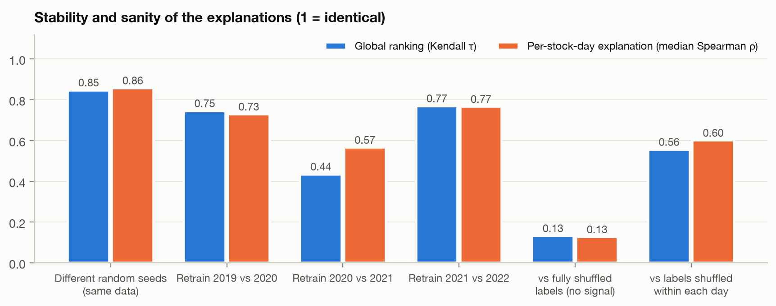
Figure 7. Stability across seeds and retraining, and comparison with no-signal models

7.4 RQ4: regime and sector drift
Regimes: significant drift (TVD 0.054 vs null 0.017, p = 0.003).
Family | Pre-COVID bull | COVID crash | Recovery | 2022 bear
Market & sector | 71.2% | 74.7% | 71.7% | 74.7%
Volatility | 5.1% | 5.9% | 8.3% | 9.2%
Past returns | 8.7% | 7.2% | 6.5% | 6.0%
Trend | 4.6% | 5.9% | 3.7% | 2.3%
Candle | 6.3% | 4.1% | 6.2% | 4.9%
Oscillators | 2.4% | 1.5% | 2.1% | 1.2%
Volume | 1.7% | 0.7% | 1.4% | 1.7%
- Volatility nearly doubles (5.1% → 9.2%); past returns fade; trend peaks in the crash.
- The feature ranking reorders: rank correlation falls to 0.46 between the COVID crash and the 2022 bear, against 0.84 between the pre-COVID bull and the crash.
- The top-3 market features never change.
Sectors: significant, but a smaller effect (TVD 0.036 vs null 0.011, p = 0.001).
- Volatile sectors use more volatility features: Energy 10.4%, Consumer Discretionary 9.5%, Communication Services 9.4%.
- Defensive sectors rely more on market context: Utilities 76.1%, Consumer Staples 76.4%, against Energy 66.8%.
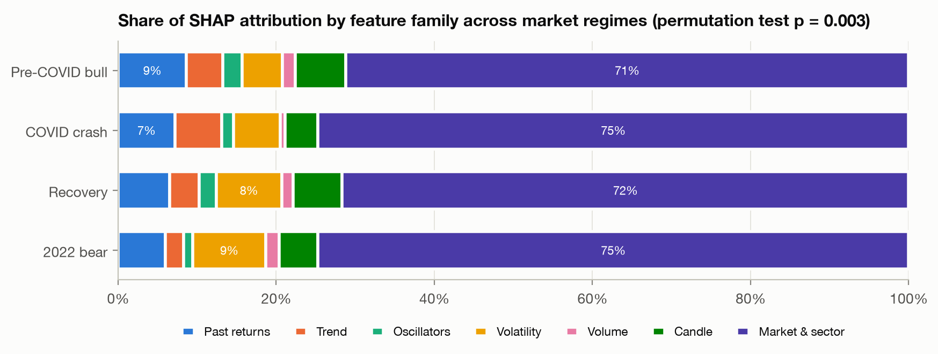
Figure 8. Share of SHAP attribution by feature family across market regimes
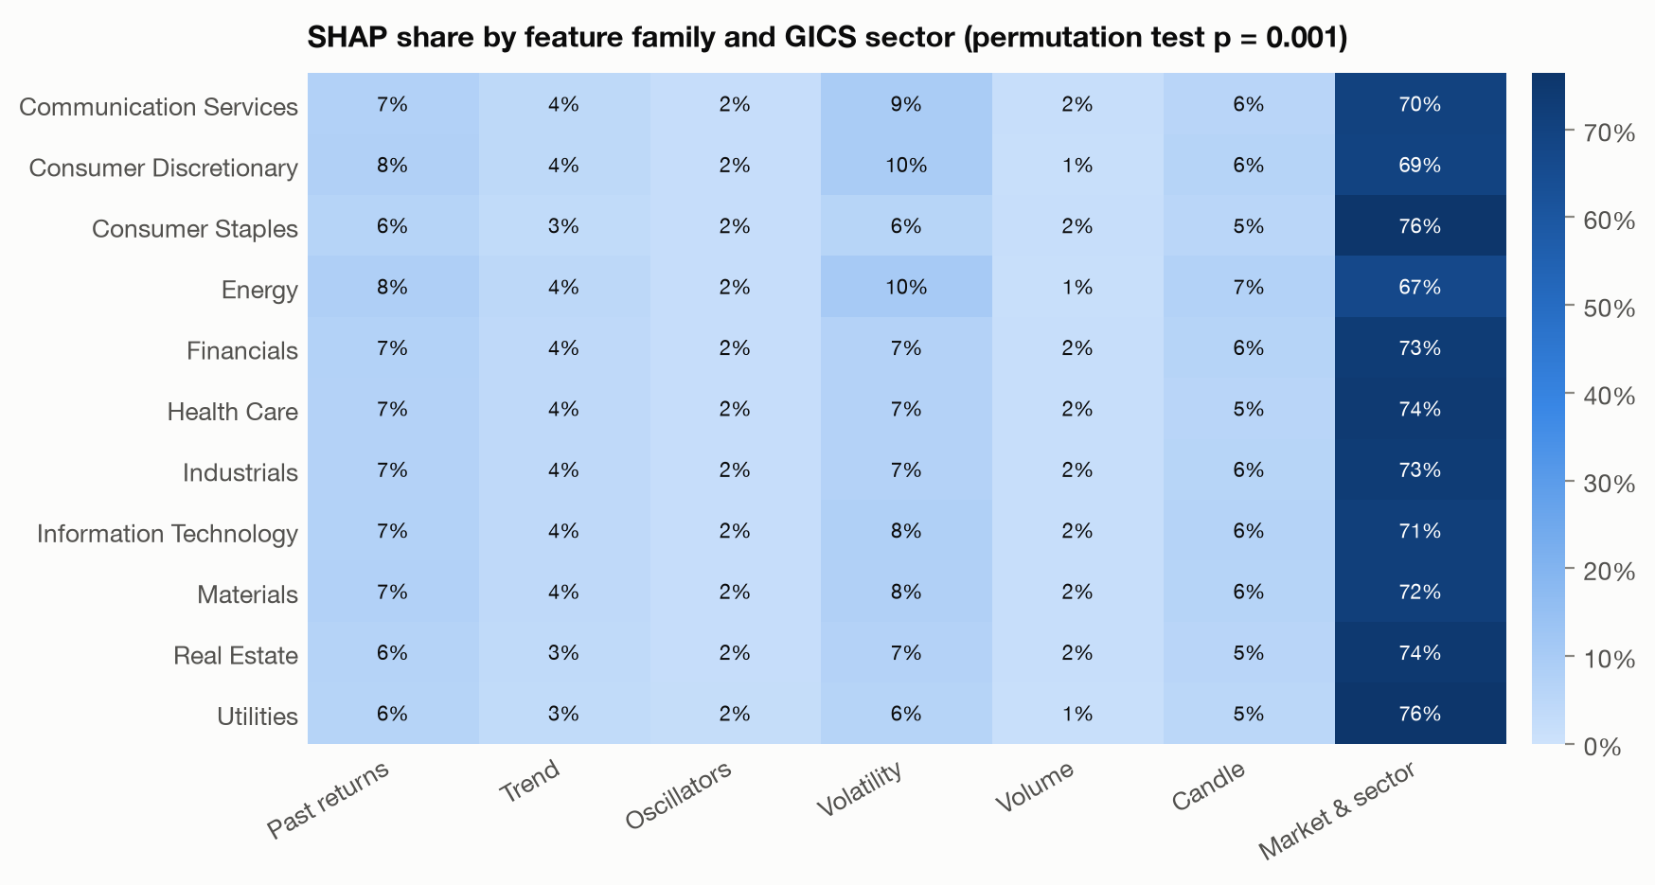
Figure 9. Share of SHAP attribution by feature family and GICS sector

7.5 RQ5: sanity check against no-signal models
Model trained on | Test IC | Total mean |SHAP| (bp) | Market & sector share | τ vs real model | Per-row ρ vs real
Real labels | +0.018 | 20.8 | 77.3% | – | –
Fully shuffled labels (no signal) | −0.023 | 2.6 | 19.6% | 0.13 | 0.13
Labels shuffled within each day (market timing only) | +0.011 | 19.5 | 84.5% | 0.56 | 0.60
- The explanations pass the sanity check. A no-signal model gives explanations 8× weaker and unrelated to the real ones.
- But they are mostly about market-wide timing. A model that can only learn market-wide timing reproduces 94% of the explanation magnitude and τ = 0.56 of the ranking.

7.6 RQ6: SHAP vs LIME
Global agreement between four explainers (Kendall τ; top-5 overlap in brackets):
 | LIME | Permutation | MDI
TreeSHAP | 0.73 (4/5) | 0.03 (3/5) | 0.69 (4/5)
LIME | – | 0.07 (3/5) | 0.69 (4/5)
Permutation | – | – | 0.15 (4/5)
- Globally, SHAP and LIME agree well (τ = 0.73), and both agree with MDI.
- All three disagree with permutation importance (τ ≤ 0.15). Only 4 of 32 features measurably improve accuracy (permutation importance > 2 SD): market volatility, sector 5-day return, Bollinger width and volume trend; 15 have negative permutation importance.
- Meaning: SHAP and LIME describe what the model uses, not what improves accuracy.
Reliability for individual forecasts (804 stock-days, 5 LIME seeds each):
Measure | TreeSHAP | LIME
Agreement with the other method: median Spearman ρ | – | 0.45
Agreement: top-5 feature overlap | – | 66%
Agreement: same top feature | – | 59%
Agreement: sign matches SHAP on SHAP’s top-5 features | – | 81%
Run-to-run stability: median ρ between runs | 1.00 (deterministic) | 0.48
Run-to-run stability: top-5 overlap between runs | 1.00 | 80%
Run-to-run stability: same top feature in all 5 runs | 100% | 92%
Local fit (surrogate R²) | exact (additive) | median 0.17; 67% of explanations below 0.3
Faithfulness AOPC (bp; random order = 3.71) | 8.70 | 8.15
Faithfulness: |Δ forecast| after removing top-1 feature (random = 0.56 bp) | 8.89 | 6.50
Time per explanation | ~0.001 s | ~0.08 s
What this shows.
- LIME is less reliable than SHAP for individual forecasts:
  - explaining the same forecast twice with different seeds gives a feature ranking that correlates only 0.48;
  - LIME’s linear surrogate explains a median of just 17% of the model’s local behaviour;
  - on a typical forecast, LIME and SHAP share only 3 of their top 5 features.
- Both are faithful, SHAP more so. Both beat random ordering, but removing LIME’s top feature changes the forecast 27% less than removing SHAP’s.
- They can contradict each other on the same forecast.
  - AAPL, 16 March 2020: they agree on the two main drivers (market volatility +$0.077 SHAP vs +$0.074 LIME; 5-day market return +$0.044 vs +$0.041), ρ = 0.53, LIME R² 0.49.
  - JPM, 18 May 2022: they disagree on the direction of the top feature. Market volatility pushes the forecast down by $0.056 per SHAP but up by $0.050 per LIME (ρ = 0.19, LIME R² 0.11).
  - Why: LIME’s discretised bins (“market volatility > 0.01”) compare against the whole training distribution, while SHAP attributes along the model’s own decision paths.
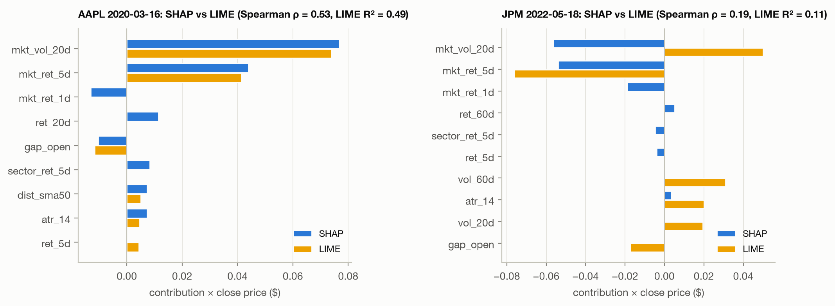
Figure 10. SHAP vs LIME explanations for the same forecasts
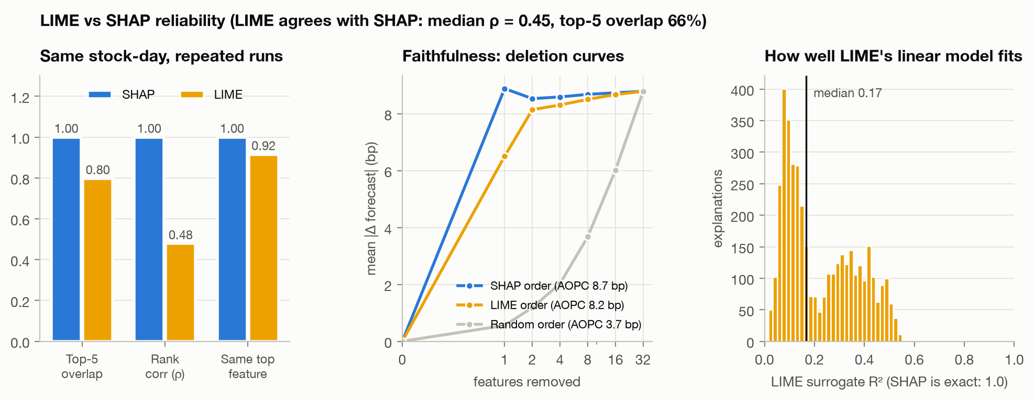
Figure 11. LIME vs SHAP: run-to-run stability, faithfulness and local fit
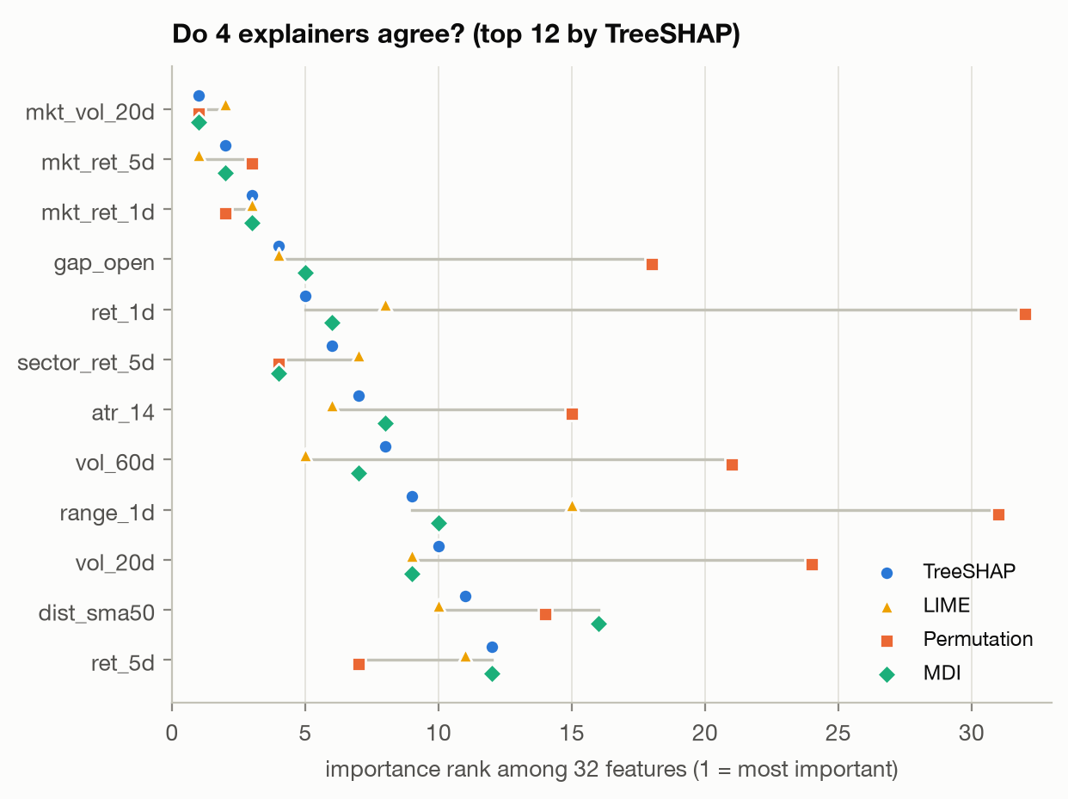
Figure 12. Feature importance ranks from TreeSHAP, LIME, permutation importance and MDI

8. Discussion
- High price accuracy needs a benchmark to mean anything.
  - The Random Forest’s 98.44% price accuracy is real, but naive persistence scores exactly the same, and a price-level Random Forest with R² 0.993 is significantly worse than naive.
  - Accuracy claims without a persistence baseline cannot be interpreted. This matches the weak signal Indra et al. (2025) found once returns were evaluated properly.
- Faithful does not mean the market insight is real.
  - SHAP is faithful (fidelity ≥ 0.98), seed-stable (τ = 0.85) and passes the sanity check.
  - Yet SHAP, LIME and MDI all disagree with permutation importance (τ ≤ 0.15).
  - Explanations describe how the model computes its forecast, not which relationships actually predict prices. Presenting SHAP or LIME rankings as market insight, as in papers 1 and 3, conflates the two.
- For tree models, SHAP should be preferred over LIME for individual explanations.
  - LIME agrees with SHAP globally (τ 0.73) but is unstable for individual forecasts (ρ 0.48 between runs), fits poorly (median R² 0.17), and can flip a feature’s sign.
  - Studies reporting a single LIME explanation per case (paper 3) risk reporting noise. Like Song et al. (2026) for neural networks, this shows explanations must be re-run before they are trusted.
- Explanations are period- and sector-specific.
  - Regime drift (p = 0.003), sector drift (p = 0.001) and the drop in agreement after retraining on COVID data (τ 0.44) mean an explanation from one period shouldn’t be generalised.
  - This turns Pagliaro’s (2026) qualitative regime observation into formal tests on 474 stocks.
- What the model learned.
  - Mainly one market-wide rule: expect a small rebound after volatile sell-offs.
  - It failed in the COVID crash (35% direction accuracy), which is exactly when a user would most rely on it.

9. Limitations
- Data:
  - price and volume only (no news, fundamentals or macroeconomic data);
  - the data ends May 2022;
  - the 474 stocks were constituents when the dataset was built (survivorship bias).
- Explanation methods:
  - TreeSHAP uses the path-dependent algorithm; interventional SHAP could differ when features are correlated;
  - LIME uses its default quartile discretisation and 5,000 samples; other settings could change its stability.
- Faithfulness test: it replaces features with values from random training rows, which can create unrealistic feature combinations.
- Regimes and costs: regimes are calendar-defined; the COVID crash has only 23 trading days. Transaction costs are not modelled.
- Literature gaps: stated from abstracts and public details; verify against full texts before submission.

10. Conclusion
- Accuracy. A walk-forward Random Forest forecasts next-day closing prices for 474 S&P 500 stocks with 98.44% price accuracy (MAPE 1.56%, R² 0.9994). That is statistically identical to naive persistence, with 51.8% directional accuracy.
- SHAP explanations are:
  - faithful and seed-stable;
  - clearly different from a no-signal model;
  - mostly about market-wide timing;
  - significantly different across market regimes and sectors, and after retraining.
- LIME explanations agree with SHAP globally, but are unstable between runs, fit the model poorly, and can contradict SHAP on individual forecasts.
- Neither SHAP nor LIME identifies the features that actually improve accuracy.
- Recommendations for stock-forecasting studies:
  - benchmark accuracy against persistence;
  - prefer TreeSHAP to single LIME runs for tree models;
  - test explanations for faithfulness, stability, sanity and regime drift before reading them as market insight.

11. References
Literature review
- Indra, S., Supian, S., Sukono, Riaman, R., Saputra, M. P. A., Azahra, A. S., & Pirdaus, D. I. (2025). Stock Return Prediction on the LQ45 Market Index in the Indonesia Stock Exchange Using a Machine Learning Algorithm Based on Technical Indicators. Journal of Risk and Financial Management. https://doi.org/10.3390/jrfm18120714
- Lee, J., & Cai, L. (2025). Comparing model-specific and model-agnostic features importance methods using machine learning with technical indicators: A NASDAQ sector-based study. Machine Learning with Applications. https://doi.org/10.1016/j.mlwa.2025.100799
- Manikrao, K. W., Allagi, S., Leong, W. Y., & Laddi, M. (2025). An Explainable AI for Stock Market Prediction: A Machine Learning Approach with XAI and Deep Neural Networks. Journal of Computational and Cognitive Engineering. https://doi.org/10.47852/bonviewjcce52026428
- Pagliaro, A. (2026). Regime-Aware LightGBM for Stock Market Forecasting: A Validated Walk-Forward Framework with Statistical Rigor and Explainable AI Analysis. Electronics, 15(6), 1334. https://doi.org/10.3390/electronics15061334
- Song, Y., Cho, W., Han, S. I., & Yoo, J. (2026). Attention Integration Strategies in MLP-Based Stock Movement Prediction: Effects on Performance, Stability, and Interpretability. Electronics, 15(17), 3942. https://doi.org/10.3390/electronics15173942
Methods and data
- Breiman, L. (2001). Random Forests. Machine Learning, 45, 5–32.
- Lundberg, S. M., Erion, G., Chen, H., et al. (2020). From local explanations to global understanding with explainable AI for trees. Nature Machine Intelligence, 2, 56–67.
- Ribeiro, M. T., Singh, S., & Guestrin, C. (2016). “Why Should I Trust You?”: Explaining the Predictions of Any Classifier. KDD 2016.
- Diebold, F. X., & Mariano, R. S. (1995). Comparing Predictive Accuracy. Journal of Business & Economic Statistics, 13(3), 253–263.
- Adebayo, J., Gilmer, J., Muelly, M., Goodfellow, I., Hardt, M., & Kim, B. (2018). Sanity Checks for Saliency Maps. NeurIPS 2018.
- Huynh, T. T., Nguyen, M. H., Nguyen, T. T., et al. (2023). Efficient Integration of Multi-Order Dynamics and Internal Dynamics in Stock Movement Prediction. WSDM 2023 (source of the S&P 500 dataset).

