BCSE418L - Explainable AI
TRUSTWORTHY EXPLANATIONS FOR RANDOM-FOREST STOCK PRICE FORECASTING
Submitted in partial fulfillment of the requirements for the degree of
Bachelor of Technology
in
Computer Science and Engineering
by
23BAI0190 | ANTONY ABISHA
23BAI0201 | AKAKSHAR SHARMA
23BAI0213 | ARCHITA KHARE

Under the Supervision of
Dr. Abdul Gaffar
Associate Professor
School of Computer Science and Engineering

Vellore Institute of Technology, Vellore - 632 014
November 2026

DECLARATION
We hereby declare that the project entitled “Trustworthy Explanations for Random-Forest Stock Price Forecasting” submitted by us, for the award of the degree of Bachelor of Technology in Computer Science and Engineering to Vellore Institute of Technology, is a record of bonafide work carried out by us under the supervision of Dr. Abdul Gaffar.
We further declare that the work reported in this project has not been submitted and will not be submitted, either in part or in full, for the award of any other degree or diploma in this institute or any other institute or university.
Place : Vellore
Date :
ANTONY ABISHA (23BAI0190), AKAKSHAR SHARMA (23BAI0201), ARCHITA KHARE (23BAI0213)
Signature of the Candidates

CERTIFICATE
This is to certify that the project entitled “Trustworthy Explanations for Random-Forest Stock Price Forecasting” submitted by ANTONY ABISHA (23BAI0190), AKAKSHAR SHARMA (23BAI0201), ARCHITA KHARE (23BAI0213), School of Computer Science and Engineering, Vellore Institute of Technology, for the award of the degree of Bachelor of Technology in Computer Science and Engineering, is a record of bonafide work carried out by them under my supervision during Fall Semester 2026-2027, as per the VIT code of academic and research ethics.
The contents of this report have not been submitted and will not be submitted either in part or in full, for the award of any other degree or diploma in this institute or any other institute or university. The project fulfills the requirements and regulations of the University and in my opinion meets the necessary standards for submission.
Place : Vellore
Date :
Dr. Abdul Gaffar
Signature of the Guide
Examiner(s)
Head of the Department
Computer Science and Engineering

TABLE OF CONTENTS
Sl. No. | Contents | Page No.
 | Abstract | x
1. | INTRODUCTION | 1
 | 1.1 Background | 1
 | 1.2 Motivations | 1
 | 1.2.1 Accuracy Reported in the Wrong Units | 1
 | 1.2.2 Explanations Presented as Findings but Never Tested | 2
 | 1.3 Scope of the Project | 2
2. | PROJECT DESCRIPTION AND GOALS | 4
 | 2.1 Literature Review | 4
 | 2.2 Research Gap | 5
 | 2.3 Objectives | 5
 | 2.4 Problem Statement | 5
 | 2.4.1 Formal Definition | 6
 | 2.4.2 Research Questions | 6
 | 2.5 Project Plan | 6
3. | TECHNICAL SPECIFICATION | 7
 | 3.1 Requirements | 7
 | 3.1.1 Functional Requirements | 7
 | 3.1.2 Non-Functional Requirements | 7
 | 3.2 Feasibility Study | 8
 | 3.2.1 Technical Feasibility | 8
 | 3.2.2 Economic Feasibility | 8
 | 3.2.3 Social Feasibility | 8
 | 3.3 System Specification | 9
 | 3.3.1 Hardware Specification | 9
 | 3.3.2 Software Specification | 9
4. | DESIGN APPROACH AND DETAILS | 10
 | 4.1 System Architecture | 10
 | 4.1.1 Dataset | 10
 | 4.1.2 Data Cleaning | 11
 | 4.1.3 Feature Engineering | 11
 | 4.2 Design | 12
 | 4.2.1 Data-Flow Diagram | 12
 | 4.2.2 Use Case Diagram | 12
 | 4.2.3 Class Diagram | 13
 | 4.2.4 Sequence Diagram | 14
5. | METHODOLOGY AND TESTING | 16
 | 5.1 Module Description | 16
 | 5.1.1 Target Formulation and Model | 16
 | 5.1.2 Walk-Forward Protocol | 17
 | 5.1.3 Baselines and Metrics | 17
 | 5.1.4 Explanation Methods | 17
 | 5.1.5 The Reliability Audit | 18
 | 5.2 Testing | 18
 | 5.2.1 Acceptance Criteria | 18
 | 5.2.2 Correctness Checks Built Into the Pipeline | 19
 | 5.2.3 A Defect Found by Testing: LIME Reproducibility | 19
6. | PROJECT DEMONSTRATION | 21
 | 6.1 Live Forecasting | 21
 | 6.2 The Interactive Demonstration | 22
 | 6.3 Input and Output | 22
 | 6.4 Guards Against Overclaiming | 23
7. | RESULT AND DISCUSSION | 24
 | 7.1 RQ1: Forecast Skill | 24
 | 7.1.1 Return Space | 24
 | 7.1.2 Price Space | 25
 | 7.1.3 Economic View and Cost Analysis | 26
 | 7.1.4 Where the Little Skill There Is Actually Lives | 27
 | 7.2 RQ2: What Drives the Forecasts | 28
 | 7.3 RQ3: Faithfulness and Stability | 30
 | 7.4 RQ4: Regime and Sector Drift | 31
 | 7.5 RQ5: Sanity Against No-Signal Models | 32
 | 7.6 RQ6: SHAP Against LIME | 33
 | 7.7 Discussion | 35
 | 7.7.1 Score the Change, Not the Level | 35
 | 7.7.2 Faithful Does Not Mean the Market Insight Is Real | 35
 | 7.7.3 For Tree Models, Prefer SHAP to a Single LIME Run | 35
 | 7.7.4 Explanations Are Period and Sector Specific | 35
 | 7.8 Limitations | 36
8. | CONCLUSION | 37
 | 8.1 Conclusion | 37
 | 8.1.1 On Accuracy | 37
 | 8.1.2 On the Explanations | 37
 | 8.1.3 On the Audit Itself | 37
 | 8.2 Recommendations for Stock-Forecasting Studies | 38
 | 8.3 Future Work | 38
9. | REFERENCES | 39
 | APPENDIX A - SAMPLE CODE | 41

LIST OF FIGURES
Figure No. | Title | Page No.
4.1 | System architecture. The six stages, their scripts and the artifacts they write | 10
4.2 | Level 0 context data-flow diagram | 12
4.3 | Level 1 data-flow diagram | 12
4.4 | Use case diagram | 13
4.5 | Module structure, showing public functions and import dependencies | 14
4.6 | Sequence diagram for a single request to the explanation endpoint | 15
7.1 | Return-space skill: out-of-sample R-squared on the next-day return and directional accuracy, by model | 25
7.2 | The same forecasts scored on the price level and on the return, and how narrowly the forecasts move | 26
7.3 | Next-day price error and the share of forecasts within two per cent, by model | 26
7.4 | AAPL one-day-ahead forecasts against actual closing prices | 26
7.5 | Actual next-day return of each decile of predicted return, with the long-short spread gross and net of cost | 27
7.6 | Top 15 features by mean absolute SHAP | 29
7.7 | How the leading features move the forecast (SHAP dependence) | 29
7.8 | Local SHAP explanations in basis points of forecast return, for individual stock-days | 30
7.9 | Faithfulness: forecast change when top-SHAP features and random features are removed | 30
7.10 | Stability across seeds and retraining, and comparison with no-signal models | 31
7.11 | Share of SHAP attribution by feature family across market regimes | 32
7.12 | Share of SHAP attribution by feature family and GICS sector | 32
7.13 | Feature importance ranks from TreeSHAP, LIME, permutation importance and MDI | 33
7.14 | SHAP against LIME explanations for the same forecasts | 34
7.15 | LIME against SHAP: run-to-run stability, faithfulness and local fit | 35

LIST OF TABLES
Table No. | Title | Page No.
1.1 | Properties an explanation must have, and the consequence of each failing | 2
2.1 | Recent work on explainable stock prediction, and the gap each leaves | 4
2.2 | What is missing from the reviewed work, and how this project supplies it | 5
2.3 | Formal specification of the forecasting and explanation problem | 6
2.4 | Research questions addressed by this project | 6
2.5 | Project plan by stage | 6
3.1 | Functional requirements | 7
3.2 | Non-functional requirements | 7
3.3 | Hardware used | 9
3.4 | Software stack | 9
4.1 | Dataset summary | 10
4.2 | Defects found in the raw panel and their repair | 11
4.3 | The 32 features, by family | 11
5.1 | Modules in execution order | 16
5.2 | Walk-forward training and forecasting | 17
5.3 | The five reliability checks and how each is measured | 18
5.4 | Market regimes, fixed in advance | 18
5.5 | Acceptance criteria and outcomes | 19
6.1 | A representative live run, as of the close of 29 October 2026 | 21
6.2 | Endpoints exposed by the demonstration | 22
7.1 | Return-space skill. One basis point is one hundredth of one per cent | 24
7.2 | Price-space accuracy, the quantity usually reported in the literature | 25
7.3 | The same model, two verdicts | 25
7.4 | Mean actual next-day return by decile of predicted return, in basis points | 26
7.5 | Skill by period and market regime | 27
7.6 | Global feature importance, by mean absolute SHAP | 28
7.7 | Faithfulness: forecast change when k features are removed | 30
7.8 | Stability of the explanations | 31
7.9 | Share of SHAP attribution by feature family across market regimes | 31
7.10 | Comparison with models trained on shuffled labels | 32
7.11 | Global agreement between four explainers, Kendall tau with top-5 overlap | 33
7.12 | Reliability for individual forecasts, over 804 stock-days with five LIME seeds each | 33

LIST OF ABBREVIATIONS
Abbreviation | Expansion
AOPC | Area Over the Perturbation Curve
API | Application Programming Interface
ATR | Average True Range
AUC | Area Under the Receiver Operating Characteristic Curve
bp | Basis Point (one hundredth of one per cent)
CSV | Comma-Separated Values
DFD | Data-Flow Diagram
DM | Diebold-Mariano (test of equal predictive accuracy)
GICS | Global Industry Classification Standard
HAC | Heteroskedasticity and Autocorrelation Consistent
IC | Information Coefficient
ICIR | Information Coefficient Information Ratio
JSON | JavaScript Object Notation
LIME | Local Interpretable Model-agnostic Explanations
MACD | Moving Average Convergence Divergence
MAE | Mean Absolute Error
MAPE | Mean Absolute Percentage Error
MDI | Mean Decrease in Impurity
MSE | Mean Squared Error
OHLCV | Open, High, Low, Close, Volume
RF | Random Forest
RMSE | Root Mean Squared Error
RSI | Relative Strength Index
SHAP | SHapley Additive exPlanations
SMA | Simple Moving Average
TVD | Total Variation Distance
UML | Unified Modeling Language
XAI | Explainable Artificial Intelligence

SYMBOLS AND NOTATIONS
Symbol | Meaning
x(i,t) | Feature vector for stock i on trading day t, 32 dimensions
r(i,t+1) | Realised next-day log return of stock i
r-hat | Forecast next-day log return produced by the Random Forest
P(i,t) | Closing price of stock i on day t
f | The trained Random Forest regressor
phi | SHAP attribution vector for one forecast, 32 dimensions
lambda | LIME weight vector for one forecast, 32 dimensions
tau | Kendall rank correlation coefficient
rho | Spearman rank correlation coefficient
k | Number of features removed in a deletion test
R-squared | Out-of-sample coefficient of determination against a stated benchmark
p | Probability value of a statistical test

ABSTRACT
Machine-learning models are widely used to forecast stock prices, and because such models are opaque, studies increasingly attach explainable-AI methods such as SHAP and LIME to describe what drove each forecast. Two weaknesses run through this literature. Accuracy is reported on the price level, where the naive forecast that tomorrow equals today already scores an R-squared above 0.999, so the reported figure describes the behaviour of daily stock prices rather than the quality of the model. And explanations are presented as findings without ever being tested, so an explanation that describes noise, a single random seed or a single market period is indistinguishable from one that describes a learned relationship.
This project addresses both. A leakage-free Random Forest is trained walk-forward on 474 S&P 500 stocks over 1,097,165 stock-days from March 2013 to May 2022, retrained at the start of each test year, and used to forecast the next-day log return for 405,545 out-of-sample stock-days. Skill is measured in return space first and in price space second. The same set of forecasts scores an R-squared of 0.9994 on the price level and +0.00013 on the return, a figure a Diebold-Mariano test cannot distinguish from predicting no change at all. A Random Forest trained directly on price levels reports an R-squared of 0.993 yet is significantly worse than naive persistence.
Every forecast is then explained with TreeSHAP and LIME, and those explanations are subjected to a five-part reliability audit: faithfulness by feature-deletion tests against a random-order control, stability across five random seeds and across consecutive yearly retrains, agreement among four explainers, sanity against models trained on shuffled labels, and drift across four market regimes and eleven GICS sectors tested by permutation. SHAP is found to be faithful, with a fidelity correlation of at least 0.98 and a 13-fold separation from random deletion, and stable to the random seed at Kendall tau 0.85. LIME is markedly less reliable for individual forecasts: run-to-run rank correlation 0.45, a median surrogate fit of 0.17, and a different top feature from SHAP on 41 per cent of forecasts. Explanations drift significantly across regimes and sectors, and neither method identifies the features that actually improve accuracy.
The audit also found a reproducibility defect in the standard LIME usage pattern, which had inflated the reported SHAP-LIME agreement from tau 0.58 to tau 0.73. The complete pipeline runs forward: the same features, hyperparameters and explanation code produce audited next-session forecasts for 431 currently traded stocks, served through an interactive page that recomputes every explanation at request time.

CHAPTER 1
1. INTRODUCTION
1.1 Background
Forecasting the next day's closing price of a listed company is one of the oldest applications of statistical learning, and tree ensembles have become the default tool for it. A Random Forest, introduced by Breiman in 2001, averages the predictions of many decision trees, each grown on a bootstrap sample of the data and a random subset of the inputs. It handles non-linear relationships without being told where they are, needs little tuning, and resists overfitting far better than a single deep tree. For price and volume data, where relationships are weak, noisy and unstable, those properties make it a sensible default.
A Random Forest with three hundred trees is, however, not something a person can read. A risk officer asked to approve a model, or an investment committee asked to act on it, cannot inspect the ensemble and see why a particular stock was forecast to rise. This is the gap that explainable artificial intelligence is meant to close, and two methods dominate practice. SHAP, which derives from the Shapley value in cooperative game theory, divides a single forecast into additive contributions, one per input feature, so that the contributions and a base value sum exactly to the forecast. LIME approaches the same problem differently: it samples perturbed versions of one input, weights them by how close they are to the original, and fits a simple linear model to the predictions, whose coefficients then serve as the explanation.
Both are now routine in published stock-forecasting work. A typical paper trains a tree ensemble, reports an accuracy figure, runs SHAP, and presents the resulting ranking of features as insight into what moves the market. The present project takes that pattern seriously enough to test it, and finds that both halves of it need qualification.
1.2 Motivations
Two weaknesses recur across recent work in this area, and together they motivate the whole of this project.
1.2.1 Accuracy Reported in the Wrong Units
Price forecasts are conventionally judged on the price level, using R-squared, mean absolute percentage error, or a derived figure described as accuracy. The difficulty is that a stock's price tomorrow is almost exactly its price today. The naive forecast that tomorrow equals today therefore achieves an R-squared of about 0.999 and a mean absolute percentage error of about 1.5 per cent on this dataset. A model that reports 98 per cent accuracy has reported a property of daily stock prices, not an achievement of its own.
What a forecaster actually has to get right is the return, which is the change. Scored on returns, forecasts that look near-perfect on prices routinely explain less than a tenth of one per cent of the variance. Without reporting skill in return space, and without testing it against a naive benchmark, a reader cannot tell whether a model has any predictive value at all.
1.2.2 Explanations Presented as Findings but Never Tested
The second weakness concerns the explanations themselves. Studies report that volume, or volatility, or some technical indicator is the most important feature, and read that as a statement about the market. An explanation method, however, always returns a ranked list. It returns one whether or not the model uses those features, whether or not the ranking would survive a change of random seed, and whether or not the model learned anything at all. Nothing in a bar chart distinguishes a true explanation from a plausible one.
Table 1.1 Properties an explanation must have, and the consequence of each failing
Property | Question it answers | If it fails
Faithful | Does removing the features the explanation ranks highest actually change the forecast most? | The explanation describes features the model does not use
Stable | Do the explanations survive re-seeding and retraining? | The explanation is an artefact of one random seed or one training run
Consistent | Do SHAP, LIME and importance measures agree? | Conclusions depend on which tool happened to be chosen
Meaningful | Do they differ from the explanations of a model trained on shuffled labels? | The explanation reflects feature structure, not a learned relationship
Contextual | Do they change across market regimes and sectors? | A single global explanation misrepresents specific periods or sectors

In finance these are not academic concerns. A misleading explanation can justify a position, pass a model through a governance process it should not have passed, and lose money. The motivation for this project is therefore to build a forecaster that is measured honestly, and then to test its explanations rather than presenting them.
1.3 Scope of the Project
The following are within scope:
- Daily data at one-day-ahead horizon, for constituents of the S&P 500 index.
- Features derived from price and volume only, computed from information available at or before the close of the day on which the forecast is made.
- Post-hoc explanation of a trained model using SHAP and LIME, together with permutation importance and mean decrease in impurity as comparison explainers.
- A reliability audit of those explanations covering faithfulness, stability, explainer agreement, sanity against signal-free models, and drift across market regimes and sectors.
- A working demonstration that applies the identical pipeline to the next trading session, so that no step can depend on knowing the outcome.
The following are outside scope:
- News, sentiment, fundamental and macroeconomic data.
- Intraday data and horizons shorter or longer than one trading day.
- Realistic execution modelling. A single flat ten basis point round-trip cost is applied to the decile portfolio as a sanity check, but slippage, market impact, borrowing costs and capacity are not modelled.
- Portfolio construction and optimisation.
- Deep-learning architectures. The project concerns the reliability of explanations for a tree ensemble, and TreeSHAP is exact only for tree models.
The project is a study of forecasting and of explanation reliability. It is not a trading system, and the results reported in Chapter 7 are the reason it should not be used as one.
CHAPTER 2
2. PROJECT DESCRIPTION AND GOALS
2.1 Literature Review
Five recent papers, published in 2025 and 2026, are closest to this work. Each predicts stock prices or returns with a tree-based or comparable model, explains the model with SHAP or LIME, or examines the stability of explanations.
Table 2.1 Recent work on explainable stock prediction, and the gap each leaves
No. | Paper and venue | Methodology | Gap
1 | Indra et al., Stock Return Prediction on the LQ45 Market Index Using a Machine Learning Algorithm Based on Technical Indicators. Journal of Risk and Financial Management, 2025 | Random Forest, XGBoost, linear and Ridge regression on technical indicators for six Indonesian stocks at 5- and 21-day horizons; SHAP used to rank features | Only six stocks. SHAP results are reported but never checked for correctness or stability.
2 | Lee and Cai, Comparing model-specific and model-agnostic feature importance methods using machine learning with technical indicators. Machine Learning with Applications, 2025 | Random Forest and neural networks across the eleven NASDAQ sectors; compares feature importance methods as a tool for selecting indicators | Importance methods are used only to select features. Whether the explanations are trustworthy, or change over time, is not examined.
3 | Manikrao et al., An Explainable AI for Stock Market Prediction. Journal of Computational and Cognitive Engineering, 2025 | LSTM with attention over sentiment and technical indicators, compared against Random Forest and XGBoost; SHAP and LIME used side by side | SHAP and LIME are presented together but never compared, and LIME is never re-run to see whether it returns the same answer.
4 | Pagliaro, Regime-Aware LightGBM for Stock Market Forecasting. Electronics, 2026 | LightGBM on 51 NASDAQ-100 stocks with a walk-forward design adjusted for bull and bear phases; explanations shown to differ by phase | The claim that explanations change across phases is asserted qualitatively, not tested statistically, and covers only 51 stocks.
5 | Song et al., Attention Integration Strategies in MLP-Based Stock Movement Prediction. Electronics, 2026 | Multi-layer perceptron variants trained 1,600 times with different random seeds on 20 stocks drawn from the CSI 300 and the S&P 500 | Establishes that explanations move with the random seed, but only for neural networks, not for a Random Forest explained by SHAP or LIME.

Taken together, these papers establish the practice this project examines. Papers 1 and 3 report explanations as findings. Paper 2 treats importance as a feature-selection device. Paper 4 observes regime dependence without testing it. Paper 5 demonstrates seed sensitivity, which is precisely the kind of check the others omit, but does so for a different model family.
2.2 Research Gap
Table 2.2 What is missing from the reviewed work, and how this project supplies it
Missing element | Papers affected | Addressed here by
Faithfulness: evidence that the explanation points at features the model really uses | 1, 3 | Deletion tests in which removing top-ranked features must change the forecast more than removing random ones
Stability under re-seeding, retraining and repeated explanation | 1, 3, 5 | Five random seeds, four consecutive yearly retrains, and five LIME runs per forecast
Agreement between explainers | 2, 3 | TreeSHAP against LIME, permutation importance and mean decrease in impurity
Statistical testing of regime and sector dependence | 2, 4 | Permutation tests across four market regimes and eleven GICS sectors
A broad stock universe | 1, 4, 5 (six to 51 stocks) | 474 S&P 500 constituents

No published study tests, for a Random Forest stock price model, whether SHAP and LIME explanations are faithful to the model, stable when the model or the explainer is re-run, in agreement with one another, and consistent across market phases such as the COVID crash and across sectors. This project supplies that test on 474 S&P 500 stocks, with forecast accuracy benchmarked against naive persistence throughout.
2.3 Objectives
1. Build a leakage-free, walk-forward Random Forest that forecasts the next-day closing price for 474 S&P 500 stocks.
2. Measure its skill in return space first, using out-of-sample R-squared against both a zero-return and a drift benchmark, the information coefficient, directional accuracy and a decile portfolio, with Diebold-Mariano and binomial significance tests against naive persistence; report price-space accuracy second, for comparability with the literature.
3. Explain every sampled forecast with TreeSHAP and LIME, and compare four explainers.
4. Audit those explanations for faithfulness, stability and sanity against models trained on shuffled labels.
5. Test explanation drift across market regimes and GICS sectors with permutation tests.
6. Demonstrate the whole pipeline running forward on a trading session that has not yet happened, with every explanation recomputed at request time.
2.4 Problem Statement
Given daily price and volume data for 474 S&P 500 stocks from 2012 to 2022, build a Random Forest that forecasts each stock's next-day closing price, measure its accuracy against naive and learned baselines with significance tests, and explain every forecast with SHAP and LIME. Then determine whether those explanations can be trusted: whether they are faithful to the model, stable across random seeds and yearly retraining, consistent with each other and with importance-based explainers, different from the explanations of a model with no real signal, and consistent across market regimes and GICS sectors.
2.4.1 Formal Definition
Table 2.3 Formal specification of the forecasting and explanation problem
Element | Definition
Universe | N = 474 S&P 500 stocks indexed by i, trading days indexed by t
Input | A feature vector x(i,t) in 32 dimensions, computed only from prices and volumes up to and including the close of day t, in seven families
Output | A forecast of the next-day closing price P-hat(i,t+1)
Model | A Random Forest f predicting the next-day log return, r-hat = f(x(i,t)); the price forecast is P(i,t) multiplied by exp(r-hat)
Explanations | A SHAP vector phi and a LIME weight vector lambda, each in 32 dimensions, for every explained forecast
Evaluation | Primary: return-space skill against zero-return and drift benchmarks, tested with Diebold-Mariano. Secondary: price-space accuracy. Plus a five-part reliability audit of phi and lambda

2.4.2 Research Questions
Table 2.4 Research questions addressed by this project
No. | Research question
RQ1 | How much skill does the Random Forest have on the quantity it predicts, the next-day return, and how much of its apparent price-level accuracy survives once it is scored in return space against naive persistence?
RQ2 | Which features and feature families drive the forecasts, globally and for individual stock-days?
RQ3 | Are the SHAP explanations faithful to the model, and stable across random seeds and yearly retraining?
RQ4 | Do the explanations change significantly across market regimes and GICS sectors?
RQ5 | Do the explanations differ from those of models trained on shuffled, signal-free labels?
RQ6 | Do SHAP and LIME agree, and which is more stable and faithful for this model?

2.5 Project Plan
The work was organised as six stages, each writing its own artifact to disk so that any stage can be re-run or inspected without repeating the ones before it. The design decision that governs the schedule is that the test period is touched only once, at the end: hyperparameters are chosen on a validation year, and the walk-forward test runs afterwards.
Table 2.5 Project plan by stage
Stage | Activity | Deliverable
1 | Literature survey and gap analysis; selection of the benchmark dataset | Reviewed set of five papers; stated research gap
2 | Data acquisition and cleaning; diagnosis of the three defects in the raw panel | panel_clean.pkl
3 | Feature engineering, with leakage control verified on wide date-by-ticker tables | features.pkl, 32 features in seven families
4 | Hyperparameter tuning on the validation year; walk-forward training | tuning.json, four yearly models, 405,545 forecasts
5 | Evaluation in return and price space, with significance tests and a decile portfolio | metrics.json and five result figures
6 | Explanation with TreeSHAP and LIME, and the five-part reliability audit | xai.json, lime.json and ten further figures
7 | Live forecasting and the interactive demonstration | live_forecast.pkl, the served audit page

CHAPTER 3
3. TECHNICAL SPECIFICATION
3.1 Requirements
3.1.1 Functional Requirements
Table 3.1 Functional requirements
ID | Requirement
FR1 | The system shall load daily OHLCV data for 474 S&P 500 stocks and repair the three known data defects before use.
FR2 | The system shall compute 32 technical, volatility, volume and market-context features per stock-day, using only information available at or before that day's close.
FR3 | The system shall train a Random Forest to predict the next-day log return, and shall derive price forecasts from it rather than training on price levels.
FR4 | The system shall retrain walk-forward at the start of each test year on all prior data, and shall never use test-period data for tuning or design.
FR5 | The system shall produce forecasts from five comparison models: naive persistence, historical drift, Ridge regression, a price-level Random Forest and a direction classifier.
FR6 | The system shall report return-space skill as the primary result and price-space accuracy as a secondary result, for the whole test set and broken down by year, market regime and GICS sector.
FR7 | The system shall test each model against its benchmark with a Diebold-Mariano test, and directional accuracy against the majority rule with a binomial test.
FR8 | The system shall compute exact TreeSHAP attributions for a stratified sample of at least 35,000 stock-days, and shall verify SHAP additivity.
FR9 | The system shall compute LIME explanations for a sample of stock-days with at least five random seeds each, to measure run-to-run stability.
FR10 | The system shall test explanation faithfulness by deleting top-ranked features against a random-order control, reporting deletion curves, AOPC and fidelity.
FR11 | The system shall test explanation stability across random seeds and across consecutive yearly retrains, using Kendall tau and Spearman rho.
FR12 | The system shall compare four explainers and report their rank agreement.
FR13 | The system shall test explanation sanity against two null models trained on shuffled labels.
FR14 | The system shall test explanation drift across the four market regimes and the eleven GICS sectors with a 1,000-draw permutation test.
FR15 | The system shall emit all results as machine-readable JSON, all figures as PNG, and the write-up as Markdown and Word.
FR16 | The system shall provide an interactive page that accepts a stock and a trading day and returns, computed live from the saved model, the forecast, its TreeSHAP and LIME explanations, their agreement, LIME's run-to-run stability and a faithfulness test for that single forecast.
FR17 | The system shall additionally forecast the next trading session, retraining with the same hyperparameters up to the latest close and presenting the result with its outcome fields explicitly blank.
FR18 | The system shall state, wherever a live forecast is shown, how many of the original 474 tickers still trade, which price vendor was used, and that the backtest found no return skill.

3.1.2 Non-Functional Requirements
Table 3.2 Non-functional requirements
ID | Requirement
NFR1 | Reproducibility. Every stochastic component is seeded, and a full re-run must reproduce every published number.
NFR2 | No look-ahead. Feature construction, scaling and model selection must be verifiable as using only past information.
NFR3 | Runtime. The complete pipeline must finish in under one hour on a laptop. Measured: approximately 25 minutes.
NFR4 | Memory. The system must run within 16 GB of RAM; the feature table holds about 1.1 million stock-days across 32 float32 columns.
NFR5 | Transparency of negative results. Results that undercut the model must be reported, not suppressed.
NFR6 | Auditability. Each pipeline stage writes its own artifact, so any stage can be re-run or inspected independently.

NFR1 proved to be more than a formality. Enforcing it uncovered a defect in the way LIME is conventionally used, described in Section 5.3.3, which had been inflating one of the headline results.
3.2 Feasibility Study
3.2.1 Technical Feasibility
The project is technically feasible on a single laptop. The dataset is 1.1 million rows by 32 float32 columns, roughly 140 MB in memory, well within the 18 GB available. The expensive steps are training four Random Forests of 300 trees each, which takes between 96 and 185 seconds per test year, and computing TreeSHAP for 38,183 stock-days. TreeSHAP is polynomial in tree depth rather than exponential in the number of features, which is what makes exact Shapley values tractable here at all; the same computation with a model-agnostic Shapley method would be infeasible. The complete pipeline runs end to end in about 25 minutes, comfortably inside the one-hour budget set by NFR3. Every library used is open source and actively maintained.
3.2.2 Economic Feasibility
The direct cost of the project is zero. The dataset is a public research benchmark released with the ESTIMATE paper and carries no licence fee; live prices come from Yahoo Finance through the open-source yfinance package; all software is open source; and the computation runs on hardware already owned. No cloud compute, no paid data subscription and no commercial solver is required. Against this, the economic finding of the project is negative and is reported as such in Section 7.1.3: the decile strategy earns 8.2 basis points a day before costs and loses 1.8 basis points a day after a ten basis point round-trip charge, so the model has no demonstrated commercial value as a trading signal.
3.2.3 Social Feasibility
The social considerations are about how the output is presented rather than whether it can be built. A forecasting model with a published explanation invites more confidence than one without, and that confidence is exactly what this project shows to be unwarranted when the explanation is untested. Three design decisions follow. Results are reported in return space first, so that no reader can mistake a property of daily prices for model skill. Negative findings are reported in full, including the periods in which the model was actively wrong. And the interactive demonstration states on the page itself that the backtest found no return skill, lists the delisted tickers rather than quietly dropping them, and warns when a live forecast has gone stale. The system is a research instrument, and it is presented as one.
3.3 System Specification
3.3.1 Hardware Specification
Table 3.3 Hardware used
Component | Specification
Processor | Apple M3 Pro, 12 cores
Memory | 18 GB unified
Storage | About 1.3 GB for the raw panel and all derived artifacts
Operating system | macOS 14.4
Minimum required | Any 64-bit machine with 16 GB of RAM; no GPU is used

3.3.2 Software Specification
Table 3.4 Software stack
Layer | Tool and version | Used for
Language | Python 3.11.13 | All code, 13 modules in src/
Environment | venv | Isolated, reproducible dependencies
Data handling | pandas 3.0.5, NumPy 2.1.3 | Cleaning the panel, feature engineering on wide tables, results
Machine learning | scikit-learn 1.9.1 | RandomForestRegressor, RandomForestClassifier, RidgeCV, permutation_importance
Explanation: SHAP | shap 0.51.0 | TreeExplainer, exact TreeSHAP values
Explanation: LIME | lime 0.2.0.1 | LimeTabularExplainer, local surrogate models
Statistics | SciPy 1.17.1 | Kendall tau, Spearman rho, binomial test, normal distribution for Diebold-Mariano
Visualisation | Matplotlib 3.11.2 | All 15 result figures and 6 design diagrams
Model storage | joblib 1.6.0 | Saved yearly Random Forest models
Live prices | yfinance 0.2.x | Prices for the next-session forecast
Demonstration | Python standard library http.server, inline SVG | The interactive page; no web framework is used
Document build | pandoc, python-docx | Markdown and Word output

CHAPTER 4
4. DESIGN APPROACH AND DETAILS
4.1 System Architecture
The system is a six-stage pipeline. Each stage reads the artifact written by the stage before it and writes its own, so a change to the explanation code does not require retraining, and a change to the features does not require re-reviewing the literature. The arrangement also makes the no-look-ahead property inspectable: the only stage that sees test-period data is the one that forecasts it.
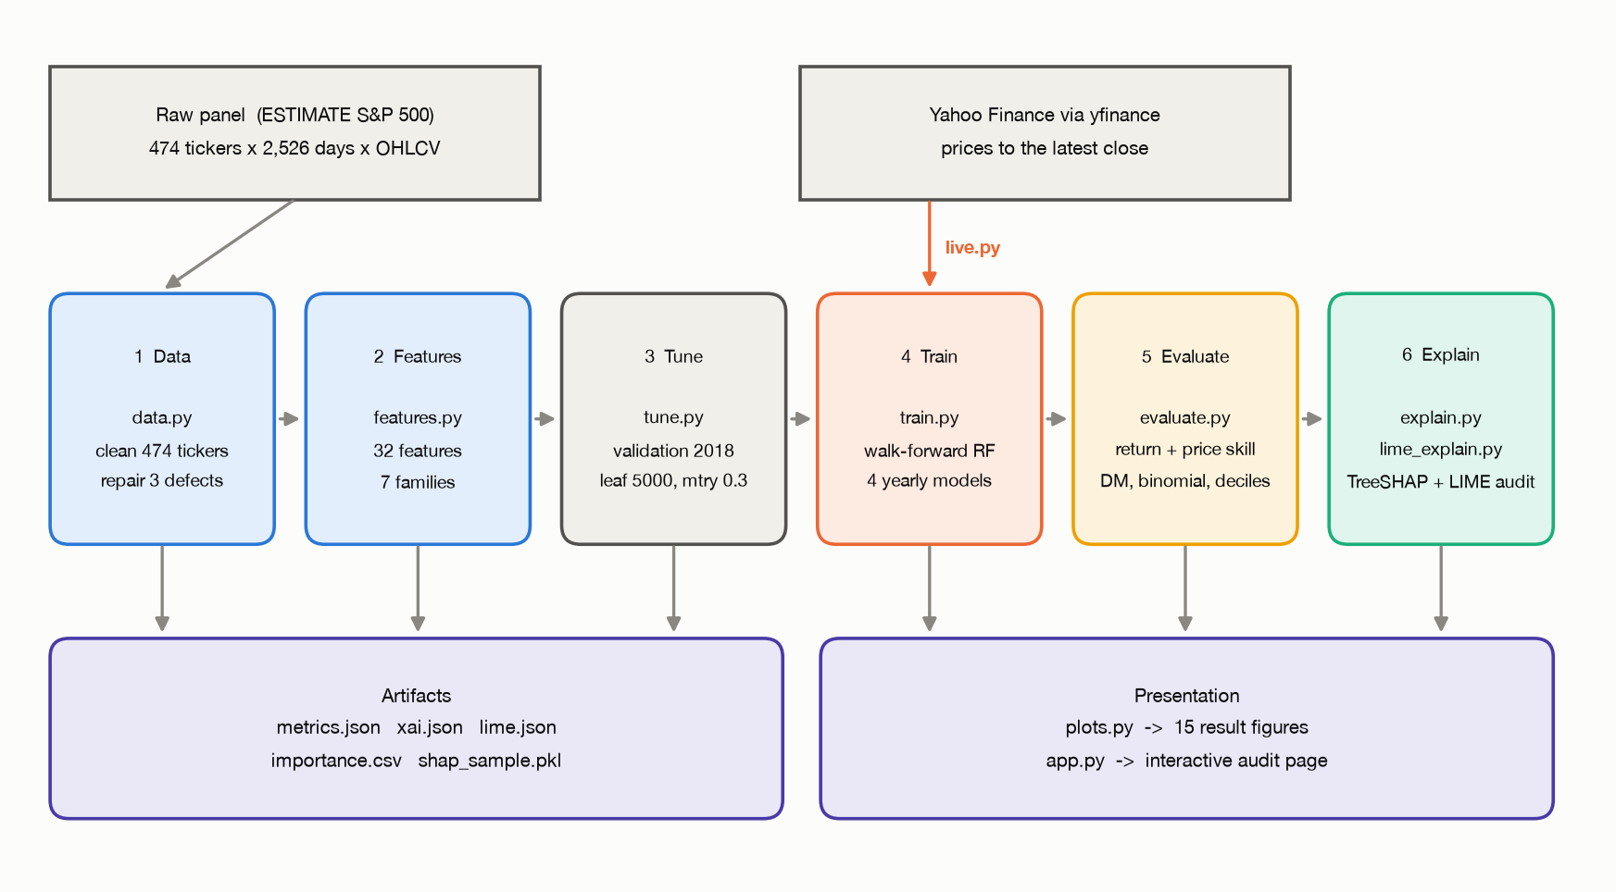
Figure 4.1 System architecture. The six stages, their scripts and the artifacts they write
4.1.1 Dataset
The raw dataset is the public S&P 500 benchmark released with the ESTIMATE paper and also used by StockMixer. It holds daily open, high, low, close, adjusted close and volume for 474 constituents across eleven GICS sectors, from 14 May 2012 to 25 May 2022, a span of 2,526 trading days that includes both the COVID crash and the 2022 bear market.
Table 4.1 Dataset summary
Item | Detail
Source | ESTIMATE S&P 500 benchmark (Huynh et al., WSDM 2023)
Universe | 474 constituents, eleven GICS sectors holding 21 to 67 stocks each
Fields | Daily open, high, low, close, adjusted close and volume
Period | 14 May 2012 to 25 May 2022, 2,526 trading days
Usable stock-days | 1,097,165, after a 200-day feature warm-up and cleaning
Training stock-days | 572,884 to the end of 2017
Validation stock-days | 118,736, the calendar year 2018
Test stock-days | 405,545 across 856 trading days, January 2019 to May 2022
Class balance | 52.64 per cent of stock-days closed higher than the previous day

4.1.2 Data Cleaning
The raw panel contains three defects, each of which would corrupt the learned model if left in place. They were found by checking an invariant that must hold for any well-formed price series: the day's close must lie between the day's low and high.
Table 4.2 Defects found in the raw panel and their repair
Defect | Rows affected | Repair
Adjusted close missing before a stock was listed | 3,450 | Rows dropped
For twelve tickers, open, high and low were already adjusted for dividends while close was not, so high and low did not bracket the close | About 27,000 | The convention is detected per ticker by testing which basis puts the close inside the day's range more often, and all four prices are put on one adjusted basis
GOOG before 27 March 2014 is a different, unadjusted share-class series, producing a single return of about minus 300 per cent | 470 | Rows dropped

Genuine extreme moves are retained. The oil-price collapse of 9 March 2020, in which APA fell 54 per cent in one session, is real and stays in the data.
4.1.3 Feature Engineering
Thirty-two features are computed for each stock-day, grouped into seven families. The grouping is not cosmetic: explanations are reported by family as well as by individual feature, because a family share is more stable and more interpretable than a ranking of 32 correlated indicators.
Table 4.3 The 32 features, by family
Family | Count | Features
Past returns | 6 | Log returns over 1, 2, 5, 10, 20 and 60 trading days
Trend | 5 | Distance from the 5, 20, 50 and 200-day simple moving averages; MACD histogram
Oscillators | 3 | RSI(14), stochastic %K(14), Bollinger %B(20)
Volatility | 6 | Realised volatility over 5, 20 and 60 days; ATR(14); the day's log range; Bollinger band width
Volume | 3 | Volume against its 20-day average; 5 against 20-day volume trend; log dollar volume
Candle | 3 | Overnight gap, open-to-close body, close position within the day's range
Market and sector | 6 | Equal-weighted market return over 1 and 5 days, 20-day market volatility, sector 5-day return, 20-day relative strength, 60-day beta

Every feature obeys one rule: the value for stock i on day t uses only prices and volumes up to and including the close of day t. Features are computed on wide tables indexed by date and ticker, where every backward shift is explicit, and are then stacked into one row per stock-day. A row survives only if all 32 features and all targets are present; no missing value is imputed, because an invented input would undermine the premise of a study about whether explanations can be trusted.
The prediction target is the next trading day's log return, with the next day's closing price and an up-or-down indicator carried alongside for the secondary price-space and directional analyses.
4.2 Design
4.2.1 Data-Flow Diagram
The context diagram shows the system as a single process between the market data vendor, which supplies prices, and the analyst, who supplies a stock and a date and receives a forecast together with its explanation and audit.
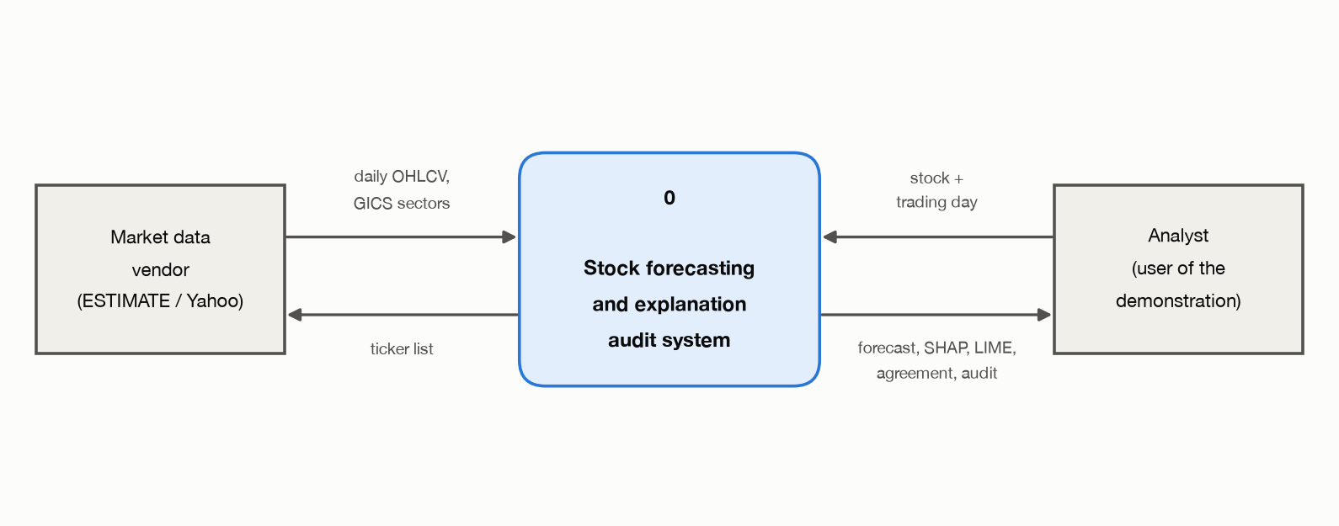
Figure 4.2 Level 0 context data-flow diagram
The level 1 diagram decomposes that process into the seven sub-processes that correspond to the pipeline stages, together with the five data stores they read and write. The lower path, processes 5.0 to 7.0, is the explanation and serving path; the upper path, 1.0 to 4.0, is the forecasting path. Process 7.0 reads from both, which is what allows a single forecast and its audit to be served together.
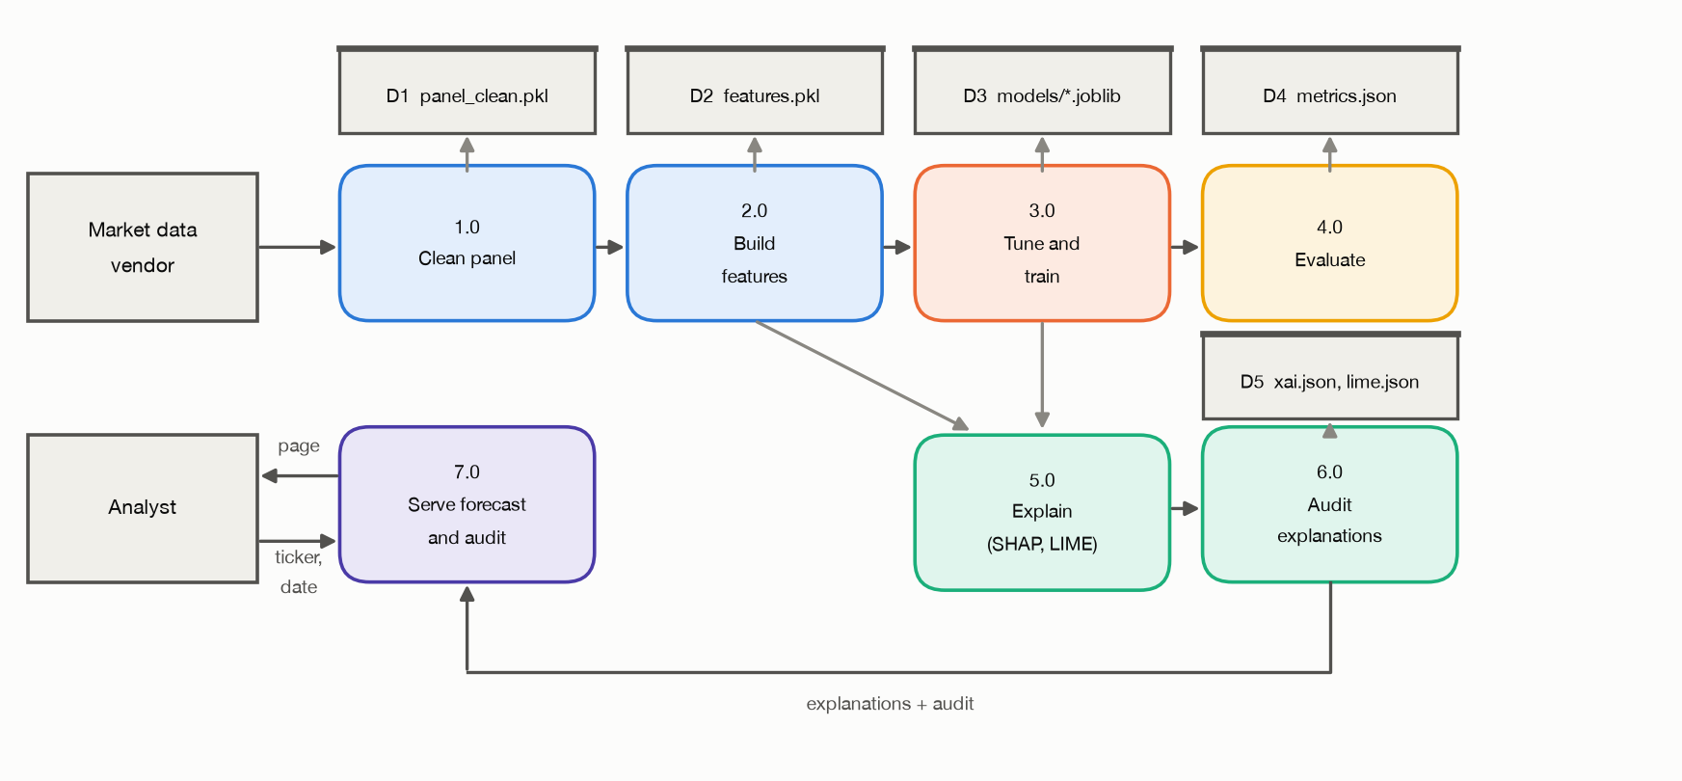
Figure 4.3 Level 1 data-flow diagram
4.2.2 Use Case Diagram
Two human actors use the system. An analyst selects a stock and a day and reads the forecast and its explanation. A researcher additionally exercises the audit functions, checking whether the explanation is faithful and whether LIME returns the same answer when re-run. The market data vendor is an external actor that supplies the prices from which the next-session forecast is built.
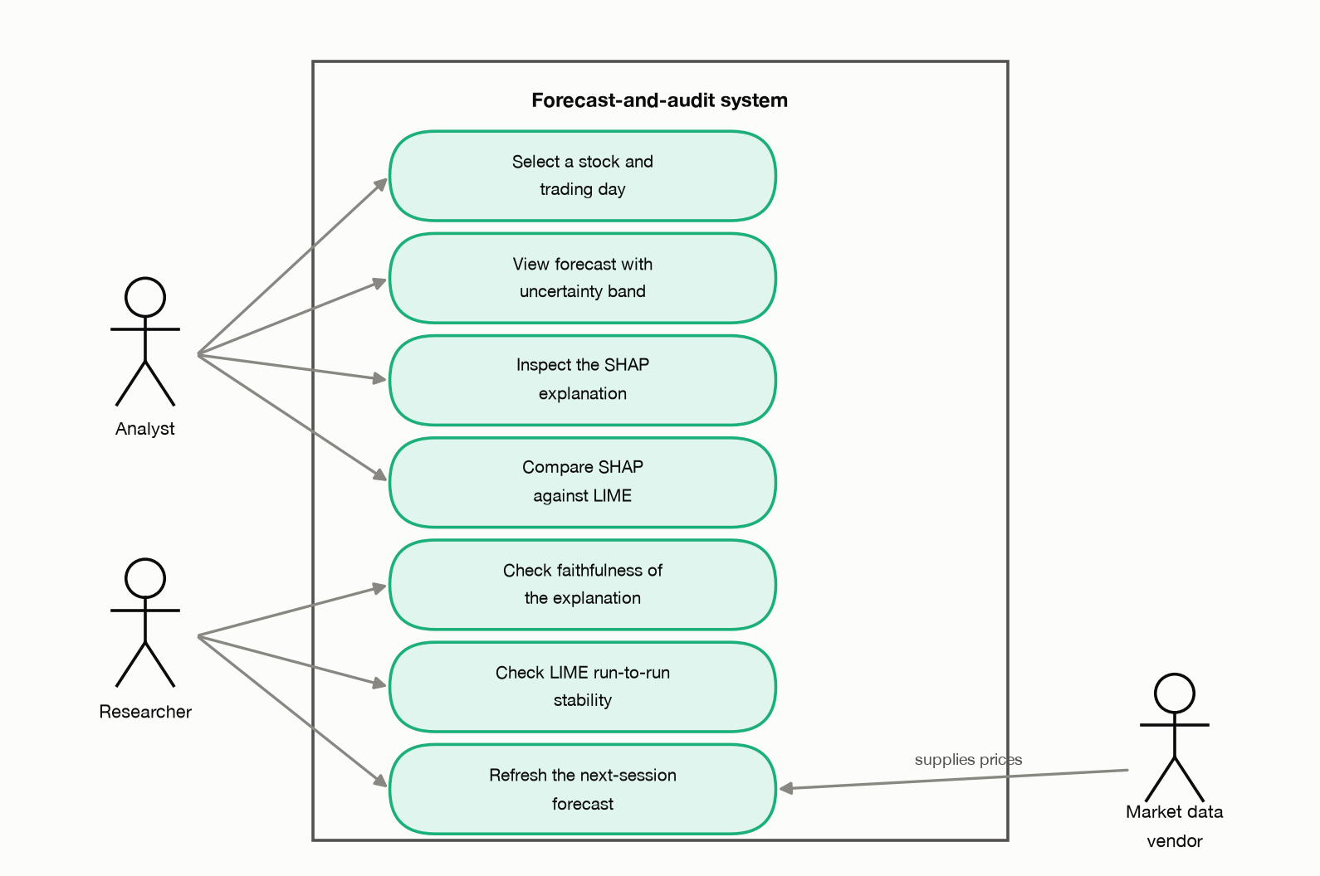
Figure 4.4 Use case diagram
4.2.3 Class Diagram
The system is organised as modules of functions rather than as a class hierarchy, which is the natural structure for a data pipeline; the only class defined is the HTTP request handler in the serving module. The diagram therefore shows the module structure, with each module's public functions and the modules it imports.
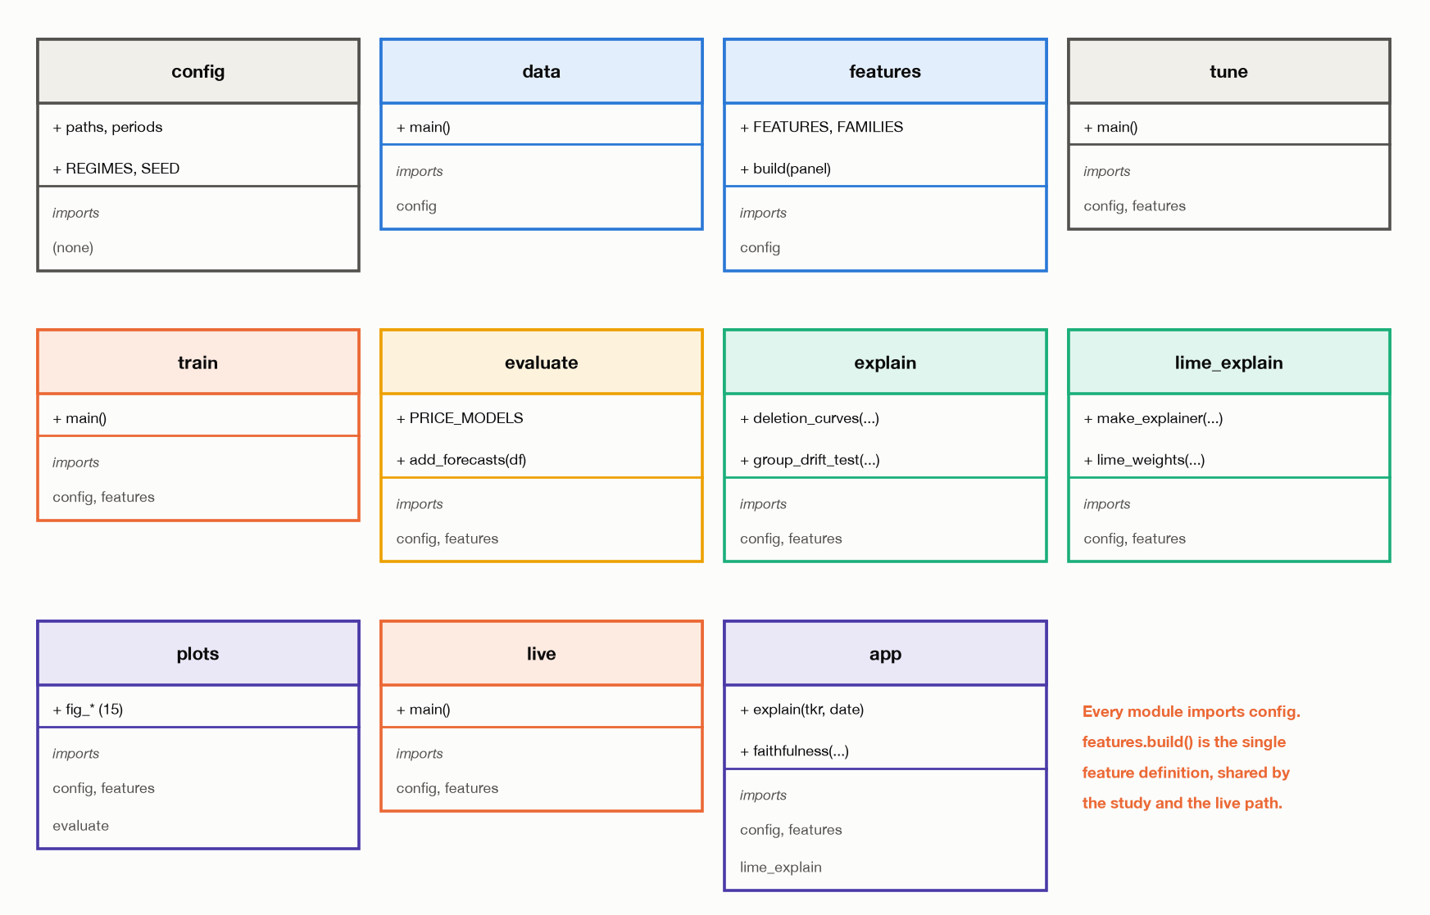
Figure 4.5 Module structure, showing public functions and import dependencies
Two dependencies carry the design. Every module imports config, so the date ranges, the regime boundaries and the random seed exist in exactly one place. And the serving module imports the explanation functions from lime_explain rather than reimplementing them, which is what prevents the demonstration from drifting into a more flattering version of the study.
4.2.4 Sequence Diagram
The sequence below traces one request to the explanation endpoint. Nothing is read from a cached result file: the forecast, the SHAP attribution, the five LIME runs, the agreement statistics and the faithfulness probe are all computed while the request is being served, which takes about 0.7 seconds.
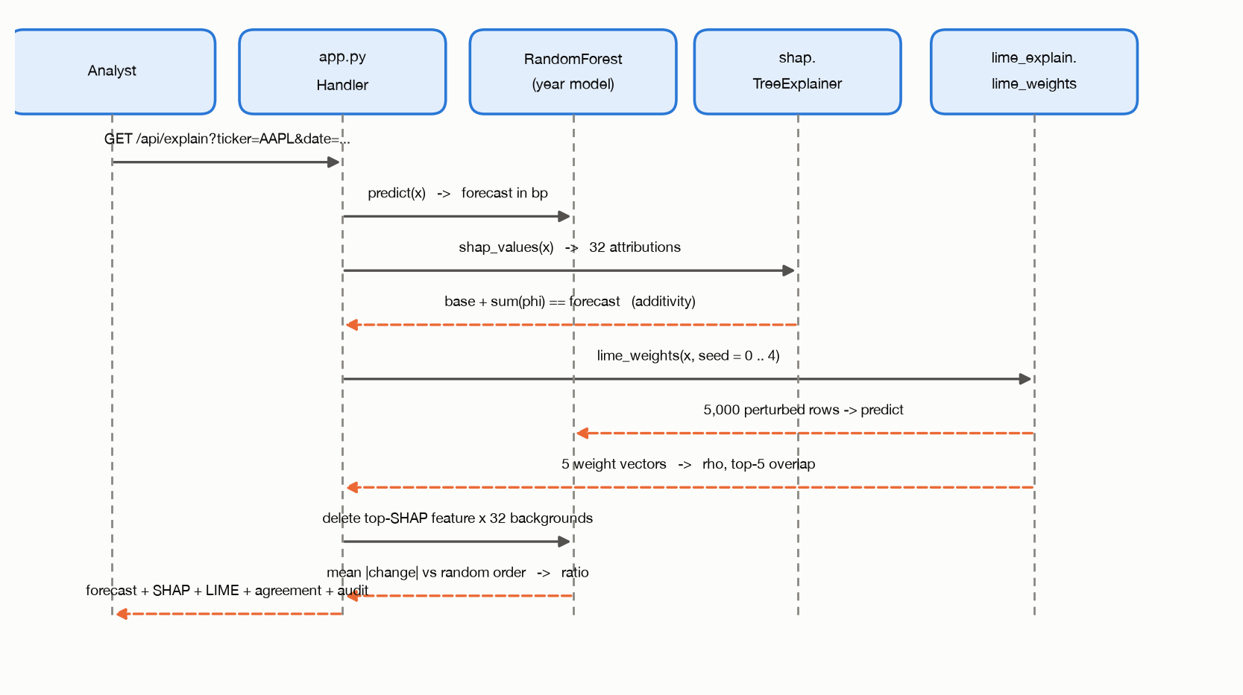
Figure 4.6 Sequence diagram for a single request to the explanation endpoint
CHAPTER 5
5. METHODOLOGY AND TESTING
5.1 Module Description
The system consists of thirteen Python modules. Eleven form the pipeline; two generate the documents and diagrams. Modules are listed in execution order.
Table 5.1 Modules in execution order
Step | Module | Responsibility | Output
- | config.py | Paths, date ranges, regime boundaries, random seed. Imported by every other module | -
1 | data.py | Load the raw panel, repair the three defects, stack to one long table | panel_clean.pkl
2 | features.py | Build the 32 features and the next-day targets; exposes build(panel), the single feature definition | features.pkl
3 | tune.py | Grid search on the validation year only | tuning.json
4 | train.py | Walk-forward retraining and forecasting for the four test years | predictions.pkl, models/
5 | evaluate.py | Return-space and price-space scoring, significance tests, decile portfolio | metrics.json
6 | explain.py | TreeSHAP attributions and the faithfulness, stability, sanity and drift tests | xai.json, importance.csv, shap_sample.pkl
7 | lime_explain.py | LIME explanations and the SHAP-against-LIME comparison | lime.json
8 | plots.py | All 15 result figures | results/figures/
9 | live.py | Retrain to the latest close and forecast the next session | live_forecast.pkl, live_meta.json
10 | app.py | Serve the interactive forecast-and-audit page | HTTP on port 8000
- | make_uml.py | The six design diagrams of Chapter 4 | figures/design/
- | make_docx.py, make_vit_report.py | Document generation | Word output

5.1.1 Target Formulation and Model
The model predicts the next-day log return, and the price forecast is that return applied to the current close. Predicting returns rather than price levels does two things. It lets one model serve stocks priced from ten dollars to three thousand, because a return is scale-free. And it avoids a structural failure of tree models on price levels: a tree predicts by averaging training labels, so it can never forecast above the highest price it was trained on. Section 7.1.2 quantifies what happens when that rule is broken.
The regressor is a scikit-learn Random Forest with 300 trees, each grown on a 25 per cent bootstrap sample. Two hyperparameters were tuned: the minimum number of samples in a leaf, over 200, 1,000 and 5,000, and the fraction of features considered at each split, over 0.3 and 0.6. Selection was by validation mean squared error, with the model trained only on data preceding the validation period. The chosen configuration is a leaf size of 5,000 and a feature fraction of 0.3, the most heavily regularised option in the grid. That choice is itself a result: a search that lands on maximum regularisation is telling you the signal-to-noise ratio is very low.
5.1.2 Walk-Forward Protocol
At the start of each test year the model is retrained on every stock-day from March 2013 up to the preceding 31 December, then forecasts every stock-day of that year. This mimics what a practitioner would actually do and guarantees that no forecast uses information from its own future.
Table 5.2 Walk-forward training and forecasting
Test year | Training stock-days | Forecasts produced | Training time
2019 | 691,620 | 119,340 | 96 s
2020 | 810,960 | 119,919 | 120 s
2021 | 930,879 | 119,448 | 160 s
2022 (to May) | 1,050,327 | 46,838 | 185 s
Total | - | 405,545 | 561 s

5.1.3 Baselines and Metrics
Five comparison models are scored on exactly the same stock-days: naive persistence, which forecasts zero return; historical drift, the mean training return; Ridge regression on the same 32 features; a Random Forest trained on raw price levels; and a Random Forest classifier for next-day direction. Every model produces one forecast, which is then scored twice, once on the return and once on the price.
Return-space metrics are the primary result: mean absolute and root mean squared error in basis points, out-of-sample R-squared against both a zero-return and a drift benchmark, the daily information coefficient and its rank and ratio variants, directional accuracy, and the standard deviation of the forecasts themselves against the realised figure. Price-space metrics follow for comparability. An economic view sorts each day's stocks into deciles of predicted return and measures what each decile actually returned, reporting the long-short spread gross and net of an assumed ten basis point round-trip cost.
Two significance tests are applied throughout. A Diebold-Mariano test with Newey-West standard errors over five lags compares daily mean squared error against the relevant benchmark. A binomial test compares directional accuracy against the rule of always predicting the majority direction, which is the benchmark a directional claim must actually beat.
5.1.4 Explanation Methods
TreeSHAP is applied through shap.TreeExplainer. For tree ensembles it computes exact Shapley values in time polynomial in tree depth, and it is additive by construction: the base value plus the 32 attributions equals the forecast. That additivity is verified rather than assumed, and the maximum observed error is 2.6 times ten to the minus seventeen, which is floating-point noise. The sample is 40 random stocks per test day plus AAPL, MSFT, JPM, XOM and PFE on every day, giving 38,183 stock-days, each explained by the model belonging to its own year.
LIME is applied through lime.lime_tabular.LimeTabularExplainer with its default settings: quartile discretisation, 5,000 perturbed samples per explanation, and a reference distribution of 5,000 training rows. The sample is 804 stock-days, 200 per test year plus the cases examined individually, and each is explained five times with five different random seeds so that run-to-run variability can be measured. Two further explainers are computed for comparison: permutation importance, the increase in test mean squared error when a feature is shuffled, over three repeats; and mean decrease in impurity, the forest's own built-in importance.
5.1.5 The Reliability Audit
Table 5.3 The five reliability checks and how each is measured
Check | Applied to SHAP | Applied to LIME
Faithfulness | Replace the top k features by absolute SHAP with values from 32 random training rows, for k in 1, 2, 4, 8, 16, 32; compare against random order; report deletion curves, AOPC and fidelity | The same deletion test, ordered by absolute LIME weight
Stability | Five random seeds on identical data, and four consecutive yearly retrains; global Kendall tau and per-row Spearman rho | The same stock-day explained with five LIME seeds
Local fit | Exact by construction, through additivity | R-squared of LIME's own linear surrogate on its perturbation sample
Agreement | Global Kendall tau among all four explainers; per-row Spearman rho, top-5 overlap, same top feature and sign agreement | The same statistics
Sanity | Forests trained on fully shuffled labels, and on labels shuffled within each day, compared against the real model | Not applicable
Drift | Mean pairwise total variation distance between family-share vectors, against a null from 1,000 permutations of whole days or whole stocks | Not applicable

The four market regimes were fixed in advance from well-known market events, before any explanation was computed. This ordering matters: boundaries chosen after seeing which ones produced a significant result would make the drift test meaningless.
Table 5.4 Market regimes, fixed in advance
Regime | From | To | Character
Pre-COVID bull | 1 Jan 2019 | 19 Feb 2020 | Steady rise to the pre-pandemic peak
COVID crash | 20 Feb 2020 | 23 Mar 2020 | 23 trading days, index down about a third
Recovery | 24 Mar 2020 | 31 Dec 2021 | Sustained rally to new highs
2022 bear | 1 Jan 2022 | 24 May 2022 | Rate-driven decline

5.2 Testing
5.2.1 Acceptance Criteria
Eleven acceptance criteria were defined before the results were produced. Each is either met or not, and the evidence is a committed artifact.
Table 5.5 Acceptance criteria and outcomes
ID | Criterion | Outcome
AC1 | Walk-forward forecasts exist for every test stock-day with no look-ahead | Met: 405,545 forecasts
AC2 | Return-space and price-space results are both reported, return space first | Met: Section 7.1
AC3 | Every accuracy claim carries a benchmark and a significance test | Met: Diebold-Mariano and binomial throughout
AC4 | SHAP additivity error below 1e-15 | Met: maximum 2.6e-17
AC5 | Deletion of top-ranked features moves the forecast materially more than random deletion | Met: 13.3 times at k = 1
AC6 | Stability and sanity are both quantified | Met: tau 0.85 across seeds; tau 0.13 against a no-signal model
AC7 | Drift is tested statistically, not asserted | Met: regimes p = 0.003, sectors p = 0.001
AC8 | The pipeline reproduces from a clean checkout | Met: 12 documented steps
AC9 | Repeating a LIME explanation with the same seed returns identical weights | Met after the defect in Section 5.3.3 was fixed; previously rho 0.46 to 0.53
AC10 | A single forecast can be explained and audited interactively | Met: about 0.7 s per stock-day, nothing served from cache
AC11 | A forecast exists for a session that has not yet traded | Met: 431 stocks, retrained on 1,473,486 stock-days, outcome fields blank

5.2.2 Correctness Checks Built Into the Pipeline
Rather than a separate test suite, correctness is enforced by assertions and invariants at the points where an error would be silent and damaging.
- Price integrity. After cleaning, the day's high must be at least the maximum of open and close, and the low at most the minimum. This invariant is what exposed the twelve mis-adjusted tickers in the first place.
- SHAP additivity. The base value plus the 32 attributions is compared against the model's own prediction for every explained row, and the maximum deviation is reported in the run log.
- Leakage. Features are built on wide date-by-ticker tables where every shift is explicit, and the target is constructed by shifting the close backwards by one day, so a sign error would produce an implausibly high R-squared rather than a silent bias.
- Live forecasting. The live module asserts that the day being forecast has no known outcome. If the script is run while a session is still in progress the assertion fails and the run stops, rather than presenting a hindsight value as a forecast.
- Deletion control. The faithfulness test is always run against a random-order control on the same rows, so a result cannot be reported without its own null.
5.2.3 A Defect Found by Testing: LIME Reproducibility
Enforcing NFR1 uncovered a defect in the conventional way LIME is used. The natural pattern is to construct one LimeTabularExplainer and reassign its random_state attribute between runs. The class, however, binds its RandomState into the discretiser and into the surrogate solver at construction time, so reassignment controls only part of the sampling. The consequence is that repeats which were intended to be identical were not: the measured Spearman correlation between two runs with the same seed was 0.46 to 0.53, where it should have been exactly 1.000.
# Wrong: the explainer binds its RandomState at construction, so the same seed
# does not reproduce the same explanation.
explainer.random_state = seed
weights = explainer.explain_instance(x, predict).as_map()

# Correct: build a fresh explainer per seed. Costs 18 ms; repeats are bit-identical.
explainer = LimeTabularExplainer(reference, random_state=seed, ...)
weights = explainer.explain_instance(x, predict).as_map()

The defect mattered because it inflated a headline result. Before the fix the global agreement between TreeSHAP and LIME read Kendall tau 0.73; after it, tau 0.58. The higher figure was partly an artefact of LIME not being reproducible across runs that were supposed to be identical. A reliability study that does not audit its own tooling can report the inflated number without ever seeing the problem, which is itself a finding of this project.
CHAPTER 6
6. PROJECT DEMONSTRATION
Every number in Chapter 7 comes from forecasting days whose outcome is already known. That is not a weakness of the design; it is the only way a forecast can be scored. An out-of-sample R-squared of plus 0.00013 cannot be established unless 405,545 forecasts have been compared against what actually happened.
It does leave one question open. Does the pipeline work on a day that has not yet happened? A backtest can be made to look good by construction, through a feature that leaks, a universe chosen after the fact, or hyperparameters tuned on the test period. Running the identical code forward on data that did not exist when the code was written removes all three possibilities at once. This chapter describes that demonstration.
6.1 Live Forecasting
The live module downloads current prices for the study's tickers from Yahoo Finance, rebuilds the 32 features by calling the same features.build function used in the study, retrains a Random Forest with the hyperparameters already selected, and forecasts the next trading session. The only substantive difference from the study path is one line: the study discards every row with a missing target, which necessarily throws away the most recent day, whereas the live path keeps it precisely because its outcome is unknown.
df = df.dropna(subset=FEATURES + ["close"]) # NOT on the target: the last day has none
train = df.dropna(subset=["target_ret"]) # train on every day with a known outcome
live = df[df.date == last_day].copy() # forecast the one day with no outcome
assert live.target_ret.isna().all(), "the last day already has a known outcome"

The assertion guards against the most tempting error in a demonstration of this kind. If the script is run while a session is still in progress, the last available day already has an outcome, and the script stops rather than presenting a hindsight value as a forecast.
Table 6.1 A representative live run, as of the close of 29 October 2026
Quantity | Value
Stocks forecast | 431
Training rows | 1,473,486 stock-days, through 28 October 2026
Hyperparameters | Unchanged from the study: 300 trees, leaf 5,000, feature fraction 0.3
Price source | Yahoo Finance via yfinance, split- and dividend-adjusted
Tickers no longer trading | 43 of the original 474

Three caveats are reported by the system itself rather than left to the reader. Forty-three of the original tickers have been acquired, merged or delisted, so the live universe is smaller than the study universe and the market-context features are computed over the survivors. That is survivorship bias made visible rather than hidden. The prices come from a different vendor than the study panel; both are adjusted, but they are not the same series. And nothing in the live output is scored, because the outcome does not exist yet: the live mode demonstrates that the mechanism runs forward, not that it is accurate.
6.2 The Interactive Demonstration
The serving module presents a single page from the Python standard library's threading HTTP server. It loads the four walk-forward models, a TreeSHAP explainer for each, the LIME reference samples, the cleaned price history and, when present, the live forecast and its retrained model.
Table 6.2 Endpoints exposed by the demonstration
Endpoint | Returns
GET /api/meta | Ticker list, date range, suggested cases, live metadata
GET /api/dates?ticker=... | The dates on which that stock can be explained
GET /api/explain?ticker=...&date=... | Forecast, SHAP attributions, five LIME runs, agreement statistics, faithfulness probe

Two design decisions carry the credibility of the demonstration. Nothing is served from a cached result file: each request runs TreeSHAP once and LIME five times, on the saved model, at request time, so the page shows what the pipeline produces rather than a transcription of the results chapter. And the live and historical paths share one function, which differs between the two modes only in which model and which feature row it selects. The TreeSHAP call, the five LIME runs, the agreement statistics and the faithfulness probe are the same lines of code in both cases, so the demonstration cannot drift into being a more flattering version of the study.
6.3 Input and Output
The user supplies two values: a stock, from 474 in historical mode or 431 in live mode, and either a trading day between 2 January 2019 and 24 May 2022 or the next session. The page returns seven things.
1. The forecast. Predicted next-day return in basis points, the implied close in dollars, and the classifier's probability that the day is up. In historical mode the realised return and close appear beside it, with the direction marked correct or incorrect.
2. The forecast in context. The last 60 closes, a dashed segment to the forecast, and a shaded band of one standard deviation of that stock's recent daily moves. The band is the point of the chart: for AAPL on 29 October 2026 the forecast is minus 4.05 basis points against a band of plus or minus 87, so the model predicts a move about 22 times smaller than a normal day.
3. A SHAP waterfall. The base value, then the top eight contributions in turn, then the remaining 24 features as one bar, ending exactly on the forecast. The exactness is the demonstration of additivity: the bars do not illustrate the forecast, they sum to it.
4. Both explanations. SHAP and LIME bar charts of the same forecast side by side, plus a table of all 32 features with both attributions in basis points.
5. Agreement. Spearman rho between the two attribution vectors, top-5 overlap, whether they name the same top feature, and sign agreement on SHAP's top five.
6. Stability. The top feature from each of five LIME runs with different seeds, the mean Spearman between runs, and the median surrogate fit. TreeSHAP is labelled deterministic, because re-running it returns identical values.
7. Faithfulness. The change in the forecast when SHAP's top feature is deleted, the mean change for eight random features, and the ratio between them.
The five preset cases are chosen to show both outcomes of the SHAP-against-LIME comparison: two stock-days where the explainers agree, and two where they name a different top feature, which happened on 41 per cent of the sampled stock-days, including one where LIME contradicts its own re-runs.
6.4 Guards Against Overclaiming
The demonstration is the part of this project most likely to be mistaken for a trading system, so three guards are built into it.
- The live forecast carries its age. The server computes how many days have passed since the close the forecast was made from, and the page displays a warning beyond three days, because a forecast for a session that has already traded is no longer a forecast.
- The 43 delisted tickers are listed on the page rather than silently dropped.
- The page states that the forecast has an out-of-sample R-squared of plus 0.00013 across 405,545 scored forecasts. The live mode demonstrates that the mechanism works; Chapter 7 remains the statement of how well it works.
CHAPTER 7
7. RESULT AND DISCUSSION
7.1 RQ1: Forecast Skill
The model predicts a next-day log return, and the price forecast is only that return applied to the current close. Skill is therefore measured on returns first. Price-space accuracy follows, because that is what the literature quotes, and the distance between the two verdicts is itself the first result of this project.
7.1.1 Return Space
Across 405,545 stock-days from January 2019 to May 2022, the realised next-day return has a standard deviation of 245 basis points.
Table 7.1 Return-space skill. One basis point is one hundredth of one per cent
Model | RMSE (bp) | R2 vs zero | R2 vs drift | Daily IC (t) | Direction | DM p
Naive, forecast zero return | 245.5 | 0.00000 | -0.00043 | - | 47.2% | -
Historical drift | 245.5 | +0.00043 | 0.00000 | - | 52.8% | 0.64
Ridge regression | 246.9 | -0.01076 | -0.01120 | +0.0019 (0.30) | 51.7% | 0.39
RF on price levels | 250.4 | -0.03972 | -0.04016 | +0.0063 (2.24) | 50.8% | <0.001 worse
Random Forest (proposed) | 245.5 | +0.00013 | -0.00030 | +0.0090 (1.39) | 51.8% | 0.97
Majority-direction rule | - | - | - | - | 52.8% | -

The proposed model explains 0.013 per cent of next-day return variance, and the Diebold-Mariano test cannot distinguish it from simply predicting zero, at p = 0.97. Against the slightly stronger drift benchmark the sign flips. Directional accuracy of 51.8 per cent is below the 52.8 per cent achieved by always predicting the majority direction, and the binomial test returns p = 1.00.
The model hedges towards zero. Its forecasts have a standard deviation of 10.8 basis points against a realised 245, a range 23 times narrower than reality. That is the statistically correct response to a near-unpredictable target, and it is precisely why the price forecasts in the next section look so good. The price-level Random Forest is the only model significantly different from the benchmark, and it is worse: training a tree on raw price levels actively destroys return information.
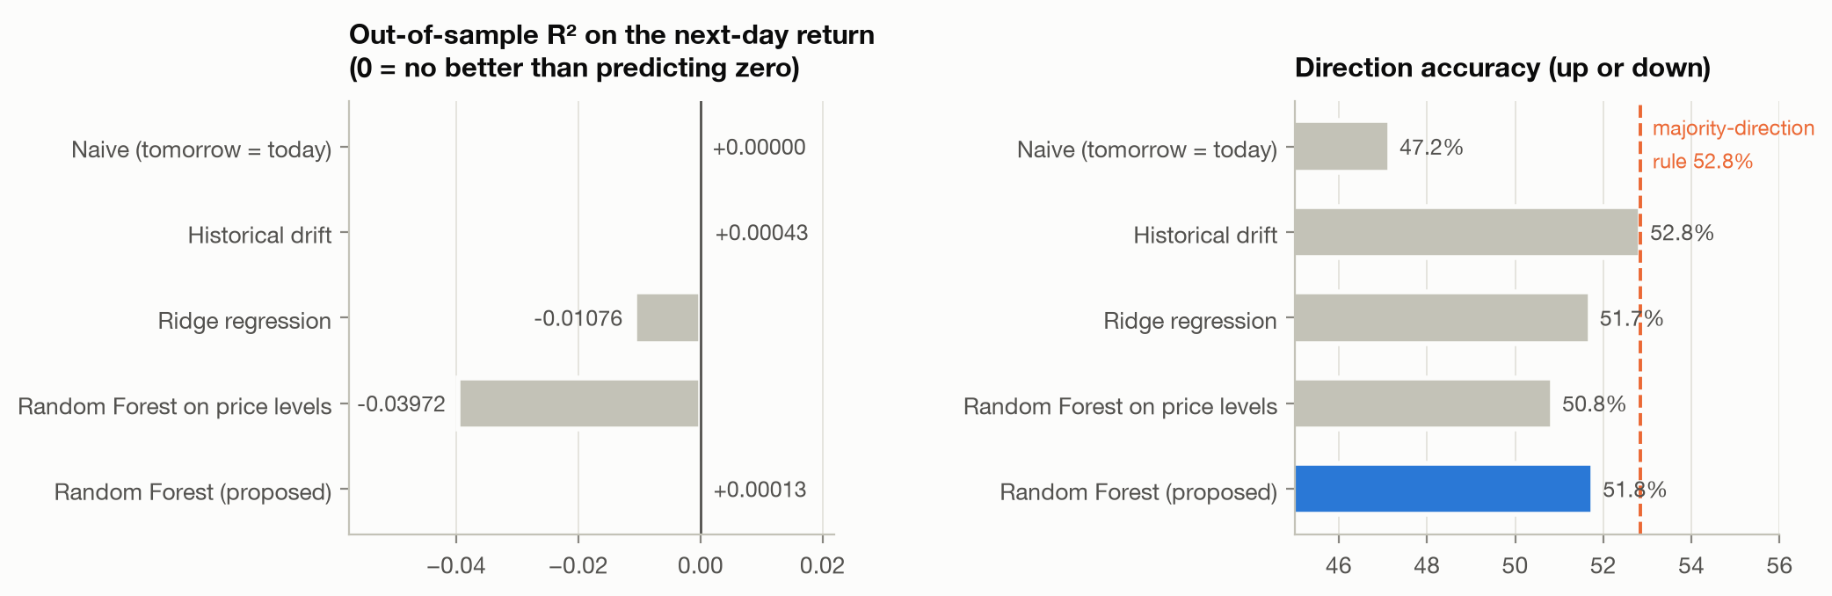
Figure 7.1 Return-space skill: out-of-sample R-squared on the next-day return and directional accuracy, by model
7.1.2 Price Space
The same forecasts, scored on the next-day closing price:
Table 7.2 Price-space accuracy, the quantity usually reported in the literature
Model | MAPE | Accuracy (100 - MAPE) | RMSE | R2 (price) | Within 2% | DM p
Naive, tomorrow equals today | 1.561% | 98.44% | $6.25 | 0.99938 | 75.3% | -
Historical drift | 1.560% | 98.44% | $6.25 | 0.99938 | 75.4% | 0.25
Ridge regression | 1.567% | 98.43% | $6.27 | 0.99937 | 75.3% | 0.17
RF on price levels | 1.583% | 98.42% | $21.56 | 0.99261 | 75.0% | <0.001 worse
Random Forest (proposed) | 1.560% | 98.44% | $6.25 | 0.99938 | 75.4% | 0.30

Table 7.3 The same model, two verdicts
Scored on | R-squared | Reading
The price level | 0.9994 | A near-perfect forecaster
The next-day return | +0.00013 | Indistinguishable from predicting no change

Both numbers come from one set of forecasts. Price-space R-squared is high because tomorrow's price is almost today's price, so the denominator, the variance of the price level across stocks and months, is enormous compared with the one-day error. It measures the price level, not the forecast. The figure of 98.44 per cent accuracy is a property of daily stock prices rather than an achievement of the model, and naive persistence matches it to three decimal places.
The price-level Random Forest demonstrates the second failure mode. It reports an R-squared of 0.993 and 98.4 per cent accuracy, yet its root mean squared error is 3.4 times that of naive persistence and it is significantly worse on the Diebold-Mariano test. Its error grows from six dollars in 2019 to thirty-six dollars in 2021 as prices trend to new highs, because a tree cannot predict above the range it was trained on.
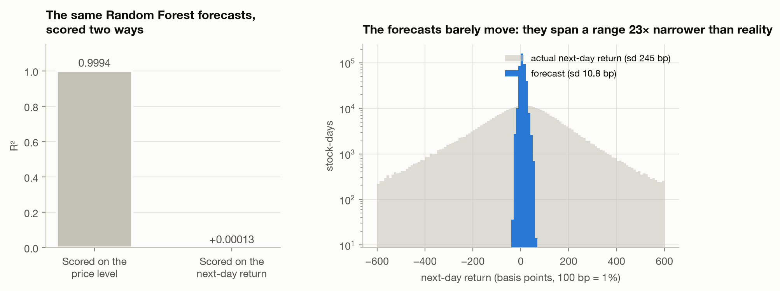
Figure 7.2 The same forecasts scored on the price level and on the return, and how narrowly the forecasts move
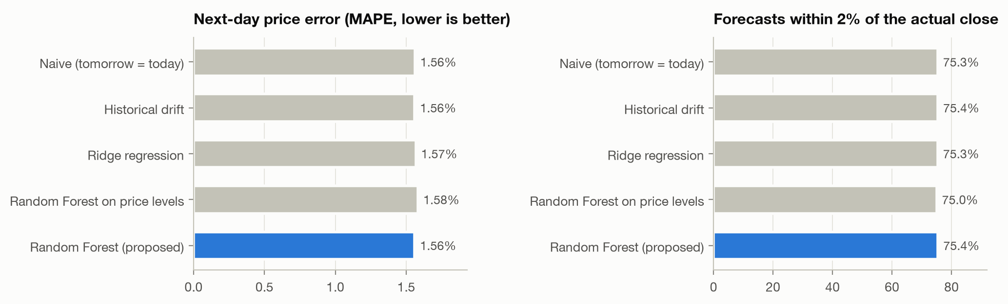
Figure 7.3 Next-day price error and the share of forecasts within two per cent, by model
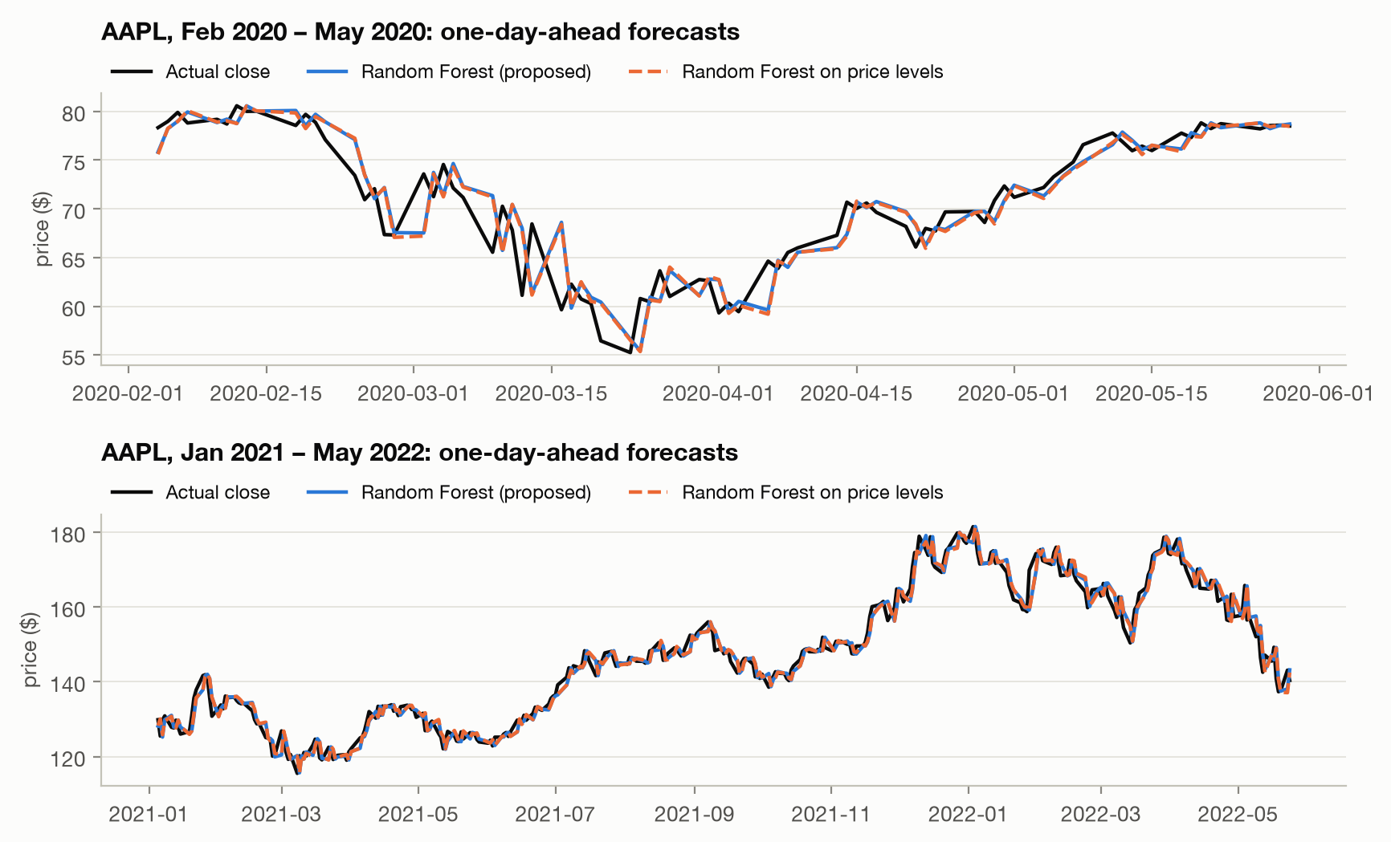
Figure 7.4 AAPL one-day-ahead forecasts against actual closing prices
7.1.3 Economic View and Cost Analysis
Sorting each day's stocks by predicted return and measuring what each decile actually returned gives the economic reading of the same forecasts.
Table 7.4 Mean actual next-day return by decile of predicted return, in basis points
Decile | 1 | 2 | 3 | 4 | 5 | 6 | 7 | 8 | 9 | 10
Actual return (bp) | +1.3 | +6.2 | +3.8 | +5.2 | +6.2 | +4.6 | +5.8 | +6.4 | +6.4 | +9.5

The ranking is weakly monotone, with a Spearman correlation of 0.75 across deciles, so the forecasts do carry a little cross-sectional information even though their level is uninformative. The long-short spread between the top and bottom deciles is 8.2 basis points a day, with a t-statistic of 1.53 and an annualised Sharpe ratio of 0.83, which is not statistically significant.
The cost analysis is decisive. A long-short decile strategy turns over its entire book daily. At an assumed ten basis point round-trip cost the strategy returns minus 1.8 basis points a day: it loses money. Because slippage, market impact, borrowing costs and capacity are not modelled, this figure is an optimistic bound rather than a backtest. The honest economic conclusion is that the model has no demonstrated commercial value.
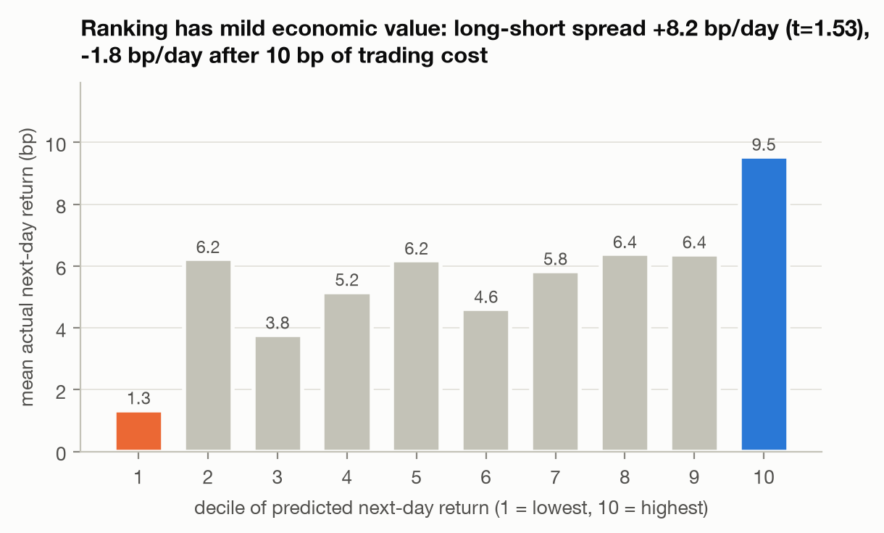
Figure 7.5 Actual next-day return of each decile of predicted return, with the long-short spread gross and net of cost
7.1.4 Where the Little Skill There Is Actually Lives
Table 7.5 Skill by period and market regime
Period | RMSE (bp) | R2 vs zero | DM p | Daily IC | Direction | Majority rule | Long-short (bp)
2019 | 164.0 | +0.00212 | 0.63 | +0.014 | 53.5% | 55.3% | -
2020 | 348.0 | -0.00016 | 0.98 | +0.018 | 51.0% | 51.8% | -
2021 | 182.0 | +0.00046 | 0.87 | -0.008 | 50.4% | 53.2% | -
2022 to May | 242.5 | -0.00113 | 0.91 | +0.018 | 52.7% | 51.5% | -
Pre-COVID bull | 164.4 | +0.00069 | 0.87 | +0.015 | 53.0% | 55.2% | +6.9
COVID crash | 766.3 | -0.01171 | 0.13 | -0.073 | 34.7% | 65.8% down | -119.0
Recovery | 233.9 | +0.00665 | 0.043 | +0.008 | 51.6% | 53.3% | +16.1
2022 bear | 242.5 | -0.00113 | 0.91 | +0.018 | 52.7% | 51.5% | +5.6

Two findings here are visible only in return space. The recovery is the one period with detectable skill: from March 2020 to December 2021 the model beat a zero-return forecast significantly, with an R-squared of plus 0.0067 at p = 0.043, and its long-short spread earned 16.1 basis points a day. In price space that period looks no different from any other. The crash is where the model was actively wrong: directional accuracy fell to 34.7 per cent, the daily information coefficient turned negative, and the long-short spread lost 119 basis points a day, because the model kept forecasting small rebounds while two thirds of stock-days fell. A user would have relied on it most at exactly the moment it inverted.
By sector, return R-squared runs from plus 0.0028 in Information Technology to minus 0.0009 in Consumer Discretionary, and the daily information coefficient from plus 0.025 in Energy to minus 0.016 in Real Estate. All of this is within noise, but none of it is visible in price space, where mean absolute percentage error differs by less than 0.004 percentage points between the model and naive persistence in every sector.
7.2 RQ2: What Drives the Forecasts
Table 7.6 Global feature importance, by mean absolute SHAP
Rank | Feature | Family | Mean |SHAP| (bp)
1 | Market 20-day volatility | Market and sector | 5.37
2 | Market 5-day return | Market and sector | 3.33
3 | Market 1-day return | Market and sector | 3.28
4 | Overnight gap | Candle | 0.77
5 | Own 1-day return | Past returns | 0.57
6 | Sector 5-day return | Market and sector | 0.53
7 | ATR(14) | Volatility | 0.43

Market and sector context accounts for 72.2 per cent of total attribution. The remaining families divide the rest: volatility 7.6 per cent, past returns 7.0 per cent, candle 5.9 per cent, trend 3.8 per cent, oscillators 2.0 per cent and volume 1.5 per cent. The dependence plots show what those features do. High market volatility raises the forecast by 10 to 15 basis points, a falling five-day market raises it by up to 25, and a strong up-day for the market lowers it. The model has mainly learned one rule: expect a small market-wide rebound after a volatile sell-off.
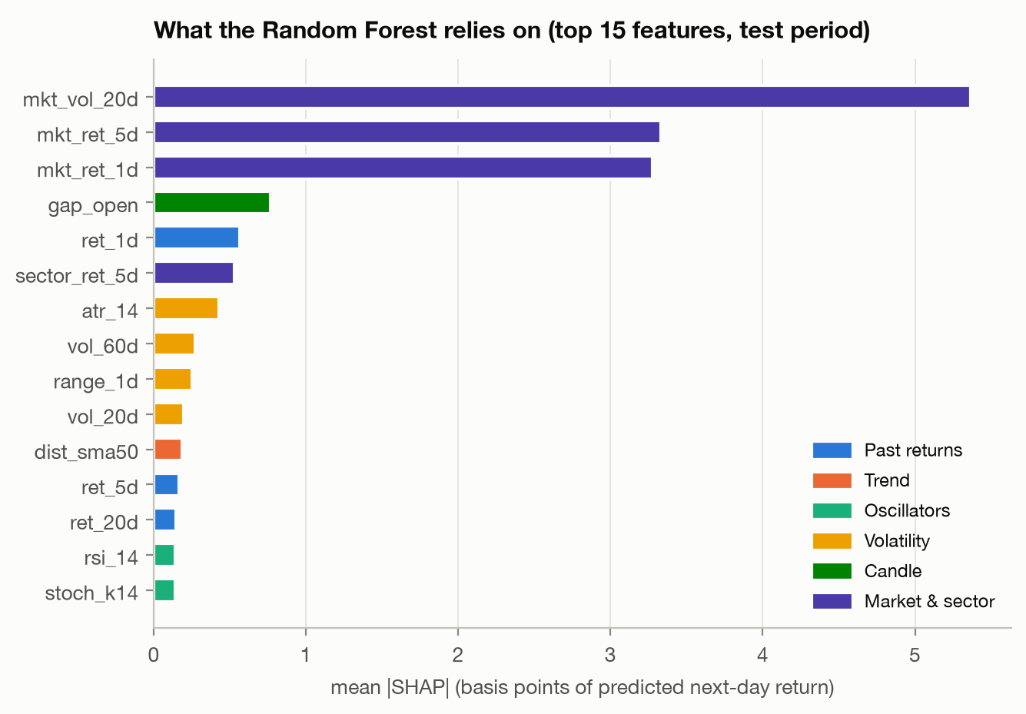
Figure 7.6 Top 15 features by mean absolute SHAP
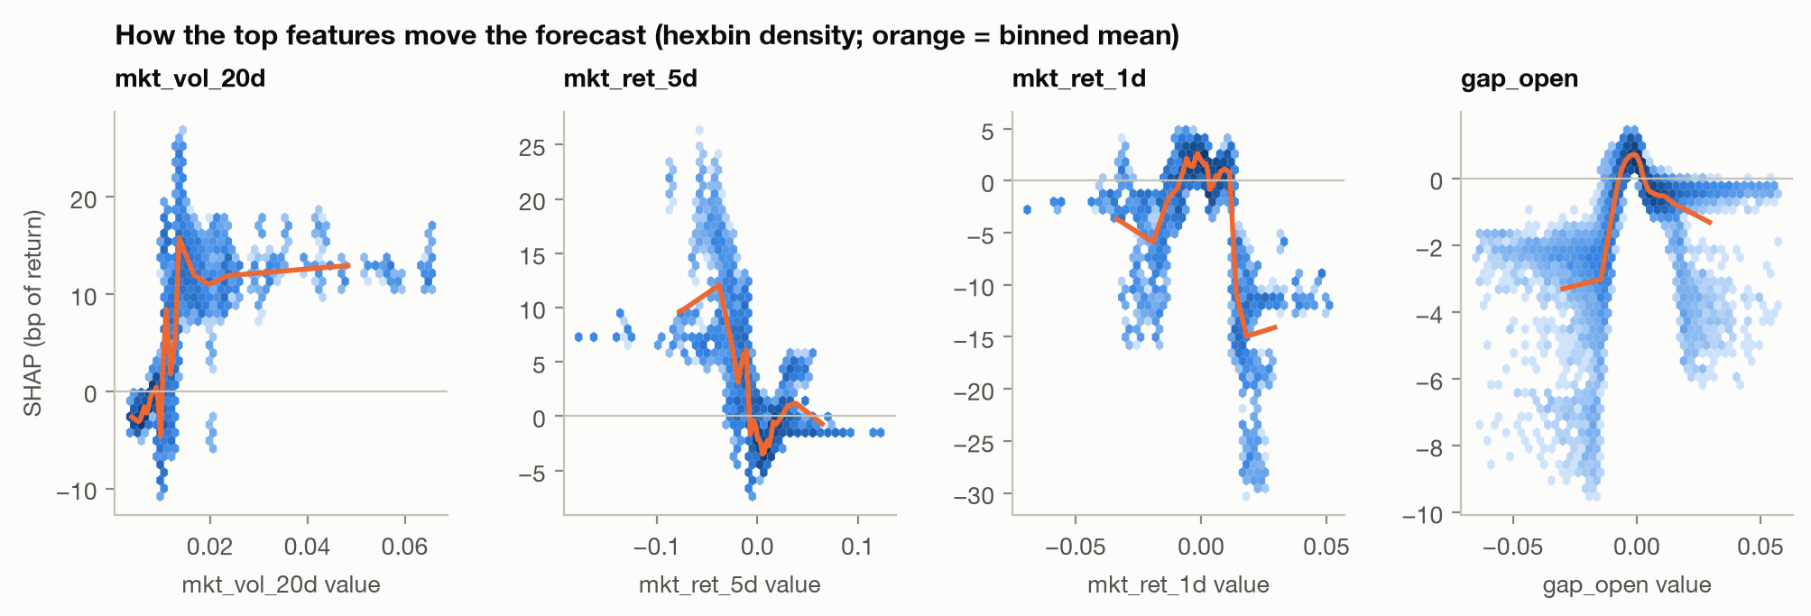
Figure 7.7 How the leading features move the forecast (SHAP dependence)
A local example makes the scale concrete. For AAPL on 16 March 2020, the worst day of the COVID crash, the model forecast plus 30 basis points while the stock actually rose 430. The attribution pushing the forecast up was market 20-day volatility at plus 12.9 basis points, the 17.8 per cent five-day market fall at plus 7.4, and the stock's own 29 per cent 20-day decline at plus 1.9; pushing it down were the 13.7 per cent market fall that day at minus 2.2 and the overnight gap at minus 1.7. The explanation is coherent, and the direction is right. But every contribution is an order of magnitude too small, which is the local view of the same 23-times-too-narrow dispersion found in Section 7.1.1. Expressed in dollars those contributions would read as eight, four and one cents and look merely small; in return units it is clear that the whole explanation accounts for one fourteenth of the move.
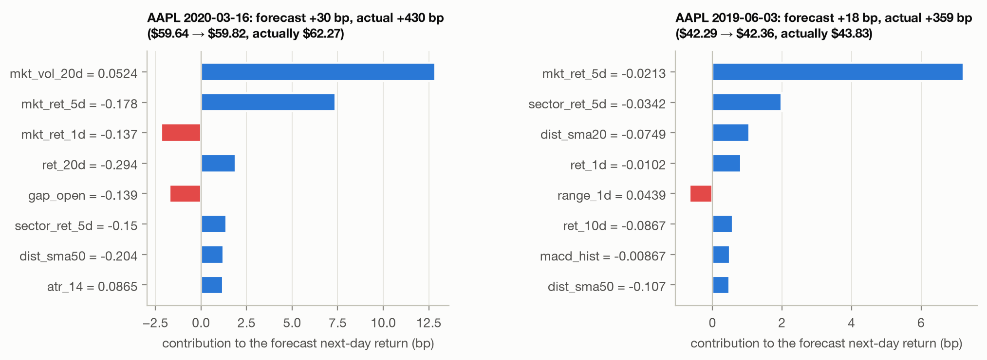
Figure 7.8 Local SHAP explanations in basis points of forecast return, for individual stock-days
7.3 RQ3: Faithfulness and Stability
Table 7.7 Faithfulness: forecast change when k features are removed
Features removed (k) | 1 | 2 | 4 | 8 | 16 | 32
Top-SHAP first, |change| in bp | 8.70 | 8.39 | 8.36 | 8.47 | 8.56 | 8.59
Random order, |change| in bp | 0.65 | 1.19 | 2.04 | 3.65 | 5.88 | 8.59
Fidelity: corr(SHAP mass removed, actual change) | 0.98 | 0.99 | 0.99 | 1.00 | 1.00 | 1.00

SHAP passes. Removing the single top-ranked feature changes a forecast 13 times more than removing a random one, with an area over the perturbation curve of 8.51 basis points against 3.67 for random order, and the fidelity correlation is at least 0.98 throughout. The two curves necessarily meet at k = 32, because replacing all 32 features gives the same answer whatever order is used.
A second finding falls out of the same table. The top-SHAP row is almost flat: removing one feature moves the forecast as much as removing sixteen. One feature does nearly all the work, which is a fact about the model that the explanation alone would not have revealed.
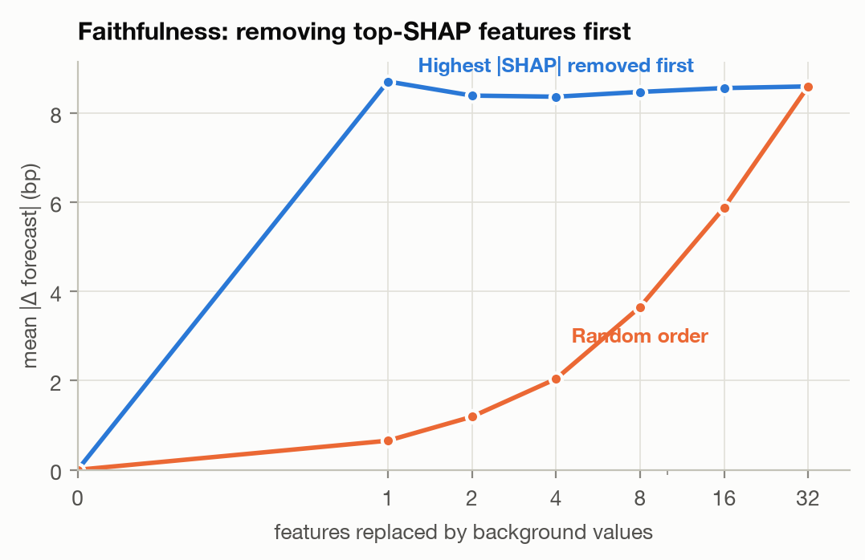
Figure 7.9 Faithfulness: forecast change when top-SHAP features and random features are removed
Table 7.8 Stability of the explanations
Comparison | Global ranking tau | Top-5 overlap | Per-stock-day rho
Five random seeds, same data | 0.85 | 92% | 0.86
2019 against 2020 model | 0.75 | 80% | 0.73
2020 against 2021 model | 0.44 | 100% | 0.57
2021 against 2022 model | 0.77 | 80% | 0.77

The explanations are stable to the random seed, with a forecast correlation between seeds of 0.99, but noticeably less stable to retraining. Once 2020 enters the training data, agreement with the previous year's model drops to tau 0.44. The top five features stay the same; the other 27 reorder. An explanation produced before the pandemic would not have survived it.
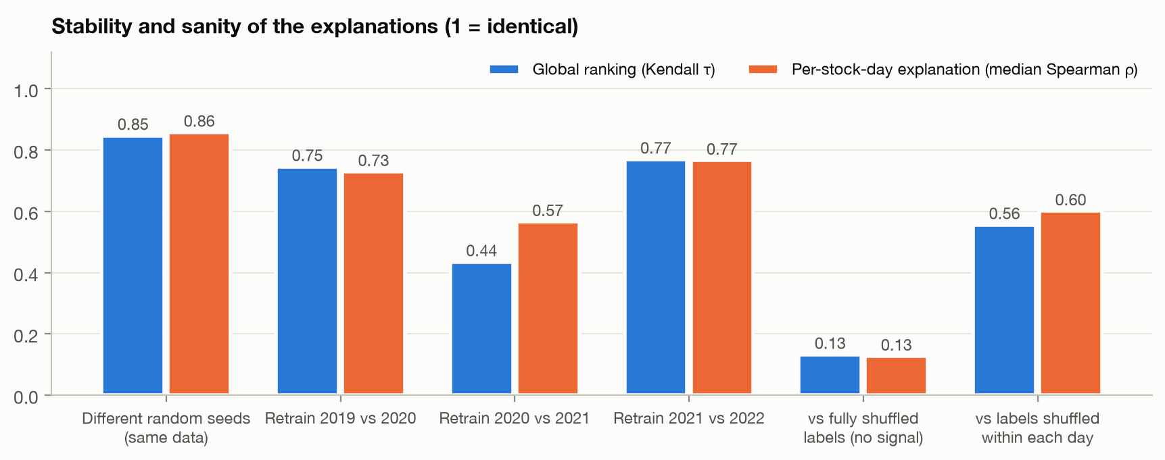
Figure 7.10 Stability across seeds and retraining, and comparison with no-signal models
7.4 RQ4: Regime and Sector Drift
Explanations drift significantly across market regimes: the mean pairwise total variation distance between family-share vectors is 0.054 against a permutation null of 0.017, giving p = 0.003.
Table 7.9 Share of SHAP attribution by feature family across market regimes
Family | Pre-COVID bull | COVID crash | Recovery | 2022 bear
Market and sector | 71.2% | 74.7% | 71.7% | 74.7%
Volatility | 5.1% | 5.9% | 8.3% | 9.2%
Past returns | 8.7% | 7.2% | 6.5% | 6.0%
Trend | 4.6% | 5.9% | 3.7% | 2.3%
Candle | 6.3% | 4.1% | 6.2% | 4.9%
Oscillators | 2.4% | 1.5% | 2.1% | 1.2%
Volume | 1.7% | 0.7% | 1.4% | 1.7%

Volatility's share nearly doubles from the pre-COVID bull to the 2022 bear, past returns fade, and trend peaks during the crash. The feature ranking reorders with them: rank correlation falls to 0.46 between the COVID crash and the 2022 bear, against 0.84 between the pre-COVID bull and the crash. The top three market features never change.
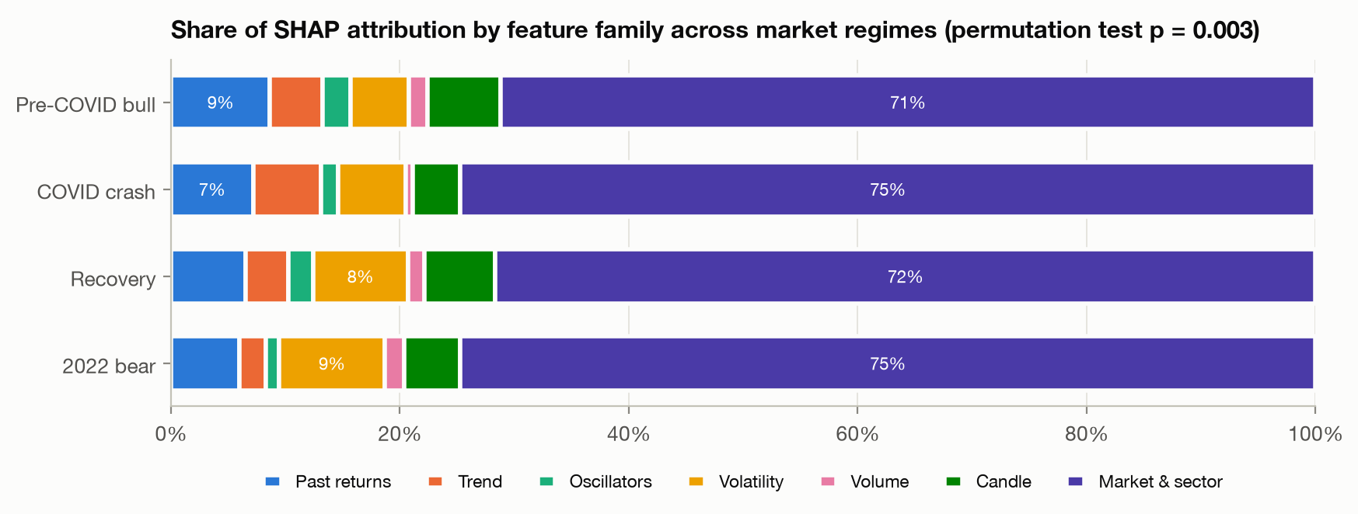
Figure 7.11 Share of SHAP attribution by feature family across market regimes
Sector drift is also significant but smaller, at a total variation distance of 0.036 against a null of 0.011, giving p = 0.001. Volatile sectors use more volatility features, with Energy at 10.4 per cent, Consumer Discretionary at 9.5 and Communication Services at 9.4. Defensive sectors rely more on market context, with Utilities at 76.1 per cent and Consumer Staples at 76.4, against Energy at 66.8.
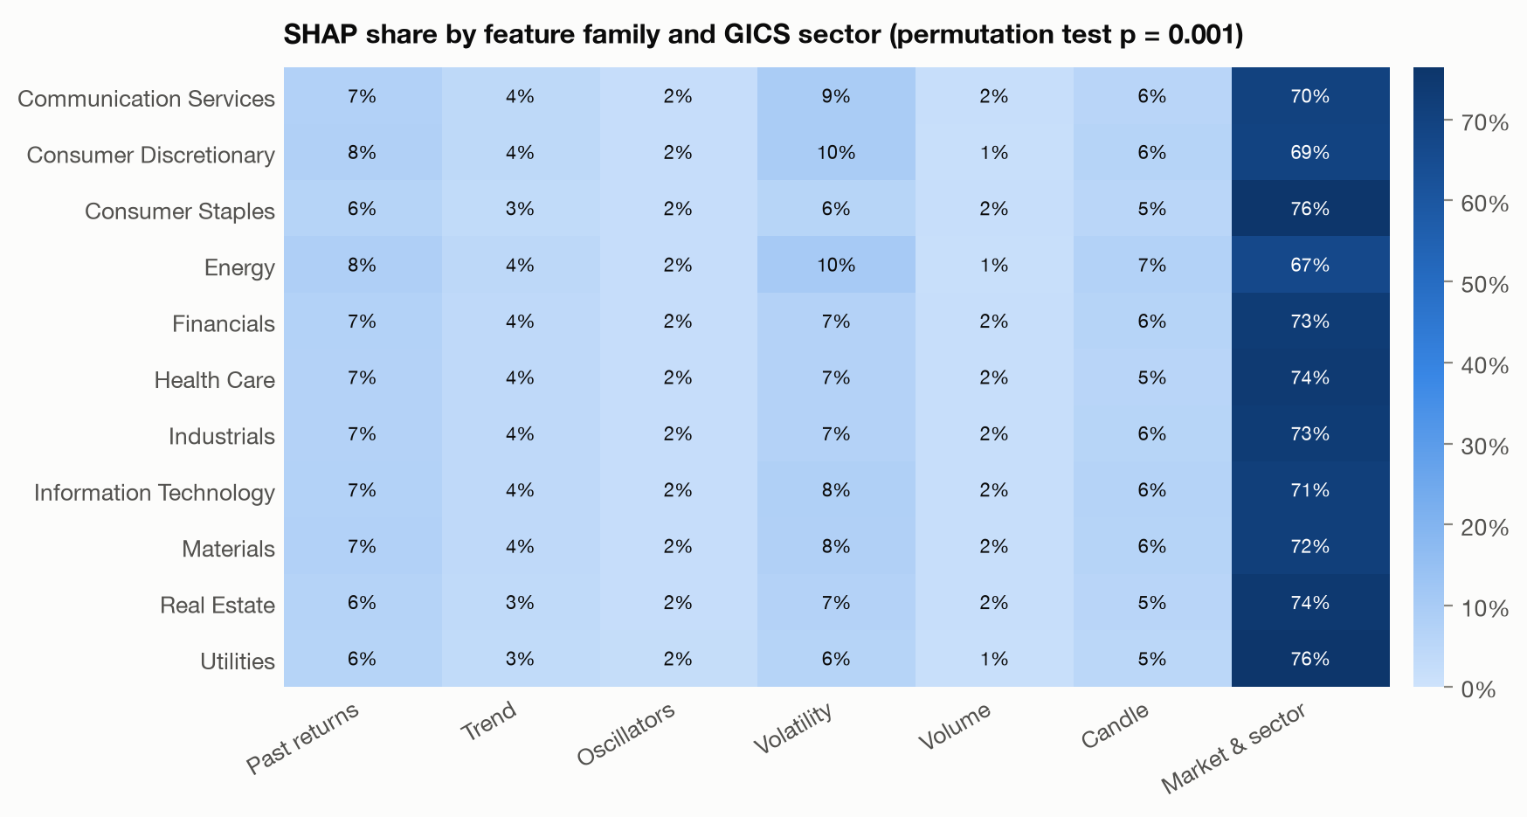
Figure 7.12 Share of SHAP attribution by feature family and GICS sector
7.5 RQ5: Sanity Against No-Signal Models
Table 7.10 Comparison with models trained on shuffled labels
Model trained on | Test IC | Total mean |SHAP| (bp) | Market share | tau vs real | Per-row rho
Real labels | +0.018 | 20.8 | 77.3% | - | -
Fully shuffled labels | -0.023 | 2.6 | 19.6% | 0.13 | 0.13
Labels shuffled within each day | +0.011 | 19.5 | 84.5% | 0.56 | 0.60

The explanations pass the sanity check. A model trained on fully shuffled labels, which by construction has no signal to learn, produces explanations eight times weaker and essentially unrelated to the real model's, at tau 0.13.
The second null is the more interesting one. Shuffling returns within each day destroys all stock-specific information while preserving the market-wide daily move. A model trained on that reproduces 94 per cent of the real explanation magnitude and tau 0.56 of its ranking. The real model's explanations are therefore mostly, though not entirely, about market-wide timing. Without this second null the first would have supported a stronger claim than the evidence allows.
7.6 RQ6: SHAP Against LIME
Table 7.11 Global agreement between four explainers, Kendall tau with top-5 overlap
 | LIME | Permutation importance | MDI
TreeSHAP | 0.58 (4/5) | 0.03 (3/5) | 0.69 (4/5)
LIME | - | 0.18 (3/5) | 0.65 (4/5)
Permutation importance | - | - | 0.15 (4/5)

Globally, SHAP and LIME agree moderately, sharing four of their top five features, and both agree with mean decrease in impurity more closely than with each other. All three disagree with permutation importance. Only four of the 32 features measurably improve accuracy, in the sense of a permutation importance more than two standard deviations above zero: market volatility, sector five-day return, Bollinger width and volume trend. Fifteen have negative permutation importance. The meaning is that SHAP and LIME describe what the model uses, not what improves accuracy, and those are different questions.
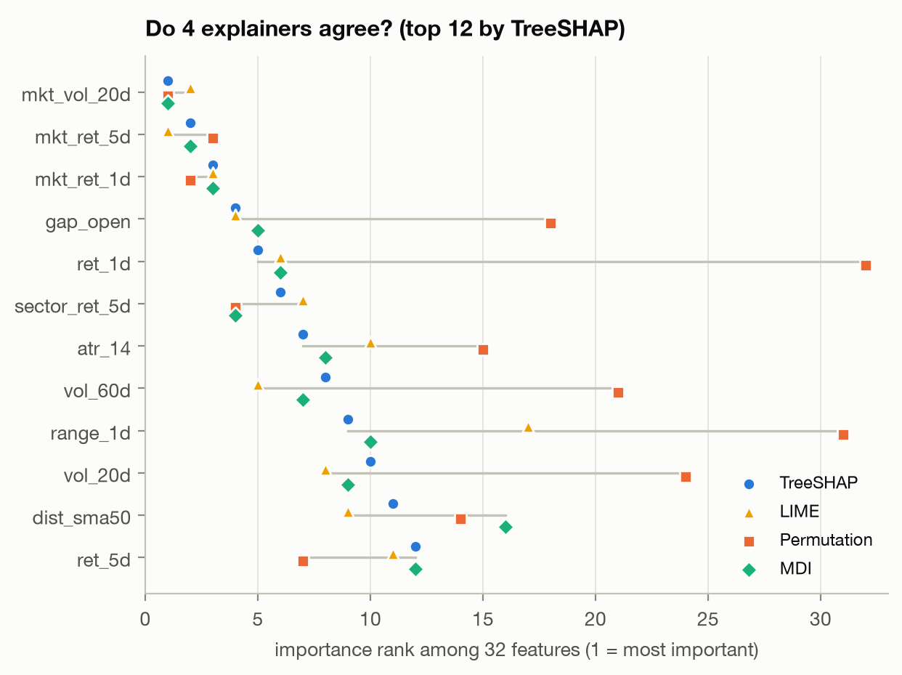
Figure 7.13 Feature importance ranks from TreeSHAP, LIME, permutation importance and MDI
Table 7.12 Reliability for individual forecasts, over 804 stock-days with five LIME seeds each
Measure | TreeSHAP | LIME
Agreement with the other method, median Spearman rho | - | 0.44
Agreement, top-5 feature overlap | - | 65%
Agreement, same top feature | - | 59%
Agreement, sign matches on SHAP's top five | - | 81%
Run-to-run stability, median rho between runs | 1.00 (deterministic) | 0.45
Run-to-run stability, top-5 overlap | 1.00 | 79%
Run-to-run stability, same top feature in all five runs | 100% | 96%
Local fit, surrogate R-squared | Exact by additivity | Median 0.17; 67% below 0.3
Faithfulness AOPC in bp, random order being 3.71 | 8.70 | 8.13
Faithfulness, |change| after removing the top feature, random being 0.56 bp | 8.89 | 6.53
Time per explanation | About 0.001 s | About 0.08 s

LIME is less reliable than SHAP for individual forecasts on three counts. Explaining the same forecast twice with different seeds gives feature rankings that correlate only 0.45. Its linear surrogate explains a median of just 17 per cent of the model's local behaviour, and two thirds of its explanations fall below an R-squared of 0.3. And on a typical forecast it shares only three of its top five features with SHAP.
Both methods are faithful, SHAP more so: both beat random ordering comfortably, but removing LIME's top feature changes the forecast 27 per cent less than removing SHAP's. The two can also contradict each other on the same forecast. For AAPL on 16 March 2020 they agree on the two main drivers, with a rho of 0.53. For JPM on 18 May 2022 they disagree on the direction of the top feature: market volatility pushes the forecast down according to SHAP and up according to LIME, with a rho of 0.19 and a LIME surrogate fit of 0.11. The cause is structural. LIME's discretised bins compare against the whole training distribution, while SHAP attributes along the model's own decision paths.
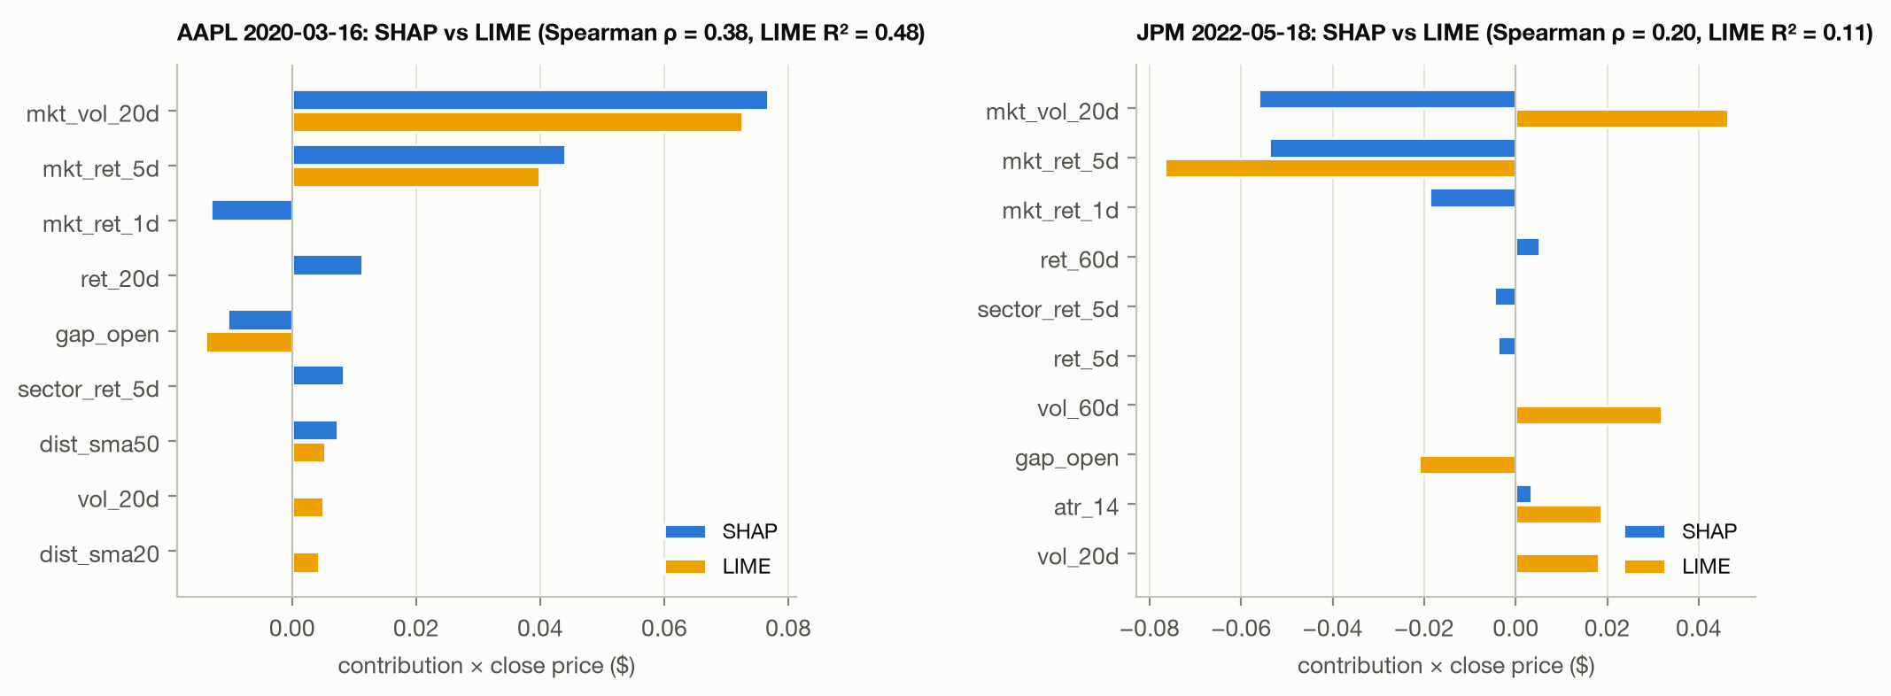
Figure 7.14 SHAP against LIME explanations for the same forecasts
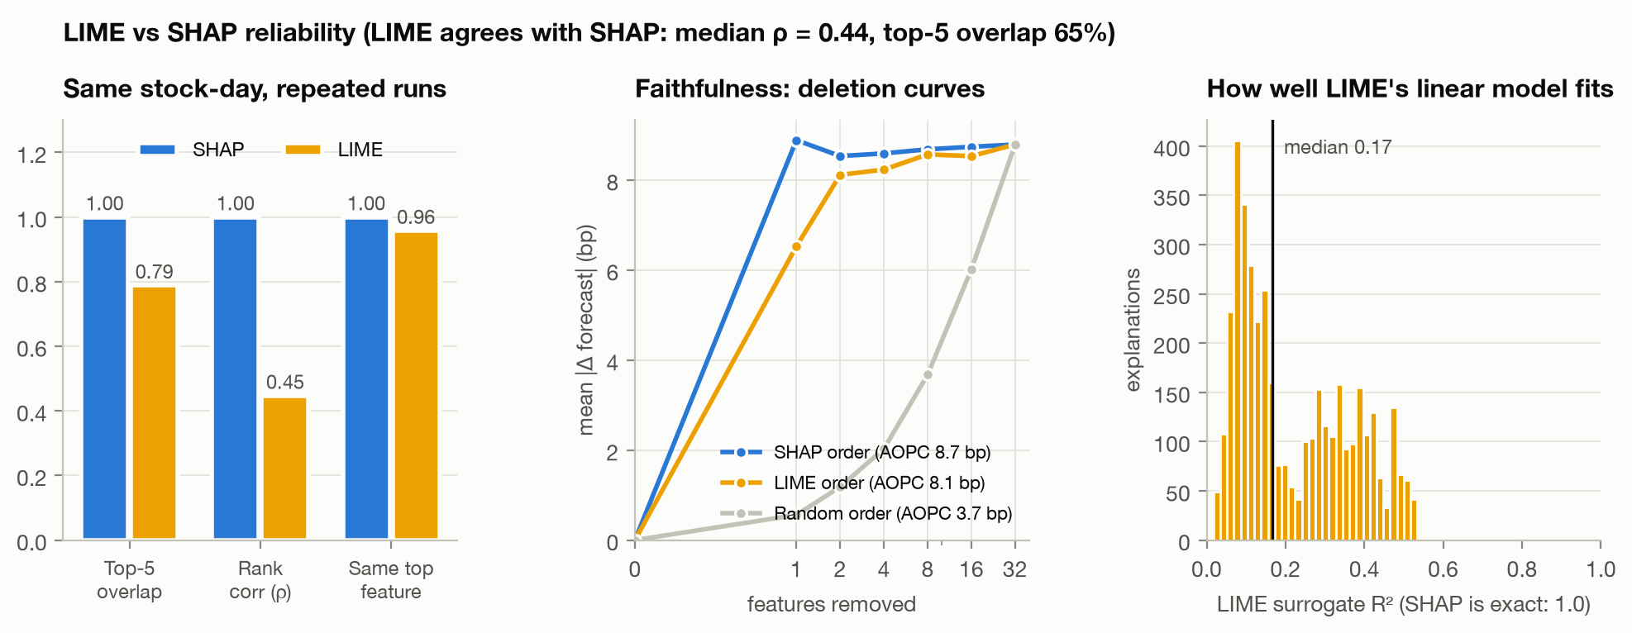
Figure 7.15 LIME against SHAP: run-to-run stability, faithfulness and local fit
7.7 Discussion
7.7.1 Score the Change, Not the Level
One set of forecasts scores an R-squared of 0.9994 on the price and plus 0.00013 on the return. The first number is a property of daily stock prices, matched exactly by naive persistence; only the second says anything about the model. The forecasts themselves vary by 10.8 basis points against a realised 245, which is the model correctly refusing to commit, and that refusal is what produces the flattering price figures. A price-level Random Forest with an R-squared of 0.993 is significantly worse than naive persistence in both spaces. Accuracy claims reported in price units without a persistence baseline cannot be interpreted at all. Return space also localises what little skill exists, to the 2020 to 2021 recovery, and reveals that the model inverted during the crash; neither fact is visible in the price-space numbers.
7.7.2 Faithful Does Not Mean the Market Insight Is Real
SHAP is faithful, seed-stable and passes the sanity check. Yet SHAP, LIME and mean decrease in impurity all disagree with permutation importance. The resolution is that explanations describe how the model computes its forecast, not which relationships actually predict prices. A faithful explanation of a model with no skill is a faithful explanation of nothing useful. Presenting SHAP or LIME rankings as market insight, as papers 1 and 3 do, conflates the two.
7.7.3 For Tree Models, Prefer SHAP to a Single LIME Run
LIME agrees with SHAP only moderately even globally, is unstable for individual forecasts, fits the local behaviour poorly, and can flip a feature's sign. A study reporting a single LIME explanation per case, as paper 3 does, risks reporting noise. The practical recommendation is to use TreeSHAP for tree models, which is exact and deterministic, and to keep LIME as a cross-check that is re-run several times before anything is concluded from it.
7.7.4 Explanations Are Period and Sector Specific
Regime drift at p = 0.003, sector drift at p = 0.001, and the fall in agreement after retraining on pandemic data together mean that an explanation from one period should not be generalised to another. This turns Pagliaro's qualitative regime observation into a formal test on 474 stocks.
7.8 Limitations
- Data. Price and volume only, with no news, fundamentals or macroeconomic inputs; the study panel ends in May 2022; and the 474 stocks were index constituents when the dataset was built, which is a survivorship bias.
- Explanation methods. TreeSHAP uses the path-dependent algorithm, and interventional SHAP could differ where features are correlated. LIME uses its default quartile discretisation and 5,000 samples; other settings could change its stability.
- The faithfulness test replaces features with values drawn from random training rows, which can create feature combinations that would not occur in the market.
- Regimes are calendar-defined, and the COVID crash contains only 23 trading days, so that regime's estimates are the least precise.
- The decile portfolio charges one flat ten basis point round-trip cost and ignores slippage, market impact, shorting costs and capacity, so the net figure of minus 1.8 basis points a day is an optimistic bound rather than a backtest.
- The live demonstration draws prices from a different vendor, covers the 431 survivors of the original 474, and scores nothing, because the outcomes do not exist yet. It evidences that the pipeline runs forward; it is not additional evidence of accuracy.
- Literature gaps are stated from abstracts and publicly available details, and should be verified against the full texts.
CHAPTER 8
8. CONCLUSION
8.1 Conclusion
This project built a walk-forward Random Forest forecaster for 474 S&P 500 stocks, measured it honestly, explained it with SHAP and LIME, and then tested whether those explanations could be trusted. The conclusions fall into three groups.
8.1.1 On Accuracy
The model predicts the next-day return with an out-of-sample R-squared of plus 0.00013, statistically indistinguishable from predicting no change at all, and a directional accuracy of 51.8 per cent, below the 52.8 per cent majority rule. Converted to prices, the identical forecasts read as 98.44 per cent accuracy with an R-squared of 0.9994, a figure naive persistence matches exactly. The decile ranking earns 8.2 basis points a day gross and loses money after a ten basis point trading cost. The headline accuracy figure quoted throughout this literature is, on this evidence, a property of daily stock prices rather than a result.
8.1.2 On the Explanations
- SHAP explanations are faithful, with a fidelity correlation of at least 0.98 and a 13-fold separation from random deletion, and stable to the random seed at tau 0.85.
- They are clearly different from the explanations of a model with no signal, but a model that can learn only market-wide timing reproduces 94 per cent of their magnitude, so they are mostly about market context.
- They drift significantly across market regimes and sectors, and after retraining on pandemic data.
- LIME agrees with SHAP only moderately even globally, is unstable between runs at rho 0.45, fits the model poorly at a median surrogate R-squared of 0.17, and names a different top feature on 41 per cent of forecasts.
- Neither method identifies the features that actually improve accuracy, which is a different question from the one either method answers.
8.1.3 On the Audit Itself
The audit found a defect in the audit tool. LimeTabularExplainer binds its random state at construction, so the natural usage pattern of reassigning that attribute between runs leaves repeats non-identical, at a measured rho of 0.46 to 0.53 where it should be exactly 1.000. Correcting it moved the headline SHAP-LIME agreement from tau 0.73 down to tau 0.58. A reliability study that does not check its own tooling can report the inflated figure without ever seeing the problem.
Finally, the pipeline runs forward. The same features, hyperparameters and explanation code produce next-session forecasts for 431 currently traded stocks, explained and audited at request time. This demonstrates that no step depends on knowing the outcome. It does not improve the accuracy reported above, and the system says so on the page.
8.2 Recommendations for Stock-Forecasting Studies
1. Benchmark accuracy against naive persistence, and report the benchmark's score beside the model's.
2. Report skill in return space, and treat price-level R-squared and accuracy percentages as descriptive statistics of the price series rather than as results.
3. Prefer TreeSHAP to single LIME runs for tree models, and re-run LIME several times before drawing any conclusion from it.
4. Test explanations for faithfulness, stability, sanity and regime drift before reading them as market insight.
5. Seed and verify the explanation tooling itself, because a defect there is indistinguishable from a finding.
8.3 Future Work
- Extend the audit to interventional SHAP, which handles correlated features differently from the path-dependent algorithm used here, and compare the two rankings on the same forecasts.
- Replace the random-background deletion test with one that samples feature values conditionally, so that the perturbed inputs remain plausible market states.
- Apply the same five-part audit to a gradient-boosted model and to a neural forecaster, to establish whether the reliability ordering between SHAP and LIME is a property of the explainers or of the model family.
- Define market regimes by a fitted change-point or hidden Markov model rather than by calendar boundaries, which would remove the dependence on hindsight in regime selection.
- Extend the feature set to news and fundamental data, and test whether explanation drift across regimes narrows once the model has access to the information that drives those regimes.
- Accumulate the live forecasts over a sustained period so that, in time, the forward-running pipeline produces a scored out-of-sample record of its own.
CHAPTER 9
9. REFERENCES
[1] S. Indra, S. Supian, Sukono, R. Riaman, M. P. A. Saputra, A. S. Azahra, and D. I. Pirdaus, "Stock return prediction on the LQ45 market index in the Indonesia Stock Exchange using a machine learning algorithm based on technical indicators," Journal of Risk and Financial Management, vol. 18, no. 12, 714, 2025. doi: 10.3390/jrfm18120714.
[2] J. Lee and L. Cai, "Comparing model-specific and model-agnostic feature importance methods using machine learning with technical indicators: A NASDAQ sector-based study," Machine Learning with Applications, 2025. doi: 10.1016/j.mlwa.2025.100799.
[3] K. W. Manikrao, S. Allagi, W. Y. Leong, and M. Laddi, "An explainable AI for stock market prediction: A machine learning approach with XAI and deep neural networks," Journal of Computational and Cognitive Engineering, 2025. doi: 10.47852/bonviewjcce52026428.
[4] A. Pagliaro, "Regime-aware LightGBM for stock market forecasting: A validated walk-forward framework with statistical rigor and explainable AI analysis," Electronics, vol. 15, no. 6, 1334, 2026. doi: 10.3390/electronics15061334.
[5] Y. Song, W. Cho, S. I. Han, and J. Yoo, "Attention integration strategies in MLP-based stock movement prediction: Effects on performance, stability, and interpretability," Electronics, vol. 15, no. 17, 3942, 2026. doi: 10.3390/electronics15173942.
[6] L. Breiman, "Random forests," Machine Learning, vol. 45, no. 1, pp. 5-32, 2001. doi: 10.1023/A:1010933404324.
[7] S. M. Lundberg, G. Erion, H. Chen, A. DeGrave, J. M. Prutkin, B. Nair, R. Katz, J. Himmelfarb, N. Bansal, and S.-I. Lee, "From local explanations to global understanding with explainable AI for trees," Nature Machine Intelligence, vol. 2, pp. 56-67, 2020. doi: 10.1038/s42256-019-0138-9.
[8] M. T. Ribeiro, S. Singh, and C. Guestrin, "Why should I trust you? Explaining the predictions of any classifier," in Proc. 22nd ACM SIGKDD International Conference on Knowledge Discovery and Data Mining (KDD), 2016, pp. 1135-1144. doi: 10.1145/2939672.2939778.
[9] F. X. Diebold and R. S. Mariano, "Comparing predictive accuracy," Journal of Business and Economic Statistics, vol. 13, no. 3, pp. 253-263, 1995. doi: 10.1080/07350015.1995.10524599.
[10] J. Adebayo, J. Gilmer, M. Muelly, I. Goodfellow, M. Hardt, and B. Kim, "Sanity checks for saliency maps," in Advances in Neural Information Processing Systems (NeurIPS), 2018, pp. 9505-9515.
[11] T. T. Huynh, M. H. Nguyen, T. T. Nguyen, P. L. Nguyen, M. Weidlich, Q. V. H. Nguyen, and K. Aberer, "Efficient integration of multi-order dynamics and internal dynamics in stock movement prediction," in Proc. 16th ACM International Conference on Web Search and Data Mining (WSDM), 2023, pp. 850-858. doi: 10.1145/3539597.3570427.
[12] J. Fan and Y. Shen, "StockMixer: A simple yet strong MLP-based architecture for stock price forecasting," in Proc. AAAI Conference on Artificial Intelligence, vol. 38, 2024, pp. 8389-8397. doi: 10.1609/aaai.v38i8.28681.
[13] F. Pedregosa, G. Varoquaux, A. Gramfort, V. Michel, B. Thirion, O. Grisel, M. Blondel, P. Prettenhofer, R. Weiss, V. Dubourg, J. Vanderplas, A. Passos, D. Cournapeau, M. Brucher, M. Perrot, and E. Duchesnay, "Scikit-learn: Machine learning in Python," Journal of Machine Learning Research, vol. 12, pp. 2825-2830, 2011.
[14] W. K. Newey and K. D. West, "A simple, positive semi-definite, heteroskedasticity and autocorrelation consistent covariance matrix," Econometrica, vol. 55, no. 3, pp. 703-708, 1987. doi: 10.2307/1913610.
APPENDIX A - SAMPLE CODE
The complete source is 3,249 lines across 13 modules, available in the project repository. The four excerpts below are the passages on which the project's claims depend; each is reproduced exactly as it runs.
Feature Construction, Showing Leakage Control
Features are built on wide tables indexed by date and ticker, so every backward shift is explicit and inspectable. The targets are produced by shifting forward, which is the only place in the pipeline where a future value is referenced at all. From features.py.
def build(panel):
wide = {c: panel.pivot(index="date", columns="ticker", values=c)
for c in ("open", "high", "low", "close", "volume")}
o, h, l, c, v = (wide[k] for k in ("open", "high", "low", "close", "volume"))
logc = np.log(c)
r1 = logc.diff()
f = {}

for n in (1, 2, 5, 10, 20, 60):
f[f"ret_{n}d"] = logc.diff(n)
for n in (5, 20, 50, 200):
f[f"dist_sma{n}"] = c / c.rolling(n, min_periods=n).mean() - 1
...
# Targets: next trading day's log return and close price.
next_ret = logc.shift(-1) - logc
next_close = c.shift(-1)

The Faithfulness Test
This is the function on which the project's central argument rests. It replaces the top k features by absolute SHAP with values drawn from background rows, measures how far the forecast moves, and does the same for a random ordering as a control. The fidelity term additionally checks that the SHAP mass removed predicts the size of the change. From explain.py.
def deletion_curves(model, X, sv, background):
"""Mean |f(x) - f(x with k features replaced by background values)|, in basis
points, removing features by |SHAP| rank ('top') or in random order."""
n, p = X.shape
base = model.predict(X)
order_top = np.argsort(-np.abs(sv), axis=1)
order_rand = np.array([rng.permutation(p) for _ in range(n)])
curves = {"top": [], "random": []}
fidelity = []
for k in K_STEPS:
for name, order in (("top", order_top), ("random", order_rand)):
Xk = np.repeat(X, len(background), axis=0)
bg = np.tile(background, (n, 1))
rows = np.repeat(np.arange(n), len(background))
cols = order[rows][:, :k]
Xk[np.arange(len(Xk))[:, None], cols] = bg[np.arange(len(Xk))[:, None], cols]
removed = model.predict(Xk).reshape(n, len(background)).mean(1)
change = base - removed
curves[name].append(float(1e4 * np.abs(change).mean()))
if name == "top":
shap_removed = np.take_along_axis(sv, order_top[:, :k], axis=1).sum(1)
fidelity.append(float(np.corrcoef(shap_removed, change)[0, 1]))
aopc = {k: float(np.mean(v[1:])) for k, v in curves.items()}
return {"k": K_STEPS, "abs_change_bp": curves, "AOPC_bp": aopc,
"fidelity_corr": dict(zip(K_STEPS[1:], fidelity))}

Reproducible LIME
A fresh explainer is constructed for every seed, which is the fix for the defect described in Section 5.3.3. From lime_explain.py.
def make_explainer(reference, seed):
"""A fresh explainer per seed: LimeTabularExplainer binds its RandomState into
the discretiser and the solver at construction, so reassigning .random_state on
a reused explainer does not make repeats reproducible."""
return LimeTabularExplainer(reference, feature_names=FEATURES, mode="regression",
discretize_continuous=True, random_state=seed)

def lime_weights(reference, x, predict, seed):
exp = make_explainer(reference, seed).explain_instance(
x, predict, num_features=len(FEATURES), num_samples=5000)
w = np.zeros(len(FEATURES))
for j, weight in exp.as_map()[0]:
w[j] = weight
return w, exp.score

The Live Forecasting Guard
The assertion that prevents a hindsight value from being presented as a forecast. From live.py.
df = df.dropna(subset=FEATURES + ["close"]) # NOT on the target: the last day has none
train = df.dropna(subset=["target_ret"]) # train on every day with a known outcome
live = df[df.date == last_day].copy() # forecast the one day with no outcome
assert live.target_ret.isna().all(), \
"the last day already has a known outcome - rerun after the close"

