**PRACTISE and HOMEWORK EXERCISE 3**

LOOP in VBA and more

**QUESTION 1:** Design the UI as below

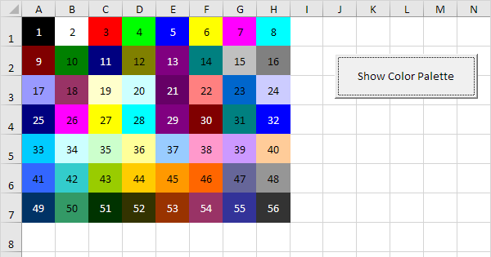

**Requirements:** Click the **Show Color Palette** button, then display the colors corresponding to the color codes of the cells

**QUESTION 2:** Design the UI as below

**Requirements:** Write the code for buttons that will highlight the numbers required by the label of buttons.

**QUESTION 3:** Design the UI as below

**Request:**

* Write a function for the button ***See Who Failed***: highlight the student's first and last name whose test score is below 5.0, reset returns the un-highlighted state.
* Write a function that reads scores into letter scores; read 2 digits; Fill in the Letter Score column
* Write a function to calculate what year students are, fill in the corresponding column

**QUESTION 4:** Design the UI as below

**Requirements:** Write a function for the button, which will calculate the required sum with the corresponding ***n*** entered.

**QUESTION 5:** Design the UI as below

**Requirements:** Write a function for a button that will read a 2-digit integer in Vietnamese and English

**QUESTION 6:** Similar to question 5, read 3-digit integers

**QUESTION 7:** Similar to question 5, read 4-digit integers