What an attrition model is worth: evaluation protocol, not algorithm choice, determines reported performance in HR analytics
Author names withheld for review
Affiliations withheld for review

Abstract
Employee attrition prediction has become a standard application of machine learning in human resource analytics, and published accuracies are high: minority-class F1 scores above 0.9 are routine. We show that on the datasets these studies use, such scores are not attainable under a correctly specified evaluation, and that the gap is explained by a single, widespread and easily corrected protocol error - applying synthetic over-sampling to the whole dataset before splitting it into training and test sets. On 6 public employee-turnover datasets, seven classifier families, four over-sampling methods and ten random seeds, we fit each model three ways while holding everything else fixed. Resampling before the split raises minority-class F1 by 0.235 on average (95% CI 0.226 to 0.244), lifting it from an honest 0.591 to 0.826. How large the inflation is depends almost entirely on how imbalanced the workforce is (r = 0.919 across datasets): on a near-balanced dataset it is 0.003 and effectively harmless, while on the IBM benchmark, whose imbalance is typical of real attrition data, it is 0.443 - it multiplies the reported F1 by 2.02. That is the practical finding: the error is largest exactly where attrition data actually sits. Under the correct protocol, mean F1 across these datasets ranges from 0.434 to 0.740 - a useful triage tool, not a solved problem. We set out what an HR analytics team should require of an attrition model, what a realistic performance expectation looks like, and why a headline F1 near 0.9 on an attrition dataset should prompt a question about the pipeline rather than a purchase decision.
Keywords: HR analytics; employee attrition; turnover prediction; class imbalance; SMOTE; model evaluation; data leakage

1 Introduction
Predicting which employees will leave is one of the few HR problems with a clean supervised-learning formulation, and the literature has grown quickly around a small number of public datasets [1]. The reported results are impressive. Studies on the IBM HR benchmark, a dataset of 1,470 employees of whom 237 left, have recently reported minority-class F1 scores of 0.99 and above [2, 3].
A practitioner reading that literature would reasonably conclude that attrition is largely a solved prediction problem, and that the remaining work is deployment. This paper argues that the conclusion does not follow, and that the reason has nothing to do with which algorithm anyone chose.
Attrition datasets are imbalanced: leavers are the minority, typically between a tenth and a fifth of the workforce. The standard response is synthetic over-sampling, usually SMOTE, which manufactures additional minority cases by interpolating between real ones. Applied correctly, the over-sampler sees only the training data. Applied to the whole dataset before the split, it manufactures near-copies of employees who then end up on both sides of the split - so the model is asked, at test time, about people it has effectively already met.
The error is old news as a matter of principle. What has not been available to this field is a measurement of how much it changes the answer on the exact datasets the field uses, and therefore of what an honest performance expectation looks like. That is what this paper supplies.
We fit seven classifier families on 6 public employee-turnover datasets, with four over-samplers, ten seeds, and three evaluation protocols that differ only in where the resampler sits. The datasets span workforces from 1.02-to-1 to 7.42-to-1 imbalance and include the IBM benchmark, a second corporate case study, a healthcare workforce, a technology-sector job-change dataset of nearly twenty thousand records, a Russian turnover dataset and survey data from 1,191 private-sector employees in Saudi Arabia [4]. That last one matters: it is primary survey data rather than a re-publication of a synthetic corporate extract, and it is the closest thing the field has to a check that findings on the IBM benchmark are not artefacts of that benchmark's construction.
Three findings follow, and each has a direct managerial reading.
- Reported performance in this literature is dominated by evaluation protocol, not by algorithm choice. Moving the resampler across the split changes minority-class F1 by 0.235; the spread between the best and worst of the seven model families, correctly evaluated, is 0.129.
- Under a correct protocol, attrition prediction on these datasets is a moderate problem, not a solved one. Honest F1 ranges from 0.434 to 0.740 depending on the dataset.
- The damage is concentrated where real attrition data sits. The premium tracks the imbalance ratio at r = 0.919: near-balanced datasets are barely affected, and the datasets with realistic leaver proportions are affected most.

2 Background

2.1 Why attrition data is imbalanced, and what is usually done about it
Annual voluntary turnover in most organisations runs between five and twenty per cent, so any dataset labelled at the employee-year level has a minority class of that size. Classifiers trained on such data tend to predict the majority class, and the standard remedy in the applied literature is to rebalance the training data with SMOTE [5] or one of its variants [6, 7].
Whether rebalancing helps at all is contested well outside HR analytics. Blagus and Lusa [8] showed it is largely ineffective in high dimensions. Van den Goorbergh and colleagues [9] showed that imbalance corrections destroy the calibration of clinical risk models - they make predicted probabilities wrong - while leaving discrimination unchanged, and Carriero and colleagues [10] confirmed this for machine learning models by simulation. Elor and Averbuch-Elor [11] found no benefit from balancing for strong, properly tuned classifiers, though weaker learners still gain from it. Calibration is not a technicality for HR use: a retention budget allocated from a model that says an employee has a 70 per cent chance of leaving, when the true figure is 20 per cent, is misallocated in proportion to the error.

2.2 The protocol error
Separately from whether to resample, there is the question of when. SMOTE creates a synthetic minority case by interpolating between a real minority case and one of its neighbours. Do this before splitting, and a synthetic employee that is nine-tenths a copy of employee A can end up in training while employee A ends up in the test set. The model does not need to generalise to A. It needs to remember the copy. The error is catalogued in the general leakage literature [12, 13] and was shown to inflate published results in perinatal medicine [14].
Within HR analytics the issue has begun to surface. Cavescu and Popescu [15] recently proposed a leakage-free evaluation protocol for attrition prediction, applying SMOTE strictly within cross-validation folds on the IBM benchmark, and reported a cross-validated F1 of 0.439 for logistic regression - a figure far below the field's headline numbers. Alyousef and colleagues [16], also on the IBM benchmark and also stating that resampling was confined to the training data, report 0.5042. Neither study measures how large the difference is, because neither runs both protocols.

3 Data and method

3.1 Datasets
We use 6 public employee-turnover datasets, listed in Table 1. Each is harmonised the same way: identifier and constant columns dropped, nominal fields one-hot encoded, numeric fields median-imputed, and the minority class coded as positive. No feature selection is performed, because feature selection carried out on the full dataset is itself a leakage mechanism and we did not want to confound one with another.
Table 1. The employee-turnover datasets. Feature counts are after one-hot encoding. The job-change dataset was stratified-subsampled to 5,000 records to keep the factorial tractable; class balance is unchanged.
Dataset | Employees | Features | Leavers | Imbalance ratio
turnover_russia | 1129 | 50 | 558 | 1.02
saudi_attrition | 1191 | 100 | 515 | 1.31
job_change_ds | 5000 | 62 | 1247 | 3.01
hr_case_study | 4410 | 33 | 711 | 5.20
ibm_hr | 1470 | 44 | 237 | 5.20
healthcare_attr | 1676 | 40 | 199 | 7.42

3.2 Three protocols, one difference
Every comparison holds the dataset, the encoding, the classifier, its hyperparameters, the over-sampler, the split proportion and both random seeds fixed. The only thing that changes is where the over-sampler sits:
- leaked - over-sample the whole dataset, then split 70:30;
- correct - split 70:30, then over-sample the training partition only;
- none - split 70:30 and do not over-sample.
Because nothing else differs, any difference in the reported score is attributable to that position alone. This is worth emphasising for a management readership: the comparison here is not between methods, and no method is being criticised. It is between two ways of measuring the same method.

3.3 Models, metrics and scale
Seven classifier families are used - logistic regression, a decision tree, 5-nearest neighbours, an RBF support vector machine, a random forest, gradient boosting and XGBoost - with library defaults, and four over-samplers: SMOTE, Borderline-SMOTE, ADASYN and random over-sampling. Ten random seeds allow every figure to carry a confidence interval. We report minority-class F1 because it is what this literature reports, and check the conclusions against Matthews correlation and average precision, which behave better under imbalance.
These datasets are part of a larger corpus of 41 problems analysed in a companion methodological study, which asks the general question of what governs the size of the effect; the present paper is confined to the HR datasets and to what an HR analytics function should do about it.

4 Results

4.1 How much the protocol is worth
Across the HR datasets, over-sampling before the split raises minority-class F1 by 0.235 on average, with a 95% confidence interval of 0.226 to 0.244. Mean F1 goes from 0.591 under the correct protocol to 0.826 under the leaked one.
To put that in the terms this literature uses: the protocol is worth 0.235 of F1, while the gap between the best and worst of the seven algorithm families - correctly evaluated, averaged over datasets, over-samplers and seeds - is 0.129. A study that changes its evaluation protocol moves its headline number nearly twice as far as a study that changes its algorithm. Since papers compete on the headline number, this is a problem the field has an incentive not to notice.
Table 2. Minority-class F1 by dataset and protocol, averaged over seven classifiers, four over-samplers and ten seeds. 'Premium' is leaked minus correct, with a bootstrap 95% interval. The premium rises steeply with the imbalance ratio, which is the point of Section 4.2.
Dataset | IR | No resampling | Correct | Leaked | Premium | CI low | CI high
turnover_russia | 1.02 | 0.6244 | 0.6277 | 0.6303 | 0.0026 | -0.0024 | 0.0077
saudi_attrition | 1.31 | 0.7332 | 0.7395 | 0.7855 | 0.0460 | 0.0419 | 0.0501
job_change_ds | 3.01 | 0.4478 | 0.5433 | 0.7989 | 0.2557 | 0.2481 | 0.2630
hr_case_study | 5.20 | 0.5057 | 0.6411 | 0.8807 | 0.2396 | 0.2268 | 0.2520
ibm_hr | 5.20 | 0.3506 | 0.4342 | 0.8767 | 0.4425 | 0.4322 | 0.4523
healthcare_attr | 7.42 | 0.5101 | 0.5677 | 0.9349 | 0.3672 | 0.3588 | 0.3754

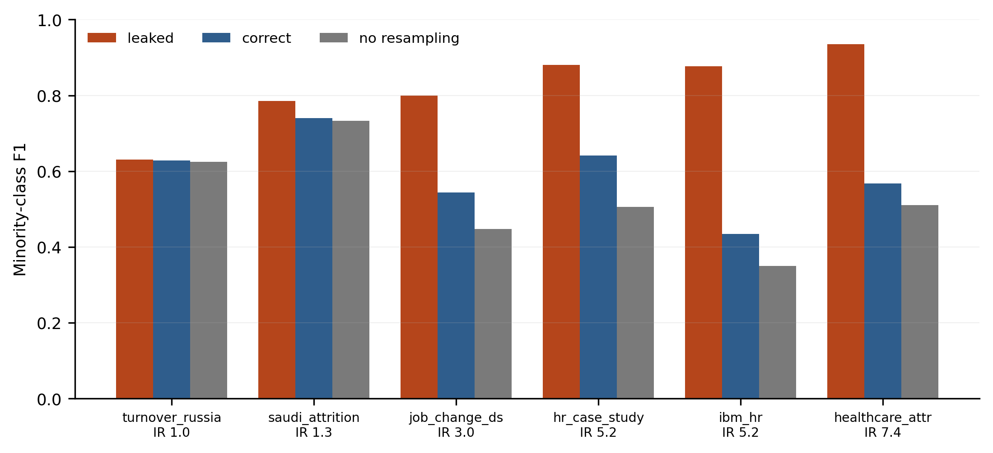
Figure 1. The three protocols on each employee-turnover dataset, averaged over all classifiers, over-samplers and seeds. Datasets are ordered by imbalance ratio. On the two near-balanced datasets at the left the three protocols agree; as the leaver proportion falls, the leaked bar detaches from the other two and the gap widens to a factor of 2.02 on the IBM benchmark.

4.2 The damage is concentrated where real attrition data sits
Table 2 and Figure 1 show that the premium is not spread evenly. It runs from 0.0026 on turnover_russia, which is close to balanced, to 0.4425 on ibm_hr. Across the six datasets the premium tracks the imbalance ratio at r = 0.919: how much a protocol error is worth is almost fully determined by how rare leavers are in the data.
The mechanism explains it. The more imbalanced the workforce, the more synthetic employees an over-sampler has to manufacture to balance the data, and so the more of the test set is present in the training partition as an interpolation. On a dataset where leavers are already half the sample, the over-sampler barely does anything and the error barely matters. On a dataset with a realistic attrition rate, it does a great deal.
Figure 2 puts the six datasets in the context of the wider benchmark corpus, and the placement inverts what looks like reassuring news. The employee-turnover datasets sit at the mild end of the imbalance range compared with general machine-learning benchmarks, and one might expect the error to matter less here. The opposite holds within the domain: the datasets that most resemble a real workforce are the ones where the protocol matters most. On the IBM benchmark the leaked protocol returns 2.02 times the honest score - not an increment, a multiple.
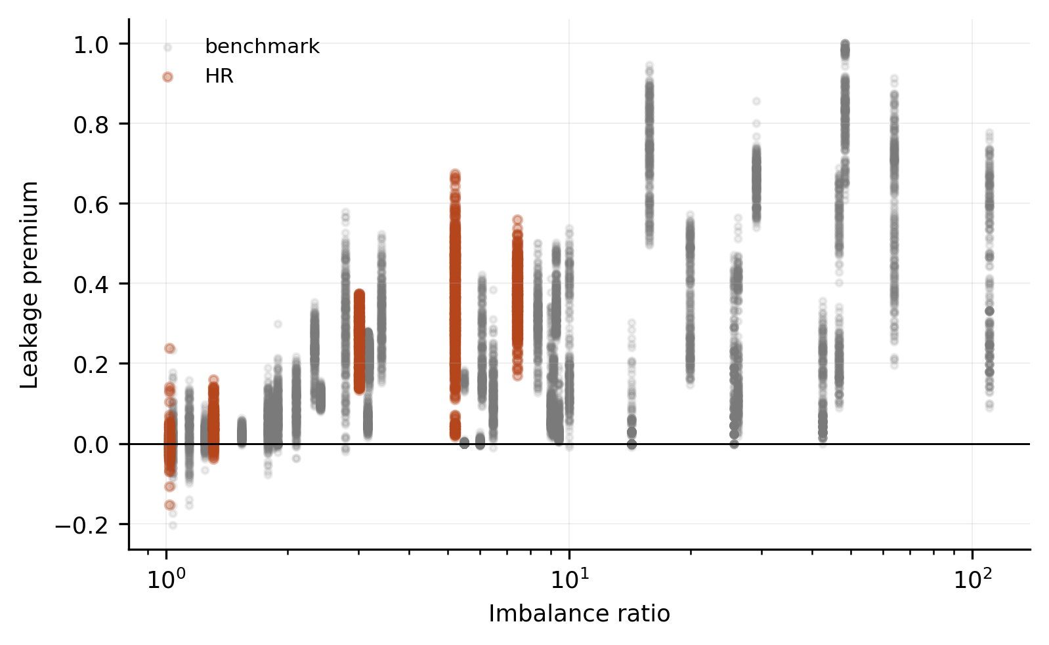
Figure 2. The HR datasets against the wider benchmark corpus. Each point is one matched comparison and the horizontal axis is the imbalance ratio. Within the HR range the premium climbs steeply with imbalance, which is why the datasets that most resemble a real workforce are the ones the protocol error damages most.

4.3 Whether to resample at all
The 'no resampling' column of Table 2 answers a question the literature usually skips, and on these datasets the answer favours resampling. Correctly-ordered resampling beat the no-resampling baseline on all 6 datasets, by -0.064 on average, and the baseline won only 20.2% of matched comparisons.
That is a narrower result than the wider benchmark literature would predict, and it is worth being precise about why. Across the full corpus of 41 datasets in the companion study, no resampling beat correctly-ordered resampling in 34.7% of matched comparisons; the sceptical case against rebalancing is strongest at high imbalance and in high dimensions, and the HR datasets are at neither extreme. On employee-turnover data of this kind, resampling the training partition is a modest but real improvement.
The recommendation therefore is not to stop resampling. It is to report the baseline. It costs one extra run, it is what makes the rebalancing step defensible, and on other workforces - a large organisation with a two per cent attrition rate, say - it may well be the winner.

4.4 What honest performance looks like, dataset by dataset
On the IBM benchmark, the dataset most of this literature uses, our correctly evaluated mean F1 is 0.434 and the no-resampling baseline is 0.351; the leaked protocol returns 0.877. Independent studies that state they confined resampling to the training data report 0.439 [15] and 0.5042 [16] on the same data with a single tuned model, which brackets our untuned average across seven families. Studies that do not state their ordering report between 0.659 and 0.990 [17, 3, 2].
Table 3 collects these figures. We are not in a position to say that any individual study is wrong, and we do not say it. Several innocent explanations exist for a high reported number: a macro-averaged F1 reported without qualification, different preprocessing, different splits. But a reader cannot distinguish between those explanations and a protocol error, because the information needed to distinguish them is usually not in the paper. That is the finding an HR analytics reader should take away: the published figures cannot currently be used to set an expectation, and the fix is a single sentence in a methods section.
Table 3. Reported minority-class F1 in recent employee-attrition studies, grouped by what each paper states about where resampling sits relative to the split. Values are as reported by the authors for the model they nominate as best. 'Not stated' means the paper does not describe the ordering; it is not a claim that the study is incorrect.
Study | Venue | Dataset | Best model | Reported F1 | Stated protocol
Hamja et al. (2025) | Annals of Data Science | IBM HR | GradientBoosting | 0.9900 | not stated
Nassreddine et al. (2026) | Computers | IBM HR | Ensemble (ROS) | 0.9774 | not stated
Baydili & Tasci (2025) | Systems | IBM HR | GAN-Transformer | 0.9158 | before-split
AL-Ali et al. (2026) | Scientific Reports | IBM HR | AdaBoost | 0.7969 | not stated
AL-Ali et al. (2026) | Scientific Reports | Job change | HistGradientBoosting | 0.6594 | not stated
Alyousef et al. (2026) | Information | IBM HR | LogisticRegression | 0.5042 | train-only
Cavescu & Popescu (2026) | Information | IBM HR | LogisticRegression | 0.4390 | train-only

5 What this means for HR analytics practice

5.1 For teams commissioning or buying a model
The five questions below can be asked of any vendor or internal team, require no technical background to ask, and cannot be answered evasively without that being obvious.
- Was the test set built before or after any rebalancing? The answer should be 'before'. If the answer is unclear, the reported number cannot be interpreted.
- Does the test set contain any synthetic employees? It should not. A test set is a sample of people, not of interpolations.
- What does the model score without rebalancing? If nobody has run it, the rebalancing step has not been justified.
- How many leavers are in the data, not what percentage? A 5 per cent minority of 20,000 employees and of 300 employees are different problems, and the second one usually cannot support a reliable model.
- Are the predicted probabilities calibrated, and was calibration checked after rebalancing? Rebalancing systematically inflates predicted probabilities, which matters whenever the output drives a budget.

5.2 A realistic expectation
Here is what the honest numbers mean in operational terms. Averaged over the six datasets and all seven model families, a correctly evaluated model recalls 0.639 of leavers at a precision of 0.584: roughly three in five of the people it flags do leave, and it finds roughly three in five of those who do. Per-dataset recall runs from 0.467 to 0.756. Ranking quality is better than the thresholded numbers suggest - ROC-AUC averages 0.808 and average precision 0.620 - which is the useful property, because a retention programme works from a ranked list rather than from a yes/no label.
For comparison, the leaked protocol reports precision 0.821 and recall 0.835 on the same data with the same models. An HR director shown those figures would reasonably plan for a system that catches five leavers in six and is right four times in five. The deployed system will catch three in five and be right three times in five. The distance between those two operating pictures is the practical cost of the error.
This is not a counsel of despair. A model with an ROC-AUC near 0.808 concentrates risk substantially relative to a random sample of the workforce, and the business case for retention programmes rarely depends on individual-level certainty. The problem with the inflated numbers is not that they are optimistic but that they set an expectation no deployed system can meet, which is how analytics functions lose credibility after a launch.

5.3 For authors and reviewers in this field
Report where the resampler sits. Report the number of leavers, not only the percentage. Report the no-resampling baseline. Report calibration. None of these requires additional data collection, and together they would make the published literature interpretable in a way it currently is not.

5.4 Limitations
- Six datasets is a small sample of workforces, all public, none of them a large contemporary enterprise HRIS extract. The imbalance ratios run from 1.02 to 7.42, which is representative of published attrition studies but not of every organisation.
- Models are untuned, so absolute scores are below what a tuned pipeline would reach. Every number we report is a difference between two evaluations of the same untuned model, which is unaffected by that choice, but readers should not read the honest column of Table 2 as an upper bound on achievable performance.
- We measure one protocol error. Feature selection performed on the full dataset, preprocessing fitted before the split, and duplicate employee-years across the split are separate problems with separate magnitudes.
- We report discrimination, not calibration or business value. The calibration literature cited above suggests rebalancing harms the first; quantifying the second requires cost data no public attrition dataset carries.

6 Conclusion
On 6 public employee-turnover datasets, applying synthetic over-sampling before rather than after the train-test split raises reported minority-class F1 by 0.235, moving it from an honest 0.591 to 0.826. The inflation is larger than the spread between the seven algorithm families we tested, which means that in this literature the choice of evaluation protocol matters more to reported performance than the choice of model. It is also concentrated where it does the most damage: the premium tracks the imbalance ratio at r = 0.919, so the datasets that most resemble a real workforce are the ones the error distorts most. On the IBM benchmark it multiplies the reported score by 2.02.
A realistic expectation for attrition prediction on data of this kind is a moderately discriminating triage tool, not an individual-level classifier. Getting to that expectation requires no new methods - only that the ordering of resampling and splitting be stated, and that the no-resampling baseline be reported alongside it.

Data and code availability
All six datasets are public. The harmonisation code, the full experimental record and the machine-readable summary from which every number in this paper was inserted are released together with the companion methodological study. Repository and archival DOI to be inserted on acceptance.

Declarations
Funding: none. Competing interests: the authors declare none. Ethics approval: not applicable; all datasets are public and de-identified. A companion methodological study by the same authors analyses the same effect across a wider corpus and is under review; it is cited here and has been supplied to the editor.

References
[1] Fallucchi, F., Coladangelo, M., Giuliano, R., De Luca, E.W. (2020). Predicting employee attrition using machine learning techniques. Computers 9(4), 86.
[2] Hamja, A., Hasan, M., Hassan, Z., Uddin, M.P., Siddikee, M.J.A. (2025). An explainable machine learning-based employee attrition predictive system. Annals of Data Science. doi:10.1007/s40745-025-00617-9
[3] Nassreddine, G., Hammoud, J., Al-Khatib, O., Al Majzoub, M. (2026). Employee attrition prediction: an explanatory and statistically robust ensemble learning model. Computers 15(3), 185.
[4] Alqahtani, H. (2025). Saudi Employee Attrition Dataset. Mendeley Data, V1. doi:10.17632/6z2hty8php.1
[5] Chawla, N.V., Bowyer, K.W., Hall, L.O., Kegelmeyer, W.P. (2002). SMOTE: Synthetic Minority Over-sampling Technique. Journal of Artificial Intelligence Research 16, 321-357.
[6] Han, H., Wang, W.-Y., Mao, B.-H. (2005). Borderline-SMOTE: a new over-sampling method in imbalanced data sets learning. In Advances in Intelligent Computing (ICIC 2005), LNCS 3644, 878-887.
[7] He, H., Bai, Y., Garcia, E.A., Li, S. (2008). ADASYN: Adaptive synthetic sampling approach for imbalanced learning. In IEEE International Joint Conference on Neural Networks (IJCNN), 1322-1328.
[8] Blagus, R., Lusa, L. (2013). SMOTE for high-dimensional class-imbalanced data. BMC Bioinformatics 14, 106.
[9] van den Goorbergh, R., van Smeden, M., Timmerman, D., Van Calster, B. (2022). The harm of class imbalance corrections for risk prediction models: illustration and simulation using logistic regression. Journal of the American Medical Informatics Association 29(9), 1525-1534.
[10] Carriero, A., Luijken, K., de Hond, A., Moons, K.G.M., van Calster, B., van Smeden, M. (2025). The harms of class imbalance corrections for machine learning based prediction models: a simulation study. Statistics in Medicine 44(3-4), e10320.
[11] Elor, Y., Averbuch-Elor, H. (2022). To SMOTE, or not to SMOTE? arXiv:2201.08528.
[12] Kaufman, S., Rosset, S., Perlich, C., Stitelman, O. (2012). Leakage in data mining: formulation, detection, and avoidance. ACM Transactions on Knowledge Discovery from Data 6(4), 15:1-21.
[13] Kapoor, S., Narayanan, A. (2023). Leakage and the reproducibility crisis in machine-learning-based science. Patterns 4(9), 100804.
[14] Vandewiele, G., Dehaene, I., Kovacs, G., Sterckx, L., Janssens, O., Ongenae, F., De Backere, F., De Turck, F., Roelens, K., Decruyenaere, J., Van Hoecke, S., Demeester, T. (2021). Overly optimistic prediction results on imbalanced data: a case study of flaws and benefits when applying over-sampling. Artificial Intelligence in Medicine 111, 101987.
[15] Cavescu, A.M., Popescu, A.N. (2026). Leakage-free evaluation for employee attrition prediction on tabular data. Information 17(3), 308.
[16] Alyousef, M.I., Khan, H.W., Sattar, M.U. (2026). A hybrid predictive model for employee turnover: integrating ensemble learning and feature-driven insights from IBM HR Analytics. Information 17(2), 208.
[17] AL-Ali, M., Alwateer, M., Alsaedi, S.A., Balaha, H.M., Badawy, M., Elhosseini, M.A. (2026). Integrating machine learning and explainable AI for employee attrition prediction in HR analytics. Scientific Reports 16, 6344.

