Clowns have a varied tradition with significant variations in costume and performance. The most recognisable modern clown character is the Auguste or "red clown" type, with outlandish costumes featuring distinctive makeup, colourful wigs, exaggerated footwear, and colourful clothing. Their entertainment style is generally designed to entertain large audiences, especially at a distance.

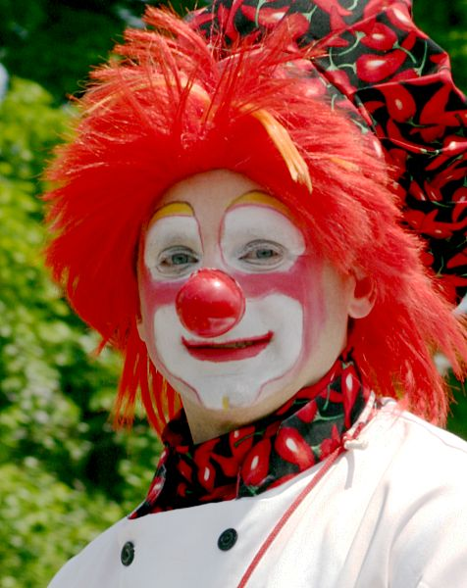

Video provides a powerful way to help you prove your point. When you click Online Video, you can paste in the embed code for the video you want to add.

$$\sin{α}±\sin{β}=2\sin{\frac{1}{2}\left(α±β\right)}\cos{\frac{1}{2}\left(α∓β\right)}$$

The "clown" character develops out of the zanni "rustic fool" characters of the early modern commedia dell'arte, which were themselves directly based on the "rustic fool" characters of ancient Greek and Roman theatre. Rustic buffoon characters in Classical Greek theater were known as sklêro-paiktês (from paizein "to play (like a child)") or deikeliktas, besides other generic terms for "rustic" or "peasant". In Roman theater, a term for clown was fossor, literally "digger; labourer".

in the early 20th century, with the gradual disappearance of the "rustic simpleton" or "village idiot" character of everyday experience, North American circus and comedy developed derived characters such as the "tramp" or "hobo," notably Charlie Chaplin's The Tramp (1914) and Emmett Kelly's Weary Willie (developed by in the 1930s based on the hobos of the Depression era). Another influential "tramp" circus clown character was played by Otto Griebling during the 1930s to 1950s.

The McDonald's fast-food restaurant chain derived its mascot clown Ronald McDonald from the Bozo character in the 1960s. Willard Scott, who had played Bozo during 1959–1962, first performed as the mascot in 1963 television spots. The McDonald's trademark application for the character dates to 1967. Based on the Bozo template, the US custom of "birthday clown", private contractors who offer to perform as clowns at children's parties, developed in the 1960s to 1970s.

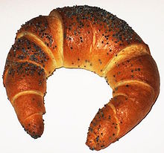

Video provides a powerful way to help you prove your point. When you click Online Video, you can paste in the embed code for the video you want to add.

Pierrot (French pronunciation: ​[pjɛʁo]) is a stock character of pantomime and Commedia dell'Arte whose origins are in the late seventeenth-century Italian troupe of players performing in Paris and known as the Comédie-Italienne; the name is a hypocorism of Pierre (Peter), via the suffix -ot. His character in contemporary popular culture—in poetry, fiction, and the visual arts, as well as works for the stage, screen, and concert hall—is that of the sad clown, pining for love of Columbine, who usually breaks his heart and leaves him for Harlequin. Performing unmasked, with a whitened face, he wears a loose white blouse with large buttons and wide white pantaloons. Sometimes he appears with a frilled collaret and a hat, usually with a close-fitting crown and wide round brim, more rarely with a conical shape like a dunce's cap. But most frequently, since his reincarnation under Jean-Gaspard Deburau, he wears neither collar nor hat, only a black skullcap. The defining characteristic of Pierrot is his naïveté: he is seen as a fool, often the butt of pranks, yet nonetheless trusting.

Jean-Antoine Watteau (French: [ʒan‿ɑ̃twan vato]; baptised October 10, 1684 – died July 18, 1721),[2] better known as Antoine Watteau, was a French painter whose brief career spurred the revival of interest in colour and movement, as seen in the tradition of Correggio and Rubens. He revitalized the waning Baroque style, shifting it to the less severe, more naturalistic, less formally classical Rococo.

Watteau is credited with inventing the genre of fêtes galantes, scenes of bucolic and idyllic charm, suffused with a theatrical air. Some of his best known subjects were drawn from the world of Italian comedy and ballet.

$$e^{x}=1+\frac{x}{1!}+\frac{x^{2}}{2!}+\frac{x^{3}}{3!}+…, -∞<x<∞$$

Like many of the smaller Aegean islands, Kythira's population is decreasing. While the island had reached a peak population of about 14,500 in 1864, that has steadily declined mostly due to emigration, both internal (to major urban centres of Greece) and external (to Australia, the United States, Germany) in the first half of the 20th century. Today its population hovers around 3,354 people (2001 census).

The island is strategically located between the Greek mainland and Crete, and from ancient times until the mid 19th century was a crossroads of merchants, sailors, and conquerors. As such, it has had a long and varied history and has been influenced by many civilisations and cultures. This is reflected in its architecture (a blend of traditional, Aegean and Venetian elements), as well as the traditions and customs, influenced by centuries of coexistence of the Greek, Venetian, and Ottoman cultures.

The painting portrays a "fête galante"; an amorous celebration or party enjoyed by the aristocracy of France during the Régence after the death of Louis XIV, which is generally seen as a period of dissipation and pleasure, and peace, after the sombre last years of the previous reign.

By 1705 he was employed as an assistant by the painter Claude Gillot, whose work represented a reaction against the turgid official art of Louis XIV's reign.[5] In Gillot's studio Watteau became acquainted with the characters of the commedia dell'arte (its actors had been expelled from France in 1697), a favorite subject of Gillot's that would become one of Watteau's lifelong passions.[2]

Afterward he moved to the workshop of Claude Audran III, an interior decorator, under whose influence he began to make drawings admired for their consummate elegance. Audran was the curator of the Palais du Luxembourg, where Watteau was able to see the magnificent series of canvases painted by Peter Paul Rubens for Queen Marie de Medici. The Flemish painter would become one of his major influences, together with the Venetian masters he would later study in the collection of his patron and friend, the banker Pierre Crozat.[2]

End