GM Standard Utility Module – LNM
User Guide

Document Meta Data
Document Name | SUM_LNM_UserGuide
Document Status | Draft

Contents
1 Introduction 3
2 SUM LNM Integration 3
2.1 SUM LNM Initialization 3
2.2 SUM LNM MainFunction 3
2.3 Cyberfill 4
2.4 Network activation / deactivation 4
2.5 Schedule management 5
2.6 Configuration of project specific logical expressions 6
2.7 MSCL Configuration 7
2.8 Dcm Services 8
2.9 Diagnostic 8
3 Practical configuration examples 11
3.1 Network configuration 12
4 Revision History 16

Introduction

This User Guide explains the configuration and usage of the ETAS developed GM SUM LNM. The LNM module has been developed towards the GM Global B requirements, specifically, the GB8002 specifications and related specifications.

SUM LNM Integration

In this chapter are provided all the relevant information needed to configure the SUM LNM to Project Specific needs and to integrate it into a project.
The approach used in this document is to proceed with an incremental integration, i.e. a complete configuration and integration guide for each SUM LNM functionality.

SUM LNM Initialization

To initialize correctly the module, the user shall invoke its initialization function “LNM_Init()”, an external function declared in the header file “SUM_LNM_MainFunction.h”.
The BswM shall invoke this function at initialization time through a BswMAction.

SUM LNM MainFunction

SUM LNM Main Function is responsible for the management of the PermitExecution and ShutdownPermission, and manges the internal state of SUM LNM. Furthermore, SUM LNM is intended to be a supervised entity. The main function is responsible to notify the aliveness of the module to the WdgM.
It is possible to configure the periodicity of these operations through the configuration parameter “LNM_MainFunction_Period”.
The user shall configure SUM SUSD in order to generate the PermitExecution and ShutdownPermission interface to the SUM LNM. When the SUM modules are generated the user shall connect “RP_SUSD_LNM_PermitExecution” to the respective PPort generated by SUM SUSD and “PP_LNM_SUSD_ShutdownPermission” to the respective RPort generated by SUM SUSD.
SUM LNM will transition to the RUNNING state when the PermitExecution relevant bits are set to 1 by SUM SUSD. It is possible to configure which are the relevant bits through the configuration parameter “LNM_PermitExecution_Mask”. The user shall put the value of the bit mask into this field, where, the bits set to 0 are relevant for the transition to the RUNNING state, while the bits set to 1 are “don’t care” for this transition.
Example: LNM_PermitExecution_Mask = 254 (i.e. 0xFE) means that only the LSB will be used for the transition to the RUNNING state. This means that when SUM SUSD sets to 1 the wakeup bit, SUM LNM immediately transitions to the RUNNING state.
SUM LNM is a WdgM supervised entity. This means that a new supervised entity shall be configured in WdgM for SUM LNM. This supervised entity shall have a unique checkpoint. The user shall connect “RP_WdgM_LNM_AliveSupervision” to the respective WdgM port.

Cyberfill

SUM LNM provides the Cyberfill value at initialization. This functionality can be turned on or off at configuration time. To support this functionality the user shall set the configuration parameter “CyberFill_Supported” to true, and configure the cyberfill value to be provided by setting the parameter “LNM_CyberFillValue”. The cyberfill value will be provided through the port “PP_LNM_Cyberfill”.

Network activation / deactivation

SUM LNM manages all the networks that are configured through the container “LMN_Networks”. For each of the network configured, SUM LNM manages its activation and deactivation. Activation and deactivation criteria are project specific. For each network a single activation signal is supported (data type uint8).
- The source of the activation signal is configurable through the parameter “LNM_ActivationSignalType”
- Activation criteria of the network is configurable through the parameter “LNM_ActivationMask”
- Deactivation criteria of the network is configurable through the parameter “LNM_DeactivationMask”
To receive correctly the activation signal the port “RP_LNM_ActivationSignal_<n>” shall be connected to the respective activation signal port provider. If the activation signal is provided from the Com, the additional port “RP_LNM_ActivationSignal_Av_<n>” shall be connected to the respective SUM SSM port that provides the availability indication for that signal.
The logic of the activation and deactivation of the network channel is similar to the PermitExecution (section 2.2). In particular:
- The network will be activated if all the relevant bits in the activation mask are set to 1
- The network will be deactivated if all the relevant bits in the deactivation mask are set to 0
Please notice that SUM LNM reacts to an activation signal notification as a Data Received Event, i.e., the occurrence of any activation signal notification has the highest priority. An activation or deactivation request must be notified only once to SUM LNM.
SUM LNM requests the activation and deactivation of the LIN Network through the port “PP_LNM_BswM_ComM_RequestComMode_<n>”. The user must connect this port to the BswM. BswM shall be configured to react to this mode switch in order to correctly activate and deactivate the LIN channel upon a SUM LNM request.
Mode switch interface:
- NOCOMM request: the BswM shall perform actions to deactivate the LIN channel
- FULLCOMM request: the BswM shall perform actions to activate the LIN channel
For the correct functionality, SUM LNM shall be always notified of the current LIN channel state from the BswM through the port “RP_LNM_BswM_LinSM_CurrentState<n>”. This means that the BswM shall be configured to receive any channel state update and to update accordingly the mode switch interface used for SUM LNM notification.
Mode switch interface:
- NOCOMM switch: the BswM shall switch the mode to this state when BswM is notified that the LIN channel transitioned to the NO COMMUNICATION state.
- FULLCOMM switch: the BswM shall switch the mode to this state when BswM is notified that the LIN channel transitioned to the FULL COMMUNICATION state.

Schedule management

SUM LNM implements a Finite State Machine (FSM) to manage the schedule tables for each configured LIN channel.
Each state of the FSM is associated to a specific schedule table, except to two specific states: the START state, which is not associated to any schedule table, and the SLEEP state that is associated with the NULL schedule. These two states are mandatory and must be configured in any configuration.
To support project specific needs, the user can configure several schedule states for each LIN network by configuring the container “LNM_ScheduleState” and providing for each of this states the reference to the respective schedule table “LNM_ScheduleRef”.
The logic to transitions between the different states is project specific. SUM LNM supports the possibility to create a link between two states by configuring the “LNM_ScheduleTransition” container. For each transition a reference to the starting state must be provided “LNM_StartStateRef” as well as a reference to the end state “LNM_EndStateRef” and a reference to a logical expression (checked periodically) that must be satisfied to transition from the start state to the end state. (See section 2.6 for details on configuration of the logical expressions).
Please notice that when the SLEEP state is entered, the NULL schedule is requested, as well the NO COMMUNICATION of the LIN channel. At this point, a new master (or slave) activation of the LIN channel is needed.
SUM LNM requests a schedule table to the BswM module through the port “PP_LNM_BswM_LinSM_ScheduleRequest_<n>”. The user must connect this port to the BswM and must configure the BswM in order to react to the mode switch with a schedule request to the LinSm.
Mode switch interface:
- NULL_SCHEDULE: BswM shall request the NULL schedule when entering this state
- <ProjectSpecificState>: BswM shall request the schedule table associated to the specific state
For the correct module functionalities, SUM LNM makes use of the current schedule feedback from BswM through the port “RP_LNM_BswM_LinSM_CurrentSchedule_<n>”.
Mode switch interface:
- NULL_SCHEDULE: BswM shall switch to this value when the current stored schedule table is the NULL schedule
- <ProjectSpecificState>: BswM shall switch to this value when the current stored schedule table is the one associated to the project specific state

Configuration of project specific logical expressions

SUM LNM supports the possibility to create project specific logical expression that needs to be checked during the execution of its functionalities (e.g. check project specific conditions to transition from one state to another during the schedule management). Each logical expression is a complex logical composition between different inputs, which create the so-called “LNM_Rule”.
A “LNM_Rule” is a logical aggregation of simpler conditions based on a single input signal, that are the so called “LNM_Condition”.
A “LNM_Condition” compares an input signal to a predefined value. To configure a condition, the following fields must be configured:
- LNM_InputRef : a reference to the input signal that must be checked
- LNM_CompareValue : the predefined value to which the input signal is compared
- LNM_CompareOperator : the operator used to compare the input signal and the predefined value
SUM LNM assumption for boolean values condition configuration: FALSE = 0 and TRUE = 1.
Multiple “LNM_Condition” connected with a logical operator (AND or OR) creates a “LNM_Rule”. To configure a rule it must be provided a list of conditions “LNM_ConditionRef”, and the logical operator to connect them “LNM_LogicOperator”.
Exception: it is possible to create rule composed by a single “LNM_Condition”. In this case the logical operator “LNM_LogicOperator” is not mandatory.
It is possible to reference a “LNM_Rule” inside the list “LNM_ConditionRef”. This allows to create complex logical expressions.

Example:
Condition_Simple
Rule_Simple
A & (B | C | D)
Rule_Complex
IMPORTANT: The possibility to reference rules inside the rule configuration gives enables the possibility to create complex rules as shown in the previous image, but it requires to pay extremely attention at configuration time: recursion is possible, and it MUST BE AVOIDED.

Input Signals

The following input signals are supported by SUM LNM to create project specific conditions
- Schedule Signals

Schedule Signals

Schedule signals are intended to be combined to create the project specific logic to enable the schedule state switch.
Different data types are supported for schedule signals (uint8, uint16 and boolean), and it is configurable with the parameter “LNM_ScheduleSignalType”.
Both SWC and Com signal sources are supported for schedule signals, and it is configurable with the parameter “LNM_ScheduleSignalSource”.
For each configured schedule signal it is created the RPort “RP_LNM_ScheduleSignal_<n>”. The user shall connect this port to the respective PPort that is providing the schedule signal.
If the configured schedule signal source is the Com, and additional port is generated, “RP_LNM_ScheduleSignal_Av_<n>”. The user shall connect this port to the respective SUM SSM PPort that is providing the availability indication of the schedule signal.

MSCL Configuration

MSCL functionality can be calibrated on or off for each network through a calibration parameter “LNM_C_Channel_Enable_<n>”. The initial value for this calibration parameter can be set at configuration time of the LIN network “LNM_ChannelEnable_InitValue”. If this parameter is set to FALSE, the MSCL value will always be 0x0000.
Each bit is associated to a LIN Slave (except for the MSB that is reserved for the “Config bit”). Each slave bit will be set to 1 at initialization time, upon the evaluation of the corresponding “SlavePresent” value.
It is possible to configure two different strategies for the evaluation of the “SlavePresent” status through the configuration parameter “LNM_MSCL_Strategy”:
- Calibration: a private calibration parameter is created for each LNM Slave. Its init value can be set at configuration time “LNM_C_SlavePresent_InitValue”
- Evaluation: for each slave a RPort “RP_LNM_Cal_<XXX>_SlavePresent” that uses a ”Parameter” interface is created. The user shall connect these ports to the “Parameter SWC” that is providing the required information, and must be sure that the data is available on the providing port before the initialization of SUM_LNM.
For each LIN network the user shall configure at least one LIN Slave, and must provide the byte and bit index in the MSCL associated to that slave (“LNM_MSCL_ByteIndex” and “LNM_MSCL_BitIndex”), accordingly to the following picture.
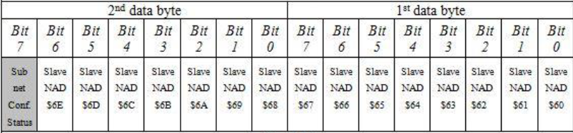
MSCL value is provided to SUM_SSM through the port “PP_<XXX>_LNM_SSM_MSCL”. The user shall connect this port to the respective SUM_SSM R-Port.
MSCL is stored in NvM. The user shall configure a NvM block, that has size in Byte equal to 2*n, where n is the number of configured LIN channels. Furthermore, the user shall connect the NvM service port of that block to the “RP_NvM_MSCL” port of SUM_LNM.

Dcm Services

In this chapter are described all the Dcm serviced that are supported by SUM_LNM.

DID F1BE: Master Network Configuration List LIN

The read operation for this DID is supported in SUM_LNM. The user shall configure this DID in its Dem configuration, enabling the services offered by SUM_LNM (“ConditionCheckRead” and “ReadData”).
The user shall connect the “DataService” port related to this DID to the providing port “PP_LNM_Dcm_DID_MSCL” of SUM_LNM.

Diagnostic

In this chapter are described all the diagnostic functions supported by SUM_LNM. The current version of SUM_LNM implements the detection of the following DTCs:
- Loss of Communication with device
- Loss of Communication with bus
- Internal Electronic Failure
- LIN Slave Device not configured

Loss of Communication with device

The condition to detect this DTC are always checked by SUM_LNM. For each slave must be configured the following mandatory parameters:
- “LNM_NoComm_Retries”: the init value for the calibration parameter that indicates the maximum number of retries before requesting to SUM_ERRH to set Loss of Communication with device.
- “LNM_LossOfComm_withDevice_Timer”: that is the debouncing timer notified to SUM_ERRH through the “NodeStatusIdx” interface (i.e., amount of time that ERRH must wait before request to Dem to set Loss of Communication with device).
For each configured slave the following ports are generated and must be properly connected:
- “RP_SSM_LNM_NodeTimeout_<n>”: this port shall be connected to SUM_SSM port that provides the signal timeout notification associated to the slave
- “PP_LNM_ERRH_NodeStatusIdx_<n>”: this port shall be connected to SUM_ERRH port that is used to detect the corresponding Loss of Communication with device DTC
- “RP_ERRH_LNM_NodeStatusIdx_<n>”: this port shall be connected to SUM_ERRH port that is used to report the corresponding status of Loss of Communication with device DTC
- “PP_LNM_SSM_LossComm_<n>”: this port shall be connected to SUM_SSM port that is used to receive the fault active indication of the corresponding Loss of Communication with device DTC

Loss of Communication with bus

The condition to detect this DTC are always checked by SUM_LNM.
The mandatory parameter “LNM_WupTxRetriesMaster” shall be configured (i.e., the number of retries before setting the Loss of Communication with bus DTC when the channel is not able to switch from NO_COMMUNICATION to FULL_COMMUNICATION).
For each configured LIN network the port “PP_LNM_ERRH_LossCommBus_<n>” is generated. This port shall be connected to the corresponding SUM_ERRH port that is checked to set the Loss of Communication with bus DTC.

Internal Electronic Failure

The condition to detect this DTC are checked only for the configured slaves that supports this DTC. This DTC can be reported due to multiple consecutive reset request reported by the slave (through APINFO2 interface), or to a fault detected by the slave (through APINFO4 interface). At least one of these two mechanism shall be configured if the slave supports Internal Electronic Failure DTC.
The following parameters are used to configure Internal Electronic Failure DTC:
- “LNM_Internal_Electronic_Failure_Supported”: is a mandatory configuration parameter. Internal Electronic Failure detection will be enabled for that slave if this parameter is set to TRUE.
- “LNM_IEF_APINFO2_Supported”: if this parameter is set to TRUE, the selected slave supports APINFO2 detection mechanism to set Internal Electronic Failure DTC
- “LNM_IEF_APINFO4_Supported”: if this parameter is set to TRUE, the selected slave supports APINFO4 detection mechanism to set Internal Electronic Failure DTC
- “LNM_IEF_Reset_Threshold”: parameter that shall be configured if APINFO2 detection mechanism is supported by the selected slave. It is the maximum number of acceptable consecutive reset request sent by the slave. When this threshold is reached, Internal Electronic Failure DTC is set
Depending on the configuration, SUM_LNM generates the following ports. Please notice that if Internal Electronic Failure is not supported by SUM_LNM, none of the following ports are generated by SUM_LNM:
- “RP_COM_LNM_APINFO2_<n>”: this port is generated only if APINFO2 detection mechanism is supported. The user shall configure a data mapping for this port to the corresponding Com signal.
- “RP_COM_LNM_APINFO4_<n>”: this port is generated only if APINFO4 detection mechanism is supported. The user shall configure a data mapping for this port to the corresponding Com signal.
- “PP_LNM_ERRH_IntElectFault_<n>”: this port shall be connected to the SUM_ERRH port that is checked to set the corresponding Internal Electronic Failure DTC
- “RP_ERRH_LNM_Ief_DTC_Confirm_<n>”: this port shall be connected to the SUM_ERRH port in which the current status of the corresponding Internal Electronic Failure DTC is published
- “PP_LNM_SSM_IefFA_<n>”: this port shall be connected to the SUM_LNM that is monitoring the corresponding fault active indication of Internal Electronic Failure DTC
If APINFO2 detection mechanism is supported, the runnable “Runnable_APINFO2_<n>”, activated by a data received event, shall be mapped to an OS task.

LIN Slave Device not configured

The condition to detect this DTC are checked only for the configured slaves that supports this DTC.
The following parameters are used to configure LIN Slave Device not configured DTC:
- “LNM_Slave_Device_Not_Configured_Supported”: is a mandatory configuration parameter. LIN Slave Device not configured detection will be enabled for that slave if this parameter is set to TRUE.
- “LNM_Config_Retries”: parameter that shall be configured if LIN Slave Device not configured is supported. This is the maximum number of acceptable consecutive configuration errors reported by the slave (through APINFO3 interface)
If the LIN Slave Device not configured DTC is supported, the following ports are generated by SUM_LNM:
- “RP_COM_LNM_APINFO3_<n>”: the user shall configure a data mapping for this port to the corresponding Com signal.
- “PP_LNM_ERRH_NotConfigured_<n>”: this port shall be connected to the corresponding SUM_ERRH port that is checked to set the LIN Slave Device not configured DTC.
If LIN Slave Device not configured is supported, the runnable “Runnable_APINFO3_<n>”, activated by a data received event, shall be mapped to an OS task.

Practical configuration examples

In this chapter is provided an example of SUM LNM configuration that can be used as reference for the user.
Example configuration requirements:
- Network name: LIN_Network_Example
- Activation deactivation criteria: only the LSB is relevant for the activation of the LIN channel
  - Network activation: activation signal equal to 0x01
  - Network deactivation: activation signal equal to 0x00
The following schedule table logic must be implemented
Sleep
Start
B*
A*

Normal_Cyclic

- A* : (SystemPowerMode == RUN || SystemPowerMode == PROPULSION) && BrakingDetected == TRUE
- B* : SystemPowerMode == OFF

Network configuration

To support the project specific activation and deactivation logic, the user shall configure SUM LNM in order to consider only the LSB of the activation signal as shown in figure.
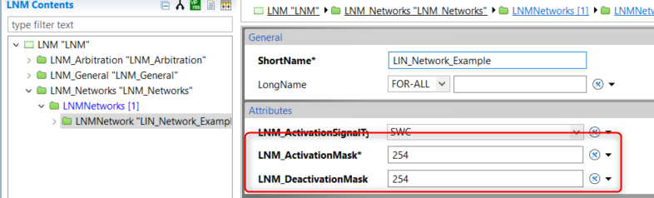
To support the project specific schedule management, from the requirement it is possible to identify that two schedule signals are needed: the BrakingDetected boolean value and the SystemPowerMode.
The first step is to configure these schedule signals as shown in figure.
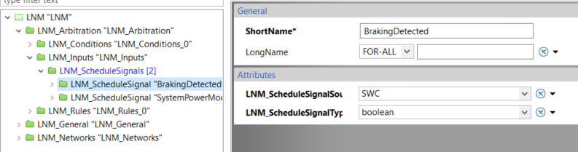
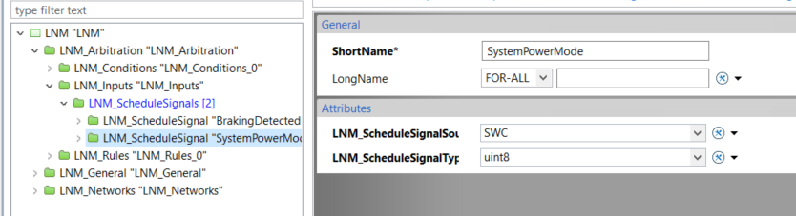
Starting from these schedule signals, it is possible to configure all the basic conditions to be checked as shown in figure.
- SystemPowerMode == RUN
- SystemPowerMode == PROPULSION
- BrakingDetected == TRUE
- SystemPowerMode == OFF
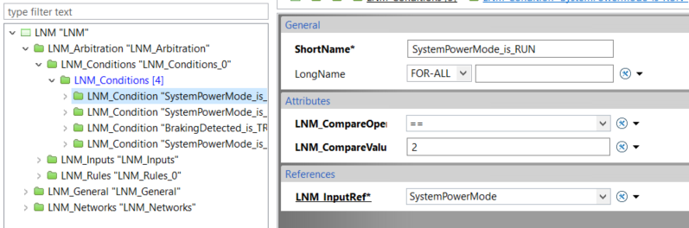
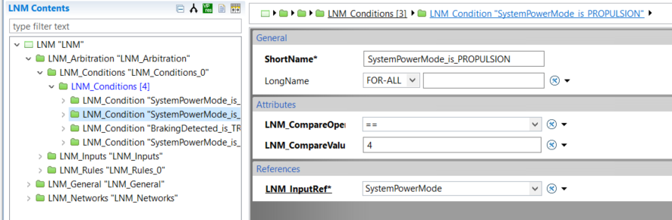
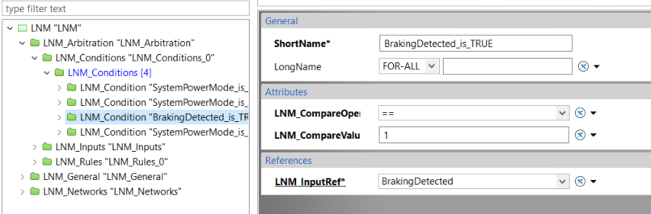
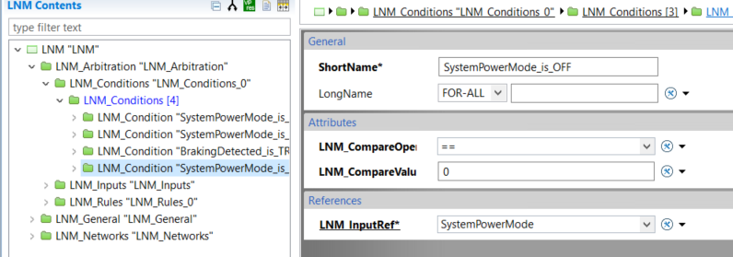
At this point it is possible to create immediately the “LNM_Rule” that implements the transition B*. Instead, for the rule that implements the transition A* is required an intermediate configuration, since it is a complex relation of AND and OR condition.
It is possible to create a “LNM_Rule” that implements the condition (SystemPowerMode == RUN || SystemPowerMode == PROPULSION) as shown in figure.
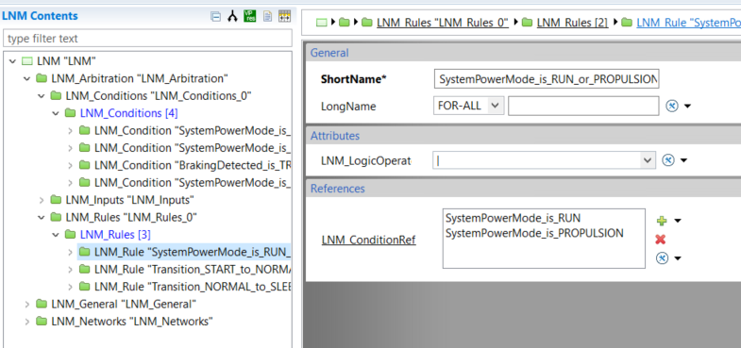
At this point everything is in place also to create a “LNM_Rule” that implements the logic for the transition A*.
It is now possible to configure the following rules:
- Transition_START_to_NORMAL : that implements the condition A*
- Transition_NORMAL_to_SLEEP : that implements the condition B*
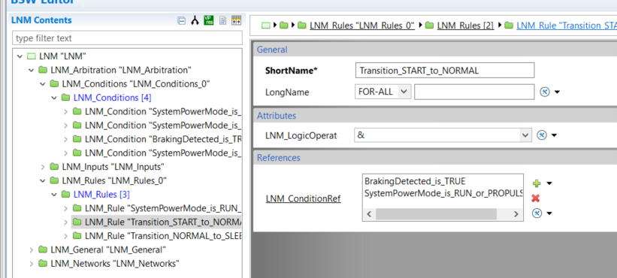
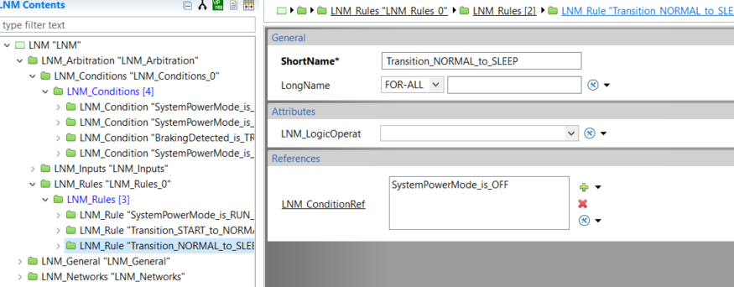
The final step is to configure the FSM as required by the requirements. It is needed just a single project specific state apart from the mandatory states START and SLEEP
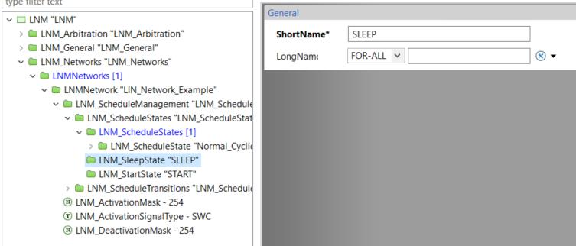
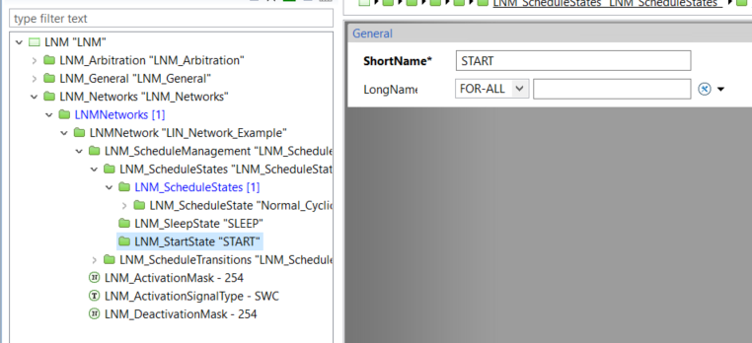
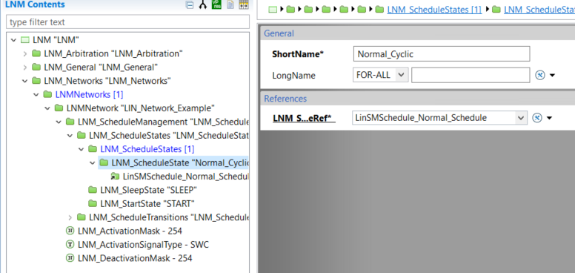
Once that the states have been configured, it is possible to proceed with the configuration of the transitions. In this case, only two transitions are needed: A* and B*
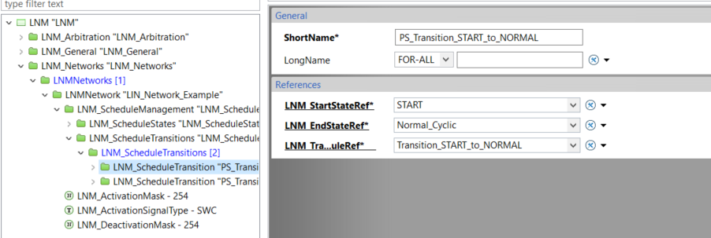
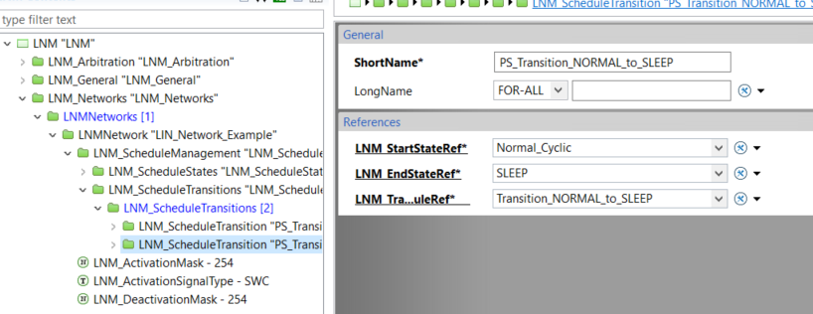

Revision History

Version | Description of Changes | Author
4.0.0 | Initial version of the document | Luigi Vicari

