[Problem Solving Methods (14513_001)](https://cyber.gachon.ac.kr/course/view.php?id=82492)

202234851 강두현 소프트웨어학부

2022-09-05

HW1

#include<stdio.h>

#include<stdlib.h>

#include<time.h>

char art[4][10] = { "BAR", "BELL", "LEMON", "CHERRY" };

#define RMAX 4

void main() {

int slot1, slot2, slot3;

char anykey;

srand((unsigned int)time(0));

while (1) {

printf("Welcome to KW Land\n");

printf("please pull the slot machine !!\n");

scanf_s("%c", &anykey);

slot1 = (int)rand() % RMAX;

slot2 = (int)rand() % RMAX;

slot3 = (int)rand() % RMAX;

printf("First is %s\n", art[slot1]);

printf("Second is %s\n", art[slot2]);

printf("Third is %s\n\n", art[slot3]);

if (slot1 == slot2 && slot2 == slot3 && slot1 == 3) {

printf("Congratulations On A JACKPOT\n\n");

}

else if (slot1 == 3 || slot2 == 3 || slot3 == 3) {

printf("Paid Out : One DIME\n\n");

}

else if (slot1 == slot2 && slot2 == slot3) {

printf("Paid Out : One Nickel\n\n");

}

else {

printf("Sorry.Better Luck Next Time\n\n");

}

}

}

빌드 사진

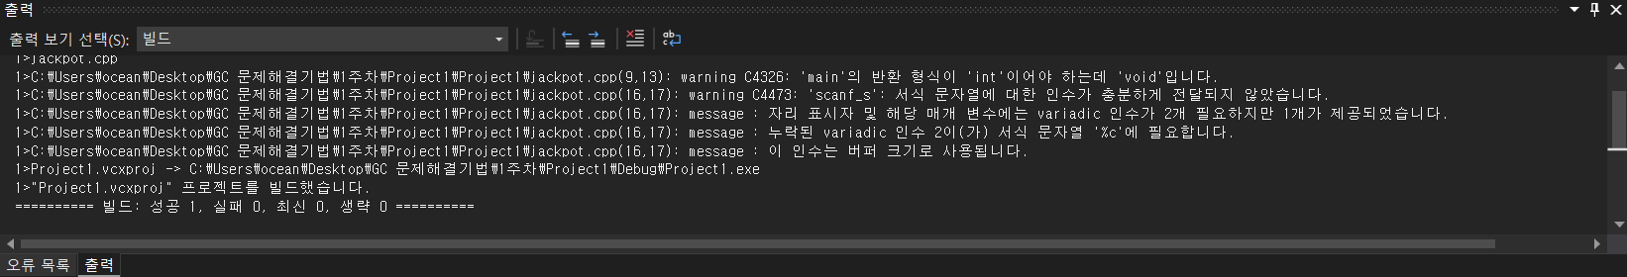

실행사진