**Modern Standby**

**Definitions**

S0 – Screen On … PC in full power

S3 – Traditional Sleep … HW power rails are Off

S4 – Hibernation … Everything running on the desktop is saved to a “hiber-file”

S5 – System Off

MSC – (S0ix) For the purposes of this document, it will stand for Modern Standby Connected. The system is still On, just in a lower power state … to conserve battery power and provide a faster resume experience. In this state, connection to the Internet is allowed.

MSD – Modern Standby Disconnected … same as MSC, except that connection to the Internet is not allowed.

**Introduction**

Modern Standby, a.k.a – Always On Always Connected (AOAC) or Connected Standby, enables smartphone functionality on a computer. This allows for experiences like “Instant On,” keeping data updated while in Sleep Mode, etc.

Traditionally, when a computer is put into Sleep Mode (S3), power is turned off internally to conserve battery power while providing a faster resume experience than from S4 or S5. For S3, Drivers do not require any “smarts.” When power is cut, the device is Off … when power is restored, the device turns back On.

Conversely, on a Modern Standby enabled computer, internal power is always On. Drivers are expected to have “smarts” to determine if they are needed or not while in Sleep Mode. If needed, Drivers are to put themselves into the lowest power state possible where they can still function. If not needed, they are supposed to turn themselves Off.

By keeping the computer in an S0 state, the computer can resume faster than from S3 Sleep … producing an “Instant On” experience … but … at a cost. MSC will consume more battery power than S3 while in Sleep mode.

**Features**

Here is a list of some of MSC’s benefits that S3 systems do not provide:

* Instant On … faster resume times
* Allows for computer data (emails, Windows Updates, etc.) to be updated while in Sleep Mode (i.e. – not possible on MSD computers)
* Allows for background computer activity, Skype notifications, etc. while in Sleep Mode
* MP3’s (local content … not streaming) can be played while the computer is in Sleep Mode
* Allows for Wake on Voice … wakes the computer from Sleep Mode by saying, “Hey Cortana”
* Allows for higher levels of Microsoft’s Modern Device Security
* Allows for a Bluetooth device to function as a wake device to resume from MSC

**Issues to note**

* Users that are used to S3 Sleep functionality often get confused with MSC functionality
  + Since the computer is always in S0 while in MSC, background computer operations can continue. For example, the system fan may stay On longer after entering Sleep or may come on during Sleep if needed to keep the computer cool.
  + Users may be surprised when battery consumption increases when activity increases during Sleep Mode … different than an S3 machine.
  + For instructions on Sleep settings, See Figure 3 below
* Not all applications function while in MSC. Microsoft Office, a Win32 App, is suspended by DAM (Microsoft’s Desktop Activity Moderator), since it is not Modern Standby aware. Therefore, Outlook email cannot be kept up to date during MSC. Also, Windows Media Player, also a Win32 app, cannot function during Modern Standby. (See Figure 2 below)
* Hotmail, Gmail, Yahoo mail …POP mail … can be kept up to date by using the Metro Mail App in the Microsoft store. In addition, Groove Player and similar Metro Apps can be used to play MP3’s while in Sleep Mode … even with the LID closed.
* The Windows O/S includes a feature called, “Battery Budget.” The O/S monitors battery consumption while in MSC and will force the computer into S4 Hibernation sooner than expected to prevent high battery consumption from continuing.
* Plugging devices into external ports, like USB Thumb Drives or USB Bluetooth transmitters, may prevent the computer from going into low power MSC; thus, consuming high power than normal.
* Some HW, like spinning Hard Drives, will only function while in Modern Standby Disconnected.
* Due to a HW & O/S bug, computers built with Kaby Lake chipsets (and before) that have both WLAN & Thunderbolt can only function in Modern Standby Disconnected. By default, installing a Clean O/S will always enable Modern Standby Connected. These affected computers MUST be forced back into Modern Standby Disconnected to prevent system instability including BSOD’s.
* “Hot Bag Effect”
  + Microsoft received complaints of PC’s waking while in a backpack or briefcase. This was a normal, but unwanted, function. Therefore, Microsoft changed the O/S functionality towards the end of RS-2.
  + Now the O/S will not allow applications to connect to the Internet if the LID is closed while on battery power. To maintain Internet connection while on battery power, the LID must remain open or the PC must be connected to AC power.
* As with all drivers, conflicts can occur … even with Modern Standby. A driver may become confused during a wake/sleep cycle and will remain awake … causing increased power consumption. Also, this confused driver may affect other drivers on the PC; thus, escalating the power consumption. As MSC matures, occurrences like this should be reduced. In addition, Microsoft is working on an initiative they’re naming, DFx (Directed Power Framework). With special code in the drivers, the O/S will better manage misbehaving drivers to reduce power consumption and resolve driver confusion. Expected to be implemented by 19H2.
* Wake on LAN (WoLAN) is presently not supported on MSC platforms … “the PC is already in S0, so what’s to wake up?” Microsoft and communications companies are working on a solution. A work-around would be to develop a UWP (Universal Windows Protocol) App that is MSC aware.
* It is not allowed to switch between an S3 mode and MSC mode (or vice versa) without reinstalling the O/S.
* Modern Standby Disconnected (MSD) REQUIRED on HP business notebooks 2017 and before. There exists a conflict between Thunderbolt and Wireless LAN on systems that have Kaby Lake and RS-3 O/S. The conflict causes platform instability, poor performance, high battery consumption, and even BSOD’s. The workaround was to ship these platforms as MSD since this mitigates the problem.
  + The issue was fixed with the Kaby Lake – R hardware and Windows RS-4 O/S
  + Systems with this problem shipped from the factory as MSD
  + Microsoft, via Windows Update, will remove MSD and force MSC; thus, causing the conflict
  + Installing HP’s SDS SoftPAQ (available on the HP website) will remedy the problem by enforcing MSD

Troubleshooting

* To verify if the PC is in MSC or not, type the following into an Admin DOS box: powercfg /a
  + MSC = Standby (S0 Low Power Idle) Network Connected
  + MSD = Standby (S0 Low Power Idle) Network Disconnected
  + S3/S4 = Standby (S3) is available (i.e. – not enabled for Modern Standby)
  + See Figure 1 below

**Figure 1**

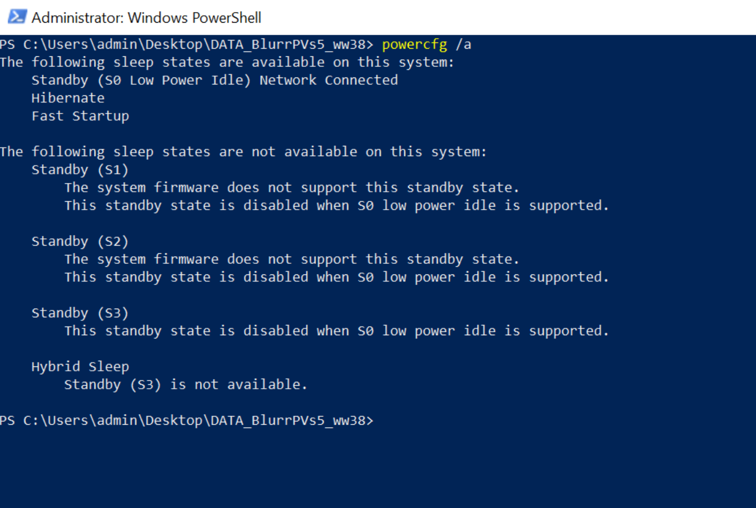

* To verify power consumption, create a Sleep Study report
  + Type the following into an Admin DOS box: powercfg /sleepstudy
  + This will provide information on battery capacity, battery usage, and possible Top Offenders of battery consumption
  + See example below

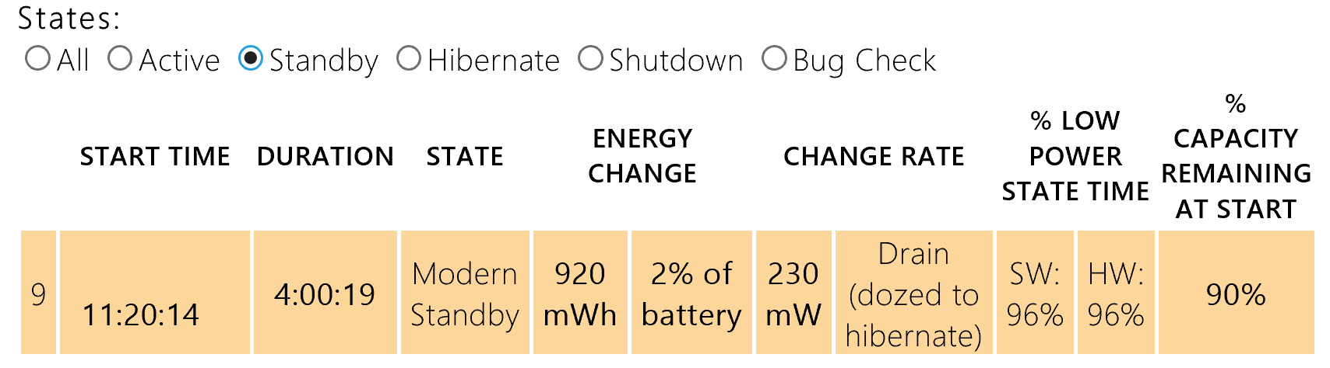  
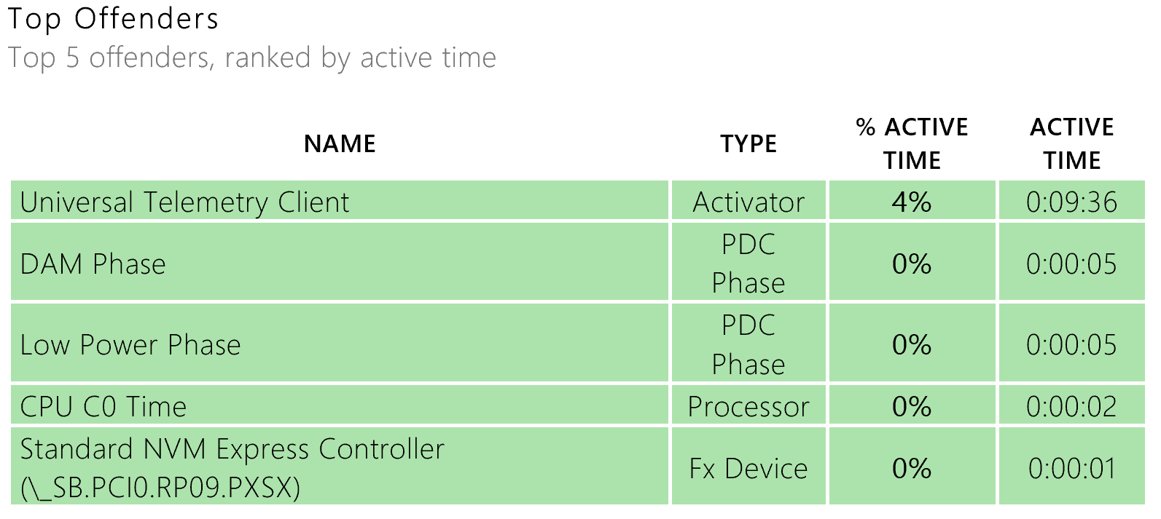

**Figure 2**

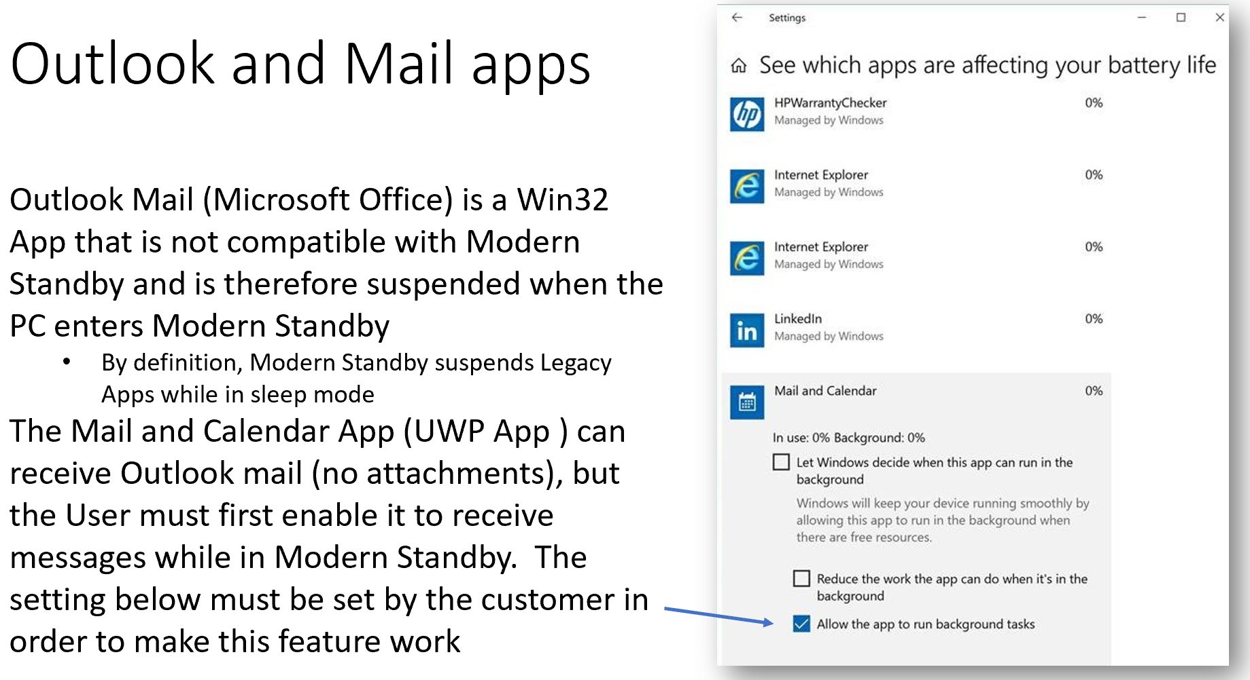

**Figure 3**

