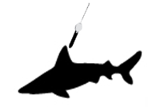

**ACCESS15-0017**

Oceanographic In-situ Interoperability Project

netCDF Templates For Electronic Tag Data

**nc-eTAG** Template Specification

**Version: 0.8**

October 25, 2019

Revision: 1

JPL URS CL#: 19-6563

Acknowledgement: The research was carried out at the Jet Propulsion Laboratory, California Institute of Technology, University Cooperation for Atmospheric Research, and University of Massachusetts-Boston under a contract with the National Aeronautics and Space Administration. NASA funding under the Advancing Collaborative Connections for Earth System Science (ACCESS) Program is acknowledged. Grant# ACCESS-015-017: Oceanographic In-situ data Interoperability Project (OIIP).

© 2019 California Institute of Technology. Government sponsorship acknowledged.

**Authors & Contributors**

* Dr. Vardis M. Tsontos. NASA Jet Propulsion Laboratory [vtsontos@jpl.nasa.gov](mailto:vtsontos@jpl.nasa.gov)
* Dr. Chihin Lam. Large Pelagics Research Center, UMASS-Boston [tagtuna@gmail.com](mailto:tagtuna@gmail.com)
* Dr. Sean C. Arms. UCAR-Unidata [sarms@ucar.edu](mailto:sarms@ucar.edu)

**Document Change Record**

|  |  |  |  |
| --- | --- | --- | --- |
| Author | Update Description | Pages/paragraphs changed | Date of revision |
| V. Tsontos | Original Draft: V0.7 | All | 9/25/2019 |
| V. Tsontos | Updated Draft: V0.8 | Template sections | 10/24/2019 |
|  |  |  |  |
|  |  |  |  |

Table of Contents

Table of Contents 3

List of Tables 4

List of Figures 4

1 Overview 5

2 Methods 6

3 nc-eTAG Templates 7

*Archival Tag Data Template* 8

*High & Low Frequency Sensor Measurement Archival Tag Data Template* 16

*Transmitted Summary Tag Data Template* 26

4 References 34

Appendix 35

*eTag Types* 35

*Native eTag Data Formats* 35

Archival Data Formats 35

Summarized Popup Satellite Archival (PSAT) Data Formats 39

# List of Tables

**Table 1.** Representative range of sample electronic tag dataset types 6

# List of Figures

Figure 1. LOTEK Archival Tag Data Files. . 36

Figure 2. Wildlife Computers Archival Tag Data Files.. 37

Figure 3. Microwave Telemetry Archival Tag Data Files.. 38

Figure 4. Wildlife Computers PSAT Bin-Frequency Summary Data.. 40

Figure 5. Wildlife Computers PSAT Summary PDT Data. . 40

# Overview

OIIP (Oceanographic In-situ data Interoperability Project) is a NASA/ACCESS technology development project that seeks to extend available (higher TRL) technologies, including the [NCEI netCDF in-situ data templates](https://www.nodc.noaa.gov/data/formats/netcdf/v2.0/), to address key interoperability and data challenges associated with oceanographic *in situ* datasets, focusing on marine animal electronic tagging data as a representative (but also more challenging) use case. Previous documentation produced by the OIIP project and published [online](https://oiip.jpl.nasa.gov/) has reviewed the applicability of the NCEI netCDF template to support the suite of (non-acoustic) electronic data produced by the range of tag manufacturers [[1](https://oiip.jpl.nasa.gov/doc/OIIP_Deliverable1.1_2.1_NodcTemplateReviewForTagSupport_20170714.pdf)]. We have also proposed extensions, based on expert tagging community input, enabling support for richer sets of domain specific metadata for inclusion in such self-describing electronic tagging data files [[2](https://oiip.jpl.nasa.gov/doc/OIIP_Deliverable1.2_TagMetadata_20170227.pdf)]. The latter, which is important in that it embeds the necessary information necessary for the correct interpretation, science utilization and long-term preservation of the instrument data, includes a specification for the packaging of such rich metadata consistent with the latest Earth Science data interoperability standards and next generation CF2.0 enhancements.

Here we take the next step, and provide detailed technical specifications on how the range of key tagging data type classes - satellite positional, archival and retrieved popup satellite archival (PSAT) trajectory series, and PSAT transmitted summary data - can be encoded consistent with the aforementioned standards. This is important because it provides a practical roadmap that will bring tagging data into direct alignment with a common data interoperability framework being used for ocean observations ranging from satellite and remotely sensed airborne observations to measurements from diverse in-situ assets. The latter includes gliders and other such instrument platforms that share similar spatial geometry sampling characteristics as tagged animals. The future successful inclusion of animal telemetry data as new and valuable element of this integrated ocean observing system in support of a whole suite of applications will hinge upon on the adoption of these common data interoperability standards for the production of archive quality instrument data files from electronic tag deployments. There are naturally nuances to the animal telemetry data which that have required some extensions, both to provide support for both the breadth of metadata desired for inclusion in self-describing data file formats and particular animal telemetry instrument data representations. All of these needs we have accounted for comprehensively, and the outcome- these netCDF electronic tag template (nc-eTAG) specifications are presented in this document.

The three detailed netCDF CDL ([Common Data Language](https://www.unidata.ucar.edu/software/netcdf/workshops/2011/utilities/CDL.html)) templates for (non-acoustic) animal telemetry data that we present here provide the necessary roadmap and engineering specifications to encode and produce interoperable instrument data files for the aforementioned three classes of electronic tagging data types. The nc-eTAG templates will serve as a valuable resource for data producers, data assembly centers, data archives, and electronic tag instrument manufacturers wanting to implement archive quality, interoperable data files consistent with Earth Science data standards.

# Methods

Foundational analyses and background information, documented by OIIP previously and that went into the development of the netCDF (nc) eTAG (electronic tagging) templates discussed below, will not be repeated here. Readers should consult those documents for further details [[1](https://oiip.jpl.nasa.gov/doc/OIIP_Deliverable1.1_2.1_NodcTemplateReviewForTagSupport_20170714.pdf), [2](https://oiip.jpl.nasa.gov/doc/OIIP_Deliverable1.2_TagMetadata_20170227.pdf)]. Here we present just the key information needed to understand the nc-eTAG template specifications presented below.

The templates are designed to support the range of key tagging data type classes (satellite positional, archival and retrieved popup satellite archival (PSAT) trajectory series, and PSAT transmitted summary data) and associated output data representations being produced by tag manufacturers. Examples of a representative range of electronic tag dataset types from different manufacturers that were reviewed prior to nc-eTAG template formulation are summarized in Table 1 below. These also include datasets involving tag data for a given deployment where instrument outputs are at different or varying measurement frequencies (eg. Periodic high frequency measurement bursts and tag sensors sampling at different frequencies). Representative examples of manufacturer instrument data output files associated with the range of tag types that the nc-eTAG templates are designed to support are provided in the Appendix and discussed in more detail in [[1](https://oiip.jpl.nasa.gov/doc/OIIP_Deliverable1.1_2.1_NodcTemplateReviewForTagSupport_20170714.pdf)]. As described therein, metadata natively present with the standards tag manufacturer instrument data file outputs is cursory. The rich suite of metadata attributes fully describing aspects of electronic tag instrument deployments are described in [[2](https://oiip.jpl.nasa.gov/doc/OIIP_Deliverable1.2_TagMetadata_20170227.pdf)] together with recommendations on the packaging of such domain metadata within self-describing netCDF data files together with the standard CF and ACDD geospatial metadata attributes. Compiled, reviewed and based on inputs from domain experts and tagging practitioners, eTAG metadata are included in the nc-eTAG template specifications below consistent with prior our recommendations [[2](https://oiip.jpl.nasa.gov/doc/OIIP_Deliverable1.2_TagMetadata_20170227.pdf)].

**Table 1.** Representative range of sample electronic tag dataset types

|  |  |  |  |  |  |  |  |  |  |
| --- | --- | --- | --- | --- | --- | --- | --- | --- | --- |
| Manufacturer | Type | Model | Processing Tool Version | Format | File | Data/Header Complexity | Notes | Provider | Species/TagID |
| [Wildlife Computers](http://wildlifecomputers.com/support/downloads/) | Popup/ Transmitting | MiniPAT | DAP 3.0 Build 434 (Desktop version) | .csv | [Popup_WildlifeComputers.7z](https://wiki.earthdata.nasa.gov/download/attachments/77400684/Popup_WildlifeComputers.7z) | High; try this second to last | [Spreadsheet header](http://wildlifecomputers.com/wp-content/uploads/manuals/Spreadsheet-File-Descriptions.pdf) | [LPRC](http://tunalab.org/) | [Sailfish/ 113674](http://www.nature.com/articles/srep38163) |
|  |  |  |  |  |  |  |  | [LPRC](http://tunalab.org/) | [Sailfish/ 142389](http://www.nature.com/articles/srep38163) |
| [Microwave Telemetry](http://www.microwavetelemetry.com/) | Popup/ Transmitting | X-tag | Manufacturer processed in-house | .xls | [Popup_MicrowaveTelemetry.7z](https://wiki.earthdata.nasa.gov/download/attachments/77400684/Popup_MicrowaveTelemetry.7z) | High; try this last |  | [LPRC](http://tunalab.org/) | [Sailfish/ 117259](http://www.nature.com/articles/srep38163) |
| [Wildlife Computers](http://wildlifecomputers.com/support/downloads/) | Implanted/ Archival | Mk-9 | Instrument Helper | .csv | [Archival_WildlifeComputers.7z](https://wiki.earthdata.nasa.gov/download/attachments/77400684/Archival_WildlifeComputers.7z) | Simple / Medium | Very detailed time series | [IATTC](https://www.iattc.org/) | Bigeye tuna/ 0390075 |
|  |  |  | DAP 3.0 Build 434 (Desktop version) | .csv |  |  | [Spreadsheet header](http://wildlifecomputers.com/wp-content/uploads/manuals/Spreadsheet-File-Descriptions.pdf)  Very detailed time series | [IATTC](https://www.iattc.org/) | Bigeye tuna/ 0590051 |
|  |  |  | Likely Instrument Helper | .csv |  |  | Detailed time series | [ATN](http://oceanview.pfeg.noaa.gov/ATN_docs/#%21/download/animal-tags) | Albacore tuna/ 1204043 |
| [Lotek](http://www.lotek.com/downloads.htm) | Implanted/ Archival |  | Viewer 2000 | .csv | [Archival_LotekWireless.7z](https://wiki.earthdata.nasa.gov/download/attachments/77400684/Archival_LotekWireless.7z) | Simple; try first | Very detailed time series | [IATTC](https://www.iattc.org/) | Yellowfin tuna/ A0525 |
|  |  |  |  |  |  |  | Very detailed time series | [IATTC](https://www.iattc.org/) | Yellowfin tuna/ C0066 |

# nc-eTAG Templates

This section provides the detailed CDL template specification for encoding of the key classes of (non-acoustic) electronic tagging datasets in netCDF consistent with prevailing Earth Science data interoperability. Three nc-eTAG templates are available for download as CDL (ascii) text files from <https://oiip.jpl.nasa.gov/>. Appropriate citation of this reference document and acknowledgement of the NASA/ACCESS15-0017 Oceanographic In-situ data Interoperability Project would be appreciated.

Note that these templates are not intended to capture every possible variable electronic tags measure now or will measure in the future. They do, however, provide a comprehensive roadmap for implementation for all the key categories of data and variables for storage in netCDF structures. This includes: 1) ***global and variable level metadata*** attributes, involving both tag domain specific and CF/ACDD geospatial attributes, and 2) standards compliant data structures supporting both ***coordinate******variable*** data (eg. Latitude, Longitude, Time, Depth), and ***geophysical measurement*** ***variable*** data (eg. Light level, Temperature etc). The block organization of the CDL templates below reflect these fundamental structural elements. Where and as new sensor measurements are available, additional data structures following the same specifications and patterns outlined in the templates can simply be added to implementations.

A global metadata block, comprised of the exact same attribute elements is present in each of the three template. Differences between templates are in some aspect of either the coordinate or geophysical measurement variables. These are necessary and reflect fundamental differences in the structure/representation of data for the different tag data type classes (eg. continuous trajectory archival series vs transmitted summary data types).

Metadata attribute values present in the templates are intended as illustrative examples of values that the given attribute should take. Template implementation for any given dataset will obviously require substitution of those values with ones applicable to the dataset and attribute in question. These substituted values should though be of the same attribute data type (eg. string, integer, double etc.).

For readers unfamiliar with the netCDF-CF and ACDD standards and NCEI implementation guidelines for in-situ data upon which the nc-eTAG templates here are based, please consult the following reference material: [[3](http://cfconventions.org/Data/cf-conventions/cf-conventions-1.7/cf-conventions.html), [4](http://cfconventions.org/Data/cf-standard-names/68/build/cf-standard-name-table.html), [5](http://wiki.esipfed.org/index.php/Attribute_Convention_for_Data_Discovery_1-3), [6](https://www.nodc.noaa.gov/data/formats/netcdf/v2.0/)].

## *Archival Tag Data Template*

This nc-eTAG (Archival) template applies to archival and retrieved popup satellite archival (PSAT) trajectory series datasets. It can also be applied to satellite positional tag trajectory datasets (eg. SPOT, GPS); in this case likely only the global attribute and coordinate variable components of this template should apply.

**netcdf file\:/C\:/Tag_Archival_Template {**

**dimensions:**

time = 2046391;

str_len = 6;

**variables:**

***\\Coordinate and Auxiliary Coordinate Variables***

char trajectory(str_len);

trajectory:cf_role = "trajectory_id";

double time(time);

string time:long_name = "Time of observation";

string time:standard_name = "time";

string time:units = "seconds since 1970-01-01T00:00:00"; // UTC

string time:axis = "T";

string time:coverage_content_type = "coordinate";

double location_freshness(time);

string location_freshness:long_name = "location_freshness";

string location_freshness:comment = "time since last latitude and longitude observations";

string location_freshness:units = "seconds";

double location_freshness:_FillValue = NaN;

double location_freshness:valid_max = 86340.0;

double location_freshness:valid_min = 0.0;

string location_freshness:coverage_content_type = "auxiliaryInformation";

double longitude(time);

string longitude:long_name = "estimated longitude";

string longitude:standard_name = "longitude";

string longitude:units = "degrees_east";

string longitude:axis = "X";

double longitude:_FillValue = NaN;

double longitude:valid_max = -118.48636166666667;

double longitude:valid_min = -127.43765333333333;

string longitude:ancillary_variables = "longitude_uncertainty";

string longitude:coverage_content_type = "coordinate";

double longitude_uncertainty(time);

string longitude_uncertainty:long_name = "derived uncertainty around longitude estimate";

string longitude_uncertainty:standard_name = "longitude standard_error";

string longitude_uncertainty:units = "degrees ";

double longitude_uncertainty:_FillValue = NaN;

double longitude_uncertainty:valid_max = 0.05;

double longitude_uncertainty:valid_min = 0.01;

string longitude_uncertainty:coverage_content_type = "qualityInformation";

double latitude(time);

string latitude:long_name = "estimated latitude";

string latitude:standard_name = "latitude";

string latitude:units = "degrees_north";

string latitude:axis = "Y";

double latitude:_FillValue = NaN;

double latitude:valid_max = 30.639526666666665;

double latitude:valid_min = 9.908965;

string latitude:ancillary_variables = "latitude_uncertainty";

string latitude:coverage_content_type = "coordinate";

double latitude_uncertainty(time);

string latitude_uncertainty:long_name = "derived uncertainty around latitude estimate";

string latitude_uncertainty:standard_name = "latitude standard_error";

string latitude_uncertainty:units = "degrees ";

double latitude_uncertainty:_FillValue = NaN;

double latitude_uncertainty:valid_max = 0.05;

double latitude_uncertainty:valid_min = 0.01;

string latitude_uncertainty:coverage_content_type = "qualityInformation";

double depth(time);

string depth:long_name = "measured depth";

string depth:standard_name = "depth";

string depth:units = "m";

string depth:axis = "Z";

string depth:positive = "down";

double depth:_FillValue = NaN;

double depth:valid_max = 563.639526666666665;

double depth:valid_min = 0.0000000000001;

string depth:coverage_content_type = "coordinate";

***\\Geophysical measurement Variables***

double external_temperature(time);

string temperature:long_name = "sea water wemperature";

string temperature:standard_name = "sea_water_temperature";

string temperature:units = "degrees_C";

double temperature:_FillValue = NaN;

double temperature:valid_max = 30.6457;

double temperature:valid_min = 20.354621874999996;

string temperature:coordinates = "time latitude longitude depth trajectory";

string temperature:coverage_content_type = "physicalMeasurement";

double internal_temperature(time);

string internal_temperature:long_name = "internal body temperature";

string internal_temperature:units = "degrees_C";

double internal_temperature:_FillValue = NaN;

double internal_temperature:valid_max = 27.75;

double internal_temperature:valid_min = 19.200000762939453;

string internal_temperature:coordinates = "time latitude longitude depth trajectory";

string internal_temperature:coverage_content_type = "physicalMeasurement";

double illuminance(time);

string illuminance:long_name = "light level";

string illuminance:units = "lux";

double illuminance:_FillValue = NaN;

double illuminance:valid_max = 173.0; // double

double illuminance:valid_min = 33.0; // double

string illuminance:coordinates = "time latitude longitude depth trajectory";

string illuminance:coverage_content_type = "physicalMeasurement";

***// global attributes:***

***// CF-ACDD global attributes***

string :Conventions = "CF-1.7, ACDD 1.3, COARDS";

string :Metadata_Conventions = "Unidata Dataset Discovery v1.3";

string :featureType = "trajectory";

string :cdm_data_type = "Trajectory";

string :nodc_template_version = "NODC_NetCDF_Trajectory_Template_v2.0, ATN extension";

string :standard_name_vocabulary = "CF Standard Name Table v27";

string :title = "Animal telemetry archival tag netCDF template";

string :source = "atn.noaa.gov";

string :platform = "Thunnus obesus";

string :instrument = "Wildlife Computers MK9";

string :uuid = "70e37fb7-da57-4dee-81f4-f965a3c08762";

string :id = "10.5067/ATN_00001"; // Dataset DOI

string :metadata_link = "https://atn.noaa.gov/dataset/ATN_00001"

string :references = "Fuller, Daniel & Schaefer, Kurt & Hampton, John & Caillot, Sylvain & Leroy, Bruno & Itano, David. (2015). Vertical movements, behavior, and habitat of bigeye tuna (Thunnus obesus) in the equatorial central Pacific Ocean. Fisheries Research. 172. 57-70. 10.1016/j.fishres.2015.06.024.";

string :sea_name = "Pacific";

string :naming_authority = "gov.noaa.gov.atn";

string :time_coverage_start = "2014-08-07T07:33:30";

string :time_coverage_end = "2014-08-31T00:00:00";

string :time_coverage_resolution = "PT1S"; //alter time interval of data accordingly

double :geospatial_lat_min = 9.908965;

double :geospatial_lat_max = 30.639526666666665;

string :geospatial_lat_units = "degrees_north";

string :geospatial_lat_resolution = "0.1 degree";

double :geospatial_lon_min = -127.43765333333333;

double :geospatial_lon_max = -118.48636166666667;

string :geospatial_lon_units = "degrees_east";

string :geospatial_lon_resolution = "0.1 degree";

double:geospatial_vertical_min = 500.000; // double

double:geospatial_vertical_max = 0.000; // double

string:geospatial_vertical_units = "m";

string:geospatial_vertical_resolution = "10 meters";

string :creator_type = "institution";

string :creator_institution = "Inter-American Tropical Tuna Commission (IATTC)";

string :creator_email = "kschaefer@iattc.org";

string :creator_name = "Schaefer, Kurt";

string :creator_role = "Researcher";

string :institution = "Inter-American Tropical Tuna Commission (IATTC)";

string :publisher_name = "Vardis Tsontos";

string :publisher_type = "person";

string :publisher_email = "vtsontos@jpl.nasa.gov";

string :publisher_url = "https://podaac.jpl.nasa.gov/";

string :project = "IATTC Bigeye tuna behavior program";

string :processing_level = "Level 2";

string :keywords_vocabulary = "CF Standard Names, GCMD Science Keywords"; // add keyword citation as necessary

string :keywords = "Temperature, electronic tag, animal telemetry, bigeye, tuna, Thunnus obesus, IATTC, Eastern Tropical Pacific Ocean";

string :acknowledgement = "Funding provided by IATTC under grant 2019-XYZ.";

string :date_created = "2019-09-18T13:53:21";

string :date_modified = "2019-09-18T13:53:21";

string :date_issued = "2019-09-18T13:53:21";

string :date_metadata_modified = "2019-09-18T13:53:21";

string :program = "IATTC Tuna Behavior and Life History";

string :product_version = "1.0";

string :license = "IATTC data are copyrighted and available publicly on condition of institution and researcher citation.";

string :summary = "Implanted archival tag dataset showing the migration and diving patterns of an adult Bigeye tuna in the Eastern Tropical Pacific courtesy of Kurt Schaefer and Dan Fuller of the IATTC";

***// Animal Telemetry domain global attributes orgnaized by categroy in Group structures***

group: Meta_eTag {

group: animal {

string :platform = "Thunnus obesus"; //REQUIRED

string :taxonomic_serial_number = "172428"; //REQUIRED

string :length_type_capture = "Straight fork length"; //REQUIRED

string :length_method_capture = "measured caliper"; //REQUIRED

double :length_capture = 67.0f; //REQUIRED

string :length_unit_capture = "cm"; //REQUIRED

string :condition_capture = "good"; //REQUIRED

string :lifestage_capture = "juvenile"; //recommended

string :length_type_recapture = "Straight fork length"; //recommended

string :length_method_recapture = "predicted"; //recommended

double :length_recapture = 159.0f; //recommended

string :length_unit_recapture = "cm"; //recommended

string :condition_recapture = "gut hooked"; //recommended

string :fate_recapture = "harvested"; //recommended

string :lifestage_recapture = "adult"; //recommended

string :tag_placement = "body cavity"; //recommended

double :hours_soaktime_capture = 0.1f; //optional

double :hours_soaktime_recapture = 1.5f; //optional

integer:implant_numsuture = 3; //optional

double :minutes_operation = 0.5f; //optional

double :minutes_revival = 1.0f; //optional

string :sex = "unknown"; //optional

string :stock = "unknown"; //optional

string :tissue_sample_capture = "Blood-ID02101"; //optional

string :tissue_sample_recapture = "Blood-ID02102"; //optional

string :weight_type_capture = "whole"; //optional

string :weight_method_capture = "measured"; //optional

double :weight_capture = 1200.0f; //optional

string :weight_unit_capture = "g"; //optional

string :weight_type_recapture = "dressed"; //optional

string :weight_method_recapture = "measured"; //optional

double :weight_recapture = 2700.0f; //optional

string :weight_unit_recapture = "g"; //optional

}

group: ancillary_positions {

string :ancillary_position_source = "Acoustic detections"; //optional

string :ancillary_position_instrumentid = "receiverID1003, receiverID1008, receiverID1121"; //optional

string :datetime_ancillary_position = "2016-01-04 22:32:21, 2016-02-01 02:41:11, 2016-03-29 09:15:31"; //optional

string :ancillary_position_lon = "-153.42,-152.42,-152.49"; //optional

string :ancillary_position_lat = "42.131,41.135,42.422"; //optional

}

group: deployment {

string :time_coverage_start = "2005-04-15"; //REQUIRED

double :geospatial_lon_start = -95.18f; //REQUIRED

double :geospatial_lat_start = -1.94f; //REQUIRED

string :person_tagger_capture = "D. Fuller"; //REQUIRED

string :location_capture = "Catalina Island"; //recommended

string :method_capture = "longline"; //recommended

string :baitlure_capture = "sardine"; //optional

string :cruise_capture = "SPURS2"; //optional

double :depth_m_capture = 10.0f; //optional

string :flag_capture = "USA"; //optional

string :hook_capture = "18/0 circle"; //optional

string :method_aboard = "net"; //optional

string :othertags_capture = "Hallprint PAR007007"; //optional

string :person_angler_capture = "D. Fuller"; //optional

string :school_capture = "FAD"; //optional

string :seastate_capture = "rough"; //optional

string :set_float_capture = "10"; //optional

string :station_capture = "TAO-10"; //optional

double :temp_degC_capture = 13.5f; //optional

string :vessel_capture = "R/V Endeavor"; //optional

double :wind_knots_capture = 8.3f; //optional

}

group: end_of_mission {

string :time_coverage_end = "2009-07-02"; //REQUIRED

string :geospatial_lon_end = -83.98f; //REQUIRED

string :geospatial_lat_end = -1.45f; //REQUIRED

string :end_details = "recovered by fishing fleet"; //REQUIRED

string :end_type = "recaptured"; //REQUIRED

string :ldatetime_death = "2017-07-11T18:24:23+00:00"; //optional

}

group: instrument {

string :instrument_name = "16P0100-Refurb2"; //REQUIRED

string :instrument_type = "archival"; //REQUIRED

string :firmware = "1235"; //REQUIRED

string :manufacturer = "Wildlife Computers"; //REQUIRED

string :model = "Mk 9"; //REQUIRED

string :person_owner = "Kurt Schaefer"; //REQUIRED

string :owner_contact = "kschaefer@iattc.org"; //REQUIRED

string :serial_number = "590051"; //REQUIRED

string :date_shipment = "2017-07-11T18:24:23+00:00"; //recommended

string :project = "SPURS2"; //recommended

string :specs = "Manufacturer WC- MK9model URI"; //recommended

}

group: programming {

string :programming_report = "URI to report"; //REQUIRED

string :programming_software = "WC-prg-v3"; //REQUIRED

string :date_programming = "2008-11-02"; //REQUIRED

integer:days_mission = 365; //recommended

integer:minutes_summary = 1440"; //recommended

string :person_programmer = "Kurt Schaefer"; //recommended

integer:seconds_sampling = 15; //recommended

integer:seconds_writingdata = 300; //recommended

integer:seconds_sampling_highfreq = 100; //optional

}

group: quality {

string :found_problem = "no"; //REQUIRED

string :person_qc = "Dan Fuller"; //REQUIRED

string :problem_affecteddates = "2008-10-02 to 2008-11-30"; //recommended

string :problem_details = "Daily drift after sunset by 1.5 degC"; //recommended

integer:problem_numof = 1; //recommended

string :problem_summary = "Temperature sensor drift"; //recommended

string :calibration_file = "URL to sensor calibration document"; //optional

}

group: recovery {

string :location_recapture = "San Pedro Channel"; //recommended

string :method_recapture = "longline"; //recommended

string :person_recapture = "Kurt Schaefer"; //recommended

string :baitlure_recapture = "sardine"; //optional

string :cruise_recapture = "Spurs3"; //optional

double :depth_m_recapture = 10.0f; //optional

string :flag_recapture = "Chile"; //optional

string :hook_recapture = "18/0 Circle"; //optional

string :person_tagger_recapture = "Kurt Schaefer"; //optional

string :retagged_recapture = "Hallprint PAR007007"; //optional

string :school_recapture = "FAD"; //optional

string :seastate_recapture = "calm"; //optional

string :set_float_recapture = "160"; //optional

string :station_recapture = "TAO-12"; //optional

double :temp_degC_recapture = 12.6f; //optional

string :vessel_recapture = "R/V Gamboa"; //optional

double :wind_knots_recapture = 6f; //optional

}

group: waypoints {

string :waypoints_source = "modeled"; //REQUIRED

string :waypoints_method = "ukfsst"; //recommended

string :geolocation_parameters = "diffusion_coefficien:0.3, MUR-SST"; //recommended

string :interpolation_method = "crawl"; //recommended

string :interpolation_time = "gap filling"; //recommended

string :waypoints_software = "UKFSST_v3"; //recommended

string :geolocation_output = ftp://myserver/myfiles.zip; //optional

}

}

**}**

## *High & Low Frequency Sensor Measurement Archival Tag Data Template*

This nc-eTAG (HFLF) template applies to the subclass of archival-type datasets produced by tags by some manufacturers (eg. Microwave Telemetry) involving instrument outputs at different or varying measurement frequencies: periodic high frequency measurement bursts at pre-programmed time intervals, and/or tag sensors sampling and recording observations at different frequencies.

**netcdf file\:/C\:/Tag_Archival_Template {**

**dimensions:**

time = 2046391;

HFtime = 1000000;

str_len = 6;

**variables:**

**\\Coordinate and Auxiliary Coordinate Variables**

char trajectory(str_len);

trajectory:cf_role = "trajectory_id";

double time(time);

string time:long_name = "Time of observation";

string time:standard_name = "time";

string time:units = "seconds since 1970-01-01T00:00:00"; // UTC

string time:axis = "T";

string time:coverage_content_type = "coordinate";

double location_freshness(time);

string location_freshness:long_name = "location_freshness";

string location_freshness:comment = "time since last latitude and longitude observations";

string location_freshness:units = "seconds";

double location_freshness:_FillValue = NaN;

double location_freshness:valid_max = 86340.0;

double location_freshness:valid_min = 0.0;

string location_freshness:coverage_content_type = "auxiliaryInformation";

double HFlocation_freshness(HFtime);

string HFlocation_freshness:long_name = "location_freshness for high frequency observation periods";

string HFlocation_freshness:comment = "time since last latitude and longitude high frequency observations";

string HFlocation_freshness:units = "seconds";

double HFlocation_freshness:_FillValue = NaN;

double HFlocation_freshness:valid_max = 25340.0;

double HFlocation_freshness:valid_min = 0.0;

string HFlocation_freshness:coverage_content_type = "auxiliaryInformation";

double longitude(time);

string longitude:long_name = "estimated longitude";

string longitude:standard_name = "longitude";

string longitude:units = "degrees_east";

string longitude:axis = "X";

double longitude:_FillValue = NaN;

double longitude:valid_max = -118.48636166666667;

double longitude:valid_min = -127.43765333333333;

string longitude:ancillary_variables = "longitude_uncertainty";

string longitude:coverage_content_type = "coordinate";

double longitude_uncertainty(time);

string longitude_uncertainty:long_name = "derived uncertainty around longitude estimate";

string longitude_uncertainty:standard_name = "longitude standard_error";

string longitude_uncertainty:units = "degrees";

double longitude_uncertainty:_FillValue = NaN;

double longitude_uncertainty:valid_max = 0.05;

double longitude_uncertainty:valid_min = 0.01;

string longitude_uncertainty:coverage_content_type = "qualityInformation";

double latitude(time);

string latitude:long_name = "estimated latitude";

string latitude:standard_name = "latitude";

string latitude:units = "degrees_north";

string latitude:axis = "Y";

double latitude:_FillValue = NaN;

double latitude:valid_max = 30.639526666666665;

double latitude:valid_min = 9.908965;

string latitude:ancillary_variables = "latitude_uncertainty";

string latitude:coverage_content_type = "coordinate";

double latitude_uncertainty(time);

string latitude_uncertainty:long_name = "derived uncertainty around latitude estimate";

string latitude_uncertainty:standard_name = "latitude standard_error";

string latitude_uncertainty:units = "degrees";

double latitude_uncertainty:_FillValue = NaN;

double latitude_uncertainty:valid_max = 0.05;

double latitude_uncertainty:valid_min = 0.01;

string latitude_uncertainty:coverage_content_type = "qualityInformation";

double depth(time);

string depth:long_name = "measured depth";

string depth:standard_name = "depth";

string depth:units = "m";

string depth:axis = "Z";

string depth:positive = "down";

double depth:_FillValue = NaN;

double depth:valid_max = 500.000;

double depth:valid_min = 0.000;

string depth:coverage_content_type = "coordinate";

double HFtime(HFtime);

string HFtime:long_name = "Time of high frequency observation periods";

string HFtime:standard_name = "time";

string HFtime:units = "seconds since 1970-01-01T00:00:00"; // UTC

string HFtime:axis = "T";

string HFtime:coverage_content_type = "coordinate";

double HFlongitude(HFtime);

string HFlongitude:long_name = "estimated longitude for high frequency observation periods";

string HFlongitude:standard_name = "longitude";

string HFlongitude:units = "degrees_east";

string HFlongitude:axis = "X";

double HFlongitude:_FillValue = NaN;

double HFlongitude:valid_max = -118.48636166666667;

double HFlongitude:valid_min = -127.43765333333333;

string HFlongitude:ancillary_variables = "HFlongitude_uncertainty";

string HFlongitude:coverage_content_type = "coordinate";

double HFlongitude_uncertainty(HFtime);

string HFlongitude_uncertainty:long_name = "derived uncertainty around longitude estimate for high frequency observation periods";

string HFlongitude_uncertainty:standard_name = "longitude standard_error";

string HFlongitude_uncertainty:units = "degrees";

double HFlongitude_uncertainty:_FillValue = NaN;

double HFlongitude_uncertainty:valid_max = 0.05;

double HFlongitude_uncertainty:valid_min = 0.01;

string HFlongitude_uncertainty:coverage_content_type = "qualityInformation";

double HFlatitude(HFtime);

string HFlatitude:long_name = "estimated latitude for high frequency observation periods";

string HFlatitude:standard_name = "latitude";

string HFlatitude:units = "degrees_north";

string HFlatitude:axis = "Y";

double HFlatitude:_FillValue = NaN;

double HFlatitude:valid_max = 30.639526666666665;

double HFlatitude:valid_min = 9.908965;

string HFlatitude:ancillary_variables = "latitude_uncertainty";

string HFlatitude:coverage_content_type = "coordinate";

double HFlatitude_uncertainty(HFtime);

string HFlatitude_uncertainty:long_name = "derived uncertainty around latitude estimate for high frequency observation periods";

string HFlatitude_uncertainty:standard_name = "latitude standard_error";

string HFlatitude_uncertainty:units = "degrees";

double HFlatitude_uncertainty:_FillValue = NaN;

double HFlatitude_uncertainty:valid_max = 0.05;

double HFlatitude_uncertainty:valid_min = 0.01;

string HFlatitude_uncertainty:coverage_content_type = "qualityInformation";

double HFdepth(HFtime);

string HFdepth:long_name = "measured depth for high frequency observation periods";

string HFdepth:standard_name = "depth";

string HFdepth:units = "m";

string HFdepth:axis = "Z";

string HFdepth:positive = "down";

double HFdepth:_FillValue = NaN;

double HFdepth:valid_max = 500.000;

double HFdepth:valid_min = 0.000;

string HFdepth:coverage_content_type = "coordinate";

**\\Geophysical measurement Variables**

double external_temperature(time);

string temperature:long_name = "sea water wemperature";

string temperature:standard_name = "sea_water_temperature";

string temperature:units = "degrees_C";

double temperature:_FillValue = NaN;

double temperature:valid_max = 30.6457;

double temperature:valid_min = 20.354621874999996;

string temperature:coordinates = "time latitude longitude depth trajectory";

string temperature:coverage_content_type = "physicalMeasurement";

double internal_temperature(time);

string internal_temperature:long_name = "internal body temperature";

string internal_temperature:units = "degrees_C";

double internal_temperature:_FillValue = NaN;

double internal_temperature:valid_max = 27.75;

double internal_temperature:valid_min = 19.200000762939453;

string internal_temperature:coordinates = "time latitude longitude depth trajectory";

string temperature:coverage_content_type = "physicalMeasurement";

double illuminance(time);

string illuminance:long_name = "light level";

string illuminance:units = "lux";

double illuminance:_FillValue = NaN;

double illuminance:valid_max = 173.0; // double

double illuminance:valid_min = 33.0; // double

string illuminance:coordinates = "time latitude longitude depth trajectory";

string illuminance:coverage_content_type = "physicalMeasurement";

double HFexternal_temperature(HFtime);

string HFexternal_temperature:long_name = "High frequency sea water temperature observations";

string HFexternal_temperature:standard_name = "sea_water_temperature";

string HFexternal_temperature:units = "degrees_C";

double HFexternal_temperature:_FillValue = NaN;

double HFexternal_temperature:valid_max = 30.6457;

double HFexternal_temperature:valid_min = 20.354621874999996;

string HFexternal_temperature:coordinates = "HFtime HFlatitude HFlongitude HFdepth trajectory";

string HFexternal_temperature:coverage_content_type = "physicalMeasurement";

string HFexternal_temperature:comment = "External temperature measurements during high frequency sensor measurement periods";

double HFinternal_temperature(HFtime);

string HFinternal_temperature:long_name = "High frequency internal body temperature";

string HFinternal_temperature:units = "degrees_C";

double HFinternal_temperature:_FillValue = NaN;

double HFinternal_temperature:valid_max = 27.75;

double HFinternal_temperature:valid_min = 19.200000762939453;

string HFinternal_temperature:coordinates = "HFtime HFlatitude HFlongitude HFdepth trajectory";

string HFinternal_temperature:coverage_content_type = "physicalMeasurement";

string HFinternal_temperature:comment = "Internal temperature measurements during high frequency sensor measurement periods";

double HFilluminance(HFtime);

string HFilluminance:long_name = "High frequency light level";

string HFilluminance:units = "lux";

double HFilluminance:_FillValue = NaN;

double HFilluminance:valid_max = 173.0; // double

double HFilluminance:valid_min = 33.0; // double

string HFilluminance:coordinates = "HFtime HFlatitude HFlongitude HFdepth trajectory";

string HFilluminance:coverage_content_type = "physicalMeasurement";

string HFilluminance:comment = "Light level measurements during high frequency sensor measurement periods";

***// global attributes:***

***// CF-ACDD global attributes***

string :Conventions = "CF-1.7, ACDD 1.3, COARDS";

string :Metadata_Conventions = "Unidata Dataset Discovery v1.3";

string :featureType = "trajectory";

string :cdm_data_type = "Trajectory";

string :nodc_template_version = "NODC_NetCDF_Trajectory_Template_v2.0, ATN extension";

string :standard_name_vocabulary = "CF Standard Name Table v27";

string :title = "Animal telemetry archival HF/LF tag netCDF template";

string :source = "atn.noaa.gov";

string :platform = "Thunnus obesus";

string :instrument = "Wildlife Computers MK9";

string :uuid = "70e37fb7-da57-4dee-81f4-f965a3c08762";

string :id = "10.5067/ATN_00001"; // Dataset DOI

string :metadata_link = "https://atn.noaa.gov/dataset/ATN_00001"

string :references = "Fuller, Daniel & Schaefer, Kurt & Hampton, John & Caillot, Sylvain & Leroy, Bruno & Itano, David. (2015). Vertical movements, behavior, and habitat of bigeye tuna (Thunnus obesus) in the equatorial central Pacific Ocean. Fisheries Research. 172. 57-70. 10.1016/j.fishres.2015.06.024.";

string :sea_name = "Pacific";

string :naming_authority = "gov.noaa.gov.atn";

string :time_coverage_start = "2014-08-07T07:33:30";

string :time_coverage_end = "2014-08-31T00:00:00";

string :time_coverage_resolution = "PT1S"; //alter time interval of data accordingly

double :geospatial_lat_min = 9.908965;

double :geospatial_lat_max = 30.639526666666665;

string :geospatial_lat_units = "degrees_north";

string :geospatial_lat_resolution = "0.1 degree";

double :geospatial_lon_min = -127.43765333333333;

double :geospatial_lon_max = -118.48636166666667;

string :geospatial_lon_units = "degrees_east";

string :geospatial_lon_resolution = "0.1 degree";

double:geospatial_vertical_min = 500.000; // double

double:geospatial_vertical_max = 0.000; // double

string:geospatial_vertical_units = "m";

string:geospatial_vertical_resolution = "10 meters";

string :creator_type = "institution";

string :creator_institution = "Inter-American Tropical Tuna Commission (IATTC)";

string :creator_email = "kschaefer@iattc.org";

string :creator_name = "Schaefer, Kurt";

string :creator_role = "Researcher";

string :institution = "Inter-American Tropical Tuna Commission (IATTC)";

string :publisher_name = "Vardis Tsontos";

string :publisher_type = "person";

string :publisher_email = "vtsontos@jpl.nasa.gov";

string :publisher_url = "https://podaac.jpl.nasa.gov/";

string :project = "IATTC Bigeye tuna behavior program";

string :processing_level = "Level 2";

string :keywords_vocabulary = "CF Standard Names, GCMD Science Keywords";

string :keywords = "Temperature, electronic tag, animal telemetry, bigeye, tuna, Thunnus obesus, IATTC, Eastern Tropical Pacific Ocean";

string :acknowledgement = "Funding provided by IATTC under grant 2019-XYZ.";

string :date_created = "2019-09-18T13:53:21";

string :date_modified = "2019-09-18T13:53:21";

string :date_issued = "2019-09-18T13:53:21";

string :date_metadata_modified = "2019-09-18T13:53:21";

string :program = "IATTC Tuna Behavior and Life History";

string :product_version = "1.0";

string :license = "IATTC data are copyrighted and available publicly on condition of institution and researcher citation.";

string :summary = "Implanted archival tag dataset showing the migration and diving patterns of an adult Bigeye tuna in the Eastern Tropical Pacific courtesy of Kurt Schaeffer and Dann Fuller of the IATTC";

***// Animal Telemetry domain global attributes orgnaized by categroy in Group structures***

group: Meta_eTag {

group: animal {

string :platform = "Thunnus obesus"; //REQUIRED

string :taxonomic_serial_number = "172428"; //REQUIRED

string :length_type_capture = "Straight fork length"; //REQUIRED

string :length_method_capture = "measured caliper"; //REQUIRED

double :length_capture = 67.0f; //REQUIRED

string :length_unit_capture = "cm"; //REQUIRED

string :condition_capture = "good"; //REQUIRED

string :lifestage_capture = "juvenile"; //recommended

string :length_type_recapture = "Straight fork length"; //recommended

string :length_method_recapture = "predicted"; //recommended

double :length_recapture = 159.0f; //recommended

string :length_unit_recapture = "cm"; //recommended

string :condition_recapture = "gut hooked"; //recommended

string :fate_recapture = "harvested"; //recommended

string :lifestage_recapture = "adult"; //recommended

string :tag_placement = "body cavity"; //recommended

double :hours_soaktime_capture = 0.1f; //optional

double :hours_soaktime_recapture = 1.5f; //optional

integer:implant_numsuture = 3; //optional

double :minutes_operation = 0.5f; //optional

double :minutes_revival = 1.0f; //optional

string :sex = "unknown"; //optional

string :stock = "unknown"; //optional

string :tissue_sample_capture = "Blood-ID02101"; //optional

string :tissue_sample_recapture = "Blood-ID02102"; //optional

string :weight_type_capture = "whole"; //optional

string :weight_method_capture = "measured"; //optional

double :weight_capture = 1200.0f; //optional

string :weight_unit_capture = "g"; //optional

string :weight_type_recapture = "dressed"; //optional

string :weight_method_recapture = "measured"; //optional

double :weight_recapture = 2700.0f; //optional

string :weight_unit_recapture = "g"; //optional

}

group: ancillary_positions {

string :ancillary_position_source = "Acoustic detections"; //optional

string :ancillary_position_instrumentid = "receiverID1003, receiverID1008, receiverID1121"; //optional

string :datetime_ancillary_position = "2016-01-04 22:32:21, 2016-02-01 02:41:11, 2016-03-29 09:15:31"; //optional

string :ancillary_position_lon = "-153.42,-152.42,-152.49"; //optional

string :ancillary_position_lat = "42.131,41.135,42.422"; //optional

}

group: deployment {

string :time_coverage_start = "2005-04-15"; //REQUIRED

double :geospatial_lon_start = -95.18f; //REQUIRED

double :geospatial_lat_start = -1.94f; //REQUIRED

string :person_tagger_capture = "D. Fuller"; //REQUIRED

string :location_capture = "Catalina Island"; //recommended

string :method_capture = "longline"; //recommended

string :baitlure_capture = "sardine"; //optional

string :cruise_capture = "SPURS2"; //optional

double :depth_m_capture = 10.0f; //optional

string :flag_capture = "USA"; //optional

string :hook_capture = "18/0 circle"; //optional

string :method_aboard = "net"; //optional

string :othertags_capture = "Hallprint PAR007007"; //optional

string :person_angler_capture = "D. Fuller"; //optional

string :school_capture = "FAD"; //optional

string :seastate_capture = "rough"; //optional

string :set_float_capture = "10"; //optional

string :station_capture = "TAO-10"; //optional

double :temp_degC_capture = 13.5f; //optional

string :vessel_capture = "R/V Endeavor"; //optional

double :wind_knots_capture = 8.3f; //optional

}

group: end_of_mission {

string :time_coverage_end = "2009-07-02"; //REQUIRED

string :geospatial_lon_end = -83.98f; //REQUIRED

string :geospatial_lat_end = -1.45f; //REQUIRED

string :end_details = "recovered by fishing fleet"; //REQUIRED

string :end_type = "recaptured"; //REQUIRED

string :locationclass_end = "2"; //recommended

string :ldatetime_death = "2017-07-11T18:24:23+00:00"; //optional

}

group: instrument {

string :instrument_name = "16P0100-Refurb2"; //REQUIRED

string :instrument_type = "archival"; //REQUIRED

string :firmware = "1235"; //REQUIRED

string :manufacturer = "Wildlife Computers"; //REQUIRED

string :model = "Mk 9"; //REQUIRED

string :person_owner = "Kurt Schaefer"; //REQUIRED

string :owner_contact = "kschaefer@iattc.org"; //REQUIRED

string :serial_number = "590051"; //REQUIRED

string :date_shipment = "2017-07-11T18:24:23+00:00"; //recommended

string :project = "SPURS2"; //recommended

string :specs = "Manufacturer WC- MK9model URI"; //recommended

}

group: programming {

string :programming_report = "URI to report"; //REQUIRED

string :programming_software = "WC-prg-v3"; //REQUIRED

string :date_programming = "2008-11-02"; //REQUIRED

integer:days_mission = 365; //recommended

integer:minutes_summary = 1440"; //recommended

string :person_programmer = "Kurt Schaefer"; //recommended

integer:seconds_sampling = 15; //recommended

integer:seconds_writingdata = 300; //recommended

integer:seconds_sampling_highfreq = 100; //optional

}

group: quality {

string :found_problem = "no"; //REQUIRED

string :person_qc = "Dan Fuller"; //REQUIRED

string :problem_affecteddates = "2008-10-02 to 2008-11-30"; //recommended

string :problem_details = "Daily drift after sunset by 1.5 degC"; //recommended

integer:problem_numof = 1; //recommended

string :problem_summary = "Temperature sensor drift"; //recommended

string :calibration_file = "URL to sensor calibration document"; //optional

}

group: recovery {

string :location_recapture = "San Pedro Channel"; //recommended

string :method_recapture = "longline"; //recommended

string :person_recapture = "Kurt Schaefer"; //recommended

string :baitlure_recapture = "sardine"; //optional

string :cruise_recapture = "Spurs3"; //optional

double :depth_m_recapture = 10.0f; //optional

string :flag_recapture = "Chile"; //optional

string :hook_recapture = "18/0 Circle"; //optional

string :person_tagger_recapture = "Kurt Schaefer"; //optional

string :retagged_recapture = "Hallprint PAR007007"; //optional

string :school_recapture = "FAD"; //optional

string :seastate_recapture = "calm"; //optional

string :set_float_recapture = "160"; //optional

string :station_recapture = "TAO-12"; //optional

double :temp_degC_recapture = 12.6f; //optional

string :vessel_recapture = "R/V Gamboa"; //optional

double :wind_knots_recapture = 6f; //optional

}

group: waypoints {

string :waypoints_source = "modeled"; //REQUIRED

string :waypoints_method = "ukfsst"; //recommended

string :geolocation_parameters = "diffusion_coefficien:0.3, MUR-SST"; //recommended

string :interpolation_method = "crawl"; //recommended

string :interpolation_time = "gap filling"; //recommended

string :waypoints_software = "UKFSST_v3"; //recommended

string :geolocation_output = ftp://myserver/myfiles.zip; //optional

}

}

**}**

## *Transmitted Summary Tag Data Template*

This nc-eTAG (PSAT-summary) template applies to popup satellite archival (PSAT) transmitted summary datasets.

**netcdf file\:/C\:/Tag_Archival_Template {**

**dimensions:**

time = 1000;

bins_freq = 14;

bins_pdt = 8;

bnds =2;

str_len = 6;

**variables:**

**\\Coordinate and Auxiliary Coordinate Variables**

char trajectory(str_len);

trajectory:cf_role = "trajectory_id";

double time(time);

string time:long_name = "Time of observation interval";

string time:standard_name = "time";

string time:units = "seconds since 1970-01-01T00:00:00"; // UTC

string time:axis = "T";

string time:bounds = “time_bnds”;

string time:coverage_content_type = "coordinate";

double time_bnds(time, bnds);

double location_freshness(time);

string location_freshness:long_name = "location_freshness";

string location_freshness:comment = "time since last latitude and longitude observations";

string location_freshness:units = "seconds";

double location_freshness:_FillValue = NaN;

double location_freshness:valid_max = 86340.0;

double location_freshness:valid_min = 0.0;

string location_freshness:coverage_content_type = "auxiliaryInformation";

double longitude(time);

string longitude:long_name = "estimated longitude";

string longitude:standard_name = "longitude";

string longitude:units = "degrees_east";

string longitude:axis = "X";

double longitude:_FillValue = NaN;

double longitude:valid_max = -118.48636166666667;

double longitude:valid_min = -127.43765333333333;

string longitude:ancillary_variables = "longitude_uncertainty";

string longitude:coverage_content_type = "coordinate";

double longitude_uncertainty(time);

string longitude_uncertainty:long_name = "derived uncertainty around longitude estimate";

string longitude_uncertainty:standard_name = "longitude standard_error";

string longitude_uncertainty:units = "degrees";

double longitude_uncertainty:_FillValue = NaN;

double longitude_uncertainty:valid_max = 0.05;

double longitude_uncertainty:valid_min = 0.01;

string longitude_uncertainty:coverage_content_type = "qualityInformation";

double latitude(time);

string latitude:long_name = "estimated latitude";

string latitude:standard_name = "latitude";

string latitude:units = "degrees_north";

string latitude:axis = "Y";

double latitude:_FillValue = NaN;

double latitude:valid_max = 30.639526666666665;

double latitude:valid_min = 9.908965;

string latitude:ancillary_variables = "latitude_uncertainty";

string latitude:coverage_content_type = "coordinate";

double latitude_uncertainty(time);

string latitude_uncertainty:long_name = "derived uncertainty around latitude estimate";

string latitude_uncertainty:standard_name = "latitude standard_error";

string latitude_uncertainty:units = "degrees";

double latitude_uncertainty:_FillValue = NaN;

double latitude_uncertainty:valid_max = 0.05;

double latitude_uncertainty:valid_min = 0.01;

string latitude_uncertainty:coverage_content_type = "qualityInformation";

double depth (bins_freq);

string depth:long_name = "depth interval lower bound";

string depth:standard_name = "depth";

string depth:units = "m";

string depth:axis = "Z";

string depth:positive = "down";

double depth:valid_max = 500.000;

double depth:valid_min = 0.000;

string depth:bounds = “depth_bnds”;

string depth:coverage_content_type = "coordinate";

string depth:comment = "lower bounds of programmed PAT depth intervals used in transmitted daily summary bin-depth data";

double depth_bnds (bins_freq, bnds);

double temperature (bins_freq);

string temperature:long_name = "temperature interval lower bound";

string temperature:standard_name = "temperature";

string temperature:units = "degrees_C";

double temperature:valid_max = 20.0;

double temperature:valid_min = 10.0;

string temperature:bounds = “temperature_bnds”;

double temperature:coverage_content_type = "coordinate";

string temperature:comment = "lower bounds of programmed PAT temperature intervals used in transmitted daily summary bin-temperature data";

double temperature_bnds (bins_freq, bnds);

PDTdepth (time, bins_pdt);

string PDTdepth:long_name = "dynamic depth interval lower bound";

string PDTdepth:standard_name = "depth";

string PDTdepth:units = "m";

string PDTdepth:axis = "Z";

string PDTdepth:positive = "down";

double PDTdepth:valid_max = 500.0;

double PDTdepth:valid_min = 0.0;

string PDTdepth:bounds = “PDTdepth_bnds”;

string PDTdepth:coverage_content_type = "coordinate";

string PDTdepth:comment = "lower bounds of PAT dynamic PDT depth intervals used in transmitted daily summary data";

double PDTdepth_bnds (time, bins_pdt, bnds);

**\\Geophysical measurement Variables**

double depth_frequency(time, bins_freq);

string depth_frequency:long_name = "Percentage time spent at a given pre-programmed depth interval";

string depth_frequency:units = "%";

double depth_frequency:_FillValue = NaN;

double depth_frequency:valid_max = 100.0;

double depth_frequency:valid_min = 0.0;

double depth_frequency:cell_methods = “time : depth : count;

string depth_frequency:coordinates = "time latitude longitude depth trajectory";

string depth_frequency:coverage_content_type = "physicalMeasurement";

double temperature_frequency(time, bins_freq);

string temperature_frequency:long_name = "Percentage time spent at a given pre-programmed temperature interval";

string temperature_frequency:units = "%";

double temperature_frequency:_FillValue = NaN;

double temperature_frequency:valid_max = 100.0;

double temperature_frequency:valid_min = 0.0;

double temperature_frequency:cell_methods = “time : temperature : count;

string temperature_frequency:coordinates = "time latitude longitude temperature trajectory";

string temperature_frequency:coverage_content_type = "physicalMeasurement";

double PDTtemperature_Min(time, bins_pdt);

string PDTtemperature_Min:long_name = "Minimum and maximum temperatures at dynamic depth intervals";

string PDTtemperature_Min:units = "degrees_C";

double PDTtemperature_Min:_FillValue = NaN;

double PDTtemperature_Min:valid_max = 32.0;

double PDTtemperature_Min:valid_min = -2.0;

double PDTtemperature_Min:cell_methods = “time : depth : min;

string PDTtemperature_Min:coordinates = "time latitude longitude PDTdepth trajectory";

string PDTtemperature_Min:coverage_content_type = "physicalMeasurement";

string PDTtemperature_Min:comment = "Minimum temperatures over time for PAT dynamic PDT depth intervals in transmitted daily summary data";

double PDTtemperature_Max(time, bins_pdt);

string PDTtemperature_Max:long_name = "Minimum and maximum temperatures at dynamic depth intervals";

string PDTtemperature_Max:units = "degrees_C";

double PDTtemperature_Max:_FillValue = NaN;

double PDTtemperature_Max:valid_max = 32.0;

double PDTtemperature_Max:valid_min = -2.0;

double PDTtemperature_Max:cell_methods = “time : depth : max;

string PDTtemperature_Max:coordinates = "time latitude longitude PDTdepth trajectory";

string PDTtemperature_Max:coverage_content_type = "physicalMeasurement";

string PDTtemperature_Max:comment = "Minimum temperatures over time for PAT dynamic PDT depth intervals in transmitted daily summary data";

***// global attributes:***

***// CF-ACDD global attributes***

string :Conventions = "CF-1.7, ACDD 1.3, COARDS";

string :Metadata_Conventions = "Unidata Dataset Discovery v1.3";

string :featureType = "trajectory";

string :cdm_data_type = "Trajectory";

string :nodc_template_version = "NODC_NetCDF_Trajectory_Template_v2.0, ATN extension";

string :standard_name_vocabulary = "CF Standard Name Table v27";

string :title = "Animal telemetry archival tag netCDF template";

string :source = "atn.noaa.gov";

string :platform = "Thunnus obesus";

string :instrument = "Wildlife Computers MK9";

string :uuid = "70e37fb7-da57-4dee-81f4-f965a3c08762";

string :id = "10.5067/ATN_00001"; // Dataset DOI

string :metadata_link = "https://atn.noaa.gov/dataset/ATN_00001"

string :references = "Fuller, Daniel & Schaefer, Kurt & Hampton, John & Caillot, Sylvain & Leroy, Bruno & Itano, David. (2015). Vertical movements, behavior, and habitat of bigeye tuna (Thunnus obesus) in the equatorial central Pacific Ocean. Fisheries Research. 172. 57-70. 10.1016/j.fishres.2015.06.024.";

string :sea_name = "Pacific";

string :naming_authority = "gov.noaa.gov.atn";

string :time_coverage_start = "2014-08-07T07:33:30";

string :time_coverage_end = "2014-08-31T00:00:00";

string :time_coverage_resolution = "PT1D"; //alter to reflect time interval of data accordingly

double :geospatial_lat_min = 9.908965;

double :geospatial_lat_max = 30.639526666666665;

string :geospatial_lat_units = "degrees_north";

string :geospatial_lat_resolution = "0.1 degree";

double :geospatial_lon_min = -127.43765333333333;

double :geospatial_lon_max = -118.48636166666667;

string :geospatial_lon_units = "degrees_east";

string :geospatial_lon_resolution = "0.1 degree";

double:geospatial_vertical_min = 500.000; // double

double:geospatial_vertical_max = 0.000; // double

string:geospatial_vertical_units = "m";

string:geospatial_vertical_resolution = "10 meters";

string :creator_type = "institution";

string :creator_institution = "Inter-American Tropical Tuna Commission (IATTC)";

string :creator_email = "kschaefer@iattc.org";

string :creator_name = "Schaefer, Kurt";

string :creator_role = "Researcher";

string :institution = "Inter-American Tropical Tuna Commission (IATTC)";

string :publisher_name = "Vardis Tsontos";

string :publisher_type = "person";

string :publisher_email = "vtsontos@jpl.nasa.gov";

string :publisher_url = "https://podaac.jpl.nasa.gov/";

string :project = "IATTC Bigeye tuna behavior program";

string :processing_level = "Level 2";

string :keywords_vocabulary = "CF Standard Names, GCMD Science Keywords";

string :keywords = "Temperature, electronic tag, animal telemetry, bigeye, tuna, Thunnus obesus, IATTC, Eastern Tropical Pacific Ocean";

string :acknowledgement = "Funding provided by IATTC under grant 2019-XYZ.";

string :date_created = "2019-09-18T13:53:21";

string :date_modified = "2019-09-18T13:53:21";

string :date_issued = "2019-09-18T13:53:21";

string :date_metadata_modified = "2019-09-18T13:53:21";

string :program = "IATTC Tuna Behavior and Life History";

string :product_version = "1.0";

string :license = "IATTC data are copyrighted and available publicly on condition of institution and researcher citation.";

string :summary = "Implanted archival tag dataset showing the migration and diving patterns of an adult Bigeye tuna in the Eastern Tropical Pacific courtesy of Kurt Schaeffer and Dann Fuller of the IATTC";

***// Animal Telemetry domain global attributes orgnaized by categroy in Group structures***

group: Meta_eTag {

group: animal {

string :platform = "Thunnus obesus"; //REQUIRED

string :taxonomic_serial_number = "172428"; //REQUIRED

string :length_type_capture = "Straight fork length"; //REQUIRED

string :length_method_capture = "measured caliper"; //REQUIRED

double :length_capture = 67.0f; //REQUIRED

string :length_unit_capture = "cm"; //REQUIRED

string :condition_capture = "good"; //REQUIRED

string :lifestage_capture = "juvenile"; //recommended

string :length_type_recapture = "Straight fork length"; //recommended

string :length_method_recapture = "predicted"; //recommended

double :length_recapture = 159.0f; //recommended

string :length_unit_recapture = "cm"; //recommended

string :condition_recapture = "gut hooked"; //recommended

string :fate_recapture = "harvested"; //recommended

string :lifestage_recapture = "adult"; //recommended

string :tag_placement = "second dorsal fin"; //recommended

double :hours_soaktime_capture = 0.1f; //optional

double :hours_soaktime_recapture = 1.5f; //optional

integer:implant_numsuture = 3; //optional

double :minutes_fighttime_capture = 13.0f; //optional

double :minutes_fighttime_recapture = 25.0f; //optional

double :minutes_operation = 0.5f; //optional

double :minutes_revival = 1.0f; //optional

string :sex = "unknown"; //optional

string :stock = "unknown"; //optional

string :tissue_sample_capture = "Blood-ID02101"; //optional

string :tissue_sample_recapture = "Blood-ID02102"; //optional

string :weight_type_capture = "whole"; //optional

string :weight_method_capture = "measured"; //optional

double :weight_capture = 1200.0f; //optional

string :weight_unit_capture = "g"; //optional

string :weight_type_recapture = "dressed"; //optional

string :weight_method_recapture = "measured"; //optional

double :weight_recapture = 2700.0f; //optional

string :weight_unit_recapture = "g"; //optional

}

group: attachment {

string :attachment_method = "implant"; //REQUIRED

string :antiseptic_product = "Iodine"; //optional

}

group: ancillary_positions {

string :ancillary_position_source = "Acoustic detections"; //optional

string :ancillary_position_instrumentid = "receiverID1003, receiverID1008, receiverID1121"; //optional

string :datetime_ancillary_position = "2016-01-04 22:32:21, 2016-02-01 02:41:11, 2016-03-29 09:15:31"; //optional

string :ancillary_position_lon = "-153.42,-152.42,-152.49"; //optional

string :ancillary_position_lat = "42.131,41.135,42.422"; //optional

}

group: deployment {

string :time_coverage_start = "2005-04-15"; //REQUIRED

double :geospatial_lon_start = -95.18f; //REQUIRED

double :geospatial_lat_start = -1.94f; //REQUIRED

string :person_tagger_capture = "D. Fuller"; //REQUIRED

string :location_capture = "Catalina Island"; //recommended

string :method_capture = "longline"; //recommended

string :baitlure_capture = "sardine"; //optional

string :cruise_capture = "SPURS2"; //optional

double :depth_m_capture = 10.0f; //optional

string :flag_capture = "USA"; //optional

string :hook_capture = "18/0 circle"; //optional

string :method_aboard = "net"; //optional

string :othertags_capture = "Hallprint PAR007007"; //optional

string :person_angler_capture = "D. Fuller"; //optional

string :school_capture = "FAD"; //optional

string :seastate_capture = "rough"; //optional

string :set_float_capture = "10"; //optional

string :station_capture = "TAO-10"; //optional

double :temp_degC_capture = 13.5f; //optional

string :vessel_capture = "R/V Endeavor"; //optional

double :wind_knots_capture = 8.3f; //optional

}

group: end_of_mission {

string :time_coverage_end = "2009-07-02"; //REQUIRED

string :geospatial_lon_end = -83.98f; //REQUIRED

string :geospatial_lat_end = -1.45f; //REQUIRED

string :end_details = "recovered by fishing fleet"; //REQUIRED

string :end_type = "recaptured"; //REQUIRED

string :locationclass_end = "2"; //recommended

string :ldatetime_death = "2017-07-11T18:24:23+00:00"; //optional

}

group: instrument {

string :instrument_name = "16P0100-Refurb2"; //REQUIRED

string :instrument_type = "archival"; //REQUIRED

string :firmware = "1235"; //REQUIRED

string :manufacturer = "Wildlife Computers"; //REQUIRED

string :model = "Mk 9"; //REQUIRED

string :person_owner = "Kurt Schaefer"; //REQUIRED

string :owner_contact = "kschaefer@iattc.org"; //REQUIRED

string :serial_number = "590051"; //REQUIRED

string :date_shipment = "2017-07-11T18:24:23+00:00"; //recommended

string :project = "SPURS2"; //recommended

string :specs = "Manufacturer WC- MK9model URI"; //recommended

}

group: programming {

string :programming_report = "URI to report"; //REQUIRED

string :programming_software = "WC-prg-v3"; //REQUIRED

string :date_programming = "2008-11-02"; //REQUIRED

integer:days_constantdepth = 1; //recommended

integer:days_mission = 365; //recommended

integer:minutes_summary = 1440"; //recommended

string :person_programmer = "Kurt Schaefer"; //recommended

integer:seconds_sampling = 15; //recommended

integer:seconds_writingdata = 300; //recommended

integer:seconds_sampling_highfreq = 100; //optional

}

group: quality {

string :found_problem = "no"; //REQUIRED

string :person_qc = "Dan Fuller"; //REQUIRED

string :problem_affecteddates = "2008-10-02 to 2008-11-30"; //recommended

string :problem_details = "Daily drift after sunset by 1.5 degC"; //recommended

integer:problem_numof = 1; //recommended

string :problem_summary = "Temperature sensor drift"; //recommended

string :calibration_file = "URL to sensor calibration document"; //optional

}

group: recovery {

string :location_recapture = "San Pedro Channel"; //recommended

string :method_recapture = "longline"; //recommended

string :person_recapture = "Kurt Schaefer"; //recommended

string :baitlure_recapture = "sardine"; //optional

string :cruise_recapture = "Spurs3"; //optional

double :depth_m_recapture = 10.0f; //optional

string :flag_recapture = "Chile"; //optional

string :hook_recapture = "18/0 Circle"; //optional

string :person_tagger_recapture = "Kurt Schaefer"; //optional

string :retagged_recapture = "Hallprint PAR007007"; //optional

string :school_recapture = "FAD"; //optional

string :seastate_recapture = "calm"; //optional

string :set_float_recapture = "160"; //optional

string :station_recapture = "TAO-12"; //optional

double :temp_degC_recapture = 12.6f; //optional

string :vessel_recapture = "R/V Gamboa"; //optional

double :wind_knots_recapture = 6f; //optional

}

group: waypoints {

string :waypoints_source = "modeled"; //REQUIRED

string :waypoints_method = "ukfsst"; //recommended

string :geolocation_parameters = "diffusion_coefficien:0.3, MUR-SST"; //recommended

string :interpolation_method = "crawl"; //recommended

string :interpolation_time = "gap filling"; //recommended

string :waypoints_software = "UKFSST_v3"; //recommended

string :geolocation_output = ftp://myserver/myfiles.zip; //optional

}

}

**}**

# References

[[1](https://doi.org/10.6084/m9.figshare.10032863.v2)] OIIP (2017). NCEI netCDF Template Review for Electronic Tag Data Support. NASA/JPL. 20p. <https://doi.org/10.6084/m9.figshare.10032863.v2>

[[2](https://doi.org/10.6084/m9.figshare.10032848.v3)] OIIP (2017). Tag Metadata Review & Recommendations Document. NASA/JPL. 30p. <https://doi.org/10.6084/m9.figshare.10032848.v3>

[[3](http://cfconventions.org/Data/cf-conventions/cf-conventions-1.7/cf-conventions.html)] CF Climate Forecast Conventions v1.7. CFconventions.org.

[[4](http://cfconventions.org/Data/cf-standard-names/68/build/cf-standard-name-table.html)] CF Climate Forecast Convention Standards Name v68. CFconventions.org.

[[5](http://wiki.esipfed.org/index.php/Attribute_Convention_for_Data_Discovery_1-3)] ACDD Attribute Conventions for Data Discovery. UCAR/Unidata & ESIP-Federation.

[[6](https://www.nodc.noaa.gov/data/formats/netcdf/v2.0/)] NCEI netCDF in-situ Oceanographic Data Templates. NOAA/NCEI.

# Appendix

## *eTag Types*

Non-acoustic, electronic archival tagging data of relevance that are the focus of the OIIP project are comprised of two basic types:

* Continuous time series of sensor observations from implanted archival tags that are retrieved upon recapture of the tagged animal (figure 1 D-E) or from physically retrieved PSAT tags (figure 1A-C) that have popped off the animal.
* Summary data transmitted to satellite from retrieved Pop-up Satellite Archival (PSAT) upon release from the animal.

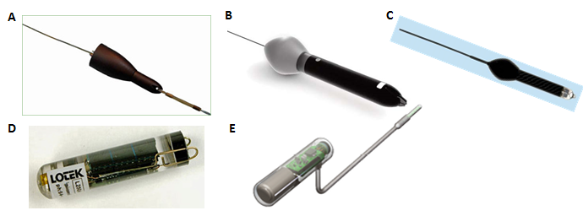Figure 1. Electronic tag types illustrated. Popup Satellite Archival (PSAT) tags (A-C) and implantable Archival tags (D-E). A. LOTEK PSAT, B. Wildlife Computers PAT, D. LOTEK LAT2500, E. Wildlife Computers MK9

## *Native eTag Data Formats*

Representative illustrations of archival and summarized popup (PSAT) data files from a range of models and manufacturers showing the typical contents and organization of associated electronic tag metadata and data are summarized below. Figures 2-5 show the typical contents and organization of electronic tag data files of different type, including metadata elements and columnar data.

### Archival Data Formats

Excerpts of outputs from LOTEK, Wildlife Computers (WC), and Microwave Telemetry (MT) archival tag data files are shown in figures 2-4 respectively. Note that the upper part of each figure shows the structure of the archival sensor data whereas the lower portion of the figures illustrates associated light-based geolocation output from archival tags. Linkage of these horizontal position and vertical profile series is based on time stamp. However, it is important to note that the number of Lat/Lon positional estimates are likely to be considerably less than available profile time series observational sensor data given the comparatively low frequency of available positional fixes.

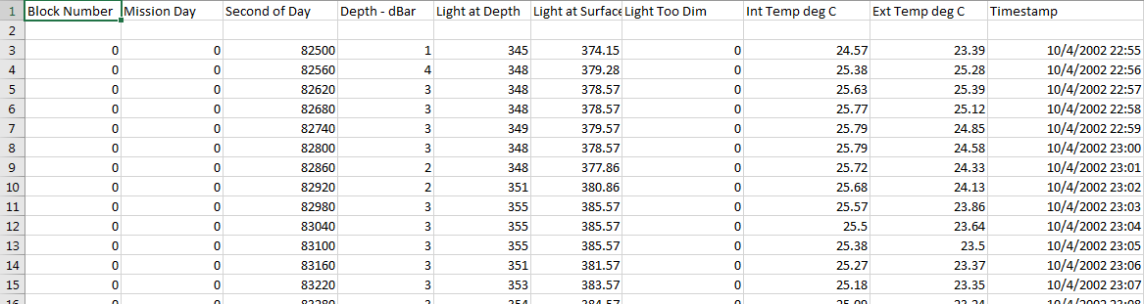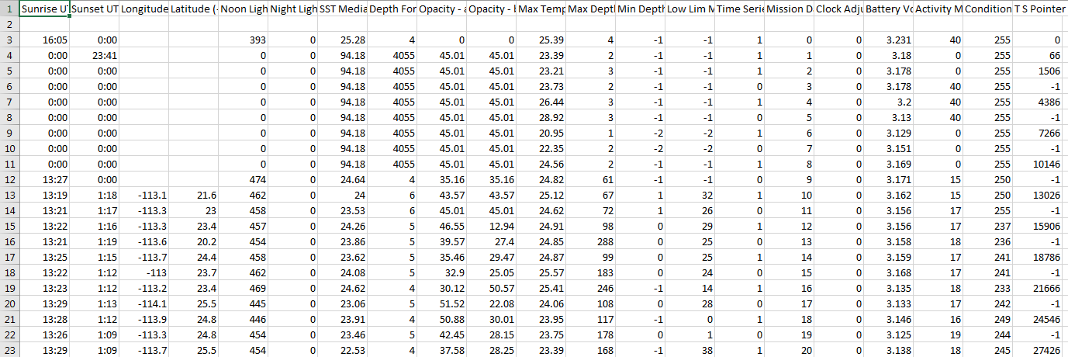

Figure 2. LOTEK Archival Tag Data Files. [Top] Geophysical sensor, depth and time stamp columnar data . [Bottom] Light based geolocation data with mission day and associated daily summary geophysical data. Linkage between detailed archival geophysical values (light, internal body temperature, ambient water temperature, light level) at depth time series is via mission day fields.

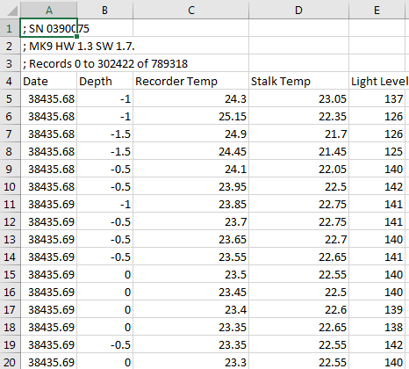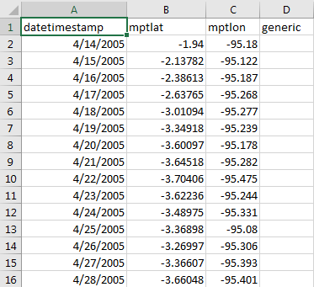

Figure 3. Wildlife Computers Archival Tag Data Files. [Top] Geophysical sensor data (light, internal body temperature, ambient water temperature, light level), depth and time stamp columnar data . [Bottom] Light based geolocation data with mission day and associated daily summary geophysical data. Linkage between detailed archival geophysical values at depth time series is via date/time fields.

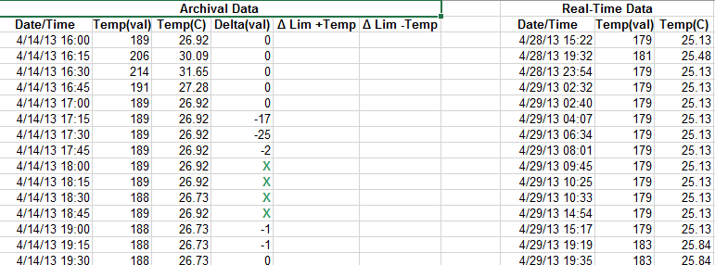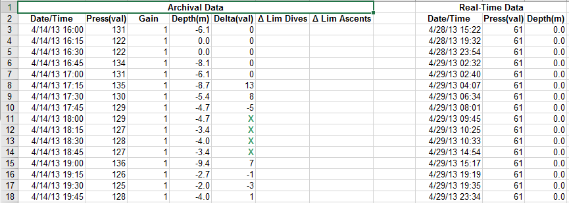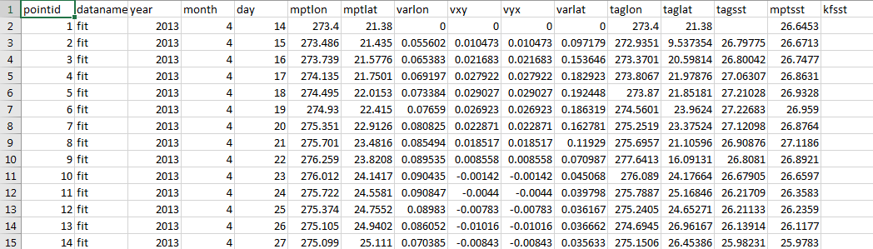

Figure 4. Microwave Telemetry Archival Tag Data Files. [Top/Middle] Geophysical sensor time series at depth data (ambient temperature, pressure, light). Lower and higher frequency data sampling records in the Archival and Real-time blocks respectively. [Bottom] Light based geolocation positional estimates at time. Linkage between detailed geophysical values and positional data is via available matching date/time field values.

### Summarized Popup Satellite Archival (PSAT) Data Formats

Typical extracts of summarized data outputs transmitted to satellite from PSAT tags that have successfully popped off the animal are illustrated in figures 5 and 6 below. Summary eTag data outputs take a variety of forms and are packaged in several CSV data product files by type. In the case, for example, of Wildlife computers CSV output data products include:

*Argos.csv. Behavior.csv, Corrupt.csv, DivePDT.csv, DDN.csv, FastlocGPS.csv, HaulOut.csv, Histos.csv, Lightloc.csv, Locations.csv, X-Locations.csv, MixLayer.csv, PDTs.csv, Series.csv, SeriesRange.csv, SST.csv, Status.csv, STP.csv, Summary.csv, RTC.csv, Labels.csv, All.csv, GPE3.csv,DailyData.csv*

Descriptions of these files and their contents is available from <http://wildlifecomputers.com/wp-content/uploads/manuals/Spreadsheet-File-Descriptions.pdf>. But of these, only a subset contain the core science data of interest; several of the other data files contain either ancillary information or alternate representations of the core data, with considerable overlap evident between products. The two products comprising the summarized science data of principal interest are:

* Time-At-Temperature and Time-At-Depth data: summarized bin-frequency temperature and depth distribution data for pre-programmed time intervals and bin classes (typically, 12-14 bin classes) from the source Histos.csv– figure 5
* Profile of Depth and Temperature (PDT): summarized Pressure/Depth/Temperature min/max range values for pre-programmed time intervals from the source *PDTs.csv*– figure 6

Locations:

* Although not shown, daily light based geolocation positional estimates are available with both the aforementioned types of summarized output and resemble those in figure 3 for archival positional estimate outputs from the source *LightLoc.csv* and *Locations.csv* with geocorrected positions from the *GP3.csv* data file. Linkage of horizontal position and summarized vertical profile series is based on matching time stamp, although again there are likely to be differences in data frequency between point geolocation and time interval summary observations as in the case of full archival series.
* Other positional data provided include known Argos-based positions at the time of deployment and post pop-off are summarized in *Argos.csv*. Linkage between geophysical values in both detailed time series or summarized forms and positional data is via available matching date/time field values

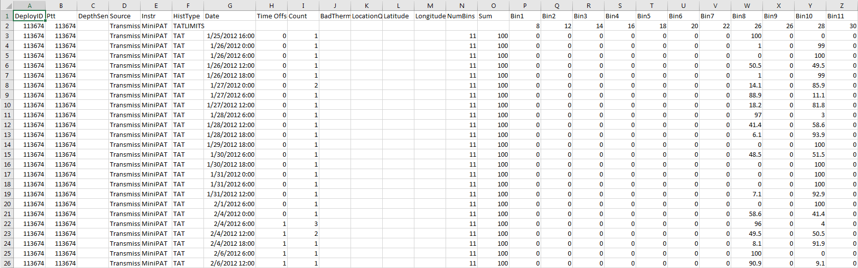

Figure 5. Wildlife Computers PSAT Bin-Frequency Summary Data. Summarized bin-frequency temperature and depth distribution data for pre-programmed time intervals and bin classes (12-14). Daily light-based geolocation positional estimates are not shown here (equivalent to those in figure 2). Linkage between detailed geophysical values and positional data is via available matching date/time field values.

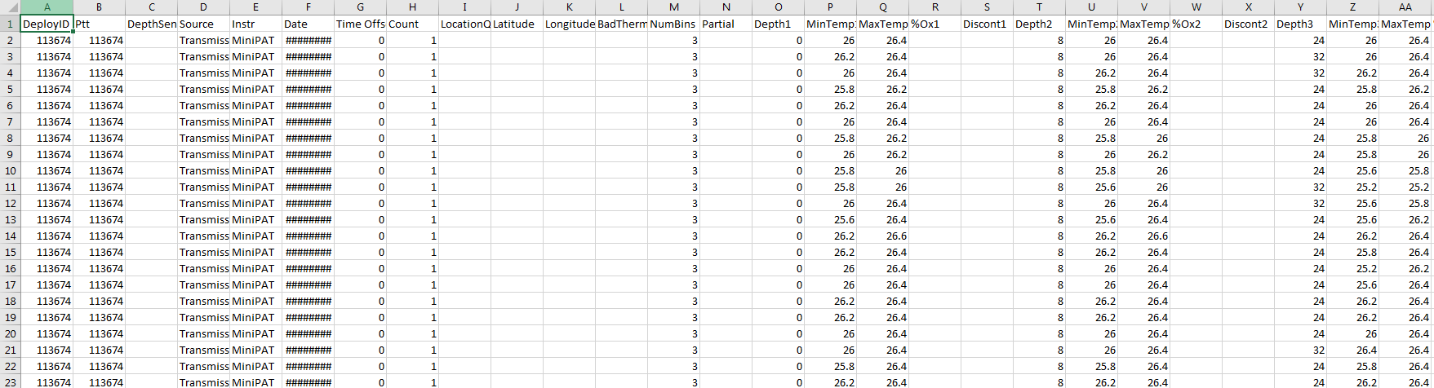

Figure 6. Wildlife Computers PSAT Summary PDT Data. Summarized Pressure/Depth/Temperature (PDT - Profile of Depth and Temperature) min/max range values for pre-programmed time intervals. Daily light based geolocation positional estimates are not shown here (equivalent to those in figure 2). Linkage between detailed geophysical values and positional data is via available matching date/time field values.