In my project I made a form which sends you an email using a php script called “Foprm.php”
Now the problem is that the mail() function using which the mail is sent does not work because a smtp server is not configured.
This is the quickest get around by usina gmail acount I created
Steps:
- Go to your XAMPP folder then sendmail and in the folder there is a folder called “sendmail.ini” make the following changes.
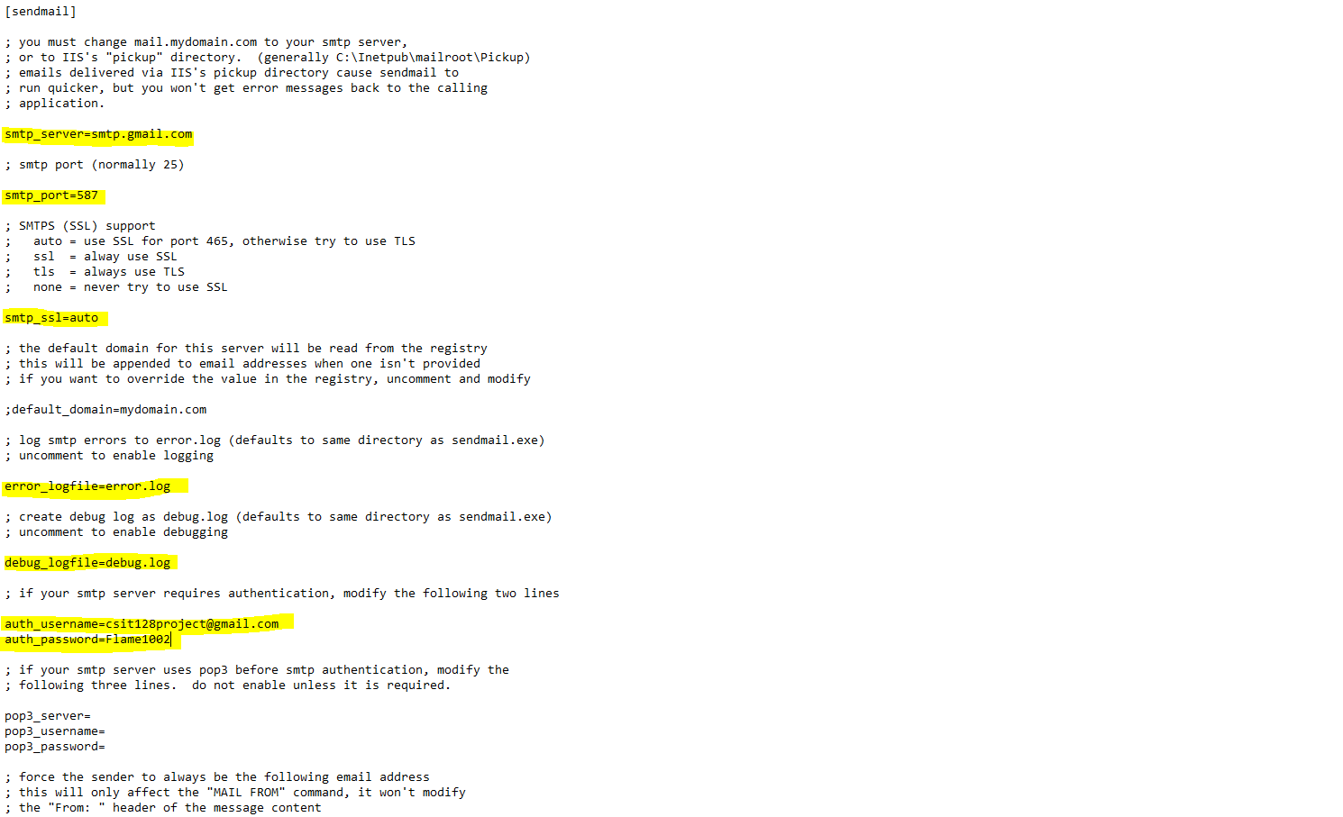

- Then in XAMPP folder look for php folder which will contain “php.ini”. In the change the following values:

