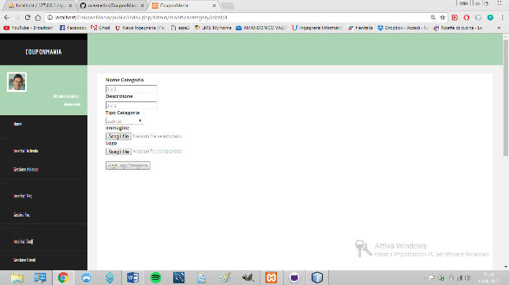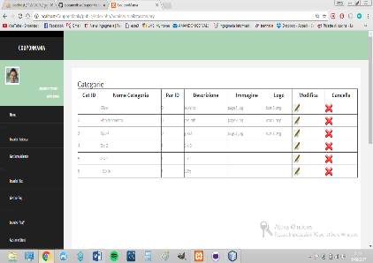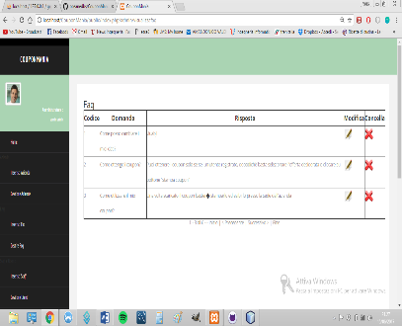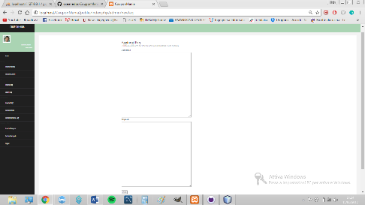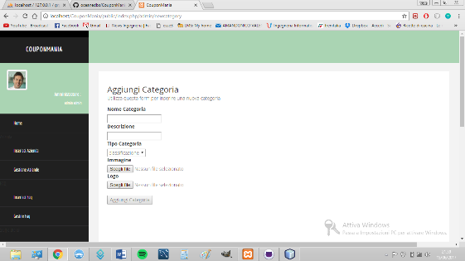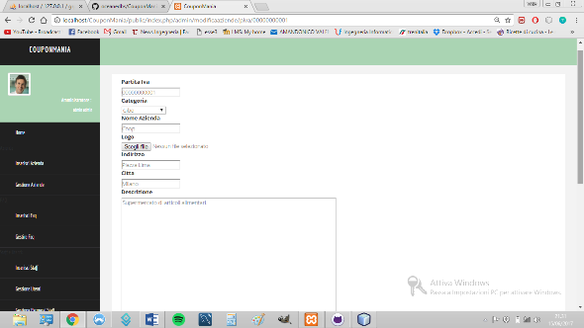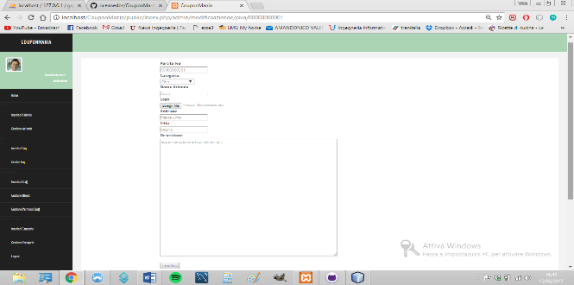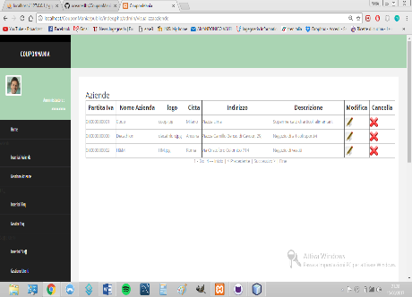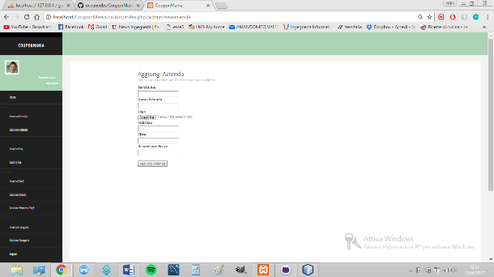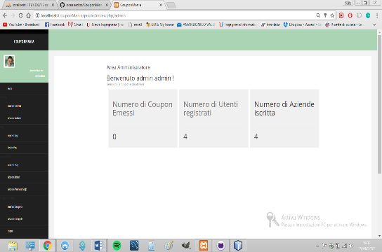

admin/visualizzacategory

admin/modificacategory/idcat/<val>

admin/visualizzacategory

admin/cancellacategory/idcat/<val>

idcat/<val>

admin/visualizzacategory

admin/newcategory

admin/cancellafaq

admin/visualizzafaq

admin/visualizzafaq

admin/visualizzafaq

admin/modificafaq/idfaq/<val>

admin/visualizzaaziende

admin/modificaaziende/piva/<val>

admin/cancella

admin/visualizzaaziende

admin/visualizzaaziende

admin/newfaq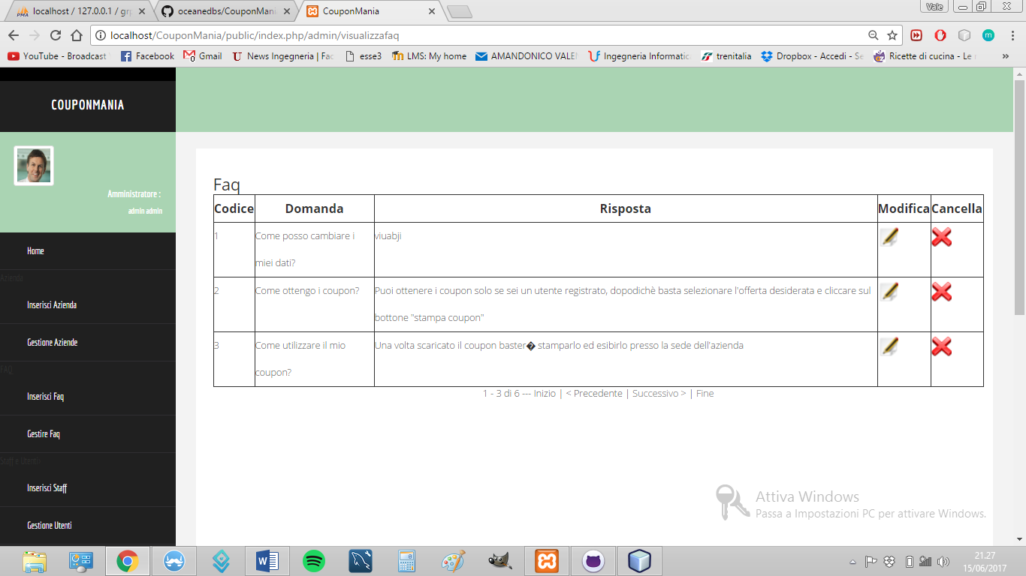

admin/newaziende

admin/index

admin/index

Public/login