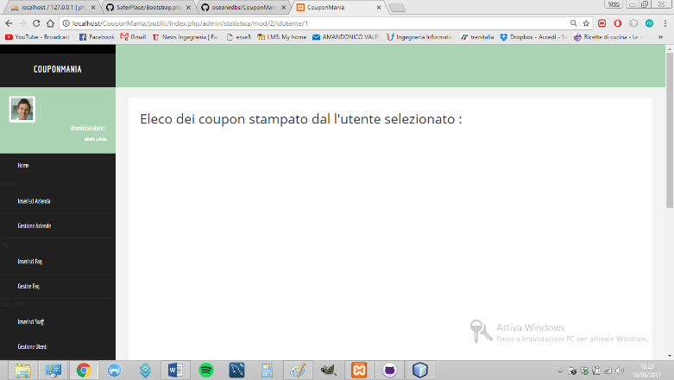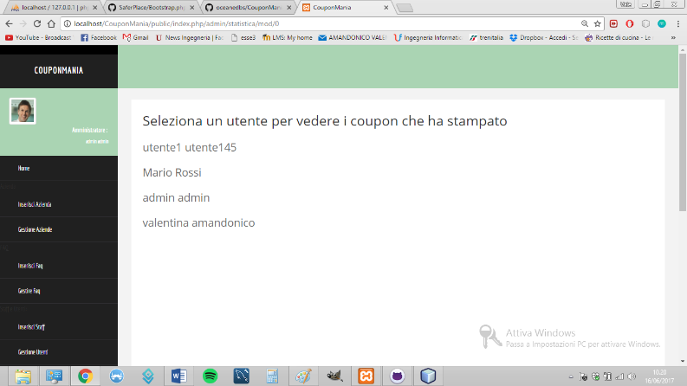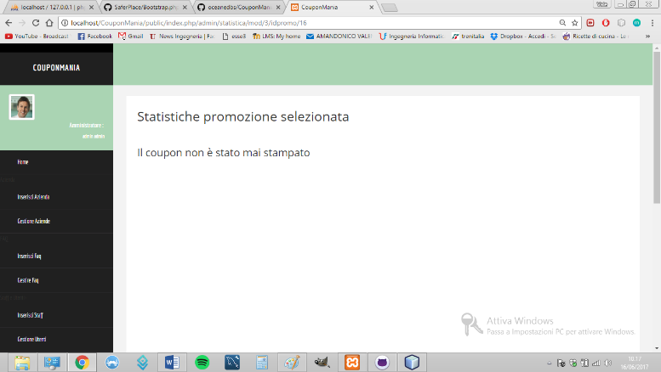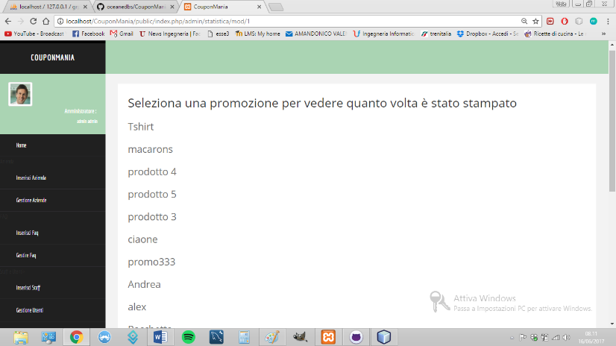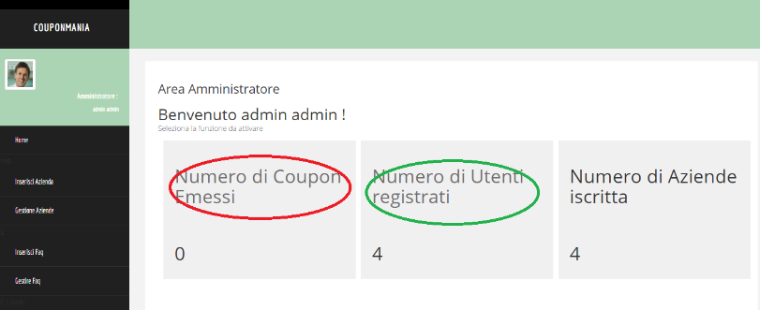

admin/statistica/mod/2/idutente/<val>

admin/statistica/mod/0

admin/statistica/mod/3/idpromo/<val>

admin/statistica/mod/1

admin/cancellapermessi/idazienda/<val>/idutente/val

idcat/<val>

admin/visualizzapermessi/idstaff/<val>

admin/visualizzastaff

admin/index

Public/login