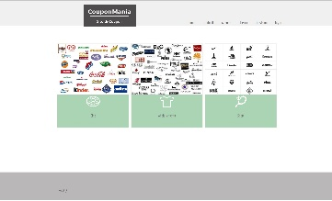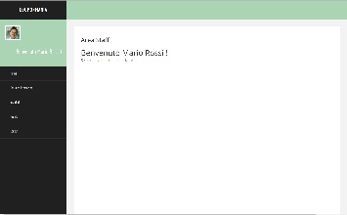

staff/index

staff/logout

staff/profilo

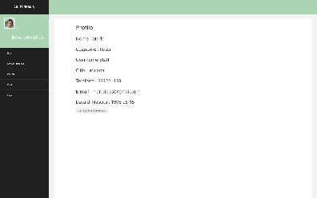

staff/visualizzapromo/idstaff/<val>

staff/newproduct

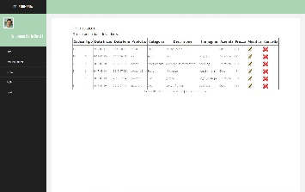

staff/visualizzapromo/idstaff/<val>

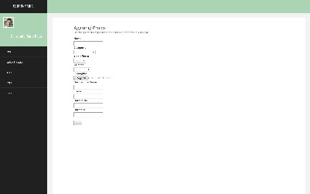

staff/cancella/codprod/<val>

staff/cambiareprofilo

staff/visualizzapromo/idstaff/<val>

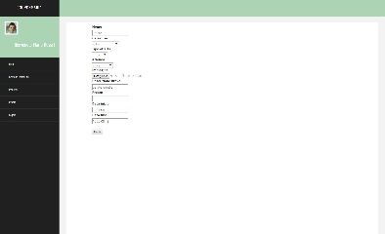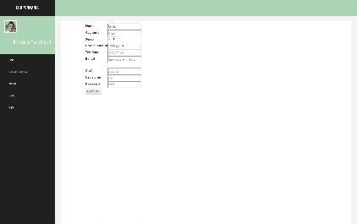

staff/modificapromo/codprod/<val>