**GO Train Schedule API**

This project is created with the help of the following,

* Lombok
* Swagger
* JPA
* Cache Enabled
* Reading data from CSV and inserting it in H2 while Application Startup.
* H2 - jdbc:h2:mem:traindb
* Tomcat Server
* Exception Handling
* Time formatter to check the 24 hours/ 12 hours Military format.
* Find the Postman collection and Postman testing documents from git repository.

Below are the URL’s to access the application;

http://localhost:9090/h2-console

http://localhost:9090/swagger-ui/index.html

http://localhost:9090/schedule

http://localhost:9090/schedule/Lakeshore

<http://localhost:9090/schedule/v1/Lakeshore?departure=800>

Please find the API tested using Postman,

1. GET /schedule that Returns the entire timetable as a JSON array.

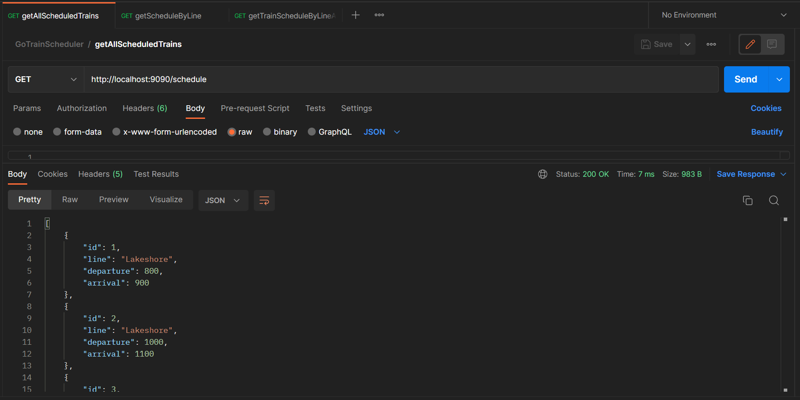

1. GET /schedule/{line} Returns a JSON array with the timetable for that specific line.

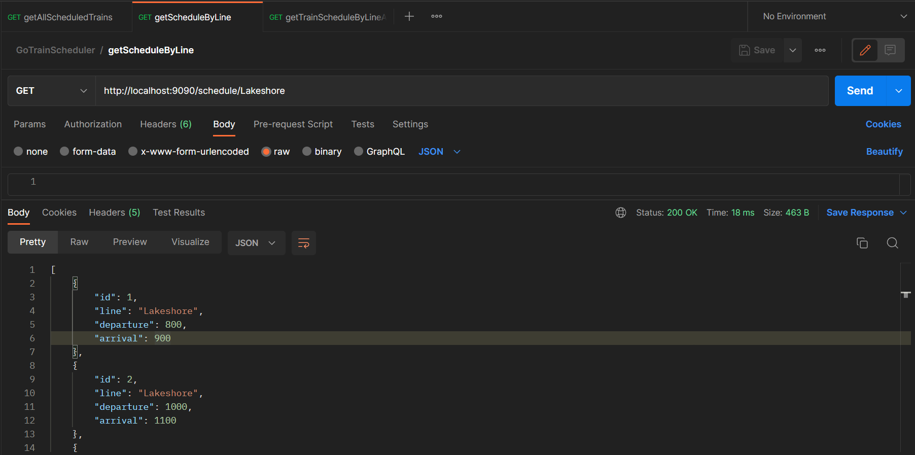

1. GET /schedule/{line}, If the line does not exist, the request returns HTTP 404 (Not Found).

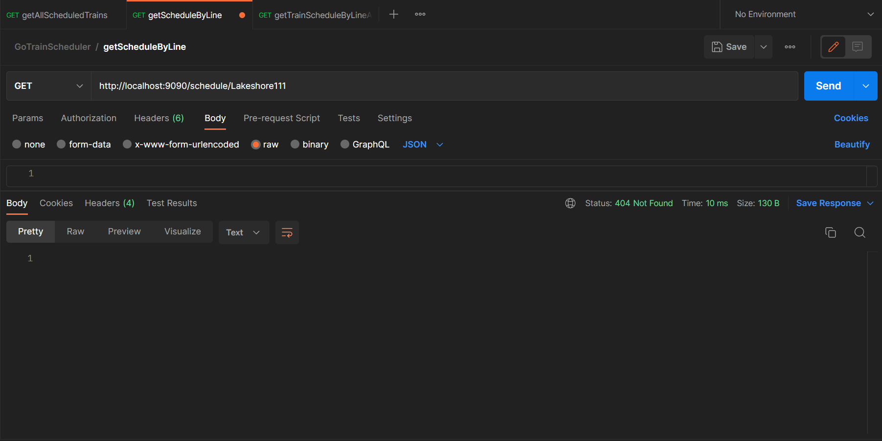

1. GET /schedule/{line}?departure={time} Returns a one-element JSON array with the record for the specified train line and departure time.

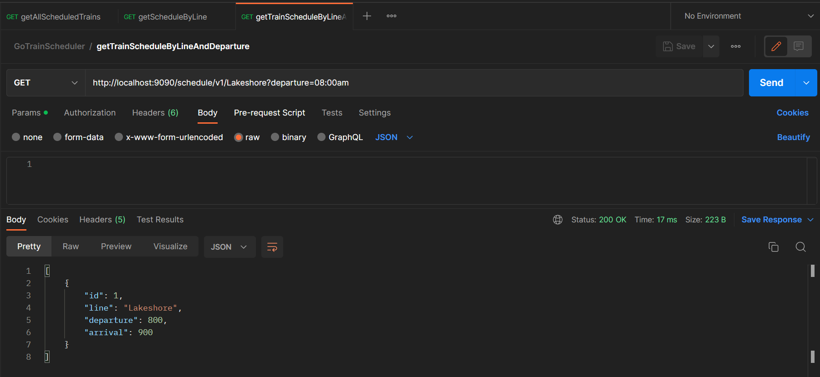

1. GET /schedule/{line}?departure={time}, If a line does not have any trains departing at the specified time, the request should still be successful but should return an empty array.

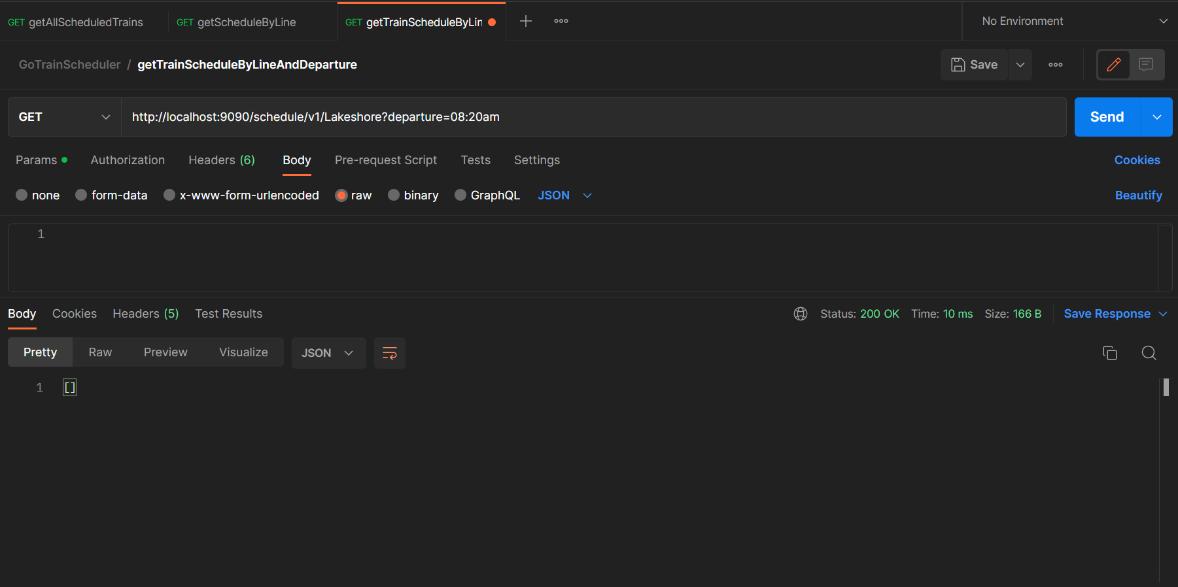

1. GET /schedule/{line}?departure={time}, to check if the input departure time is in format other than 24 hours/12 hours military format, and send 400 Bad Request.

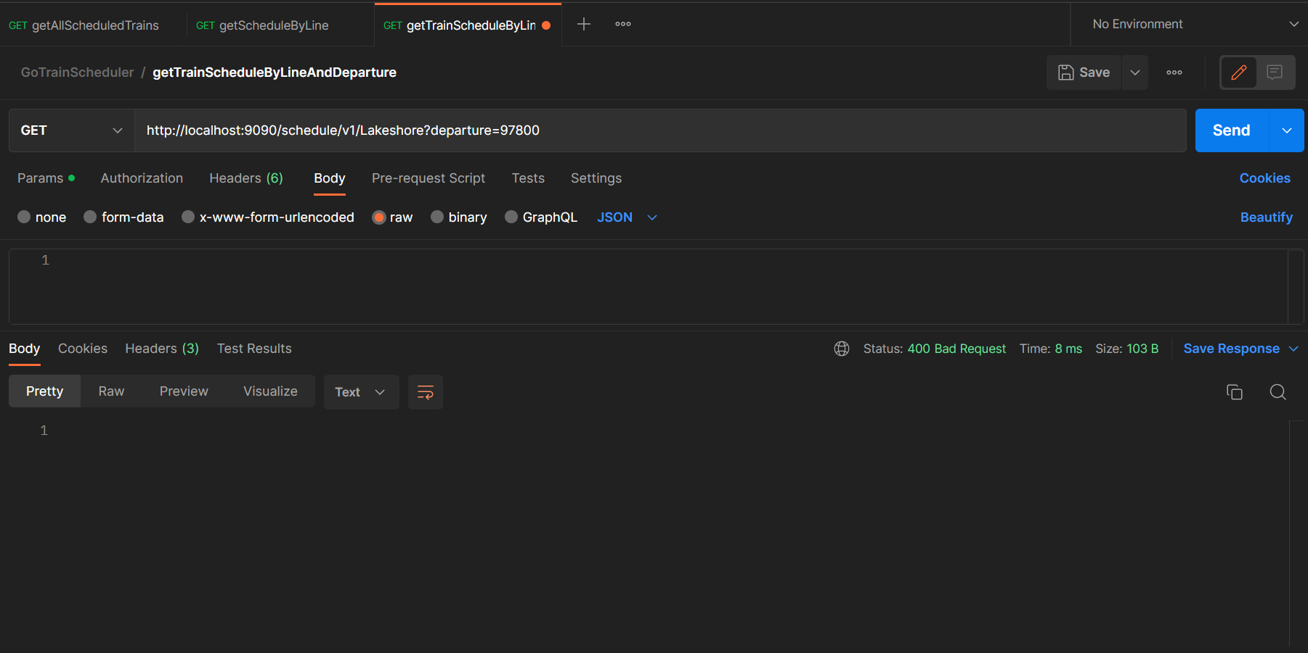

The below screenshot is of Swaager documentation,

