**CS 3800 Computer Networks**

**Quiz # 1**

**Duration: 15 minutes**

1. Consider sending a packet from a source host to a destination host over a fixed route. List the delay components in the end-to-end delay. Which of these delays are constant and which are variable?

The delay components are processing delays, transmission delays, propagation delays, and queuing delays. All of these delays are fixed, except for the queuing delays, which are variable.

1. Consider the figure below, with three links, each with the specified transmission rate and link length

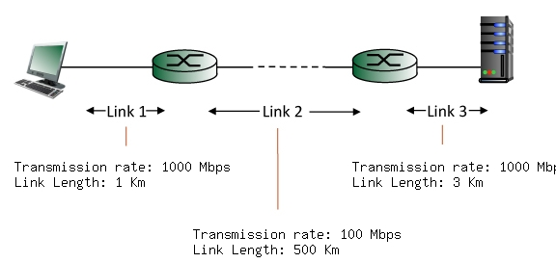

Find the end-to-end delay (including the transmission delays and propagation delays on each of the three links, but ignoring queueing delays and processing delays) from when the left host begins transmitting the first bit of a packet to the time when the last bit of that packet is received at the server at the right. The speed of light propagation delay on each link is 3x10**8 m/sec. Note that the transmission rates are in Mbps and the link distances are in Km. Assume a packet length of 8000 bits. Give your answer in milliseconds.

Solution:

Link 1 transmission delay = L/R = 8000 bits / 1000 Mbps = 0.008000 msec.

Link 1 propagation delay = d/s = 1 Km / 3*10**8 m/sec = 0.003333 msec.

Link 2 transmission delay = L/R = 8000 bits / 100 Mbps = 0.080000 msec.

Link 2 propagation delay = d/s = 500 Km / 3*10**8 m/sec = 1.666667 msec.

Link 3 transmission delay = L/R = 8000 bits / 1000 Mbps = 0.008000 msec.

Link 3 propagation delay = d/s = 3 Km / 3*10**8 m/sec = 0.010000 msec.

Thus, the total end-to-end delay is the sum of these six delays: 1.776000 msecs.

1. A packet switch receives a packet and determines the outbound link to which the packet should be forwarded. When the packet arrives, one other packet is halfway done being transmitted on this outbound link and four other packets are waiting to be transmitted. Packets are transmitted in order of arrival. Suppose all packets are 1,500 bytes and the link rate is 2 Mbps. What is the queuing delay for the packet?

The arriving packet must first wait for the link to transmit 4.5 *1,500 bytes = 6,750 bytes or 54,000 bits. Since these bits are transmitted at 2 Mbps, the queuing delay is 27 msec. Generally, the queuing delay is (nL + (L - x))/R.