**CS 3800 Computer Networks**

Instructor: John Korah

**Quiz # 5**

**Duration: 15 minutes**

**NAME: _________________________**

**SECTION: _________________________**

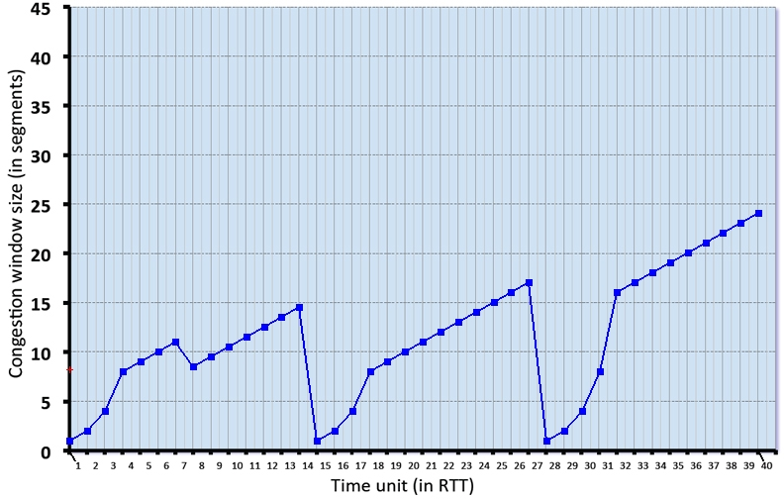

Consider the figure above, which plots the evolution of TCP's congestion window at the beginning of each time unit (where the unit of time is equal to the RTT). In the abstract model for this problem, TCP sends a "flight" of packets of size cwnd at the beginning of each time unit. The result of sending that flight of packets is that either *(i)*all packets are ACKed at the end of the time unit, *(ii)*there is a timeout for the first packet, or *(iii)*there is a triple duplicate ACK for the first packet. In this problem, you are asked to reconstruct the sequence of events (ACKs, losses) that resulted in the evolution of TCP's cwnd shown below.

**Please Turn Over**

1. Which state is TCP at the first time unit = 1 RTT? (pick one option)
2. Slow Start
3. Congestion avoidance
4. Fast recover
5. None of the above
6. What is the value of the variable *ssthresh* at time unit = 5 RTT?(pick the best option)
7. 1
8. 8
9. 4
10. 16
11. What event occurs at time unit = 7 RTT? (pick the best option)
12. No event – normal operation
13. timeout
14. triple ACK
15. new ACK
16. What event occurs at time unit = 14 RTT? (pick the best option)
17. No event – normal operation
18. timeout
19. triple ACK
20. new ACK
21. What is the value of the variable *ssthresh* at time unit = 31 RTT?(pick one)
22. 1
23. 7
24. 8.5
25. 8
26. What occurs at time unit = 32 RTT? (pick the best option)
27. Transition to slow start
28. Transition to fast recovery
29. Transition to congestion avoidance
30. timeout