**Activitity: Amazon EC2 Setup (Step 1 – Step 7: 5 points)**

**Goal:** Get familiar with Amazon EC2 platform and infrastructure.

**Task**: Configure an image on EC2 and edit an html file on EC2.

**Instructions (Note: this is just a guideline, you decide your own choices.):**

1. Sign in to AWS console (via AWS Educate or console.ams.amazon.com) and read/watch tutorials on EC2.
2. Find services 🡺 EC2
3. Launch instance. Now follow the steps

Step 1: Choose an Amazon Machine Image (AMI)

e.g. Amazon Linux 2 AMI (HVM), SSD Volume Type - ami-02bcbb802e03574ba (64-bit x86)

Click on select

(Note: you may choose any version of Linux/Ubuntu system, but not the Windows.)

Step 2: Choose instance type

Choose the Free tier eligible or low-cost (whatever your account supports but make sure you well manage your budget)

Step 3-6: Configure instance

Choose default or make any reasonable choices, and click Review and Launch

Step 7: Review => click Launch

1. Select keypair (first time choose to create a keypair, remember the file name and where you saved this file; afterwards, can just select the saved file)
2. Now your instance has been launched

e.g. Instance: i-03710b602f095ad78

View instance to check instance status

1. Now connect to your instance using ssh command or putty

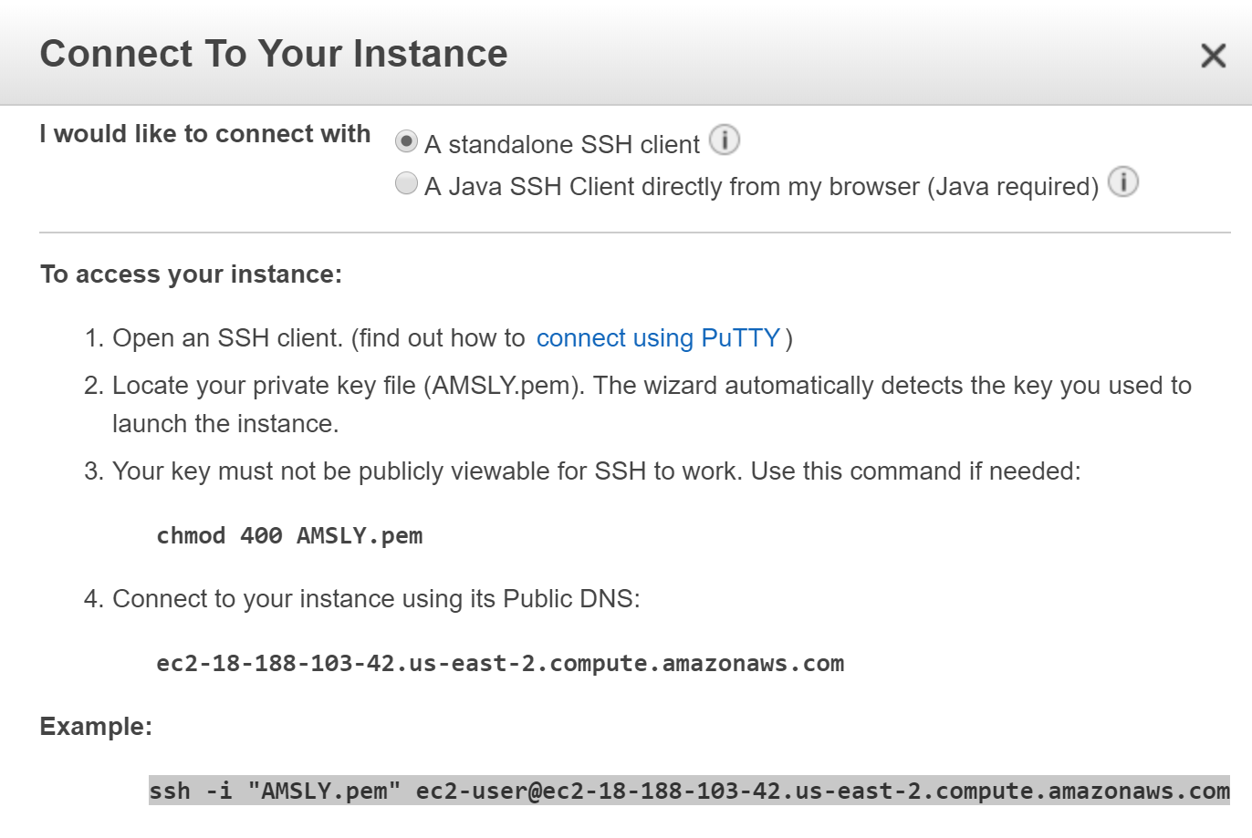

1. Once you connect to EC2 console, you may use it the same way using any linux console. Make sure your favorite editor is there. If not, install one.

Now, try to type in and run a python program.

**Report:**

Write up what you have done on EC2 in details. Provide detailed description of step-by-step actions including screen shots for major steps (a detailed readme file that you could reference later on). Report any problems you encounter if any.

References:

1. Sign in to console.aws.amazon.com, click on support (upper right corner), click on document, click on EC2.
2. Sign in to the console, scroll down to the section “Learn to build”. Note to use some features introduced in the tutorial may cost money (i.e. some features are not supported by free tier.)