**Assignment #3:**  **Exploring Amazon AWS S3 Services (10 points)**

**Goal:** Get familiar with file storage provided by AWS S3; Create a static webpage via S3.

**Basic steps to get started with S3.**

**Step 1: Sign in to AWS console**

<https://aws.amazon.com/console/> or via Amazon Educate site

Using the account name and password selected in account creation

**Step 2: Find services**

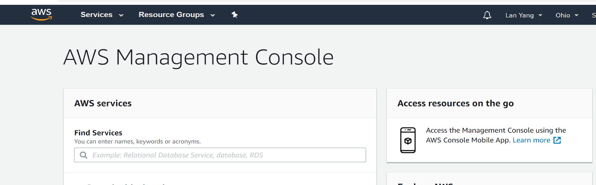

At the Finding Services box, choose S3 (or other service)

**Step 3: Now use the service**

1. Create a new bucket (once you create, you can delete, empty, …)

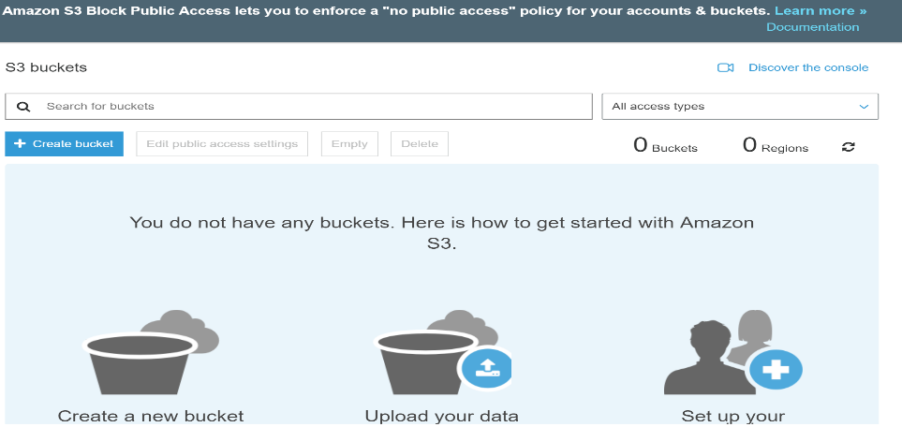

1. Click the bucket you created, and then you can upload files!

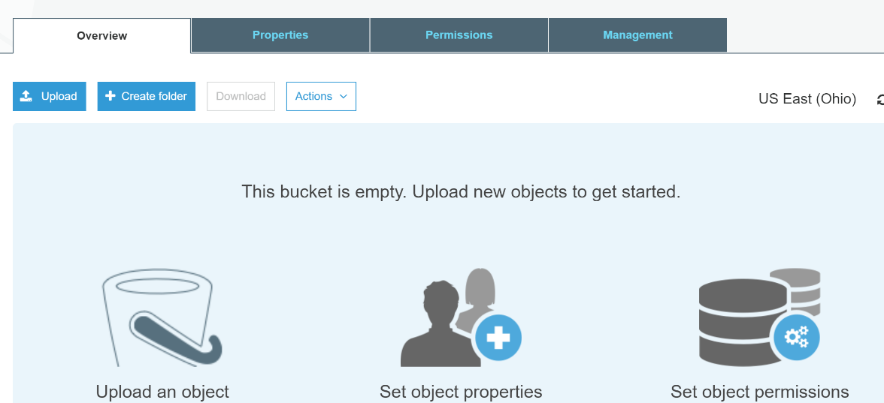

1. Now explore more … (Click ***Learn More*** to learn more S3 features!)
2. Suggested practice: upload photos and videos, change permissions, set properties, …

Reference: <https://aws.amazon.com/getting-started/tutorials/backup-files-to-amazon-s3/>

(Sign in to console.aws.amazon.com, scroll down to “Learn to build”, click on Storage, follow tutorials on S3.)

(5) Create a simple HTML file and store it on a S3 bucket. The HTML file should display some photos and videos stored on the S3. Then, on your cpp webpage (e.g. <http://www.cpp.edu/~lyang/>) make a link to the HTML file on S3. Now open your cpp webpage and from there view the videos and photos you stored on S3.

**Assignment Requirements:**

1. **Create at least two folders at S3 (for example, one folder for videos, one for photos, one for documents, …) and store at least three files at each folder.**
2. **Practice basic file operations (store, retrieve, delete, …) on your folders.**
3. **Create a html file that accesses the files stored in your S3 folders.**
4. **Host the website on your S3 and link the webpage with your CPP homepage.**

**Submission requirements:**

Write a report describing what you have done. Provide detailed step by step actions that you performed (e.g. a readme document that you could reference.) Include at least 3 screen shots showing the actions you performed on S3. Complete all tasks listed on the above Assignment Requirements.

Link the report as well as the website hosted on S3 with your CPP website. Submit your CPP website link as your submission to blackboard under Assignment #4 link.