There are N network nodes, labelled 1 to N.

Given times, a list of travel times as **directed** edges times[i] = (u, v, w), where u is the source node, v is the target node, and w is the time it takes for a signal to travel from source to target.

Now, we send a signal from a certain node K. How long will it take for all nodes to receive the signal? If it is impossible, return -1.

**Example 1:**

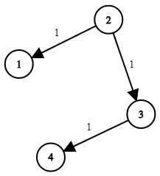

**Input:** times = [[2,1,1],[2,3,1],[3,4,1]], N = 4, K = 2

**Output:** 2

**Note:**

1. N will be in the range [1, 100].
2. K will be in the range [1, N].
3. The length of times will be in the range [1, 6000].
4. All edges times[i] = (u, v, w) will have 1 <= u, v <= N and 0 <= w <= 100.