- 输入字段
"context": { "task_goal": "采集重点企业在智能驾驶算法路线和典型算力规模方面的最新公开信息。",
"background_knowledge": "重点关注 2024 年至今的公开信息，优先采用官方发布与高可信信源。",
"business_boundary": "只采集公开可验证信息，不对未公开技术路线和参数做推断性补全。",
"source_policy": { "search_engines": ["bing"], "preferred_sites": [ "pony.ai", "xiaopeng.com", "ir.xiaopeng.com" ], "site_policy": "preferred", "knowledge_bases": ["autonomous-driving-kb"],
"fixed_urls": [],
"null_policy": "暂无公开信息",
"source_priority": "官方发布会/技术博客 > 财报/投资者关系 > 权威行业报告 > 头部券商研报 > 经核实的行业媒体",
"value_format": "只返回结构化 JSON" }
},
当前将输入yaml文件结构化入参，这个部分可能还存在问题。
（1）接口只支持query和background两个字段，如果用户约束信息，需要放入background里面。
（2）搜索引擎配置参数，这个后续我暴露出来，只针对境外的tavily可以配置。
2. 输出字段json格式
{ "row_id": 101,
"business_date": "2026-03-31",
"dimension_values":
{ "comcode": "PONY", "company_name": "小马智行" },
"indicator_key": "algorithm_route",
"indicator_name": "算法路线",
"value_type": "string",
"indicator_unit": "text",
"indicator_description": "聚焦 BEV、Transformer、端到端、大模型、VLM/VLA/世界模型及自研/外供方案",
"audit_rules": [ "仅写公开可验证信息", "禁止将未明确披露内容写成确定结论" ],
"value": null,
"raw_value": null,
"value_description": null,
"published_at": null,
"source_site": null,
"indicator_logic": null,
"indicator_logic_supplement": null,
"max_value": null,
"min_value": null,
"data_source": null,
"source_url": null,
"source_link": null,
"quote_text": null,
"confidence": null,
"semantic": null,
"status": null },
当前业务真实采集输出：
存在一个药品多个规格，一次性采集的情况。
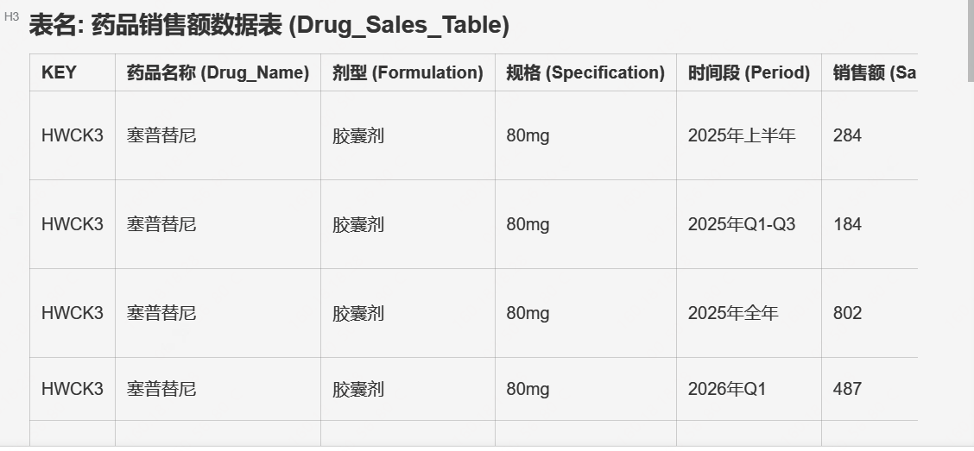
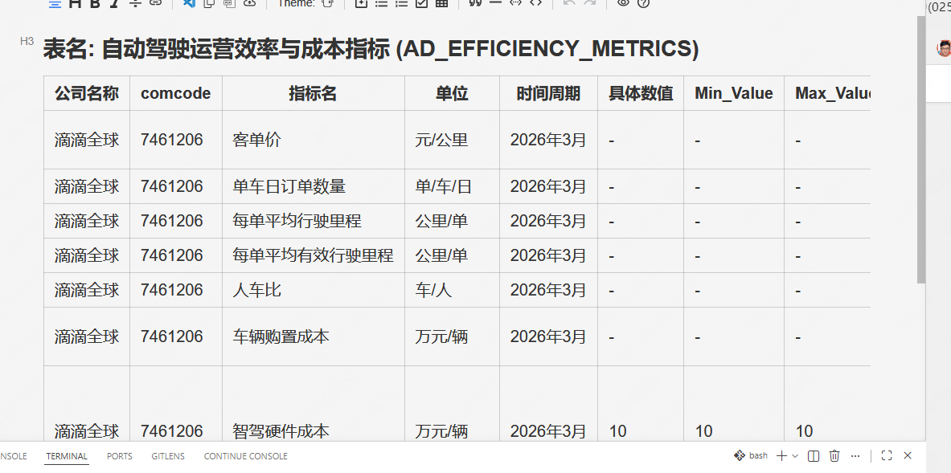
当前算法侧能提供的json结构输出字段schema：
{
"schema": "http://json-schema.org/draft-07/schema#",
"title": "MetricData",
"description": "指标数据记录",
"type": "object",
"properties": {
"metric_id": {
"type": "string",
"description": "指标id, 用于join，最好是当前批次唯一key",
},
"group_text_key": {
"type": "string",
"description": "实际指标组合文本key，用“-”拼接",
},
"metric_name": {
"type": "string",
"description": "指标名称"
},
"value": {
"type": "string",
"description": "指标值"
},
"unit": {
"type": "string",
"description": "单位"
},
"data_period": {
"type": "string",
"description": "数据时间",
},
"min_value": {
"type": "string",
"description": "Min_Value"
},
"max_value": {
"type": "string",
"description": "Max_Value"
},
"source_url": {
"type": "string",
"description": "Source_URL",
},
"source_evidence": {
"type": "string",
"description": "Source_Evidence"
}
},
"required": ["metric_id", "metric_name", "value", "data_period"],
"additionalProperties": false }
如果抽象成上述字段schema，一次采集的组合metric_id则必须唯一，通过指标名+时间来关联区分指标。
