KABALE UNIVERSITY
RECOMBINANT DNA TECHNOLOGIES
PRACTICAL 1
NAME: OCHAAKI NYARWA ABSOLOM
REG: 2025/A/KIB/6554/F
TITLE: RETRIEVAL, ANNOTATION AND ANALYSIS OF A GENE SEQUENCE FROM PUBLIC MOLECULAR DATABASES.
INTRODUCTION
Genes contain the genetic information responsible for the production of functional RNA and proteins in living organisms. Studying gene sequences is therefore important in molecular biology because the nucleotide sequence can provide information about the structure and possible function of a gene. With the development of bioinformatics, gene sequences can be obtained and studied using online molecular databases without necessarily having to determine the sequence experimentally.
The National Center for Biotechnology Information (NCBI) is one of the major public databases used for accessing biological sequence information. It contains nucleotide and protein sequences from different organisms and provides tools that can be used to retrieve and analyze these sequences. One of the commonly used formats for obtaining a nucleotide sequence is FASTA format, which presents the sequence in a simple form that can be used in different sequence analysis programs.
In this practical, the phytoene synthase 2a (PSY2a) gene from Musa troglodyte was retrieved from the NCBI nucleotide database. The selected record has the GenBank is described as a complete coding sequence (CDS). The retrieved nucleotide sequence was then examined as part of the annotation and analysis of the gene.
The PSY2a gene is associated with phytoene synthase, an enzyme involved in the carotenoid biosynthetic pathway in plants. Analyzing this gene provides an opportunity to understand how information stored in a public molecular database can be used to study a gene sequence and its biological significance.
The main purpose of this practical was therefore to retrieve a selected gene sequence from NCBI, examine the information associated with the sequence, and carry out basic annotation and analysis of the retrieved gene. The practical also provided experience in using an online molecular database and interpreting sequence information obtained in FASTA format.
Methodology:
- I opened Https:www.ncbi.nlm.nih.gov and accessed the website

- I searched for the gene Asupina ptytoene synthase (psy2a) in the search bar.

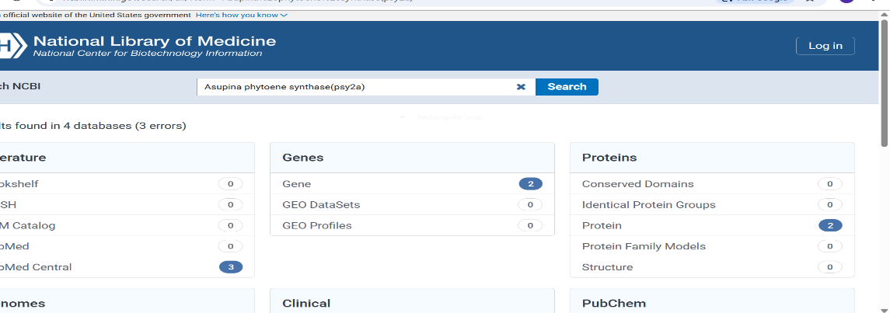
I clicked on the option of nucleotide and it brought and pick first one

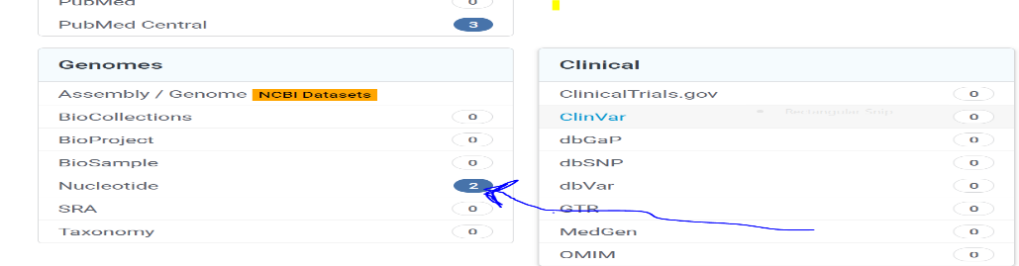
- 2Nucleotides appear and I clicked the first option.
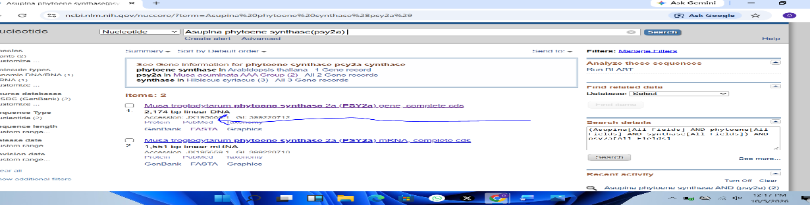
- I clicked the nucleotide and its nucleotide features appeared for analysis
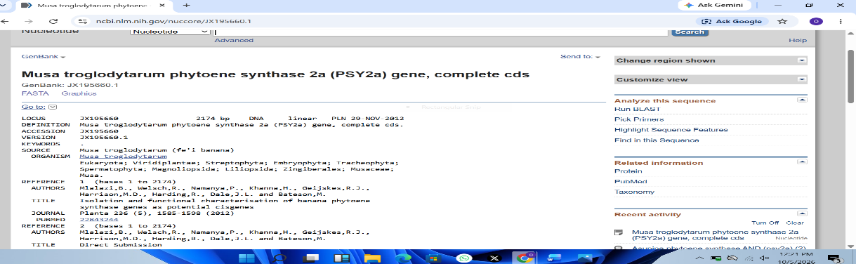
5.i clicked on FASTA to access the gene details
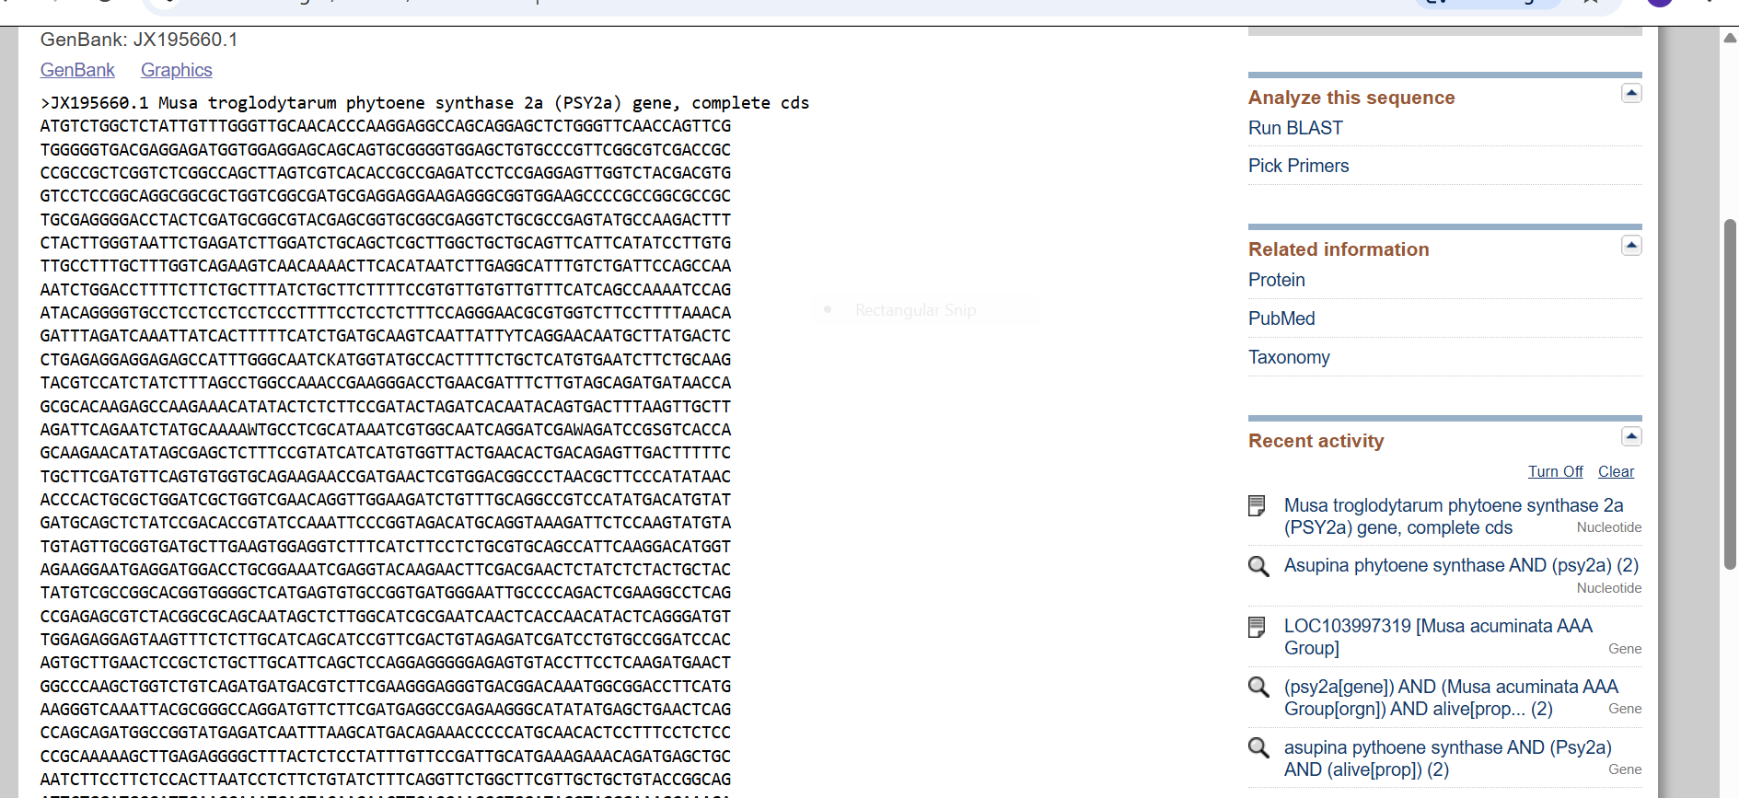
Resuts:
- Start codon
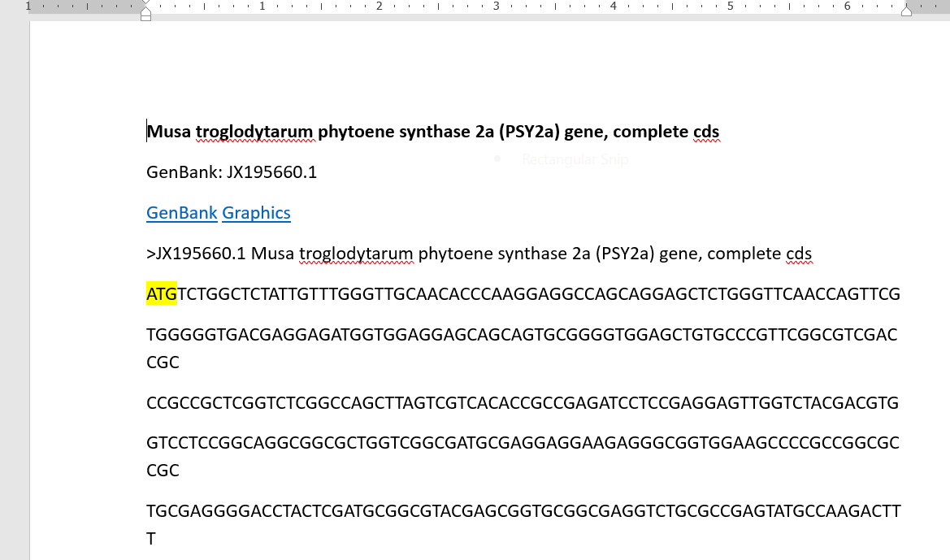
Stop codon.
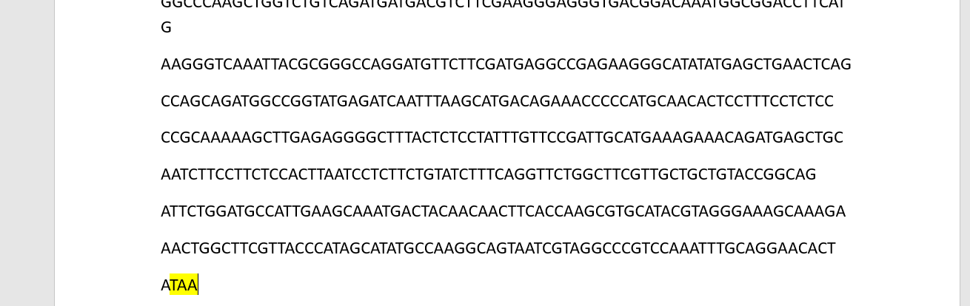
Coding sequence
I went to ncbi and in the features I clicked CDS and copied the sequence.
ORIGIN
1 atgtctggct ctattgtttg ggttgcaaca cccaaggagg ccagcaggag ctctgggttc
61 aaccagttcg tgggggtgac gaggagatgg tggaggagca gcagtgcggg gtggagctgt
121 gcccgttcgg cgtcgaccgc ccgccgctcg gtctcggcca gcttagtcgt cacaccgccg
181 agatcctccg aggagttggt ctacgacgtg gtcctccggc aggcggcgct ggtcggcgat
241 gcgaggagga agagggcggt ggaagccccg ccggcgccgc tgcgagggga cctactcgat
301 gcggcgtacg agcggtgcgg cgaggtctgc gccgagtatg ccaagacttt ctacttgggt
361 aattctgaga tcttggatct gcagctcgct tggctgctgc agttcattca tatccttgtg
421 ttgcctttgc tttggtcaga agtcaacaaa acttcacata atcttgaggc atttgtctga
481 ttccagccaa aatctggacc ttttcttctg ctttatctgc ttcttttccg tgttgtgttg
541 tttcatcagc caaaatccag atacaggggt gcctcctcct cctccctttt cctcctcttt
601 ccagggaacg cgtggtcttc cttttaaaca gatttagatc aaattatcac tttttcatct
661 gatgcaagtc aattattytc aggaacaatg cttatgactc ctgagaggag gagagccatt
721 tgggcaatck atggtatgcc acttttctgc tcatgtgaat cttctgcaag tacgtccatc
781 tatctttagc ctggccaaac cgaagggacc tgaacgattt cttgtagcag atgataacca
841 gcgcacaaga gccaagaaac atatactctc ttccgatact agatcacaat acagtgactt
901 taagttgctt agattcagaa tctatgcaaa awtgcctcgc ataaatcgtg gcaatcagga
961 tcgawagatc cgsgtcacca gcaagaacat atagcgagct ctttccgtat catcatgtgg
1021 ttactgaaca ctgacagagt tgactttttc tgcttcgatg ttcagtgtgg tgcagaagaa
1081 ccgatgaact cgtggacggc cctaacgctt cccatataac acccactgcg ctggatcgct
1141 ggtcgaacag gttggaagat ctgtttgcag gccgtccata tgacatgtat gatgcagctc
1201 tatccgacac cgtatccaaa ttcccggtag acatgcaggt aaagattctc caagtatgta
1261 tgtagttgcg gtgatgcttg aagtggaggt ctttcatctt cctctgcgtg cagccattca
1321 aggacatggt agaaggaatg aggatggacc tgcggaaatc gaggtacaag aacttcgacg
1381 aactctatct ctactgctac tatgtcgccg gcacggtggg gctcatgagt gtgccggtga
1441 tgggaattgc cccagactcg aaggcctcag ccgagagcgt ctacggcgca gcaatagctc
1501 ttggcatcgc gaatcaactc accaacatac tcagggatgt tggagaggag taagtttctc
1561 ttgcatcagc atccgttcga ctgtagagat cgatcctgtg ccggatccac agtgcttgaa
1621 ctccgctctg cttgcattca gctccaggag ggggagagtg taccttcctc aagatgaact
1681 ggcccaagct ggtctgtcag atgatgacgt cttcgaaggg agggtgacgg acaaatggcg
1741 gaccttcatg aagggtcaaa ttacgcgggc caggatgttc ttcgatgagg ccgagaaggg
1801 catatatgag ctgaactcag ccagcagatg gccggtatga gatcaattta agcatgacag
1861 aaacccccat gcaacactcc tttcctctcc ccgcaaaaag cttgagaggg gctttactct
1921 cctatttgtt ccgattgcat gaaagaaaca gatgagctgc aatcttcctt ctccacttaa
1981 tcctcttctg tatctttcag gttctggctt cgttgctgct gtaccggcag attctggatg
2041 ccattgaagc aaatgactac aacaacttca ccaagcgtgc atacgtaggg aaagcaaaga
2101 aactggcttc gttacccata gcatatgcca aggcagtaat cgtaggcccg tccaaatttg
2161 caggaacact ataa
//

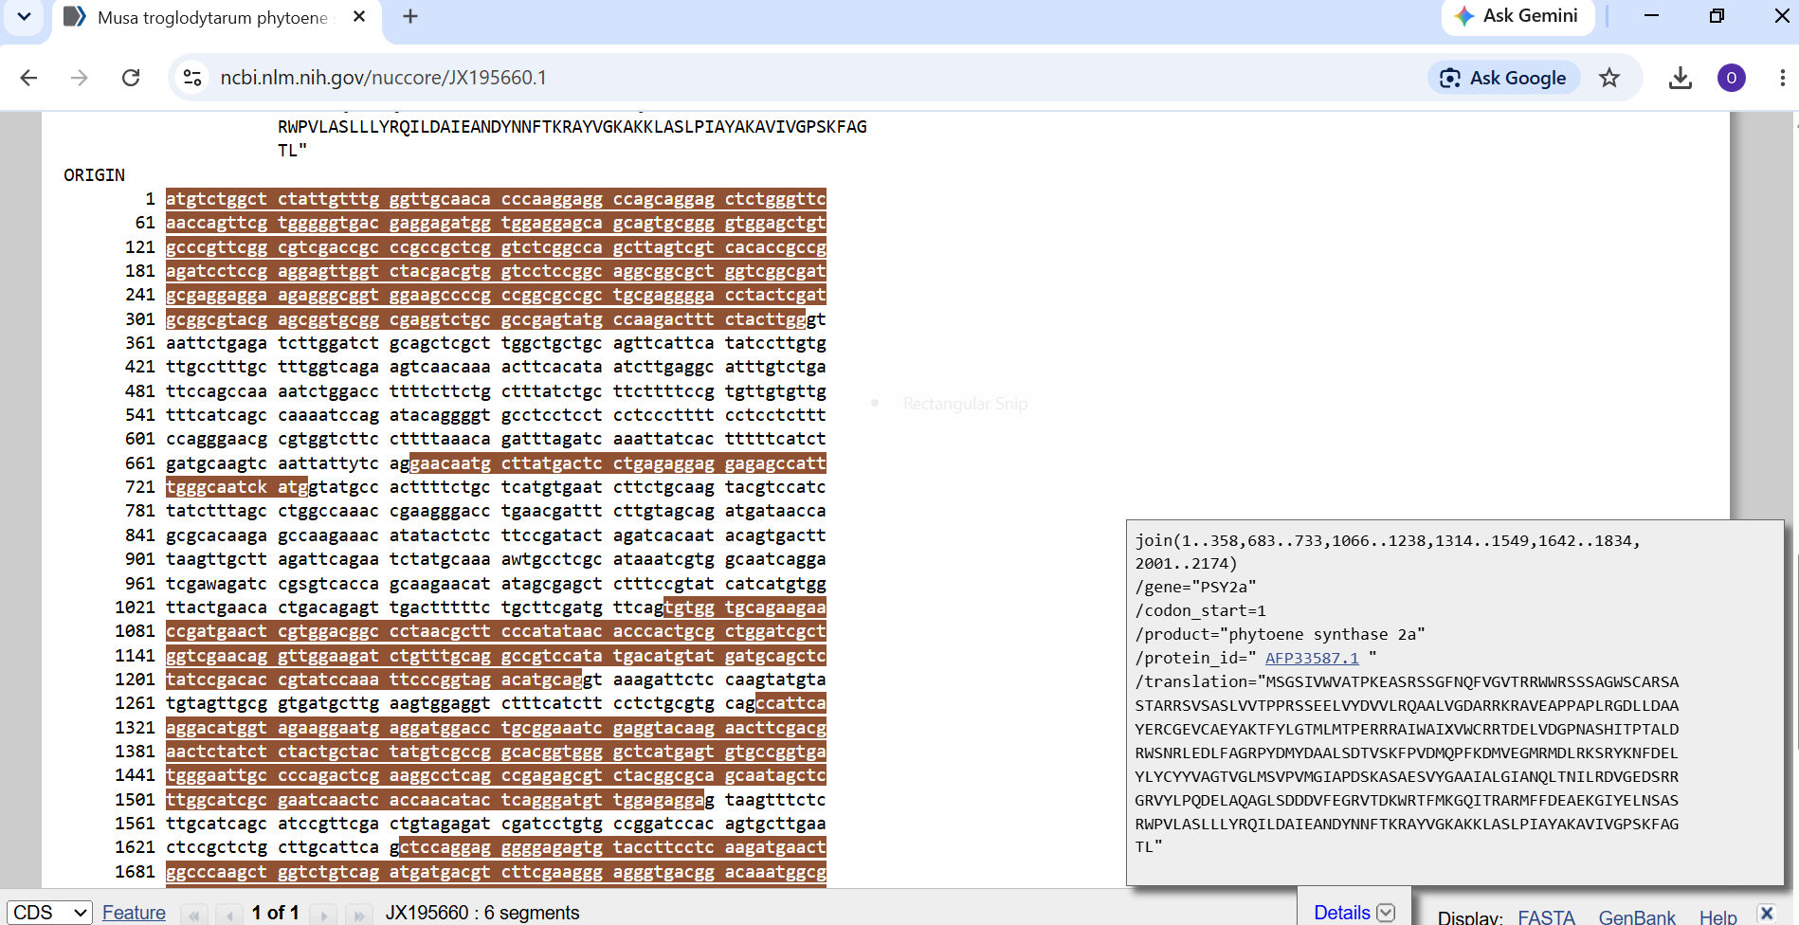
From CDS the orientation is as follows
5’
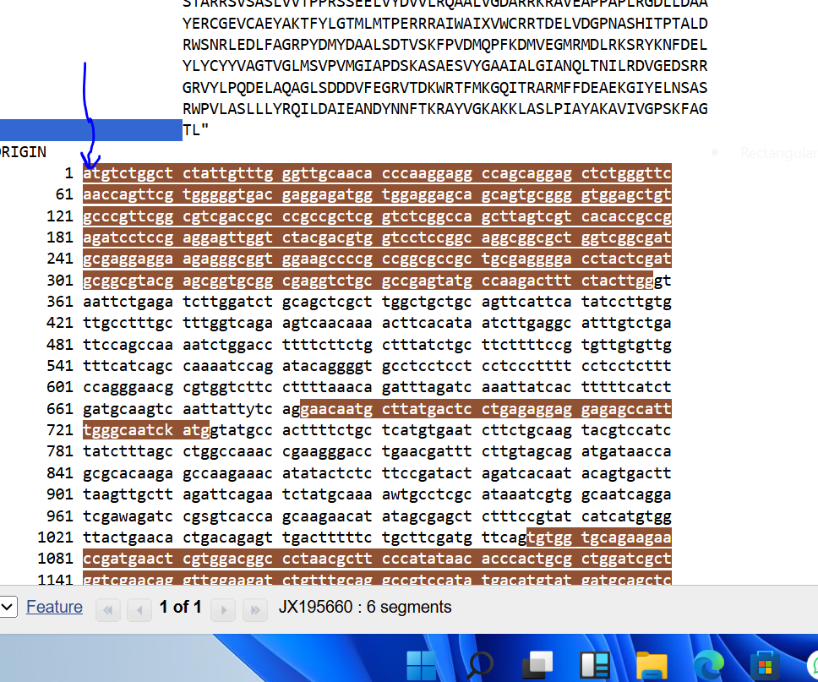
3’
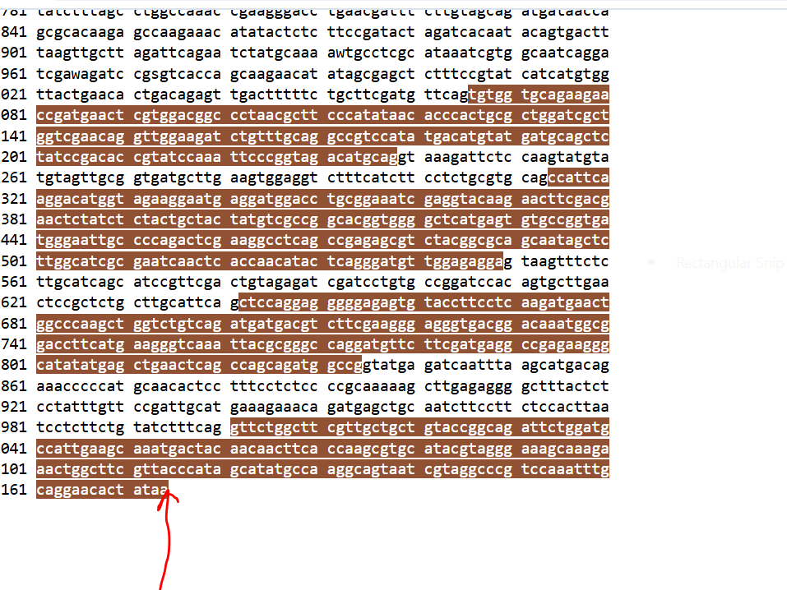
Position for start codon
1-3
Position for stop codon
2172-2174
Gene size.
Was gotten by counting all the characters
2174
Coding region length.
= position of last base of stop codon – position of first of base of start codon
= 2174 –(1+1)
=2174bp
Total nucleotide length
= 2174bp.
Coding region length.
= 2174bp
Conclusion:
In this practical I successfully retrieved the complete coding sequence of the phytoene synthase 2a (PSY2a) gene from Musa troglodytarum using the NCBI nucleotide database. By carefully examining the sequence in FASTA format and the CDS feature annotation, I was able to locate the start codon (ATG at positions 1–3) and the stop codon (TAA at positions 2172–2174). Counting the cleaned nucleotide characters showed that the gene is 2174 bp long, and the coding region occupies the full length of the sequence.
Carrying out this exercise helped me gain practical experience in navigating an online molecular database, retrieving sequence data, and performing basic gene annotation. It also reinforced the importance of accurate identification of start and stop codons and correct calculation of sequence length when working with publicly available genomic data. Overall, the practical demonstrated how bioinformatics tools can be used to study a gene of biological interest without the need for laboratory sequencing.

References:
National Center for Biotechnology Information (NCBI). (2012). Musa troglodyte phytoene synthase 2a (PSY2a) gene, complete cds. GenBank accession: JX195660https://www.ncbi.nlm.nih.gov.
Mlalazi, B., Welsch, R., Namanya, P., Khanna, H., Gieskes, R.J., Harrison, M.D., Harding, R., Dale, J.L. & Bateson, M. (2012). Isolation and functional characterization of banana phytoene synthase genes as potential CIS genes. Planta, 236, 1585–1598. https://doi.org/10.1007/s00425-012-1717-8.

