# **Chapter 9**

In chapter 9, the author talks about what a city needs to function and what worked in suburbia and what did not. While also taking into consideration the developers knowledge in what the cites must know to stay competitive in the markets.

When Creating a city the the author noted that they need to see it at the eyes of the residents that live there to have the city as efficient as possible. To make a city as effective as possible one must have it clean 24hrs a day because of the simple fact that it brings a sense of safety to the person commuting in the residence. Due to ever growing auto industry there has been auto dependent cities that make it less accessible for pedestrians. The author uses the example of LA, where crosswalks have been eliminated due to the fact that there are so many pedestrians accidents with cars. Making again a more auto dependent city. The author then discusses the issues with the parking outside which on of the most impactful theory to me. Due to the fact that much land is used for parking there has to be a change in the building and therefore having to destroy the current urban setting. One potential solution for this is creating a centralized parking where people will have the opportunity to use the sidewalks and keep the building the way it is.

In the business sense there are many reason why every little thing should be taken into consideration because it can either make or break a business. In the case for suburban shopping center, many have failed because they cannot find their niche. Suburban shopping centers have figured out the science to compete with malls. For example, they found that women clothing store did not do so well when located next to a restaurant, sunglasses were purchased more if they close to a restrooms, people like one stops shops and more.

One resource that I thought is a primary resource of myself. When I visited San Francisco, I noticed that there were rarely any business with parking unless it was well known Franchises but even then some of them did not have parking lot. A lot of the stores used a centralized approach to parking, where the individual would pay for parking. While also allowing cars to park in the side of roads for extra security because the cars would provide a wall barrier. Which made it feel safe when cars would pass by.

Due changing demographics and improvements of the economy some changes are being made better suburbia. The author believes that there going to more improvements in parking and pedestrian usage of the suburbia in the near future.

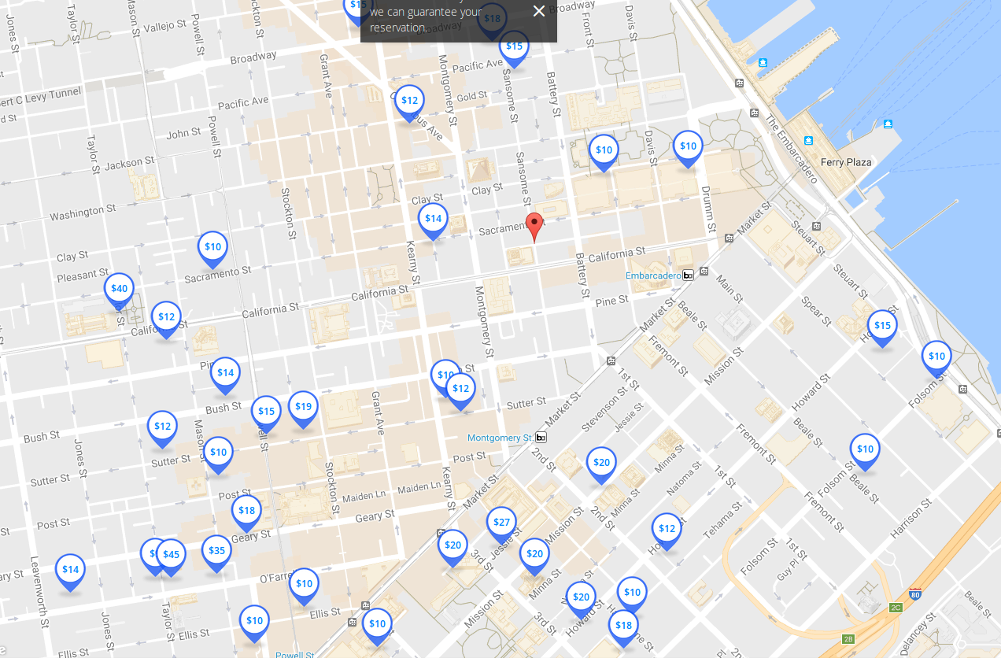

*This picture is a google search of parking structures in san francisco*

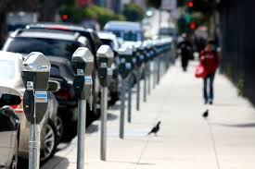

This is an example of the wall barriers