Chapter 8 Infographic Figure 8.1 Page 151

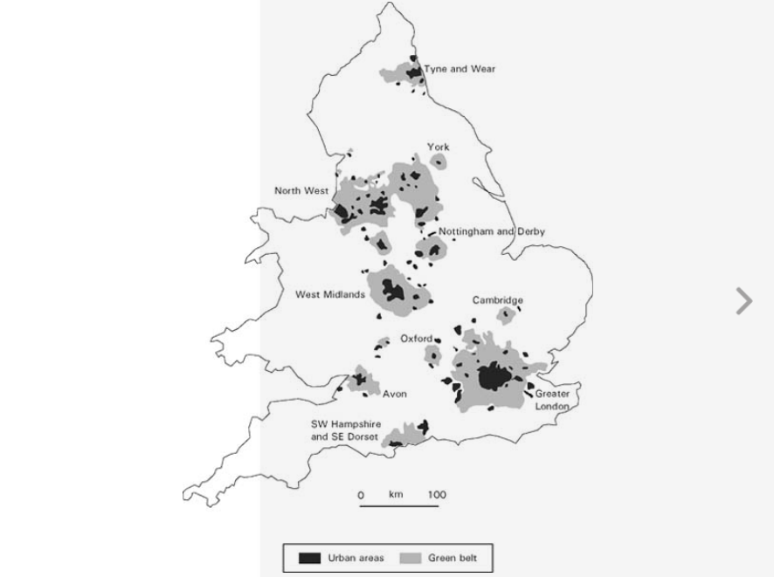

One thing I do not like in general about all of the graphics is the simple fact that there is no color. The texts are way too small to read in the book and in the pdf version of the textbook. Black and white is very unattractive for the user. It confusing to understand what is going on in the beginning of the chapter. I felt that this should have gone underneath section 8.3.1 because the simple fact that green belts are defined and green space are explained in more depth. It does also fit in the introduction though.

Overall this graphic is easy to understand and I feel that there is just the right amount information. He did not over do it like other infographic just a simple visualization on how the green belts were set up. He does a very good job in describing why they were important in the introduction and in the caption. I just shows a simple concept that brings great value to reader because it put in an image on the reader.