Chapter 7 Infographic Figure 7.1 Page 136

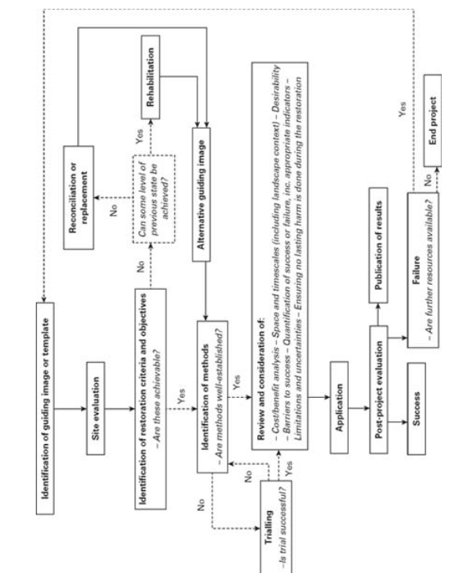

In chapter 7, section 3 we see a very nice flowchart that display the steps taken to restore ecological locations. Whether it is a lake, forest, or park. The The things that make this infographics terrible is that it does not capture the attention of the person. Originally the image is rotated 180 degrees clockwise. Making it very difficult for the reader to read. At first glance I feel that a person would just ignore it because it is not appealing to the eye.

The objective of the flow chart is to show steps that are taken for revitalizations, rehabilitation, reconciliation or replacement of an improved ecosystem. So the person must first look at an issue and try to solve the issue by following the steps. I feel that this a good graphic, but because ecosystem are so complex, can this flow chart actually fit into all the components I don’t think so. It is also not very clear if taking to consideration of doing nothing and problem fixing itself. There are a lot holes in these flow chart, and I think it is because it is so complex and species respond to different things.