**Figure 9.2, Page 176**

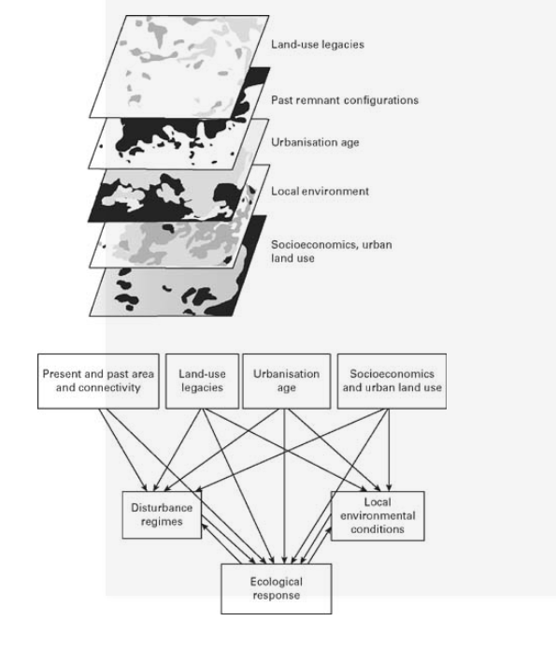

What I think this graphic is trying to display is the trying show the biodiversity in there different stages. The graphic below it show the different approaches or effects on that particular topic. The first one for example, Present and past area and connectivity is connected to disturbances regimes, and the ecological response. The second one, “Land-use legacies” correlates to disturbance regimes, local environmental conditions. “Urbanisation age” and “socioeconomic and urban land use” both correlate to,“ecological response” , “disturbance regimes” and “ local environment conditions”

One of worst graphic I have seen, I mean after reading the section several times I kind of understand what this graphic is trying to display, but still does not make any sense. I don’t know why the Author chose to put this pointless graphics. It way to difficult to understand even after reading the chapter and section several time it is still difficult to understand. First off, graphics overlap each other. Second the graphics I feel do not have enough information. Third, the the graphics has so many arrows going all over, He could have combined some of the section one that same correlation.