Chapter 6 Figure 6.5 Page 120

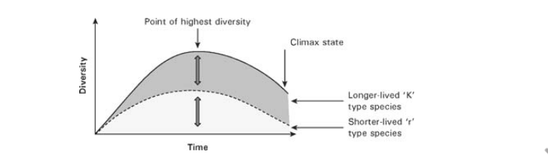What I think this graphic is trying to display is the highest point of diversity while also showing the lowest point of diversity. This graphics displays K type of species, which are species that are longer lived species. He also displays r type species , which are the shorter lived species. The shows that longer lived species have higher diversity compared than the ones that live shorter amount of time. Please note that ch.6 covers how species respond to the environment. This can help the scientist figure out when to add in species.

This graphic is a little bit hard to understand based how it was described in the text. I feel like that graphic could displayed with little bit more information on the side. It is straightforward in the sense that it has arrows displaying the key information. It also displays what each line represents, while also showing the climax state. I feel that the graph could have been extended a little more, so it could show maybe some patterns of when it starts to grow. I think my problem is not with the infographic i think it with the author writing. The writing is very dull and difficult to understand.