ST211 Individual Technical Report
Candidate Number: 48372
Word Count: 1491
Introduction
This technical report presents the results of a logistic regression analysis, which is based on a survey conducted in England and Scotland that investigates how health, lifestyle, and socio-economic factors correlate to gambling.

This report focuses on socio-economic variables. The major purpose of gambling is money, thus, Individuals experiencing insufficient education, low income, or other lower socio-economic backgrounds may be more susceptible to the attraction of quick financial gain offered by gambling. The relationship between socio-economic variables and our target variable: PROBGAM (“Is a person problem gambler?") is presumably stronger and more direct compared to other factors about health or lifestyle. However, this report also incorporates part of these relevant variables to account for potential confounders.

Predictor Selection
For predictor selection, there are 35 predictors provided, and 11 of them are relevant to the socio-economic topic:
- SrcInc7, SrcInc15 (trouble on income)
- eqv5, eqvinc, Totinc (direct income indication)
- Econact_2, OwnRnt08, Hhdtypb, Numcars (indirect income indication)
- EducEnd, HighQual (education related)
While the variables of interest are socio-economic ones, several other variables are included in the logistic regression model to improve the robustness of the results by controlling potential confounders. These factors could influence both socio-economic predictors and PROBGAM, which bias associations if left unaccounted for. To determine which non-socio-economic variables to involve, I have used 2 methods:
1, I design a single logistic regression model that each variable is individually regressed on PROBGAM to assess its independent performance. If one variable is not significant in the single model, it is unlikely to be significant with other variables are introduced.
2, The 2nd method is a full logistic regression model that includes all available variables to examine their p-values in an “all variables situation”. However, because P-values in a full model can be over-conservative due to multicollinearity (overfitting). Therefore, Variables with p-values below 0.2 in the ANOVA still have the potential to become more significant in a model with fewer predictors.
Following these 2 methods, the selected non-socio-economic variables are:
- sex, age, maritalg, Religsc (personal background)
- RG15
- compm9, wemwbs, drating, cigst1 (health problems)

Exploratory Data Analysis
After determining predictors, I have conducted an Exploratory Data Analysis (EDA) to understand the patterns of selected variables and its relationship with PROBGAM. Whatsoever, the major purpose of EDA is still giving insights into categories merging and variables dropping.

For categorical variables, bar plots of within-group proportions were generated to compare the proportion of problem gamblers in different categories for the same variable. To enhance visual clarity and emphasize differences, the y-axis scale was adjusted to start at 0.70 instead of 0.

Through observing bar plots, there are some critical issues spotted: There are too many redundant categories in certain variables. Specifically, the variable “totinc” has 31 categories. This high cardinality phenomenon introduces unnecessary noises to the model, because some categories may have very few observations, which leads to unstable parameter estimates. Another concern is: closely related categories would worsen multicollinearity. For instance, “Religsc” has 5 categories of Christian denomination branches, which share very similar patterns and therefore worsen $GVIF^{1/(2df)}$. By merging all denominations into “Christian”, multicollinearity and clarity of interpretation are improved; Thus, merging some categories is necessary for improving model’s performance, where details are in the appendix.

For continuous variables, boxplots of log-transformed values (using the log1p function) are applied to compare distributions between gamblers and non-gamblers. This usage of natural logarithm is for the purpose of “compressing” extreme values in data, which significantly improves diagrams’ visual interpretability in comparing differences between gamblers and non-gamblers.

In terms of findings, there is a negative correlation between age and gambling, which suggests gamblers have relatively smaller ages compared to non-gamblers. Also, gamblers consume slightly more alcohol per week than non-gamblers. People with mental health issues are slightly more likely to become gamblers. However, there is barely any correlation between gambling and equivalized income.

Logistic Regression Model Analysis
The logistic regression model does not include all 20 predictors mentioned above. Predictors “eqv5” and “totinc” are dropped for driving most of the collinearity with “eqvinc”. According to Table 2, eqvinc’s $GVIF^{1/(2df)}$ was originally 2.36, which exceeds the threshold of 2.0 for indicating moderate multicollinearity. However, after dropping “eqv5” and “totinc”, eqvinc’s $GVIF^{1/(2df)}$ falls to 1.12, which is well below the threshold. This reduction confirms that removing two redundant income variables effectively addresses the collinearity issue.

Additionally, three predictors—"compm9” (has condition in digestive‐system?), “maritalg” (marital status), and “RG15a” (provide regular help?)—were dropped for two reasons. First, each factor failed to produce a statistically significant reduction in model deviance when tested with ANOVA (all p-values > 0.1), indicating that none contributed meaningfully to the model. Second, these variables lie outside the primary interest: socio‑economic topics, and their retention would only increase model complexity without improving explanatory power. Thus, omitting these predictors maintains parsimony and ensures that the remaining predictors are theoretically and statistically relevant.

Moving on to the analysis of logistic model. Through observing Table 1, the strongest 2 predictors are all non-socio-economic predictors that are related to personal backgrounds: age and Sex, which their p-values all lie below 0.001. For age, each additional year lowers the probability of becoming
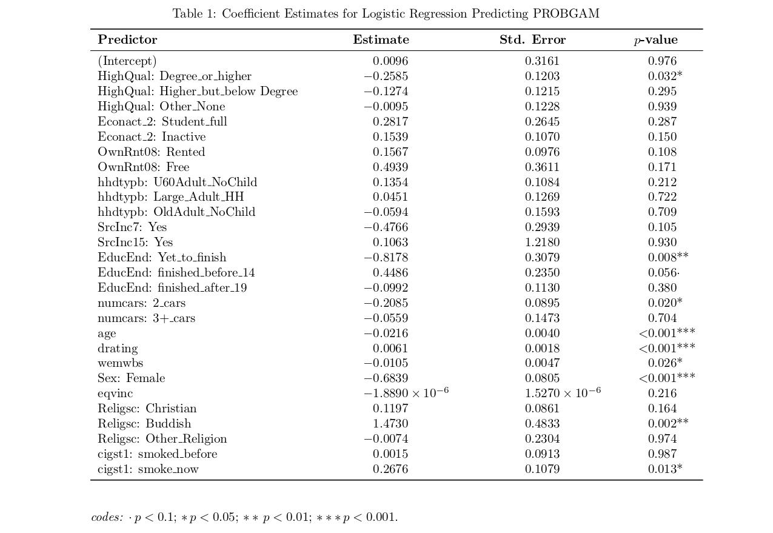
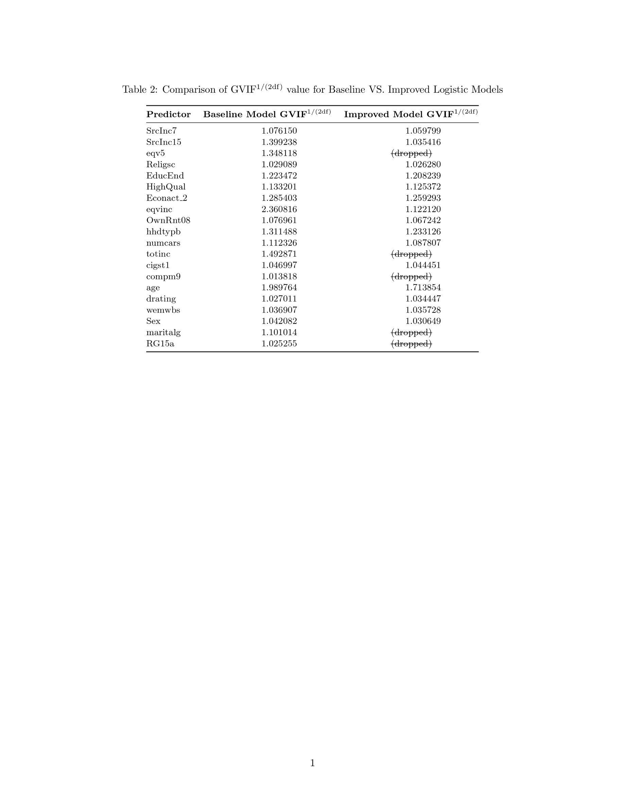
gamblers (Hereafter referred to as “PoBgambler”) by 2.1%. As for gender, the Estimate of sex is -0.684, which suggests that females are very likely to have much lower (68.4%) PoBgambler than males. Based on these findings, policymakers may consider providing extra focus to aging males in gambling issues. However, neither age nor gender are likely to entitle the root cause of gambling, where true reasons may lie outside.

Turning into one sphere of socio-economic predictors: Education. Compared to A/GCSE highest qualification, holding a university degree is moderately likely (p-value = 0.032) to reduce the PoBgambler by 25.9%. However, holding a below-degree or other qualifications can not find statistical proof in reducing the PoBgambler. This might suggest a higher cognitive ability may buffer against problematic betting behaviors, but comes with a threshold. This deduction could be further enhanced by findings from EducEnd. Compared to people who finish full-time education between age 15-18, those who finished before 14 are moderately likely (p-value = 0.056) to increase the PoBgambler by 44.9%, which is a massive increase. In contrast, survey takers who haven’t finished school are 88.9% less likely to become gamblers. Based on these findings, education is very closely related to gambling issues, which should receive more attention from policymakers.

Moving on to the 2nd sphere of socio-economic: Income-related. Unlike education, the correlation between the PoBgambler and income is very insignificant. There is no statistical connection between gambling and total household income (totinc), nor any with economic activity status (Econact_2), household type (hhdtype), and no income situation (SrcInc15). In terms of household tenure (OwnRnt08) and income support (SrcInc7), there are very mild correlations between them and the PoBgambler: renting a house increases the PoBgambler by 15.7% and people who receive income support are 47.7% less likely to gamble. However, despite statistics being close, neither’ p-value falls below 0.10. The only significant predictor is the number of cars, in which an increase from 1 car to 2 cars per household will decrease the PoBgambler by 20.9%. These findings have suggested that income might not play a very important role in influencing gambling behavior.

However, lifestyle predictors like alcohol consumption (each additional unit of alcohol consumption per week could increase the PoBgambler by 0.61%, p-value < 0.001), and mental well-being (every point increase in the wemwbs scale reduces the PoBgambler by 1.05%, p-value = 0.026) emerge as more sensitive indicators of the gambling issue. Similarly, compared to people who never smoke before, current smokers “suffer” a 26.8% increase in the PoBgambler (p-value = 0.013). And unexpectedly, compared to atheists, followers of Buddhism have a severe gambling problem. The log-odds scale statistic 1.473 means Buddhists are 4.4 times more likely to become gamblers compared to atheists. These findings have suggested that lifestyle has a much more influence on the gambling affair compared to income.

In conclusion, predictors related to lifestyle and education generally have a statistically significant correlation with PROBGAM, while income-related factors do not. The outside representation of this falls on gender and age, but is unlikely to be the root cause of gambling.

In terms of the model performance, although the overall accuracy of the model remains high (86.62%), this masks a pronounced class‐imbalance issue. At a 0.5 cutoff, the model almost never predicts “Gambler”. In Table 3, it correctly classifies 5 out of 809 true gamblers (sensitivity ≈0.6%) while almost perfectly identifying non‐gamblers (specificity ≈99.94%). In other words, it trades nearly all false negatives for very few false positives. The AUC of 0.659 indicates only modest discrimination, which is better than random but far from excellent—and suggests the model can’t reliably separate gamblers from non‐gamblers across thresholds. To improve practical utility, procedures are needed to lower the classification threshold, incorporate additional predictors, or explore alternative algorithms that better handle imbalanced outcomes.
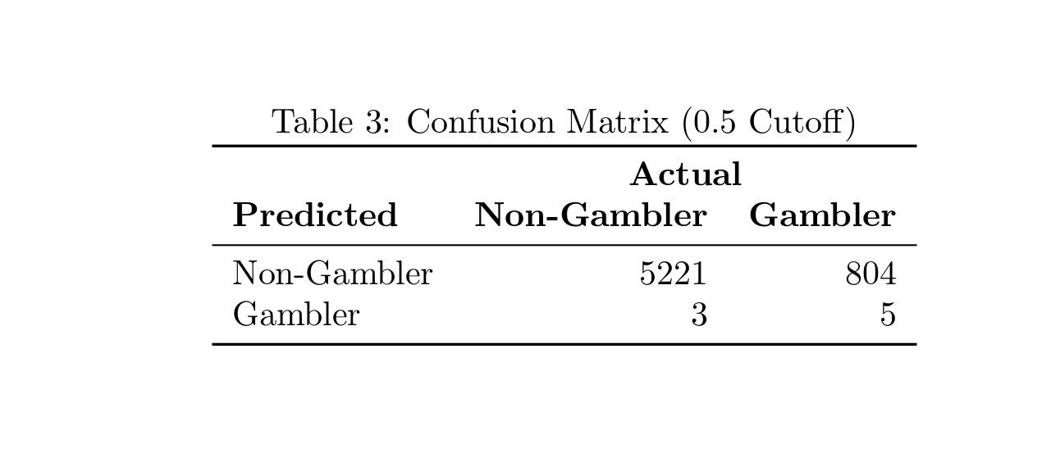

Appendix
Missingness Coding
In the data provided, both categorical and continuous variables contain missingness, which is indicated by distinctive codes. These values should be recorded as NA to ensure that the glm() function can automatically exclude them during logistic regression analysis.

According to the accompanying data dictionary, the following codes were identified as indicators of missingness in categorical variables:
- -1: Item not applicable
- -2: Schedule not applicable
- -6: Schedule not obtained
- -8, 96: Don’t know
- -9, 97: Refused

Continuous variables share similar missingness codes, with the exception that 96 and 97 are not applicable. However, code -90, despite not being mentioned in the data dictionary, appears frequently in the variable “eqvinc”, and is abnormal as an income value, therefore, is treated as a code of missingness.

Setting Baseline
For each categorical predictor, the baseline is generally set at the most common (largest sample size) category. However, for “eqv5”, “hhdtypb”, “Religsc”, and “Sex”, the baseline is chosen following the conceptually meaningful principle rather than the strictly most numerous categories: 1) Bottom <£13 k for equivalized income quintile, 2) Family for household type, 3) No_Religion for religion, and 4) Male for sex.
The numbers inside () are the raw counts of observations in each category, as returned by table(gambling.dat$<variable>):
SrcInc7
– No (12,105) ––> Baseline
– Yes (548)
SrcInc15
– No (12,632) ––> Baseline
– Yes (21)
eqv5 (Equivalised income quintile)
– Bottom < £13k (2,150) ––> Baseline
– 4th £13–£19k (2,202)
– 3rd £19–£30k (2,122)
– 2nd £30–£49k (2,105)
– Top > £49k (2,159)
EducEnd (Age education finished)
– finished 15–18 (8,393) ––> Baseline
– Yet_to_finish (554)
– finished_before_14 (771)
– finished_after_19 (3,337)
HighQual (Highest qualification)
– A/GCSE (5,156) ––> Baseline
– Degree_or_higher (3,321)
– Higher_but_below_Degree (1,431)
– Other_None (3,157)
Econact_2 (Economic activity)
– Employed (6,734) ––> Baseline
– Student_full (521)
– Inactive (5,822)
OwnRnt08 (Housing tenure)
– Owned (8,808) ––> Baseline
– Rented (4,141)
– Free (134)
hhdtypb (Household type)
– Family (3,216) ––> Baseline
– U60Adult_NoChild (2,975)
– Large_Adult_HH (2,444)
– OldAdult_NoChild (4,466)
numcars (Number of cars)
– 1 car (5,502) ––> Baseline
– 2 cars (3,841)
– 3+ cars (1,040)
Religsc (Religion)
– No_Religion (3,990) ––> Baseline
– Christian (7,560)
– Buddish (45)
– Other_Religion (626)
cigst1 (Smoking status)
– Never_smoke (6,313) ––> Baseline
– smoked_before (4,039)
– smoke_now (2,660)
Sex
– Male (5,808) ––> Baseline
– Female (7,298)
Maritalg (Marital status)
– Married (6,926) ––> Baseline
– Not_Married (4,316)
RG15a (Regular carer)
– No (10,793) ––> Baseline
– Yes (2,310)

Categories Merging & Renaming
The categories merging aims to tackle 2 main issues: 1) some categories have very few observations, leading to unstable parameter estimates, and 2) closely related categories would worsen because it “triggers” multicollinearity. To address both concerns, categories are combined with the following principles:

1, Ensure each category has adequate sample numbers. Levels with fewer than certain cases should be combined with their adjacent groups so that each category has a sufficient sample size for reliable estimation. For instance, in “EducEnd”, “never_school” (25 cases), and “Yet_to_finish” (554 cases) categories were merged.

2, Reduce redundant parameters. When conceptual meanings for multiple categories are similar, they should be aggregated to eliminate multicollinearity. In “Religsc”, the five Christian denominations were combined into a single “Christian” category, and minor faiths (“Hindu,” “Jewish,” etc.) were merged into “Other_Religion.” This both simplifies the model and prevents any one small denomination from driving a high GVIF. Similar examples could also be found in “Econact_2” or “OwnRnt08”.

Below are details of the merging and renaming procedures:

Merge and Rename:
Variable name / Merged Category / Original Category
maritalg / Married / 1, 2, 4
maritalg / Not_Married / 3, 5, 6
EducEnd / Yet_to_finish / 1
EducEnd / finished_before_14 / 2, 3
EducEnd / finished_15–18 / 4, 5, 6, 7
EducEnd / finished_after_19 / 8
HighQual / Degree_or_higher / 1
HighQual / Higher_but_below_Degree / 2
HighQual / A/GCSE / 3, 4
HighQual / Other_None / 5, 6
Econact_2 / Employed / 1
Econact_2 / Student_full / 2
Econact_2 / Inactive / 3, 4, 5
OwnRnt08 / Owned / 1, 2
OwnRnt08 / Rented / 3, 4
OwnRnt08 / Free / 5
hhdtypb / U60Adult_NoChild / 1, 2
hhdtypb / Family / 3, 4
hhdtypb / Large_Adult_HH / 5
hhdtypb / OldAdult_NoChild / 6, 7
totinc / <£1.6k 1, 2
totinc / £1.6–20.8k / 3–10
totinc / £20.8–46.8k / 11–19
totinc / £46.8–120k / 20–27
totinc / £120k+ / 28–31
Religsc / No_Religion / 1
Religsc / Christian / 2, 3
Religsc / Buddish / 4
Religsc / Other_Religion / 5, 6, 7, 8, 9
cigst1 / Never_smoke / 1
cigst1 / smoked_before / 2, 3
cigst1 / smoke_now / 4

Only Rename:
Variable / New Name / Original Code

Sex / Male / “1”
Sex / Female / “2”
SrcInc7 / No / 0
SrcInc7 / Yes / 1
SrcInc15 / No / 0
SrcInc15 / Yes / 1
eqv5 / Top >£49k / 1
eqv5 / 2nd £30–49k / 2
eqv5 / 3rd £19–30k / 3
eqv5 / 4th £13–19k / 4
eqv5 / Bottom <£13k / 5
numcars / 1 car / 1
numcars / 2 cars / 2
numcars / 3+ cars / 3
RG15a / No / 2
RG15a / Yes / 1
compm9 / no_condition / 0
compm9 / has_condition / 1

