**Instructions:**

This is a weekend project for a science project. At the moment it provides transliteration of English to circular, which was designed to look like Gallifreyan. The program does not translate the grammar yet, which is planned. The program will do words, sentences and paragraphs, with punctuation. The program allows a limited number of editing options which include dragging and rotating words and sentences and changing the position of the decorations. Many features can be edited from the side menu.

Some exporting features have been built as well. Enjoy and let me know what needs to be fixed.

**The alphabet**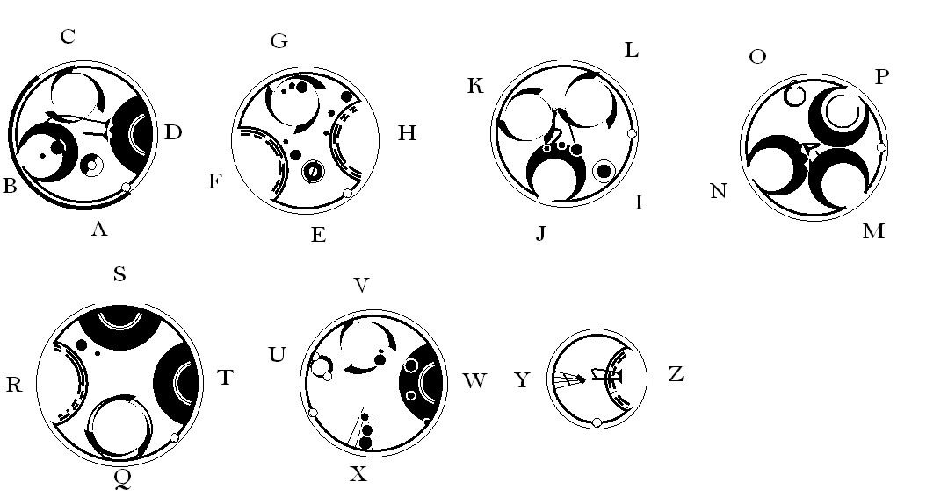

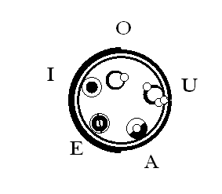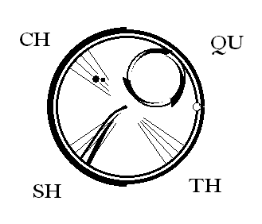 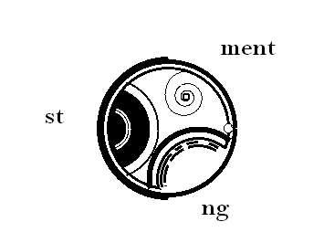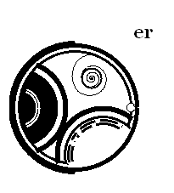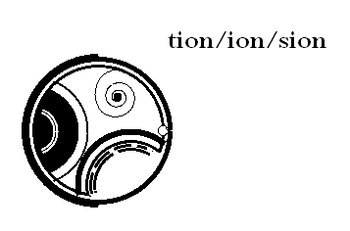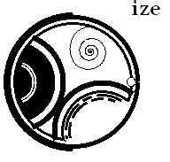

Sentence punctuation:

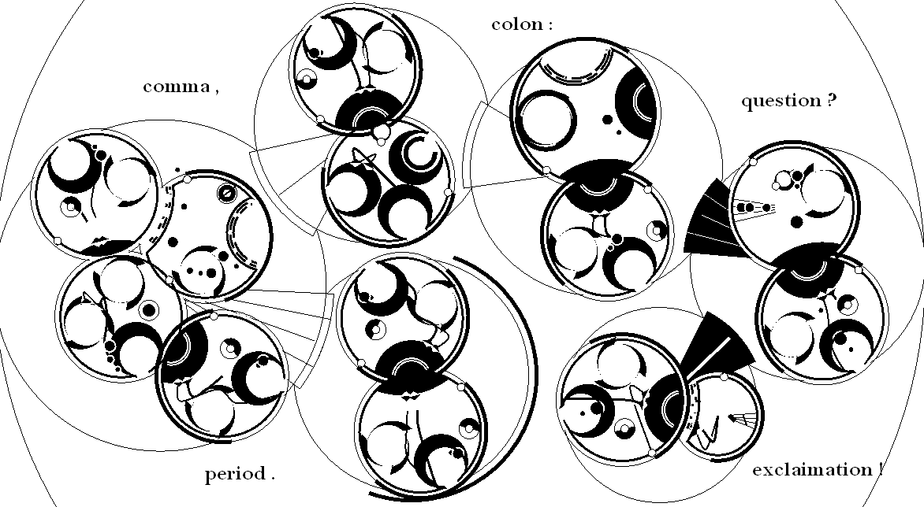

The alphabet in tables

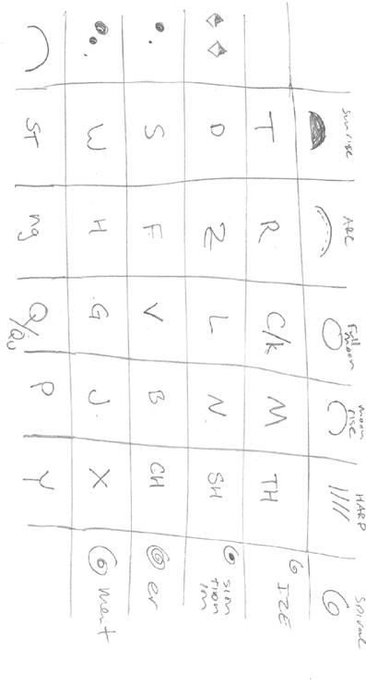

**Entering Text:**

Example:

{spinning counterclockwise}

Each turn robs the planet of angular momentum [it]

Slowing its spin by the tiniest bit [can]

Lengthening the night, pushing back the dawn [last]

Giving me a little more time here

WITH YOU [forever]

Result:

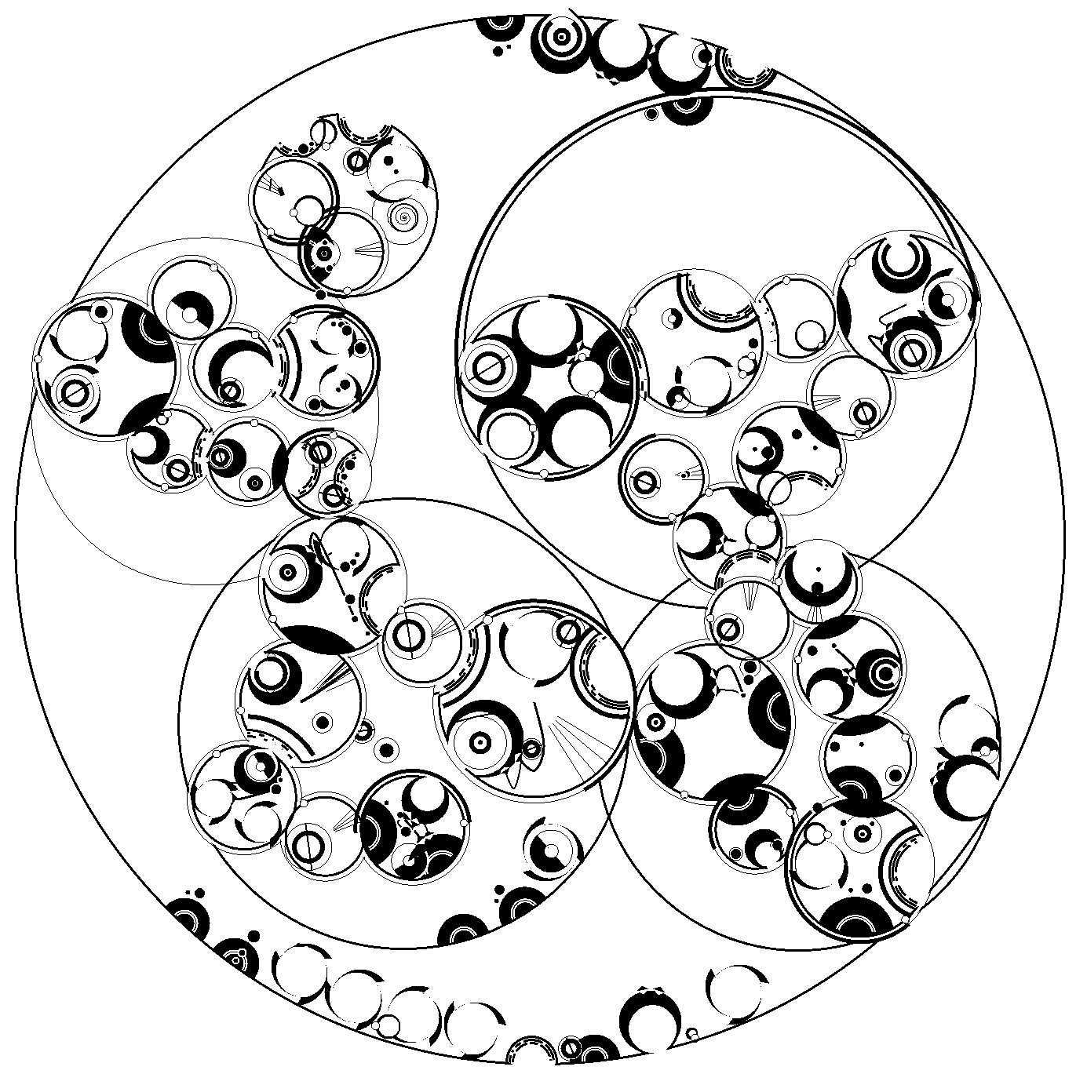

{} tell the program to put the words on the boundry of the paragraph.

[] tells the program to put the words on the sentence boundary.

".", ":", ";", "!", "?", "(", ")", "\"", "-", enter/linebreak

all tell the program to start a new circle. The program is a little dumb here, so if you enter an error, it will propagate the error.

The program will group a number of letter pairs (ng, st, ize, refer to the alphabet above). If you wish to prevent the grouping, add an underscore to break the pair i.e. ng-> n_g, st->s_t, ize -> iz_e. This can produce cleaner words.

**Things that do not work:**

The rotation of sentences does not work at times. Moving vowels is results in all kinds of bad behavior. Tight Circle is the only truly safe sentence arrangement. The program does not parse the parts of speech.

**Coming soon, the grammar:**

Circular is a language that uses the position of the words relative to other words to convey meaning and grammar. All words are states, things, and operators. Most of the language is made of metaphor and similes, making translation difficult. These elements are being built into the editor as fast as possible.

