.. home page
- Digital Silk: Web Design Agency [Top-Rated Company]
- Internet Marketing Services, San Diego Marketing Services that Deliver (ignitevisibility.com)
- Optimiser | Power of one CRM Platform
OnWebApp
More than just a website builder,
Five built-in pillars supporting Web 4.0, the autonomous web.,
AI, Automation, Integration, Validation

Built-in AI , automation, integration, validation on website and application
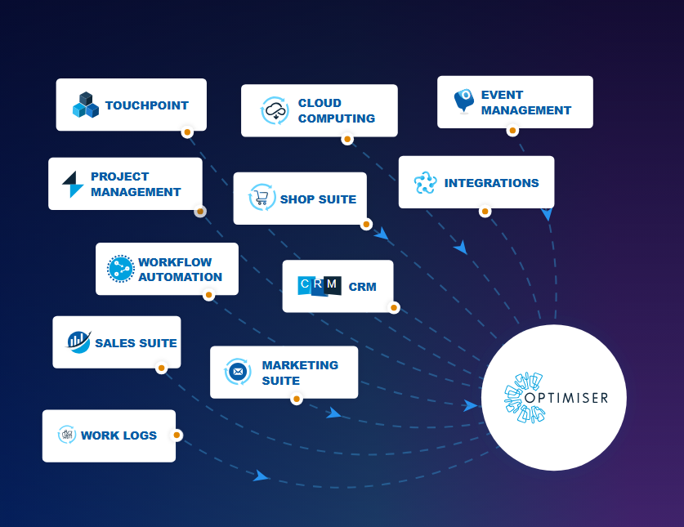
Book a consultation for a comprehensive overview of our approach to building integrated web sites
GDPR ,ISO27001,WCAG guidelines
..
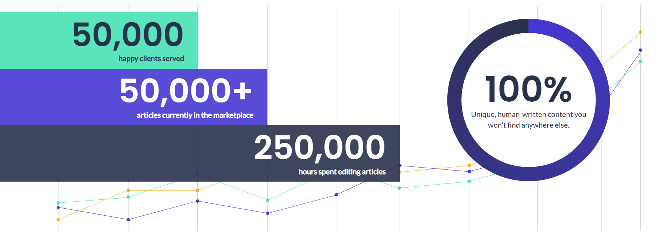

BEYOND THE ORDINARY Approach.

Five pillars of an excellence-Approach:

Built-in Information Architecture (IA)
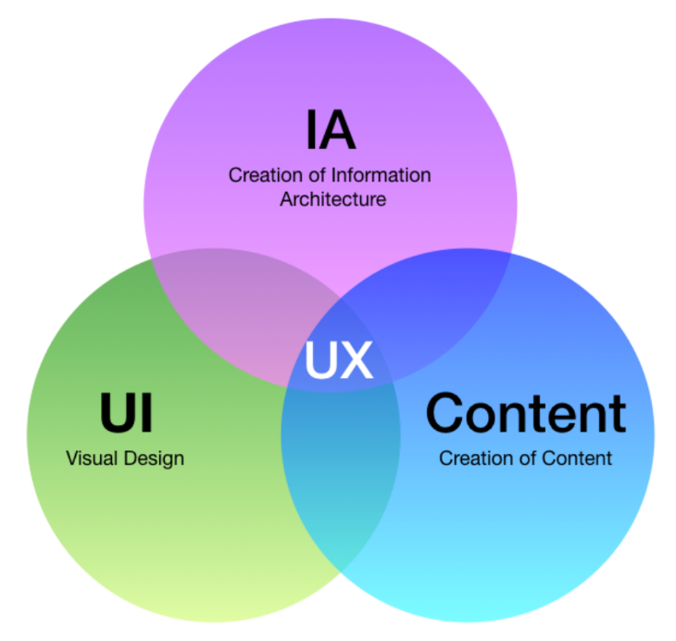
Structuring, classifying, and arranging website content for an interactive user experience and user interface.

….

Built-in Integration

• B2B & B2C Integration
• ERP integration
 | 
Website ERP Integration  Improve your operations and save time and money with website integration with an ERP system that best meets your B2B business needs. | IoT Automation
Infrastructure Automation | Industrial automation ( robot , kiosk )
API Integration

..

Built-in Automation
Integrate website automation with enterprise automation through innovative automation recipes for workflow and workload automation.
Get Custom automation recipes from the simplest to the most complex.

Website Automation  Enable workflow automation to run a series of business tasks based on defined rules.  - Automated customer journey.  - repetitive tasks Automated  - Chatbots  - TEST automation | Enterprise Automation  Enable workload automation to schedule, manage, and execute complex IT processes across multiple computing systems.  Infrastructure Automation  - ERP automation  - (iPaaS) Automation  - IoT Automation  - Industrial automation ( robot , kiosk )  - Infrastructure Automation
…….

Built-in SEO

Rank high,
Website structuring strategies take into account more than 200 factors that Google considers.

………………..
…………………………………
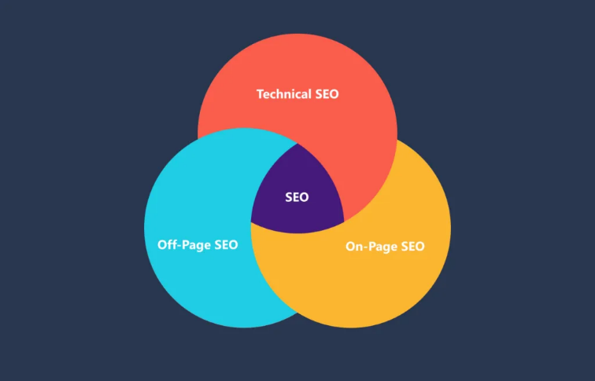 | Structure Content for AI Answer Engines: GEO and AEO  Content from a perspective AI SEO and AEO
…….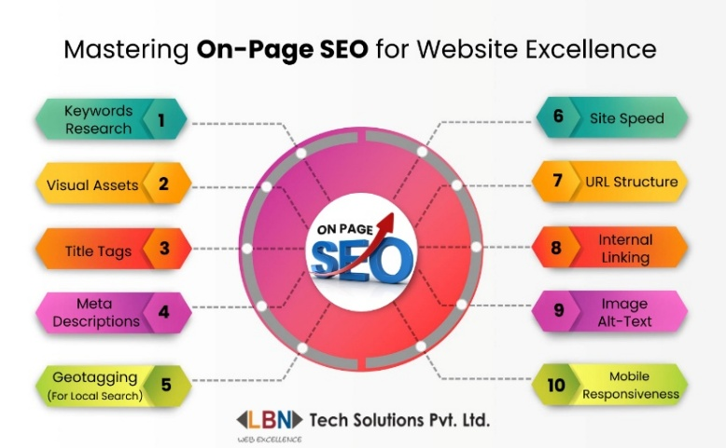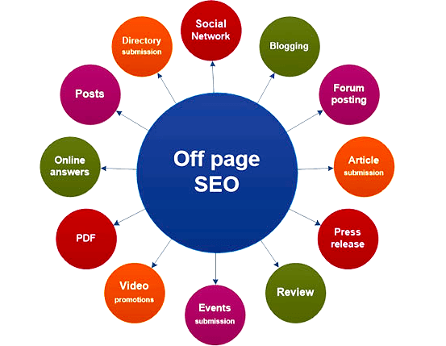

Built-in AI.

﻿Stand-out productivity
Let AI and machine learning(ML) predict the future and generate automation..

..

Built-in validation From chaos to control

Where We Shine
Website monitoring platform | dashboard design | API design

..

End-to-End Web & Mobile App Development

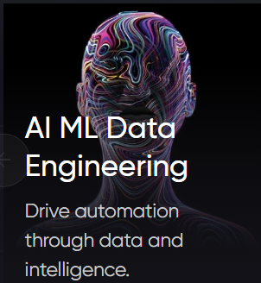  AI Development Services | AI Development Company - Codiant |   UI/UX Design & Development services To Engage Your Users | 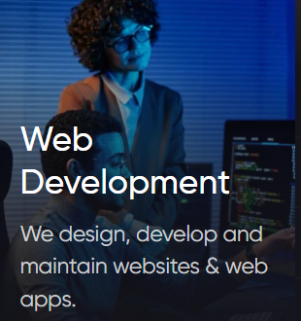  Custom Web Development Services - Scalable Solutions | 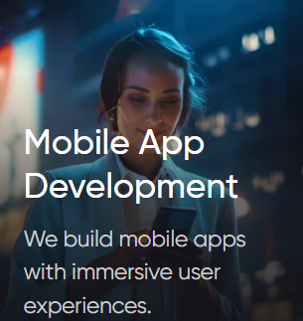  Mobile App Development Services - Scalable iOS & Android Apps
  eCommerce Software Development Services - Grow Your Business | 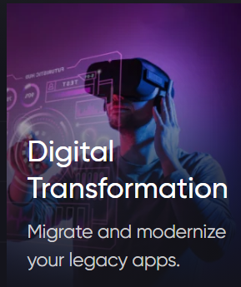  Best Digital Modernization and Transformation Services | Codiant |   Digital Product Engineering Services | Codiant
.. .
Custom Web Design | - eCommerce
B2B Website Design | Manufacturing Website design  Lform | Web Design & SEO Agency for Manufacturers

Footing
 | Discover  Sitemap  Case studies  Research  Blogs  Articles  Privacy Policy  Privacy Policy  Privacy  Cookie Preferences | Connect  Documentation  Events  Newsletters  Support  TechXchange community | 
About
Overview
Careers
Investor relations
Leadership
Newsroom
Security, privacy and trust
© 2027 Website © OnWebApp Design. All rights reserved.

End of home page
..

Certification

..
..
Events
Attend our latest events at international exhibitions and seminars to learn about what's new in your digital world through our TV channel www.onwebapp.tv and social media channels.
Register now

Webinars | UX and Product Development Webinars  Insider advice from top companies. All based on case studies.

..

OnWebApp news
 | Your website in  Android | Data Robot | New branches | Save up to 90% on wasted marketing expenses
 | New innovation for your swebite in Android | Robot for data analysis (market, customers, etc.) | Riyadh Al Khobar  Coming soon | New innovations for search engines

..

Valuable partnerships

RSD

Security solutions

..
..

OnWebApp Around the World

For you

Day after day, my website offices are expanding all over the world wherever you are.

Thanks to our main office in the Kingdom of Saudi Arabia to cover the Gulf Cooperation Council countries.

In addition to our branch in the Hashemite Kingdom of Jordan "Amman" to cover Asia and Africa,

My website's global offices enable us to provide the highest level of support and cooperation to our customers..

Visit us

K,S,A Address Jordan

Location Location
…

Website homepage design: My favorite 32 examples to inspire you | 14 critical elements I think every website homepage should have | How to create a landing page with high ROI [+ expert and data-backed tips]

