Contents
SECTION A: SELECTION, INVESTIGATION AND ANALYSIS 3
1. Introduction 3
2. Background of the Study 3
3. Problem Statement 3
4. Existing System Evaluation 3
5. Investigation of the Current System 4
6. Research Methods 4
7. Requirements Specification 4
8. Aim and Objectives 5
9. Evidence of Research 5
SECTION B: DESIGN AND ALTERNATIVE SOLUTIONS 6
9. Consideration of Alternative Solutions 6
10. Justification of Selected Solution 6
11. Input Design 6
12. Output Design 7
3. Interface Design 7
14. Data Flow Diagram (DFD) 7
15. System Flowchart 8
16. Test Plan 8
17. System Architecture 9
18. Pseudocode 9
Login System 9
Upload Resource 9
Catalog Display 10
19. Flowcharts (Text Representation) 10
Login Flowchart 10
Upload Flowchart 10
Catalog Flowchart 10
20. Code Listings 10
server.js (Node.js backend) 10
21. User Documentation (Manual) 10
Installation 10
Starting the System 10
Navigation 11
Exiting 11
SECTION D: TESTING AND EVALUATION 11
22. Testing Strategy 11
23. Test Cases 11
23.1 Normal Data 11
23.2 Abnormal Data 11
23.3 Extreme Data 12
24. Evaluation of the System 12
SECTION E: GENERAL EXPECTATIONS 13
25. Depth of Knowledge and Understanding 13
26. Degree of Originality 13
27. Quality of the Completed Report 13

SECTION A: SELECTION, INVESTIGATION AND ANALYSIS

1. Introduction
The Classroom Resource Management System (CRMS) is a web-based application designed to streamline the storage, organization, and retrieval of academic resources in classrooms. It provides a centralized platform where teachers and students can securely log in, upload learning materials, view stored resources, and manage them through editing or deletion. The system now integrates Node.js with an upload folder, enabling actual file storage beyond simple file names.

2. Background of the Study
In many schools, resource sharing is informal and fragmented. Teachers distribute printed handouts, share files via messaging apps, or send email attachments. These methods often result in duplication, loss of files, and difficulty retrieving older materials. The CRMS was developed to overcome these challenges by introducing a structured, centralized platform that supports both metadata storage and actual file uploads.

3. Problem Statement
The lack of a centralized classroom resource management system leads to:
- Inefficient storage and retrieval of academic materials.
- Difficulty accessing previously shared content.
- Duplication of resources and lack of version control.
- Reduced productivity for both teachers and students.

4. Existing System Evaluation
Inputs: Printed handouts, email attachments, WhatsApp messages. Processes: Manual distribution, ad-hoc sharing. Outputs: Scattered files, inconsistent formats. Storage: Individual devices, paper files, messaging apps.

Strengths:
- Familiarity of use.
- Low cost.
Weaknesses:
- No structured storage.
- Difficult retrieval of old materials.
- No centralized control or updates.
- Prone to duplication and loss.

5. Investigation of the Current System
Research instruments used:
- Questionnaires (distributed to teachers and students).
- Interviews (with administrators and staff).
- Observation (of classroom practices).
- Document inspection (handouts, email records).
Findings: Resources were scattered across multiple platforms, with teachers struggling to locate specific materials and students missing important documents.

6. Research Methods
- Observation: Monitored how resources were shared in classrooms.
- Questionnaires: Example questions:
  - “How do you currently share study materials?”
  - “What challenges do you face retrieving old resources?”
- Interviews: Teachers highlighted duplication and lack of version control.
- Online Research: Studied existing learning management systems (e.g., Moodle, Google Classroom).

7. Requirements Specification
Functional Requirements:
- Secure login system.
- Upload resources (actual files stored in uploads folder).
- View, edit, and delete resources.
- Catalog display of resources.
Non-Functional Requirements:
- Usability (simple interface).
- Reliability (consistent performance).
- Performance (fast retrieval).
- Simplicity (minimal training required).
Software Requirements:
- Node.js (server runtime).
- Express (routing).
- Multer (file upload handling).
- Visual Studio Code (development environment).
Hardware Requirements:
- Input: Keyboard, mouse.
- Output: Monitor, printer.
- Processing: CPU.
- Storage: Hard drive + uploads folder.

8. Aim and Objectives
Aim: To develop a centralized system that improves classroom resource management.
Objectives:
- Provide secure access through login authentication.
- Enable structured storage of resources in an upload folder.
- Improve accessibility by allowing retrieval of both file names and actual documents.
- Enhance usability with a simple, user-friendly interface.

9. Evidence of Research
- Filled Questionnaires: Responses showed most students preferred a centralized system.
- Interview Notes: Teachers emphasized the need for version control and easy retrieval.
- Sample Documents: Screenshots of scattered WhatsApp messages and printed handouts.
- Observation Write-Up: Recorded inefficiencies in manual distribution during lessons.

SECTION B: DESIGN AND ALTERNATIVE SOLUTIONS

9. Consideration of Alternative Solutions
Before selecting the final solution, several alternatives were evaluated:
- Manual System Resources distributed physically (handouts, printed notes). Limitation: Inefficient, prone to loss, not scalable.
- Messaging Platforms Sharing via WhatsApp, email, or Telegram. Limitation: Disorganized, difficult to manage, no central storage.
- Pre-built Website Builders Using platforms like Wix or WordPress. Limitation: Limited flexibility, difficult to customize for classroom needs.
- Custom Web Application Built with HTML, CSS, JavaScript, and Node.js. Advantage: Flexible, supports dynamic features, allows actual file uploads into an uploads folder.

10. Justification of Selected Solution
The custom web application was chosen because:
- It allows full control over design and functionality.
- It supports Node.js integration, enabling actual file storage and retrieval.
- It is scalable, meaning more features (multi-user support, database integration) can be added later.
- It ensures structured resource management, unlike fragmented messaging platforms.

11. Input Design
Inputs were designed to ensure accuracy and ease of use:
- Login Form: Username and password fields with validation.
- Upload Form: Resource name, subject, and file upload field.
- Validation Rules: Prevent empty entries and invalid file types.
Screen Layouts:
- Simple forms with labeled fields.
- Buttons for submission and navigation.

12. Output Design
Outputs include:
- Dashboard Interface: Central hub for navigation.
- Resource Catalog: Table displaying resource name, subject, and file link.
- Confirmation Messages: Alerts for successful uploads, edits, or deletions.
- Error Messages: Alerts for invalid inputs or failed upload

3. Interface Design
The interface emphasizes usability:
- Consistent colors (blue theme for buttons and headers).
- Clear navigation (Dashboard → Upload → Catalog → Logout).
- Structured layouts with tables and buttons.
- Responsive design for different screen sizes.

14. Data Flow Diagram (DFD)
The DFD illustrates how data flows through the system:
- User Input → Login Module → Dashboard → Upload Module → Storage (uploads folder + localStorage) → Catalog Display → Edit/Delete → Output.
- 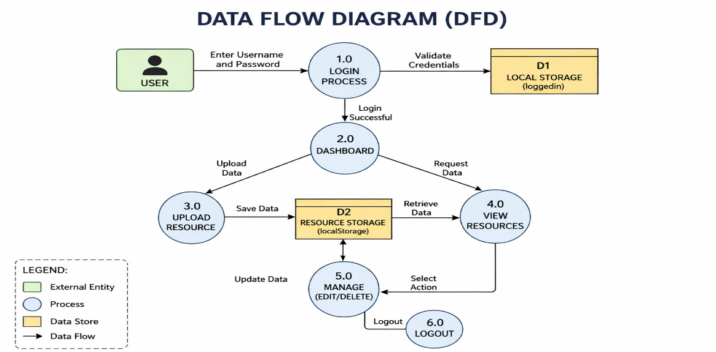

15. System Flowchart
The flowchart represents the logical sequence:
- Start → Login → Verify Credentials.
- If valid → Dashboard → Choose Upload or View.
- Upload → Save file in uploads folder → Update catalog.
- View → Display catalog table → Edit/Delete options.
- Logout → End session.

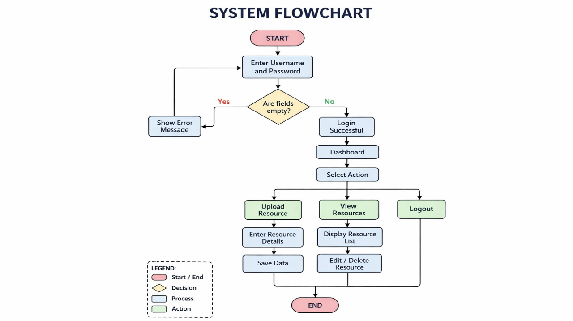

16. Test Plan
A test plan was designed to ensure system reliability:
- Login Test: Valid credentials → access granted; invalid → error message.
- Upload Test: Valid file → stored in uploads; invalid file → error message.
- Catalog Test: Uploaded files appear correctly in table.
- Edit/Delete Test: Changes reflected immediately in catalog.
- Extreme Data Test: Large file uploads handled gracefully.

SECTION C: SOFTWRE DEVELOPMENT
16 DEVELOPMENT TOOLS

The Classroom Resource Management System was developed using:
- HTML, CSS, JavaScript → Front-end interface.
- Node.js → Server runtime environment.
- Express.js → Routing and server logic.
- Multer → File upload handling, storing files in the uploads folder.
- Visual Studio Code → Development environment.

17. System Architecture
The system follows a modular architecture:
- Login Module → Authentication using localStorage.
- Dashboard Module → Navigation hub.
- Upload Module → Uploads actual files into uploads folder.
- Catalog Module → Displays resources, supports edit/delete.
Flow: Login → Dashboard → Upload → Storage (uploads folder + metadata) → Catalog → Edit/Delete → Output → Logout

18. Pseudocode

Login System
Code
FUNCTION login(user, pass)
IF user == "admin" AND pass == "admin"
SET loggedIn = true
REDIRECT to dashboard
ELSE
DISPLAY "Invalid login"
END FUNCTION

Upload Resource
Code
FUNCTION uploadResource(file, name, subject)
IF file IS NOT EMPTY
SAVE file TO uploads folder
STORE {name, subject, filePath} IN metadata
DISPLAY "Upload successful"
ELSE
DISPLAY "Upload failed"
END FUNCTION

Catalog Display
Code
FUNCTION displayCatalog()
FETCH resources FROM metadata
FOR EACH resource IN list
DISPLAY resource.name, resource.subject, resource.filePath
PROVIDE edit/delete options
END FUNCTION

19. Flowcharts (Text Representation)

Login Flowchart
- Start → Login Page → Check Credentials
- If valid → Dashboard
- If invalid → Access Denied → End

Upload Flowchart
- Dashboard → Upload Resource → Save to uploads folder → Update Catalog → Confirmation Message

Catalog Flowchart
- Dashboard → View Catalog → Display Table of Resources
- Options: Edit Resource → Update Catalog
- Options: Delete Resource → Update Catalog
- Logout → End

20. Code Listings

server.js (Node.js backend)
javascript
const express = require('express');
const multer = require('multer');
const path = require('path');

const app = express();
const storage = multer.diskStorage({
destination: './uploads/',
filename: (req, file, cb) => {
cb(null, Date.now() + path.extname(file.originalname));
}
});

const upload = multer({ storage: storage });

app.use(express.static('public'));

app.post('/upload', upload.single('resource'), (req, res) => {
res.send('File uploaded successfully');
});

app.listen(3000, () => console.log('Server running on port 3000'));

21. User Documentation (Manual)

Installation
- Install Node.js.
- Run npm install express multer.
- Create an uploads folder in the project directory.

Starting the System
- Run node server.js.
- Open browser → http://localhost:3000.
- Login with credentials.

Navigation
- Dashboard → Upload or View.
- Upload → Add new resources.
- Catalog → View, edit, delete resources.
- Logout → End session.

Exiting
- Click Logout.
- Stop server with CTRL + C.

SECTION D: TESTING AND EVALUATION

22. Testing Strategy
The system was tested using a structured approach to verify functionality, reliability, and usability. Testing covered:
- Normal Data → Valid inputs producing expected results.
- Abnormal Data → Invalid inputs triggering error messages.
- Extreme Data → Large datasets or oversized files to test system limits.

23. Test Cases

23.1 Normal Data
- Login Test: Input: Username = admin, Password = admin Expected Outcome: Access granted, dashboard displayed.
- Upload Test: Input: Resource name = “Math Notes”, Subject = “Mathematics”, File = notes.pdf Expected Outcome: File stored in uploads folder, catalog updated.
- Catalog Test: Input: View resources after upload. Expected Outcome: Table displays resource name, subject, and file link.

23.2 Abnormal Data
- Login Test: Input: Username = wrong, Password = 1234 Expected Outcome: Error message “Invalid login details.”
- Upload Test: Input: Empty file field. Expected Outcome: Error message “Upload failed.”
- Catalog Test: Input: Attempt to edit resource with empty name. Expected Outcome: Error message, no update performed.

23.3 Extreme Data
- Upload Test: Input: Large file (50MB PDF). Expected Outcome: File successfully stored, catalog updated, system performance remains stable.
- Catalog Test: Input: 100 resources uploaded. Expected Outcome: Catalog displays all entries without crashing.

24. Evaluation of the System

Achievements:
- Provides a centralized platform for classroom resource management.
- Supports actual file uploads via Node.js and Multer.
- User-friendly interface with clear navigation.
- Enables editing and deletion of resources for flexibility.
Limitations:
- Security is limited (basic login only, no encryption).
- No database integration (relies on localStorage + uploads folder).
- Single-user system (no role-based access yet).

Opportunities for Future Development:
- Integration with a database (e.g., MySQL, MongoDB).
- Multi-user support with role-based permissions.
- Enhanced security (hashed passwords, SSL).
- Online deployment for remote access.

SECTION E: GENERAL EXPECTATIONS

25. Depth of Knowledge and Understanding
The project reflects a strong understanding of computing concepts applied to real-world classroom needs. By integrating front-end technologies (HTML, CSS, JavaScript) with Node.js and Multer for actual file handling, the system demonstrates practical application of software engineering principles such as modular design, structured storage, and user authentication.

26. Degree of Originality
The Classroom Resource Management System is unique in its progression:
- Initially limited to storing only file names.
- Later upgraded to handle actual file uploads with a dedicated uploads folder. This innovation shows imagination and problem-solving, moving beyond basic prototypes to a more functional, scalable solution.

27. Quality of the Completed Report
The documentation is structured into clear sections with defined headings, page numbers, and a table of contents. Each chapter aligns with the CS312 marking guide, ensuring completeness. The inclusion of pseudocode, flowcharts (text-based), code listings, user manual, and testing evidence makes the report easy to follow and academically rigorous.

