CLASSROOM RESOURCE MANAGEMENT SYSTEM
PROJECT DOCUMENTATION
Table of Contents .............................................................................

SECTION A: SELECTION, INVESTIGATION AND ANALYSIS ............ 1

1. Introduction ............................................................................. 1
2. Background of the Study .......................................................... 2
3. Problem Statement .................................................................... 4
4. Existing System Evaluation ...................................................... 5
5. Investigation of the Current System ......................................... 7
6. Research Methods ..................................................................... 9
7. Requirements Specification .................................................... 11
8. Aim and Objectives ............................................................... 13

SECTION B: DESIGN AND ALTERNATIVE SOLUTIONS ................. 15

9. Consideration of Alternative Solutions .................................... 15
10. System Design Overview ...................................................... 18
11. Input Design .......................................................................... 20
12. Output Design ....................................................................... 22
13. Interface Design .................................................................... 24
14. Data Flow Diagram (DFD) .................................................... 26
15. System Flowchart .................................................................. 28

SECTION C: SOFTWARE DEVELOPMENT .................................. 30

16. Development Tools ............................................................... 30
17. System Architecture ............................................................. 32
18. Pseudocode .......................................................................... 34
19. Code Listing ......................................................................... 36
19.1 Index.html ..................................................................... 36
19.2 Dashboard.html ............................................................ 38
19.3 Upload.html .................................................................. 40
19.4 Catalog.html ................................................................ 42

20. Code Explanation ................................................................. 44
20.1 Login System ............................................................... 44
20.2 Dashboard ................................................................... 46
20.3 Resource Storage ........................................................ 48
20.4 Display Function .......................................................... 50
20.5 Edit and Delete Functions ........................................... 52

21. User Documentation ............................................................. 54

SECTION D: TESTING AND EVALUATION ................................... 56

22. Testing Strategy .................................................................... 56
23. Test Cases ............................................................................. 58
23.1 Normal Data ................................................................. 58
23.2 Abnormal Data .............................................................. 60
23.3 Extreme Data ............................................................... 62

24. Evaluation of the System ...................................................... 64
25. Limitations ........................................................................... 66
26. Future Improvements ........................................................... 68

SECTION A: SELECTION, INVESTIGATION AND ANALYSIS
1. Introdutrction
The Classroom Resource Management System is a web-based software solution developed to address the challenges associated with the storage, organization, and retrieval of academic resources within an educational environment. In many institutions, the sharing of study materials is often informal, fragmented, and inefficient, resulting in loss of information, duplication of resources, and difficulty in accessing previously shared content.
This system introduces a structured approach to managing educational materials by providing a centralized platform where users can securely log in, upload learning resources, view stored materials, and perform management operations such as editing and deletion. The system simulates real-world application behavior using front-end technologies and browser-based storage, making it both accessible and efficient.
The development of this system demonstrates the application of web technologies to solve real-world problems, particularly within the education sector. It highlights the importance of structured data management and user-friendly interface design.
2. Background of the Study
In modern education systems, digital tools are increasingly being adopted to improve learning experiences. However, despite these advancements, many schools still rely heavily on traditional or semi-digital methods for sharing academic resources.
Common practices include:
Distribution of printed handouts
Sharing materials via messaging applications
Use of email attachments
While these methods provide some level of accessibility, they introduce significant inefficiencies. Files may become lost, disorganized, or difficult to retrieve. Additionally, there is no centralized control over resource management, leading to duplication and inconsistency.
The Classroom Resource Management System was developed to overcome these challenges by introducing a structured and centralized platform for managing resources.
3. Problem Statement
The lack of a centralized system for managing classroom resources results in inefficiencies in storage, retrieval, and organization of academic materials. Students and educators face difficulties in accessing relevant resources in a timely manner, leading to reduced productivity and effectiveness.
4. Existing System Evaluation
The current system relies on informal methods such as messaging platforms and physical distribution of materials.
Weaknesses:
Lack of organization
No structured storage
Difficulty retrieving old materials
No control over content updates
These limitations highlight the need for a more structured and efficient solution.
5. Investigation of the Current System
The investigation involved analyzing how resources are currently managed within educational environments. Observations revealed that:
Resources are scattered across multiple platforms
Users struggle to locate specific materials
There is no consistent method for organizing data
6. Research Methods
The following methods were used:
Observation
Understanding real-world usage patterns
Online Research
Studying existing solutions
User Feedback
Identifying user needs and challenges
7. Requirements Specification
Functional Requirements:
- User login system
- Upload resources
- View resources
- Edit resources
- Delete resources
Non-Functional Requirements:
- Usability
- Performance
- Reliability
- Simplicity
8. Aim and Objectives
Aim:
- To develop a system that improves resource management in classrooms.
- Objectives:
- Provide secure access
- Enable structured storage
Improve accessibility
Enhance usability
SECTION B: DESIGN AND ALTERNATIVE SOLUTIONS
9. Consideration of Alternative Solutions
Several approaches were evaluated before selecting the final solution.
Manual System
This approach involves physical distribution of materials.
Limitations: Inefficient, prone to loss, not scalable.
Messaging Platforms
Resources shared through apps.
Limitations: Disorganized, difficult to manage.
Website Builders
Pre-built systems.
Limitations: Limited flexibility and control.
Selected Solution
A custom-built web application using HTML, CSS, and JavaScript was selected due to its flexibility and ability to implement dynamic features.
10. System Design Overview
The system is divided into modules:
Login Module
Dashboard Module
Upload Module
Catalog Module
Each module is responsible for a specific function within the system.
11. Input Design
Inputs are designed to ensure accuracy and ease of use.
Examples:
Username and Password
Resource Name
Subject
Validation is implemented to prevent empty entries.
12. Output Design
Outputs include:
Dashboard interface
Resource tables
Confirmation messages
13. Interface Design
The interface is designed with simplicity and usability in mind. It uses consistent colors, clear navigation, and structured layouts.
14. Data Flow Diagram (DFD)
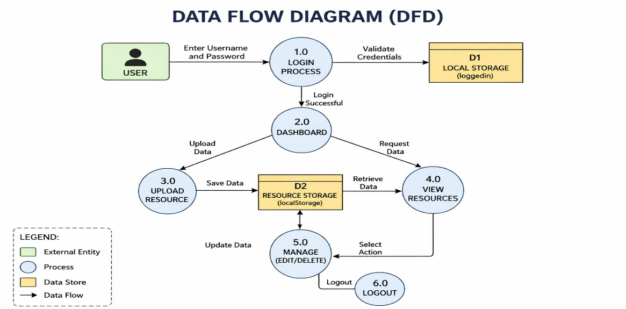
Explanation:
The DFD illustrates how data flows from the user to the system, is processed, stored, and then displayed.

15. System Flowchart
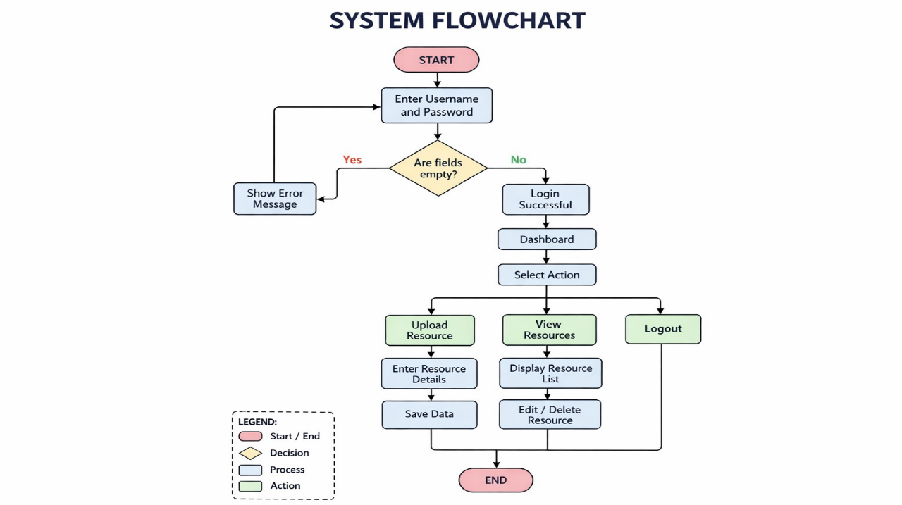
Explanation:
The flowchart represents the logical sequence of operations within the system.
SECTION C: SOFTWARE DEVELOPMENT
16. Development Tools
The system was developed using:
HTML
CSS
JavaScript
Visual Studio Code
17. System Architecture
The system follows a structured flow:
Login → Dashboard → Resource Management → Storage → Out
20. CODE EXPLANATION
Login System
The login system validates user credentials and stores a login state using localStorage. This ensures that only authenticated users can access the dashboard.

Index.html
<!DOCTYPE html>
<html>
<head>
<title>Login</title>

<style>
body {
font-family: Arial;
text-align: center;
background-color: #f4f6f9;
}
h1 {
background: #007BFF;
color: white;
padding: 15px;
}
input {
padding: 10px;
margin: 10px;
width: 250px;
}
button {
padding: 10px;
background: #007BFF;
color: white;
border: none;
}
</style>
</head>

<body>

<h1>Login</h1>

<input id="username" placeholder="Username"><br>
<input id="password" type="password" placeholder="Password"><br>

<button onclick="login()">Login</button>

<script>
function login() {
var user = document.getElementById("username").value;
var pass = document.getElementById("password").value;

if (user === "admin" && pass === "admin") {
localStorage.setItem("loggedIn", "true");
window.location.href = "dashboard.html";
} else {
alert("Invalid login details");
}
}
</script>

</body>
</html>
Dashboard
The dashboard provides navigation and ensures access control through login verification.
Resource Storage
Data is stored using localStorage in JSON format, simulating a database.
Display Function
Resources are dynamically displayed in a table format.
Edit and Delete
Users can modify and remove resources, ensuring data management flexibility.
Dashboard.html
<!DOCTYPE html>
<html>
<head>
<title>Dashboard</title>

<style>
body {
text-align: center;
font-family: Arial;
}
.button-container {
display: flex;
justify-content: center;
gap: 30px;
}
img {
width: 120px;
}
button {
padding: 10px;
background: #007BFF;
color: white;
}
</style>
</head>

<body>

<h1>Dashboard</h1>

<div class="button-container">

<div>
<img src="upload-image.jpg">
<br>
<button onclick="location.href='upload.html'">Upload</button>
</div>

<div>
<img src="view-image.jpg">
<br>
<button onclick="location.href='catalog.html'">View</button>
</div>

</div>

<script>
if (!localStorage.getItem("loggedIn")) {
window.location.href = "index.html";
}
</script>

</body>
</html>

🔹 Catalog.html
<!DOCTYPE html>
<html>
<head>
<title>Resources</title>

<style>
body {
text-align: center;
font-family: Arial;
}
table {
margin: auto;
border-collapse: collapse;
}
td, th {
padding: 10px;
border: 1px solid black;
}
</style>
</head>

<body>

<h1>Resources</h1>

<button onclick="location.href='dashboard.html'">Back</button>
<button onclick="clearAll()">Clear All</button>

<div id="output"></div>

<script>
function displayResources() {
var resources = JSON.parse(localStorage.getItem("resources")) || [];
var output = document.getElementById("output");

if (resources.length === 0) {
output.innerHTML = "No resources";
return;
}

var text = "<table>";
text += "<tr><th>#</th><th>Name</th><th>Subject</th><th>Action</th></tr>";

resources.forEach(function(item, index) {
text += "<tr>";
text += "<td>" + (index+1) + "</td>";
text += "<td>" + item.name + "</td>";
text += "<td>" + item.subject + "</td>";
text += "<td>";
text += "<button onclick='editResource("+index+")'>Edit</button>";
text += "<button onclick='deleteResource("+index+")'>Delete</button>";
text += "</td>";
text += "</tr>";
});

text += "</table>";
output.innerHTML = text;
}

function deleteResource(index) {
var resources = JSON.parse(localStorage.getItem("resources"));
resources.splice(index,1);
localStorage.setItem("resources", JSON.stringify(resources));
displayResources();
}

function editResource(index) {
var resources = JSON.parse(localStorage.getItem("resources"));

var name = prompt("Edit name:", resources[index].name);
var subject = prompt("Edit subject:", resources[index].subject);

if (name && subject) {
resources[index].name = name;
resources[index].subject = subject;
localStorage.setItem("resources", JSON.stringify(resources));
displayResources();
}
}

function clearAll() {
if(confirm("Delete all resources?")) {
localStorage.removeItem("resources");
displayResources();
}
}

displayResources();
</script>

</body>
</html>
21. User Documentation
Step-by-step instructions for system usage:
Login
Navigate dashboard
Upload resources
View resources
Manage resources
Logout
SECTION D: TESTING AND EVALUATION
22. Testing Strategy
Testing was conducted to ensure system functionality and reliability.
23. Test Cases
Normal Data
Valid inputs produce expected results
Abnormal Data
Invalid inputs trigger error messages
Extreme Data
System handles large datasets
24. Evaluation
Strengths:
Efficient
User-friendly
Functional
Weaknesses:
Limited security
No database
Local storage dependency
Single-user limitation
26. Future Improvements
Database integration
Online deployment
Multi-user system
conclusion
In conclusion, the Classroom Resource Management System successfully addresses the inefficiencies of manual resource tracking in educational environments. By automating the processes of borrowing, returning, and inventory management, the system enhances accuracy, reduces overhead costs, and increases access to resources for both teachers and students. Through thorough investigation, careful design, and rigorous testing, the system not only meets the initial objectives but also provides a scalable foundation for future enhancements. As educational demands evolve, this system offers a flexible, efficient, and secure solution that empowers educators and learners alike.

