

**DEPARTMENT OF**

**MECHANICAL ENGINEERING & TECHNOLOGY**

**MECH690 MECHANICAL DESIGN PROJECT, SUMMER 2013**

**PRE-PROPOSAL OF THE PROJECT**

**(Controlled Smoker)**

**CLIENT:** (Professor Bo Tao)

**CLIENT CONTACT:** ( )

**PROJECT MANAGER**: Robert Chase Giovannani SIGNATURE: DATE:

**TEAM MEMBER:**  Christopher Ryan Newell SIGNATURE: DATE:

**TEAM MEMBER:**  Jason Mak SIGNATURE: DATE:

**TEAM MEMBER:**  Gabriel Ochoa SIGNATURE: DATE:

**PROJECT ADVISORS**:

**APPROVED/REJECTED**: SIGNATURE: DATE:

**COMMENTS:**

*Pre-proposal of the project is actually the report of the need assessment. In this pre-proposal, each group must evaluate whether there is a real and feasible need. If the answer to the need assessment is yes, the group needs to evaluate the feasibility of the project as the senior project in a semester (summer semester) to answer whether or not the group can complete it. If the answer to the second question is yes, you can start to write the pre-proposal. The general rule is that only after the need assessment is passed, the project is formed.*

*The pre-proposal of the project will consist of following sections:*

**INTRODUCTION**

Smoking food is an old style of cooking which dates back thousands of years. This project will encompass hot smoking, which is the cooking of food with no open flame. Rather this style of cooking uses the steam of water combined with the smoke of the charcoal, and wood. This cooks it, and gives it a more flavorful taste. Controlling the heat of a smoker is fairly difficult, and it takes a well experienced chef to know when to check up on the food being cooked. This project will take out the element of guessing, and will consistently keep the temperature inside the smoker at a uniform temperature.

**NEED ASSESSMENT**

The application of the project will be to deliver perfectly cooked meals, through a hot smoking process. This new design will give the user more control over the temperature in the smoker. Current problems with the existing technology is the uneven cooking temperature within the confinement. By dissipating heat from the cooker when temperatures exceed the set boundaries the cooker will intake cold air, or exhaust hot air. This will be done by placing multiple fans on the outside of the smoker. The technology does not exist for charcoal smokers, it does however exist for propane, and electrical smokers. The issue with existing temperature controlled smokers is that they do not appeal to customers due to the lack of taste which only comes from the burning of charcoal and wood. This technology will benefit the client for it closely resembles the old style of smoking. The project team does have more than enough experience to accomplish a physical model, and a comparison to existing models

**COST AND SUPPORT REQUIREMENT**

This project will have arrange of cost from 300 to 400 dollars. We think the project will take roughly a month to a month and a half to complete. This will include the planning, modeling, calculations, and the building of the physical model. There may be more weeks which we may have to be added to the work schedule to improve design, and also to test the model for improvements. We will need to use the projects lab to store, and to cut certain materials. We have ample resources from outside of WIT. The courses which will help us in this project will be thermodynamics, Heat transfer, machine design, fluids, instrumentations, and CAD Apps for simulation.

***Wentworth will not contribute unless the project is one involving laboratory equipment improvement or fabrication of new laboratory equipment for Wentworth.***

**PREDICTED RESULTS**

This project will result in a physical model, FEA analysis, a comparative study, and a demonstration of how the new design works. The smoker will be evaluated based on our goals. The faculty can grade our project is based on how the physical model can maintain a controlled temperature. Our project will maintain an average uniform temperature, and maintain it in that temperature throughout the cooking process. This is how faculty will know if the project is complete.

**PLAN**

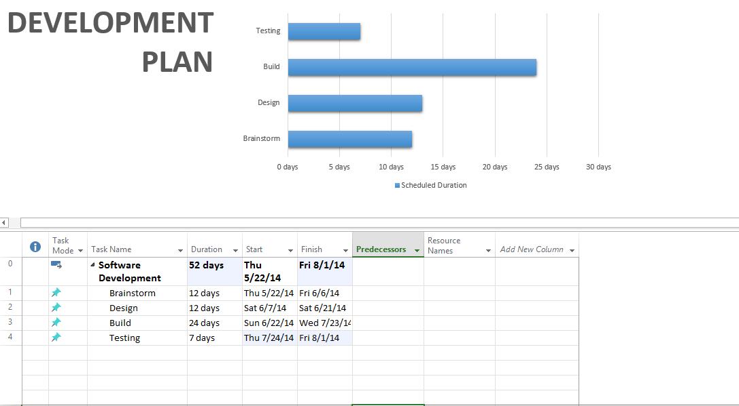

**TEAM QUALIFICATIONS**

*Resume of each group member*

