2D SPIFI Research Proposal

Brennan W. Fieck

November 19, 2016



# Introduction

The basis of the broader project to which this team’s efforts contribute is to expand upon an existing technology called Spatial Frequency Modulated Single Detector Imaging (SPIFI). This team’s project is primarily to provide simulation software to compare the output predicted by an ideal system to actual data collected from these systems once they have been constructed, and to produce a software suite for collecting, analyzing and visualizing the output of implementations of 2-dimensional SPIFI systems. Currently, the technique is used to scan small objects in order to provide high-resolution imaging of those objects. The next step is to enable the system to scan the object much faster by eliminating the current need to scan over a diffraction grating by implementing a larger diffraction grating that need not be scanned.

# Background (1D SPIFI)

SPIFI is a revolutionary imaging technique that allows a line to be scanned across an object by a single laser at one time, without using a raster pattern along the line. In particular, it is impressive because a full, two-dimensional image can be extracted from light collected at a single point. Traditionally, scanning more than a single point at a time would require multiple collectors to be able to resolve which photons were used to scan what part of the object (e.g. using a camera). SPIFI enables scientists to scan objects with one collector by encoding this information in a frequency change that maps directly to a plane normal to the laser’s direction of propagation.

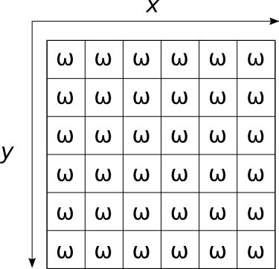

Figure 1: A Visual Depiction of Spatial Frequency Mapping (each *ω* is unique)

Figure 1 shows a visual depiction of how frequency changes can be associated with certain areas; each inscribed *ω* is unique to the section of the *xy* plane that bounds it. Figure 1 shows a low-resolution simplification, of course, but the result is the same. Up to some resolution, every point in the *xy* plane can be uniquely identified by the frequency associated with it. Thus, the light can be re-combined back into a well-collimated laser beam and directed at a single point of detection without losing position information. The mapping is resolved after detection by simply taking a Fourier transform of the intensity incident on the detector (the detector transforms that intensity linearly into a voltage) and determine which areas of the plane were attenuated due to passing through the object by looking for drops in the intensities of individual frequencies.

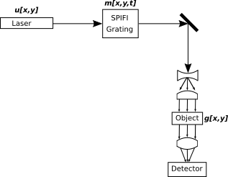

Figure 2: A Simple SPIFI System Setup

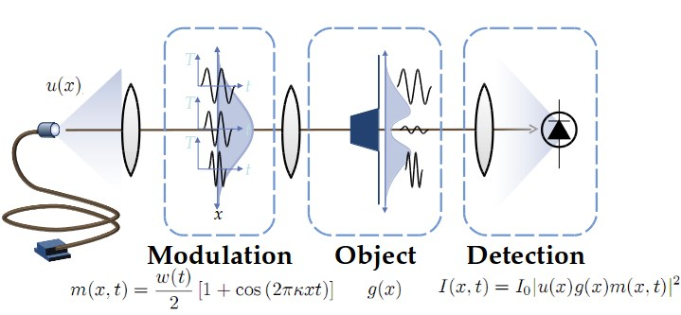

Figure 3: A Graphical Representation of a Simple SPIFI System

In an ideal situation where diffraction from the optics apparatus is ignored, a simple SPIFI system can be modeled by Figure 2. Each component that modifies the oscillation function that represents the electric field of the laser is labeled with a function of *x*, *y* and *t*, continuing the convention that the laser propagates in the ˆ*z* direction. Again, assuming ideal conditions, these transfer functions can fully describe the signal’s output at the detector. Specifically, the output has the form

*I*out = |*E*0 *u*[*x,y*] *m*[*x,y,t*] *g*[*x,y*]|2 (1)

where *E*0 is the amplitude of the initial electric field of the laser. Of course, electromagnetic waves vary in time as well as space. However, because phase does not affect intensity in any way any time variances can be trivially eliminated it from the calculations. The transfer function *u*[*x,y*] represents the initial form of the laser before it passes through any apparatus, and it takes the same form as a traditional wave oscillation. The transfer function *g*[*x,y*] is determined by the object being imaged, and represents an attenuation of amplitude of specific sections of the *xy* plane based on the object’s ability to absorb and reflect light, usually directly proportionally to the object’s thickness in that section. Typically this function is used to describe the object, and solving for *g* is the entire purpose of any imaging system. The function *m*[*x,y,t*] is the transformation applied by the SPIFI grating, and its form depends on the pattern used.



Figure 4: Left: A Circular SPIFI Grating - Right: A Rectangular SPIFI Grating

Examples of typical gratings are shown in Figure 4. For the common circular grating - similar to the one in the figure -, the form of the pattern in polar coordinates is

pattern[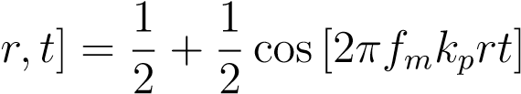*.* (2)

Here, *fm* is the rotational of the grating, and *kp* is a constant that has to do with the density of the lines in the pattern.

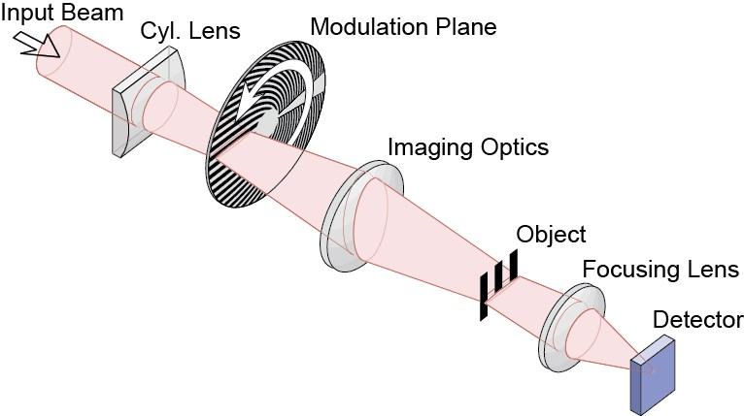

Figure 5: A Simple SPIFI System Using a Circular Grating

As shown in Figure 5, this function modulates the laser as it passes through the grating as a line, and then is scanned along the object from top to bottom by some optics equipment. Thus a transformation from Equation 2 to the *m*[*x,y,t*] transfer function requires sampling the output in intervals of *τm* = 1*/fm*, the period of the pattern’s spinning.

Once the light has been scanned over the object, the intensity recorded by the detector during *τm* can be Fourier-transformed to find the contributions from each frequency at a given time. In other words, 1 represents the intensity of a specific horizontal line on the object, and the time-domain and frequencydomain plots of this for some unknown object looks like Figure 6.

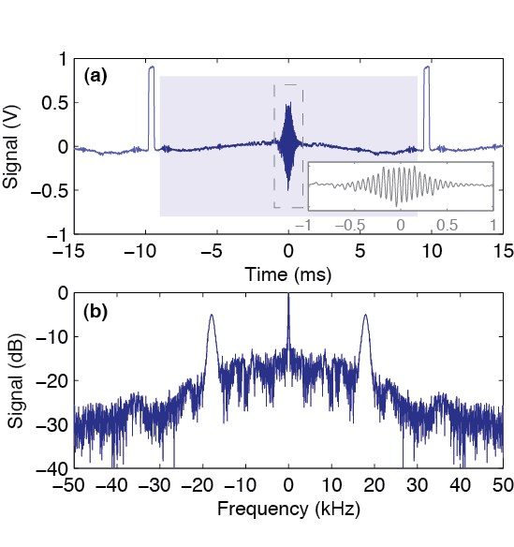

Figure 6: Top: Time-Domain SPIFI Output - Bottom: Corresponding Frequency-Domain SPIFI Output

Given that the forms of *m*[*x,y,t*] and *u*[*x,y*] are known, the form of *g*[*x,y*] can be obtained (and equivalently the shape of the scanned object) by comparing the contribution of each frequency produced by the SPIFI grating to what it would be if *g*[*x,y*] were always 1.

# Theory of 2D SPIFI

The focus of this project is to expand the capabilities of SPIFI by using a diffraction grating which, unlike those presented in the Background section, diffracts the entire beam in two dimensions at any one time, thereby eliminating the need to scan the laser along the object. Because using splitting the beam in two dimensions will allow scanning of the object to occur all at once, there’s no need to accumulate readings over some time interval, and therefore real-time imaging is made much easier. A basic, somewhat crude example of a circular grating that could be used is presented in Figure 7.



Figure 7: Crude Rendering of a Potential 2-Dimensional SPIFI Grating

Keep in mind, this is only meant to show how the 2-dimensional diffraction gratings might be mounted on a wheel to modulate the laser. Figure 8 shows a low-density, possible pattern for one of these squares.



Figure 8: Possible Pattern for Single Square on 2-Dimensional SPIFI Grating

At the time of this writing, the idea for this technology is little more than a week old, and only one of these wheels has been produced and tested, so images of a real, working grating wheel are unavailable. The team’s job will be to first construct a working simulation of one of these wheels given a wheel pattern, then to create a data collection routine for this new system- either from scratch or by modifying existing code written by the SPIFI team.

# Procedure

Our team is tasked with developing simulations of 2-dimensional SPIFI systems, and with writing data collection software. Each task will occur in increments, and each will require a report as well as documentation. Firstly, the simulation will be built up in the following steps:

1. Simulate 2D SPIFI using a perfectly continuous grating wheel
2. Incorporate gaps between patterns on the wheel
3. Incorporate refraction and diffraction caused by equipment

Documentation for this program will be made available in exhaustive pdf form as well as POSIX-compliant manual pages for the first incarnation, and subsequently updated for each change. The program will be written in an open language standard (C) using a free and open runtime for that language (the GNU Standard C library, compiled using the GNU C Compiler), and will be written and run on existing computers.

Secondly, data collection software will be written in the following two steps:

1. Analysis of existing codebase
2. Development of actual software

Data collection software already exists for simple, 1-dimensional SPIFI systems, so it may be advantageous to build the 2-dimensional analysis tool by writing a new version of this suite, or even to simply add it directly into the existing structure. Alternatively, if the current software is found to be devoid of functionality that can be used for the new system, or if it is deemed too bloated, slow, or incapable of interfacing properly with the detection hardware in some way, it would be more prudent to begin a new program and build it from the ground up. To determine which is better, the existing code will be analyzed, ideally in collaboration with the original team that wrote it - a coalition of researchers and research assistants from the Colorado School of Mines and the University of Colorado in Fort Collins, with the latter currently in charge of maintaining and updating. After the analysis, the actual code will have to be written. Whatever decision is reached regarding the use of the 1-dimensional analysis software, the final product *will* be written in an open language standard, and utilize a free and open runtime (the existing software has equivalent versions written in C++ and C#, so it’s impossible to say exactly what language and runtime will be used until the analysis is conducted, or even which will be used given that the existing software is used in some capacity). However, the current software is packaged as ”Solutions” for the Microsoft IDE and Development Environment called Visual Studio. Therefore, even if neither of these codebases is used, Visual Studio must be used in their analysis. Not only is Visual Studio itself not free, it only runs on the proprietary operating system Windows version 7 or higher. Furthermore, the company Jet Brains produces a proprietary plugin for Visual Studio that makes working with C# so much easier, and consequentially saves developers so much time that the vast majority of companies that work with C# deem it worth the cost. Given this usefulness, and the fact that the head software engineer is already familiar with the plugin, it would be very difficult to complete the analysis of the existing data collection software inside of the estimated timeframe - certainly not with the 10 h/week estimate - without the use of the plugin.

# Statement of Work

A breakdown of the costs of completing each part of the project is given in Table 1, and a timeline given for these tasks and their various parts, as well as the report to be presented on completion is given in Table 2 and the data is visualized in Chart 9.

|  |  |  |  |  |
| --- | --- | --- | --- | --- |
| **Item** | **Unit Cost** | **Quantity** | **Unit** | **Cost** |
| 2D Simulation Software · Labor | $63.00 | 28 | day | $1764.00 |
| Data Collection Suite |  |  |  | $6401.00 |
| · Labor | $63.00 | 87 | day | $5481.00 |
| · Visual Studio License | $500.00 | 1 | ea | $500.00 |
| · Windows 10 Product License | $120.00 | 1 | ea | $120.00 |
| · JetBrains Resharper License | $300.00 | 1 | ea | $300.00 |
| Final Report · Labor | $63.00 | 36 | day | $2268.00 |
| · Overhead | 50% of Labor | – | – | $4756.50 |
| **Total Cost** |  |  |  | **$15,189.00** |

Table 1: Cost Estimates for Project Deliverables

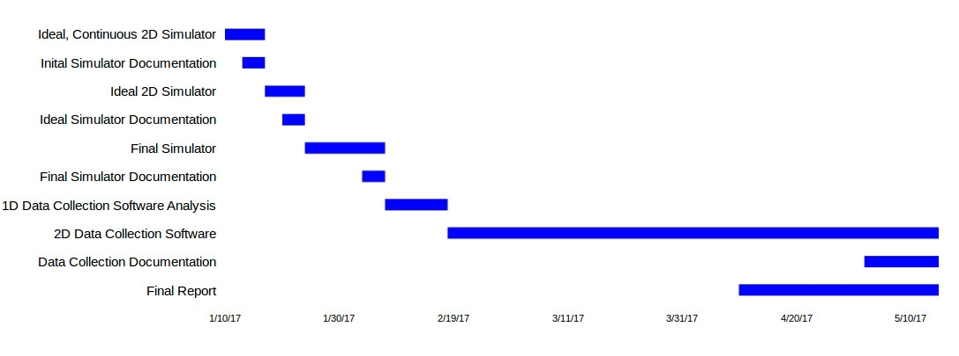

Figure 9: Project Timeline

Labor cost estimates are based on a rough $44.00/hr starting pay for software engineers, equivalent to $440.00 per 7 days or about $63.00/day, assuming I spend 10 hours week (standard part-time employment hours/week) working on these tasks.

In short, the team requests $15,189.50 to complete this project.

|  |  |  |  |
| --- | --- | --- | --- |
| **Deliverable** | **Start Date** | **Duration (Days)** | **End Date** |
| Ideal, Continuous 2D Simulation | 1/10/17 | 7 | 1/16/17 |
| Initial Simulator Documentation | 1/13/17 | 4 | 1/16/17 |
| Ideal 2D Simulator | 1/17/17 | 7 | 1/23/16 |
| Ideal Simulator Documentation | 1/20/17 | 4 | 1/23/17 |
| Final Simulator | 1/24/17 | 14 | 2/6/17 |
| Final Simulator Documentation | 2/3/17 | 4 | 2/6/17 |
| 1D Data Collection Software Analysis | 2/7/17 | 11 | 2/17/17 |
| 2D Data Collection Software | 2/18/17 | 87 | 5/15/17 |
| Data Collection Documentation | 5/2/17 | 14 | 5/15/17 |
| Final Report | 4/10/17 | 36 | 5/15/17 |

Table 2: Timeline Breakdown

# Conclusion

The ability to reliably simulate 2D SPIFI systems is crucial to the ability of the other teams working on the broader project to ensure the diffraction patterns, wheel designs, and optical systems are correct implementations of the theory, and are operating properly when placed into the system. Furthermore, the entire point of performing SPIFI microscopy on an object is to collect the output signal data, making the production of data collection software imperative to the success of the project. The team feels that costs have been estimated accurately, and that said costs are well worth the advances to science this technology will bring.

Upon the project’s completion, each of these software suites and their corresponding source code will be made publicly available via a public source control repository hosted by [GitLab.](http://www.gitlab.com/) Specifically, both will be initiated as private repositories, but will be made public upon publication of the larger body of work this team is contributed to. As such, though links are provided in the Appendix, following them will be useless to anyone without access to the repositories, and will remain empty for a little while anyway. To request access to these repositories, contact the project lead and/or head software engineer. All links and contact information is available in Appendix A.

**Appendix**

# A Miscellaneous Information

**A.1 Contact Information**

* Project Lead: Dr. Jeff Squire, jsquier@mines.edu
* Team Head Software Engineer: Brennan W. Fieck, bfieck@mines.edu

**A.2 Links**

* [2D SPIFI Grating Simulation Software](https://gitlab.com/PiercingGaze/2DSimulator)
* [Data Collection Suite](https://gitlab.com/PiercingGaze/SPIFIDataCollectionSoftware)
* [Original SPIFI Article](https://www.researchgate.net/profile/Alyssa_Allende_Motz/publication/281058706_Super-resolved_multimodal_multiphoton_microscopy_with_spatial_frequency-modulated_imaging/links/5790535d08ae64311c0c7dbb.pdf?origin=publication_detail&ev=pub_int_prw_xdl&msrp=c3fj9RD45iTpvk8bRBlzYkN6ndcAYlW9SDWsP0gVb8WzFV5pplCJ3WT6D9fQrP2OT3rGfRWxpWECBz07rTxtH3ZWQ-V2CIIn99KlfPF-otY.9HgCklW2b18-KeSg_Y6vX11zOug1uQ3SSCEpbGXSzk5y_fIuZAdBHJtjk82L1NpfpV2e2Cvcd6QBkqBT24bFzQ.uEqPWNYXdN8Ge_jgkDmRdTlNB8rMwiFPPFdueuZQ9VY6c_KOsp-YvgMVBaNkL6Ldag5ifDVuL2YqcNGnICTcHA) - hosted by [Research Gate](https://www.researchgate.net/)