App Flow Document
AI Hair & Beauty Intelligence Platform
Screens, navigation structure & user journeys
Field | Value
Product | AI Hair & Beauty Intelligence Platform
Document | App Flow Document
Version | 1.0 (Draft)
Date | 22 June 2026
Companion to | Product Requirements Document v1.0
Status | For review

1. Introduction

1.1 Purpose
This document maps every screen, page, and user journey in the AI Hair & Beauty Intelligence Platform. Where the PRD defined what the system does and who may do it, this document defines how users move through it — the navigation shell, the path between sections, and the behaviour of each screen including empty, loading, and error states. It is the reference for designers building wireframes and developers wiring up routing and state.
The platform is a responsive web application for a single business: one central store supplying multiple shops, with three role types — Admin, Store-keeper, and Seller — governed by full custom RBAC. Navigation is always filtered by the signed-in user’s permissions.

1.2 How to read the diagrams
Flow diagrams in this document use a consistent visual language:
Shape / colour | Meaning
Dark navy rounded box | Start or end point of a journey (entry, terminal state)
Blue rounded box | A process or system action (e.g. “price tier auto-applied”)
Light box with blue outline | A screen or page the user sees
Amber diamond | A decision / branch point
Green box | A successful outcome / confirmation
Red box | An error, block, or unhappy-path message
Dashed arrow | A deferred, background, or follow-on transition

2. Global Application Shell
Every authenticated screen is rendered inside one consistent shell: a persistent left sidebar for primary navigation, a top bar for global controls, and a content area with breadcrumbs. Menu items and controls appear only if the user holds the relevant permission.
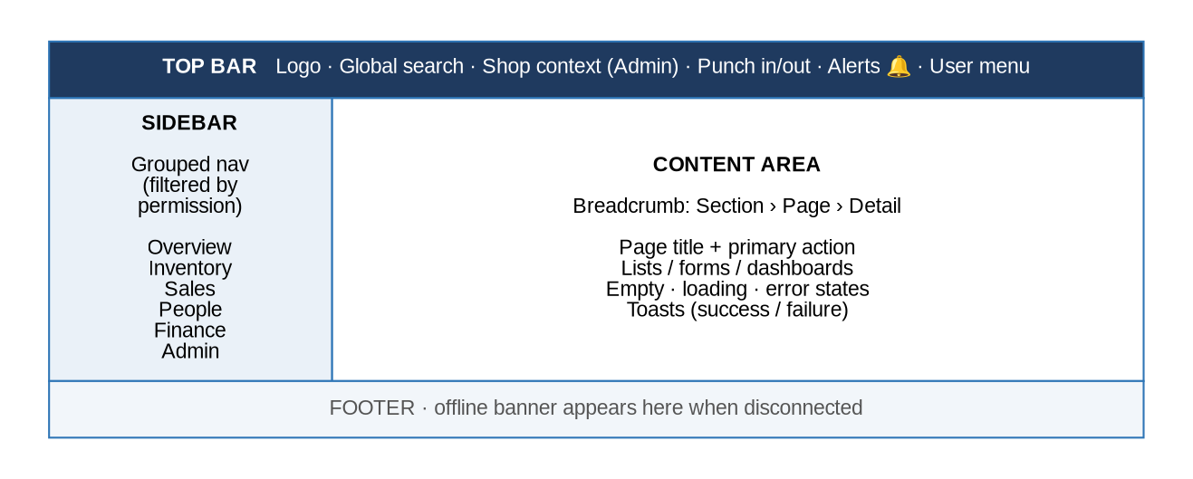
Figure 1 — Application shell anatomy

2.1 Top bar
Element | Behaviour
Logo | Top-left; returns the user to their role dashboard.
Global search | Searches across products, clients, and sales; results grouped by type; respects permissions.
Shop context selector | Admin only. Sets the active shop for shop-scoped actions; includes an “All shops” option for dashboards and reports. Hidden for sellers (fixed to their shop) and store-keepers (store level).
Punch in / out widget | Always visible for sellers (and admin acting in a shop). Shows current state and triggers the geofenced attendance flow.
Alerts bell | Badge with unread count; opens a dropdown of recent alerts with a “see all” link to the Alerts page.
User menu | Profile, change password, and logout.

2.2 Sidebar navigation (grouped, permission-filtered)
The sidebar is organised into groups. The table shows the default item visibility per role; custom RBAC can change any of these per user.
Group | Admin | Store-keeper | Seller
Overview | Dashboard, Alerts, News | Dashboard, Alerts, News | Dashboard, Alerts, News
Catalogue & Pricing | Products, Pricing | — | —
Store & Distribution | Purchases, Store stock, Distributions | Purchases, Store stock, Distributions | —
Selling | POS, Sales, Reconciliations | — | POS, My sales, Reconciliation
Stock (shop) | — | — | Pending confirmations, My stock
People | Users & Roles, Clients, Attendance | Attendance (if enabled) | Clients, Attendance
Finance & Reports | Expenses, Reports | — | —
Administration | News mgmt, Alert & shop settings | — | —
Account | Profile | Profile | Profile

2.3 Shop context model (Admin)
- Dashboards and reports default to “All shops” so the admin sees the whole business at a glance.
- Shop-scoped actions (selling, viewing a shop’s stock, recording expenses, confirming stock) require a specific shop. The admin’s last-used shop is remembered and shown in the top bar; they can switch at any time.
- If an admin starts a shop-scoped action with “All shops” active, the system prompts them to pick a shop first.
- Sellers never see the selector (locked to their shop). Store-keepers operate at store level and instead choose a destination shop within each distribution.

2.4 Breadcrumbs
Detail and edit pages show a breadcrumb trail (e.g. Products › Product detail › Edit) so users always know where they are and can step back one level. Back from a detail page returns to its list with prior filters preserved.

3. Role Navigation Maps
Each role lands on its own dashboard after login and navigates within the destinations below. Items the user lacks permission for are removed from the sidebar entirely.

3.1 Admin
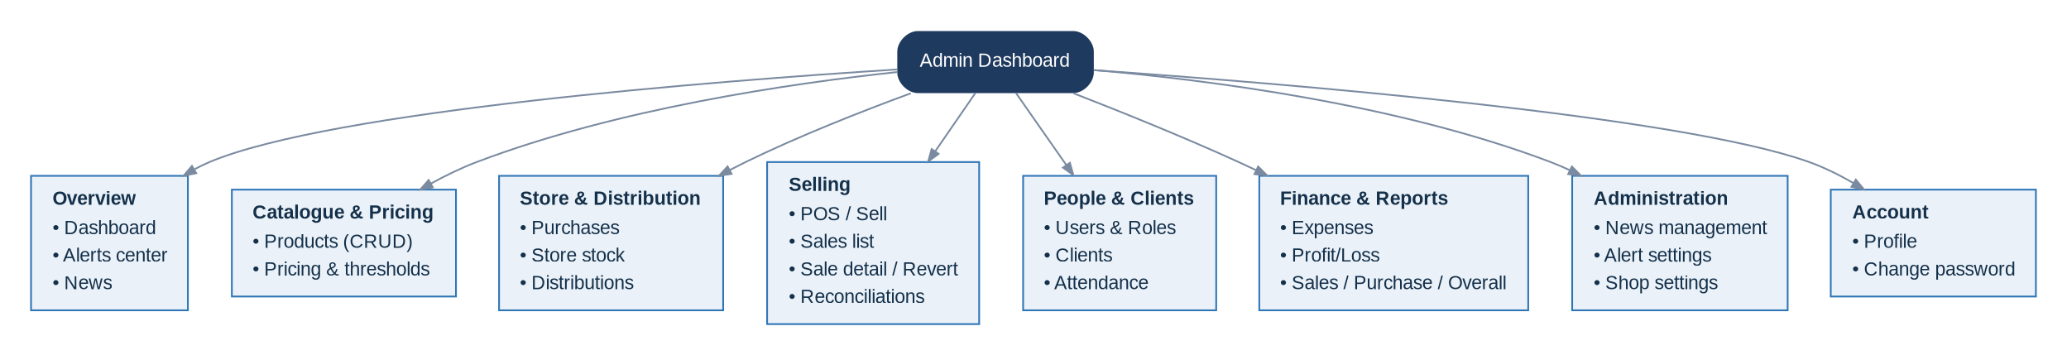
Figure 2 — Admin navigation map

3.2 Store-keeper
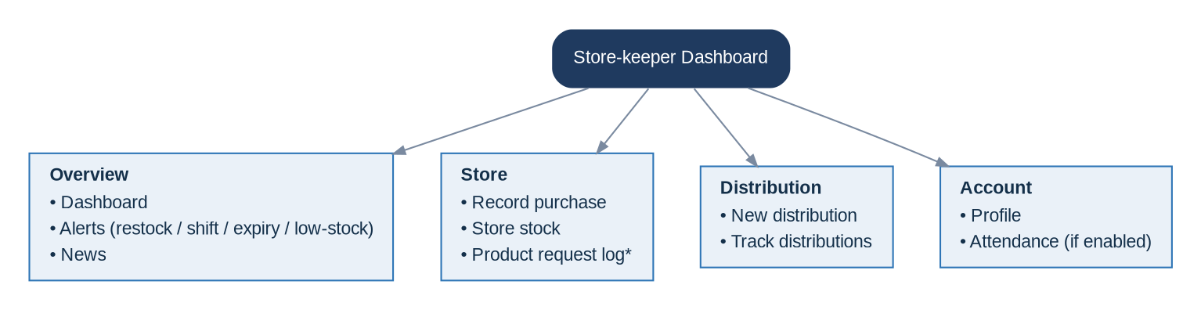
Figure 3 — Store-keeper navigation map (*product request log deferred to a later release)

3.3 Seller
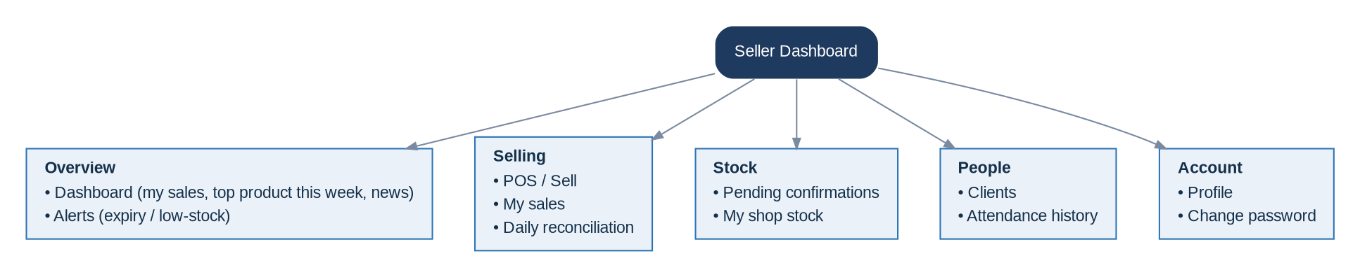
Figure 4 — Seller navigation map

4. Authentication & Session

4.1 Login & first login
There is no public sign-up. The first admin is seeded in the database; all other users are created by an admin and given credentials manually. New users (and anyone whose password an admin has reset) must set a new password before reaching any screen.
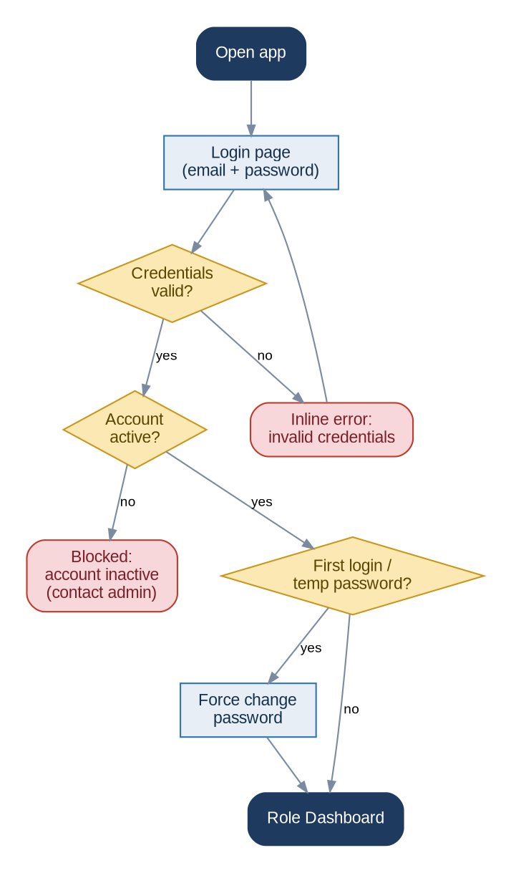
Figure 5 — Login and first-login flow

4.2 Password reset
There is no self-service “forgot password”. An admin with the relevant permission resets a user’s password from the Users list; the user is then forced to change it on next login.

4.3 Session timeout & logout
- Auto-logout after 30 minutes of inactivity, returning the user to the login page with a “session expired” notice.
- Manual logout is available in the user menu.
- Unsaved form changes prompt a confirmation before navigating away or timing out where possible.

5. Screen Inventory
Every page in the application, grouped by area. Each entry notes its purpose and key actions, what it shows before any data exists (empty state), and its error / edge-case behaviour.

5.1 Authentication & account
Screen | Purpose & key content / actions | Empty state | Error / edge states
Login | Email + password sign-in; no public sign-up. | — | • Invalid credentials → inline error  • Inactive account → blocked message
First-login password change | Forces a new password on first login or after an admin reset. | — | • Weak / mismatched password → inline error
Profile / account | View own details; change password. | — | • Wrong current password → inline error

5.2 Dashboards
Screen | Purpose & key content / actions | Empty state | Error / edge states
Admin dashboard | KPIs (purchases, sales, profit) over a date range, All shops or a selected shop; alert cards; news; quick links. | • Fresh system → zeroed KPIs with “No data for this range” + CTA to add products / record a sale | • Query failure → retry card
Store-keeper dashboard | Store stock health; restock / shift / expiry / low-stock cards; pending distributions; news. | • “All good — no alerts” | • —
Seller dashboard | My sales (today / this week); top-selling product this week; pending-confirmations widget; punch widget; news; my alerts. | • “No sales recorded today — Start a sale” | • —

5.3 Products & pricing
Screen | Purpose & key content / actions | Empty state | Error / edge states
Products list | Searchable / filterable (category, brand, status); + New product; row view / edit / delete. | • “No products yet — Add your first product” | • Delete with history → soft-deactivate  • Delete confirmation modal
Product detail | All fields, batches & expiry, stock by location, price tiers. | • New product → “No stock recorded yet” | • —
Product create / edit | Name, category, brand, SKU, image, description; required-field validation. | — | • Inline + summary validation  • Duplicate SKU → inline error
Pricing | Wholesale price, retail price, wholesale threshold (default 12) per product. | — | • Price / threshold ≤ 0 → inline error

5.4 Purchasing & store inventory
Screen | Purpose & key content / actions | Empty state | Error / edge states
Purchases list | Stock-in history; + New purchase; filter by date / product. | • “No purchases yet — Record your first purchase” | • —
New purchase | Select / create product; batch + expiry (cosmetics); quantity + unit cost; updates latest cost & store stock. | — | • Missing expiry for cosmetic → inline error  • Qty / cost ≤ 0 → inline error
Store stock | Current store quantities by product / batch; low-stock & expiry indicators. | • “Store is empty — Record a purchase” | • —

5.5 Distribution
Screen | Purpose & key content / actions | Empty state | Error / edge states
Distributions list | All store → shop transfers with status (pending / confirmed / discrepancy); filters. | • “No distributions yet — Create one” | • —
New distribution | Choose destination shop; add products / batches + qty; submit → pending. | — | • Insufficient store stock → inline block  • No shop chosen → inline error
Distribution detail | Sent vs confirmed qty; status; discrepancy notes. | — | • —

5.6 Selling & sales
Screen | Purpose & key content / actions | Empty state | Error / edge states
POS / Sell | Add products + qty (auto price tier), discount, payment method, optional client; review; confirm. | • Empty cart → “Add a product to start” | • Insufficient / unconfirmed stock → inline block  • Admin with no shop → prompt to select
My sales / Sales list | Sales with date, items, total, payment, status; filters; open detail. | • “No sales in this range” | • —
Sale detail | Line items, totals, payment, client; admin Revert action. | — | • Already reverted → Revert disabled

5.7 Daily reconciliation
Screen | Purpose & key content / actions | Empty state | Error / edge states
Daily reconciliation | Enter total amount sold + upload bank receipt for the day; reminder banner at cutoff / logout. | • Not submitted → reminder banner + “No reconciliation for today yet” | • Invalid / oversized file → inline error  • Already submitted → view / replace

5.8 Clients
Screen | Purpose & key content / actions | Empty state | Error / edge states
Clients list | Shop-shared clients (brand / name, phone, area); search; + New client. | • “No clients yet — Add a client” | • —
Client create / edit | Form fields with phone-format validation. | — | • Invalid phone → inline error

5.9 Attendance
Screen | Purpose & key content / actions | Empty state | Error / edge states
Punch widget (top bar) | Always-visible Punch in / out; geofenced; offline-capable within radius. | • Not punched in → shows “Punch in” | • Outside geofence → “Move within 100 m”  • Location off → enable-location error  • Offline → saved & queued
Attendance history | Seller’s punch records; admins can view all. | • “No attendance records yet” | • —

5.10 Alerts
Screen | Purpose & key content / actions | Empty state | Error / edge states
Alerts bell / dropdown | Badge + recent alerts; “see all”. | • “No new alerts” | • —
Alerts page | Full list (expiry / low-stock / restock / shift); filter; mark as read; read history. | • “No alerts” | • —
Alert settings (admin) | Edit thresholds: expiry 60 d, cover 30 d, restock 3 mo, shift 1 mo. | — | • Out-of-range value → inline error

5.11 News
Screen | Purpose & key content / actions | Empty state | Error / edge states
News page | All announcements; admin CRUD. | • “No news yet” | • —
News create / edit (admin) | Title, body, image, publish date. | — | • Inline validation errors

5.12 Expenses
Screen | Purpose & key content / actions | Empty state | Error / edge states
Expenses list | Per-shop operating expenses; filter by shop / category / date; + New expense. | • “No expenses in this range” | • —
New / edit expense | Shop, category (salary / security / electricity / cleanliness / rent / transport), amount, date, note. | — | • Amount ≤ 0 → inline error

5.13 Reports
Screen | Purpose & key content / actions | Empty state | Error / edge states
Reports hub | Sales, purchase, profit / loss, overall — per shop & overall; adjustable date range; export PDF. | • “Nothing to report for this range” | • Generation failure → retry  • Email send failure → notice

5.14 Users & roles (RBAC)
Screen | Purpose & key content / actions | Empty state | Error / edge states
Users list | All users (role, shop, status); + New user; activate / deactivate; reset password. | • Always ≥ 1 admin | • Cannot delete / deactivate last admin → blocked
User create / edit | Details, role, shop (sellers), initial password. | — | • Duplicate email → inline error
Roles & permissions | Define roles; toggle granular permissions; assign to users. | — | • Removing own critical permission → confirm / guard

5.15 Settings
Screen | Purpose & key content / actions | Empty state | Error / edge states
Shop settings | Name, area, coordinates, geofence radius (default 100 m), report recipient. | — | • Invalid coordinates → inline error
System / alert settings | Thresholds, payment-method list, defaults. | — | • —

6. Core User Journeys

6.1 Seller — a typical day
The seller’s day is a single continuous flow from login to logout, anchored by attendance and reconciliation.
- Log in (forced password change on first login).
- Punch in — geofenced to the shop.
- Review and confirm any deliveries distributed from the store.
- Sell throughout the day; price tier applies automatically by quantity.
- Respond to expiry / low-stock alerts as they appear.
- At day-end, complete the daily reconciliation (amount + bank receipt).
- Punch out and log out.
Figure 6 — Seller daily journey

6.2 Make a sale
Sellers sell from their shop; admins must have a shop selected. Pricing is automatic: 12 or more units uses the wholesale price, fewer uses retail. Only confirmed shop stock can be sold.
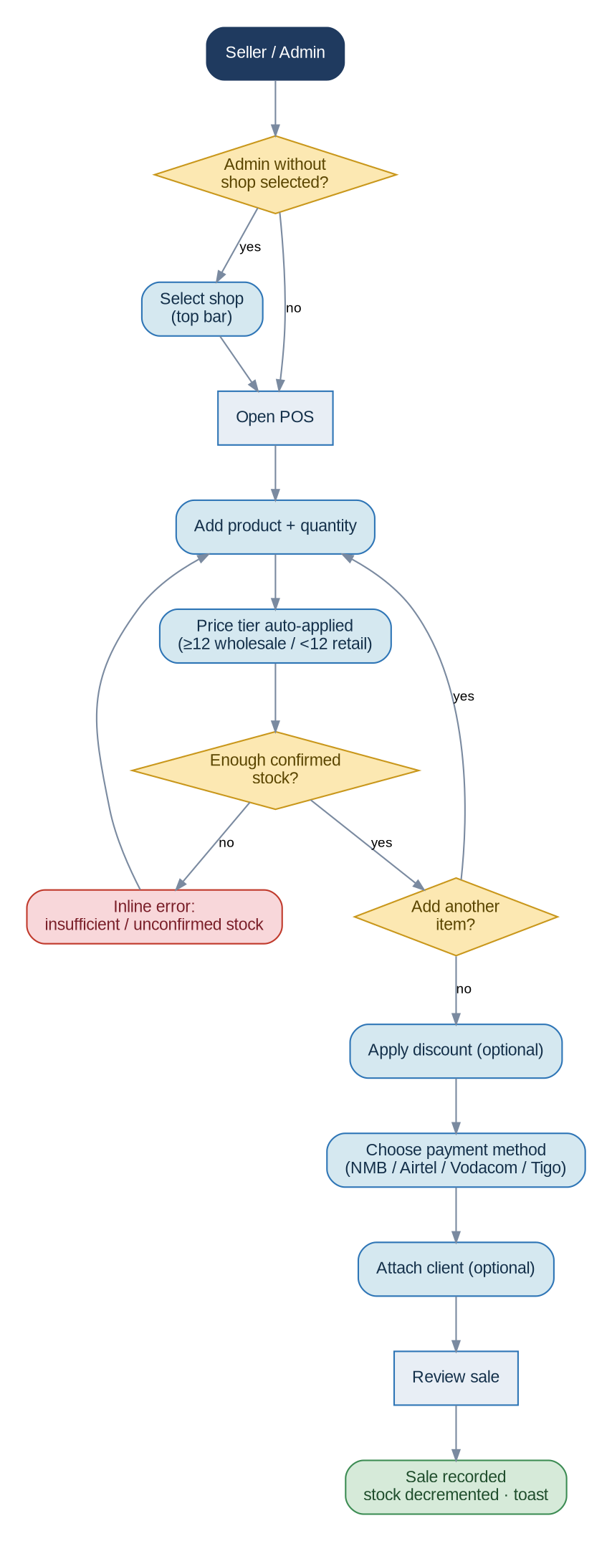
Figure 7 — Make a sale

6.3 Daily reconciliation
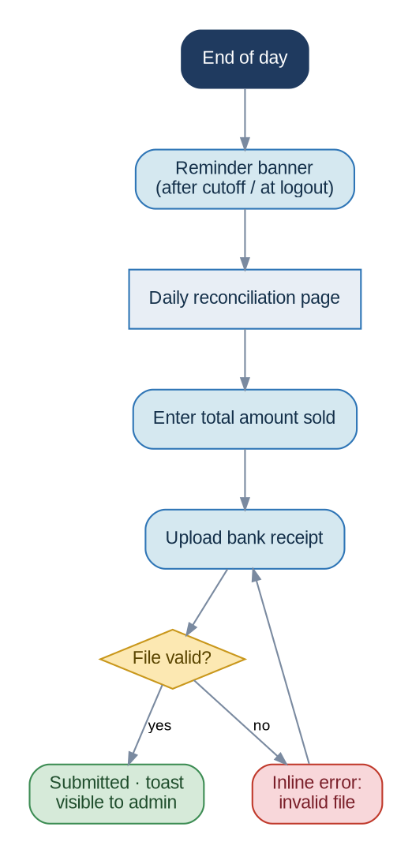
Figure 8 — End-of-day reconciliation

6.4 Record a purchase (store-keeper)
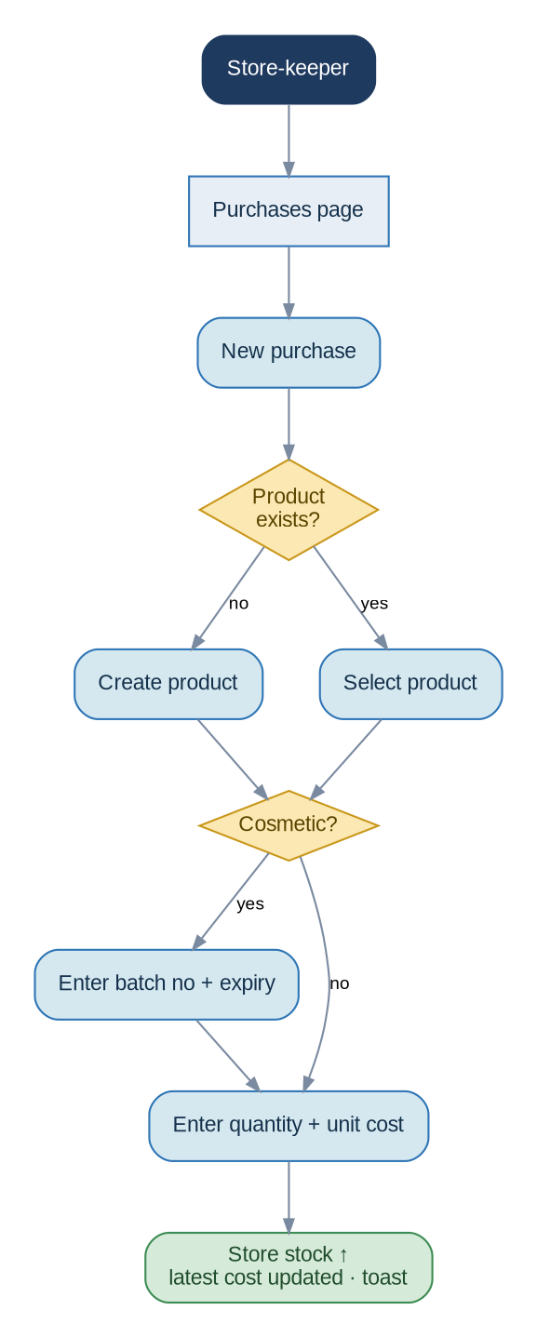
Figure 9 — Record a purchase — increases store stock and updates latest cost

6.5 Distribute stock to a shop
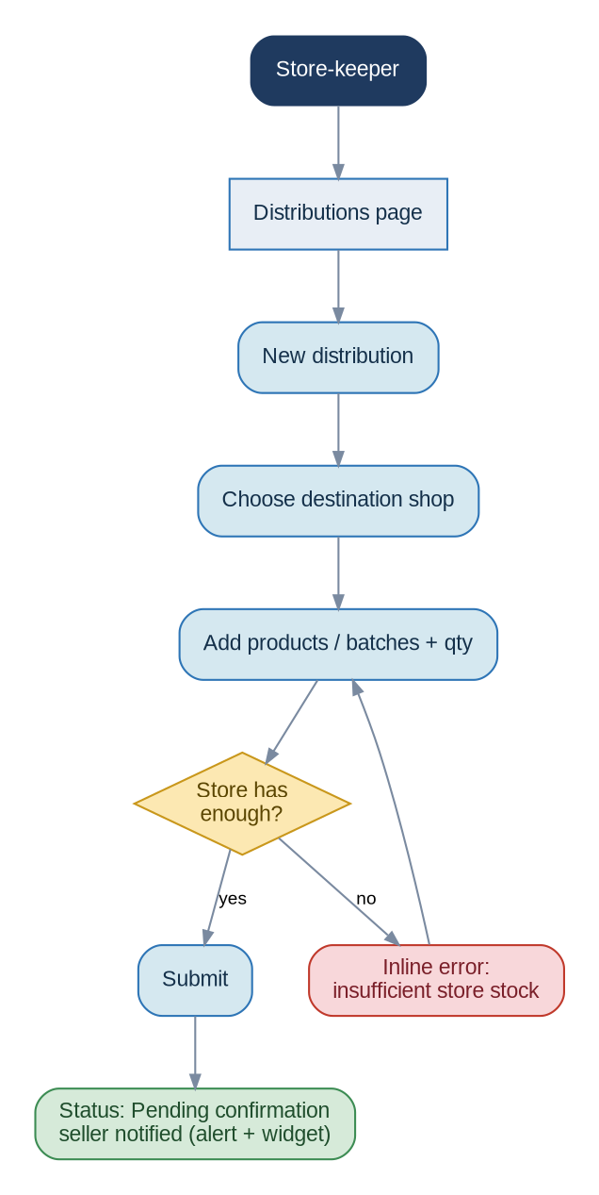
Figure 10 — Distribute stock — lands as “pending” until the seller confirms

6.6 Confirm received stock (seller)
Distributed stock is not sellable until confirmed. The seller can adjust the received quantity to flag a discrepancy; only the confirmed quantity becomes sellable and the difference is surfaced to the store-keeper and admin.
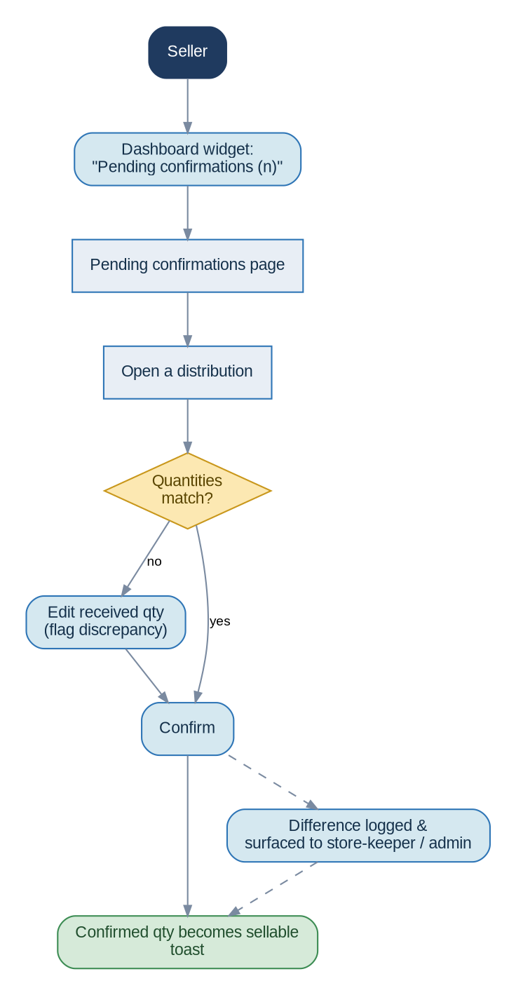
Figure 11 — Confirm received stock, with discrepancy branch

6.7 Revert a sale (admin)
Only an admin with the revert permission can reverse a sale. Reverting restores stock automatically, marks the sale reverted, and logs the action; the seller can then re-enter the corrected sale.
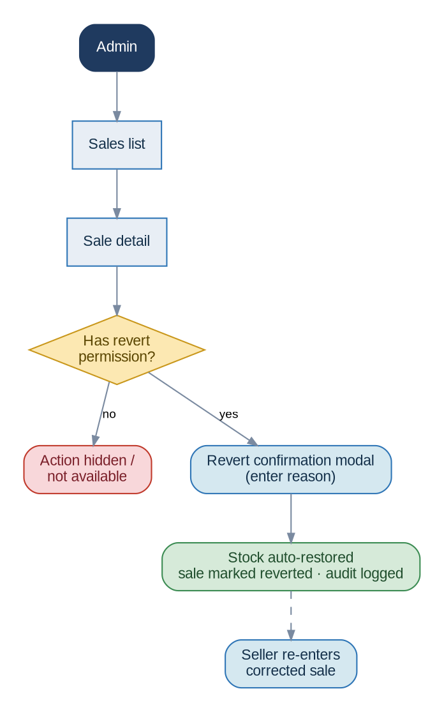
Figure 12 — Revert a sale

6.8 Attendance punch (geofence + offline)
Punching requires the seller to be within the shop’s geofence (default 100 m). It works offline while inside the radius and syncs when connectivity returns; outside the radius it is blocked.
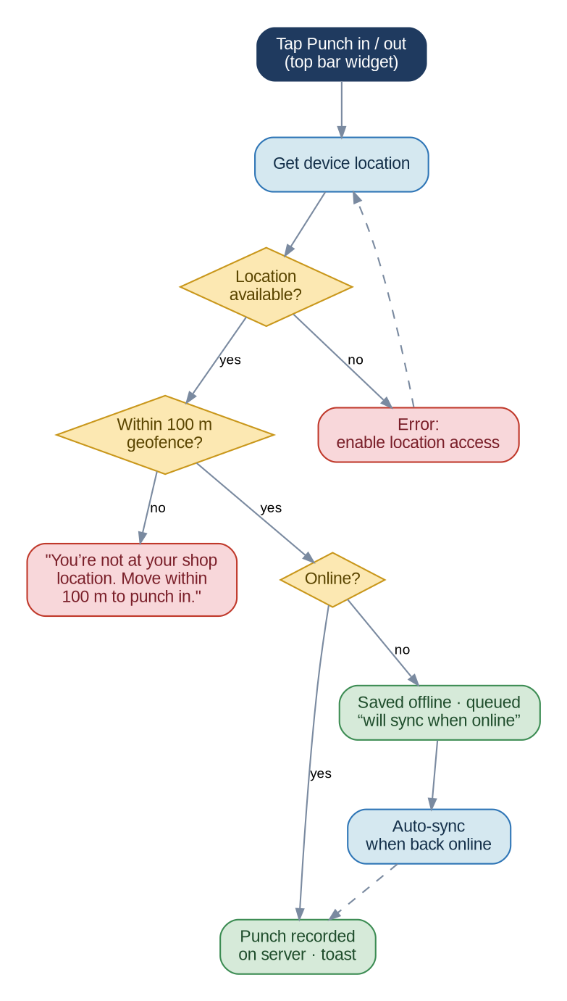
Figure 13 — Attendance punch with geofence and offline branches

6.9 Alert lifecycle
Alerts are generated by scheduled rules and surfaced in three places: the bell badge, dashboard cards, and the Alerts page. Users act on them and mark them as read, after which they move to history.
Figure 14 — Alert lifecycle

6.10 Create a user & assign permissions (admin)
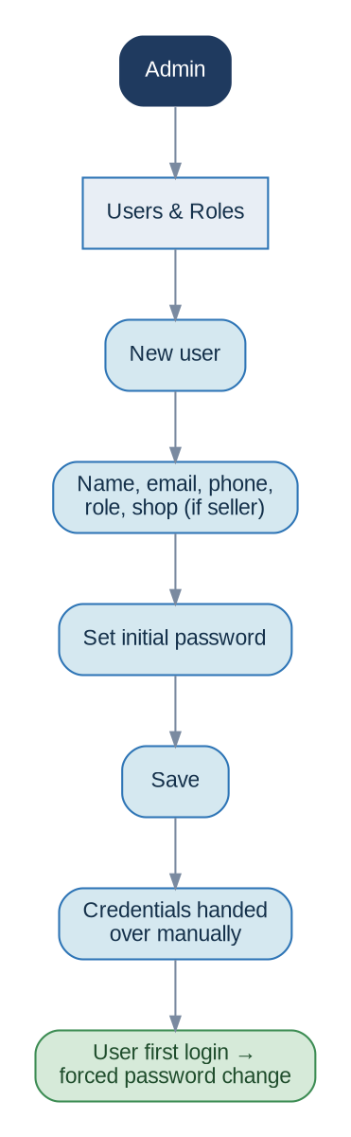
Figure 15 — Create a user; credentials are handed over manually

7. Cross-cutting State & Interaction Patterns
These patterns apply consistently across every screen so the app behaves predictably.

7.1 Loading states
- Lists and dashboards show skeleton placeholders while data loads; actions show inline spinners on their button and disable double-submission.

7.2 Empty states
Every list and dashboard has a friendly empty state: a short message plus the primary action that resolves it (e.g. “No products yet — Add your first product”). The per-screen empty states are listed in Section 5.

7.3 Error, offline & permission states
Situation | Where | Behaviour / message | Recovery
Invalid login | Login | Inline error under the form | Re-enter credentials
Permission denied | Anywhere | Item hidden from nav; direct access → “You don’t have access” page | Navigate elsewhere / ask admin
Outside geofence | Punch widget | “You’re not at your shop location. Move within 100 m to punch in.” | Move into radius
Location disabled | Punch widget | “Enable location access to punch” | Grant permission, retry
Offline write attempt | Any write except attendance | Offline banner; action blocked with retry message | Reconnect, retry
Insufficient / unconfirmed stock | POS, distribution | Inline block; sale / transfer prevented | Adjust quantity / confirm stock
Validation error | Forms | Field-level errors + summary | Fix flagged fields
Invalid file | Reconciliation, images | Inline error (type / size) | Upload a valid file
Delete with history | Products | Soft-deactivate instead of hard delete | —
Report generation / email fails | Reports | Retry option; failure notice | Retry
Session expired | Anywhere | Redirect to login with notice | Sign in again
Concurrent edit | Any record | Last-write-wins; user informed on conflict where detected | Reload, re-apply

7.4 Offline behaviour
- A persistent banner indicates lost connectivity.
- Only attendance punching works offline — and only inside the geofence — queuing locally and syncing on reconnect.
- All other write actions are blocked with a clear “you’re offline” retry message; read views show last-loaded data where possible.

7.5 Permission-denied behaviour
- Anything a user cannot do is removed from navigation rather than shown disabled.
- If a restricted route is reached directly (e.g. a bookmarked URL), a friendly “no access” page is shown.

7.6 Confirmations & destructive actions
- Destructive or irreversible actions (delete product, revert sale, deactivate user) require a confirmation modal; revert also captures a reason.
- Forms with unsaved changes warn before the user navigates away.

7.7 Feedback (toasts)
- Success and failure of actions are announced with toast notifications; toasts never replace inline validation, which stays next to the relevant field.

7.8 List page conventions
- Every list has: search, relevant filters, sortable columns, pagination, and a primary “+ New…” action.
- Row-level actions (view / edit / delete / revert) appear only where permitted.
- Filters and search terms persist when returning from a detail page.

7.9 Date ranges
- Dashboards, reports, and time-filtered lists default to the last 30 days, with quick presets (Today, 7 d, 30 d, This month, Custom).

7.10 Global search
- The top-bar search spans products, clients, and sales; results are grouped by type and filtered by the user’s permissions and shop context.

8. Notifications & Alerts Presentation
- Alerts appear in three coordinated places: a bell badge with a dropdown of recent items, dashboard cards, and a full Alerts page with history.
- Alerts can be marked as read; read items move to history and the badge count decreases.
- News appears as dashboard cards for sellers and store-keepers and on a dedicated News page; the admin manages news via CRUD.
- Alert types and their default rules: expiry within 60 days, stock cover below 30 days, restock from 3-month sales, shift-between-shops from 1-month behaviour — all admin-configurable.

9. Responsiveness (desktop & phone)
The application is responsive and used on both desktops/laptops (primarily admin and store-keeper) and phone browsers (primarily sellers, who also need GPS for attendance).
Region | Desktop | Phone / narrow
Sidebar | Always visible, grouped | Collapses to a hamburger / drawer; key items reachable in a bottom bar
Top bar | Full controls inline | Condensed: punch, alerts, search, and menu remain accessible
Lists / tables | Full tables with columns | Reflow to stacked cards; primary action stays prominent
POS / forms | Standard responsive form | Single-column stacked form; large tap targets
Attendance | Uses browser geolocation | Uses device GPS; same geofence and offline rules

10. Navigation Rules & Guarantees
- Navigation is always filtered by permission — users never see what they cannot use.
- Every role lands on its own dashboard; the logo always returns there.
- Breadcrumbs appear on detail and edit pages; Back returns to the originating list with filters intact.
- Primary actions sit consistently (top-right of a page or list); destructive actions are confirmed.
- Feedback is immediate: toasts for action outcomes, inline messages for field validation.
- Admin shop context is explicit and persistent; shop-scoped actions cannot proceed under “All shops”.
- Date-filtered views default to the last 30 days.
- Offline degrades gracefully: only geofenced attendance continues; everything else fails safely with retry.

