**Prob 6.04**

(a) D ~ A+G

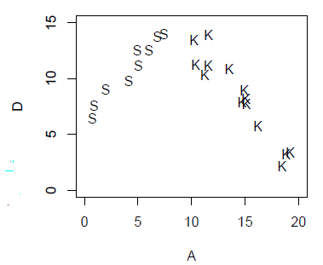

(b) D ~ A-1



(c) D ~ A



(d) D ~ A*G



(e) D ~ 1



(f) D ~ poly(A,2)



**Prob 6.05**

Model 1: speed ~ 1 + steepness

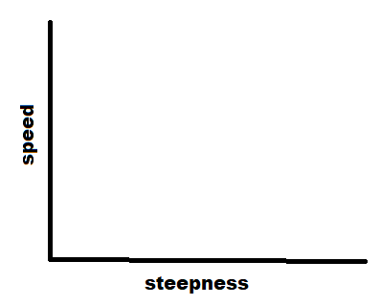

Model 2: speed ~ 1 + fitness



Model 3: speed ~ 1 + steepness + fitness



Model 4: speed ~ 1 + steepness + fitness + steep

